SUPPORTING FIGURES AND TABLES

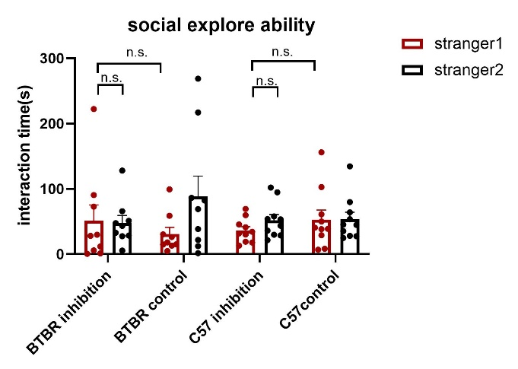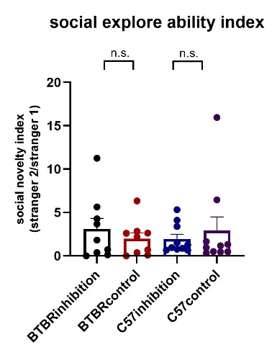
Fig. S1. GsMTx4 administration did not change the social novelty of mice

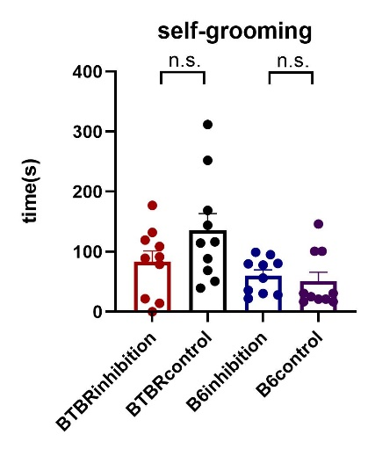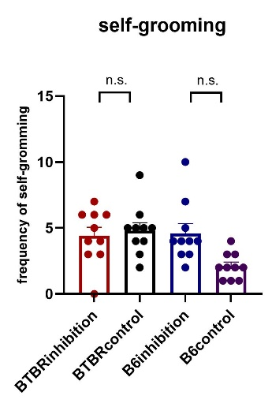
Fig S2. The administration of GsMTx4 did not change the mice’s grooming time and frequency

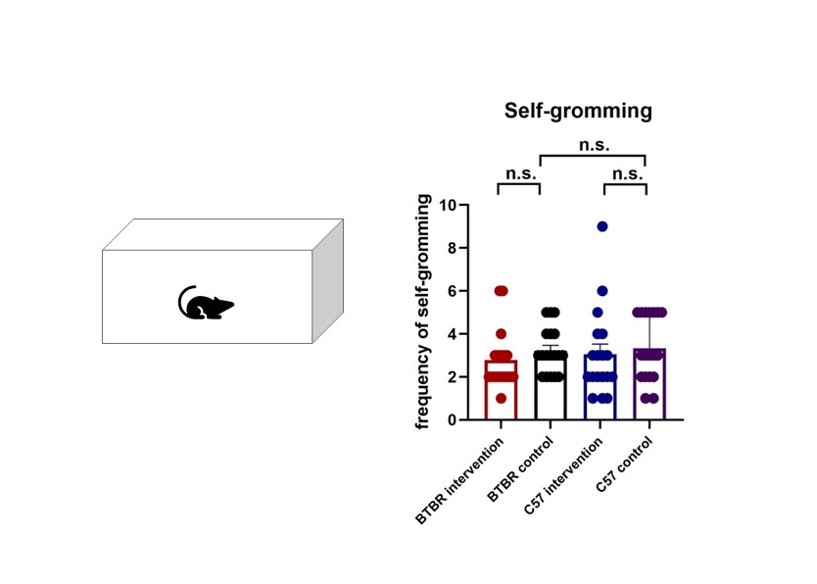
Fig S3. Mild intervention does not affect the frequency of self-grooming in mice
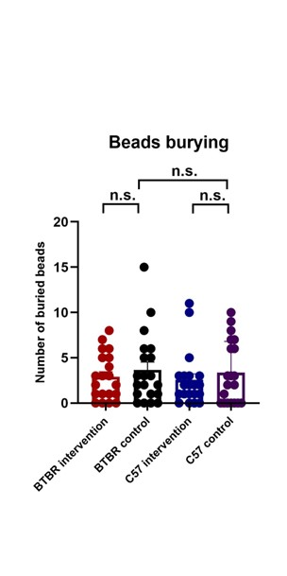
Fig S4. Mild intervention does not affect the number of buried beads in mice
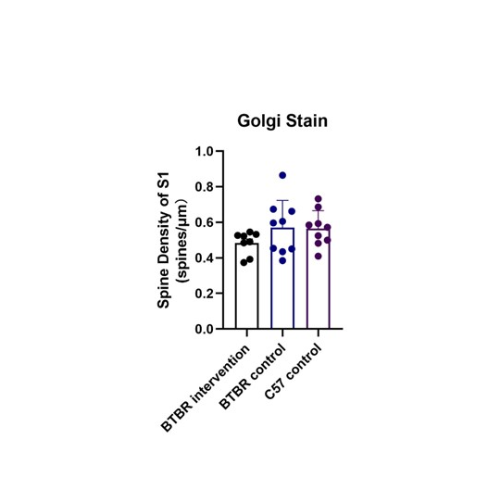
Fig S5. Mild intervention does not affect the dendritic spine density of S1 in mice

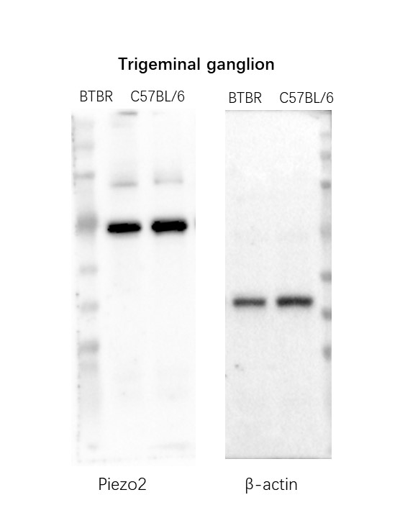
Fig S6. Complete blot of Piezo2 in trigeminal ganglion of BTBR and C57 mice

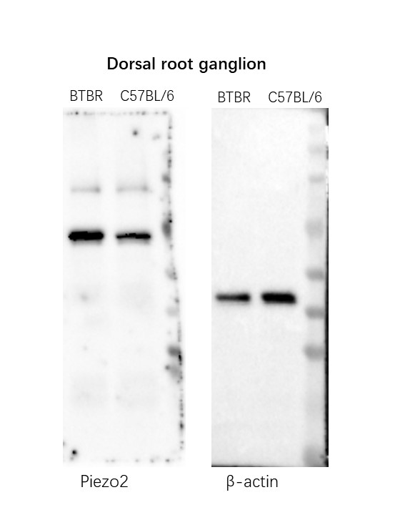
Fig S7. Complete blot of Piezo2 in dorsal root ganglion of BTBR and C57 mice

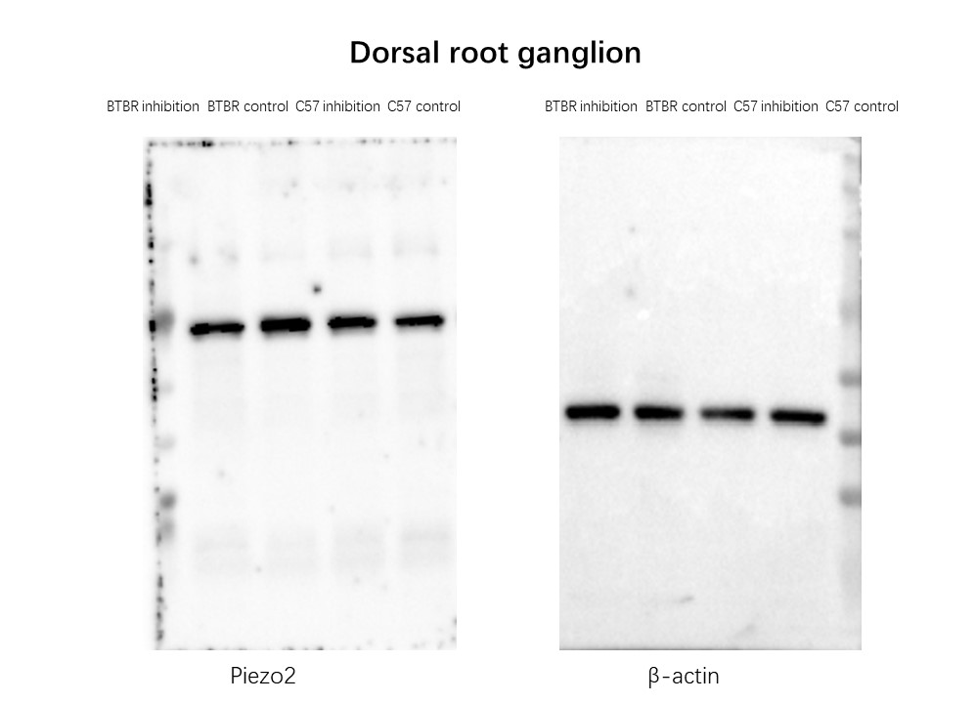
Fig S8. Complete blot of Piezo2 in dorsal root ganglion of BTBR/C57 mice administration group and control group

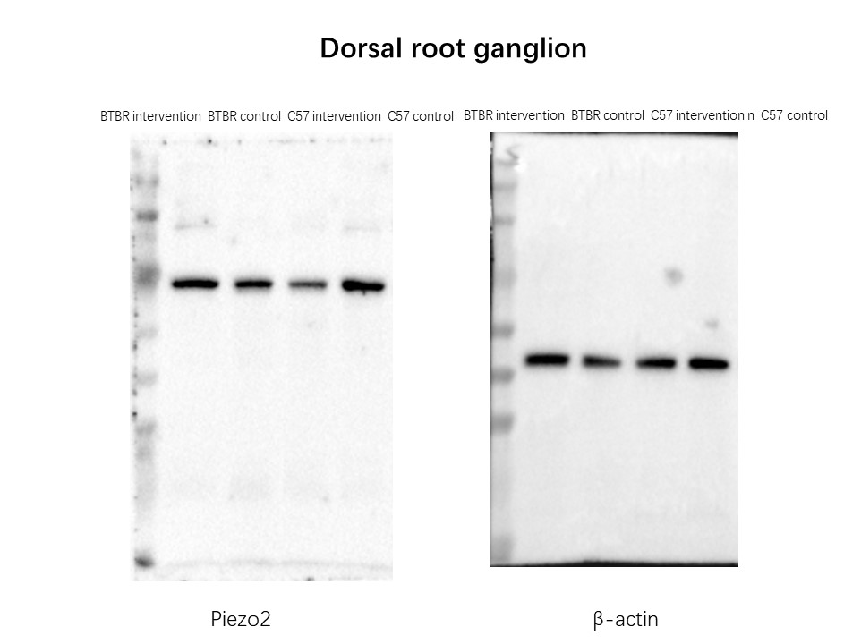
Fig S9. Complete blot of Piezo2 in dorsal root ganglion of BTBR/C57 mice touch intervention group and control group

Antibody | Catalog number/manufacturer | Dilution
Rabbit anti-Piezo2 | NBP1-78624, NOVUS | 1:400
Mouse anti-β-actin | 4970, Cell Signaling | 1:1000
Rabbit anti | Abs20002, Absin | 1:20000
Alexa Fluor 488 goat anti-rabbit IgG | 4412, Cell Signaling | 1:1000
Table S1. Antibody information related to experimental procedures, with catalog number/manufacturer, and used dilutions.

