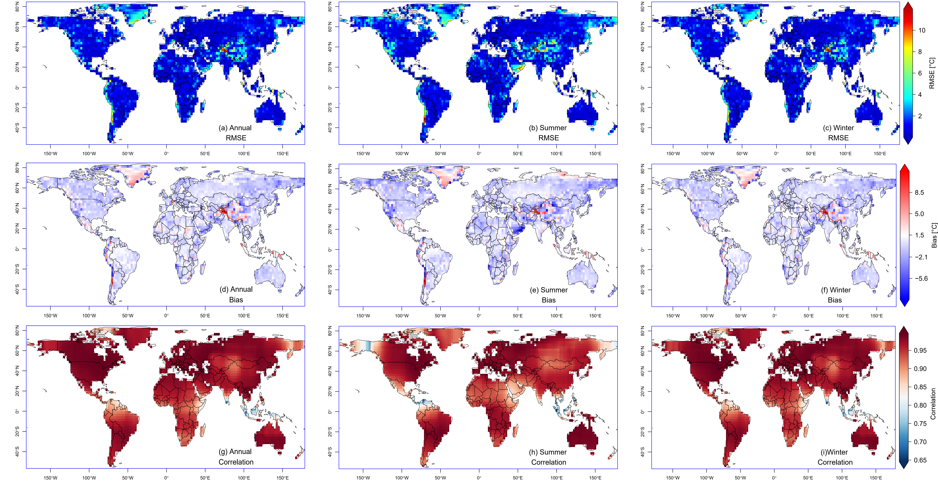
Fig S 1: Error metrics between reference and bias-corrected CANESM5 during the annual, summer and winter historical periods
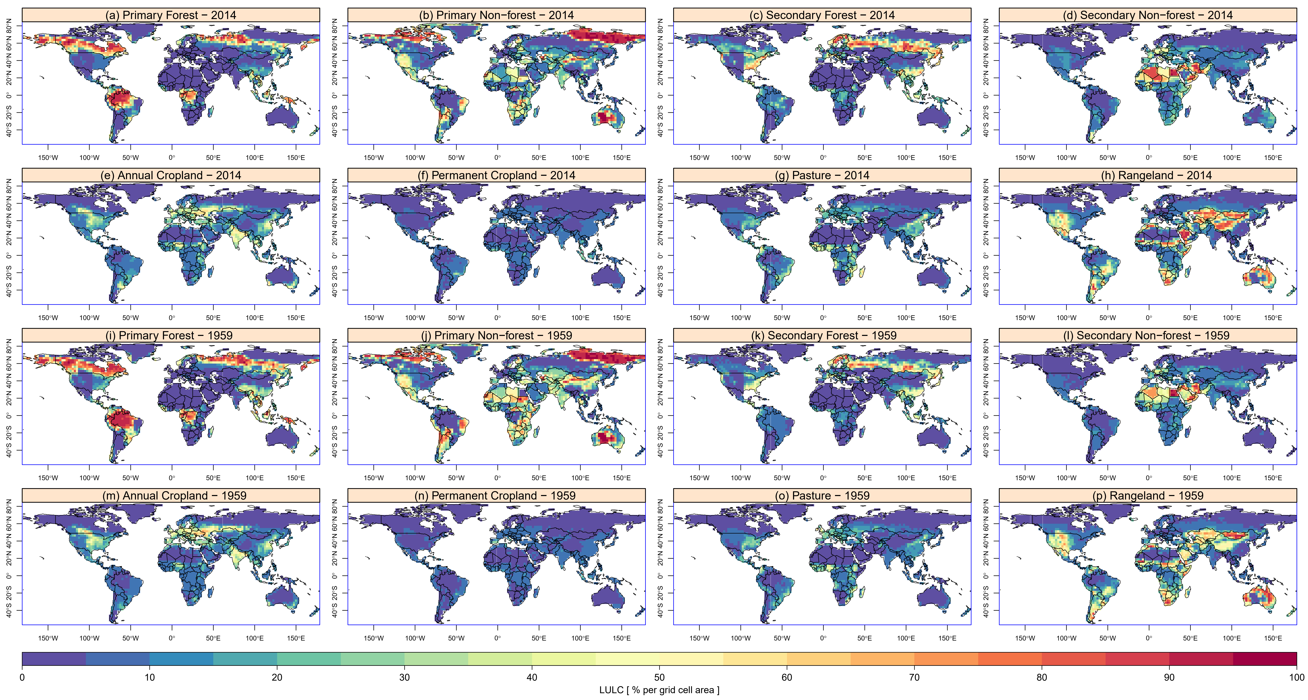
Fig S 2: Percentage grid cell area of the dominant LULC types
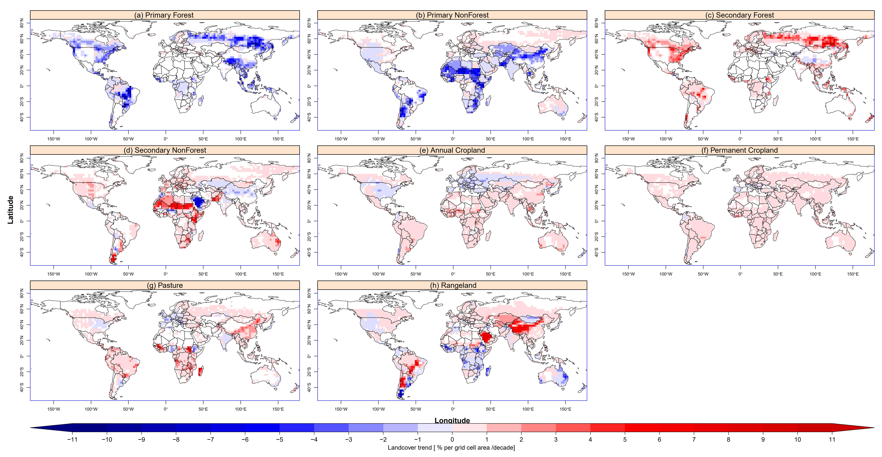
Fig S 3: Trend in LULC between 1959 to 2014
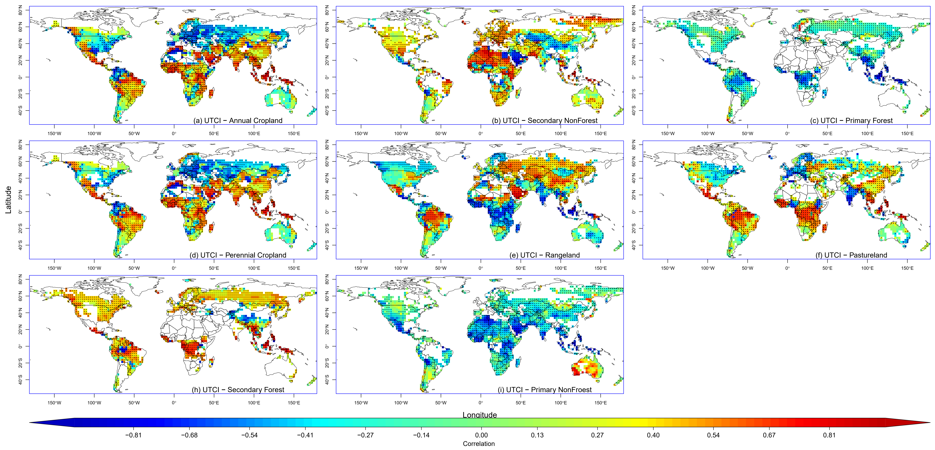
Fig S 4: Correlation between dominant LULC and the Annual Universal Thermal Comfort Index between 1959 and 2014. Dots represent significant correlation at 95 % confidence interval

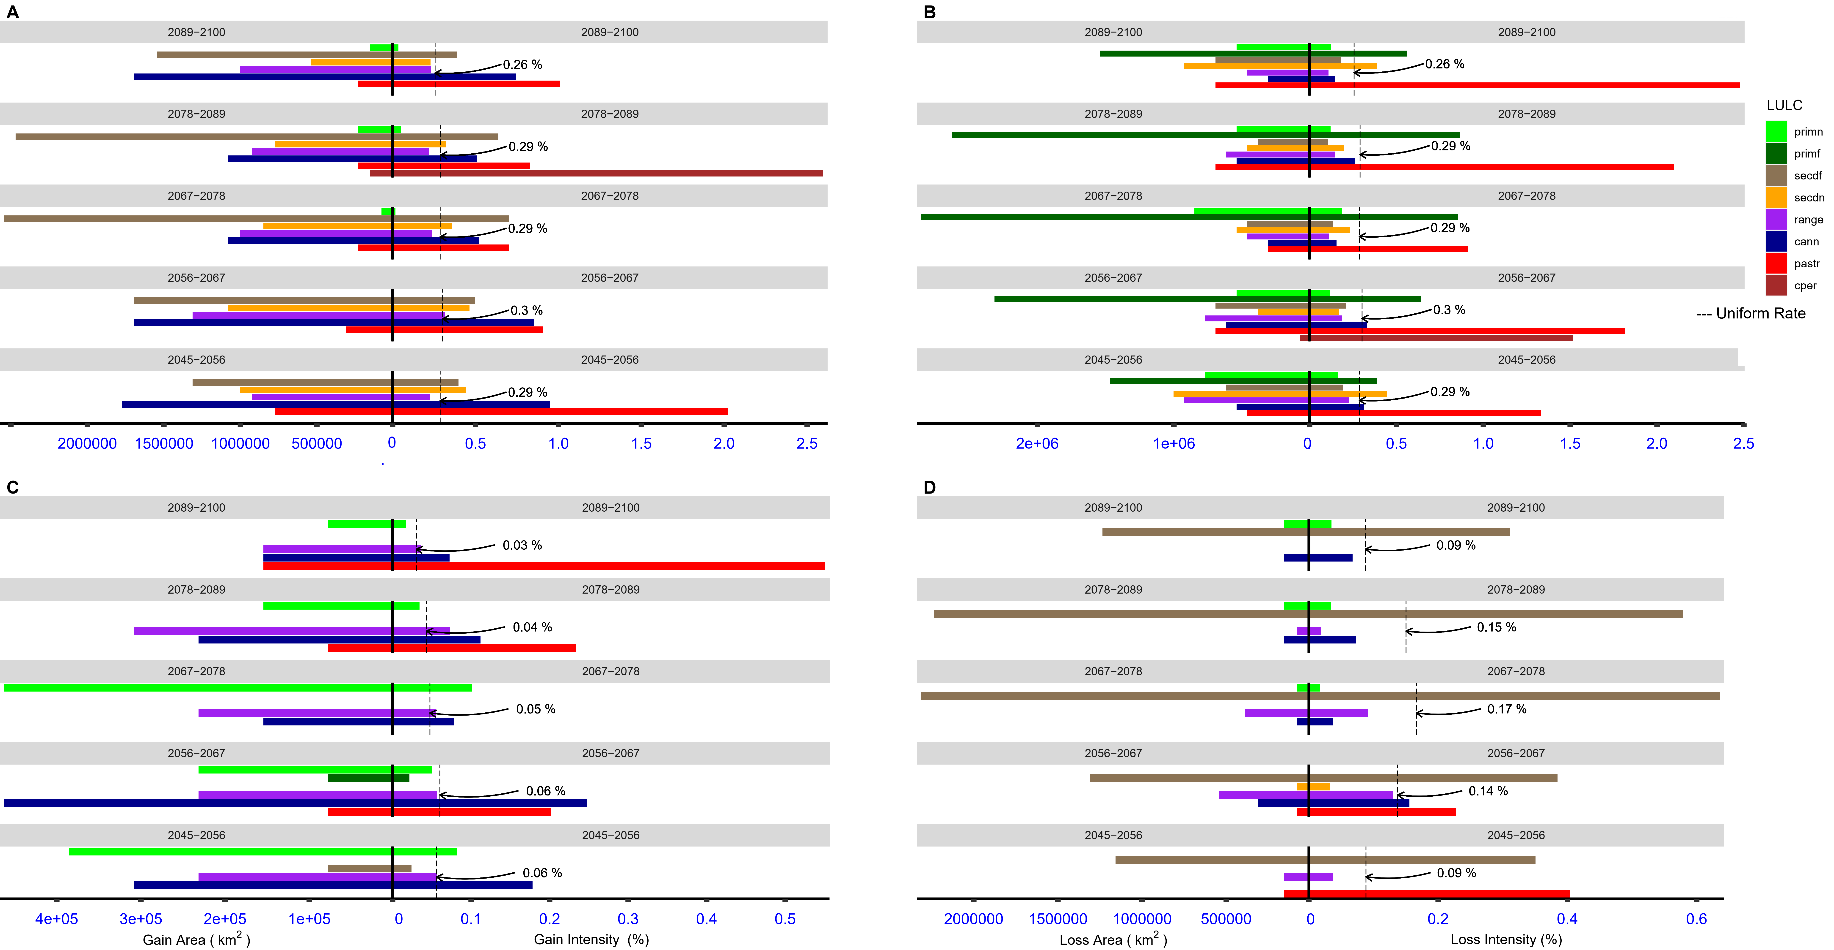
Fig S 5: Categorical intensities of all LULC types (a and b), and Transition intensities for (c) secondary non forest (d) primary forest for the future period under SSP370
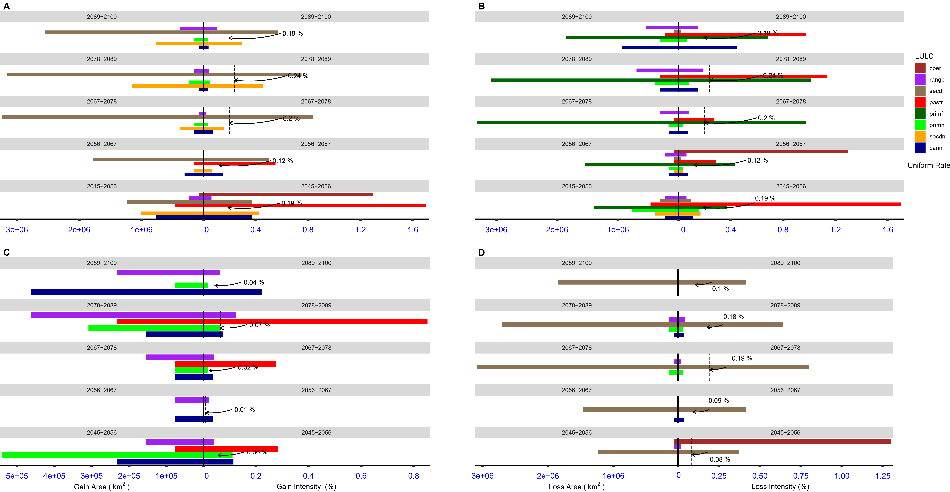
Fig S 6: Categorical intensities of all LULC types (a and b), and Transition intensities for (c) secondary non forest (d) primary forest for the future period under SSP585

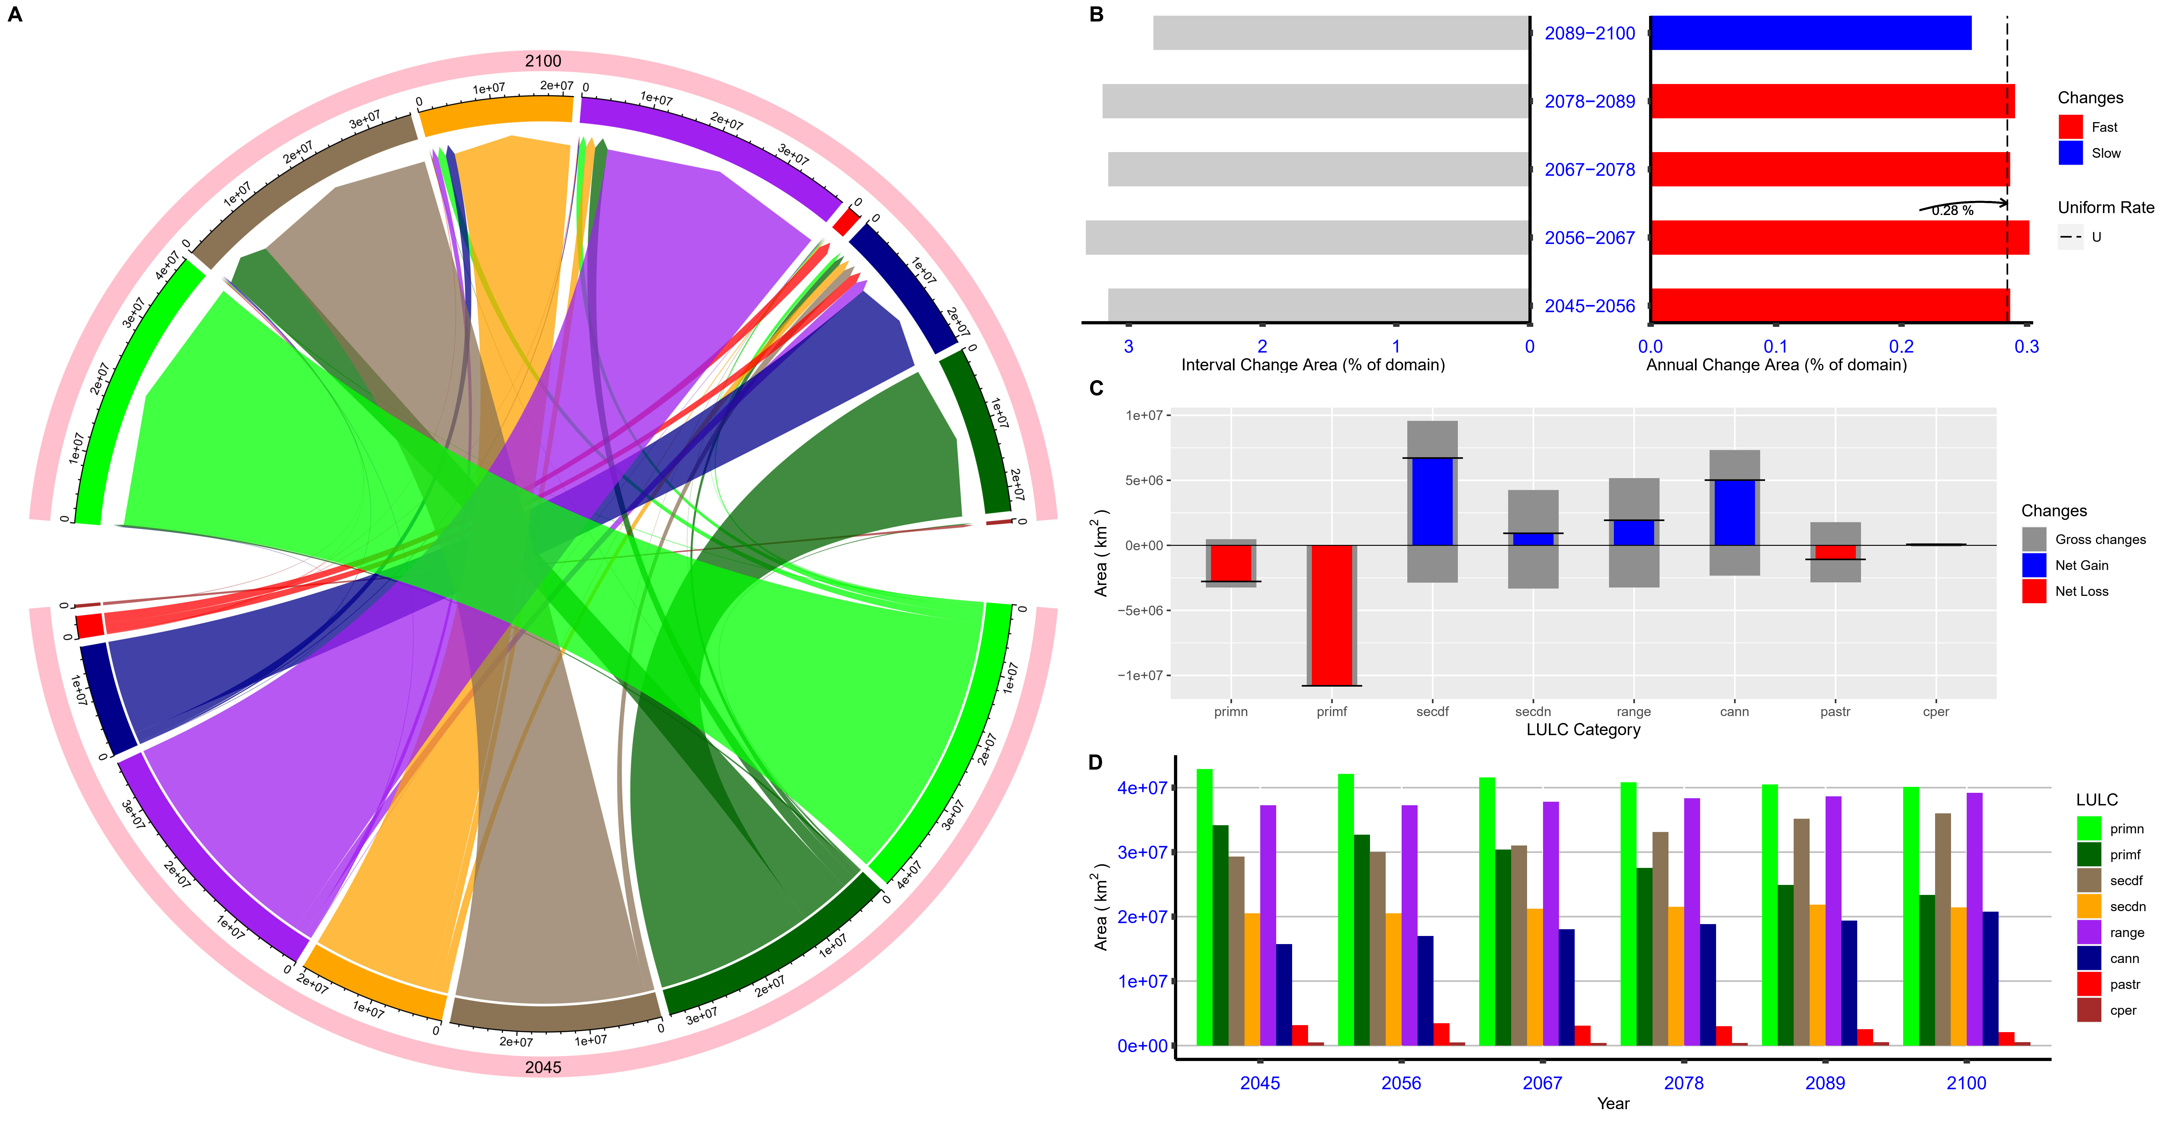
Fig S 7: LULC dynamics during the future under SSP370
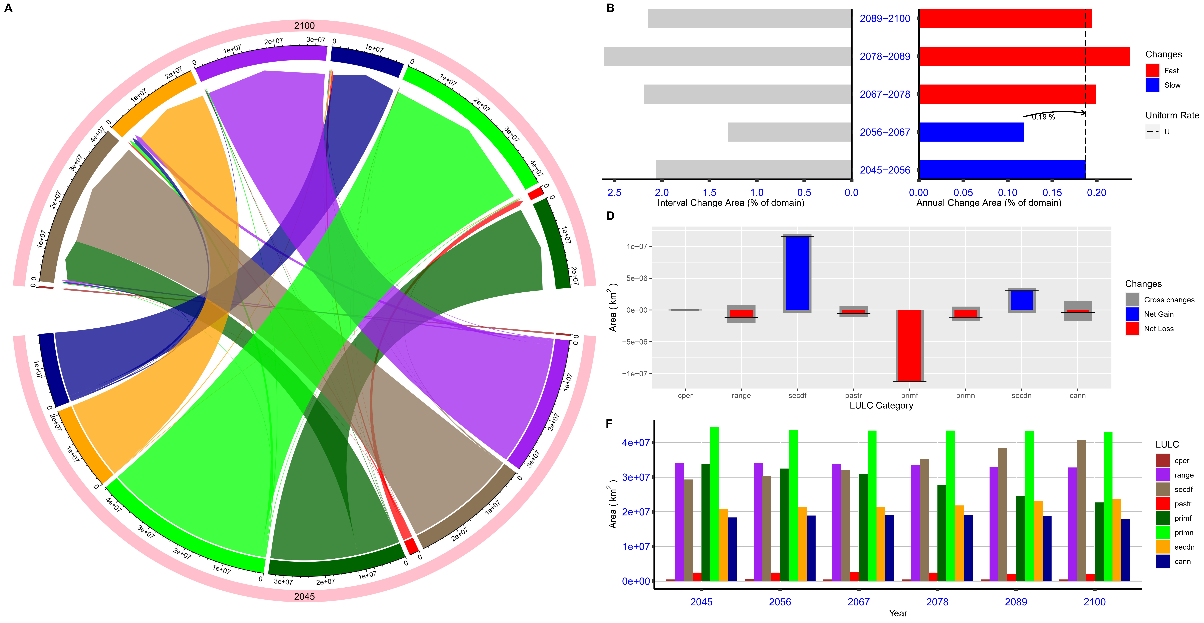
Fig S 8: LULC dynamics during the future under SSP585

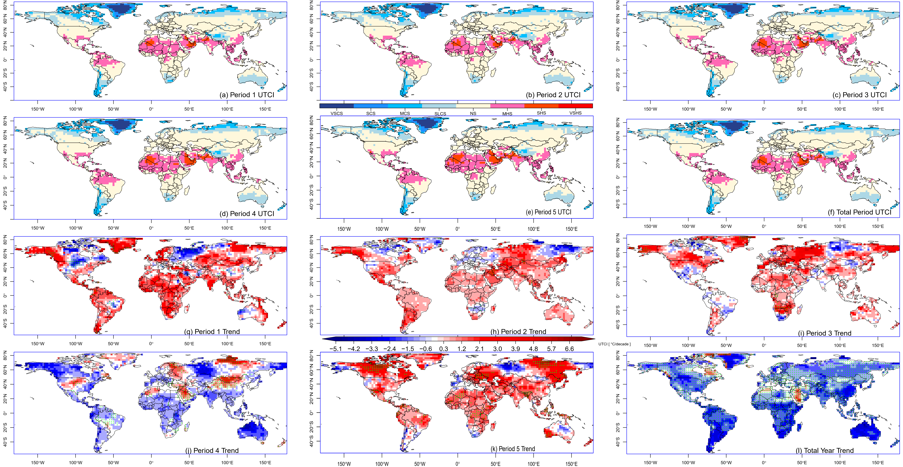
Fig S 9: Summer spread trend representation of UTCI for the different LULC transition periods during the historical period. Dots represent significant correlation at 95 % confidence interval
ECS means extreme heat stress, VSHS is very strong heat stress, SHS denotes strong heat stress, MHS is moderate heat stress, NS means no thermal stress, SLCS means slight cold stress, MCS denotes moderate cold stress, SCS means strong cold stress, VSCS is very strong cold stress and ECS denotes extreme cold stress

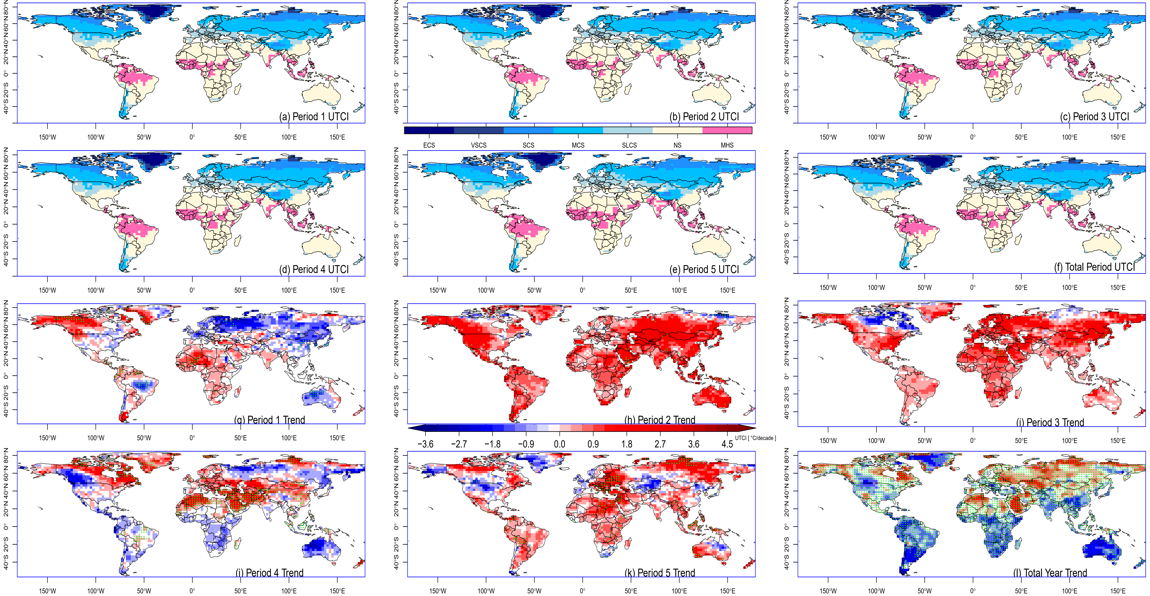
Fig S 10: As in S6 but for winter

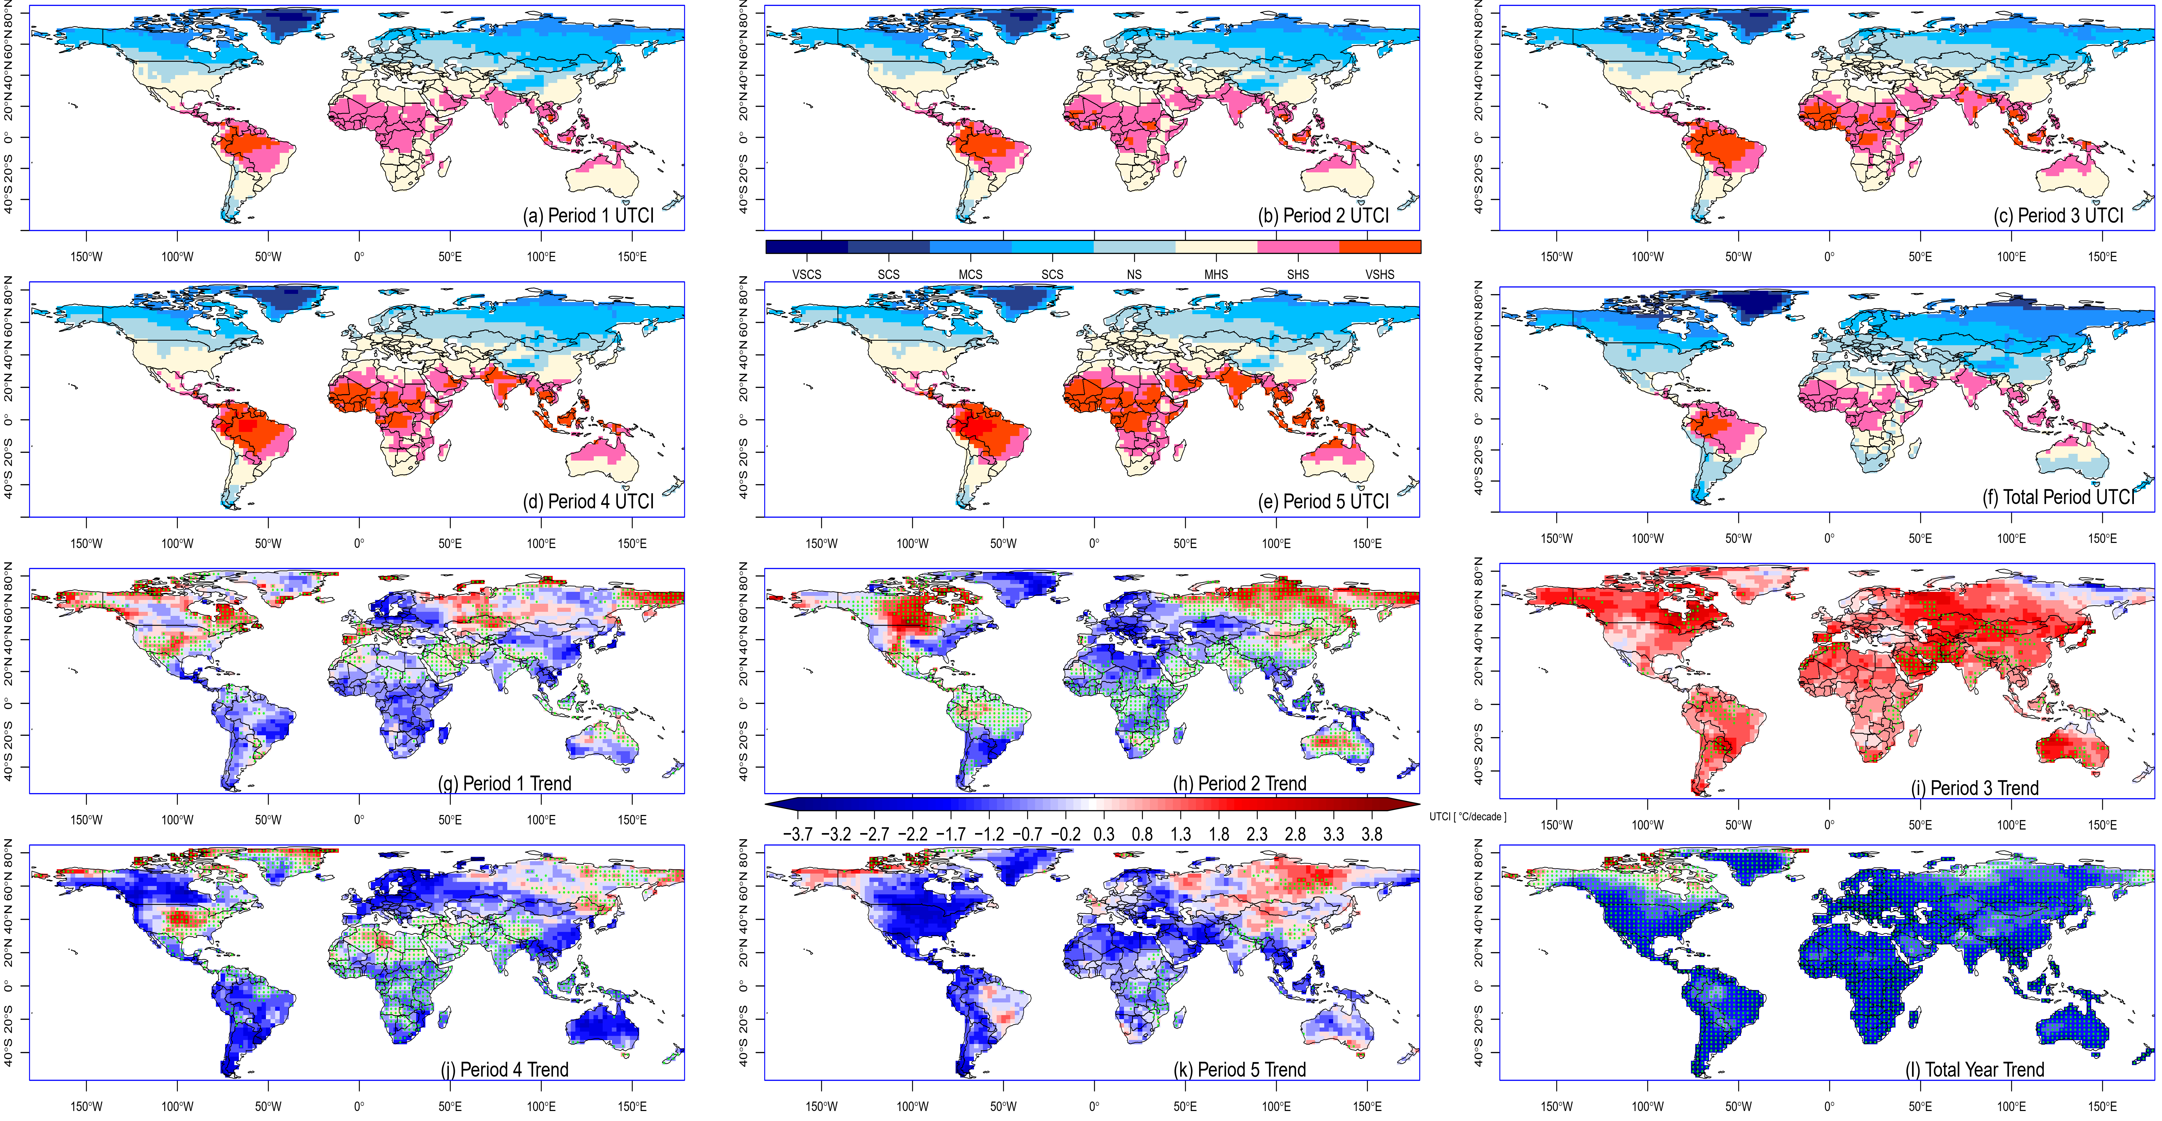
Fig S 11: Annual spread trend representation of UTCI for the different LULC transition periods during the future period under SSP370. Dots represent significant correlation at 95 % confidence interval

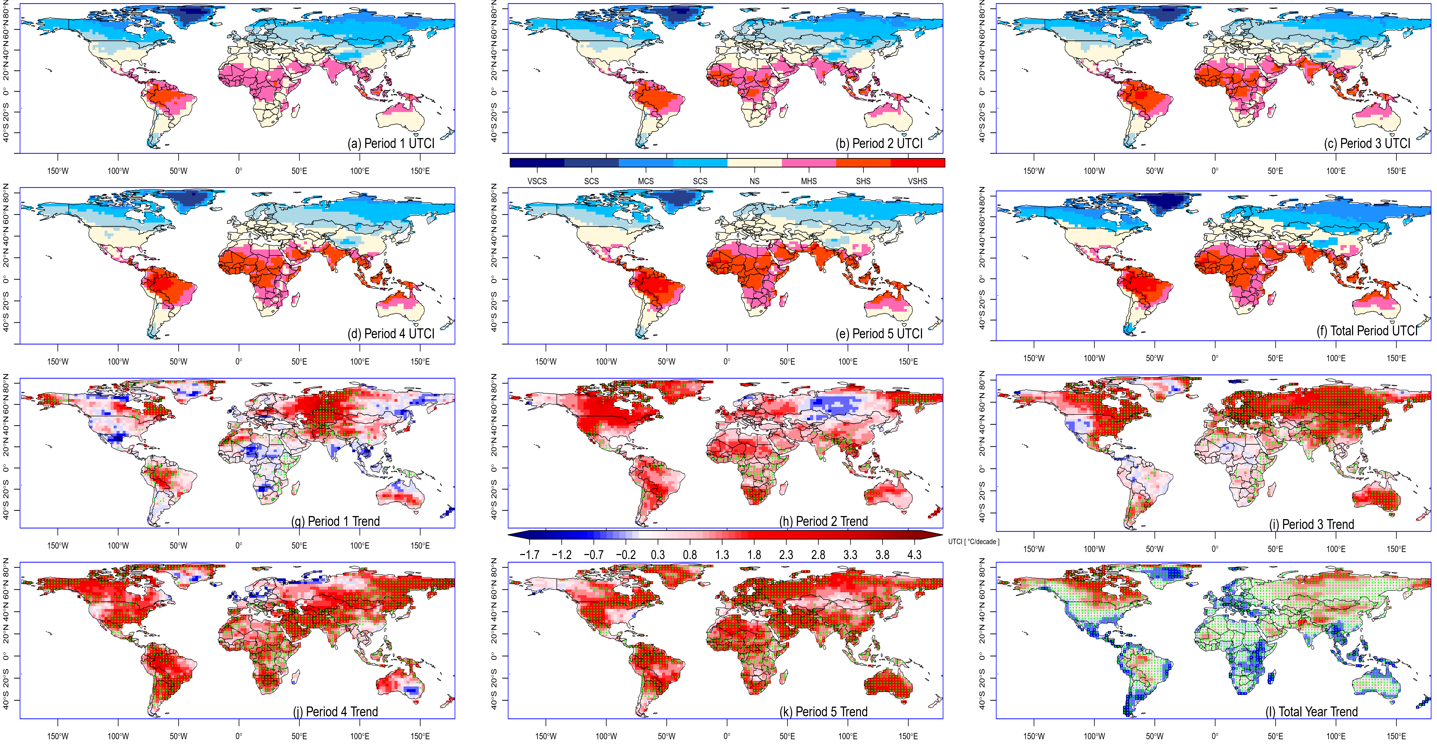
Fig S 12: As in S10 but for SSP585
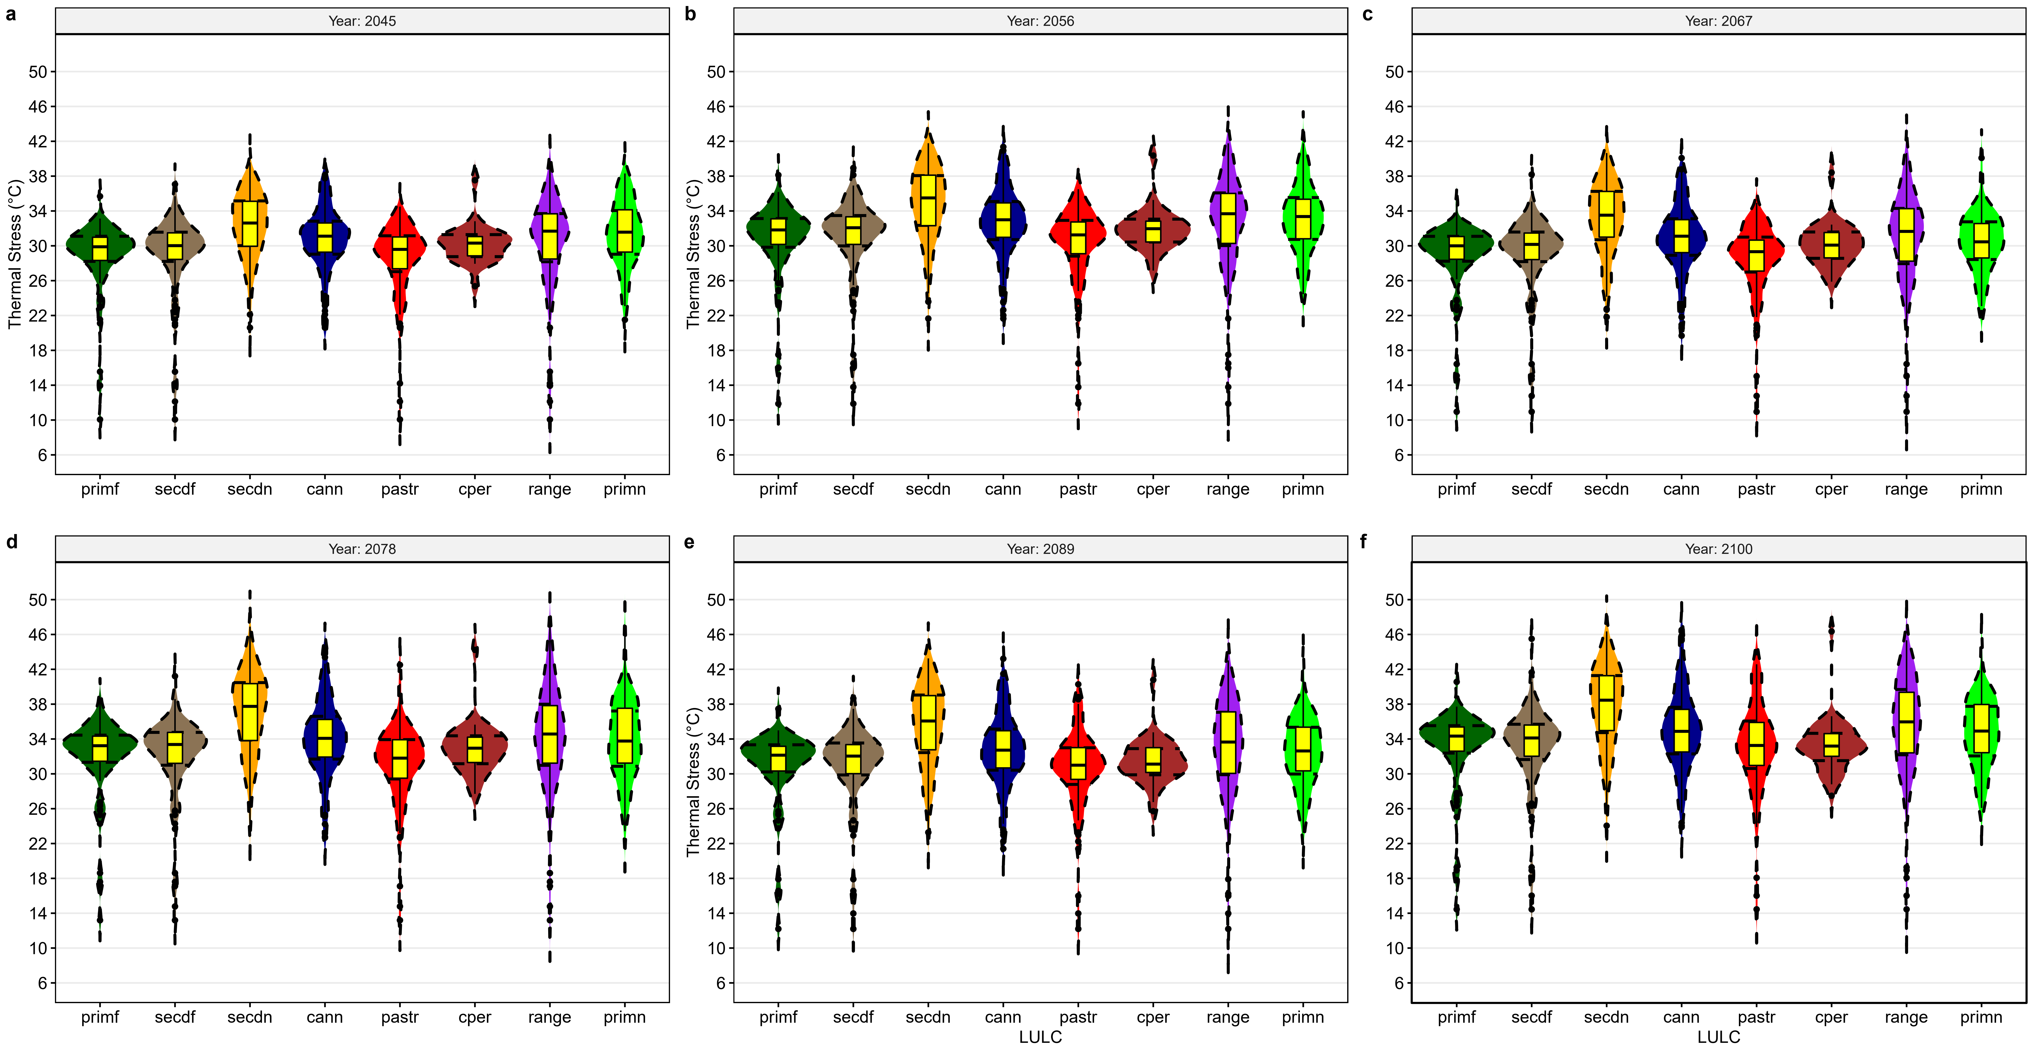
Fig S 13: Summer distribution of UTCI over different LULC in the tropical north for the future under SSP370
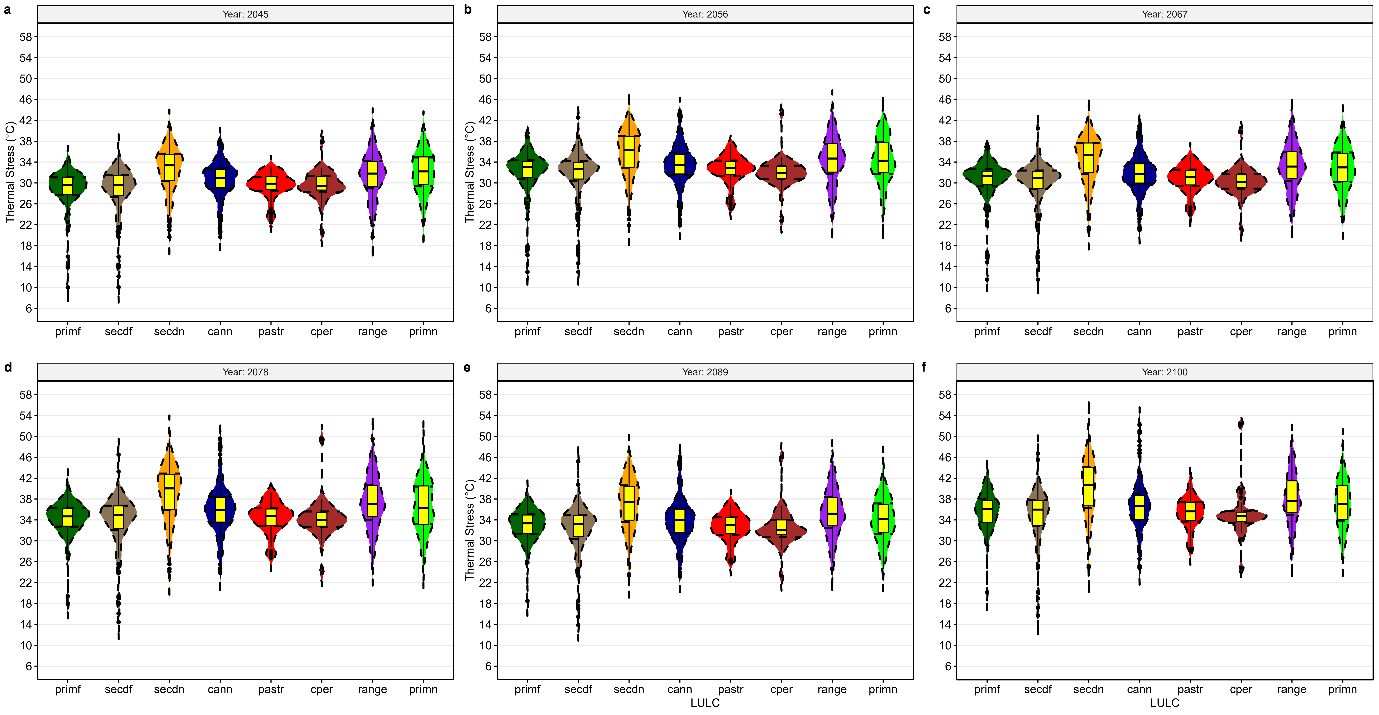
Fig S 14: As in Fig 6 but for SSP 585

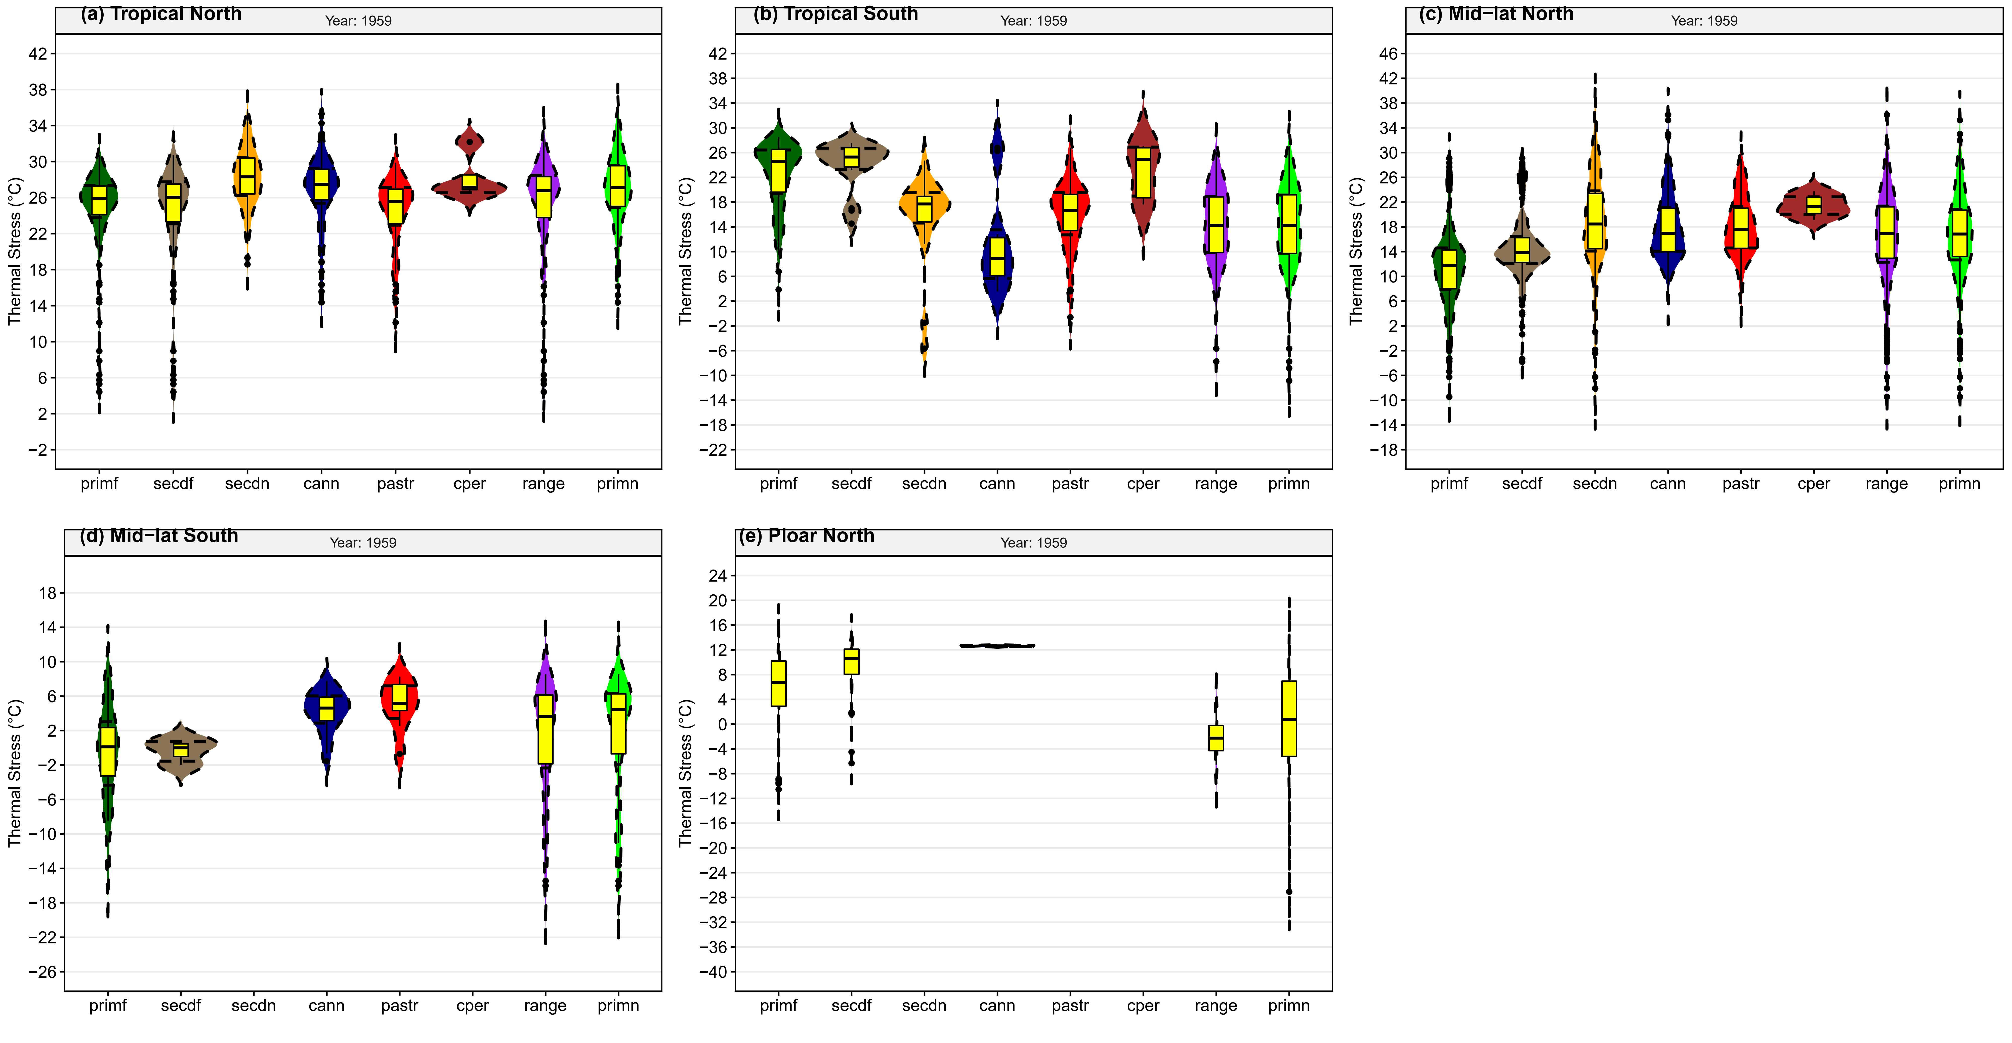
Fig S 15: Summer distribution of UTCI over different LULC based on atmospheric circulation sub-division in 1959
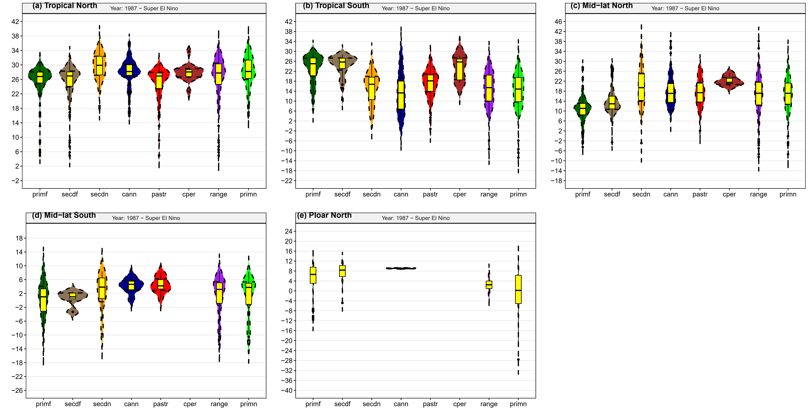
Fig S 16: As in S12 but for Super El Nino year 1987
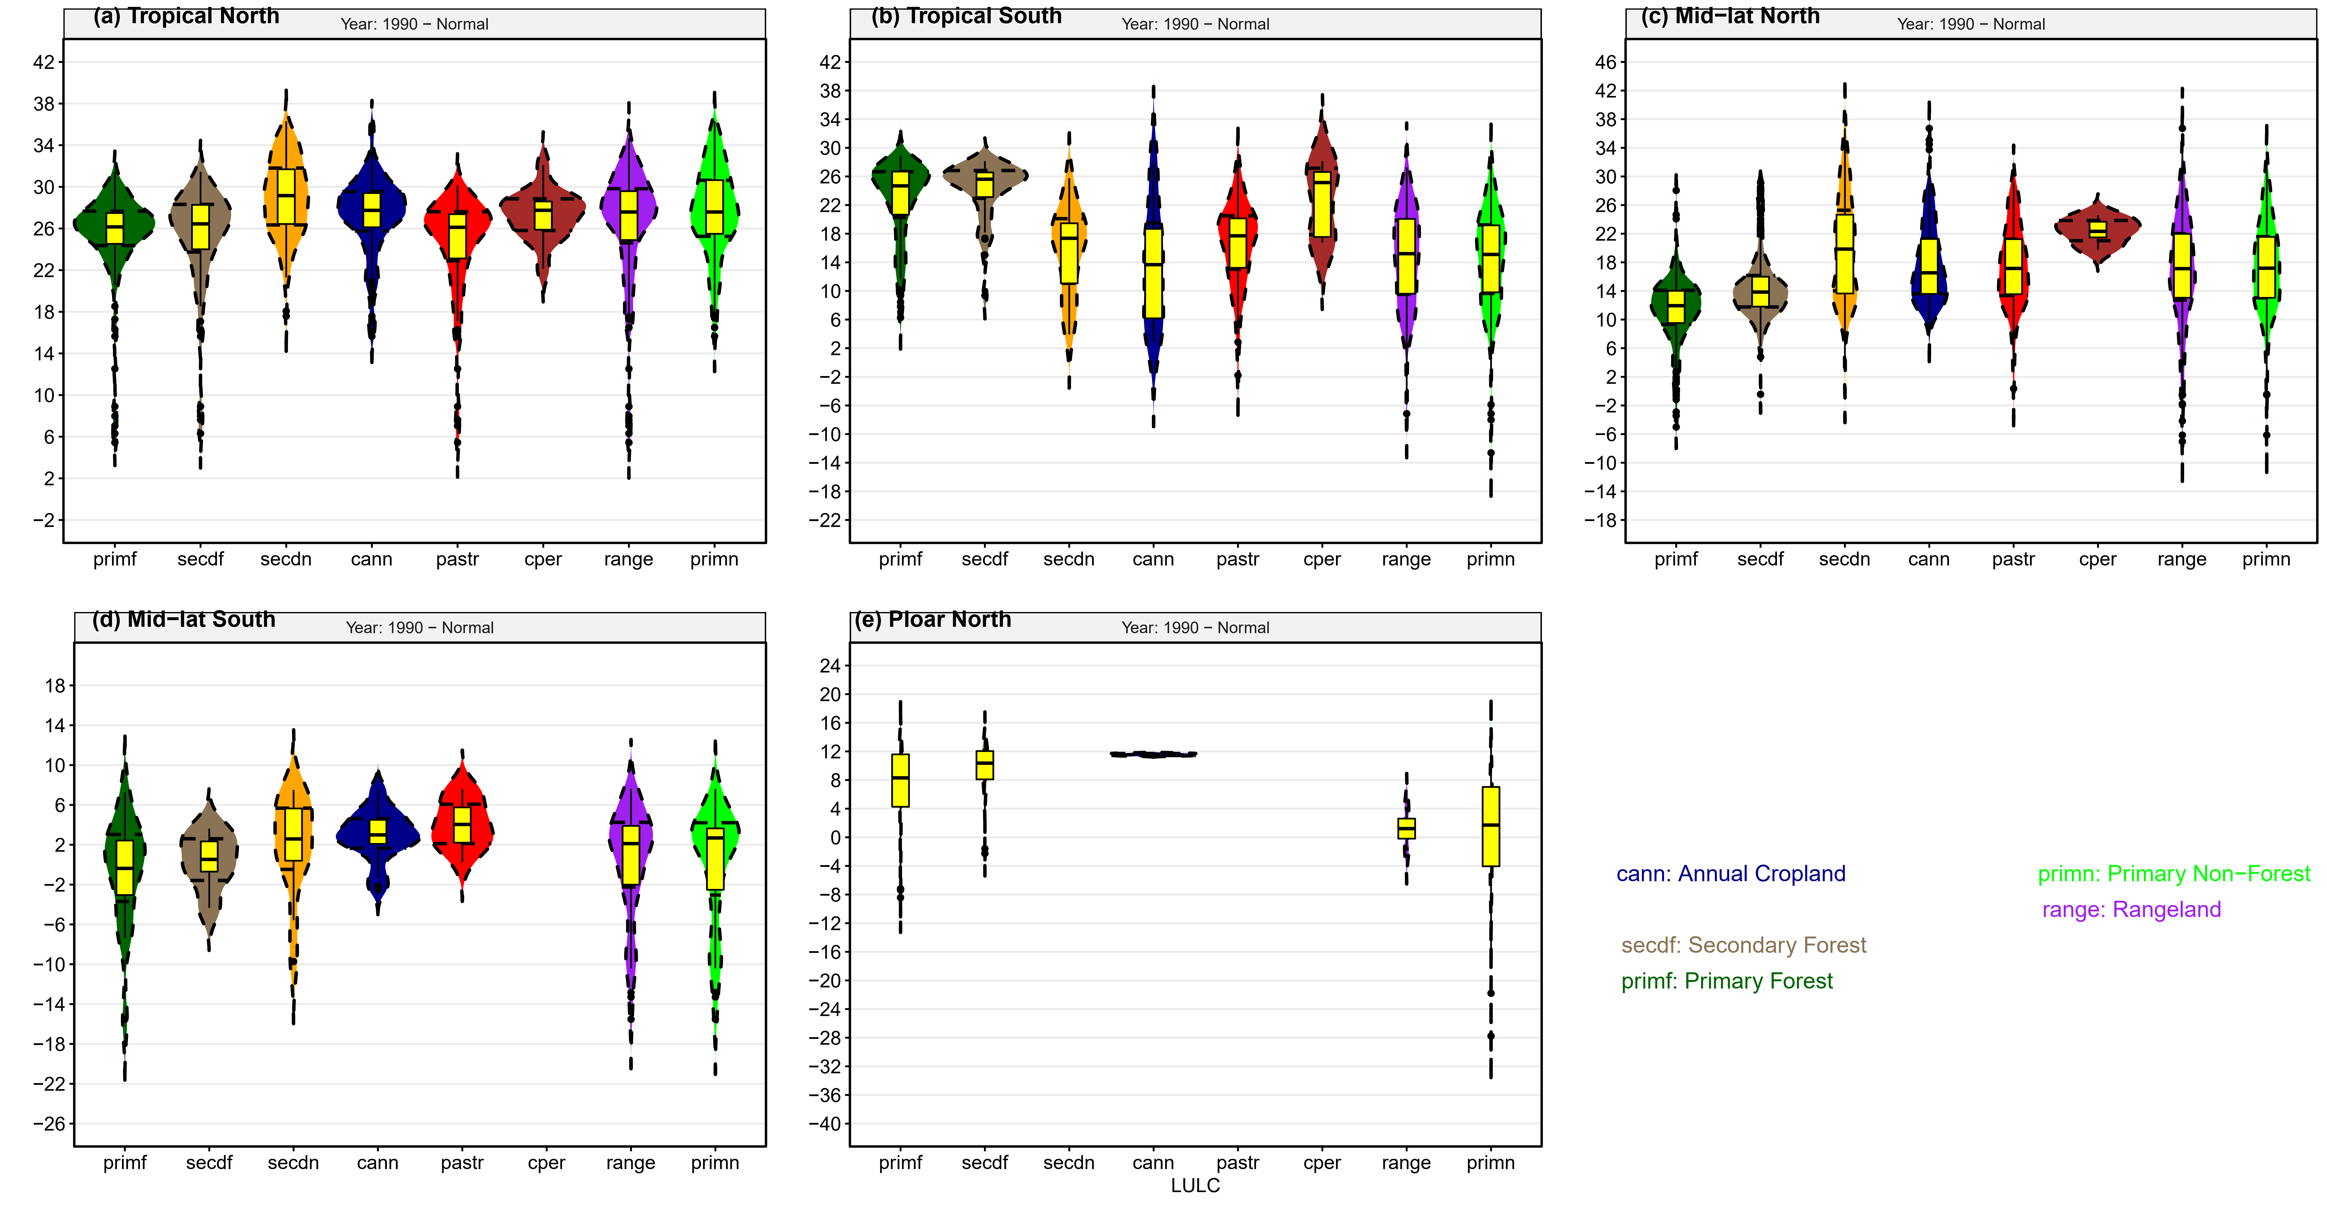
Fig S 17: As in S12 but for Normal year 1990

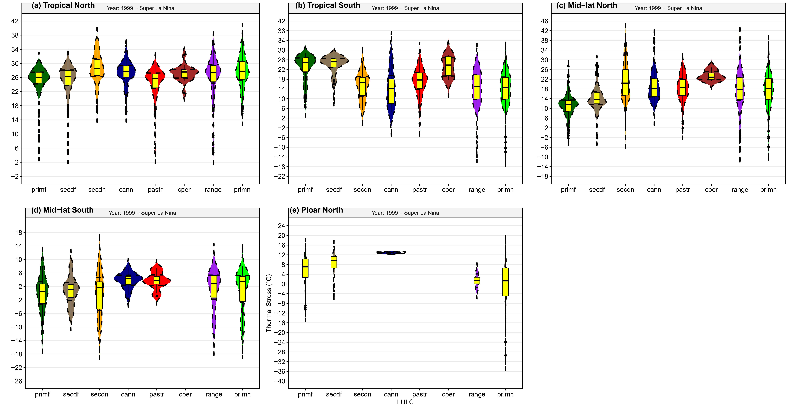
Fig S 18: As in S12 but for Super La Nina year 1999

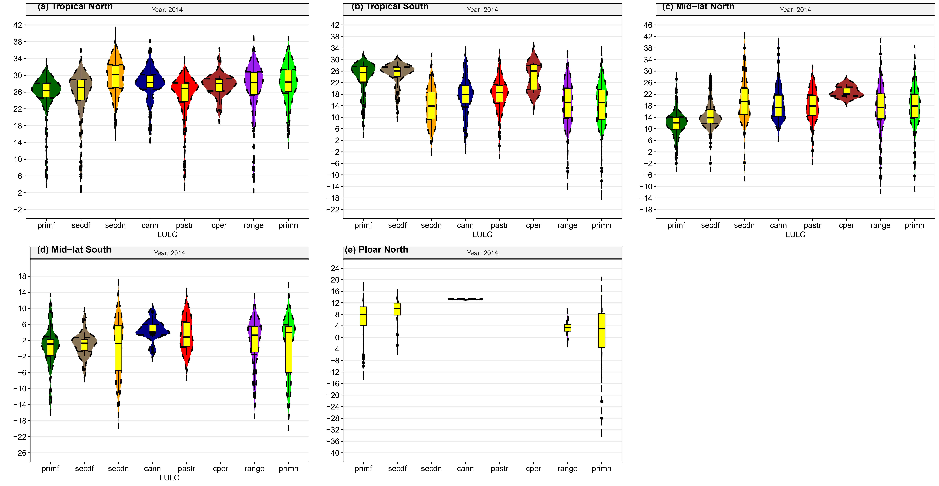
Fig S 19: As in S12 but for 2014
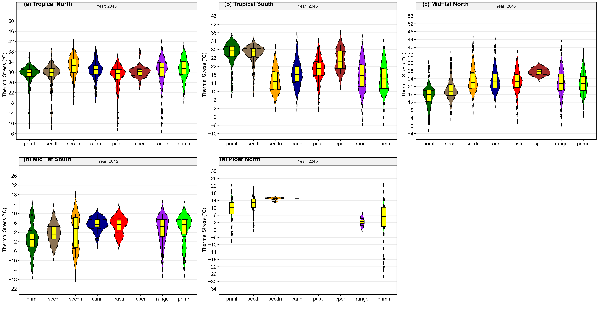
Fig S 20: Summer distribution of UTCI over different LULC based on atmospheric circulation sub-division under SSP 370 in 2045

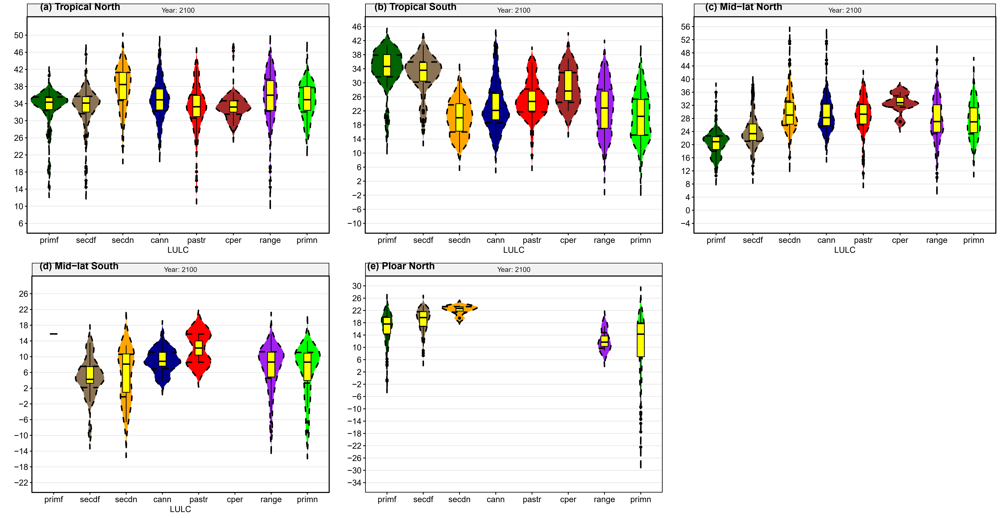
Fig S 21: As in S17 but for year 2100
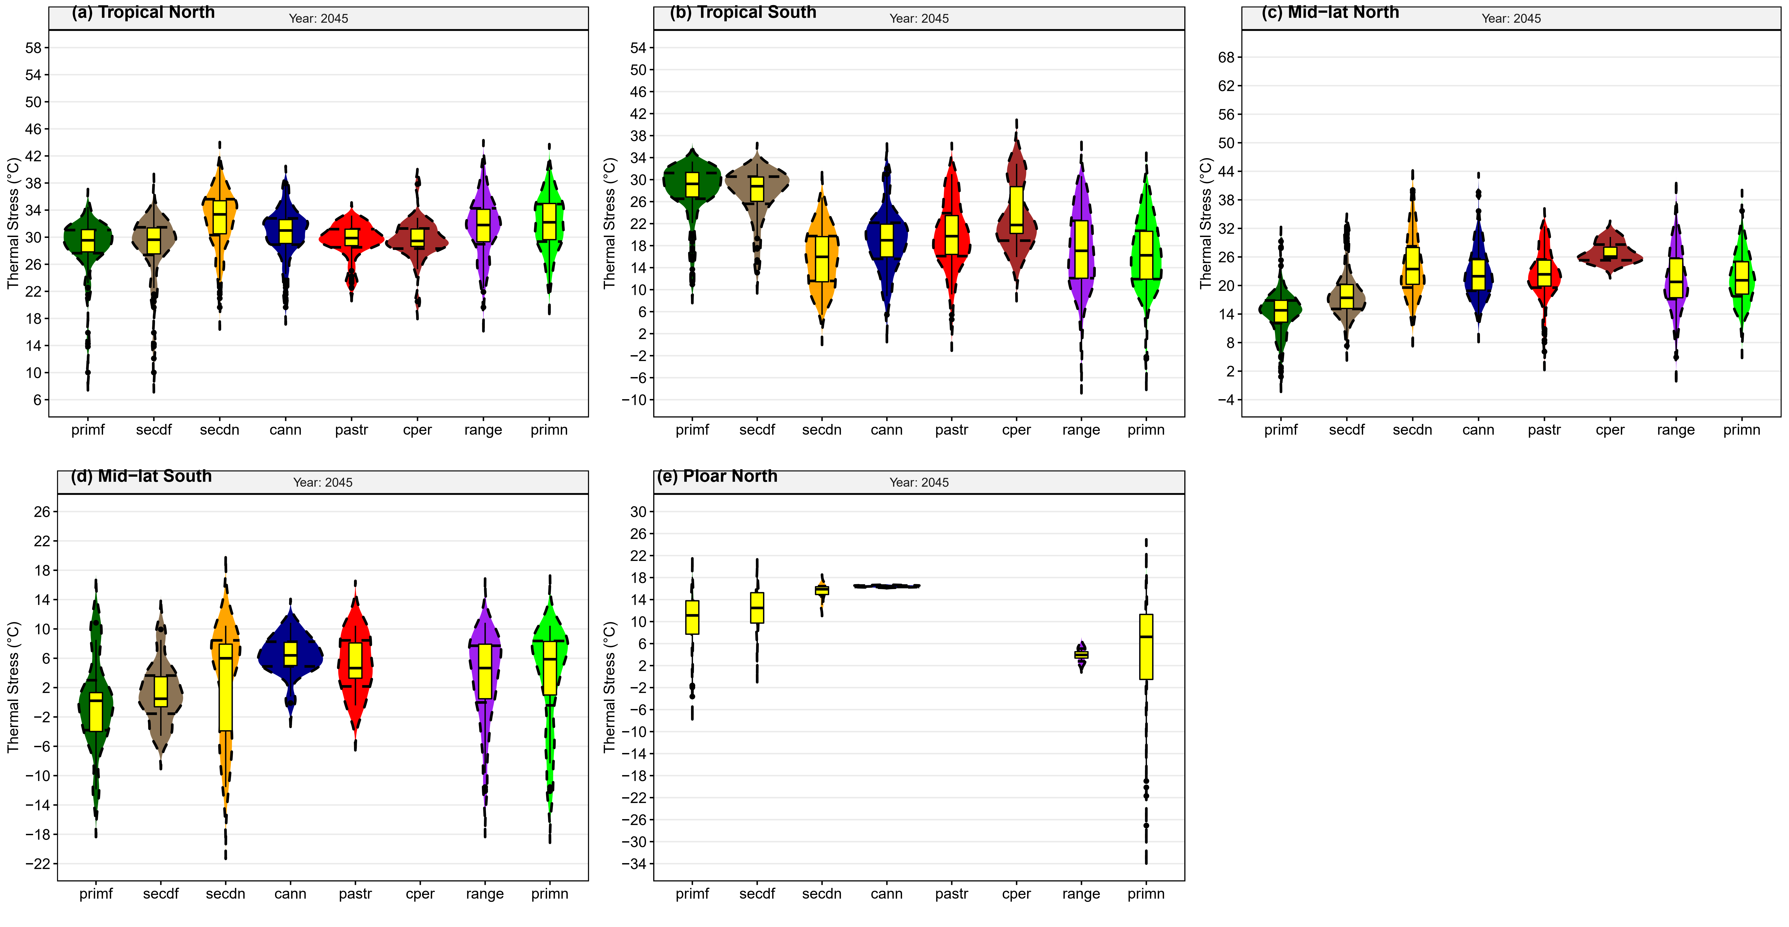
Fig S 22: As in S17 but for SSP 585

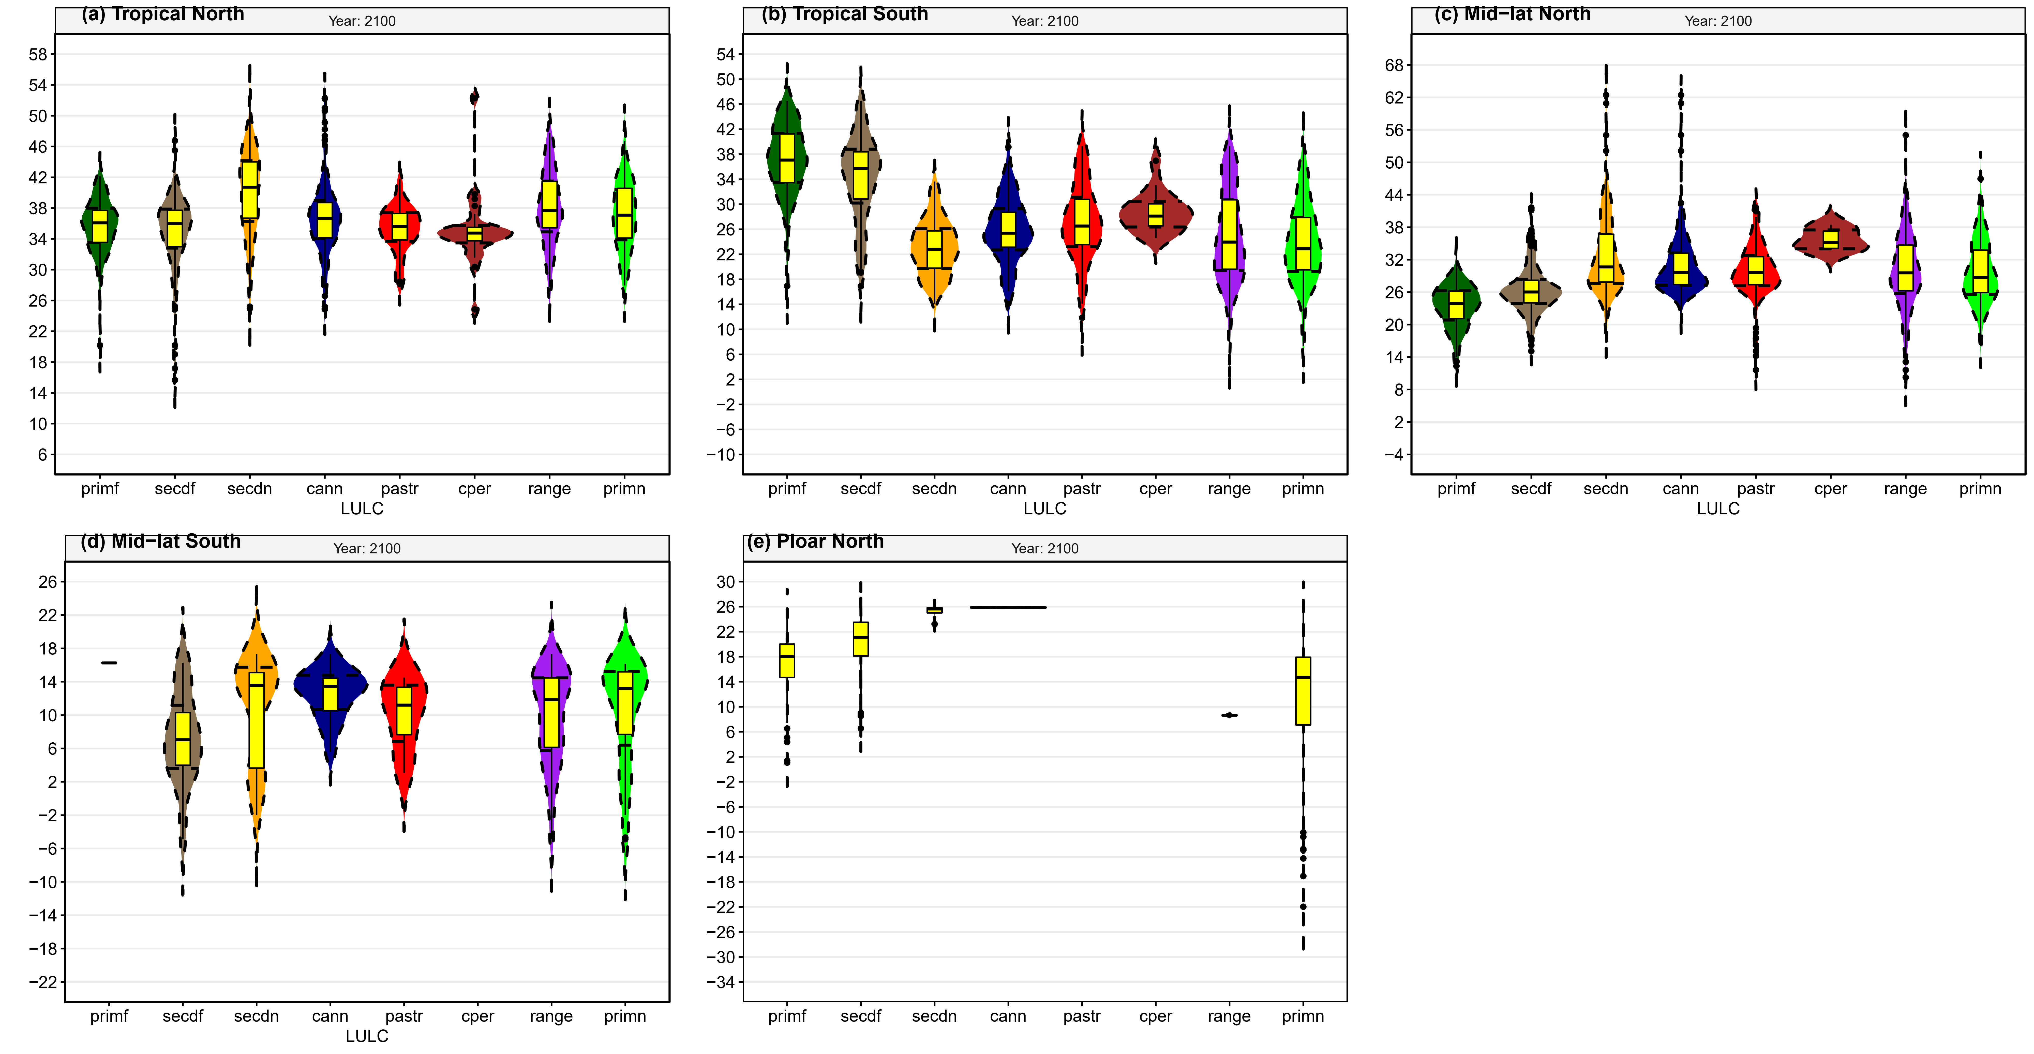
Fig S 23: Summer distribution of UTCI over different LULC based on atmospheric circulation sub-division for SSP585 in year 2100
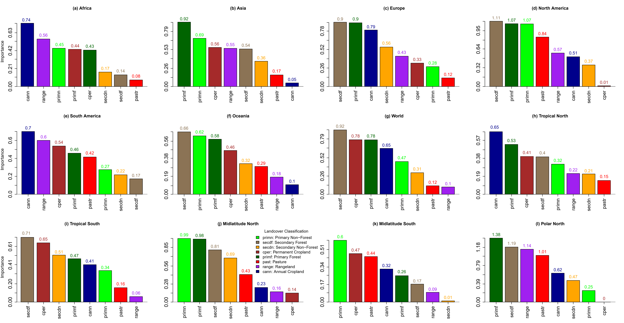
Fig S 24: Modulating LULC for the future under SSP370
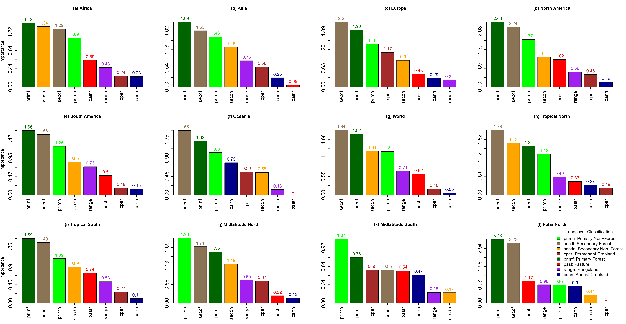
Fig S 25: Same as S23 but for SSP585

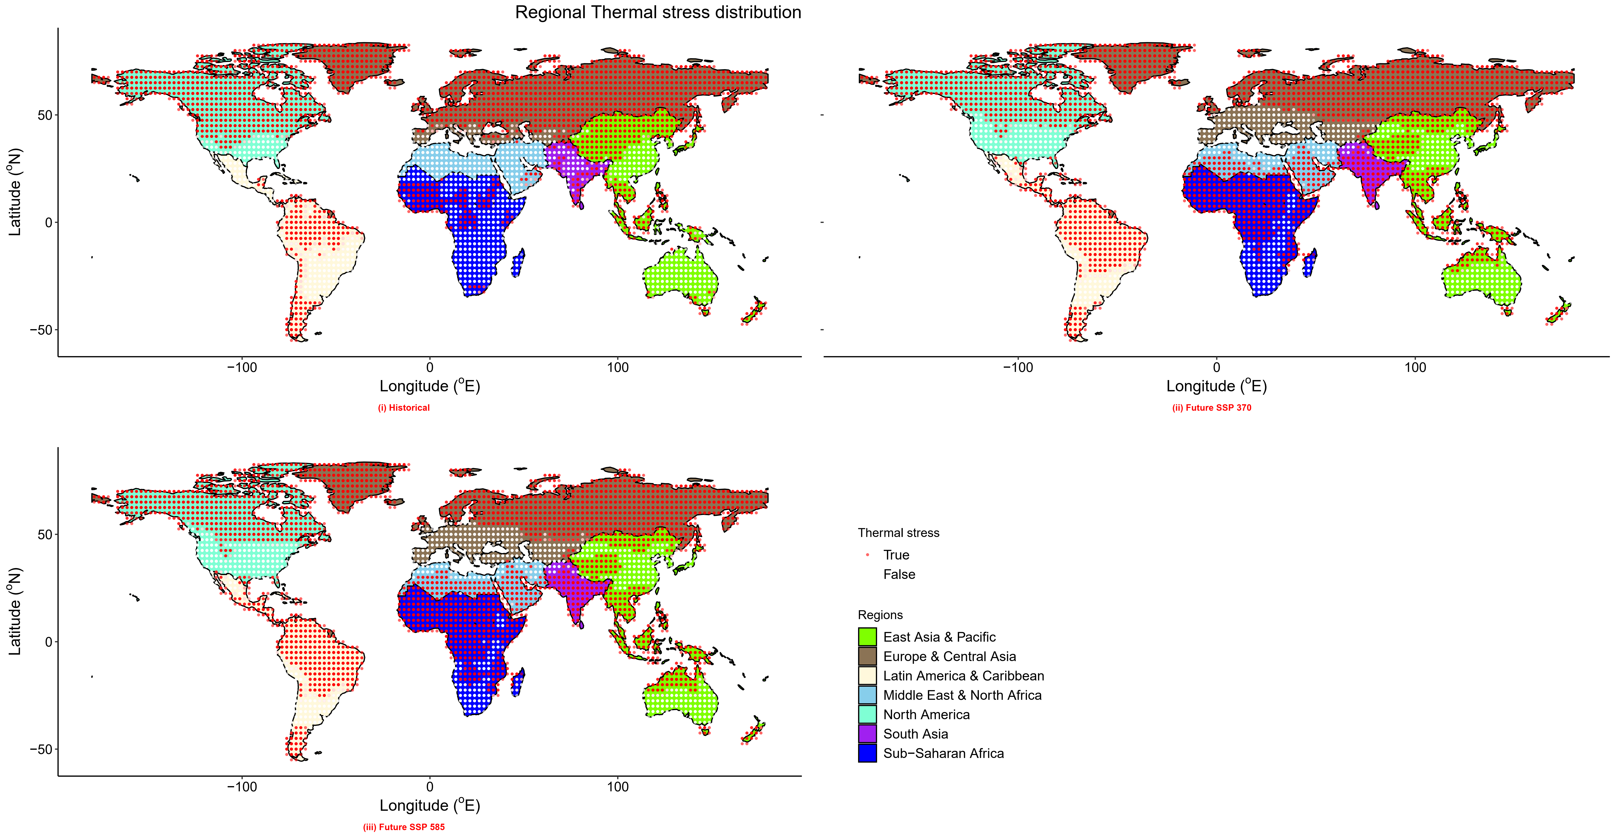
Fig S 26: Winter regional thermal stress distribution

Table T 1: Historical global LULC transition matrix (sqkm2)
Periods | LULC | Primary Forest | Primary NonForest | Secondary Forest | Secondary NonForest | Range land | Pastureland | Perennial Cropland | Annual Cropland | Total
Historical
1959 - 2014 | Primary Forest | 38495386 | 154290 | 7868796 |  | 1465756 | 385725 |  | 540015 | 48909970
1959 - 2014 | Primary NonForest | 77145 | 49218550 | 617161 | 6094460 | 3857253 | 1080031 |  | 1697191 | 62641791
1959 - 2014 | Secondary Forest |  |  | 15814738 | 77145 | 154290 |  | 77145 | 77145 | 16200463
1959 - 2014 | Secondary NonForest |  |  |  | 8331667 | 540015 | 77145 |  | 231435 | 9180262
1959 - 2014 | Range land | 77145 | 462870 | 385725 | 771451 | 29006544 | 77145 | 77145 | 540015 | 31398040
1959 - 2014 | Pastureland |  |  | 77145 |  |  | 231435 |  | 462870 | 771451
1959 - 2014 | Perennial Cropland |  | 77145 |  |  |  |  |  |  | 77145
1959 - 2014 | Annual Cropland |  | 231435 | 771451 | 1311466 | 231435 | 231435 |  | 11571759 | 14348982
1959 - 2014 | Total | 38649676 | 50144291 | 25535016 | 16586188 | 35255294 | 2082917 | 154290 | 15120432 | 183528104
SSP370
2045 - 2100 | Primary Forest | 23374954 | 308580 | 7405926 | 77145 | 1928627 | 77145 | 154290 | 848596 | 34175263
2045 - 2100 | Primary NonForest |  | 39729707 | 154290 | 1234321 | 1080031 | 154290 |  | 540015 | 42892655
2045 - 2100 | Secondary Forest |  |  | 28003658 |  |  | 77145 |  | 1234321 | 29315124
2045 - 2100 | Secondary NonForest |  |  |  | 17820509 | 1388611 | 154290 |  | 1157176 | 20520587
2045 - 2100 | Range land |  |  | 154290 | 848596 | 34560988 | 77145 |  | 1620046 | 37261065
2045 - 2100 | Pastureland |  |  | 77145 | 77145 | 77145 | 1542901 |  | 1388611 | 3162948
2045 - 2100 | Perennial Cropland |  |  | 77145 |  |  |  | 385725 |  | 462870
2045 - 2100 | Annual Cropland |  | 77145 | 154290 | 1388611 | 154290 |  |  | 13963256 | 15737593
2045 - 2100 | Total | 23374954 | 40115433 | 36026744 | 21446327 | 39189692 | 2082917 | 540015 | 20752022 | 183528104
SSP585
2045 - 2100 | Primary Forest | 22680648 | 77145 | 10877454 |  | 154290 |  |  | 77145 | 33866682
2045 - 2100 | Primary NonForest |  | 42892655 | 154290 | 925741 | 231435 | 154290 |  |  | 44358411
2045 - 2100 | Secondary Forest |  | 77145 | 28852253 |  |  | 231435 |  | 154290 | 29315124
2045 - 2100 | Secondary NonForest |  |  |  | 20289151 |  | 154290 |  | 308580 | 20752022
2045 - 2100 | Range land |  |  | 462870 | 1157176 | 32169491 |  |  | 154290 | 33943828
2045 - 2100 | Pastureland |  | 77145 | 77145 | 385725 | 77145 | 1388611 |  | 462870 | 2468642
2045 - 2100 | Perennial Cropland |  |  |  |  |  |  | 462870 |  | 462870
2045 - 2100 | Annual Cropland |  |  | 385725 | 1002886 | 154290 |  |  | 16817624 | 18360525
2045 - 2100 | Total | 22680648 | 43124090 | 40809738 | 23760679 | 32786652 | 1928627 | 462870 | 17974800 | 183528104

Table T 2: Historical global LULC transition matrix (sqkm²) for different continents during the historical period
LULC | Primary Forest | Primary NonForest | Secondary Forest | Secondary NonForest | Range land | Pastureland | Perennial Cropland | Annual Cropland | Total
Africa
Primary Forest | 3625818 | 77145 | 231435 |  |  | 77145 |  |  | 4011543
Primary NonForest |  | 6865911 | 77145 | 5708735 | 462870 | 617161 |  | 231435 | 13963256
Secondary Forest |  |  | 231435 |  |  |  |  |  | 231435
Secondary NonForest |  |  |  | 3934398 | 77145 | 77145 |  | 154290 | 4242978
Range land | 77145 | 385725 |  | 231435 | 7097346 | 77145 |  | 77145 | 7945941
Pastureland |  |  |  |  |  | 154290 |  | 308580 | 462870
Annual Cropland |  |  |  |  |  |  |  |  | 308580
Total | 3702963 | 7328781 | 540015 | 9874568 | 7637361 | 1002886 |  | 1080031 | 31166605
Asia
Primary Forest | 2622932 |  | 1851482 |  | 308580 |  |  | 540015 | 5323009
Primary NonForest |  | 4551559 | 308580 | 385725 | 2237207 | 462870 |  | 771451 | 8717392
Secondary Forest |  |  | 3162948 | 77145 | 154290 |  | 77145 | 77145 | 3548673
Secondary NonForest |  |  |  | 3780108 | 462870 |  |  | 77145 | 4320124
Rangeland |  |  | 77145 | 154290 | 10800309 |  |  |  | 11031744
Pastureland |  |  |  |  |  |  |  | 77145 | 77145
Annual Cropland |  |  | 77145 |  | 77145 |  |  | 3857253 | 4011543
Total | 2622932 | 4551559 | 5477299 | 4397269 | 14040401 | 462870 | 77145 | 5400154 | 37029630
Europe
Primary Forest | 8408812 |  | 4474414 |  |  |  |  |  | 12883225
Primary NonForest |  | 14194692 | 154290 |  |  |  |  |  | 14348982
Secondary Forest |  |  | 9411698 |  |  |  |  |  | 9411698
Secondary NonForest |  |  |  | 617161 |  |  |  |  | 617161
Range land |  |  | 77145 |  | 308580 |  |  |  | 385725
Pastureland |  |  | 77145 |  |  | 77145 |  | 77145 | 231435
Perennial Cropland |  | 77145 |  |  |  |  |  |  | 77145
Annual Cropland |  | 231435 | 308580 | 1311466 | 77145 |  |  | 5091574 | 7020201
Total | 8408812 | 14503272 | 14503272 | 1928627 | 385725 | 77145 |  | 5168719 | 44975571
North America
Primary Forest | 14734707 |  | 1080031 |  |  |  |  |  | 15814738
Primary NonForest |  | 15506158 | 77145 |  | 77145 |  |  | 77145 | 15737593
Secondary Forest |  |  | 2931512 |  |  |  |  |  | 2931512
Range land |  |  | 77145 |  | 4011543 |  |  |  | 4088688
Annual Cropland |  |  | 385725 |  | 77145 | 231435 |  | 2314352 | 3008657
Total | 14734707 | 15506158 | 4551559 |  | 4165833 | 231435 |  | 2391497 | 41581189
South America
Primary Forest | 8331667 | 77145 | 154290 |  | 1157176 | 308580 |  |  | 10028858
Primary NonForest | 77145 | 4551559 |  |  | 1080031 |  |  | 385725 | 6094460
Secondary Forest |  |  | 77145 |  |  |  |  |  | 77145
Range land |  | 77145 |  | 385725 | 2005772 |  | 77145 | 231435 | 2777222
Total | 8408812 | 4705849 | 231435 | 385725 | 4242978 | 308580 | 77145 | 617161 | 18977685
Oceania
Primary Forest | 771451 |  | 77145 |  |  |  |  |  | 848596
Primary NonForest |  | 3548673 |  |  |  |  |  | 231435 | 3780108
Secondary Forest |  |  | 154290 |  | 4782994 |  |  | 231435 | 5168719
Total | 771451 | 3548673 | 231435 |  | 4782994 |  |  | 462870 | 9797423

Table T 3: Historical inter-period global LULC transition matrix (sqkm2)
Periods | LULC | Primary Forest | Primary NonForest | Secondary Forest | Secondary NonForest | Range land | Pastureland | Perennial Cropland | Annual Cropland | Total
Historical
1959 - 1970 | Primary Forest | 45669877 | 385725 | 2082917 |  | 771451 |  |  |  | 48909970
1959 - 1970 | Primary NonForest |  | 59710278 | 77145 | 1080031 | 1234321 |  |  | 540015 | 62641791
1959 - 1970 | Secondary Forest |  |  | 16200463 |  |  |  |  |  | 16200463
1959 - 1970 | Secondary NonForest |  |  |  | 9025972 | 77145 |  |  | 77145 | 9180262
1959 - 1970 | Range land | 77145 | 617161 | 154290 |  | 30163719 | 77145 |  | 308580 | 31398040
1959 - 1970 | Pastureland |  |  |  |  |  | 694306 |  | 77145 | 771451
1959 - 1970 | Perennial Cropland |  |  |  |  |  |  | 77145 |  | 77145
1959 - 1970 | Annual Cropland |  | 77145 | 154290 | 231435 |  |  |  | 13886111 | 14348982
1959 - 1970 | Total | 45747022 | 60790309 | 18669105 | 10337438 | 32246636 | 771451 | 77145 | 14888997 | 183528104
1970 - 1981 | Primary Forest | 43741250 | 154290 | 1620046 |  | 154290 |  |  | 77145 | 45747022
1970 - 1981 | Primary NonForest | 77145 | 58244522 | 77145 | 1157176 | 925741 | 154290 |  | 154290 | 60790309
1970 - 1981 | Secondary Forest |  |  | 18514815 |  | 154290 |  |  |  | 18669105
1970 - 1981 | Secondary NonForest |  |  |  | 10106003 | 77145 | 77145 |  | 77145 | 10337438
1970 - 1981 | Range land |  | 231435 |  | 154290 | 31783766 |  |  | 77145 | 32246636
1970 - 1981 | Pastureland |  |  |  |  |  | 771451 |  |  | 771451
1970 - 1981 | Perennial Cropland |  |  |  |  |  |  | 77145 |  | 77145
1970 - 1981 | Annual Cropland |  |  | 154290 | 154290 | 77145 |  |  | 14503272 | 14888997
1970 - 1981 | Total | 43818396 | 58630248 | 20366297 | 11571759 | 33172377 | 1002886 | 77145 | 14888997 | 183528104
1981 - 1992 | Primary Forest | 41581189 |  | 1697191 |  | 308580 |  |  | 231435 | 43818396
1981 - 1992 | Primary NonForest |  | 56007315 | 308580 | 771451 | 925741 | 385725 |  | 231435 | 58630248
1981 - 1992 | Secondary Forest |  |  | 20212006 |  |  |  |  | 154290 | 20366297
1981 - 1992 | Secondary NonForest |  |  |  | 10877454 | 540015 | 77145 |  | 77145 | 11571759
1981 - 1992 | Range land |  | 308580 |  |  | 32786652 |  |  | 77145 | 33172377
1981 - 1992 | Pastureland |  |  | 308580 |  |  | 617161 |  | 77145 | 1002886
1981 - 1992 | Perennial Cropland |  |  |  |  |  |  | 77145 |  | 77145
1981 - 1992 | Annual Cropland |  | 77145 | 154290 |  | 154290 | 77145 |  | 14426127 | 14888997
1981 - 1992 | Total | 41581189 | 56393041 | 22680648 | 11648904 | 34715278 | 1157176 | 77145 | 15274722 | 183528104
1992 - 2003 | Primary Forest | 45669877 | 385725 | 2082917 |  | 771451 |  |  |  | 48909970
1992 - 2003 | Primary NonForest |  | 59710278 | 77145 | 1080031 | 1234321 |  |  | 540015 | 62641791
1992 - 2003 | Secondary Forest |  |  | 16200463 |  |  |  |  |  | 16200463
1992 - 2003 | Secondary NonForest |  |  |  | 9025972 | 77145 |  |  | 77145 | 9180262
1992 - 2003 | Range land | 77145 | 617161 | 154290 |  | 30163719 | 77145 |  | 308580 | 31398040
1992 - 2003 | Pastureland |  |  |  |  |  | 694306 |  | 77145 | 771451
1992 - 2003 | Perennial Cropland |  |  |  |  |  |  | 77145 |  | 77145
1992 - 2003 | Annual Cropland |  | 77145 | 154290 | 231435 |  |  |  | 13886111 | 14348982
1992 - 2003 | Total | 40115433 | 53152948 | 24532130 | 14657562 | 35101003 | 1388611 | 77145 | 14503272 | 183528104
2003 - 2014 | Primary Forest | 38572531 |  | 1157176 |  | 231435 | 77145 |  | 77145 | 40115433
2003 - 2014 | Primary NonForest | 77145 | 49912855 | 77145 | 1542901 | 771451 | 231435 |  | 540015 | 53152948
2003 - 2014 | Secondary Forest |  |  | 23837824 | 77145 |  | 154290 | 77145 | 385725 | 24532130
2003 - 2014 | Secondary NonForest |  |  |  | 14194692 |  | 308580 |  | 154290 | 14657562
2003 - 2014 | Range land |  | 77145 | 231435 | 385725 | 34175263 | 154290 | 77145 |  | 35101003
2003 - 2014 | Pastureland |  |  | 77145 | 77145 |  | 925741 |  | 308580 | 1388611
2003 - 2014 | Perennial Cropland |  | 77145 |  |  |  |  |  |  | 77145
2003 - 2014 | Annual Cropland |  | 77145 | 154290 | 308580 | 77145 | 231435 |  | 13654676 | 14503272
2003 - 2014 | Total | 38649676 | 50144291 | 25535016 | 16586188 | 35255294 | 2082917 | 154290 | 15120432 | 183528104

Table T 4: Historical inter-period global LULC transition matrix (sqkm2)
Periods | LULC | Primary Forest | Primary NonForest | Secondary Forest | Secondary NonForest | Range land | Pastureland | Perennial Cropland | Annual Cropland | Total
SSP370
2045 - 2056 | Primary Forest | 32709507 |  | 1157176 |  | 154290 | 154290 |  |  | 34175263
2045 - 2056 | Primary NonForest |  | 42121204 |  | 385725 | 154290 |  |  | 231435 | 42892655
2045 - 2056 | Secondary Forest |  |  | 28697963 | 77145 | 77145 | 154290 |  | 308580 | 29315124
2045 - 2056 | Secondary NonForest |  |  |  | 19517701 | 462870 | 231435 |  | 308580 | 20520587
2045 - 2056 | Range land |  |  | 77145 | 231435 | 36335324 | 77145 |  | 540015 | 37261065
2045 - 2056 | Pastureland |  |  | 77145 |  |  | 2700077 |  | 385725 | 3162948
2045 - 2056 | Perennial Cropland |  |  |  |  |  |  | 462870 |  | 462870
2045 - 2056 | Annual Cropland |  |  |  | 308580 | 77145 | 154290 |  | 15197577 | 15737593
2045 - 2056 | Total | 32709507 | 42121204 | 30009429 | 20520587 | 37261065 | 3471528 | 462870 | 16971914 | 183528104
2056 - 2067 | Primary Forest | 30395155 |  | 1311466 | 77145 | 540015 | 77145 |  | 308580 | 32709507
2056 - 2067 | Primary NonForest |  | 41581189 |  | 231435 | 308580 |  |  |  | 42121204
2056 - 2067 | Secondary Forest |  |  | 29315124 |  |  | 154290 |  | 540015 | 30009429
2056 - 2067 | Secondary NonForest |  |  |  | 20134861 | 308580 | 77145 |  |  | 20520587
2056 - 2067 | Range land |  |  | 154290 | 231435 | 36489615 |  |  | 385725 | 37261065
2056 - 2067 | Pastureland |  |  | 77145 | 77145 | 77145 | 2777222 |  | 462870 | 3471528
2056 - 2067 | Perennial Cropland |  |  | 77145 |  |  |  | 385725 |  | 462870
2056 - 2067 | Annual Cropland |  |  | 77145 | 462870 | 77145 |  |  | 16354753 | 16971914
2056 - 2067 | Total | 30395155 | 41581189 | 31012315 | 21214892 | 37801081 | 3085803 | 385725 | 18051945 | 183528104
2067 - 2078 | Primary Forest | 27540787 | 77145 | 2314352 |  | 385725 |  |  | 77145 | 30395155
2067 - 2078 | Primary NonForest |  | 40732593 | 77145 | 462870 | 231435 | 77145 |  |  | 41581189
2067 - 2078 | Secondary Forest |  |  | 30549445 |  | 77145 | 77145 |  | 308580 | 31012315
2067 - 2078 | Secondary NonForest |  |  |  | 20674877 | 308580 | 77145 |  | 154290 | 21214892
2067 - 2078 | Range land |  |  |  | 231435 | 37338210 |  |  | 231435 | 37801081
2067 - 2078 | Pastureland |  |  |  |  |  | 2777222 |  | 308580 | 3085803
2067 - 2078 | Perennial Cropland |  |  |  |  |  |  | 385725 |  | 385725
2067 - 2078 | Annual Cropland |  |  | 154290 | 154290 |  |  |  | 17743364 | 18051945
2067 - 2078 | Total | 27540787 | 40809738 | 33095232 | 21523472 | 38341096 | 3008657 | 385725 | 18823395 | 183528104
2078 - 2089 | Primary Forest | 24917855 | 154290 | 2237207 |  | 77145 |  |  | 154290 | 27540787
2078 - 2089 | Primary NonForest |  | 40269723 |  | 154290 | 308580 |  |  | 77145 | 40809738
2078 - 2089 | Secondary Forest |  |  | 32709507 |  | 308580 |  | 77145 |  | 33095232
2078 - 2089 | Secondary NonForest |  |  |  | 21060602 | 154290 | 77145 |  | 231435 | 21523472
2078 - 2089 | Range land |  |  | 77145 | 308580 | 37723936 | 154290 |  | 77145 | 38341096
2078 - 2089 | Pastureland |  |  |  | 77145 |  | 2314352 | 77145 | 540015 | 3008657
2078 - 2089 | Perennial Cropland |  |  |  |  |  |  | 385725 |  | 385725
2078 - 2089 | Annual Cropland |  | 77145 | 154290 | 231435 | 77145 |  |  | 18283380 | 18823395
2078 - 2089 | Total | 24917855 | 40501158 | 35178149 | 21832053 | 38649676 | 2545787 | 540015 | 19363411 | 183528104
2089 - 2100 | Primary Forest | 23374954 | 154290 | 1234321 |  |  |  |  | 154290 | 24917855
2089 - 2100 | Primary NonForest |  | 39961142 | 154290 | 77145 | 154290 | 77145 |  | 77145 | 40501158
2089 - 2100 | Secondary Forest |  |  | 34483843 |  | 462870 |  |  | 231435 | 35178149
2089 - 2100 | Secondary NonForest |  |  |  | 20906312 | 385725 | 154290 |  | 385725 | 21832053
2089 - 2100 | Range land |  |  |  | 154290 | 38186806 |  |  | 308580 | 38649676
2089 - 2100 | Pastureland |  |  |  | 154290 |  | 1851482 |  | 540015 | 2545787
2089 - 2100 | Perennial Cropland |  |  |  |  |  |  | 540015 |  | 540015
2089 - 2100 | Annual Cropland |  |  | 154290 | 154290 |  |  |  | 19054830 | 19363411
2089 - 2100 | Total | 23374954 | 40115433 | 36026744 | 21446327 | 39189692 | 2082917 | 540015 | 20752022 | 183528104

Table T 5: Future inter-period global LULC transition matrix (sqkm2) under SSP585
Periods | LULC | Primary Forest | Primary NonForest | Secondary Forest | Secondary NonForest | Range land | Pastureland | Perennial Cropland | Annual Cropland | Total
SSP585
2045 - 2056 | Primary Forest | 32478071 |  | 1234321 |  | 77145 |  | 77145 |  | 33866682
2045 - 2056 | Primary NonForest |  | 43586960 |  | 540015 | 154290 | 77145 |  |  | 44358411
2045 - 2056 | Secondary Forest |  |  | 29006544 |  |  | 154290 |  | 154290 | 29315124
2045 - 2056 | Secondary NonForest |  |  |  | 20366297 |  | 231435 |  | 154290 | 20752022
2045 - 2056 | Range land |  |  |  | 154290 | 33712392 |  |  | 77145 | 33943828
2045 - 2056 | Pastureland |  |  |  | 77145 |  | 2005772 |  | 385725 | 2468642
2045 - 2056 | Perennial Cropland |  |  |  |  |  |  | 462870 |  | 462870
2045 - 2056 | Annual Cropland |  |  |  | 231435 |  |  |  | 18129090 | 18360525
2045 - 2056 | Total | 32478071 | 43586960 | 30240865 | 21369182 | 33943828 | 2468642 | 540015 | 18900540 | 183528104
2056 - 2067 | Primary Forest | 30935170 |  | 1465756 |  |  |  |  | 77145 | 32478071
2056 - 2067 | Primary NonForest |  | 43432670 | 77145 |  |  | 77145 |  |  | 43586960
2056 - 2067 | Secondary Forest |  |  | 30163719 |  |  | 77145 |  |  | 30240865
2056 - 2067 | Secondary NonForest |  |  |  | 21292037 |  |  |  | 77145 | 21369182
2056 - 2067 | Range land |  |  | 77145 | 77145 | 33712392 |  |  | 77145 | 33943828
2056 - 2067 | Pastureland |  |  |  |  |  | 2391497 |  | 77145 | 2468642
2056 - 2067 | Perennial Cropland |  |  | 77145 |  |  |  | 462870 |  | 540015
2056 - 2067 | Annual Cropland |  |  | 77145 | 77145 |  |  |  | 18746250 | 18900540
2056 - 2067 | Total | 30935170 | 43432670 | 31938056 | 21446327 | 33712392 | 2545787 | 462870 | 19054830 | 183528104
2067 - 2078 | Primary Forest | 27617932 | 154290 | 3085803 |  | 77145 |  |  |  | 30935170
2067 - 2078 | Primary NonForest |  | 43278380 | 77145 | 77145 |  |  |  |  | 43432670
2067 - 2078 | Secondary Forest |  |  | 31938056 |  |  |  |  |  | 31938056
2067 - 2078 | Secondary NonForest |  |  |  | 21446327 |  |  |  |  | 21446327
2067 - 2078 | Range land |  |  |  | 154290 | 33403812 |  |  | 154290 | 33712392
2067 - 2078 | Pastureland |  |  |  | 77145 |  | 2468642 |  |  | 2545787
2067 - 2078 | Perennial Cropland |  |  |  |  |  |  | 462870 |  | 462870
2067 - 2078 | Annual Cropland |  |  | 77145 | 77145 |  |  |  | 18900540 | 19054830
2067 - 2078 | Total | 27617932 | 43432670 | 35178149 | 21832053 | 33480957 | 2468642 | 462870 | 19054830 | 183528104
2078 - 2089 | Primary Forest | 24532130 | 154290 | 2700077 |  | 154290 |  |  | 77145 | 27617932
2078 - 2089 | Primary NonForest |  | 43046945 | 77145 | 308580 |  |  |  |  | 43432670
2078 - 2089 | Secondary Forest |  |  | 35178149 |  |  |  |  |  | 35178149
2078 - 2089 | Secondary NonForest |  |  |  | 21832053 |  |  |  |  | 21832053
2078 - 2089 | Range land |  | 77145 | 154290 | 462870 | 32786652 |  |  |  | 33480957
2078 - 2089 | Pastureland |  |  | 77145 | 231435 |  | 2160062 |  |  | 2468642
2078 - 2089 | Perennial Cropland |  |  |  |  |  |  | 462870 |  | 462870
2078 - 2089 | Annual Cropland |  |  | 154290 | 154290 |  |  |  | 18746250 | 19054830
2078 - 2089 | Total | 24532130 | 43278380 | 38341096 | 22989229 | 32940942 | 2160062 | 462870 | 18823395 | 183528104
2089 - 2100 | Primary Forest | 22680648 |  | 1851482 |  |  |  |  |  | 24532130
2089 - 2100 | Primary NonForest |  | 42969800 | 154290 | 77145 | 77145 |  |  |  | 43278380
2089 - 2100 | Secondary Forest |  | 77145 | 38263951 |  |  |  |  |  | 38341096
2089 - 2100 | Secondary NonForest |  |  |  | 22989229 |  |  |  |  | 22989229
2089 - 2100 | Range land |  |  | 308580 | 231435 | 32400926 |  |  |  | 32940942
2089 - 2100 | Pastureland |  | 77145 |  |  | 77145 | 1928627 |  | 77145 | 2160062
2089 - 2100 | Perennial Cropland |  |  |  |  |  |  | 462870 |  | 462870
2089 - 2100 | Annual Cropland |  |  | 231435 | 462870 | 231435 |  |  | 17897655 | 18823395
2089 - 2100 | Total | 22680648 | 43124090 | 40809738 | 23760679 | 32786652 | 1928627 | 462870 | 17974800 | 183528104

