Supplemental Information for:

Environmentally acquired gut-associated bacteria are not critical for growth and survival in a solitary bee, Megachile rotundata
Gagandeep Brar¹, Madison Floden¹, Quinn McFrederick³, Arun Rajamohan², George Yocum², Julia Bowsher¹

Supplementary figures

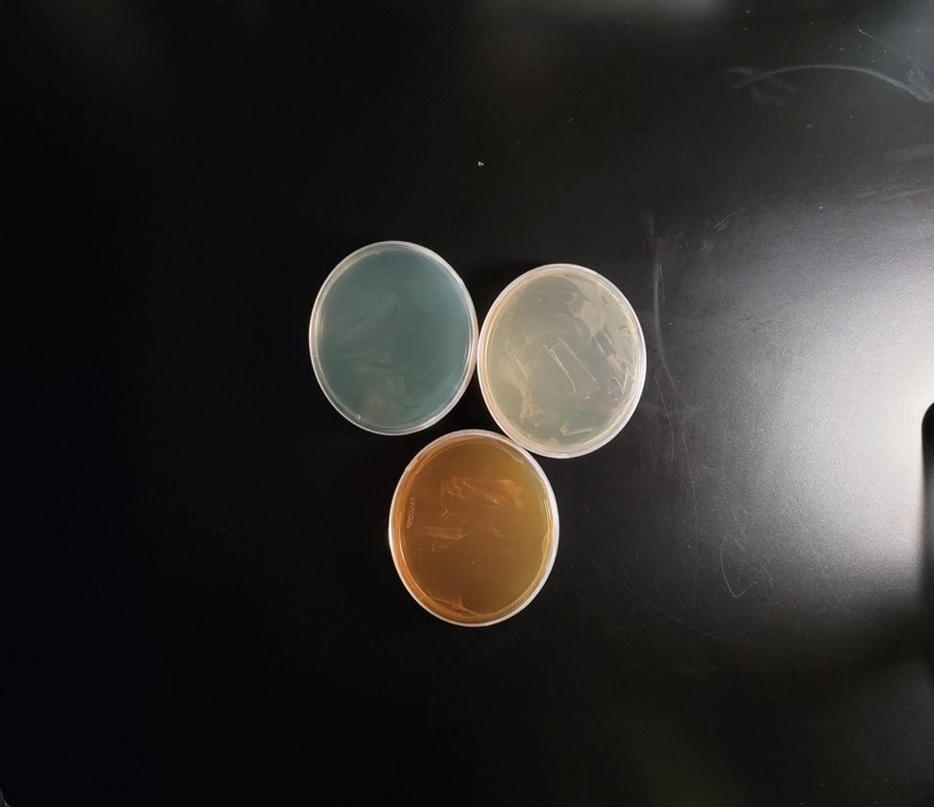
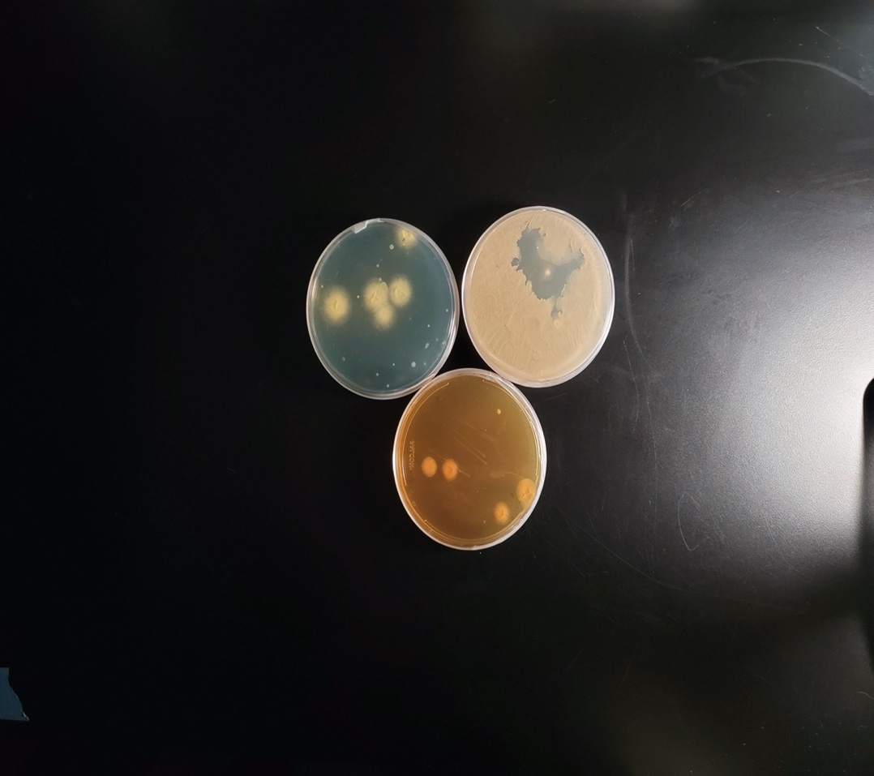
A.
B.

Supplementary figure 1: Confirmation of sterility after plating pollen on different agar (A) sterile pollen using gamma-irradiation (28 kGy for 12 h) and (B) natural pollen

