Supporting information for
Long-term evaluation of machine learning based methods for air emission monitoring
Minxing Siª, Brett M. Wiens^{b} and Ke Duª*
ª Department of Mechanical and Manufacturing Engineering, University of Calgary, 2500 University Drive NW, Calgary AB Canada T2N 1N4
^{b} Cenovus Data Office, Cenovus Energy Inc. 225 6 Ave SW PO Box 766 Calgary, AB Canada T2P 0M5

Table SI-1: Hyperparameters for adaptive boosting, gradient boosting, and artificial neural network algorithm
Algorithm | Hyperparameters
Adaptive boosting | - Number of trees  - Learning rate
Gradient boosting | - Number of trees to fit  - Maximum depth of a tree  - Learning rate  - Subsample ratio of columns when constructing each tree  - Minimum loss reduction required to make a further partition on a leaf node of the tree  - L2 regularization on weights  - Minimum sum of instance weight needed in a child
ANN | - Number of layers  - Number of units on each layer  - Learning rate  - Dropout rate  - Optimization function  - Activation function

Table SI-2: Overall Net Difference in the monitoring period
Algorithm | Net Difference
Linear | 0.87%
Lasso | -0.10%
Ridge | 1.11%
Gradient boosting | 0.94%
Adaptive boosting | 0.63%
ANN | -0.32%
Note: the net difference is calculated by (sum of the CEMS values minus sum of the predicted values) divide by sum of the CEMS values.

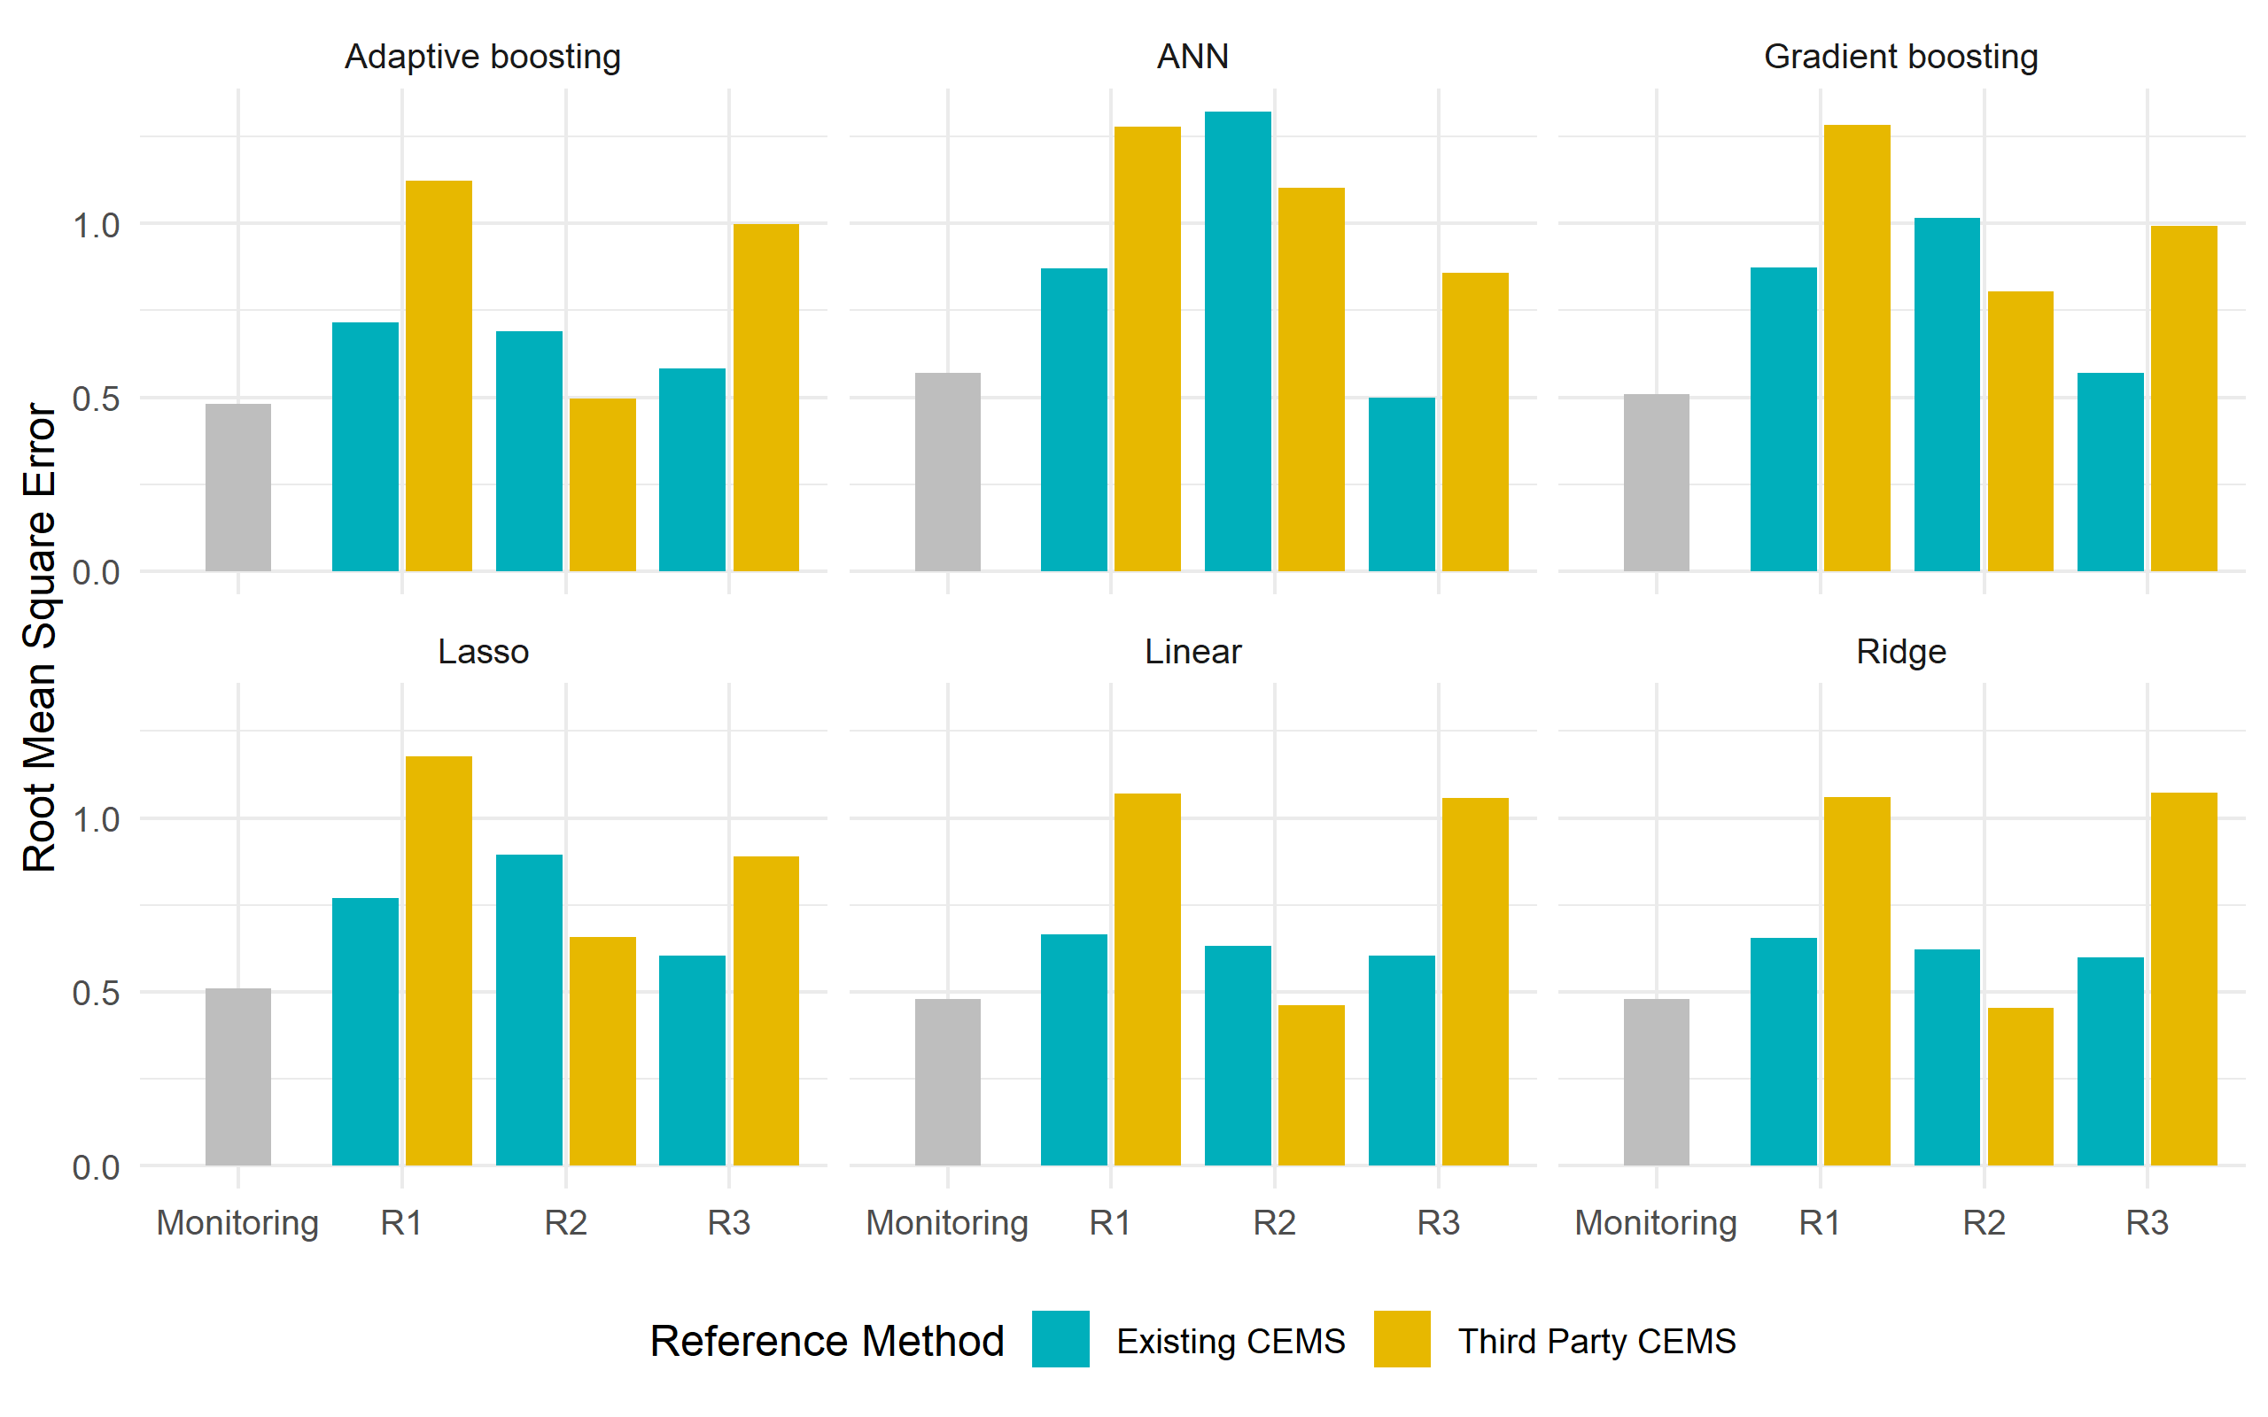
Figure SI-1: RMSE Comparison Between the three RATA tests and Monitoring Period. R1, R2, and R3 represent March 2020, August 2020, and March 2021 RATA tests. One RATA test had 4.5 hourly samples. The monitoring period had 17,097 hourly samples.

Table SI-3: Summary statistics for residuals from the six predictive models
Algorithm | Min. | Q1 | Median | Mean | Q3 | Max.
Linear | -6.49 | -0.25 | 0.09 | -0.01 | 0.39 | 2.57
Lasso | -6.70 | -0.31 | 0.01 | -0.01 | 0.32 | 2.28
Ridge | -6.55 | -0.23 | 0.11 | 0.08 | 0.40 | 2.91
Gradient boosting | -6.57 | -0.23 | 0.11 | 0.07 | 0.40 | 2.22
Adaptive boosting | -6.56 | -0.24 | 0.08 | 0.05 | 0.37 | 2.27
ANN | -6.67 | -0.33 | 0.01 | -0.02 | 0.33 | 2.84

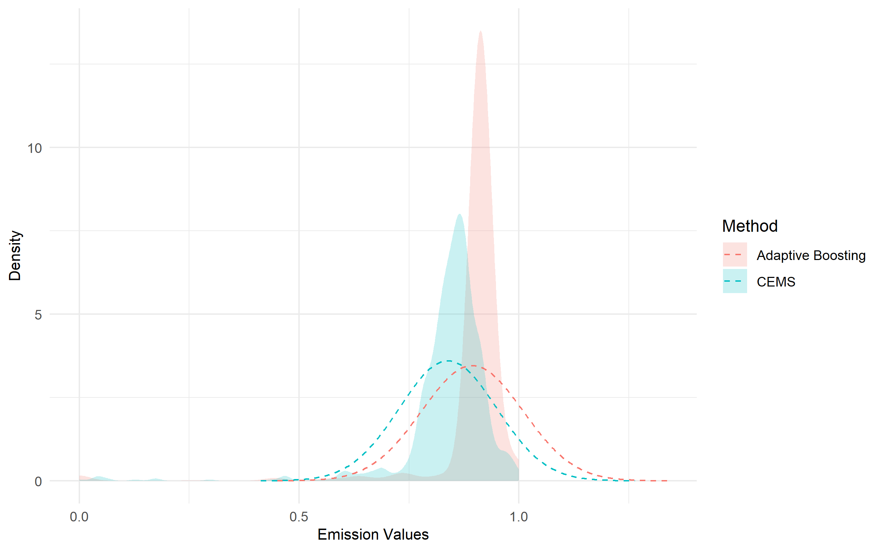
Figure SI-2: Density Distribution of Predictive Values by the adaptive boosting model and CEMS values in the test dataset (844 samples). The green and red dashed line represent normal distribution lines. The NO_{x} emission values in the x axis were min-max scaled.

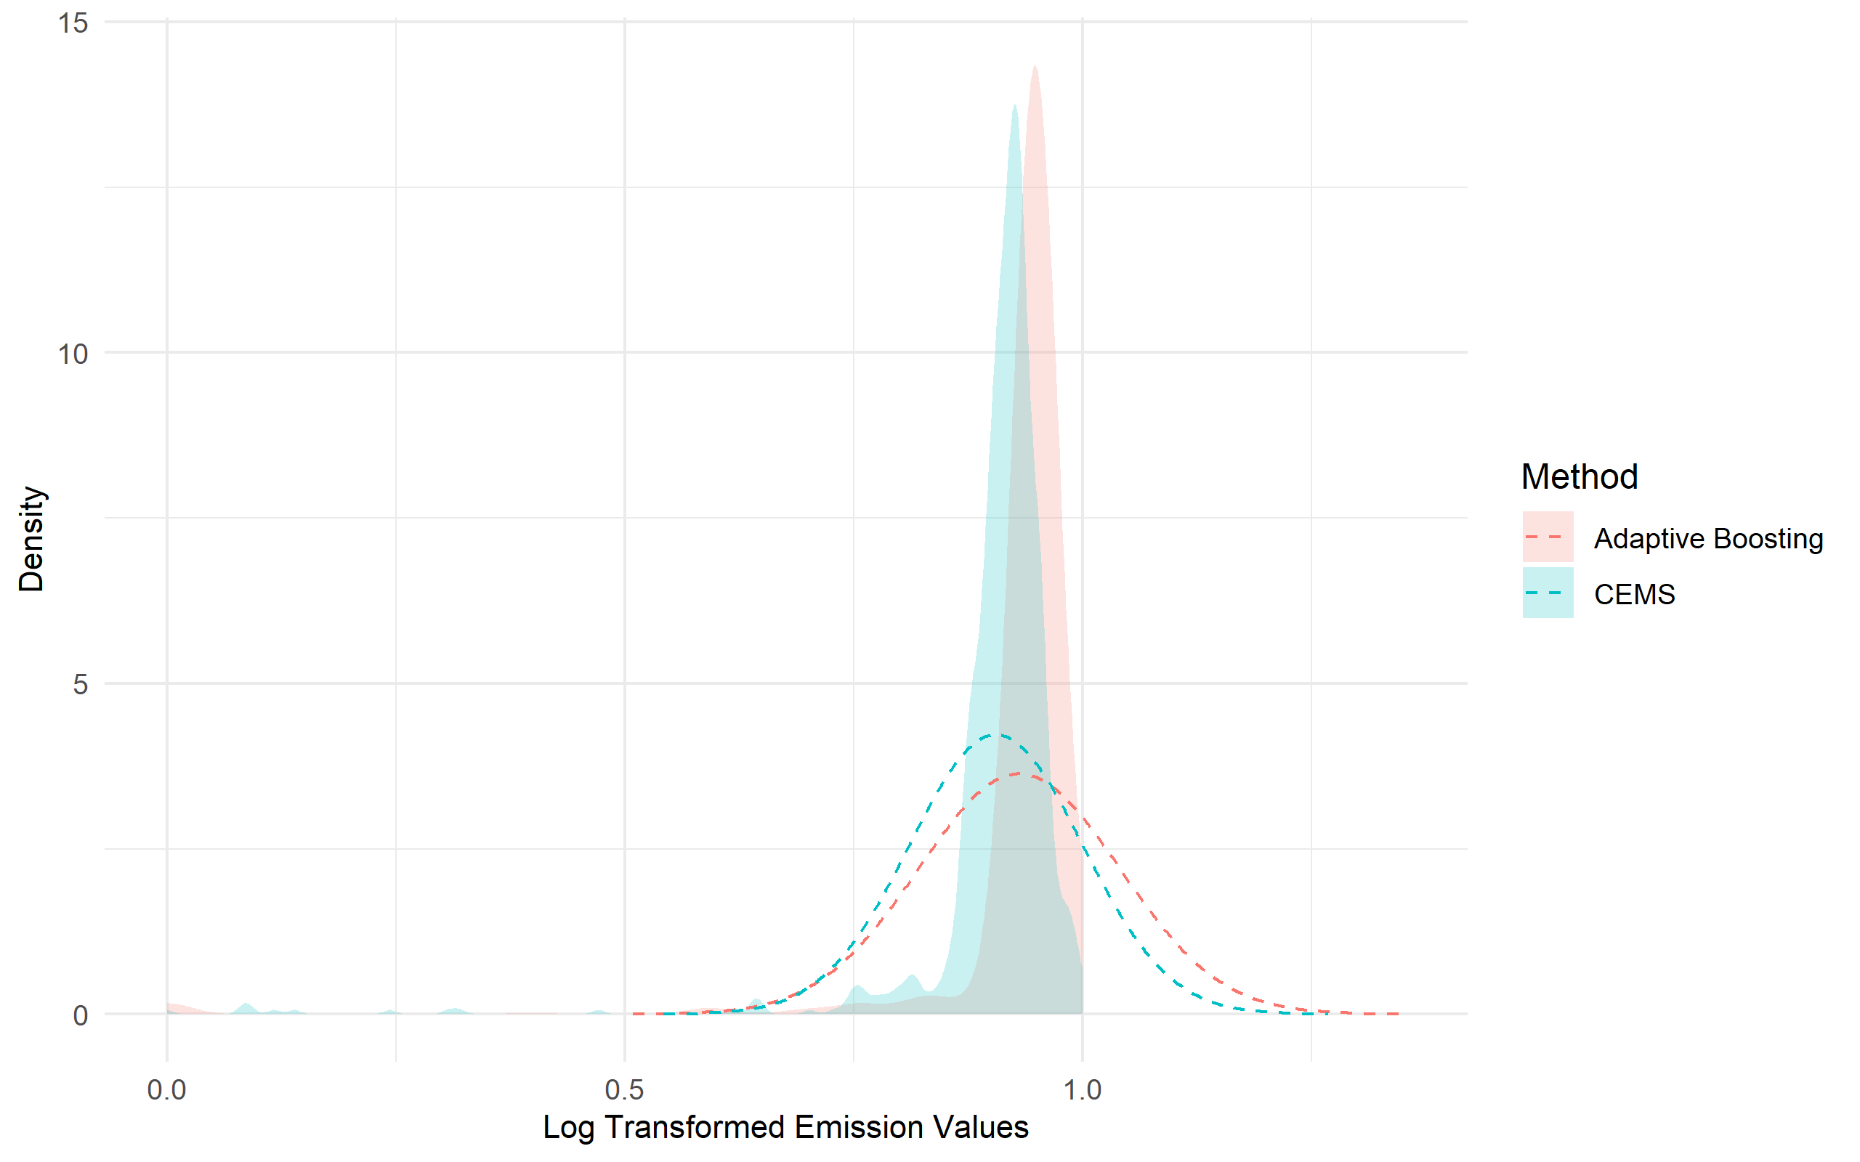
Figure SI-3: Density Distribution of log transformed predictive values and CEMS values in the test dataset (844 samples). The predictive values were produced by the adaptive boosting model. The green and red dashed line represent normal distribution lines. The NO_{x} emission values on the x axis were log transformed and min-max scaled.

