Additional file 1 – Characteristics of ‘What matters to me’
This file shows the four essential pages of ‘What matters to me’, including the homepage, category page, proposition pages, and overview. The homepage (Figure 1) contains several items informing the users about the purpose and use of ‘What matters to me’. The homepage also provides access to the preference elicitation section of ‘What matters to me’. The preference elicitation starts at the category page (Figure 2) where a user can choose a category to answer propositions. The propositions are all provided on separate pages (Figure 3). Users can click on the answers that match their opinion and continue with the subsequent propositions. The overview (Figure 4) is a list with all the answers the user has given to the propositions. The answers are shown per category and users are able to change their answers.
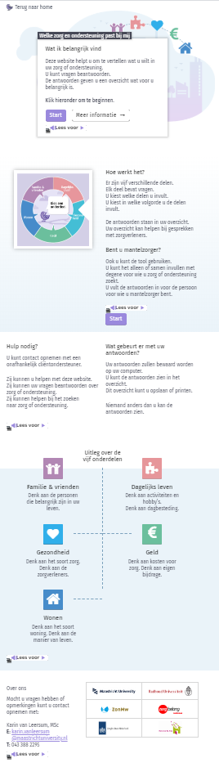
Figure 1. Homepage of ‘What matters to me’.

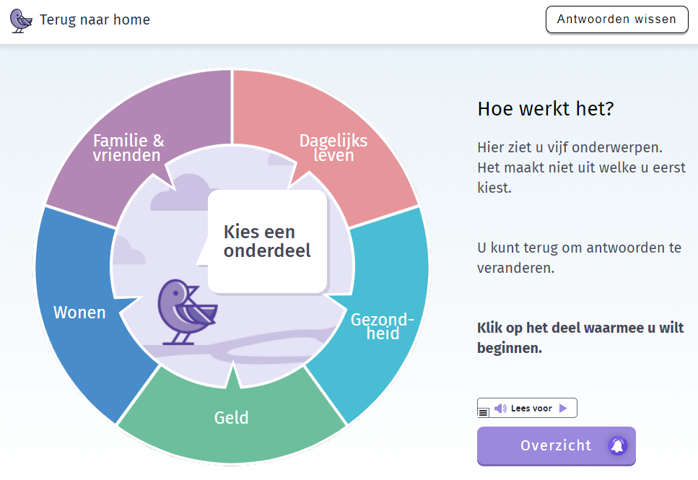
Figure 2. Category page of ‘What matters to me’.

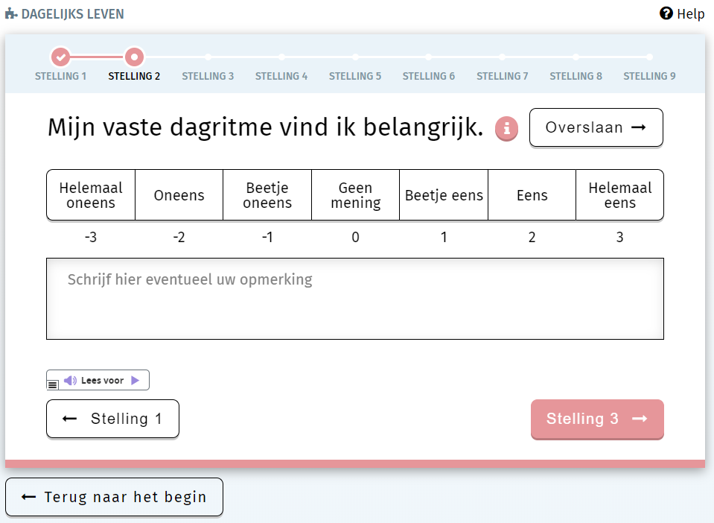
Figure 3. Proposition page of ‘What matters to me’.

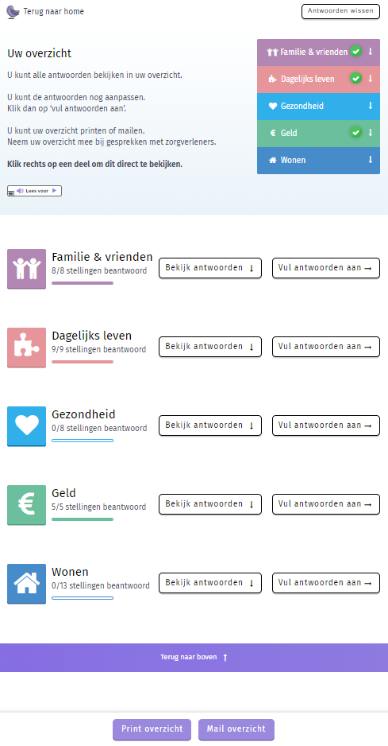
Figure 4. Overview of ‘What matters to me’.

