Synthetic exploration of sulfinyl radicals using sulfinyl sulfones
Supplementary Information
Zikun Wang¹†, Zhansong Zhang¹†, Wanjun Zhao¹, Paramasivam Sivaguru¹, Giuseppe Zanoni², Yingying Wang¹, Edward A. Anderson³ and Xihe Bi^{1,4}*
¹ Department of Chemistry, Northeast Normal University, Changchun 130024, China;
² Department of Chemistry, University of Pavia, Viale Taramelli 12, 27100, Pavia, Italy;
³ Chemistry Research Laboratory, University of Oxford, 12 Mansfield Road, Oxford, OX1 3TA, U.K.;
⁴ State Key Laboratory of Elemento-Organic Chemistry, Nankai University, Tianjin 300071, China;
† These authors contributed equally to this work;
* Corresponding author: bixh507@nenu.edu.cn.

Table of contents

I. General experimental details 2
II. General synthetic procedures 2
III. Study on the instability of sulfinyl sulfone 1 5
IV. Synthetic utility of 2 6
V. Mechanistic investigations 10
VI. Analysis of EPR spectra 11
VII. X-Ray crystallographic data 12
VIII. Density functional theory calculations 18
IX. Characterization data of the products 44
X. Copies of NMR spectra 71
XI. References 228

I. General experimental details
All reagents and solvents were purchased from commercial sources and used without purification unless otherwise stated. The products were purified by column chromatography over silica gel (200-400 size). ¹H, ¹³C and ¹⁹F Nuclear Magnetic Resonance (NMR) spectra were recorded at 25 °C on a Bruker 600 MHz, 150 MHz and 564 MHz, respectively and TMS was used as internal standard. Coupling constants are given in hertz. The following abbreviations are used: s, singlet; d, doublet; t, triplet; q, quadruplet, quint., quintet, m, multiplet. Mass spectra were recorded on TSQ 8000 Evo by using EI method. High resolution mass spectra (HRMS) were recorded on Bruck microTof by using ESI method.

II. General synthetic procedures
General procedure for synthesis of sulfinyl sulfones:
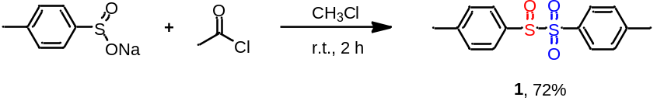
The solution of CH₃COCl (94 mg, 1.2 mmol) and sodium p-toluene sulfinate (320 mg, 1.8 mmol) in CHCl₃ (3 mL) was transferred into the Schlenk tube. The reaction mixture was stirred at room temperature for 2 h. After the completion of reaction, petroleum ether (15 mL) was poured into the reaction mixture. The mixture was filtered and solid were collected. The resulting crude product was purified by a mixture of petroleum ether and ethyl acetate (petroleum ether/ethyl acetate=10/1, 3 × 10 mL) to afford sulfinyl sulfone 1 with 72% yield. (All the above operations were performed in the glove box.)
General procedure for sulfinylsulfonation of alkynes:
In the glove box, the solution of sulfinyl sulfone 1 (441 mg, 1.5 mmol) and phenylacetylene (102 mg, 1.0 mmol) in CHCl₃ (3 mL) was transferred into the Schlenk tube. The reaction mixture was stirred at 40 ºC for 30 min. After the completion of reaction, CH₂Cl₂ (10 mL) was poured into the reaction mixture. The organic layers were extracted with water (3 × 20 mL). The combined organic layers were dried with anhydrous Na₂SO₄ and filtered and solvent was removed under reduced pressure. The resulting crude product was purified by column chromatography on silica gel using Petroleum ether/EtOAc/DCM (10/1/1) as eluent to afford 2 with 98% yield.
Oven dried Schlenk tube was repeatedly purged with N₂ and added sodium sulfinates (1.8 mmol). The solution of alkyne (0.3 mmol) and CH₃COCl (1.2 mmol) in CHCl₃ (3 mL) was transferred into the tube. The reaction mixture was stirred at 40 ºC for 30 min. After the completion of reaction, CH₂Cl₂ (10 mL) was poured into the reaction mixture. The organic layers were extracted with water (3 × 20 mL). The combined organic layers were dried with anhydrous Na₂SO₄ and filtered and solvent was removed under reduced pressure. The resulting crude product was purified by column chromatography on silica gel using Petroleum ether/EtOAc/DCM (10/1/1) as eluent to afford the corresponding product.

General procedure for sulfinylsulfonation of alkenes:
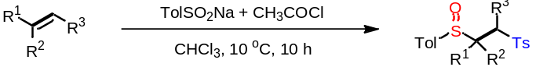
Oven dried Schlenk tube was repeatedly purged with N₂ and added sodium sulfinates (1.8 mmol). The solution of alkene (0.3 mmol), CH₃COCl (94.2 mg, 1.2 mmol) in CHCl₃ (3 mL) was transferred into the tube. The reaction mixture was stirred at 10 ºC for 10 h. After the completion of reaction, CH₂Cl₂ (10 mL) was poured into the reaction mixture. The organic layers were extracted with water (3 × 20 mL). The combined organic layers were dried with anhydrous Na₂SO₄ and filtered and solvent was removed under reduced pressure. The resulting crude product was purified by column chromatography on silica gel using Petroleum ether/EtOAc/DCM (8/1/1) as eluent to afford the corresponding product.
General procedure for sulfinylsulfonation of enynes:
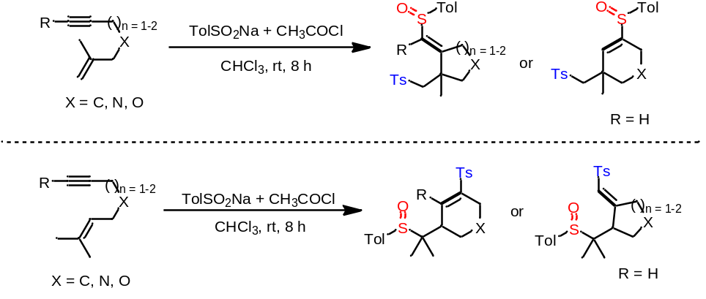
Oven dried Schlenk tube was repeatedly purged with N₂ and added p-toluene sulfinate (320 mg, 1.8 mmol). The solution of enyne (0.3 mmol) and CH₃COCl (94.2 mg, 1.2 mmol) in CHCl₃ (3 mL) was transferred into the tube. The reaction mixture was stirred at room temperature for 8 h. After the completion of reaction, CH₂Cl₂ (10 mL) was poured into the reaction mixture. The organic layers were extracted with water (3 × 20 mL). The combined organic layers were dried with anhydrous Na₂SO₄ and filtered and solvent was removed under reduced pressure. The resulting crude product was purified by column chromatography on silica gel using Petroleum ether/EtOAc/DCM (5/1/1) as eluent to afford the corresponding product.
The procedure for sulfinylsulfonation of ethylene/1,3-butadiene:
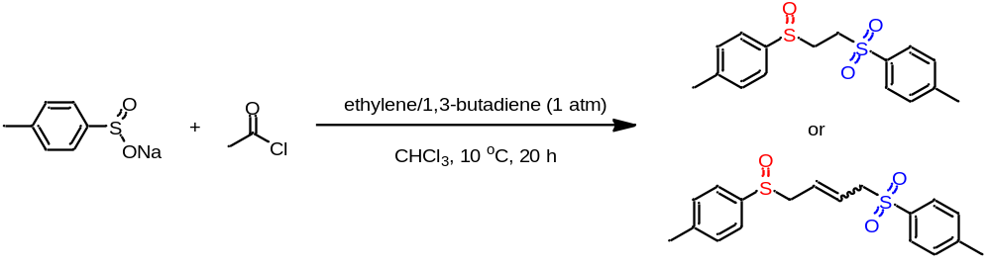
Put sodium sulfinate (320 mg, 1.8 mmol) into an oven dried Schlenk tube, replace it with nitrogen three times, and then connect the ethylene/1,3-butadiene gas ballon under vacuum. The solution CH₃COCl (94.2 mg, 1.2 mmol) in CHCl₃ (3 mL) was transferred into the tube. The reaction mixture was stirred at 10 ºC for 20 h. After the completion of reaction, CH₂Cl₂ (10 mL) was poured into the reaction mixture. The organic layers were extracted with water (3 × 20 mL). The combined organic layers were dried with anhydrous Na₂SO₄ and filtered and solvent was removed under reduced pressure. The resulting crude product was purified by column chromatography on silica gel using Petroleum ether/EtOAc/DCM (5/1/1) as eluent to afford the corresponding product.
The procedure for sulfinylsulfonation of arynes:
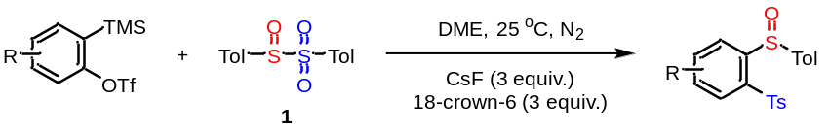
In the glove box, the solution of sulfinyl sulfone 1 (147 mg, 0.5 mmol), arynes (0.5 mmol), CsF (228 mg, 1.5 mmol), 18-crown-6 (395 mg, 1.5 mmol) in DME (3 mL) was transferred into the Schlenk tube. The reaction mixture was stirred at room temperature for 3 h. After the completion of reaction, CH₂Cl₂ (10 mL) was poured into the reaction mixture. The organic layers were extracted with water (3 × 20 mL). The combined organic layers were dried with anhydrous Na₂SO₄ and filtered and solvent was removed under reduced pressure. The resulting crude product was purified by column chromatography on silica gel using Petroleum ether/EtOAc/DCM (5/1/1) as eluent to afford the corresponding product.
The procedure for the synthesis of 100,102,106:
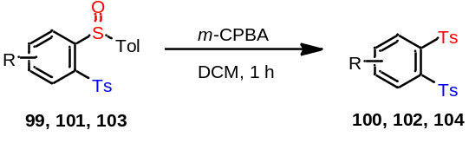
An oven dried 25 mL round-bottomed flask was charged with 99, 101, 103 (0.5 mmol), m-CPBA (0.75 mmol) and DCM (3 mL) , The reaction mixture was stirred at room temperature for 1 h. After completion of the reaction, 10 mL saturated Na₂SO₃ solution was added and the resulting mixture was extracted with DCM (3 × 10 mL) and the organic layer was combined and dried with anhydrous NaSO₄. The combined organic extracts were washed with water, brine, dried over anhydrus NaSO₄, and concentrated under reduced pressure. The resulting crude product was purified by column chromatography on silica gel using Petroleum ether/EtOAc/DCM (8:1:1) as eluent to afford the 100, 102, 104.
The procedure for the synthesis of 124:
An oven dried 25 mL round-bottomed flask was charged with 121 (97.2mg, 0.2 mmol), m-CPBA (68.8 mg, 0.4 mmol) and DCM (3 mL).The reaction mixture was stirred at room temperature for overnight. After completion of the reaction, 10 mL saturated Na₂SO₃ solution was added and the resulting mixture was extracted with DCM (3 × 10 mL) and the organic layer was combined and dried with anhydrous NaSO₄. The combined organic extracts were washed with water, brine, dried over anhydrus NaSO₄, and concentrated under reduced pressure. The resulting crude product was purified by column chromatography on silica gel using Petroleum ether/EtOAc/DCM (8:1:1) as eluent to afford the 124 with 86% yield.
The procedure for the synthesis of 125:
An oven dried 25 mL round-bottomed flask was charged with 122 (162.0mg, 0.2 mmol), m-CPBA (137.6 mg, 0.8 mmol) and DCM (5 mL).The reaction mixture was stirred at room temperature for overnight. After completion of the reaction, 10 mL saturated Na₂SO₃ solution was added and the resulting mixture was extracted with DCM (3 × 10 mL) and the organic layer was combined and dried with anhydrous NaSO₄. The combined organic extracts were washed with water, brine, dried over anhydrus NaSO₄, and concentrated under reduced pressure. The resulting crude product was purified by column chromatography on silica gel using Petroleum ether/EtOAc/DCM (8:3:1) as eluent to afford the 125 with 84% yield.

III. Study on the instability of sulfinyl sulfone 1
Figure. S1. The instability of sulfinyl sulfone 1.
Study on the stability of sulfinyl sulfone 1 in air: In the glove box, the solution of sulfinyl sulfone 1 (441 mg, 1.5 mmol) and 1,3,5-trimethoxybenzene (56 mg, 0.5 mmol) in CDCl₃ (3 mL) was transferred into the Schlenk tube. Removd the reaction system from the glove box and stirred in the air. Every ten minutes, took samples from the reaction system for ¹H NMR detection. Then draw a curve based on the obtained data.
Study on the stability of sulfinyl sulfone 1 in nitrogen: In the glove box, the solution of sulfinyl sulfone 1 (441 mg, 6.0 mmol) and CH₂Br₂ (3.0 mmol) in CDCl₃ (18 mL) was divided into six equal parts and placed in six Schlenk tubes. The six reaction systems were placed at 15 ºC, 25 ºC, 35 ºC, 45 ºC, 55 ºC, and 65 ºC respectively, and stirred for 30 minutes. Then took samples from the reaction system for ¹H NMR detection and draw a curve based on the obtained data.

IV. Synthetic utility of 2
Multigram-scale synthesis of product 2:
Oven dried three-necked flask was repeatedly purged with N₂ and added sodium sulfinates (600 mmol, 106.8 g). The solution of phenylacetylene (100 mmol, 10.24 g) in CHCl₃ (200 mL) was transferred into the flask. The reaction mixture was stirred at 40 ºC for 10 min. Then the solution of acetyl chloride (400 mmol, 31.4 g) in CHCl₃ (100 mL) was slowly dropped to the above reaction mixture. After the completion of reaction, the reaction mixture was filtered and the filtrate is collected. The solvent of the filtrate was removed under reduced pressure. The resulting crude product was washed by petroleum ether/EtOAc (20:1, 3 × 200 mL) to afford the product 2 in the yield of 85% as a white solid.
The procedure for the synthesis of 128:
The solution of 2 (198 mg, 0.5 mmol) and NaH (0.75 mmol) in acetonitrile (3 mL) was transferred into the Schlenk tube. The reaction system was stirred at room temperature for 6 h. After the completion of reaction, saturated ammonium chloride solution (10 mL) was added to the reaction system to quench the reaction. Then CH₂Cl₂ (20 mL) was poured into the reaction mixture. The organic layers were extracted with water (3 × 20 mL). The combined organic layers were dried with anhydrous Na₂SO₄ and filtered and solvent was removed under reduced pressure. The resulting crude product was purified by column chromatography on silica gel using Petroleum ether/EtOAc (10/1) as eluent to afford the product 128 in the yield of 69% as a white solid.
The procedure for the synthesis of 129:
The solution of 2 (198 mg, 0.5 mmol) and DBU (5.0 mmol) in Toluene (3 mL) was transferred into the Schlenk tube. The reaction system was stirred at 100ºC for 6 h. After the completion of reaction, saturated ammonium chloride solution (10 mL) was added to the reaction system to quench the reaction. Then CH₂Cl₂ (20 mL) was poured into the reaction mixture. The organic layers were extracted with water (3 × 20 mL). The combined organic layers were dried with anhydrous Na₂SO₄ and filtered and solvent was removed under reduced pressure. The resulting crude product was purified by column chromatography on silica gel using Petroleum ether/EtOAc (20/1) as eluent to afford the product 129 in the yield of 46% as a white solid.

The procedure for the synthesis of 130:¹
In the glove box, the solution of compound 2 (396 mg, 1.0 mmol), methanol (405 μL, 10.0 mmol), and hexamethylphosphoric triamide (HMPA, 896 mg, 5.0 mmol) in THF (1 mL) was transferred into the Schlenk tube. The six reaction systems were placed at -20 ºC and stirred for 10 min. The solution of samarium iodide in THF (0.1 M, 50 mL) was slowly dropped into the above reaction system. Then, the reaction system was stirred at -20 ºC for 2 h. After the completion of reaction, added hydrochloric acid (1 M) to the reaction system to quench the reaction. CH₂Cl₂ (20 mL) was poured into the reaction mixture. The organic layers were extracted with water (3 × 20 mL). The combined organic layers were dried with anhydrous Na₂SO₄ and filtered and solvent was removed under reduced pressure. The resulting crude product was purified by column chromatography on silica gel using Petroleum ether/EtOAc (8/1) as eluent to afford the 130 with 74% yield.
The procedure for the synthesis of 131: ¹
In the glove box, the solution of compound 2 (396 mg, 1.0 mmol), in methanol/THF (v/v = 1/1, 1 mL) was transferred into the Schlenk tube. The solution of samarium iodide in THF (0.1 M, 50 mL) was slowly dropped into the above reaction system at room temperature. Then, the reaction system was stirred at 60 ºC for 3 h. After the completion of reaction, hydrochloric acid (1 M, 10 mL) was added to the reaction system to quench the reaction. CH₂Cl₂ (20 mL) was poured into the reaction mixture. The organic layers were extracted with water (3 × 20 mL). The combined organic layers were dried with anhydrous Na₂SO₄ and filtered and solvent was removed under reduced pressure. The resulting crude product was purified by column chromatography on silica gel using Petroleum ether/EtOAc (8/1) as eluent to afford the 131 with 72% yield.
General procedure for the synthesis of 132-134: ²
The solution of 2 (396 mg, 1.0 mmol), RXH (1.5 mmol) and NaH (1.5 mmol) in acetonitrile (3 mL) was transferred into the Schlenk tube. The reaction system was stirred at room temperature for 5 h. After the completion of reaction, saturated ammonium chloride solution (10 mL) was added to the reaction system to quench the reaction. Then CH₂Cl₂ (20 mL) was poured into the reaction mixture. The organic layers were extracted with water (3 × 20 mL). The combined organic layers were dried with anhydrous Na₂SO₄ and filtered and solvent was removed under reduced pressure. The resulting crude product was purified by column chromatography on silica gel using Petroleum ether/EtOAc (10/1) as eluent to afford the corresponding products.
General procedure for the synthesis of 135,136 and 138-140:
The solution of 2 (396 mg, 1.0 mmol), RXH (1.5 mmol) and NaH (1.5 mmol) in acetonitrile (3 mL) was transferred into the Schlenk tube. The reaction system was stirred at room temperature for 5 h. After the completion of reaction, saturated ammonium chloride solution (10 mL) was added to the reaction system to quench the reaction. Then CH₂Cl₂ (20 mL) was poured into the reaction mixture. The organic layers were extracted with water (3 × 20 mL). The combined organic layers were dried with anhydrous Na₂SO₄ and filtered and solvent was removed under reduced pressure. The resulting crude product was purified by column chromatography on silica gel using Petroleum ether/EtOAc (10/1) as eluent to afford the corresponding products.
The procedure for the synthesis of 137:
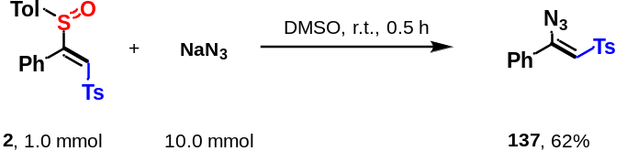
The solution of 2 (396 mg, 1.0 mmol) and NaN₃ (10.0 mmol) in DMSO (3 mL) was transferred into the Schlenk tube. The reaction system was stirred at room temperature for 0.5 h. After the completion of reaction, CH₂Cl₂ (20 mL) was poured into the reaction mixture. The organic layers were extracted with water (3 × 20 mL). The combined organic layers were dried with anhydrous Na₂SO₄ and filtered and solvent was removed under reduced pressure. The resulting crude product was purified by column chromatography on silica gel using Petroleum ether/EtOAc (15/1) as eluent to afford 137 with 62% yield.
The procedure for the synthesis of 141:
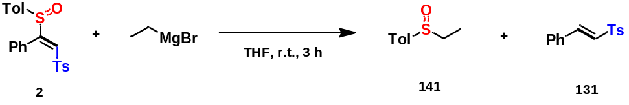
In the glove box, the solution of compound 2 (198 mg, 0.5 mmol), in THF (3 mL) was transferred into the Schlenk tube. The solution of EtMgBr (1.0 mmol) was slowly dropped into the above reaction system at room temperature. Then, the reaction system was stirred at room temperature for 3 h. Saturated ammonium chloride solution (10 mL) was added to the reaction system to quench the reaction. CH₂Cl₂ (20 mL) was poured into the reaction mixture. The organic layers were extracted with water (3 × 20 mL). The combined organic layers were dried with anhydrous Na₂SO₄ and filtered and solvent was removed under reduced pressure. The resulting crude product was purified by column chromatography on silica gel using Petroleum ether/EtOAc (8/1) as eluent to afford the 141 with 87% yield and 131 with 89% yield.
The procedure for the synthesis of 142:
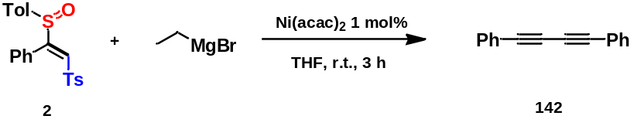
In the glove box, the solution of compound 2 (198 mg, 0.5 mmol) and Ni(acac)₂ (1 mol%, 0.005mmol) in THF (3 mL) was transferred into the Schlenk tube. The solution of EtMgBr (1.0 mmol) was slowly dropped into the above reaction system at room temperature. Then, the reaction system was stirred at room temperature for 3 h. Saturated ammonium chloride solution (10 mL) was added to the reaction system to quench the reaction. CH₂Cl₂ (20 mL) was poured into the reaction mixture. The organic layers were extracted with water (3 × 20 mL). The combined organic layers were dried with anhydrous Na₂SO₄ and filtered and solvent was removed under reduced pressure. The resulting crude product was purified by column chromatography on silica gel using Petroleum ether/EtOAc (8/1) as eluent to afford the 142 with 73% yield.
The procedure for the synthesis of 143: ³

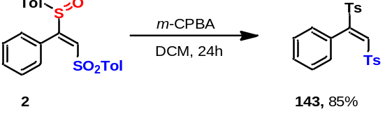

An oven dried 25 mL round-bottomed flask was charged with 2 (198.2 mg, 0.5 mmol), m-CPBA (129.4 mg, 0.75 mmol) and DCM (10 mL).The reaction mixture was stirred at room temperature for 24 h. After completion of the reaction, 20 mL saturated Na₂SO₃ solution was added and the resulting mixture was extracted with DCM (3 × 20 mL) and the organic layer was combined and dried with anhydrous NaSO₄. The combined organic extracts were washed with water, brine, dried over anhydrus NaSO₄, and concentrated under reduced pressure. The resulting crude product was purified by column chromatography on silica gel using Petroleum ether/EtOAc/DCM (8:1:1) as eluent to afford the 143 with 85% yield.
The procedure for the synthesis of 144: ⁴
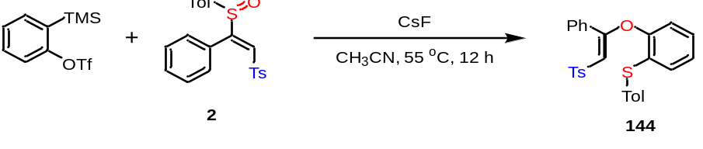
A screw capped reaction vial was charged with 2 (198.3 mg, 0.5 mmol), CsF (455.7 mg, 3 mmol), 2-(trimethylsilyl)phenyl trifluoromethanesulfonate (447.5 mg, 1.5 mmol) acetonitrile (5 mL) in the glove box. The reaction mixture was stirred for 12 h at 55 ºC. After completion of the reaction, water was added and the resulting mixture was extracted with EtOAc (2 × 20 mL ). The combined organic extracts were washed with water, brine, dried over anhydrus NaSO₄, and concentrated under reduced pressure. The resulting crude product was purified by column chromatography on silica gel using Petroleum ether/EtOAc (10:1) as eluent to afford the 144 with 61% yield.
The procedure for the synthesis of 145: ⁵

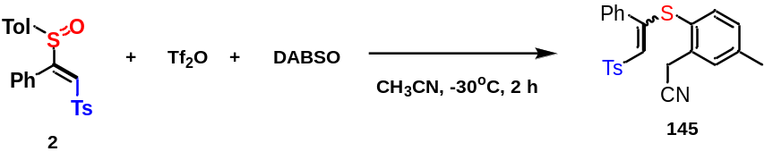

To a solution of 2 (198.9 mg, 0.5 mmol) in MeCN (3 mL) was added Tf₂O (167 μL, 1.0 mmol) under -30℃. After stirring for 10 min, DABSO (300 mg, 2.5 mmol) was added to the mixture under the same temperature. The mixture was then stirred for 2 h. After completion of the reaction, water was added and the resulting mixture was extracted with EtOAc (2 × 20 mL ). The combined organic extracts were washed with water, brine, dried over anhydrus NaSO₄, and concentrated under reduced pressure. The resulting crude product was purified by column chromatography on silica gel using Petroleum ether/EtOAc (10:1) as eluent to afford the 145 with 90% yield.

V. Mechanistic investigations
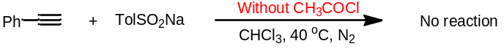
Oven dried Schlenk tube was repeatedly purged with N₂ and added sodium p-toluene sulfinate (320 mg, 1.8 mmol). The solution of phenylacetylene (32 mg, 0.3 mmol) in CHCl₃ (3 mL) was transferred into the tube. The reaction mixture was stirred at 40 ºC for 30 min. Then, CH₂Cl₂ (10 mL) was poured into the reaction mixture. The organic layers were extracted with water (3 × 20 mL). The combined organic layers were dried with anhydrous Na₂SO₄ and filtered and solvent was removed under reduced pressure. The resulting crude product was analyzed by ¹H-NMR.
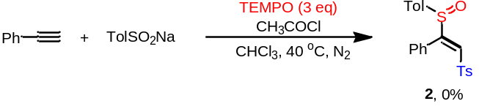
Oven dried Schlenk tube was repeatedly purged with N₂ and added sodium p-toluene sulfinate (320 mg, 1.8 mmol) and TEMPO (141 mg, 0.9 mmol). The solution of phenylacetylene (32 mg, 0.3 mmol), CH₃COCl (94.2 mg, 1.2 mmol) in CHCl₃ (3 mL) was transferred into the tube. The reaction mixture was stirred at 40 ºC for 30 min. Then, CH₂Cl₂ (10 mL) was poured into the reaction mixture. The organic layers were extracted with water (3 × 20 mL). The combined organic layers were dried with anhydrous Na₂SO₄ and filtered and solvent was removed under reduced pressure. The resulting crude product was analyzed by ¹H-NMR.
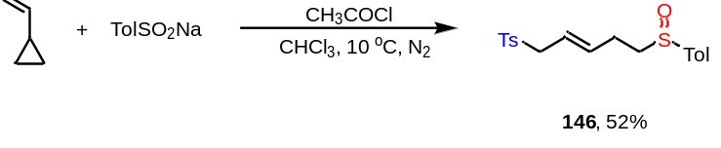
Oven dried Schlenk tube was repeatedly purged with N₂ and added sodium p-toluene sulfinate (320 mg, 1.8 mmol). The solution of cyclopropylethylene (0.3 mmol), CH₃COCl (94.2 mg, 1.2 mmol) in CHCl₃ (3 mL) was transferred into the tube. The reaction mixture was stirred at 10 ºC for 10 h. After the completion of reaction, CH₂Cl₂ (10 mL) was poured into the reaction mixture. The organic layers were extracted with water (3 × 20 mL). The combined organic layers were dried with anhydrous Na₂SO₄ and filtered and solvent was removed under reduced pressure. The resulting crude product was purified by column chromatography on silica gel using petroleum ether/EtOAc/DCM (8/1/1) as eluent to afford 146 with 52% yield.

VI. Analysis of EPR spectra
EPR measurements: EPR spectra were recorded at room temperature on a Bruker EMX nano spectrometer: Mod. Amplitude = 1 G; Time Constan = 120 sec; Sweep time = 120 sec; Power = 0.3 mw. DMPO (5,5-dimethyl-1-pyrroline N-oxide) was employed as the radical trap. EPR spectra (X band, 9.64 GHz, RT) of conditions: In glove box, 1 (0.5 mmol), phenylacetylene (0.5 mmol), and DMPO (1 mmol) in CHCl₃ (5 mL) was stirring at room temperature for 5 min. 0.02 mL of this reaction solution was taken out into a small tube and sealed it under N₂. Then, this mixture was used for EPR measurement.
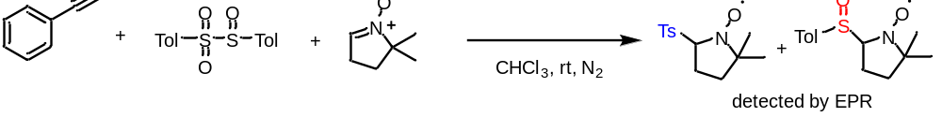
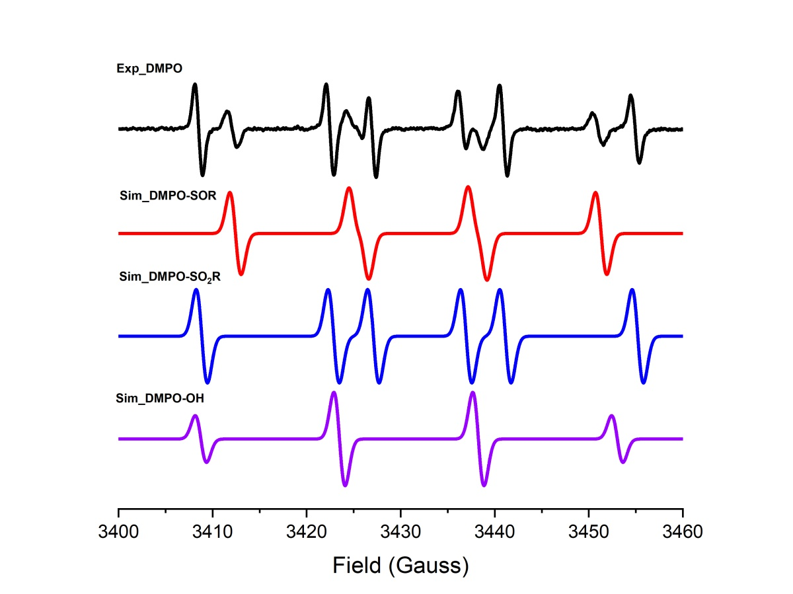
Fig. S2. EPR spectra of experiments (Exp) and simulation (Sim). The hyperfine parameters of the DMPO adduct radical are: DMPO-OH, A_{N} = 14.8 G, A_{Hβ} = 14.8 G; DMPO-SOR, A_{N} = 13.7 G, A_{Hβ} = 12.65 G; DMPO-SO₂R, A_{N} = 14.1 G, A_{Hβ} = 18.3 G.
Note: Fig. S2 shows that both the signals of adducts of DMPO with sulfinyl radical and sulfonyl radical could be observed in this reaction system.

VII. X-Ray crystallographic data
Table S1. Crystal structure of 1
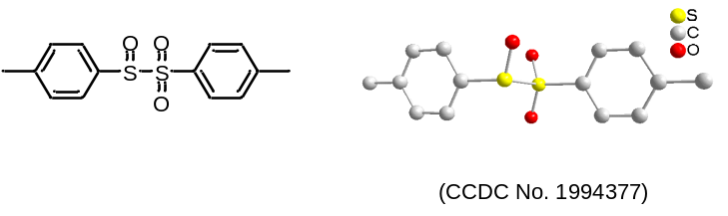
Empirical formula | C₁₄H₁₄O₃S₂
Temperature | 173 K
Wavelength | 1.54178 Å
Unit cell dimensions | a = 7.1257(4) Å  b = 7.3028(4) Å  c = 7.5619(4) Å  alpha = 82.433(3) deg.  beta = 67.200(3) deg.  gamma = 71.699(3) deg.
Volume | 344.39(3) Å ³
Z | 1
Calculated density | 1.419 g/cm³
Absorption coefficient | 3.519 mm-1
F(000) | 154.0
Crystal size | 0.21 x 0.20 x 0.15 mm
Theta range for data collection | 6.349 to 62.565 deg.
Reflections collected / unique | 4525 / 1081 [R(int) = 0.0374]
Data / restraints / parameters | 1081/427/150
Goodness-of-fit on F² | 1.060
Final R indices [I>2sigma(I)] | R1 = 0.0532, wR2 = 0.1536
Rindices (all data) | R1 = 0.0565, wR2 = 0.1565

Table S2. Crystal structure of 2
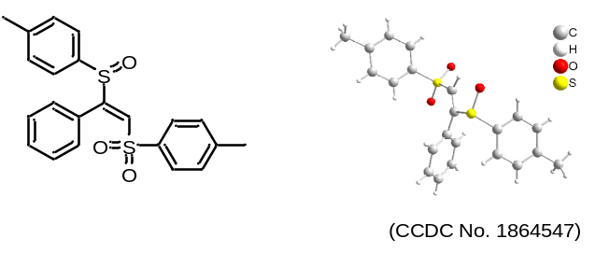
Empirical formula | C₂₂H₂₀O₃S₂
Temperature | 298(2)
Wavelength | 1.40700 Å
Unit cell dimensions | a = 10.1993(15) Å  b = 8.4606(13) Å  c = 22.825(3) Å  alpha = 90 deg.  beta = 96.224(3) deg.  gamma = 90 deg.
Volume | 1958.0(5) Å ³
Z | 4
Calculated density | 1.658 Mg/m³
Absorption coefficient | 0.942 mm⁻¹
F(000) | 992.0
Crystal size | 0.21 x 0.30 x 0.15 mm
Theta range for data collection | 3.59 to 52.788 deg.
Reflections collected / unique | 10770 / 4003 [R(int) = 0.0662]
Data / restraints / parameters | 4003 / 0 / 244
Goodness-of-fit on F² | 1.059
Final R indices [I>2sigma(I)] | R1 = 0.0590, wR2 = 0.1099
Rindices (all data) | R1 = 0.1144, wR2 = 0.1306

Table S3. Crystal structure of 49
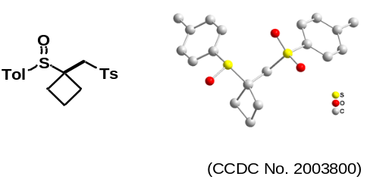
Empirical formula | C₁₉H₂₂O₃S₂
Temperature | 293 K
Wavelength | 0.71073 Å
Unit cell dimensions | a = 7.6658(7) Å  b = 11.2719(8) Å  c = 21.6538(16) Å  alpha = 90 deg.  beta = 90 deg.  gamma = 90 deg.
Volume | 1871.1(3) Å ³
Z | 4
Calculated density | 1.287 g/cm3
Absorption coefficient | 0.298 mm-1
F(000) | 768.0
Crystal size | 0.20 x 0.14 x 0.15 mm
Theta range for data collection | 3.349 to 29.291deg.
Reflections collected / unique | 8891 / 4029 [R(int) = 0.0395]
Data / restraints / parameters | 4003 / 0 / 219
Goodness-of-fit on F² | 1.011
Final R indices [I>2sigma(I)] | R1 = 0.0620, wR2 = 0.1411
Rindices (all data) | R1 = 0.1115, wR2 = 0.1735

Table S4. Crystal structure of 79
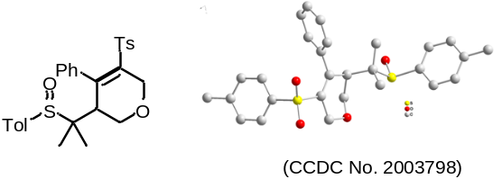
Empirical formula | C₂₈H₃₀O₄S₂
Temperature | 293 K
Wavelength | 0.71073 Å
Unit cell dimensions | a = 9.8456(9) Å  b = 10.6822(8) Å  c = 13.2774(11) Å  alpha = 84.982(7) deg.  beta = 70.901(8) deg.  gamma = 74.808(7) deg.
Volume | 1273.4(2) Å ³
Z | 2
Calculated density | 1.290 g/cm3
Absorption coefficient | 0.241 mm-1
F(000) | 524.0
Crystal size | 0.15 x 0.13 x 0.15 mm
Theta range for data collection | 3.351 to 29.221 deg.
Reflections collected / unique | 9360 / 5813 [R(int) = 0.0236]
Data / restraints / parameters | 5813 / 0 / 311
Goodness-of-fit on F² | 1.029
Final R indices [I>2sigma(I)] | R1 = 0.0596, wR2 = 0.1354
Rindices (all data) | R1 = 0.1000, wR2 = 0.1636

Table S4. Crystal structure of 91
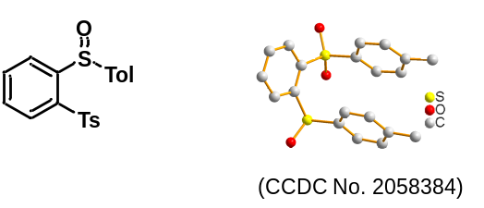
Empirical formula | C₂₀H₁₈O₃S₂
Temperature | 293 K
Wavelength | 0.71073 Å
Unit cell dimensions | a = 11.655(3) Å  b = 14.655(3) Å  c = 20.785(5) Å  alpha = 90 deg.  beta = 90 deg.  gamma = 90 deg.
Volume | 3550.1(14) Å ³
Z | 8
Calculated density | 1.319 g/cm3
Absorption coefficient | 0.314 mm-1
F(000) | 1409.0
Crystal size | 0.18 x 0.21 x 0.15 mm
Theta range for data collection | 6.804 to 59.348 deg.
Reflections collected / unique | 11969 / 4275 [R_{int}= 0.0615, R_{sigma}= 0.0843]
Data / restraints / parameters | 4275/0/228
Goodness-of-fit on F² | 1.038
Final R indices [I>2sigma(I)] | R₁= 0.0784, wR₂= 0.2150
Rindices (all data) | R₁= 0.1556, wR₂= 0.2653

Table S5. Crystal structure of (119)
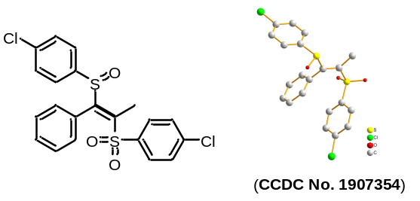
Empirical formula | C₂₁H₁₆Cl₂O₃S₂
Temperature | 273.15 K
Wavelength | 1.54178 Å
Unit cell dimensions | a = 10.0347(6) Å  b = 9.9087(6) Å  c = 21.0829(12) Å  alpha = 90 deg.  beta = 98.721(3) deg.  gamma = 90 deg.
Volume | 2072.1(2) Å ³
Z | 4
Calculated density | 1.447 g/cm3
Absorption coefficient | 4.871 mm-1
F(000) | 928.0
Crystal size | 0.15 × 0.12 × 0.1 mm
Theta range for data collection | 8.486 to 130.29 deg.
Reflections collected / unique | 18069 / 3499 [R_{int} = 0.0416, R_{sigma} = 0.0305]
Data / restraints / parameters | 3499/0/254
Goodness-of-fit on F² | 1.045
Final R indices [I>2sigma(I)] | R₁ = 0.0482, wR₂ = 0.1083
Rindices (all data) | R₁ = 0.0585, wR₂ = 0.1146

VIII. Density functional theory calculations
Computational methods: All of the density functional theory (DFT) calculations were implemented with the Gaussian 09⁶ package. Geometry optimizations and frequencies were calculated with the B3LYP^{7,8} density functional and 6-31+G(d,p) basis set for all atoms in conjunction with the SMD implicit solvation model to account for the solvation effects of chloroform. Frequency calculations were examined for all intermediates and transition structures to determine minima (zero imaginary frequencies) or transition structures (only one imaginary frequency), respectively. Intrinsic reaction coordinate (IRC)^{9,10} was used to confirmed whether transition states connected the reactant and product. The key 3D structures were prepared using the CYL view visualization program ¹¹.
Figure S3. Free energy profiles for the conversion from TolSO₂Na and CH₃COCl into sulfinyl sulfones (1). The energies are in kcal/mol and represent the relative free energies calculated with the SMD-B3LYP/6-31+G(d,p) level in chloroform.
As shown in Fig. S3, the reaction from the complex TolSO₂Na and CH₃COCl (CP) into sulfinyl sulfones (1) undergoes transition states (TS3 and TS4), including anion exchange, nucleophilic attack of Ts− (negative charge on sulfur atom), for which the energy barriers are 12.6, 9.8 kcal/mol, suggesting the conversion from CP to 1 proceeds fast and smoothly under the standard condition. In the anion exchang step, the energy barrier of the Ts- tautomeric (negative charge on the sulfur atom) nucleophilic attack on CH₃COCl is 8 kcal/mol higher than that of TS3 (Pink line). Futhermore, the path of nucleophilic attack of Ts− tautomers (O=S-O−, negative charge on oxygen atom) for the reaction from I to 1 was also calculated, and the free energy profile is drawn in blue line. The reaction from I easily undergoes nucleophilic attack of Ts− (negative charge on oxygen atom) via TS4′ to form sulfinic anhydride (Ⅲ). Subsequently, the homolysis of sulfinic anhydride (Ⅲ) or isomerizes to sulfinyl sulfone (1) through TS5′′ (red line) and TS5′ (blue line) were taken into account and are excluded due to the high energy barriers (ΔΔG = 51.6 and 30.5 kcal.mol⁻¹). Calculation results show that nucleophilic attack of Ts− tautomers (O=S-O−, negative charge on oxygen atom) is impossible.
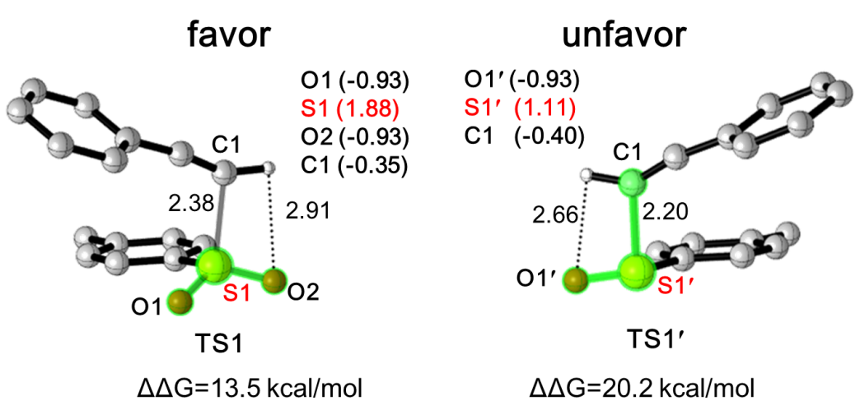
Figure S4. Optimized geometries and Gibbs energy barriers for radical addition transition state TS1 and TS1′. The values in parentheses are corresponding NPA charge of certain atoms.
We have performed the Natural Population Analysis (NPA) of the key transition states to study the electronic effect (Fig. S4). NPA charge shows that the charge on S1 in TS1 is 1.88 e whereas the charge on S1′ is 1.11 e in TS1′, confirming the relatively higher electrophilicity of sulfur S1 in the transition state TS1. NPA charge demonstrates that the strong electrophilicity of sulfur S1 in forming S-C bond of transition state TS1 might result in a lower energy barrier.

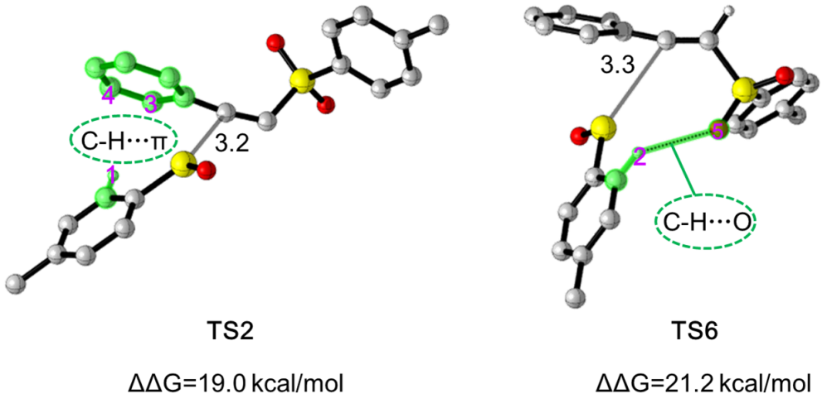
Figure S5. Optimized structures of transition state TS2 and TS6. The selected bond lengths are given in angstroms. Some hydrogen atoms are hidden for clarity.
Figure S5 shows the structures of two key transition states, TS2 and TS6. In TS2, we identified C−H…π interaction, where the π system comes from the benzene ring in the phenylacetylene and the C-H unit comes from the sulfinyl radical B. Meanwhile, in TS6, we identified one C−H…O interaction between the benzene ring and the sulfonyl radical A. These interactions stabilize transition states TS2 and TS6, and shorten the reaction site. However, in TS2, the C-S bond distance of the sulfinyl radical B to the alkenyl radical was 3.2 Å, which was 0.1 Å shorter than that in TS6. Therefore, the elecrostaction interaction in TS2 is stronger, resulting in lower energy barrier.
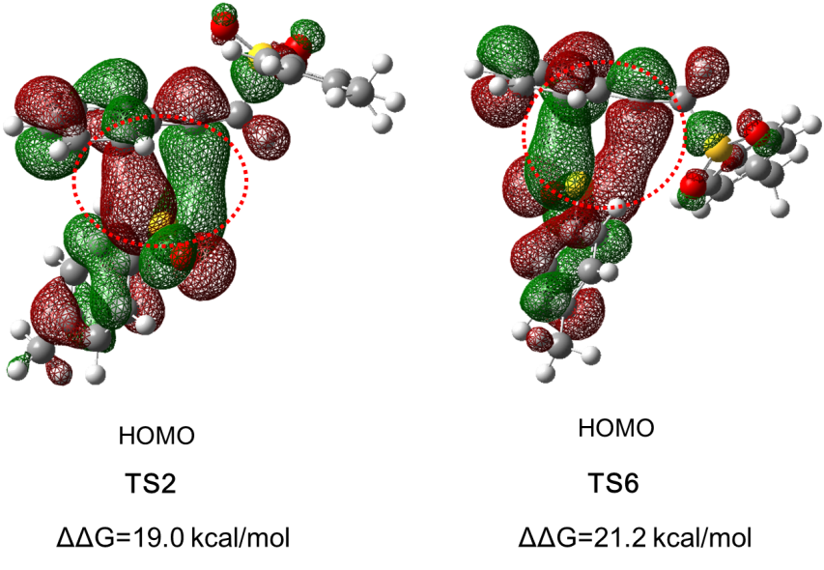
Figure S6. Diagrams of the HOMOs of TS2 and TS6. The values are calculated energy barriers (in kcal/mol).
This fact can be understood by analyzing the natures of the transition states involved in these different processes. Figure S6 compares the calculated patterns of the higest occupied molecular orbitals (HOMOs) of transition states TS2 and TS6. The bonding interaction between the S and C atom in the TS2 is larger than that of TS6, confirming the former expected to be the suitable transition state.

Cartesian coordinates of the SMD-B3LYP/6-31+G(d,p) computed structures

CP
Zero-point correction= 0.174365 (Hartree/Particle)
Thermal correction to Energy= 0.192197
Thermal correction to Enthalpy= 0.193141
Thermal correction to Gibbs Free Energy= 0.123577
Sum of electronic and zero-point Energies= -1595.278279
Sum of electronic and thermal Energies= -1595.260447
Sum of electronic and thermal Enthalpies= -1595.259502
Sum of electronic and thermal Free Energies= -1595.329066

C -3.99253800 0.74250600 -1.17025900
C -2.94151100 -0.17690700 -1.20709300
C -2.39867900 -0.65827100 -0.01202100
C -2.91764300 -0.23215100 1.21311900
C -3.96951800 0.68827300 1.23821900
C -4.52464400 1.18995600 0.05045200
H -4.40176700 1.12266400 -2.10365600
H -2.53240400 -0.50485200 -2.15810000
H -2.49087700 -0.60282700 2.14046600
H -4.36036000 1.02580300 2.19540500
C -5.68276800 2.15862400 0.08069700
H -5.73196000 2.69519200 1.03328500
H -5.60970500 2.89766000 -0.72426300
H -6.63746700 1.63218000 -0.04890000
S -1.07189500 -1.92786300 -0.05341500
O -0.24856300 -1.50683700 -1.30666700
O -0.22543200 -1.56345700 1.20208600
Na 1.44560500 -0.65702400 -0.04722500
C 4.89909300 2.46081500 -0.12857500
H 4.03737300 3.12734200 -0.19106100
H 5.51534700 2.70850100 0.74124000
H 5.52785300 2.56740500 -1.01915400
C 4.42861800 1.05067400 -0.02622900
O 3.29422700 0.65686100 -0.05357700
Cl 5.76284200 -0.15468500 0.14966200

TS3
Zero-point correction= 0.174095 (Hartree/Particle)
Thermal correction to Energy= 0.190963
Thermal correction to Enthalpy= 0.191908
Thermal correction to Gibbs Free Energy= 0.127260
Sum of electronic and zero-point Energies= -1595.262210
Sum of electronic and thermal Energies= -1595.245341
Sum of electronic and thermal Enthalpies= -1595.244397
Sum of electronic and thermal Free Energies= -1595.309044

C -3.71522300 -1.00528000 -0.08843400
C -2.38204600 -1.23041700 0.27247000
C -1.52070000 -0.14432500 0.41534600
C -1.98342400 1.16241600 0.22345700
C -3.31424600 1.37131300 -0.13350900
C -4.20324900 0.29260600 -0.29417400
H -4.38466700 -1.85359200 -0.20727600
H -2.01209200 -2.23760200 0.43682200
H -1.31245800 2.00949300 0.33543000
H -3.66991100 2.38686000 -0.29064500
C -5.64459100 0.53737600 -0.67048600
H -5.71993500 1.11139900 -1.60157200
H -6.18619900 -0.40282900 -0.80795600
H -6.16271400 1.11404400 0.10538000
S 0.19909800 -0.41091300 0.95926300
O 0.41035200 -1.92894800 0.79460800
O 0.97523500 0.28604600 -0.24999700
Na 1.81628200 -1.77891700 -0.99583200
C 2.85730800 1.58565400 1.32550700
H 2.78254100 0.66981800 1.90519700
H 3.84891700 2.02743800 1.46755000
H 2.08972300 2.30397200 1.63095400
C 2.69399500 1.35189500 -0.13134100
O 2.63837200 2.01357000 -1.09423700
Cl 4.03785400 -0.43994600 -0.49905600

Ⅰ
Zero-point correction= 0.173563 (Hartree/Particle)
Thermal correction to Energy= 0.187109
Thermal correction to Enthalpy= 0.188053
Thermal correction to Gibbs Free Energy= 0.131587
Sum of electronic and zero-point Energies= -972.686152
Sum of electronic and thermal Energies= -972.672607
Sum of electronic and thermal Enthalpies= -972.671663
Sum of electronic and thermal Free Energies= -972.728129

C -2.72655100 0.70581600 0.84513000
C -1.38771500 1.05651600 0.66438500
C -0.63432200 0.36275300 -0.28173100
C -1.19613500 -0.65547200 -1.06024900
C -2.53351600 -0.99149700 -0.86425600
C -3.31862600 -0.31885300 0.09003800
H -3.32050100 1.23846400 1.58272600
H -0.93474300 1.85526700 1.24303400
H -0.60270500 -1.18273100 -1.80278900
H -2.97746800 -1.78365800 -1.46152000
C -4.76497000 -0.69663100 0.28850600
H -5.31971300 -0.64240100 -0.65521900
H -4.85335900 -1.72620400 0.65569100
H -5.25508800 -0.03777800 1.01032900
S 1.07738800 0.82489900 -0.58051100
O 1.33816900 2.08547500 0.18237100
O 1.68811100 -0.52484500 0.39990900
C 3.97382500 -0.07213200 -0.44681100
H 3.98891400 0.96807200 -0.10557900
H 4.97220100 -0.49828200 -0.34602000
H 3.68713800 -0.07912000 -1.50402500
C 3.01493100 -0.88726300 0.37739800
O 3.32567100 -1.85180900 1.04235700

Int4
Zero-point correction= 0.298553 (Hartree/Particle)
Thermal correction to Energy= 0.324105
Thermal correction to Enthalpy= 0.325049
Thermal correction to Gibbs Free Energy= 0.236367
Sum of electronic and zero-point Energies= -1792.287089
Sum of electronic and thermal Energies= -1792.261537
Sum of electronic and thermal Enthalpies= -1792.260592
Sum of electronic and thermal Free Energies= -1792.349275

C 1.27289700 2.85861100 1.27522100
C 1.66666500 1.53002500 1.12514300
C 1.43299800 0.88835800 -0.09420600
C 0.79967200 1.54427100 -1.14836700
C 0.40921000 2.87356400 -0.97961600
C 0.64026900 3.55090300 0.22832800
H 1.44973200 3.36242300 2.22195200
H 2.13896800 1.00474400 1.95098300
H 0.61072700 1.01850400 -2.07902200
H -0.08550200 3.39110300 -1.79755000
C 0.18806600 4.97820000 0.41536200
H 0.91173500 5.55318800 1.00266000
H 0.04668100 5.48232800 -0.54543700
H -0.76822800 5.01581500 0.95286200
O 1.40495600 -1.31237200 -1.58292800
S 1.94089400 -0.83603600 -0.27188100
O 3.65495200 -0.29614800 -0.62880100
C 4.59381000 -1.26781300 -0.56365900
C 5.96584300 -0.72510900 -0.87375900
H 6.20643900 0.09984900 -0.19610300
H 6.70628900 -1.51989400 -0.77388000
H 5.98180800 -0.33049100 -1.89507900
O 4.34436600 -2.42942300 -0.29450600
S -0.98472000 -1.47195700 1.48398300
O -1.22729600 -2.97147200 1.72713500
O -1.15674300 -0.62352400 2.75605100
C -2.47469000 -0.98836700 0.49084900
C -3.19952900 0.16095300 0.80306900
C -2.83838500 -1.75308200 -0.62332600
C -4.29692200 0.53314900 0.01616900
H -2.91081100 0.74825100 1.67024600
C -3.93007200 -1.37456600 -1.40640200
H -2.27786300 -2.65098900 -0.86909600
C -4.67950300 -0.22473300 -1.09955800
H -4.86377000 1.42522600 0.27557300
H -4.20865700 -1.98145000 -2.26609000
C -5.86253600 0.17343600 -1.95228800
H -6.62945500 -0.61099300 -1.96275900
H -6.32950500 1.09137800 -1.58187700
H -5.56600200 0.34558700 -2.99438000

TS4
Zero-point correction= 0.298839 (Hartree/Particle)
Thermal correction to Energy= 0.323574
Thermal correction to Enthalpy= 0.324518
Thermal correction to Gibbs Free Energy= 0.239823
Sum of electronic and zero-point Energies= -1792.274638
Sum of electronic and thermal Energies= -1792.249903
Sum of electronic and thermal Enthalpies= -1792.248959
Sum of electronic and thermal Free Energies= -1792.333654

C 1.49067300 2.93929500 0.98877100
C 1.61289000 1.55659000 0.88808400
C 1.00637000 0.89607400 -0.18786900
C 0.30321400 1.60632800 -1.16207800
C 0.20201200 2.99502500 -1.05206300
C 0.78907300 3.68205100 0.02118800
H 1.96016600 3.45435400 1.82328400
H 2.18650100 1.00042500 1.62110400
H -0.14869300 1.07599300 -1.99433600
H -0.33916000 3.55163800 -1.81305800
C 0.69769600 5.18431600 0.13061900
H 0.02625600 5.60103900 -0.62584300
H 0.33173300 5.48993900 1.11771400
H 1.68316300 5.64779300 -0.00353200
O 0.46672400 -1.27244600 -1.60326900
S 1.16489800 -0.89438100 -0.32175700
O 3.74103300 -1.90172800 -1.48793500
C 4.40635900 -1.24693100 -0.63643200
C 5.85248800 -1.70965300 -0.38213700
H 6.43237000 -1.62724700 -1.30931600
H 6.33828600 -1.11649000 0.39748100
H 5.85744300 -2.76641300 -0.09041800
O 3.98483300 -0.24807100 0.02021000
S -0.60149200 -1.37527200 1.34637600
O -0.55435300 -2.86011500 1.50382600
O -0.45930700 -0.52378000 2.56548000
C -2.17667300 -0.96645700 0.56929900
C -2.78563100 0.26151800 0.84605500
C -2.73936400 -1.86225300 -0.34430700
C -3.98970600 0.57573400 0.21686200
H -2.33125500 0.94908600 1.55136000
C -3.94210000 -1.52691000 -0.96752600
H -2.25185500 -2.80754400 -0.55645300
C -4.58700200 -0.30964700 -0.69660300
H -4.47320200 1.52394500 0.43806300
H -4.38389900 -2.22247700 -1.67615400
C -5.90306700 0.03264400 -1.35084300
H -6.04263100 -0.52344400 -2.28258600
H -6.74327500 -0.21565900 -0.68940100
H -5.97126900 1.10227500 -1.57443700

1
Zero-point correction= 0.249747 (Hartree/Particle)
Thermal correction to Energy= 0.269048
Thermal correction to Enthalpy= 0.269992
Thermal correction to Gibbs Free Energy= 0.199270
Sum of electronic and zero-point Energies= -1563.702344
Sum of electronic and thermal Energies= -1563.683043
Sum of electronic and thermal Enthalpies= -1563.682099
Sum of electronic and thermal Free Energies= -1563.752821

C 4.20801000 -1.09185500 -0.55327800
C 2.88712600 -0.92875600 -0.97073600
C 2.22234500 0.26413700 -0.66252400
C 2.86281200 1.29281400 0.03732300
C 4.18406800 1.11262200 0.43662500
C 4.87592000 -0.07981300 0.15482300
H 4.72920100 -2.01550100 -0.78886400
H 2.39016900 -1.71899900 -1.52650200
H 2.33194700 2.21395600 0.25462500
H 4.68900700 1.90858400 0.97770100
C 6.29683200 -0.26628900 0.62247100
H 6.89138200 0.63866900 0.45882100
H 6.32308500 -0.48081700 1.69853900
H 6.78422800 -1.09800900 0.10611600
O 0.18646200 1.94605000 -1.11527700
S 0.53712400 0.47918100 -1.23646200
S -0.45117400 -0.53464800 0.66944500
O -0.11686100 -1.97497000 0.55680900
O -0.04709800 0.24135100 1.86461700
C -2.20506600 -0.31218800 0.40021700
C -2.83698100 0.82325400 0.91898600
C -2.89885600 -1.24773400 -0.37332600
C -4.19602500 1.00333500 0.67146400
H -2.28050600 1.54290500 1.50921500
C -4.25868400 -1.04586700 -0.60667000
H -2.39356600 -2.12115800 -0.77187900
C -4.92793100 0.07597800 -0.09028400
H -4.69635200 1.87884300 1.07650900
H -4.80795500 -1.77336700 -1.19779500
C -6.40374900 0.27343200 -0.32531900
H -6.76040500 -0.33160700 -1.16353800
H -6.97807600 -0.01700600 0.56373300
H -6.63631000 1.32311100 -0.53222800

A
Zero-point correction= 0.125274 (Hartree/Particle)
Thermal correction to Energy= 0.133987
Thermal correction to Enthalpy= 0.134931
Thermal correction to Gibbs Free Energy= 0.090057
Sum of electronic and zero-point Energies= -819.434372
Sum of electronic and thermal Energies= -819.425659
Sum of electronic and thermal Enthalpies= -819.424714
Sum of electronic and thermal Free Energies= -819.469589

S -2.14136700 -0.00175100 -0.22812000
O -2.63349300 1.26442300 0.27482100
O -2.62959800 -1.26760500 0.27958300
C -0.36650400 0.00099000 -0.09543600
C 0.30897800 -1.21134000 -0.07926500
C 0.30417700 1.21329800 -0.07689800
C 1.69109400 -1.19668200 -0.01807500
H -0.24649300 -2.13935000 -0.09552800
C 1.68894200 1.20331400 -0.01535200
H -0.25360300 2.13996000 -0.09167700
C 2.39909400 0.00545300 0.01459300
H 2.23347600 -2.13423600 0.00686000
H 2.22700800 2.14280700 0.01144700
C 3.89858900 -0.00254000 0.10206500
H 4.31406900 0.97770500 -0.12495400
H 4.21955600 -0.27979800 1.10823700
H 4.32637100 -0.72856900 -0.58948600

B
Zero-point correction= 0.122445 (Hartree/Particle)
Thermal correction to Energy= 0.131098
Thermal correction to Enthalpy= 0.132042
Thermal correction to Gibbs Free Energy= 0.086137
Sum of electronic and zero-point Energies= -744.196673
Sum of electronic and thermal Energies= -744.188020
Sum of electronic and thermal Enthalpies= -744.187076
Sum of electronic and thermal Free Energies= -744.232981

C -1.53511100 1.18440100 -0.00897600
C -0.16040300 1.33847600 -0.00274800
C 0.65617300 0.20953700 0.00013000
C 0.09928700 -1.06472300 -0.00490400
C -1.27814000 -1.19918300 -0.01136900
C -2.11569700 -0.08384300 -0.01088700
H -2.17164500 2.06114700 -0.01498600
H 0.27994200 2.32923800 -0.00361200
H 0.75433400 -1.92636500 -0.00728500
H -1.71640400 -2.19021200 -0.01927200
C -3.60929000 -0.24286800 0.01477300
H -3.91362700 -1.18222500 -0.44524000
H -3.97668800 -0.24348300 1.04355200
H -4.10208700 0.57479000 -0.51040200
O 3.02326200 -0.91065000 0.00477800
S 2.39494700 0.43822000 0.00393100

Int1
Zero-point correction= 0.235570 (Hartree/Particle)
Thermal correction to Energy= 0.253875
Thermal correction to Enthalpy= 0.254819
Thermal correction to Gibbs Free Energy= 0.182477
Sum of electronic and zero-point Energies= -1127.753204
Sum of electronic and thermal Energies= -1127.734899
Sum of electronic and thermal Enthalpies= -1127.733955
Sum of electronic and thermal Free Energies= -1127.806297

C -4.14226700 0.80403900 -0.79578000
C -3.65380700 -0.46152600 -0.47200900
C -2.40301600 -0.55363200 0.14325800
C -1.66096400 0.58087600 0.48646300
C -2.17204600 1.83303000 0.15270900
C -3.41438800 1.96673600 -0.49289600
H -5.10502000 0.88781500 -1.29207000
H -4.22296400 -1.35319900 -0.71143900
H -0.70074400 0.48904700 0.98208500
H -1.59541400 2.72100800 0.39697800
C -3.93738800 3.32949200 -0.86845200
H -3.75285300 4.05918300 -0.07334000
H -3.43306200 3.69874300 -1.77067800
H -5.01119400 3.30507400 -1.07432200
S -1.78337200 -2.18224700 0.62315200
O -2.41648200 -3.20702400 -0.26234900
O -0.29528600 -2.10429400 0.74223200
C 3.49093800 -1.09451000 -1.25856100
C 2.94045300 -0.56896800 -0.08949900
C 3.51279900 0.57099000 0.51037000
C 4.64348200 1.16828700 -0.08279700
C 5.18641700 0.63404700 -1.25125900
C 4.61335800 -0.49739200 -1.84205100
H 3.04185800 -1.97318600 -1.71261000
H 2.06989100 -1.03448700 0.36161300
H 5.08761900 2.04544500 0.37761400
H 6.05849100 1.10093300 -1.70028300
H 5.03926900 -0.91134300 -2.75164100
C 2.95537800 1.11427500 1.71313700
C 2.48668500 1.57391600 2.73416600
H 2.07840400 1.97349200 3.63780500

TS1
Zero-point correction= 0.235613 (Hartree/Particle)
Thermal correction to Energy= 0.252558
Thermal correction to Enthalpy= 0.253502
Thermal correction to Gibbs Free Energy= 0.187048
Sum of electronic and zero-point Energies= -1127.745594
Sum of electronic and thermal Energies= -1127.728649
Sum of electronic and thermal Enthalpies= -1127.727705
Sum of electronic and thermal Free Energies= -1127.794159

C -2.42326200 1.72763200 0.86139600
C -1.57338700 0.62411100 0.95557700
C -1.87160100 -0.52096900 0.21382600
C -2.98082000 -0.56861600 -0.63647700
C -3.81687300 0.54404400 -0.71443900
C -3.55325500 1.70809700 0.02871500
H -2.20277500 2.61674500 1.44611700
H -0.70643000 0.64931300 1.60737700
H -3.19667400 -1.46362200 -1.21040000
H -4.68909100 0.50795900 -1.36235100
C -4.48008800 2.89487600 -0.05482000
H -5.42914000 2.68365800 0.45389200
H -4.04073300 3.77970000 0.41412000
H -4.71987000 3.14006200 -1.09524600
S -0.74169400 -1.92952600 0.27664700
O -0.06925300 -1.90764600 1.60813100
O -1.50566600 -3.14464600 -0.14022500
C 4.81712000 0.38963100 0.70868400
C 3.85001800 -0.47906000 0.21305100
C 2.79966700 0.01832800 -0.59770900
C 2.75249900 1.40244600 -0.89836100
C 3.72825700 2.25742700 -0.39601100
C 4.76131800 1.75671400 0.40733000
H 5.61689400 0.00241800 1.33296500
H 3.88605200 -1.53843500 0.44547800
H 1.95074100 1.78469200 -1.52213100
H 3.68621600 3.31710400 -0.62998000
H 5.51986600 2.42939400 0.79676700
C 1.82291900 -0.85909700 -1.11431600
C 0.89360200 -1.61776600 -1.42817500
H 0.43472100 -2.28502000 -2.13582000

Ⅱ
Zero-point correction= 0.237528 (Hartree/Particle)
Thermal correction to Energy= 0.254310
Thermal correction to Enthalpy= 0.255254
Thermal correction to Gibbs Free Energy= 0.188731
Sum of electronic and zero-point Energies= -1127.757006
Sum of electronic and thermal Energies= -1127.740224
Sum of electronic and thermal Enthalpies= -1127.739280
Sum of electronic and thermal Free Energies= -1127.805803

C -2.99106100 1.62356200 0.69957900
C -1.89687200 0.76963400 0.83321400
C -1.91893000 -0.46642400 0.18080700
C -3.00957900 -0.85157400 -0.60390000
C -4.09328300 0.01824100 -0.72714200
C -4.10508200 1.26353300 -0.07769400
H -2.98112200 2.58178400 1.21211200
H -1.04561700 1.05267700 1.44343600
H -3.01793600 -1.81726300 -1.09839500
H -4.94589600 -0.27890600 -1.33196200
C -5.30048400 2.17670400 -0.18408900
H -6.02597600 1.95392900 0.60895200
H -5.01305500 3.22720800 -0.07882700
H -5.81535800 2.05225300 -1.14165600
S -0.50437700 -1.56212400 0.32646000
O 0.20419600 -1.24356600 1.58379600
O -0.96872500 -2.94545000 0.07006300
C 5.21106000 0.04409400 0.18049800
C 4.04801200 -0.61501800 -0.18821900
C 2.87108600 0.13260700 -0.51148400
C 2.92995800 1.56129600 -0.44848700
C 4.10662900 2.19391400 -0.07641600
C 5.25307700 1.44668400 0.23968600
H 6.09644400 -0.53495400 0.42713900
H 4.01365400 -1.69872200 -0.23168600
H 2.04382500 2.13805900 -0.69323100
H 4.13717800 3.27875800 -0.02866600
H 6.16929700 1.95217100 0.52932600
C 1.71367300 -0.50854400 -0.90360900
C 0.58332400 -1.11448400 -1.08545700
H 0.16164300 -1.44624000 -2.03450100

Int2
Zero-point correction= 0.359376 (Hartree/Particle)
Thermal correction to Energy= 0.387111
Thermal correction to Enthalpy= 0.388055
Thermal correction to Gibbs Free Energy= 0.291455
Sum of electronic and zero-point Energies= -1872.008959
Sum of electronic and thermal Energies= -1871.981223
Sum of electronic and thermal Enthalpies= -1871.980279
Sum of electronic and thermal Free Energies= -1872.076879

C 4.55655400 -2.24131200 1.47495100
C 4.18951100 -1.20675700 0.61564900
C 3.39261300 -1.49949700 -0.49529000
C 2.95943700 -2.80272300 -0.75175400
C 3.33815400 -3.82438100 0.11999200
C 4.13834500 -3.56297900 1.24374400
H 5.17812600 -2.01845700 2.33822900
H 4.52307800 -0.19085400 0.80019200
H 2.34594500 -3.01603700 -1.62068700
H 3.00592000 -4.84007400 -0.07722900
C 4.56145200 -4.67939700 2.16587100
H 5.52015400 -5.10608200 1.84395200
H 4.69113600 -4.32277800 3.19233000
H 3.82738400 -5.49080200 2.17203200
S 2.87643900 -0.16672600 -1.58280500
O 3.90570100 0.89433300 -1.54469200
O 2.48441800 -0.76201300 -2.88171700
C 1.18934100 5.37240900 -0.12519000
C 1.10446600 4.08953600 -0.64490300
C 1.39651600 2.95812500 0.18213600
C 1.76940400 3.18733900 1.54547200
C 1.84686400 4.48126100 2.03825100
C 1.55855800 5.58132700 1.21387400
H 0.96851600 6.22238300 -0.76458300
H 0.82194600 3.92703900 -1.67993100
H 1.99090700 2.33689300 2.18212900
H 2.13467800 4.64134000 3.07347500
H 1.62233200 6.59021200 1.60994800
C 1.29377400 1.67478700 -0.31269100
C 1.34001600 0.48113300 -0.81312800
H 0.52179200 -0.23992900 -0.85779100
C -6.04157400 -2.06148300 0.01287100
C -4.71423900 -1.65006100 -0.05256100
C -4.41539100 -0.28191800 0.03929000
C -5.44294300 0.66195700 0.19751700
C -6.76660500 0.22903100 0.26040400
C -7.09063200 -1.13442700 0.16820700
H -6.27349800 -3.12131300 -0.05916300
H -3.91140300 -2.37032800 -0.17472500
H -5.21579700 1.72301400 0.26989900
H -7.56027200 0.96133000 0.38106700
C -8.52202900 -1.60299100 0.22873000
H -8.67070900 -2.31395600 1.05021200
H -9.21067200 -0.76637900 0.37579900
H -8.80724100 -2.11802700 -0.69662400
S -2.74867900 0.32250200 -0.04327400
O -1.81462200 -0.88150600 -0.22482900

TS2
Zero-point correction= 0.360514 (Hartree/Particle)
Thermal correction to Energy= 0.386762
Thermal correction to Enthalpy= 0.387707
Thermal correction to Gibbs Free Energy= 0.299404
Sum of electronic and zero-point Energies= -1871.986315
Sum of electronic and thermal Energies= -1871.960066
Sum of electronic and thermal Enthalpies= -1871.959122
Sum of electronic and thermal Free Energies= -1872.047425

C 5.01063100 -1.01666100 1.48330600
C 4.22661900 0.01343000 0.96411300
C 4.10217900 0.13378400 -0.42249100
C 4.74107200 -0.75833000 -1.28942000
C 5.51894800 -1.78147200 -0.74965700
C 5.66819200 -1.92725100 0.64015100
H 5.11487800 -1.11241000 2.56063300
H 3.72965000 0.71604400 1.62471700
H 4.64198700 -0.64734200 -2.36402800
H 6.02145100 -2.47476100 -1.41896200
C 6.53686300 -3.02111600 1.20815700
H 6.31514100 -3.20018800 2.26404000
H 6.40245500 -3.96090900 0.66270800
H 7.59801400 -2.75114600 1.13271100
S 3.07190100 1.43376000 -1.10228100
O 2.99152000 2.53567400 -0.12264600
O 3.51860200 1.70452000 -2.48702400
C -2.13617700 3.28477200 0.90720700
C -1.20803300 2.77882300 0.03019600
C -0.45382800 1.59823200 0.37987700
C -0.73246900 0.95042000 1.64141200
C -1.67092500 1.51226500 2.51585900
C -2.37629200 2.65369100 2.15697200
H -2.68981300 4.18195300 0.64621700
H -1.01421600 3.25817500 -0.92364200
H -0.10339400 0.12985700 1.96405400
H -1.84588800 1.03937700 3.47743900
H -3.10620700 3.07798500 2.83958900
C 0.42671000 1.04975700 -0.49946600
C 1.40637500 0.66841600 -1.25543900
H 1.37470500 -0.07841200 -2.04646800
C -5.69342200 -2.21139200 -0.35176400
C -4.32567700 -2.30419400 -0.11473400
C -3.53325200 -1.14550600 -0.16416000
C -4.12477400 0.09843700 -0.44394400
C -5.49709300 0.17033500 -0.68269100
C -6.30580000 -0.97696100 -0.64138900
H -6.30200500 -3.11192400 -0.31342500
H -3.85905600 -3.25893000 0.10649800
H -3.52362300 1.00288300 -0.47418100
H -5.94833900 1.13539400 -0.89865700
C -7.78866300 -0.90082300 -0.90405400
H -8.05407000 -1.43790000 -1.82330200
H -8.36006300 -1.36035500 -0.08904300
H -8.12382300 0.13461800 -1.01237500
S -1.77803600 -1.23724100 0.12775100
O -1.47471300 -2.69497600 0.51338100

2
Zero-point correction= 0.363955 (Hartree/Particle)
Thermal correction to Energy= 0.389847
Thermal correction to Enthalpy= 0.390791
Thermal correction to Gibbs Free Energy= 0.303152
Sum of electronic and zero-point Energies= -1872.052378
Sum of electronic and thermal Energies= -1872.026487
Sum of electronic and thermal Enthalpies= -1872.025543
Sum of electronic and thermal Free Energies= -1872.113182

C 3.77300200 1.37646800 -1.67253600
C 3.00498900 0.25752700 -1.34635600
C 3.09237700 -0.27036100 -0.05642800
C 3.93471000 0.29994300 0.90462700
C 4.69230500 1.41698300 0.55952400
C 4.62481700 1.97325600 -0.73019100
H 3.71312500 1.78664500 -2.67686900
H 2.35993200 -0.20550800 -2.08541900
H 4.00552500 -0.12810000 1.89913200
H 5.35148100 1.86124600 1.30082400
C 5.46642800 3.17158100 -1.08957200
H 6.52966500 2.90379600 -1.12498900
H 5.18990600 3.57587200 -2.06709900
H 5.36056000 3.96825100 -0.34490100
S 2.09894800 -1.69921200 0.37988400
O 1.70522600 -2.39337600 -0.86018800
O 2.81143700 -2.44672100 1.43998200
C -2.61890800 -3.56896900 -1.20923300
C -1.96777200 -2.96396400 -0.13176600
C -1.26442500 -1.76178600 -0.31739200
C -1.24720900 -1.16058900 -1.58677800
C -1.90362400 -1.76726500 -2.65788900
C -2.58908200 -2.97243800 -2.47283700
H -3.14651600 -4.50647000 -1.05934500
H -1.98425900 -3.43565600 0.84653600
H -0.71910300 -0.22341600 -1.73052300
H -1.87978500 -1.29811800 -3.63728600
H -3.09656400 -3.44398400 -3.30953600
C -0.61025600 -1.10648000 0.83518400
C 0.66775700 -0.98180100 1.19007100
H 0.93674900 -0.46044900 2.10841900
C -2.27867200 3.15357700 0.11405700
C -1.72600800 2.12014300 0.86623800
C -2.46799500 0.95171200 1.06406800
C -3.75453500 0.82034100 0.54244200
C -4.29234200 1.86600500 -0.21543600
C -3.56664500 3.04309800 -0.44374600
H -1.70477700 4.06389300 -0.04185400
H -0.73697000 2.22107000 1.30304000
H -4.33611400 -0.08035000 0.71844900
H -5.29394900 1.76413500 -0.62443000
C -4.14065000 4.17089000 -1.26575200
H -4.10775100 5.11853000 -0.71608900
H -3.56642000 4.31328800 -2.18954100
H -5.18009300 3.97479600 -1.54314900
S -1.80105600 -0.39044700 2.09434700
O -0.94547500 0.24732700 3.18334700

Int1′
Zero-point correction= 0.230862 (Hartree/Particle)
Thermal correction to Energy= 0.248465
Thermal correction to Enthalpy= 0.249410
Thermal correction to Gibbs Free Energy= 0.177295
Sum of electronic and zero-point Energies= -1052.570765
Sum of electronic and thermal Energies= -1052.553162
Sum of electronic and thermal Enthalpies= -1052.552218
Sum of electronic and thermal Free Energies= -1052.624333

C 3.17266200 -0.96223500 -1.06859800
C 2.19497400 -0.00561100 -0.81485900
C 2.42450200 0.96383600 0.17357900
C 3.62734100 0.97024900 0.89774200
C 4.59484400 0.00332400 0.62758000
C 4.38819500 -0.97655900 -0.35732900
H 2.99497700 -1.71332400 -1.83438000
H 1.26169100 -0.00035700 -1.36878000
H 3.80923100 1.71975500 1.66428400
H 5.52541200 0.01116400 1.18852100
C 5.43635900 -2.01810300 -0.65673300
H 5.76608800 -1.95575900 -1.70082200
H 6.31506400 -1.89690000 -0.01717200
H 5.04273100 -3.03038200 -0.50551000
S 1.22786800 2.22129300 0.54671700
O 0.02591700 2.02142100 -0.38461300
C -4.02581900 1.18794300 -0.62825600
C -3.03550100 0.30854500 -0.18934800
C -3.38706000 -0.97990800 0.26174100
C -4.74326700 -1.36479300 0.26302000
C -5.72465300 -0.47726600 -0.17794900
C -5.36991500 0.80030500 -0.62467500
H -3.74430200 2.17902200 -0.97239200
H -1.99398800 0.61584100 -0.19296600
H -5.01651200 -2.35655900 0.60998700
H -6.76694500 -0.78332400 -0.17245500
H -6.13654500 1.48955700 -0.96736000
C -2.37878800 -1.89077300 0.71632800
C -1.52908000 -2.66629800 1.10328500
H -0.77888700 -3.34673400 1.44531500

TS1′
Zero-point correction= 0.230916 (Hartree/Particle)
Thermal correction to Energy= 0.246905
Thermal correction to Enthalpy= 0.247849
Thermal correction to Gibbs Free Energy= 0.183742
Sum of electronic and zero-point Energies= -1052.547367
Sum of electronic and thermal Energies= -1052.531378
Sum of electronic and thermal Enthalpies= -1052.530434
Sum of electronic and thermal Free Energies= -1052.594542

C -4.02796200 0.07171700 0.55258600
C -3.06099400 -0.91471200 0.34519200
C -1.89857300 -0.59395100 -0.35900400
C -1.70367900 0.69951100 -0.86300100
C -2.67844300 1.67141800 -0.64576500
C -3.85560600 1.37681000 0.06628700
H -4.93158500 -0.17820900 1.10286200
H -3.20353100 -1.92458700 0.71752200
H -0.80328800 0.94834500 -1.41964400
H -2.52636800 2.67446100 -1.03704700
C -4.91202300 2.43387500 0.27609700
H -5.63873600 2.12608600 1.03348300
H -4.46834100 3.38387900 0.59359200
H -5.46238700 2.62905400 -0.65320100
S -0.63536900 -1.84414000 -0.65076400
O -1.23168200 -3.18259700 -0.21552700
C 3.99572100 2.10689700 -0.01601400
C 2.84795700 1.43938600 0.39716600
C 2.83542200 0.02057200 0.47729300
C 4.01569700 -0.69440300 0.13705600
C 5.15455200 -0.00972800 -0.27262900
C 5.15271600 1.38987900 -0.35197100
H 3.99275600 3.19153300 -0.07556800
H 1.95288400 1.99311100 0.66280800
H 4.01582600 -1.77797700 0.20115200
H 6.05021300 -0.56727000 -0.53137700
H 6.04634400 1.91790000 -0.67140800
C 1.68863500 -0.66308000 0.91183600
C 0.60910000 -1.28690100 1.07031100
H 0.02045700 -1.73305100 1.86063600

Ⅱ′
Zero-point correction= 0.232007 (Hartree/Particle)
Thermal correction to Energy= 0.248169
Thermal correction to Enthalpy= 0.249113
Thermal correction to Gibbs Free Energy= 0.184565
Sum of electronic and zero-point Energies= -1052.550151
Sum of electronic and thermal Energies= -1052.533989
Sum of electronic and thermal Enthalpies= -1052.533045
Sum of electronic and thermal Free Energies= -1052.597593

C -4.04285500 -0.04140100 0.59909100
C -3.00238800 -0.95167000 0.39897900
C -1.87828800 -0.54982300 -0.32243400
C -1.79352400 0.73654000 -0.86290500
C -2.84129800 1.63395300 -0.65268500
C -3.98066400 1.26219600 0.08111600
H -4.91770600 -0.34996600 1.16606500
H -3.06040900 -1.96311100 0.78991300
H -0.92353500 1.04143800 -1.43950400
H -2.77494500 2.63585700 -1.06934800
C -5.12283600 2.22872300 0.27639900
H -4.76802200 3.26299700 0.32526900
H -5.83473100 2.16759800 -0.55707800
H -5.67756400 2.01173200 1.19451300
S -0.51333200 -1.71857600 -0.60584900
O -1.04907800 -3.10977300 -0.26943600
C 4.05369900 2.10722900 -0.00042200
C 2.86993800 1.46311900 0.32881400
C 2.82418400 0.03508400 0.41206300
C 4.02546800 -0.69871600 0.15484900
C 5.19618300 -0.02977400 -0.17238700
C 5.22327100 1.37199900 -0.25325600
H 4.07212300 3.19179700 -0.06139300
H 1.96753100 2.03202400 0.52927200
H 4.00581400 -1.78200100 0.21887300
H 6.09973600 -0.60050900 -0.36778900
H 6.14538500 1.88572400 -0.50774200
C 1.65559000 -0.61515200 0.76711300
C 0.51927300 -1.21994500 0.88293000
H 0.03773300 -1.55236000 1.80441800

Int2′
Zero-point correction= 0.359233 (Hartree/Particle)
Thermal correction to Energy= 0.387015
Thermal correction to Enthalpy= 0.387959
Thermal correction to Gibbs Free Energy= 0.290953
Sum of electronic and zero-point Energies= -1872.009890
Sum of electronic and thermal Energies= -1871.982108
Sum of electronic and thermal Enthalpies= -1871.981164
Sum of electronic and thermal Free Energies= -1872.078171

C -3.47101200 -1.87116900 1.40410600
C -2.63639500 -1.09040600 0.60487900
C -3.12091700 -0.61256700 -0.61593500
C -4.42147500 -0.89964500 -1.04063700
C -5.24032100 -1.68211600 -0.22674600
C -4.78191700 -2.17999600 1.00437300
H -3.09599700 -2.24892000 2.35149300
H -1.62322900 -0.86584200 0.92122400
H -4.78138000 -0.52929300 -1.99469800
H -6.25031100 -1.91171100 -0.55603100
C -5.66858600 -3.04871000 1.86084200
H -5.63774500 -4.09039200 1.51649300
H -5.34936600 -3.03803300 2.90704600
H -6.71231400 -2.72191500 1.81414300
S -2.07119100 0.42523000 -1.63641500
O -0.66047800 0.07028400 -1.37158900
O -2.59170600 0.37902600 -3.02272200
C 1.80774300 4.60145600 -0.11920600
C 0.67827700 4.04587900 -0.70110500
C -0.28047800 3.35617000 0.10727500
C -0.04809700 3.26576800 1.51633700
C 1.09014100 3.83096400 2.07167000
C 2.02441800 4.50058700 1.26477100
H 2.53119400 5.11676900 -0.74455600
H 0.51039200 4.12053700 -1.77052700
H -0.77085100 2.74916400 2.13950700
H 1.25838800 3.75090300 3.14181200
H 2.91247500 4.93855200 1.71016100
C -1.41843400 2.81686000 -0.45887200
C -2.36162100 2.13528300 -1.02852900
H -3.37522500 2.47135000 -1.24756700
C 5.04578200 -2.39171500 -0.27949600
C 4.29998800 -2.07757500 0.85243800
C 3.05325800 -1.45155000 0.69975500
C 2.56109000 -1.14238100 -0.57890200
C 3.32563300 -1.46604100 -1.69909400
C 4.57523200 -2.09465000 -1.57326500
H 6.01174100 -2.87685800 -0.16144200
H 4.66963800 -2.30964200 1.84630900
H 1.59487600 -0.65971300 -0.70570400
H 2.94294700 -1.22553800 -2.68722900
C 5.39094800 -2.45892800 -2.78796000
H 5.42663800 -3.54727300 -2.92409000
H 4.96886000 -2.02282800 -3.69773400
H 6.42644900 -2.11325400 -2.69128100
S 2.04609800 -1.02203500 2.09688400
O 2.79277900 -1.44309700 3.36993400

TS6
Zero-point correction= 0.360469 (Hartree/Particle)
Thermal correction to Energy= 0.386605
Thermal correction to Enthalpy= 0.387549
Thermal correction to Gibbs Free Energy= 0.300801
Sum of electronic and zero-point Energies= -1871.982670
Sum of electronic and thermal Energies= -1871.956533
Sum of electronic and thermal Enthalpies= -1871.955589
Sum of electronic and thermal Free Energies= -1872.042338

C 3.62443300 -1.28086200 -1.90730700
C 2.64207900 -1.15438500 -0.92784000
C 3.02761800 -1.13523100 0.41720300
C 4.37021000 -1.23338100 0.78827000
C 5.33875000 -1.35919800 -0.20978000
C 4.98534600 -1.38425000 -1.56746700
H 3.32856500 -1.30311400 -2.95296800
H 1.59490600 -1.08527100 -1.20241700
H 4.65438100 -1.22598700 1.83521200
H 6.38415600 -1.44341500 0.07445100
C 6.03247700 -1.53049500 -2.64306900
H 5.94709900 -0.73285000 -3.38984400
H 7.04236700 -1.49939600 -2.22505800
H 5.91634600 -2.48237700 -3.17543700
S 1.77433700 -0.95072300 1.68706200
O 0.50267900 -1.48485400 1.16475200
O 2.32127000 -1.46754600 2.96225000
C -1.80127600 4.10258400 0.49252500
C -1.13507000 3.04220400 1.11054800
C 0.21367200 2.71609800 0.71368400
C 0.81320900 3.46573500 -0.36353800
C 0.11466500 4.48544000 -0.96419200
C -1.19998300 4.80908400 -0.54510700
H -2.80531000 4.35948100 0.81673100
H -1.57388300 2.52809600 1.95750800
H 1.81761500 3.20912400 -0.68320200
H 0.57356700 5.04709200 -1.77245500
H -1.73368500 5.61997700 -1.03116800
C 0.88299300 1.67534700 1.28492800
C 1.63311000 0.86490200 1.96030700
H 2.28465200 1.15677200 2.78676300
C -4.85276600 -1.72630200 -1.46852700
C -3.82400900 -0.78866300 -1.53875000
C -3.05675900 -0.51702200 -0.39635700
C -3.32773200 -1.18991800 0.81032700
C -4.36172400 -2.11909900 0.86272300
C -5.14161600 -2.40749000 -0.27327300
H -5.44084100 -1.93759000 -2.35815100
H -3.60456800 -0.26700100 -2.46520400
H -2.72809100 -0.99608500 1.69616400
H -4.56182800 -2.64053200 1.79547300
C -6.26837300 -3.40658100 -0.19806200
H -6.59167200 -3.72101000 -1.19468900
H -5.97334300 -4.29905600 0.36462200
H -7.13974300 -2.97710800 0.31357500
S -1.72910700 0.66419300 -0.42627300
O -1.62018400 1.16535600 -1.87525300

2-1
Zero-point correction= 0.364172 (Hartree/Particle)
Thermal correction to Energy= 0.389846
Thermal correction to Enthalpy= 0.390790
Thermal correction to Gibbs Free Energy= 0.304454
Sum of electronic and zero-point Energies= -1872.048601
Sum of electronic and thermal Energies= -1872.022927
Sum of electronic and thermal Enthalpies= -1872.021983
Sum of electronic and thermal Free Energies= -1872.108320

C 4.76014100 -0.60197900 -1.39160900
C 3.49819000 -0.95239600 -0.91756900
C 3.19609100 -0.72570900 0.42966700
C 4.13235600 -0.15840300 1.29760400
C 5.38976300 0.18834200 0.80108600
C 5.72392700 -0.02541300 -0.54505600
H 5.00371200 -0.78437500 -2.43502200
H 2.76755600 -1.40809100 -1.57740200
H 3.89122500 -0.00363400 2.34407400
H 6.12298000 0.62473500 1.47353000
C 7.08418500 0.34584700 -1.07934600
H 7.72995000 0.74118400 -0.29044800
H 7.58221100 -0.52369300 -1.52369000
H 7.00384700 1.10669800 -1.86493700
S 1.57493300 -1.15830900 1.05927600
O 0.97666400 -2.17364000 0.16614300
O 1.70202200 -1.44149200 2.50553900
C -2.52497100 3.34698200 1.66667300
C -1.82894800 2.15821700 1.44325700
C -1.06545200 1.98985700 0.27265000
C -1.01373600 3.03145400 -0.67088600
C -1.71042800 4.21941300 -0.43773000
C -2.46655200 4.38092500 0.72704500
H -3.11156300 3.46363200 2.57347400
H -1.87984700 1.35144800 2.16838900
H -0.42554700 2.91252200 -1.57216900
H -1.65790600 5.02093600 -1.16907800
H -3.00702000 5.30697100 0.90210400
C -0.31288700 0.72589100 0.08544500
C 0.63172700 0.36508900 0.96563200
H 0.89511900 1.02122900 1.79230600
C -4.73305100 -0.90838100 -0.89206800
C -3.50479900 -0.38452700 -1.30766200
C -2.32880200 -0.94480100 -0.81448600
C -2.35840800 -2.03418900 0.06285900
C -3.59274100 -2.53848600 0.47012200
C -4.79876600 -1.98605600 0.00238100
H -5.65218400 -0.47147400 -1.27392000
H -3.45624200 0.44333900 -2.00808300
H -1.43616200 -2.47935100 0.42302600
H -3.61919900 -3.38216600 1.15549900
C -6.12504200 -2.53733400 0.46663700
H -6.95816700 -2.08507000 -0.07888300
H -6.17607900 -3.62318600 0.32756900
H -6.27785000 -2.34181900 1.53528100
S -0.73147800 -0.30205300 -1.42994000
O -1.07179700 0.70887000 -2.51904100

Int4′
Zero-point correction= 0.298717 (Hartree/Particle)
Thermal correction to Energy= 0.323022
Thermal correction to Enthalpy= 0.323966
Thermal correction to Gibbs Free Energy= 0.240813
Sum of electronic and zero-point Energies= -1792.286901
Sum of electronic and thermal Energies= -1792.262596
Sum of electronic and thermal Enthalpies= -1792.261652
Sum of electronic and thermal Free Energies= -1792.344805

C 0.10597600 2.49993900 -0.69424100
C -0.72880700 1.39152300 -0.82840100
C -1.27501600 0.80939600 0.31708700
C -0.99095700 1.30914900 1.58500800
C -0.15197200 2.41929600 1.70355000
C 0.40994100 3.02947200 0.57158800
H 0.53704700 2.95387300 -1.58317900
H -0.94088000 0.98364400 -1.81302300
H -1.41100500 0.82778200 2.46247900
H 0.07590400 2.81155300 2.69164400
C 1.35011400 4.20220700 0.70837300
H 1.21604900 4.92169100 -0.10635100
H 1.20095600 4.72628900 1.65749300
H 2.39485600 3.86658500 0.67805200
O -2.65587500 -1.11391700 1.51301200
S -2.34234600 -0.64425600 0.13218200
O -3.75786300 0.50154300 -0.29159400
C -4.84333000 -0.09811100 -0.80690800
C -5.91972200 0.90309600 -1.15556700
H -5.53420700 1.63087600 -1.87697900
H -6.78342800 0.38577800 -1.57605000
H -6.21872500 1.45406100 -0.25802600
O -4.94592700 -1.30459500 -0.97110300
S 1.08304700 -2.75003600 0.24701500
O -0.16563200 -2.08430100 -0.38941200
O 1.04807800 -2.72149800 1.78214200
C 2.42159100 -1.51962800 -0.13278400
C 3.24898500 -1.03582300 0.87917400
C 2.66296200 -1.14522300 -1.45960100
C 4.30304100 -0.16717000 0.56938200
H 3.05279400 -1.33481000 1.90537500
C 3.71750100 -0.28228900 -1.76337900
H 2.02115200 -1.51739600 -2.25478200
C 4.55822200 0.22012900 -0.75359000
H 4.93748400 0.21152100 1.36845600
H 3.89336400 0.00679700 -2.79810600
C 5.71092800 1.13623600 -1.09598900
H 5.37714700 1.99888800 -1.68507000
H 6.20047900 1.51521100 -0.19332600
H 6.47079300 0.61526400 -1.69233200

TS4′
Zero-point correction= 0.297303 (Hartree/Particle)
Thermal correction to Energy= 0.322310
Thermal correction to Enthalpy= 0.323254
Thermal correction to Gibbs Free Energy= 0.237399
Sum of electronic and zero-point Energies= -1792.283211
Sum of electronic and thermal Energies= -1792.258204
Sum of electronic and thermal Enthalpies= -1792.257260
Sum of electronic and thermal Free Energies= -1792.343115

C -0.34659700 2.43394200 0.38092500
C 0.40564200 1.27928900 0.59015900
C 0.99872900 0.64446800 -0.50420700
C 0.84905900 1.14889200 -1.79447000
C 0.08949900 2.30312700 -1.98928000
C -0.52076200 2.96195900 -0.90982100
H -0.80476000 2.93276300 1.23128700
H 0.53491300 0.88806600 1.59557700
H 1.32026800 0.64163700 -2.63027300
H -0.03127200 2.69742500 -2.99525800
C -1.36604000 4.19281700 -1.13071500
H -1.25220400 4.91007400 -0.31096200
H -1.10273200 4.69621200 -2.06609500
H -2.43042800 3.92951900 -1.18653100
O 2.64127200 -1.16737200 -1.50765100
S 2.01195900 -0.82071400 -0.20319400
O 3.54665700 0.65267000 0.58788600
C 4.50560600 0.07329600 1.24325300
C 5.57787000 1.03636900 1.75110200
H 5.13210700 1.96244400 2.12542000
H 6.17458200 0.56272400 2.53427700
H 6.23936500 1.29955400 0.91699600
O 4.60818600 -1.14718500 1.45119900
S -1.03674000 -2.56217200 -0.92078200
O 0.34800500 -2.30675900 -0.19643900
O -1.08310200 -2.01252900 -2.34042400
C -2.17522700 -1.45198000 0.00723700
C -3.04720700 -0.61005000 -0.68003300
C -2.24637400 -1.54724100 1.40159700
C -3.97535500 0.15867900 0.03158100
H -2.98368100 -0.54957800 -1.76246000
C -3.17749700 -0.77978200 2.10211800
H -1.56876900 -2.20562800 1.93898900
C -4.05902200 0.08534100 1.42911600
H -4.64495300 0.82355200 -0.50974500
H -3.22203100 -0.85115700 3.18696700
C -5.07950500 0.89292300 2.19668900
H -4.61868800 1.42767800 3.03534100
H -5.56958900 1.63055400 1.55391100
H -5.86069700 0.24743900 2.61809900

Ⅲ
Zero-point correction= 0.248920 (Hartree/Particle)
Thermal correction to Energy= 0.268183
Thermal correction to Enthalpy= 0.269128
Thermal correction to Gibbs Free Energy= 0.197842
Sum of electronic and zero-point Energies= -1563.707546
Sum of electronic and thermal Energies= -1563.688283
Sum of electronic and thermal Enthalpies= -1563.687338
Sum of electronic and thermal Free Energies= -1563.758624

C 3.29619200 1.61691600 1.05977600
C 2.52925100 0.46009300 1.21026400
C 2.44749500 -0.44067700 0.14620300
C 3.13582800 -0.21805100 -1.04842800
C 3.89459100 0.94300100 -1.18114300
C 3.98651000 1.87811000 -0.13432900
H 3.36285800 2.32275600 1.88320700
H 2.00525200 0.27175400 2.14402000
H 3.07591000 -0.94412200 -1.85307900
H 4.42863100 1.12562000 -2.11024200
C 4.80490300 3.13386600 -0.30223700
H 5.82357700 2.90168200 -0.63253300
H 4.36124400 3.78977100 -1.06136700
H 4.86978900 3.69734600 0.63271000
O 1.86719300 -2.87689300 -0.74592100
S 1.48319800 -1.94926100 0.36453200
S -1.46391500 -1.86665400 0.57776500
O -0.01087100 -1.16349200 -0.08685100
O -1.95650500 -2.92068000 -0.36457000
C -2.42728000 -0.37656600 0.24664600
C -2.32892900 0.70144400 1.13041500
C -3.30280800 -0.34713100 -0.83969900
C -3.10648500 1.83642300 0.90039400
H -1.65694500 0.66537400 1.98386800
C -4.07082400 0.79680800 -1.05494500
H -3.37958100 -1.20677800 -1.49799300
C -3.98484400 1.90422300 -0.19380200
H -3.03528100 2.67835900 1.58375500
H -4.75332500 0.82757800 -1.90034300
C -4.80265800 3.14459700 -0.45315200
H -4.92884200 3.73885400 0.45660200
H -4.31158900 3.78232200 -1.19949500
H -5.79442000 2.89429900 -0.84290900

TS5′
Zero-point correction= 0.247366 (Hartree/Particle)
Thermal correction to Energy= 0.266570
Thermal correction to Enthalpy= 0.267514
Thermal correction to Gibbs Free Energy= 0.196085
Sum of electronic and zero-point Energies= -1563.658840
Sum of electronic and thermal Energies= -1563.639637
Sum of electronic and thermal Enthalpies= -1563.638692
Sum of electronic and thermal Free Energies= -1563.710121

C 4.03140100 0.51593600 -0.67591200
C 3.26995400 -0.58350000 -0.32574700
C 2.16136800 -0.39679100 0.52655200
C 1.81979300 0.88387300 1.01353400
C 2.59997600 1.97193100 0.64754500
C 3.71177000 1.81080200 -0.20035600
H 4.88758400 0.38842800 -1.33212700
H 3.50655400 -1.57533300 -0.69657800
H 0.96099500 1.01969600 1.66565600
H 2.34926700 2.96080200 1.01862900
C 4.55259900 2.98713600 -0.60373700
H 5.60414300 2.82114700 -0.34062500
H 4.51905400 3.12984000 -1.69101800
H 4.21498100 3.90913400 -0.12471800
S 1.18198300 -1.71741000 1.08104700
O 1.82783500 -3.00640300 0.70696700
C -2.43398900 1.91693000 -0.81964000
C -1.77063000 0.69361600 -0.96328800
C -2.16502800 -0.39233000 -0.18312000
C -3.20397700 -0.26305200 0.74388500
C -3.85279200 0.96389300 0.88131800
C -3.48058800 2.07355900 0.10097000
H -2.13295700 2.76114100 -1.43552100
H -0.96069800 0.57645500 -1.67659800
H -3.51213200 -1.11122100 1.35055300
H -4.66298500 1.06162000 1.60021400
C -4.19364900 3.39494800 0.25921700
H -3.78910800 4.15103900 -0.41990600
H -5.26521500 3.29349000 0.04959700
H -4.10165500 3.77600100 1.28336900
S -1.35400900 -2.02839500 -0.36511800
O -2.36183600 -2.87473500 -1.12000600
O -0.10883400 -1.70524400 -1.22610100

TS5′′
Zero-point correction= 0.245852 (Hartree/Particle)
Thermal correction to Energy= 0.265375
Thermal correction to Enthalpy= 0.266320
Thermal correction to Gibbs Free Energy= 0.193728
Sum of electronic and zero-point Energies= -1563.624272
Sum of electronic and thermal Energies= -1563.604749
Sum of electronic and thermal Enthalpies= -1563.603805
Sum of electronic and thermal Free Energies= -1563.676397

C -3.56596600 -1.22805700 0.52794000
C -2.38253800 -0.71445100 -0.00140100
C -2.26426800 0.67130400 -0.16625100
C -3.30291000 1.53833400 0.20533500
C -4.47335200 0.99827700 0.73001300
C -4.62899900 -0.38955500 0.90000600
H -3.66018100 -2.30300400 0.65565900
H -1.57371900 -1.38327700 -0.27480500
H -3.19505700 2.61018500 0.08086600
H -5.28193400 1.66710400 1.01362200
C -5.91275500 -0.95639300 1.44912600
H -6.69417400 -0.96312400 0.67813100
H -5.77970700 -1.98504400 1.79590400
H -6.28818400 -0.35542800 2.28407600
O -0.93078300 2.89730000 -0.89536000
S -0.75331400 1.37619500 -0.82928100
S 1.19661900 -1.51115800 -1.46019800
O 0.06281600 0.06897300 -1.70339100
O 0.45036700 -2.51519900 -0.61244400
C 2.43898000 -0.76045500 -0.40900700
C 3.36139200 0.11812100 -0.98918300
C 2.50860400 -1.08214200 0.95081200
C 4.35255400 0.68700700 -0.18947100
H 3.30718900 0.36533200 -2.04626700
C 3.50548500 -0.50328100 1.73322200
H 1.79312700 -1.77628700 1.38025600
C 4.44199200 0.38883100 1.18008200
H 5.06726300 1.37289400 -0.63587400
H 3.56043800 -0.74872600 2.79097300
C 5.51982000 0.99770800 2.04181100
H 6.19299400 0.22571500 2.43404400
H 6.12311900 1.71668000 1.48059800
H 5.08851400 1.51633000 2.90584400

TS3′
Zero-point correction= 0.174779 (Hartree/Particle)
Thermal correction to Energy= 0.191277
Thermal correction to Enthalpy= 0.192221
Thermal correction to Gibbs Free Energy= 0.128621
Sum of electronic and zero-point Energies= -1595.250096
Sum of electronic and thermal Energies= -1595.233598
Sum of electronic and thermal Enthalpies= -1595.232653
Sum of electronic and thermal Free Energies= -1595.296254

C 3.21926400 0.13396900 1.07995700
C 1.87126900 -0.15387700 1.30909100
C 1.04656600 -0.46956900 0.22771000
C 1.55365500 -0.49031500 -1.07539900
C 2.90131600 -0.20278600 -1.28631700
C 3.75521600 0.11718500 -0.21610500
H 3.86249100 0.37131800 1.92338800
H 1.47252300 -0.15050900 2.31837200
H 0.90617000 -0.73980400 -1.90893800
H 3.29793100 -0.22697900 -2.29848700
C 5.21269400 0.41919300 -0.46486100
H 5.73838100 -0.46673600 -0.84174700
H 5.33147700 1.20832100 -1.21623800
H 5.71599200 0.74400700 0.45029500
S -0.71145000 -0.78628800 0.53470300
O -1.14480800 -1.70515600 -0.60597800
O -0.79571900 -1.38931700 1.91040400
Na -3.19207100 -1.46230100 -1.37966700
C -2.10276300 1.62900300 1.67038900
H -2.40926300 0.95483700 2.47490800
H -1.08654900 1.98255400 1.84494100
H -2.78268600 2.48830000 1.64743400
C -2.23664900 0.90275300 0.35754900
O -3.24734100 0.31169000 -0.01501300
Cl -1.37476100 1.96762000 -1.04119000

I′
Zero-point correction= 0.174071 (Hartree/Particle)
Thermal correction to Energy= 0.187443
Thermal correction to Enthalpy= 0.188388
Thermal correction to Gibbs Free Energy= 0.132980
Sum of electronic and zero-point Energies= -972.654318
Sum of electronic and thermal Energies= -972.640946
Sum of electronic and thermal Enthalpies= -972.640001
Sum of electronic and thermal Free Energies= -972.695409

C 2.35147300 1.22659200 0.08494200
C 0.98659800 1.19744200 0.37582000
C 0.32237000 -0.03179300 0.37276000
C 0.99593900 -1.22295400 0.07536000
C 2.35648300 -1.17025200 -0.21648400
C 3.05629600 0.05005000 -0.21378000
H 2.87604600 2.17794100 0.09635400
H 0.45227000 2.11031600 0.61725400
H 0.46851900 -2.17095100 0.08453700
H 2.88700200 -2.09160300 -0.44199500
C 4.53413200 0.08183000 -0.51006700
H 5.10149900 -0.40373900 0.29346000
H 4.76442700 -0.45594400 -1.43647600
H 4.90105300 1.10715600 -0.60776600
S -1.43192300 -0.08803000 0.73466900
O -1.74536000 -1.39290500 1.35669600
O -1.81829800 1.17704500 1.40585600
C -2.73324600 1.23041500 -1.50394600
H -3.43489100 1.66791200 -0.78595500
H -1.88047800 1.91445200 -1.57777200
H -3.20750400 1.11211000 -2.48026400
C -2.27962800 -0.10300200 -1.01270200
O -2.38130200 -1.17278100 -1.54098800

IX. Characterization data of the products
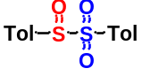p-Toluenesulfinyl p-tolyl sulfone (1): White Solid; ¹H-NMR (500 MHz, CDCl₃) δ 7.52 (d, J = 8.5 Hz, 2H), 7.48 (d, J = 8.0 Hz, 2H), 7.32–7.28 (m, 4H), 2.46 (s, 3H), 2.44 (s, 3H); ¹³C-NMR (125 MHz, CDCl₃) δ 146.9, 144. 6, 134.8, 130.3, 129.9, 129.81, 129.77, 125.8, 21.9, 21.8; HRMS (ESI) m/z calculated C₁₄H₁₄NaO₃S₂ [M+Na]⁺ 317.0277, found 317.0258.

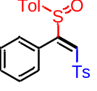(E)-1-Methyl-4-((2-phenyl-2-(p-tolylsulfinyl)vinyl)sulfonyl)benzene (2) White Solid; mp: 167-168 °C; ¹H-NMR (600 MHz, CDCl₃) δ 7.55 (d, J = 7.8 Hz, 2H), 7.35 (t, J = 7.8 Hz, 1H), 7.33 (s, 1H), 7.24 (t, J = 7.8 Hz, 2H), 7.21 (d, J = 8.4 Hz, 2H), 7.12 – 7.08 (m, 4H), 6.91 (d, J = 7.2 Hz, 2H), 2.40 (s, 3H), 2.33 (s, 3H); ¹³C-NMR (150 MHz, CDCl₃) δ 160.7, 144.8, 142.8, 137.5, 136.9, 130.1, 129.9, 129.7, 129.5, 129.3, 128.2, 128.1, 127.9, 125.5, 21.6, 21.5; HRMS (ESI) m/z calculated C₂₂H₂₀NaO₃S₂ [M+Na]⁺ 419.0746, found 419.0751.

(E)-1-Methyl-4-((2-(p-tolylsulfinyl)oct-1-en-1-yl)sulfonyl)benzene (3): White Solid; mp: 108-109 °C; ¹H-NMR (600 MHz, CDCl₃) δ 7.82 (d, J = 8.4 Hz, 2H), 7.48 (d, J = 8.4 Hz, 2H), 7.37 (d, J = 8.4 Hz, 2H), 7.30 (d, J = 7.8 Hz, 2H), 7.13 (s, 1H), 2.99 – 2.93 (m, 1H), 2.47 (s, 3H), 2.42 (s, 3H), 2.05 – 1.98 (m, 1H), 1.56 – 1.49 (m, 1H), 1.28 – 1.17 (m, 7H), 0.86 (t, J = 7.2 Hz, 3H); ¹³C-NMR (150 MHz, CDCl₃) δ 162.2, 145.0, 143.5, 137.9, 137.7, 130.4, 130.0, 127.7, 127.5, 126.5, 31.2, 29.3, 29.2, 26.7, 22.4, 21.7, 21.6, 14.0; HRMS (ESI) m/z calculated C₂₂H₂₈NaO₃S₂ [M+Na]⁺ 427.1372, found 427.1385.

(E)-1-Methyl-4-((5-methyl-1-tosylhex-1-en-2-yl)sulfinyl)benzene (4): White Solid; mp: 104-105 °C; ¹H-NMR (600 MHz, CDCl₃) δ 7.82 (d, J = 8.4 Hz, 2H), 7.48 (d, J = 8.4 Hz, 2H), 7.37 (d, J = 8.4 Hz, 2H), 7.30 (d, J = 8.4 Hz, 2H), 7.12 (s, 1H), 2.98 – 2.91 (m, 1H), 2.47 (s, 3H), 2.42 (s, 3H), 2.05 – 1.98 (m, 1H), 1.55 – 1.47 (m, 1H), 1.45 – 1.38 (m, 1H), 1.16 – 1.07 (m, 1H), 0.86 – 0.82 (m, 6H); ¹³C-NMR (150 MHz, CDCl₃) δ 162.5, 145.0, 143.5, 137.9, 137.7, 130.4, 130.0, 127.6, 127.4, 126.5, 38.1, 28.3, 24.8, 22.04, 22.01, 21.7, 21.5; HRMS (ESI) m/z calculated C₂₁H₂₆NaO₃S₂ [M+Na]⁺ 413.1216, found 413.1214.

(E)-1-((3-Cyclohexyl-1-tosylprop-1-en-2-yl)sulfinyl)-4-methylbenzene (5): White Solid; mp: 130-131 °C; ¹H-NMR (600 MHz, CDCl₃) δ 7.81 (d, J = 8.4 Hz, 2H), 7.43 (d, J = 8.4 Hz, 2H), 7.37 (d, J = 8.4 Hz, 2H), 7.28 (d, J = 8.4 Hz, 2H), 7.21 (s, 1H), 3.25 (dd, J = 14.4, 7.8 Hz, 1H), 2.47 (s, 3H), 2.41 (s, 3H), 1.74 – 1.63 (m, 6H), 1.62 – 1.56 (m, 1H), 1.24 – 1.10 (m, 3H), 1.02 – 0.93 (m, 2H); ¹³C-NMR (150 MHz, CDCl₃) δ 161.2, 144.9, 143.4, 137.9, 130.4, 130.0, 127.9, 127.7, 126.4, 37.9, 33.8, 33.5, 32.7, 26.1, 26.0, 21.6, 21.5; HRMS (ESI) m/z calculated C₂₃H₂₈NaO₃S₂ [M+Na]⁺ 439.1372, found 439.1381.

(E)-1-Methyl-4-((3-phenyl-1-tosylprop-1-en-2-yl)sulfinyl)benzene (6): White Solid; mp: 142-143 °C; ¹H-NMR (400 MHz, CDCl₃) δ 7.73 (d, J = 8.4 Hz, 2H), 7.42 (d, J = 8.4 Hz, 2H), 7.35 – 7.31 (m, 3H), 7.30 – 7.22 (m, 5H), 7.11 – 7.07 (m, 2H), 4.83 (d, J = 16.0 Hz, 1H), 3.12 (d, J = 16.0 Hz, 1H), 2.46 (s, 3H), 2.41 (s, 3H); ¹³C-NMR (150 MHz, CDCl₃) δ 160.4, 145.2, 143.6, 137.5, 137.4, 135.2, 130.4, 130.0, 128.9, 128.74, 128.72, 127.8, 127.1, 126.7, 31.8, 21.7, 21.6; HRMS (ESI) m/z calculated C₂₃H₂₂NaO₃S₂ [M+Na]⁺ 433.0903, found 433.0913.

(E)-1-Methyl-4-((4-phenyl-1-tosylbut-1-en-2-yl)sulfinyl)benzene (7): White Solid; mp: 125-126 °C; ¹H-NMR (400 MHz, DMSO) δ 7.84 (d, J = 8.4 Hz, 2H), 7.57 (d, J = 8.0 Hz, 2H), 7.50 (d, J = 8.0 Hz, 2H), 7.41 (d, J = 8.0 Hz, 2H), 7.29 (t, J = 7.2 Hz, 2H), 7.21 (t, J = 7.2 Hz, 1H), 7.15 (s, 1H), 7.10 (d, J = 7.2 Hz, 2H), 3.01 – 2.92 (m, 1H), 2.75 – 2.67 (m, 1H), 2.46 – 2.27 (m, 8H); ¹³C-NMR (150 MHz, DMSO) δ 162.5, 145.7, 143.6, 140.2, 138.0, 137.7, 130.9, 130.8, 129.0, 128.6, 128.1, 127.8, 126.9, 126.5, 35.2, 28.3, 21.6, 21.5; HRMS (ESI) m/z calculated C₂₄H₂₄NaO₃S₂ [M+Na]⁺ 447.1059, found 447.1055.

(E)-1-((2-cyclopropyl-2-(p-tolylsulfinyl)vinyl)sulfonyl)-4-methylbenzene (8): White Solid; mp: 101-102 °C; ¹H-NMR (600 MHz, CDCl₃) δ 7.85 (d, J = 8.4 Hz, 2H), 7.51 (d, J = 7.8 Hz, 2H), 7.37 (d, J = 7.8 Hz, 2H), 7.31 – 7.27 (m, 3H), 2.46 (s, 3H), 2.41 (s, 3H), 1.99 – 1.94 (m, 1H), 1.11 – 1.07 (m, 1H), 0.83 – 0.78 (m, 2H), 0.73 – 0.69 (m, 1H); ¹³C-NMR (150 MHz, CDCl₃) δ 161.9, 145.0, 143.4, 138.4, 138.1, 130.5, 130.4, 130.0, 127.7, 126.7, 21.7, 21.6, 9.3, 8.7, 5.9; HRMS (ESI) m/z calculated C₁₉H₂₀NaO₃S₂ [M+Na]⁺ 383.0746, found 383.0755.

(E)-1-((2-Cyclopentyl-2-(p-tolylsulfinyl)vinyl)sulfonyl)-4-methylbenzene (9): White Solid; mp: 117-118 °C; ¹H-NMR (600 MHz, CDCl₃) δ 7.85 (d, J = 8.4 Hz, 2H), 7.50 (d, J = 8.4 Hz, 2H), 7.38 (d, J = 8.4 Hz, 2H), 7.29 (d, J = 8.4 Hz, 2H), 7.23 (s, 1H), 3.53 – 3.45 (m, 1H), 2.47 (s, 3H), 2.41 (s, 3H), 1.78 – 1.73 (m, 2H), 1.70 – 1.64 (m, 1H), 1.63 – 1.58 (m, 1H), 1.56 – 1.50 (m, 2H), 1.48 – 1.43 (m, 1H), 1.24 – 1.16 (m, 1H); ¹³C-NMR (150 MHz, CDCl₃) δ 163.8, 144.9, 143.5, 138.8, 138.0, 130.4, 130.0, 128.2, 127.7, 127.3, 39.3, 32.0, 31.9, 25.5, 25.1, 21.7, 21.6; HRMS (ESI) m/z calculated C₂₁H₂₄NaO₃S₂ [M+Na]⁺ 411.1059, found 411.1067.

(E)-1-((2-Cyclohexyl-2-(p-tolylsulfinyl)vinyl)sulfonyl)-4-methylbenzene (10): White Solid; mp: 138-139 °C; ¹H-NMR (600 MHz, CDCl₃) δ 7.85 (d, J = 8.4 Hz, 2H), 7.51 (d, J = 8.4 Hz, 2H), 7.38 (d, J = 7.8 Hz, 2H), 7.29 (d, J = 7.8 Hz, 2H), 7.17 (s, 1H), 3.20 (tt, J = 12.6, 3.2 Hz, 1H), 2.46 (s, 3H), 2.42 (s, 3H), 1.73 – 1.70 (m, J = 13.8 Hz, 1H), 1.66 – 1.58 (m, 3H), 1.51 – 1.48 (m, 1H), 1.41 – 1.38 (m, 1H), 1.24 – 1.13 (m, 2H), 1.07 – 0.93 (m, 2H); ¹³C-NMR (150 MHz, CDCl₃) δ 165.0, 144.9, 143.6, 138.6, 138.0, 130.3, 130.0, 127.7, 127.6, 127.3, 39.0, 31.3, 30.6, 26.3, 26.2, 25.2, 21.63, 21.57; HRMS (ESI) m/z calculated C₂₂H₂₆NaO₃S₂ [M+Na]⁺ 425.1216, found 425.1224.

(E)-1-((5-Chloro-1-tosylpent-1-en-2-yl)sulfinyl)-4-methylbenzene (11) White Solid; mp: 122-123 °C; ¹H-NMR (600 MHz, CDCl₃) δ 7.81 (d, J = 8.4 Hz, 2H), 7.50 (d, J = 8.4 Hz, 2H), 7.38 (d, J = 8.4 Hz, 2H), 7.31 (d, J = 8.4 Hz, 2H), 7.17 (s, 1H), 3.56 – 3.46 (m, 2H), 2.98 – 2.91 (m, 1H), 2.47 (s, 3H), 2.42 (s, 3H), 2.39 – 2.33 (m, 1H), 2.06 – 1.97 (m, 1H), 1.70 – 1.62 (m, 1H); ¹³C-NMR (150 MHz, CDCl₃) δ 160.5, 145.3, 143.7, 137.5, 137.2, 130.5, 130.1, 128.6, 127.7, 126.5, 44.3, 32.0, 24.2, 21.7, 21.6; HRMS (ESI) m/z calculated C₁₉H₂₁ClNaO₃S₂ [M+Na]⁺ 419.0513, found 419.0521.

(E)-4-(p-tolylsulfinyl)-5-tosylpent-4-enoic acid (12) White Solid; mp: 90-91 °C; ¹H-NMR (600 MHz, CDCl₃) δ 7.82 (d, J = 8.4 Hz, 2H), 7.70 (br., 1H), 7.50 (d, J = 7.8 Hz, 2H), 7.38 (d, J = 7.8 Hz, 2H), 7.31 (d, J = 7.8 Hz, 2H), 7.19 (s, 1H), 3.03 – 2.97 (m, 1H), 2.67 – 2.60 (m, 1H), 2.58 – 2.53 (m, 1H), 2.47 (s, 3H), 2.41 (s, 3H), 2.24 – 2.16 (m, 1H); ¹³C-NMR (150 MHz, CDCl₃) δ 176.3, 159.3, 145.4, 144.0, 137.2, 136.7, 130.6, 130.2, 129.3, 127.7, 126.5, 32.9, 21.7, 21.6, 21.5; HRMS (ESI) m/z calculated C₁₉H₂₀NaO₅S₂ [M+Na]⁺ 415.0644, found 415.0648.

(E)-4-(p-tolylsulfinyl)-5-tosylpent-4-enamide (13) White Solid; mp: 189-190 °C; ¹H-NMR (600 MHz, DMSO) δ 7.86 (d, J = 8.4 Hz, 2H), 7.54 – 7.49 (m, 4H), 7.39 (d, J = 7.8 Hz, 2H), 7.35 (s, 1H), 7.11 (s, 1H), 6.87 (s, 1H), 2.98 – 2.90 (m, 1H), 2.44 (s, 3H), 2.37 (s, 3H), 2.36 – 2.30 (m, 1H), 2.29 – 2.23 (m, 1H), 2.12 – 2.06 (m, 1H); ¹³C-NMR (150 MHz, DMSO) δ 172.4, 163.3, 145.7, 143.5, 138.2, 137.7, 130.9, 130.8, 127.9, 127.8, 126.4, 34.4, 21.9, 21.6, 21.5; HRMS (ESI) m/z calculated C₁₉H₂₂NO₄S₂ [M+H]⁺ 392.0985, found 392.0974.

(E)-1-Methyl-4-((2-(p-tolyl)-2-(p-tolylsulfinyl)vinyl)sulfonyl)benzene (14) White Solid; mp: 166-167 °C; ¹H-NMR (600 MHz, CDCl₃) δ 7.57 (d, J = 8.0 Hz, 2H), 7.28 (s, 1H), 7.22 (d, J = 8.0 Hz, 2H), 7.13 – 7.10 (m, 4H), 7.07 (d, J = 7.8 Hz, 2H), 6.85 (d, J = 7.8 Hz, 2H), 2.40 (s, 3H), 2.34 (s, 3H), 2.33 (s, 3H); ¹³C-NMR (150 MHz, CDCl₃) δ 160.6, 144.7, 142.6, 140.4, 137.6, 137.1, 129.8, 129.7, 129.1, 128.9, 128.8, 127.9, 125.4, 125.1, 21.6, 21.44, 21.41; HRMS (ESI) m/z calculated C₂₃H₂₂NaO₃S₂ [M+Na]⁺ 433.0903, found 433.0912.

(E)-1-(tert-Butyl)-4-(1-(p-tolylsulfinyl)-2-tosylvinyl)benzene (15) White Solid; mp: 157-158 °C; ¹H-NMR (600 MHz, CDCl₃) δ 7.52 (d, J = 7.8 Hz, 2H), 7.32 (s, 1H), 7.24 (d, J = 7.8 Hz, 2H), 7.17 (d, J = 8.4 Hz, 2H), 7.11 – 7.06 (m, 4H), 6.84 (d, J = 8.4 Hz, 2H), 2.39 (s, 3H), 2.33 (s, 3H), 1.30 (s, 9H); ¹³C-NMR (150 MHz, CDCl₃) δ 160.8, 153.5, 144.5, 142.5, 137.5, 137.2, 129.7, 129.5, 129.3, 129.0, 127.9, 125.3, 125.1, 125.0, 34.8, 31.2, 21.6, 21.4; HRMS (ESI) m/z calculated C₂₆H₂₈NaO₃S₂ [M+Na]⁺ 475.1372, found 475.1381.

(E)-4-(1-(p-Tolylsulfinyl)-2-tosylvinyl)-1,1'-biphenyl (16) White Solid; mp: 162-163 °C; ¹H-NMR (600 MHz, CDCl₃) δ 7.61 – 7.57 (m, 4H), 7.49 (d, J = 7.8 Hz, 2H), 7.46 (t, J = 7.8 Hz, 2H), 7.38 (t, J = 7.2 Hz, 1H), 7.35 (s, 1H), 7.22 (d, J = 7.8 Hz, 2H), 7.15 (d, J = 7.8 Hz, 2H), 7.12 (d, J = 8.4 Hz, 2H), 7.01 (d, J = 8.4 Hz, 2H), 2.40 (s, 3H), 2.34 (s, 3H); ¹³C-NMR (150 MHz, CDCl₃) δ 160.3, 144.8, 142.7, 139.7, 137.5, 137.0, 129.9, 129.7, 129.5, 128.9, 128.0, 127.9, 127.03, 127.01, 126.6, 125.5, 21.6, 21.4; HRMS (ESI) m/z calculated C₂₈H₂₄NaO₃S₂ [M+Na]⁺ 495.1059, found 495.1047.

(E)-1-Methoxy-4-(1-(p-tolylsulfinyl)-2-tosylvinyl)benzene (17) White Solid; mp: 150-151 °C; ¹H-NMR (600 MHz, CDCl₃) δ 7.58 (d, J = 8.4 Hz, 2H), 7.27 (s, 1H), 7.23 (d, J = 8.4 Hz, 2H), 7.12 (s, 4H), 6.93 (d, J = 8.4 Hz, 2H), 6.79 (d, J = 8.4 Hz, 2H), 3.81 (s, 3H), 2.41 (s, 3H), 2.33 (s, 3H); ¹³C-NMR (150 MHz, CDCl₃) δ 161.2, 160.5, 144.8, 142.6, 137.7, 137.4, 130.9, 129.9, 129.7, 128.7, 127.9, 125.4, 120.2, 113.7, 55.3, 21.7, 21.5; HRMS (ESI) m/z calculated C₂₃H₂₂NaO₄S₂ [M+Na]⁺ 449.0852, found 449.0853.

(E)-1-Fluoro-4-(1-(p-tolylsulfinyl)-2-tosylvinyl)benzene (18) White Solid; mp: 148-149 °C; ¹H-NMR (600 MHz, CDCl₃) δ 7.57 (d, J = 8.4 Hz, 2H), 7.34 (s, 1H), 7.24 (d, J = 7.8 Hz, 2H), 7.15 – 7.10 (m, 4H), 6.95 (t, J = 8.4 Hz, 2H), 6.93 – 6.89 (m, 2H), 2.41 (s, 3H), 2.34 (s, 3H); ¹³C-NMR (150 MHz, CDCl₃) δ 163.6 (d, J = 251.5 Hz), 159.5, 145.0, 142.9, 137.3, 136.7, 131.2 (d, J = 9.0 Hz), 129.88, 129.87, 129.7, 127.8, 125.4, 124.1 (d, J = 3.2 Hz), 115.4 (d, J = 21.0 Hz), 21.5, 21.4; HRMS (ESI) m/z calculated C₂₂H₁₉FNaO₃S₂ [M+Na]⁺ 437.0652, found 437.0637.

(E)-1-Chloro-4-(1-(p-tolylsulfinyl)-2-tosylvinyl)benzene (19) White Solid; mp: 185-186 °C; ¹H-NMR (600 MHz, CDCl₃) δ 7.58 (d, J = 8.4 Hz, 2H), 7.33 (s, 1H), 7.26 (d, J = 8.4 Hz, 2H), 7.24 – 7.22 (m, 2H), 7.16 – 7.12 (m, 4H), 6.86 (d, J = 8.4 Hz, 2H), 2.42 (s, 3H), 2.35 (s, 3H); ¹³C-NMR (150 MHz, CDCl₃) δ 159.4, 145.1, 143.1, 137.3, 136.7, 136.5, 130.5, 130.1, 130.0, 129.9, 128.5, 127.9, 126.7, 125.5, 21.7, 21.5; HRMS (ESI) m/z calculated C₂₂H₁₉ClNaO₃S₂ [M+Na]⁺ 453.0356, found 453.0339.

(E)-1-Bromo-4-(1-(p-tolylsulfinyl)-2-tosylvinyl)benzene (20) White Solid; mp: 189-190 °C; ¹H-NMR (600 MHz, CDCl₃) δ 7.58 (d, J = 8.4 Hz, 2H), 7.39 (d, J = 8.4 Hz, 2H), 7.33 (s, 1H), 7.26 (d, J = 8.4 Hz, 2H), 7.17 – 7.12 (m, 4H), 6.79 (d, J = 8.4 Hz, 2H), 2.43 (s, 3H), 2.36 (s, 3H); ¹³C-NMR (150 MHz, CDCl₃) δ 159.3, 145.1, 143.1, 137.2, 136.6, 131.4, 130.7, 130.0, 129.8, 127.9, 127.2, 125.5, 124.8, 21.7, 21.5; HRMS (ESI) m/z calculated C₂₂H₁₉BrNaO₃S₂ [M+Na]⁺ 496.9851, found 496.9841.

(E)-1-Methyl-4-((2-(p-tolylsulfinyl)-2-(4-(trifluoromethyl)phenyl)vinyl)sulfo nyl)benzene (21) White Solid; mp: 174-175 °C; ¹H-NMR (600 MHz, CDCl₃) δ 7.56 (d, J = 8.4 Hz, 2H), 7.49 (d, J = 8.4 Hz, 2H), 7.38 (s, 1H), 7.24 (d, J = 8.4 Hz, 2H), 7.16 (d, J = 8.4 Hz, 2H), 7.13 (d, J = 8.4 Hz, 2H), 7.00 (d, J = 8.4 Hz, 2H), 2.42 (s, 3H), 2.36 (s, 3H); ¹³C-NMR (125 MHz, CDCl₃) δ 158.8, 145.2, 143.3, 136.9, 136.2, 132.0, 131.8 (q, J = 34.5 Hz), 130.7, 130.1, 129.9, 129.6, 127.9, 125.5, 124.9 (q, J = 3.0 Hz), 123.5 (q, J = 271.5 Hz), 21.6, 21.5; HRMS (ESI) m/z calculated C₂₃H₁₉F₃NaO₃S₂ [M+Na]⁺ 487.0620, found 487.0628.

(E)-1-(4-(1-(p-Tolylsulfinyl)-2-tosylvinyl)phenyl)ethanone (22) White Solid; mp: 145-146 °C; ¹H-NMR (600 MHz, CDCl₃) δ 7.84 (d, J = 8.4 Hz, 2H), 7.60 (d, J = 8.4 Hz, 2H), 7.34 (s, 1H), 7.27 (d, J = 8.4 Hz, 2H), 7.15 – 7.11 (m, 4H), 7.04 (d, J = 8.4 Hz, 2H), 2.60 (s, 3H), 2.43 (s, 3H), 2.35 (s, 3H); ¹³C-NMR (125 MHz, CDCl₃) δ 197.2, 159.4, 145.2, 143.2, 137.8, 137.2, 136.4, 133.0, 130.1, 130.0, 129.9, 129.5, 127.9, 127.8, 125.5, 26.6, 21.6, 21.5; HRMS (ESI) m/z calculated C₂₄H₂₂NaO₄S₂ [M+Na]⁺ 461.0852, found 461.0863.

(E)-1-Methyl-4-((2-(4-nitrophenyl)-2-(p-tolylsulfinyl)vinyl)sulfonyl)benzene (23) White Solid; mp: 180-181 °C; ¹H-NMR (600 MHz, CDCl₃) δ 8.11 (d, J = 8.4 Hz, 2H), 7.61 (d, J = 8.4 Hz, 2H), 7.38 (s, 1H), 7.30 (d, J = 7.8 Hz, 2H), 7.19 – 7.13 (m, 4H), 7.09 (d, J = 8.4 Hz, 2H), 2.44 (s, 3H), 2.36 (s, 3H); ¹³C-NMR (150 MHz, CDCl₃) δ 158.1, 148.4, 145.5, 143.6, 136.8, 136.0, 135.0, 131.0, 130.18, 130.16, 130.0, 127.9, 125.5, 123.1, 21.6, 21.5; HRMS (ESI) m/z calculated C₂₂H₁₉NNaO₅S₂ [M+Na]⁺ 464.0597, found 464.0586.

(E)-1-Methyl-3-(1-(p-tolylsulfinyl)-2-tosylvinyl)benzene (24) White Solid; mp: 157-158 °C; ¹H-NMR (600 MHz, CDCl₃) δ 7.54 (d, J = 8.4 Hz, 2H), 7.31 (s, 1H), 7.20 (d, J = 8.4 Hz, 2H), 7.15 – 7.08 (m, 6H), 6.68 (d, J = 7.2 Hz, 1H), 6.64 (s, 1H), 2.39 (s, 3H), 2.33 (s, 3H), 2.23 (s, 3H); ¹³C-NMR (150 MHz, CDCl₃) δ 160.8, 144.6, 142.6, 137.7, 137.5, 136.9, 130.7, 129.7, 129.5, 129.4, 129.3, 127.93, 127.86, 126.4, 125.4, 21.5, 21.4, 21.1; HRMS (ESI) m/z calculated C₂₃H₂₂NaO₃S₂ [M+Na]⁺ 433.0903, found 433.0898.

(E)-1-Methoxy-3-(1-(p-tolylsulfinyl)-2-tosylvinyl)benzene (25) White Solid; mp: 153-154 °C; ¹H-NMR (600 MHz, CDCl₃) δ 7.56 (d, J = 7.8 Hz, 2H), 7.32 (s, 1H), 7.22 (d, J = 7.8 Hz, 2H), 7.15 (t, J = 7.8 Hz, 1H), 7.13 – 7.11 (m, 4H), 6.88 (dd, J = 8.4, 2.4 Hz, 1H), 6.50 (d, J = 7.2 Hz, 1H), 6.37 – 6.35 (m, 1H), 3.66 (s, 3H), 2.40 (s, 3H), 2.34 (s, 3H); ¹³C-NMR (150 MHz, CDCl₃) δ 160.4, 158.9, 144.8, 142.7, 137.4, 137.0, 129.8, 129.63, 129.59, 129.3, 129.1, 127.9, 125.5, 121.5, 116.3, 114.2, 55.2, 21.6, 21.4; HRMS (ESI) m/z calculated C₂₃H₂₂NaO₄S₂ [M+Na]⁺ 449.0852, found 449.0851.

(E)-1-Fluoro-3-(1-(p-tolylsulfinyl)-2-tosylvinyl)benzene (26) White Solid; mp: 166-167 °C; ¹H NMR (600 MHz, CDCl₃) δ 7.59 (d, J = 8.4 Hz, 2H), 7.34 (s, 1H), 7.26 (d, J = 7.8 Hz, 2H), 7.23 (dd, J = 7.8, 5.4 Hz, 1H), 7.16 – 7.12 (m, 4H), 7.07 – 7.03 (m, 1H), 6.73 – 6.70 (m, 1H), 6.61 – 6.57 (m, 1H), 2.42 (s, 3H), 2.35 (s, 3H); ¹³C-NMR (150 MHz, CDCl₃) δ 161.9 (d, J = 250.0 Hz), 159.0 (d, J = 3.0 Hz), 145.1, 143.1, 137.3, 136.6, 130.3, 130.2 (d, J = 9.0 Hz) , 130.0, 129.82, 129.76, 127.9, 125.5, 125.2 (d, J = 3.0 Hz), 117.0 (d, J = 21.0 Hz), 116.2 (d, J = 22.5 Hz), 21.6, 21.5; HRMS (ESI) m/z calculated C₂₂H₁₉FNaO₃S₂ [M+Na]⁺ 437.0652, found 437.0657.

(E)-3-(1-(p-tolylsulfinyl)-2-tosylvinyl)phenol (27) White Solid; mp: 165-166 °C; ¹H-NMR (600 MHz, CDCl₃) δ 7.58 (d, J = 8.4 Hz, 2H), 7.29 (s, 1H), 7.22 (d, J = 7.8 Hz, 2H), 7.14 – 7.08 (m, 4H), 7.04 (t, J = 7.8 Hz, 1H), 6.79 – 6.76 (m, 1H), 6.48 (s, 1H), 6.42 – 6.40 (m, 1H), 6.39 – 6.38 (m, 1H), 2.39 (s, 3H), 2.31 (s, 3H); ¹³C-NMR (150 MHz, CDCl₃) δ 160.1, 155.8, 145.0, 142.9, 137.1, 136.4, 129.9, 129.8, 129.4, 129.2, 128.9, 127.9, 125.5, 121.1, 117.5, 116.0, 21.6, 21.4; HRMS (ESI) m/z calculated C₂₂H₂₀NaO₄S₂ [M+Na]⁺ 435.0695, found 435.0670.

(E)-3-(1-(p-tolylsulfinyl)-2-tosylvinyl)aniline (28) White Solid; mp: 162-163 °C; ¹H-NMR (600 MHz, CDCl₃) δ 7.59 (d, J = 8.4 Hz, 2H), 7.26 (s, 1H), 7.23 (d, J = 8.4 Hz, 2H), 7.14 – 7.10 (m, 4H), 7.01 (t, J = 7.8 Hz, 1H), 6.66 – 6.63 (m, 1H), 6.30 (d, J = 7.8 Hz, 1H), 6.25 – 6.23 (m, 1H), 3.65 (br., 2H), 2.41 (s, 3H), 2.34 (s, 3H); ¹³C-NMR (150 MHz, CDCl₃) δ 160.7, 146.1, 144.7, 142.5, 137.5, 137.1, 129.7, 129.6, 128.98, 128.96, 128.0, 125.4, 119.2, 116.7, 115.5, 21.6, 21.5; HRMS (ESI) m/z calculated C₂₂H₂₁NNaO₃S₂ [M+Na]⁺ 434.0855, found 434.0833.

(E)-1-Methoxy-2-(1-(p-tolylsulfinyl)-2-tosylvinyl)benzene (29) White Solid; mp: 138-139 °C; ¹H-NMR (400 MHz, CDCl₃) δ 7.52 (d, J = 8.4 Hz, 2H), 7.40 (s, 1H), 7.32 – 7.27 (m, 1H), 7.18 (d, J = 8.4 Hz, 2H), 7.14 – 7.08 (m, 4H), 6.78 (t, J = 7.2 Hz, 1H), 6.67 (d, J = 8.4 Hz, 1H), 6.57 (s, 1H), 3.45 (s, 3H), 2.39 (s, 3H), 2.34 (s, 3H); ¹³C-NMR (150 MHz, CDCl₃) δ 156.2, 144.3, 142.3, 137.3, 131.6, 131.0, 129.7, 129.34, 129.27, 127.9, 125.6, 119.8, 116.7, 110.2, 54.9, 21.5, 21.4; HRMS (ESI) m/z calculated C₂₃H₂₂NaO₄S₂ [M+Na]⁺ 449.0852, found 449.0852.

(E)-2-(1-(p-Tolylsulfinyl)-2-tosylvinyl)naphthalene (30) White Solid; mp: 168-169 °C; ¹H-NMR (600 MHz, CDCl₃) δ 7.80 (d, J = 7.8 Hz, 1H), 7.72 (d, J = 7.8 Hz, 1H), 7.66 (d, J = 8.4 Hz, 1H), 7.55 – 7.49 (m, 4H), 7.42 – 7.40 (m, 2H), 7.10 (d, J = 8.4 Hz, 4H), 7.06 (d, J = 8.4 Hz, 2H), 6.93 (dd, J = 8.4, 1.8 Hz, 1H), 2.32 (s, 3H), 2.30 (s, 3H); ¹³C-NMR (150 MHz, CDCl₃) δ 160.4, 144.8, 142.7, 137.3, 136.8, 133.5, 132.1, 129.83, 129.81, 129.5, 128.8, 128.3, 127.9, 127.74, 127.73, 127.4, 126.7, 126.4, 125.7, 125.5, 21.5, 21.4; HRMS (ESI) m/z calculated C₂₆H₂₂NaO₃S₂ [M+Na]⁺ 469.0903, found 469.0895.

(E)-3-(1-(p-Tolylsulfinyl)-2-tosylvinyl)thiophene (31) White Solid; mp: 163-164 °C; ¹H-NMR (600 MHz, CDCl₃) δ 7.58 (d, J = 8.4 Hz, 2H), 7.32 (s, 1H), 7.26 – 7.21 (m, 4H), 7.18 – 7.10 (m, 4H), 6.84 (d, J = 4.8 Hz, 1H), 2.40 (s, 3H), 2.33 (s, 3H); ¹³C-NMR (150 MHz, CDCl₃) δ 155.9, 144.8, 142.6, 137.44, 137.35, 129.9, 129.6, 129.1, 128.4, 127.9, 127.8, 127.7, 126.0, 125.2, 21.6, 21.4; HRMS (ESI) m/z calculated C₂₀H₁₈NaO₃S₃ [M+Na]⁺ 425.0310, found 425.0316.

(E)-2-(1-(p-Tolylsulfinyl)-2-tosylvinyl)thiophene (32) White Solid; mp: 156-157 °C; ¹H-NMR (600 MHz, CDCl₃) δ 7.66 (d, J = 8.4 Hz, 2H), 7.48 (dd, J = 5.4, 1.2 Hz, 1H), 7.33 (s, 1H), 7.26 (d, J = 8.4 Hz, 2H), 7.21 (d, J = 8.4 Hz, 2H), 7.16 – 7.13 (m, 3H), 7.03 (dd, J = 5.4, 4.2 Hz, 1H), 2.42 (s, 3H), 2.34 (s, 3H); ¹³C-NMR (150 MHz, CDCl₃) δ 153.8, 144.9, 142.8, 137.8, 137.3, 132.1, 130.5, 130.0, 129.8, 129.4, 127.9, 127.7, 127.5, 125.3, 21.6, 21.5; HRMS (ESI) m/z calculated C₂₀H₁₈NaO₃S₃ [M+Na]⁺ 425.0310, found 425.0306.

(E)-1-((2-(cyclohex-1-en-1-yl)-2-(p-tolylsulfinyl)vinyl)sulfonyl)-4-methylbenzene (33) White Solid; mp: 141-142 °C; ¹H-NMR (600 MHz, CDCl₃) δ 7.77 (d, J = 7.8 Hz, 2H), 7.44 (d, J = 7.8 Hz, 2H), 7.33 (d, J = 7.8 Hz, 2H), 7.26 (d, J = 7.8 Hz, 2H), 6.95 (s, 1H), 5.59 – 5.56 (m, 1H), 2.44 (s, 3H), 2.40 (s, 3H), 2.33 – 2.26 (m, 1H), 2.11 – 2.00 (m, 2H), 1.58 – 1.49 (m, 2H), 1.42 – 1.40 (m, 1H), 1.32 – 1.29 (m, 1H), 1.03 – 1.00 (m, 1H); ¹³C-NMR (150 MHz, CDCl₃) δ 162.0, 144.8, 142.9, 138.0, 137.7, 132.8, 129.91, 129.86, 128.6, 127.9, 126.9, 126.1, 29.4, 25.4, 22.0, 21.7, 21.6, 21.1; HRMS (ESI) m/z calculated C₂₂H₂₄NaO₃S₂ [M+Na]⁺ 423.1059, found 423.1043.

(E)-1-methyl-4-((3-(p-tolylsulfinyl)but-2-en-2-yl)sulfonyl)benzene (34) White Solid; mp: 81-82 °C; ¹H-NMR (600 MHz, CDCl₃) δ 7.73 (d, J = 7.2 Hz, 2H), 7.38 – 7.33 (m, 4H), 7.29 (d, J = 7.8 Hz, 2H), 2.46 (s, 3H), 2.42 (s, 3H), 2.41 (s, 3H), 2.20 (s, 3H); ¹³C-NMR (150 MHz, CDCl₃) δ 153.5, 145.2, 141.9, 140.0, 138.4, 136.5, 130.2, 130.1, 127.7, 123.9, 21.7, 21.4, 16.7, 8.7; HRMS (ESI) m/z calculated C₁₈H₂₀NaO₃S₂ [M+Na]⁺ 371.0746, found 371.0737.

(E)-1-Methyl-4-((1-phenyl-1-(p-tolylsulfinyl)prop-1-en-2-yl)sulfonyl)benzene (35) White Solid; mp: 143-144 °C; ¹H-NMR (600 MHz, CDCl₃) δ 7.29 – 7.24 (m, 3H), 7.18 – 7.12 (m, 3H), 7.11 (d, J = 8.4 Hz, 2H), 7.03 – 7.69 (m, 3H), 6.76 (d, J = 6.6 Hz, 1H), 6.21 (d, J = 6.6 Hz, 1H), 2.72 (s, 3H), 2.38 (s, 3H), 2.37 (s, 3H); ¹³C-NMR (150 MHz, CDCl₃) δ 153.6, 144.5, 144.0, 142.0, 137.8, 136.5, 131.0, 129.6, 129.4, 128.8, 128.0, 126.7, 126.5, 124.3, 21.6, 21.4, 15.7; HRMS (ESI) m/z calculated C₂₃H₂₂NaO₃S₂ [M+Na]⁺ 433.0903, found 433.0896.

(E)-1-Methyl-4-((1-(p-tolyl)-1-(p-tolylsulfinyl)hex-1-en-2-yl)sulfonyl)be nzene (36) White Solid; mp: 140-141 °C; ¹H-NMR (600 MHz, CDCl₃) δ 7.13 (d, J = 8.0 Hz, 4H), 7.00 (d, J = 8.0 Hz, 4H), 6.81 (d, J = 5.4 Hz, 1H), 6.72 (d, J = 5.4 Hz, 1H), 6.52 (d, J = 6.0 Hz, 1H), 6.04 (d, J = 6.0 Hz, 1H), 3.26 – 3.19 (m, 1H), 3.17 – 3.11 (m, 1H), 2.36 (s, 3H), 2.35 (s, 3H), 2.27 (s, 3H), 2.05 – 1.96 (m, 1H), 1.84 – 1.76 (m, 1H), 1.63 – 1.54 (m, 2H), 1.05 (t, J = 7.2 Hz, 3H); ¹³C-NMR (150 MHz, CDCl₃) δ 153.2, 150.1, 143.9, 141.8, 138.6, 137.7, 137.3, 131.0, 130.8, 129.5, 129.0, 127.8, 127.2, 127.1, 124.6, 123.6, 33.2, 29.2, 23.0, 21.5, 21.41, 21.36, 13.7; HRMS (ESI) m/z calculated C₂₇H₃₀NaO₃S₂ [M+Na]⁺ 489.1529 found 489.1526.

(E)-1-Chloro-4-(1-(p-tolylsulfinyl)-2-tosylhex-1-en-1-yl)benzene (37) White Solid; mp: 132-133 °C; ¹H-NMR (600 MHz, CDCl₃) δ 7.15 (d, J = 7.8 Hz, 4H), 7.06 (d, J = 7.8 Hz, 2H), 6.99 (d, J = 7.8 Hz, 2H), 6.96 (d, J = 7.8 Hz, 1H), 6.89 (d, J = 7.8 Hz, 1H), 6.53 (d, J = 7.2 Hz, 1H), 6.10 (d, J = 7.2 Hz, 1H), 3.30 – 3.20 (m, 1H), 3.17 – 3.10 (m, 1H), 2.37 (s, 3H), 2.36 (s, 3H), 2.08 – 1.96 (m, 1H), 1.85 – 1.75 (m, 1H), 1.63 – 1.57 (m, 2H), 1.06 (t, J = 7.2 Hz, 3H); ¹³C-NMR (150 MHz, CDCl₃) δ 151.6, 151.0, 144.4, 142.1, 137.2, 137.0, 135.1, 132.5, 131.9, 129.7, 129.2, 127.7, 126.7, 126.6, 125.0, 124.4, 33.2, 29.3, 23.0, 21.6, 21.4, 13.7; HRMS (ESI) m/z calculated C₂₆H₂₇ClNaO₃S₂ [M+Na]⁺ 509.0982, found 509.0981.
(E)-3-Phenyl-3-(p-tolylsulfinyl)-2-tosylallyl acetate (38) White Solid; mp: 134-135 °C; ¹H-NMR (600 MHz, CDCl₃) δ 7.28 (t, J = 7.8 Hz, 1H), 7.22 (d, J = 8.4 Hz, 2H), 7.16 (d, J = 7.8 Hz, 2H), 7.14 – 7.10 (m, 1H), 7.09 (d, J = 7.8 Hz, 2H), 7.06 (d, J = 8.4 Hz, 2H), 7.03 – 6.97 (m, 1H), 6.70 (s, 1H), 6.21 (s, 1H), 5.66 (d, J =12.6 Hz, 1H), 5.57 (d, J = 12.6 Hz, 1H), 2.38 (s, 3H), 2.37 (s, 3H), 2.20 (s, 3H); ¹³C-NMR (150 MHz, CDCl₃) δ 169.9, 160.5, 144.7, 142.3, 142.1, 136.74, 136.66, 130.4, 129.7, 129.4, 129.2, 128.1, 126.5, 125.7, 124.8, 58.1, 21.6, 21.4, 20.9; HRMS (ESI) m/z calculated C₂₅H₂₄NaO₅S₂ [M+Na]⁺ 491.0957, found 491.0948.

(E)-1-((3-Chloro-1-phenyl-1-(p-tolylsulfinyl)prop-1-en-2-yl)sulfonyl)-4-methylbenzene (39) White Solid; mp: 109-110 °C; ¹H-NMR (600 MHz, CDCl₃) δ 7.25 (t, J = 7.8 Hz, 1H), 7.16 (d, J = 8.4 Hz, 2H), 7.13 (d, J = 8.4 Hz, 2H), 7.11 – 7.05 (m, 3H), 7.02 (d, J = 7.8 Hz, 2H), 6.93 (t, J = 7.8 Hz, 1H), 6.65 (d, J = 6.0 Hz, 1H), 6.12 (d, J = 6.0 Hz, 1H), 5.28 (d, J = 12.0 Hz, 1H), 5.25 (d, J = 12.0 Hz, 1H), 2.35 (s, 6H); ¹³C-NMR (150 MHz, CDCl₃) δ 158.4, 144.8, 144.6, 142.4, 136.6, 136.2, 130.8, 130.4, 129.7, 129.3, 129.2, 128.1, 126.6, 126.5, 125.6, 125.0, 36.4, 21.6, 21.5; HRMS (ESI) m/z calculated C₂₃H₂₁ClNaO₃S₂ [M+Na]⁺ 467.0513, found 467.0507.

(Z)-1-((2-Bromo-1-phenyl-2-tosylvinyl)sulfinyl)-4-methylbenzene (40) White Solid; mp: 174-175 °C; ¹H-NMR (600 MHz, CDCl₃) δ 7.46 (d, J = 8.4 Hz, 2H), 7.28 – 7.18 (m, 8H), 7.10 (d, J = 5.4 Hz, 1H), 6.83 (d, J = 5.4 Hz, 1H), 6.21 (d, J = 5.4 Hz, 1H), 2.44 (s, 3H), 2.39 (s, 3H); ¹³C-NMR (150 MHz, CDCl₃) δ 156.7, 145.9, 142.8, 137.7, 136.2, 134.5, 131.8, 131.5, 129.9, 129.7, 128.9, 128.3, 127.3, 127.1, 125.2, 124.2, 21.7, 21.5; HRMS (ESI) m/z calculated C₂₂H₁₉BrNaO₃S₂ [M+Na]⁺ 496.9851, found 496.9852.

1-methyl-4-((2-(p-tolylsulfinyl)ethyl)sulfonyl)benzene (41) White Solid; ¹H-NMR (600 MHz, CDCl₃) δ 7.73 (d, J = 7.8 Hz, 2H), 7.41 (d, J = 7.8 Hz, 2H), 7.37 – 7.31 (m, 4H), 3.53 – 3.47 (m, 1H), 3.30 – 2.25 (m, 1H), 3.05 (td, J = 13.2, 3.6 Hz, 1H), 2.97 – 2.92 (m, 1H), 2.46 (s, 3H), 2.43 (s, 3H); ¹³C-NMR (150 MHz, CDCl₃) δ 145.4, 142.2, 138.5, 135.5, 130.3, 130.2, 128.1, 123.9, 48.2, 47.9, 21.7, 21.4; HRMS (ESI) m/z calculated C₁₆H₁₈NaO₃S₂ [M+Na]⁺ 345.0590, found 345.0595.

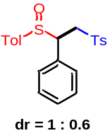1-methyl-4-(((2R)-2-phenyl-2-(p-tolylsulfinyl)ethyl)sulfonyl)benzene (42) White Solid; dr = 1 : 0.6. ¹H-NMR (500 MHz, CDCl₃) δ 7.55 (d, J = 8.0 Hz, major, 2H), 7.45 (d, J = 8.0 Hz, minor, 2H), 7.24 – 7.04 (m, major, 7H, minor, 9H), 6.90 (d, J = 7.5 Hz, minor, 2H), 6.84 (d, J = 8.0 Hz, major, 2H), 6.69 (d, J = 7.5 Hz, major, 2H), 4.38 (dd, J = 10.5, 3.5 Hz, major, 1H), 4.13 – 4.01 (m, major, 1H, minor, 1H), 3.93 (dd, J = 14.5, 3.0 Hz, minor, 1H), 3.84 (dd, J = 14.5, 11.5 Hz, minor, 1H), 3.58 (dd, J = 14.5, 10.5 Hz, major, 1H), 2.39 – 2.34 (m, major, 6H, minor, 6H). ¹³C-NMR (125 MHz, CDCl₃) δ 144.8, 144.6, 142.3, 142.2, 137.7, 136.4, 136.2, 135.5, 131.5, 129.73, 129.70, 129.6, 129.22, 129.19, 128.7, 128.62, 128.56, 128.1, 128.0, 127.9, 125.0, 124.9, 66.8, 63.7, 54.9, 52.9, 21.59, 21.56, 21.50, 21.45; HRMS (ESI) m/z calculated C₂₂H₂₃O₃S₂ [M+H]⁺ 399.1083, found 399.1093.

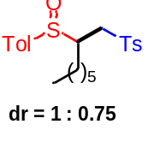1-methyl-4-(((2R)-2-(p-tolylsulfinyl)octyl)sulfonyl)benzene (43): White Solid; dr = 1 : 0.75. ¹H-NMR (500 MHz, CDCl₃) δ 7.77 (d, J = 8.5 Hz, minor, 2H), 7.49 (d, J = 8.0 Hz, major, 2H), 7.38 –7.36 (m, minor, 4H), 7.31 – 7.22 (m, major, 6H, minor, 2H), 3.76 (dd, J = 14.5, 3.0 Hz, minor, 1H), 3.24 – 3.10 (m, major, 2H, minor, 1H), 2.86 – 2.84 (m, major, 1H), 2.72 (dd, J = 14.0, 9.0 Hz, minor, 1H), 2.46 – 2.42 (m, major, 6H, minor, 6H), 2.07 – 2.02 (m, major, 2H), 1.93 – 1.90 (m, minor, 1H), 1.73 – 1.19 (m, major, 8H, minor, 9H), 0.92 – 0.86 (m, major, 3H, minor, 3H). ¹³C-NMR (125 MHz, CDCl₃) δ145.2, 144.8, 142.3, 141.6, 137.9, 136.2, 135.7, 130.1, 130.0, 129.9, 128.1, 127.7, 127.6, 125.2, 124.2, 59.5, 57.8, 52.61, 52.56, 31.5, 31.4, 29.5, 28.90, 28.86, 27.2, 26.8, 26.4, 22.6, 22.5, 21.70, 21.66, 21.47, 21.46, 14.1, 14.0; HRMS (ESI) m/z calculated C₂₂H₃₀NaO₃S₂ [M+Na]⁺ 429.1529, found 429.1556.

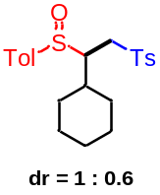1-(((2R)-2-cyclohexyl-2-(p-tolylsulfinyl)ethyl)sulfonyl)-4-methylbenzene (44) White Solid; dr = 1 : 0.6. ¹H-NMR (600 MHz, CDCl₃) δ 7.68 (d, J = 7.8 Hz, minor, 2H), 7.45–7.43 (m, major, 2H, minor, 2H), 7.32 (d, J = 7.8 Hz, minor, 2H), 7.29–7.22 (m, major, 4H, minor, 2H), 7.20 (d, J = 7.8 Hz, major, 2H), 3.54 (dd, J = 14.4, 3.6 Hz, minor, 1H), 3.33–3.24 (m, major, 2H), 3.17–3.15 (m, minor, 1H), 3.11 (dd, J = 14.4, 6.6 Hz, minor, 1H), 2.87–2.85 (m, major, 1H), 2.46–2.40 (m, major, 6H, minor, 6H), 2.16–2.13 (m, major, 1H), 2.01–1.98 (m, major, 1H), 1.90–1.77 (m, major, 2H, minor, 2H), 1.76–1.60 (m, major, 3H, minor, 2H), 1.48–1.44 (m, major, 1H), 1.40–1.35 (m, major, 1H, minor, 1H), 1.28–1.20 (m, major, 2H, minor, 6H). ¹³C-NMR (150 MHz, CDCl₃) δ 145.0, 144.6, 142.3, 141.2, 139.0, 137.4, 136.5, 136.3, 130.0, 129.92, 129.85, 129.77, 128.1, 127.7, 125.5, 124.0, 65.5, 62.7, 51.0, 49.3, 39.4, 36.8, 32.1, 31.5, 29.5, 29.0, 26.40, 26.35, 26.28, 26.12, 26.11, 25.9, 21.7, 21.6, 21.51, 21.46; HRMS (ESI) m/z calculated C₂₂H₂₈NaO₃S₂ [M+Na]⁺ 427.1372, found 427.1373.

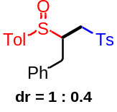1-methyl-4-(((2R)-3-phenyl-2-(p-tolylsulfinyl)propyl)sulfonyl)benzene (45) White Solid; dr = 1 : 0.4. ¹H-NMR (600 MHz, CDCl₃) δ 7.67 (d, J = 7.8 Hz, minor, 2H), 7.51 (d, J = 7.8 Hz, major, 2H), 7.43 (d, J = 7.2 Hz, minor, 2H), 7.38 – 7.34 (m, major, 3H, minor, 2H), 7.32 – 7.28 (m, major, 2H, minor, 2H), 7.28 – 7.25 (m, minor, 2H), 7.25 – 7.21 (m, major, 2H, minor, 1H), 7.18 (d, J = 7.8 Hz, major, 2H), 7.13 (d, J = 7.8 Hz, major, 2H), 7.08 (d, J = 7.2 Hz, minor, 2H), 3.63 (dd, J = 15.0, 5.4 Hz, minor, 1H), 3.51 (dd, J = 14.4, 3.6 Hz, major, 1H), 3.43 – 3.41 (m, minor, 1H), 3.26 – 3.18 (m, major, 3H, minor, 1H), 3.09 – 3.06 (m, major, 1H), 2.99 (dd, J = 15.0, 6.2 Hz, minor, 1H), 2.74 (dd, J = 15.0, 6.6 Hz, minor, 1H), 2.44 – 2.39 (m, major, 6H, minor, 6H). ¹³C-NMR (150 MHz, CDCl₃) δ 145.2, 144.9, 142.2, 141.5, 137.5, 137.1, 136.6, 135.9, 130.1, 130.00, 129.96, 129.6, 129.3, 128.9, 128.8, 128.0, 127.7, 127.2, 127.1, 125.1, 124.1, 61.3, 59.2, 52.4, 35.4, 31.0, 21.70, 21.67, 21.48, 21.45; HRMS (ESI) m/z calculated C₂₃H₂₄NaO₃S₂ [M+Na]⁺ 435.1059, found 435.1056.

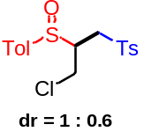1-(((2S)-3-chloro-2-(p-tolylsulfinyl)propyl)sulfonyl)-4-methylbenzene (46) White Solid; dr = 1 : 0.6. ¹H-NMR (500 MHz, CDCl₃) δ 7.65 (d, J = 8.0 Hz, minor, 2H), 7.60 (d, J = 8.0 Hz, major, 2H), 7.44 (d, J = 8.5 Hz, minor, 2H), 7.39 (d, J = 8.5 Hz, major, 2H), 7.33 – 7.26 (m, major, 4H, minor, 4H), 4.25 (dd, J = 12.0, 4.5 Hz, minor, 1H), 4.16 – 4.07 (m, major, 1H), 3.94 (dd, J = 12.5, 3.5 Hz, major, 1H), 3.65 (dd, J = 12.5, 6.5 Hz, minor, 1H), 3.48 – 3.36 (m, major, 2H, minor, 2H), 3.27 – 3.13 (m, major, 1H, minor, 1H), 2.46 – 2.42 (m, major, 6H, minor, 6H). ¹³C-NMR (125 MHz, CDCl₃) δ 145.5, 145.3, 143.2, 142.5, 137.2, 135.5, 135.4, 135.3, 130.3, 130.24, 130.19, 130.1, 128.0, 127.8, 125.4, 124.5, 62.1, 60.0, 50.7, 50.2, 41.4, 40.6, 21.72, 21.71, 21.6, 21.5; HRMS (ESI) m/z calculated C₁₇H₁₉ClNaO₃S₂ [M+Na]⁺ 393.0356, found 393.0360.

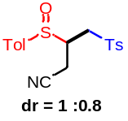 (3R)-3-(p-tolylsulfinyl)-4-tosylbutanenitrile (47) White Solid; dr = 1 : 0.8. ¹H-NMR (600 MHz, CDCl₃) δ 7.68 (d, J = 7.8 Hz, minor, 2H), 7.55 (d, J = 7.8 Hz, major, 2H), 7.40 (d, J = 7.8 Hz, minor, 2H), 7.34 – 7.30 (m, major, 2H, minor, 2H), 7.28 (d, J = 7.8 Hz, minor, 2H), 7.25 (d, J = 7.8 Hz, major, 4H), 3.56 (dd, J = 14.4, 3.6 Hz, minor, 1H), 3.36 – 3.34 (m, minor, 1H), 3.29 – 3.22 (m, major, 1H), 3.19 – 2.98 (m, major, 4H, minor, 2H), 2.58 (dd, J = 17.4, 7.2 Hz, minor, 1H), 2.43 – 2.34 (m, major, 6H, minor, 6H). ¹³C-NMR (150 MHz, CDCl₃) δ 145.8, 145.6, 143.5, 143.1, 136.1, 135.3, 135.22, 135.18, 130.45, 130.42, 130.3, 130.2, 128.0, 127.8, 124.9, 124.5, 115.8, 115.6, 55.2, 53.7, 52.4, 51.6, 21.67, 21.65, 21.5, 17.4, 15.3; HRMS (ESI) m/z calculated C₁₈H₁₉NNaO₃S₂ [M+Na]⁺ 384.0699, found 384.0693.

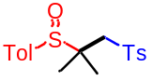1-methyl-4-((2-methyl-1-tosylpropan-2-yl)sulfinyl)benzene (48) White Solid; ¹H-NMR (500 MHz, CDCl₃) δ 7.75 (d, J = 8.5 Hz, 2H), 7.41 (d, J = 8.0 Hz, 2H), 7.35 (d, J = 8.5 Hz, 2H), 7.30 (d, J = 8.0 Hz, 2H), 3.53 (d, J = 14.0 Hz, 1H), 2.96 (d, J = 14.0 Hz, 1H), 2.45 (s, 3H), 2.42 (s, 3H), 1.62 (s, 3H), 1.36 (s, 3H). ¹³C-NMR (125 MHz, CDCl₃) δ 144.9, 142.7, 138.4, 134.8, 130.0, 129.6, 127.6, 126.4, 58.9, 58.1, 21.7, 21.5, 21.4, 20.0; HRMS (ESI) m/z calculated C₁₈H₂₂NaO₃S₂ [M+Na]⁺ 373.0903, found 373.0913.

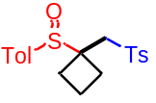1-methyl-4-(((1-(p-tolylsulfinyl)cyclobutyl)methyl)sulfonyl)benzene (49) White Solid; ¹H-NMR (500 MHz, CDCl₃) δ 7.78 (d, J = 8.5 Hz, 2H), 7.55 (d, J = 8.5 Hz, 2H), 7.36 (d, J = 8.5 Hz, 2H), 7.30 (d, J = 8.0 Hz, 2H), 3.62 (d, J = 14.5 Hz, 1H), 2.92 (d, J = 14.5 Hz, 1H), 2.78 – 2.71 (m, 1H), 2.63 – 2.57 (m, 1H), 2.50 – 2.48 (m, 1H), 2.45 (s, 3H), 2.40 (s, 3H), 2.39 – 2.33 (m, 1H), 2.08 – 2.02 (m, 1H), 1.95 – 1.87 (m, 1H). ¹³C-NMR (125 MHz, CDCl₃) δ 145.1, 142.3, 137.9, 135.8, 130.1, 129.7, 127.8, 125.9, 61.3, 56.7, 25.5, 25.3, 21.7, 21.5, 15.2; HRMS (ESI) m/z calculated C₁₉H₂₂NaO₃S₂ [M+Na]⁺ 385.0903, found 385.0908.

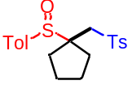1-methyl-4-(((1-(p-tolylsulfinyl)cyclopentyl)methyl)sulfonyl)benzene (50) White Solid; ¹H-NMR (500 MHz, CDCl₃) δ 7.73 (d, J = 8.0 Hz, 2H), 7.47 (d, J = 8.0 Hz, 2H), 7.34 (d, J = 8.0 Hz, 2H), 7.29 (d, J = 8.0 Hz, 2H), 3.70 (d, J = 14.0 Hz, 1H), 2.96 (d, J = 14.0 Hz, 1H), 2.50 – 2.43 (m, 4H), 2.41 (s, 3H), 2.36 – 2.32 (m, 1H), 2.30 – 2.26 (m, 1H), 1.93 – 1.86 (m, 3H), 1.75 – 1.67 (m, 2H); ¹³C-NMR (125 MHz, CDCl₃) δ 144.9, 142.5, 138.5, 135.7, 130.0, 129.7, 127.5, 126.4, 68.6, 56.1, 31.4, 31.2, 25.6, 25.2, 21.7, 21.5; HRMS (ESI) m/z calculated C₂₀H₂₄NaO₃S₂ [M+Na]⁺ 399.1059, found 399.1051.

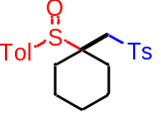1-methyl-4-(((1-(p-tolylsulfinyl)cyclohexyl)methyl)sulfonyl)benzene (51) White Solid; ¹H-NMR (500 MHz, CDCl₃) δ 7.72 (d, J = 8.5 Hz, 2H), 7.40 (d, J = 8.0 Hz, 2H), 7.33 (d, J = 8.0 Hz, 2H), 7.29 (d, J = 8.0 Hz, 2H), 3.69 (d, J = 14.5 Hz, 1H), 2.62 (d, J = 14.5 Hz, 1H), 2.47 – 2.40 (m, 7H), 2.31 – 2.26 (m, 1H), 2.20 – 2.17 (m, 1H), 1.98 – 1.93 (m, 1H), 1.79 – 1.45 (m, 6H); ¹³C-NMR (125 MHz, CDCl₃) δ 144.7, 142.2, 138.5, 134.7, 129.9, 129.7, 127.5, 126.3, 63.8, 56.5, 29.8, 28.3, 25.2, 22.0, 21.6, 21.52, 21.45; HRMS (ESI) m/z calculated C₂₁H₂₆NaO₃S₂ [M+Na]⁺ 413.1216, found 413.1235.

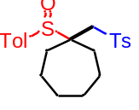1-(p-tolylsulfinyl)-1-(tosylmethyl)cycloheptane (52) White Solid; ¹H-NMR (500 MHz, CDCl₃) δ 7.71 (d, J = 8.5 Hz, 2H), 7.41 (d, J = 8.0 Hz, 2H), 7.33 (d, J = 8.0 Hz, 2H), 7.27 (d, J = 8.0 Hz, 2H), 3.54 (d, J = 14.0 Hz, 1H), 2.73 (d, J = 14.0 Hz, 1H), 2.65 – 2.60 (m, 1H), 2.44 (s, 3H), 2.41 (s, 3H), 2.33 – 2.28 (m, 1H), 2.01 – 1.96 (m, 1H), 1.86 – 1.79 (m, 2H), 1.77 – 1.66 (m, 5H), 1.57 – 1.54 (m, 1H), 1.49 – 1.44 (m, 1H); ¹³C-NMR (125 MHz, CDCl₃) δ 144.7, 142.4, 138.6, 135.0, 129.9, 129.6, 127.4, 126.6, 65.9, 58.7, 33.2, 31.7, 31.2, 30.5, 23.9, 23.2, 21.6, 21.4; HRMS (ESI) m/z calculated C₂₂H₂₈NaO₃S₂ [M+Na]⁺ 427.1372, found 427.1378.

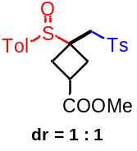methyl 3-(p-tolylsulfinyl)-3-(tosylmethyl)cyclobutanecarboxylate (53): white solid; dr = 1:1. ¹H-NMR (500 MHz, CDCl₃) δ 7.82 (d, J = 8.0 Hz, 2H), 7.77 (d, J = 8.0 Hz, 2H), 7.67 (d, J = 8.0 Hz, 2H), 7.51 (d, J = 8.0 Hz, 2H), 7.39 – 7.36 (m, 4H), 7.34 (d, J = 8.0 Hz, 2H), 7.30 (d, J = 8.0 Hz, 2H), 3.87 (d, J = 15.0 Hz, 1H), 3.71 (s, 3H), 3.66 (s, 3H), 3.58 (d, J = 14.5 Hz, 1H), 3.39 (p, J = 8.5 Hz, 1H), 3.07 – 3.03 (m, 2H), 2.95 – 2.90 (m, 3H), 2.85 – 2.77 (m, 4H), 2.71 – 2.66 (m, 1H), 2.46 (s, 6H), 2.42 – 2.40 (m, 6H), 2.33 – 2.30 (m, 1H). ¹³C-NMR (125 MHz, CDCl₃) δ 175.0, 174.0, 145.4, 145.3, 142.62, 142.61, 137.7, 137.5, 135.4, 135.2, 130.20, 130.16, 129.88, 129.87, 128.0, 127.7, 126.1, 125.7, 58.5, 58.4, 57.1, 55.7, 52.11, 52.10, 32.3, 31.2, 29.7, 29.4, 29.1, 28.10, 28.07, 21.7, 21.5; HRMS (ESI) m/z calculated C₂₁H₂₄NaO₅S₂ [M+Na]⁺ 443.0957, found 443.0948.

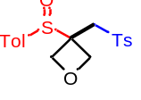3-(p-tolylsulfinyl)-3-(tosylmethyl)oxetane (54) White Solid; ¹H-NMR (500 MHz, CDCl₃) δ 7.82 (d, J = 8.0 Hz, 2H), 7.64 (d, J = 8.0 Hz, 2H), 7.40 (d, J = 8.0 Hz, 2H), 7.34 (d, J = 8.0 Hz, 2H), 5.05 (d, J = 7.5 Hz, 1H), 4.91 (d, J = 8.0 Hz, 1H), 4.85 (d, J = 8.0 Hz, 1H), 4.56 (d, J = 7.5 Hz, 1H), 3.90 (d, J = 15.0 Hz, 1H), 3.19 (d, J = 15.0 Hz, 1H), 2.47 (s, 3H), 2.42 (s, 3H); ¹³C-NMR (125 MHz, CDCl₃) δ 145.8, 143.0, 137.0, 135.0, 130.3, 130.1, 127.9, 125.6, 73.0, 72.4, 60.6, 56.2, 21.7, 21.5; HRMS (ESI) m/z calculated C₁₈H₂₀NaO₄S₂ [M+Na]⁺ 387.0695, found 387.0698.

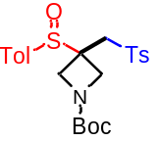tert-butyl 3-(p-tolylsulfinyl)-3-(tosylmethyl)azetidine-1-carboxylate (55) White Solid; ¹H-NMR (600 MHz, CDCl₃) δ 7.81 (d, J = 7.8 Hz, 2H), 7.63 (d, J = 7.8 Hz, 2H), 7.39 (d, J = 7.8 Hz, 2H), 7.35 (d, J = 7.8 Hz, 2H), 4.36 – 4.10 (m, 4H), 3.75 (d, J = 15.0 Hz, 1H), 3.16 (d, J = 15.0 Hz, 1H), 2.47 (s, 3H), 2.42 (s, 3H), 1.41 (s, 9H); ¹³C-NMR (150 MHz, CDCl₃) δ 155.6, 145.7, 143.1, 137.1, 134.9, 130.3, 130.1, 127.9, 125.8, 80.3, 55.2, 52.9, 51.8, 28.2, 21.7, 21.5, 21.0; HRMS (ESI) m/z calculated C₂₃H₂₉NNaO₅S₂ [M+Na]⁺ 486.1379, found 486.1385.

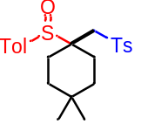1-(((4,4-dimethyl-1-(p-tolylsulfinyl)cyclohexyl)methyl)sulfonyl)-4-methylbenzene (56) White Solid; ¹H-NMR (600 MHz, CDCl₃) δ 7.72 (d, J = 7.8 Hz, 2H), 7.39 (d, J = 7.8 Hz, 2H), 7.33 (d, J = 7.8 Hz, 2H), 7.29 (d, J = 7.8 Hz, 2H), 3.70 (d, J = 14.4 Hz, 1H), 2.63 – 2.57 (m, 2H), 2.47– 2.41 (m, 7H), 2.13 – 2.07 (m, 1H), 1.88 – 1.83 (m, 1H), 1.69 – 1.64 (m, 1H), 1.48 – 1.35 (m, 3H), 1.05 (s, 3H), 1.00 (s, 3H); ¹³C-NMR (125 MHz, CDCl₃) δ 144.7, 142.3, 138.6, 134.6, 130.0, 129.7, 127.4, 126.3, 63.5, 56.2, 34.8, 34.2, 31.2, 30.0, 25.8, 25.5, 24.3, 21.6, 21.5; HRMS (ESI) m/z calculated C₂₃H₃₀NaO₃S₂ [M+Na]⁺ 441.1529, found 441.1515.

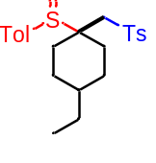1-(((4-ethyl-1-(p-tolylsulfinyl)cyclohexyl)methyl)sulfonyl)-4-methylbenzene (57) White Solid; ¹H-NMR (500 MHz, CDCl₃) δ 7.69 (d, J = 8.0 Hz, 2H), 7.35 – 7.27 (m, 6H), 3.70 (d, J = 14.0 Hz, 1H), 2.57 – 2.48 (m, 3H), 2.43 (s, 3H), 2.40 (s, 3H), 2.32 – 2.28 (m, 1H), 1.84 – 1.77 (m, 1H), 1.74 – 1.67 (m, 2H), 1.62 – 1.59 (m, 1H), 1.48 – 1.41 (m, 2H), 1.38 – 1.32 (m, 2H), 0.93 (t, J = 7.0 Hz, 3H); ¹³C-NMR (125 MHz, CDCl₃) δ 144.6, 142.3, 138.6, 134.6, 129.9, 129.7, 127.4, 126.1, 63.9, 56.3, 38.4, 30.1, 29.5, 28.8, 28.2, 27.6, 21.6, 21.5, 11.4; HRMS (ESI) m/z calculated C₂₃H₃₀NaO₃S₂ [M+Na]⁺ 441.1529, found 441.1506.

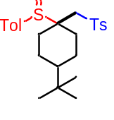1-(((4-(tert-butyl)-1-(p-tolylsulfinyl)cyclohexyl)methyl)sulfonyl)-4-methylbenz ene (58) White Solid; ¹H-NMR (500 MHz, CDCl₃) δ 7.69 (d, J = 8.5 Hz, 2H), 7.35 – 7.27 (m, 6H), 3.68 (d, J = 14.0 Hz, 1H), 2.58 – 2.50 (m, 3H), 2.43 – 2.35 (m, 7H), 1.84 – 1.74 (m, 3H), 1.68 – 1.65 (m, 1H), 1.61 – 1.53 (m, 1H), 1.34 – 1.28 (m, 1H), 0.92 (s, 9H); ¹³C-NMR (125 MHz, CDCl₃) δ 144.6, 142.3, 138.6, 134.5, 129.9, 129.7, 127.4, 126.1, 63.7, 56.2, 47.1, 32.5, 30.6, 29.4, 27.5, 22.9, 22.3, 21.6, 21.5; HRMS (ESI) m/z calculated C₂₅H₃₄NaO₃S₂ [M+Na]⁺ 469.1842, found 469.1837.

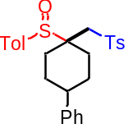1-methyl-4-(((4-phenyl-1-(p-tolylsulfinyl)cyclohexyl)methyl)sulfonyl)benzene (59) White Solid; ¹H-NMR (600 MHz, CDCl₃) δ 7.72 (d, J = 8.4 Hz, 2H), 7.37 (d, J = 8.4 Hz, 2H), 7.35 – 7.32 (m, 4H), 7.29 (d, J = 8.4 Hz, 4H), 7.23 (t, J = 7.2 Hz, 1H), 3.74 (d, J = 13.8 Hz, 1H), 2.83 – 2.71 (m, 3H), 2.58 (d, J = 13.8 Hz, 1H), 2.48 – 2.43 (m, 4H), 2.41 (s, 3H), 2.33 – 2.30 (m, 1H), 2.02 – 1.87 (m, 3H), 1.75 – 1.72 (m, 1H); ¹³C-NMR (150 MHz, CDCl₃) δ 146.0, 144.8, 142.5, 138.6, 134.4, 130.0, 129.9, 128.6, 127.5, 126.8, 126.5, 126.2, 63.3, 56.2, 43.2, 30.5, 29.9, 29.3, 28.6, 21.7, 21.5; HRMS (ESI) m/z calculated C₂₇H₃₀NaO₃S₂ [M+Na]⁺ 489.1529, found 489.1556.

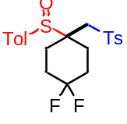1-(((4,4-difluoro-1-(p-tolylsulfinyl)cyclohexyl)methyl)sulfonyl)-4-methylbenzene (60) White Solid; ¹H-NMR (500 MHz, CDCl₃) δ 7.73 (d, J = 8.5 Hz, 2H), 7.39 (d, J = 8.5 Hz, 2H), 7.37-7.31 (m, 4H), 3.68 (d, J = 14.5 Hz, 1H), 2.71 – 2.57 (m, 3H), 2.46 (s, 3H), 2.44 (s, 3H), 2.39 – 2.33 (m, 1H), 2.30 – 2.26 (m, 1H), 2.22 – 2.11 (m, 3H), 1.70 – 1.62 (m, 1H); ¹³C-NMR (125 MHz, CDCl₃) δ 145.1, 143.0, 138.0, 133.9, 130.1, 130.0, 127.6, 126.2, 121.78 (t, J = 240.5 Hz), 61.7, 55.3, 30.1 (t, J = 25.0 Hz), 29.7 (t, J = 25.0 Hz), 26.2 (dd, J = 7.5 Hz, 1.5 Hz), 25.1 (dd, J = 7.5 Hz, 1.5Hz), 21.7, 21.5; HRMS (ESI) m/z calculated C₂₁H₂₅F₂O₃S₂ [M+H]⁺ 427.1208, found 427.1197.

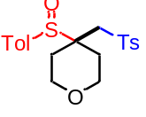4-(p-tolylsulfinyl)-4-(tosylmethyl)tetrahydro-2H-pyran (61) White Solid; ¹H-NMR (600 MHz, CDCl₃) δ 7.70 (d, J = 8.4 Hz, 2H), 7.35 (d, J = 8.4 Hz, 2H), 7.29 (d, J = 7.8 Hz, 2H), 7.25 (d, J = 7.8 Hz, 2H), 4.02 – 3.98 (m, 1H), 3.89 – 3.85 (m, 1H), 3.79 – 3.76 (m, 1H), 3.74 – 3.69 (m, 2H), 2.75 (d, J = 14.4 Hz, 1H), 2.49 – 2.44 (m, 1H), 2.38 (s, 3H), 2.35 (s, 3H), 2.33 – 2.90 (m, 1H), 2.07 – 2.03 (m, 1H), 1.62 – 1.59 (m, 1H); ¹³C-NMR (150 MHz, CDCl₃) δ 145.1, 142.8, 138.1, 134.1, 130.1, 129.8, 127.6, 126.6, 63.5, 63.4, 61.0, 55.4, 29.1, 27.7, 21.7, 21.5; HRMS (ESI) m/z calculated C₂₀H₂₄NaO₄S₂ [M+Na]⁺ 415.1008, found 415.1017.

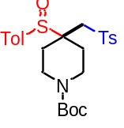tert-butyl 4-(p-tolylsulfinyl)-4-(tosylmethyl)piperidine-1-carboxylate (62) White Solid; ¹H-NMR (500 MHz, CDCl₃) δ 7.74 (d, J = 8.0 Hz, 2H), 7.42 (d, J = 7.5 Hz, 2H), 7.35 (d, J = 8.0 Hz, 2H), 7.32 (d, J = 8.0 Hz, 2H), 3.74 – 3.67 (m, 4H), 3.61 – 3.47 (m, 1H), 2.74 (d, J = 14.5 Hz, 1H), 2.45 – 2.42 (m, 8H), 2.22 – 2.10 (m, 1H), 1.70 – 1.58 (m, 1H), 1.47 (s, 9H); ¹³C-NMR (125 MHz, CDCl₃) δ 154.7, 145.1, 142.8, 138.1, 134.0, 130.1, 129.9, 127.5, 126.4, 80.1, 61.8, 55.5, 40.0, 39.1, 28.6, 28.4, 27.2, 21.7, 21.5; HRMS (ESI) m/z calculated C₂₅H₃₃NNaO₅S₂ [M+Na]⁺ 514.1692, found 514.1699.

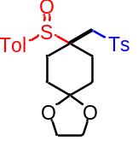8-(p-tolylsulfinyl)-8-(tosylmethyl)-1,4-dioxaspiro[4.5]decane (63) White Solid; ¹H-NMR (500 MHz, CDCl₃) δ 7.73 (d, J = 8.5 Hz, 2H), 7.39 (d, J = 8.0 Hz, 2H), 7.34 – 7.30 (m, 4H), 3.99 – 3.95 (m, 4H), 3.69 (d, J = 14.0 Hz, 1H), 2.73 – 2.66 (m, 1H), 2.64 (d, J = 14.5 Hz, 1H), 2.61 – 2.55 (m, 1H), 2.44 (s, 3H), 2.42 (s, 3H), 2.26 – 2.22 (m, 1H), 2.18 – 2.12 (m, 1H), 2.02 – 1.96 (m, 1H), 1.79 – 1.72 (m, 2H), 1.64 – 1.59 (m, 1H); ¹³C-NMR (125 MHz, CDCl₃) δ 144.8, 142.5, 138.4, 134.5, 130.0, 129.8, 127.6, 126.2, 107.3, 64.6, 62.6, 55.6, 31.0, 30.6, 27.4, 26.2, 21.7, 21.5; HRMS (ESI) m/z calculated C₂₃H₂₈NaO₅S₂ [M+Na]⁺ 471.1270, found 471.1259.

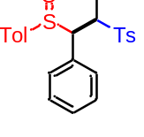1-methyl-4-(((1R,2R)-1-phenyl-1-(p-tolylsulfinyl)propan-2-yl)sulfonyl)benzene (64) White Solid; ¹H-NMR (500 MHz, CDCl₃) δ 7.28 (d, J = 8.5 Hz, 2H), 7.05 – 6.99 (m, 5H), 6.84 – 6.79 (m, 4H), 6.53 (d, J = 7.0 Hz, 2H), 4.09 – 4.03 (m, 1H), 3.74 (d, J = 10.5 Hz, 1H), 2.31 (s, 3H), 2.29 (s, 3H), 2.08 (d, J = 7.0 Hz, 3H); ¹³C-NMR (125 MHz, CDCl₃) δ 144.0, 141.4, 136.9, 135.8, 129.8, 129.34, 129.32, 129.2, 128.2, 127.8, 127.1, 124.3, 71.0, 61.2, 21.5, 21.4, 13.0; HRMS (ESI) m/z calculated C₂₃H₂₄NaO₃S₂ [M+Na]⁺ 435.1059, found 435.1045.

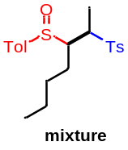1-methyl-4-(((2R,3R)-3-(p-tolylsulfinyl)heptan-2-yl)sulfonyl)benzene (65) White Solid; mixture. ¹H-NMR (500 MHz, CDCl₃) δ 7.75 – 7.71 (m, 0.74H), 7.59 – 7.55 (m, 0.26H), 7.46 – 7.37 (m, 2H), 7.37 – 7.32 (m, 2H), 7.31 – 7.26 (m, 2H), 7.25 – 7.21 (m, 1H), 3.83 – 3.81 (m, 0.12H), 3.74 – 3.68 (m, 0.27H), 3.51 – 3.46 (m, 0.27H), 3.41 – 3.33 (m, 0.59H), 3.27 – 3.23 (m, 0.21H), 3.07 – 3.02 (m, 0.46H), 2.50 – 2.39 (m, 6H), 2.06 – 2.04 (m, 0.58H), 1.99 – 1.84 (m, 0.8H), 1.83 – 1.22 (m, 7.14H), 1.17 (d, J = 7.1 Hz, 0.42H), 1.13 – 1.03 (m, 0.29H), 0.94 – 0.91 (m, 2.16H), 0.90 – 0.82 (m, 1.49H), 0.80 – 0.72 (m, 0.2H). ¹³C-NMR (125 MHz, CDCl₃) δ 145.0, 144.9, 144.7, 142.6, 142.2, 141.6, 138.3, 137.1, 134.4, 134.3, 130.1, 130.0, 129.93, 129.92, 129.7, 128.9, 128.7, 128.6, 128.5, 125.5, 125.0, 124.8, 124.6, 64.1, 61.3, 61.1, 60.6, 58.8, 58.5, 56.8, 56.4, 30.4, 30.2, 29.9, 29.8, 24.4, 23.9, 23.8, 23.2, 22.8, 22.7, 22.6, 22.4, 21.70, 21.65, 21.53, 21.49, 21.46, 13.9, 13.8, 13.7, 10.1, 9.2, 8.9, 6.8; HRMS (ESI) m/z calculated C₂₁H₂₉O₃S₂ [M+H]⁺ 393.1553, found 393.1571.

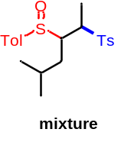1-methyl-4-(((2R)-5-methyl-2-tosylhexan-3-yl)sulfinyl)benzene (66) White Solid; mixture. ¹H-NMR (600 MHz, CDCl₃) δ 7.75 – 7.52 (m, 1H), 7.37 – 7.23 (m, 3H), 7.23 – 7.15 (m, 3H), 7.13 – 7.09 (m, 1H), 3.73 – 3.67 (m, 0.25H), 3.55 – 3.52 (m, 0.25H), 3.34 – 3.28 (m, 0.6H), 3.06 – 3.02 (m, 0.5H), 2.40 – 2.32 (m, 6H), 1.98 – 1.88 (m, 1.3H), 1.82 – 1.63 (m, 1.3H), 1.56 – 1.40 (m, 0.7H), 1.38 – 1.36 (m, 1.6H), 1.21 – 1.18 (m, 0.4H), 1.06 – 1.05 (m, 0.3H), 0.94 – 0.88 (m, 3.8H), 0.85 – 0.68 (m, 3H). ¹³C-NMR (150 MHz, CDCl₃) δ 145.0, 144.9, 144.6, 142.6, 142.2, 141.5, 139.7, 139.1, 138.3, 136.7, 135.4, 134.3, 130.01, 129.96, 129.9, 129.8, 129.72, 129.68, 128.9, 128.8, 128.6, 128.5, 128.0, 127.8, 125.6, 124.9, 124.8, 124.4, 124.1, 112.6, 68.0, 62.8, 59.3, 59.1, 58.5, 58.4, 58.2, 58.0, 56.5, 56.1, 55.6, 40.3, 37.3, 35.7, 33.4, 33.12, 33.06, 32.5, 29.9, 28.2, 27.9, 25.9, 25.6, 25.5, 25.4, 25.0, 24.3, 23.4, 23.2, 22.5, 22.4, 22.1, 21.71, 21.68, 21.6, 21.51, 21.48, 21.4, 21.2, 20.6, 12.5, 11. 6, 10.6, 9.8, 9.0, 8.1, 6.1; HRMS (ESI) m/z calculated C₂₁H₂₈NaO₃S₂ [M+Na]⁺ 415.1372, found 415.1396.

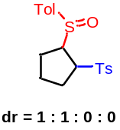1-methyl-4-(((1S,2R)-2-(p-tolylsulfinyl)cyclopentyl)sulfonyl)benzene (67) White Solid; dr = 1 : 1 : 0 : 0. ¹H-NMR (500 MHz, CDCl₃) δ 7.81 (d, J = 8.0 Hz, 2H), 7.53 (d, J = 8.0 Hz, 2H), 7.39 (d, J = 8.0 Hz, 2H), 7.37 – 7.34 (m, 4H), 7.31 – 7.23 (m, 6H), 3.93 – 3.89 (m, 1H), 3.88 – 3.82 (m, 1H), 3.62 – 3.55 (m, 1H), 3.50 – 3.46 (m, 1H), 2.49 – 2.39 (m, 12H), 2.31 – 2.08 (m, 5H), 2.04 – 1.71 (m, 6H), 1.55 – 1.50 (m, 1H). ¹³C-NMR (125 MHz, CDCl₃) δ 145.2, 144.6, 141.8, 141.5, 138.9, 138.6, 135.1, 135.0, 130.1, 129.91, 129.90, 129.8, 128.6, 128.4, 124.4, 123.9, 65.3, 64.2, 63.8, 62.7, 29.4, 28.6, 28.2, 25.4, 25.2, 22.9, 21.7, 21.6, 21.5, 21.4; HRMS (ESI) m/z calculated C₁₉H₂₂NaO₃S₂ [M+Na]⁺ 385.0903, found 385.0894.

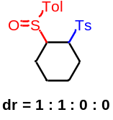1-methyl-4-(((1S,2R)-2-(p-tolylsulfinyl)cyclohexyl)sulfonyl)benzene (68) White Solid; dr = 1 : 1 : 0 : 0. ¹H-NMR (500 MHz, CDCl₃) δ 7.73 (d, J = 8.0 Hz, 2H), 7.64 (d, J = 8.0 Hz, 2H), 7.50 (d, J = 8.0 Hz, 2H), 7.37 – 7.34 (m, 4H), 7.30 – 7.26 (m, 4H), 7.23 (d, J = 8.0 Hz, 2H), 3.59 – 3.53 (m, 1H), 3.25 – 3.19 (m, 2H), 3.00 –2.96 (m, 1H), 2.47 – 2.41 (m, 12H), 2.40 – 2.27 (m, 2H), 2.08 – 1.90 (m, 6H), 1.86 – 1.68 (m, 4H), 1.61 – 1.46 (m, 2H), 1.45 – 1.38 (m, 2H). ¹³C-NMR (125 MHz, CDCl₃) δ 144.92, 144.87, 142.3, 141.7, 138.5, 138.3, 135.2, 134.3, 129.94, 129.87, 129.86, 128.8, 128.6, 125.5, 124.8, 60.7, 60.2, 59.7, 58.3, 24.9, 23.0, 22.7, 22.4, 22.1, 21.9, 21.7, 21.52, 21.47, 21.1, 19.5; HRMS (ESI) m/z calculated C₂₀H₂₄NaO₃S₂ [M+Na]⁺ 399.1059, found 399.1064.

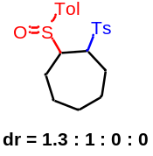 (1R,2S)-1-(p-tolylsulfinyl)-2-tosylcycloheptane (69) White Solid; dr = 1.3 : 1 : 0 : 0. (major isomer): ¹H-NMR (500 MHz, CDCl₃) δ 7.67 (d, J = 8.0 Hz, 2H), 7.41 (d, J = 8.0 Hz, 2H), 7.33 (d, J = 8.0 Hz, 2H), 7.29 (d, J = 8.0 Hz, 2H), 3.94 – 3.87 (m, 1H), 3.70 –3.67 (m, 1H), 2.46 (s, 3H), 2.42 (s, 3H), 2.16 – 2.07 (m, 1H), 2.02 – 1.94 (m, 2H), 1.94 – 1.80 (m, 3H), 1.78 – 1.70 (m, 2H), 1.60 – 1.53 (m, 1H), 1.49 – 1.40 (m, 1H). ¹³C-NMR (125 MHz, CDCl₃) δ 144.8, 142.1, 139.4, 134.8, 129.9, 129.8, 129.0, 125.0, 62.7, 60.4, 30.8, 27.1, 26.5, 25.2, 24.3, 21.7, 21.5; (minor isomer): ¹H-NMR (500 MHz, CDCl₃) δ 7.72 (d, J = 8.0 Hz, 2H), 7.51 (d, J = 8.0 Hz, 2H), 7.35 (d, J = 8.0 Hz, 2H), 7.31 (d, J = 8.0 Hz, 2H), 3.76 – 3.71 (m, 1H), 3.43 – 3.39 (m, 1H), 2.47 (s, 3H), 2.43 (s, 3H), 2.07 – 2.06 (m, 1H), 2.01 – 1.86 (m, 4H), 1.83 – 1.74 (m, 1H), 1.57 – 1.47 (m, 4H). ¹³C-NMR (125 MHz, CDCl₃) δ 145.1, 141.7, 138.4, 135.0, 130.0, 129.9, 128.8, 125.0, 64.3, 62.2, 30.7, 27.3, 26.0, 24.8, 23.3, 21.7, 21.5; HRMS (ESI) m/z calculated C₂₁H₂₆NaO₃S₂ [M+Na]⁺ 413.1216, found 413.1211.

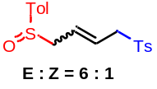1-methyl-4-((4-(p-tolylsulfinyl)but-2-en-1-yl)sulfonyl)benzene (70) White Solid; E : Z = 6 : 1. (major isomer): ¹H-NMR (600 MHz, CDCl₃) δ 7.73 (d, J = 7.8 Hz, 2H), 7.41 (d, J = 7.8 Hz, 2H), 7.35 (d, J = 8.4 Hz, 2H), 7.30 (d, J = 7.8 Hz, 2H), 5.62 – 5.55 (m, 1H), 5.47 – 5.19 (m, 1H), 3.82 – 3.68 (m, 2H), 3.51 (dd, J = 12.6, 7.8 Hz, 1H), 3.42 (dd, J = 12.6, 7.8 Hz, 1H), 2.45 (s, 3H), 2.42 (s, 3H).¹³C-NMR (150 MHz, CDCl₃) δ 145.0, 141.8, 139.4, 135.5, 129.91, 129.85, 128.5, 127.5, 125.4, 124.2, 59.9, 59.7, 21.7, 21.5; HRMS (ESI) m/z calculated C₁₈H₂₀NaO₃S₂ [M+Na]⁺ 371.0746, found 371.0742.

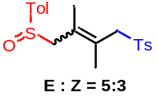1-((2,3-dimethyl-4-(p-tolylsulfinyl)but-2-en-1-yl)sulfonyl)-4-methylbenzene (71) White Solid; E : Z = 5 : 3. (major isomer): ¹H-NMR (500 MHz, CDCl₃) δ 7.71 (d, J = 8.0 Hz, 2H), 7.45 (d, J = 8.0 Hz, 2H), 7.34 – 7.30 (m, 4H), 4.07 (d, J = 14.0 Hz, 1H), 3.60 (dd, J = 18.0, 14.0 Hz, 2H), 3.21 (d, J = 13.5 Hz, 1H), 2.43 (s, 3H), 2.42 (s, 3H), 1.81 (s, 3H), 1.77 (s, 3H). ¹³C-NMR (125 MHz, CDCl₃) δ 144.8, 141.8, 140.6, 136.6, 129.93, 129.89, 129.1, 128.1, 125.8, 123.9, 63.7, 61.3, 21.7, 21.5, 20.8, 20.4. (minor isomer): ¹H-NMR (500 MHz, CDCl₃) δ 7.77 (d, J = 8.0 Hz, 2H), 7.54 (d, J = 8.0 Hz, 2H), 7.37 – 7.31 (m, 4H), 3.90 – 3.81 (m, 2H), 3.71 (d, J = 12.5 Hz, 1H), 3.40 (d, J = 12.5 Hz, 1H), 2.45 (s, 3H), 2.42 (s, 3H), 1.71 (q, J = 1.5 Hz, 3H), 1.49 (q, J = 1.5 Hz, 3H). ¹³C-NMR (150 MHz, CDCl₃) δ 144.9, 141.9, 140.7, 136.4, 129.98, 129.93, 129.4, 128.3, 125.4, 124.1, 64.5, 61.9, 21.7, 21.5, 20.2, 20.1; HRMS (ESI) m/z calculated C₂₀H₂₄NaO₃S₂ [M+Na]⁺ 399.1059, found 399.1057.

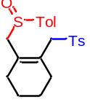1-methyl-4-(((2-((p-tolylsulfinyl)methyl)cyclohex-1-en-1-yl)methyl)sulfonyl)benz ene (72) White Solid; ¹H-NMR (600 MHz, CDCl₃) δ 7.72 (d, J = 7.8 Hz, 2H), 7.48 (d, J = 8.4 Hz, 2H), 7.34 – 7.30 (m, 4H), 4.05 (d, J = 14.4 Hz, 1H), 3.67 (d, J = 13.2 Hz, 1H), 3.52 (d, J = 14.4 Hz, 1H), 3.18 (d, J = 13.8 Hz, 1H), 2.43 (s, 3H), 2.42 (s, 3H), 2.11 – 2.03 (m, 4H), 1.59 – 1.53 (m, 4H); ¹³C-NMR (125 MHz, CDCl₃) δ 144.9, 142.1, 139.9, 136.5, 130.8, 130.0, 129.9, 128.2, 124.2, 62.5, 60.4, 31.4, 31.2, 22.4, 22.3, 21.7, 21.5; HRMS (ESI) m/z calculated C₂₂H₂₆NaO₃S₂ [M+Na]⁺ 425.1216, found 425.1210.

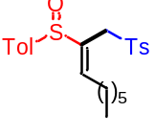(E)-1-methyl-4-((2-(p-tolylsulfinyl)non-2-en-1-yl)sulfonyl)benzene (73) White Solid; ¹H-NMR (500 MHz, CDCl₃) δ 7.79 (d, J = 8.0 Hz, 2H), 7.46 (d, J = 8.5 Hz, 2H), 7.37 (d, J = 8.0 Hz, 2H), 7.30 (d, J = 8.0 Hz, 2H), 7.13 (t, J = 7.5 Hz, 1H), 3.82 (d, J = 14.0 Hz, 1H), 3.55 (d, J = 14.0 Hz, 1H), 2.45 (s, 3H), 2.41 (s, 3H), 2.09 – 2.02 (m, 1H), 1.81 – 1.74 (m, 1H), 1.40 – 1.19 (m, 8H), 0.86 (t, J = 7.5 Hz, 3H); ¹³C-NMR (125 MHz, CDCl₃) δ 149.2, 144.9, 142.1, 140.3, 136.1, 132.8, 130.1, 129.9, 128.4, 124.3, 56.3, 31.5, 28.9, 28.8, 28.1, 22.5, 21.7, 21.5, 14.0; HRMS (ESI) m/z calculated C₂₃H₃₀NaO₃S₂ [M+Na]⁺ 441.1529, found 441.1518.

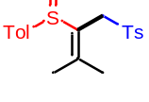1-methyl-4-((3-methyl-1-tosylbut-2-en-2-yl)sulfinyl)benzene (74) White Solid; ¹H-NMR (600 MHz, CDCl₃) δ 7.86 (d, J = 7.8 Hz, 2H), 7.61 (d, J = 7.8 Hz, 2H), 7.35 (d, J = 7.8 Hz, 4H), 4.08 (d, J = 13.8 Hz, 1H), 3.98 (d, J = 13.8 Hz, 1H), 2.44 (s, 3H), 2.43 (s, 3H), 2.09 (s, 3H), 1.90 (s, 3H); ¹³C-NMR (150 MHz, CDCl₃) δ 156.7, 144.2, 141.7, 140.7, 139.0, 130.0, 129.8, 129.4, 127.5, 124.1, 59.3, 25.1, 23.2, 21.6, 21.5; HRMS (ESI) m/z calculated C₁₉H₂₂NaO₃S₂ [M+Na]⁺ 385.0903, found 385.0895.

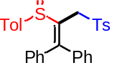(2-(p-tolylsulfinyl)-3-tosylprop-1-ene-1,1-diyl)dibenzene (75) White Solid; ¹H-NMR (600 MHz, CDCl₃) δ 7.57 (d, J = 8.4 Hz, 2H), 7.35 (d, J = 8.4 Hz, 2H), 7.27 – 7.26 (m, 2H), 7.23 – 7.16 (m, 4H), 7.07 (t, J = 7.2 Hz, 2H), 7.03 (d, J = 8.4 Hz, 2H), 6.91 (d, J = 7.2 Hz, 2H), 6.84 (d, J = 5.4 Hz, 2H), 4.23 (d, J = 12.6 Hz, 1H), 4.14 (d, J = 12.6 Hz, 1H), 2.40 (s, 3H), 2.33 (s, 3H); ¹³C-NMR (150 MHz, CDCl₃) δ 158.2, 143.6, 141.7, 140.7, 139.6, 138.4, 137.5, 134.1, 129.8, 129.3, 129.1, 128.7, 128.6, 128.3, 127.8, 127.6, 124.7, 59.8, 21.6, 21.5; HRMS (ESI) m/z calculated C₂₉H₂₆NaO₃S₂ [M+Na]⁺ 509.1216, found 509.1236.

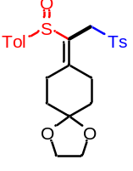8-(1-(p-tolylsulfinyl)-2-tosylethylidene)-1,4-dioxaspiro[4.5]decane (76) White Solid; ¹H-NMR (500 MHz, CDCl₃) δ 7.85 (d, J = 8.5 Hz, 2H), 7.62 (d, J = 8.0 Hz, 2H), 7.36 – 7.33 (m, 4H), 4.08 (s, 2H), 3.94 – 3.87 (m, 4H), 2.87 – 2.82 (m, 1H), 2.71 – 2.59 (m, 2H), 2.43 (s, 6H), 2.41 – 2.36 (m, 1H), 1.81 – 1.76 (m, 1H), 1.68 – 1.61 (m, 1H), 1.54 – 1.49 (m, 1H), 1.40 – 1.34 (m, 1H); ¹³C-NMR (125 MHz, CDCl₃) δ 160.6, 144.2, 141.8, 140.6, 139.6, 130.0, 129.9, 128.2, 127.2, 124.1, 107.2, 64.5, 64.4, 58.4, 35.4, 34.5, 31.2, 29.2, 21.6, 21.5; HRMS (ESI) m/z calculated C₂₄H₂₈NaO₅S₂ [M+Na]⁺ 483.1270, found 483.1273.

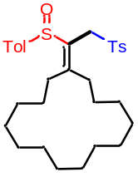 (1-(p-tolylsulfinyl)-2-tosylethylidene)cyclopentadecane (77) White Solid; ¹H-NMR (600 MHz, CDCl₃) δ 7.87 – 7.84 (m, 2H), 7.65 – 7.61 (m, 2H), 7.35 – 7.33 (m, 4H), 4.03 – 3.95 (m, 2H), 2.43 – 2.40 (m, 8H), 2.32 – 2.29 (m, 1H), 2.00 –1.94 (m, 1H), 1.33 – 1.25 (m, 23H), 1.01 – 0.98 (m, 1H); ¹³C-NMR (150 MHz, CDCl₃) δ 164.7, 144.1, 141.6, 140.8, 139.7, 129.9, 129.8, 129.2, 127.4, 124.2, 59.3, 33.8, 33.3, 27.8, 27.7, 26.7, 26.6, 26.4, 26.3, 26.2, 26.0, 25.9, 25.8, 21.6, 21.5; HRMS (ESI) m/z calculated C₃₁H₄₄NaO₃S₂ [M+Na]⁺ 551.2624, found 551.2629.

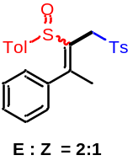1-methyl-4-((3-phenyl-1-tosylbut-2-en-2-yl)sulfinyl)benzene (78) White Solid; E : Z = 2 : 1. ¹H-NMR (600 MHz, CDCl₃) δ 8.03 (d, J = 8.4 Hz, major, 2H), 7.74 (d, J = 8.4 Hz, minor, 2H), 7.43 – 7.35 (m, major, 4H, minor, 2H), 7.32 – 7.28 (m, major, 2H, minor, 2H), 7.25 – 7.17 (m, major, 2H, minor, 3H), 7.11 – 7.07 (m, major, 2H, minor, 2H), 7.00 (d, J = 8.4 Hz, minor, 2H), 6.85 (d, J = 7.2 Hz, major, 1H), 4.22 (dd, J = 28.8, 7.2 Hz, minor, 2H), 3.93 (d, J = 13.2 Hz, major, 1H), 3.85 (dd, J = 13.2, 1.2 Hz, major, 1H), 2.47 (s, major, 3H), 2.45 (s, minor, 3H), 2.39 (s, major, 3H), 2.34 (s, minor, 3H), 2.32 (s, major, 3H), 2.08 (s, minor, 3H). ¹³C-NMR (150 MHz, CDCl₃) δ 157.9, 156.7, 144.5, 143.4, 141.9, 141.5, 141.01, 140.97, 139.6, 138.8, 137.9, 132.8, 131.8, 130.0, 129.9, 129.8, 129.0, 128.5, 128.4, 127.82, 127.79, 127.7, 127.2, 124.22, 124.17, 60.1, 59.1, 26.4, 24.1, 21.7, 21.53, 21.51, 21.4; HRMS (ESI) m/z calculated C₂₄H₂₄NaO₃S₂ [M+Na]⁺ 447.1059, found 447.1053.

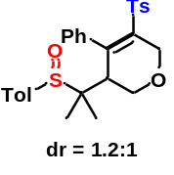4-phenyl-3-(2-(p-tolylsulfinyl)propan-2-yl)-5-tosyl-3,6-dihydro-2H-pyran (79) White Solid; dr = 1.2 : 1. (major isomer): ¹H-NMR (600 MHz, CDCl₃) δ 7.60 – 7.35 (m, 1H), 7.30 (d, J = 8.4 Hz, 2H), 7.26 – 7.15 (m, 5H), 7.12 (d, J = 8.4 Hz, 2H), 7.01 (d, J = 8.4 Hz, 2H), 6.70 m, 2H), 4.62 (dd, J = 17.4, 2.4 Hz, 1H), 3.59 (dd, J = 12.6, 3.0 Hz, 1H), 2.80 (t, J = 2.4 Hz, 1H), 2.36 (s, 3H), 2.34 (s, 3H), 1.14 (s, 3H), 0.55 (s, 3H). ¹³C-NMR (150 MHz, CDCl₃) δ 148.4, 143.8, 141.9, 141.3, 138.4, 137.8, 135.1, 133.1, 129.2, 129.1, 128.6, 127.2, 126.9, 66.0, 65.8, 63.1, 46.4, 21.5, 21.4, 19.6, 19.1; (minor isomer): ¹H-NMR (600 MHz, CDCl₃) δ 7.75 – 7.60 (m, 1H), 7.40 – 7.30 (m, 1H), 7.29 – 7.27 (m, 1H), 7.21 – 7.18 (m, 4H), 7.17 (d, J = 8.4 Hz, 2H), 7.12 – 7.05 (m, 1H). 7.02 (d, J = 8.4 Hz, 2H), 6.66 – 6.50 (m, 1H), 4.86 (d, J = 17.2 Hz, 1H), 4.59 (dd, J = 17.2, 2.4 Hz, 1H), 4.34 (d, J = 12.0 Hz, 1H), 3.57 (dd, J = 12.0, 3.0 Hz, 1H), 3.05 (t, J = 2.4 Hz, 1H), 2.36 (s, 3H), 2.34 (s, 3H), 1.09 (s, 3H), 1.03 (s, 3H). ¹³C-NMR (150 MHz, CDCl₃) δ 148.8, 143.8, 140.4, 140.3, 137.9, 134.3, 129.1, 129.0, 127.3, 126.9, 126.6, 66.9, 66.1, 63.2, 44.1, 21.5, 21.4, 20.9, 17.3; HRMS (ESI) m/z calculated C₂₈H₃₀NaO₄S₂ [M+Na]⁺ 517.1478, found 517.1485.

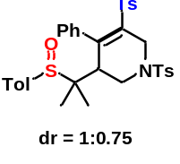4-phenyl-3-(2-(p-tolylsulfinyl)propan-2-yl)-1,5-ditosyl-1,2,3,6-tetrahydropy ridine (80) White Solid; dr = 1 : 0.75. ¹H-NMR (600 MHz, CDCl₃) δ 7.78 (d, J = 8.4 Hz, major, 2H), 7.72 (d, J = 8.4 Hz, minor, 2H), 7.58 (d, J = 7.2 Hz, minor, 1H), 7.44 – 7.38 (m, major, 4H), 7.35 – 7.30 (m, major, 1H), 7.30 – 7.26 (minor, 4H), 7.26 – 7.24 (m, minor, 1H), 7.23 – 7.16 (m, major, 4H, minor, 4H), 7.13 – 7.09 (m, major, 1H, minor, 1H), 7.07– 7.04 (m, major, 2H, minor, 1H), 7.00 – 6.97 (m, major, 3H, minor, 1H), 6.59 – 6.49 (m, minor, 1H), 6.48 – 6.29 (m, minor, 1H), 4.75 – 4.64 (m, major, 2H, minor, 1H), 4.10 (d, J = 12.3 Hz, minor, 1H), 3.70 –3.63 (m, major, 1H, minor, 1H), 3.36 (br., minor, 1H), 2.99 (br., major, 1H), 2.53 – 2.44 (m, major, 4H, minor, 4H), 2.36 – 3.32 (m, major, 6H, minor, 6H), 1.20 – 1.17 (m, major, 3H, minor, 3H), 1.15 (s, minor, 3H), 0.61 (s, major, 3H); ¹³C-NMR (150 MHz, CDCl₃) δ 149.2, 148.6, 144.5, 144.4, 144.0, 143.9, 142.0, 141.7, 139.7, 138.1, 138.0, 137.5, 136.6, 135.1, 135.0, 131.9, 131.6, 130.11, 130.08, 129.3, 129.14, 129.09, 129.06, 128.8, 128.05, 128.03, 127.4, 127.2, 127.0, 126.7, 63.71, 63.69, 47.6, 46.4, 46.3, 46.2, 45.2, 45.0, 21.7, 21.6, 21.4, 20.7, 19.4, 19.2, 16.1; HRMS (ESI) m/z calculated C₃₅H₃₇NNaO₅S₃ [M+Na]⁺ 670.1726, found 670.1735.

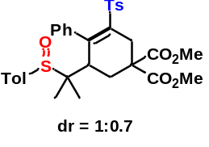dimethyl 6-(2-(p-tolylsulfinyl)propan-2-yl)-2-tosyl-5,6-dihydro-[1,1'- biphenyl]-4,4(3H)-dicarboxylate (81) White Solid; dr = 1:0.7. ¹H-NMR (600 MHz, CDCl₃) δ 7.70 – 7.60 (m, minor, 1H), 7.30 – 7.29 (m, major, 2H), 7.26 – 7.23 (m, major, 4H), 7.23 – 7.18 (m, major, 3H, minor, 4H), 7.14 – 7.11 (m, minor, 6H), 7.04 – 7.01 (m, major, 2H), 6.99 – 6.97 (m, major, 1H, minor, 2H),6.46 – 6.29 (m, major, 1H), 3.81 (s, major, 3H), 3.80 (s, minor, 3H), 3.66 (s, major, 3H), 3.60 (s, minor, 3H), 3.39 – 3.33 (m, major, 1H, minor, 1H), 3.05 (dd, J = 17.2, 3.0 Hz, minor, 1H), 2.87 (dd, J = 17.4, 3.6 Hz, major, 1H), 2.83 – 2.79 (m, minor, 1H), 2.65 – 2.61 (m, major, 1H), 2.50 (dd, J = 13.2, 10.2 Hz, major, 1H), 2.46 – 2.39 (m, minor, 2H), 2.36 – 2.35 (m, major, 3H, minor, 3H), 2.33 (s, minor, 3H), 2.31 (s, major, 3H), 1.98 (dd, J = 13.8, 10.8 Hz, major, 1H), 1.05 (s, major, 3H), 0.78 – 0.77 (m, major, 3H, minor, 3H), 0.64 (s, minor, 3H); ¹³C-NMR (150 MHz, CDCl₃) δ 171.2, 170.2, 169.9, 150.4, 150.3, 143.4, 143.3, 141.8, 141.4, 141.0, 140.6, 138.1, 137.9, 136.7, 136.3, 135.9, 135.4, 129.13, 129.11, 129.0, 128.9, 128.8, 128.6, 128.2, 127.8, 127.6, 127.6, 126.7, 126.4, 124.3, 64.4, 63.0, 54.8, 54.2, 53.3, 53.2, 52.9, 52.8, 50.6, 48.7, 46.0, 32.1, 31.5, 30.8, 21.5, 21.4, 18.2, 18.1, 17.3; HRMS (ESI) m/z calculated C₃₃H₃₆NaO₇S₂ [M+Na]⁺ 631.1795, found 631.1788.

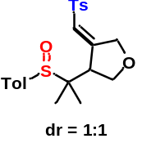 (Z)-3-(2-(p-tolylsulfinyl)propan-2-yl)-4-(tosylmethylene)tetrahydrofuran (82) White Solid; dr = 1 : 1. ¹H-NMR (600 MHz, CDCl₃) δ 7.80 – 7.76 (m, 4H), 7.43 (d, J = 8.4 Hz, 2H), 7.39 – 7.33 (m, 6H), 7.32 – 7.29 (m, 4H), 6.71 (s, 1H), 6.33 (s, 1H), 4.96 – 4.89 (m, 2H), 4.88 – 4.77 (m, 2H), 4.57 (dd, J = 10.2, 1.8 Hz, 1H), 4.10 (dd, J = 9.8, 1.8 Hz, 1H), 3.84 – 3.79 (m, 2H), 3.14 (t, J = 6.6 Hz, 2H), 2.44 – 2.41 (m, 12H), 1.06 (s, 3H), 1.01 (s, 3H), 0.97 (s, 3H) , 0.99 (s, 3H); ¹³C-NMR (150 MHz, CDCl₃) δ 157.3, 155.8, 144.9, 144.8, 142.4, 142.3, 138.1, 138.0, 135.1, 134.9, 130.1, 130.0, 129.49, 129.45, 127.3, 127.2, 126.52, 126.50, 125.5, 125.2, 70.3, 70.2, 68.9, 68.6, 61.3, 61.2, 50.0, 49.5, 21.7, 21.5, 17.64, 17.55, 17.48, 17.2; HRMS (ESI) m/z calculated C₂₂H₂₆NaO₄S₂ [M+Na]⁺ 441.1165, found 441.1169.

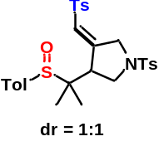 (Z)-3-(2-(p-tolylsulfinyl)propan-2-yl)-1-tosyl-4-(tosylmethylene)pyrrolidine (83) White Solid; dr = 1 : 1. ¹H-NMR (600 MHz, CDCl₃) δ 7.75 – 7.72 (m, 6H), 7.69 (d, J = 8.4 Hz, 2H), 7.41 (d, J = 7.8 Hz, 2H), 7.39 – 7.36 (m, 4H), 7.34 – 7.27 (m, 10H), 6.66 – 6.64 (m, 1H), 6.32 – 6.20 (m, 1H), 4.49 – 4.45 (m, 2H), 4.37 – 4.26 (m, 2H), 4.13 (dd, J = 10.4, 1.2 Hz, 1H), 3.60 (dd, J = 10.4, 1.2 Hz, 1H), 3.15 (d, J = 6.0 Hz, 1H), 3.11 – 3.04 (m, 3H), 2.46 – 2.40 (m, 18H), 1.03 (s, 3H), 0.99 (s, 3H), 0.95 (s, 3H), 0.88 (s, 3H); ¹³C-NMR (150 MHz, CDCl₃) δ 152.1, 150.8, 145.1, 145.0, 144.4, 144.3, 142.49, 142.46, 137.8, 137.7, 134.8, 134.7, 131.6, 131.5, 130.2, 130.1, 130.02, 130.00, 129.5, 127.94, 127.89, 127.5, 127.3, 127.2, 126.5, 61.7, 61.6, 50.8, 50.6, 48.7, 48.4, 48.1, 21.7, 21.6, 21.5, 17.53, 17.51, 17.1; HRMS (ESI) m/z calculated C₂₉H₃₃NNaO₅S₃ [M+Na]⁺ 594.1413, found 594.1420.

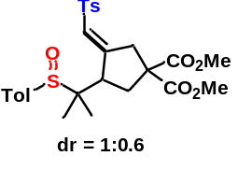 (E)-dimethyl 3-(2-(p-tolylsulfinyl)propan-2-yl)-4-(tosylmethyle ne)cyclopentane-1,1-dicarboxylate (84) White Solid; dr = 1 : 0.6. ¹H-NMR (600 MHz, CDCl₃) δ 7.83 – 7.81 (m, major, 2H, minor, 2H), 7.44 (d, J = 8.4 Hz, major, 2H), 7.40 (d, J = 8.4 Hz, minor, 2H), 7.36 – 7.34 (m, major, 2H, minor, 2H), 7.32 – 7.30 (m, major, 2H minor, 2H), 6.79– 6.76 (m, major, 1H), 6.53– 6.51 (m, minor, 1H), 4.15 – 4.10 (m, major, 1H, minor, 1H), 3.78 – 3.77 (m, major, 3H, minor, 3H), 3.62 – 3.60 (m, major, 3H, minor, 3H), 3.30–3.26 (m, major, 1H), 3.13–3.09 (m, minor, 1H), 3.00 – 2.93 (m, major, 1H, minor, 1H), 2.78 – 2.70 (m, minor, 1H), 2.66 – 2.62 (m, major, 1H), 2.44 (s, major, 3H, minor, 3H), 2.43 – 2.42 (m, minor, 1H), 2.41 (s, major, 3H, minor, 3H), 2.14 (dd, J = 13.8, 10.2 Hz, major, 1H), 1.13 (s, minor, 3H), 1.02 (s, major, 3H), 0.96 (s, major, 3H), 0.92 (s, minor, 3H); ¹³C-NMR (150 MHz, CDCl₃) δ 170.9, 170.7, 170.63, 170.58, 157.4, 156.3, 144.5, 144.4, 142.3, 142.2, 138.57, 138.55, 135.1, 135.0, 129.94, 129.85, 129.5, 128.2, 128.0, 127.4, 127.3, 126.52, 126.49, 62.5, 62.3, 58.50, 58.47, 53.19, 53.15, 53.1, 53.0, 49.4, 47.2, 39.7, 39.6, 34.5, 34.0, 21.6, 21.5, 17.5, 17.3, 16.9, 16.8; HRMS (ESI) m/z calculated C₂₇H₃₂NaO₇S₂ [M+Na]⁺ 555.1482, found 555.1487.

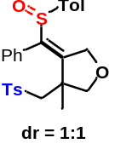 (Z)-3-methyl-4-(phenyl(p-tolylsulfinyl)methylene)-3-(tosylmethyl)tetrahydrofu ran (85) White Solid; dr = 1 : 1. ¹H-NMR (500 MHz, CDCl₃) δ 7.54 (d, J = 8.5 Hz, 2H), 7.47 (d, J = 8.5 Hz, 2H), 7.30 – 7.24 (m, 8H), 7.22 – 7.13 (m, 6H), 7.14 – 7.11 (m, 4H), 7.05 – 7.00 (m, 4H), 5.25 (d, J = 15.0 Hz, 1H), 5.09 (d, J = 15.0 Hz, 1H), 4.95 (dd, J = 15.0, 6.5 Hz, 2H), 4.29 (d, J = 9.0 Hz, 1H), 4.23 (d, J = 9.0 Hz, 1H), 3.91 (d, J = 9.5 Hz, 1H), 3.78 (d, J = 9.5 Hz, 1H), 3.07 – 2.98 (m, 3H), 2.87 (d, J = 14.5 Hz, 1H), 2.40 (s, 6H), 2.36 (s, 3H), 2.34 (s, 3H), 1.22 (s, 3H), 1.08 (s, 3H); ¹³C-NMR (150 MHz, CDCl₃) δ 153.1, 152.9, 144.74, 144.66, 141.5, 141.3, 138.8, 138.7, 138.1, 138.0, 137.9, 131.3, 129.9, 129.84, 129.83, 129.6, 129.53, 129.50, 129.4, 128.9, 128.8, 128.0, 127.6, 127.5, 127.3, 127.2, 124.4, 124.1, 78.0, 77.8, 70.9, 70.1, 61.7, 61.1, 47.1, 47.1, 23.7, 23.1, 21.6, 21.5, 21.4; HRMS (ESI) m/z calculated C₂₇H₂₈NaO₄S₂ [M+Na]⁺ 503.1321, found 503.1324.

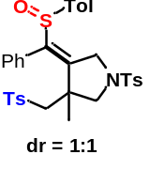 (Z)-3-methyl-4-(phenyl(p-tolylsulfinyl)methylene)-1-tosyl-3-(tosylmethyl)pyr rolidine (86) White Solid; dr = 1 : 1. ¹H-NMR (600 MHz, CDCl₃) δ 7.80 – 7.74 (m, 4H), 7.51 (d, J = 8.4 Hz, 2H), 7.42 – 7.40 (m, 4H), 7.38 (d, J = 8.4 Hz, 2H), 7.34 – 7.16 (m, 9H), 7.12 – 7.09 (m, 6H), 7.03 – 6.98 (m, 6H), 6.00 –6.10 (m, 1H), 4.68 – 4.60 (m, 2H), 4.41 (d, J = 15.0 Hz, 1H), 4.32 (d, J = 15.0 Hz, 1H), 3.86 (d, J = 10.2 Hz, 1H), 3.60 (d, J = 10.2 Hz, 1H), 3.32 (d, J = 10.2 Hz, 1H), 3.16 – 3.06 (m, 2H), 2.97 (d, J = 14.4 Hz, 1H), 2.82 (d, J = 14.4 Hz, 1H), 2.73 (d, J = 14.4 Hz, 1H), 2.48 (s, 6H), 2.39 (s, 6H), 2.35 – 2.29 (m, 6H), 1.30 (s, 3H), 1.04 (s, 3H); ¹³C-NMR (150 MHz, CDCl₃) δ 149.1, 148.8, 144.83, 144.75, 144.5, 144.4, 141.7, 141.5, 141.3, 140.8, 138.0, 137.8, 137.52, 137.46, 131.6, 131.3, 130.11, 130.07, 130.0, 129.9, 129.8, 129.6, 129.5, 129.0, 128.9, 128.12, 128.10, 127.7, 127.5, 127.4, 127.3, 127.1, 124.4, 124.1, 61.52, 61.47, 58.0, 57.5, 51.4, 50.6, 46.8, 46.5, 24.4, 24.2, 21.67, 21.66, 21.6, 21.44, 21.41; HRMS (ESI) m/z calculated C₃₄H₃₅NNaO₅S₃ [M+Na]⁺ 656.1570, found 656.1589.

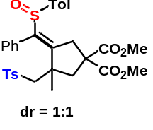 (E)-dimethyl 3-methyl-4-(phenyl(p-tolylsulfinyl)methylene)-3- (tosylmethyl)cyclopentane-1,1-dicarboxylate (87) White Solid; dr = 1 : 1. ¹H-NMR (500 MHz, CDCl₃) δ 7.49 (d, J = 8.0 Hz, 2H), 7.43 (d, J = 8.0 Hz, 2H), 7.34 – 7.00 (m, 1H), 7.28 – 7.20 (m, 7H), 7.16 – 7.12 (m, 9H), 7.10 – 7.05 (m, 1H), 6.97 – 6.85 (m, 2H), 6.05 – 5.91 (m, 2H), 4.05 (d, J = 17.5 Hz, 1H), 3.92 (d, J = 17.5 Hz, 1H), 3.83 – 3.81 (m, 12H), 3.75 – 3.65 (m, 2H), 3.29 (d, J = 14.5 Hz, 1H), 3.21 (d, J = 14.5 Hz, 1H), 3.01 – 3.00 (m, 3H), 2.92 (d, J = 14.5 Hz, 1H), 2.60 (d, J = 14.5 Hz, 1H), 2.53 (d, J = 14.5 Hz, 1H), 2.40 – 2.34 (m, 12H), 1.15 (s, 3H), 1.01 (s, 3H); ¹³C-NMR (150 MHz, CDCl₃) δ 171.8, 171.32, 171.27, 153.4, 153.3, 144.5, 144.4, 141.90, 141.86, 141.0, 140.9, 138.8, 138.7, 138.5, 138.4, 133.4, 132.4, 131.1, 130.1, 129.8, 129.7, 129.41, 129.36, 128.63, 128.58, 128.2, 128.0, 127.2, 127.1, 124.4, 124.1, 63.8, 63.6, 58.2, 57.8, 53.33, 53.30, 53.22, 53.15, 46.8, 46.7, 45.6, 44.6, 40.0, 39.3, 27.6, 27.1, 21.6, 21.40, 21.37; HRMS (ESI) m/z calculated C₃₂H₃₄NaO₇S₂ [M+Na]⁺ 617.1638, found 617.1642.

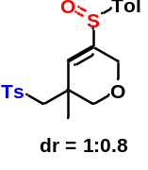3-methyl-5-(p-tolylsulfinyl)-3-(tosylmethyl)-3,6-dihydro-2H-pyran (88) White Solid; dr = 1 : 0.8. ¹H-NMR (600 MHz, CDCl₃) δ 7.76 (d, J = 7.8 Hz, major, 2H), 7.69 (d, J = 7.8 Hz, minor, 2H), 7.51 (d, J = 7.8 Hz, minor, 2H), 7.45 (d, J = 7.8 Hz, major, 2H), 7.36 – 7.27 (m, major, 4H, minor, 4H), 6.07 (s, minor, 1H), 6.01 (s, major, 1H), 4.95 (d, J = 15.6 Hz, minor, 1H), 4.84 (d, J = 15.6 Hz, major, 1H), 4.75 – 4.71 (m, major, 1H, minor, 1H), 4.28 (d, J = 9.6 Hz, major, 1H), 4.22 (d, J = 9.6 Hz, minor, 1H), 3.83 (d, J = 9.6 Hz, major, 1H), 3.70 (d, J = 9.6 Hz, minor, 1H), 3.25 – 3.14 (m, major, 2H, minor, 2H), 2.49 – 2.40 (m, major, 6H, minor, 6H), 1.46 – 1.45 (m, major, 3H, minor, 3H); ¹³C-NMR (125 MHz, CDCl₃) δ 159.3, 158.3, 145.12, 145.07, 141.9, 141.8, 140.3, 138.0, 137.9, 130.3, 130.2, 130.09, 130.06, 128.9, 127.70, 127.66, 126.9, 126.7, 124.3, 124.1, 77.0, 69.1, 68.7, 62.4, 62.2, 47.0, 46.9, 22.5, 22.4, 21.7, 21.5; HRMS (ESI) m/z calculated C₂₁H₂₄NaO₄S₂ [M+Na]⁺ 427.1008, found 427.1026.

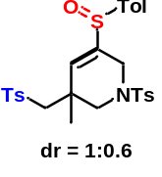3-methyl-5-(p-tolylsulfinyl)-1-tosyl-3-(tosylmethyl)-1,2,3,6-tetrahydropyridine (89) White Solid; dr = 1 : 0.6. ¹H-NMR (600 MHz, CDCl₃) δ 7.74 – 7.72 (m, major, 2H, minor, 2H), 7.70 (d, J = 8.4 Hz, major, 2H), 7.65 (d, J = 8.4 Hz, minor, 2H), 7.48 (d, J = 8.4 Hz, minor, 2H), 7.41 (d, J = 8.4 Hz, major, 2H), 7.40 – 7.37 (m, major, 2H, minor, 2H), 7.35 – 7.33 (m, major, 2H), 7.32 – 7.29 (m, major, 2H, minor, 4H), 6.13 (t, J = 2.4 Hz, minor, 1H), 5.99 (t, J = 2.4 Hz, major, 1H), 4.36 – 4.25 (m, major, 2H), 4.19 (dd, J = 16.1, 2.4 Hz, major, 1H), 3.82 (d, J = 10.2 Hz, minor, 1H), 3.51 (d, J = 10.2 Hz, major, 1H), 3.40 (d, J = 10.2 Hz, major, 1H), 3.22 – 3.09 (m, major, 1H, minor, 4H), 2.88 (d, J = 10.2 Hz, minor, 1H), 2.46 – 2.43 (m, major, 6H, minor, 6H), 2.39 (s, major, 3H), 2.38 (s, minor, 3H), 1.43 (s, major, 3H), 1.42 (s, minor, 3H); ¹³C-NMR (150 MHz, CDCl₃) δ 154.8, 153.5, 145.2, 145.1, 144.5, 144.4, 142.1, 141.9, 139.8, 139.6, 137.8, 137.7, 131.9, 131.8, 130.3, 130.2, 130.10, 130.08, 130.05, 129.7, 128.9, 128.0, 127.9, 127.68, 127.65, 124.3, 124.1, 62.1, 62.0, 57.4, 57.0, 49.5, 49.1, 46.2, 46.1, 23.7, 22.4, 21.7, 21.67, 21.64, 21.4; HRMS (ESI) m/z calculated C₂₈H₃₁NNaO₅S₃ [M+Na]⁺ 580.1257, found 580.1253.

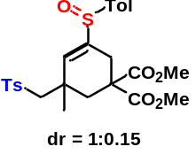dimethyl 5-methyl-3-(p-tolylsulfinyl)-5-(tosylmethyl)cyclohex-3-ene-1,1- dicarboxylate (90) White Solid; dr = 1 : 0.15. (major isomer): ¹H-NMR (600 MHz, CDCl₃) δ 7.69 (d, J = 7.8 Hz, 2H), 7.39 (d, J = 7.8 Hz, 2H), 7.28 (d, J = 7.8 Hz, 2H), 7.24 (d, J = 7.8 Hz, 2H), 5.90 (s, 1H), 3.71 (s, 6H), 3.51 (d, J = 18.0 Hz, 1H), 3.36 (dd, J = 18.1, 1.8 Hz, 1H), 3.21– 3.13 (m, 2H), 3.05 (d, J = 13.8 Hz, 1H), 2.52 (d, J = 14.4 Hz, 1H), 2.38 (s, 3H), 2.33 (s, 3H), 1.30 (s, 3H); ¹³C-NMR (150 MHz, CDCl₃) δ 171.5, 171.4, 160.3, 144.9, 141.5, 140.7, 138.2, 130.18, 130.16, 130.0, 127.6, 123.9, 64.7, 58.5, 53.4, 53.2, 46.3, 44.0, 37.6, 26.7, 21.6, 21.4; HRMS (ESI) m/z calculated C₂₆H₃₀NaO₇S₂ [M+Na]⁺ 541.1325, found 541.1328.

1-(p-tolylsulfinyl)-2-tosylbenzene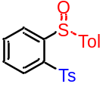 (91) White Solid; mp: 156-157 °C; ¹H-NMR (500 MHz, CDCl₃) δ 8.22 (d, J = 8.0 Hz, 1H), 8.10 (d, J = 8.0 Hz, 1H), 7.86 (d, J = 8.0 Hz, 2H), 7.76 – 7.70 (m, 3H), 7.60 (t, J = 7.5 Hz, 1H), 7.32 (d, J = 8.0 Hz, 2H), 7.25 (d, J = 8.0 Hz, 2H), 2.41 (s, 3H), 2.36 (s, 3H); ¹³C-NMR (150 MHz, CDCl₃) δ 146.5, 145.0, 142.3, 141.4, 139.3, 138.1, 134.5, 131.3, 130.1, 129.9, 129.5, 128.0, 126.4, 125.7, 21.6, 21.3; HRMS (ESI) m/z calculated C₂₀H₁₈NaO₃S₂ [M+Na]⁺ 393.0590, found 393.0583.

1-Methoxy-2-(p-tolylsulfinyl)-3-tosylbenzene (92) White Solid; mp: 199-200 °C; ¹H-NMR (600 MHz, CDCl₃) δ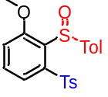 7.95 – 7.92 (m, 1H), 7.90 (d, J = 8.4 Hz, 2H), 7.59 (t, J = 7.8 Hz, 1H), 7.54 (d, J = 8.4 Hz, 2H), 7.35 (d, J = 7.8 Hz, 2H), 7.20 (d, J = 8.4 Hz, 2H), 7.11 (d, J = 8.4 Hz, 1H), 3.61 (s, 3H), 2.41 (s, 3H), 2.36 (s, 3H); ¹³C-NMR (150 MHz, CDCl₃) δ 160.2, 144.8, 143.1, 139.9, 139.4, 138.1, 133.0, 130.3, 130.0, 128.9, 128.4, 124.9, 120.9, 118.8, 56.2, 21.6, 21.2; HRMS (ESI) m/z calculated C₂₁H₂₀NaO₄S₂ [M+Na]⁺ 423.0695, found 423.0687.

1,4-Dimethyl-2-(p-tolylsulfinyl)-3-tosylbenzene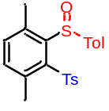 (93) White Solid; mp: 145-146 °C; ¹H-NMR (600 MHz, CDCl₃) δ 7.91 (d, J = 8.4 Hz, 2H), 7.60 (d, J = 7.8 Hz, 2H), 7.35 (d, J = 8.4 Hz, 2H), 7.29 (d, J = 7.8 Hz, 1H), 7.27 – 7.23 (m, 3H), 2.82 (s, 3H), 2.42 (s, 3H), 2.38 (s, 3H), 2.25 (s, 3H); ¹³C-NMR (150 MHz, CDCl₃) δ 144.5, 143.6, 141.0, 140.6, 140.1, 140.0, 139.1, 138.6, 137.9, 135.8, 130.0, 129.3, 127.1, 126.1, 22.5, 21.6, 21.2, 18.9; HRMS (ESI) m/z calculated C₂₂H₂₂NaO₃S₂ [M+Na]⁺ 421.0903, found 421.0897.

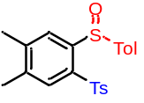1,2-dimethyl-4-(p-tolylsulfinyl)-5-tosylbenzene (94) White Solid; mp: 149-150 °C; ¹H-NMR (600 MHz, CDCl₃) δ 7.89 (s, 1H), 7.85 – 7.82 (m, 3H), 7.72 (d, J = 7.8 Hz, 2H), 7.29 (d, J = 7.8 Hz, 2H), 7.23 (d, J = 7.8 Hz, 2H), 2.39 (s, 3H), 2.35 (s, 3H), 2.33 (s, 3H), 2.32 (s, 3H); ¹³C-NMR (150 MHz, CDCl₃) δ 144.63, 144.58, 143.0, 142.6, 141.1, 141.0, 138.5, 136.4, 130.3, 130.0, 129.8, 127.8, 127.1, 125.6, 21.5, 21.3, 20.0, 19.7; HRMS (ESI) m/z calculated C₂₂H₂₂NaO₃S₂ [M+Na]⁺ 421.0903, found 421.0894.

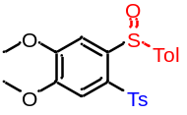1,2-Dimethoxy-4-(p-tolylsulfinyl)-5-tosylbenzene (95) White Solid; mp: 168-169 °C; ¹H-NMR (600 MHz, CDCl₃) δ 7.84 (d, J = 8.4 Hz, 2H), 7.71 (d, J = 8.4 Hz, 2H), 7.60 (s, 1H), 7.54 (s, 1H), 7.30 (d, J = 7.8 Hz, 2H), 7.24 (d, J = 7.8 Hz, 2H), 3.97 (s, 3H), 3.93 (s, 3H), 2.40 (s, 3H), 2.36 (s, 3H); ¹³C-NMR (150 MHz, CDCl₃) δ 153.7, 150.7, 144.6, 142.6, 141.2, 138.7, 131.2, 130.0, 129.8, 127.5, 125.4, 111.3, 107.6, 56.6, 56.5, 21.5, 21.2; HRMS (ESI) m/z calculated C₂₂H₂₂NaO₅S₂ [M+Na]⁺ 453.0801, found 453.0799.

1,2-Difluoro-4-(p-tolylsulfinyl)-5-tosylbenzene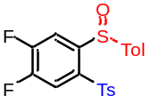 (96) White Solid; mp: 141-142 °C; ¹H-NMR (600 MHz, CDCl₃) δ 8.02 (dd, J = 9.6, 7.2 Hz, 1H), 7.91 (dd, J = 9.6, 7.2 Hz, 1H), 7.84 (d, J = 8.4 Hz, 2H), 7.74 (d, J = 7.8 Hz, 2H), 7.35 (d, J = 8.4 Hz, 2H), 7.27 (d, J = 7.8 Hz, 2H), 2.43 (s, 3H), 2.38 (s, 3H); ¹³C-NMR (150 MHz, CDCl₃) δ 154.0 (dd, J = 262.5, 13.5 Hz), 151.18 (dd, J = 258.0, 13.5 Hz), 145.6, 144.7 (t, J = 4.5 Hz), 142.0, 141.6, 137.4, 136.2 (t, J = 4.5 Hz), 130.3, 130.1, 128.0, 125.5, 119.3 (d, J = 21.0 Hz), 116.1 (d, J = 21.0 Hz), 21.6, 21.3; HRMS (ESI) m/z calculated C₂₀H₁₆F₂NaO₃S₂ [M+Na]⁺ 429.0401, found 429.0392.

5-(p-tolylsulfinyl)-6-tosylbenzo[d][1,3]dioxole (97) White Solid; mp: 152-153 °C; ¹H-NMR (600 MHz, CDCl₃) δ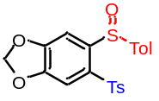 7.85 (d, J = 8.4 Hz, 2H), 7.51 (s, 1H), 7.50 (s, 1H), 7.50 (d, J = 8.4 Hz, 2H), 7.32 (d, J = 7.8 Hz, 2H), 7.25 (d, J = 8.4 Hz, 2H), 6.07 (ABq, J = 1.2 Hz, 2H),, 2.41 (s, 3H), 2.36 (s, 3H); ¹³C-NMR (150 MHz, CDCl₃) δ 152.7, 150.0, 144.8, 142.4, 142.2, 141.3, 138.5, 133.6, 130.1, 129.8, 127.7, 125.3, 108.9, 105.9, 103.2, 21.6, 21.3; HRMS (ESI) m/z calculated C₂₁H₁₈NaO₅S₂ [M+Na]⁺ 437.0488, found 437.0476.

2-(p-tolylsulfinyl)-3-tosylnaphthalene (98) White Solid; mp: 148-149 °C; ¹H-NMR (600 MHz, CDCl₃) δ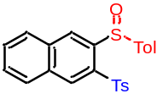 8.75 (s, 1H), 8.69 (s, 1H), 8.03 (d, J = 7.8 Hz, 1H), 8.00 (d, J = 7.8 Hz, 1H), 7.86 (d, J = 8.4 Hz, 2H), 7.75 – 7.65 (m, 4H), 7.28 (d, J = 7.8 Hz, 2H), 7.21 (d, J = 8.4 Hz, 2H), 2.38 (s, 3H), 2.33 (s, 3H); ¹³C-NMR (150 MHz, CDCl₃) δ 144.7, 142.8, 141.4, 140.8, 138.2, 135.5, 134.9, 133.0, 131.8, 130.1, 130.0, 129.8, 129.3, 129.2, 128.7, 127.9, 127.7, 126.1, 21.6, 21.3; HRMS (ESI) m/z calculated C₂₄H₂₀NaO₃S₂ [M+Na]⁺ 443.0746, found 443.0740.

4-Methyl-1-(p-tolylsulfinyl)-2-tosylbenzene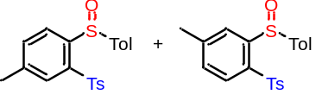 and 4-Methyl-2-(p-tolylsulfinyl)-1-tosylbenzene (99) White Solid; 1:1; ¹H-NMR (600 MHz, CDCl₃) δ 8.08 (d, J = 8.4 Hz, 1H), 7.98 (s, 1H), 7.97 (d, J = 7.8 Hz, 1H), 7.90 (s, 1H), 7.85 (d, J = 8.4 Hz, 2H), 7.82 (d, J = 8.4 Hz, 2H), 7.73 (d, J = 7.8 Hz, 2H), 7.71 (d, J = 8.4 Hz, 2H), 7.51 (d, J = 7.8 Hz, 1H), 7.37 (d, J = 8.4 Hz, 1H), 7.30 (d, J = 8.4 Hz, 2H), 7.28 (d, J = 8.4 Hz, 2H), 7.25 – 7.20 (m, 4H), 2.43 (s, 3H), 2.42 (s, 3H), 2.39 (s, 3H), 2.38 (s, 3H), 2.35 (s, 3H), 2.34 (s, 3H); ¹³C-NMR (150 MHz, CDCl₃) δ 145.94, 145.90, 144.8, 144.6, 143.2, 142.6, 142.31, 142.29, 141.22, 141.16, 139.0, 138.4, 138.2, 136.4, 135.2, 132.0, 129.99, 129.95, 129.76, 129.72, 129.66, 129.60, 127.9, 127.7, 126.46, 126.45, 125.6, 125.5, 21.6, 21.52, 21.49, 21.24, 21.23, 21.18; HRMS (ESI) m/z calculated C₂₁H₂₀NaO₃S₂ [M+Na]⁺ 407.0746, found 407.0750.

4,4'-(4-Methyl-1,2-phenylenedisulfonyl)bis(methylbenzene)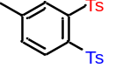 (100) White Solid; mp: 140-141 °C; ¹H-NMR (500 MHz, CDCl₃) δ 8.33 (d, J = 8.0 Hz, 1H), 8.26 (s, 1H), 7.85 (d, J = 8.5 Hz, 2H), 7.82 (d, J = 8.0 Hz, 2H), 7.56 (d, J = 7.5 Hz, 1H), 7.30 – 7.25 (m, 4H), 2.51 (s, 3H), 2.39 (s, 3H), 2.38 (s, 3H); ¹³C-NMR (125 MHz, CDCl₃) δ 145.2, 144.0, 143.9, 140.1, 138.9, 138.7, 137.5, 134.0, 133.5, 133.2, 129.23, 129.20, 128.0, 127.9, 21.6, 21.5, 21.4; HRMS (ESI) m/z calculated C₂₁H₂₀NaO₄S₂ [M+Na]⁺ 423.0695, found 423.0696.

4-Chloro-1-(p-tolylsulfinyl)-2-tosylbenzene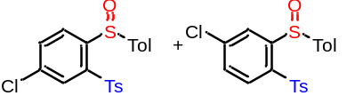 and 4-Chloro-2-(p-tolylsulfinyl)-1-tosylbenzene (101) White Solid; 1:1; ¹H-NMR (600 MHz, CDCl₃) δ 8.17 (d, J = 2.4 Hz, 1H), 8.15 (d, J = 8.4 Hz, 1H), 8.05 (d, J = 2.4 Hz, 1H), 8.00 (d, J = 8.4 Hz, 1H), 7.86 (d, J = 8.4 Hz, 2H), 7.82 (d, J = 8.4 Hz, 2H), 7.75 (d, J = 8.4 Hz, 2H), 7.72 (d, J = 8.4 Hz, 2H), 7.66 (dd, J = 8.4, 1.8 Hz, 1H), 7.52 (dd, J = 8.4, 2.1 Hz, 1H), 7.34 (d, J = 8.4 Hz, 2H), 7.32 (d, J = 7.8 Hz, 2H), 7.28 – 7.23 (m, 4H), 2.42 (s, 3H), 2.41 (s, 3H), 2.37 (s, 3H), 2.36 (s, 3H); ¹³C-NMR (150 MHz, CDCl₃) δ 148.6, 145.5, 145.3, 144.9, 142.0, 141.8, 141.74, 141.69, 141.6, 140.8, 137.80, 137.78, 137.5, 137.4, 134.5, 131.6, 131.0, 130.3, 130.2, 130.03, 129.98, 129.2, 128.1, 128.1, 127.9, 126.4, 125.7, 125.6, 21.7, 21.6, 21.4, 21.3; HRMS (ESI) m/z calculated C₂₀H₁₇ClNaO₃S₂ [M+Na]⁺ 427.0200, found 427.0213.

4,4'-(4-Chloro-1,2-phenylenedisulfonyl)bis(methylbenzene)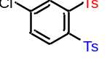 (102) White Solid; mp: 143-144 °C; ¹H-NMR (600 MHz, CDCl₃) δ 8.43 (d, J = 2.4 Hz, 1H), 8.38 (d, J = 8.4 Hz, 1H), 7.87 (d, J = 8.4 Hz, 2H), 7.83 (d, J = 8.4 Hz, 2H), 7.73 (dd, J = 8.4, 2.4 Hz, 1H), 7.32 (d, J = 8.4 Hz, 2H), 7.30 (d, J = 8.4 Hz, 2H), 2.42 (s, 3H), 2.41 (s, 3H); ¹³C-NMR (150 MHz, CDCl₃) δ 144.7, 144.5, 142.3, 140.6, 139.0, 138.3, 138.0, 134.5, 133.5, 133.0, 129.5, 129.4, 128.4, 128.2, 21.7, 21.6; HRMS (ESI) m/z calculated C₂₀H₁₇ClNaO₄S₂ [M+Na]⁺ 443.0149, found 443.0133.

1-(p-tolylsulfinyl)-2-tosylnaphthalene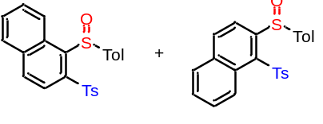 and 2-(p-tolylsulfinyl)-1-tosylnaphthalene (103) White Solid; 1:1; ¹H-NMR (600 MHz, CDCl₃) δ 8.89 (d, J = 9.0 Hz, 1H), 8.79 (d, J = 9.0 Hz, 1H), 8.56 (d, J = 9.0 Hz, 1H), 8.42 (d, J = 9.0 Hz, 1H), 8.25 (d, J = 9.0 Hz, 1H), 8.14 (d, J = 8.4 Hz, 1H), 7.93 (d, J = 8.4 Hz, 2H), 7.89 (d, J = 8.4 Hz, 2H), 7.84 – 7.80 (m, 5H), 7.64 – 7.61 (m, 3H), 7.62 – 7.58 (m, 1H), 7.58 – 7.52 (m, 2H), 7.45 – 7.41 (m, 1H), 7.34 (d, J = 8.4 Hz, 2H), 7.26 – 7.20 (m, 6H), 2.40 (s, 3H), 2.36 (s, 3H), 2.34 (s, 3H), 2.33 (s, 3H); ¹³C-NMR (150 MHz, CDCl₃) δ 149.5, 144.9, 144.7, 143.6, 141.19, 141.15, 140.3, 140.0, 139.3, 138.7, 138.3, 136.9, 135.9, 134.9, 133.6, 133.3, 130.1, 130.0, 129.9, 129.8, 129.7, 129.1, 129.1, 129.02, 128.97, 128.3, 128.0, 127.0, 126.4, 126.2, 125.1, 125.0, 123.5, 120.3, 21.6, 21.5, 21.24, 21.17; HRMS (ESI) m/z calculated C₂₄H₂₀NaO₃S₂ [M+Na]⁺ 443.0746, found 443.0752.

1,2-Ditosylnaphthalene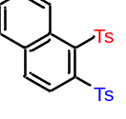 (104) White Solid; mp: 178-179 °C; ¹H-NMR (600 MHz, CDCl₃) δ 8.84 – 8.79 (m, 2H), 8.29 (d, J = 8.4 Hz, 1H), 8.06 (d, J = 8.4 Hz, 2H), 7.94 (d, J = 8.4 Hz, 1H), 7.78 (d, J = 8.4 Hz, 2H), 7.62 (t, J = 7.2 Hz, 1H), 7.60 – 7.56 (m, 1H), 7.30 – 7.26 (m, 4H), 2.40 (s, 3H), 2.37 (s, 3H); ¹³C-NMR (150 MHz, CDCl₃) δ 144.4, 143.3, 142.3, 140.9, 139.6, 137.4, 136.2, 134.8, 130.6, 129.8, 129.1, 129.01, 128.97, 128.7, 127.2, 127.0, 126.9, 126.6, 21.59, 21.57; HRMS (ESI) m/z calculated C₂₄H₂₀NaO₄S₂ [M+Na]⁺ 459.0695, found 459.0683.

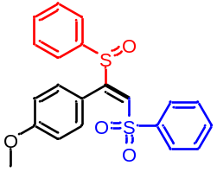(E)-1-Methoxy-4-(1-(phenylsulfinyl)-2-(phenylsulfonyl)vinyl)benzene (105) White Solid; mp: 139-140 °C; ¹H-NMR (600 MHz, CDCl₃) δ 7.71– 7.68 (m, 2H), 7.57 (t, J = 7.8 Hz, 1H), 7.47 – 7.39 (m, 3H), 7.33 – 7.29 (m, 3H), 7.22 – 7.20 (m, 2H), 6.91 (d, J = 9.0 Hz, 2H), 6.78 (d, J = 9.0 Hz, 2H), 3.79 (s, 3H); ¹³C-NMR (150 MHz, CDCl₃) δ 161.2, 161.0, 140.5, 140.4, 133.6, 131.8, 130.8, 129.03, 128.99, 128.5, 127.7, 125.1, 119.8, 113.6, 55.2; HRMS (ESI) m/z calculated C₂₁H₁₈NaO₄S₂ [M+Na]⁺ 421.0539, found 421.0553.

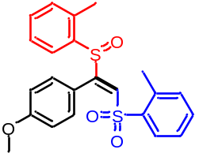(E)-1-((2-(4-Methoxyphenyl)-2-(o-tolylsulfinyl)vinyl)sulfonyl)-2-methylbenzene (106) White Solid; mp: 151-152 °C; ¹H-NMR (600 MHz, CDCl₃) δ 7.68 (dd, J = 7.8, 0.6 Hz, 1H), 7.62 (dd, J = 7.8, 0.6 Hz, 1H), 7.43 (s, 1H), 7.41 (td, J = 7.8, 1.2 Hz, 1H), 7.35 (t, J = 7.2 Hz, 1H), 7.31 (td, J = 7.2, 1.2 Hz, 1H), 7.25 (d, J = 7.8 Hz, 1H), 7.14 (t, J = 7.8 Hz, 1H), 6.98 (d, J = 7.2 Hz, 1H), 6.72 (d, J = 8.4 Hz, 2H), 6.66 (d, J = 8.4 Hz, 2H), 3.76 (s, 3H), 2.61 (s, 3H), 1.86 (s, 3H); ¹³C-NMR (150 MHz, CDCl₃) δ 161.4, 160.9, 139.3, 138.7, 138.0, 137.9, 133.6, 132.3, 131.8, 130.6, 130.4, 129.4, 129.2, 127.5, 126.2, 125.0, 119.7, 113.6, 55.3, 20.5, 18.5; HRMS (ESI) m/z calculated C₂₃H₂₂NaO₄S₂ [M+Na]⁺ 449.0852, found 449.0834.

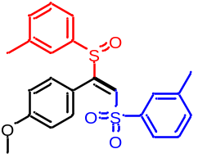(E)-1-((2-(4-Methoxyphenyl)-2-(m-tolylsulfinyl)vinyl)sulfonyl)-3-methylbenzene (107) White Solid; mp: 139-140 °C; ¹H-NMR (600 MHz, CDCl₃) δ 7.50 (d, J = 7.8 Hz, 1H), 7.45 (s, 1H), 7.37 (d, J = 7.8 Hz, 1H), 7.33 (t, J = 7.2 Hz, 1H), 7.29 (s, 1H), 7.22 (d, J = 7.2 Hz, 1H), 7.17 (t, J = 7.8 Hz, 1H), 7.10 (s, 1H), 6.93 – 6.89 (m, 3H), 6.83 – 6.77 (m, 2H), 3.82 (s, 3H), 2.35 (s, 3H), 2.30 (s, 3H); ¹³C-NMR (150 MHz, CDCl₃) δ 161.1, 160.7, 140.2, 139.5, 139.3, 134.4, 132.7, 130.9, 128.9, 128.8, 128.7, 128.2, 125.2, 124.9, 122.6, 120.1, 113.6, 55.3, 21.3, 21.2; HRMS (ESI) m/z calculated C₂₃H₂₂NaO₄S₂ [M+Na]⁺ 449.0852, found 449.0854.

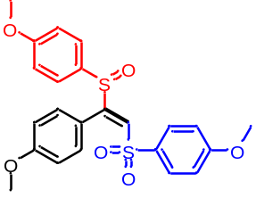(E)-1-Methoxy-4-((2-(4-methoxyphenyl)-2-((4-ethoxyphenyl)sulfinyl) vinyl)sulfonyl)benzene (108) White Solid; mp: 126-127 °C; ¹H-NMR (600 MHz, CDCl₃) δ 7.61 (d, J = 8.4 Hz, 2H), 7.29 (s, 1H), 7.20 (d, J = 8.4 Hz, 2H), 6.91 (d, J = 8.4 Hz, 2H), 6.89 (d, J = 8.4 Hz, 2H), 6.82 (d, J = 8.4 Hz, 2H), 6.78 (d, J = 8.4 Hz, 2H), 3.85 (s, 3H), 3.80 (s, 3H), 3.79 (s, 3H); ¹³C-NMR (150 MHz, CDCl₃) δ 163.7, 162.5, 161.0, 160.0, 132.1, 131.3, 130.8, 130.0, 129.1, 127.5, 120.3, 114.6, 114.2, 113.6, 55.7, 55.5, 55.2; HRMS (ESI) m/z calculated C₂₃H₂₂NaO₆S₂ [M+Na]⁺ 481.0750, found 481.0754.

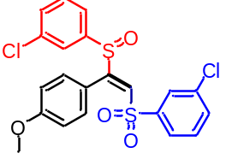(E)-1-Chloro-3-((2-((3-chlorophenyl)sulfinyl)-2-(4-methoxyphenyl)vin yl)sulfonyl)benzene (109) White Solid; mp: 122-123 °C; ¹H-NMR (600 MHz, CDCl₃) δ 7.60 (d, J = 7.8 Hz, 1H), 7.56 – 7.51 (m, 2H), 7.42 – 7.37 (m, 2H), 7.27 (s, 1H), 7.25 (t, J = 7.8 Hz, 1H), 7.19 (s, 1H), 7.00 (d, J = 7.8 Hz, 1H), 6.91 (d, J = 8.4 Hz, 2H), 6.85 (d, J = 8.4 Hz, 2H), 3.84 (s, 3H); ¹³C-NMR (150 MHz, CDCl₃) δ 161.7, 161.5, 142.4, 141.9, 135.5, 135.3, 133.9, 132.1, 130.9, 130.4, 130.2, 128.8, 128.1, 126.0, 124.8, 123.1, 119.2, 114.0, 55.4; HRMS (ESI) m/z calculated C₂₁H₁₆Cl₂NaO₄S₂ [M+Na]⁺ 488.9759, found 488.9764.

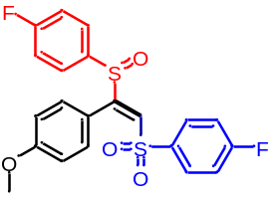(E)-1-Fluoro-4-((2-((4-fluorophenyl)sulfinyl)-2-(4-methoxyphenyl)vin yl)sulfonyl)benzene (110) White Solid; mp: 150-151 °C; ¹H-NMR (600 MHz, CDCl₃) δ 7.71 – 7.66 (m, 2H), 7.28 (s, 1H), 7.24 – 7.19 (m, 2H), 7.11 (t, J = 8.4 Hz, 2H), 7.03 (t, J = 8.4 Hz, 2H), 6.92 (d, J = 8.4 Hz, 2H), 6.81 (d, J = 8.4 Hz, 2H), 3.82 (s, 3H); ¹³C-NMR (150 MHz, CDCl₃) δ 165.7 (d, J = 256.0 Hz), 164.7 (d, J = 253.5 Hz), 161.4, 161.0, 136.4 (d, J = 3.0 Hz), 135.9 (d, J = 3.0 Hz), 130.8, 130.7 (d, J = 9.0 Hz), 128.7, 127.5 (d, J = 9.0 Hz), 119.6, 116.5 (d, J = 22.5 Hz), 116.3 (d, J = 22.5 Hz), 113.9, 55.3; ¹⁹F-NMR (564 MHz, CDCl₃) δ (-102.93)–(-103.00) (m), (-106.19)–(-106.27) (m); HRMS (ESI) m/z calculated C₂₁H₁₆F₂NaO₄S₂ [M+Na]⁺ 457.0350, found 457.0349.

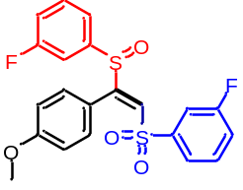(E)-1-Fluoro-3-((2-((3-fluorophenyl)sulfinyl)-2-(4-methoxyphenyl)vinyl) sulfonyl)benzene (111) White Solid; mp: 93-94 °C; ¹H-NMR (600 MHz, CDCl₃) δ 7.54 – 7.51 (m, 1H), 7.46 (td, J = 7.8, 5.4 Hz, 1H), 7.37 – 7.33 (m, 1H), 7.32 – 7.27 (m, 2H), 7.26 (s, 1H), 7.14 – 7.10 (m, 1H), 7.00 – 6.94 (m, 3H), 6.92 – 6.89 (m, 1H), 6.85 (d, J = 8.4 Hz, 2H), 3.84 (s, 3H); ¹³C-NMR (150 MHz, CDCl₃) δ 162.6 (d, J = 253.0 Hz), 162.3 (d, J = 252.6 Hz), 161.6, 161.4, 142.9 (d, J = 6.0 Hz), 142.3 (d, J = 6.6 Hz), 131.0 (d, J = 7.5 Hz), 130.9, 130.7 (d, J = 7.5 Hz), 128.4, 123.7 (d, J = 3.3 Hz), 121.1 (d, J = 21.0 Hz), 120.8 (d, J = 3.3 Hz), 119.4, 119.2 (d, J = 21.0 Hz), 115.3 (d, J = 24.0 Hz), 114.0, 112.1 (d, J = 24.0 Hz), 55.4; ¹⁹F-NMR (470 MHz, CDCl₃) δ (-108.98)–(-109.07) (m), (-109.21)–(-109.30) (m); HRMS (ESI) m/z calculated C₂₁H₁₆F₂NaO₄S₂ [M+Na]⁺ 457.0350, found 457.0352.

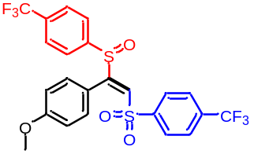(E)-1-Methoxy-4-(1-((4-(trifluoromethyl)phenyl)sulfinyl)-2-((4-(trifluoromethyl)phenyl)sulfonyl)vinyl)benzene (112) White Solid; mp: 141-142 °C; ¹H-NMR (600 MHz, CDCl₃) δ 7.81 (d, J = 7.8 Hz, 2H), 7.70 (d, J = 8.4 Hz, 2H), 7.60 (d, J = 8.4 Hz, 2H), 7.32 – 7.26 (m, 3H), 6.95 (d, J = 8.4 Hz, 2H), 6.84 (d, J = 8.4 Hz, 2H), 3.85 (s, 3H); ¹³C-NMR (150 MHz, CDCl₃) δ 161.8, 161.6, 144.9, 143.6, 135.4 (q, J = 33.0 Hz), 133.8 (q, J = 33.0 Hz), 131.0, 128.5, 128.4, 126.2 (q, J = 3.6 Hz), 126.1 (q, J = 3.6 Hz), 125.2, 123.2 (q, J = 271.5 Hz), 123.0 (q, J = 271.5 Hz), 119.1, 114.1, 55.4; ¹⁹F-NMR (564 MHz, CDCl₃) δ -63.00 (s), -63.29 (s); HRMS (ESI) m/z calculated C₂₃H₁₆F₆NaO₄S₂ [M+Na]⁺ 557.0286, found 557.0275.

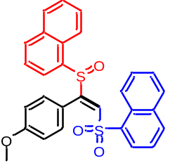(E)-1-((2-(4-Methoxyphenyl)-2-(naphthalen-1-ylsulfinyl)vinyl)sulfonyl) naphthalene (113) White Solid; mp: 164-165 °C; ¹H-NMR (600 MHz, CDCl₃) δ 8.54 (d, J = 8.4 Hz, 1H), 7.97 (d, J = 8.4 Hz, 1H), 7.92 – 7.85 (m, 3H), 7.81 (d, J = 8.4 Hz, 1H), 7.78 – 7.73 (m, 2H), 7.71 (s, 1H), 7.67 (t, J = 7.8 Hz, 1H), 7.61 (t, J = 7.8 Hz, 1H), 7.43 (t, J = 7.8 Hz, 1H), 7.40 (t, J = 7.8 Hz, 1H), 7.31 (t, J = 7.8 Hz, 1H), 7.23 (t, J = 7.8 Hz, 1H), 6.44 – 6.35 (m, 4H), 3.63 (s, 3H); ¹³C-NMR (150 MHz, CDCl₃) δ 161.04, 161.03, 160.7, 136.4, 135.3, 135.0, 134.0, 133.2, 132.6, 130.6, 130.4, 130.0, 129.9, 129.0, 128.6, 128.5, 127.2, 126.9, 126.6, 125.7, 125.2, 124.4, 124.1, 122.4, 119.4, 113.3, 55.2; HRMS (ESI) m/z calculated C₂₉H₂₂NaO₄S₂ [M+Na]⁺ 521.0852, found 521.0859.

(E)-3-(1-(p-tolylsulfinyl)-2-tosylvinyl)aniline (114) White Solid; mp: 140-141 °C;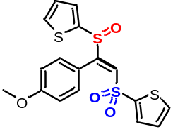 ¹H-NMR (600 MHz, CDCl₃) δ 7.66 (dd, J = 4.8, 1.2 Hz, 1H), 7.59 – 7.57 (m, 1H), 7.49 (dd, J = 3.6, 1.2 Hz, 1H), 7.45 (s, 1H), 7.12 – 7.09 (m, 1H), 7.08 – 7.03 (m, 3H), 6.92 – 6.89 (m, 1H), 6.83 – 6.80 (m, 2H), 3.78 (s, 3H); ¹³C-NMR (150 MHz, CDCl₃) δ 161.2, 159.9, 141.7, 141.3, 134.6, 134.2, 132.8, 132.4, 130.6, 129.2, 127.8, 127.2, 119.6, 113.8, 55.2; HRMS (ESI) m/z calculated C₁₇H₁₄NaO₄S₄ [M+Na]⁺ 432.9667, found 432.9663.

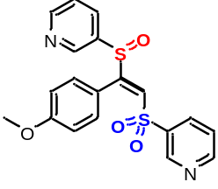(E)-3-((2-(4-methoxyphenyl)-2-(pyridin-3-ylsulfinyl)vinyl)sulfonyl)pyridine (115) White Solid; mp: 148-149 °C; ¹H-NMR (600 MHz, CDCl₃) δ 8.85 (d, J = 1.8 Hz, 1H), 8.79 (dd, J = 4.8, 1.2 Hz, 1H), 8.65 (dd, J = 4.8, 1.8 Hz, 1H), 8.16 (d, J = 1.8 Hz, 1H), 7.97 – 7.94 (m, 1H), 7.74 – 7.72 (m, 1H), 7.40 – 7.36 (m, 2H), 7.33 (s, 1H), 6.98 (d, J = 8.4 Hz, 2H), 6.85 (d, J = 9.0 Hz, 2H), 3.82 (s, 3H); ¹³C-NMR (150 MHz, CDCl₃) δ 161.8, 161.7, 154.1, 152.6, 148.7, 146.3, 137.4, 136.7, 135.4, 132.2, 130.7, 128.5, 124.3, 123.5, 118.6, 114.2, 55.3; HRMS (ESI) m/z calculated C₁₉H₁₆N₂NaO₄S₄ [M+Na]⁺ 423.0444, found 423.0434.

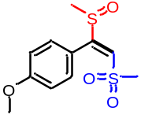(E)-1-methoxy-4-(1-(methylsulfinyl)-2-(methylsulfonyl)vinyl)benzene (116) White Solid; ¹H-NMR (500 MHz, CDCl₃) δ 7.41 – 7.39 (m, 2H), 7.12 (s, 1H), 7.01 – 6.98 (m, 2H), 3.85 (s, 3H), 2.93 (s, 3H), 2.47 (s, 3H); ¹³C-NMR (125 MHz, CDCl₃) δ 161.9, 161.4, 130.1, 127.9, 120.1, 114.7, 55.4, 43.4, 39.3; HRMS (ESI) m/z calculated C₁₁H₁₄NaO₄S₂ [M+Na]⁺ 297.0226, found 297.0226.

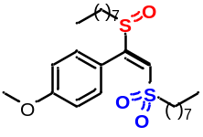(E)-1-methoxy-4-(1-(octylsulfinyl)-2-(octylsulfonyl)vinyl)benzene (117) White Solid; ¹H-NMR (600 MHz, CDCl₃) δ 7.40 (d, J = 9.0 Hz, 2H), 6.98 (d, J = 8.4 Hz, 2H), 6.97 (s, 1H), 3.84 (s, 3H), 2.98 – 2.93 (m, 2H), 2.61 – 2.55 (m, 1H), 2.40 – 2.34 (m, 1H), 1.80 – 1.71 (m, 3H), 1.61 – 1.55 (m, 1H), 1.37 – 1.33 (m, 3H), 1.30 – 1.17 (m, 17H), 0.90 – 0.83 (m, 6H); ¹³C-NMR (150 MHz, CDCl₃) δ 161.6, 159.6, 129.9, 127.1, 120.4, 114.3, 55.2, 55.1, 51.1, 31.48, 31.47, 28.8, 28.74, 28.73, 28.69, 28.2, 28.1, 22.4, 22.0, 21.0, 13.9; HRMS (ESI) m/z calculated C₂₅H₄₂NaO₄S₂ [M+Na]⁺ 493.2417, found 493.2415.

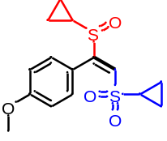(E)-1-(1-(cyclopropylsulfinyl)-2-(cyclopropylsulfonyl)vinyl)-4-methoxyben zene (118) White Solid; ¹H-NMR (500 MHz, CDCl₃) δ 7.40 (d, J = 9.0 Hz, 2H), 7.01 (s, 1H), 6.97 (d, J = 9.0 Hz, 2H), 3.84 (s, 3H), 2.42 – 2.37 (m, 1H), 1.92 – 1.87 (m, 1H), 1.26 – 1.22 (m, 1H), 1.18 – 1.43 (m, 1H), 1.04 – 0.96 (m, 3H), 0.79 – 0.71 (m, 3H); ¹³C-NMR (125 MHz, CDCl₃) δ 161.5, 159.8, 130.3, 127.4, 121.0, 114.2, 55.3, 32.0, 29.2, 5.40, 5.35, 4.1, 0.8; HRMS (ESI) m/z calculated C₁₅H₁₈NaO₄S₂ [M+Na]⁺ 349.0539, found 349.0520.

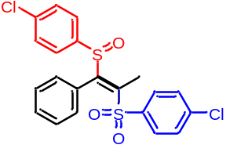(E)-1-Chloro-4-((1-((4-chlorophenyl)sulfinyl)-1-phenylprop-1-en-2-yl)sulfonyl)benzene (119) White Solid; mp: 183-184 °C; ¹H-NMR (600 MHz, CDCl₃) δ 7.33 (d, J = 8.4 Hz, 2H), 7.28 (t, J = 7.8 Hz, 1H), 7.26 – 7.22 (m, 4H), 7.14 (t, J = 7.2 Hz, 1H), 7.06 – 7.00 (m, 3H), 6.68 (d, J = 7.2 Hz, 1H), 6.20 (d, J = 7.2 Hz, 1H), 2.78 (s, 3H); ¹³C-NMR (150 MHz, CDCl₃) δ 153.3, 144.9, 140.3, 139.4, 137.9, 137.8, 131.0, 130.8, 129.3, 129.2, 129.1, 126.9, 126.8, 126.2, 125.6, 15.5; HRMS (ESI) m/z calculated C₂₁H₁₆Cl₂NaO₃S₂ [M+Na]⁺ 472.9810, found 472.9820.

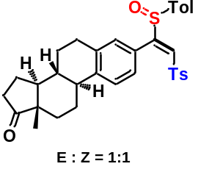(8R,9S,13S,14S)-13-Methyl-3-((E)-1-(p-tolylsulfinyl)-2-tosylvinyl)-7,8, 9,11,12,13,15,16-octahydro-6H-cyclopenta[a]phenanthren-17(14H)-one (120) White Solid; E : Z = 1 : 1. mp: 169-170 °C; ¹H-NMR (600 MHz, CDCl₃) δ 7.60 – 7.56 (m, 4H), 7.30 – 7.26 (m, 2H), 7.23 – 7.21 (m, 4H), 7.17 – 7.10 (m, 10H), 6.71 – 6.66 (m, 2H), 6.63 (s, 1H), 6.59 (s, 1H), 2.86 – 2.78 (m, 2H), 2.75 – 2.63 (m, 2H), 2.55 – 2.49 (m, 2H), 2.41 (s, 6H), 2.39 – 2.33 (m, 8H), 2.32 – 2.25 (m, 2H), 2.21 – 2.11 (m, 2H), 2.10 – 2.04 (m, 2H), 2.03 – 1.94 (m, 4H), 1.68 – 1.44 (m, 12H), 0.94 (s, 6H); ¹³C-NMR (150 MHz, CDCl₃) δ 220.44, 220.42, 160.6, 160.5, 144.6, 142.6, 142.0, 141.9, 137.6, 137.2, 136.3, 136.2, 129.70, 129.67, 129.59, 129.56, 129.2, 129.0, 128.9, 127.9, 126.9, 126.5, 125.5, 125.4, 125.0, 50.50, 50.47, 47.84, 47.82, 44.4, 44.3, 37.81, 37.76, 35.8, 31.5, 29.1, 29.0, 26.24, 26.20, 25.5, 25.4, 21.6, 21.5, 21.4, 13.84, 13.82; HRMS (ESI) m/z calculated C₃₄H₃₆NaO₄S₂ [M+Na]⁺ 595.1947, found 595.1933. HRMS (ESI) m/z calculated C₃₄H₃₆NaO₄S₂ [M+Na]⁺ 595.1947, found 595.1958.

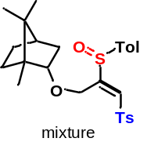(1S,2S,4R)-1,7,7-trimethyl-2-(((E)-2-(p-tolylsulfinyl)-3-tosylallyl)oxy) bicyclo[2.2.1]heptane (121) White Solid; mixture. ¹H-NMR (600 MHz, CDCl₃) δ 7.85 – 7.80 (m, 2H), 7.55 – 7.50 (m, 2H), 7.37 (d, J = 7.8 Hz, 2H), 7.31 – 7.27 (m, 2H), 7.19 – 7.14 (m, 1H), 5.25 – 5.12 (m, 1H), 4.08 – 3.94 (m, 0.5H), 3.90 (d, J = 15.0 Hz, 0.25H), 3.78 (d, J = 15.0 Hz, 0.25H), 3.54 (t, J = 10.2 Hz, 0.5H), 3.23 (d, J = 5.4 Hz, 0.25H), 3.15 (d, J = 5.4 Hz, 0.25H),2.46 (s, 3H), 2.41 (s, 3H), 2.14 – 1.74 (m, 1.33H), 1.74 – 1.51 (m, 3H), 1.26 – 1.11 (m, 1H), 1.03 – 0.70 (m, 12H); ¹³C-NMR (150 MHz, CDCl₃) δ 161.00, 160.95, 160.8, 145.3, 143.00, 142.97, 138.3, 138.1, 137.4, 130.30, 130.28, 130.24, 130.16, 130.14, 128.6, 128.2, 128.1, 127.8, 127.7, 127.6, 126.40, 126.35, 126.2, 88.7, 87.5, 86.7, 85.5, 63.9, 63.4, 63.0, 62.0, 49.6, 49.5, 49.43, 49.37, 48.02, 48.00, 46.59, 46.56, 45.0, 44.93, 44.86, 44.8, 38.2, 37.9, 35.8, 35.3, 34.29, 34.25, 28.14, 28.12, 27.2, 27.1, 26.6, 26.5, 21.7, 21.6, 20.23, 20.20, 20.17, 19.72, 19.70, 18.8, 14.1, 12.12, 12.08; HRMS (ESI) m/z calculated C₂₇H₃₄NaO₄S₂ [M+Na]⁺ 509.1791, found 509.1796.

(3R,6R)-3,6-bis(((E)-2-(p-tolylsulfinyl)-3-tosylallyl)oxy)hexahy drofuro[3,2-b]furan (122) White Solid; mixture. ¹H-NMR (600 MHz, CDCl₃) δ 7.86 – 7.76 (m, 4H), 7.58 – 7.46 (m, 4H), 7.42 – 7.34 (m, 4H), 7.31 – 7.30 (m, 4H), 7.23 – 7.19 (m, 2H), 5.45 – 5.34 (m, 1H), 5.24 (d, J = 14.4 Hz, 1H), 4.69 – 4.64 (m, 0.5H), 4.60 – 4.56 (m, 0.5H), 4.48 – 4.44 (m, 0.5H), 4.33 – 4.27 (m, 0.5H), 4.20 – 4.09 (m, 1.5H), 4.06 – 3.95 (m, 1.5H), 3.94 – 3.78 (m, 3.5H), 3.75 – 3.70 (m, 0.5H), 3.69 – 3.63 (m, 0.5H), 3.49 – 3.46 (m, 0.5H), 2.51 – 2.37 (m, 12H); ¹³C-NMR (150 MHz, CDCl₃) δ 159.4, 159.32, 159.27, 159.2, 158.74, 158.67, 158.63, 158.58, 145.61, 145.57, 145.55, 143.4, 143.2, 143.1, 138.3, 137.9, 137.83, 137.79, 137.1, 137.0, 136.9, 130.4, 130.33, 130.28, 130.26, 130.2, 130.08, 130.05, 129.3, 129.2, 129.1, 129.0, 128.9, 128.5, 128.3, 127.9, 127.83, 127.78, 127.4, 126.4, 126.33, 126.29, 126.26, 126.2, 85.79, 85.75, 85.4, 85.3, 84.5, 84.4, 84.3, 80.6, 80.5, 80.44, 80.39, 80.3, 80.0, 79.9, 73.2, 73.0, 72.44, 72.41, 70.4, 70.1, 70.0, 64.53, 64.48, 63.6, 63.5, 62.93, 62.91, 62.89, 62.85, 21.8, 21.6; HRMS (ESI) m/z calculated C₄₀H₄₂NaO₁₀S₄ [M+Na]⁺ 833.1553, found 833.1559.

(E)-4-Methyl-7-(1-(p-tolylsulfinyl)-2-tosylvinyl)-2H-chromen-2-one (123) White Solid; mp: 177-178 °C; ¹H-NMR (600 MHz, CDCl₃) δ 7.64 (d, J = 7.8 Hz, 2H), 7.50 (d, J = 8.4 Hz, 1H), 7.35 (s, 1H), 7.30 (d, J = 7.8 Hz, 2H), 7.19 – 7.14 (m, 4H), 6.92 (dd, J = 7.8, 1.8 Hz, 1H), 6.85 (d, J = 1.8 Hz, 1H), 6.35 (q, J = 1.2 Hz, 1H), 2.44 (s, 3H), 2.43 (d, J = 1.2 Hz, 3H), 2.37 (s, 3H); ¹³C-NMR (150 MHz, CDCl₃) δ 159.9, 158.3, 152.6, 151.7, 145.4, 143.5, 137.1, 136.4, 132.0, 130.5, 130.2, 130.0, 127.9, 125.7, 125.5, 124.3, 120.9, 117.1, 116.4, 21.7, 21.6, 18.6; HRMS (ESI) m/z calculated C₂₆H₂₂NaO₅S₂ [M+Na]⁺ 501.0801, found 501.0800.

(1S,2S,4R)-2-(((E)-2,3-ditosylallyl)oxy)-1,7,7-trimethylbicyclo[2.2.1]heptane (124) White Solid; dr = 1:1; ¹H-NMR (600 MHz, CDCl₃) δ 7.86 – 7.81 (m, 4H), 7.74 – 7.70 (m, 4H), 7.47 (s, 1H), 7.46 (s, 1H), 7.39 (d, J = 8.4 Hz, 4H), 7.35 – 7.31 (m, 4H), 4.65 – 4.61 (m, 2H), 4.59 (d, J = 11.4 Hz, 1H),4.49 (d, J = 11.4 Hz, 1H), 3.57 – 3.53 (m, 1H), 3.23 – 3.19 (m, 1H), 2.48 (s, 6H), 2.44 (m, 3H), 2.43 (m, 3H), 2.02 – 1.96 (m, 1H), 1.61 – 1.53 (m, 5H), 1.50 – 1.38 (m, 3H), 1.03 – 0.91 (m, 4H), 0.82 – 0.79 (m, 1H), 0.78 (s, 3H), 0.77 (s, 3H), 0.72 (s, 3H), 0.69 (s, 3H), 0.664 (s, 3H), 0.655 (s, 3H); ¹³C-NMR (150 MHz, CDCl₃) δ 149.6, 149.5, 145.9, 145.5, 145.4, 138.5, 138.4, 136.39, 136.37, 135.1, 134.9, 130.26, 130.25, 130.0, 129.9, 128.9, 128.8, 128.21, 128.17, 88.8, 86.4, 60.7, 60.1, 49.4, 49.2, 47.9, 46.3, 45.0, 44.8, 37.6, 35.2, 34.3, 27.9, 27.1, 26.2, 21.7, 21.6, 20.1, 19.9, 19.6, 18.8, 13.6, 11.5; HRMS (ESI) m/z calculated C₂₇H₃₄NaO₅S₂ [M+Na]⁺ 525.1740, found 525.1749.

(3R,3aR,6R,6aR)-3,6-bis(((E)-2,3-ditosylallyl)oxy)hexahydrofuro[3,2-b]furan (125) White Solid; ¹H-NMR (600 MHz, CDCl₃) δ 7.84 – 7.81 (m, 4H), 7.73 (d, J = 8.4 Hz, 2H), 7.70 (d, J = 8.4 Hz, 2H), 7.58 (s, 1H), 7.52 (s, 1H), 7.40 (d, J = 8.4 Hz, 4H), 7.35 (d, J = 8.4 Hz, 2H), 7.32 (d, J = 7.8 Hz, 2H), 4.96 (d, J = 12.6 Hz, 1H), 4.85 (d, J = 13.2 Hz, 1H), 4.77 – 4.73 (m, 2H), 4.47 (t, J = 3.6 Hz, 1H), 4.18 (d, J = 4.2 Hz, 1H), 3.85 – 3.82 (m, 1H), 3.78 (t, J = 3.0 Hz, 1H), 3.63 (d, J = 2.4 Hz, 2H), 3.38 (dd, J = 9.0, 6.6 Hz, 1H), 3.14 (dd, J = 9.0, 6.6 Hz, 1H), 2.48 (s, 3H), 2.46 (s, 3H), 2.44 (s, 3H), 2.43 (s, 3H); ¹³C-NMR (150 MHz, CDCl₃) δ 149.3, 148.6, 146.21, 146.19, 145.8, 145.7, 139.6, 139.3, 136.0, 135.9, 135.2, 135.0, 130.382, 130.375, 130.0, 129.9, 129.0, 128.8, 128.23, 128.19, 85.3, 84.0, 80.2, 79.1, 72.6, 69.9, 61.02, 59.98, 21.72, 21.70, 21.65; HRMS (ESI) m/z calculated C₄₀H₄₂NaO₁₂S₄ [M+Na]⁺ 865.1451, found 865.1462.

(E)-6,7-bis(2-methoxyethoxy)-N-(3-(1-(p-tolylsulfinyl)-2-tosylvinyl)phenyl)quinazolin-4-amine (126) White Solid; mp: 190-191 °C; ¹H-NMR (600 MHz, CDCl₃) δ 8.56 (s, 1H), 7.89 (d, J = 7.8 Hz, 1H), 7.81 (br., 1H), 7.61 (d, J = 8.4 Hz, 2H), 7.36 (s, 1H), 7.32 (s, 2H), 7.25 – 7.18 (m, 6H), 7.11 (d, J = 8.4 Hz, 2H), 6.63 (d, J = 7.2 Hz, 1H), 4.33 – 4.23 (m, 4H), 3.85 – 3.77 (m, 4H), 3.45 (s, 6H), 2.35 (s, 3H), 2.28 (s, 3H); ¹³C-NMR (150 MHz, CDCl₃) δ 160.4, 156.1, 154.6, 153.0, 149.0, 145.0, 142.8, 138.9, 137.2, 136.7, 129.9, 129.8, 129.2, 128.64, 128.61, 127.8, 125.6, 124.3, 123.0, 121.8, 109.1, 108.3, 102.6, 70.9, 70.4, 69.2, 68.3, 59.23, 59.21, 21.6, 21.4; HRMS (ESI) m/z calculated C₃₆H₃₇N₃NaO₇S₂ [M+Na]⁺ 710.1965, found 710.1950.

(E)-2-(p-tolylsulfinyl)-3-tosylallyl 2-(4-((5-chloro-3-fluoropyridin-2-yl)oxy)phenoxy)propanoate (127) White Solid; dr = 1 : 1; ¹H-NMR (600 MHz, CDCl₃) δ 7.88 – 7.84 (m, 4H), 7.82 (d, J = 2.4 Hz, 1H), 7.80 (d, J = 2.4 Hz, 1H), 7.50 – 7.46 (m, 2H), 7.46 – 7.44 (m, 4H), 7.39 (d, J = 7.8 Hz, 4H), 7.30 (d, J = 8.4 Hz, 2H), 7.27 (d, J = 7.8 Hz, 2H), 7.25 (d, J = 10.2 Hz, 2H), 7.11 – 7.07 (m, 4H), 6.92 – 6.88 (m, 4H), 5.88 (d, J = 13.8 Hz, 1H), 5.82 (d, J = 14.4 Hz, 1H), 4.76 – 4.73 (m, 2H), 4.59 (d, J = 14.4 Hz, 1H), 4.50 (d, J = 14.4 Hz, 1H), 2.47 (s, 6H), 2.41 (s, 3H), 2.40 (s, 3H), 1.63 (d, J = 6.6 Hz, 3H), 1.58 (d, J = 7.2 Hz, 3H); ¹³C-NMR (150 MHz, CDCl₃) δ 171.0, 155.6, 155.5, 154.64, 154.60, 151.23 (d, J = 11.0 Hz), 151.21 (d, J = 11.0 Hz), 147.3, 146.97 (d, J = 264.2 Hz), 146.93 (d, J = 264.2 Hz), 145.66, 145.65, 143.8, 140.10 (d, J = 6.1 Hz), 140.09 (d, J = 11.0 Hz), 137.0, 136.9, 136.59, 136.56, 130.7, 130.6, 130.5, 130.2, 128.03, 127.99, 126.33, 126.27, 125.06 (d, J = 1.4 Hz), 124.95 (d, J = 18.1 Hz), 124.90 (d, J = 18.1 Hz), 124.8 (d, J = 1.4 Hz), 122.5, 122.4, 116.10, 116.07, 73.0, 72.8, 57.6, 57.3, 21.7, 21.6, 18.49, 18.46; HRMS (ESI) m/z calculated C₃₁H₂₇ClFNNaO₇S₂ [M+Na]⁺ 666.0794, found 666.0796.

Methyl-4-((phenylethynyl)sulfonyl)benzene (128) White Solid; mp: 73-74 °C; ¹H-NMR (600 MHz, CDCl₃) δ 7.96 (d, J = 8.4 Hz, 2H), 7.53 – 7.50 (m, 2H), 7.47 (t, J = 7.8 Hz, 1H), 7.41 – 7.34 (m, 4H), 2.47 (s, 3H); ¹³C-NMR (150 MHz, CDCl₃) δ 145.4, 138.9, 132.7, 131.4, 130.0, 128.6, 127.5, 118.0, 92.9, 85.6, 21.7; HRMS (ESI) m/z calculated C₁₅H₁₂NaO₂S [M+Na]⁺ 279.0450, found 279.0455.

(E)-Phenyl(2-phenyl-2-(phenylsulfinyl)vinyl)sulfane (129) White Solid; mp: 117-118 °C; ¹H-NMR (600 MHz, CDCl₃) δ 7.42 (s, 1H), 7.36 (d, J = 7.8 Hz, 2H), 7.32 – 7.28 (m, 3H), 7.26 (d, J = 8.4 Hz, 2H), 7.18 – 7.15 (m, 4H), 7.11 (d, J = 7.8 Hz, 2H), 2.35 (s, 3H), 2.30 (s, 3H); ¹³C-NMR (150 MHz, CDCl₃) δ 141.4, 139.8, 139.1, 138.1, 132.0, 131.5, 130.8, 130.4, 130.1, 129.5, 128.9, 128.8, 128.5, 125.0, 21.3, 21.1; HRMS (ESI) m/z calculated C₂₂H₂₀NaOS₂ [M+Na]⁺ 387.0848, found 387.0844.

1-methyl-4-((1-phenylvinyl)sulfinyl)benzene (130) White Solid; mp: 105-106 °C; ¹H-NMR (600 MHz, CDCl₃) δ 7.33 (d, J = 8.4 Hz, 2H), 7.29 – 7.26 (m, 3H), 7.22 – 7.18 (m, 2H), 7.12 (d, J = 7.8 Hz, 2H), 6.24 (s, 1H), 5.92 (s, 1H), 2.30 (s, 3H); ¹³C-NMR (150 MHz, CDCl₃) δ 154.4, 141.7, 139.5, 133.8, 129.7, 129.0, 128.6, 127.5, 125.5, 116.1, 21.4; HRMS (ESI) m/z calculated C₁₅H₁₄NaOS [M+Na]⁺ 265.0658, found 265.0655.

(E)-1-methyl-4-(styrylsulfonyl)benzene (131) White Solid; ¹H-NMR (600 MHz, CDCl₃) δ 7.83 (d, J = 8.4 Hz, 2H), 7.66 (d, J = 15.6 Hz, 1H), 7.48 (d, J = 6.6 Hz, 2H), 7.41 – 7.37 (m, 3H), 7.34 (d, J = 7.8 Hz, 2H), 6.85 (d, J = 15.6 Hz, 1H), 2.44 (s, 3H); ¹³C-NMR (150 MHz, CDCl₃) δ 144.4, 142.0, 137.8, 132.5, 131.1, 130.0, 129.1, 128.6, 127.74, 127.65, 21.6; HRMS (ESI) m/z calculated C₁₅H₁₄NaO₂S [M+Na]⁺ 281.0607, found 281.0622.

(Z)-methyl(2-phenyl-2-(p-tolylsulfinyl)vinyl)sulfane (132) White Solid; ¹H-NMR (600 MHz, CDCl₃) δ 7.28 – 7.25 (m, 5H), 7.18 (s, 1H), 7.12 – 7.10 (m, 4H), 2.45 (s, 3H), 2.31 (s, 3H); ¹³C-NMR (150 MHz, CDCl₃) δ 141.5, 140.0, 137.8, 133.4, 131.9, 129.6, 128.9, 128.6, 128.5, 125.1, 21.4, 17.7; HRMS (ESI) m/z calculated C₁₆H₁₆NaOS₂ [M+Na]⁺ 311.0535, found 311.0552.

(Z)-allyl(2-phenyl-2-(p-tolylsulfinyl)vinyl)sulfane (133) White Solid; ¹H-NMR (600 MHz, CDCl₃) δ 7.29 – 7.24 (m, 5H), 7.22 (s, 1H), 7.12 – 7.10 (m, 4H), 5.91 – 5.84 (m, 1H), 5.33 – 5.29 (m, 1H), 5.23 (d, J = 9.6 Hz, 1H), 3.47 (d, J = 6.6 Hz, 2H), 2.31 (s, 3H); ¹³C-NMR (150 MHz, CDCl₃) δ 141.4, 140.0, 138.8, 133.3, 131.9, 131.2, 129.6, 128.9, 128.7, 128.5, 125.1, 118.8, 37.1, 21.4; HRMS (ESI) m/z calculated C₁₈H₁₈NaOS₂ [M+Na]⁺ 337.0691, found 337.0690.

(Z)-phenyl(2-phenyl-2-(p-tolylsulfinyl)vinyl)selane (134) White Solid; ¹H-NMR (600 MHz, CDCl₃) δ 7.74 (s, 1H), 7.60 – 7.58 (m, 2H), 7.34 – 7.30 (m, 6H), 7.25 (d, J = 8.4 Hz, 2H), 7.13 – 7.10 (m, 4H), 2.31 (s, 3H); ¹³C-NMR (150 MHz, CDCl₃) δ 142.5, 141.6, 139.8, 133.1, 132.6, 129.60, 129.55, 129.47, 129.1, 128.73, 128.70, 128.4, 128.2, 125.1, 21.4; HRMS (ESI) m/z calculated C₂₁H₁₈NaOSSe [M+Na]⁺ 421.0136, found 421.0156.

(Z)-N-(1-phenyl-2-tosylvinyl)cyclohexanamine (135) White Solid; ¹H-NMR (600 MHz, CDCl₃) δ 7.81 (d, J = 8.4 Hz, 2H), 7.41 – 7.38 (m, 1H), 7.35 (t, J = 7.2 Hz, 2H), 7.30 – 7.26 (m, 4H), 4.71 (s, 1H), 3.01 – 2.98 (m, 1H), 2.42 (s, 3H), 1.75 – 1.72 (m, 2H), 1.68 – 1.65 (m, 2H), 1.50 – 1.47 (m, 1H), 1.30 – 1.24 (m, 3H), 1.17 – 1.08 (m, 3H); ¹³C-NMR (150 MHz, CDCl₃) δ 159.3, 142.7, 142.2, 135.9, 129.7, 129.5, 128.5, 127.8, 125.9, 92.9, 53.1, 34.4, 25.2, 24.6, 21.5; HRMS (ESI) m/z calculated C₂₁H₂₅NNaO₂S [M+Na]⁺ 378.1498,found 378.1512.

(Z)-1-(1-phenyl-2-tosylvinyl)pyrrolidine (136) White Solid; ¹H-NMR (600 MHz, CDCl₃) δ 7.35 (t, J = 7.8 Hz, 1H), 7.31 – 7.26 (m, 4H), 7.07 (d, J = 7.8 Hz, 2H), 7.00 (d, J = 7.2 Hz, 2H), 5.24 (s, 1H), 3.23 (s, br., 2H), 2.85 (s, br., 2H), 2.35 (s, 3H), 2.07 – 1.91 (m, 2H), 1.81 – 1.69 (m, 2H); ¹³C-NMR (150 MHz, CDCl₃) δ 158.2, 143.1, 141.5, 133.9, 128.82, 128.79, 128.6, 127.9, 126.7, 95.6, 29.3, 25.3, 21.4; HRMS (ESI) m/z calculated C₁₉H₂₁NNaO₂S [M+Na]⁺ 350.1185, found 350.1183.

(Z)-1-((2-azido-2-phenylvinyl)sulfonyl)-4-methylbenzene (137) White Solid; ¹H-NMR (600 MHz, CDCl₃) δ 7.29 – 7.26 (m, 5H), 7.21 (s, 1H), 7.14 (d, J = 7.8 Hz, 2H), 7.10 – 7.08 (m, 2H), 2.33 (s, 3H); ¹³C-NMR (150 MHz, CDCl₃) δ 141.8, 139.4, 134.2, 129.8, 129.7, 129.3, 129.2, 128.9, 128.4, 125.1, 21.4; HRMS (ESI) m/z calculated C₁₅H₁₃N₃NaO₂S [M+Na]⁺ 322.0621, found 322.0628.

(Z)-1-((2-methoxy-2-phenylvinyl)sulfonyl)-4-methylbenzene (138) White Solid; ¹H-NMR (600 MHz, CDCl₃) δ 7.44 – 7.39 (m, 3H), 7.33 – 7.28 (m, 4H), 7.13 (d, J = 7.8 Hz, 2H), 5.89 (s, 1H), 3.75 (s, 3H), 2.37 (s, 3H); ¹³C-NMR (150 MHz, CDCl₃) δ 169.2, 143.3, 140.2, 132.9, 130.3, 129.2, 129.1, 127.7, 127.2, 106.2, 56.7, 21.5; HRMS (ESI) m/z calculated C₁₆H₁₆NaO₃S [M+Na]⁺ 311.0712, found 311.0725.

(Z)-1-((2-(allyloxy)-2-phenylvinyl)sulfonyl)-4-methylbenzene (139) White Solid; ¹H-NMR (600 MHz, CDCl₃) δ 7.43 – 7.40 (m, 3H), 7.33 – 7.28 (m, 4H), 7.13 (d, J = 7.8 Hz, 2H), 5.96 – 5.92 (m, 1H), 5.90 (s, 1H), 5.38 – 5.33 (m, 1H), 5.30 (d, J = 10.8 Hz, 1H), 4.42 (d, J = 5.4 Hz, 2H), 2.37 (s, 3H); ¹³C-NMR (150 MHz, CDCl₃) δ 167.9, 143.2, 140.2, 132.8, 131.0, 130.3, 129.23, 129.20, 127.7, 127.2, 119.2, 107.1, 70.2, 21.5; HRMS (ESI) m/z calculated C₁₈H₁₈NaO₃S [M+Na]⁺ 337.0869, found 337.0865.

(Z)-1-methyl-4-((2-phenyl-2-((3-phenylprop-2-yn-1-yl)oxy)vinyl)sulfonyl) benzene (140) White Solid; ¹H-NMR (600 MHz, CDCl₃) δ 7.71 – 7.68 (m, 2H), 7.45 – 7.39 (m, 5H), 7.28 (t, J = 7.2 Hz, 2H), 7.25 – 7.23 (m, 1H), 7.21 (d, J = 7.2 Hz, 2H), 7.09 (d, J = 7.8 Hz, 2H), 6.92 (s, 1H), 4.00 (s, 2H), 2.33 (s, 3H); ¹³C-NMR (150 MHz, CDCl₃) δ 157.8, 143.8, 140.7, 139.6, 138.7, 130.0, 129.8, 129.4, 129.1, 129.0, 128.5, 128.0, 126.8, 126.5, 126.0, 122.6, 30.6, 21.5; HRMS (ESI) m/z calculated C₂₄H₂₀NaO₃S [M+Na]⁺ 411.1025, found 411.1029.

1-(ethylsulfinyl)-4-methylbenzene (141) Cololrless oil; ¹H-NMR (600 MHz, CDCl₃) δ 7.50 (d, J = 7.8 Hz, 2H), 7.32 (d, J = 7.8 Hz, 2H), 2.91 – 2.83 (m, 1H), 2.79 – 2.72 (m, 1H), 2.42 (s, 3H), 1.19 (t, J = 7.2 Hz, 2H); ¹³C-NMR (150 MHz, CDCl₃) δ 141.3, 140.1, 129.8, 124.2, 50.3, 21.4, 6.0; HRMS (ESI) m/z calculated C₉H₁₂NaOS [M+Na]⁺ 191.0501, found 191.0501.

1,4-Diphenylbuta-1,3-diyne (142) White Solid; mp: 87-88 °C; ¹H-NMR (600 MHz, CDCl₃) δ 7.55 – 7.51 (m, 4H), 7.39 – 7.32 (m, 6H); ¹³C-NMR (150 MHz, CDCl₃) δ 132.5, 129.2, 128.4, 121.8, 81.5, 73.9; HRMS (ESI) m/z calculated C₁₆H₁₀Na [M+Na]⁺ 225.0675, found 225.0678.

(E)-4,4'-(1-Phenylethene-1,2-diyldisulfonyl)bis(methylbenzene) (143) White Solid; mp: 152-153 °C; ¹H-NMR (600 MHz, CDCl₃) δ 7.75 (s, 1H), 7.45 (d, J = 8.4 Hz, 2H), 7.38 – 7.34 (m, 3H), 7.22 – 7.16 (m, 6H), 6.92 (d, J = 7.8 Hz, 2H), 2.41 (s, 3H), 2.39 (s, 3H); ¹³C-NMR (150 MHz, CDCl₃) δ 152.7, 145.7, 145.4, 137.5, 136.3, 133.1, 130.2, 130.0, 129.8, 129.7, 129.2, 128.2, 127.7, 127.0, 21.69, 21.65; HRMS (ESI) m/z calculated C₂₂H₂₀NaO₄S₂ [M+Na]⁺ 435.0695, found 435.0686.

(E)-(2-((1-Phenyl-2-tosylvinyl)oxy)phenyl)(p-tolyl)sulfane (144) Yellow Liquid; ¹H-NMR (600 MHz, CDCl₃) δ 7.62 – 7.59 (m, 2H), 7.46 – 7.42 (m, 1H), 7.40 (d, J = 8.4 Hz, 2H), 7.35 (t, J = 7.8 Hz, 2H), 7.26 (d, J = 8.4 Hz, 2H), 7.21 (td, J = 7.8, 1.2 Hz, 1H), 7.17 (d, J = 8.4 Hz, 2H), 7.11 – 7.05 (m, 4H), 6.97 (dd, J = 7.8, 1.2 Hz, 1H), 5.73 (s, 1H), 2.37 (s, 3H), 2.32 (s, 3H); ¹³C-NMR (150 MHz, CDCl₃) δ 167.4, 149.4, 143.2, 139.5, 138.7, 133.6, 131.6, 131.3, 130.6, 130.5, 130.4, 129.7, 129.0, 128.2, 127.7, 127.6, 127.2, 127.1, 122.4, 110.2, 21.5, 21.2; HRMS (ESI) m/z calculated C₂₈H₂₄NaO₃S₂ [M+Na]⁺ 495.1059, found 495.1045.

4-Phenyl-4-(p-tolylthio)-3-tosylbut-3-enenitrile (145) White Solid; E : Z = 1 : 2; ¹H-NMR (600 MHz, CDCl₃) δ 8.21 (d, J = 8.4 Hz, minor, 2H), 7.42 (d, J = 8.4 Hz, minor, 2H), 7.21 (d, J = 8.4 Hz, major, 2H), 7.15 – 7.10 (m, minor, 3H), 7.04 (d, J = 8.4 Hz, major, 2H), 7.02 (t, J = 7.8 Hz, major, 1H), 7.00 – 6.97 (m, minor, 2H), 6.93 (d, J = 7.8 Hz, major, 2H), 6.90 (t, J = 7.8 Hz, major, 2H), 6.81 (d, J = 7.8 Hz, major, 2H), 6.73 (d, J = 7.8 Hz, minor, 2H), 6.69 (d, J = 7.2 Hz, major, 2H), 6.58 (d, J = 8.4 Hz, minor, 2H), 4.13 (s, major, 2H), 3.46 (s, minor, 2H), 2.48 (s, minor, 3H), 2.33 (s, major, 3H), 2.15 (s, major, 3H), 2.12 (s, minor, 3H); ¹³C-NMR (150 MHz, CDCl₃) δ 159.4, 158.5, 144.9, 143.9, 139.7, 139.1, 137.27, 136.6, 135.4, 134.5, 132.89, 129.7, 129.40, 129.37, 129.3, 129.2, 129.1, 128.8, 128.41, 128.37, 128.1, 127.4, 127.1, 126.9, 126.7, 126.4, 124.5, 117.0, 115.7, 21.6, 21.4, 21.1, 21.0, 20.9, 19.6 HRMS (ESI) m/z calculated C₂₄H₂₁NNaO₂S₂ [M+Na]⁺ 442.0906, found 442.0897.

(E)-1-methyl-4-((5-(p-tolylsulfinyl)pent-2-en-1-yl)sulfonyl)benzene (146) White Solid; ¹H-NMR (600 MHz, CDCl₃) δ 7.73 (d, J = 8.4 Hz, 2H), 7.32 (d, J = 8.4 Hz, 2H), 7.21 (d, J = 8.4 Hz, 2H), 7.10 (d, J = 8.4 Hz, 2H), 5.60 – 5.51 (m, 1H), 5.51 – 5.39 (m, 1H), 3.73 (d, J = 7.2 Hz, 2H), 2.79 (t, J = 7.2 Hz, 2H), 2.43 (s, 3H), 2.32 (s, 3H), 2.29 (q, J = 7.2 Hz, 2H); ¹³C-NMR (150 MHz, CDCl₃) δ 144.7, 138.8, 136.5, 135.4, 132.0, 130.4, 129.8, 129.7, 128.6, 118.1, 60.1, 33.6, 32.2, 21.7, 21.0; HRMS (ESI) m/z calculated C₁₉H₂₂NaO₃S₂ [M+Na]⁺ 385.0903, found 385.0902.

p-Toluenesulfonic anhydride (147): White Solid; mp: 120-121 °C; ¹H-NMR (500 MHz, CDCl₃) δ 7.76 (d, J = 8.0 Hz, 4H), 7.27 (d, J = 8.0 Hz, 4H), 2.38 (s, 6H); ¹³C-NMR (125 MHz, CDCl₃) δ 145.9, 132.4, 129.2, 127.9, 21.1; HRMS (ESI) m/z calculated C₁₄H₁₄NaO₅S₂ [M+Na]⁺ 349.0175, found 349.0173.

p-Tolyl p-toluenethiolsulfonate (148): White Solid; mp: 79-80 °C; ¹H-NMR (500 MHz, CDCl₃) δ 7.46 (d, J = 8.5 Hz, 2H), 7.25 – 7.20 (m, 4H), 7.14 (d, J = 8.0 Hz, 2H), 2.42 (s, 3H), 2.38 (s, 3H); ¹³C-NMR (125 MHz, CDCl₃) δ 144.6, 142.1, 140.5, 136.5, 130.2, 129.4, 127.6, 124.6, 21.7, 21.5; HRMS (ESI) m/z calculated C₁₄H₁₄NaO₂S₂ [M+Na]⁺ 301.0327, found 301.0343.

p-Toluenesulfonic acid monohydrate (149): White Solid; mp: 108-109 °C; ¹H-NMR (600 MHz, DMSO) δ 7.51 (d, J = 8.4 Hz, 2H), 7.15 (d, J = 8.4 Hz, 2H), 6.99 (s, br., 3H), 2.30 (s, 3H); ¹³C-NMR (150 MHz, DMSO) δ 145.3, 138.7, 128.7, 126.0, 21.3; HRMS (ESI) m/z calculated C₇H₁₁O₄S [M+H]⁺ 191.0373, found 191.0355.

X. Copies of NMR spectra

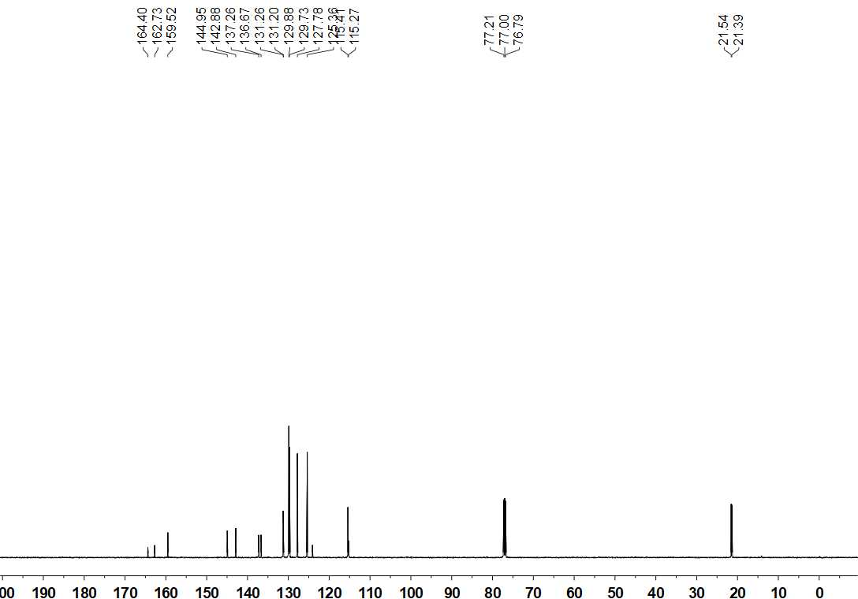

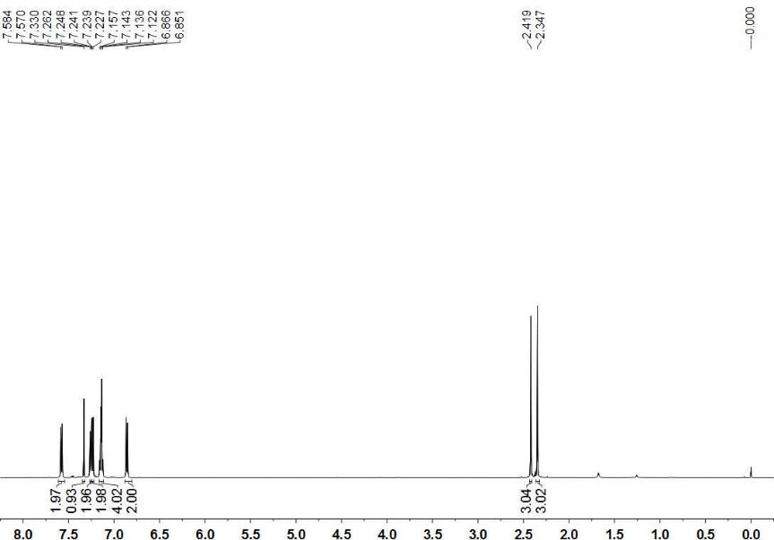

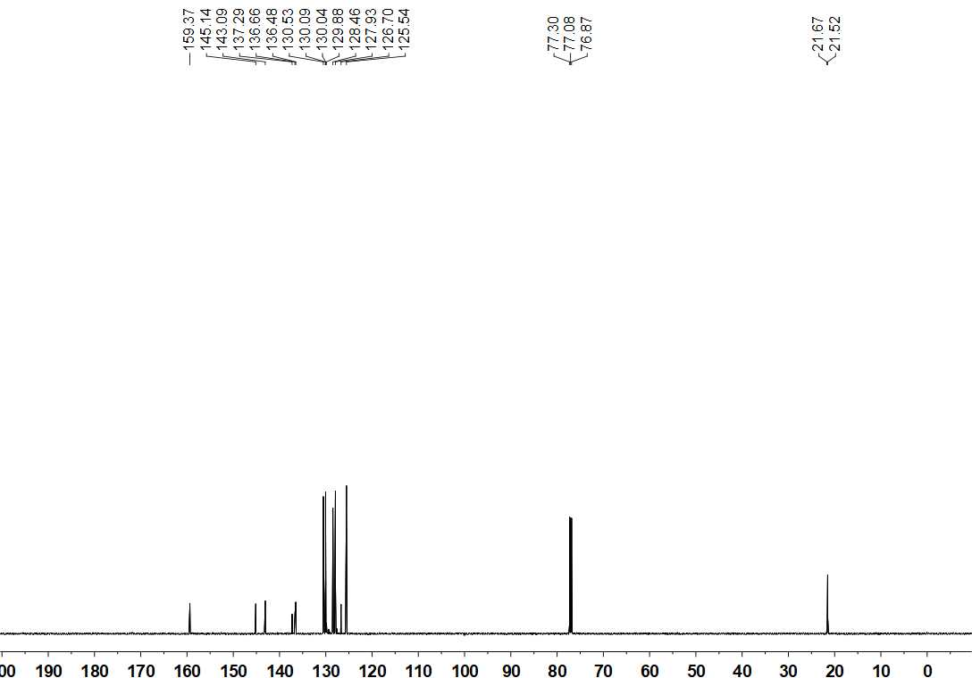

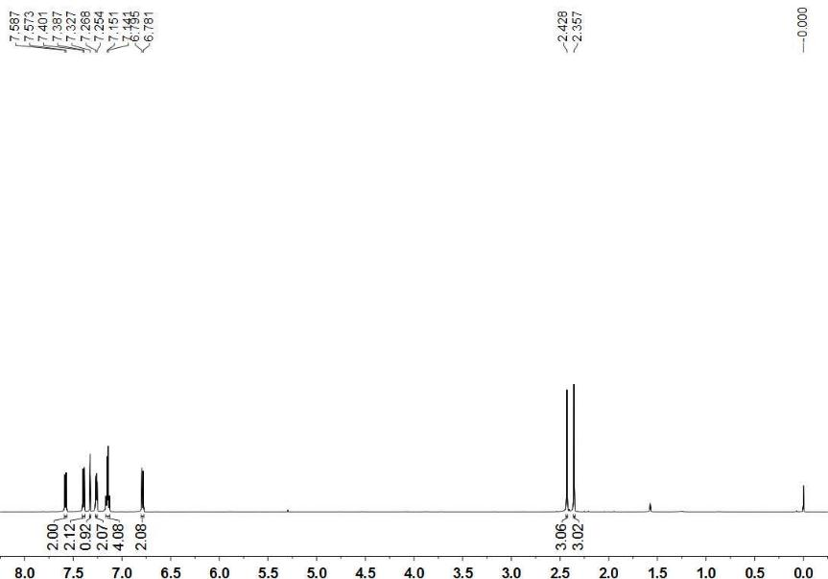

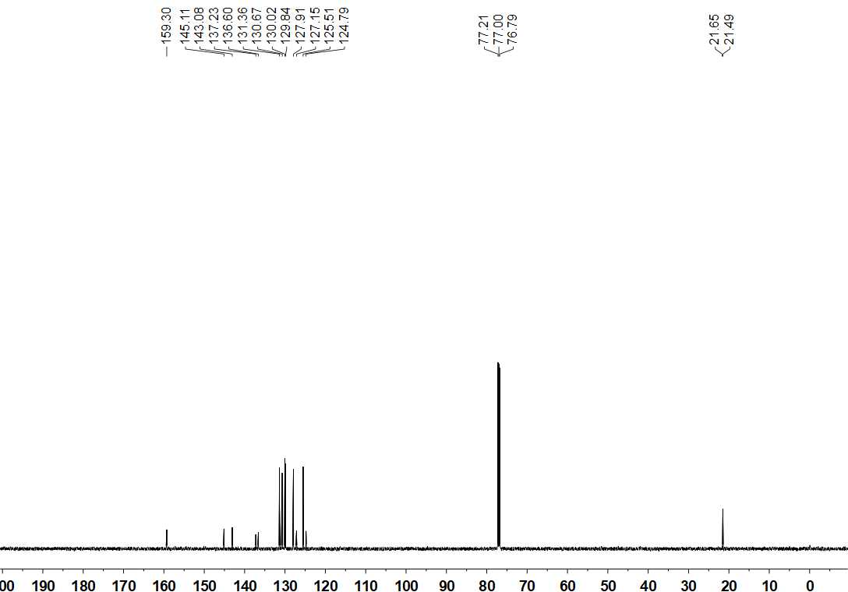

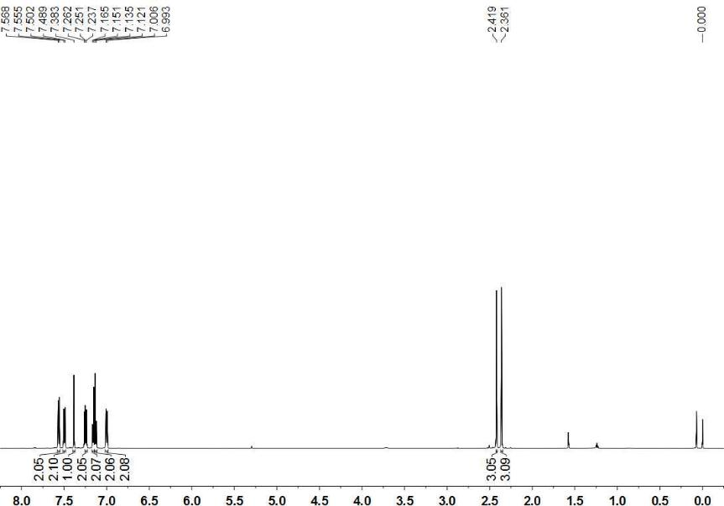

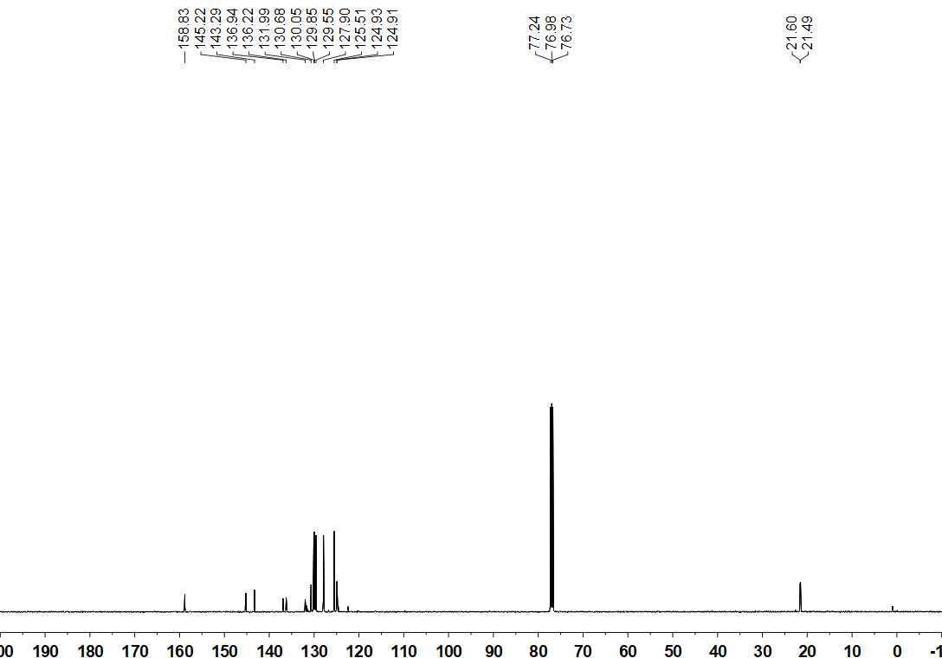

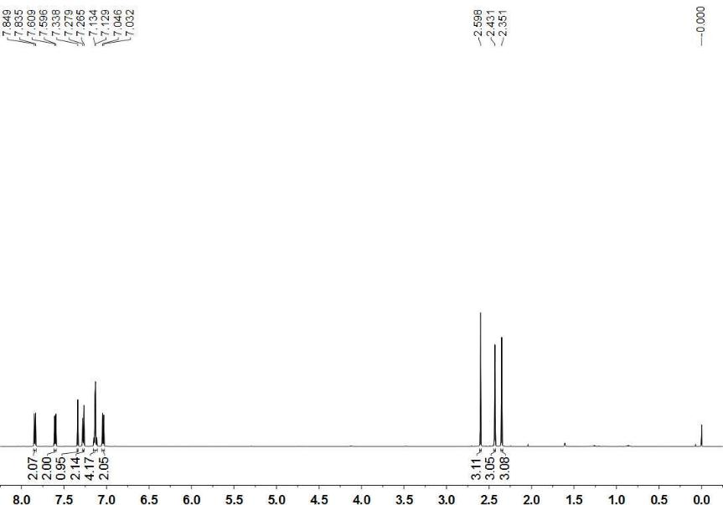

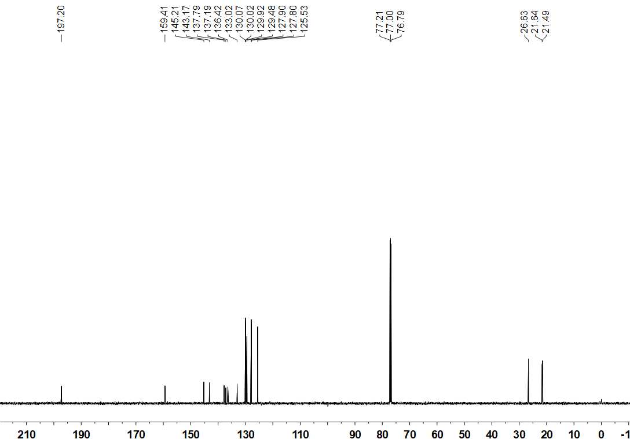

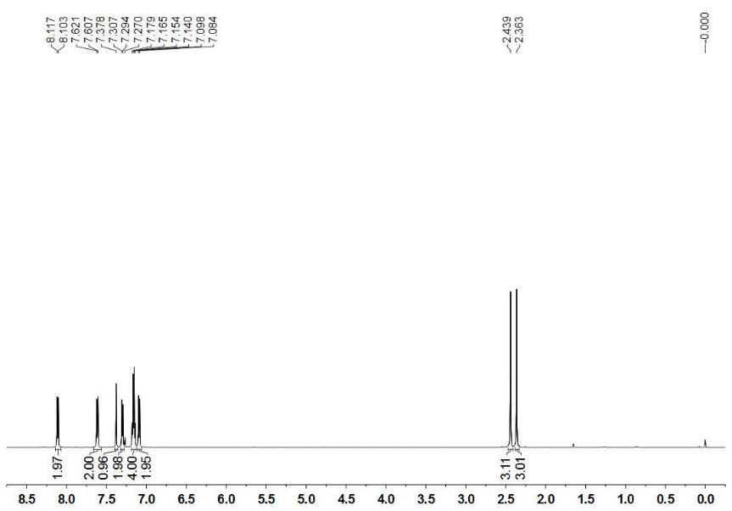

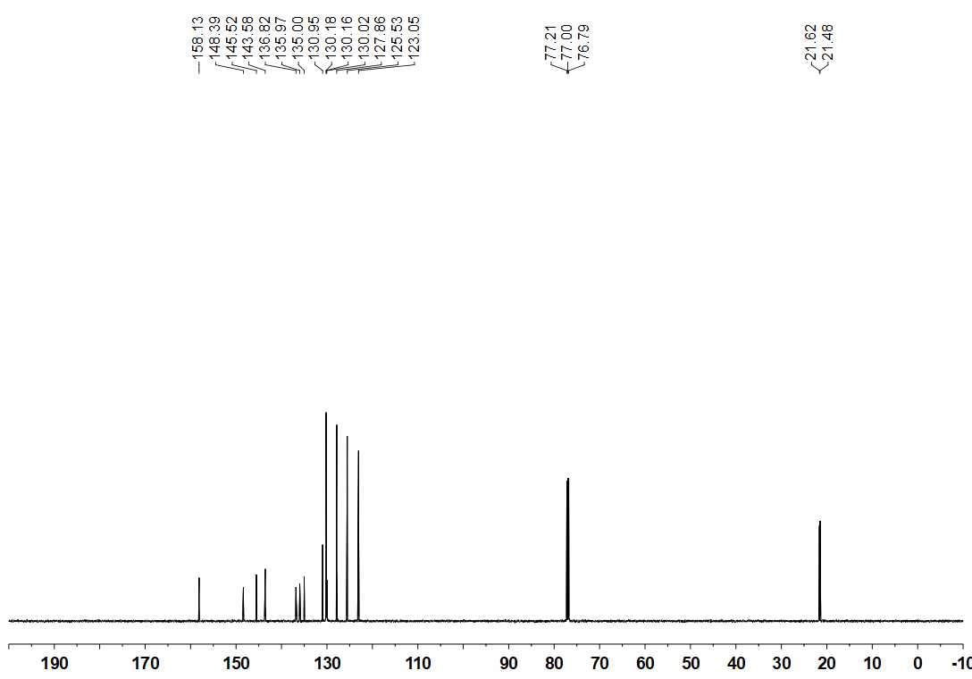

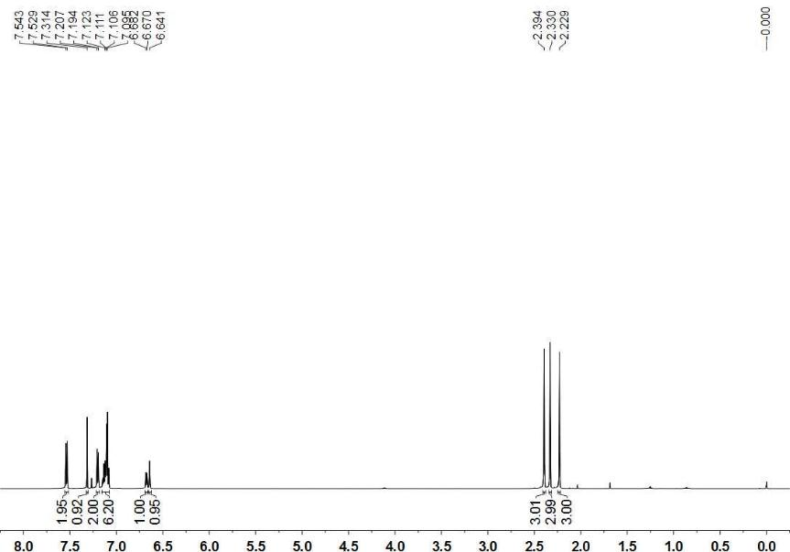

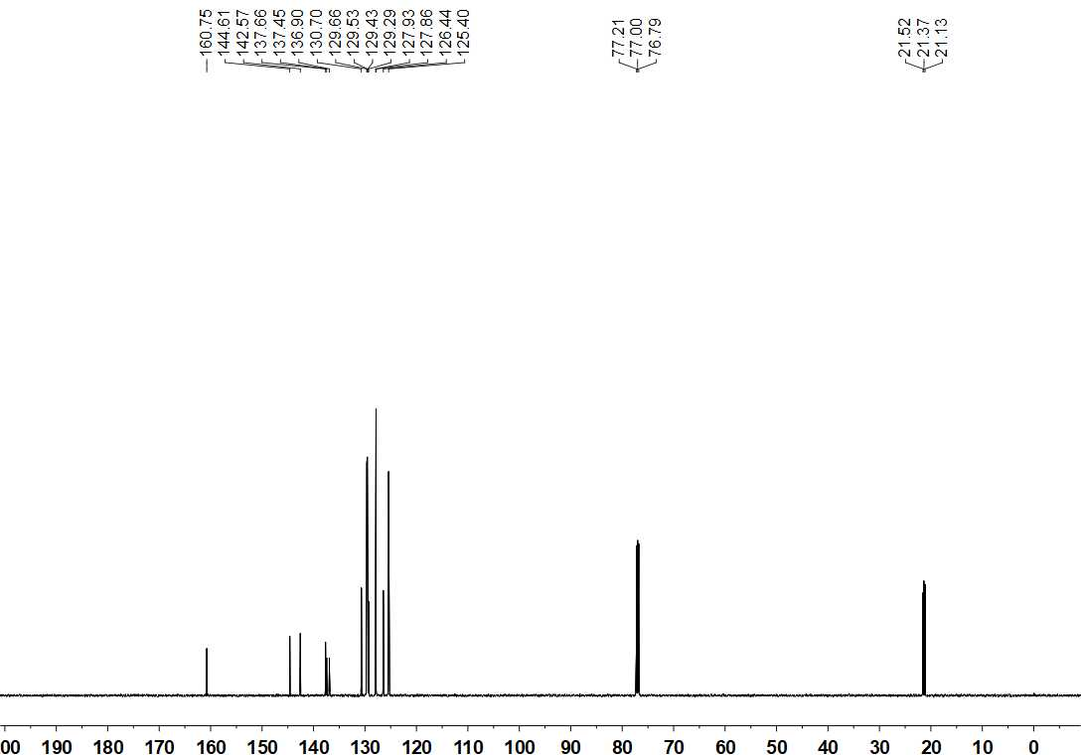

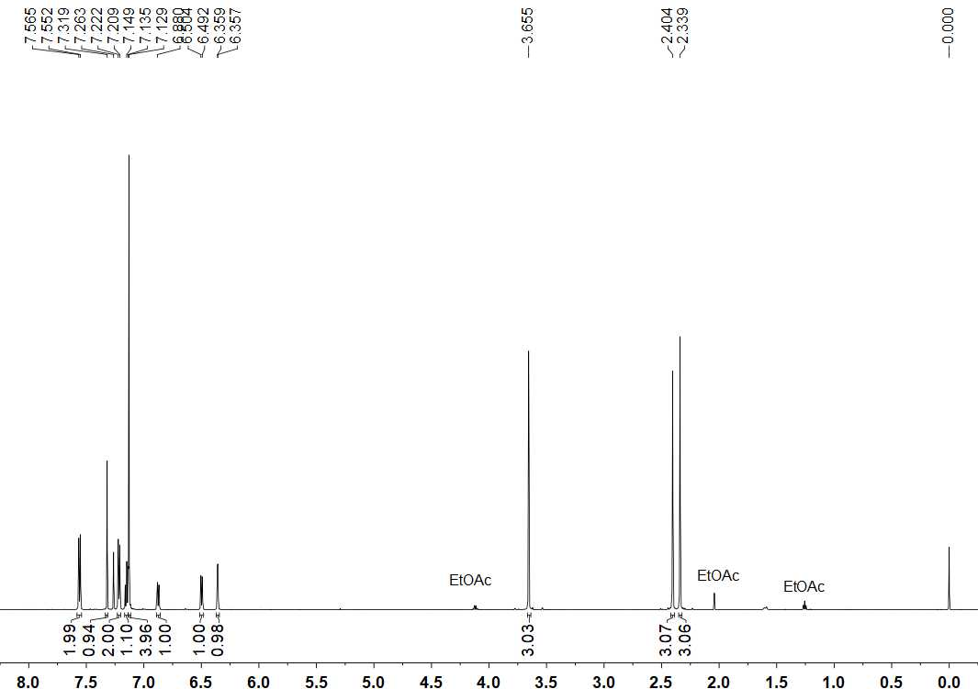

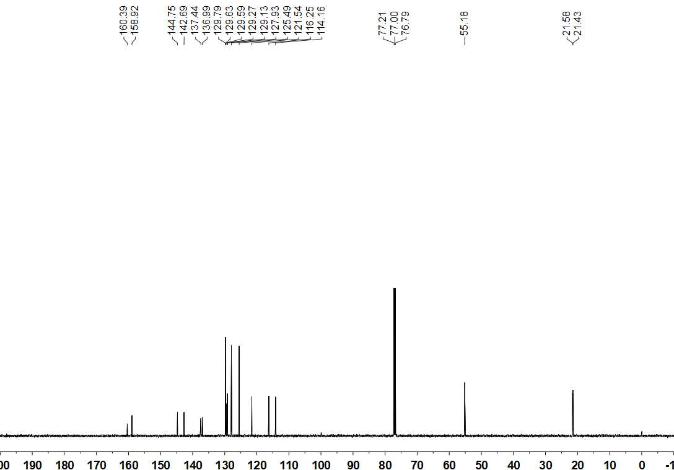

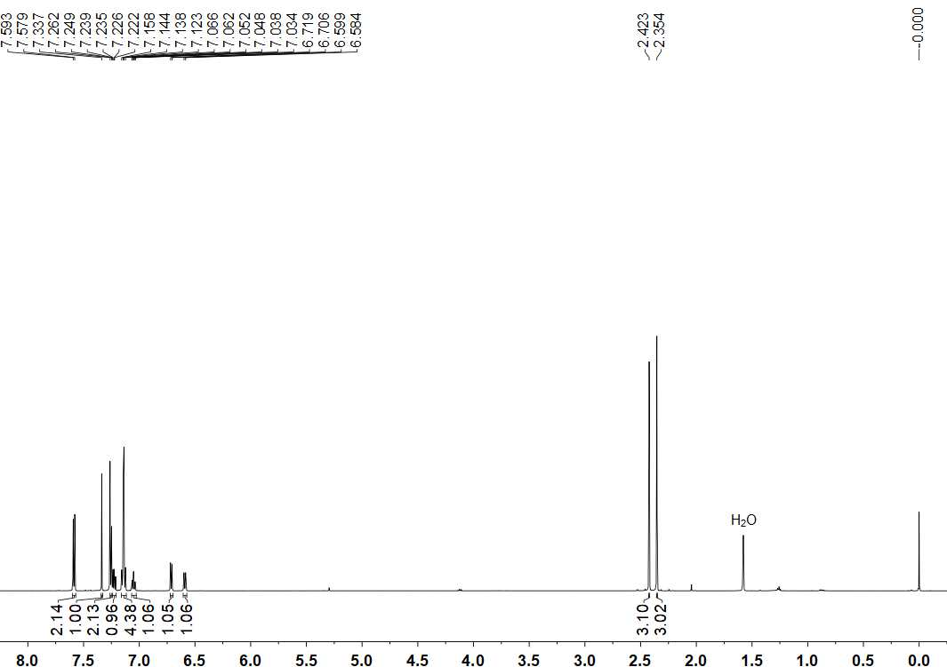

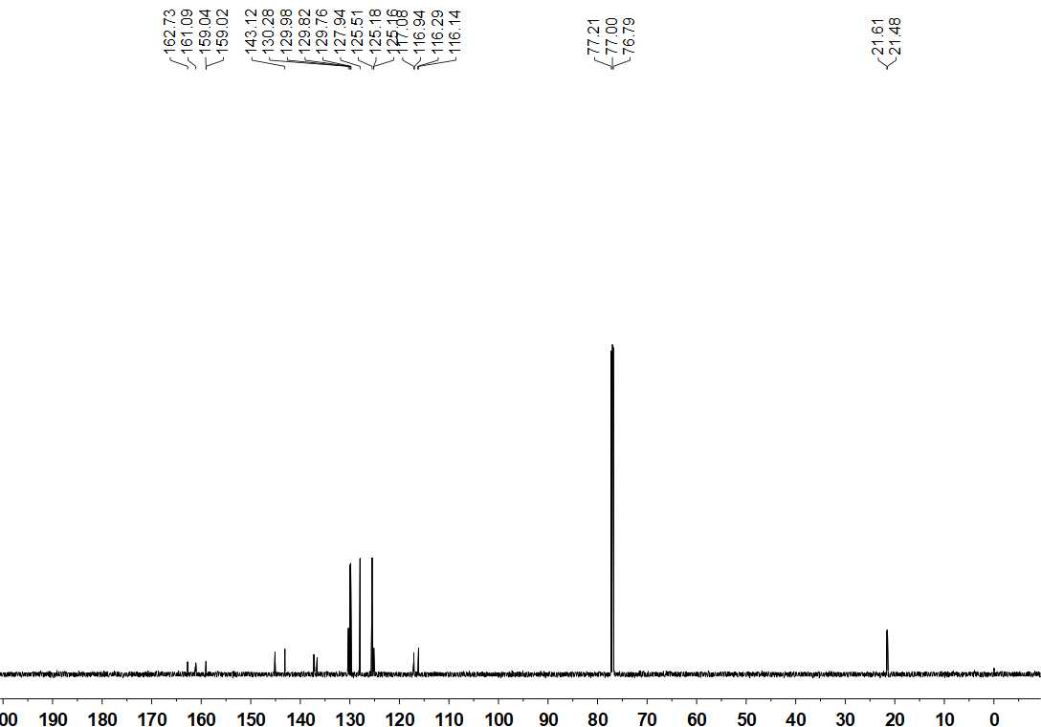
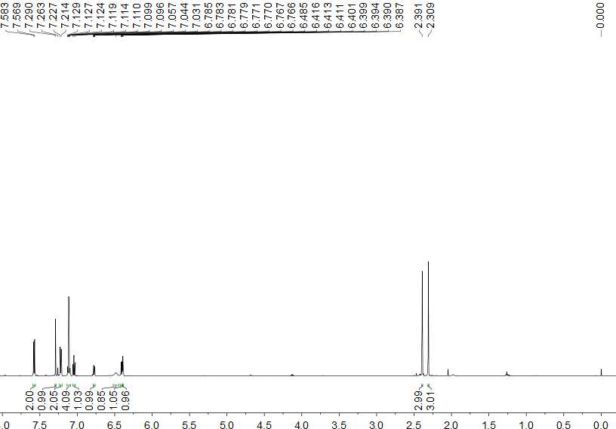

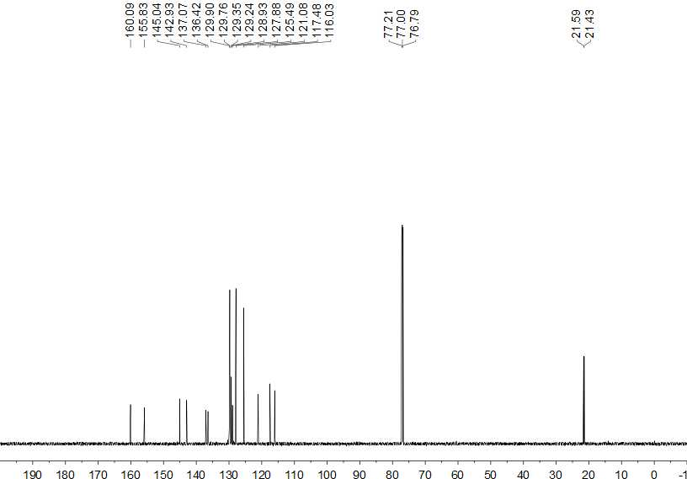
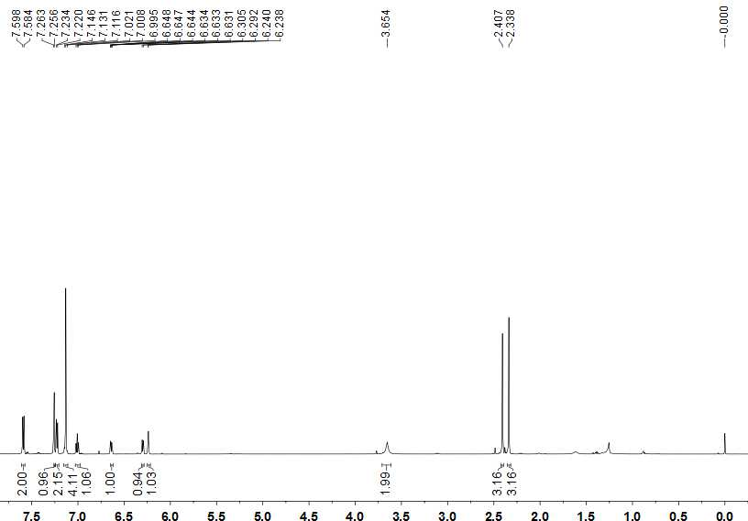

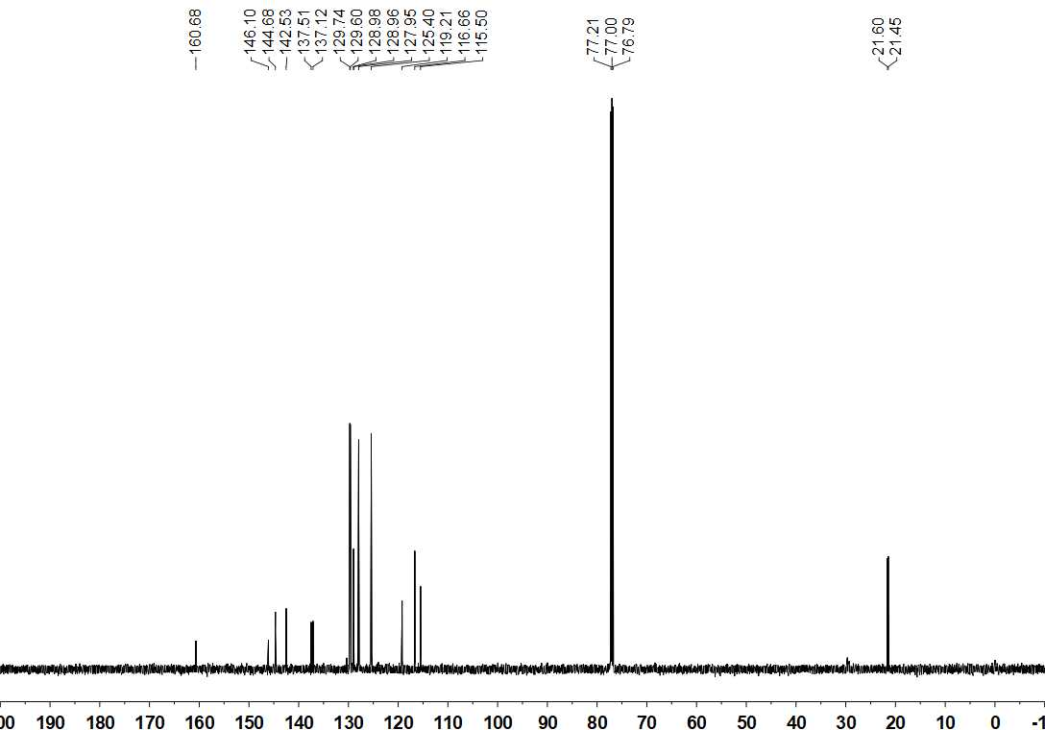

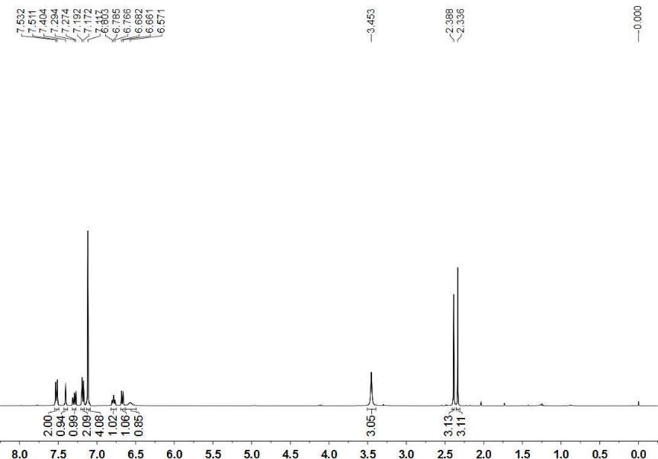

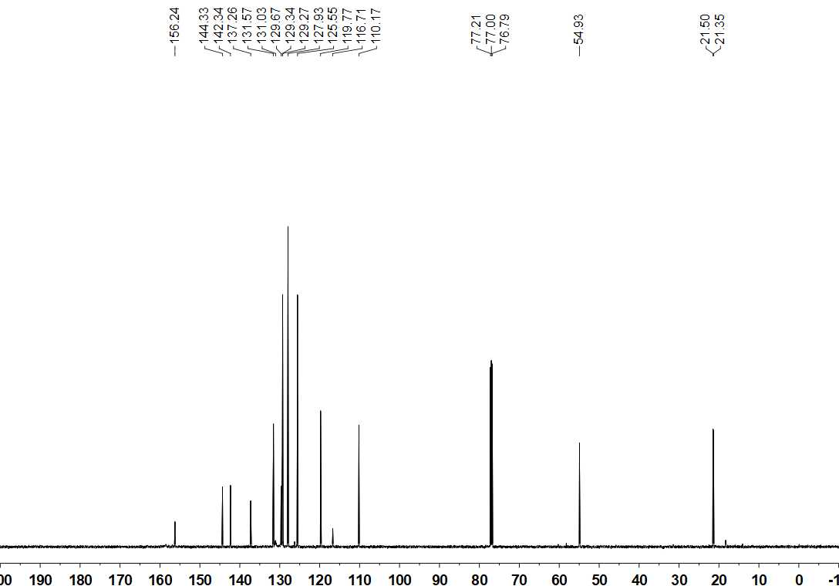

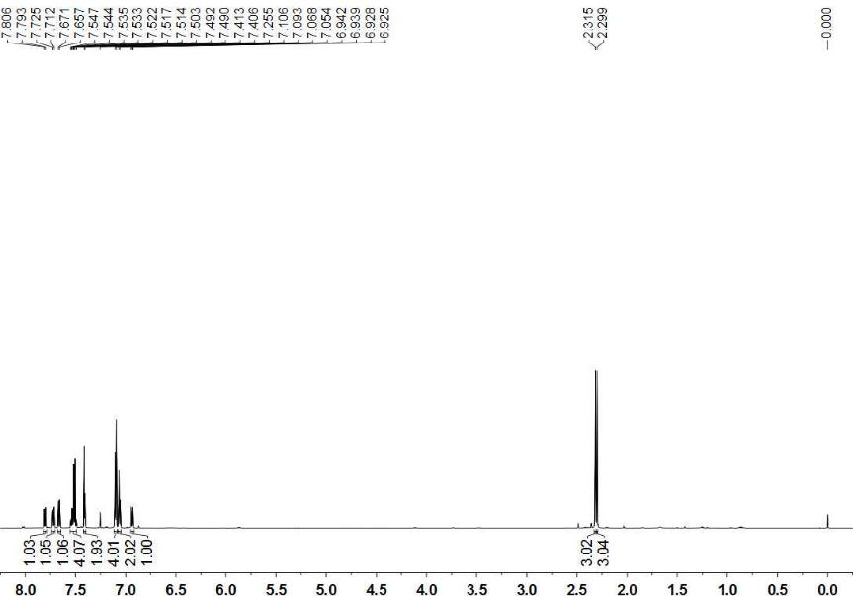

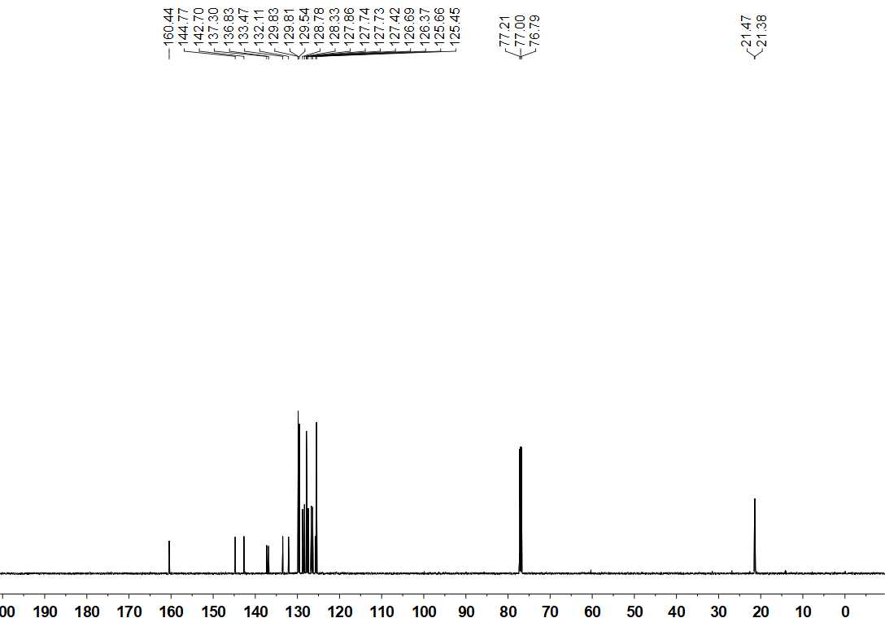

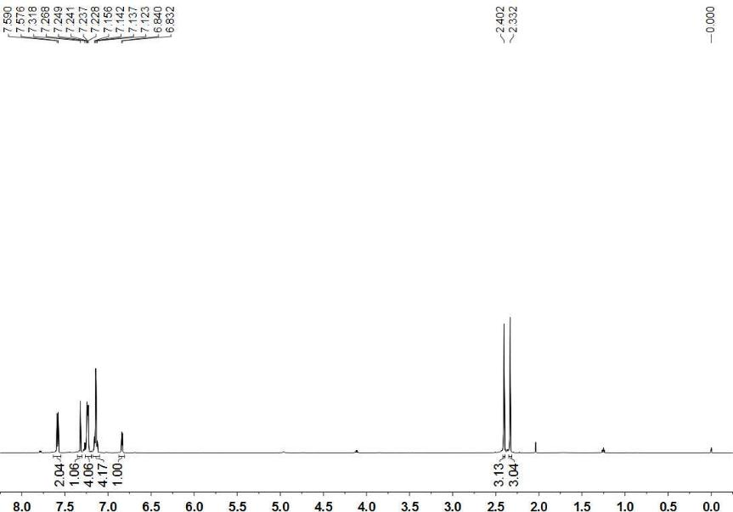

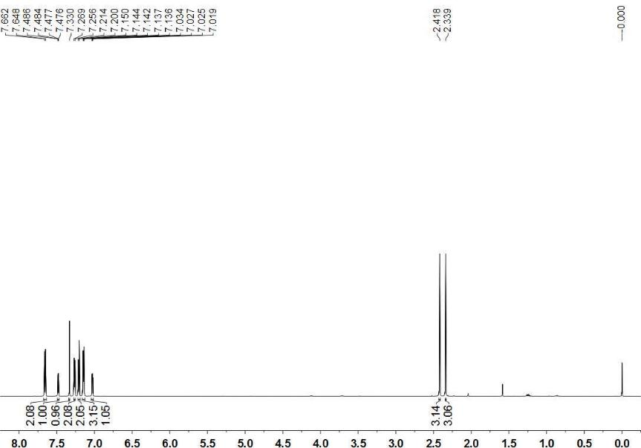

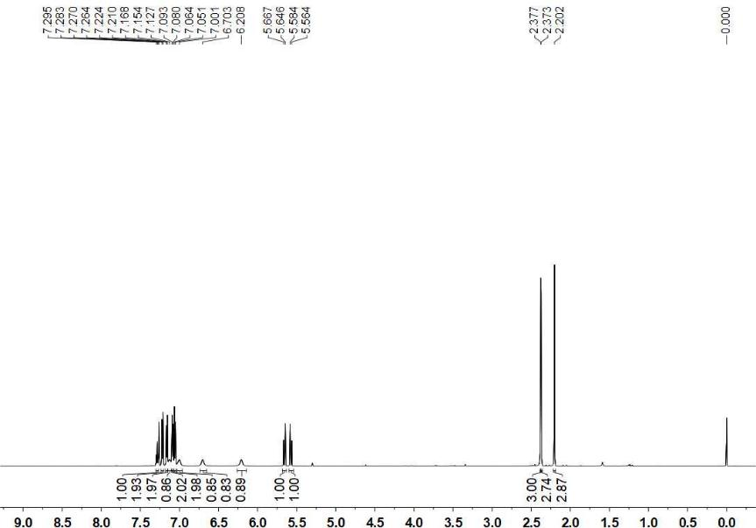

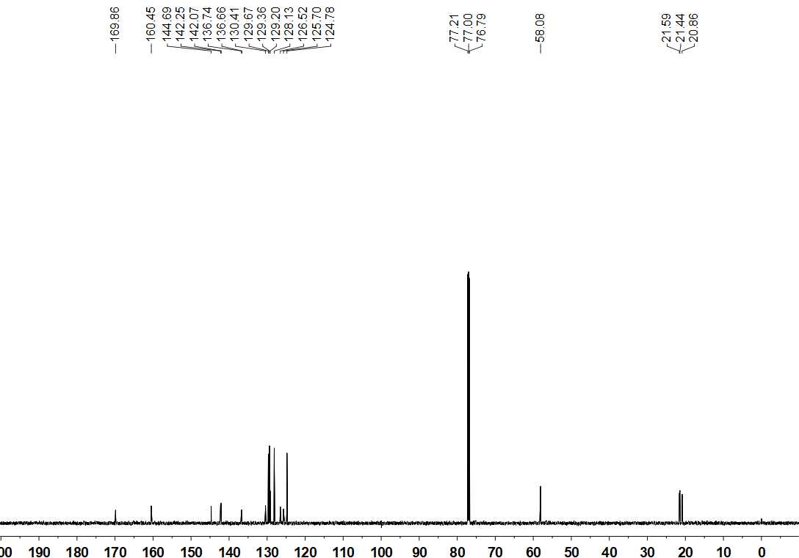

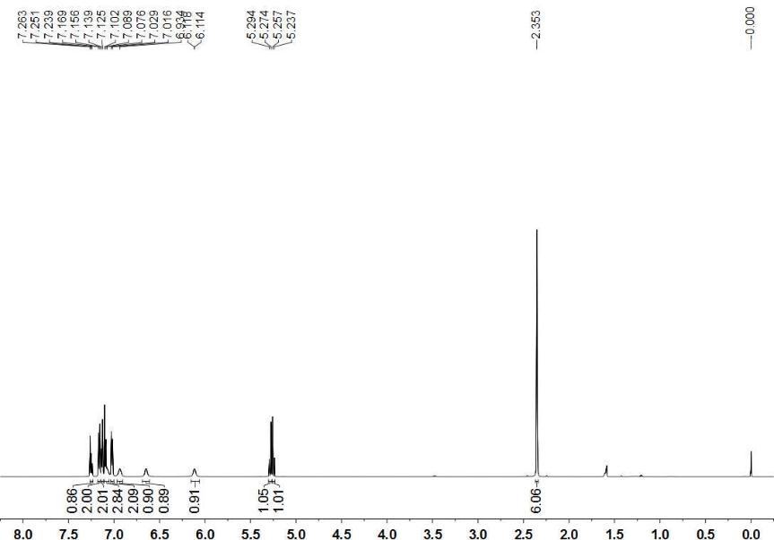

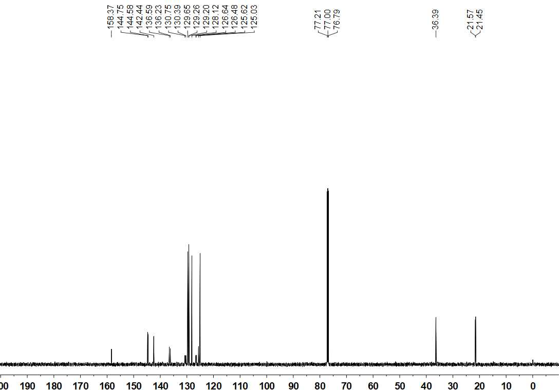

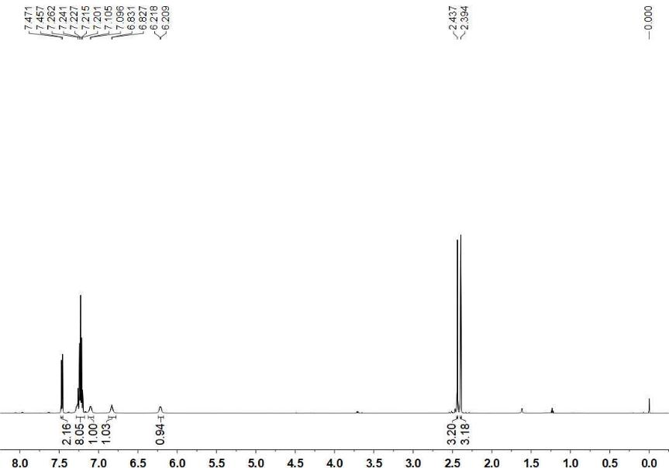

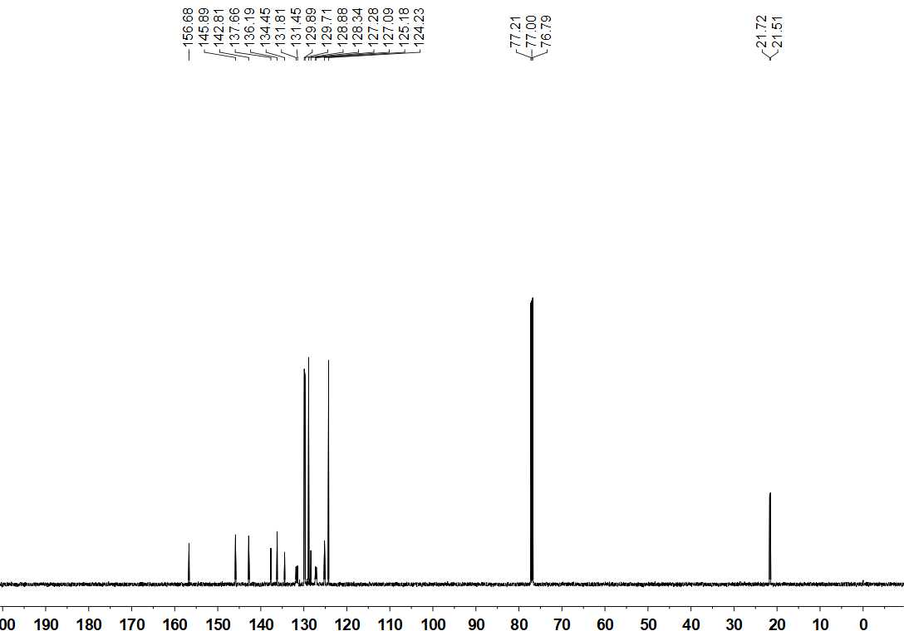

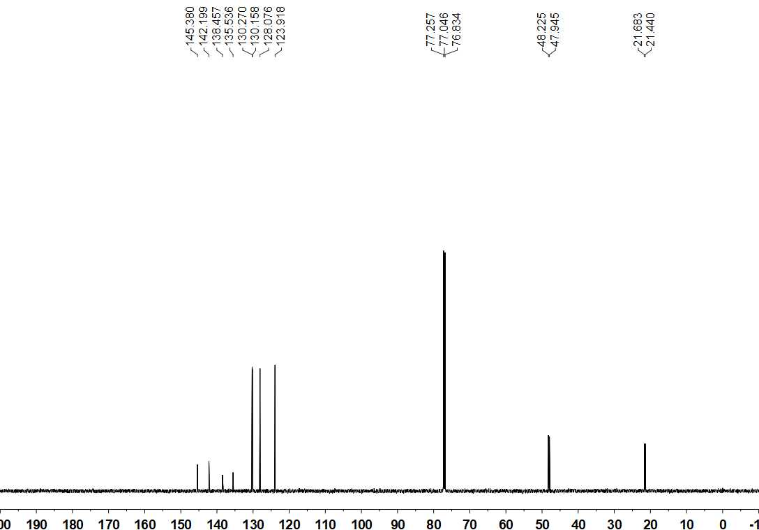

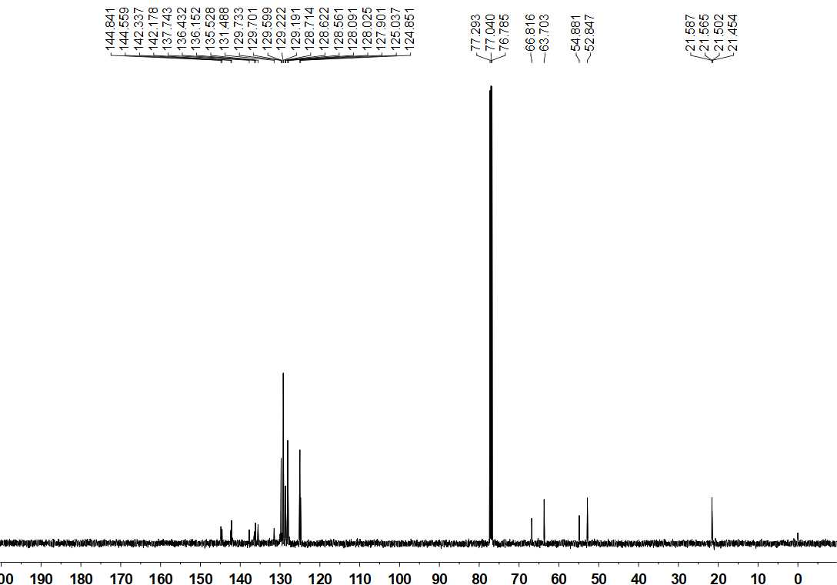
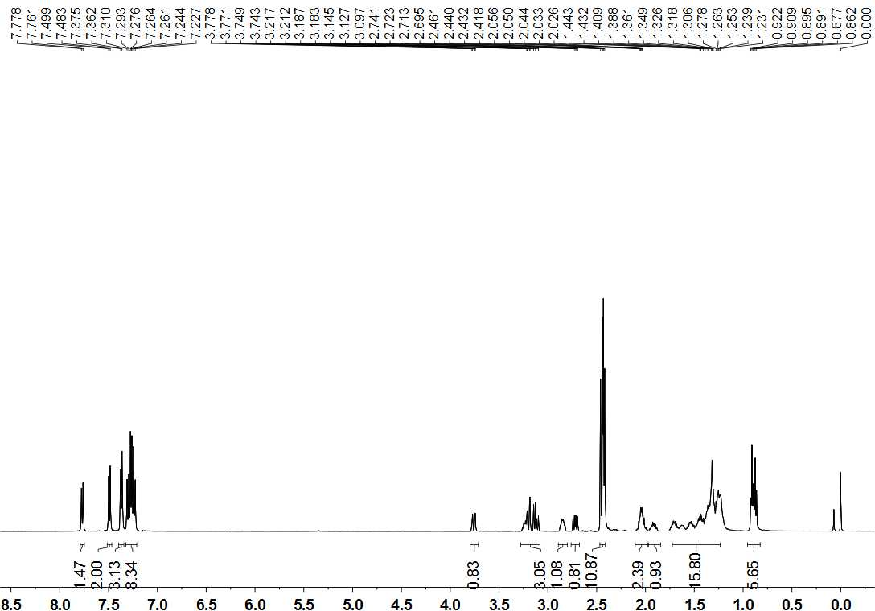

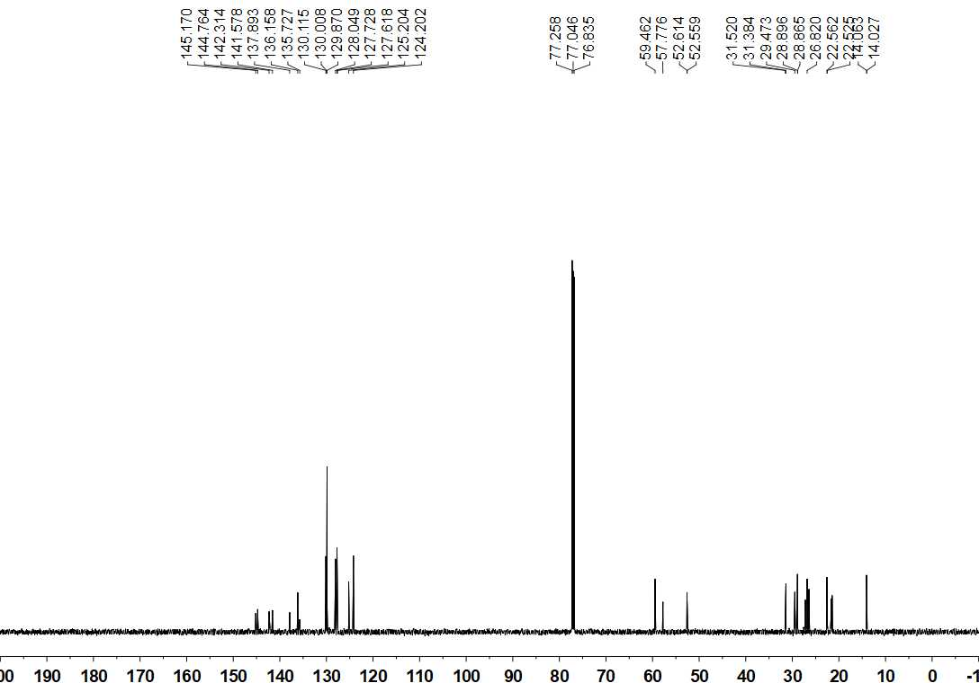
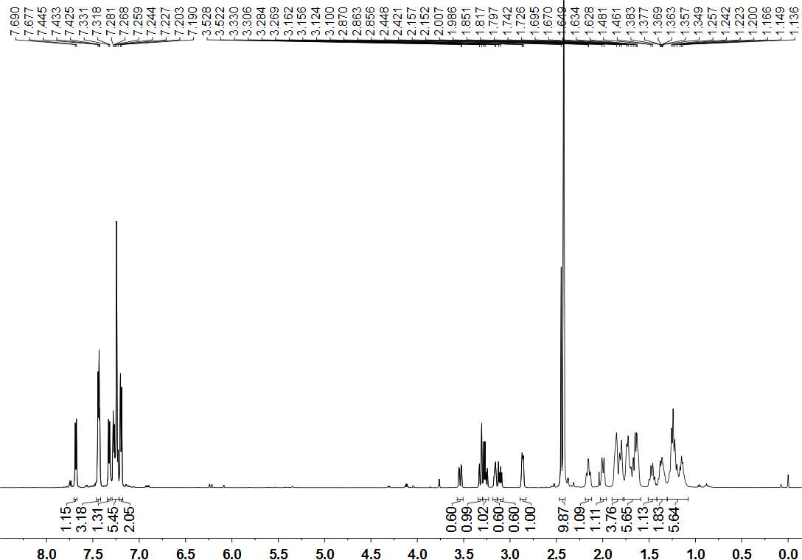

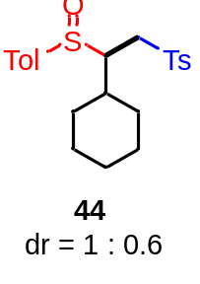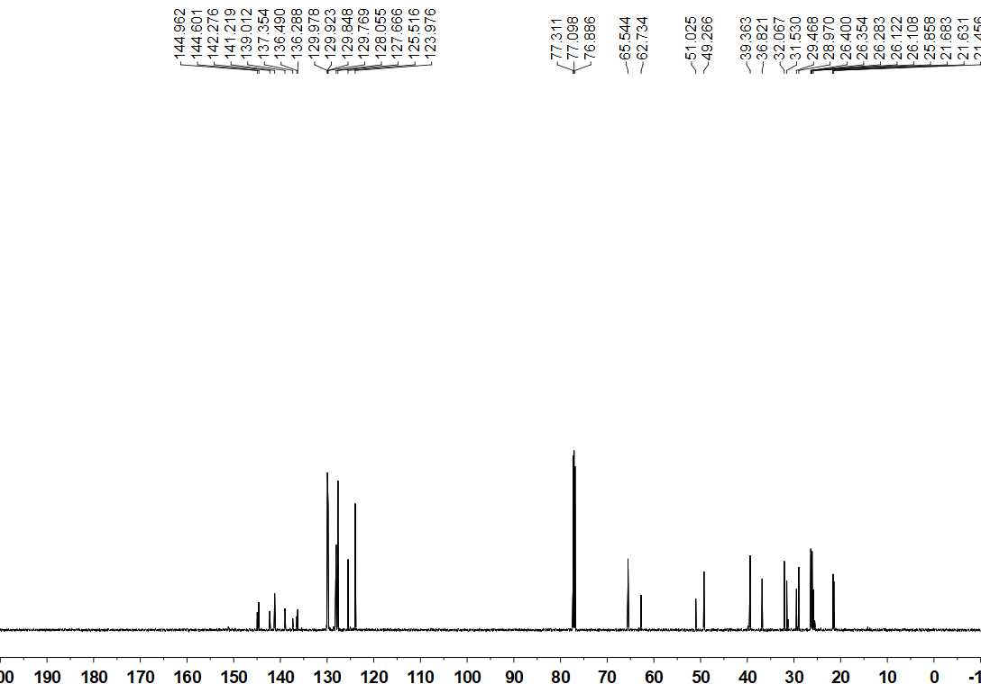

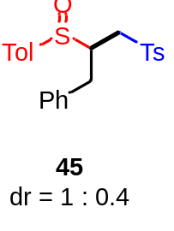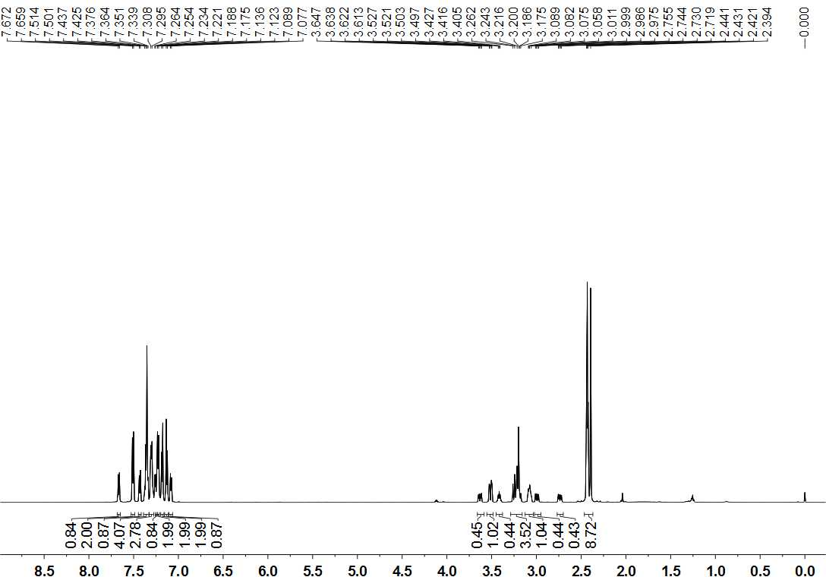

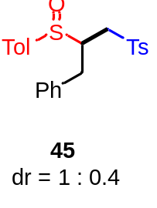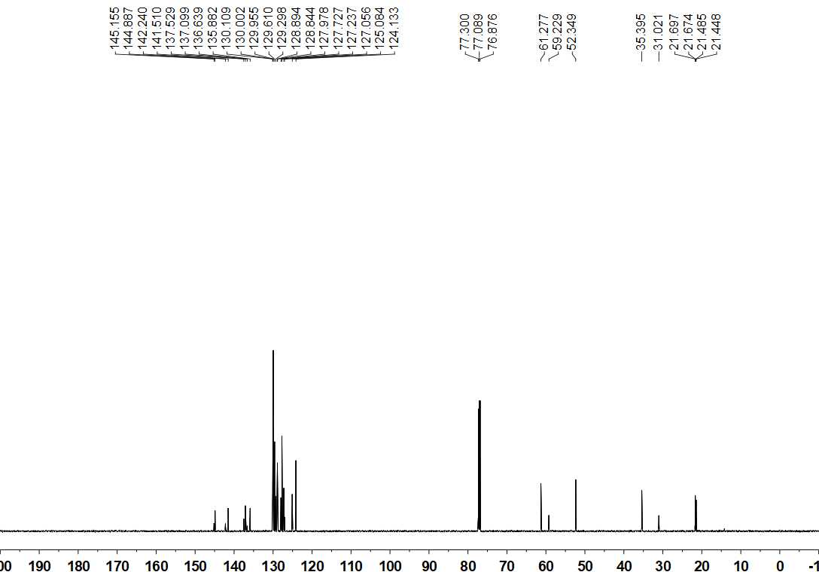

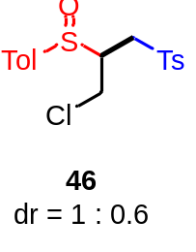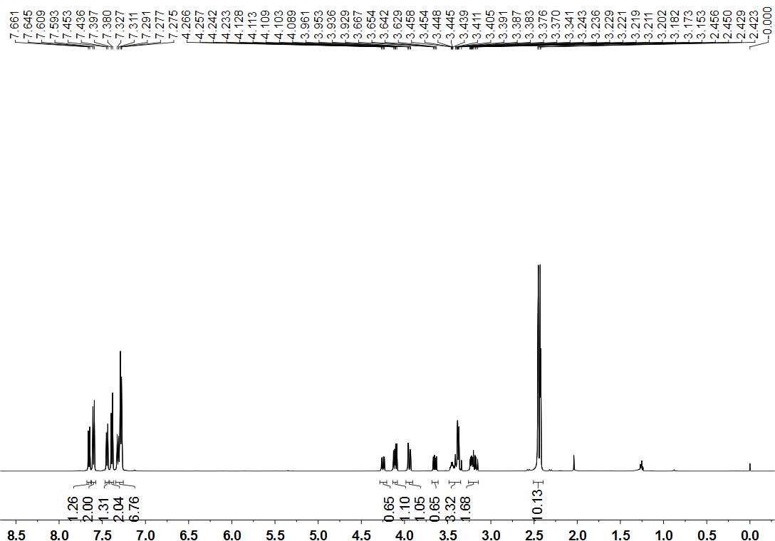

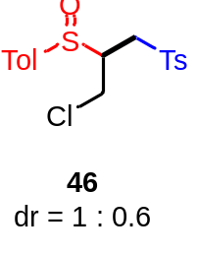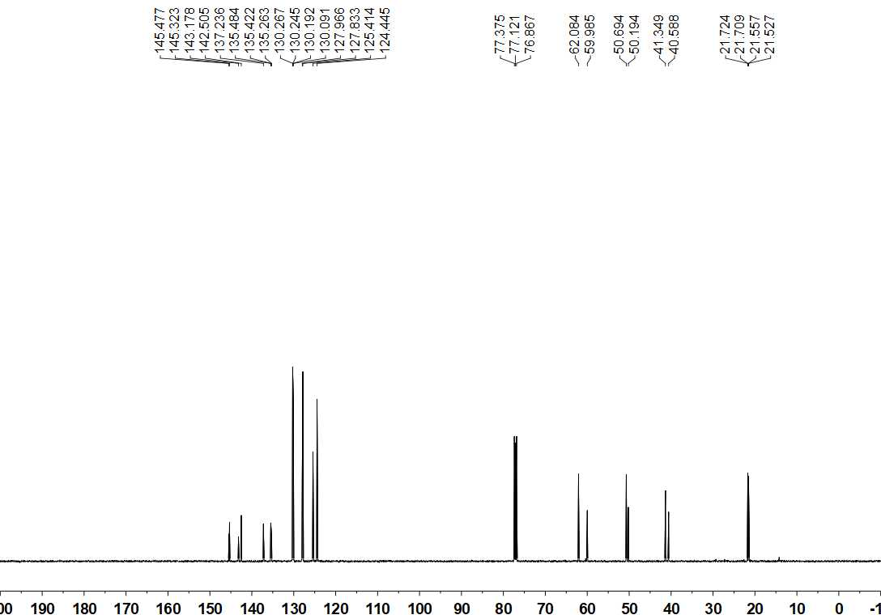

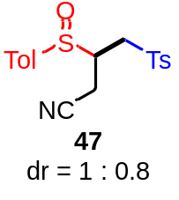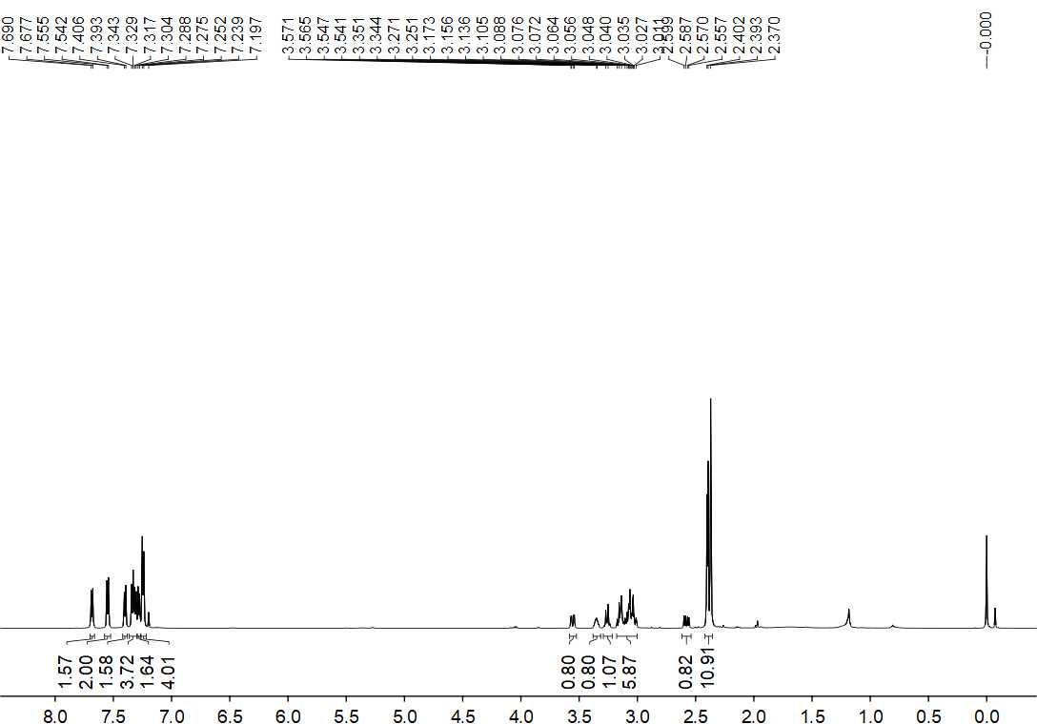

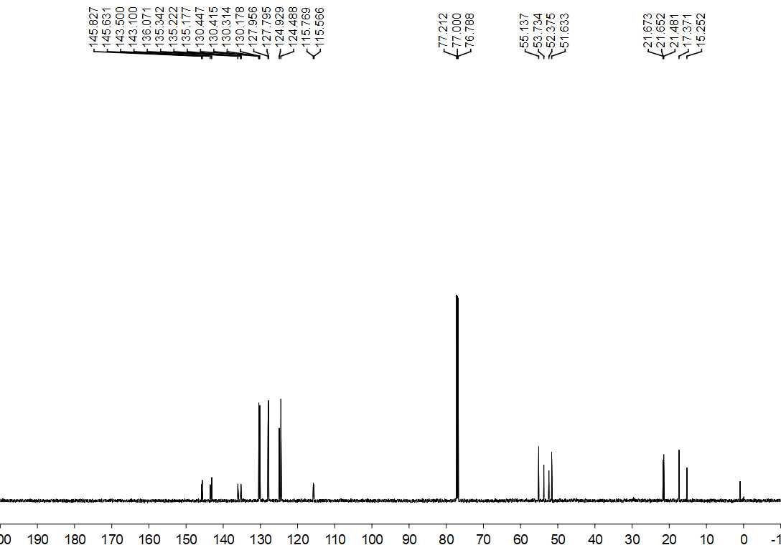

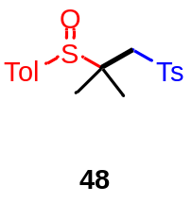

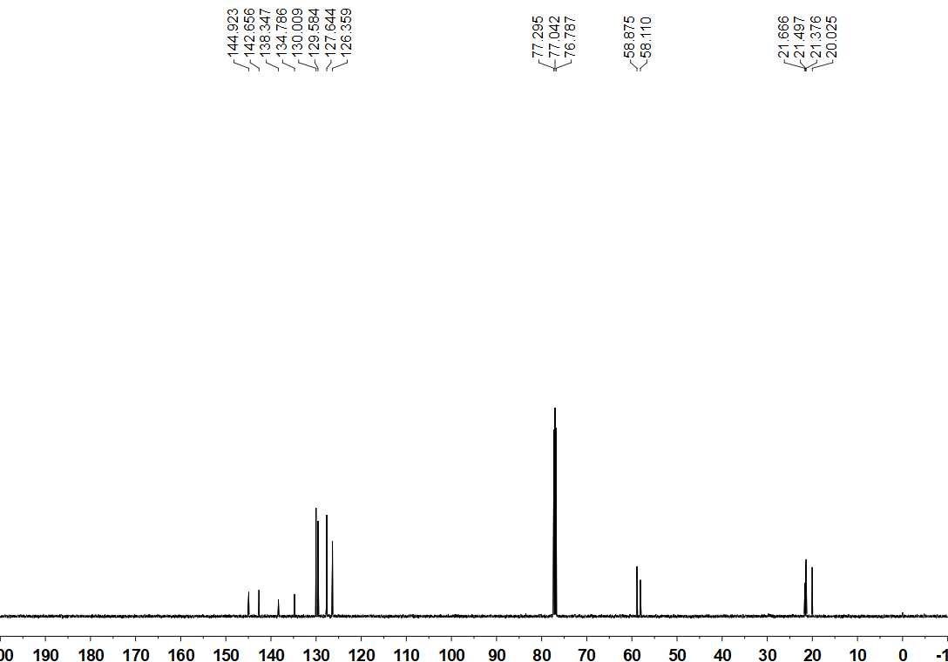

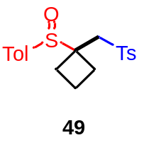

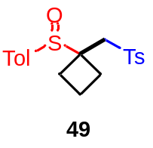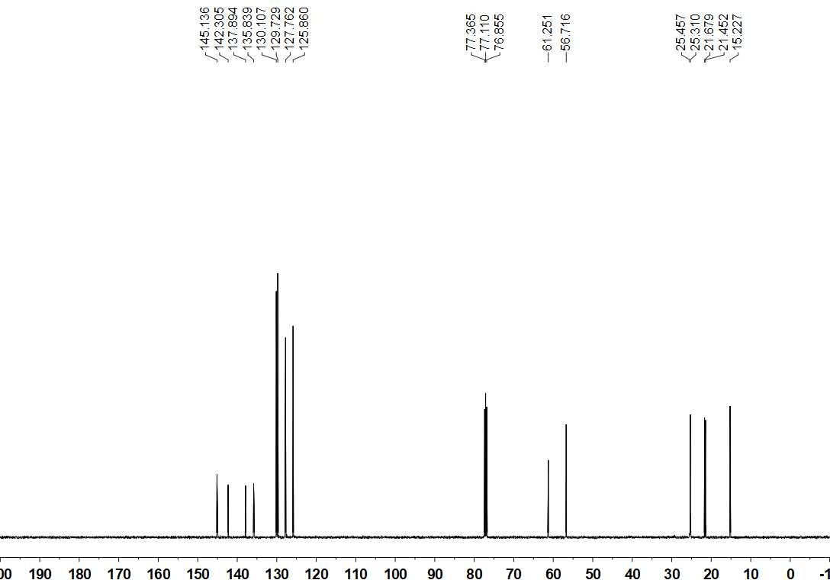
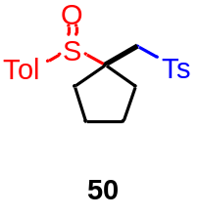

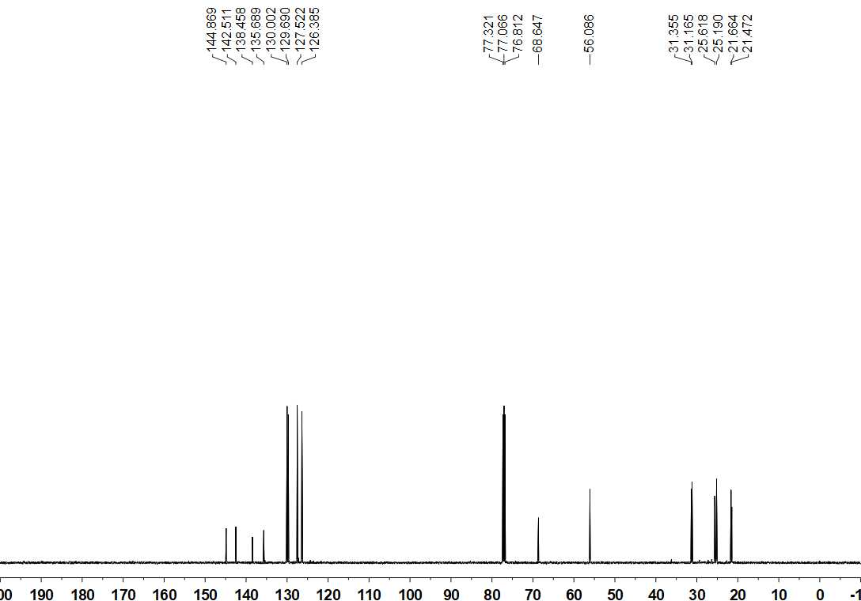

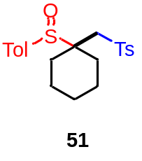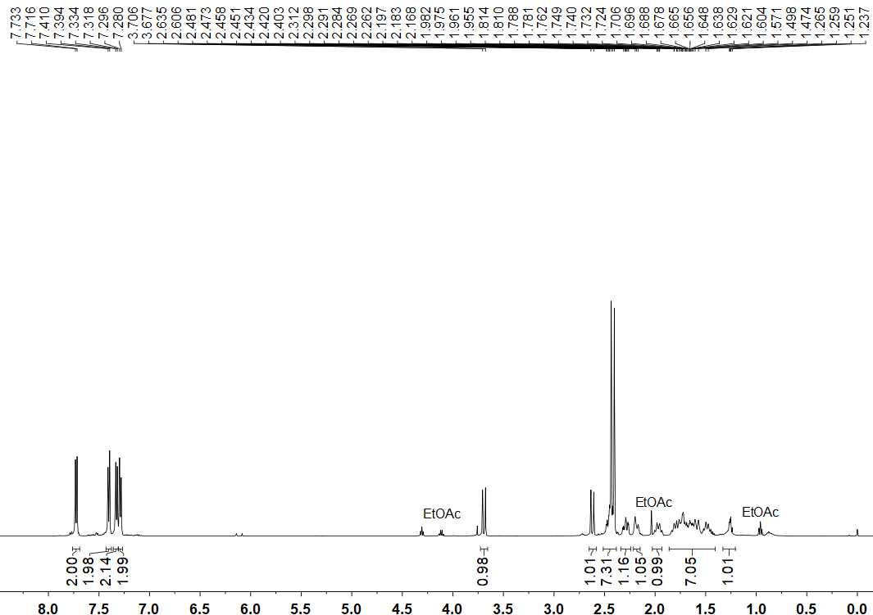

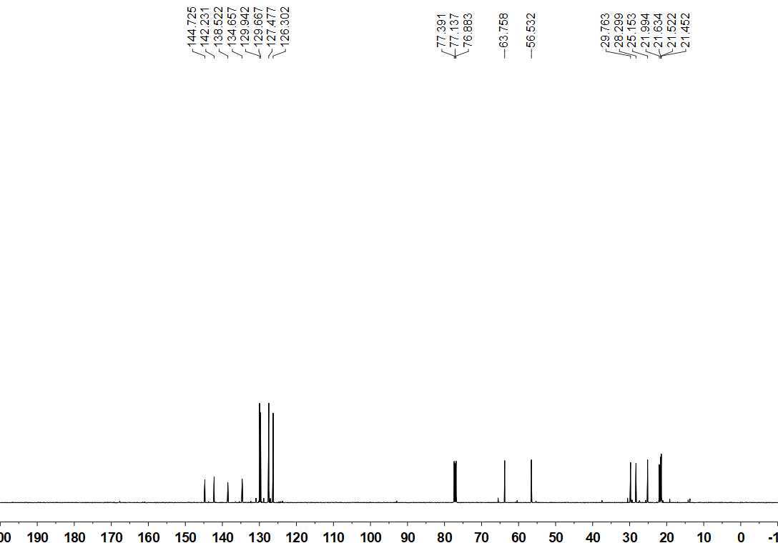
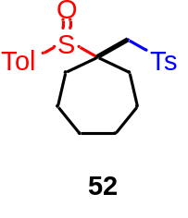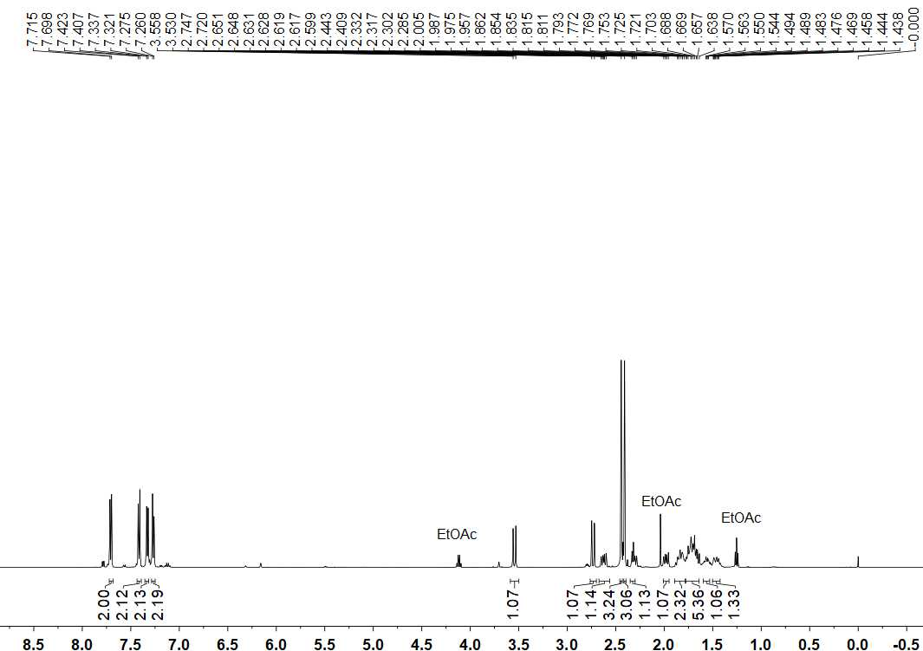

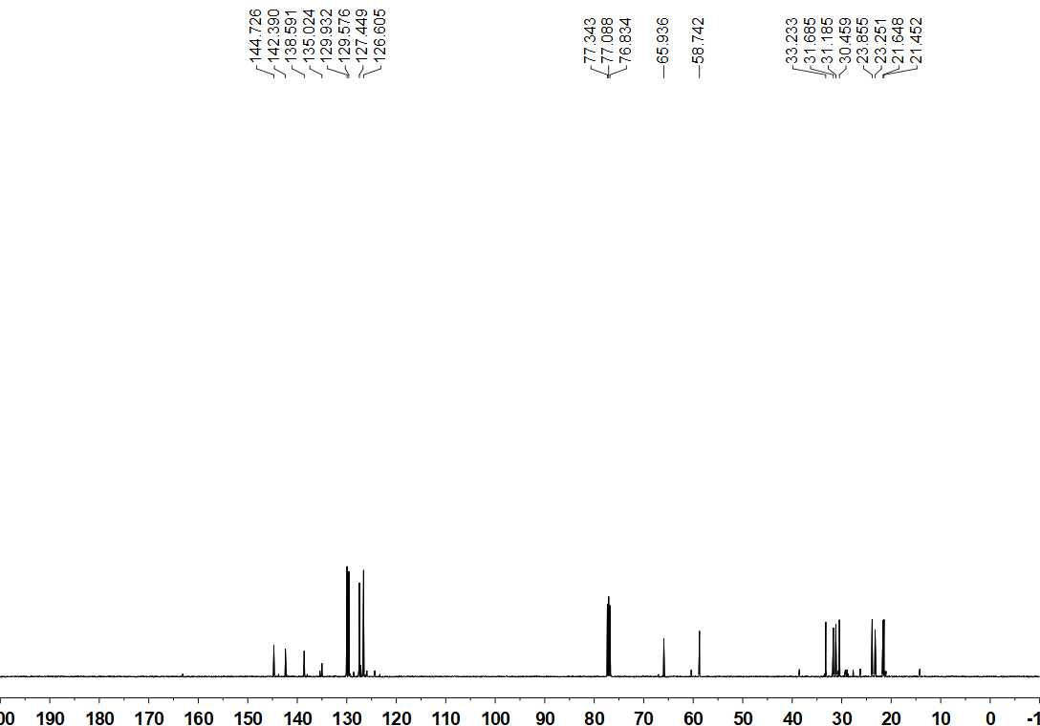

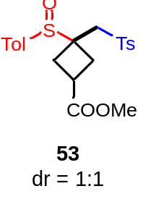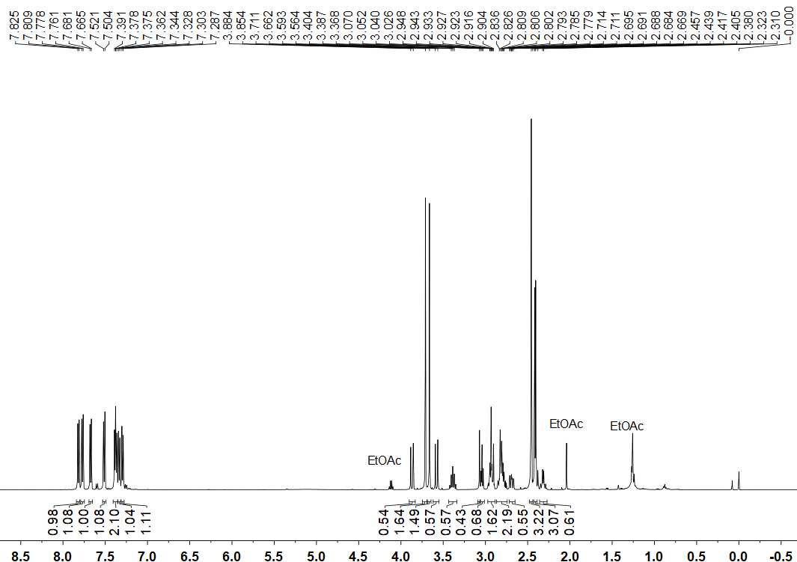

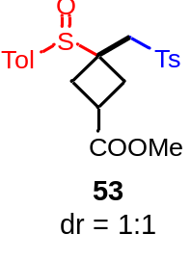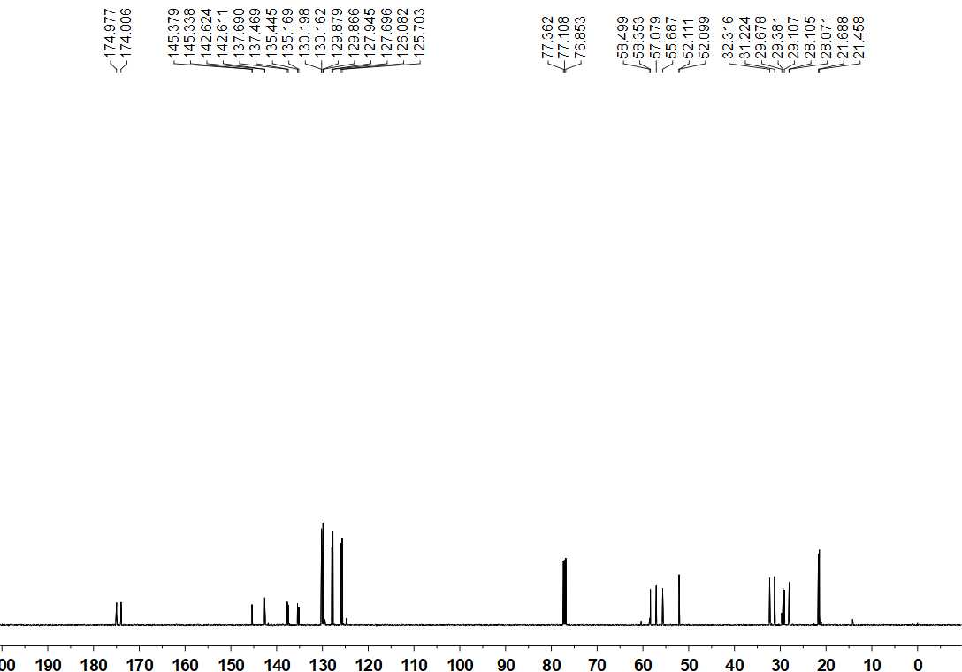

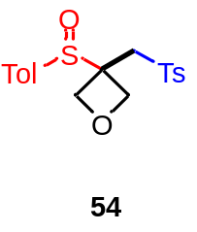

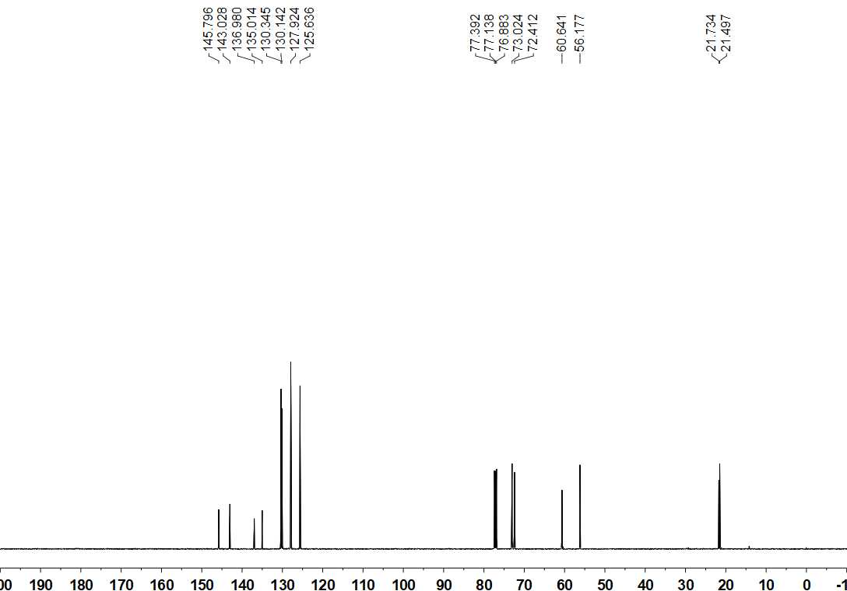

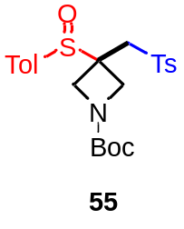

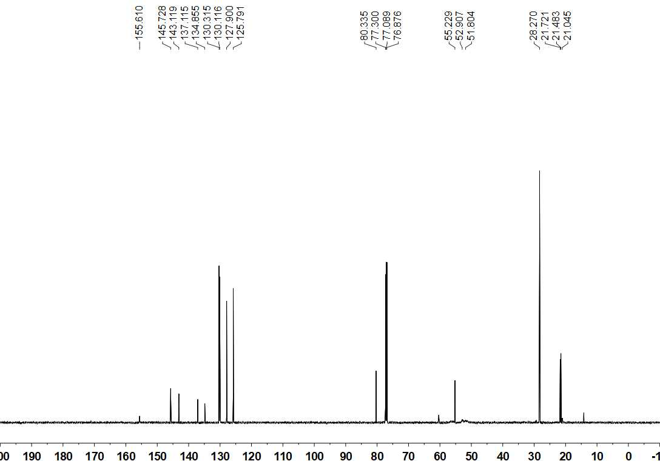

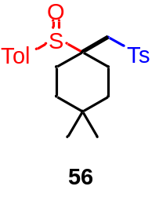

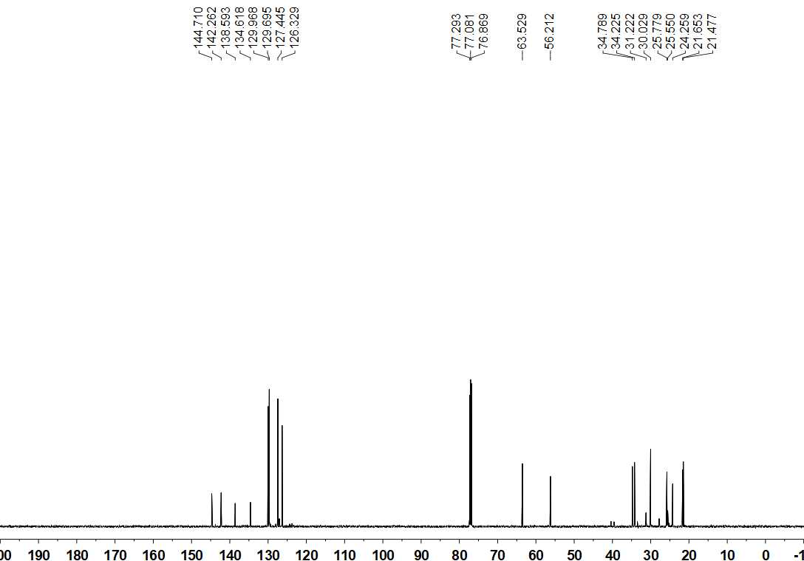

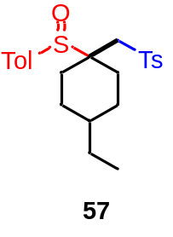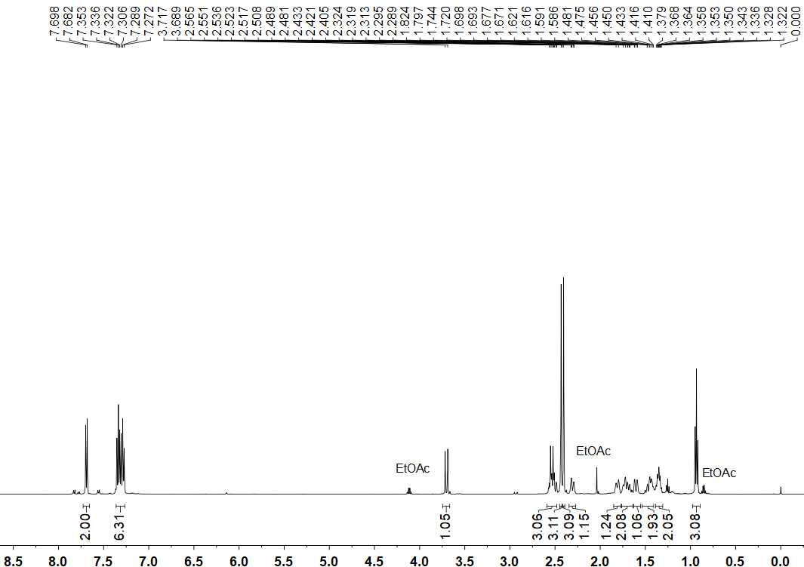

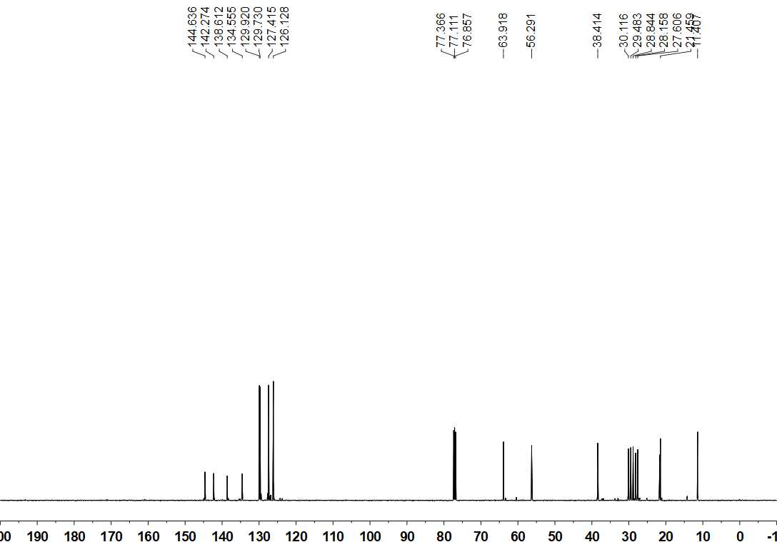

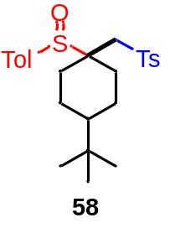

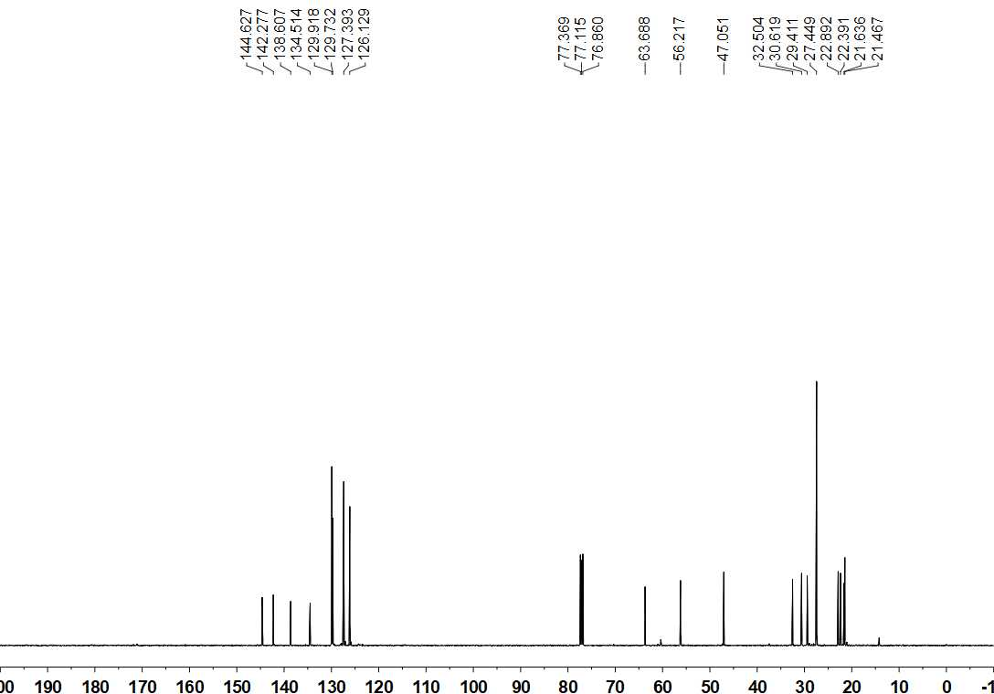

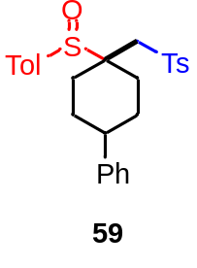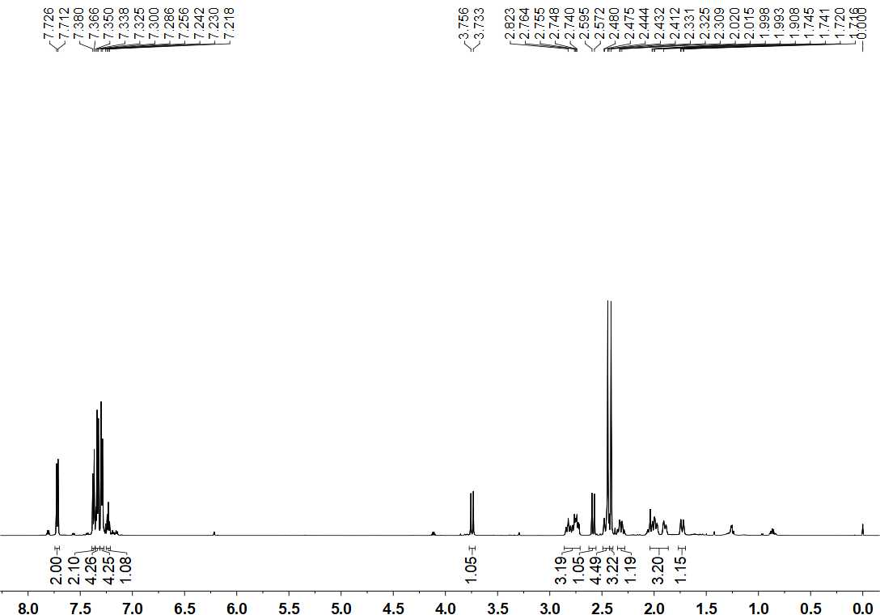

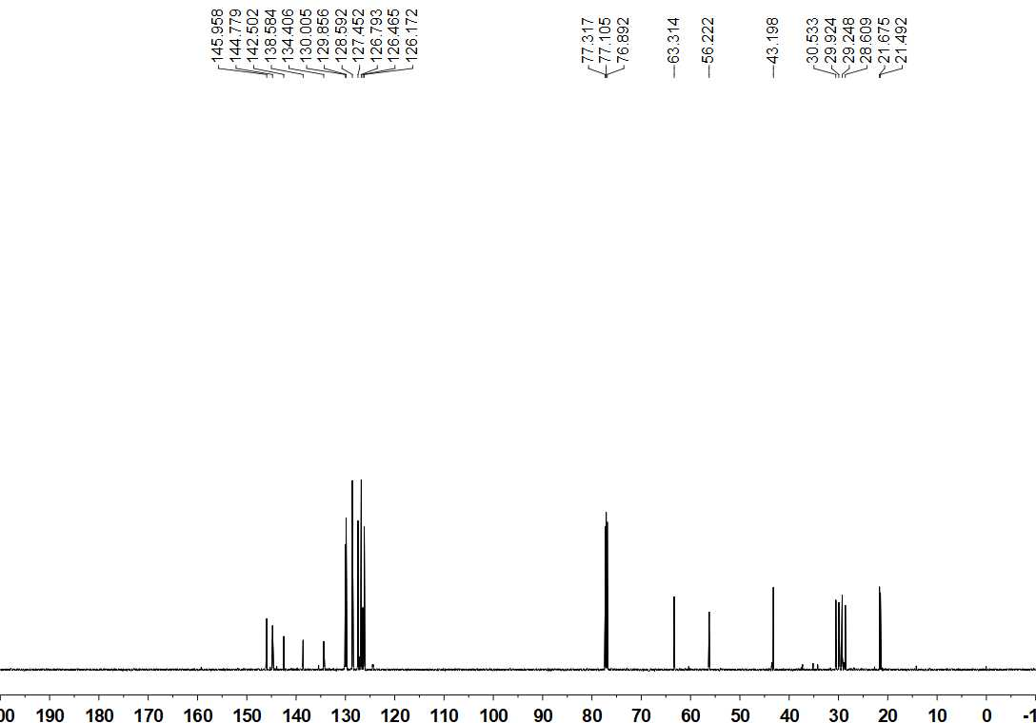

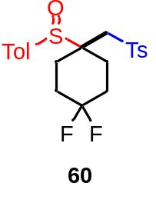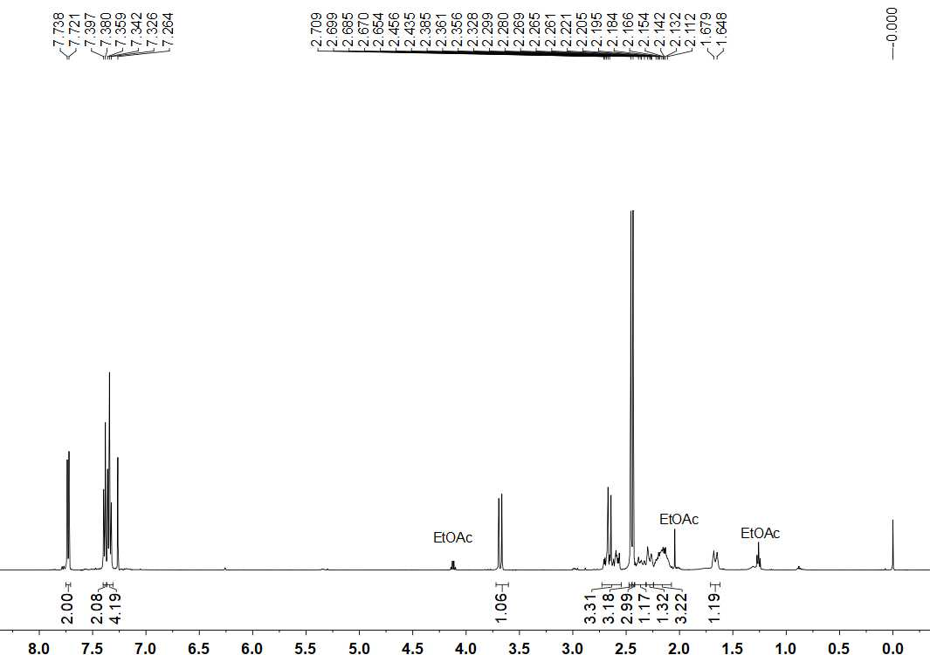

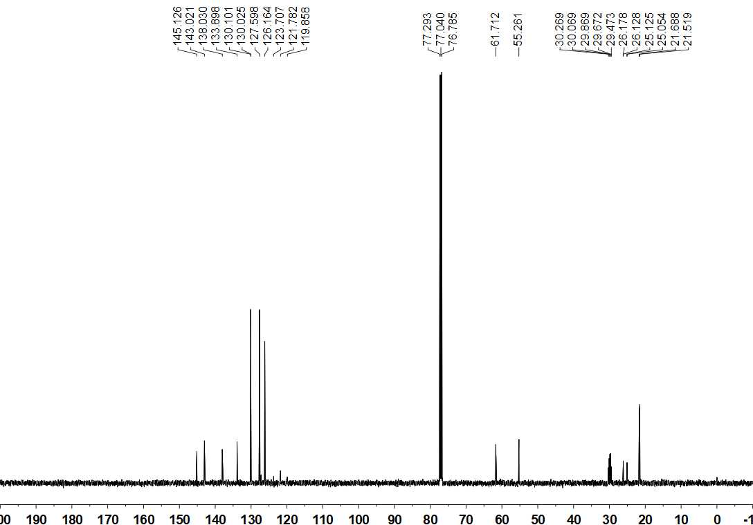

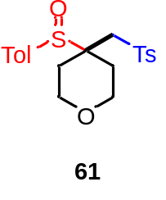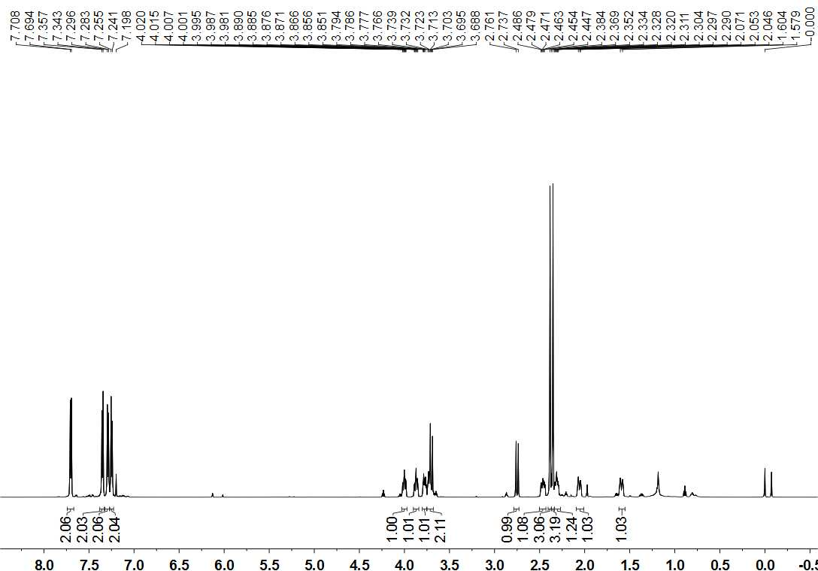

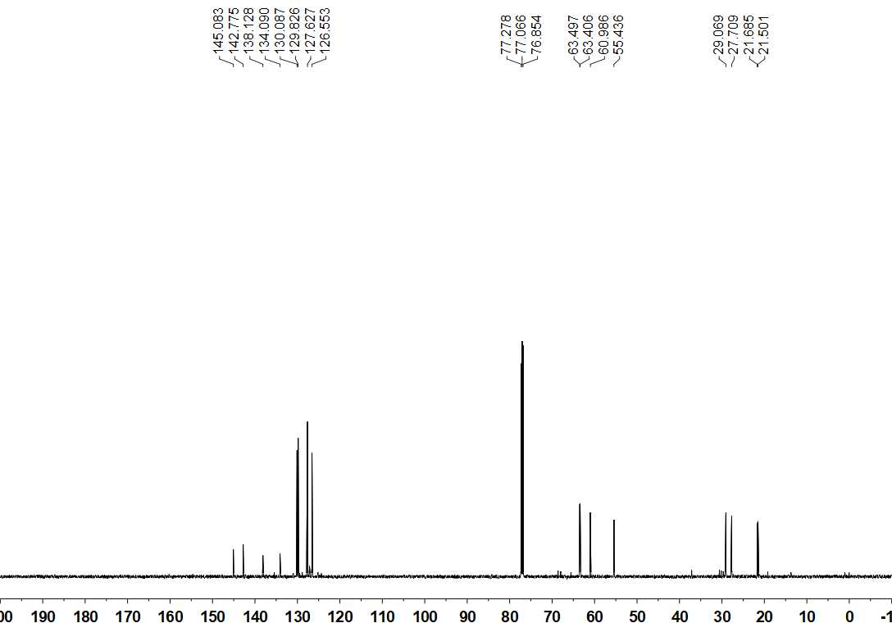
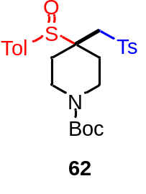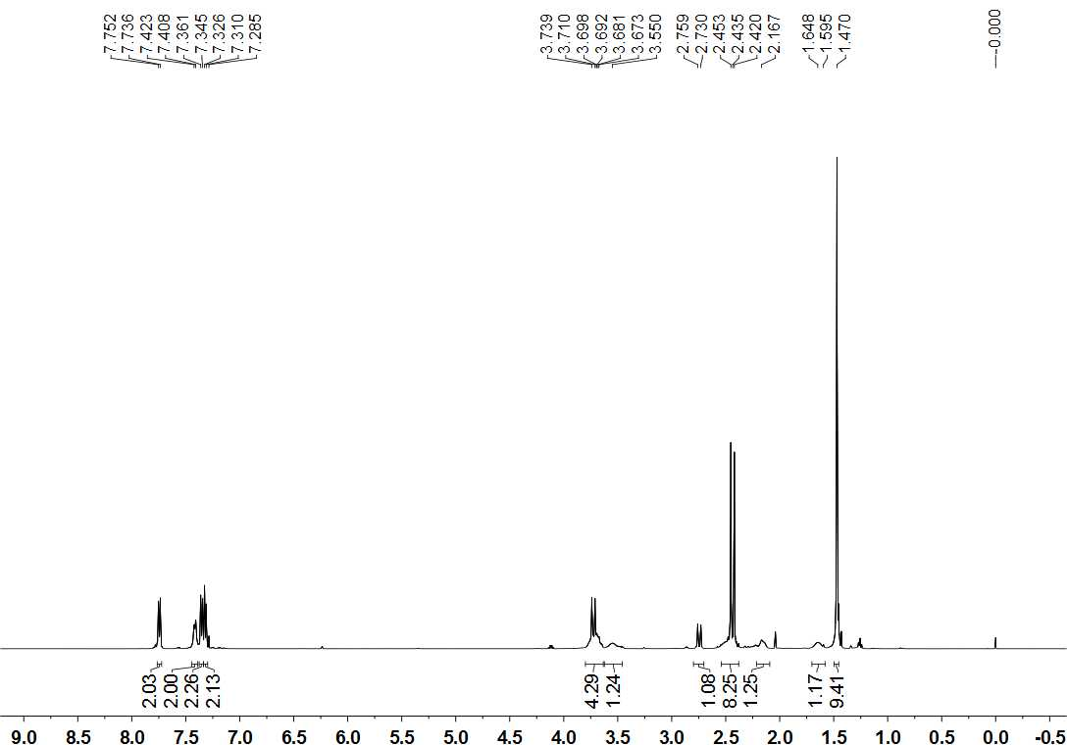

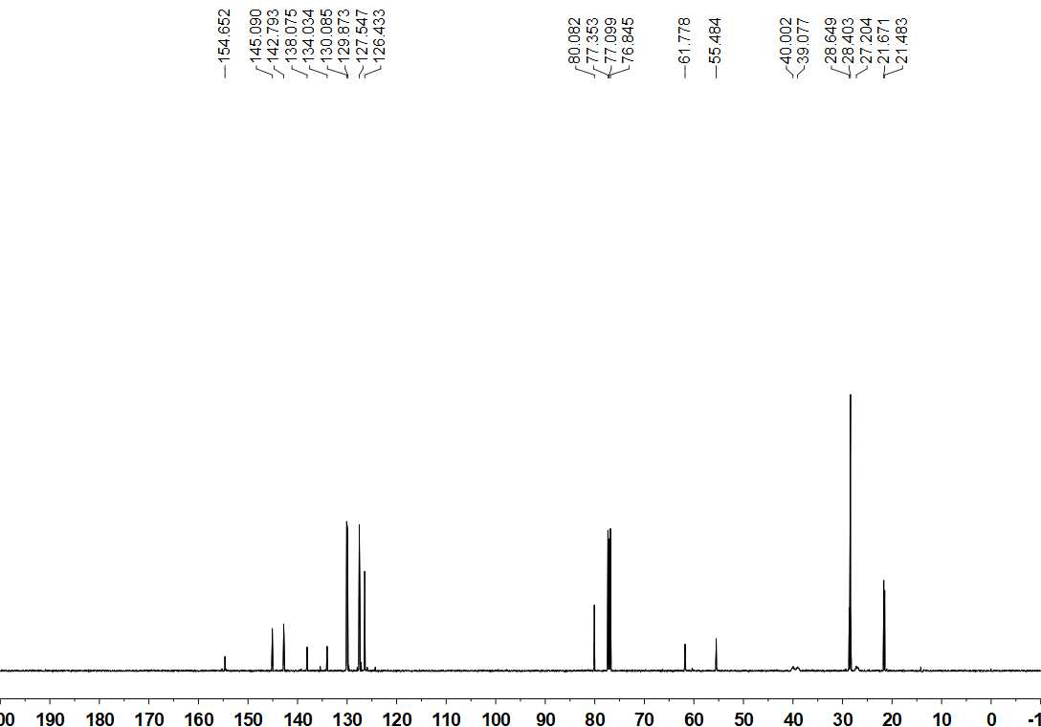
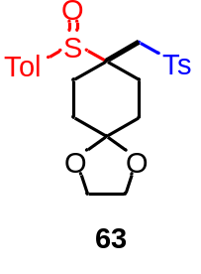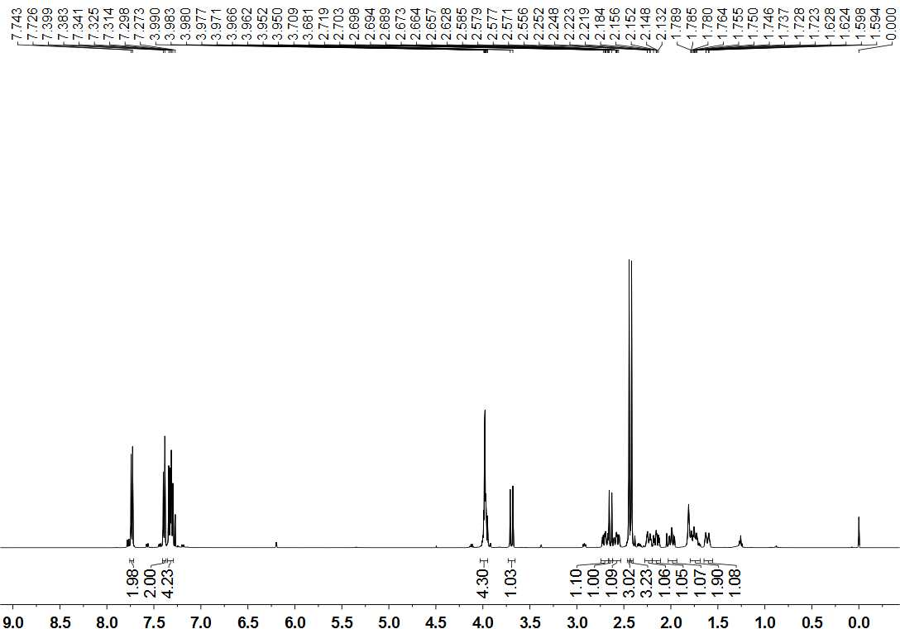

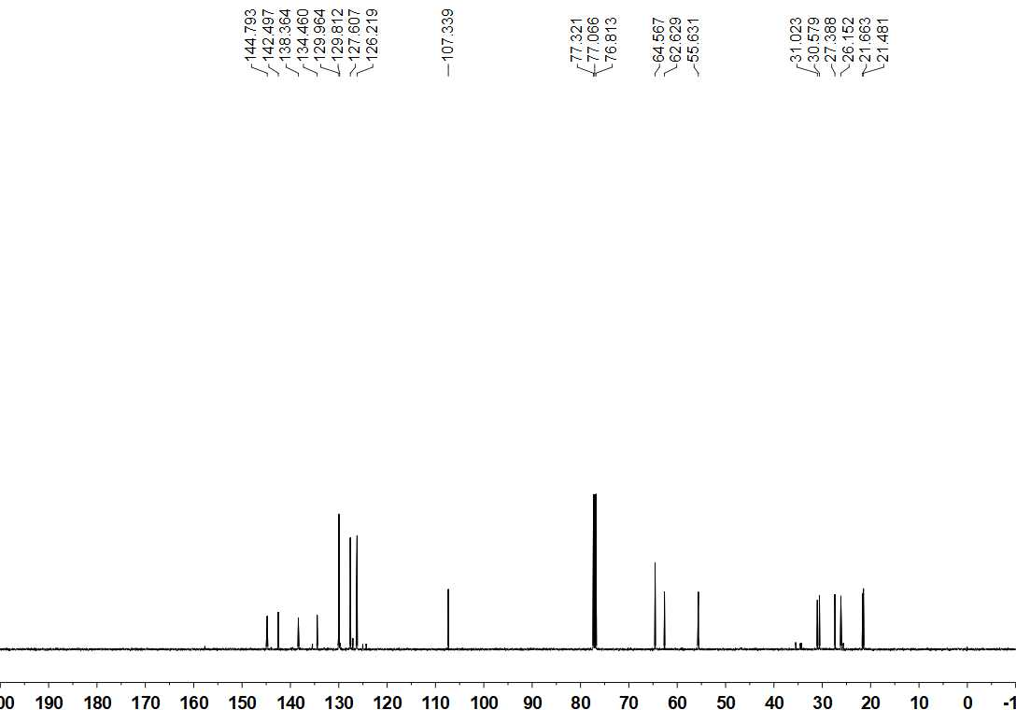
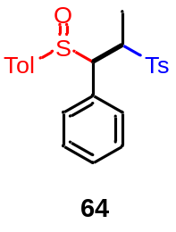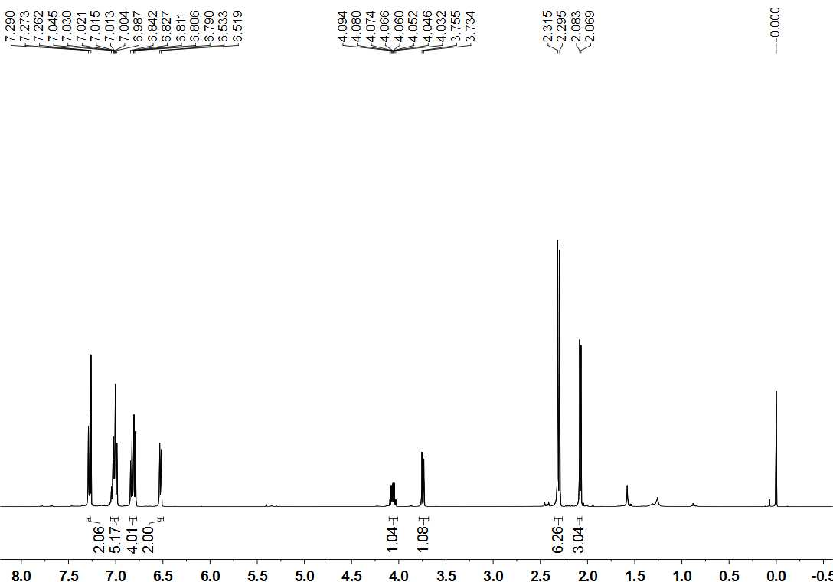

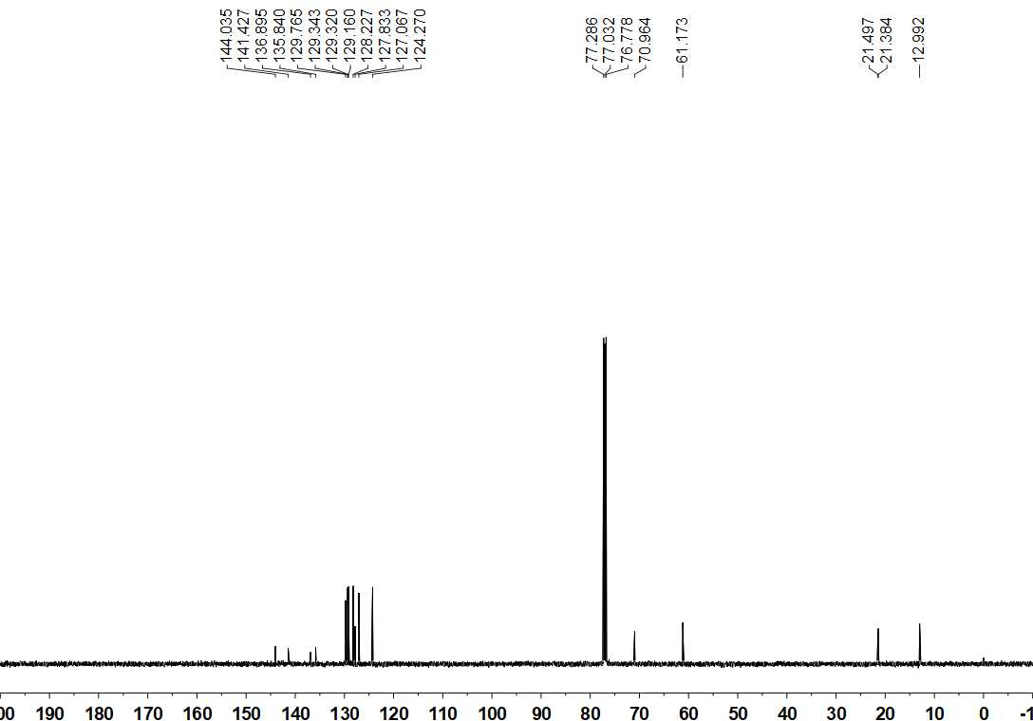

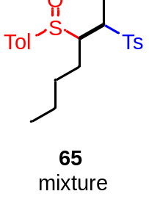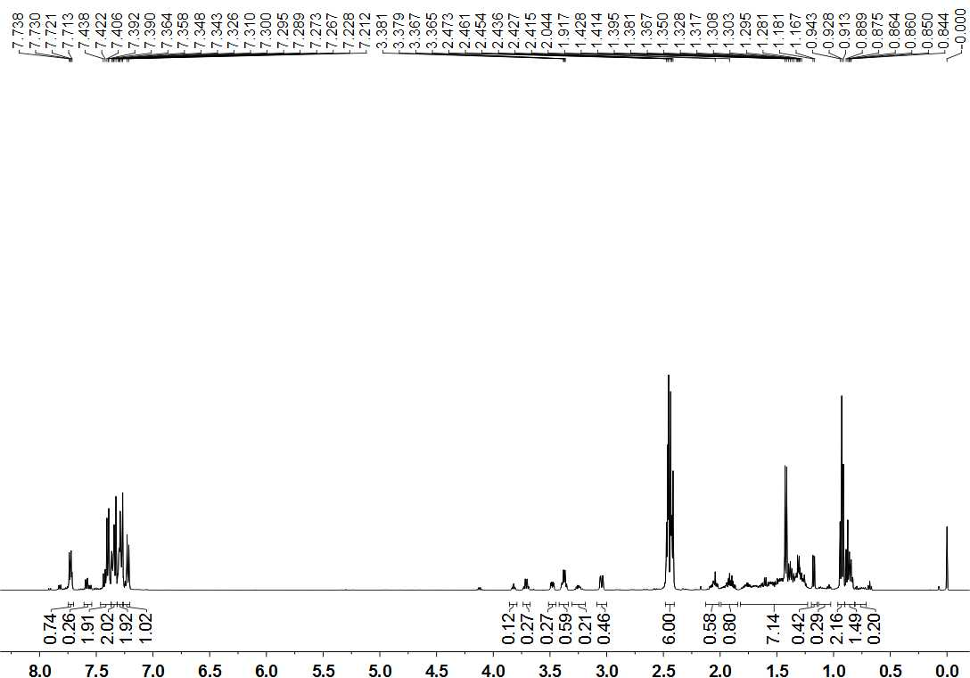

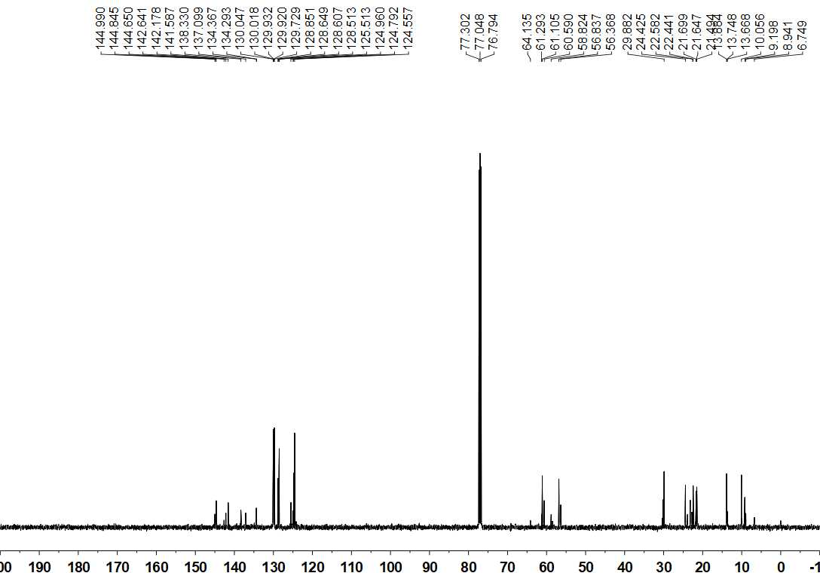
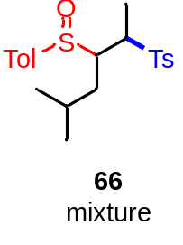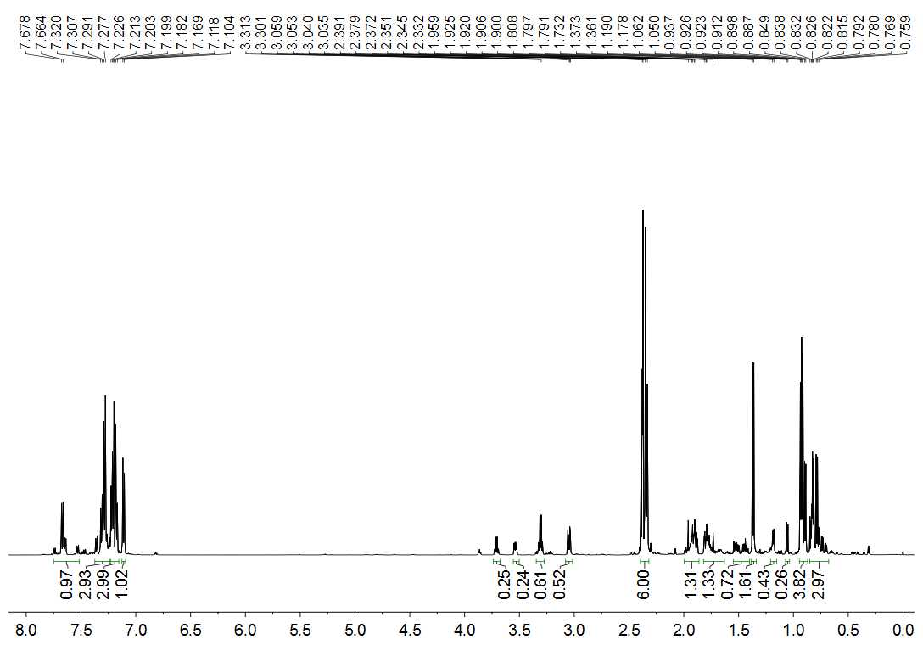

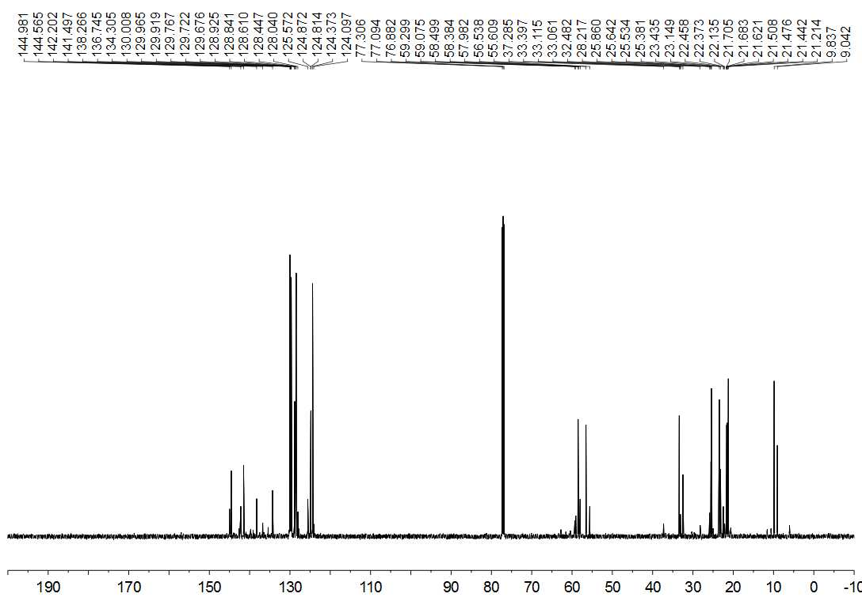

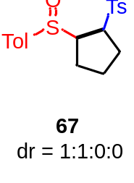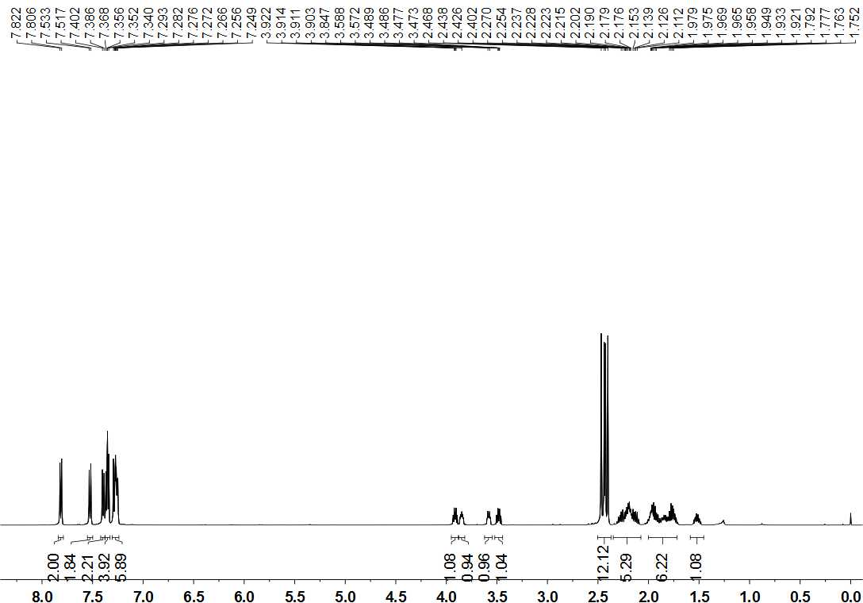

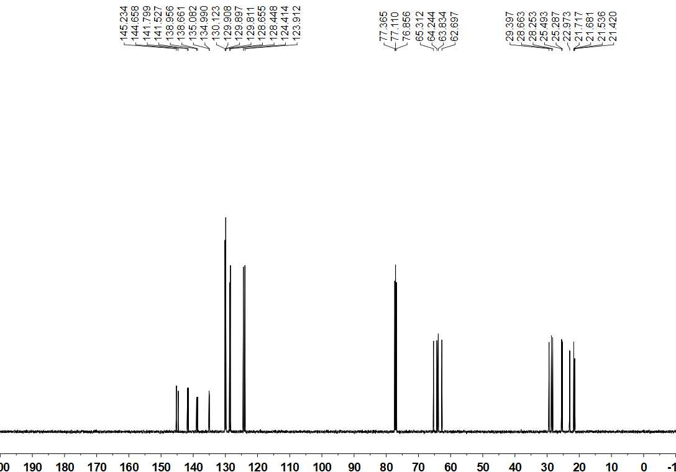

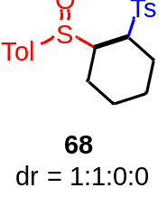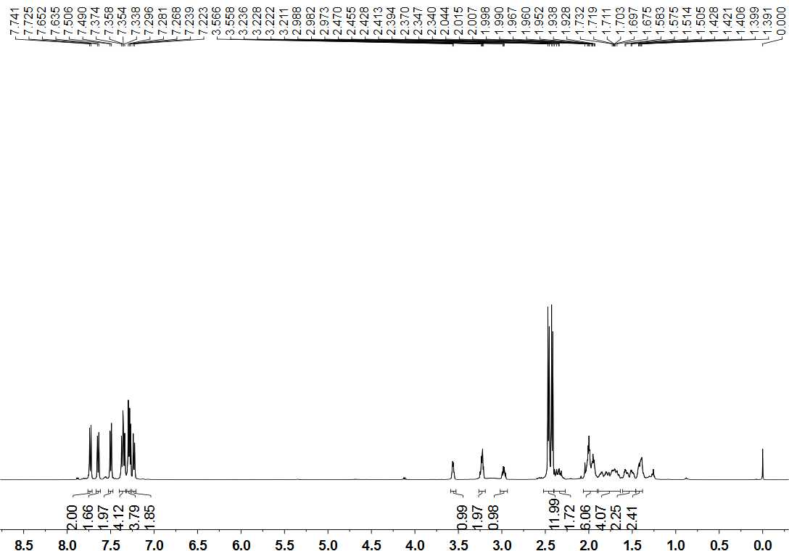

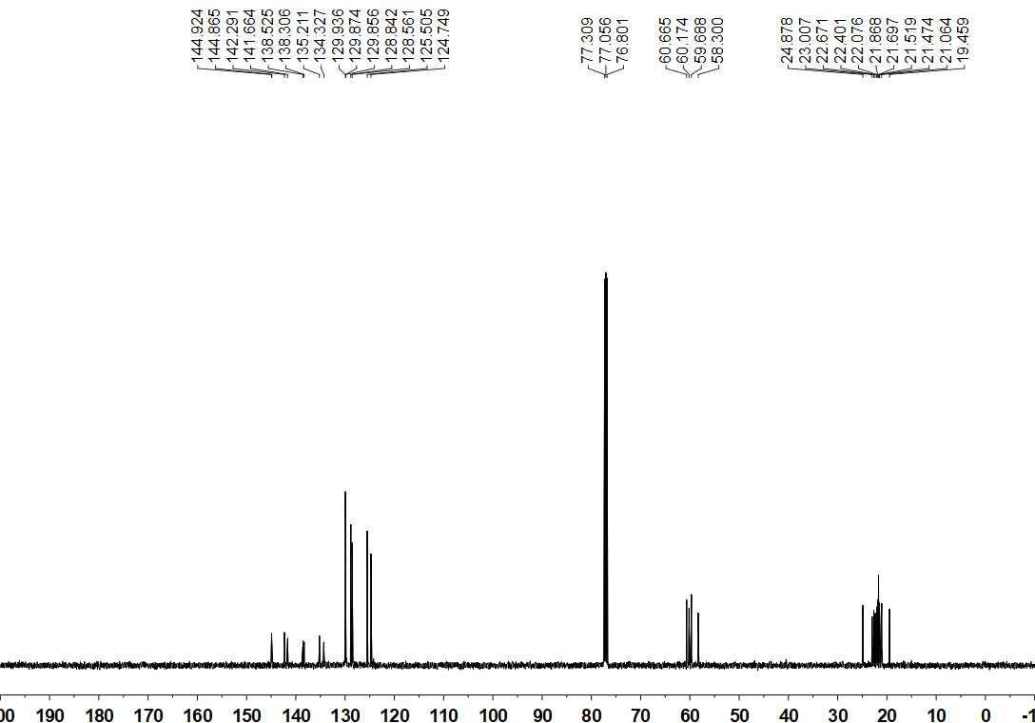
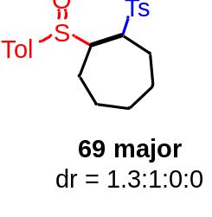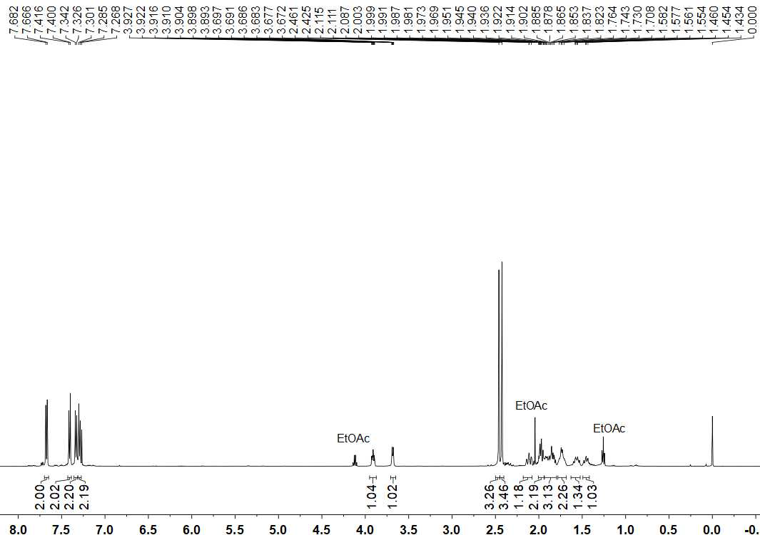

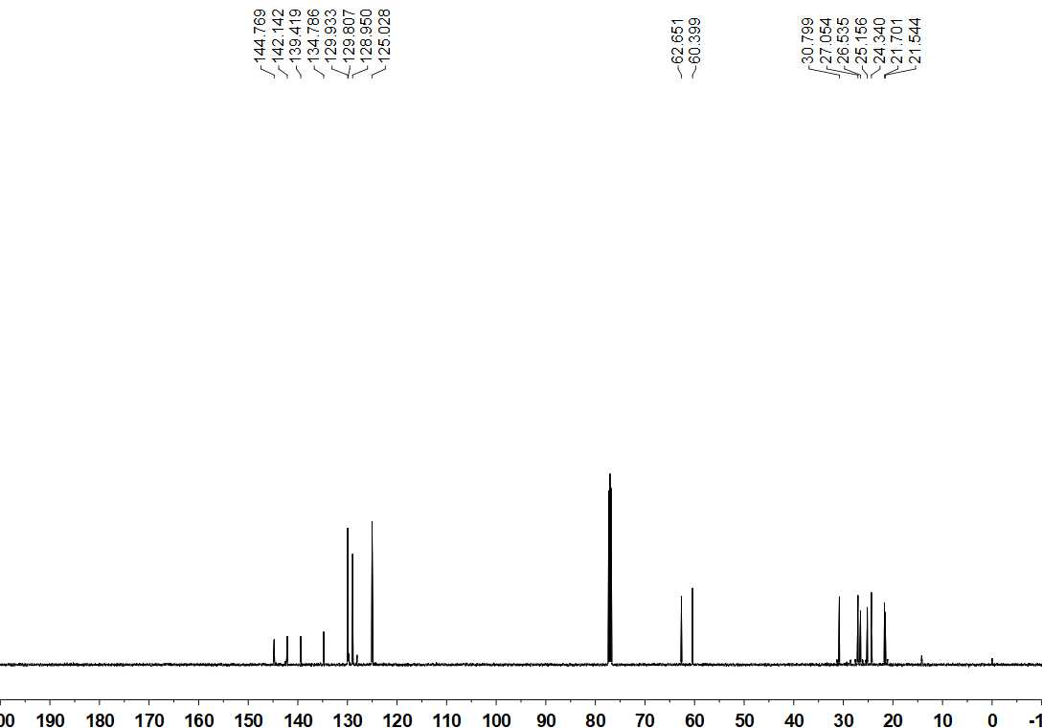
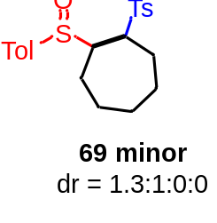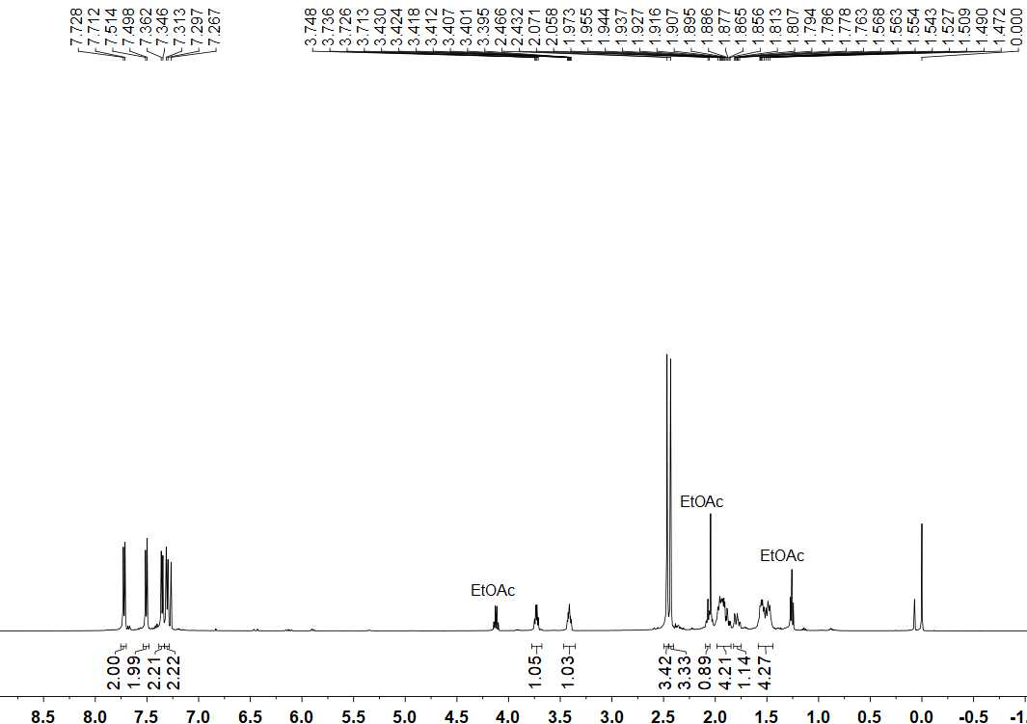

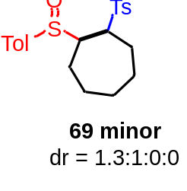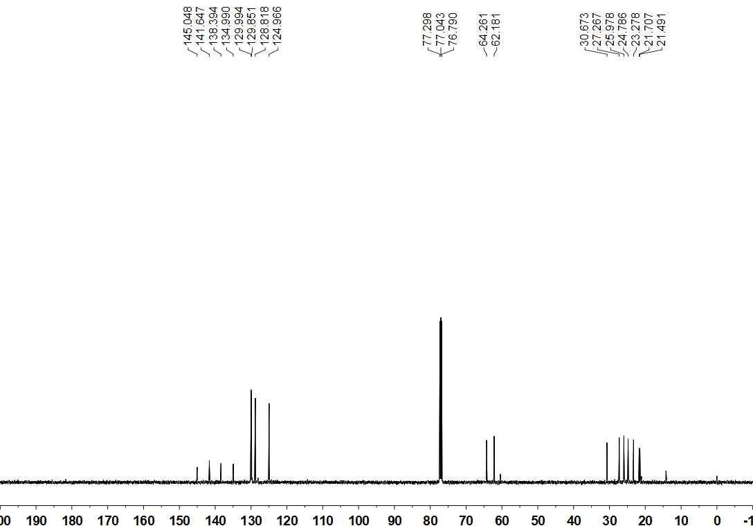

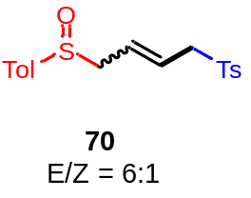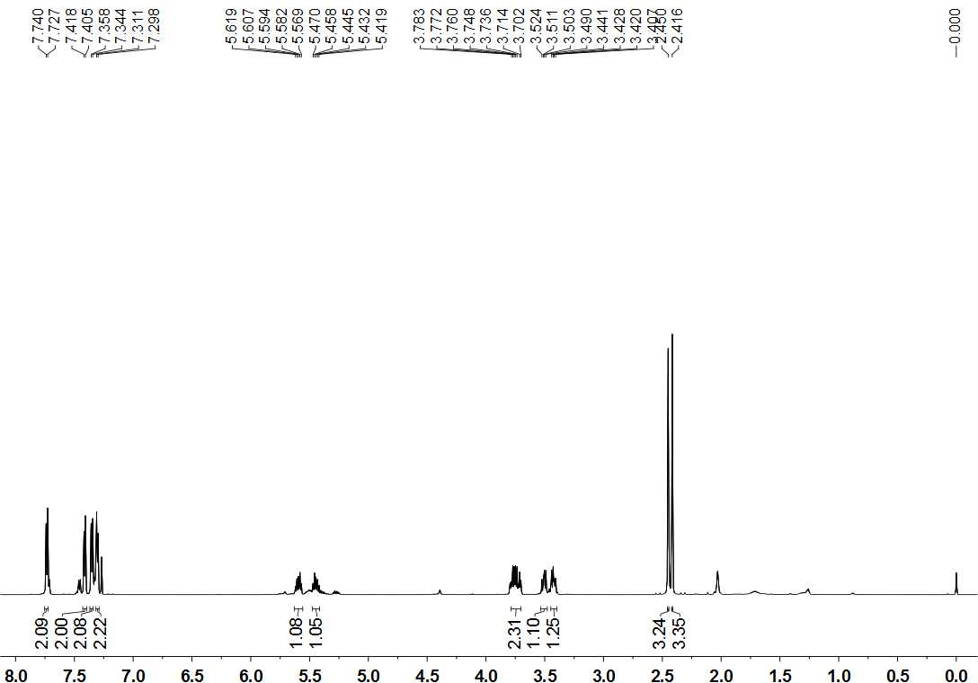

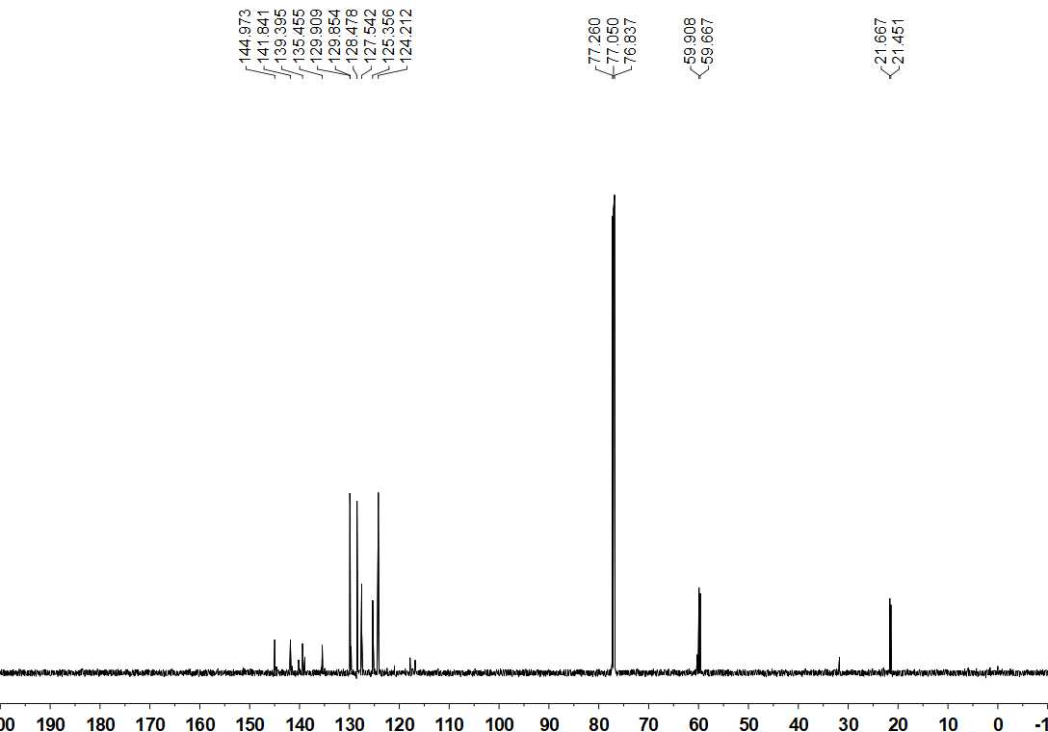
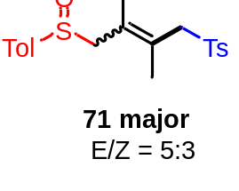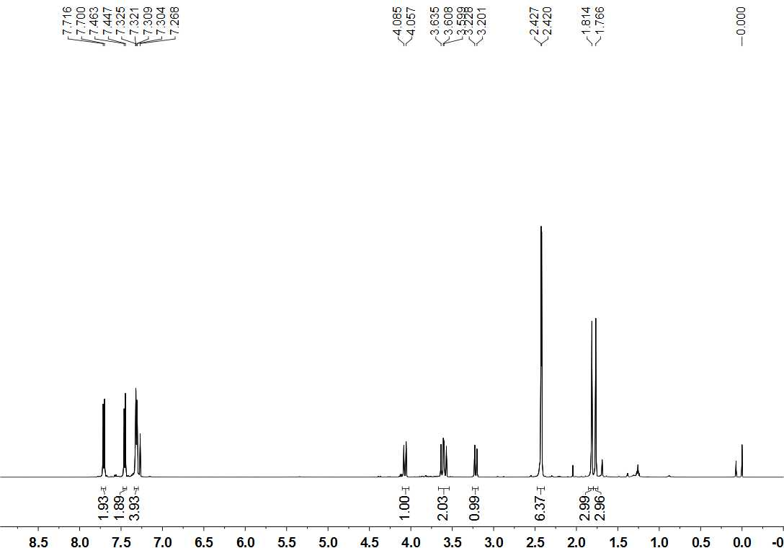

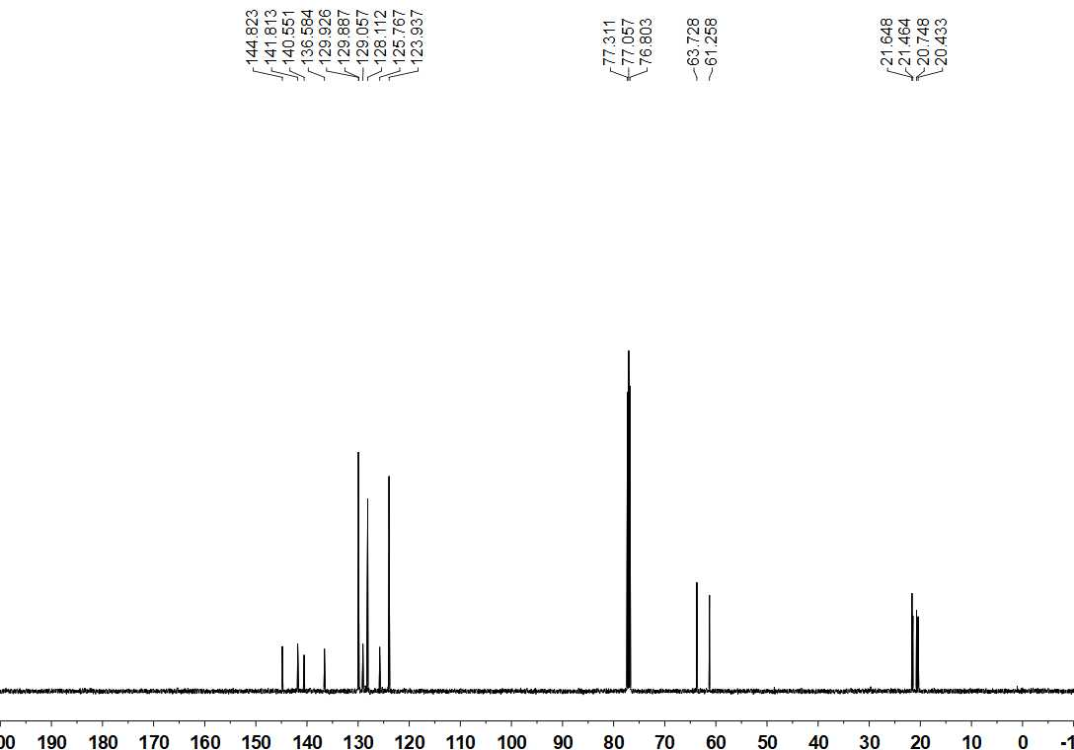
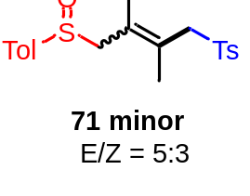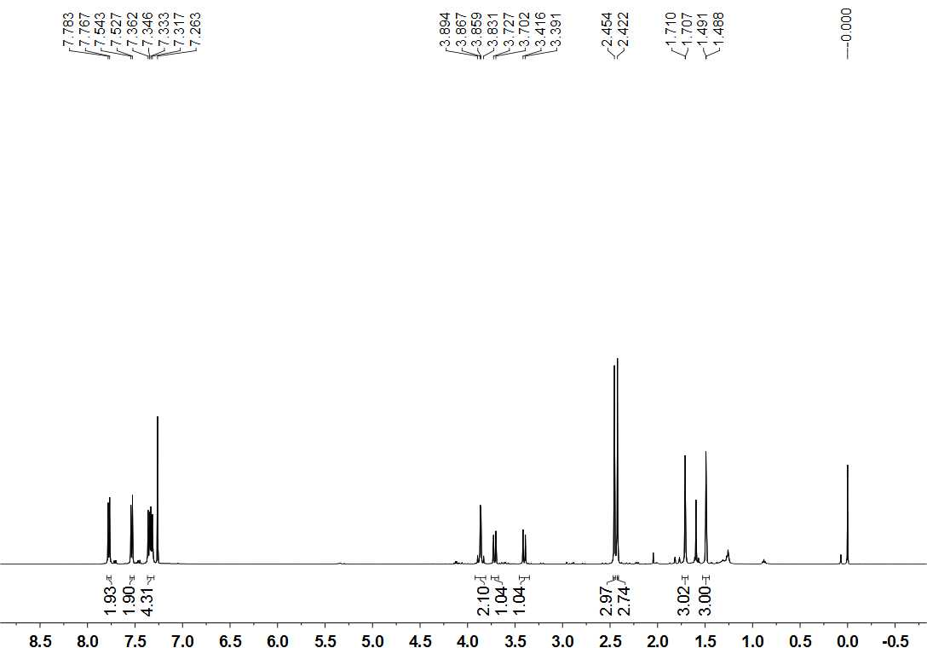

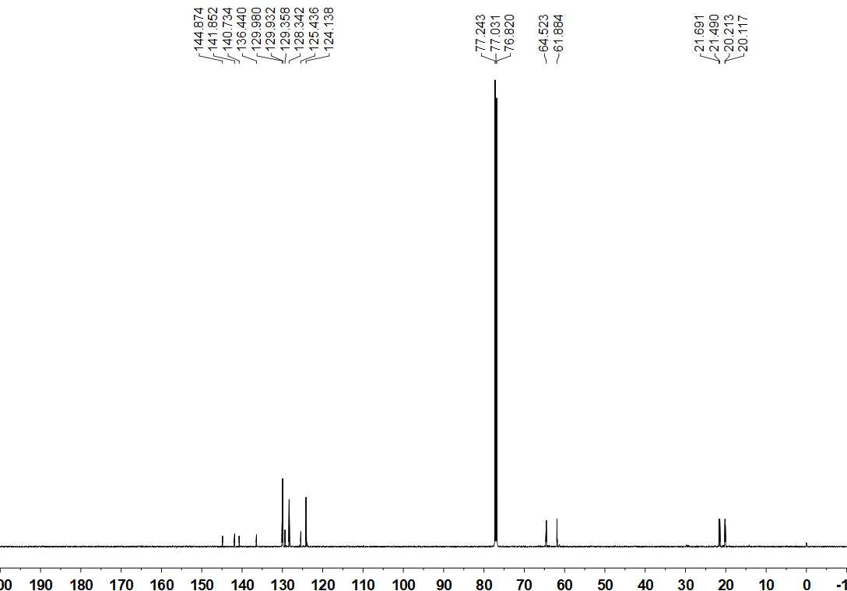
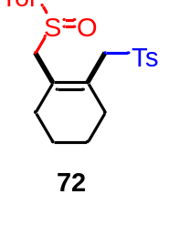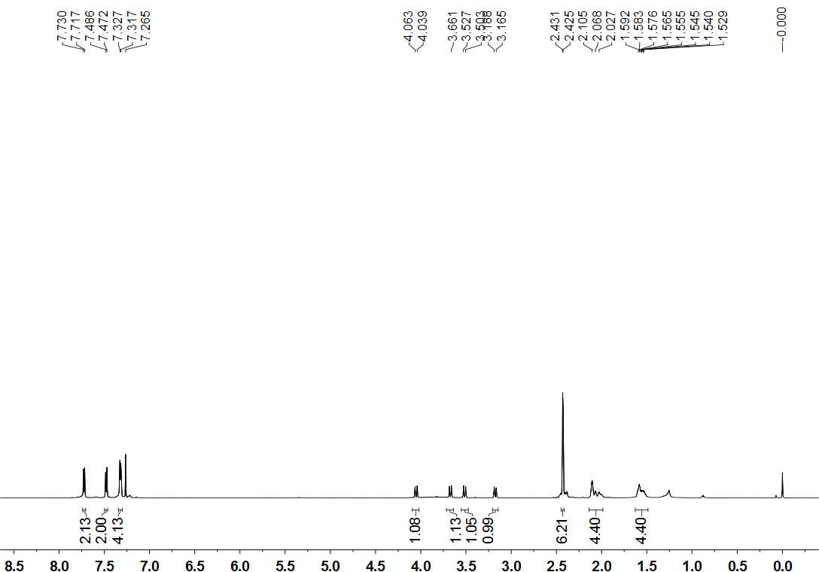

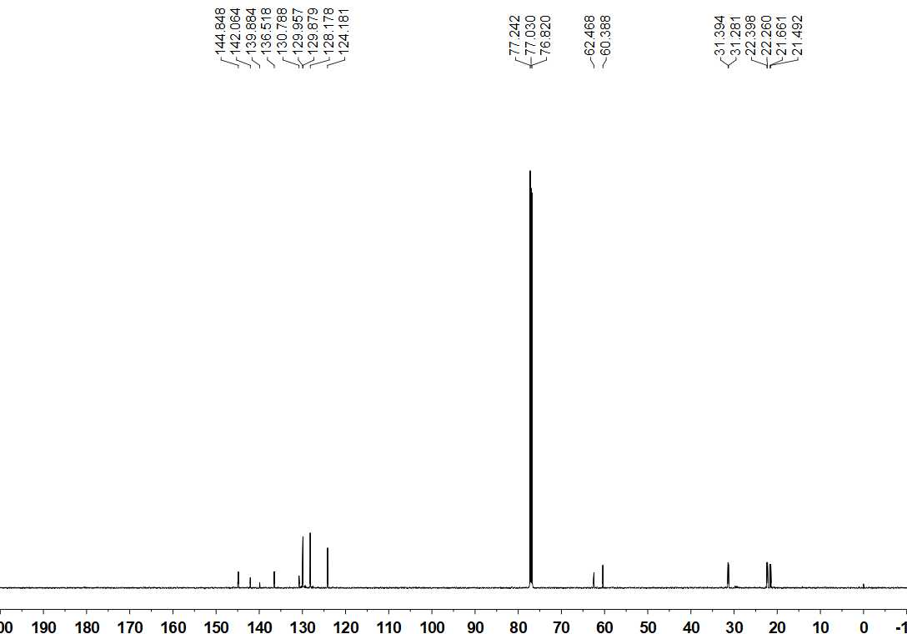
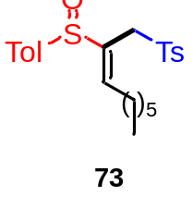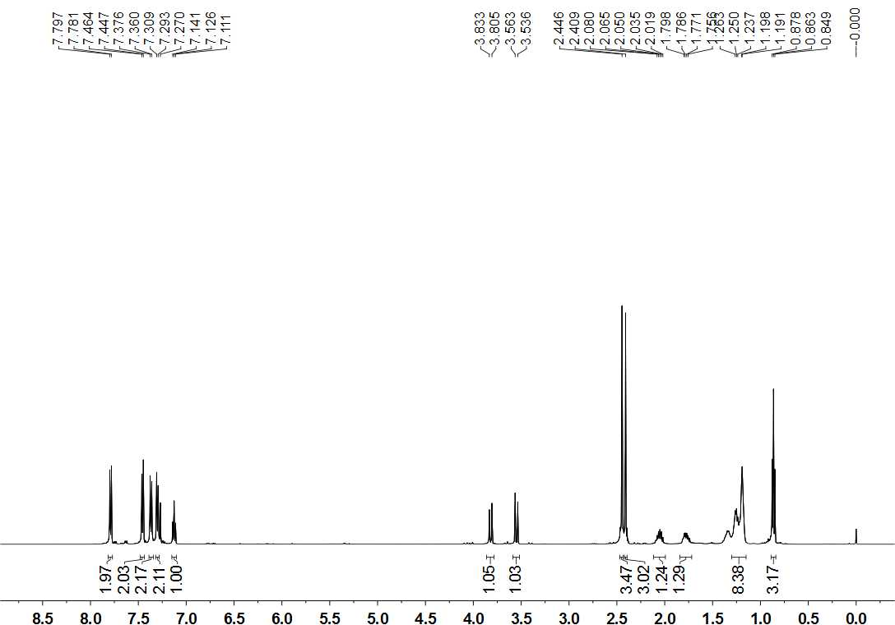

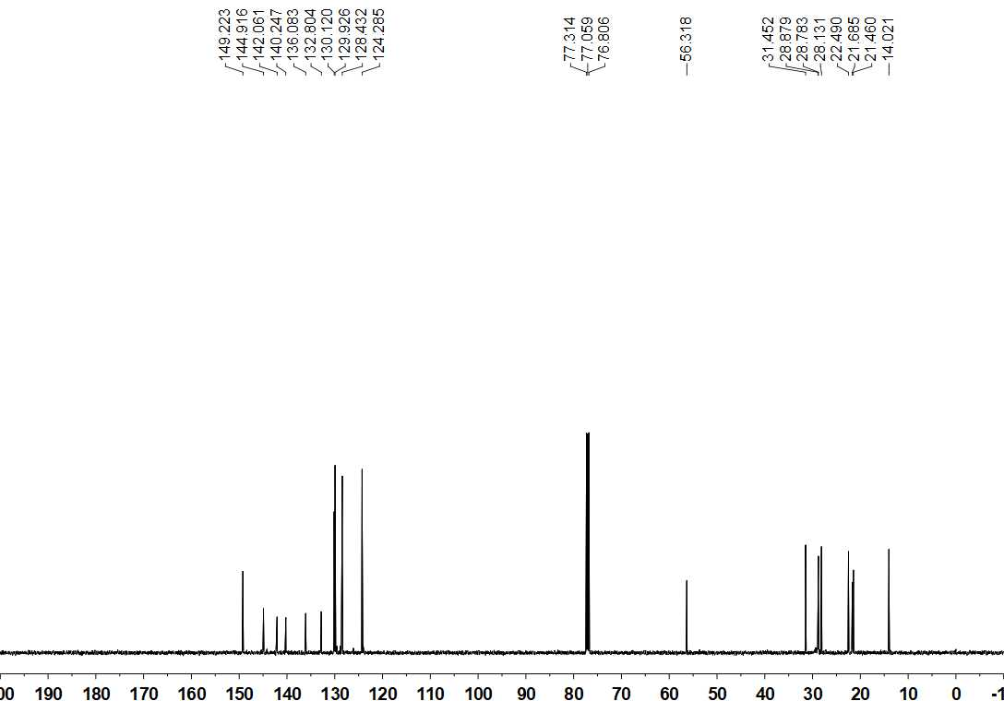
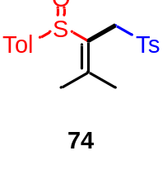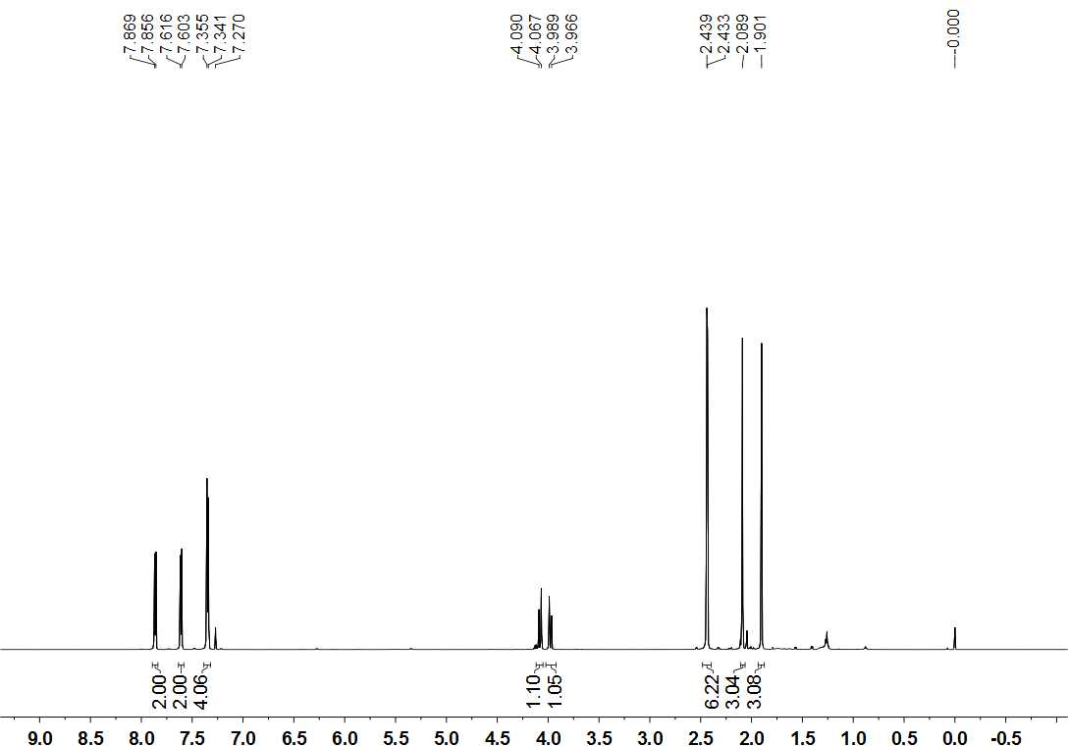

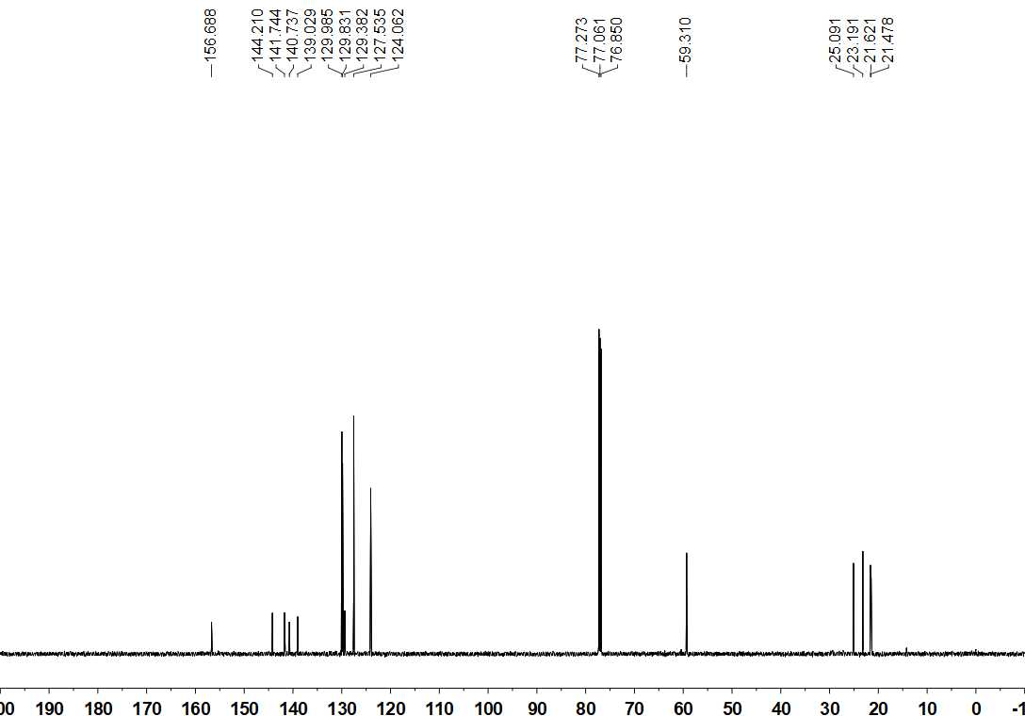

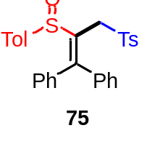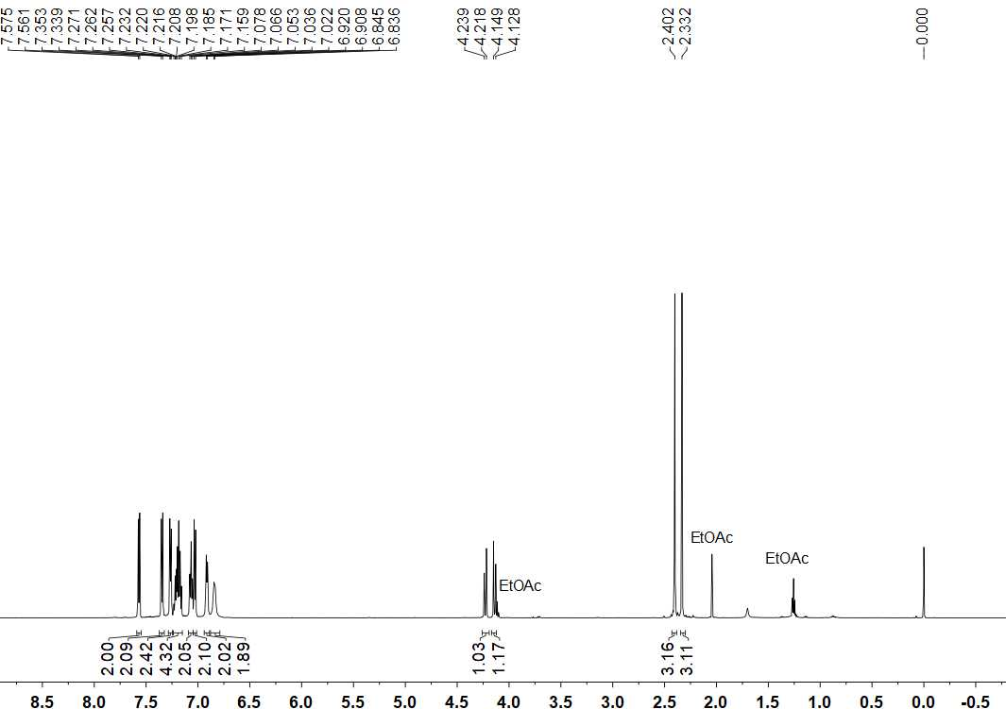

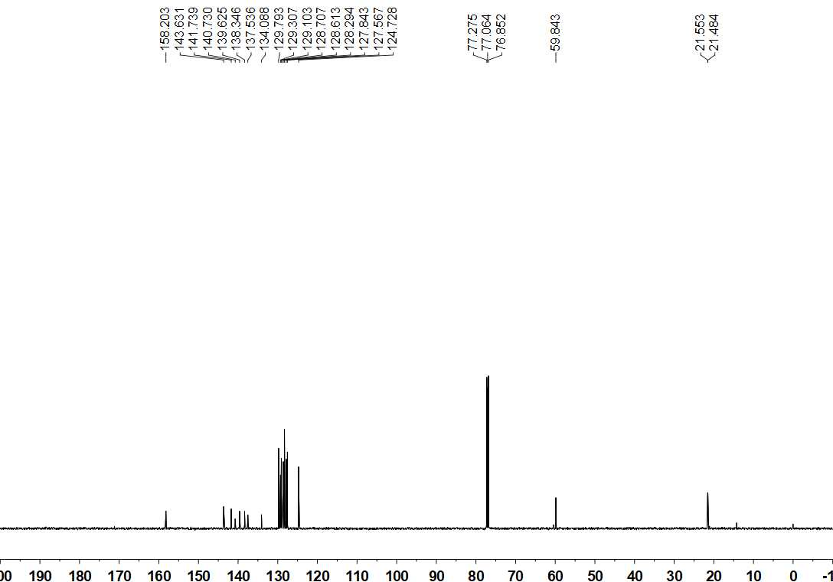

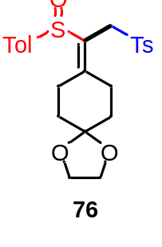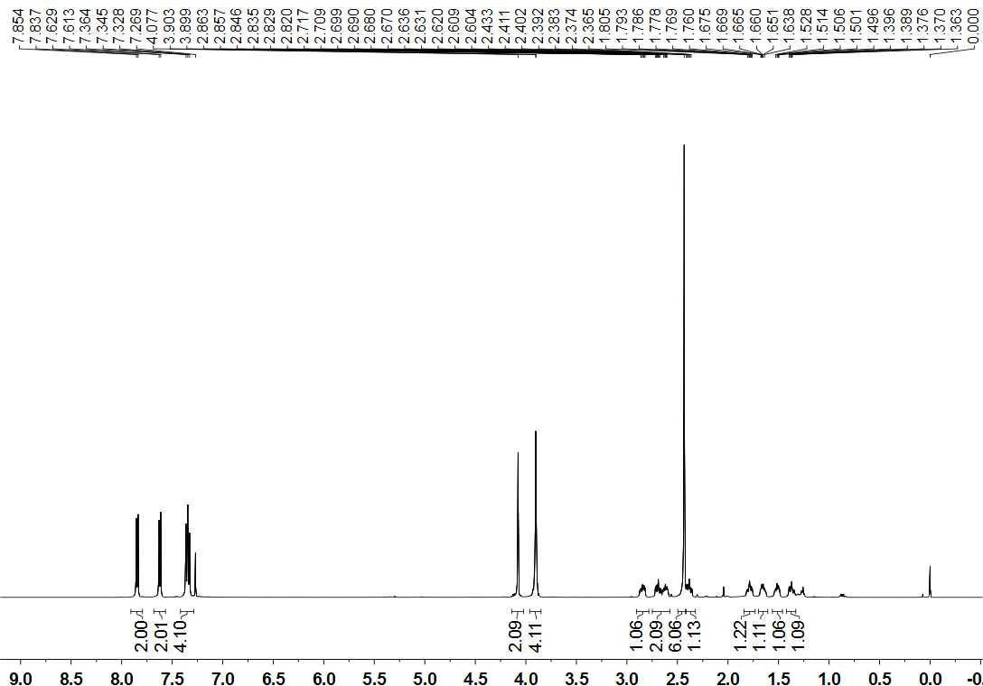

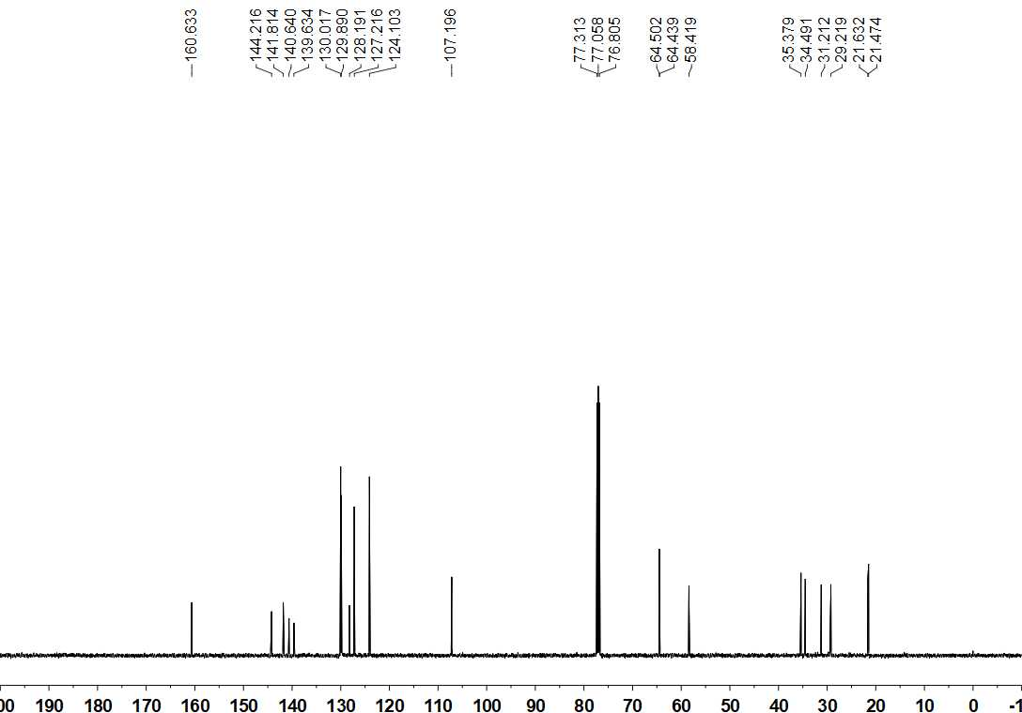
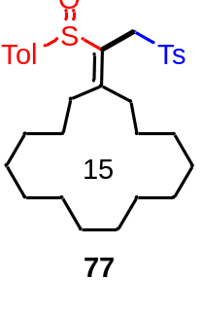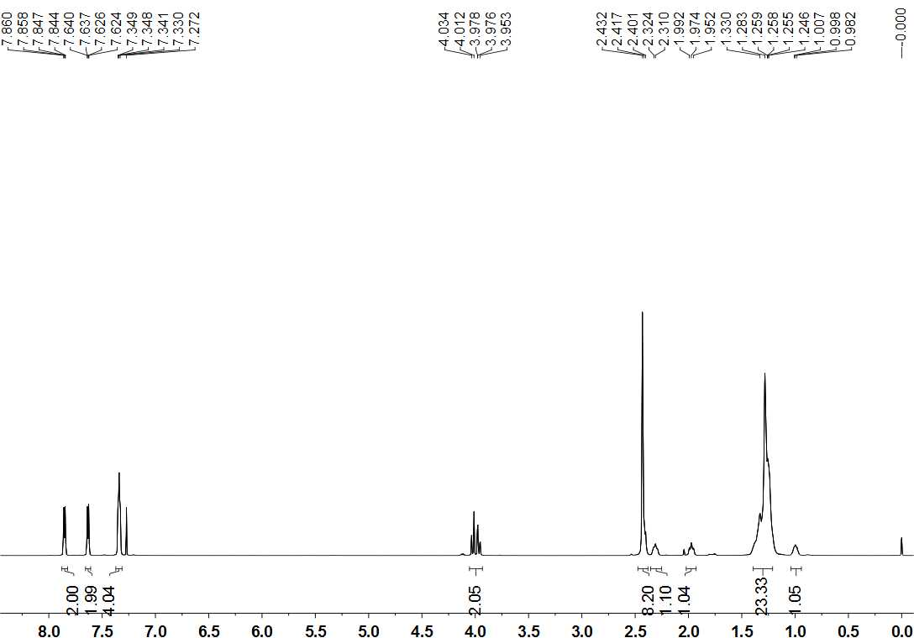

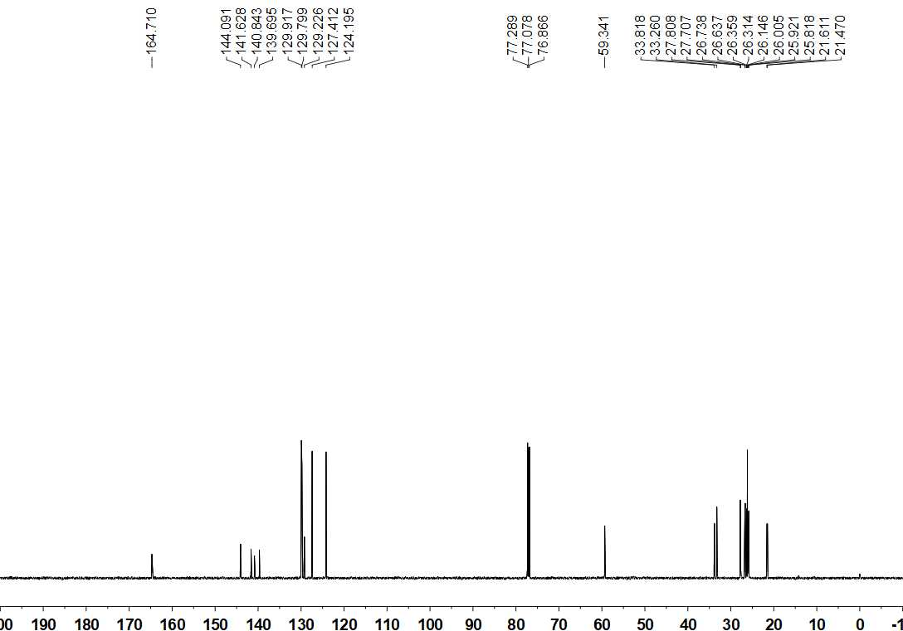
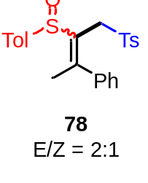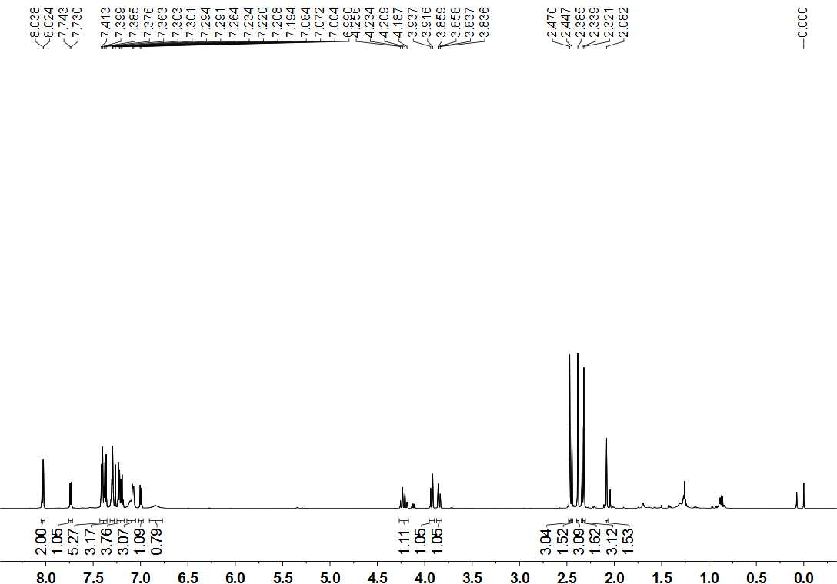

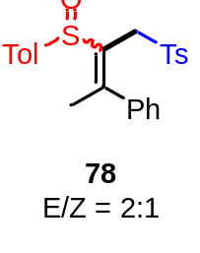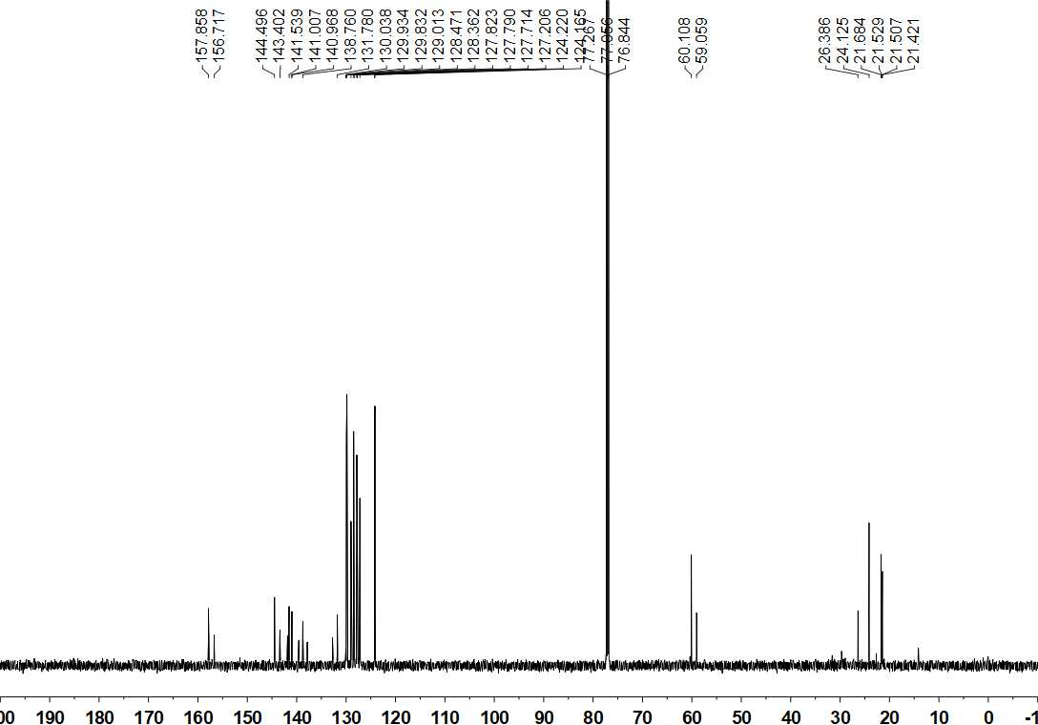
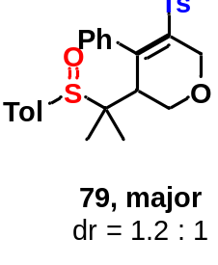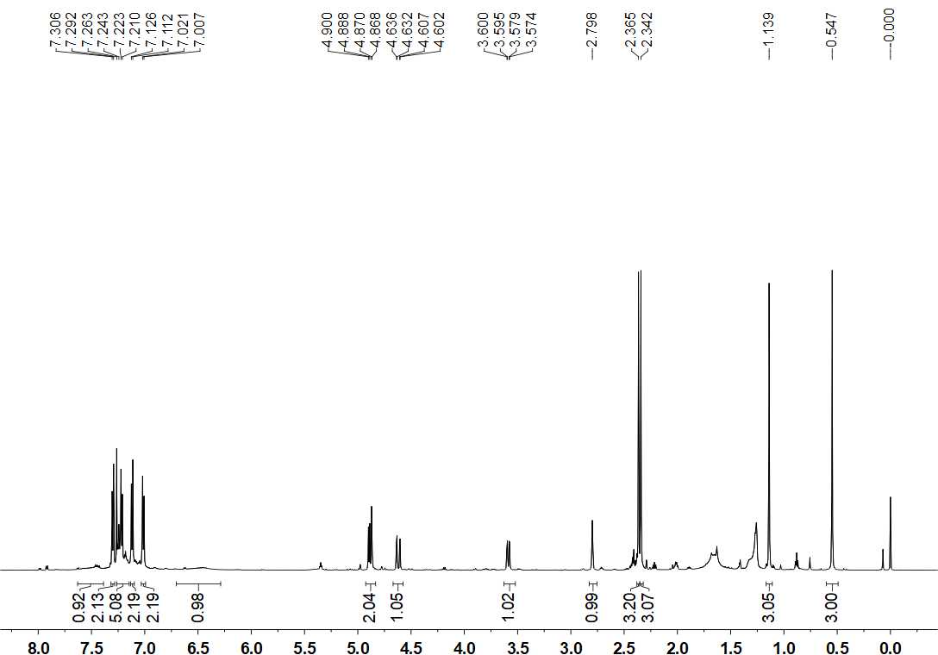

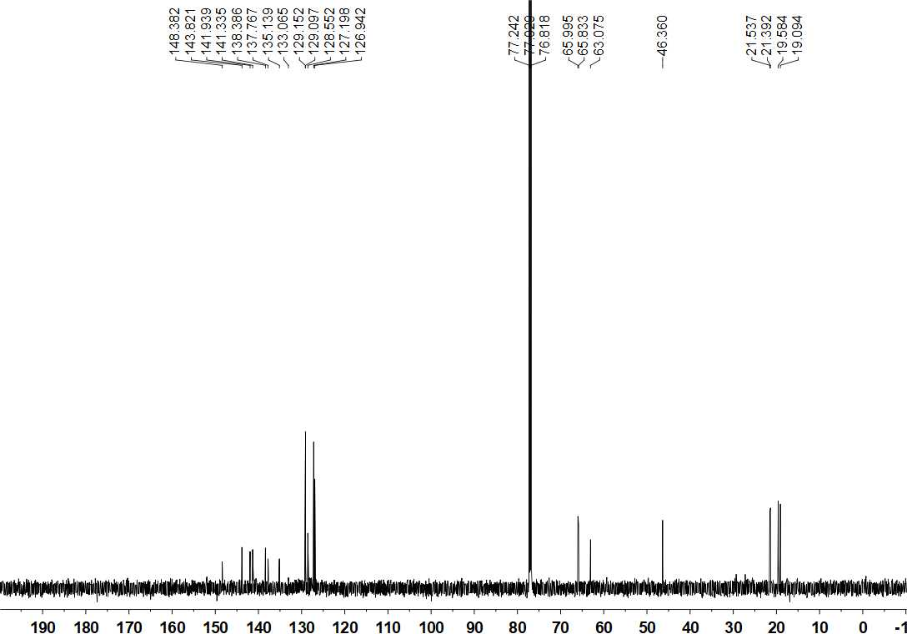

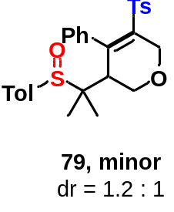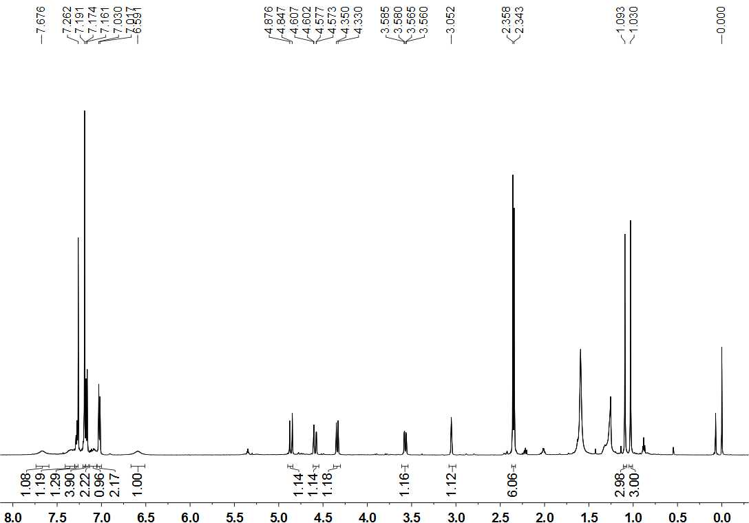

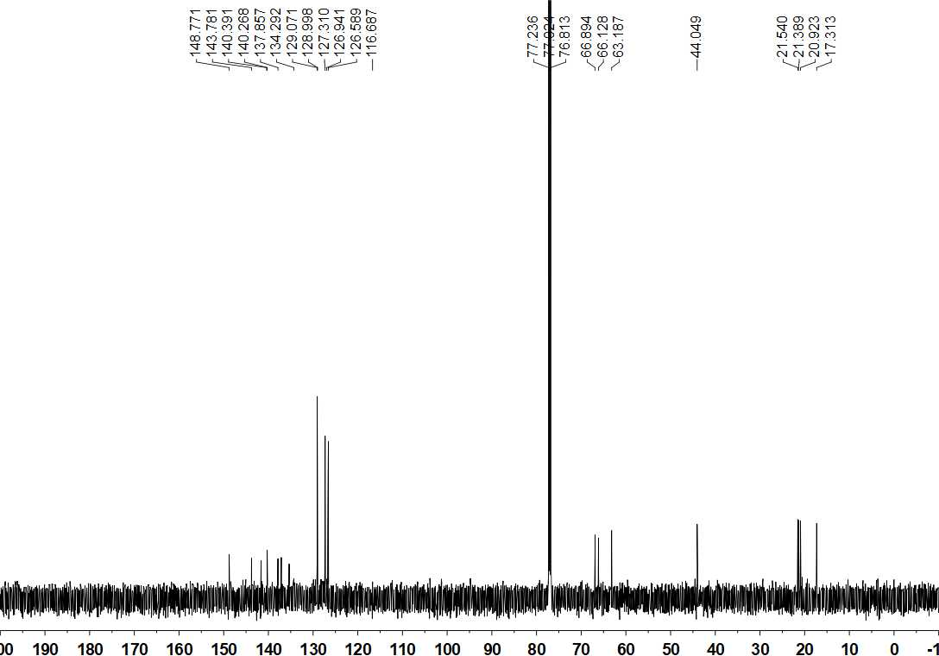

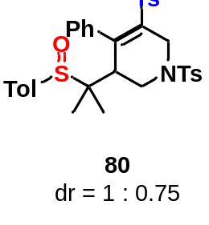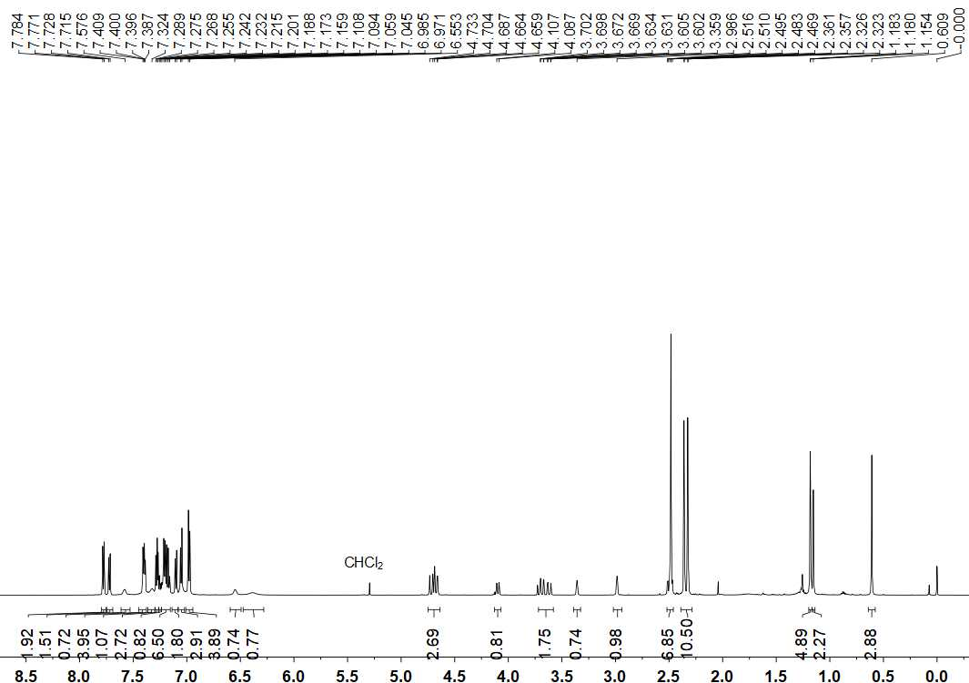

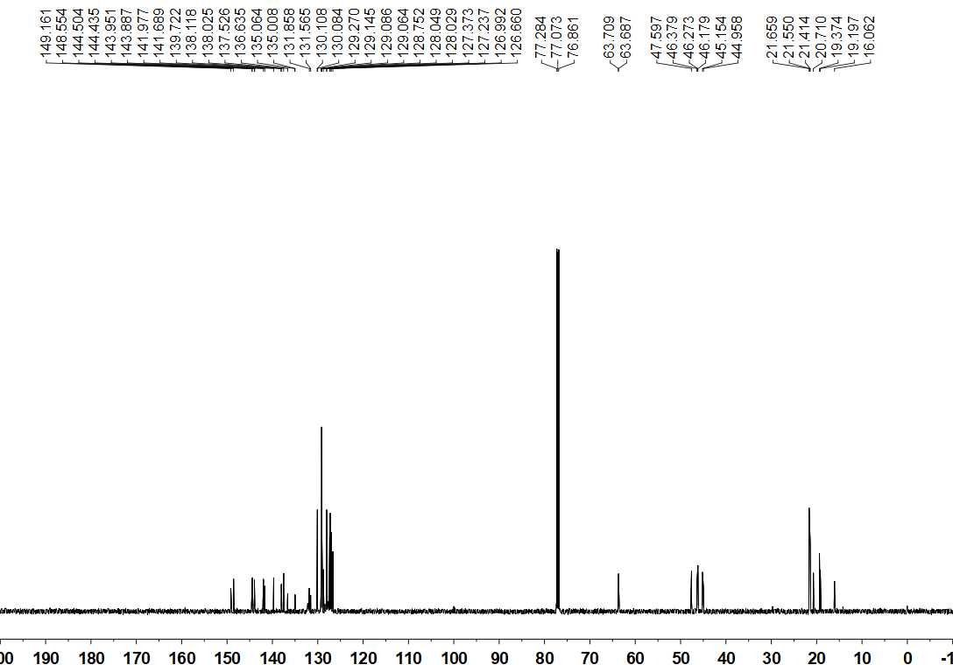

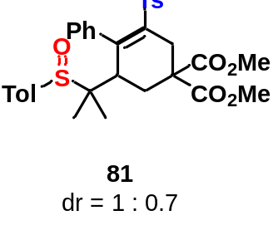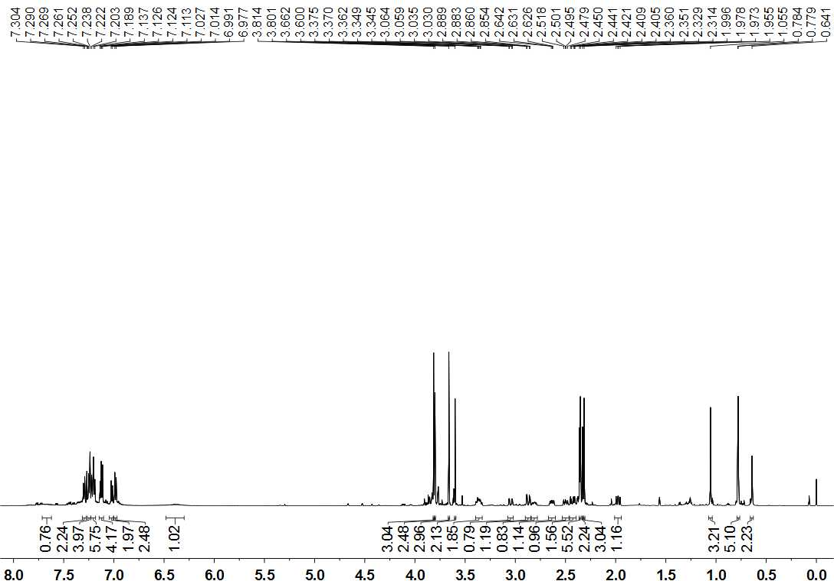

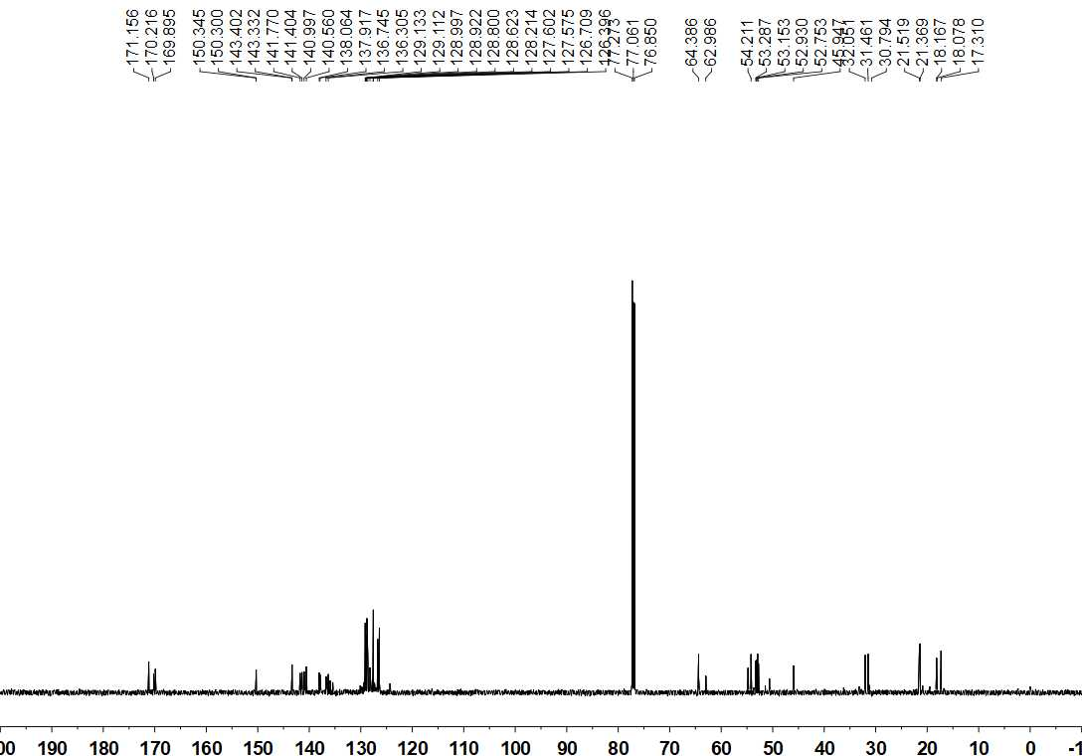

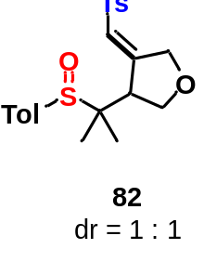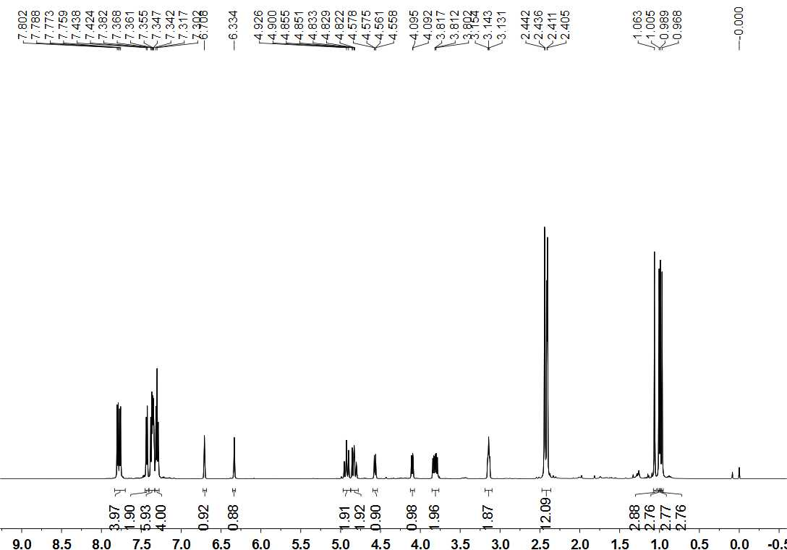

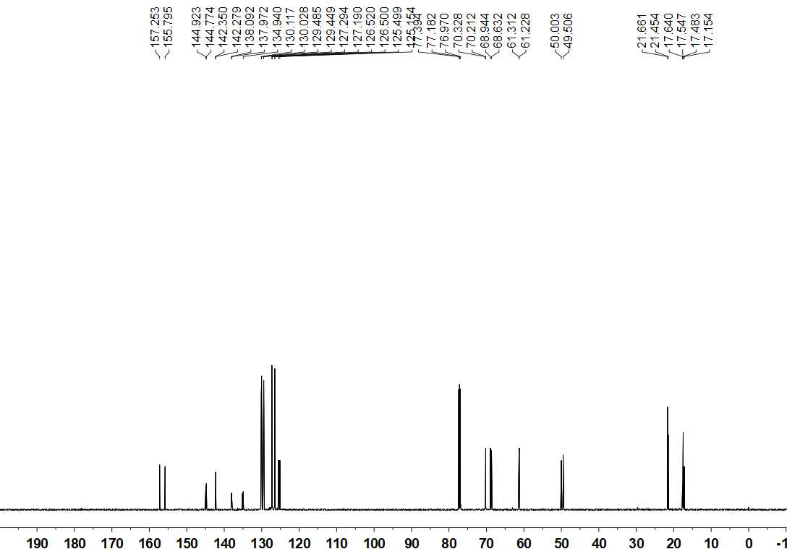
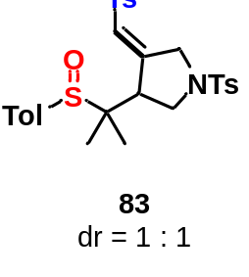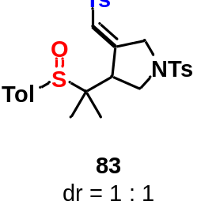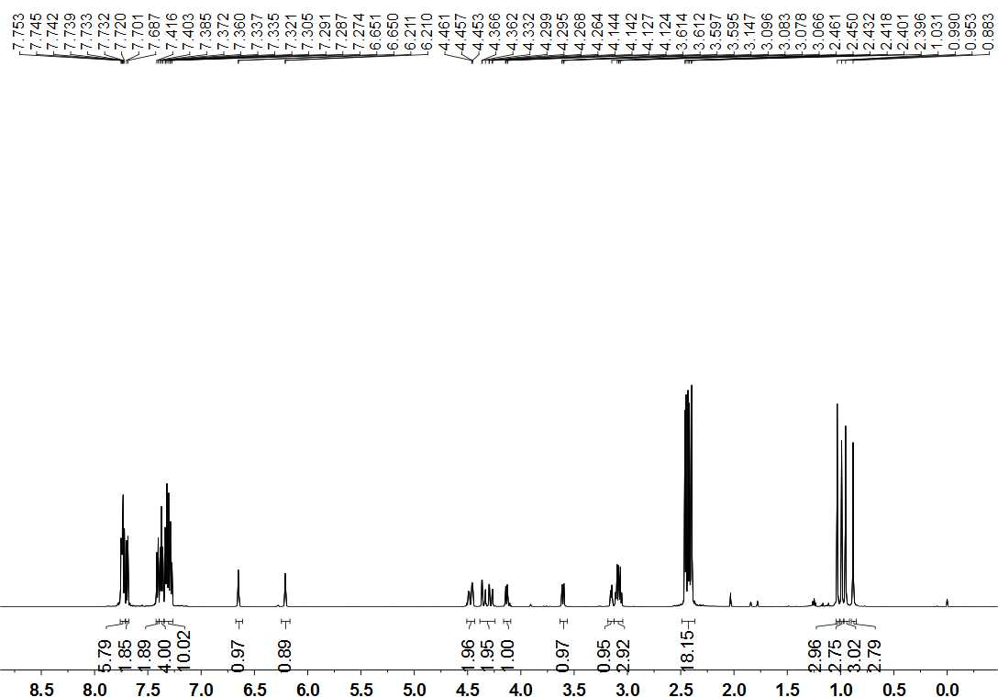

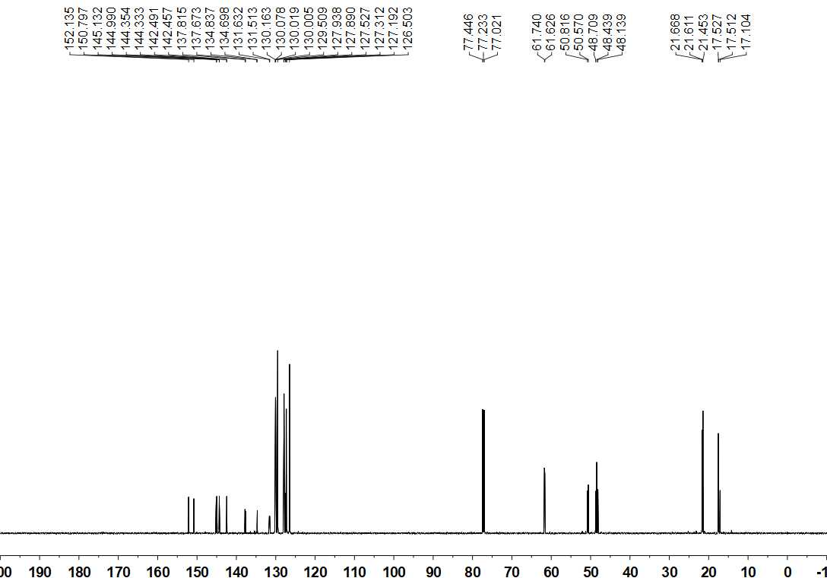
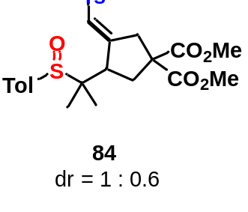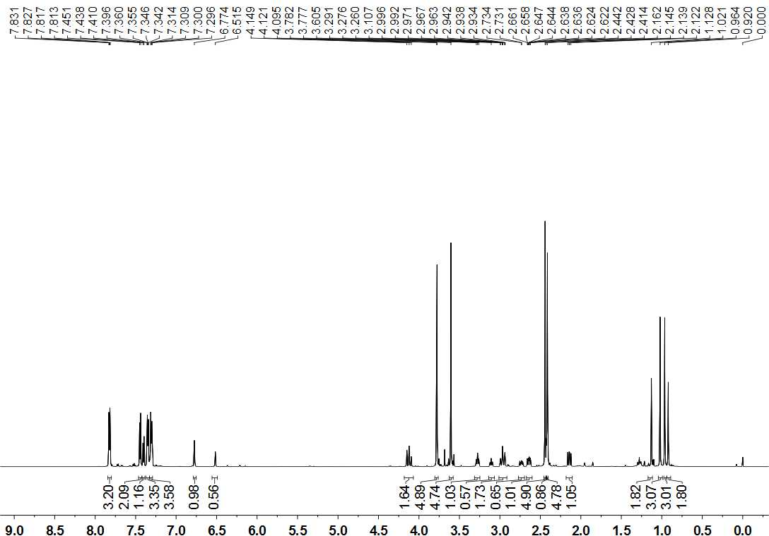

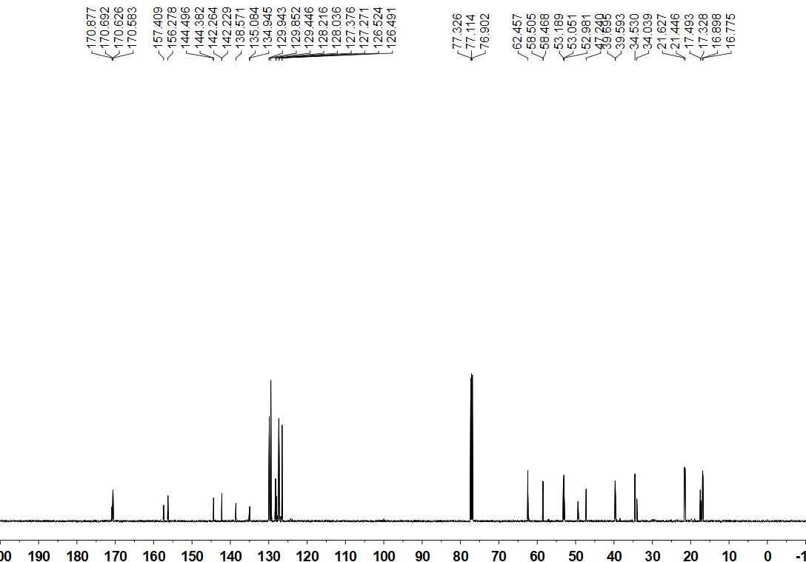

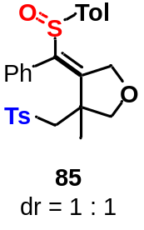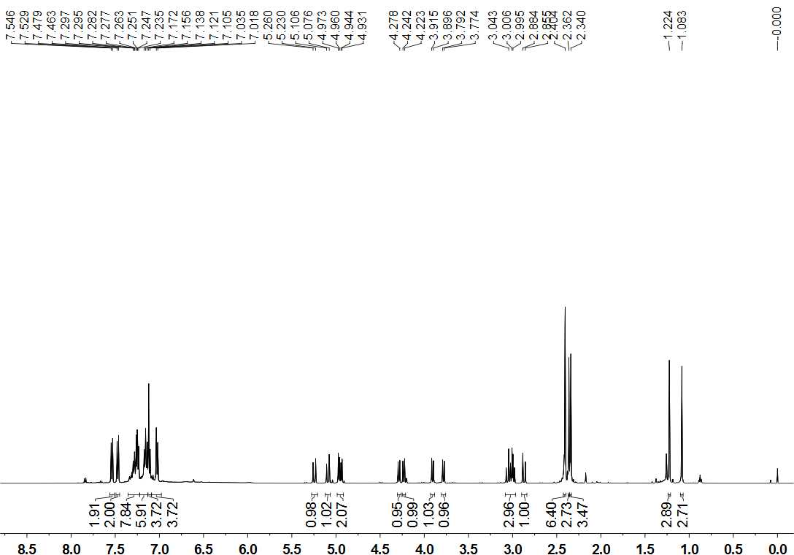

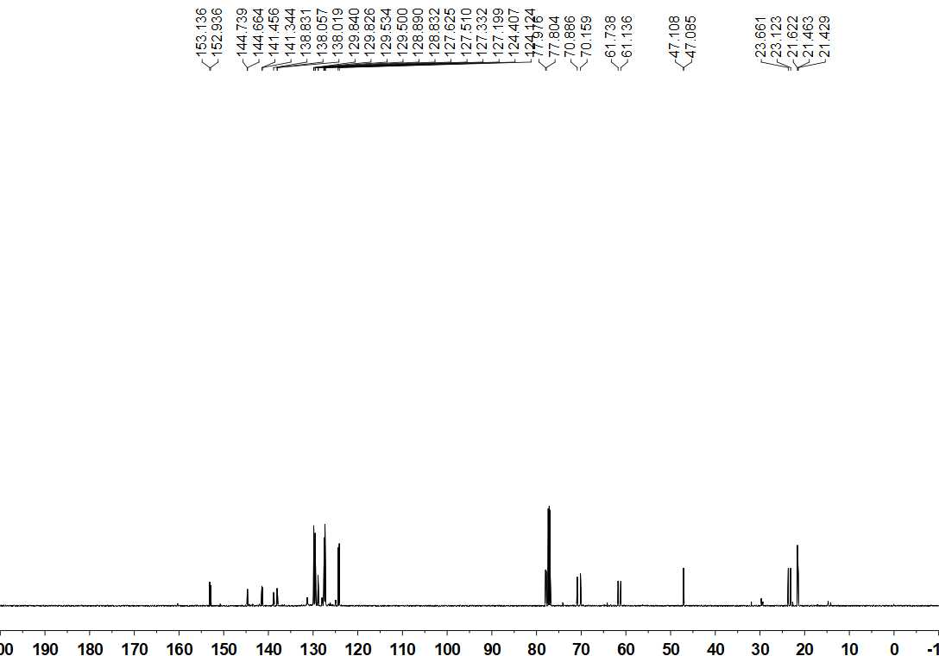

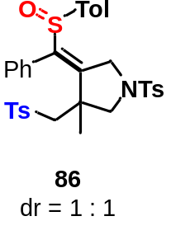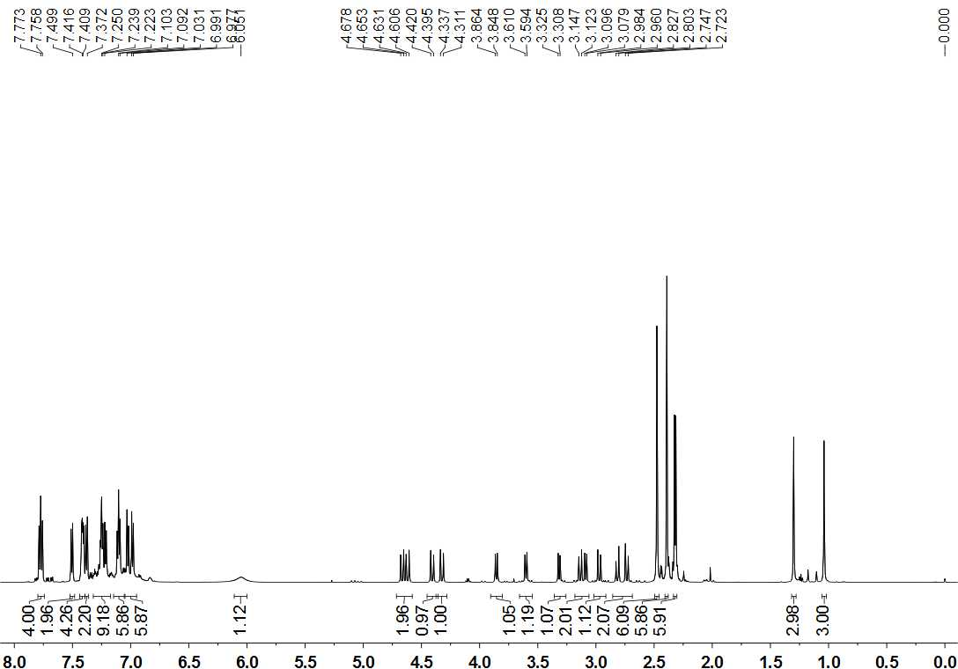

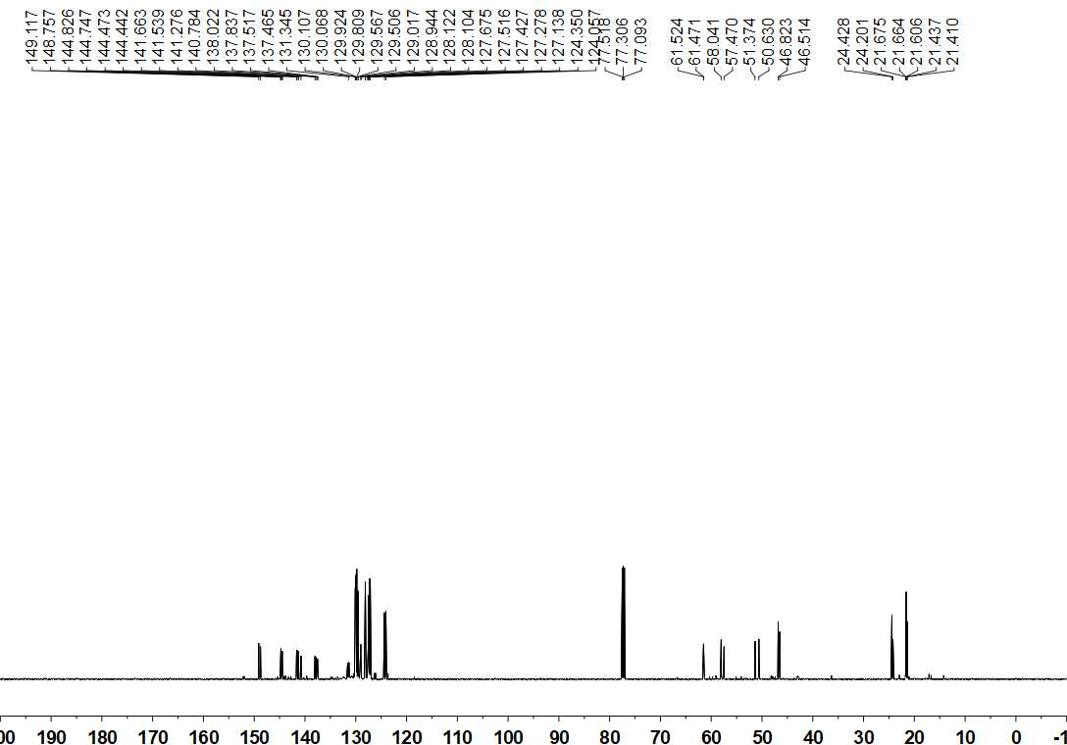

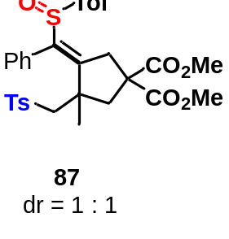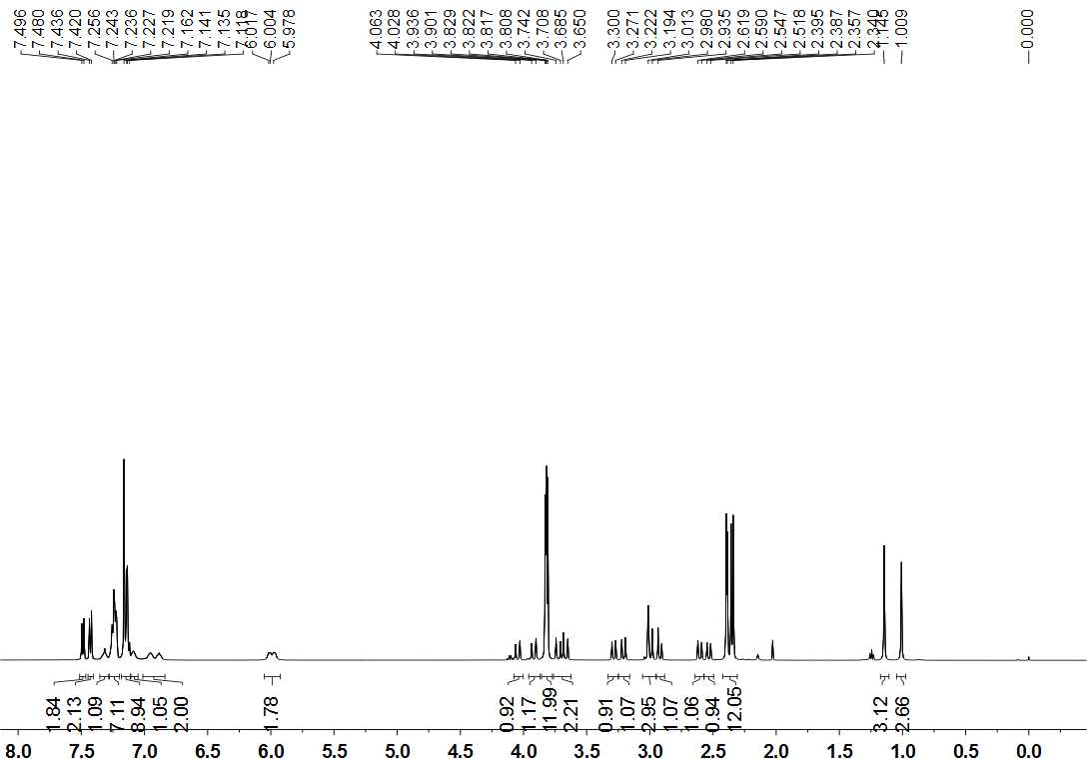

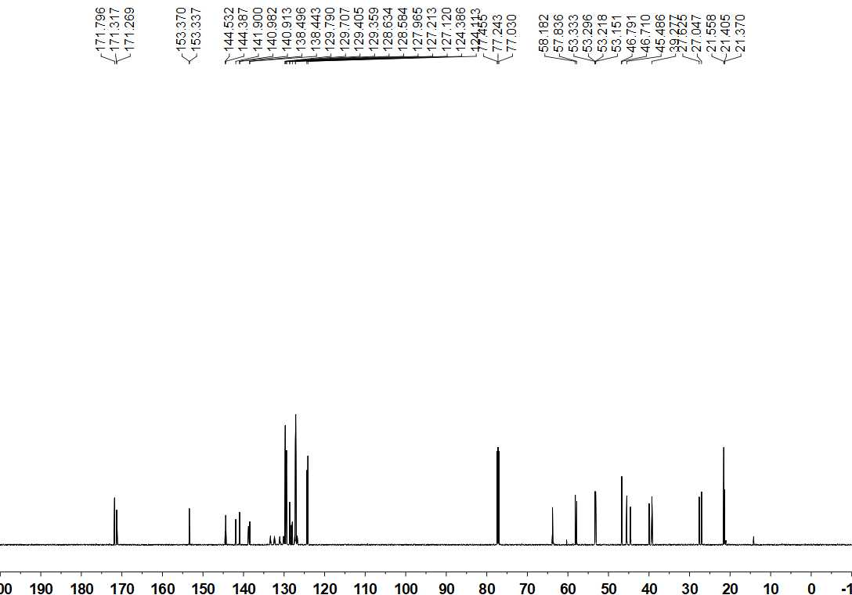

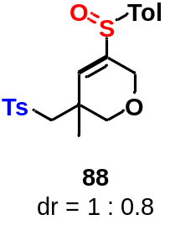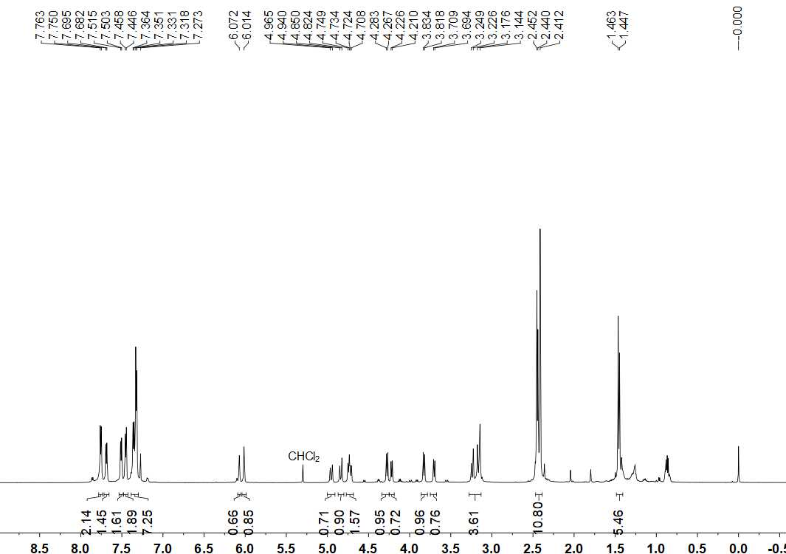

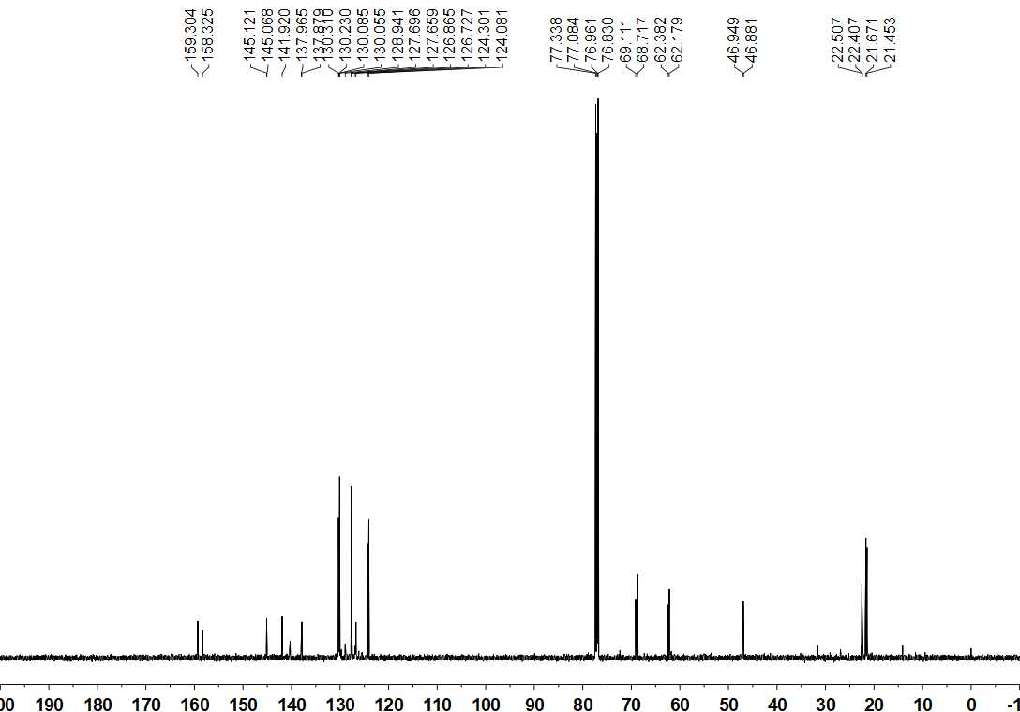

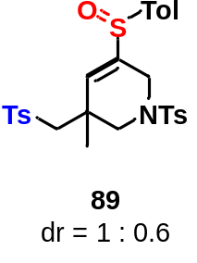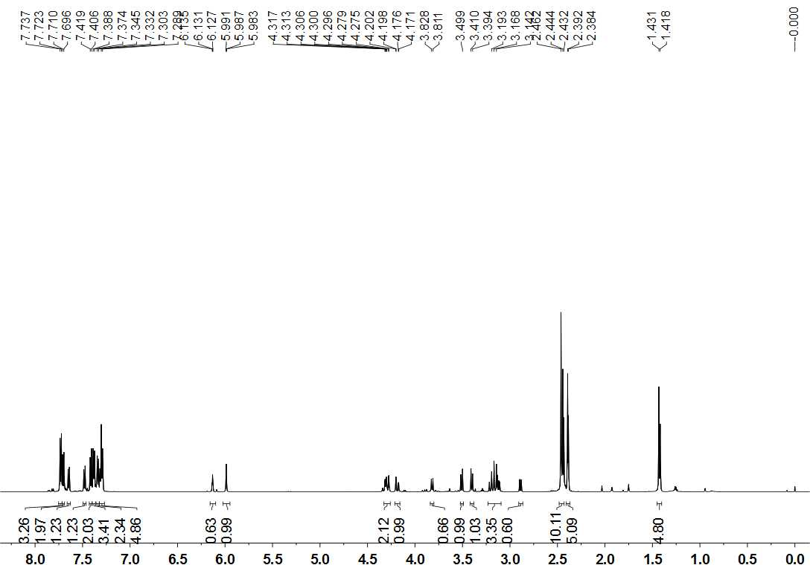

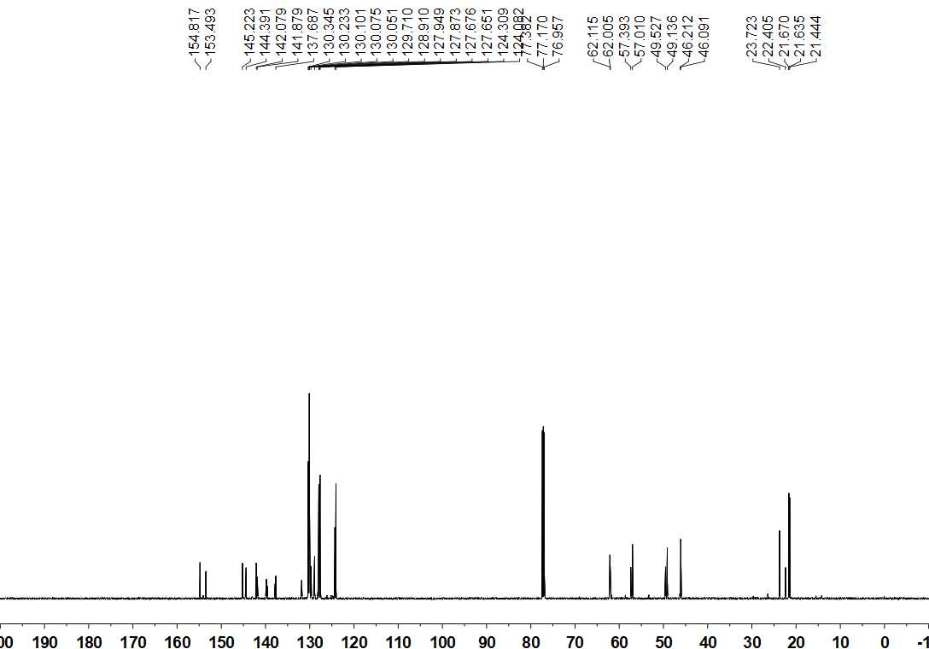
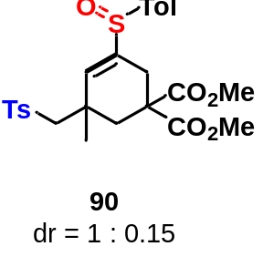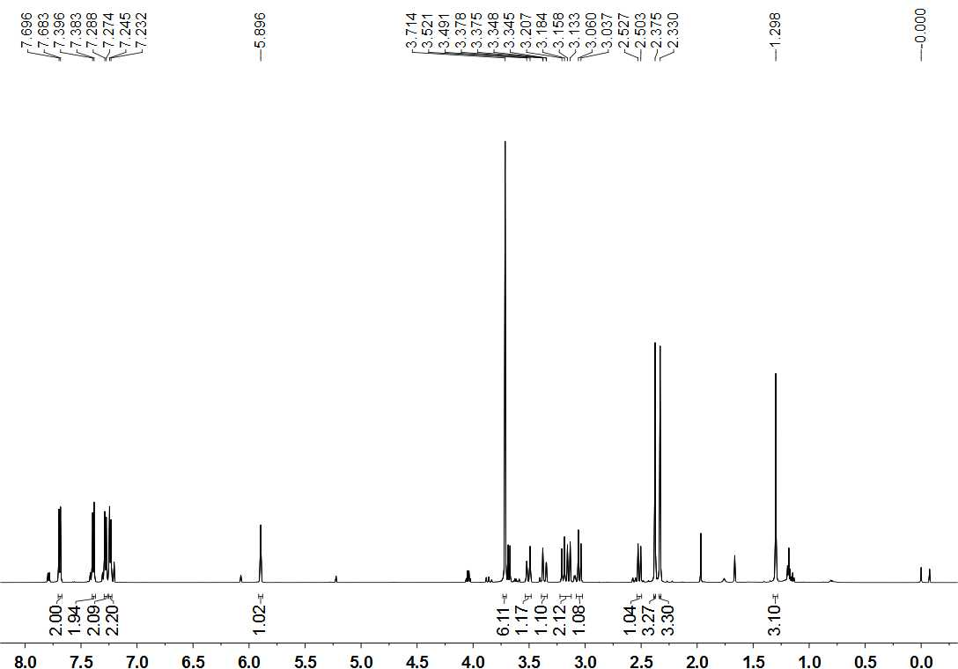

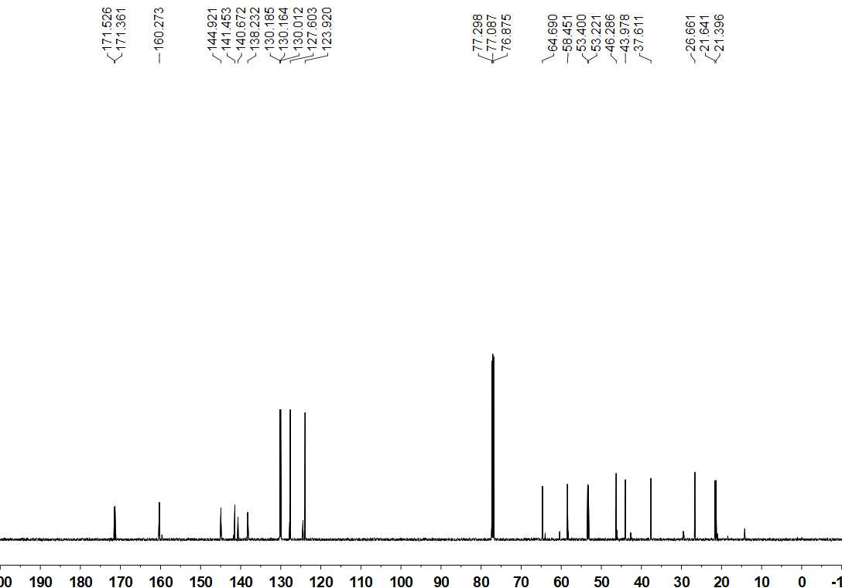
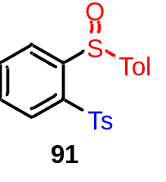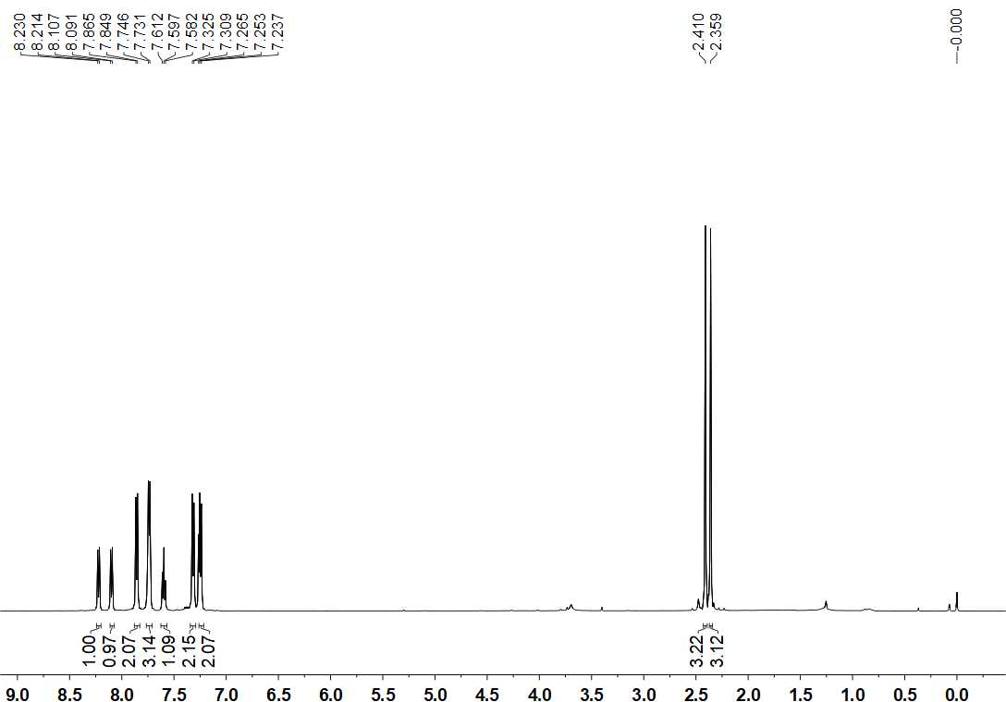

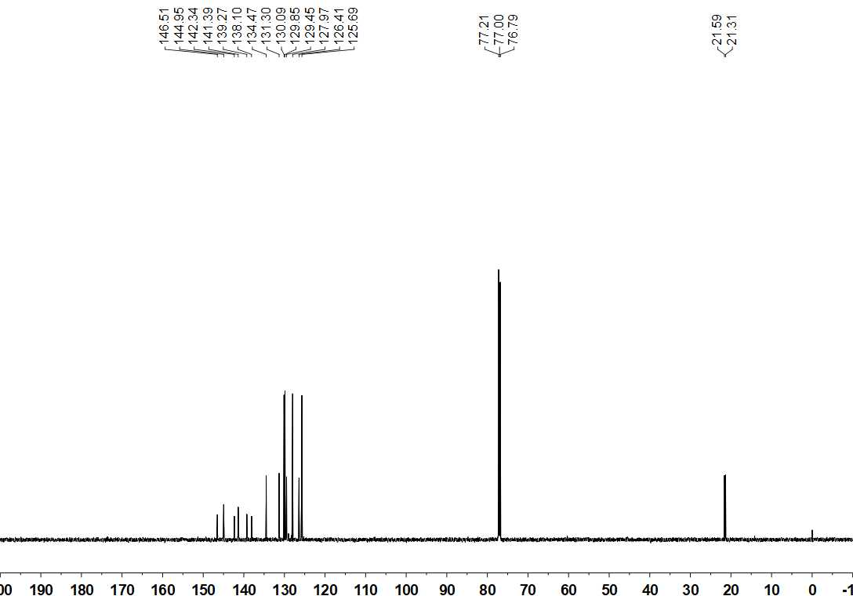

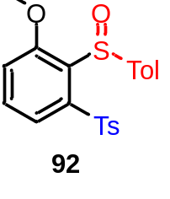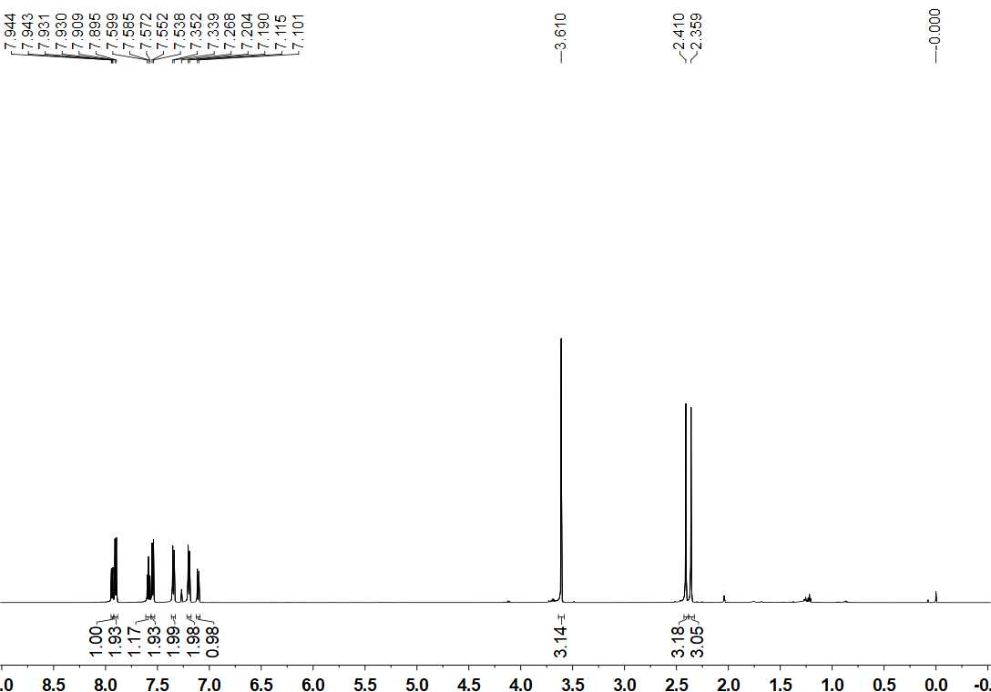

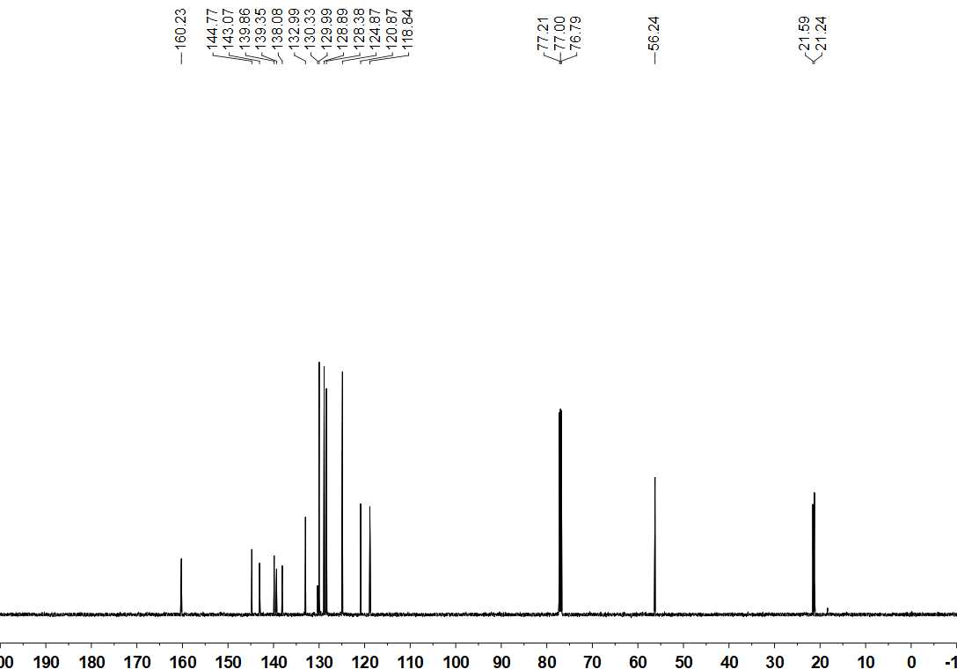

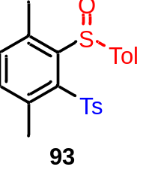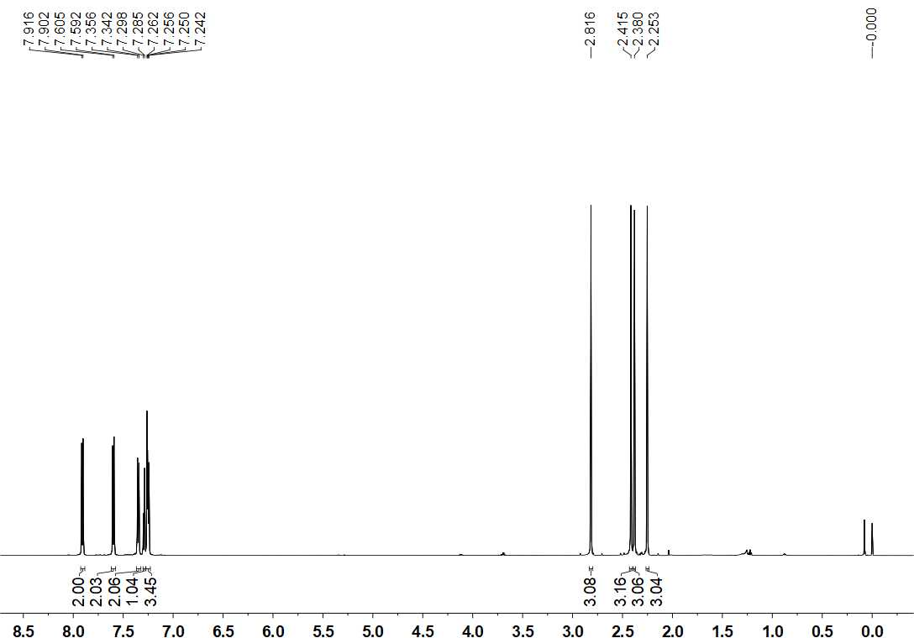

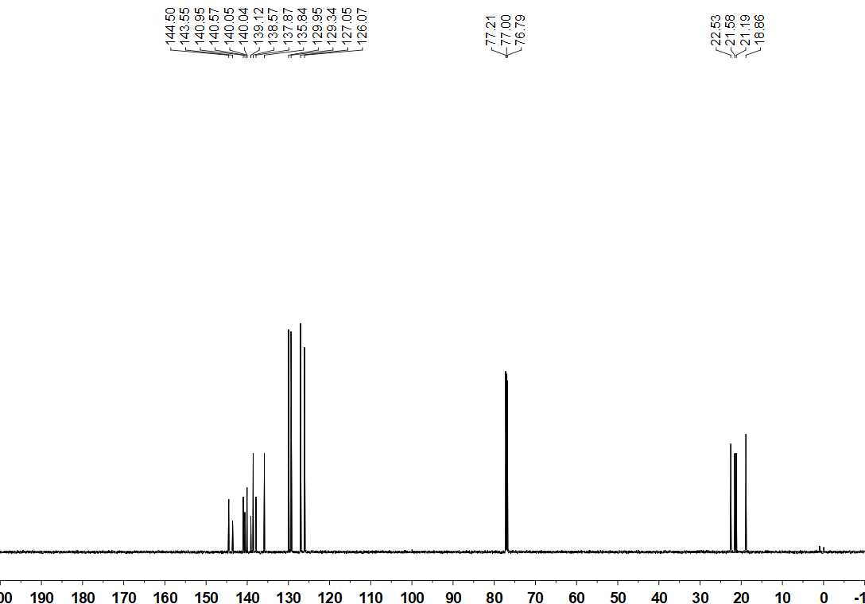
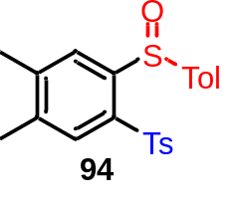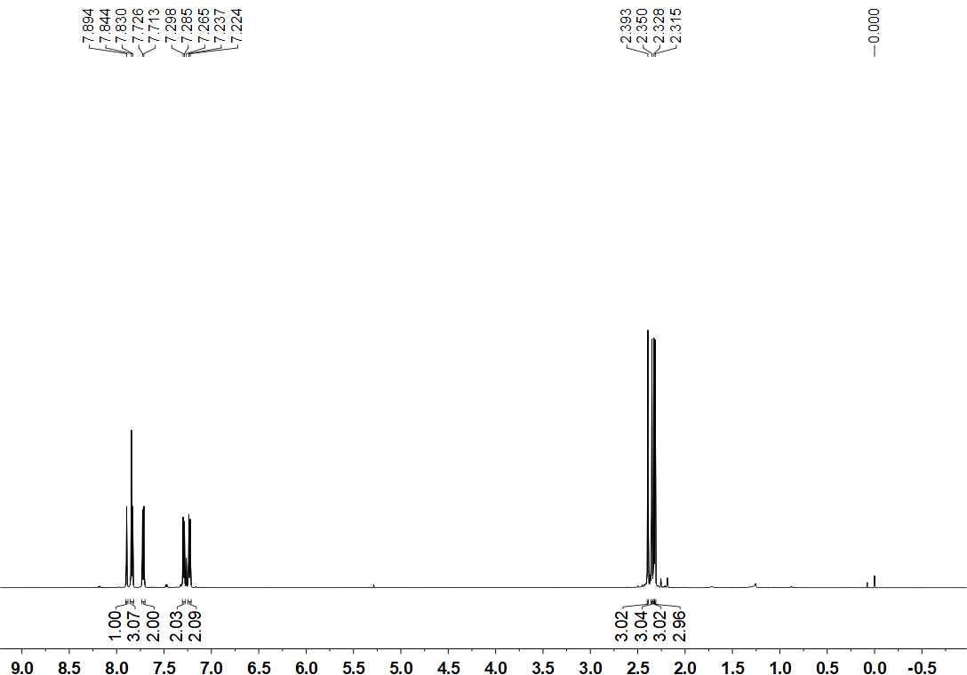

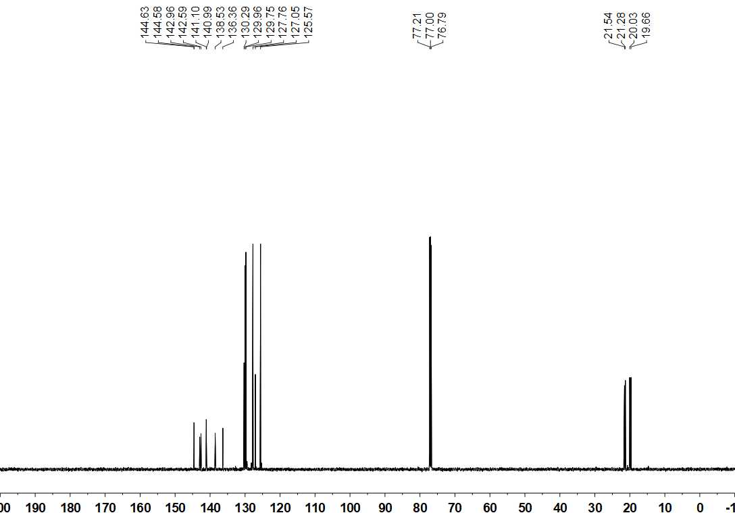

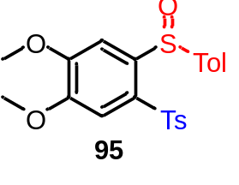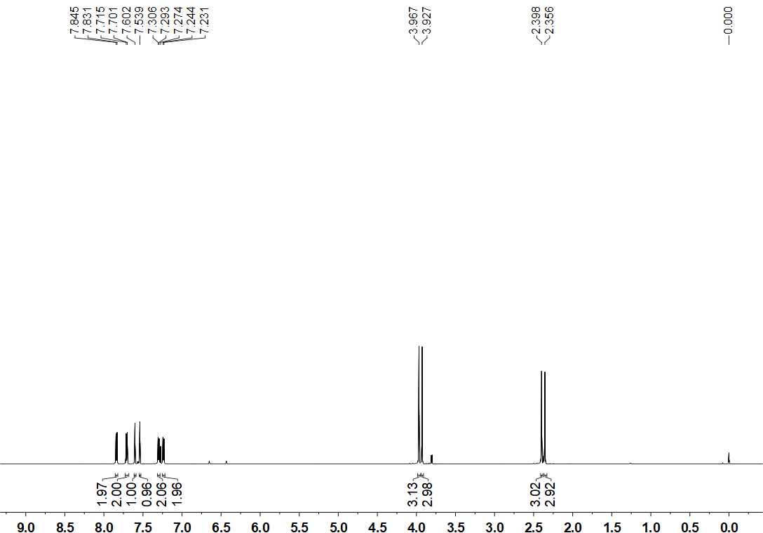

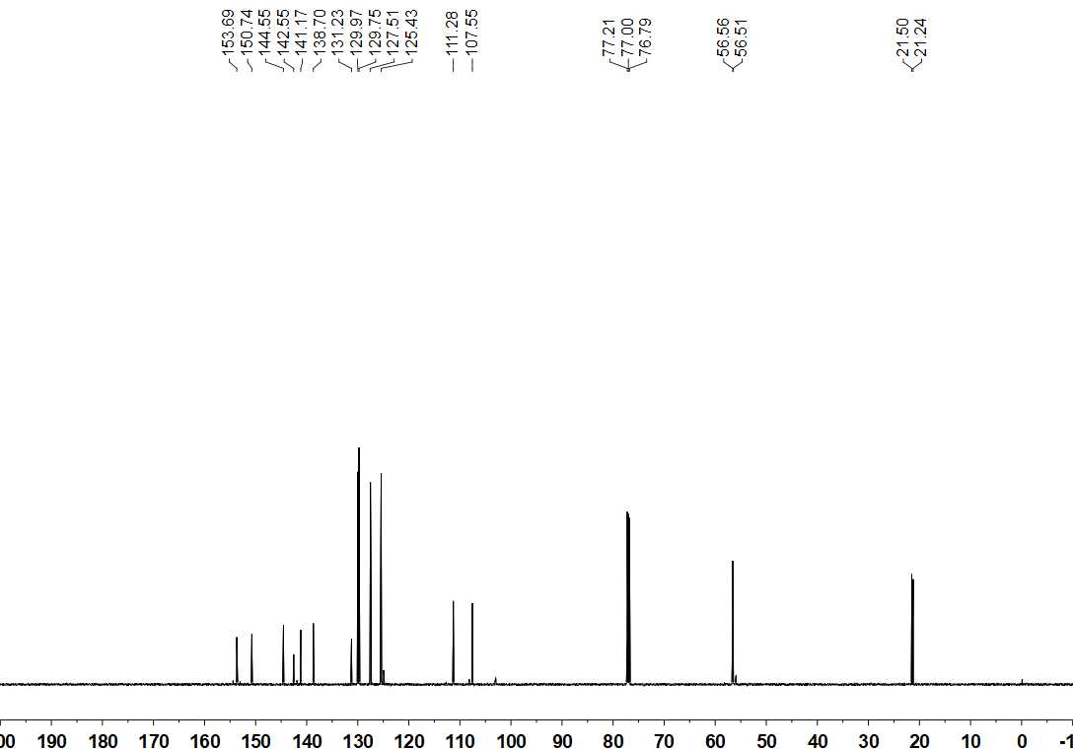

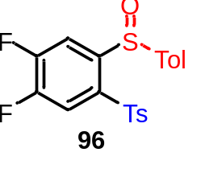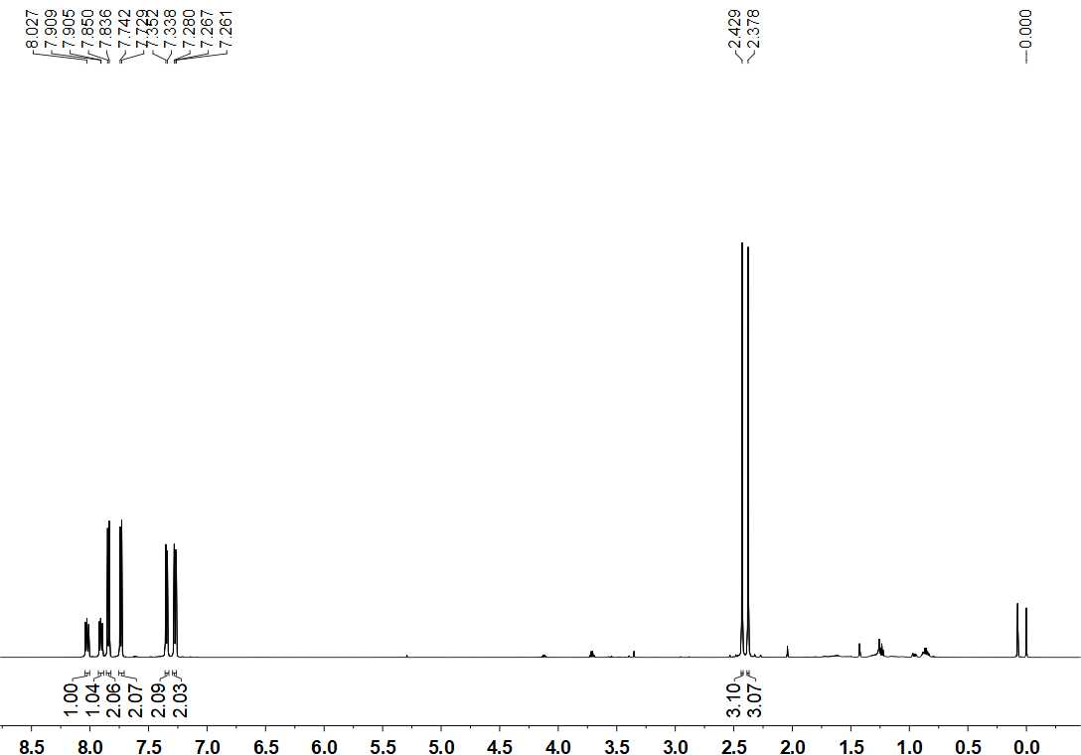

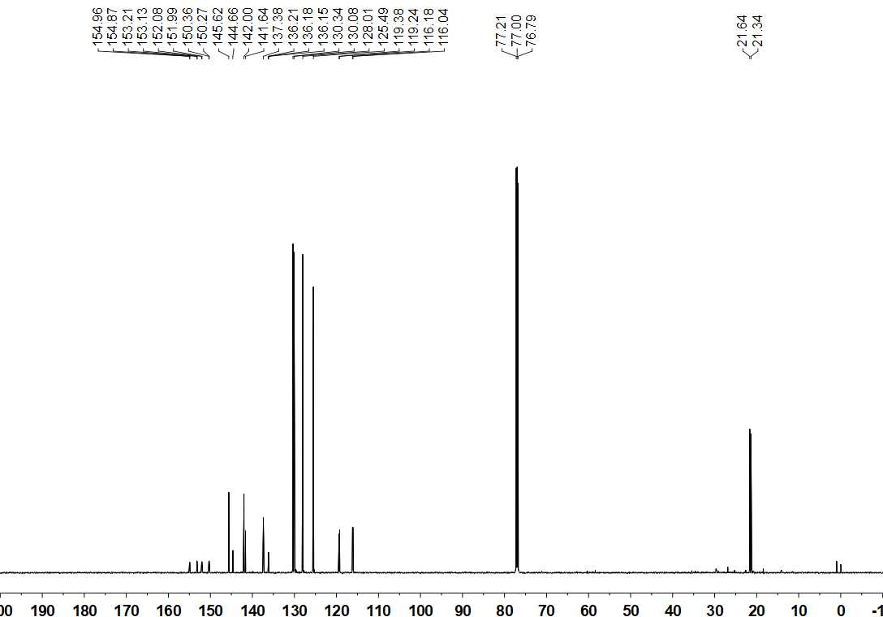

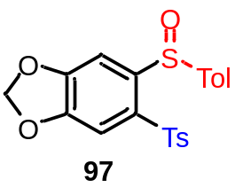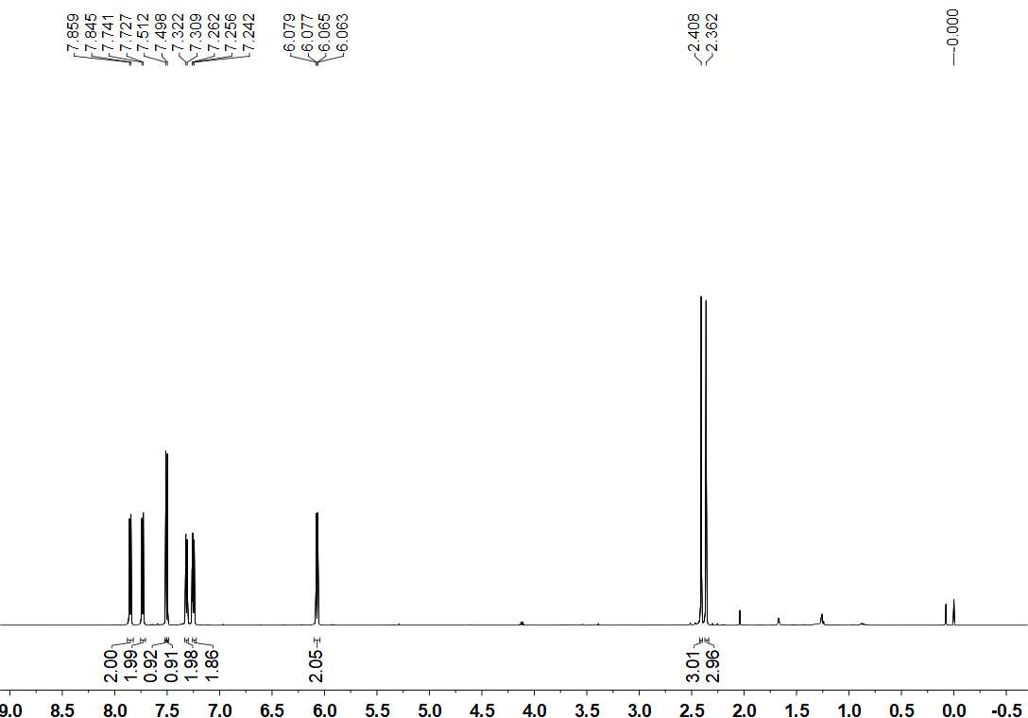

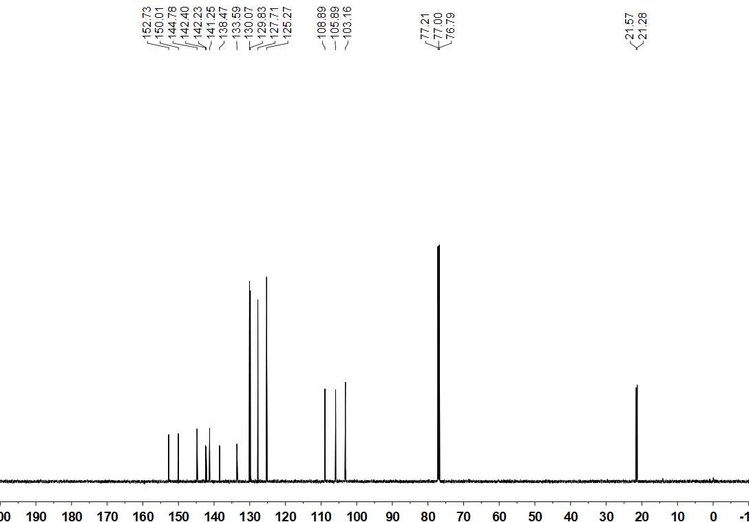

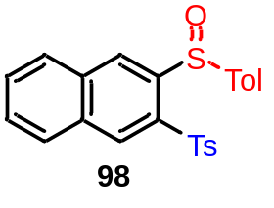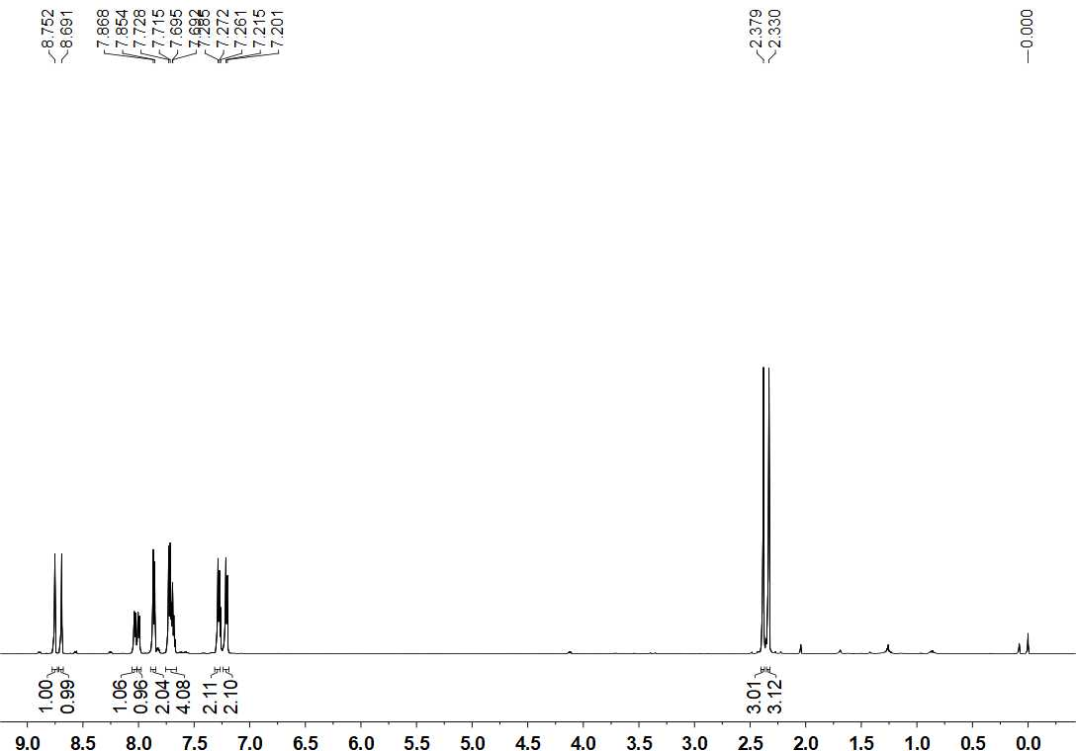

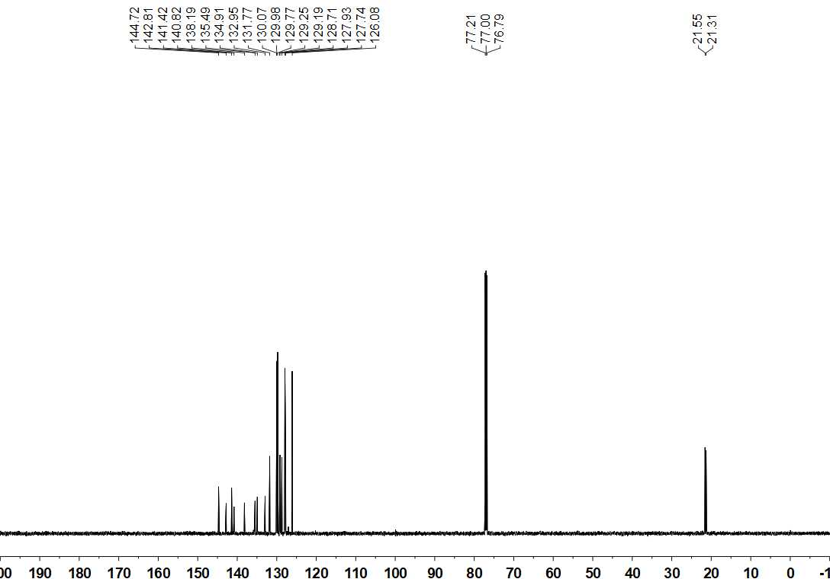

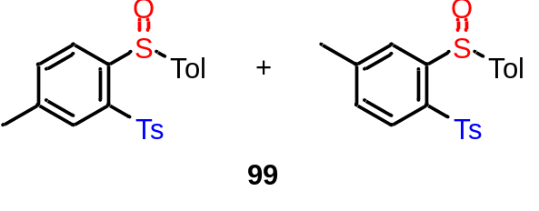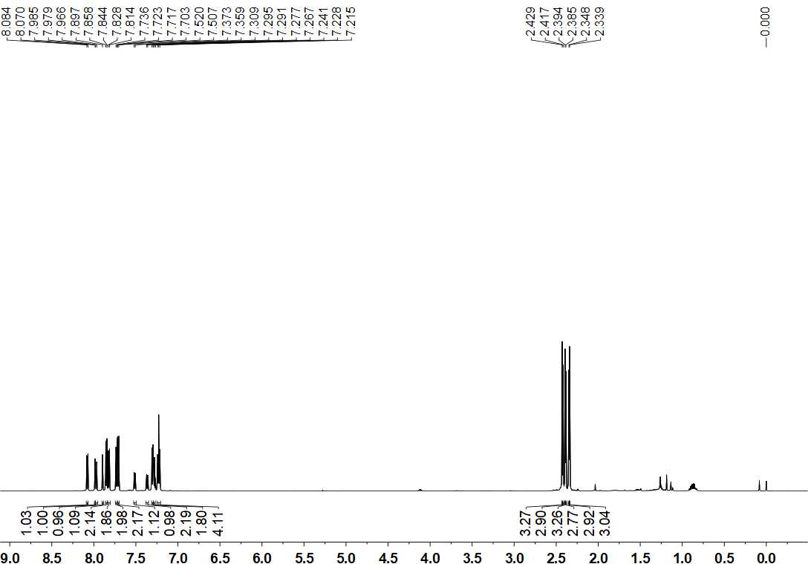

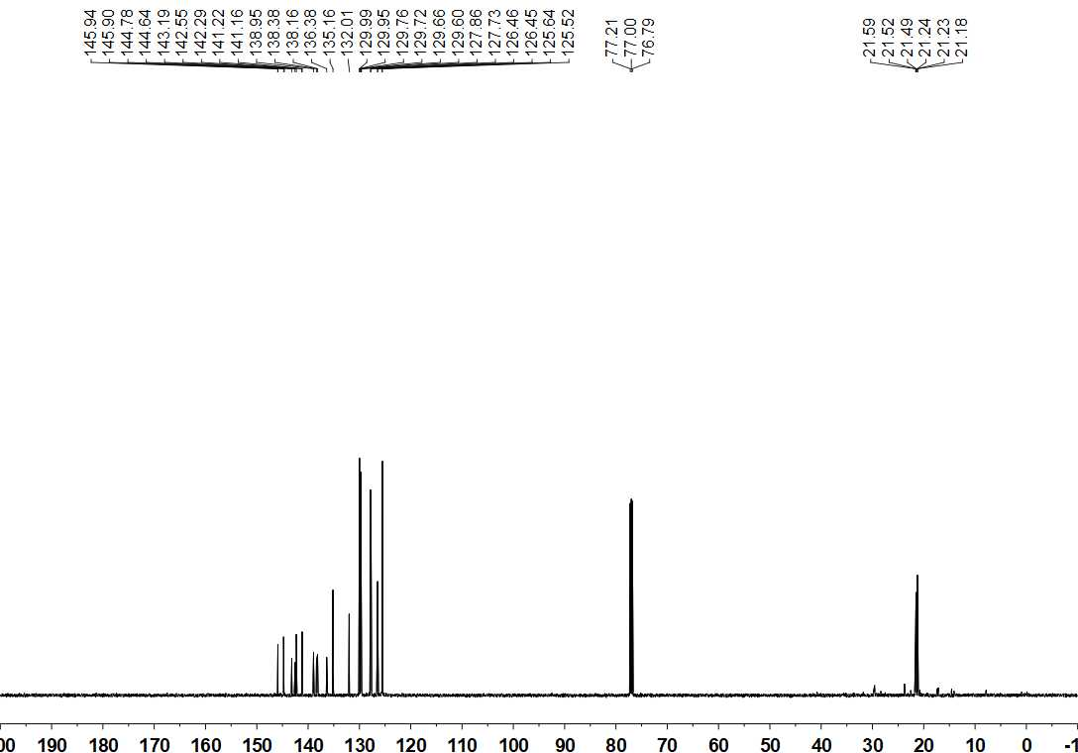

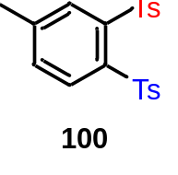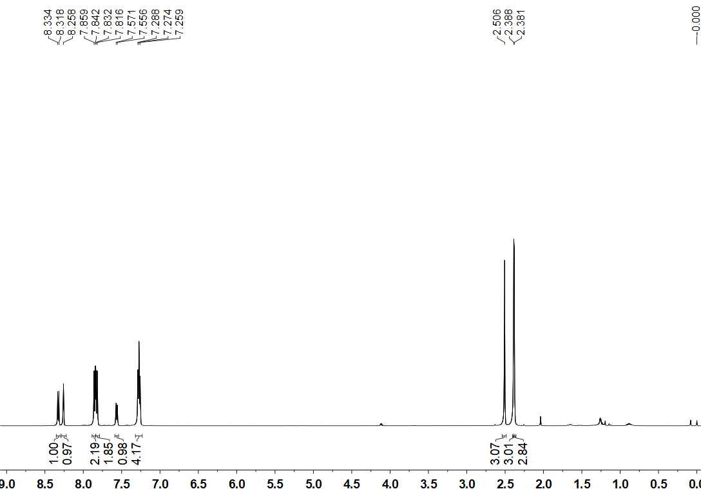

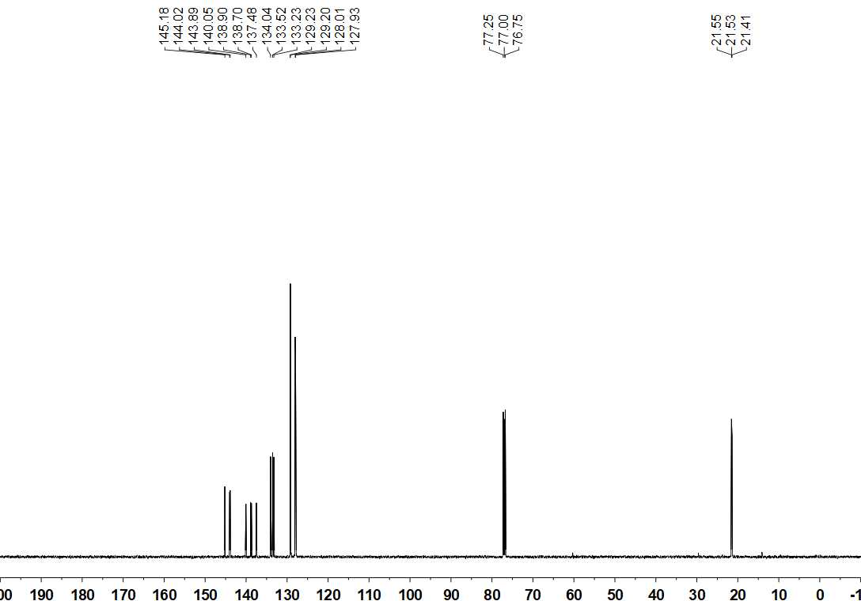

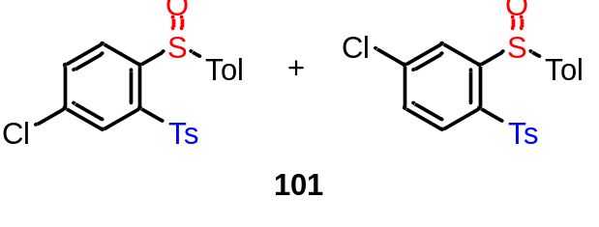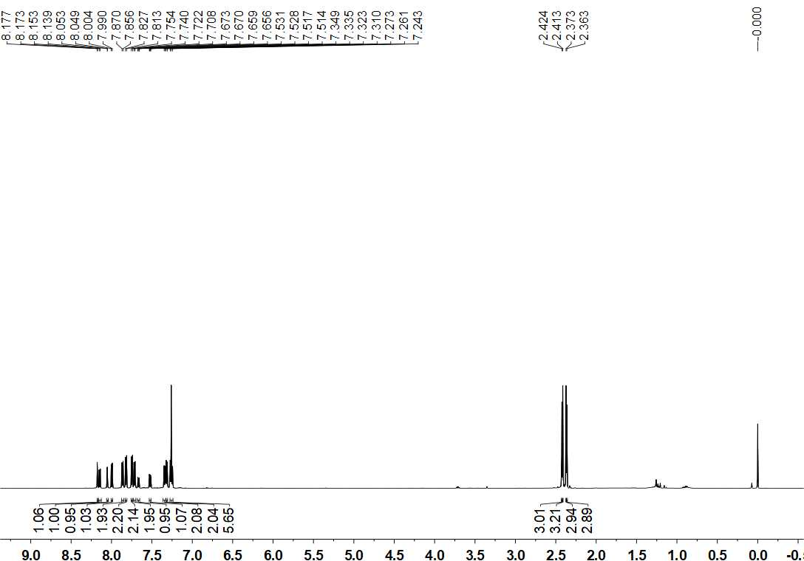

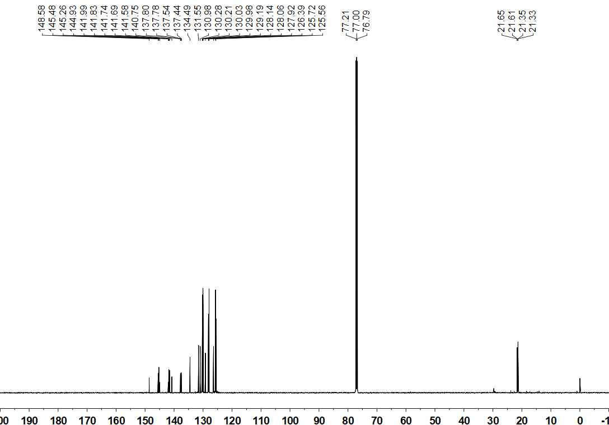

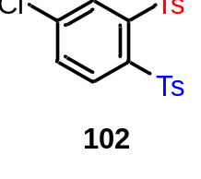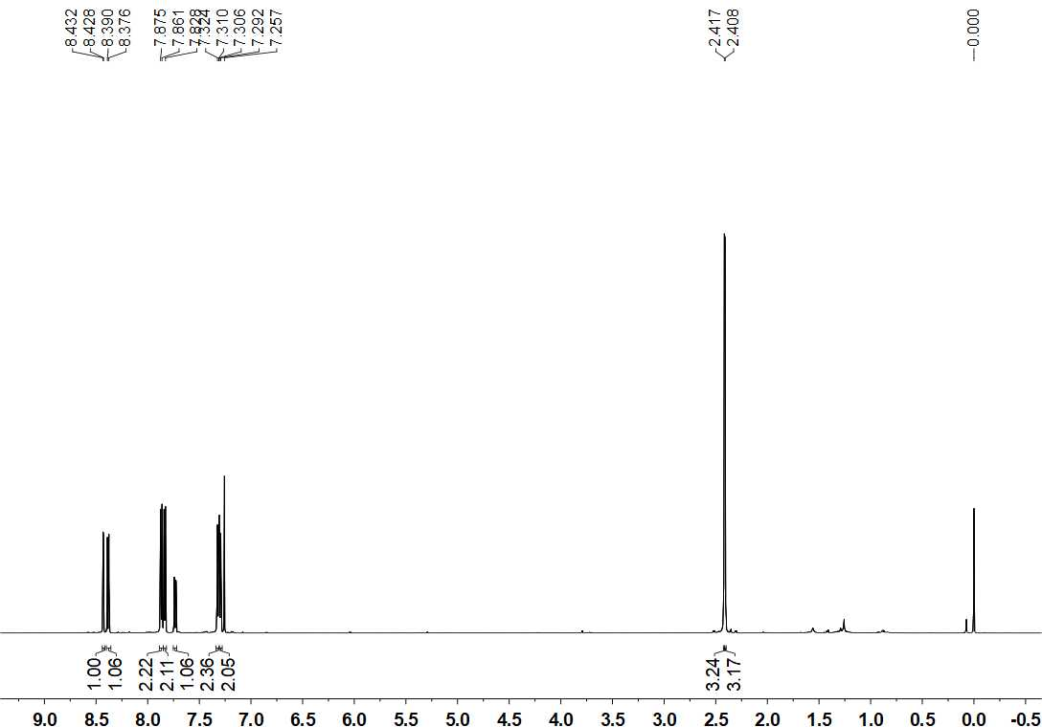

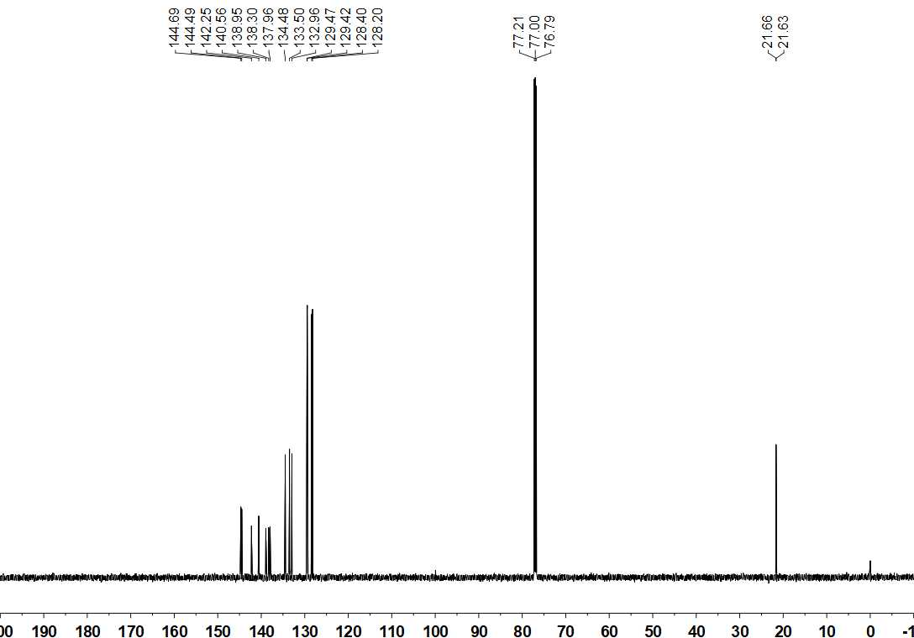

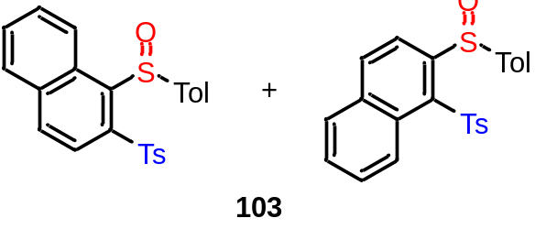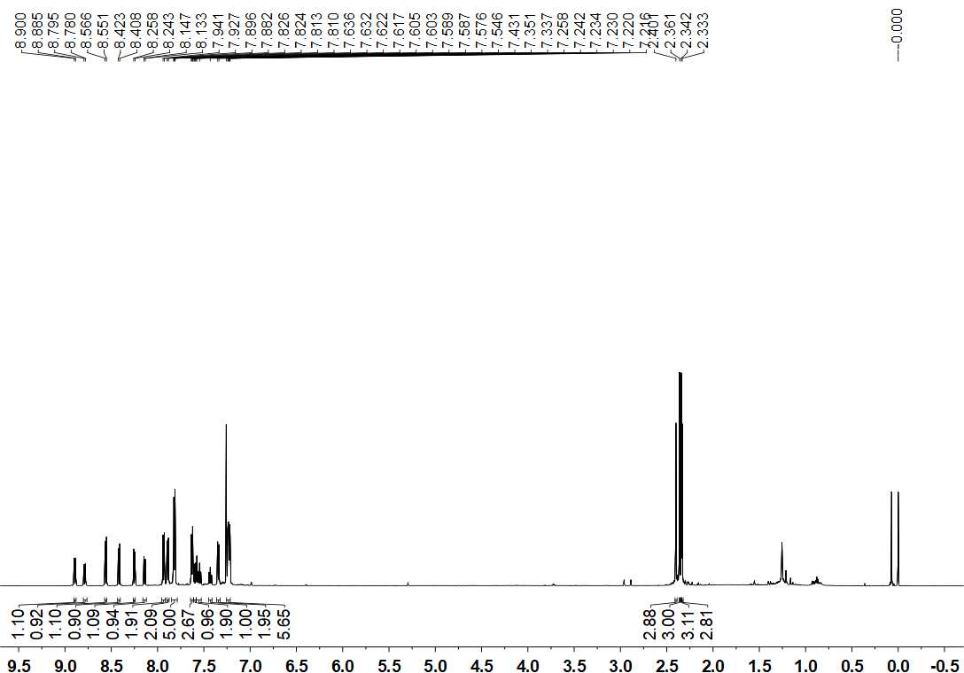

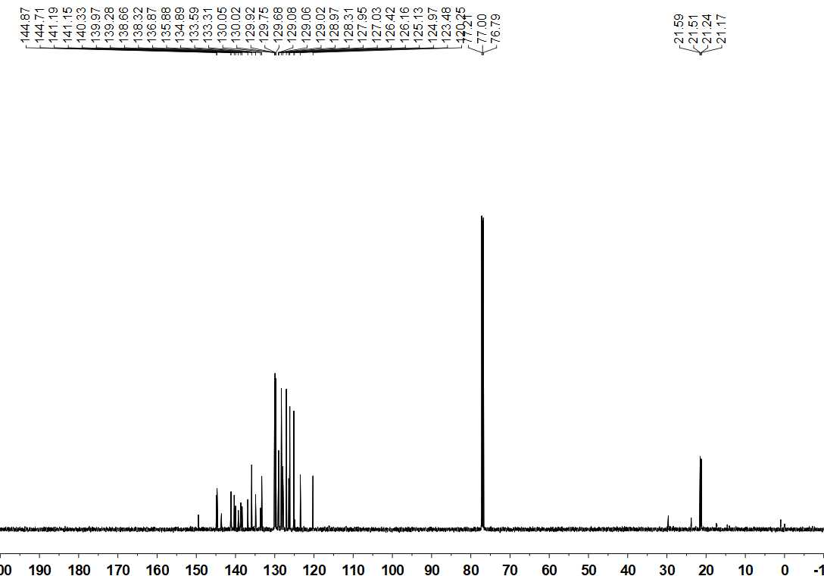

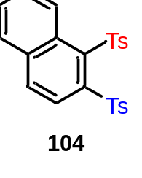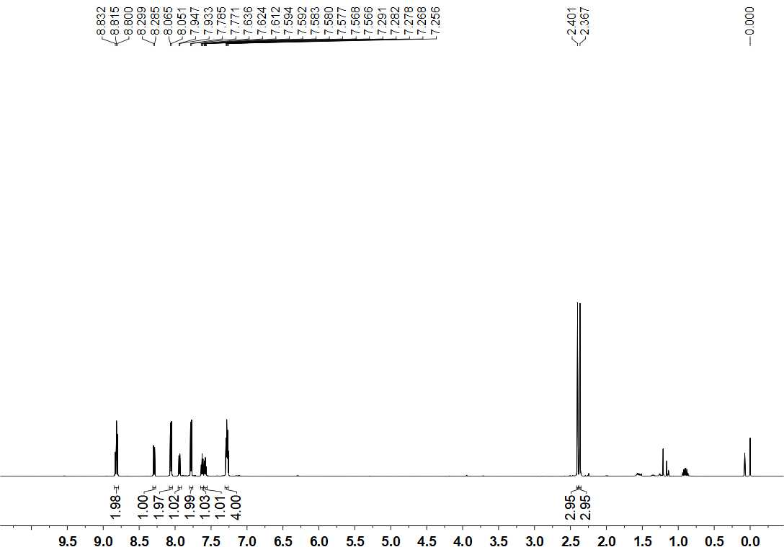

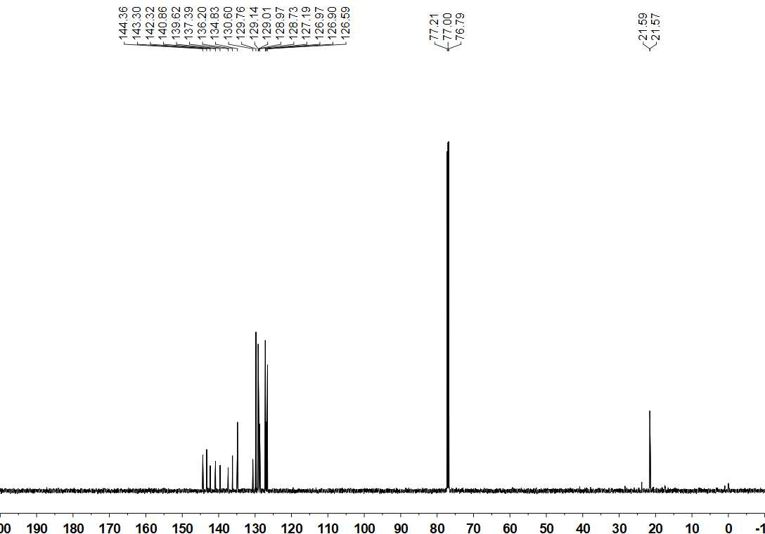

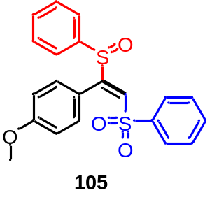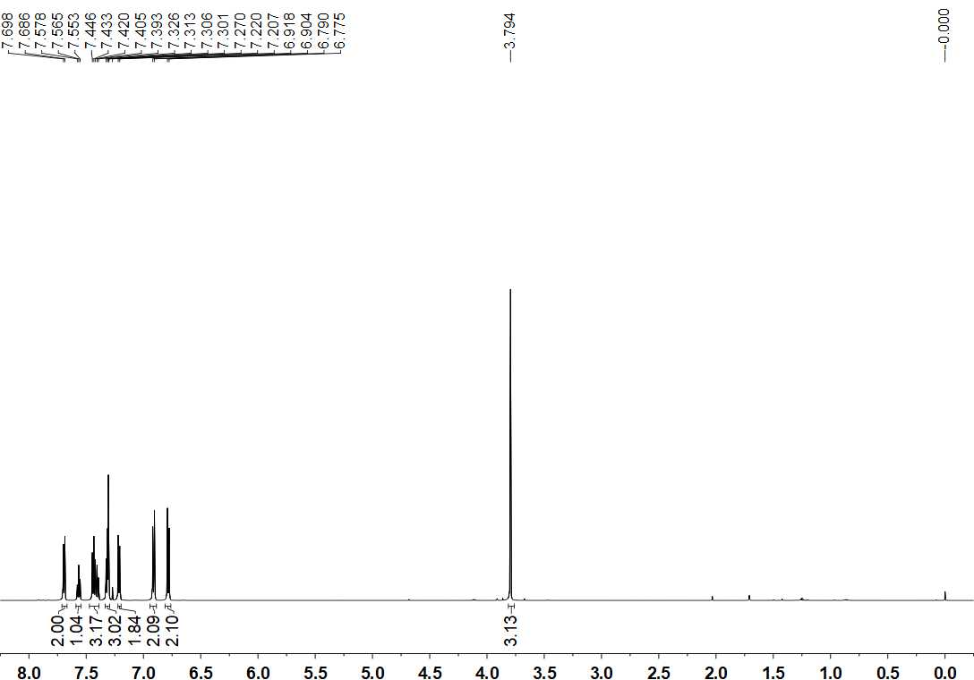

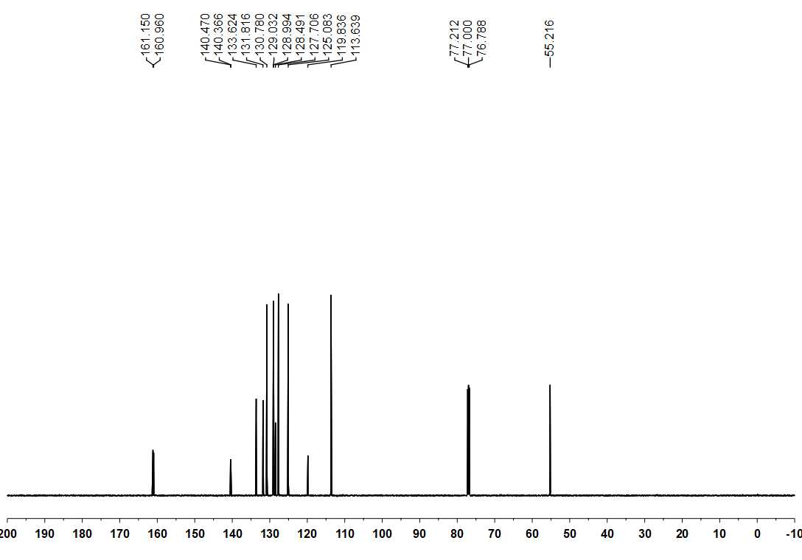

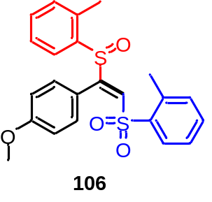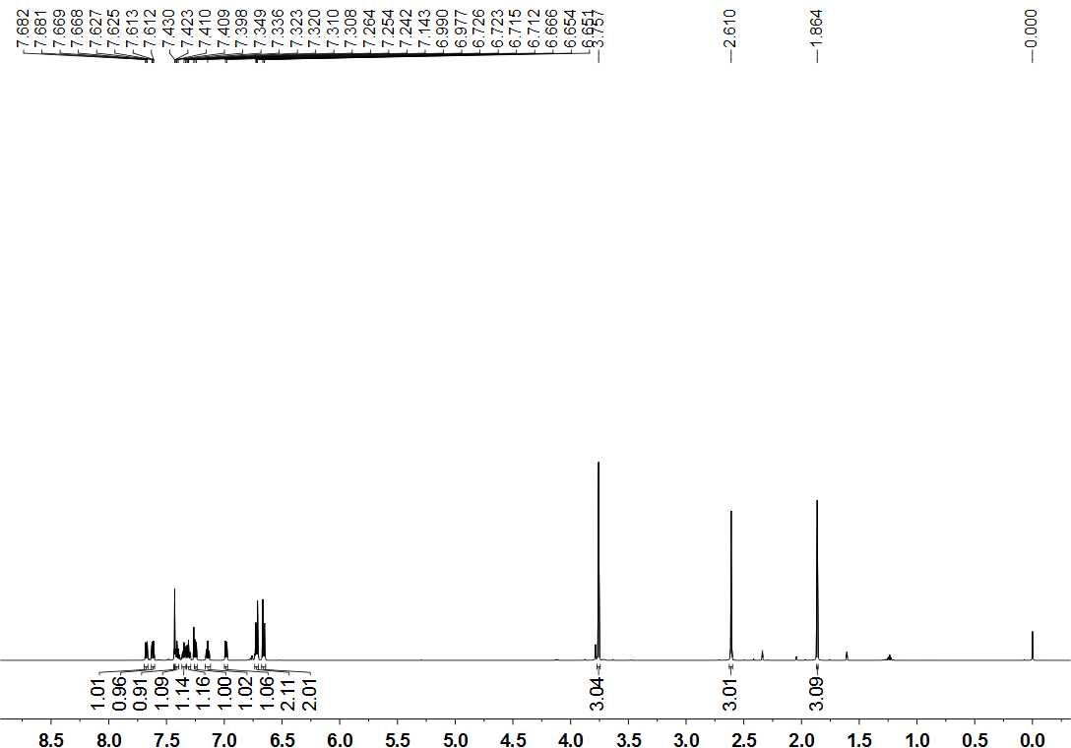

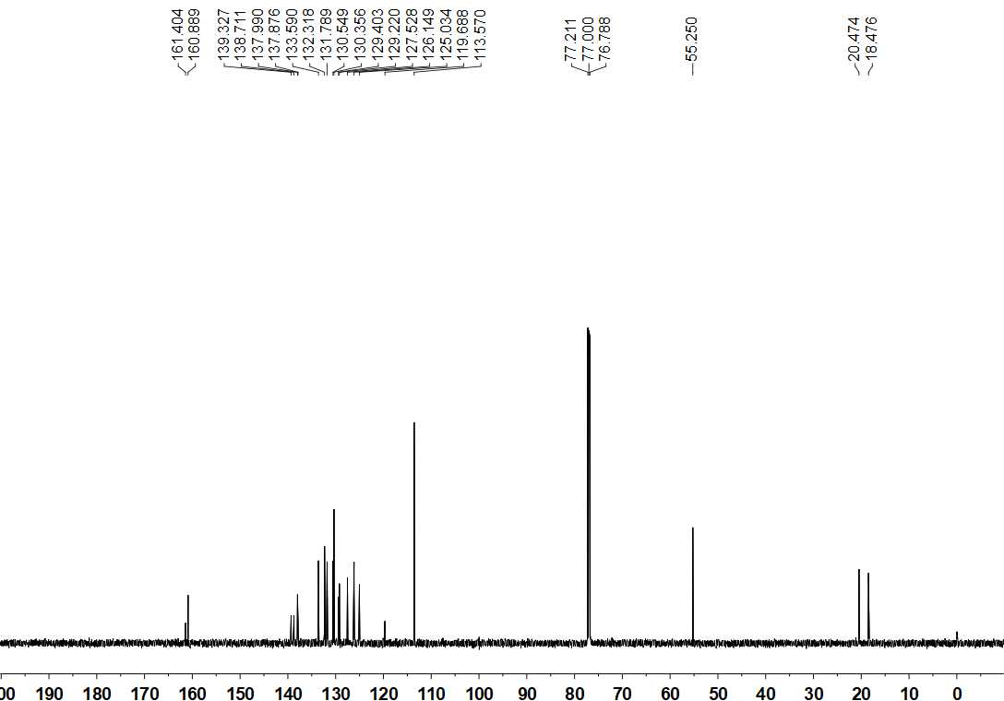

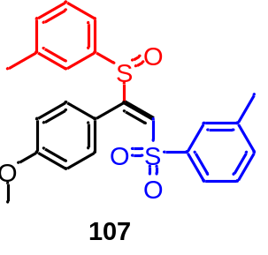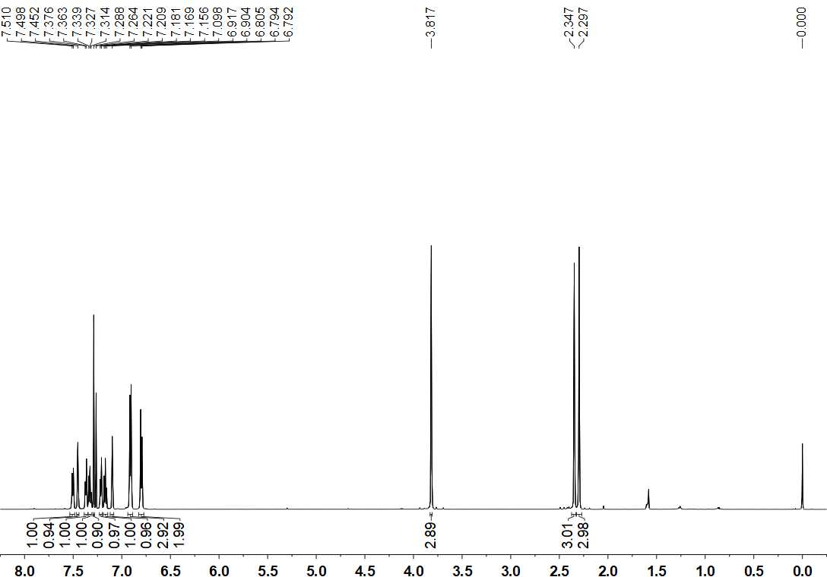

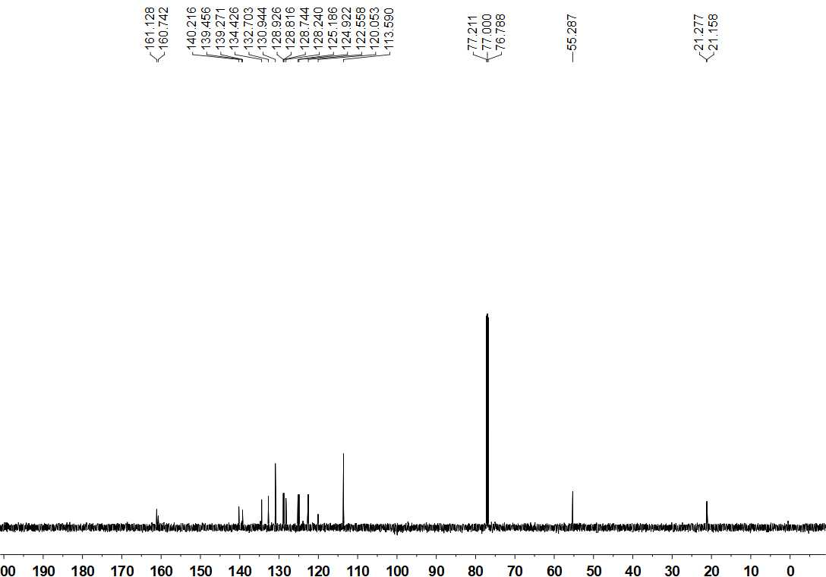

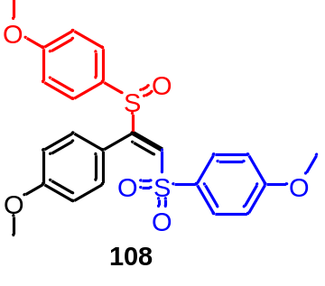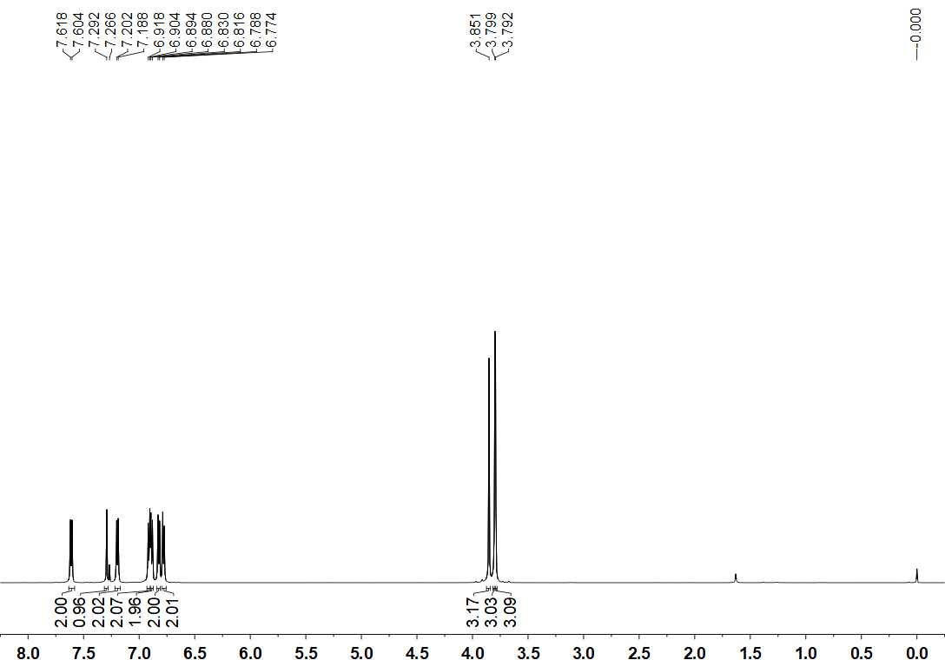

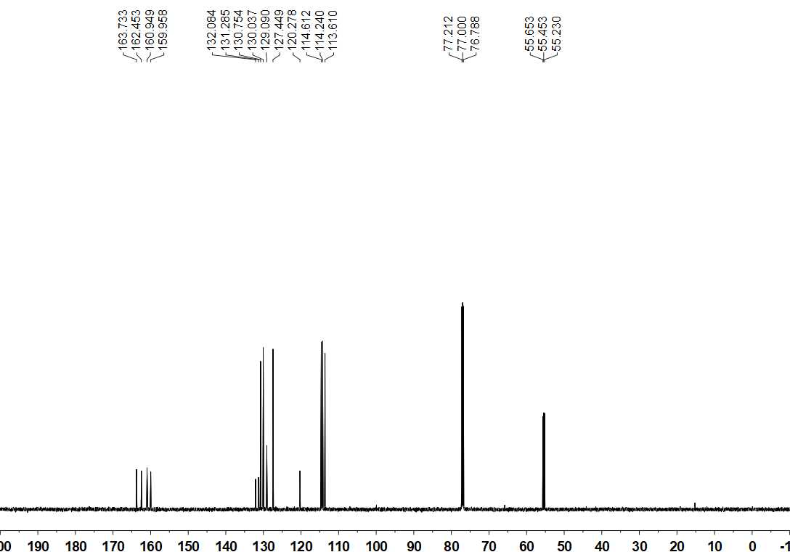

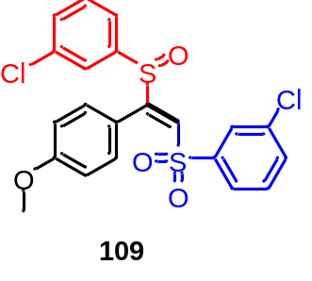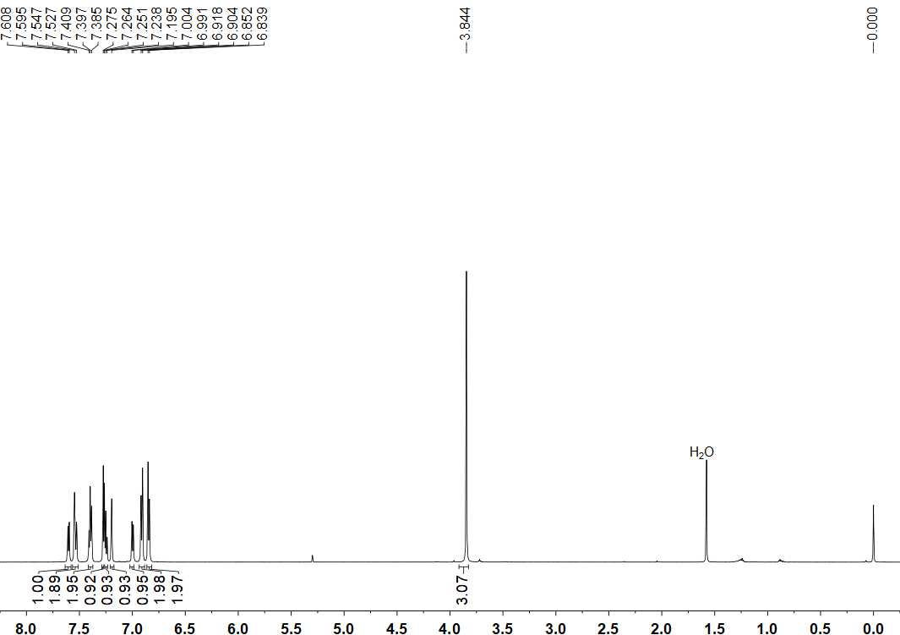

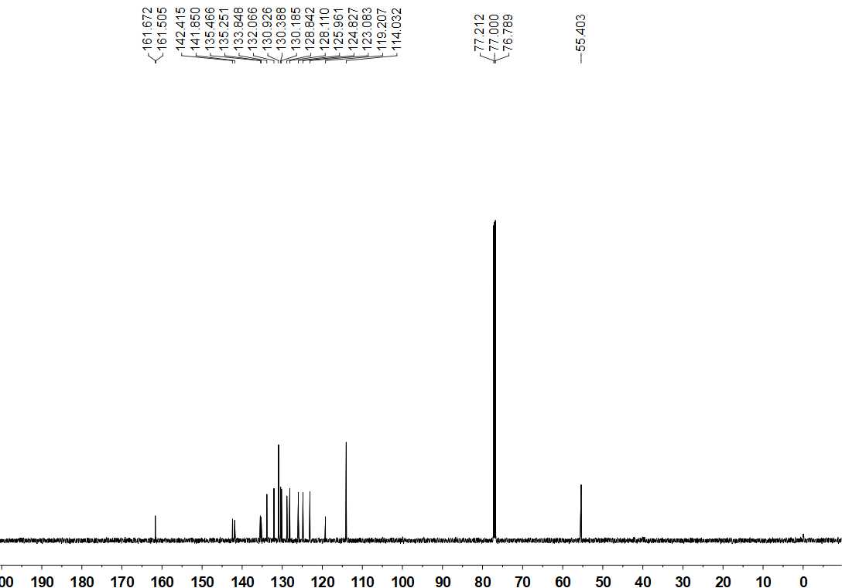

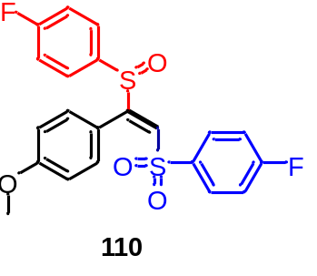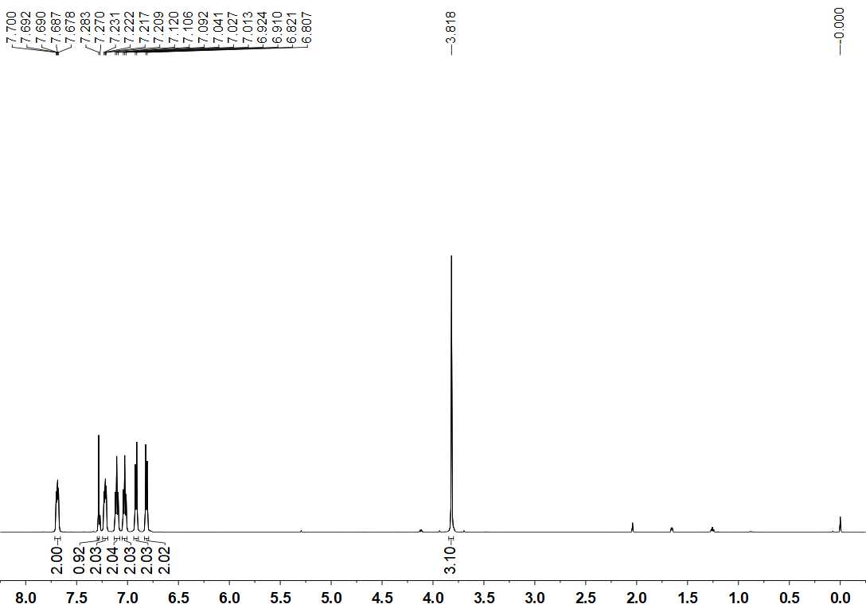

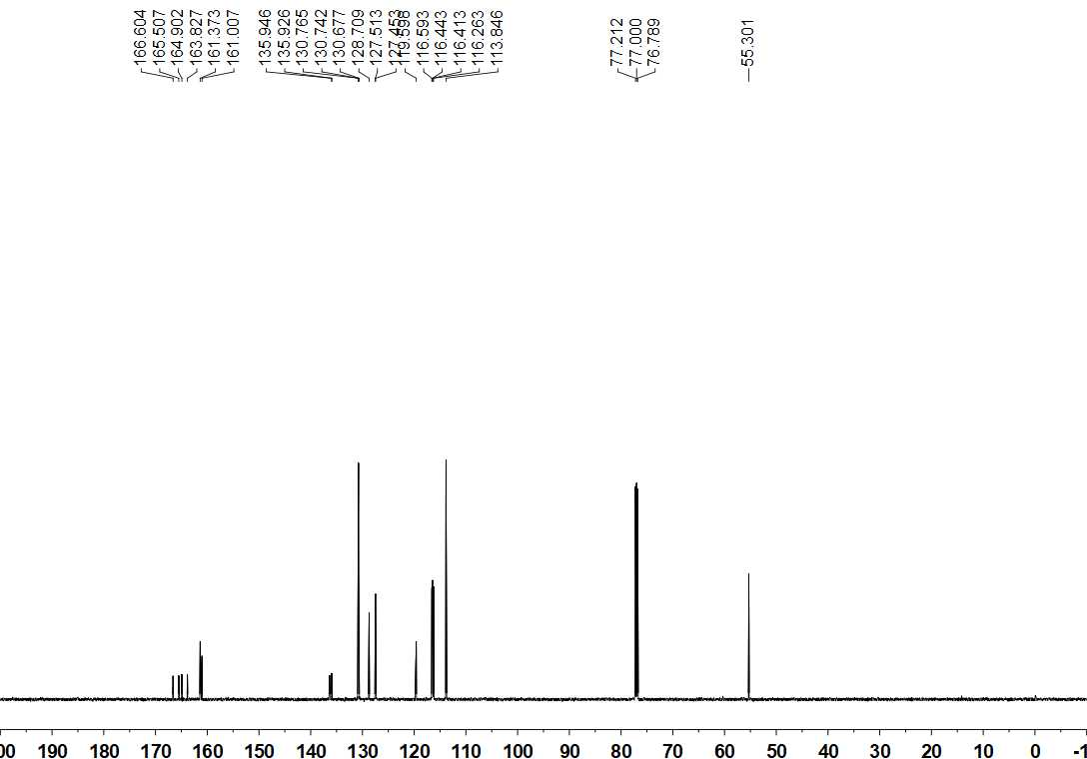
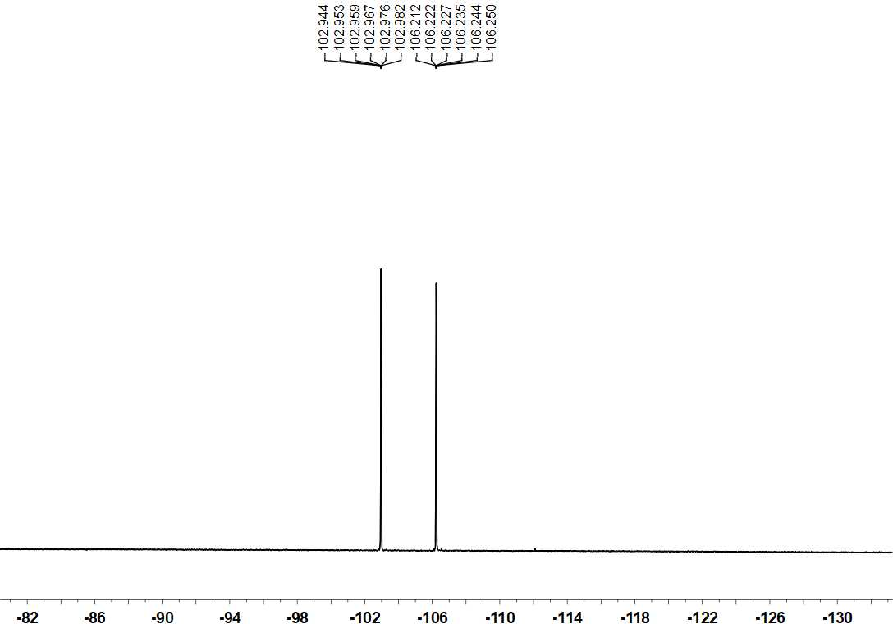
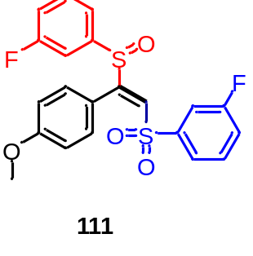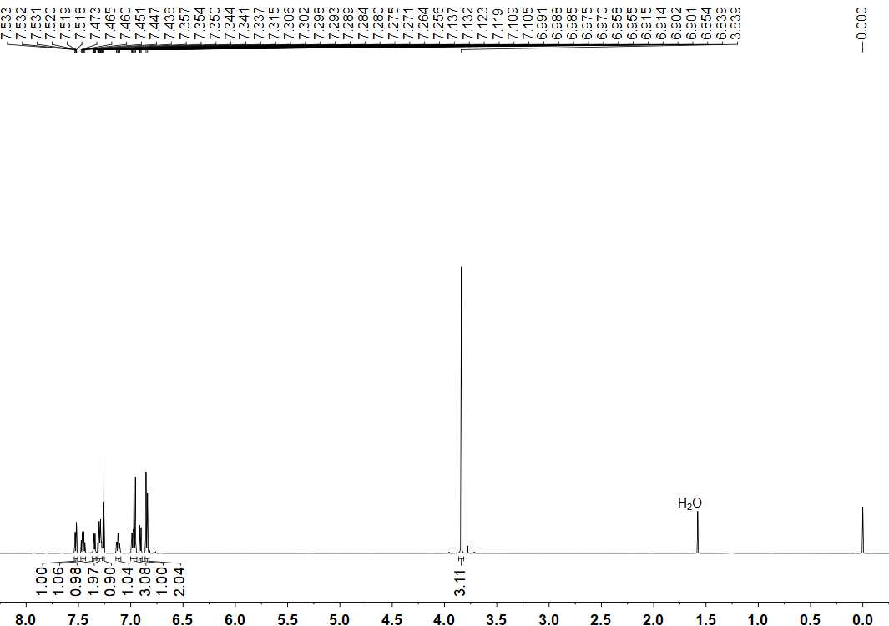

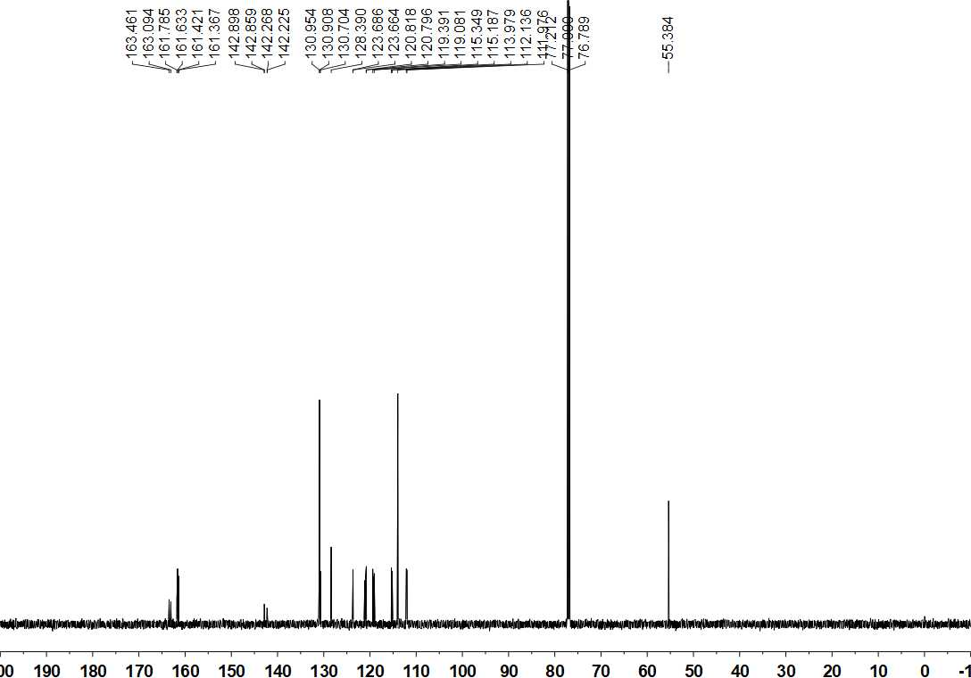
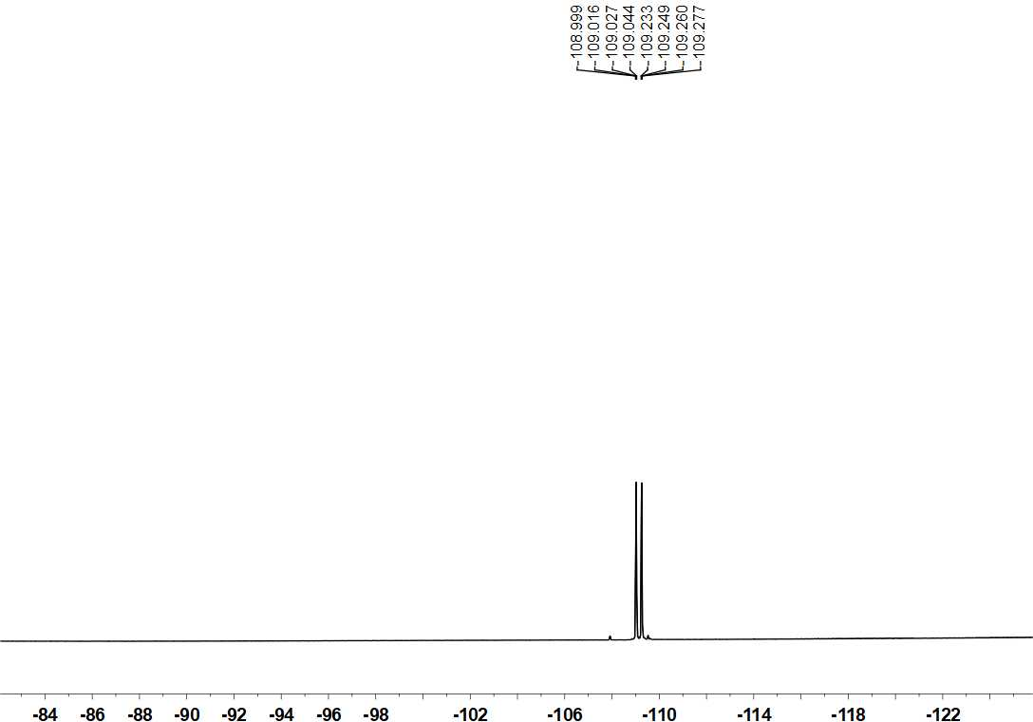
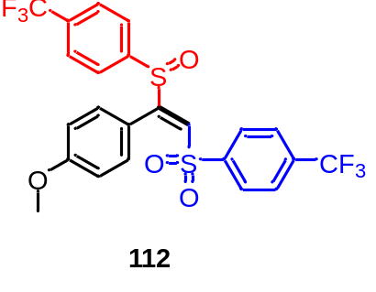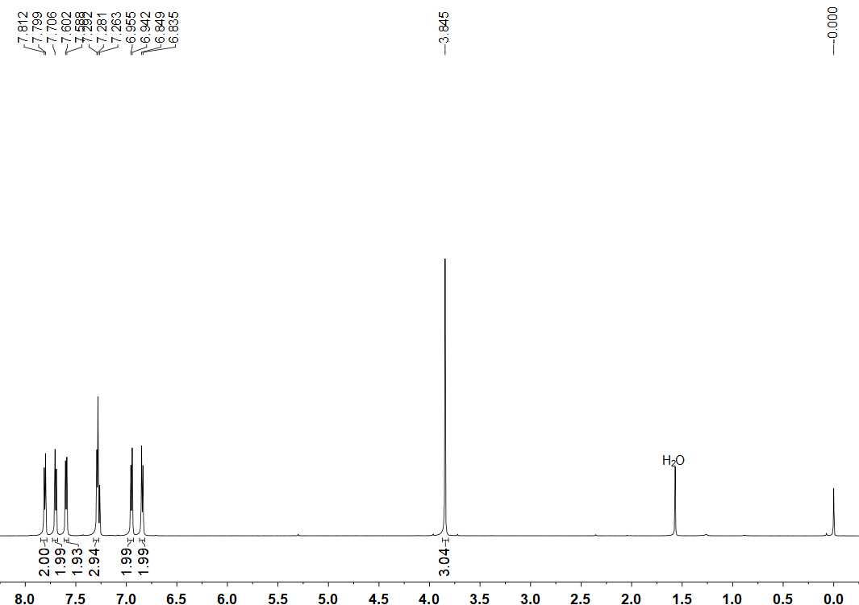

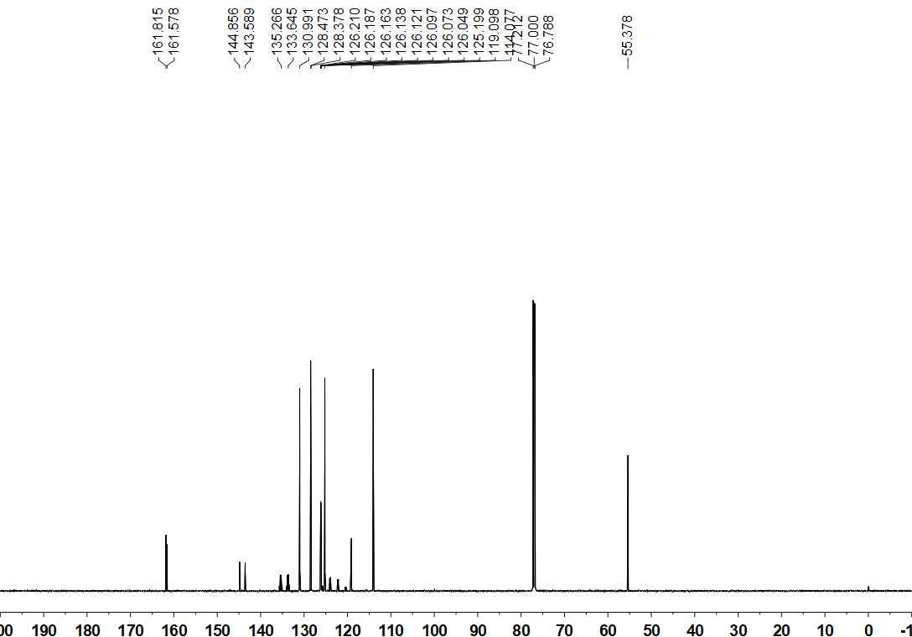

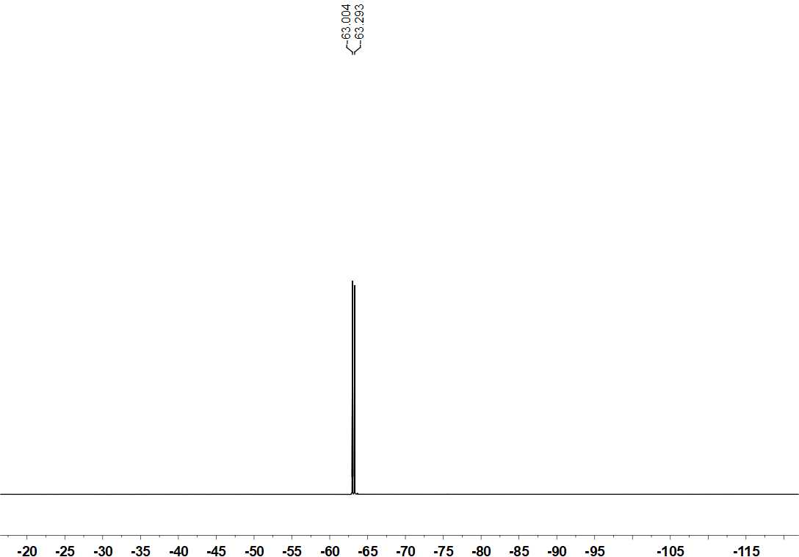
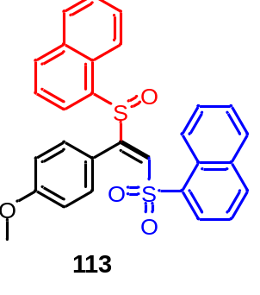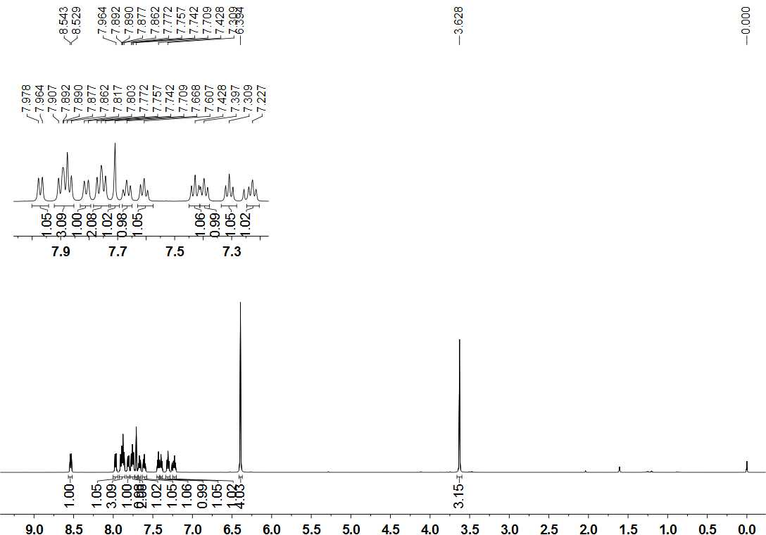

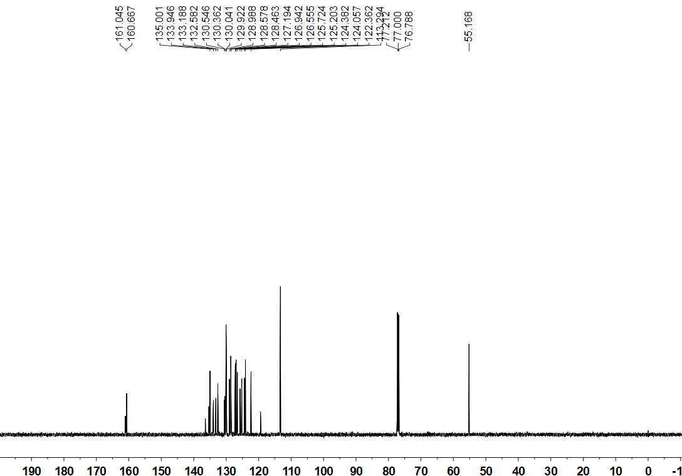
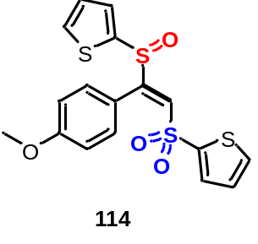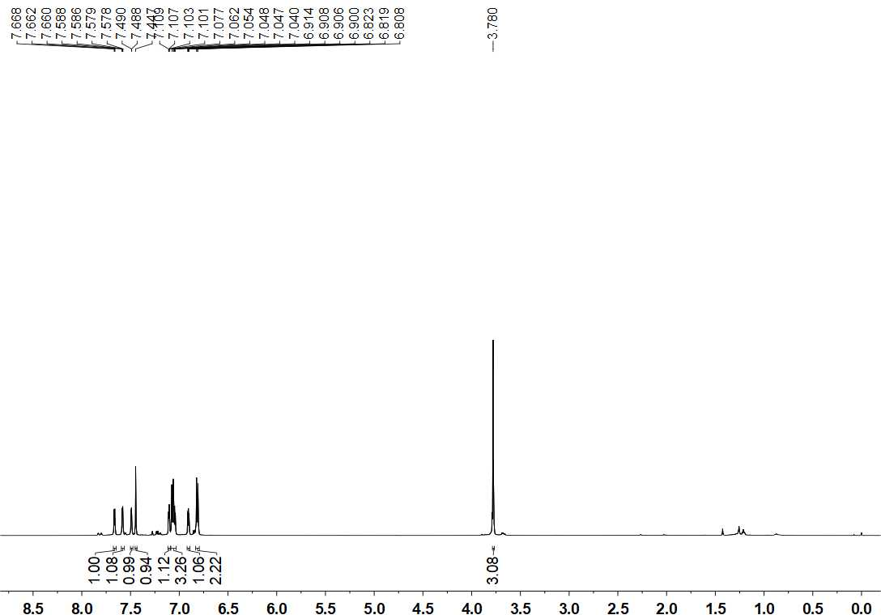

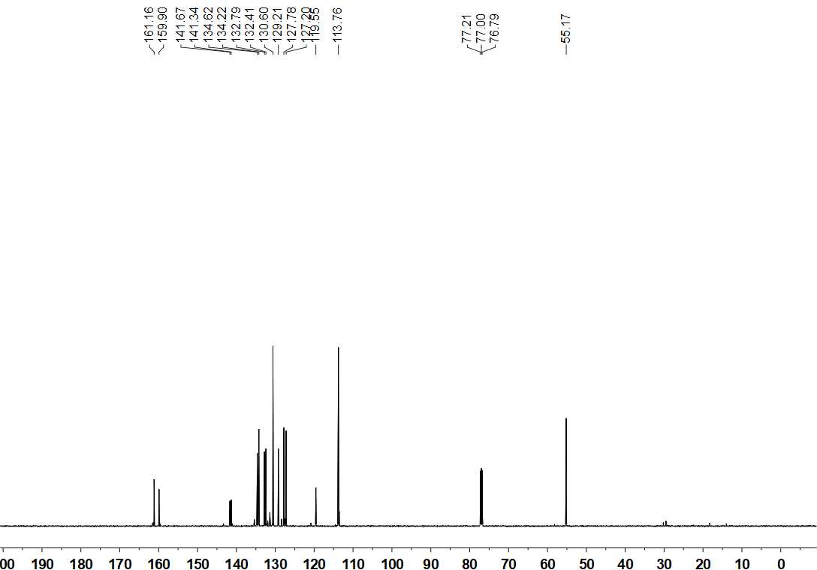

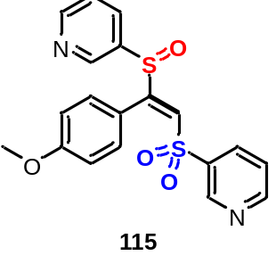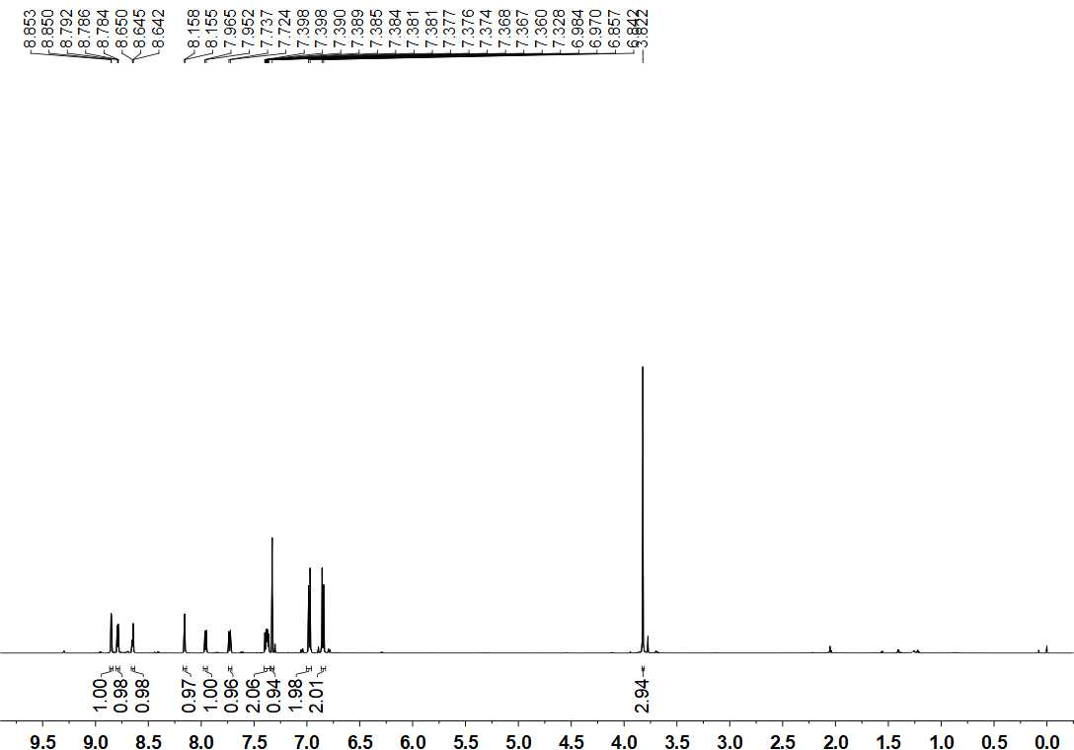

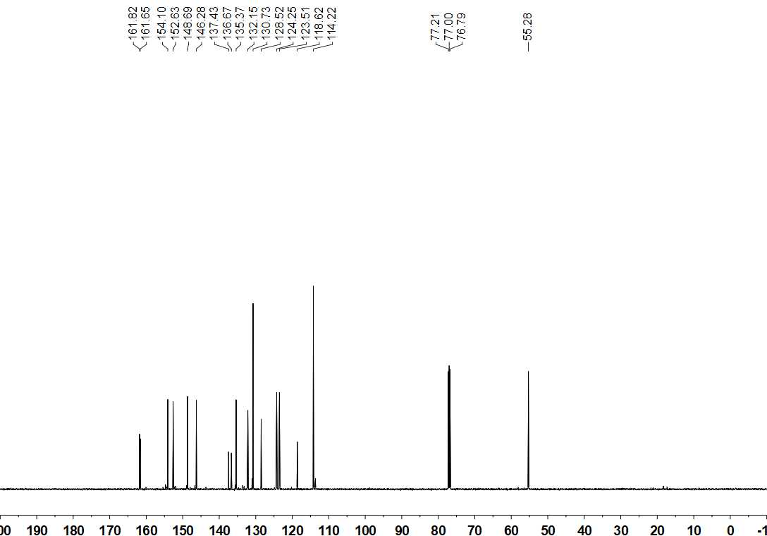

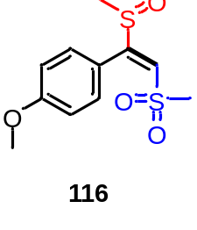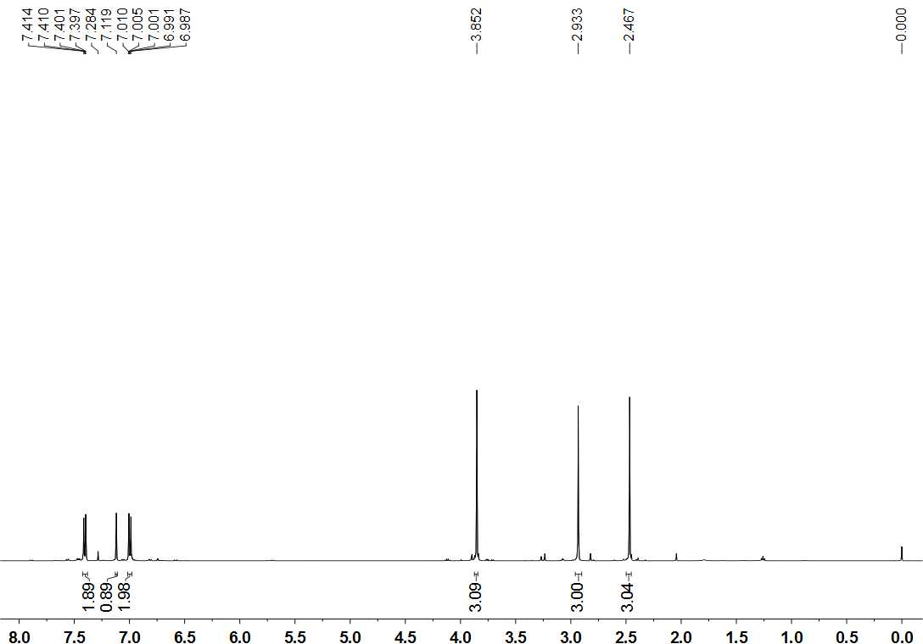

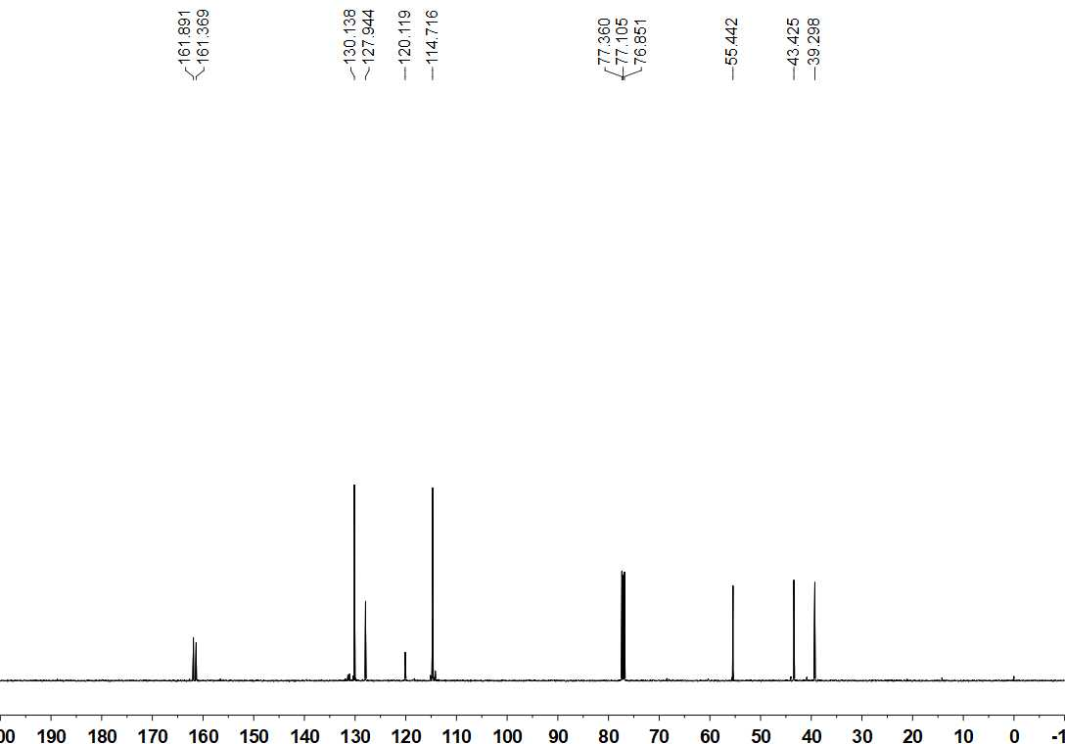
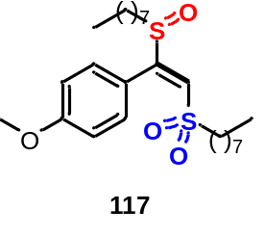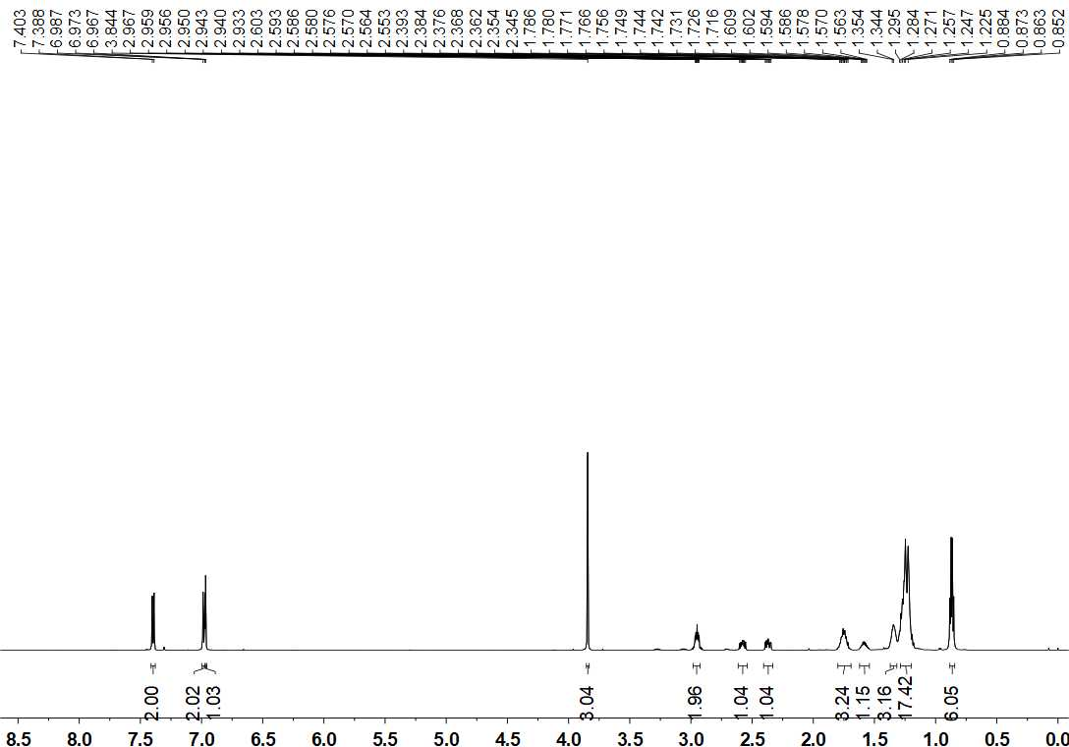

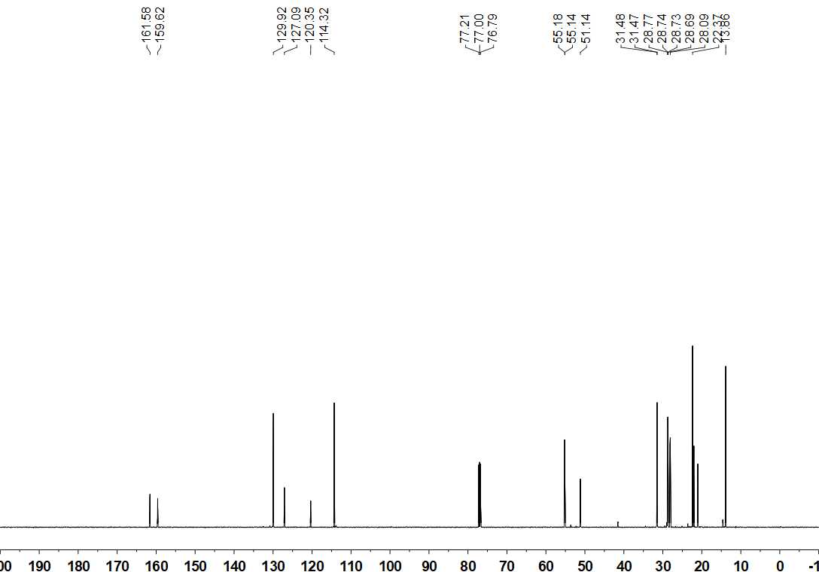
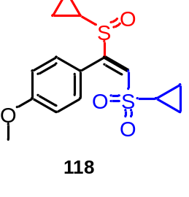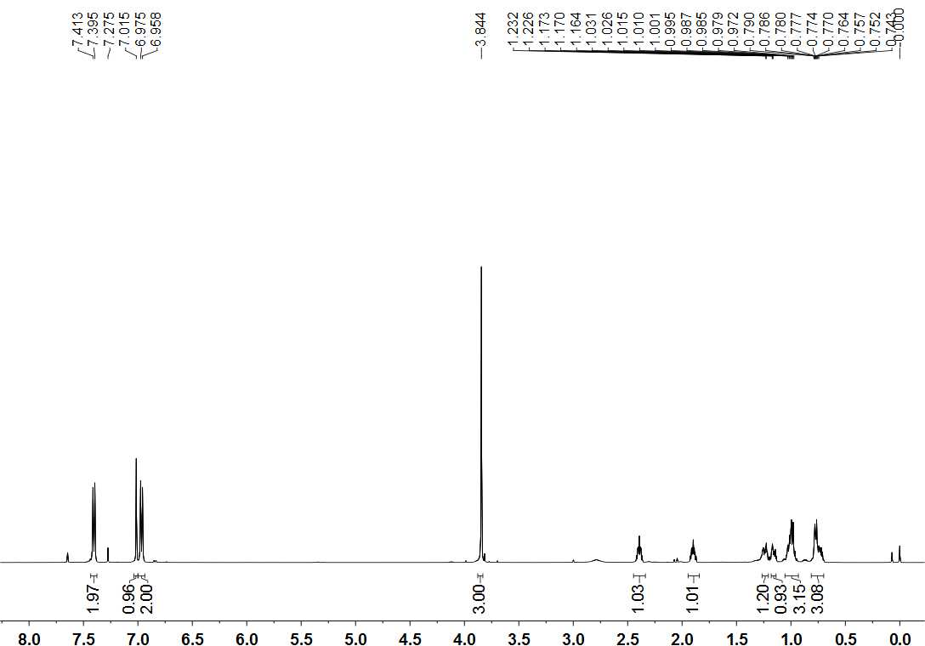

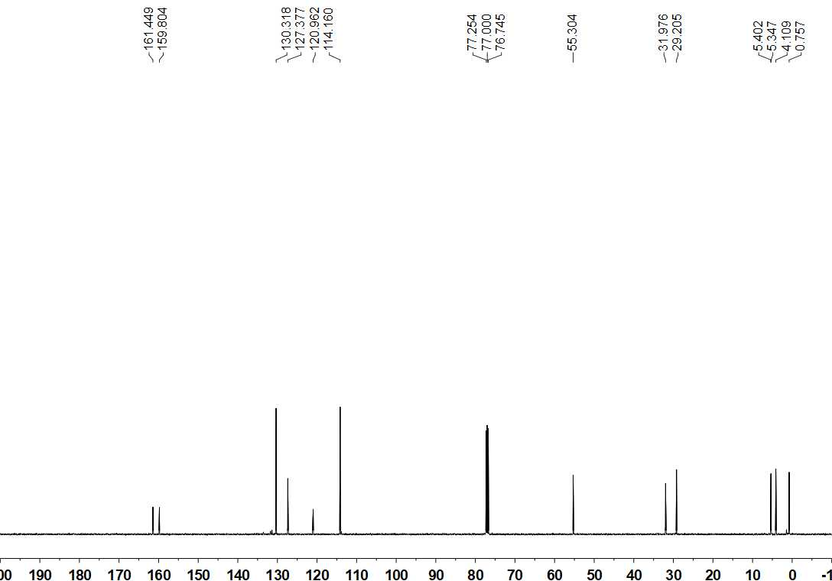

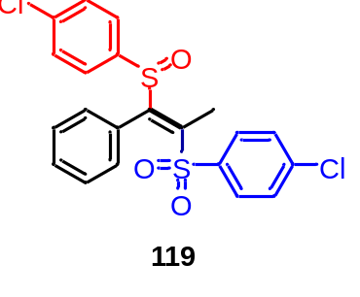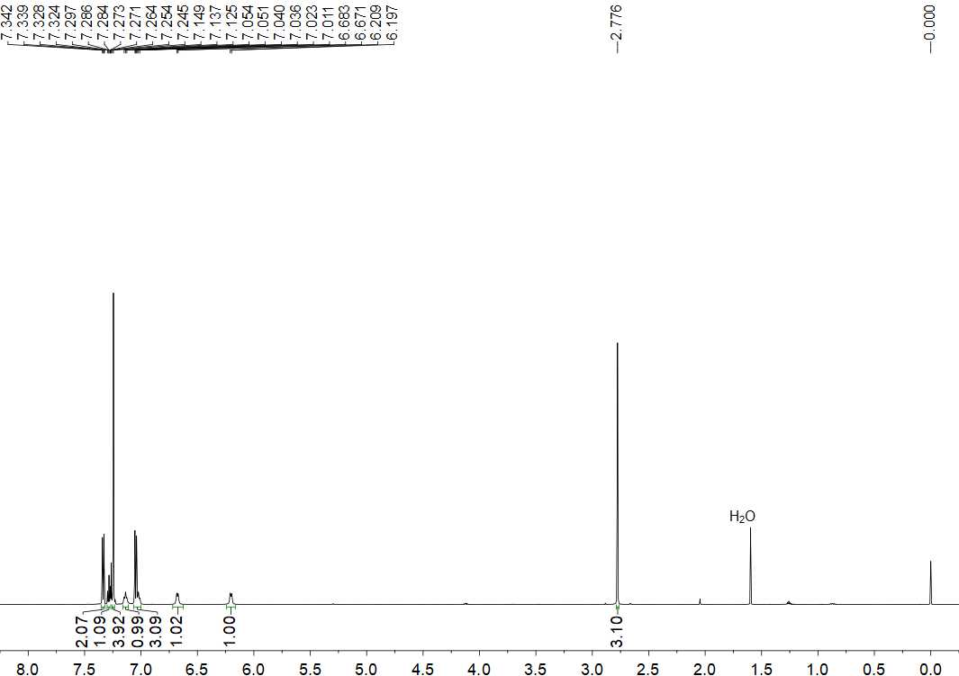

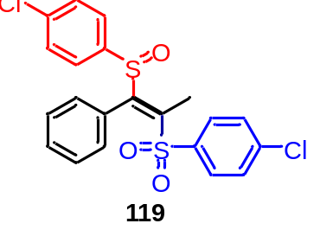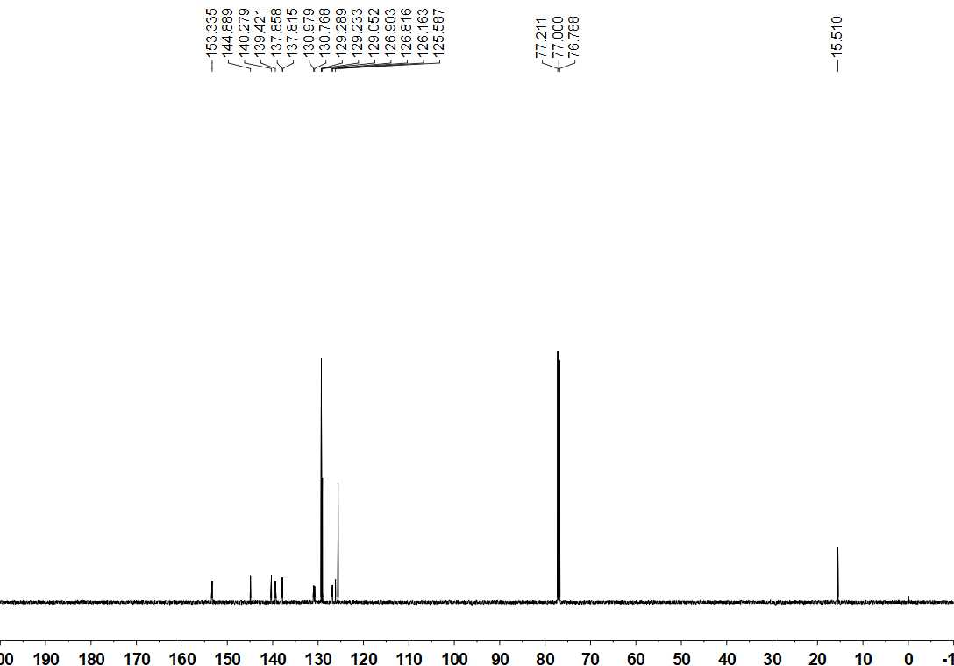

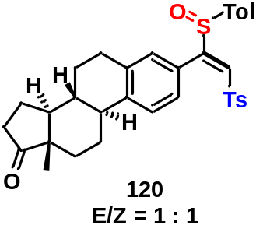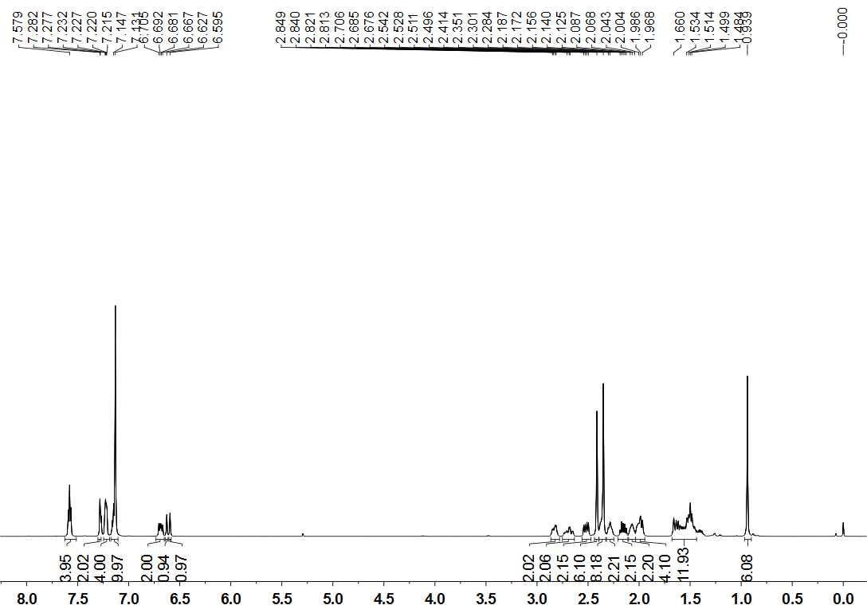

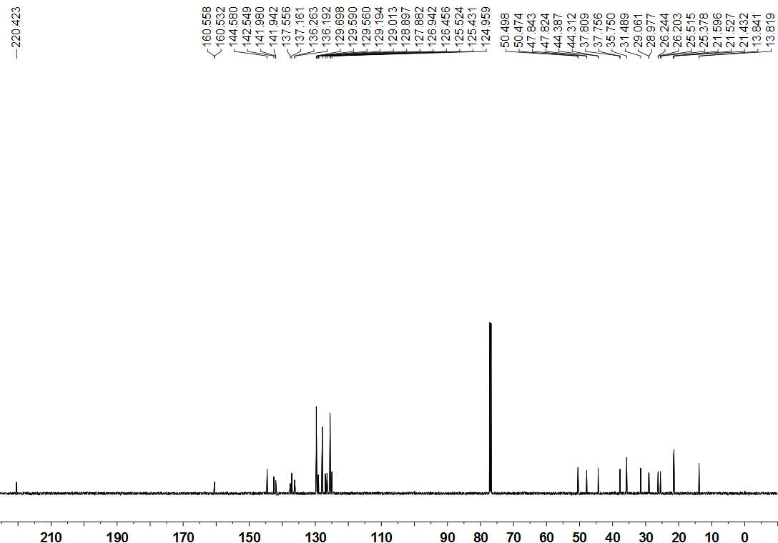
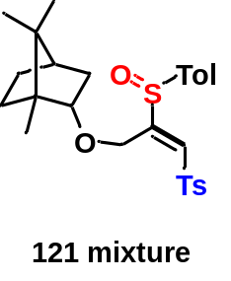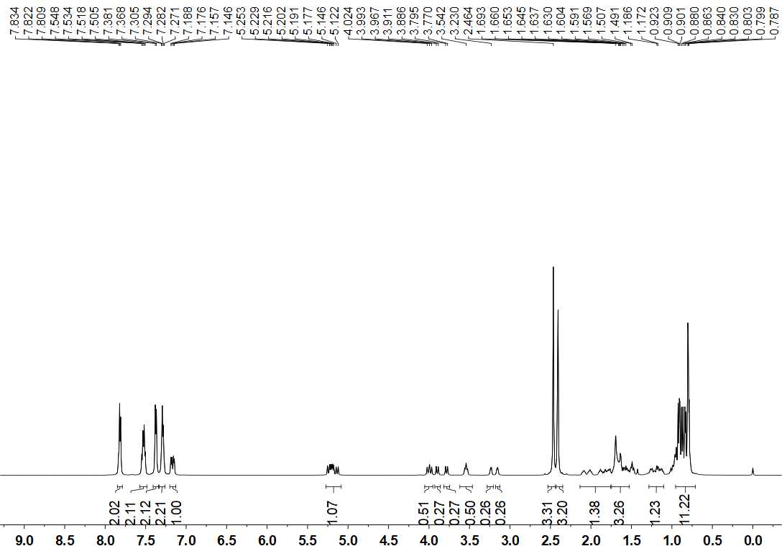

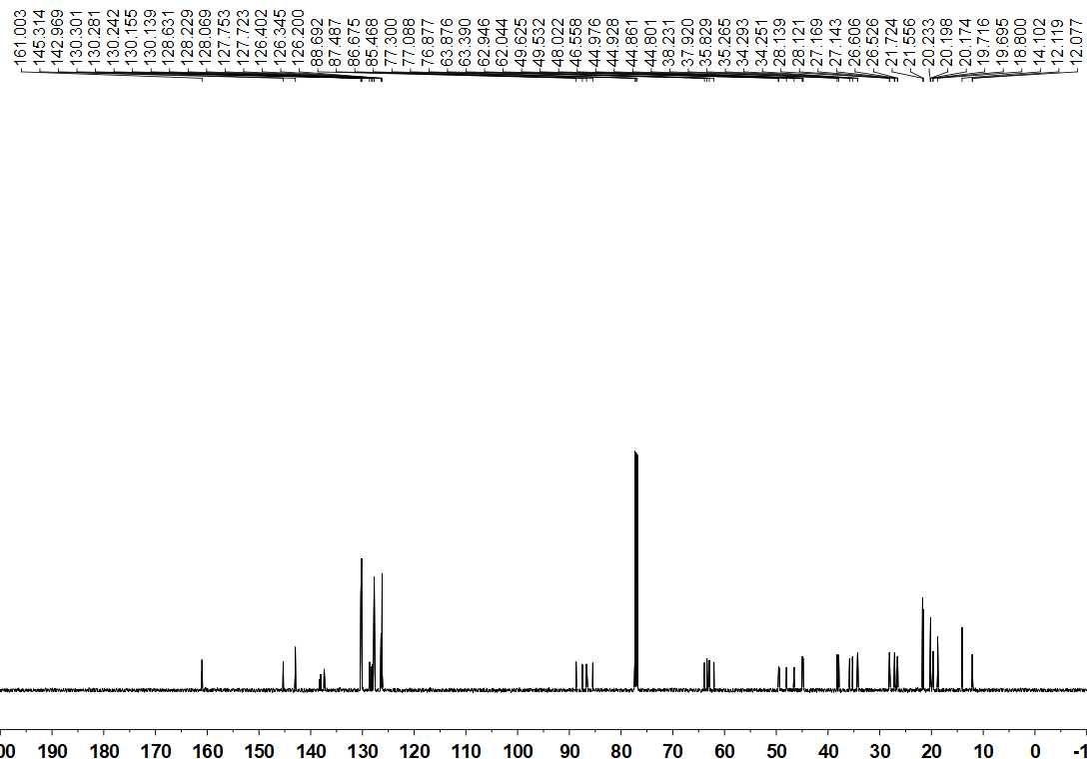
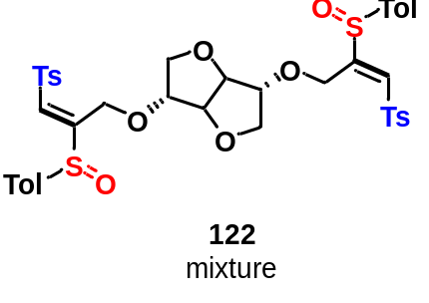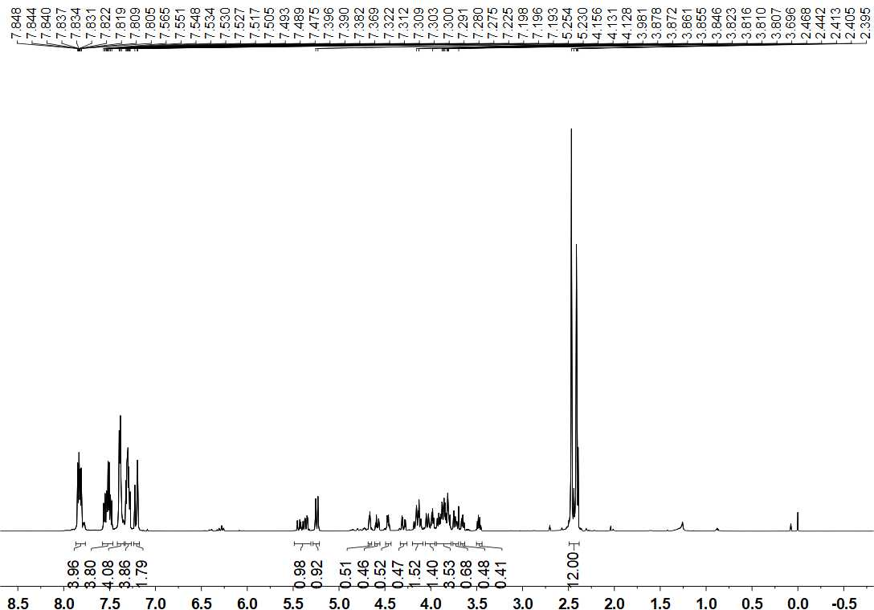

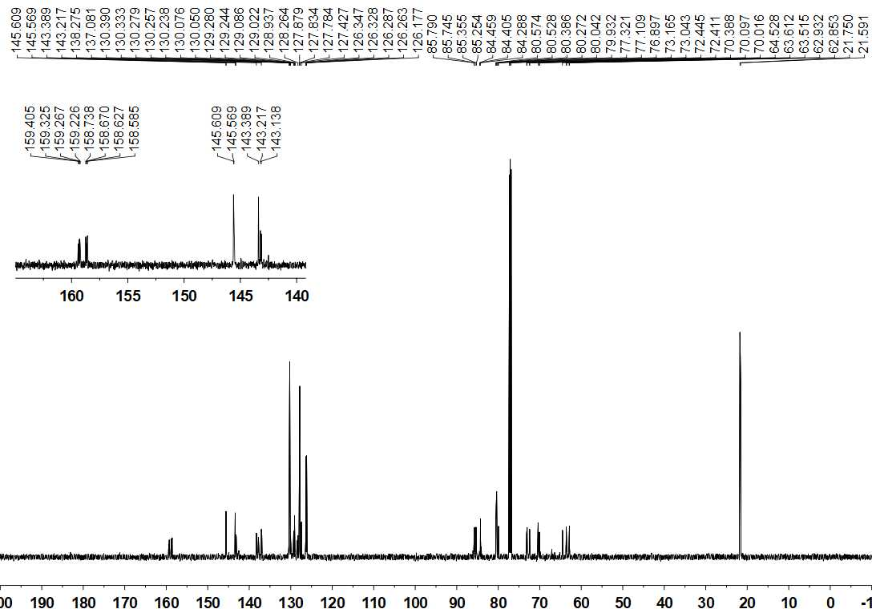

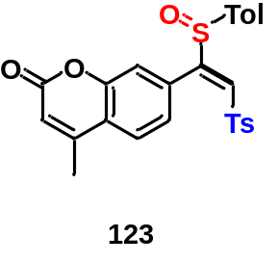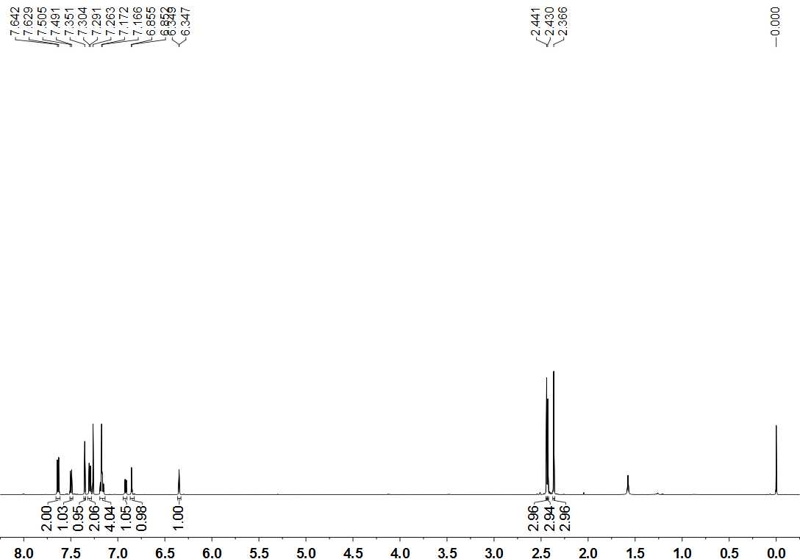

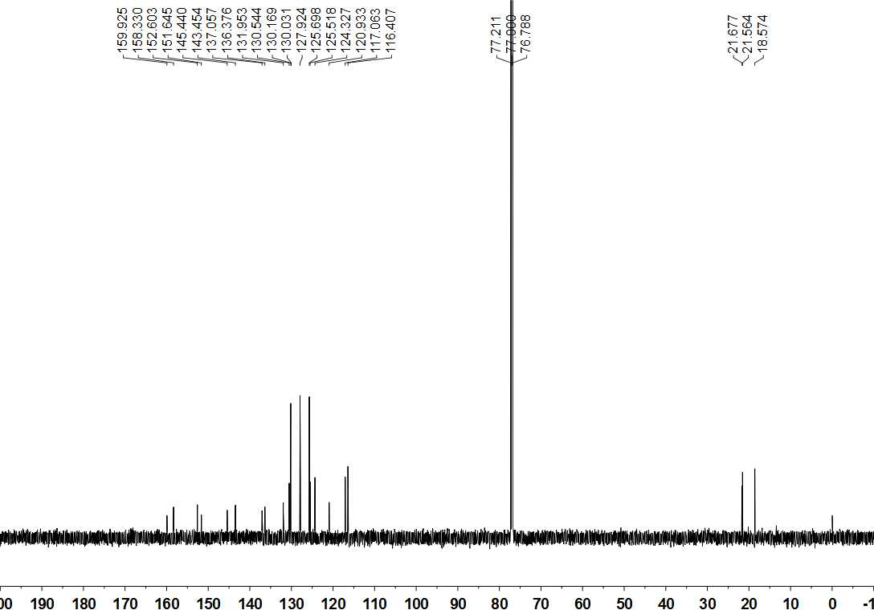
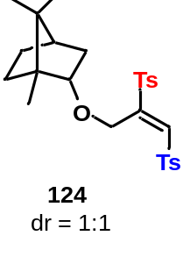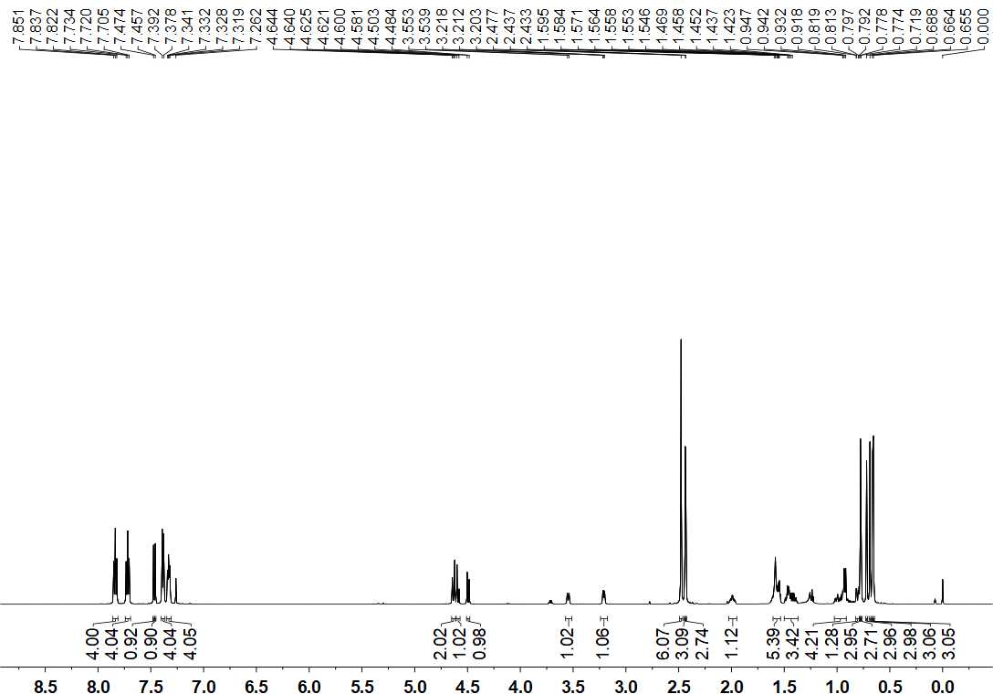

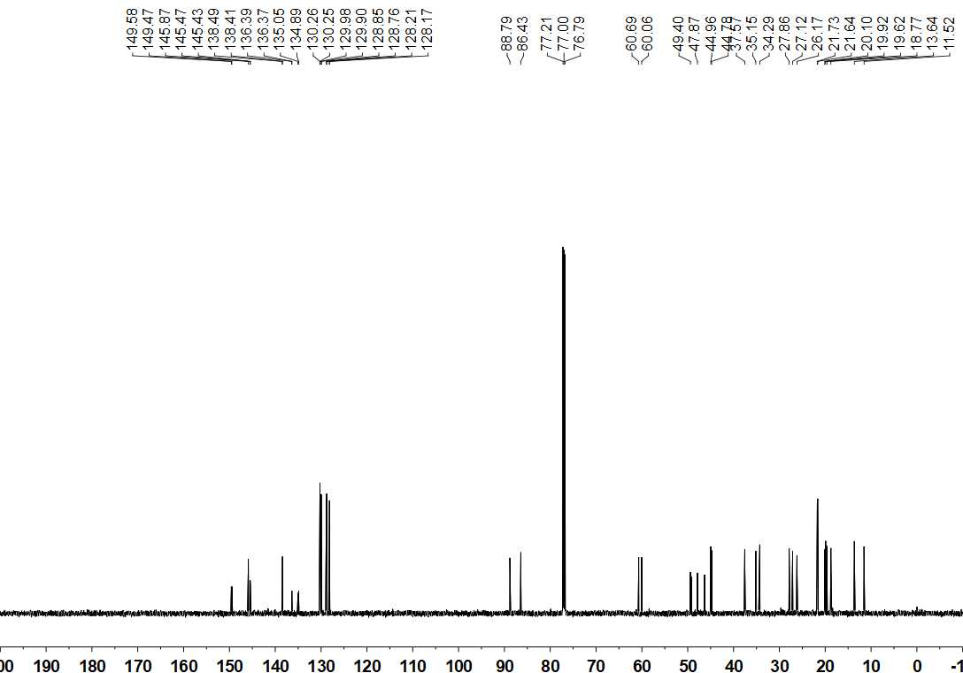

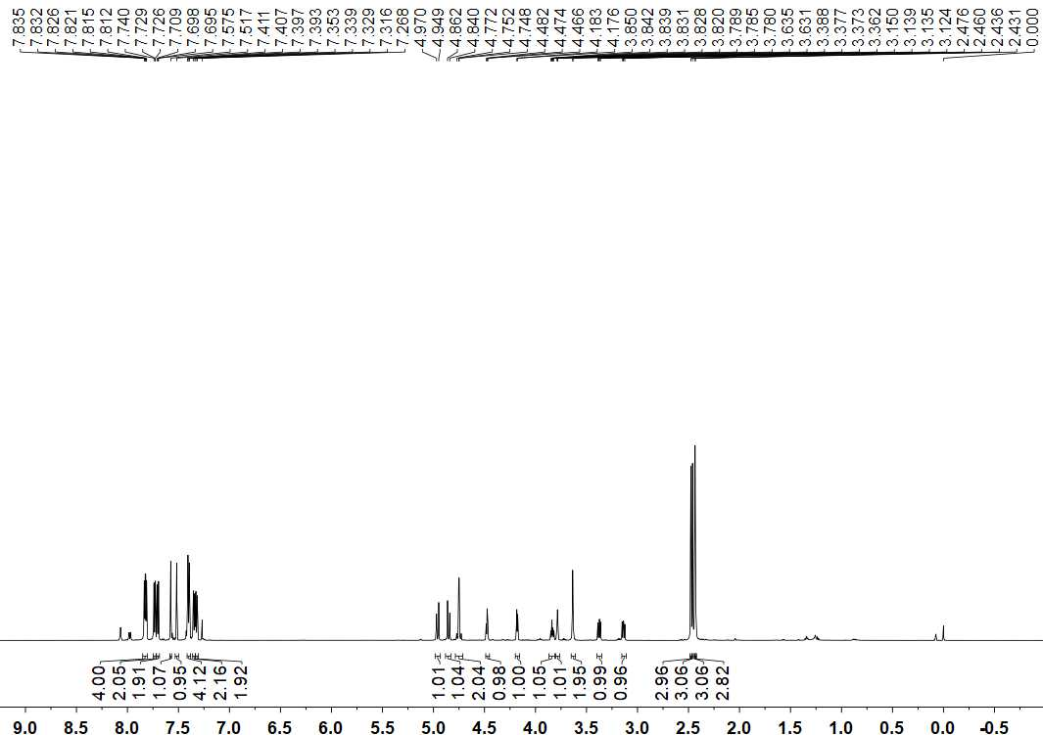

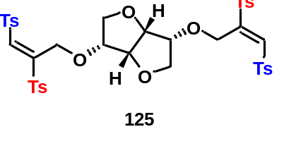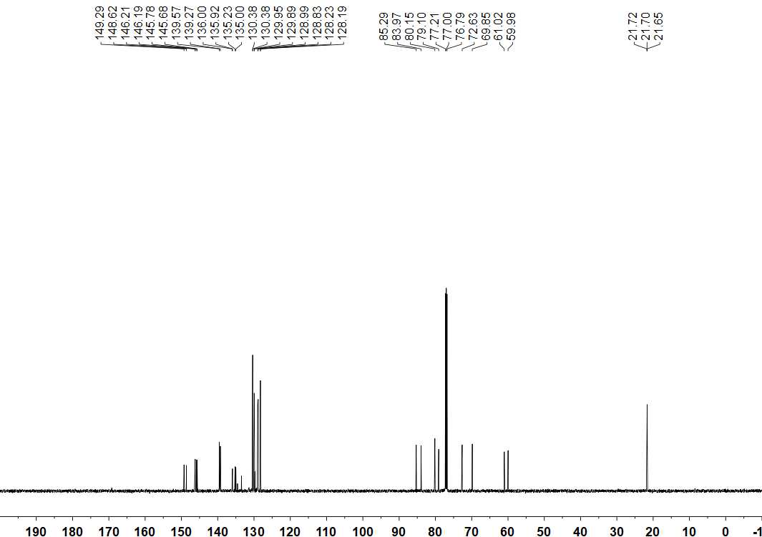
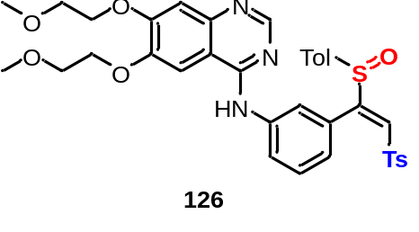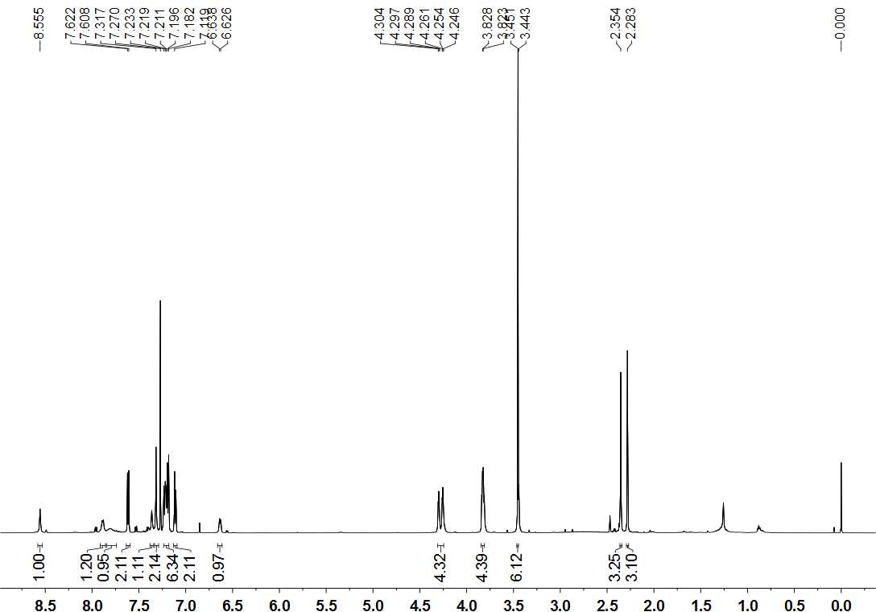

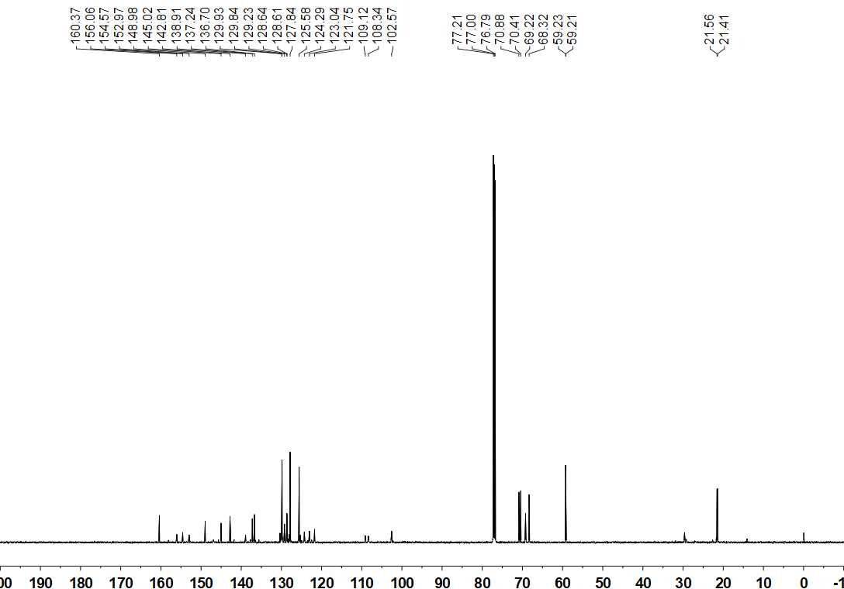
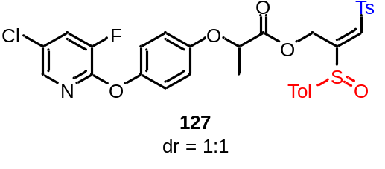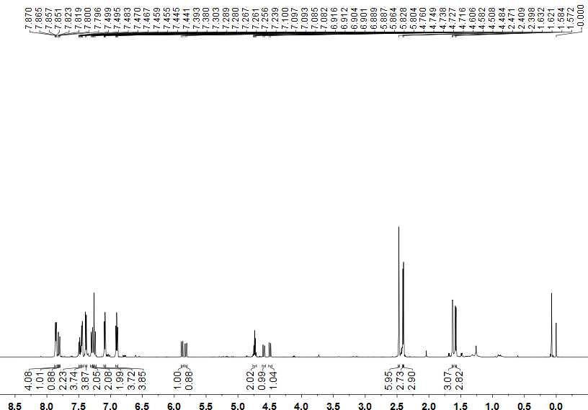

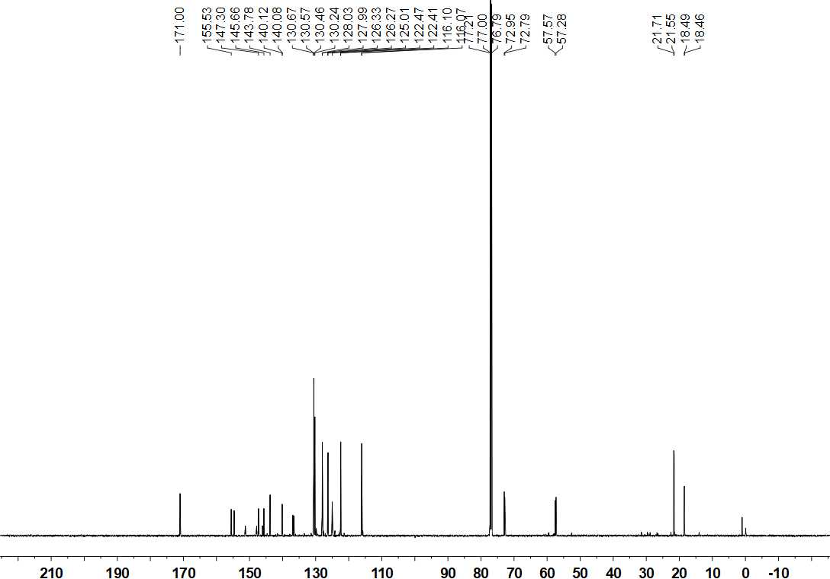
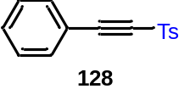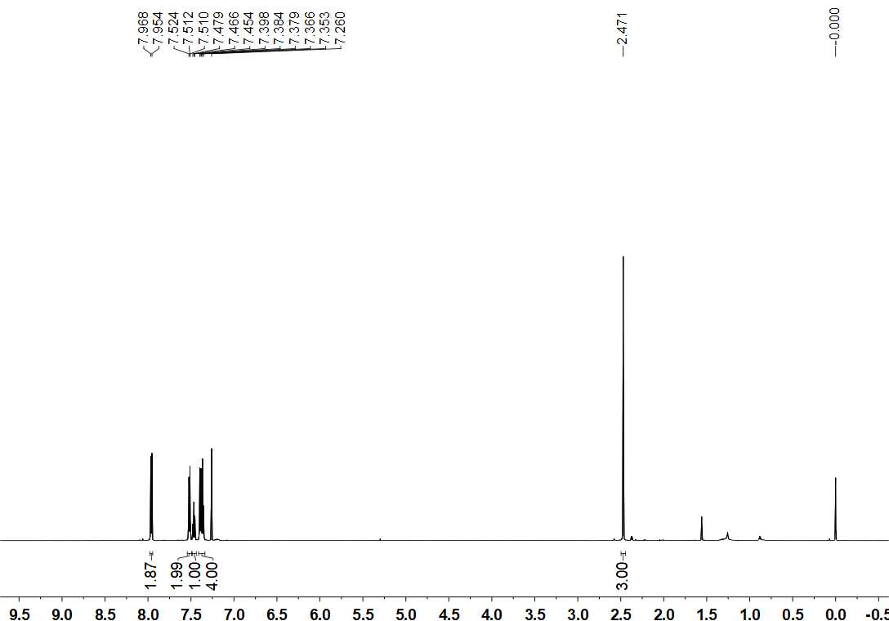

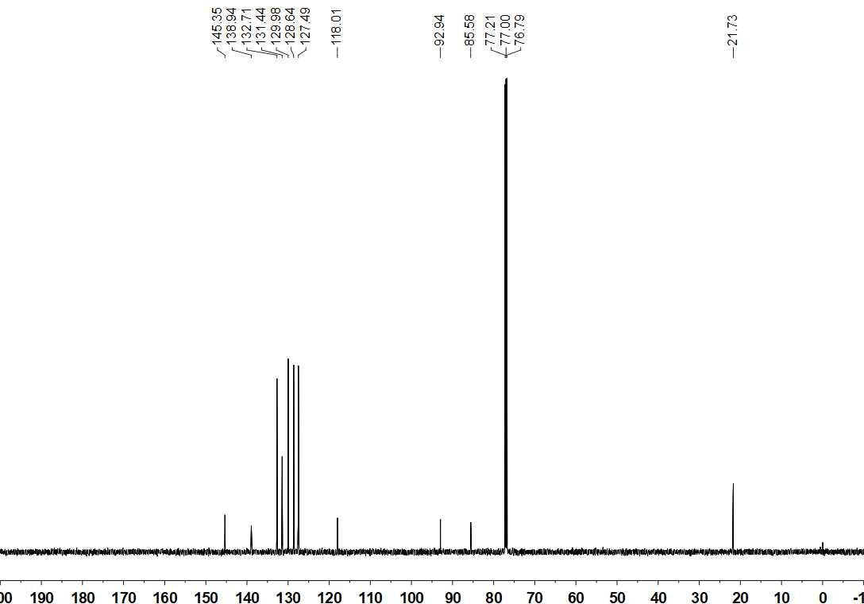
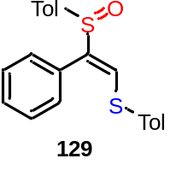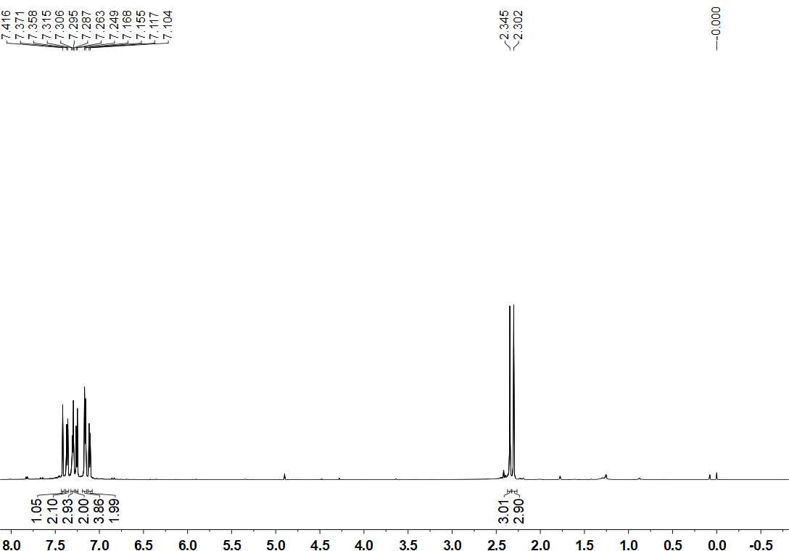

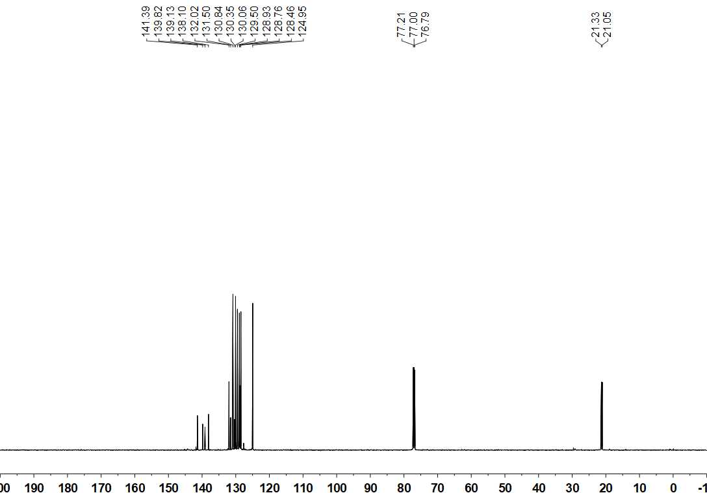

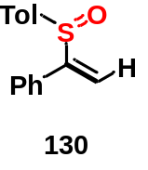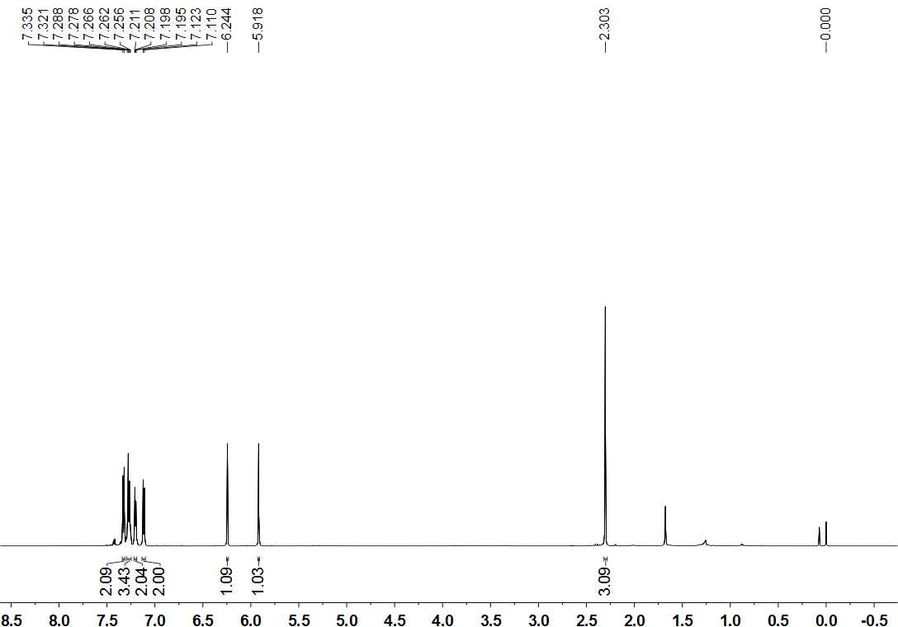

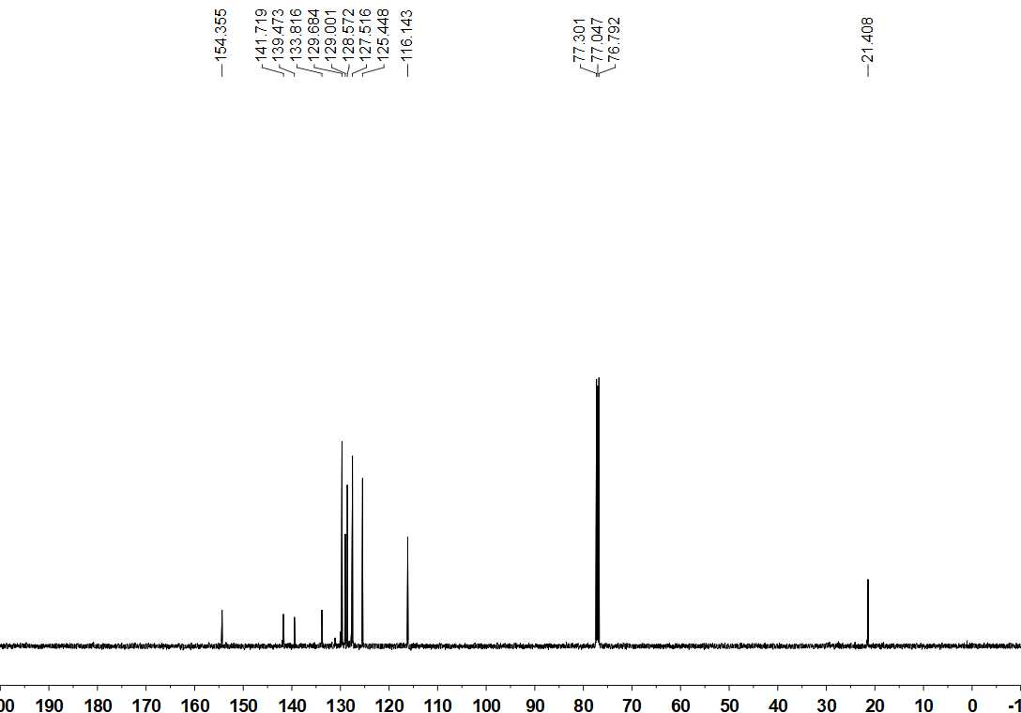
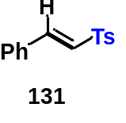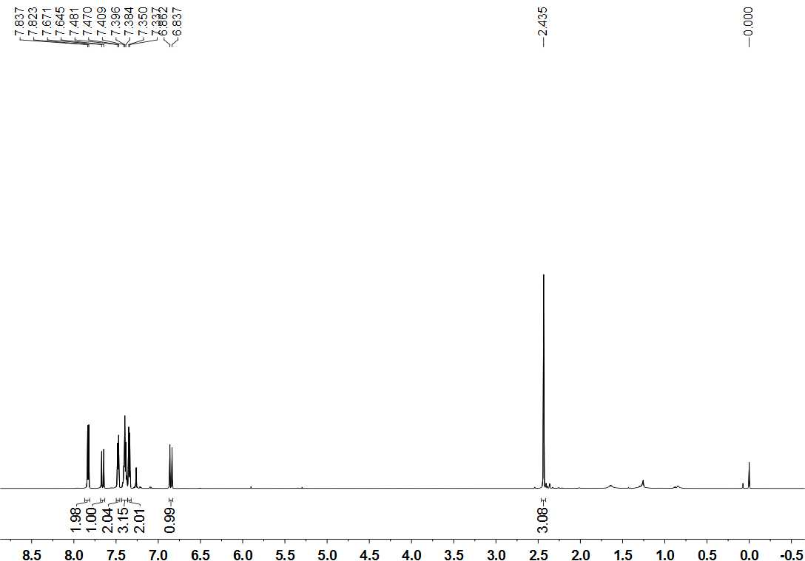

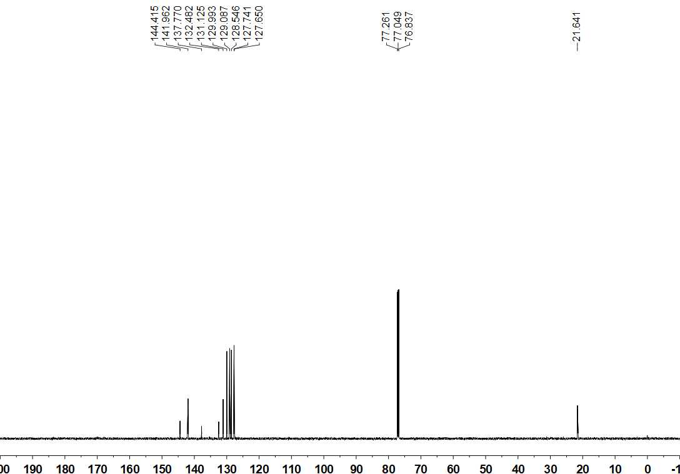

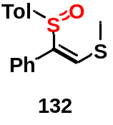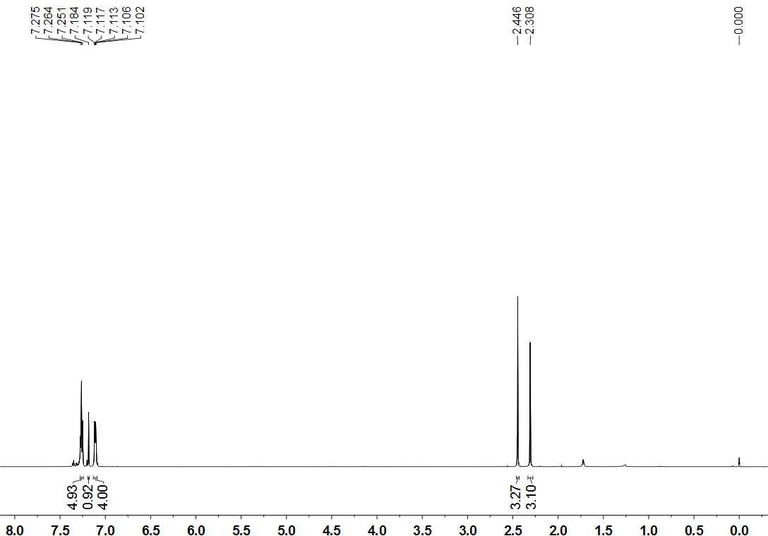

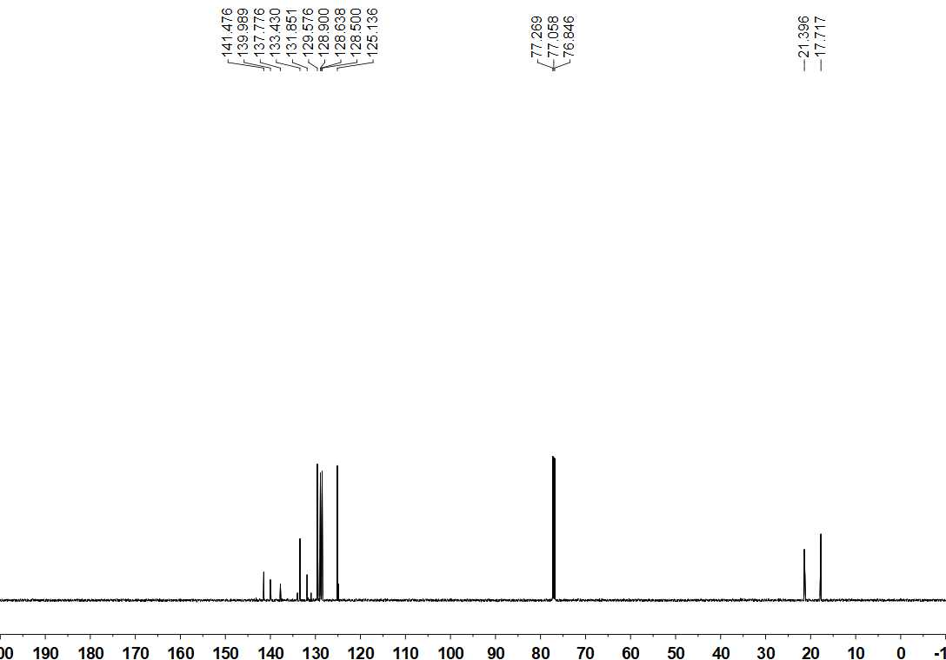

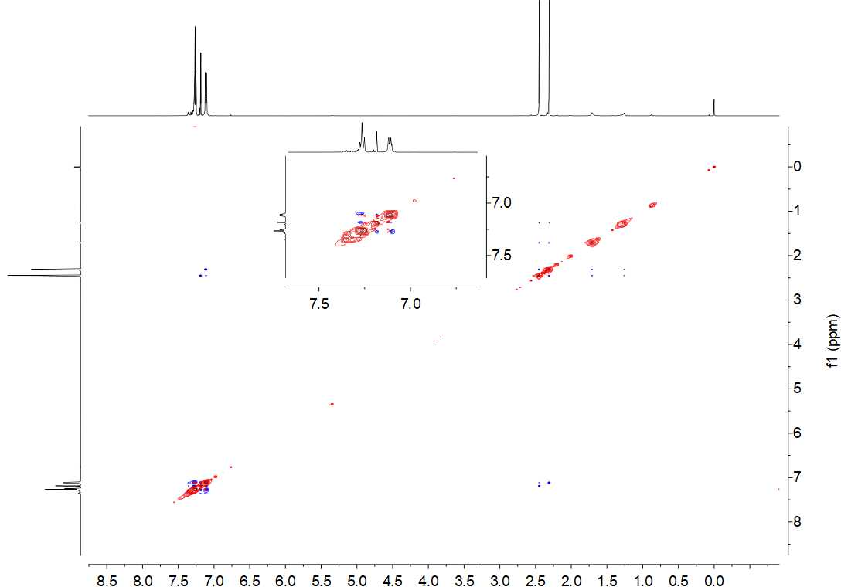

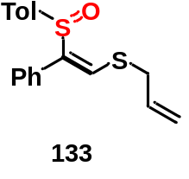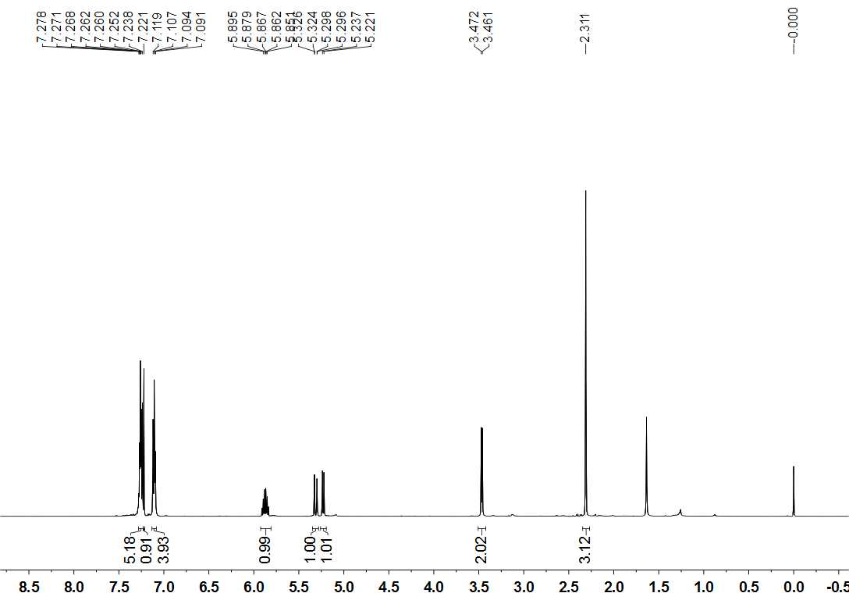

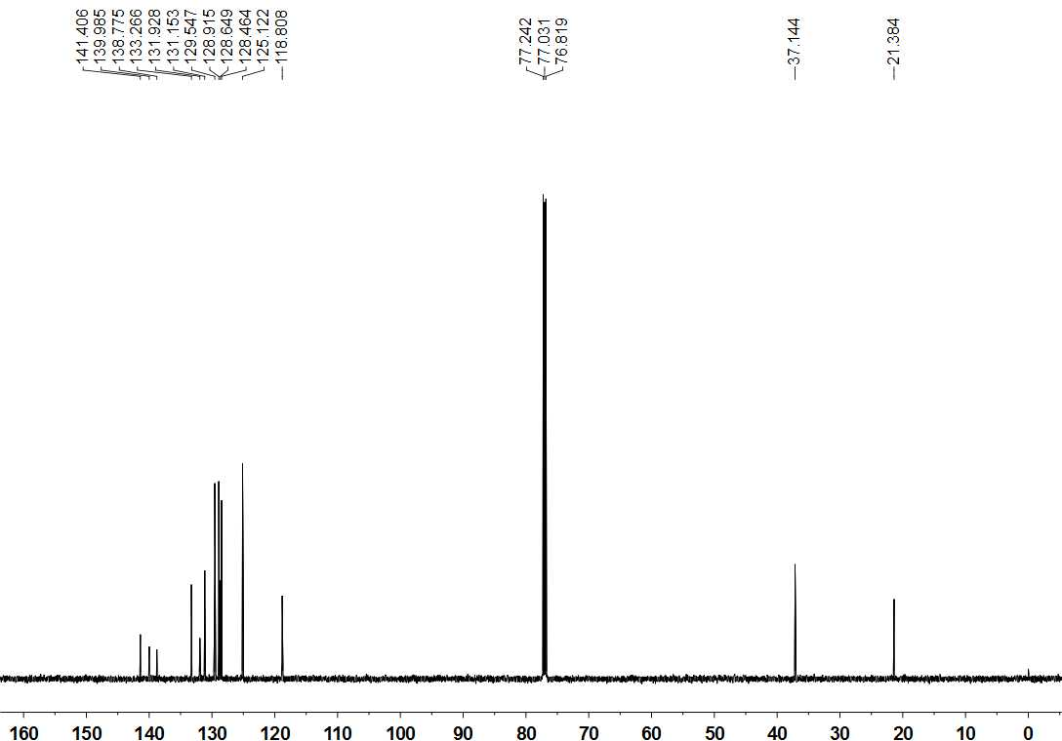

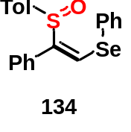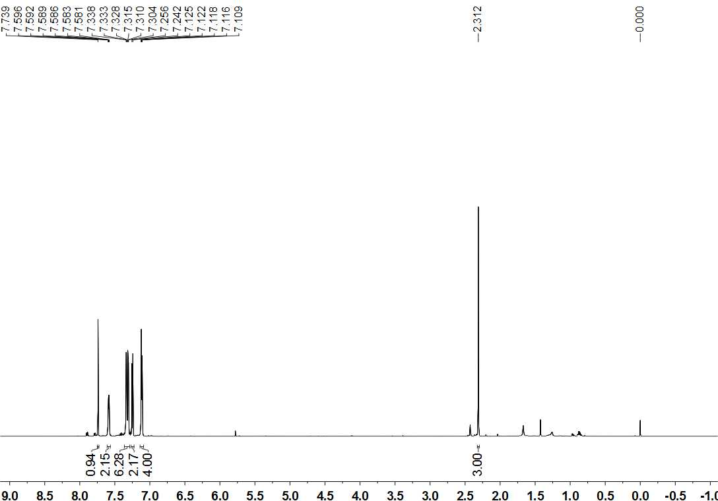

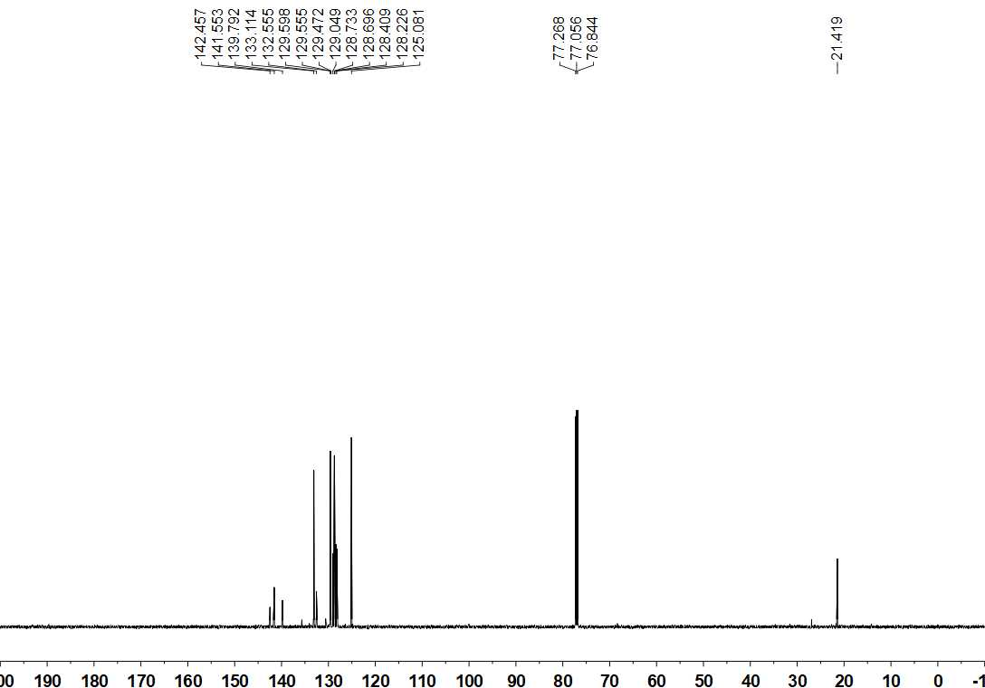

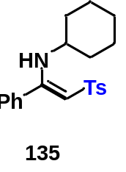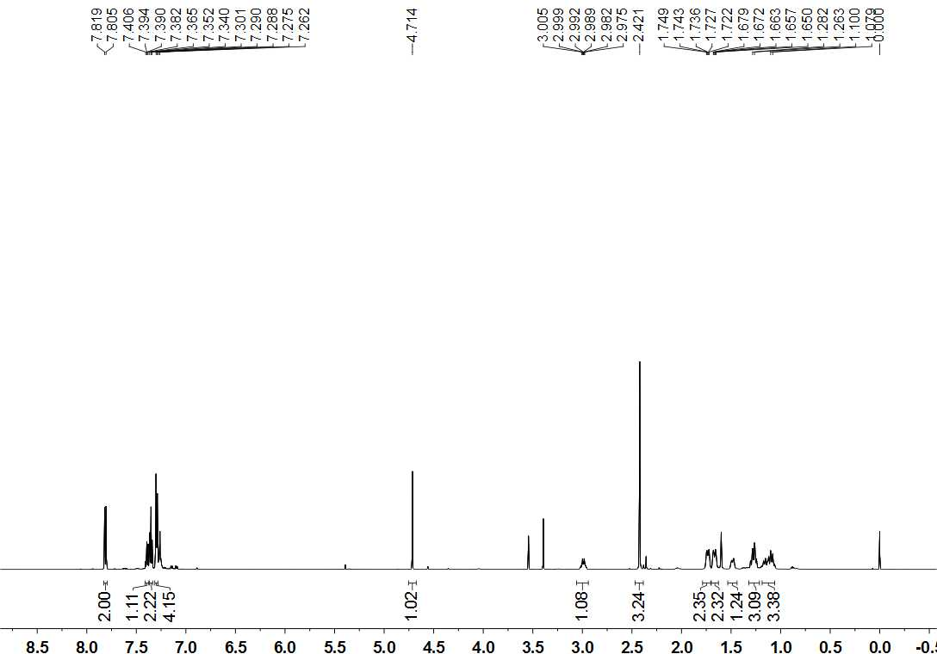

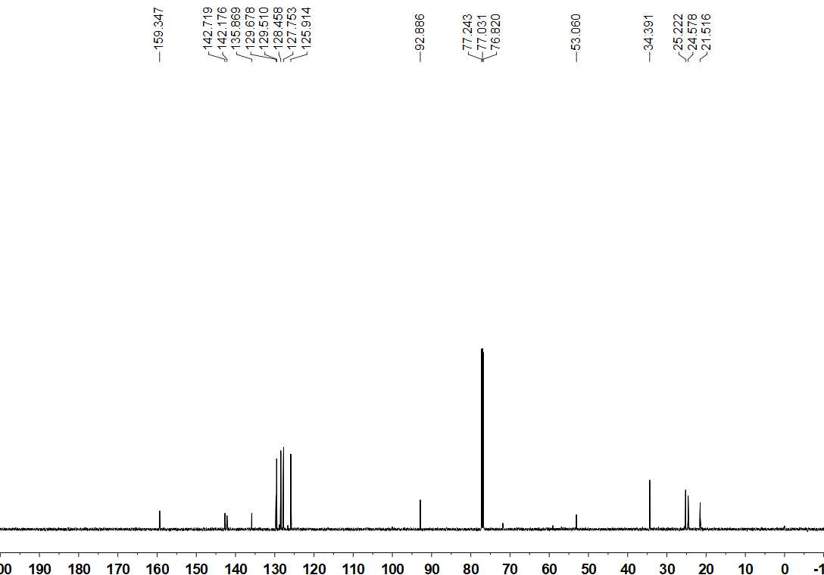

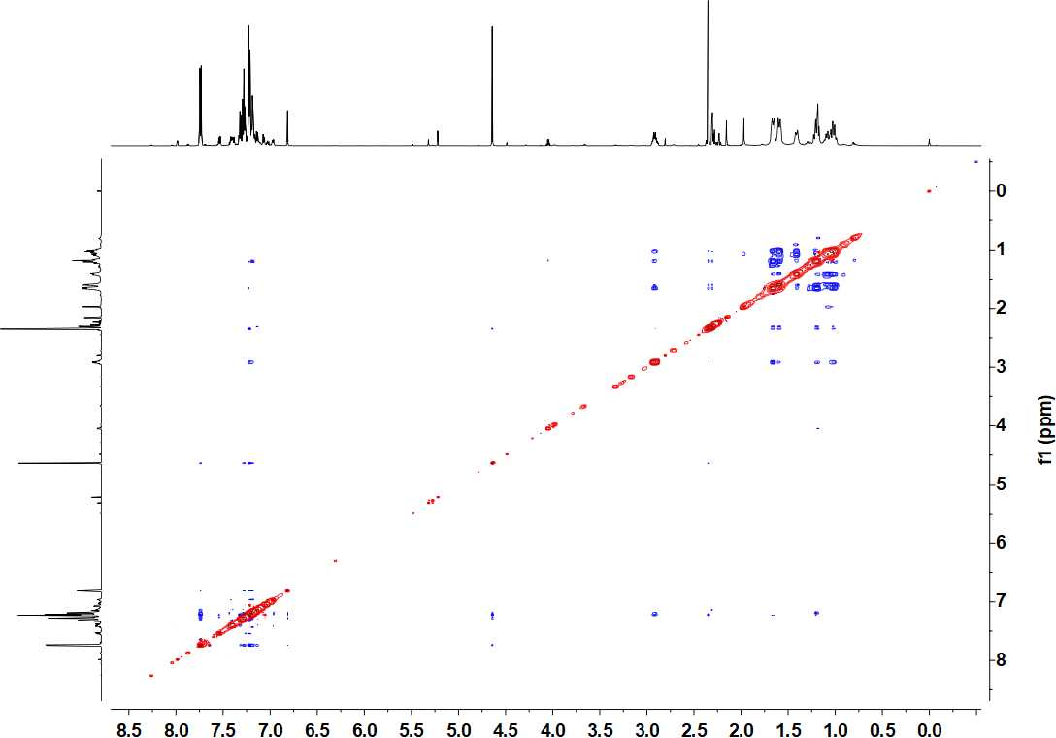

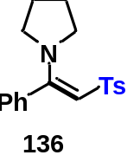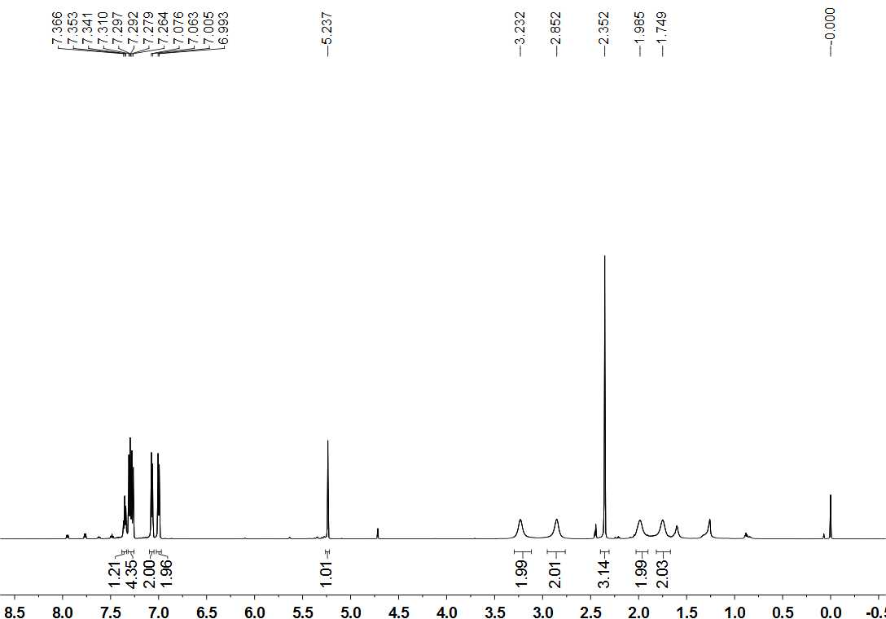

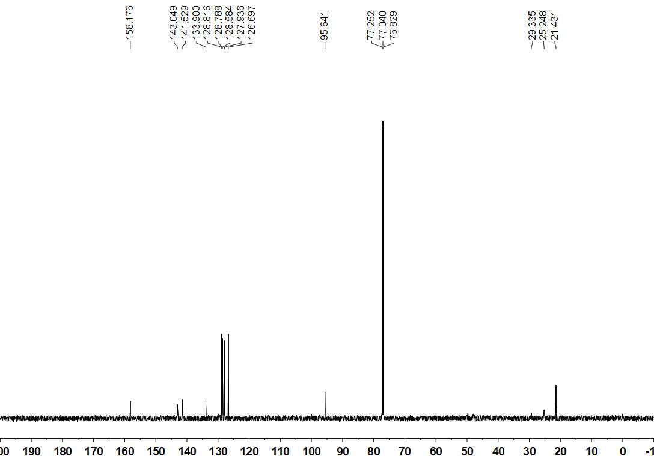
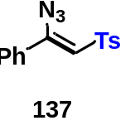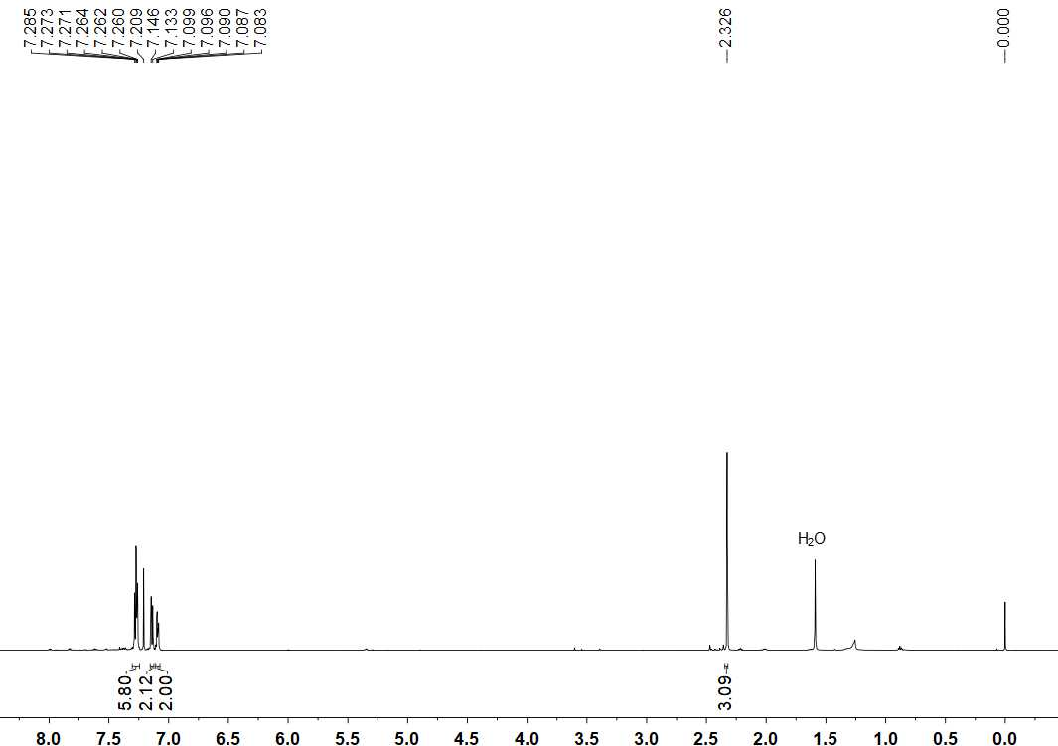

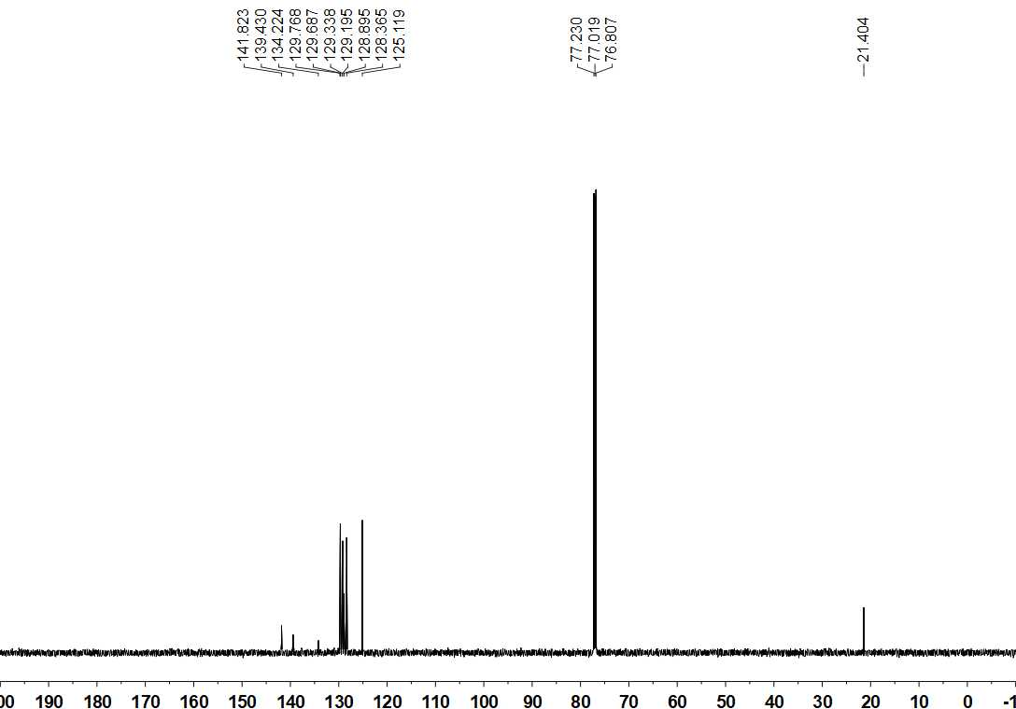
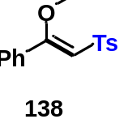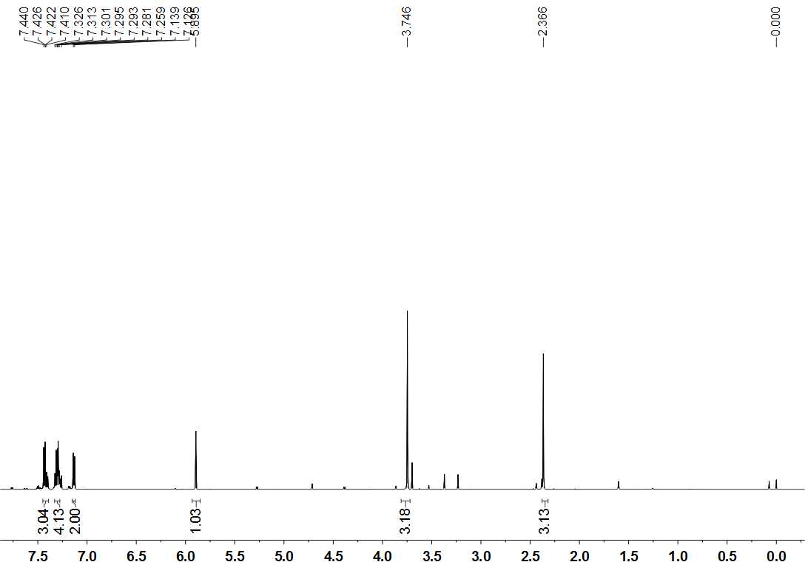

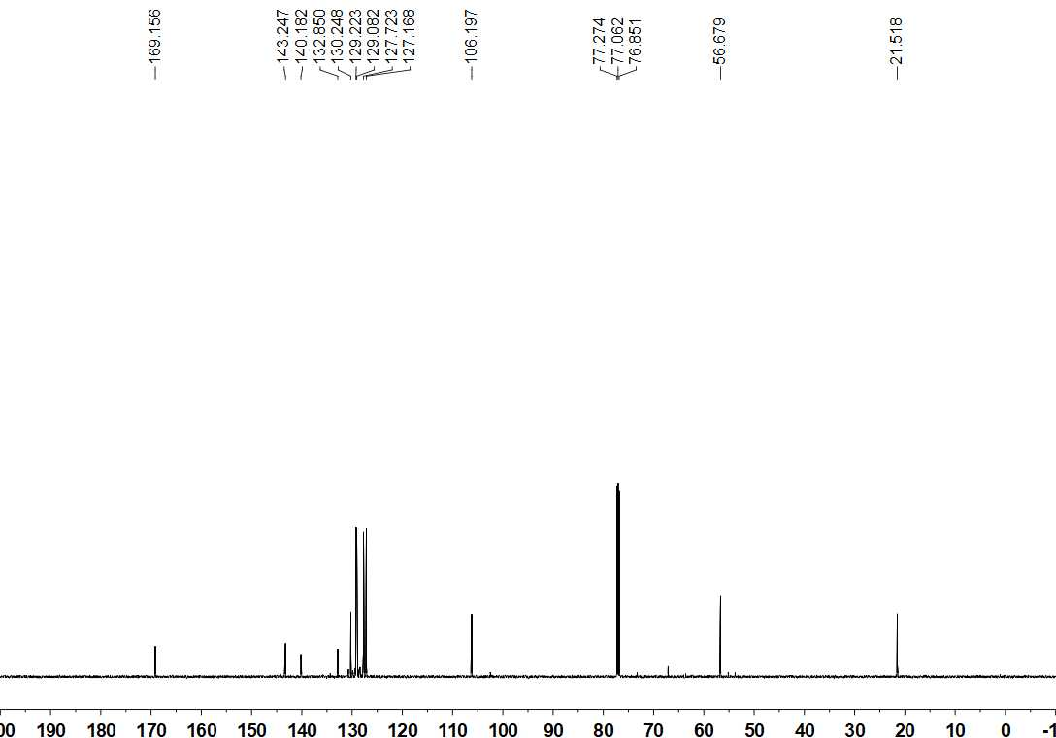
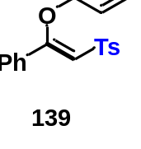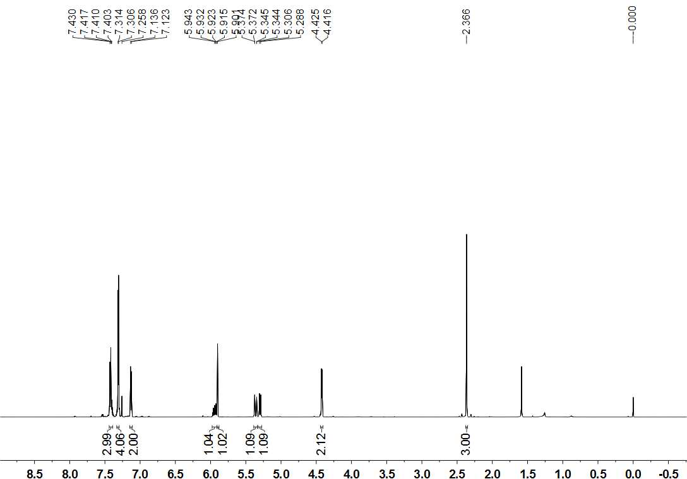

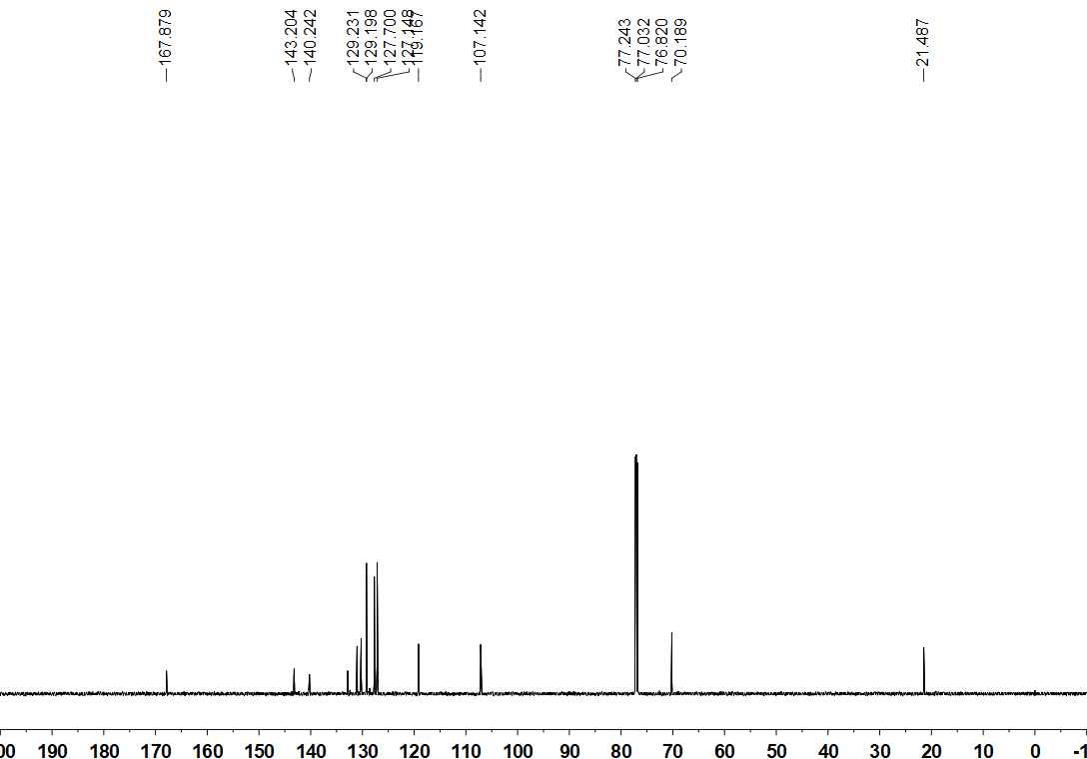

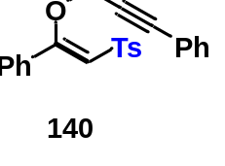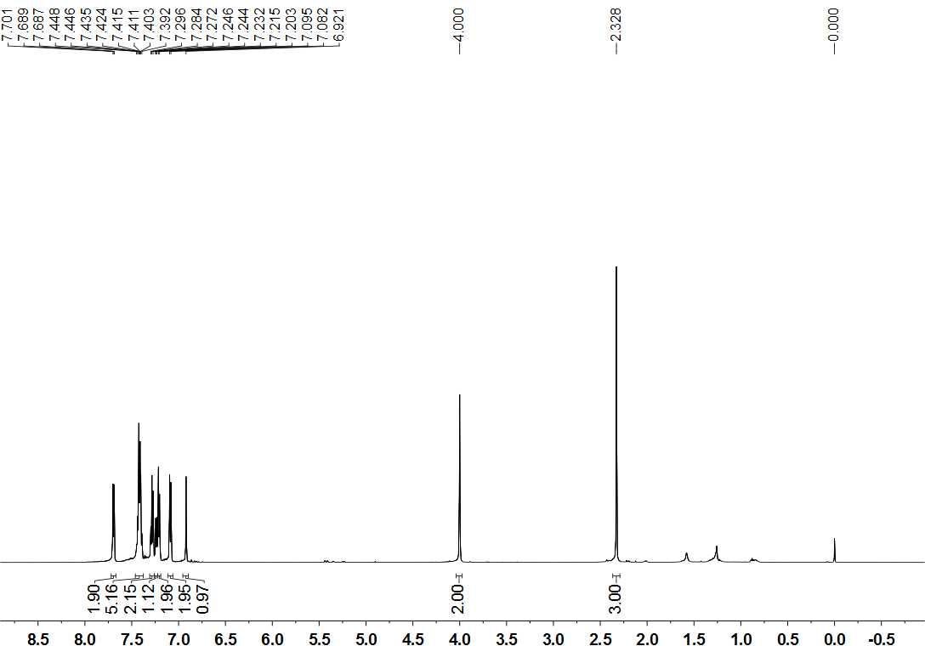

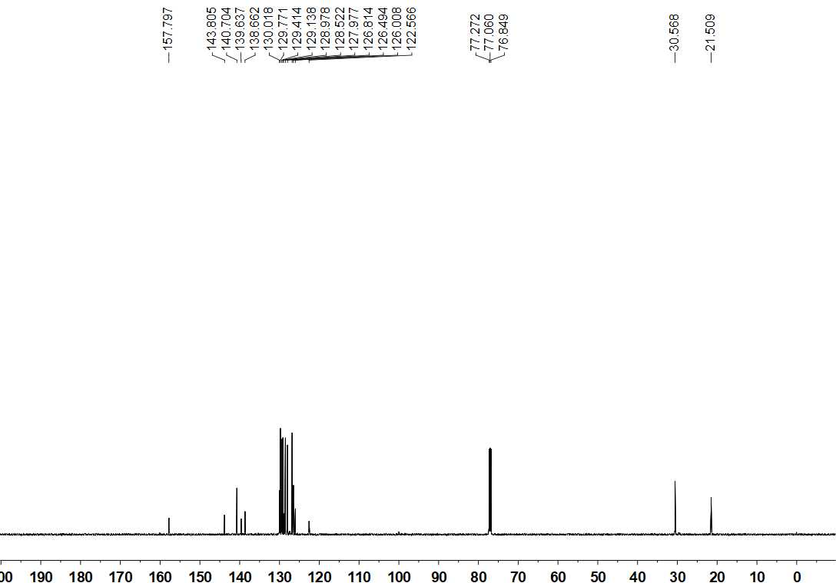
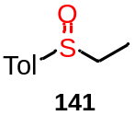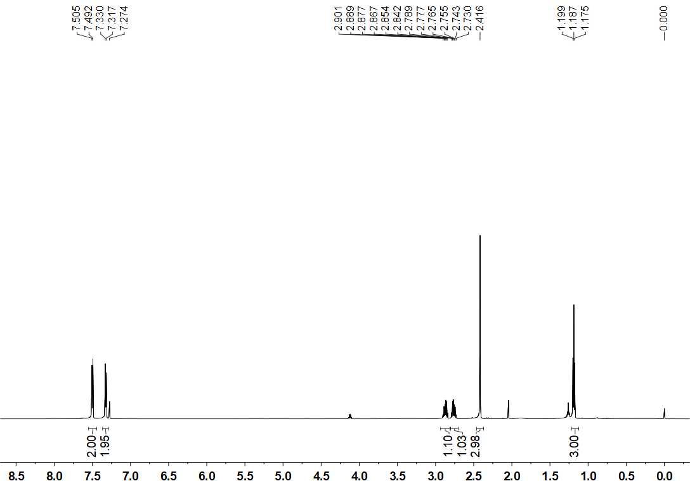

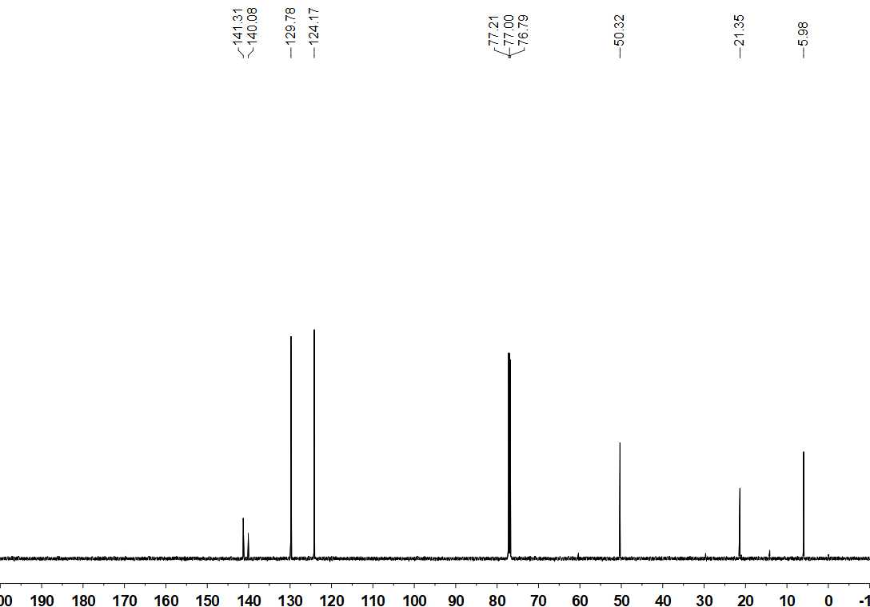

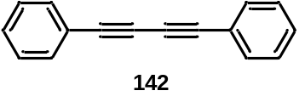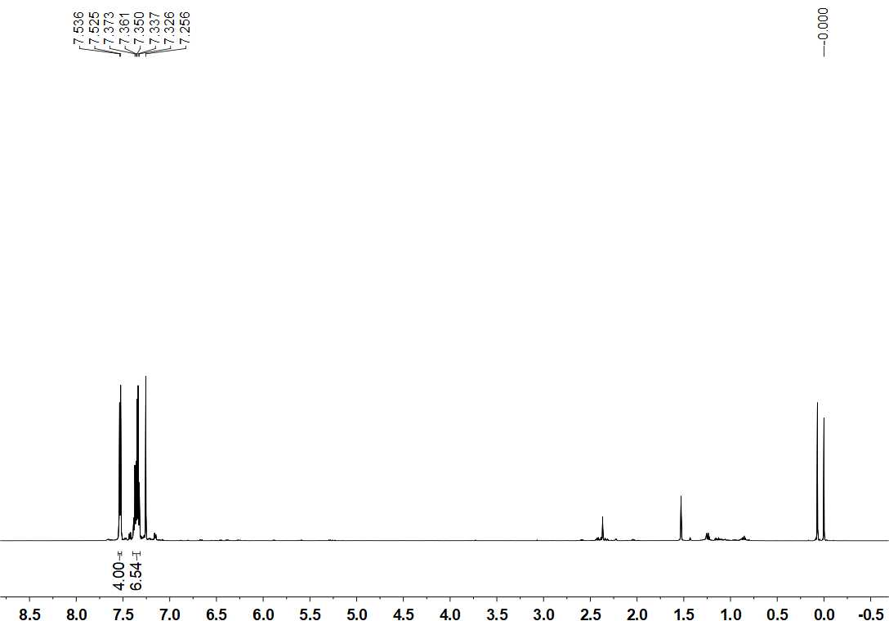

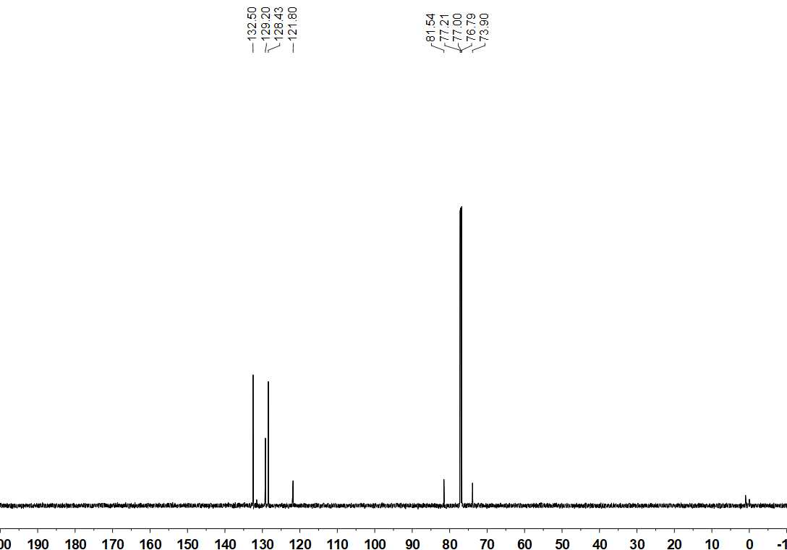

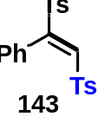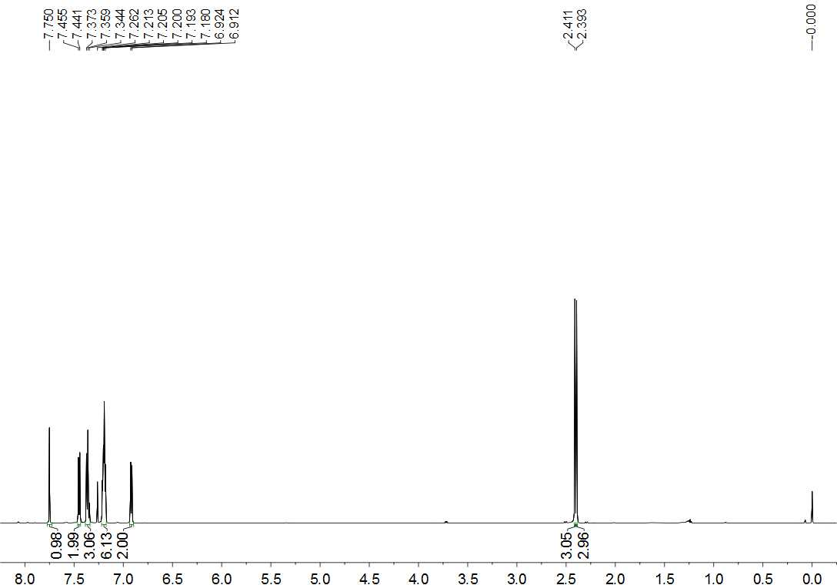

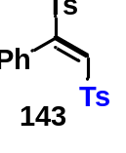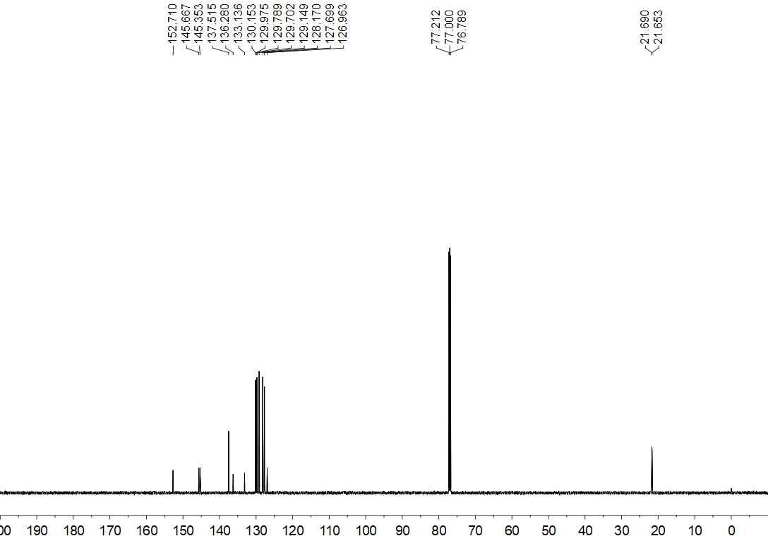
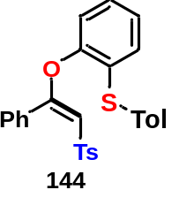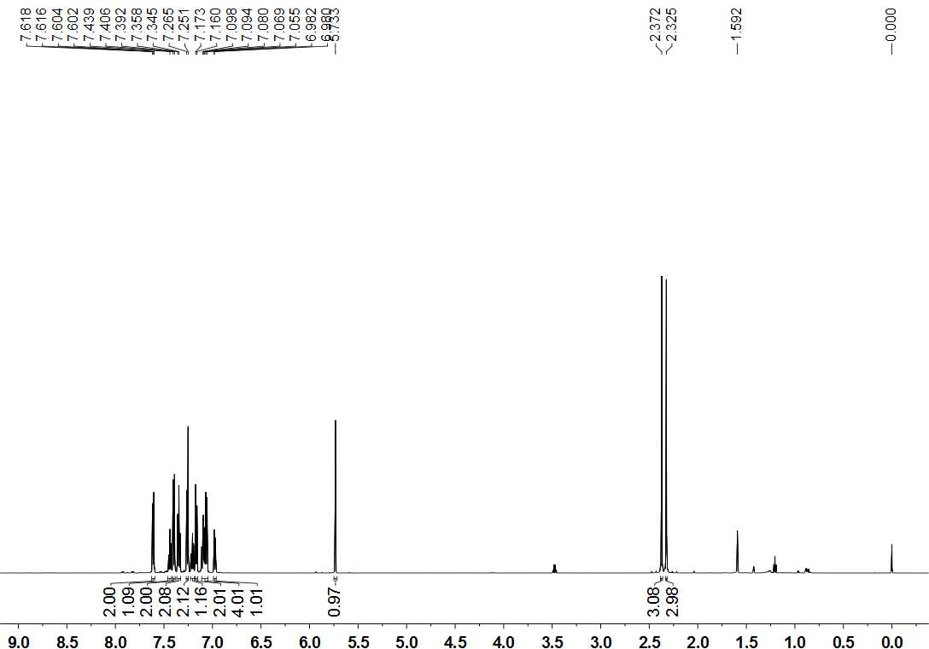

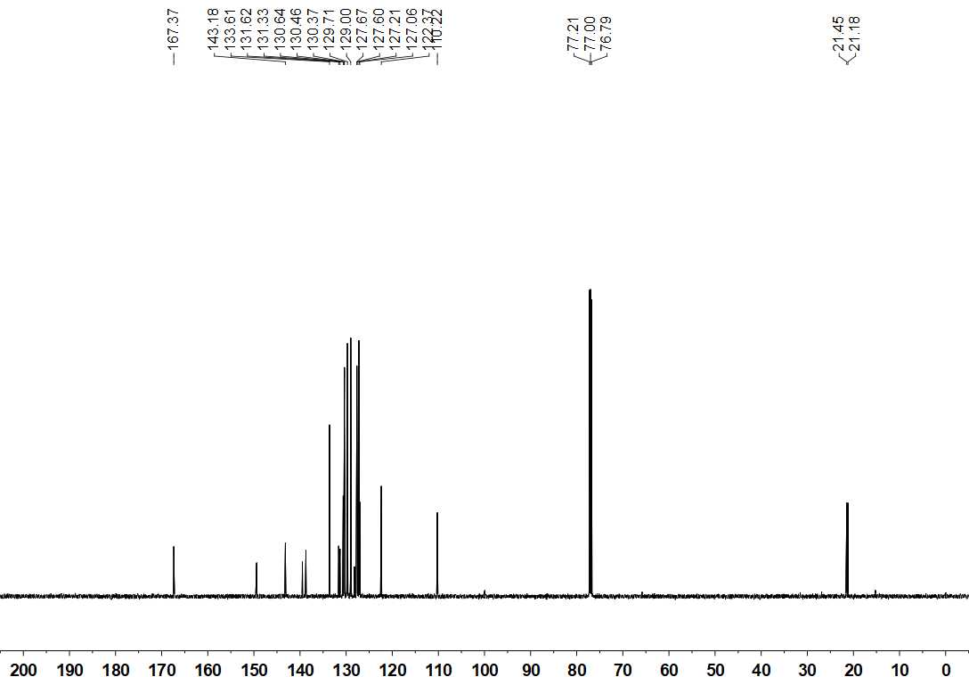
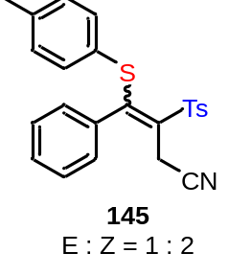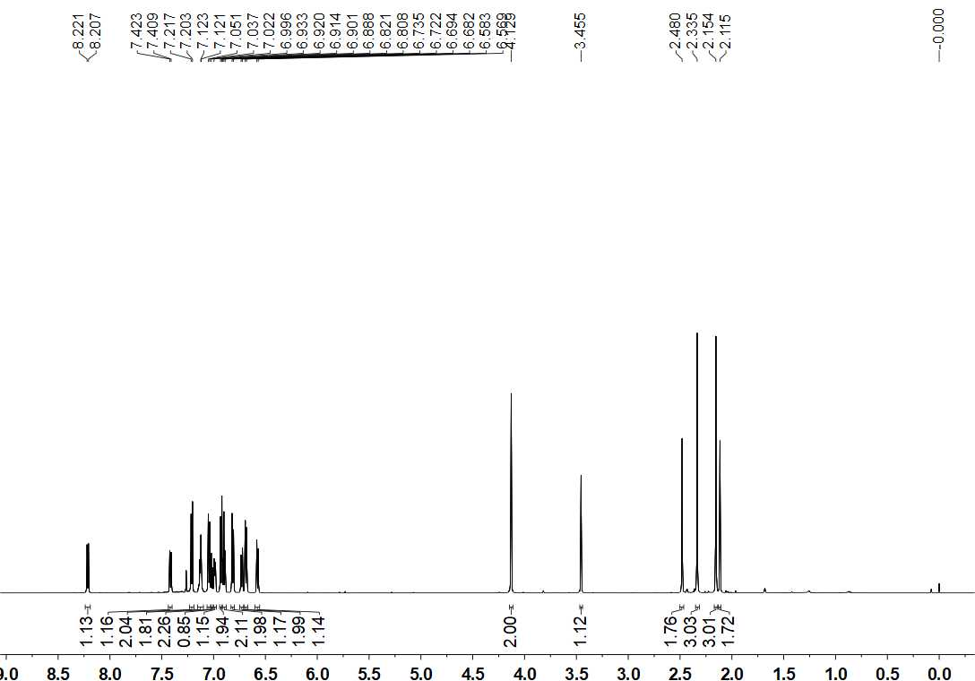

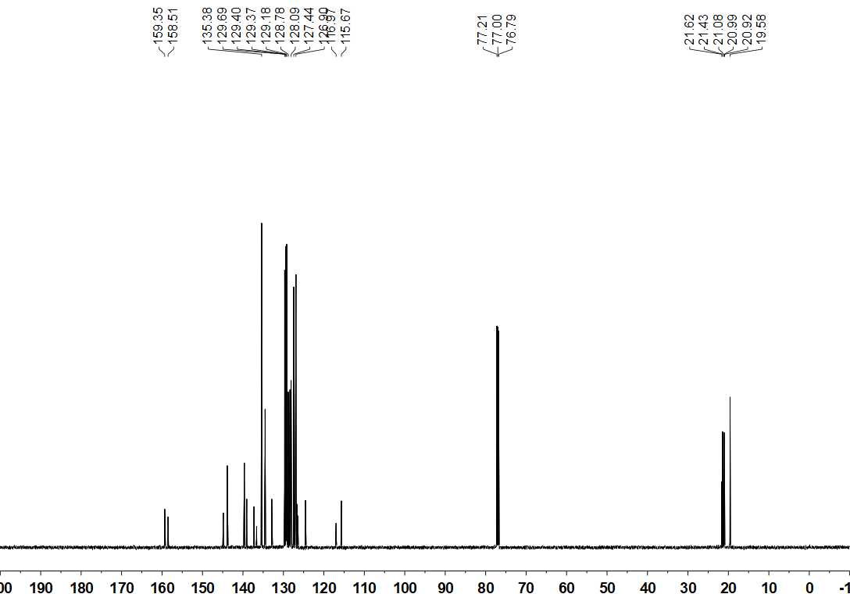

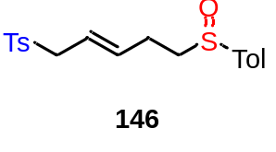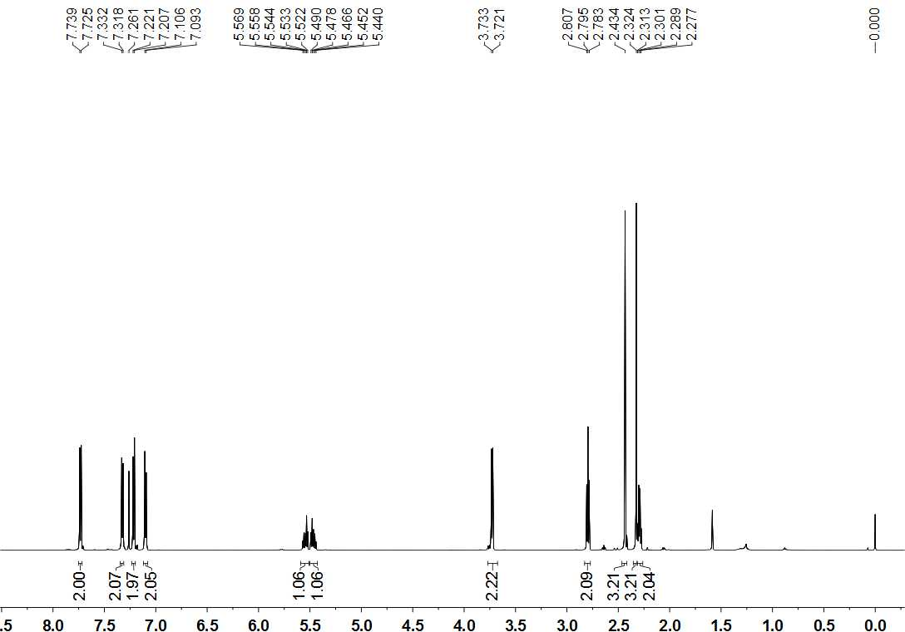

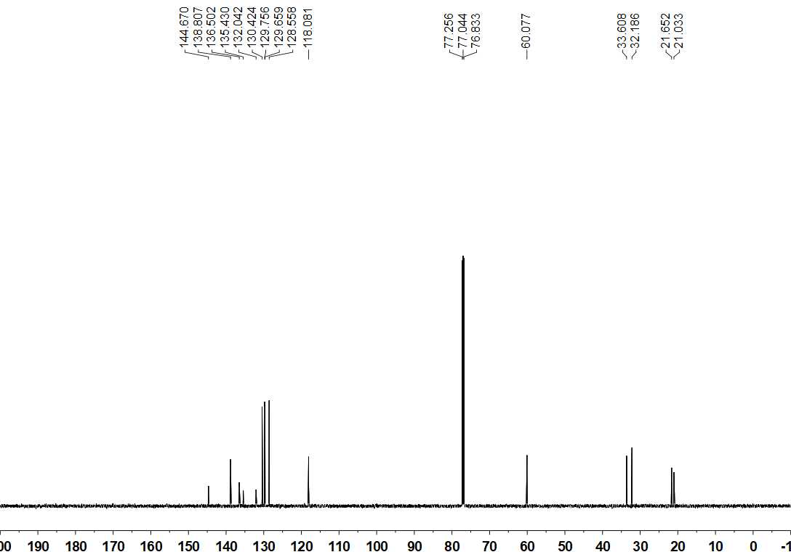

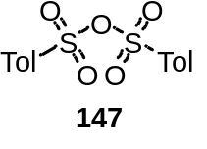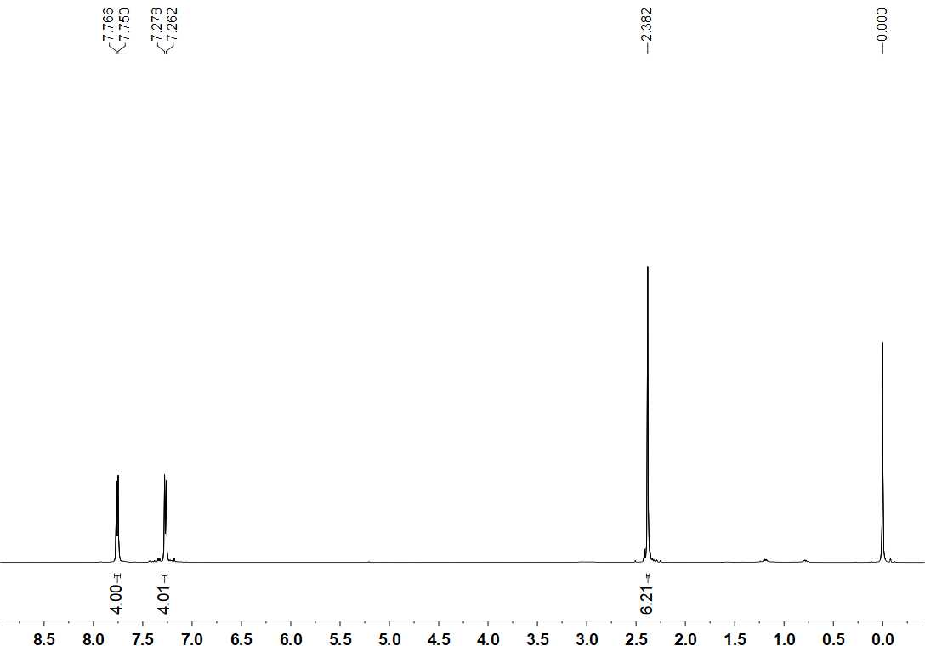

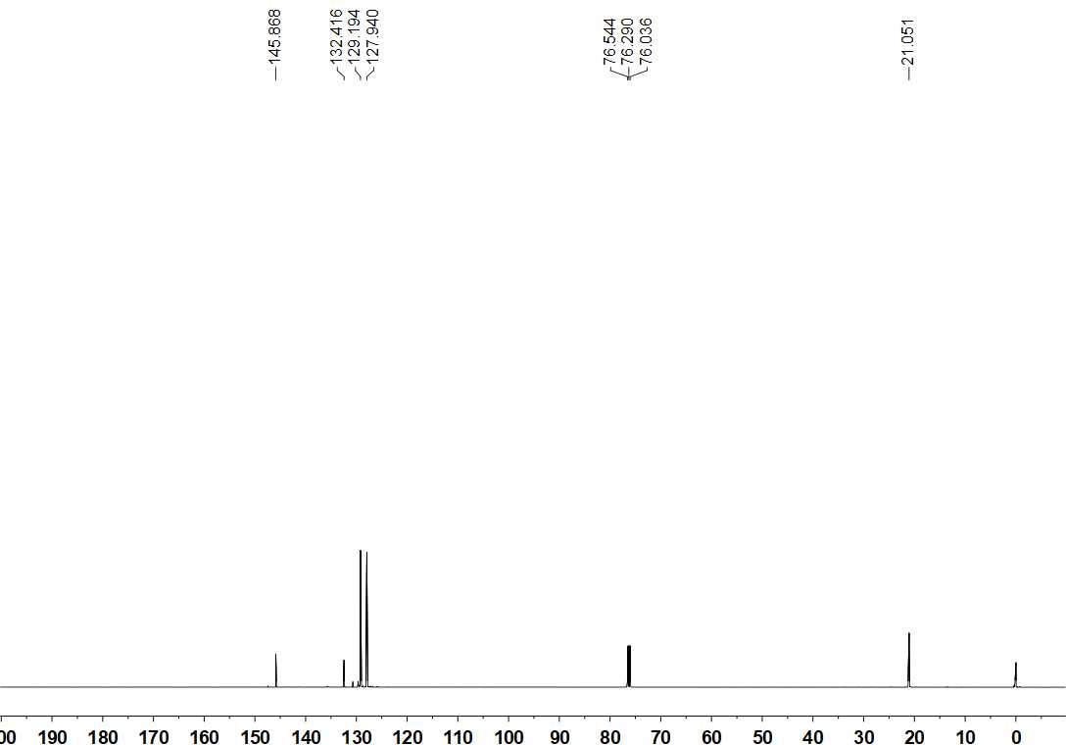
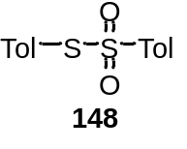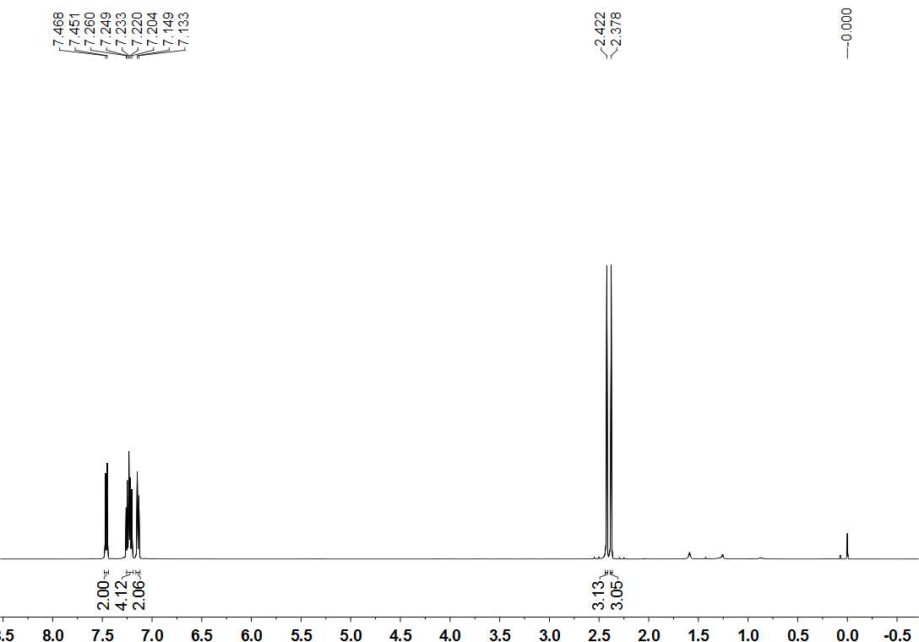

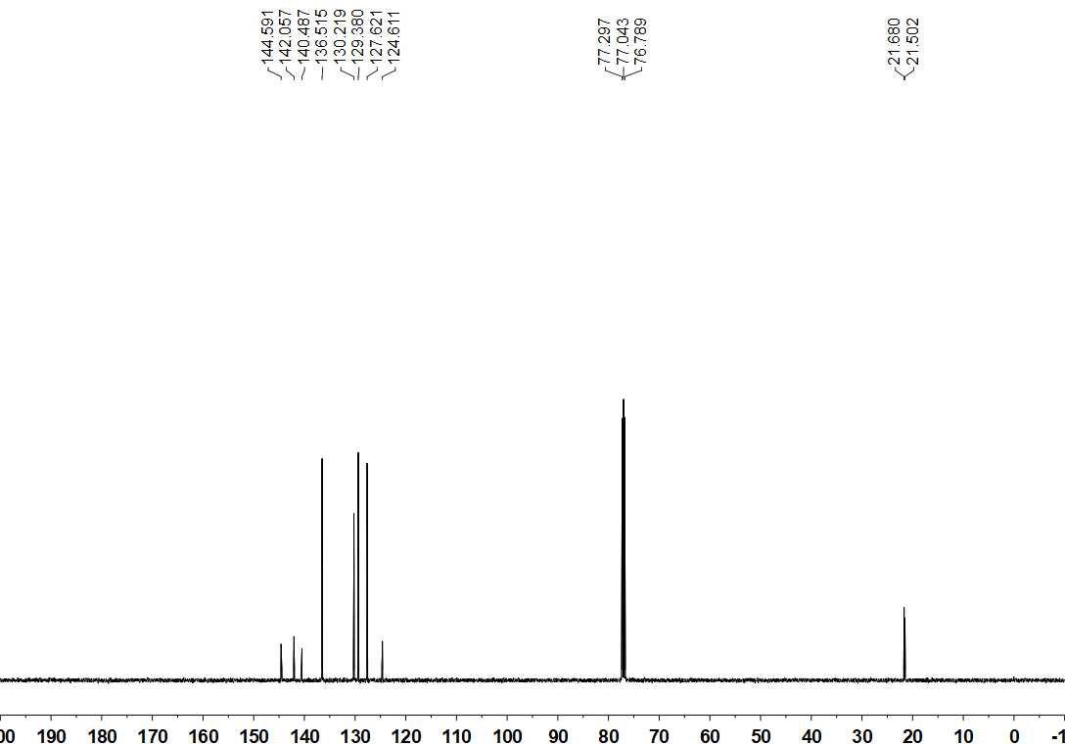
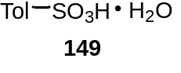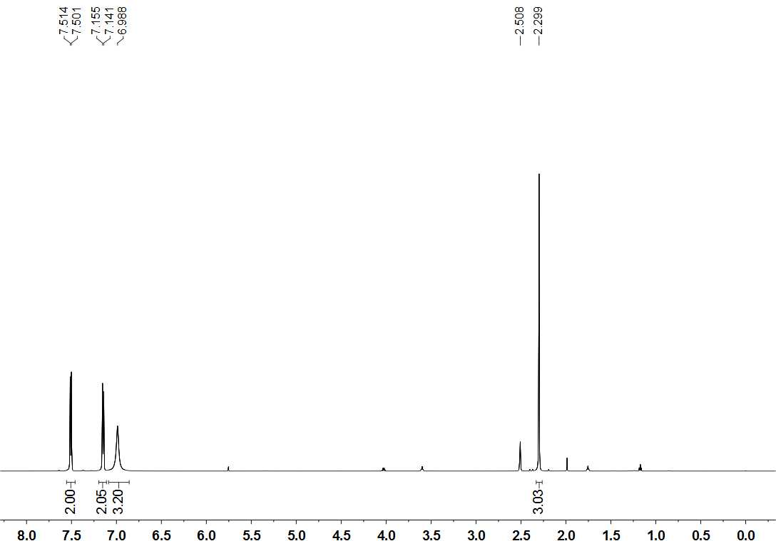

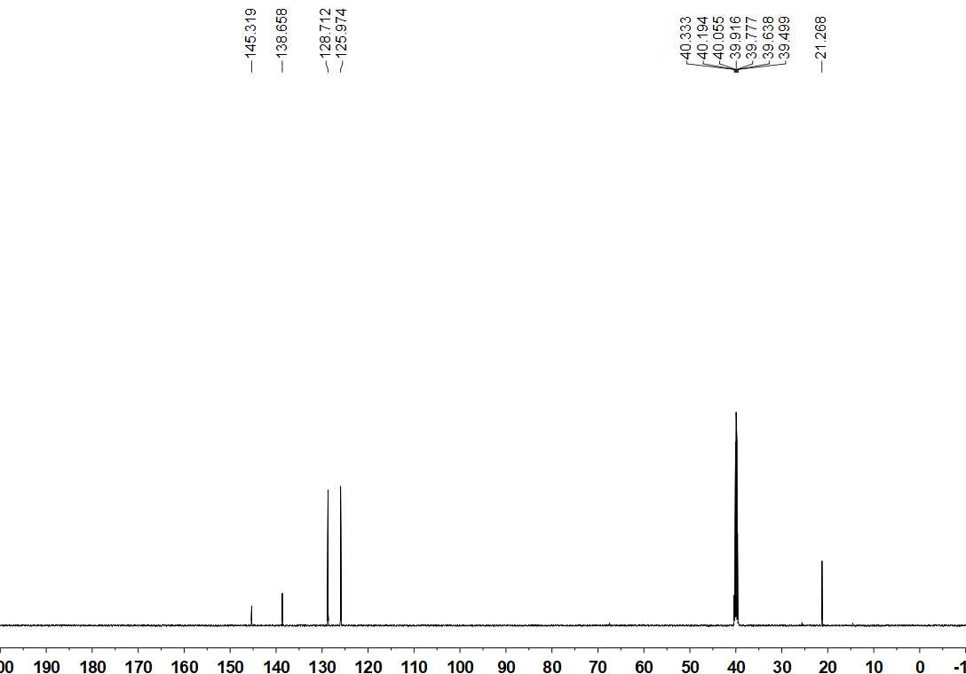

XI. References
- Mark, I. E., Murphy, F. & Dolan, S. Efficient preparation of trisubstituted alkenes using the Julia-Lythgoe olefination of ketones. On the key-role of SmI₂ in the reductive elimination step. Tetrahedron Lett. 37, 2089–2092 (1996).
- Meek, J. S. & Fowler. J. S. Nucleophilic addition-elimination reactions of 1,2-bis(p-tolylsulfonyl)ethane. J. Org. Chem. 33, 985–991(1968)
- Peng, B., Huang, X., Xie, L. -G. & Maulide, N. A brønsted acid catalyzed redox arylation. Angew. Chem. Int. Ed. 53, 8718–8721 (2014).
- Yuanming, L., Armido, S. Reaction of Arynes with Vinyl Sulfoxides: Highly Stereospecific Synthesis of ortho-Sulfinylaryl Vinyl Ethers. Org. Lett. 19, 666–669 (2017).
- Li, S., Yonghui, C., Fan, L., Jia-Ni, H., Xin, H., Lei, Z., Lichun, K., Kaixiao, L., Bo, P. Redox-Neutral α-Arylation of Alkyl Nitriles with Aryl Sulfoxides: A Rapid Electrophilic Rearrangement. J. Am. Chem. Soc. 139, 4211−4217 (2017).
- Frisch, M. J. et al. Gaussian 09, Revision A.01; Gaussian, Inc.: Wallingford, CT, 2009.
- Lee, C. T. et al. Development of the Colle-Salvetti correlation-energy formula into a functional of the electron density. Phys. Rev. B: Condens.Matter Mater. Phys. 37, 785–789 (1988).
- Becke, A. D. Density-functional thermochemistry. III. The role of exact exchange. J. Chem. Phys. 98, 5648–5652 (1993).
- Fukui, K. Formulation of the reaction coordinate. J. Phys. Chem. 74, 4161–4163 (1970).
- Fukui, K. The path of chemical reactions – the IRC approach. Acc. Chem. Res. 14, 363–368 (2002).
- Legault, C.Y. CYLview, version 1.0b; 2009 (http://www.cylview.org/).

