Title: Proteomic insights into the pathophysiology of hypertension-associated albuminuria: Pilot study in a South African cohort

Melanie A. Govender (MAG)^{1,2}, Stoyan H. Stoychev (SHS)^{3,4}, Jean-Tristan Brandenburg (JB)², Michèle Ramsay (MR)^{1,2}, June Fabian (JF)^{5*}, Ireshyn S. Govender (ISG)^{3,4*}
*Joint senior authors
Authors for correspondence:
Ireshyn S. Govender - IGovender@csir.co.za
Melanie A. Govender – Melanieanngovender@gmail.com

Author details
¹Division of Human Genetics, National Health Laboratory Service and School of Pathology, Faculty of Health Sciences, University of the Witwatersrand, Johannesburg, South Africa
²Sydney Brenner Institute for Molecular Bioscience, Faculty of Health Sciences, University of the Witwatersrand, Johannesburg, South Africa
³Council for Scientific and Industrial Research, NextGen Health, Pretoria, South Africa
⁴ReSyn Biosciences, Edenvale, South Africa
⁵Wits Donald Gordon Medical Centre, School of Clinical Medicine, Faculty of Health Sciences, University of the Witwatersrand, Johannesburg, South Africa

Supplementary

Supplementary Figure 1. Project specific system suitability-quality control.
CV, co-efficient of variation.

Supplementary Figure 2. Dynamic range of proteins quantified.
Orange dots indicate cases and blue dots indicate controls. The high disease scoring proteins are annotated.

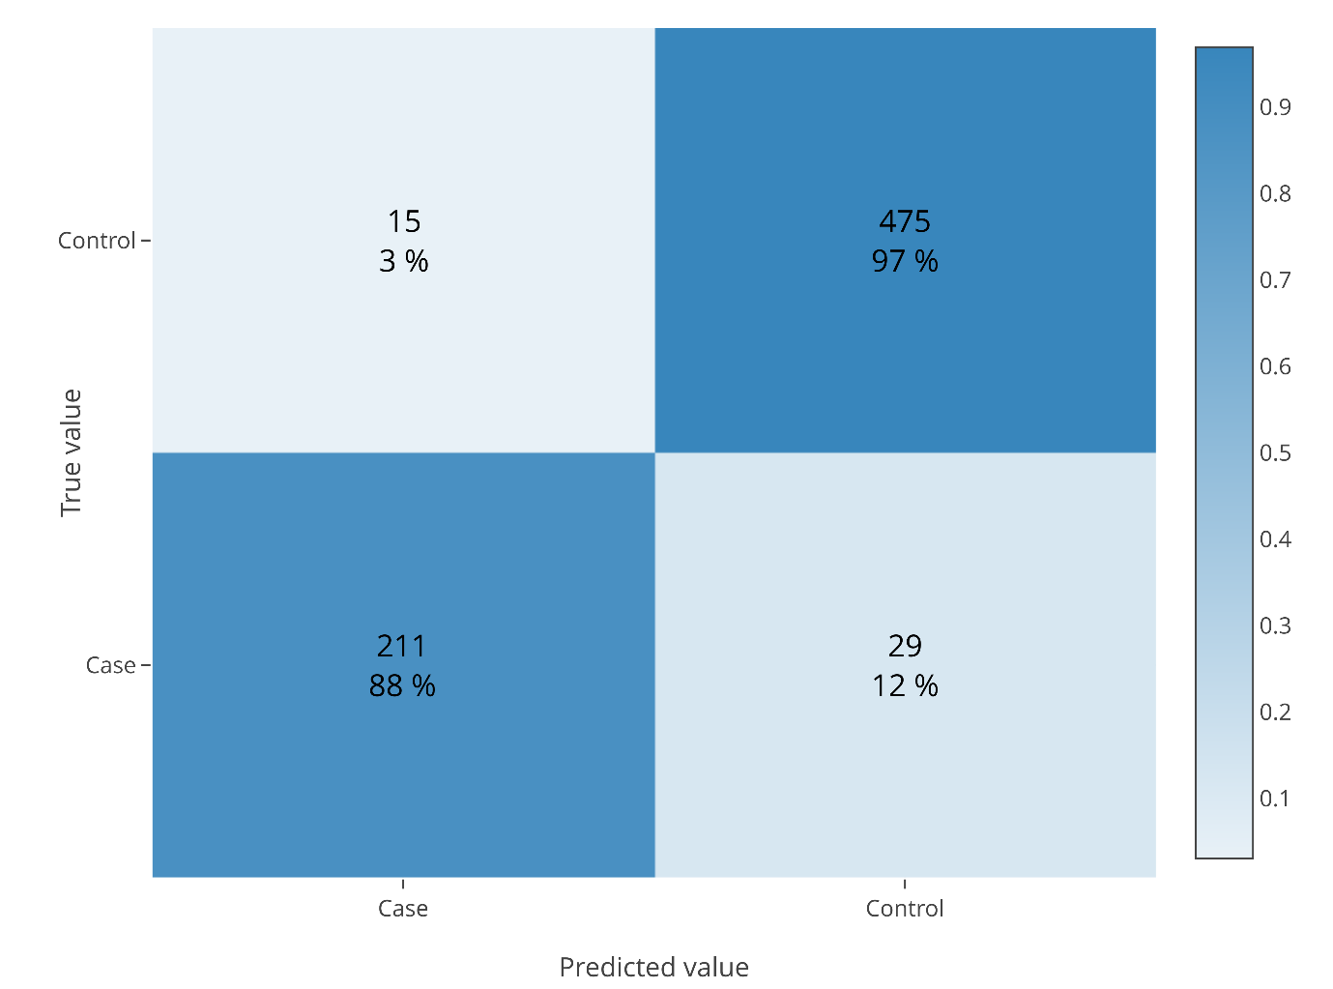
Supplementary Figure 3: Confusion matrix following machine learning using the XGBoost algorithm.
Confusion matrix refers to the percentage of samples assigned to each group.

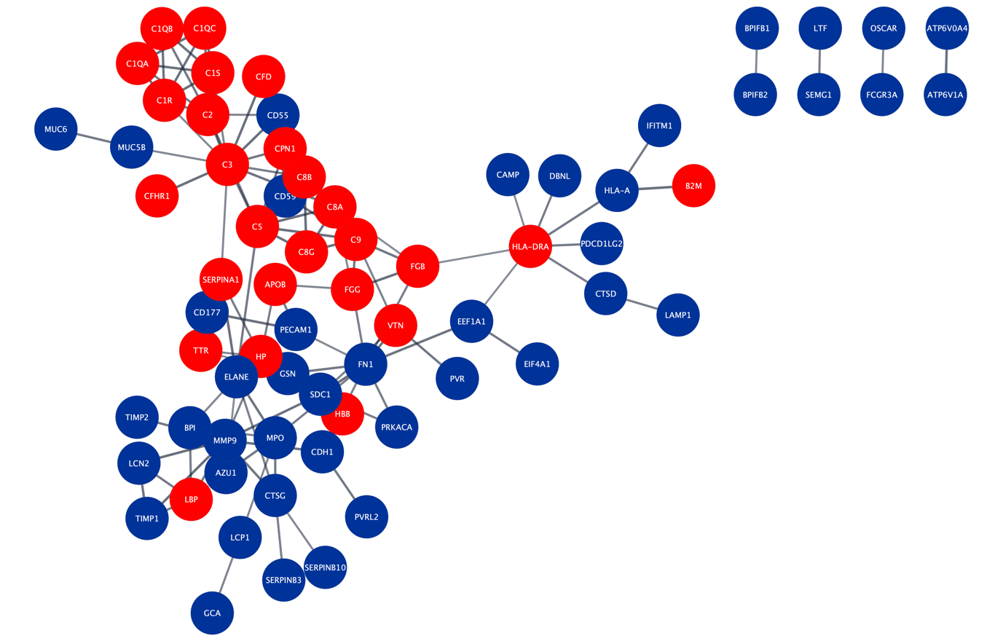

Supplementary Figure 4. Differentially abundant proteins associated with the immune system.
The gene names for each protein in the network are shown. Differentially abundant proteins were detected at an FDR of 0.01 and a fold-change of 2. Red indicates proteins with higher abundance in cases while blue represents proteins with lower abundance.
FDR, false discovery rate.

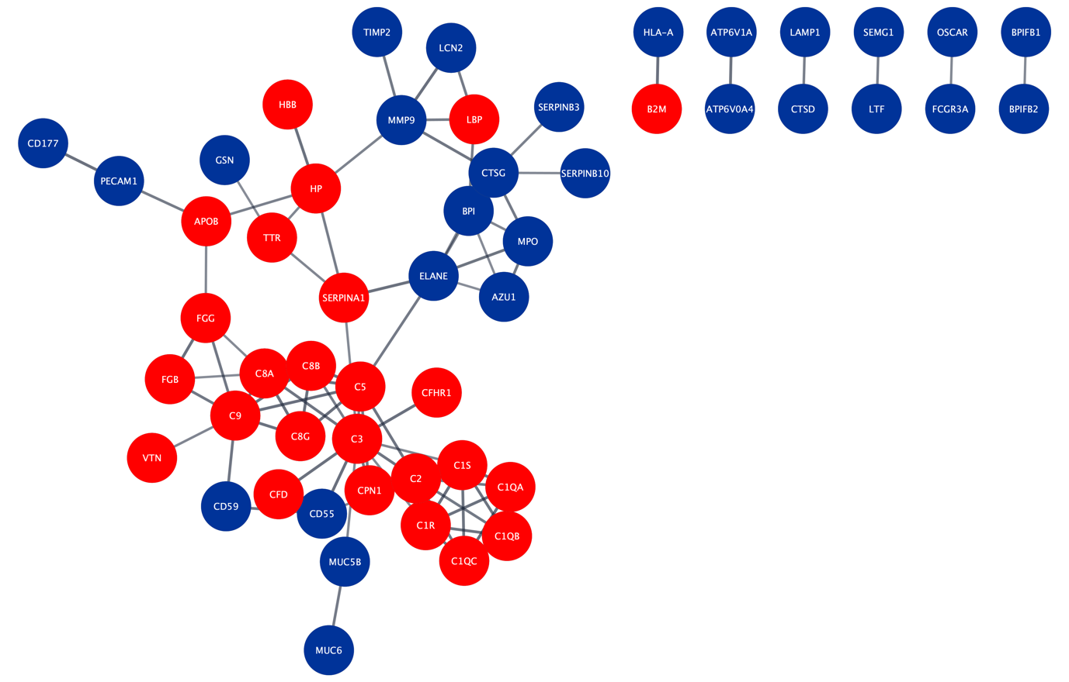
Supplementary Figure 5. Differentially abundant proteins associated with the innate immune system.
The gene names for each protein in the network are shown. Differentially abundant proteins were detected at an FDR of 0.01 and a fold-change of 2. Red indicates proteins with higher abundance in cases while blue represents proteins with lower abundance.
FDR, false discovery rate.

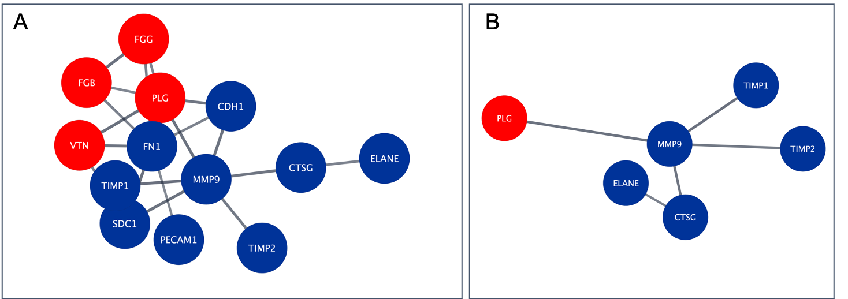
Supplementary Figure 6. Differentially abundant proteins associated with extracellular matrix organisation (A) and activation of matrix metalloproteinases (B).
The gene names for each protein in the network are shown. Differentially abundant proteins were detected at an FDR of 0.01 and a fold-change of 2. Red indicates proteins with higher abundance in cases while blue represents proteins with lower abundance.
FDR, false discovery rate.

Supplementary Table 1. Significantly different proteins in the volcano plot

Protein Groups | Difference | Direction | Log q-value
P43652 | 4,01 | Positive | 14,79
P25691; P78386 | 3,65 | Positive | 10,24
Q9Y625 | 3,03 | Positive | 9,85
P02787 | 3,00 | Positive | 13,76
P02144 | 2,87 | Positive | 8,61
P01024 | 2,58 | Positive | 7,00
P01009 | 2,66 | Positive | 18,70
P02647 | 2,51 | Positive | 5,45
Q8WYP5 | 2,49 | Positive | 7,59
P02766 | 2,43 | Positive | 7,54
P01008 | 2,38 | Positive | 10,34
P19823 | 2,35 | Positive | 5,40
Q9UGM5 | 2,23 | Positive | 6,23
P69905 | 2,15 | Positive | 2,55
Q9NYQ6 | 2,10 | Positive | 2,80
P06727 | 2,07 | Positive | 4,21
P00450 | 2,00 | Positive | 8,21
P02774 | 1,99 | Positive | 9,26
P02748 | 1,99 | Positive | 7,57
P02768 | 1,98 | Positive | 10,99
P00747 | 1,93 | Positive | 5,55
P36955 | 1,89 | Positive | 7,18
P27169 | 1,85 | Positive | 4,34
P00738 | 1,81 | Positive | 2,89
P01019 | 1,80 | Positive | 5,35
P01860 | 1,77 | Positive | 3,08
P08697 | 1,77 | Positive | 7,77
P06681 | 1,76 | Positive | 6,70
P00739 | 1,73 | Positive | 3,73
P18428 | 1,66 | Positive | 4,77
P04217 | 1,64 | Positive | 5,17
Q96KN2 | 1,50 | Positive | 5,10
P07357 | 1,48 | Positive | 5,68
P07360 | 1,47 | Positive | 3,36
A0A0C4DH38 | 1,46 | Positive | 3,17
P08185 | 1,37 | Positive | 3,76
P28072 | -1,15 | Negative | 4,44
Q9UN73; Q9Y5H7 | -1,16 | Negative | 4,15
P28070 | -1,17 | Negative | 4,09
P06733 | -1,18 | Negative | 4,79
P60174 | -1,21 | Negative | 5,01
Q12907 | -1,21 | Negative | 4,45
P04275 | -1,22 | Negative | 4,13
P05362 | -1,22 | Negative | 3,88
P27930 | -1,22 | Negative | 4,15
Q8TER0 | -1,22 | Negative | 6,23
Q9HAT2 | -1,22 | Negative | 3,79
O00462 | -1,23 | Negative | 5,53
P05067 | -1,24 | Negative | 4,84
O75083 | -1,24 | Negative | 4,40
P16083 | -1,26 | Negative | 3,82
A0A0C4DH25 | -1,27 | Negative | 3,92
Q99497 | -1,27 | Negative | 4,76
O00182 | -1,28 | Negative | 3,70
Q15113 | -1,29 | Negative | 4,94
Q08257 | -1,29 | Negative | 4,93
Q99536 | -1,29 | Negative | 3,69
P21709 | -1,30 | Negative | 4,12
P50395 | -1,30 | Negative | 4,63
Q04760 | -1,31 | Negative | 3,57
O00241 | -1,31 | Negative | 3,57
P68104; Q5VTE0 | -1,31 | Negative | 4,58
P40121 | -1,32 | Negative | 6,02
P41222 | -1,32 | Negative | 3,49
Q9P2B2 | -1,32 | Negative | 5,32
Q16651 | -1,32 | Negative | 4,51
Q14894 | -1,33 | Negative | 4,81
Q96J84 | -1,34 | Negative | 5,58
P51148 | -1,34 | Negative | 4,85
Q14393 | -1,34 | Negative | 4,11
O94919 | -1,34 | Negative | 3,39
P11021 | -1,34 | Negative | 4,88
Q96JQ0 | -1,34 | Negative | 4,58
P09619 | -1,35 | Negative | 3,77
Q15223 | -1,35 | Negative | 4,84
Q06830 | -1,36 | Negative | 5,40
P07204 | -1,36 | Negative | 4,16
P07711 | -1,37 | Negative | 6,11
P13639 | -1,38 | Negative | 4,76
P11233 | -1,39 | Negative | 4,37
Q9H8L6 | -1,39 | Negative | 4,22
P05090 | -1,39 | Negative | 3,94
P38606 | -1,39 | Negative | 3,90
Q96AP7 | -1,39 | Negative | 3,15
Q86T13 | -1,40 | Negative | 5,49
P23526 | -1,41 | Negative | 5,12
Q13332 | -1,41 | Negative | 4,95
P30086 | -1,41 | Negative | 4,22
Q13621 | -1,41 | Negative | 3,45
P23284 | -1,42 | Negative | 4,55
P17174 | -1,42 | Negative | 4,20
Q8WVQ1 | -1,43 | Negative | 6,00
P61970 | -1,44 | Negative | 5,76
P08582 | -1,45 | Negative | 5,80
Q8N3J6 | -1,45 | Negative | 6,53
P11597 | -1,45 | Negative | 3,13
P14174 | -1,46 | Negative | 3,53
P52758 | -1,46 | Negative | 3,49
O95967 | -1,46 | Negative | 5,46
P55285 | -1,47 | Negative | 4,18
P35555 | -1,48 | Negative | 3,55
Q7Z7M0 | -1,48 | Negative | 4,99
Q14118 | -1,48 | Negative | 3,66
Q9HCU0 | -1,49 | Negative | 4,99
P04156 | -1,50 | Negative | 4,36
Q9Y624 | -1,51 | Negative | 4,05
O00757 | -1,51 | Negative | 2,98
P05937 | -1,51 | Negative | 3,67
Q16769 | -1,52 | Negative | 3,44
P12109 | -1,52 | Negative | 5,28
P15941 | -1,53 | Negative | 3,22
O60888 | -1,53 | Negative | 3,06
O00391 | -1,54 | Negative | 6,36
P0DJD8 | -1,55 | Negative | 4,96
Q6UX71 | -1,55 | Negative | 6,07
P01133 | -1,55 | Negative | 4,05
P12111 | -1,55 | Negative | 4,38
P06396 | -1,56 | Negative | 3,64
Q10588 | -1,56 | Negative | 4,48
Q99983 | -1,56 | Negative | 4,85
P42785 | -1,56 | Negative | 4,36
P19022 | -1,57 | Negative | 3,82
P14618 | -1,57 | Negative | 3,55
O75882 | -1,57 | Negative | 5,56
P13645 | -1,57 | Negative | 2,95
A6NI73 | -1,57 | Negative | 5,77
Q53RD9 | -1,57 | Negative | 4,44
Q01459 | -1,58 | Negative | 4,02
P29323 | -1,58 | Negative | 6,59
Q92692 | -1,58 | Negative | 4,22
P08572 | -1,58 | Negative | 3,66
P15121 | -1,59 | Negative | 6,18
P00966 | -1,59 | Negative | 2,82
Q9HCN6 | -1,60 | Negative | 3,51
O00115 | -1,60 | Negative | 6,66
Q6UXB4 | -1,60 | Negative | 3,35
O95865 | -1,61 | Negative | 3,90
P98160 | -1,61 | Negative | 3,82
Q12860 | -1,61 | Negative | 8,78
Q8WW52 | -1,62 | Negative | 3,89
P16035 | -1,62 | Negative | 8,09
P10153 | -1,62 | Negative | 3,36
O75144 | -1,63 | Negative | 3,72
Q01973 | -1,63 | Negative | 5,42
P35908 | -1,63 | Negative | 3,20
Q9UNN8 | -1,64 | Negative | 4,34
Q07507 | -1,64 | Negative | 4,28
P04899 | -1,65 | Negative | 5,41
P55287 | -1,65 | Negative | 4,26
P56537 | -1,66 | Negative | 5,07
P19440 | -1,66 | Negative | 3,75
P63000 | -1,66 | Negative | 4,48
Q9UKU9 | -1,67 | Negative | 5,25
P26992 | -1,67 | Negative | 6,09
P24821 | -1,68 | Negative | 5,45
O00592 | -1,68 | Negative | 3,19
P10253 | -1,68 | Negative | 6,72
Q7Z3B1 | -1,68 | Negative | 4,13
P07858 | -1,70 | Negative | 4,99
P07911 | -1,71 | Negative | 5,28
P08294 | -1,71 | Negative | 4,92
P19835 | -1,72 | Negative | 4,07
Q9HD42 | -1,72 | Negative | 2,98
P08571 | -1,72 | Negative | 3,03
Q15375 | -1,72 | Negative | 7,75
Q9Y2E5 | -1,72 | Negative | 5,31
Q92859 | -1,73 | Negative | 6,10
Q12805 | -1,73 | Negative | 4,70
P07998 | -1,74 | Negative | 3,02
Q15907 | -1,74 | Negative | 7,36
P01591 | -1,74 | Negative | 3,88
Q15746 | -1,74 | Negative | 3,74
Q9HBB8 | -1,75 | Negative | 3,18
P05091 | -1,76 | Negative | 4,74
O43451 | -1,76 | Negative | 3,86
P05452 | -1,76 | Negative | 4,84
P63092; Q5JWF2 | -1,76 | Negative | 8,03
Q9UBX5 | -1,76 | Negative | 5,63
Q99574 | -1,77 | Negative | 6,23
O15197 | -1,77 | Negative | 7,21
P98164 | -1,78 | Negative | 5,99
A0A075B6I9 | -1,79 | Negative | 3,21
P08519 | -1,79 | Negative | 2,74
P14543 | -1,80 | Negative | 8,06
P12429 | -1,81 | Negative | 3,26
Q8IUL8 | -1,82 | Negative | 5,10
Q08174 | -1,83 | Negative | 5,27
Q9UIB8 | -1,83 | Negative | 5,14
P43121 | -1,84 | Negative | 7,49
Q8N6C8 | -1,86 | Negative | 6,47
Q8WZ75 | -1,86 | Negative | 5,74
Q9UBD6 | -1,86 | Negative | 3,71
P58499 | -1,87 | Negative | 7,58
Q9BXP8 | -1,87 | Negative | 6,15
Q9UBI6 | -1,88 | Negative | 2,42
Q9Y6R7 | -1,88 | Negative | 2,47
Q8IV08 | -1,89 | Negative | 7,72
P40189 | -1,89 | Negative | 8,51
Q5T011 | -1,89 | Negative | 2,96
P61916 | -1,90 | Negative | 5,15
O75339 | -1,90 | Negative | 5,41
Q03403 | -1,91 | Negative | 3,91
P06703 | -1,94 | Negative | 3,30
O43278 | -1,94 | Negative | 10,56
Q9UJX4 | -1,95 | Negative | 2,71
P05451 | -1,95 | Negative | 2,74
Q7Z3E2 | -1,96 | Negative | 4,84
P54760 | -1,97 | Negative | 9,31
P98172 | -1,98 | Negative | 6,59
Q8IYS5 | -1,99 | Negative | 4,65
P50895 | -1,99 | Negative | 6,86
P12830 | -2,01 | Negative | 5,57
P11279 | -2,02 | Negative | 5,66
Q14956 | -2,02 | Negative | 4,90
Q15828 | -2,04 | Negative | 2,66
P01833 | -2,04 | Negative | 10,27
P80188 | -2,05 | Negative | 4,43
P02751 | -2,05 | Negative | 6,26
Q96RW7 | -2,09 | Negative | 6,41
Q6UVK1 | -2,11 | Negative | 7,77
Q9GZX9 | -2,13 | Negative | 3,20
P14384 | -2,14 | Negative | 8,54
O00533 | -2,15 | Negative | 7,84
Q969P0 | -2,16 | Negative | 6,44
Q7KYR7; Q8WVV5 | -2,17 | Negative | 5,58
P19961 | -2,18 | Negative | 4,81
Q9P121 | -2,22 | Negative | 8,78
Q6UXG3 | -2,22 | Negative | 3,94
P08174 | -2,22 | Negative | 5,44
Q9BX67 | -2,22 | Negative | 5,98
O60494 | -2,23 | Negative | 8,65
Q9UMR5 | -2,26 | Negative | 8,14
P04745; P0DTE7; P0DTE8; P0DUB6 | -2,27 | Negative | 7,08
Q96NY8 | -2,30 | Negative | 7,71
O95716 | -2,32 | Negative | 6,10
P08637 | -2,33 | Negative | 5,30
P06870 | -2,33 | Negative | 5,05
Q8NFZ8 | -2,34 | Negative | 7,58
P0DP57 | -2,35 | Negative | 5,12
P54753 | -2,37 | Negative | 12,14
Q8N6Q3 | -2,37 | Negative | 6,42
Q9UN70 | -2,39 | Negative | 8,09
Q14982 | -2,42 | Negative | 8,03
P15328 | -2,44 | Negative | 6,89
P62879 | -2,46 | Negative | 8,12
P78324 | -2,47 | Negative | 8,97
P13987 | -2,51 | Negative | 6,63
P30530 | -2,52 | Negative | 7,16
Q9BQ51 | -2,54 | Negative | 7,30
O75594 | -2,54 | Negative | 8,31
Q8NBJ4 | -2,85 | Negative | 7,86
Q9NYU1; Q9NYU2 | -3,09 | Negative | 9,70
Q9H299 | -3,10 | Negative | 4,12

Supplementary Table 2. Top 20 proteins identified from the classifier
Commonª | Unique^{b}
P01009 (SERPINA1) | Q9UMR5 (PPT2)
P43652 (AFM) | Q9Y5Y6 (ST14)
P02768 (ALB) | Q12841 (FSTL1)
P78386 (KRT85) | O15197 (EPHB6)
P00450 (CP)
Q9Y625 (GPC6)
P01008 (SERPINC1)
P02787 (TF)
P02748 (C9)
P02766 (TTR)
P01833 (PIGR)
O75882 (ATRN)
P02774 (GC)
Q9NYU1 (UGGT2)
Q92859 (NEO1)
P14543 (NID1)
Gene names are shown in parentheses.
ªOverlap with the list differentially abundant proteins.
^{b}Unique to the machine learning algorithm.

