- 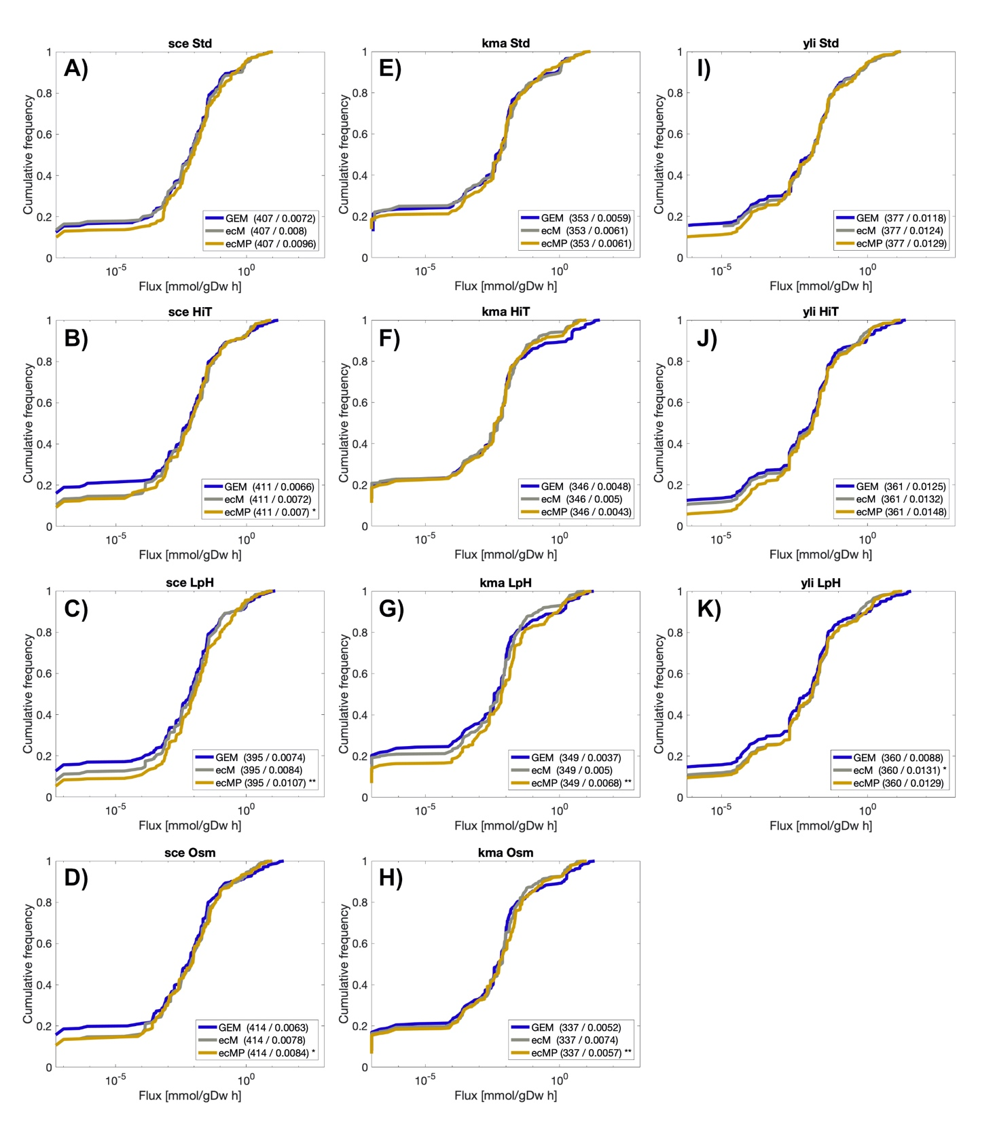
- Figure S1. Cumulative distributions of metabolic fluxes. Flux distributions of ecModels were mapped to their corresponding reactions in the original GEMs and plotted together as cumulative distributions for all organisms and conditions. A-D) Cumulative distributions for S. cerevisiae models; E-H) Cumulative distributions for K. marxianus models; I-K) Cumulative distributions for Y. lipolytica models. Sample size and median flux values, in mmol/gDwh, are shown within parenthesis for all distributions in all the plots. Statistical significance under a two-sample Kolmogorov-Smirnov test between flux distributions for ecModels and their corresponding GEMs are shown as * (0.01 <= p-value < 0.05) and ** (p-value<0.01).
- sce – S. cerevisiae, kma – K. marxianus, yli – Y. lipolytica, std – Reference condition, HiT – High temperature condition, LpH – Low pH condition, Osm – Osmotic stress condition, GEM – Genome-scale metabolic model, ecM – ecModel with total protein pool constraint – ecP – ecModel with proteomics constraints.
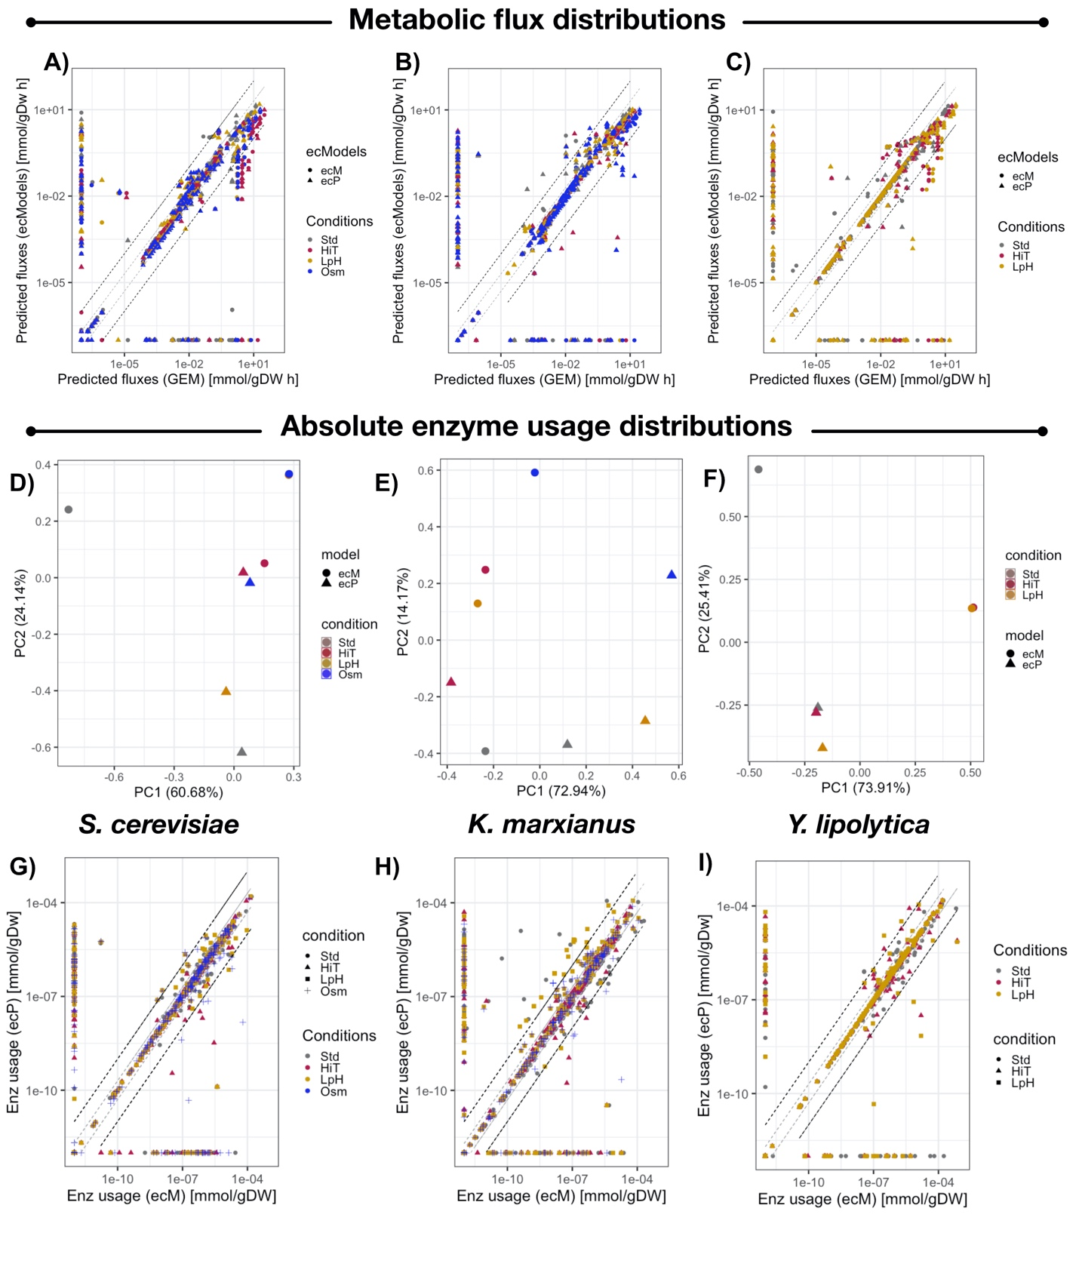
- Figure S2. Comparison of predicted metabolic fluxes and enzyme usage distributions. Pairwise comparison of metabolic fluxes predicted by GEMs, ecModels and proteomics-constrained ecModels for A) S. cerevisiae, B) K. marxianus and C) Y. lipolytica. Principal component analysis on enzyme usage distributions predicted by ecModels and proteomics-constrained ecModels for D) S. cerevisiae, E) K. marxianus and F) Y. lipolytica subject to different environmental conditions. Pairwise comparison of enzyme usage profiles in mmol/gDw predicted by ecModels and ecModels with proteomics constraints for G) S. cerevisiae H) K. marxianus I) Y. lipolytica. Grey dashed lines indicate predictions in the interval $0.5≤fold change≤2$, whilst black dashed lines delimit the region of predictions within $0.1≤fold change≤10$, when comparing GEMs to ecModels (A-C) and ecModels to ecModels with proteomics data (G-I). Std – Reference condition, HiT – High temperatura condition, LpH – Low pH condition, Osm – Osmotic stress condition, GEM – Genome-scale metabolic model, ecM – ecModel with total protein pool constraint – ecP – ecModel with proteomics constraints.

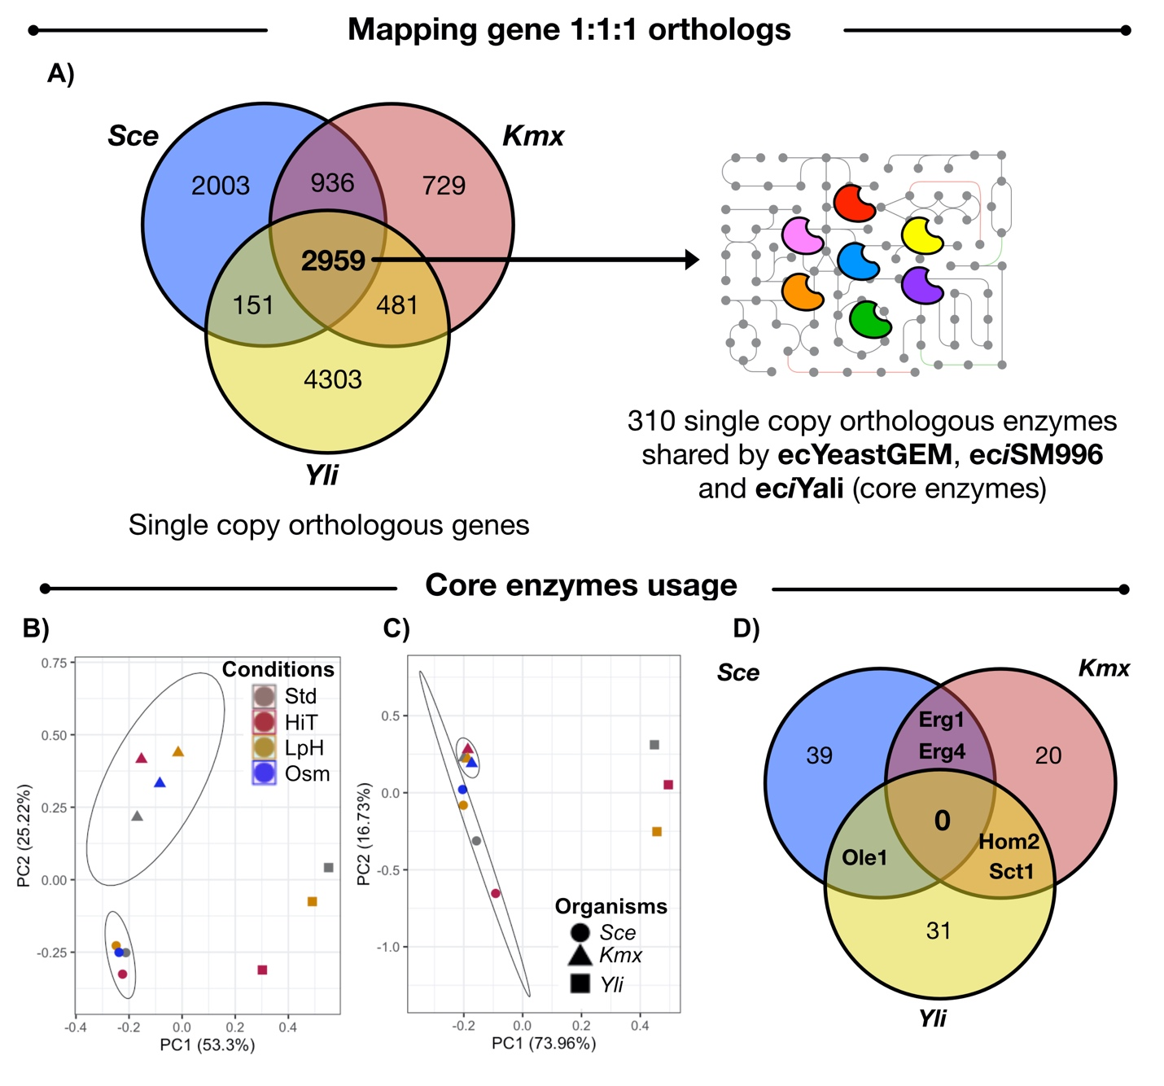
- Figure S3. Evolutionary conserved enzymes across S. cerevisiae, K. marxianus and Y. lipolytica. A) Conservation of protein-coding genes amongst the three budding yeasts. Overlaps indicate number of genes conserved as single copy orthologs between yeast species. The uniprot codes for the 2,959 conserved protein-coding genes amongst the three species were mapped to their corresponding ecModels (ecYeastGEM, eciSM996 and eciYali), 310 enzymes were found as single copy orthologs across the three ecModels. B) Principal component analysis on absolute abundances for the 310 core enzymes across the three yeast species for several experimental conditions. C) Principal component analysis on absolute enzyme usages predicted for the 310 core enzymes by ecYeastGEM, eciSM996 and eciYali for several experimental conditions. D) Venn diagram for all core enzymes predicted as highly saturated ($relative usage ≥0.95$) in at least one environmental condition across the three yeast species. Std – Reference condition, HiT – High temperature condition, LpH – Low pH condition, Osm – Osmotic stress condition, Sce – S. cerevisiae, Kmx – K. marxianus, Yli – Y. lipolytica.

