Supplementary Information for

Metabolic plasticity drives mismatches in physiological traits between prey and predator

Flavio Affinito1, Miguel Matias2, Rebecca L. Kordas1 and Samraat Pawar1
1. Department of Life Sciences, Imperial College London, Silwood Park Buckhurst Road, SL5 7PY, Ascot UK
2. Museo Nacional de Ciencias Naturales (CSIC), Madrid, 28006, Spain

Corresponding author: E-mail: flavio.affinito@mail.mcgill.ca

Figure S1. The Iberian Ponds network is located in the thermally diverse Iberian Peninsula.
EXPERIMENTS
Feeding trials
Table S1 Length-weight regression equations, where L stands for length.
MODELLING
Velocity estimation
Search rate model derivation
Dimensionality effect
Biological rates and temperature-dependence

Table S2. Sharpe-Schoolfield model parameters and fit
Figure S2. Yearly recorded temperatures at each site.
Figure S3. Mean monthly temperatures recorded during the larval stage of all taxa.
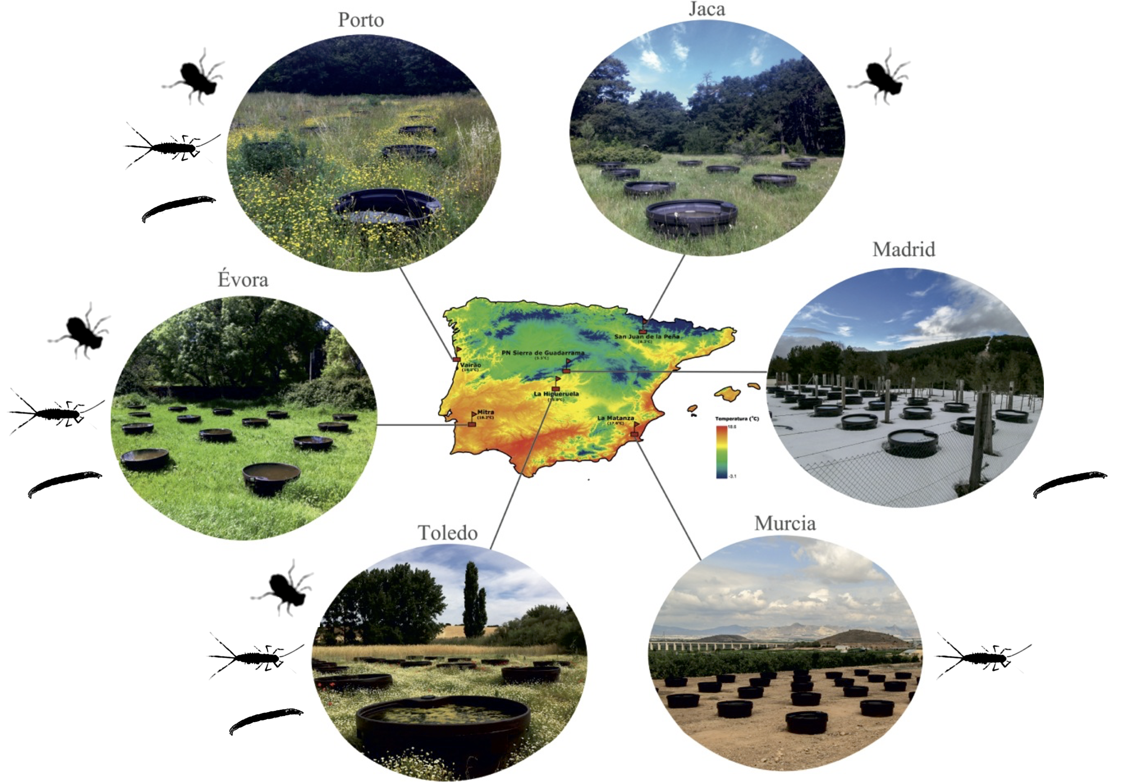
Figure S1. The Iberian Ponds network is located in the thermally diverse Iberian Peninsula. The location of all six mesocosm experimental sites is shown with respect to a thermal map of the peninsula. Individual taxa sampled at each site are displayed (Jaca: S. striolatum alone; Madrid: Chironomus spp. alone; Murcia: C. cloeon alone). Coordinates for the sites are: Peñalara: ,; Jaca: 42.506643, -0.668493; Porto: ,; Toledo: ,; Evora: ,; Murcia: ,.

EXPERIMENTS

Feeding trials
To determine predator-prey relationships between species, we conducted feeding trials at each site. For each potential predator-prey pair, we placed one individual of a predator species into a water filled jar (50 ml), then added 2 individuals of a potential prey species. Individuals were left in jars overnight and the number of prey individuals was counted in the morning. These trials revealed a predatory relationship between the dragonfly species Sympetrum striolatum and two prey taxa, the mayfly species Cloeon dipterum and the chironomid genus Chironomus. Some taxa were not found in high enough abundance at some sites to use in respirometry experiments due to differences in larval phenology (Fig S1).

Table S1 Length-weight regression equations, where L stands for length. Individuals were measured under the microscope and placed in an individual foil cup. Cloeon and Sympetrum individuals were measured from the tip of the abdomen to the midpoint between the eyes and all antennae were ignored. Chironomus individuals were measured from the mouth to the base of the terminal prolegs. All cups were labelled and left in an oven at 80°C for 16 to 18 hours to dry completely. Dry-weights were then recorded for each individual. Cloeon and Sympetrum linear models yielded satisfactory fit (R² > 0.6), Chironomidae was taken from the literature.
Taxa | Regression | R² |  | N | Reference
Odonata | $$W=-0.63.{10}^{-3}+0.22.{10}^{-3}L$$ | 0.88 |  | 49
Ephemeroptera | $$W=e^{-10.12+0.41L}$$ | 0.65 |  | 104
Chironomidae | $$W={0.6.{10}^{-3}L}^{2.77}$$ | 0.86 |  |  | Benke et al., 1999

MODELLING

Velocity calculation
The taxa used in this study are swimmers. The energetics of swimming have been studied for various species (Videler and Nolet, 1990; Videler, 1993; Alexander, 2003). Assuming velocity scales linearly with metabolic rate (Tucker, 1970), we can convert a measure of oxygen consumption (B; equation 1) into one of velocity. The relationship between respiration and velocity is linked to a measure of the cost of transport (C): the amount of energy in J needed to transport 1N over 1m in submerged swimmers (Videler, 1993). Thus, we express velocity as:
 | $$v=\frac{B_{j}}{Cmg}$$ | (S1)
Where B_{j} is oxygen consumption converted in J.s⁻¹, C is in J.N⁻¹.m⁻¹, m is mean mass in kg and g is gravitational acceleration in m.s⁻². Cost of transport in swimmers scales with body mass as follows (Videler and Nolet, 1990):
 | $$C=1.1m^{-0.038}$$ | (S2)
Oxygen consumption for nutrient combustion is the primary means by which nutrients are converted into energy. Oxygen consumption, measured in μmol.h⁻¹ can be converted to g.h⁻¹ by multiplying by the atomic mass of O₂: 31.988g/mol. The combustion of carbohydrates, fat and protein yields 3.34cal per 1mg of oxygen (Elliott and Davison, 1975) and 1cal yields 4.2868J (Merrill and Watt, 1973; Food and Agriculture Organization, 2015). Thus, we estimate the energetic output of respiration by defining a conversion coefficient of oxygen combustion:
 | $$γ=M_{O_{2}}KE_{k}$$ | (S3)

Where M_{O2} is the atomic mass of oxygen, K is the caloric value of oxygen combustion and E_{k} is the energetic value of a calorie. We can express velocity’s temperature dependence with respect to metabolic rate as:
 | $$v=\frac{\left(\frac{B_{0}m^{β}e^{\frac{-E}{k}\left(\frac{1}{T}-\frac{1}{T_{ref}}\right)}}{1+ e^{\frac{E_{d}}{k}\left(\frac{1}{T_{pk}}-\frac{1}{T}\right)}}\right)γ}{1.1m^{0.962}g}$$ | (S4)

Search rate model

Dimensionality effect
The dimensionality component D for equation 4 expands into (Pawar, Dell and Savage, 2012):

 | $$D=d^{\left(D_{m}-1\right)}s_{D}$$ | (S5)

Species interactions in nature can be defined as either 2D (D_{m}=2; s_{D}=2) or 3D (D_{m}=3; s_{D}=π) dependent on the environment they interact in (Pawar, Dell and Savage, 2012). In this component, d is the detection distance of a predator and is dependent upon the respective body masses of the predator-prey pair:

 | $$d= d_{0}{\left(m_{r}m_{c}\right)}^{p_{d}}$$ | (S6)

Where d₀ is the minimum detection distance, m_{r} and m_{c} are prey and predator mass respectively and p_{d} is the empirical scaling exponent of dimensionality(Pawar, Dell and Savage, 2012). Thus, when considering the effect of dimensionality on search rates, we obtain two scenarios:

 | $$2D:D=2d_{0}{\left(m_{r}m_{c}\right)}^{p_{d}}$$ | (S7)
 | $$3D:D= π{\left(d_{0}{\left(m_{r}m_{c}\right)}^{p_{d}}\right)}^{2}$$ | (S8)

Biological rates and temperature-dependence
Relative body velocity is expressed as (Dell, Pawar and Savage, 2011, 2014):

 | $$v=\sqrt{{v_{r}}^{2}+{v_{c}}^{2}}$$ | (S9)

Where v_{r} and v_{c} are prey and predator body velocities respectively. Here, we consider two interaction cases, one where prey species are relatively sessile compared to the predator ($v_{r}≈v_{c}$) and one where both predator and prey are in active movement and equation S4 holds true. Predator and prey velocities as a biological rates scale with temperature and mass:

 | $$v_{c,r}=v_{0_{c,r}}{m_{c,r}}^{β_{c,r}}e^{\frac{{-E}_{c,r}}{k}\left(\frac{1}{T}-\frac{1}{T_{ref}}\right)}$$ | (S10)

Where c and r subscripts apply to predator(consumer) and prey (resource) respectively, v_{O} is the baseline trait performance at a reference temperature (T_{ref}), m is mass, β is the mass scaling exponent, E is activation energy and T is temperature. Hence when the prey is considered sessile we get:

 | $$2D:a=v_{0_{c}}{m_{c}}^{β_{c}}e^{\frac{{-E}_{c}}{k}\left(\frac{1}{T}-\frac{1}{T_{ref}}\right)}2d_{0}{\left(m_{r}m_{c}\right)}^{p_{d}}$$ | (S11)
 | $$3D:a=v_{0_{c}}{m_{c}}^{β_{c}}e^{\frac{{-E}_{c}}{k}\left(\frac{1}{T}-\frac{1}{T_{ref}}\right)}π{\left(d_{0}{\left(m_{r}m_{c}\right)}^{p_{d}}\right)}^{2}$$ | (S12)

When both predator and prey species are active we have:
 | $$v_{r}=\sqrt{{v_{0_{r}}}^{2}{m_{r}}^{{2β}_{r}}e^{\frac{{-2E}_{r}}{k}\left(\frac{1}{T}-\frac{1}{T_{ref}}\right)}+{{{v_{0_{c}}}^{2}m}_{c}}^{{2β}_{c}}e^{\frac{{-2E}_{c}}{k}\left(\frac{1}{T}-\frac{1}{T_{ref}}\right)}}$$ | (S13)

Thus, for active predator-prey search rate models we have:
 | $$2D: a=\sqrt{{v_{0_{r}}}^{2}{m_{r}}^{{2β}_{r}}e^{\frac{{-2E}_{r}}{k}\left(\frac{1}{T}-\frac{1}{T_{ref}}\right)}+{{{v_{0_{c}}}^{2}m}_{c}}^{{2β}_{c}}e^{\frac{{-2E}_{c}}{k}\left(\frac{1}{T}-\frac{1}{T_{ref}}\right)}}.2d_{0}{\left(m_{r}m_{c}\right)}^{p_{d}}$$ | (S14)
 | $$3D:a=\sqrt{{v_{0_{r}}}^{2}{m_{r}}^{{2β}_{r}}e^{\frac{{-2E}_{r}}{k}\left(\frac{1}{T}-\frac{1}{T_{ref}}\right)}+{{{v_{0_{c}}}^{2}m}_{c}}^{{2β}_{c}}e^{\frac{{-2E}_{c}}{k}\left(\frac{1}{T}-\frac{1}{T_{ref}}\right)}} .π{\left(d_{0}{\left(m_{r}m_{c}\right)}^{p_{d}}\right)}^{2}$$ | (S15)

Table S2 Parameter estimates and model fits for all Sharpe-Schoolfield models.
Species | Site | Parameter | Value | SE | t value | p value | R² | N
Chironomus spp. | Toledo | B₀ | 0.198 | 0.065 | 3.05 | 0.003 | 0.56 | 108
Chironomus spp. | Toledo | E | 0.533 | 0.076 | 7.0 | <0.001 | 0.56 | 108
Chironomus spp. | Toledo | β | 1.38 | 0.262 | 5.23 | <0.001 | 0.56 | 108
Chironomus spp. | Toledo | E_{d} | 32.4 | 2 .10⁷ | 1.73 .10⁻⁶ | 1 | 0.56 | 108
Chironomus spp. | Toledo | T_{pk} | 316.7 | 4 .10⁵ | 8.4 .10⁻⁴ | 1 | 0.56 | 108
Chironomus spp. | Porto | B₀ | 0.107 | 0.026 | 4.05 | <0.001 | 0.79 | 110
Chironomus spp. | Porto | E | 0.614 | 0.040 | 15.4 | <0.001 | 0.79 | 110
Chironomus spp. | Porto | β | 0.910 | 0.257 | 3.54 | <0.001 | 0.79 | 110
Chironomus spp. | Porto | E_{d} | 32.1 | 1 .10⁷ | 2.96 .10⁻⁶ | 1 | 0.79 | 110
Chironomus spp. | Porto | T_{pk} | 316.8 | 4 .10⁵ | 8.8 .10⁻⁴ | 1 | 0.79 | 110
Chironomus spp. | Evora | B₀ | 0.102 | 0.059 | 1.72 | 0.09 | 0.68 | 164
Chironomus spp. | Evora | E | 0.598 | 0.042 | 14.1 | <0.001 | 0.68 | 164
Chironomus spp. | Evora | β | 0.943 | 0.518 | 1.82 | 0.07 | 0.68 | 164
Chironomus spp. | Evora | E_{d} | 32.1 | 1 .10⁷ | 3.05 .10⁻⁶ | 1 | 0.68 | 164
Chironomus spp. | Evora | T_{pk} | 316.7 | 7 .10⁵ | 4.6 .10⁻⁴ | 1 | 0.68 | 164
Cloeon dipterum | Toledo | B₀ | 0.046 | 0.009 | 5.12 | <0.001 | 0.82 | 86
Cloeon dipterum | Toledo | E | 1.68 | 0.203 | 8.27 | <0.001 | 0.82 | 86
Cloeon dipterum | Toledo | β | 0.5 | 0.353 | 1.42 | 0.16 | 0.82 | 86
Cloeon dipterum | Toledo | E_{d} | 2.09 | 0.284 | 7.36 | <0.001 | 0.82 | 86
Cloeon dipterum | Toledo | T_{pk} | 310.0 | 5.06 | 151 | <0.001 | 0.82 | 86
Cloeon dipterum | Porto | B₀ | 0.184 | 0.042 | 4.38 | <0.001 | 0.79 | 102
Cloeon dipterum | Porto | E | 0.770 | 0.062 | 12.4 | <0.001 | 0.79 | 102
Cloeon dipterum | Porto | β | 0.5 | 0.580 | 0.86 | 0.39 | 0.79 | 102
Cloeon dipterum | Porto | E_{d} | 2.95 | 1.09 | 2.70 | 0.008 | 0.79 | 102
Cloeon dipterum | Porto | T_{pk} | 311.1 | 1.02 | 306 | <0.001 | 0.79 | 102
Cloeon dipterum | Evora | B₀ | 0.245 | 0.035 | 6.99 | <0.001 | 0.72 | 109
Cloeon dipterum | Evora | E | 0.665 | 0.057 | 11.7 | <0.001 | 0.72 | 109
Cloeon dipterum | Evora | β | 0.617 | 0.295 | 2.09 | 0.04 | 0.72 | 109
Cloeon dipterum | Evora | E_{d} | 4.18 | 1.50 | 2.79 | 0.006 | 0.72 | 109
Cloeon dipterum | Evora | T_{pk} | 312.1 | 1.54 | 203 | <0.001 | 0.72 | 109
Sympetrum striolatum | Toledo | B₀ | 0.050 | 0.037 | 1.35 | 0.18 | 0.57 | 75
Sympetrum striolatum | Toledo | E | 1.96 | 0.554 | 3.53 | <0.001 | 0.57 | 75
Sympetrum striolatum | Toledo | β | 0.5 | 1.01 | 0.46 | 0.62 | 0.57 | 75
Sympetrum striolatum | Toledo | E_{d} | 2.02 | 0.447 | 4.52 | <0.001 | 0.57 | 75
Sympetrum striolatum | Toledo | T_{pk} | 310.3 | 12.3 | 23.4 | <0.001 | 0.57 | 75
Sympetrum striolatum | Porto | B₀ | 0.152 | 0.014 | 10.6 | <0.001 | 0.69 | 94
Sympetrum striolatum | Porto | E | 0.773 | 0.075 | 10.3 | <0.001 | 0.69 | 94
Sympetrum striolatum | Porto | β | 1.69 | 0.39 | 4.30 | <0.001 | 0.69 | 94
Sympetrum striolatum | Porto | E_{d} | 7.48 | 2.77 | 2.70 | 0.008 | 0.69 | 94
Sympetrum striolatum | Porto | T_{pk} | 312.5 | 1.57 | 199 | <0.001 | 0.69 | 94
Sympetrum striolatum | Evora | B₀ | 0.246 | 0.093 | 2.64 | 0.009 | 0.59 | 111
Sympetrum striolatum | Evora | E | 0.802 | 0.096 | 8.37 | 0.04 | 0.59 | 111
Sympetrum striolatum | Evora | β | 1.24 | 0.589 | 2.11 | <0.001 | 0.59 | 111
Sympetrum striolatum | Evora | E_{d} | 2.56 | 0.448 | 5.72 | <0.001 | 0.59 | 111
Sympetrum striolatum | Evora | T_{pk} | 307.5 | 1.19 | 258 | <0.001 | 0.59 | 111

Table S3. Activation energies of predator search rates.

Prey | Site | Strategy | Activation energy (E) | SE | p value
Chironomus spp. | Toledo | Sessile 2D | 1.96 | 2.55 .10⁻¹⁶ | <0.001
Chironomus spp. | Porto | Sessile 2D | 0.77 | 1.79 .10⁻¹⁶ | <0.001
Chironomus spp. | Evora | Sessile 2D | 0.80 | 1.58 .10⁻¹⁶ | <0.001
Cloeon dipterum | Toledo | Active 3D | 1.85 | 1.88 .10⁻³ | <0.001
Cloeon dipterum | Porto | Active 3D | 0.77 | 1.43 .10⁻⁷ | <0.001
Cloeon dipterum | Evora | Active 3D | 0.74 | 5.04 .10⁻⁴ | <0.001

Figure S2 Yearly recorded temperatures at each site. Temperatures recorded by loggers over 2-3 years plotted per month. Site mean temperature added in red.
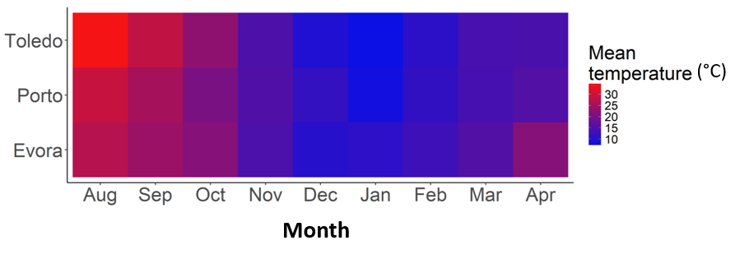
Figure S3. Mean monthly water temperatures recorded at each site in the Iberian Ponds network, during the aquatic stage of the individuals used in our experiments (August 2016 to April 2017).

