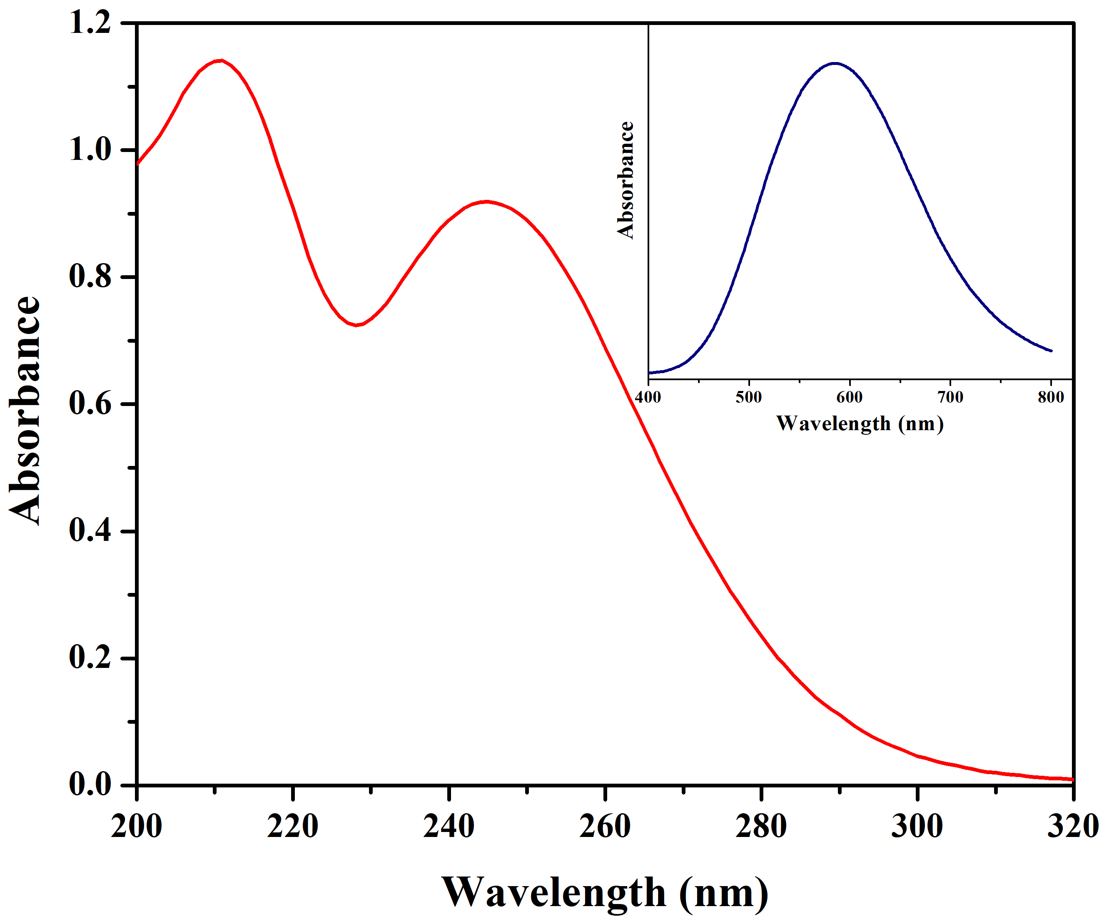
Fig. S1 UV-Visible absorption spectra of [Cu(dien)(1-MeIm)Cl]Cl·H₂O complex in water at 25°C; Complex concentration = 2 x 10⁻⁴M.
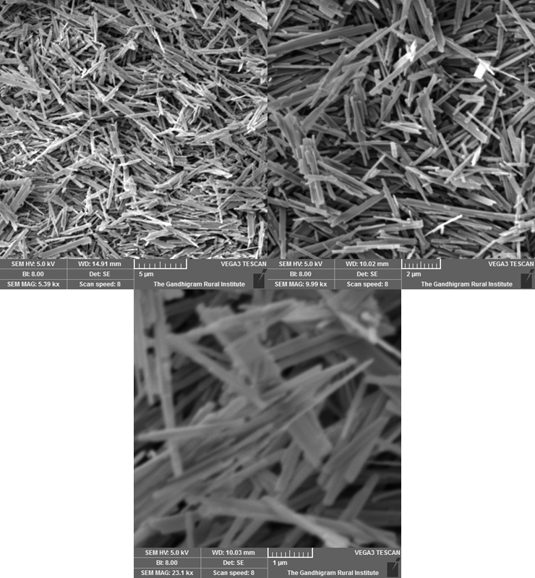
Fig. S2 SEM micrographs of MoO₃ rods with magnification range 5x to 300,000x; magnified at 50 & 20 μm.
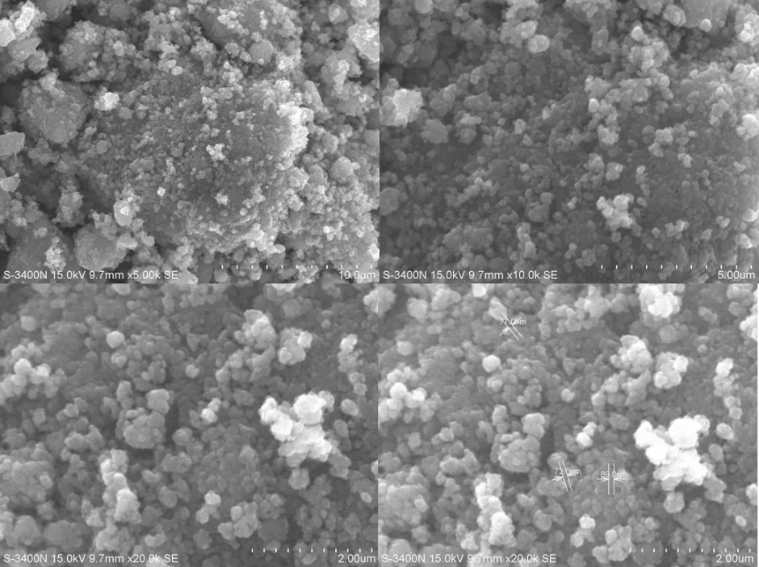
Fig. S3 SEM micrographs of TiO₂ nanospheres with magnification range 5x to 300,000x; magnified at 10, 5 & 2 μm.
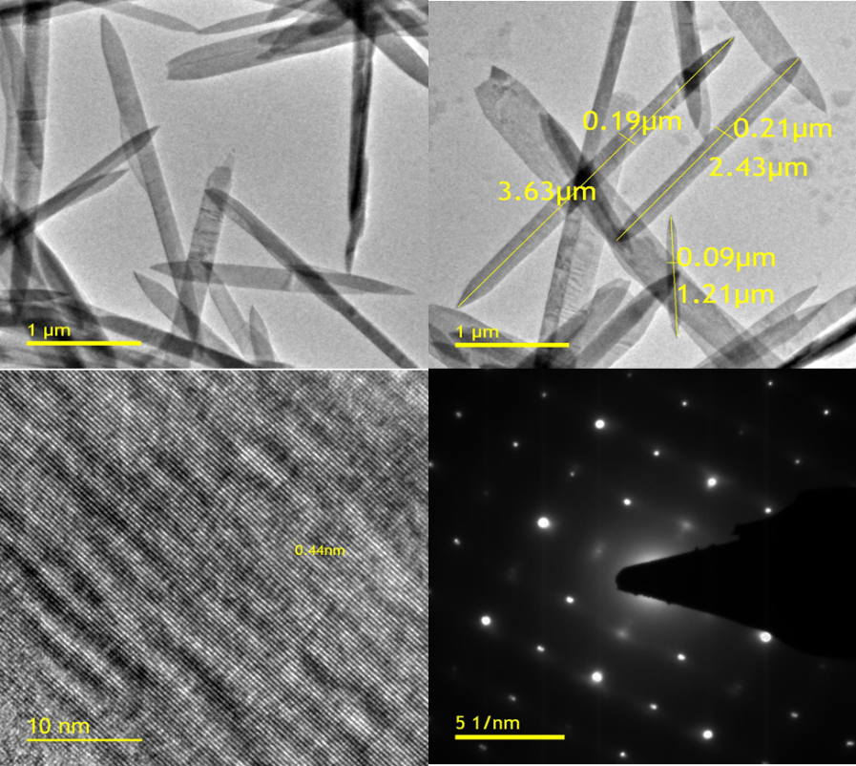
Fig. S4 TEM photographic depictions of MoO₃ rods (a) & (b) magnification at 1 μm (c) lattice fringes and (d) SAED pattern.
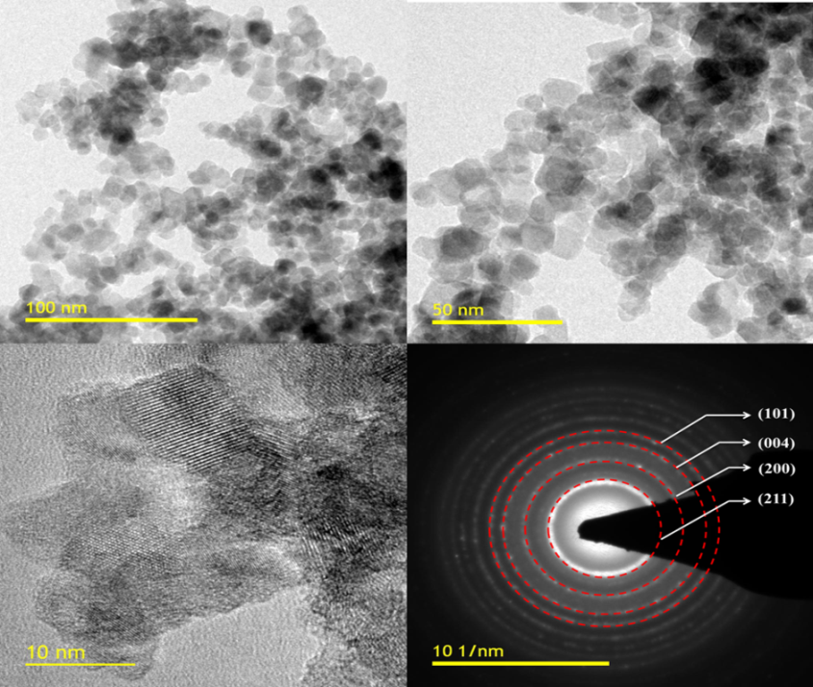
Fig. S5 TEM photographic depictions of TiO₂ nanospheres (a) & (b) magnification at 100 and 50 nm (c) lattice fringes and (d) SAED pattern.

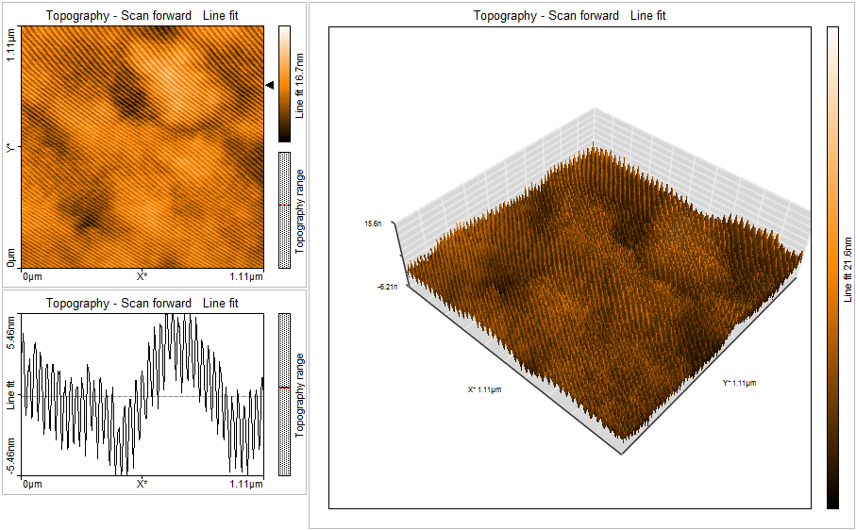
Fig. S6 2D and 3D AFM images of MoO₃ nanocomposites spin coated on a glass substrate

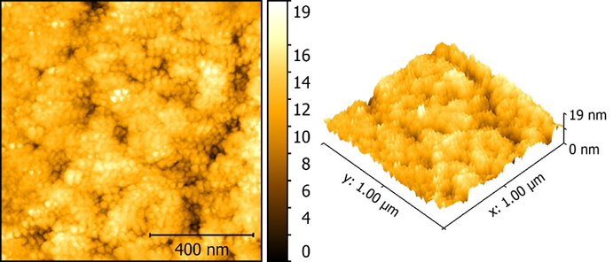
Fig. S7 2D and 3D AFM images of TiO₂ nanocomposites spin coated on a glass substrate
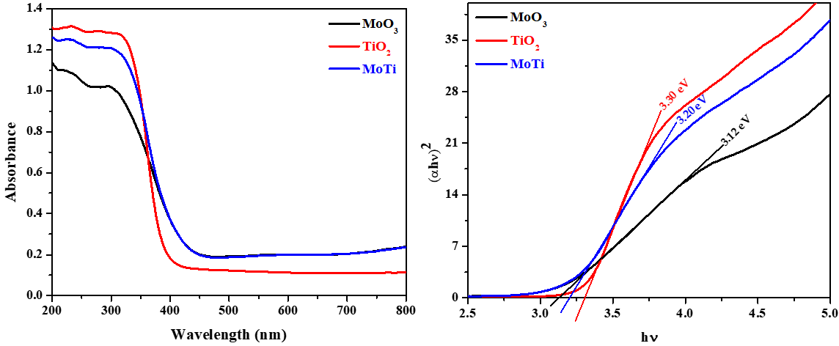
Fig. S8 (a) UV-Visible absorption spectra and (b) Tauc’s plot of (αhν) ² vs. hν of MoO₃ rod, TiO₂ nanospheres and MoO₃-TiO₂ nanocomposite.
Fig. S9 Steady state emission and excitation spectra of (a) MoO₃ rod (b) TiO₂ nanospheres and (c) MoO₃-TiO₂ nanocomposite recorded with an excitation wavelength of 298 nm at room temperature.
Fig. S10 PL Lifetime studies of (a) MoO₃ rod (b) TiO₂ nanospheres and (c) MoO₃-TiO₂ nanocomposite excited at a wavelength of 298 nm at room temperature with the experimental and fitted data.
Fig. S11 FTIR spectra of (a) MoO₃ rod (b) TiO₂ nanospheres and (c) MoO₃-TiO₂ nanocomposite at room temperature; (range 4000 – 400 cm⁻¹).

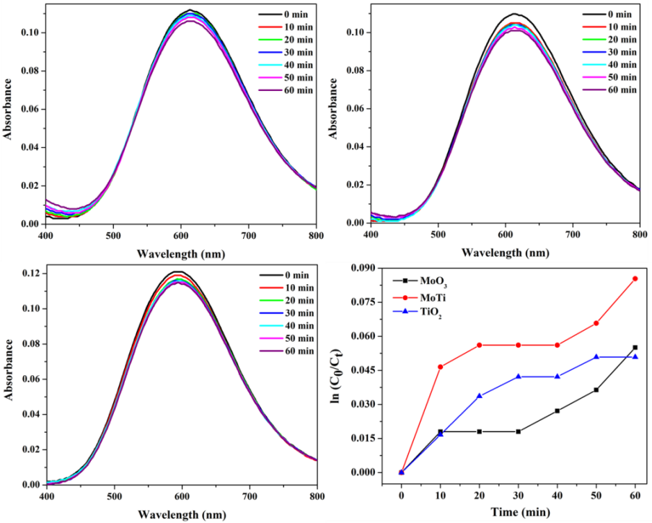
Fig. S12 Repetitive scan spectra for the surface adsorption of [Cu(dien)(1-MeIm)Cl]Cl⋅H₂O complex in neat water suspension for (a) MoO₃ rod (b) TiO₂ nanospheres (c) MoO₃-TiO₂ nanocomposite. Ionic strength = 0.01 M NaClO₄; Dosage of adsorbent = 200mg/150ml; Concentration of Cu(II) complex = 1.5 x 10⁻⁴ M.
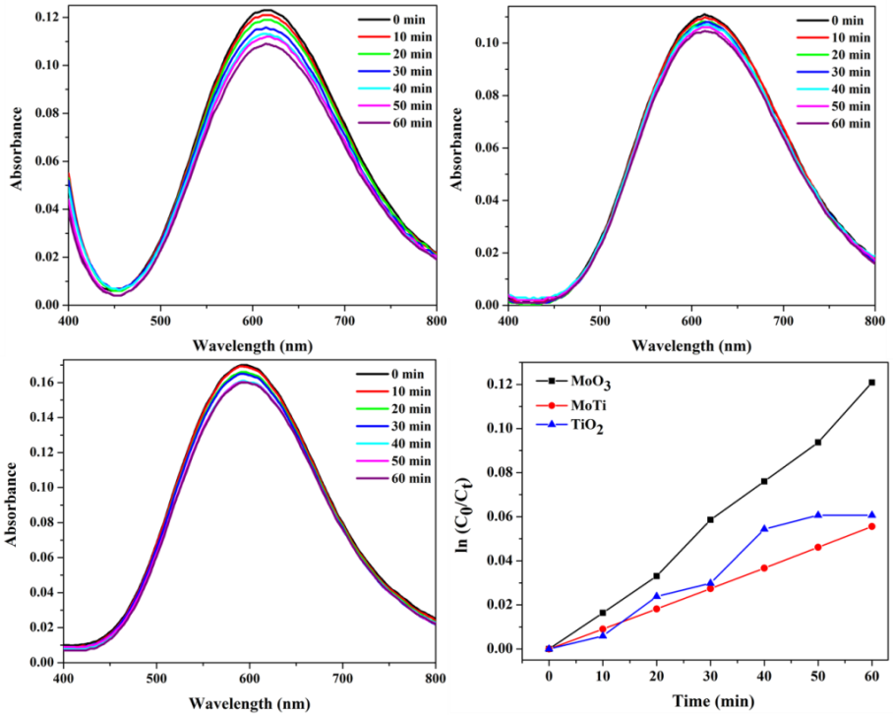
Fig. S13 Repetitive scan spectra for the surface adsorption of [Cu(dien)(1-MeIm)Cl]Cl⋅H₂O complex in 30% IPA suspension for (a) MoO₃ rod (b) TiO₂ nanospheres (c) MoO₃-TiO₂ nanocomposite. Ionic strength = 0.01 M NaClO₄; Dosage of adsorbent = 200mg/150ml; Concentration of Cu(II) complex = 1.5 x 10⁻⁴ M.
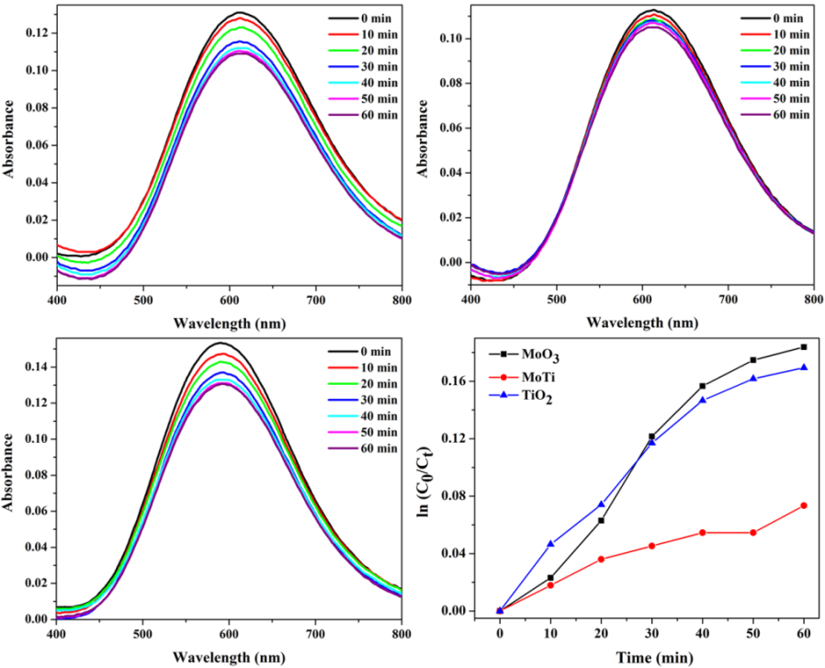
Fig. S14 Repetitive scan spectra for the surface adsorption of [Cu(dien)(1-MeIm)Cl]Cl⋅H₂O complex in 30% ACN suspension for (a) MoO₃ rod (b) TiO₂ nanospheres (c) MoO₃-TiO₂ nanocomposite. Ionic strength = 0.01 M NaClO₄; Dosage of adsorbent = 200mg/150ml; Concentration of Cu(II) complex = 1.5 x 10⁻⁴ M.
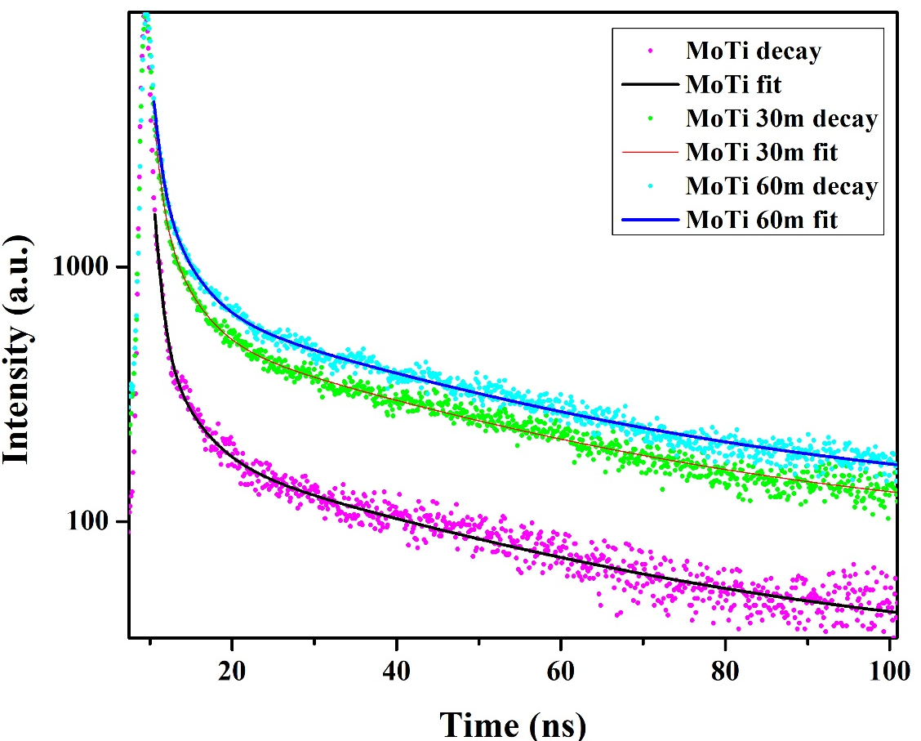
Fig. S15 The experimental and decay fit of the prepared nanocomposites.

