Photograph 1: Observation and Classification Images from the Çarşamba Bazaar 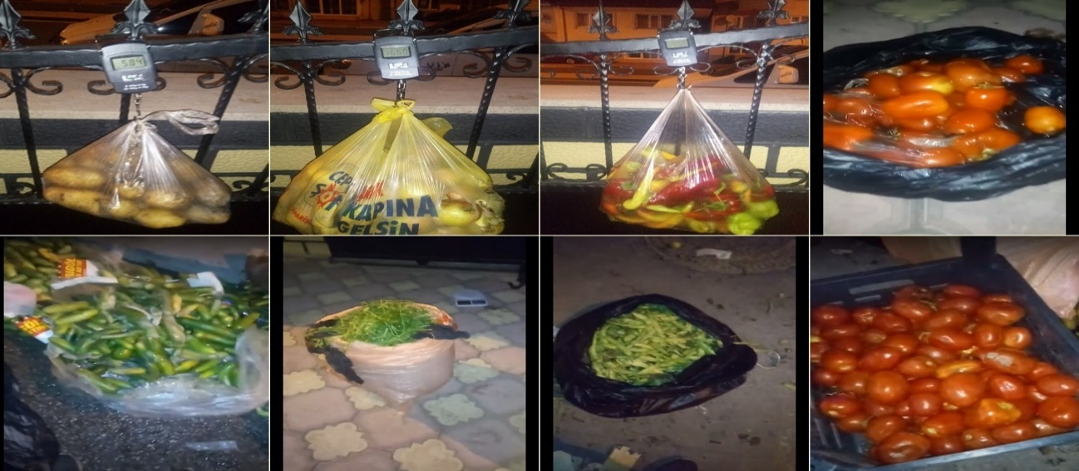
Source: Created by the author.
Photograph 2: Observation and Classification Images from the Çarşamba Bazaar 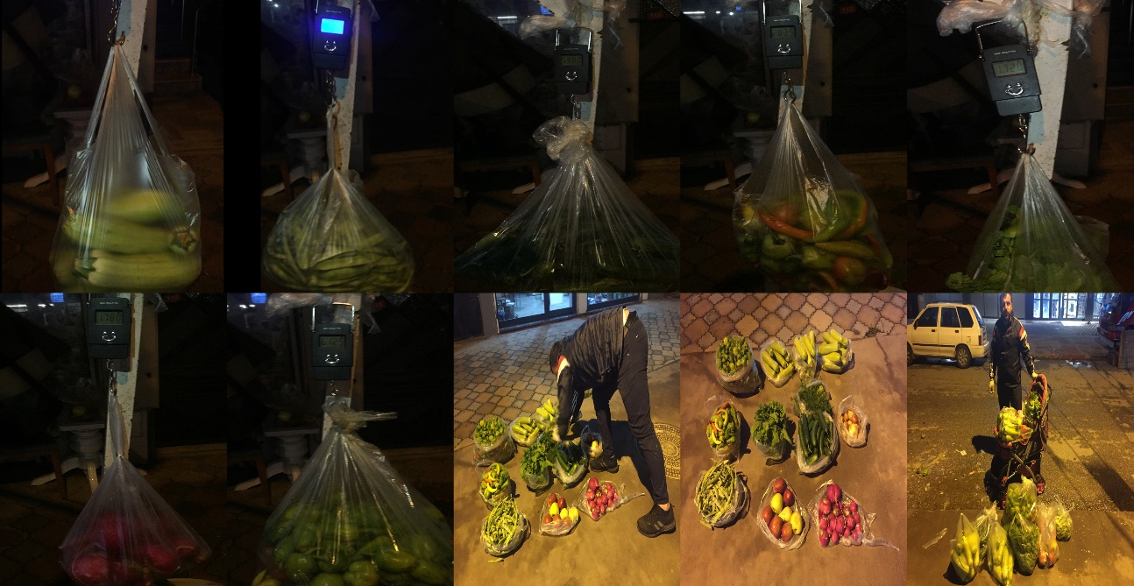
Source: Created by the author.
Photograph 3: Observation and Classification Images from the Çarşamba Bazaar 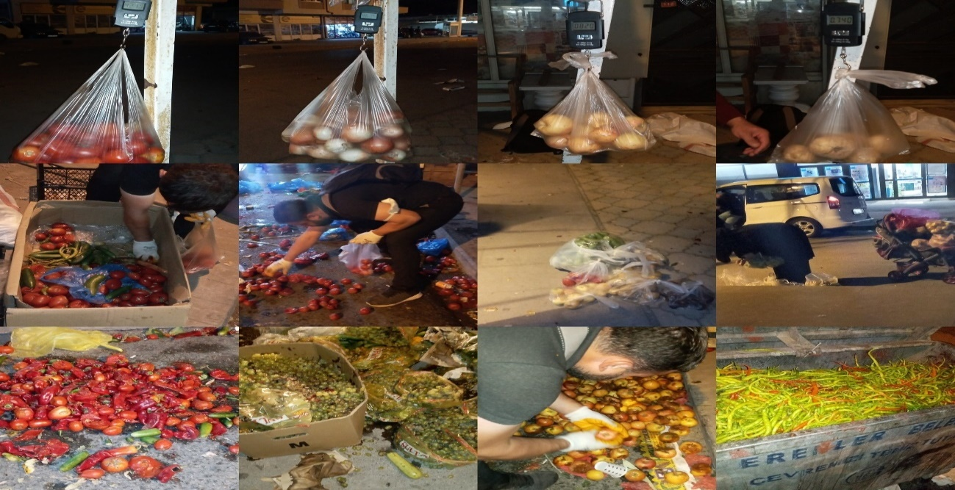
Source: Created by the author.
Photograph 4: Observation and Classification Images from the Çarşamba Bazaar
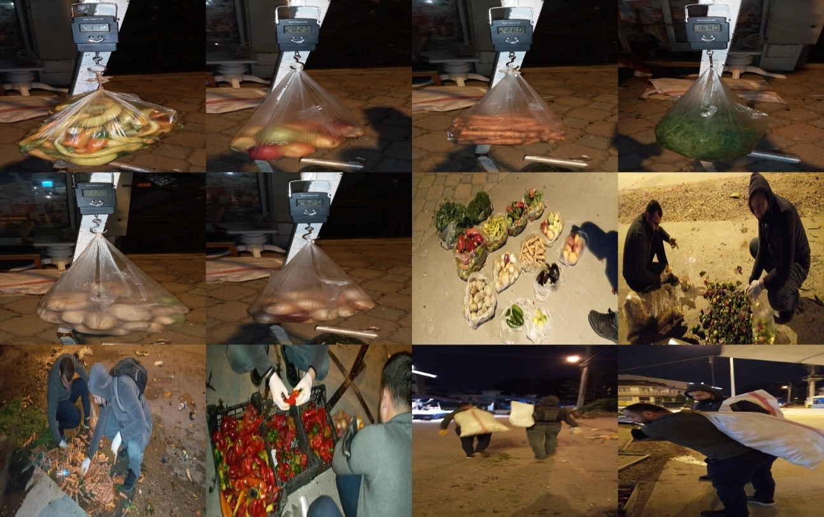
Source: Created by the author.
Photograph 5: Observation and Classification Images from the Çarşamba Bazaar 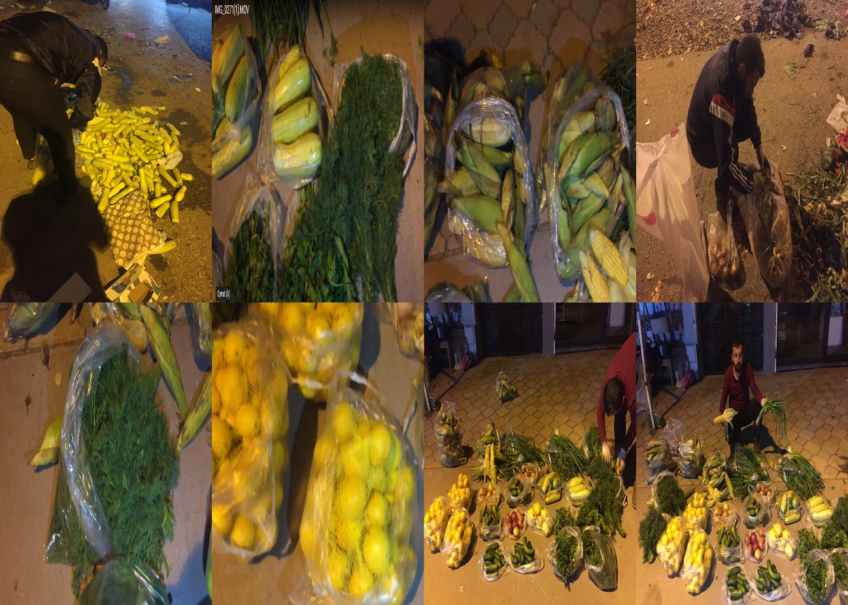
Source: Created by the author.

