Supplementary Information

A Late Pleistocene Hominin footprint site on the North African Coast of Morocco
Mouncef Sedrati^{1*}, Juan A. Morales^{2,3}, Jérémy Duveau^{4,5}, Abdelmounim El M’rini⁶, Eduardo Mayoral^{2,3}, Ignacio Díaz‐Martínez⁷, Edward J. Anthony⁸, Glen Bulot¹, Anass Sedrati⁹, Romain Le Gall¹, Ana Santos¹⁰, Jorge Rivera-Silva¹¹
¹Geo-Ocean, Univ Bretagne Sud, Univ Brest, CNRS, Ifremer, UMR6538, F-56000 Vannes, France
²Departamento de Ciencias de la Tierra, Facultad de Ciencias Experimentales, Campus de El Carmen, Universidad de Huelva, Huelva, Spain
³Centro Científico Tecnológico de Huelva, Universidad de Huelva, Huelva, Spain
⁴DFG Center for Advanced Studies ‘‘Words, Bones, Genes, Tools: Tracking Linguistic, Cultural and Biological Trajectories of the Human Past’’, Eberhard Karls University of Tübingen, Rümelinstrasse 23, 72070 Tübingen, Germany
⁵UMR 7194 Histoire Naturelle de l’Homme Préhistorique, CNRS, Muséum National d’Histoire Naturelle, Université Perpignan Via Domitia, Paris, France
⁶LR3G, FS, Abdelmalek Essaadi University, Tétouan 93000, Morocco
⁷ Department of Earth Sciences and Condensed Matter Physics, Faculty of Sciences, University of Cantabria, Santander 39005, Cantabria, Spain
⁸CNRS, IRD, INRA, Coll France, CEREGE, Aix Marseille University, 13545 Aix-en-Provence, France
⁹Lixus archaeological site, Ministry of Youth, Culture and Communication – Larache, Morocco
¹⁰Departamento de Geología, Facultad de Geología, Campus de Llamaquique, Universidad de Oviedo, Oviedo, Spain
¹¹Centro de Investigación, Tecnología e Innovación (CITIUS), Universidad de Sevilla, Sevilla, Spain
*Email: mouncef.sedrati@univ-ubs.fr

Footprint ID | Laterality | 3D | Footprint length (cm) | Orientation (°) | Estimated stature (cm) |  |  | Estimated age class
 |  |  |  |  | Dingwall et al., 2013 | Duveau, 2022 | Mean | Estimated age class
C01-01 | right | x | 21,1 | 92,1 | 154,1 | 153,5 | 153,8 | child
C01-02 | right | x | 16,6 | 122,2 | 135,7 | 136,4 | 136,0 | child
C01-03 | right | x | unknown | 80,4 | not estimated | not estimated | not estimated | not estimated
C01-04 | unknown | x | 24,9 | 102,1 | 169,7 | 167,9 | 168,8 | adolescent
C01-05 | left | x | 18,5 | 135,6 | 143,5 | 143,6 | 143,5 | child
C01-06 | left | x | 18,5 | 42,5 | 143,5 | 143,6 | 143,5 | child
C01-07 | right | x | 26,5 | 178,6 | 176,3 | 174,0 | 175,1 | adult
C01-08 | unknown | x | 23,4 | 248,1 | 163,5 | 162,2 | 162,9 | adolescent
C01-09 | unknown | x | 22,5 | 281,2 | 159,9 | 158,8 | 159,3 | adolescent
C01-10 | unknown | x | 28,2 | 263,5 | 183,2 | 180,5 | 181,8 | adult
C01-11 | unknown | x | 28,8 | 277,5 | 185,7 | 182,7 | 184,2 | adult
C01-12 | right | x | 26,6 | 296,7 | 176,7 | 174,4 | 175,5 | adult
C01-13 | unknown |  | unknown | 302,8 | not estimated | not estimated | not estimated | not estimated
C01-18 | unknown |  | unknown | 33,9 | not estimated | not estimated | not estimated | not estimated
C01-20 | left |  | 24,6 | 98,0 | 168,6 | 166,9 | 167,8 | adolescent
C01-25 | right |  | 29,8 | 59,9 | 189,7 | 186,4 | 188,0 | adult
C01-26 | left |  | 26,9 | 299,2 | 178,0 | 175,6 | 176,8 | adult
C01-28 | right |  | 26,3 | 41,6 | 175,4 | 173,2 | 174,3 | adult
C02-01 | right | x | 20,3 | 90,6 | 150,8 | 150,4 | 150,6 | child
C02-04 | unknown |  | 19,9 | 42,1 | 149,2 | 148,9 | 149,0 | child
C02-05 | unknown |  | 21,9 | 316,6 | 157,3 | 156,4 | 156,8 | adolescent
C02-07 | right |  | 24,7 | 300,8 | 168,7 | 167,0 | 167,8 | adolescent
C02-08 | right |  | 20,8 | 294,0 | 153,0 | 152,5 | 152,7 | child
C02-09 | unknown |  | 19,4 | 299,4 | 147,1 | 147,0 | 147,1 | child
C02-15 | left |  | 21,0 | 283,1 | 153,6 | 153,0 | 153,3 | child
C02-18 | right |  | 24,5 | 265,8 | 167,9 | 166,3 | 167,1 | adolescent
C03-01 | right | x | 23,9 | 66,7 | 165,6 | 164,1 | 164,9 | adolescent
C03-04 | left |  | 13,2 | 138,2 | 121,7 | 123,5 | 122,6 | child
C03-05 | right |  | 19,8 | 34,8 | 148,9 | 148,7 | 148,8 | child
C03-11 | right |  | 19,1 | 341,8 | 146,0 | 146,0 | 146,0 | child
C03-15 | right |  | 22,3 | 281,1 | 158,9 | 157,9 | 158,4 | adolescent
C03-16 | left |  | 26,8 | 26,0 | 177,3 | 175,0 | 176,2 | adult
C03-21 | left | x | 16,2 | 72,0 | 134,0 | 134,9 | 134,4 | child
C04-01 | right |  | 26,1 | 85,8 | 174,6 | 172,5 | 173,5 | adult
C04-02 | right | x | 21,8 | 129,9 | 157,0 | 156,1 | 156,6 | adolescent
C04-04 | left | x | 19,2 | 275,5 | 146,3 | 146,3 | 146,3 | child
C04-07 | left | x | 22,8 | 319,8 | 161,1 | 159,9 | 160,5 | adolescent
C04-08 | left |  | 24,8 | 68,6 | 169,1 | 167,4 | 168,3 | adolescent
C04-12 | left |  | 22,9 | 109,6 | 161,6 | 160,4 | 161,0 | adolescent
C04-17 | right |  | 28,0 | 268,0 | 182,5 | 179,8 | 181,2 | adult
C04-21 | left |  | 21,2 | 226,8 | 154,7 | 154,0 | 154,3 | child
C04-24 | left |  | 25,5 | 217,7 | 172,3 | 170,3 | 171,3 | adult
C04-25 | left |  | 21,7 | 271,0 | 156,6 | 155,8 | 156,2 | adolescent
C04-27 | right |  | 23,9 | 237,0 | 165,5 | 164,0 | 164,7 | adolescent
C05-01 | left | x | 28,0 | 217,0 | 182,4 | 179,7 | 181,1 | adult
C05-02 | unknown | x | 24,6 | 17,9 | 168,5 | 166,8 | 167,6 | adolescent
C05-05 | right | x | 26,7 | 42,7 | 177,1 | 174,8 | 175,9 | adult
C05-16 | right | x | 30,0 | 59,2 | 190,6 | 187,3 | 189,0 | adult
C05-21 | unknown |  | 27,6 | 237,5 | 180,8 | 178,2 | 179,5 | adult
C05-24 | unknown | x | 17,6 | 115,5 | 139,8 | 140,2 | 140,0 | child
C05-25 | left | x | 28,1 | 296,8 | 182,8 | 180,1 | 181,4 | adult
C05-26 | left |  | 28,6 | 166,9 | 184,9 | 182,0 | 183,4 | adult
C05-28 | right | x | 24,8 | 293,6 | 169,3 | 167,5 | 168,4 | adolescent
C05-29 | right | x | 18,2 | 121,3 | 142,2 | 142,5 | 142,3 | child
C05-32 | left |  | 25,2 | 22,5 | 170,8 | 168,9 | 169,8 | adolescent
C05-36 | right |  | 29,6 | 231,0 | 189,1 | 185,9 | 187,5 | adult
C05-37 | right |  | 25,8 | 345,0 | 173,5 | 171,5 | 172,5 | adult
C05-39 | right |  | 15,9 | 90,9 | 132,9 | 133,8 | 133,4 | child
C05-40 | unknown |  | 20,6 | 238,0 | 152,2 | 151,7 | 152,0 | child
C05-43 | left |  | 28,8 | 340,0 | 185,8 | 182,9 | 184,3 | adult
C05-46 | right |  | 21,7 | 3,6 | 156,6 | 155,8 | 156,2 | adolescent
Ca-02 | left | x | 22,8 | 138,0 | 161,1 | 159,9 | 160,5 | adolescent
Ca-03 | right | x | 25,1 | 165,8 | 170,5 | 168,7 | 169,6 | adolescent
OC001 | right |  | 18,6 | 356,5 | 143,7 | 143,9 | 143,8 | child
OC003 | left |  | 18,3 | 300,7 | 142,6 | 142,8 | 142,7 | child
OC005 | right |  | 23,6 | 110,3 | 164,4 | 163,0 | 163,7 | adolescent
OC006 | right |  | 22,6 | 351,0 | 160,4 | 159,3 | 159,9 | adolescent
OC010 | left |  | unknown | 7,5 | not estimated | not estimated | not estimated | not estimated
OC014 | right |  | 24,2 | 46,2 | 166,8 | 165,2 | 166,0 | adolescent
OC017 | left |  | 26,2 | 128,2 | 174,9 | 172,7 | 173,8 | adult
OC022 | right |  | 12,7 | 119,8 | 119,8 | 121,7 | 120,8 | child
OC023 | right |  | 14,0 | 324,0 | 124,8 | 126,4 | 125,6 | child
OC025 | right |  | 21,1 | 220,9 | 154,0 | 153,4 | 153,7 | child
OC026 | right |  | 26,6 | 167,7 | 176,8 | 174,5 | 175,7 | adult
OC028 | right |  | 19,0 | 152,2 | 145,4 | 145,4 | 145,4 | child
OC029 | left |  | 18,6 | 140,6 | 144,0 | 144,1 | 144,0 | child
OC033 | right |  | 28,8 | 273,2 | 185,8 | 182,9 | 184,3 | adult
OC042 | unknown |  | 17,8 | 281,9 | 140,6 | 140,9 | 140,8 | child
OC046 | left |  | 23,1 | 306,9 | 162,4 | 161,2 | 161,8 | adolescent
OC048 | right |  | 17,9 | 153,5 | 141,1 | 141,4 | 141,3 | child
OC052 | left |  | 29,9 | 275,2 | 190,2 | 186,9 | 188,5 | adult
OC062 | unknown |  | 14,1 | 247,3 | 125,6 | 127,0 | 126,3 | child
OC063 | left |  | 18,8 | 106,8 | 144,5 | 144,6 | 144,6 | child
OC064 | left |  | 14,0 | 20,1 | 124,9 | 126,4 | 125,6 | child
OC066 | left |  | 21,6 | 112,0 | 156,3 | 155,5 | 155,9 | adolescent

Table S1. Inventory of the footprints discovered at Larache site. Statures estimated from the total length of the footprints using the average of the estimates obtained from: 1) 15% ratio between foot length and stature. 2) the relationship used by Dingwall and his collaborators. and 3) that used by Duveau and his collaborators.

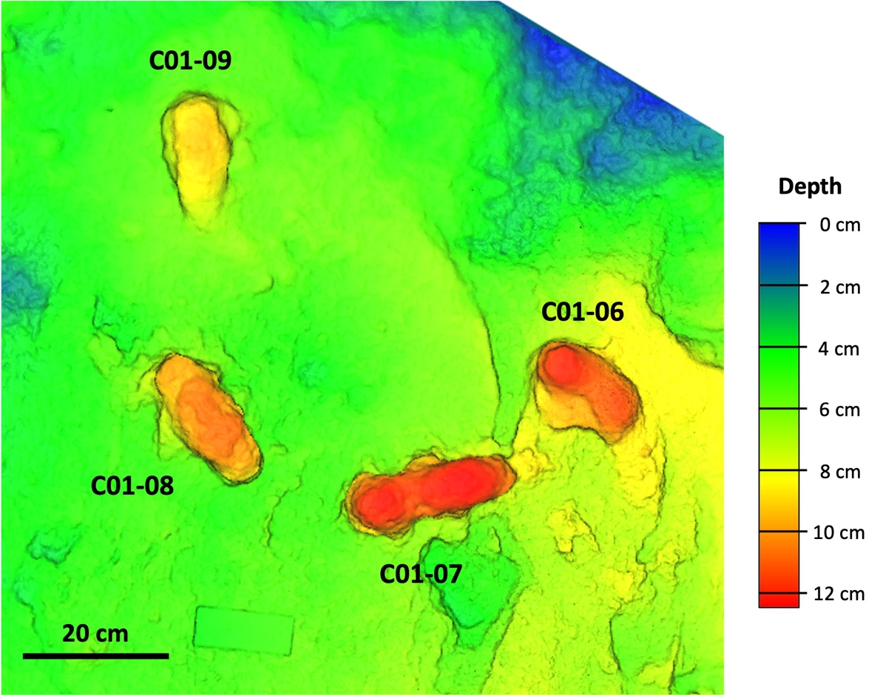
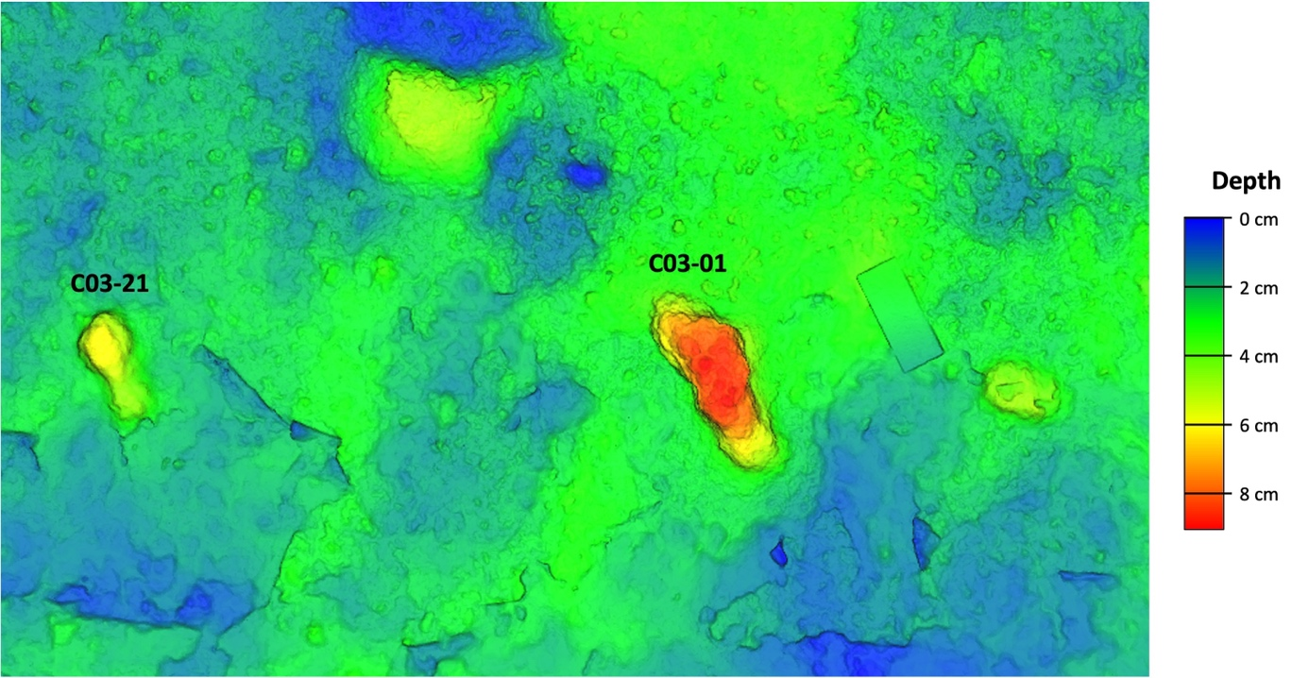

Figure S1. Depth map of a group of Larache footprints.

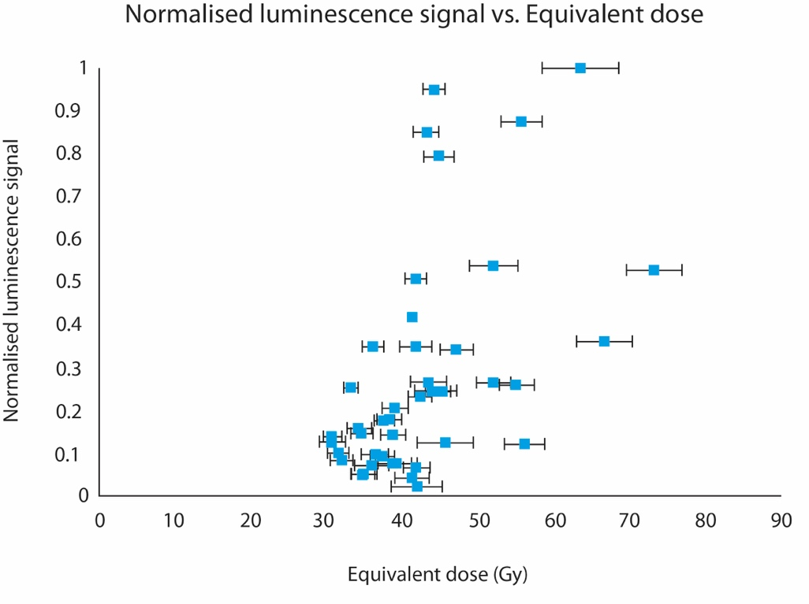
Figure S2. Dose distribution obtained from the OSL measurements. Normalized OSL signal is plotted as a function of the individual equivalent dose values.

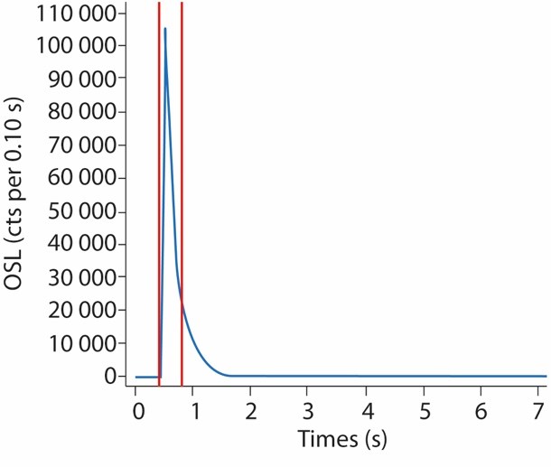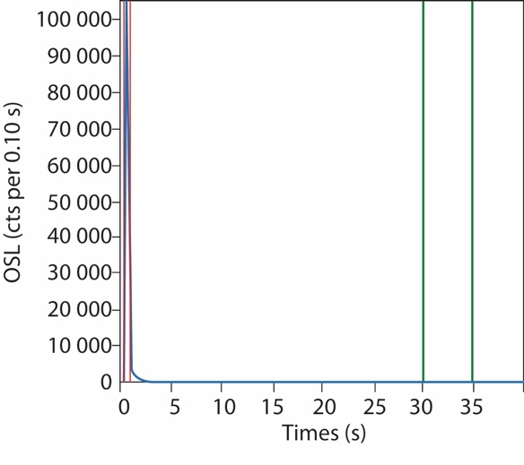

Figure S3. Example of the OSL decay curves obtained. OSL signal is shown in blue. Red and green lines represent the integration limits selected for the curve and the background, respectively (left). Fast component section of the OSL curve (right).

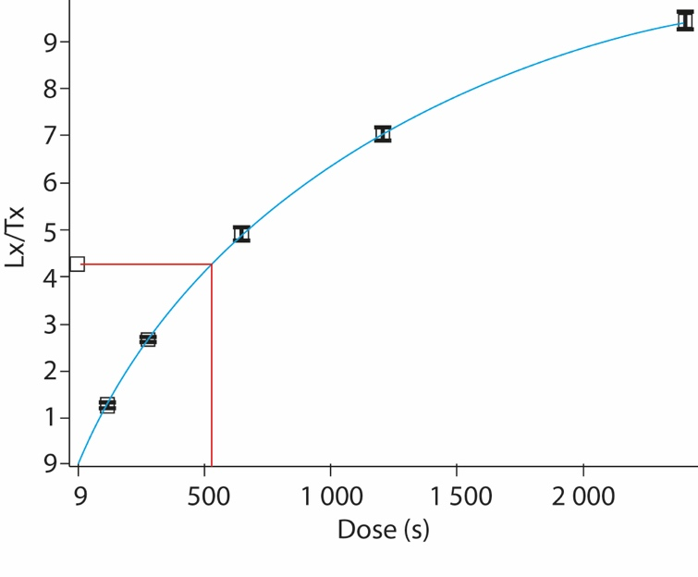

Figure S4. Example of the dose response curves obtained.

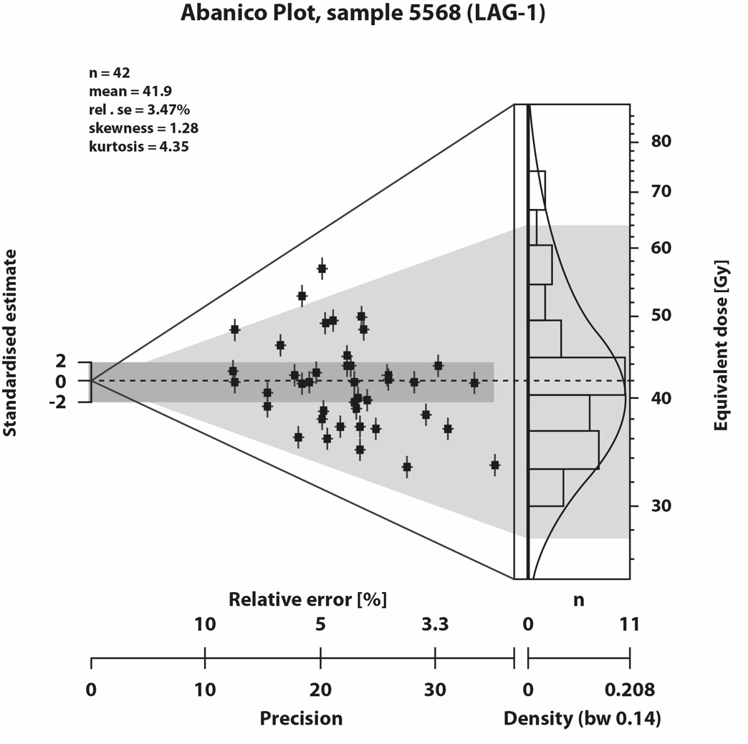
Figure S5. Abanico plot for the OSL measurements.

