Supplementary Information

Wireless Power Reception System based on Metasurface Lens for Compact Unmanned Mobilities
Wonwoo Lee¹†, Hong Soo Park²†, Semin Jo¹, Seonhye Jang², Yongchan Kim², Changkun Park^{1,2,3}*, Sun K. Hong^{1,2,3}*, Hojin Lee^{1,2,3}*
¹Department of Information Communication Convergence Technology, Soongsil University, Seoul 06978, Republic of Korea.
²School of Electronic Engineering, Soongsil University, Seoul 06978, Republic of Korea.
³Department of Intelligent Semiconductors, Soongsil University, Seoul 06978, Republic of Korea.

†These authors contributed equally to this work.
*Corresponding author. E-mail: pck77@ssu.ac.kr (C.P); shong215@ssu.ac.kr (S.K.H); hojinl@ssu.ac.kr (H.L.).

This PDF file includes:

Supplementary Notes 1 to 9
Supplementary Figures 1 to 6

Separate supplementary file for this manuscript: Supplementary Movie 1 to 2

Supplementary Note 1 | The structured design procedure of metasurface lens.

To realize polarization independent electromagnetic wave focusing characteristics, the respective unit cell of proposed metasurface is composed polarization symmetric structures such as cross, square, and square ring shapes as shown in Fig. S1. in manuscript. Also, to achieve larger phase coverage range, unit cell structure is composed by combining two different elements¹ including square or cross-shaped metallic patterns and square rings as shown in Fig. S1. By adjusting the thickness of empty spaces the capacitance and inductance, it can achieve a much larger phase range with lower slope compared to conventional elements. Therefore, to demonstrate enlarged phase coverage range of proposed unit cell structure, the phase responses of differential unit cells are investigated as shown in Fig. S1. By varying the geometrical parameters of unit cells, the square and square ring composed structure (Structure D in Fig. S1.) showed the larger phase coverage compared to other structures (Structure A, B, and C in Fig. S1.).
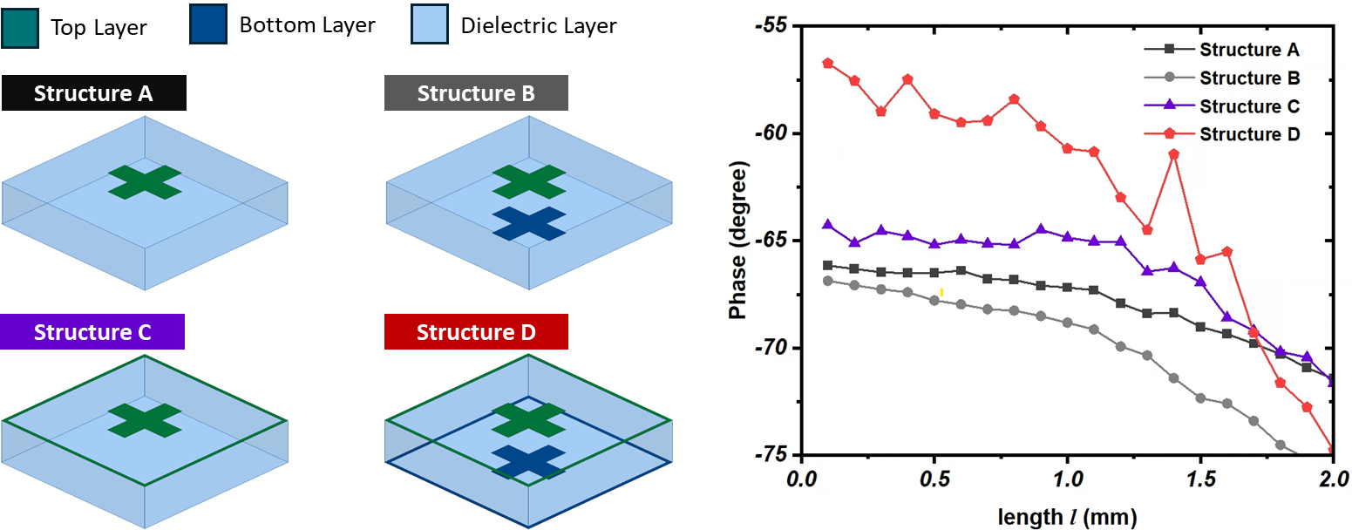
Fig. S1 | Phase response for differential unit cells.

Supplementary Note 2 | Fabrication Process of Phase Gradient Single-Layer Metasurface Lens

The 22.5 GHz metasurface lens was fabricated on 0.787-mm thick RT/duroid 5880 laminates with permittivity of $ε_{r}$ = 2.2 and a loss tangent of $tanδ$= 0.0009 via a conventional photolithography process. To form the copper pattern on the top and bottom layers, both layers were coated with a photoresist, and the top and bottom layers were sequentially exposed to each photomask using an ultraviolet (UV) source for 30 s under vacuum. Following UV exposure, the photoresist was developed using a film striper (PNR-08, Scheme Muse Execute Trading Co., Korea), and the final copper patterns were formed by etching with a copper etchant (Ferric Chloride Anhydrouse Solvent).

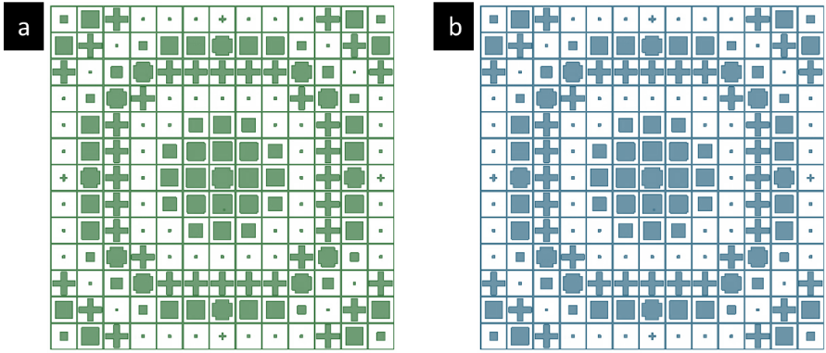
Supplementary Note 3 | Detailed Layout of Electromagnetic Wave Focusing Metasurface Lens

Supplementary Fig. S2 | Structural layout for a, upper and b, lower layers of proposed metasurface.

Supplementary Note 4 | Gain Profiles based on the Distance Between the Metasurface Lens and Patch Antenna
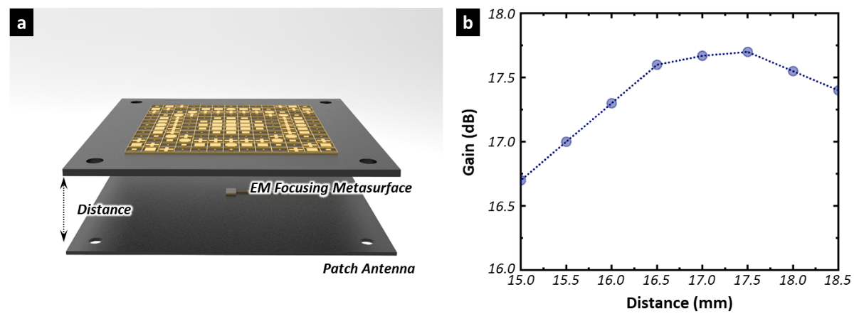

Supplementary Fig. S3 | a, Schematic of the distance between the metasurface lens and patch antenna. b, Received gain profile based on the distance between metasurface lens and patch antenna.

Supplementary Note 5 | Wireless Power Reception Measurement System
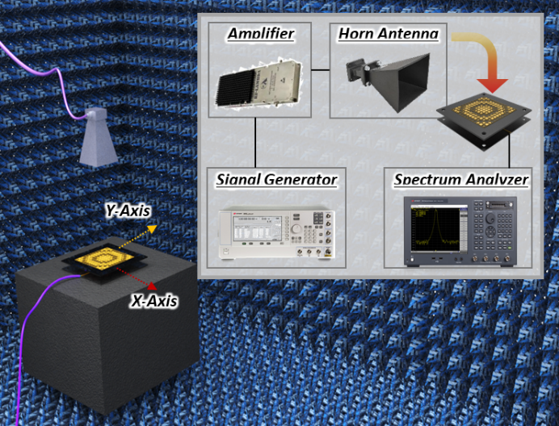

Supplementary Fig. S4 | Anechoic chamber measurement system wireless power reception IC system.
Fig. S4 shows the measurement system for the wireless power reception system. All measurements were performed in an anechoic chamber that encompassed a frequency range of 2–110 GHz to suppress internal insulation and external noise sources. The transmit horn antenna (EMCO 3160-09) was placed 24 cm from the receiving structure (satisfying the far-field condition), and has a maximum transmit power of 33.2 dBm at 22.5 GHz using a signal generator (Agilent E8247C) followed by an amplifier (RF Lamda RFLUPA18G45G32CDK). The power received by each receiving structure was monitored using a spectrum analyser (Agilent E4407B).

Supplementary Note 6 | Validity Confirmation of Received Power Distribution

To confirm the validity of the received power distribution based on various positions, the received gain was calculated based on the received power, which can be directly compared with the measured received gain shown in Fig. 3d. Using the Friis equation, the received gain $G_{r}$ can be calculated as
$G_{r}= \frac{P_{r}{(4πR)}^{2}}{P_{t}G_{t}λ^{2}}$ (1)
where $P_{r}$ denotes the received power, $R$ denotes the distance between the transmit antenna and receiving structure, $P_{t}$ indicates the transmit power, $G_{t}$ indicates the transmit antenna gain, and $λ$ signifies the wavelength at the operating frequency. As shown in Fig. 3f in the main text, the received gain distribution of the wireless power structure exhibits a consistent and reliable tendency owing to the wide incident angle and polarisation independence of the metasurface lens. Therefore, the overall results imply that the proposed metasurface lens-integrated patch antenna structure can maximise the reception of available incident waves, regardless of the receiving angle, thereby enhancing the efficiency of wireless power transfer in various environments.

Supplementary Note 7 | Fabrication Process of CMOS Rectifier IC

The rectifier was implemented using a 65-nm radio frequency CMOS (RF-CMOS) process (one poly and nine metal layers). A series inductor (L_{IN}) and shunt capacitor (C_{IN}) were used as the input matching networks, and the values of L_{IN} and C_{IN} were 76 fF and 0.51 nH, respectively. The diodes were designed using MOSFETs with a gate width of 12 μm and a gate length of 0.4 μm. To minimise the threshold voltage, native MOSFETs were utilised with a threshold voltage of 0.1 V. The values of the charging node capacitor CC and load resistor RL were 460 fF and 6 $kΩ$, respectively, and dimension of core chip size is 0.25 × 0.40 mm². The rectified DC voltage level increases during each stage. The input impedance Z_{IN} for each stage can be represented R + (j$ω$C)0.5. The simulated R value decreases as the input power increases, whereas the C value increases. Consequently, the input impedance depended on the input power.

Supplementary Note 8 | Scalability of Wireless Power Reception System

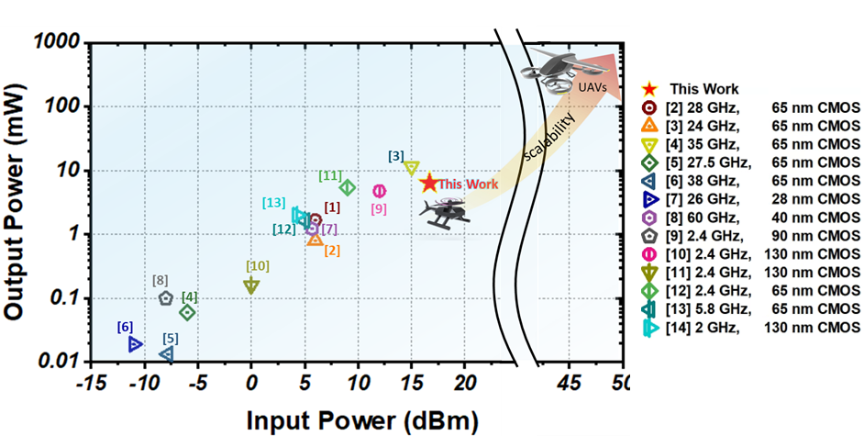Supplementary Fig. S5 | Comparison with other reported CMOS IC rectifiers.

Since our work focuses specifically on the wireless power reception system rather than the entire WPT system (including the transmitter), we compared the power reception performance in relation to the CMOS IC rectifier to validate the scalability of the proposed power reception system. Figure S5 shows a comparison of input vs. output power performance of the CMOS IC rectifier used in this work with that of other reported works. For comparison, CMOS IC rectifiers designed for both microwave and mm-wave systems were selected. It can be seen that our rectifier was optimized for the highest input power while maintaining high output power, which was sufficient for conceptual validation of the proposed system through scaled-down experiments. In this work, a relatively low incident power was used due to the constraints of the laboratory environment, necessitating the use of a CMOS IC rectifier that is suitable for low-power applications and enabling system miniaturization in mm-wave WPT. Nevertheless, considering that the proposed system is an integration of a metasurface, antenna, and rectifier, this concept has the potential to be expanded to more practical UAV powering by replacing the rectifier with high-power versions as the transmission power increases.

Supplementary Note 9 | Wireless Power Reception System for powering Small Unmanned Device
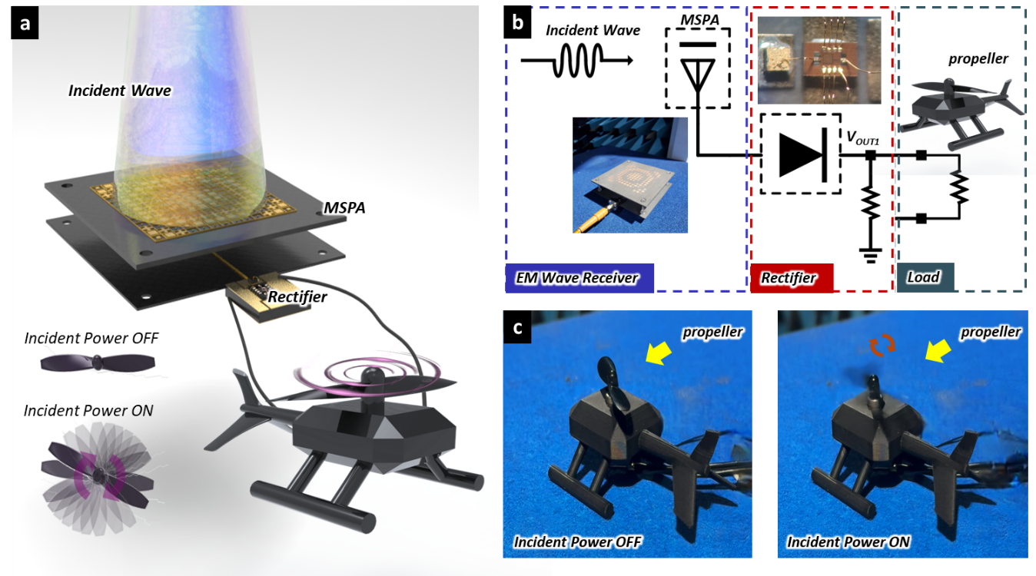
Fig. S6 | a, Schematic of the driving mechanism of the helicopter-mounted propeller powered by a wireless power reception system. b, Block diagram of the overall WPT system. c, without (left) and with (right) incident power transmitted.
To conceptually validate the WPT capability of the proposed wireless power reception system for powering small, unmanned devices, a low-power, scaled-down experiment was conducted using a miniature helicopter-mounted propeller driven by a conventional motor. Fig. S6a shows a schematic of the driving mechanism for a helicopter-mounted propeller powered by the proposed system. Fig. S6b presents a block diagram of the entire WPT system. When the focused incident wave power from the metasurface lens-integrated patch antenna entered the rectifier, the rectifier generated DC voltage to drive the helicopter-mounted propeller. Fig. S6c shows captured images of the helicopter-mounted propeller without (left) and with (right) input power, indicating that the propeller on the helicopter operates properly when the incident power is transmitted. These results validate the feasibility of the proposed WPT system for powering small, unmanned devices, which can potentially be extended to full-scale, high-power, and long-range applications.

References
- Q.-Y. Li, Y.-C., Jiao, and G. Zhao, “A Novel Microstrip Rectangular-Patch/Ring- Combination Reflectarray Element and Its Application,” IEEE Antennas and Wireless Propagation Letters, vol. 8, pp. 1119-1122, 2009
- T. Elazar, E. Shaulov, and E. Socher, “Analysis of mm-wave CMOS rectifiers and Ka-band implementation,” IEEE Trans. Microw. Theory Techn., vol. 71, no. 6, pp. 2758–2768, Jun. 2023.
- P. Burasa, N. G. Constantin, and K. Wu, “High-efficiency wideband rectifier for single-chip batteryless active millimeter-wave identification (MMID) tag in 65-nm bulk CMOS technology,” IEEE Trans. Microw. Theory Techn., vol. 62, no. 4, pp. 1005–1011, Apr. 2014.
- P. He and D. Zhao, “High-efficiency millimeter-wave CMOS switching rectifiers: Theory and implementation,” IEEE Trans. Microw. Theory Techn., vol. 67, no. 12, pp. 5171–5180, Dec. 2019.
- E. Shaulov, T. Elazar, and E. Socher, “A high sensitivity CMOS rectifier for 5G mm-wave energy harvesting,” IEEE Trans. Circuits Syst. I, Reg. Papers, pp. 1–9, Feb. 2024.
- Y. Fang, G. Hueber, and H. Gao, “38/60-GHz dual-frequenc y 3-stage transformer-based differential inductor-peaked rectifier in 40-nm CMOS technology,” IEEE Solid-State Circuits Lett., vol. 4, pp. 174–177, Aug. 2021.
- T. Elazar, E. Shaulov, and E. Socher, “A two-way power combined Kaband rectifier for low input power energy harvesting,” IEEE Microw. Wireless Technol. Lett., vol. 34, no. 5, pp. 556–559, May 2024.
- M. Nariman, F. Shirinfar, S. Pamarti, A. Rofougaran, and F. De Flaviis, “High-efficiency millimeter-wave energy-harvesting systems with milliwatt-level output power,” IEEE Trans. Circuits Syst. II, Exp. Briefs, vol. 64, no. 6, pp. 605–609, Jun. 2017.
- Z.-Y. Huang and Y.-J E. Chen, “A 2.4-GHz CMOS efficiency-enhanced rectifier with a differential-feed patch antenna,” IEEE Microw. Wireless Tech. Lett., vol. 34, no. 2, pp. 229-232, Feb. 2024.
- S. Dehghani and T. Johnson, “A 2.4-GHz CMOS class-E synchronous rectifier,” IEEE Trans. Microw. Theory Techn., vol. 64, no. 5, pp. 1655–1666, May 2016.
- J. Masuch, “Co-integration of an RF energy harvester into a 2.4GHz transceiver,” IEEE J. Solid-State Circuits, vol. 48, no. 27, pp. 1565–1574, Jul. 2013.
- T. Hu, M. Huang, Y. Lu, X. Y. Zhang, F. Maloberti, and R. P. Martins, “A 2.4-GHz CMOS differential class-DE rectifier with coupled inductors,” IEEE Trans. Power Electron., vol. 36, no. 9, pp. 9864–9875, Sep. 2021.
- S. Dehghani, S. Mirabbasi, and T. Johnson, ‘‘A 5.8-GHz bidirectional and reconfigurable RF energy harvesting circuit with rectifier and oscillator modes,’’ IEEE Solid-State Circuits Lett., vol. 1, no. 3, pp. 66–69, Mar. 2018.
- A. K. Moghaddam, J. H. Chuah, H. Ramiah, J. Ahmadian, P.-I. Mak, and R. P. Martins, ‘‘A 73.9%-efficiency CMOS rectifier using a lower DC feeding (LDCF) self-body-biasing technique for far-field RF energyharvesting systems,’’ IEEE Trans. Circuits Syst. I, Reg. Papers, vol. 64, no. 4, pp. 992–1002, Apr. 2017.
- S. Y. Kim, Y. Kim, C. Cho, H. Choi, H. W. Park, D. Lee, E. Heo, S. Park, H. Lee, and D. H. Kim, ‘‘Deformable Ionic Polymer Artifical Mechanotransducer with an Interpenetrating Nanofibillar Network,“ ACS Appl. Mater. Interfaces, vol. 11, no. 32, pp. 29350-29359, July 2019

