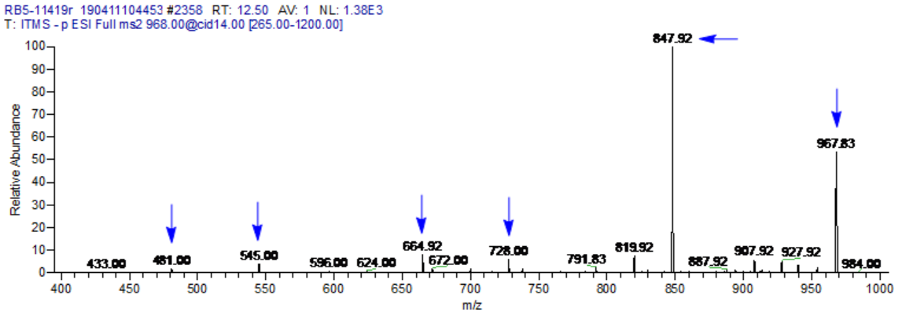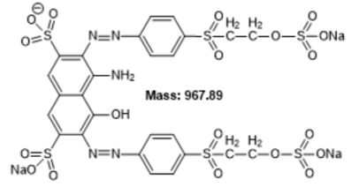
A

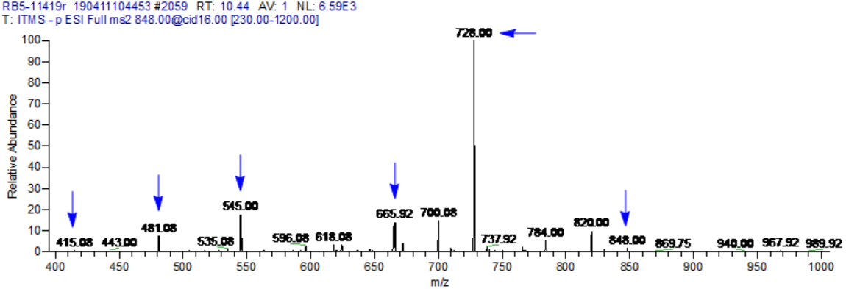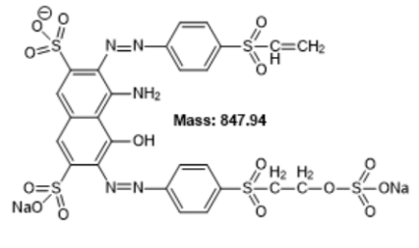
B

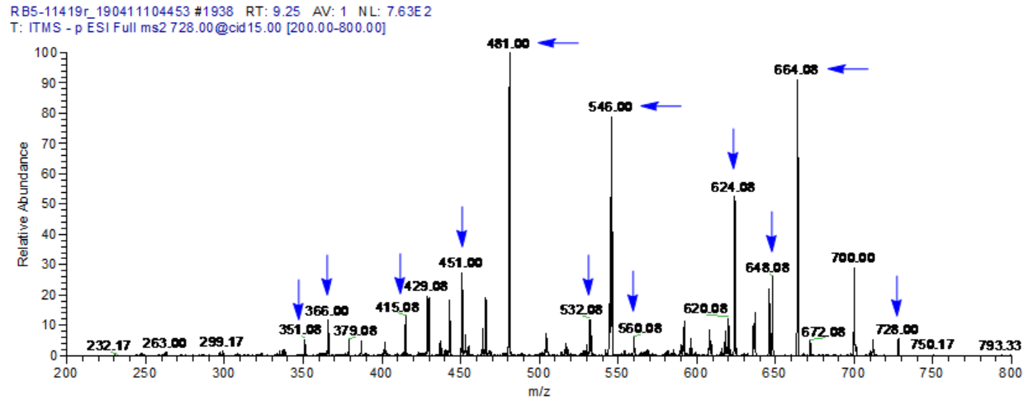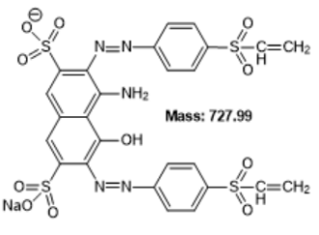
C

Figure S1: ESI-MS² of parent ion peak at m/z 968 corresponding to a singly ionized Reactive Black 5 (standard) (A). ESI-MS² of ion peak at m/z 848 correlated to the deletion of 120 mass units (SO₃NaH) to 968 (B) and ESI-MS² of ion peak at m/z 728 correlated to the deletion of 120 mass units (SO₃NaH) to 848 (C).

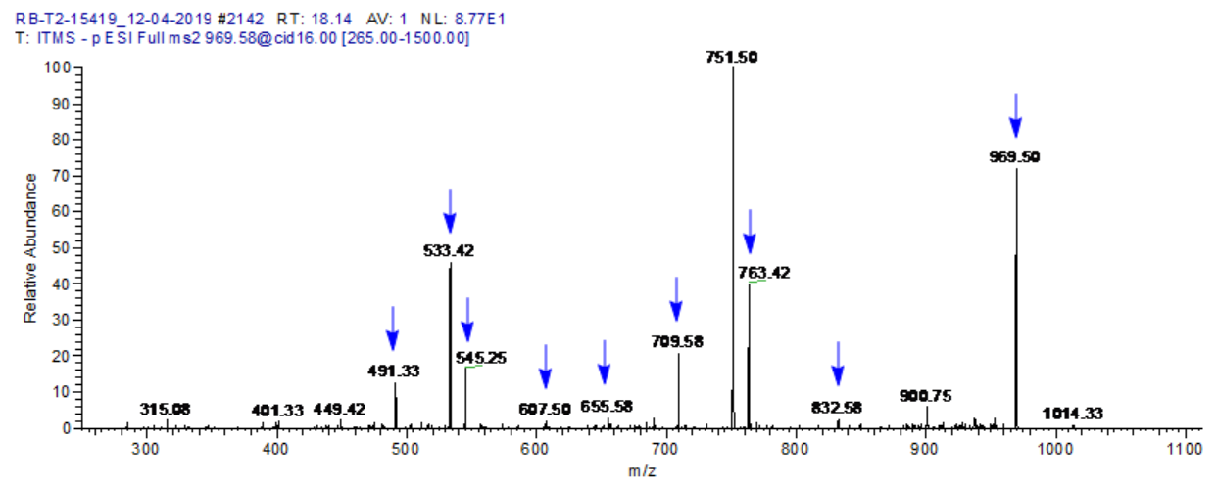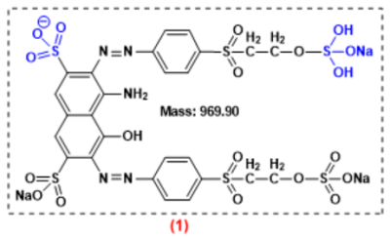
A

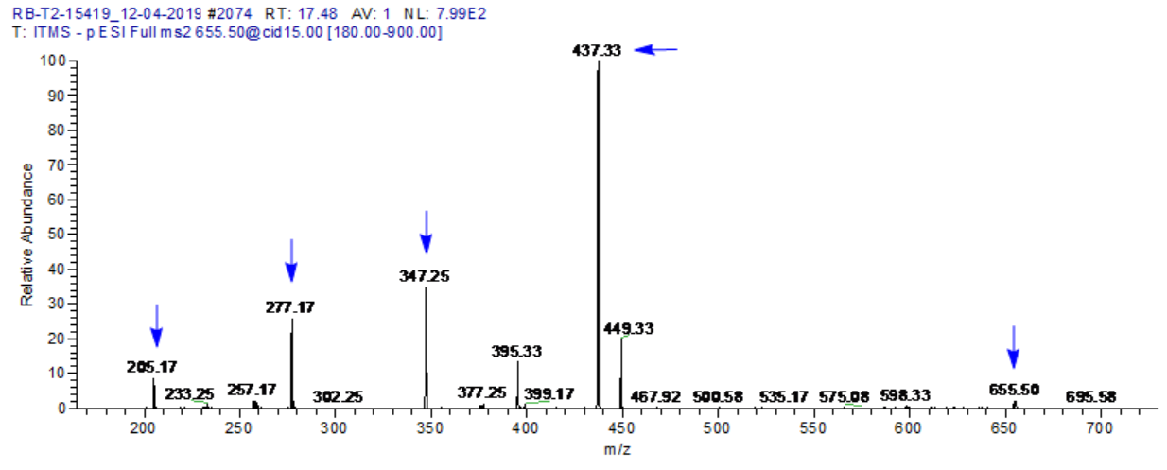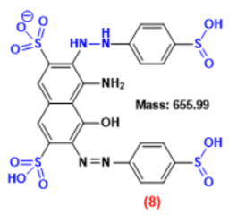
B

B

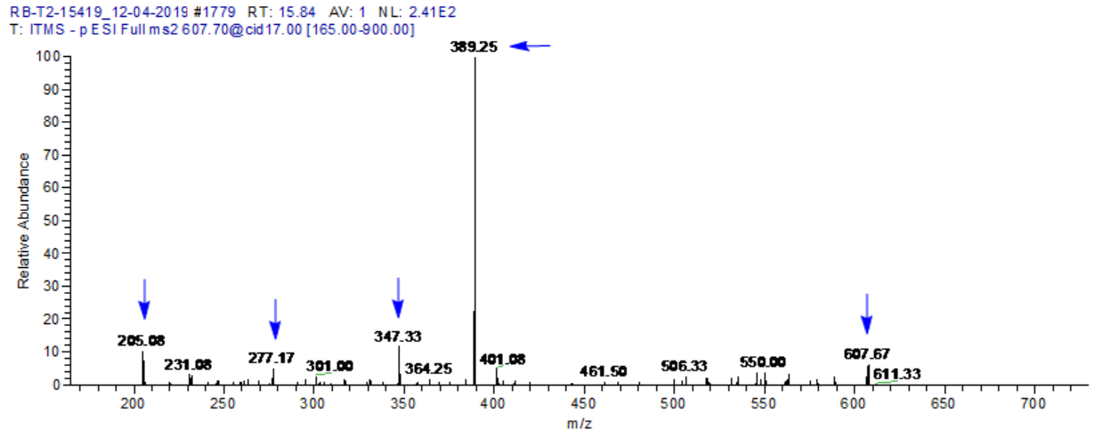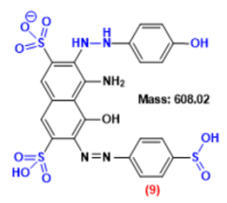
C

C

Figure S2: ESI-MS² of main ion peak at m/z 970 corresponding to singly ionized Reactive Black 5 (sample) primarily hydrogenated at one sulfonic group (A), ESI-MS² of ion peak at m/z 656 correlated to the deletion of 238 mass unit 2(-O-SO3Na group), 54 mass unit 2(H•C=CH₂), and 23 mass unit (Na⁺) to 970 (B) and ESI-MS² of ion peak at m/z 608 correlated to the deletion of 48 mass unit 2(S=O) to 656 (C).
A
A
C

