Supplementary materials
Title. Disparities in the association between ambient temperature and preterm birth according to individual and regional characteristics: a nationwide time-stratified case-crossover study
Authors. Jieun Min, Whanhee Lee, Jongmin Oh, Youngrin Kwag, Eunji Kim, Joyce Mary Kim, Kyung A Lee*, Eunhee Ha*
Affiliation
¹Department of Environmental Medicine, College of Medicine, Ewha Womans University, Seoul, Republic of Korea
²Graduate Program in System Health Science and Engineering, College of Medicine, Ewha Womans University, Seoul, Republic of Korea
³School of Biomedical Convergence Engineering, College of Information and Biomedical Engineering, Pusan National University, Yangsan, Republic of Korea
⁴Institute of Ewha-SCL for Environmental Health (IESEH), Ewha Womans University College of Medicine, Seoul, Republic of Korea
⁵Department of Human Systems Medicine, College of Medicine, Seoul National University, Seoul, Republic of Korea
⁶Department of Obstetrics and Gynecology, Ewha Womans University College of Medicine, Seoul, Republic of Korea
⁷Department of Medical Science, Ewha Womans University School of Medicine and Ewha Medical Research Institute, Seoul, Republic of Korea

*Co-correspondence

Contents
Table S1. Detailed description on district-level indicators
Table S2. Descriptive statistics of exposures and regional indicators in 229 districts
Table S3. Number of preterm births by regional characteristics
Table S4. Number of preterm births by individual and regional characteristics in rural and urban
Table S5. Sensitivity analysis with different time window of exposure to ambient temperature
Table S6. Sensitivity analysis without PM₁₀ adjustment in a conditional logistic model
Fig. S1. Time-stratified case-crossover design
Fig. S2. Time trend of proportion of preterm birth (PTB) during 2011–2019
Fig. S3. Spatial distribution of district-level mean temperature and PM₁₀ concentration during 2011–2019

Table S1. Detailed description on district-level indicators
 | Definition | Collection period | Data source
Population density (/km²) | Number of population / Area (km²) | 2011–2019 | Database of community health outcomes and determinants distributed by the Korea Diseases Control and Prevention Agency (KCDA)
Park area per person (m²) | All parks prescribed by ordinance were considered. | 2011–2019 | Database of community health outcomes and determinants distributed by the KCDA
Enhanced vegetation index (EVI) | EVI was obtained with a 1km × 1km spatial resolution and averaged across each district for the analysis. | 2011–2019 | Moderate Resolution Imaging Spectroradiometer (MODIS) (MOD13A2 v006)
# OB/GYN specialists per 1,000 persons | Number of obstetrics and gynecology (OB/GYN) specialists per 1,000 persons. | 2011–2019 | Database of community health outcomes and determinants distributed by the KCDA
ER utilization rate within standard time (%) | Percentage of utilization within standard time (60 minutes) out of total emergency room utilization by local residents. | 2011–2019 | Database of community health outcomes and determinants distributed by the KCDA
DR utilization rate within standard time (%) | Percentage of utilization within standard time (60 minutes) out of total delivery room utilization by local residents. | 2011–2019 | Database of community health outcomes and determinants distributed by the KCDA
DR=delivery room, ER=emergency room, OB/GYN=obstetrics and gynecology

Table S2. Descriptive statistics of exposures and regional indicators in 229 districts during 2011–2019
 | Mean±SD | Min. | Q1 | Q2 | Q3 | Max.
Exposure variable
Temperature (℃) | 12.81±1.29 | 8.84 | 12.13 | 12.91 | 13.60 | 16.45
PM₁₀ concentration (µg/m³) | 42.08±7.26 | 19.82 | 38.02 | 42.61 | 46.64 | 62.16
District-level indicator
Population density (/km²) | 3958.08±6232.03 | 19.77 | 97.41 | 476.89 | 5827.13 | 27647.03
Park area per person (m²) | 21.81±20.71 | 0.00 | 8.61 | 17.87 | 26.53 | 136.45
Enhanced vegetation index (EVI) | 2831±687 | 1018 | 2326 | 3062 | 3359 | 3771
# OB/GYN specialists per 1,000 persons
ER utilization rate  within standard time (%) | 47.31±30.32 | 0.00 | 18.54 | 48.47 | 77.98 | 91.16
DR utilization rate  within standard time (%) | 64.13±34.68 | 0.00 | 34.14 | 82.79 | 93.08 | 96.58
DR=delivery room, ER=emergency room, OB/GYN=obstetrics and gynecology

Table S3. Number of preterm births by regional characteristics (PTB, n=160,067)
 | N | %
Urbanization
Rural | 27,689 | 17.30
Urban | 132,378 | 82.70
Park area per person
Low | 69,183 | 43.22
Mid | 53,959 | 33.71
High | 36,925 | 23.07
Enhanced vegetation index (EVI)
Low | 80,892 | 50.54
Mid | 57,007 | 35.61
High | 20,181 | 12.61
# OB/GYN specialists per 1,000 persons
Low | 34,112 | 21.31
Mid | 67,411 | 42.11
High | 58,544 | 36.57
ER utilization rate within standard time
Low | 11,398 | 7.12
Mid | 61,274 | 38.28
High | 87,395 | 54.60
DR utilization rate within standard time
Low | 9,700 | 6.06
Mid | 66,347 | 41.45
High | 84,020 | 52.49
Note: Urban and rural were categorized using median of population density.
DR=delivery room, ER=emergency room, OB/GYN=obstetrics and gynecology

Table S4. Number of preterm births by individual and regional characteristics in rural and urban (PTB, n=160,067)
 | N (%)
 | Rural  (n=27,689) | Urban  (n=132,378)
Individual characteristics
Maternal age
< 35 years | 19,848 (71.68) | 92,476 (69.86)
≥ 35 years | 7,841 (28.31) | 39,902 (30.14)
Parity
Primiparity | 12,501 (45.15) | 67,818 (51.23)
Multiparity | 10,426 (37.65) | 49,857 (37.66)
Maternal education level
≤ College | 26,370 (95.24) | 121,736 (91.96)
> College | 1,196 (4.32) | 9,774 (7.38)
Classification of prematurityª
Late to moderate preterm | 24,733 (89.32) | 117,937 (89.09)
Very to extreme preterm | 2,956 (10.68) | 14,441 (10.91)
Regional characteristics
Park area per person
Low | 13,790 (49.80) | 65,074 (49.16)
High | 13,899 (50.20) | 67,304 (50.84)
Enhanced vegetation index (EVI)
Low | 12,822 (46.31) | 64,948 (49.06)
High | 12,880 (46.52) | 67,430 (50.94)
# OB/GYN specialists per 1,000 persons
Low | 13,470 (48.65) | 65,890 (49.77)
High | 14,219 (51.35) | 66,488 (50.23)
ER utilization rate within standard time
Low | 13,745 (49.64) | 66,126 (49.95)
High | 13,944 (50.36) | 66,252 (50.05)
DR utilization rate within standard time
Low | 13,704 (49.49) | 65,947 (49.82)
High | 13,985 (50.51) | 66,431 (50.18)
Note: Urban and rural were categorized using median of population density.
DR=delivery room, ER=emergency room, OB/GYN=obstetrics and gynecology

Table S5. Sensitivity analysis with different time window of exposure to ambient temperature: association between ambient temperature during the last three and five weeks before delivery and preterm birth by individual characteristics
 | OR (95% CI)
 | 3 weeks | 5 weeks
Overall | 1.02 (1.01, 1.04) | 1.04 (1.02, 1.06)
Maternal age
< 35 years | 1.01 (0.99, 1.03) | 1.03 (1.01, 1.05)
≥ 35 years | 1.07 (1.03, 1.11) | 1.09 (1.06, 1.13)
Parity
Primiparity | 1.02 (1.00, 1.05) | 1.04 (1.02, 1.07)
Multiparity | 1.04 (1.02, 1.07) | 1.05 (1.03, 1.08)
Maternal education level
≤ College | 1.03 (1.01, 1.04) | 1.04 (1.03, 1.06)
> College | 1.01 (0.95, 1.08) | 1.01 (0.95, 1.07)
Classification of prematurityª
Late to moderate preterm | 1.02 (1.01, 1.04) | 1.04 (1.02, 1.06)
Very to extreme preterm | 1.03 (0.98, 1.09) | 1.06 (1.00, 1.12)
Note: ORs were presented as those for 5℃ increase in moving averaged-temperature during the last three or five weeks before delivery.
ªClassification of prematuriy was specified based on gestational age: late to moderate preterm (32 to 37 weeks) and very to extreme preterm (20 to 32 weeks).
CI=confidence interval, OR=odds ratio

Table S6. Sensitivity analysis without PM₁₀ adjustment in a conditional logistic model: association between ambient temperature during the last four weeks before delivery and preterm birth by individual characteristics
 | OR (95% CI)
Overall | 1.04 (1.02, 1.05)
Maternal age
< 35 years | 1.03 (1.01, 1.05)
≥ 35 years | 1.06 (1.03, 1.09)
Parity
Primiparity | 1.04 (1.02, 1.06)
Multiparity | 1.03 (1.01, 1.06)
Maternal education level
≤ College | 1.05 (1.03, 1.06)
> College | 1.02 (0.96, 1.09)
Classification of prematurityª
Late to moderate preterm | 1.04 (1.02, 1.05)
Very to extreme preterm | 1.04 (0.99, 1.09)
Note: ORs were presented as those for 5℃ increase in moving averaged-temperature during the last four weeks before delivery.
ªClassification of prematuriy was specified based on gestational age: late to moderate preterm (32 to 37 weeks) and very to extreme preterm (20 to 32 weeks).
CI=confidence interval, OR=odds ratio

Fig. S1. Time-stratified case-crossover design
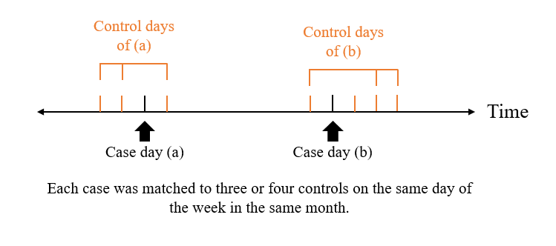

Fig. S2. Time trend of proportion of preterm birth (PTB) and temperature during 2011–2019. Proportion of PTB was calculated by dividing the number of PTB by total number of births.
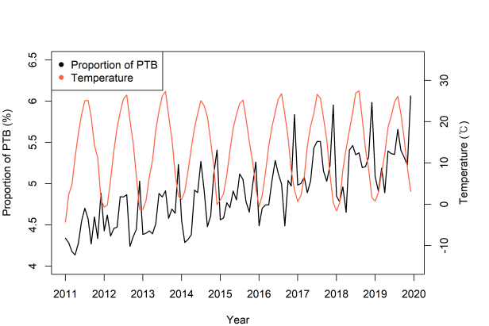
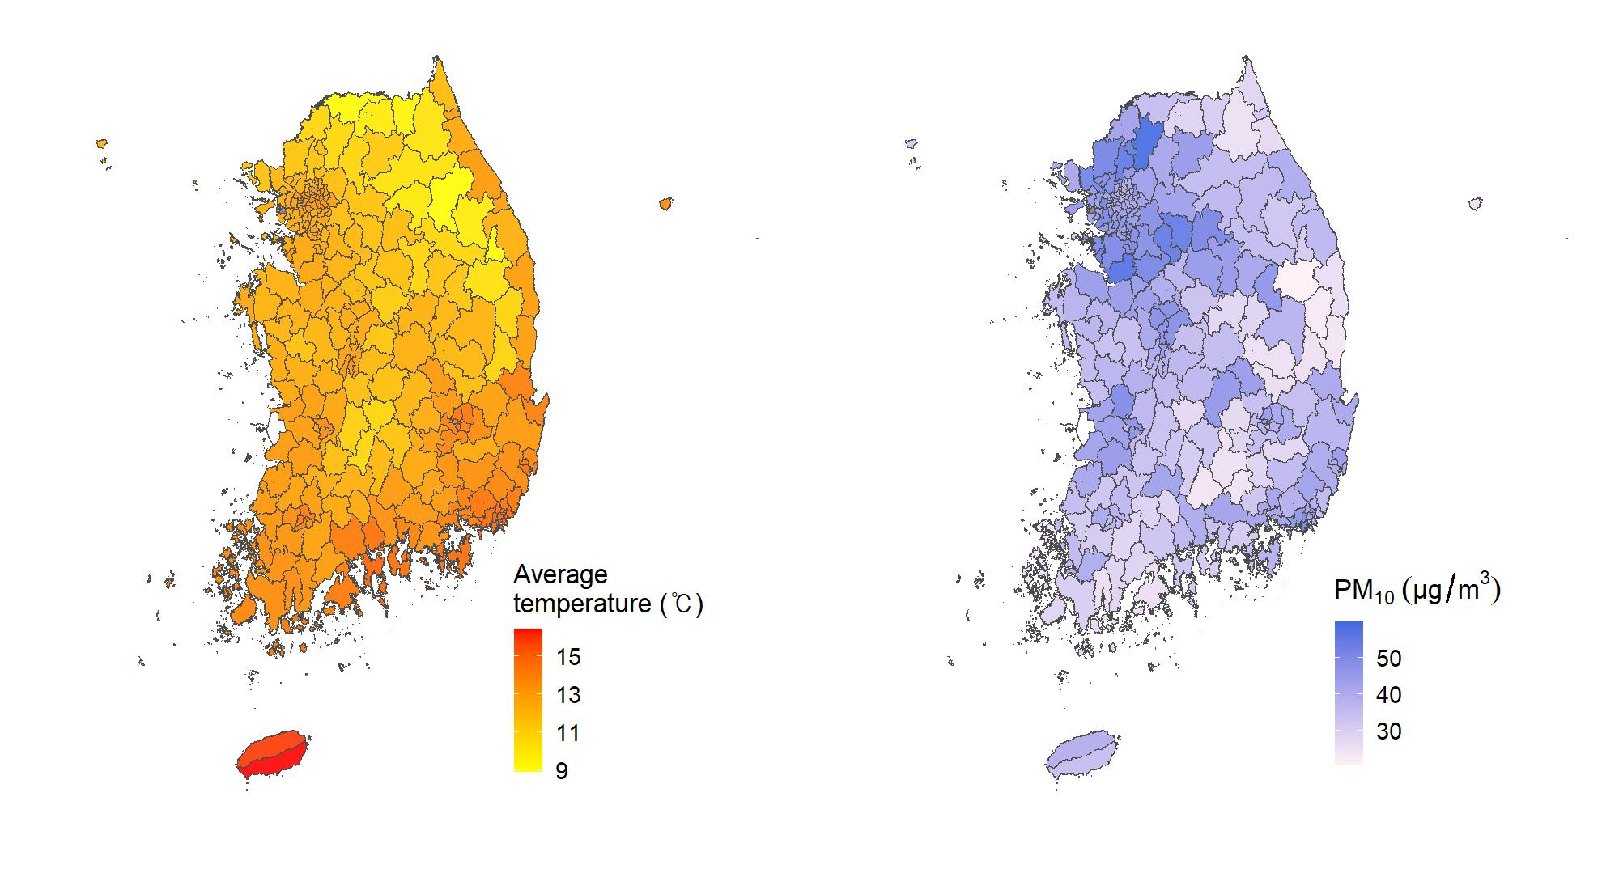
Fig. S3. Spatial distribution of district-level mean temperature and PM₁₀ concentration during 2011–2019

