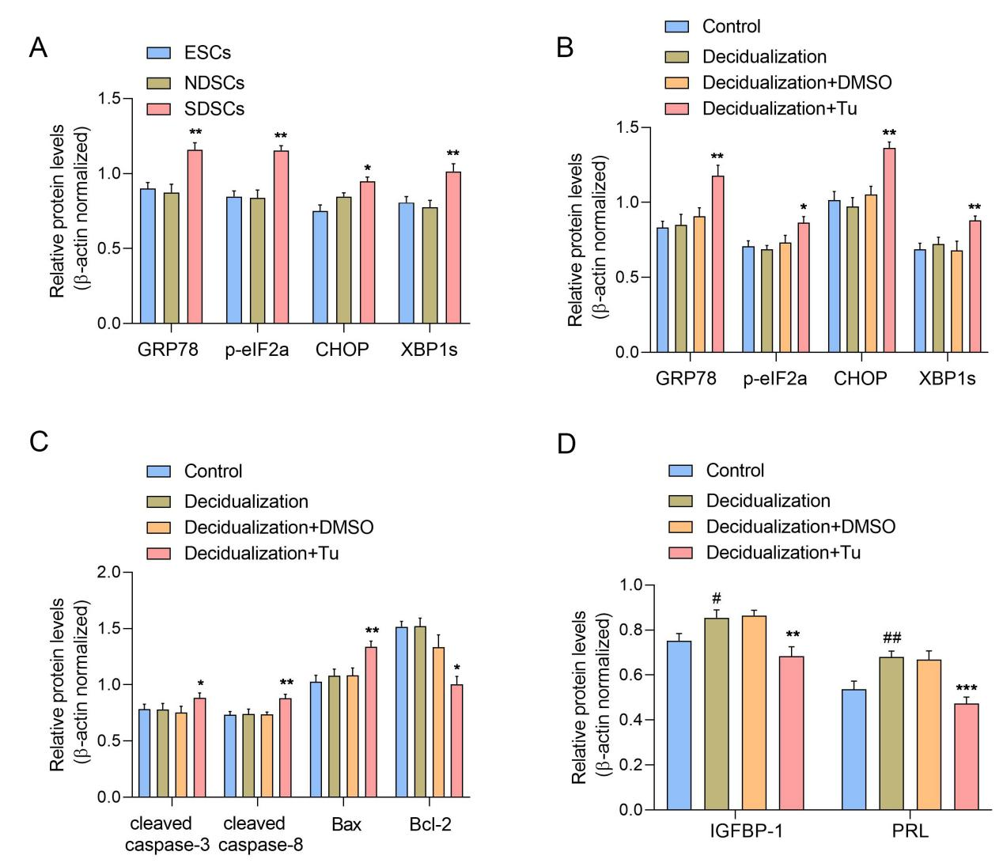
Supplementary Figure 1. ERS and apoptotic proteins were increased in ERS-DSCs. (A) Quantification of GRP78, p-eIF2α, CHOP and XBP1s protein in primary cultured ESCs, NDSCs, and SDSCs. (B) Quantification of GRP78, p-eIF2α, CHOP and XBP1s protein in ESCs with or without ERS. (C) Quantification of cleaved caspase-3, cleaved caspase-8, Bax and Bcl-2 protein in ESCs with or without ERS. (D) Quantification of IGFBP-1 and PRL protein in ESCs with or without ERS. * P<0.05, ** P<0.01, *** P<0.001 VS Decidulization+Tu group. # P<0.05, ## P<0.01 VS Control.

Supplementary Table 1. Primers for RT-qPCR.
Gene | Forward sequence (5'-3') | Reverse sequence (5'-3')
XBP1 | ACACGCTTGGGAATGGACAC | GGTCCAAGTTGTCCAGAATGC
TRAF2 | TCTCACCCTCTACCGTCTCG | CCCTTAACTTGTGACGGCTG
TRAF6 | TGCACAAGATGGAACTGAGAC | CCTGTCTCCTTGGACAATCC
MAP3K8 | ATGAGCCCAGAGGTCATCCT | ATTCCTCGGTGCTTCCTGTG
TNFAIP3 | CTTGTGGCGCTGAAAACGAA | GCAGTTGGGCGTTTCACATT
ULK4 | TTCTTTGCTTTGGTGGCAGC | CTGAAGAAGCTTTAGGACGAGA
IL-6 | TGAACTCCTTCTCCACAAGCG | ATTTGTGGTTGGGTCAGGGG
IL-1β | GCTCGCCAGTGAAATGATGG | AACACGCAGGACAGGTACAG
TNF-α | GTGACAAGCCTGTAGCCCAT | CAGACTCGGCAAAGTCGAGA
IL-18 | TGACCAAGGAAATCGGCCTC | ATGGTCCGGGGTGCATTATC
β-actin | ATCAAGATCATTGCTCCTCCTGAG | CTGCTTGCTGATCCACATCTG

