Supplementary Fig. S1
DRG2 and p53 expressions in prostate cancer cell lines as determined via western blot analysis.
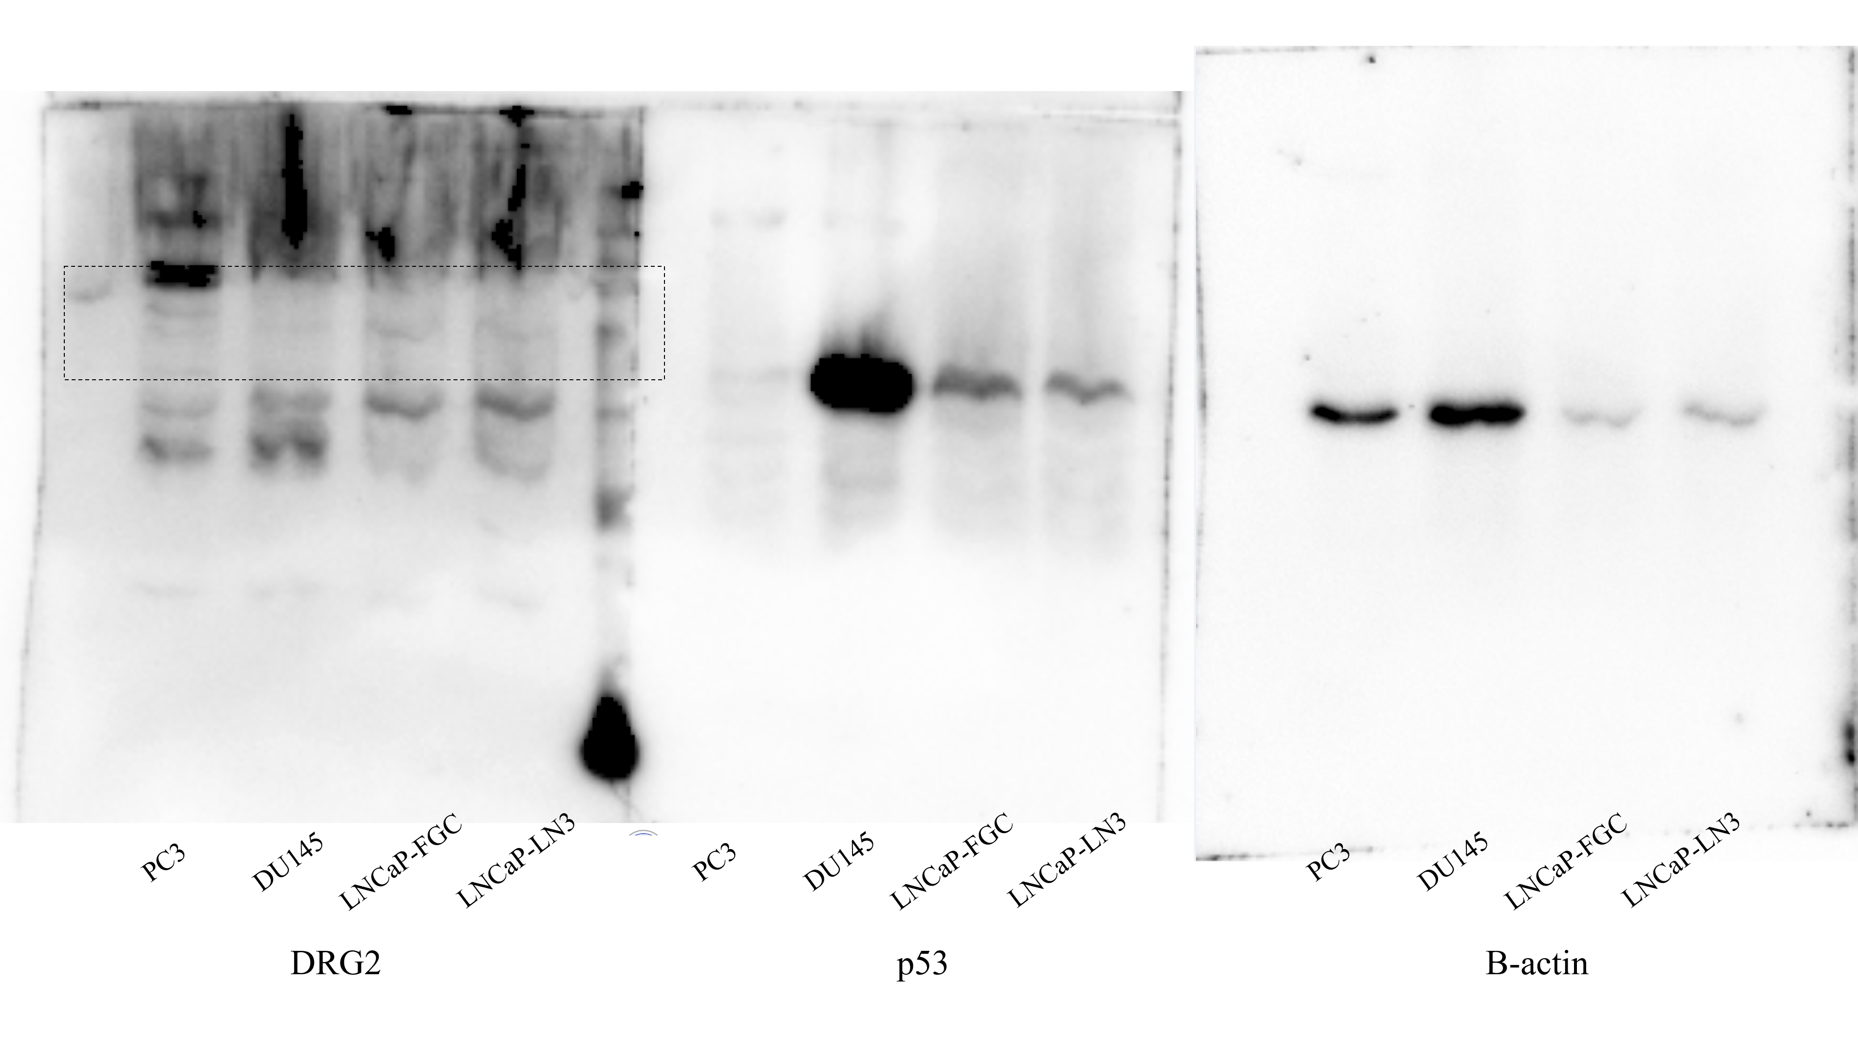
→ 41-45kDa
→ 53kDa
→ 43kDa

Supplementary Fig. S2
Change in cdc2 expression after docetaxel treatment analyzed via western blot analysis.
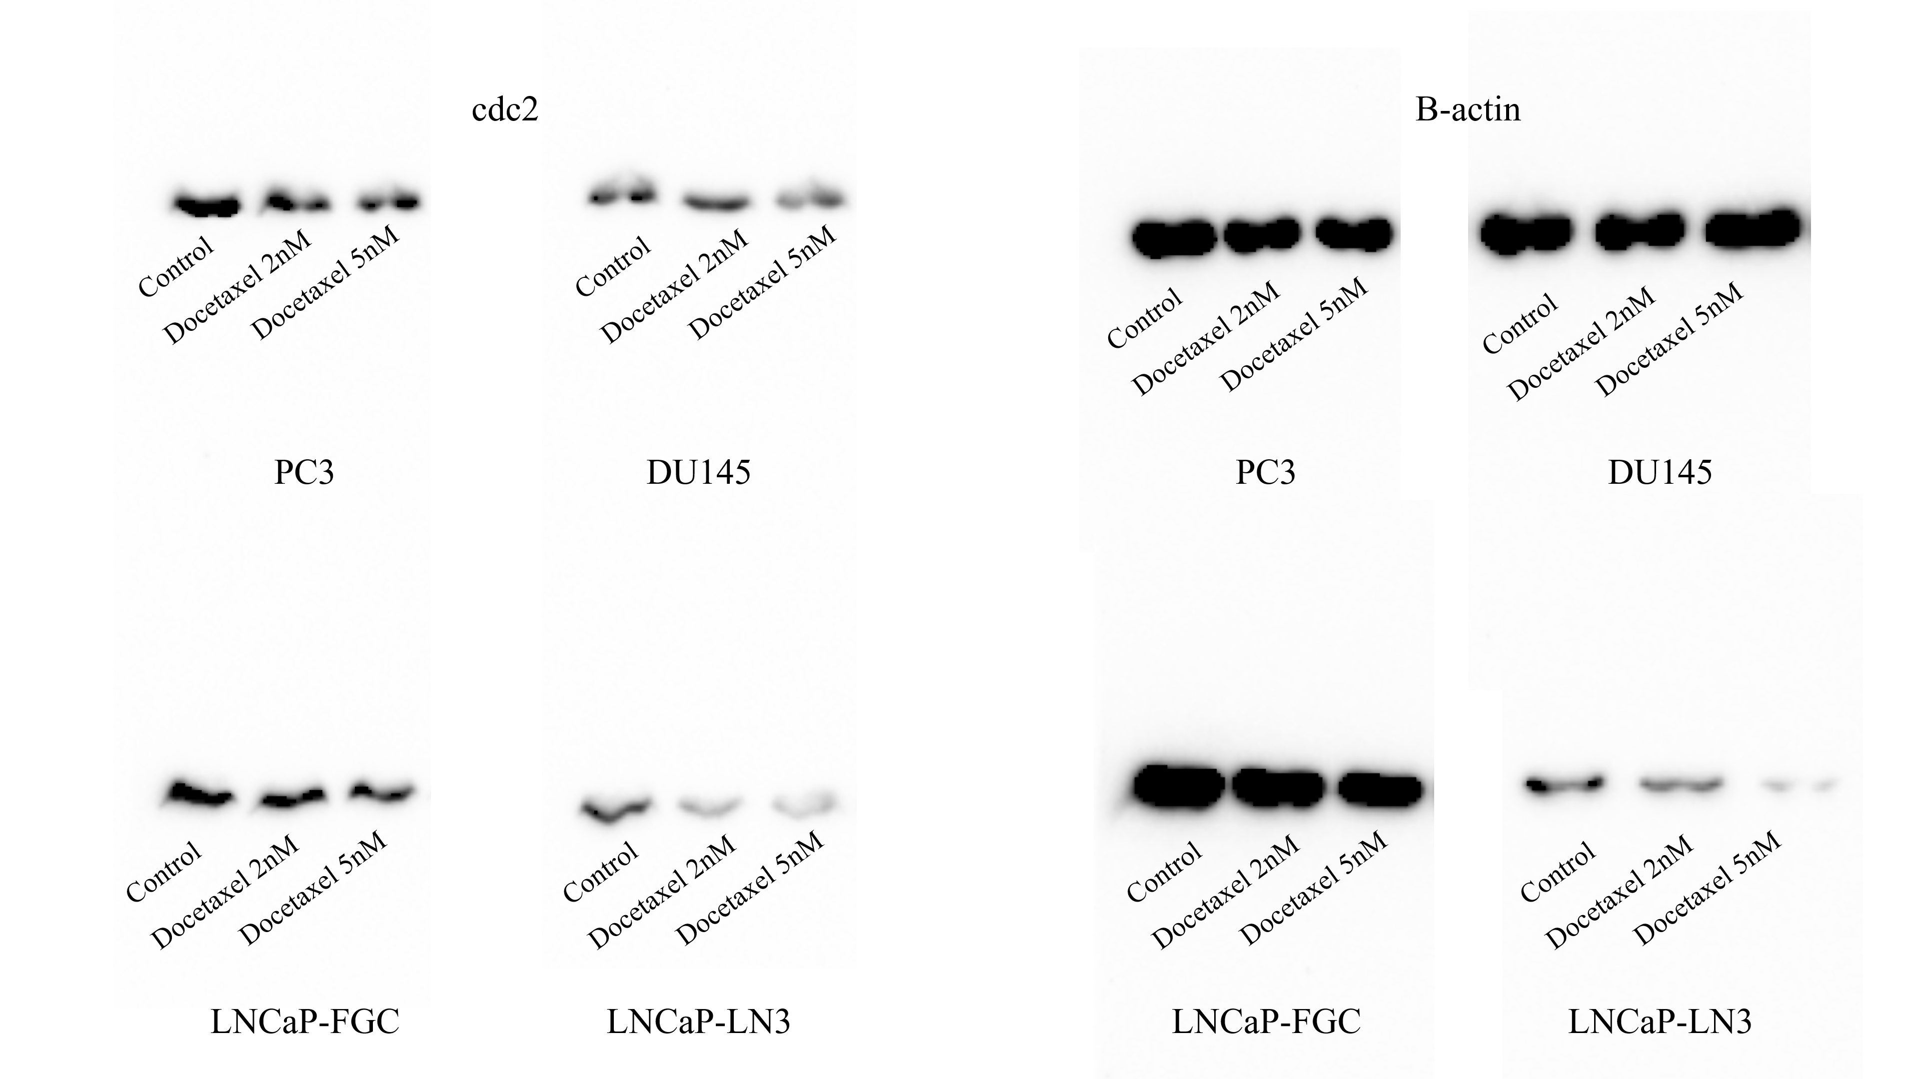
→ 43kDa
→ 34kDa
Supplementary Fig. S3
Changes in DRG2 expression in the cytoplasm and nuclear extracts after docetaxel treatment analyzed via western blot analysis
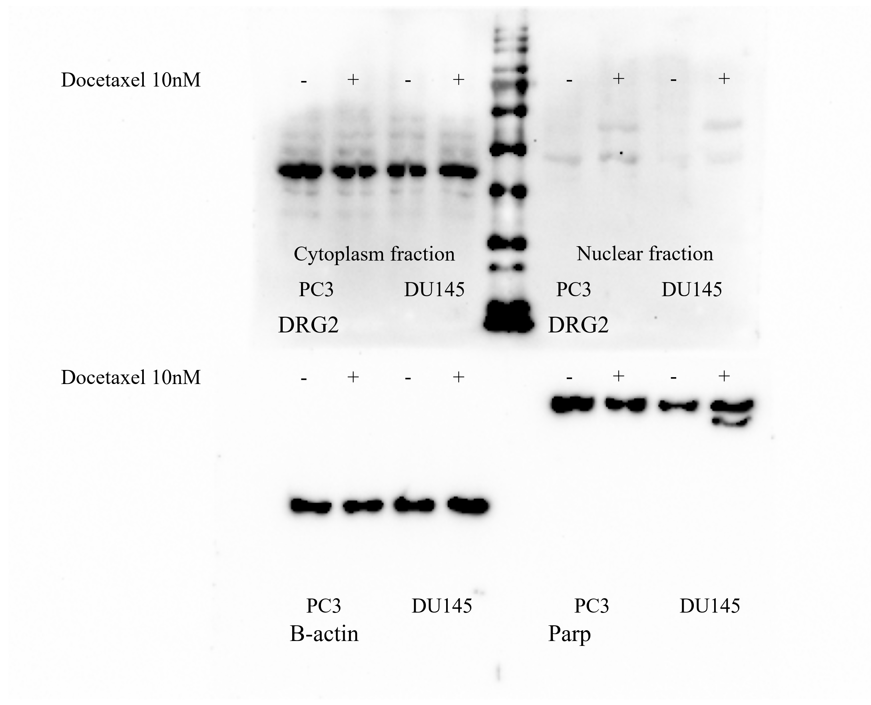
→ 43kDa
→ 86, 119kDa
→ 41-45kDa
→ 41-45kDa

Supplementary Fig. S4
PARP and Rad 51 expressions in PC3 and DU145 cells as determined via western blot analysis
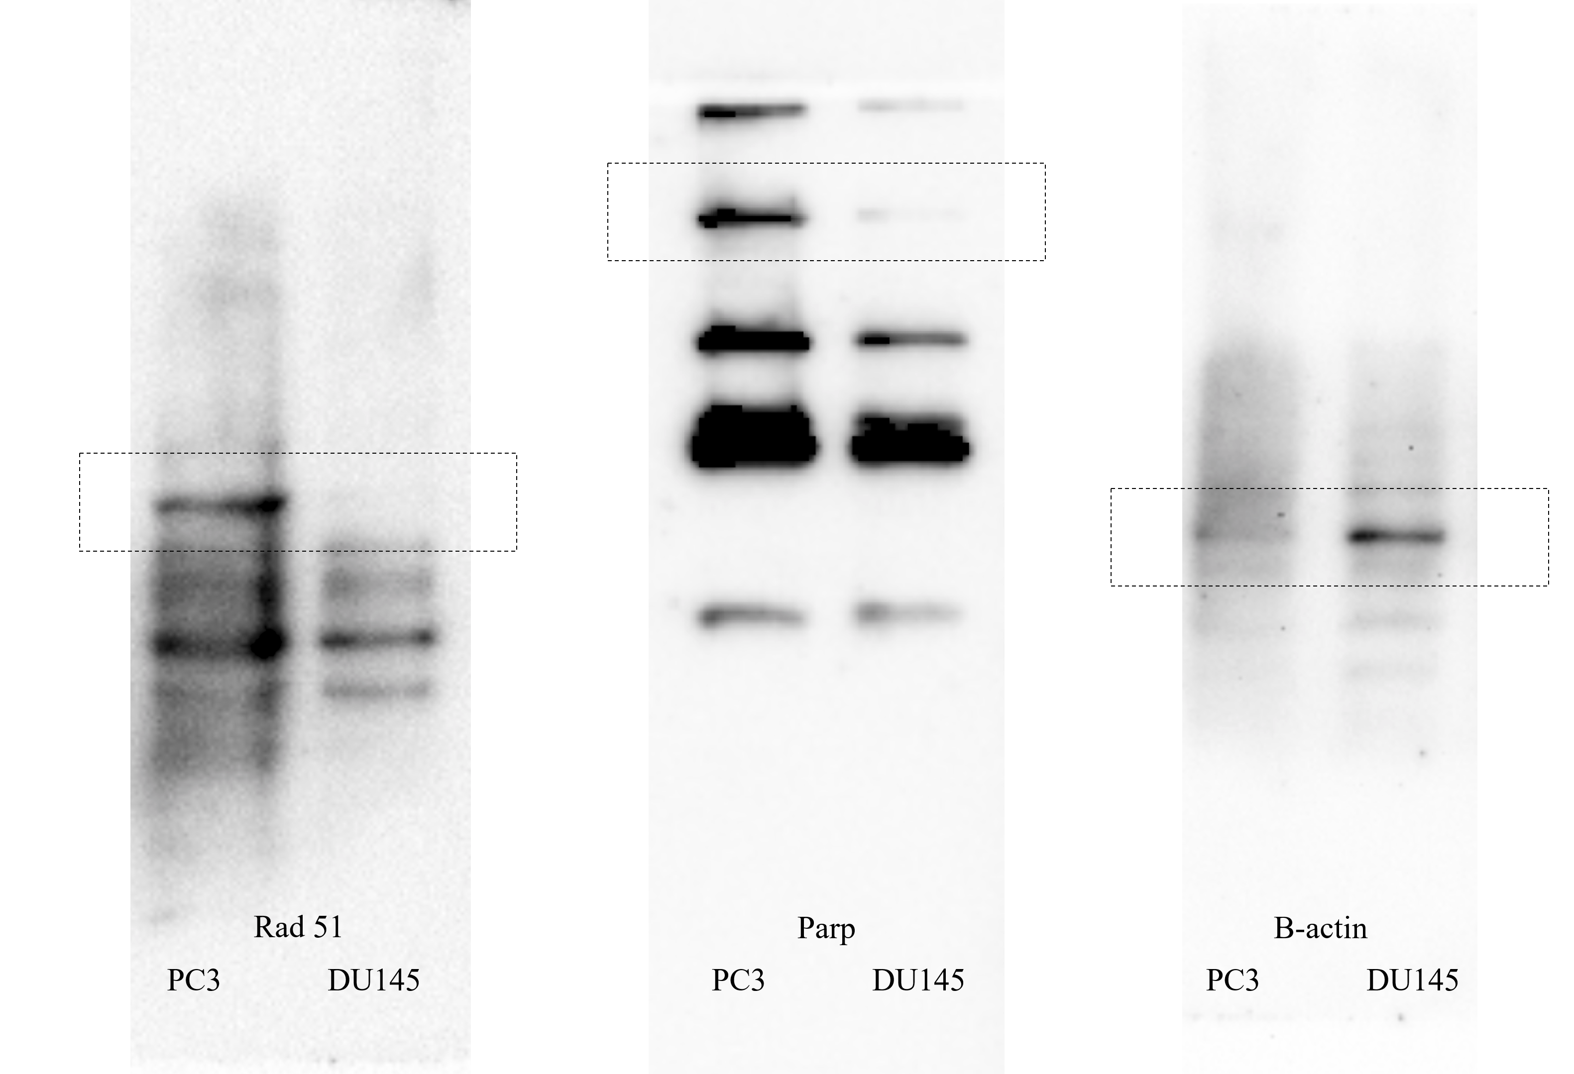
→ 43kDa
→ 119kDa
→ 37kDa
Supplementary Fig. S5
Changes in prostate cancer cell lines (PC3, DU145) caused by administration of etoposide and PARP inhibitor. (a) Cell Viability of PC3 and DU145 cells after treatment with etoposide and olaparib for 72 h. (b) Flow cytometry analysis showing differences in the cell cycle of PC3 and DU145 cells after treatment with etoposide and olaparib for 72 h.

(a)
(b)

