SUPPLEMENTARY MATERIAL for

Seasonal Succession, Host Associations and Biochemical Roles of Aquatic Viruses in a Eutrophic Lake Plagued by Cyanobacterial Blooms
Ling Yuan^{1,2,3,4}, Pingfeng Yu², Xinyu Huang^{1,2}, Ze Zhao^{1,2}, Linxing Chen⁵, Feng Ju^{2,3,4,6}*
¹ Key Laboratory of Coastal Environment and Resources of Zhejiang Province, School of Engineering, Westlake University, Hangzhou 310024, Zhejiang Province, China
² College of Environmental and Resource Sciences, Zhejiang University, Hangzhou 310058, China
³ Institute of Advanced Technology, Westlake Institute for Advanced Study, Hangzhou 310024, Zhejiang Province, China.
⁴ Center of Synthetic Biology and Integrated Bioengineering, Westlake University, Hangzhou 310030, Zhejiang Province, China
⁵ Department of Earth and Planetary Sciences, University of California, Berkeley, CA, USA
⁶ Westlake Laboratory of Life Sciences and Biomedicine, Hangzhou 310024, Zhejiang Province, China
* Correspondence to
Dr. Feng Ju, Email: jufeng@westlake.edu.cn
Address: Westlake University, 600 Dunyu Road, Hangzhou 310030, China
Tel.: 571-87963205 (lab), 571-87380995 (office), Fax: 0571-85271986

Legends
Supplementary Figures and Table
Figure S1. Bioinformatic framework for Taihu viral study
Figure S2. PCA analysis of bacterial communities in free-living biomass metagenomes in Taihu
Figure S3. Strong correlations between viral clusters and environmental parameters; Variance partitioning analysis for representative environmental factors and representatives of microbial community
Figure S4. Genomic contexts and gene annotation of 19 Microcystis phages
Figure S5. Genomic contexts and gene annotation of a near-complete T4-like Synechococcus phage genome
Figure S6. Phylogenetic trees of viral photosynthetic genes
Table S1. The occurrence rate of different vAMG groups in viral clusters in seasons
Supplementary Text. A brief introduction of potential metabolic capabilities brought by viruses
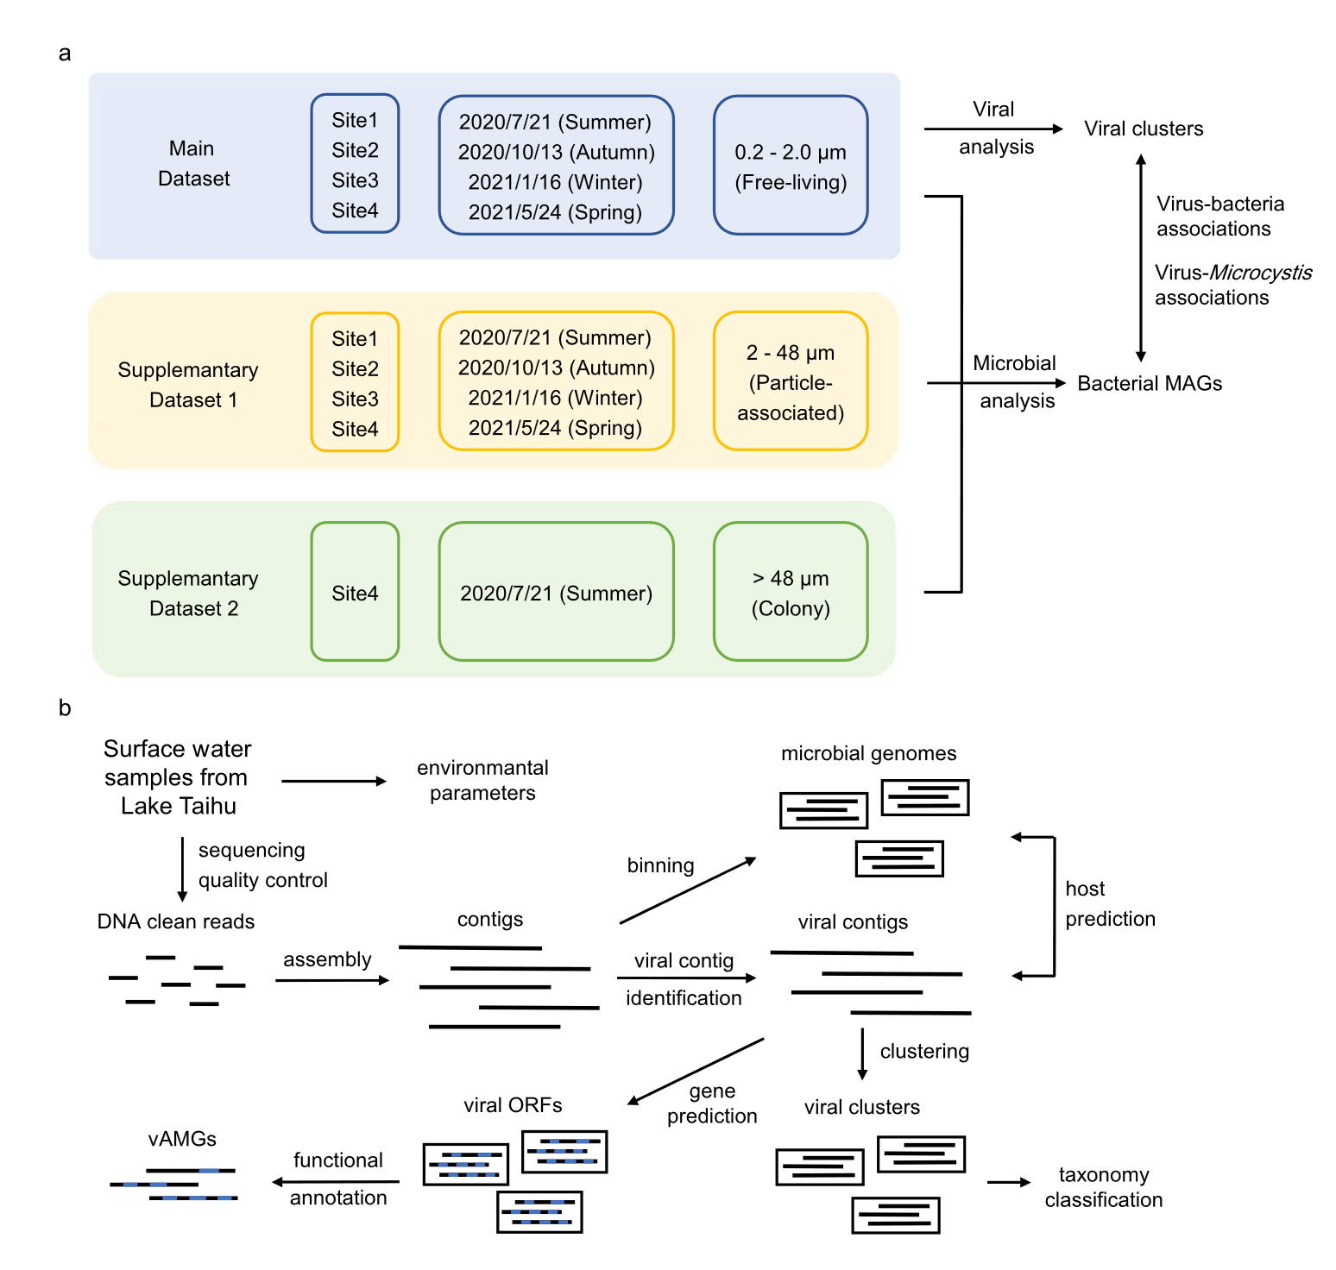

Figure S1. Bioinformatic framework for Taihu viral study. a. Sampling design. A total of 33 water samples of Taihu were sequenced. Sixteen free-living biomass metagenomes from four sites and four seasons (main dataset) were used for viral contigs recovery. Then, 16 free-living, 16 particle-associated (supplementary dataset 1) and 1 colony metagenome (Supplemaentary dataset 2) were used to recover metagenome-assembled genomes (MAGs) and predict the virus-host associations in the downstream analysis. b. Bioinformatic steps for viral recovery, details in Methods.
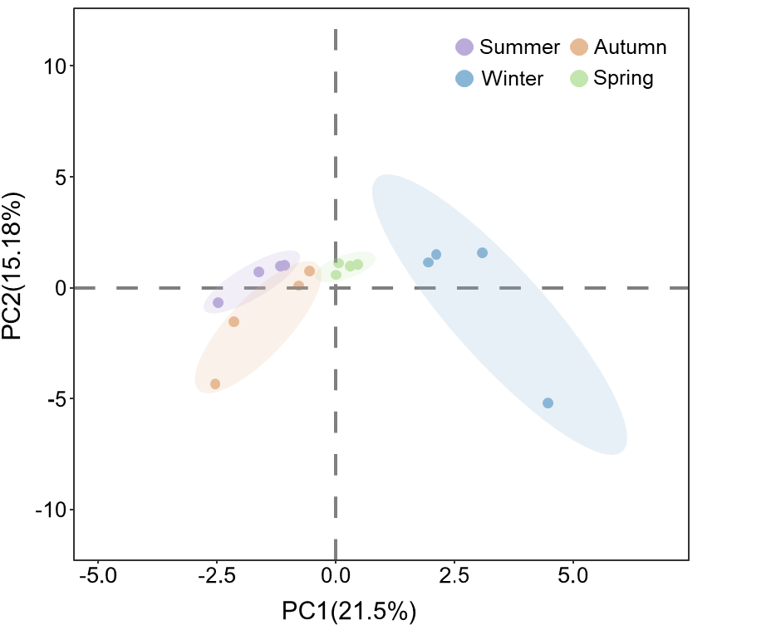

Figure S2. PCA analysis of bacterial communities in free-living biomass metagenomes in Taihu.
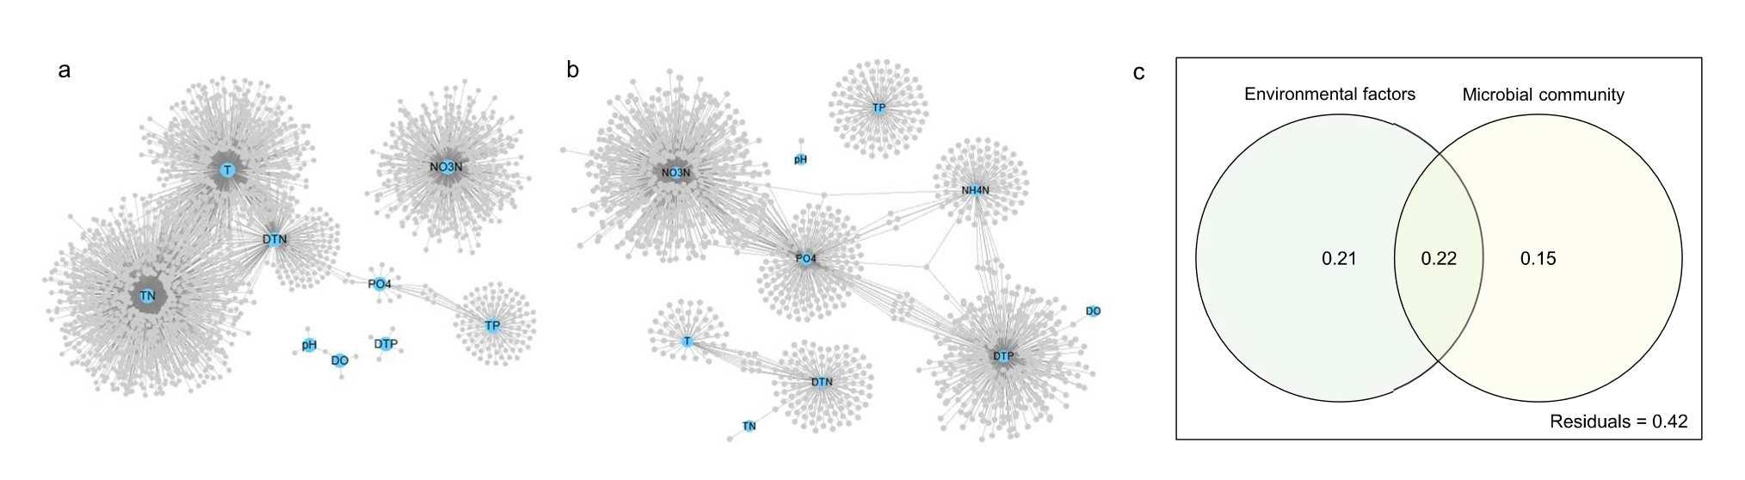

Figure S3. Strong correlations between viral clusters and environmental parameters (a and b). The abundance of viral clusters showed strong positive (a) and negative (b) correlation with measured environmental parameters. A strong correlation was identified if Pearson coeffiency r > 0.7 and FDR-adjusted P < 0.05.
c. Variance partitioning analysis for representative environmental factors (TN, NO₃-N, DTN, TP and temperature) and representatives of microbial community (Cyanobacteria, Planctomycetes, Proteobacteria, Actinobacteria, Bacteroidetes) on viral community structure.
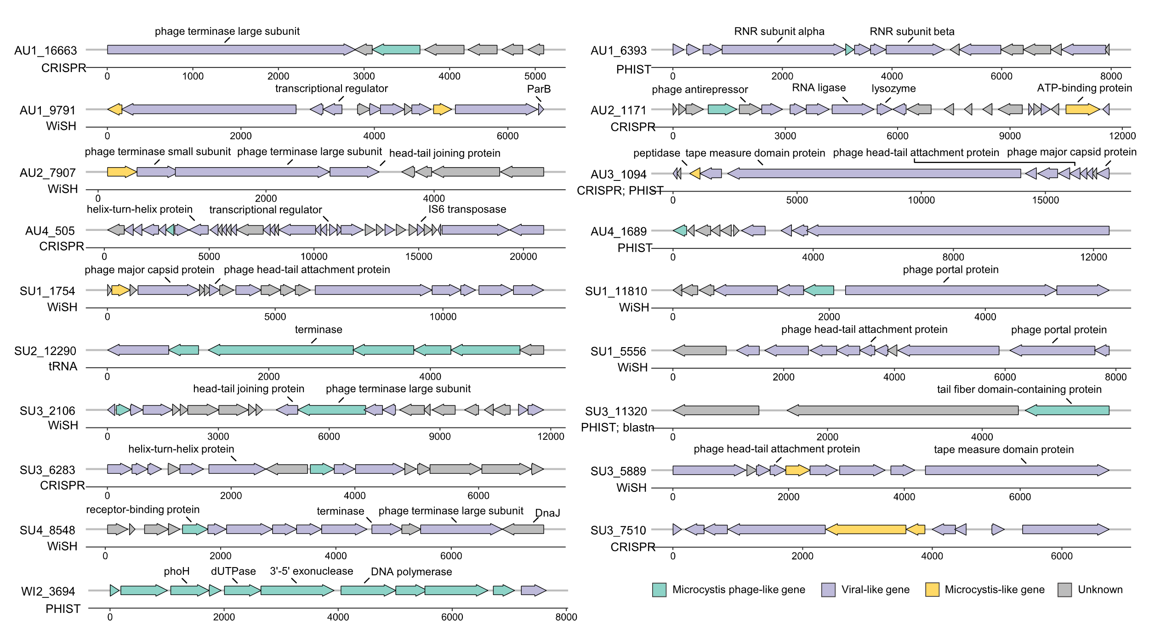

Figure S4. Genomic contexts and gene annotation of 19 Microcystis phages. Only the viral clusters encoded at least one Microcystis virus-like or Microcystis-like gene were regarded as high-confidence Microcystis phages and illustrated.

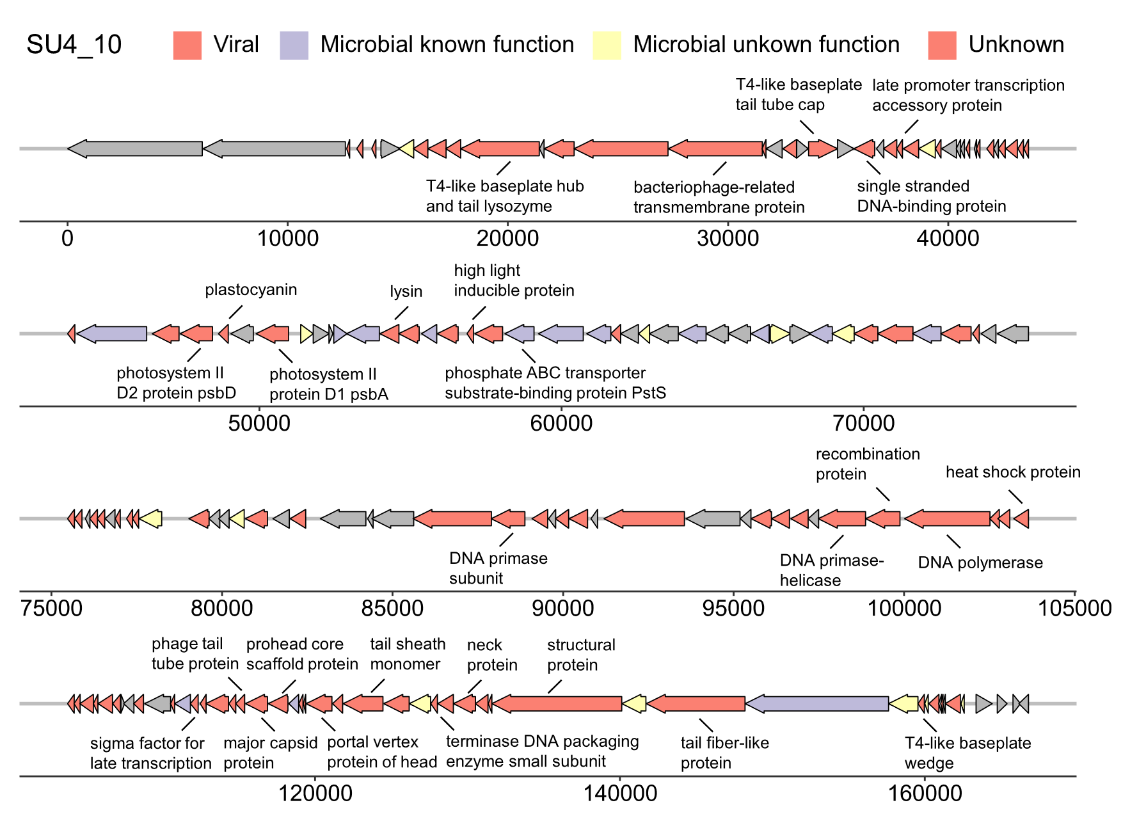

Figure S5. Genomic contexts and gene annotation of a near-complete T4-like Synechococcus phage genome.
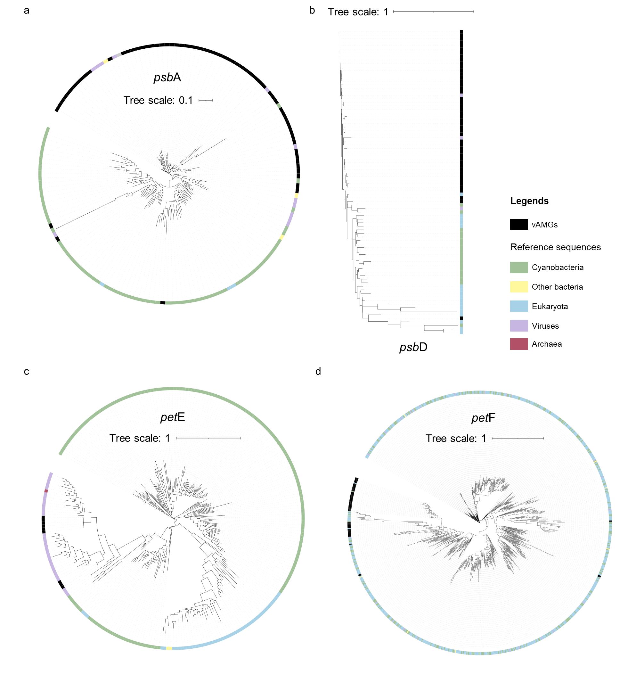Figure S6. Phylogenetic trees of viral photosynthetic genes. Phylogenetic trees of viral psbA (a), psbD (b), petE (c) and petF (d). Reference sequences similar to vAMGs were recruited from NCBI nr database (blastp, bit-score > 50, e-value < 0.00001) and then clustered by cd-hit with 90% global sequence identity.

Table S1. The occurrence rate of different vAMG groups in viral clusters in seasons.
Occurrence rate (%) | SU | AU | WI | SP
Antibiotic resistance | 3.18 ± 0.04 | 3.35 ± 0.14 | 2.55 ± 0.43 | 2.82 ± 0.50
Photosynthesis | 1.30 ± 0.83 | 0.74 ± 0.09 | 1.64 ± 0.59 | 3.66 ± 1.64
Amino acids | 6.84 ± 1.01 | 5.29 ± 0.16 | 7.20 ± 0.53 | 9.32 ± 1.34
Phosphate regulation | 7.76 ± 0.35 | 6.34 ± 0.13 | 7.10 ± 0.25 | 8.75 ± 1.54
Vitamins and cofactors | 11.24 ± 0.94 | 8.53 ± 0.50 | 12.53 ± 0.07 | 12.69 ± 1.26
Iron-sulfur | 2.70 ± 0.22 | 2.16 ± 0.06 | 2.77 ± 0.26 | 3.24 ± 0.22
Sulfur metabolism | 1.18 ± 0.04 | 1.26 ± 0.18 | 1.14 ± 0.09 | 1.08 ± 0.16
Carbohydrates | 9.87 ± 1.16 | 9.04 ± 0.66 | 10.16 ± 0.31 | 12.60 ± 1.74
Glycans | 2.67 ± 0.30 | 2.29 ± 0.26 | 2.16 ± 0.43 | 3.79 ± 0.34
Queuosine synthesis | 4.66 ± 0.14 | 3.54 ± 0.68 | 3.74 ± 0.25 | 4.23 ± 0.83
Lipids | 3.79 ± 0.10 | 3.06 ± 0.11 | 4.41 ± 0.17 | 3.42 ± 0.22

Supplementary Text. A brief introduction of potential metabolic capabilities brought by viruses
Functionally, the most representative vAMGs were those involved in photosynthesis, Calvin cycle repression, and pentose phosphate pathway as later discussed in the manuscript. Phosphate starvation-inducible protein phoH was the most numerous vAMG gene type (n = 356), which has been regarded as a universal vAMG in different ecosystems (1, 2) and even as a marker gene for marine viruses (3). The metabolic function of phoH remained elusive but was predicted to assist in phosphate uptake for the cell (3). Five nitric oxide reductase norQ proteins and 64 phosphoadenosine phosphosulfate reductase cysH involved in nitrogen metabolism and sulfur metabolism were found in the viral clusters, which may impact nitrogen and sulfur cycling in Taihu, respectively. A total of 96 vAMGs were related to iron-sulfur cluster, which can be classified into four ISC machinery gene types (IscS, IscU, IscA and fdx) and one SUF machinery gene (WhiB). Iron-sulfur cluster proteins involve in a variety of physiological pathways including electron transfer, catalysis and gene regulation (4), and viruses probably took use of the iron-sulfur cluster proteins to promote various physiochemical properties, e.g., photosynthesis, which ironically depends on the iron-sulfur clusters. queC, queD, queE, and queF, which involved in queuosine biosynthesis, were found encoded by 23, 88, 112, and 18 viral clusters, respectively (Dataset S1). These genes are responsible for tRNA modification, which may increase translation efficiency and provide a feedback signal to virus controlling self-assembly (4, 5). The most common vAMGs involved in metabolism of vitamins and cofactors included 238 cobS and 20 cobT responsible for Vitamin B12 biosynthesis. One near-complete (84.94%, CheckV) T4-like phage SU4_10 was found to encode typical types of aforementioned vAMGs including photosynthetic genes, CP12, and phosphate regulons (Fig. S5s). SU4_10 was predicted to infect Microcystis by PHIST, but gene annotation indicated this virus is more likely a Synechococcus phage (Dataset S1 and Dataset S8), which was often occurred in the ocean but also found to present in this freshwater ecosystem. These identified vAMGs highlighted the potential biochemical impacts of viruses in Taihu.

References
1. Han LL, Yu DT, Bi L, Du S, Silveira C, Cobian Guemes AG, et al. Distribution of soil viruses across China and their potential role in phosphorous metabolism. Environ Microbiome. 2022;17(1):6.
2. Goldsmith DB, Parsons RJ, Beyene D, Salamon P, Breitbart M. Deep sequencing of the viral phoH gene reveals temporal variation, depth-specific composition, and persistent dominance of the same viral phoH genes in the Sargasso Sea. PeerJ. 2015;3:e997.
3. Goldsmith DB, Crosti G, Dwivedi B, McDaniel LD, Varsani A, Suttle CA, et al. Development of phoH as a novel signature gene for assessing marine phage diversity. Appl Environ Microbiol. 2011;77(21):7730-9.
4. Rouault TA. Biogenesis of iron-sulfur clusters in mammalian cells: new insights and relevance to human disease. Dis Model Mech. 2012;5(2):155-64.
5. Sabri M, Hauser R, Ouellette M, Liu J, Dehbi M, Moeck G, et al. Genome annotation and intraviral interactome for the Streptococcus pneumoniae virulent phage Dp-1. J Bacteriol. 2011;193(2):551-62.

