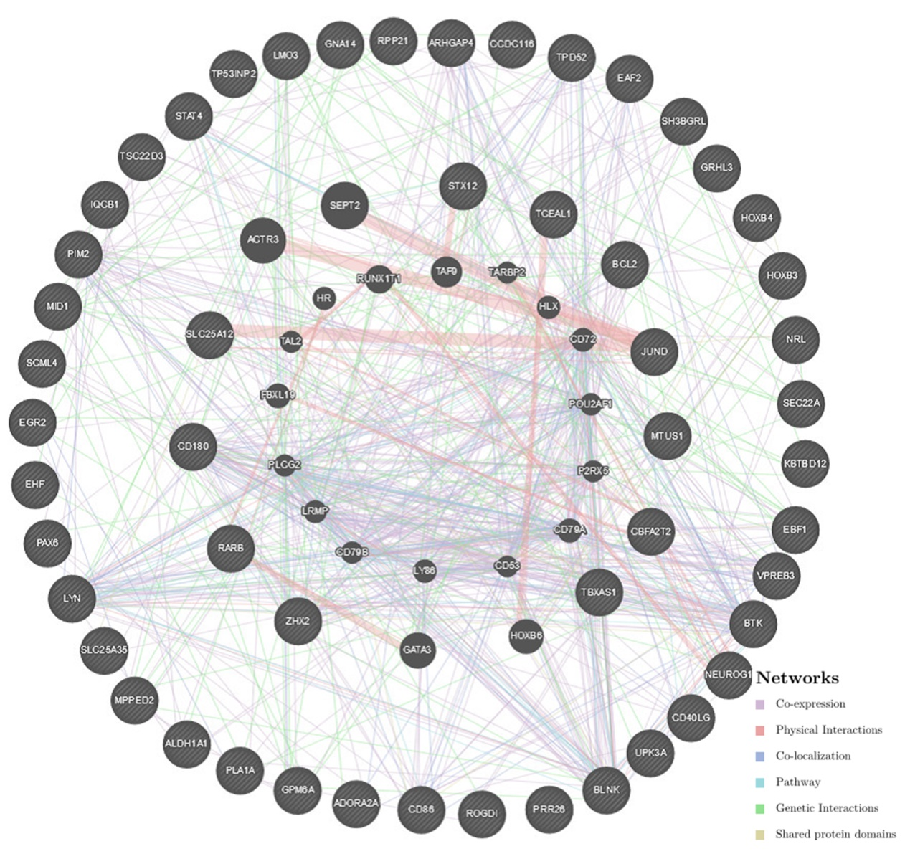
Additional file 10: Figure S3 Protein-protein interaction network of transcription factor OCT1-target networks (GeneMANIA). PPI network analysis indicates the gene set that was enriched in the target networks of transcription factor OCT1. Different colors of the network edge indicate the bioinformatics methods applied: co-expression, physical interactions, co-localization, pathway, genetic interactions and shared protein domains.

