Supporting Information

Title: A completely foldable patch elastically encapsulated by bilayer microfluidics enables in vivo long-term high-resolution electrical imaging at human-machine interfaces

Authors: Chen Hang^{1, †}, Yizhou Jiang^{1,2, †}, Qingyan Rao^{1, †}, Li Ding¹, Jialu Wu¹, Haixuan Zhao¹, Yanwei Cai¹, Jie Qi¹, Yan Zhang^{2,} *, Xingyu Jiang^{1,} *

This file includes:
Supporting Information Figure 1-43, Supplementary Table 1, Supplementary Movie 1-10.
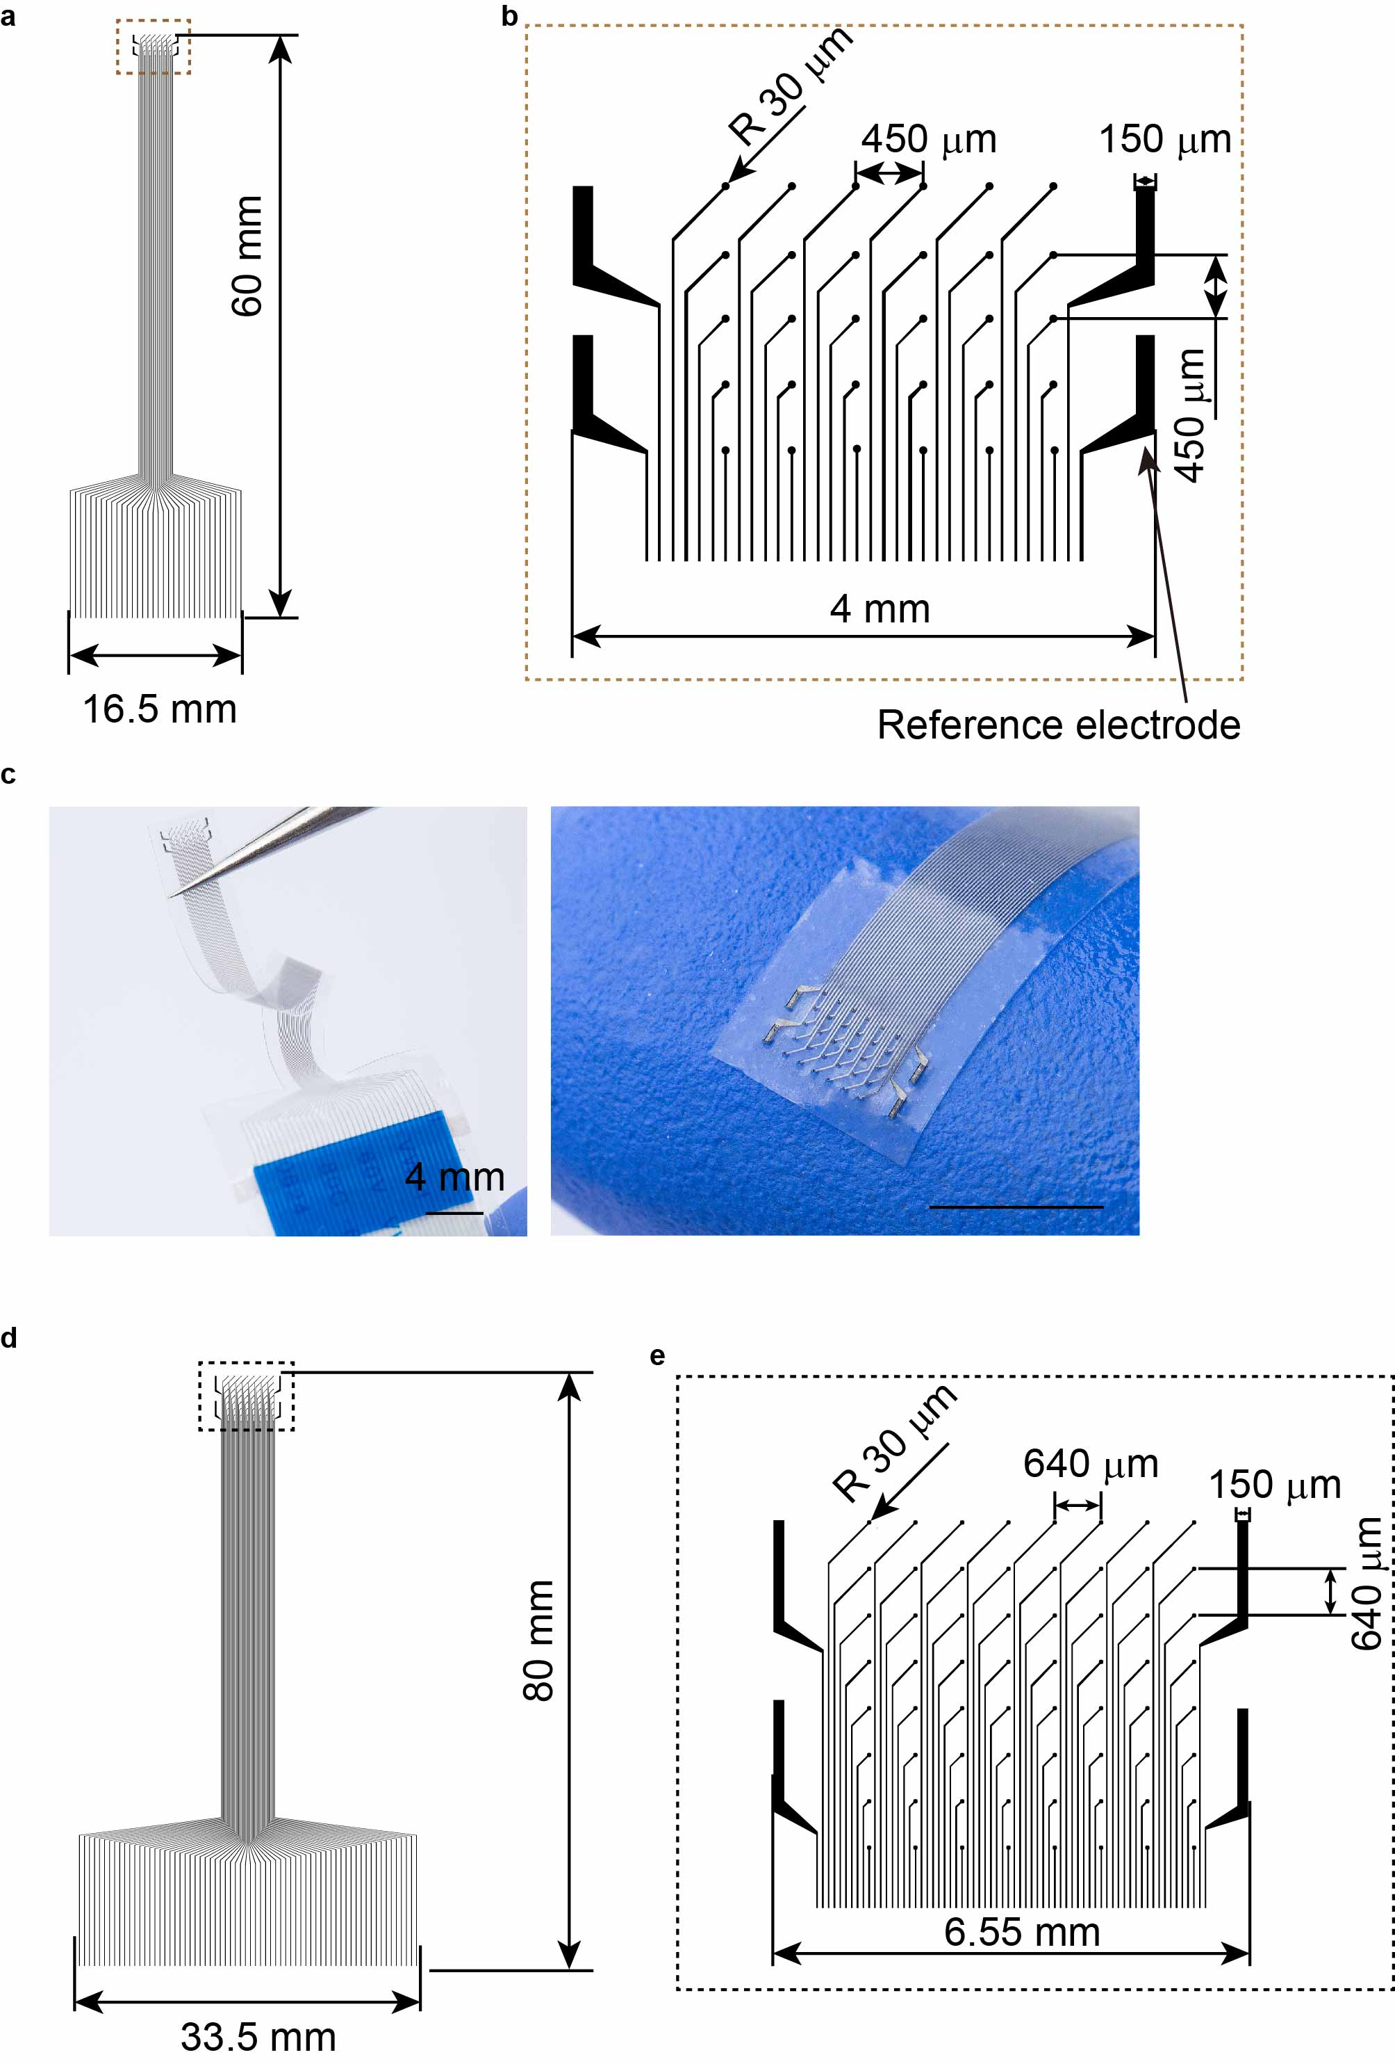
Supplementary Fig. 1. CAD designs of the high-resolution cardiac patch. a, The CAD image of the first layer of a 30-channel cardiac epicardial patch. b, The magnified view of the 30-electrode array. c, The optical images of a 30-channel cardiac patch. Scale bar, 4 mm. d, The CAD image of the first layer of a 64-channel cardiac epicardial patch. e, The magnified view of the 64-electrode array.
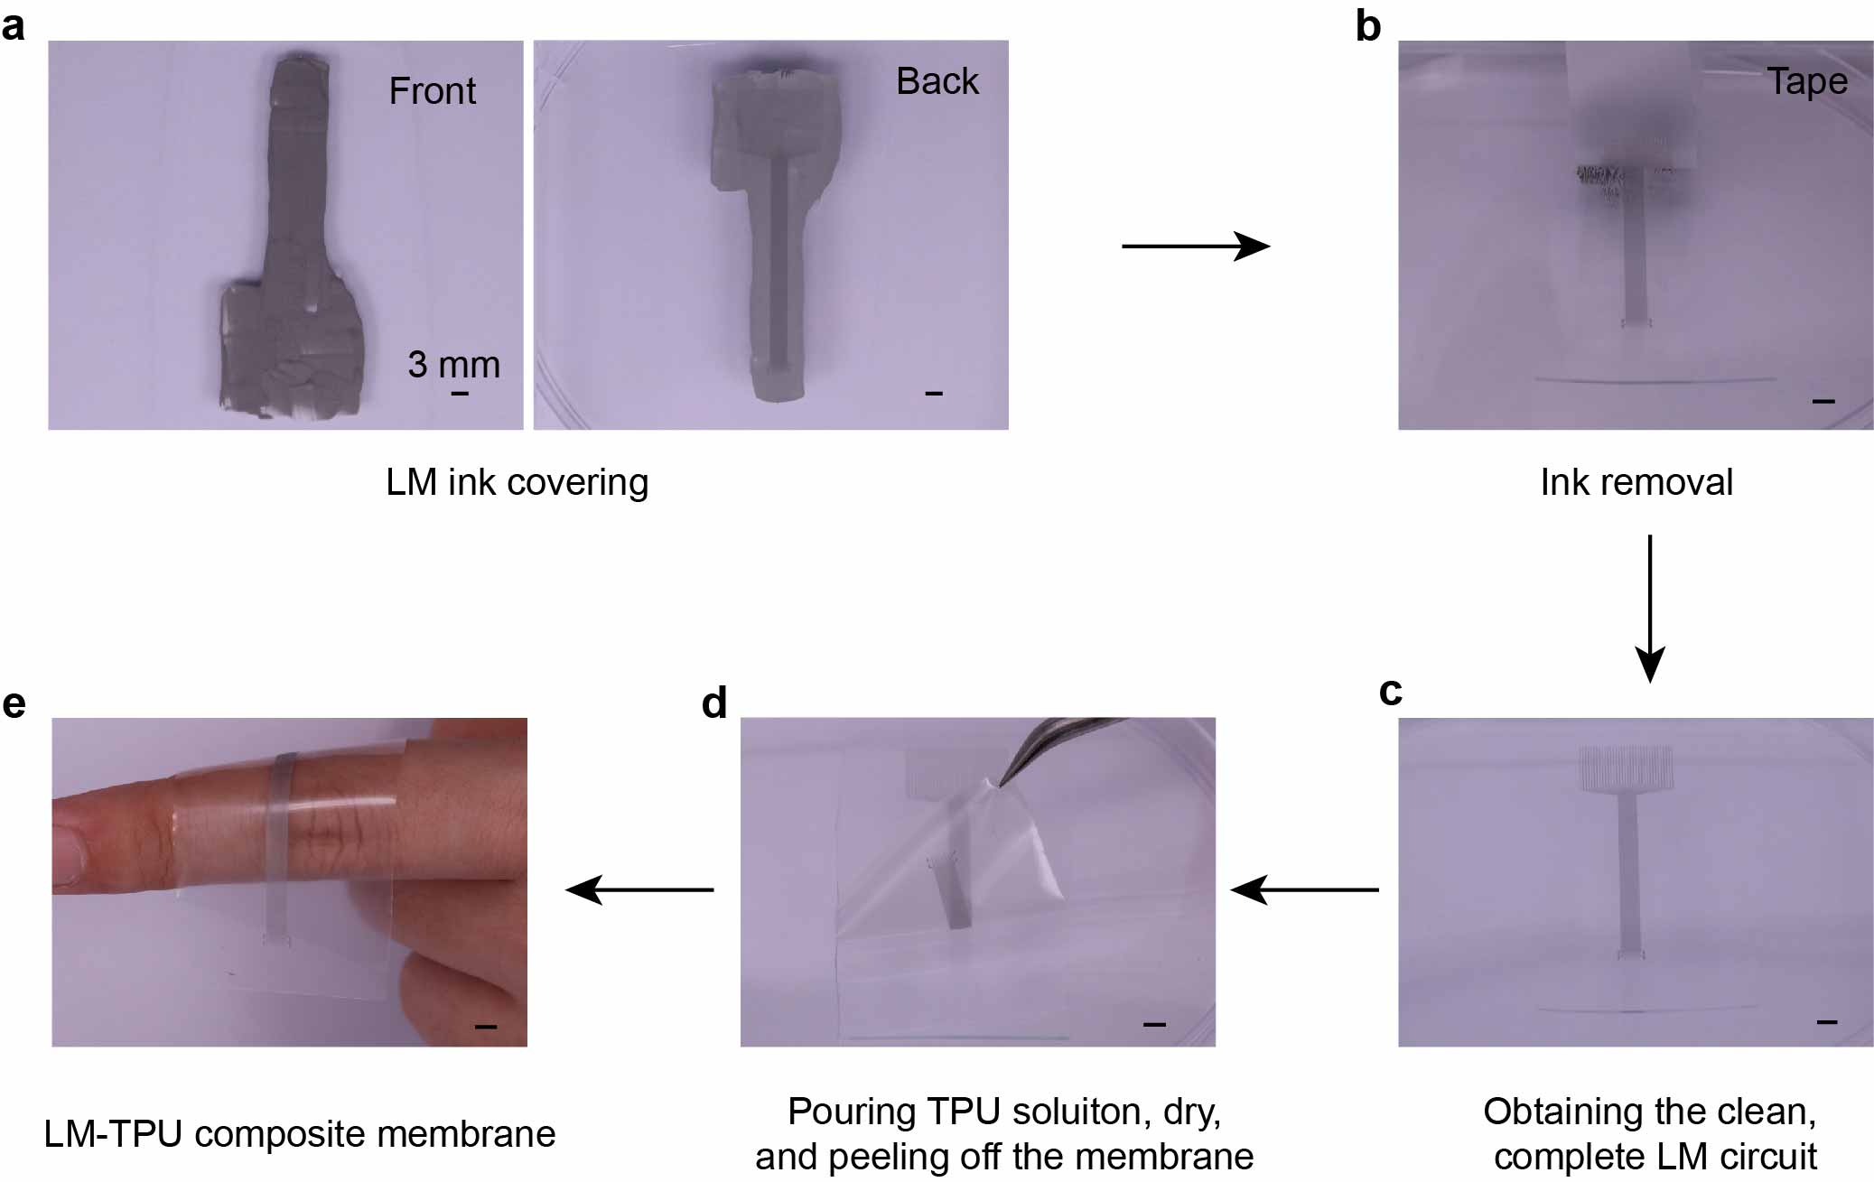
Supplementary Fig. 2. Optical images of the high-resolution liquid metal circuit which was patterned and transferred into a LM-TPU composite membrane.
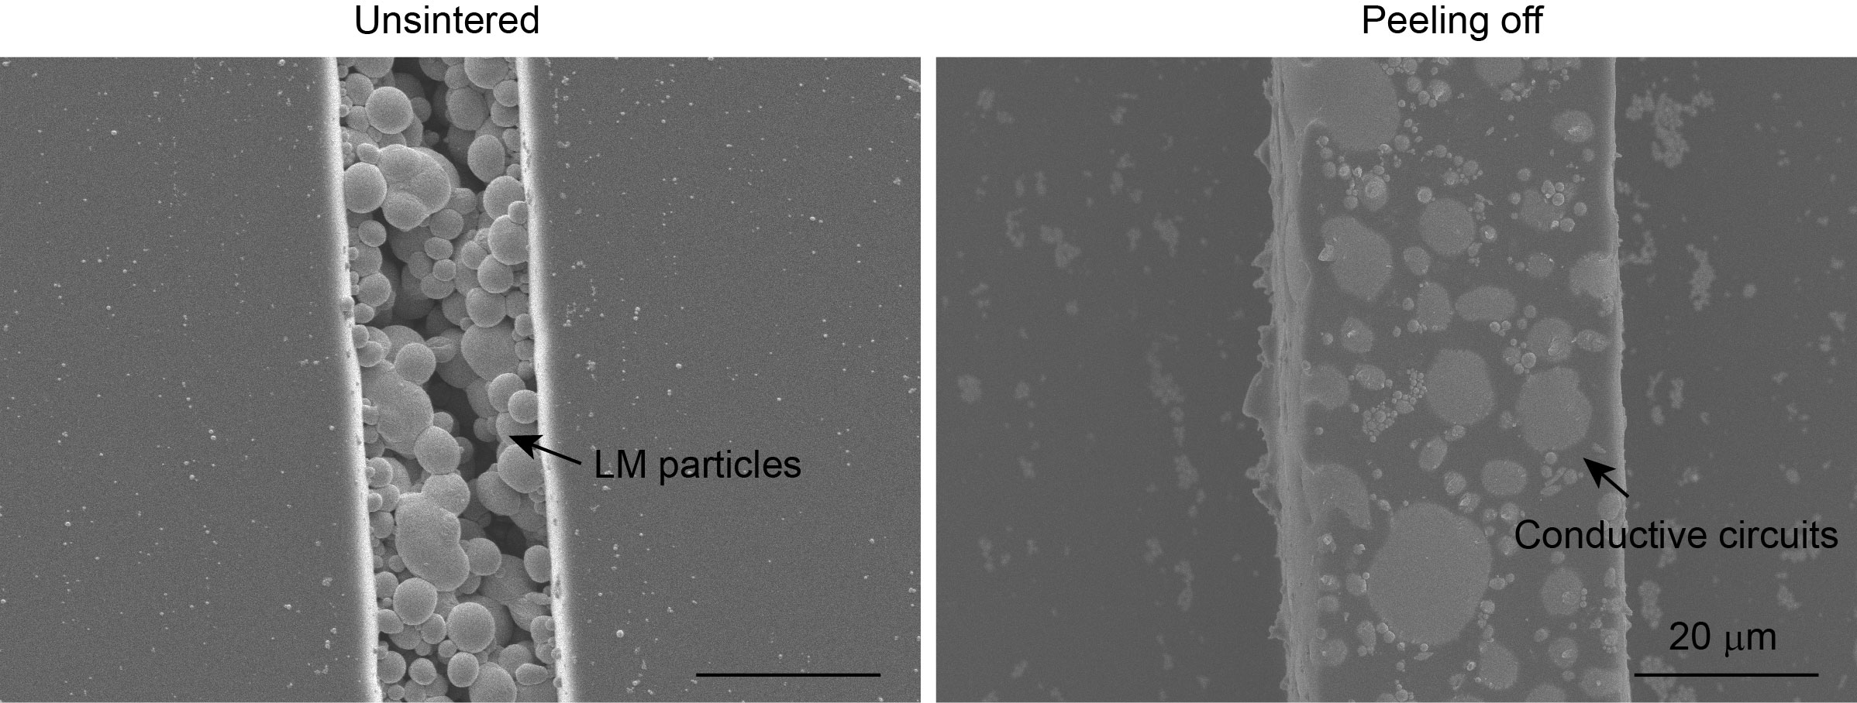
Supplementary Fig. 3. The SEM images of the LM circuits before and after sintering. The sintering process was peeling off the MPC membrane from the PDMS mold. Scale bar, 20 μm.
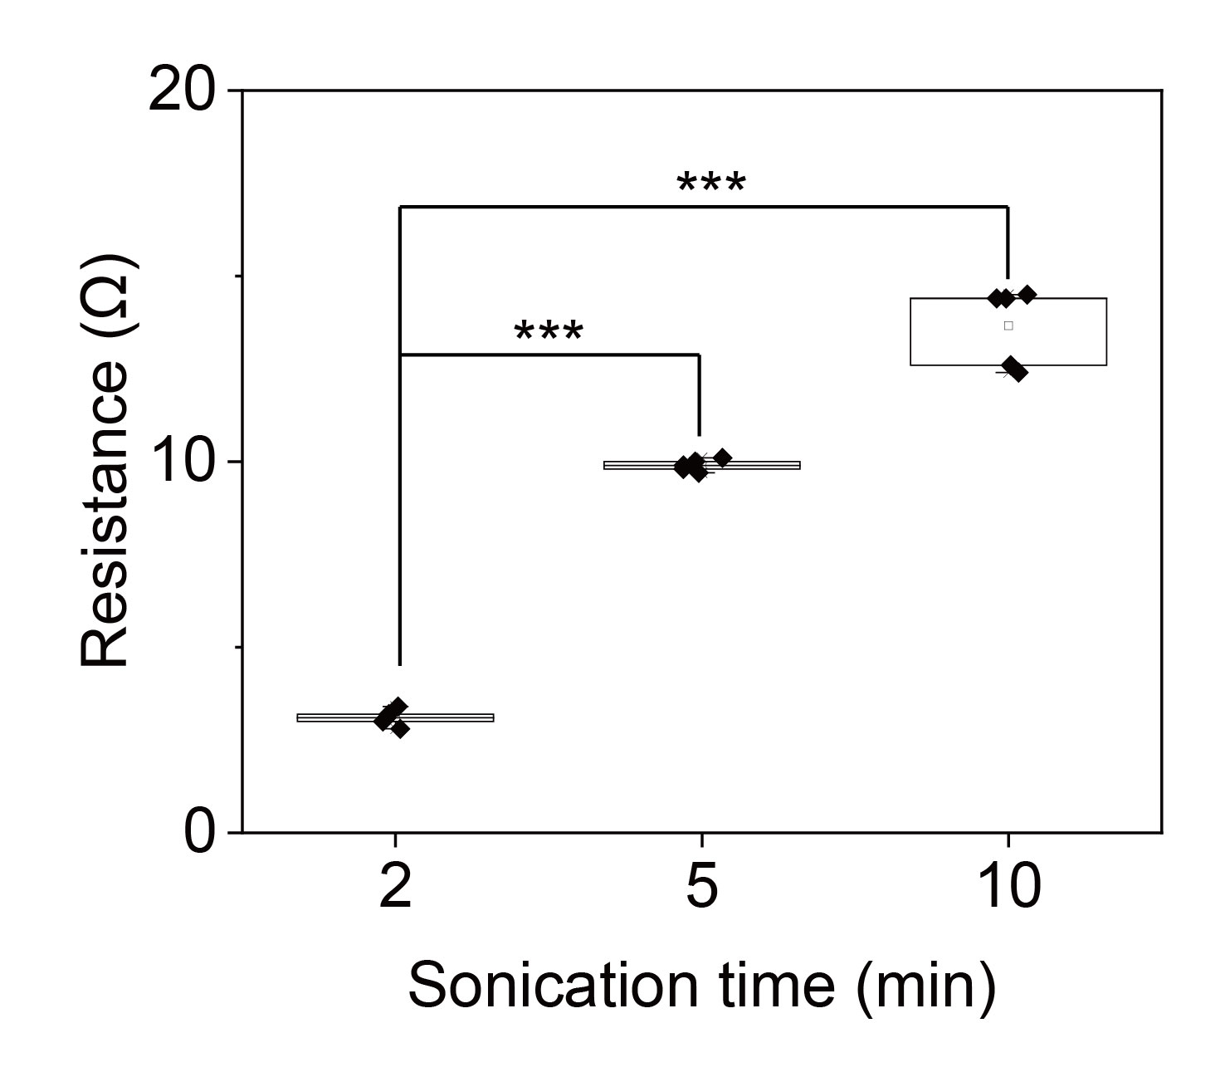
Supplementary Fig. 4. The resistances of the entire channels of the RE patches with different LM sonication times. One-way ANOVA and Tukey’s multiple comparison test determine statistical significance and P values. ***P ≤ 0.001.
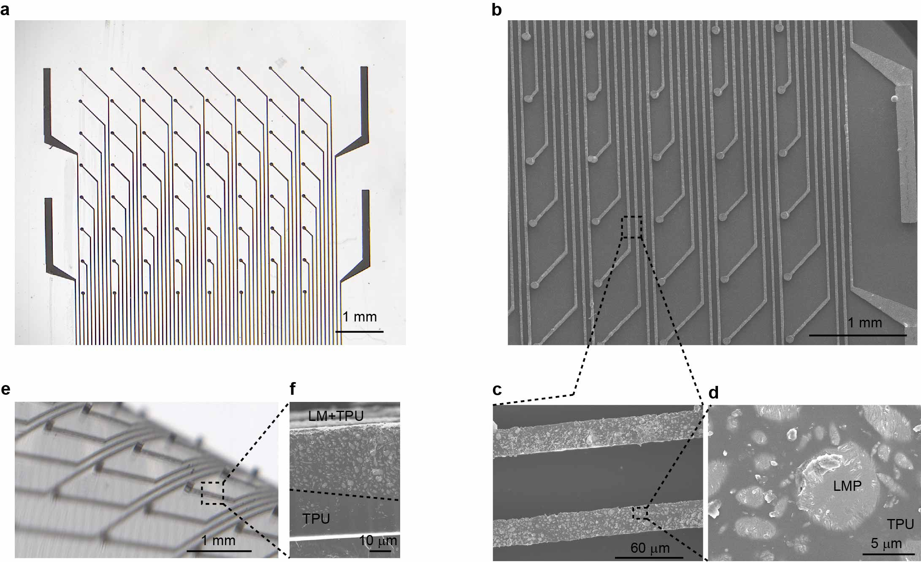
Supplementary Fig. 5. The images of the 3D raised electrode fabricated by the double-layer microfluidics. a, The optical image of the 64-electrode array. Scale bar, 1 mm. b, The SEM image of the 64-electrode array. Scale bar, 1 mm. c, The magnified view of the LM-TPU composite circuit. Scale bar, 60 μm. d, The magnified view of the LM-TPU composite circuit. The light grey represents the liquid metal particles, embedded into TPU (dark gray). Scale bar, 5 μm. e, The optical image of the 3D raised electrodes. Scale bar, 1 mm. f, The magnified side-view of LM-TPU circuit. Scale bar, 10 μm.
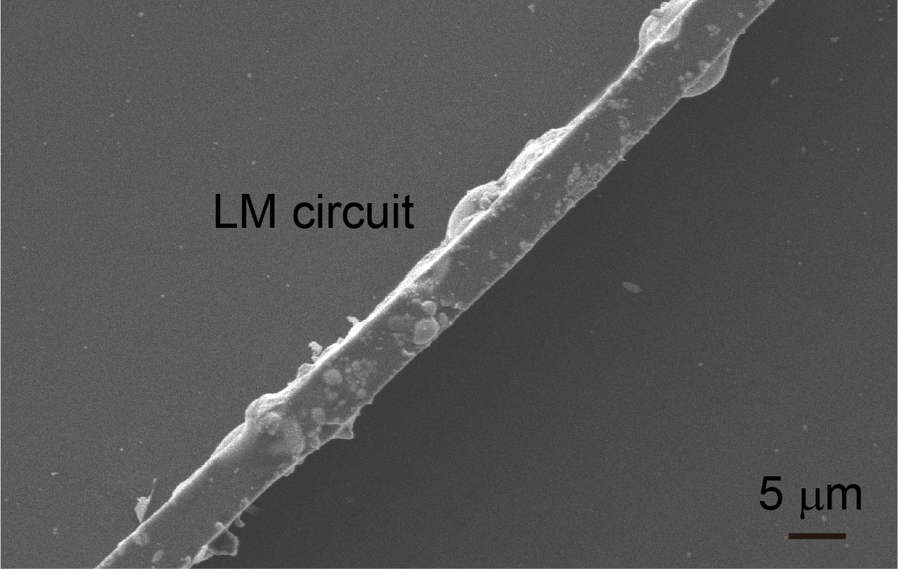
Supplementary Fig. 6. The SEM image of the fabricated LM circuits. The resolution of the LM circuit fabricated by the bilayer microfluidics technique was 5 μm. Scale bar, 5 μm.
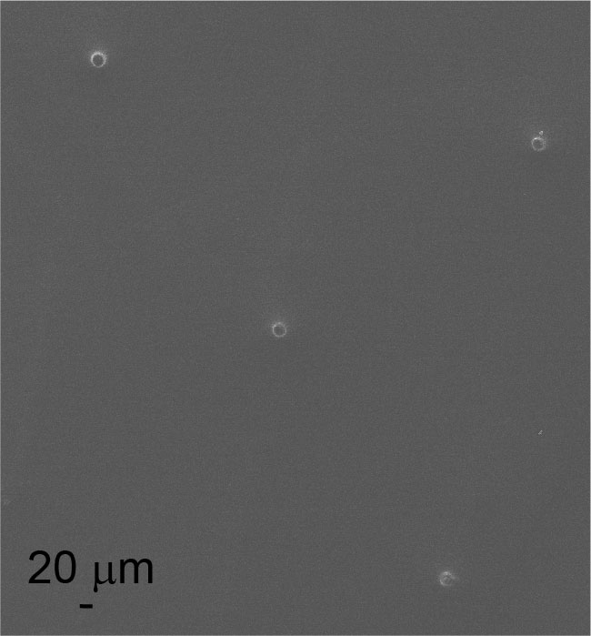
Supplementary Fig. 7. The SEM image of the encapsulated electrodes. The resolution of the elastic encapsulation method was 20 μm. Scale bar, 20 μm.
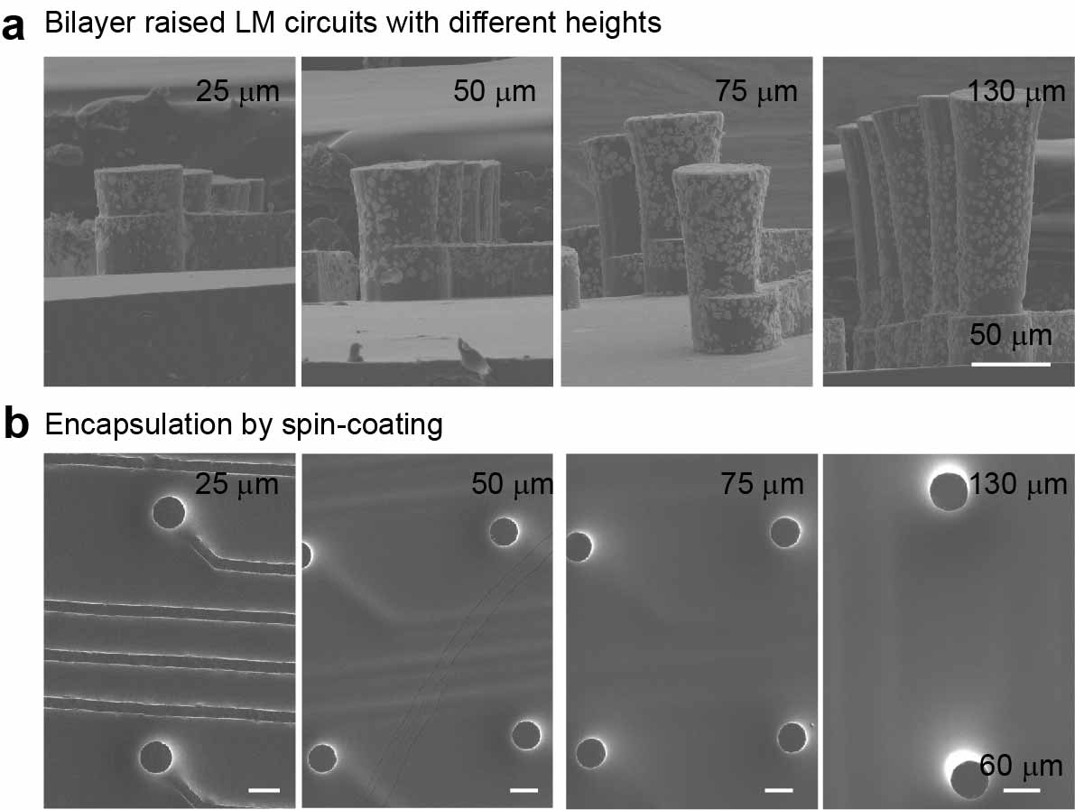
Supplementary Fig. 8. a, The SEM images of the raised LM electrodes with different heights. Scale bar, 50 μm. b, The encapsulated electrodes after spin-coating the packaging layer. Scale bar, 60 μm.
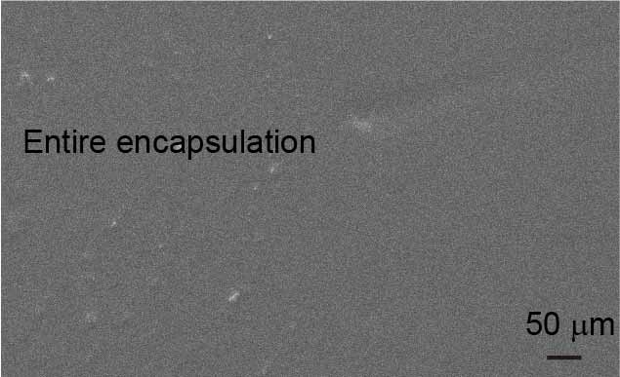
Supplementary Fig. 9. The 5 μm electrodes were covered with the PDMS entirely. Scale bar, 50 μm.
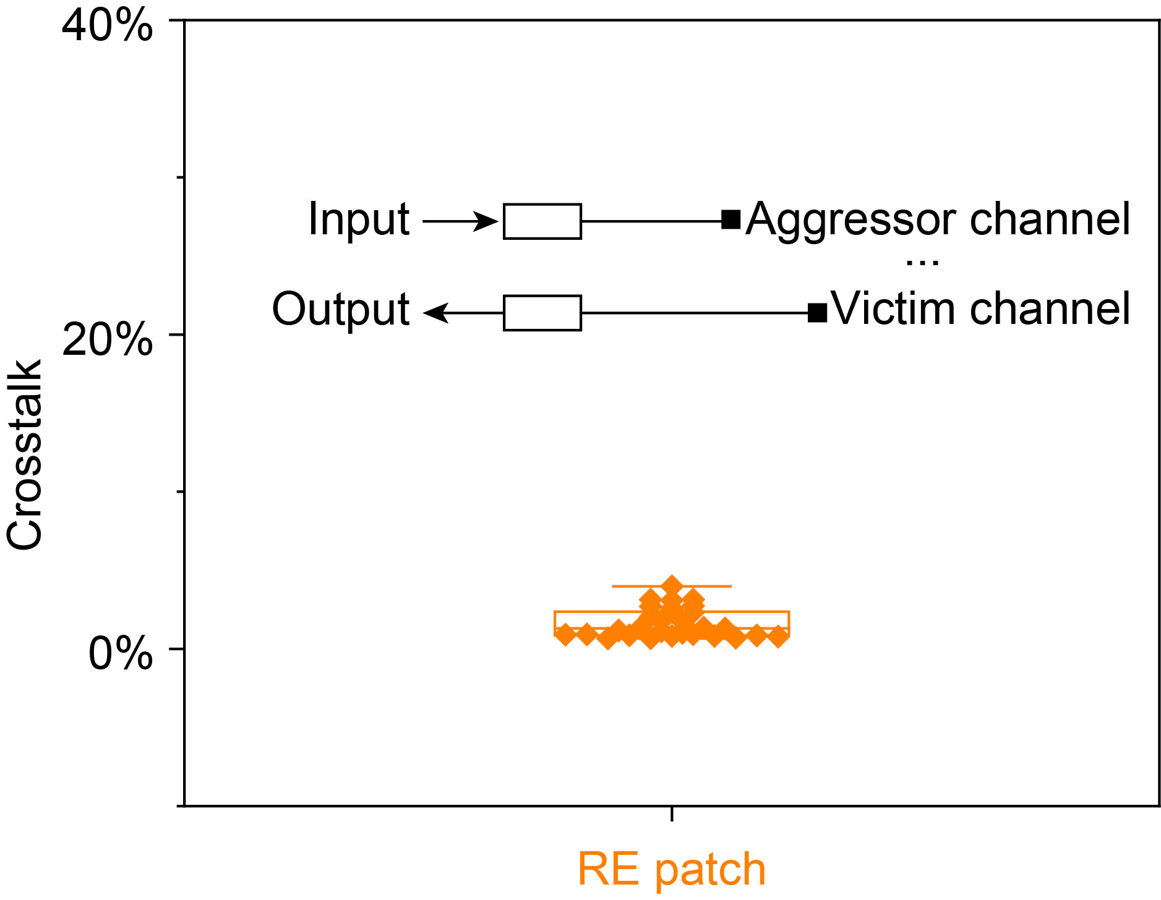
Supplementary Fig. 10. The crosstalk test of the channels in the RE patch with a 75 μm PDMS layer. The insert was the measuring principle.
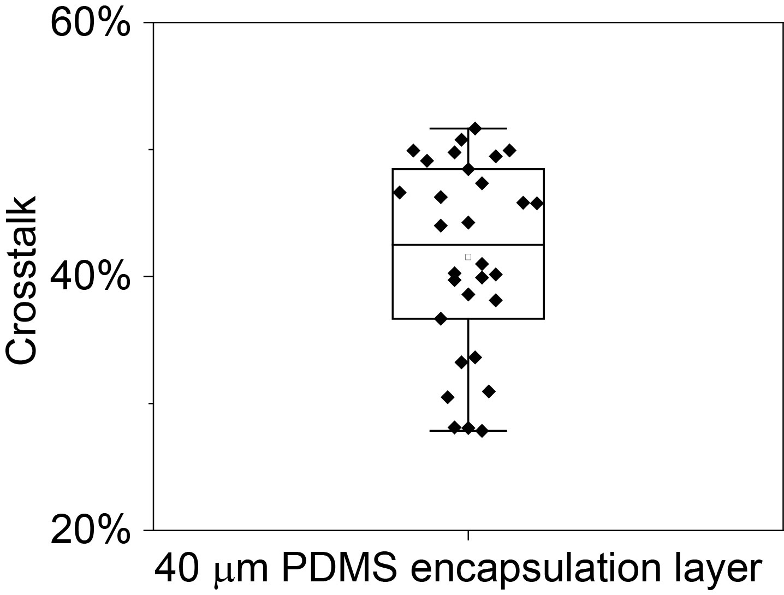
Supplementary Fig. 11. The crosstalk test of the channels in the RE patch with a 45 μm PDMS layer.
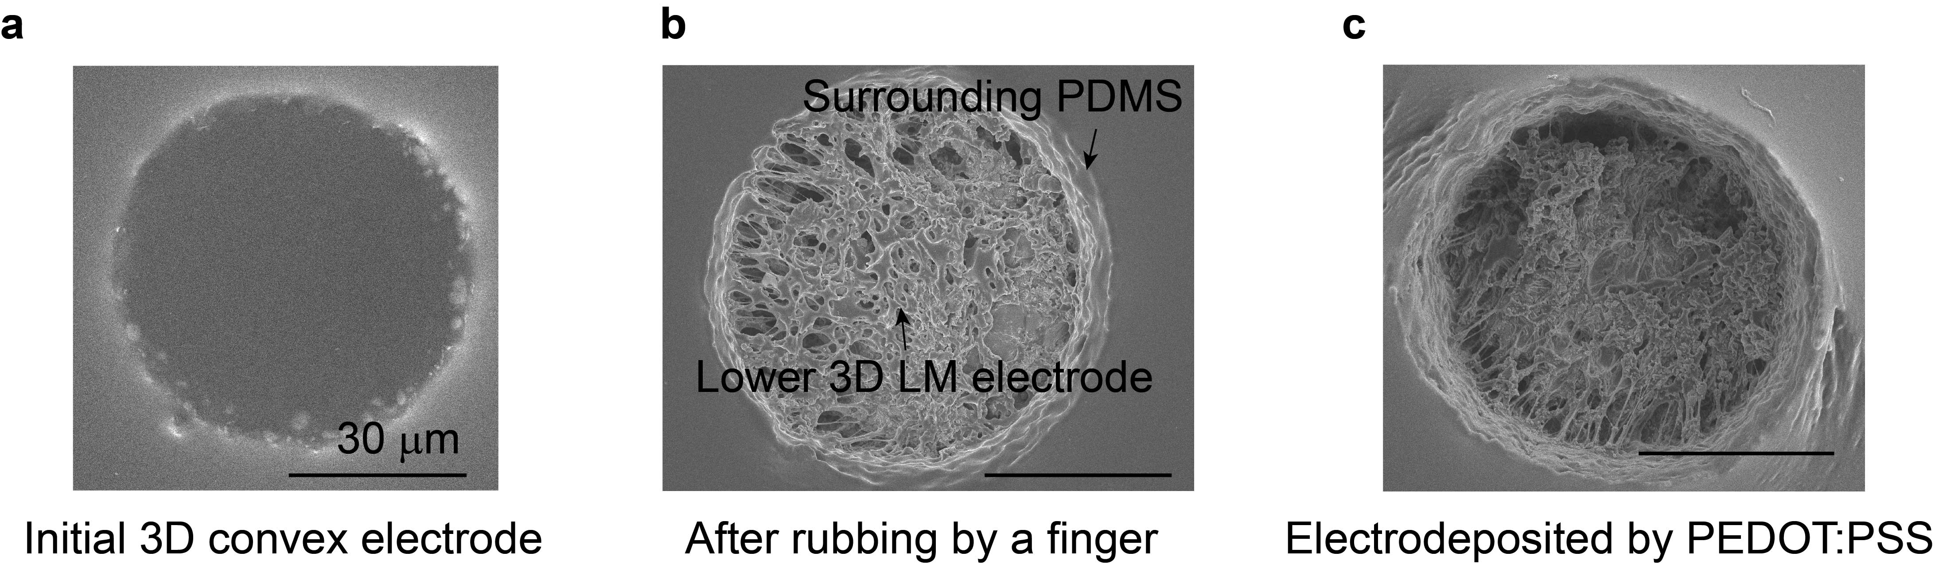
Supplementary Fig. 12. The SEM images of the raised electrode before, after rubbing, and electrodeposited by PEDOT:PSS. a, The SEM image of the primary 3D convex LM electrode. b, The SEM image of the electrode after rubbing by a finger. c, The SEM image of the electrode with a PEDOT:PSS layer . Scale bar, 30 μm.
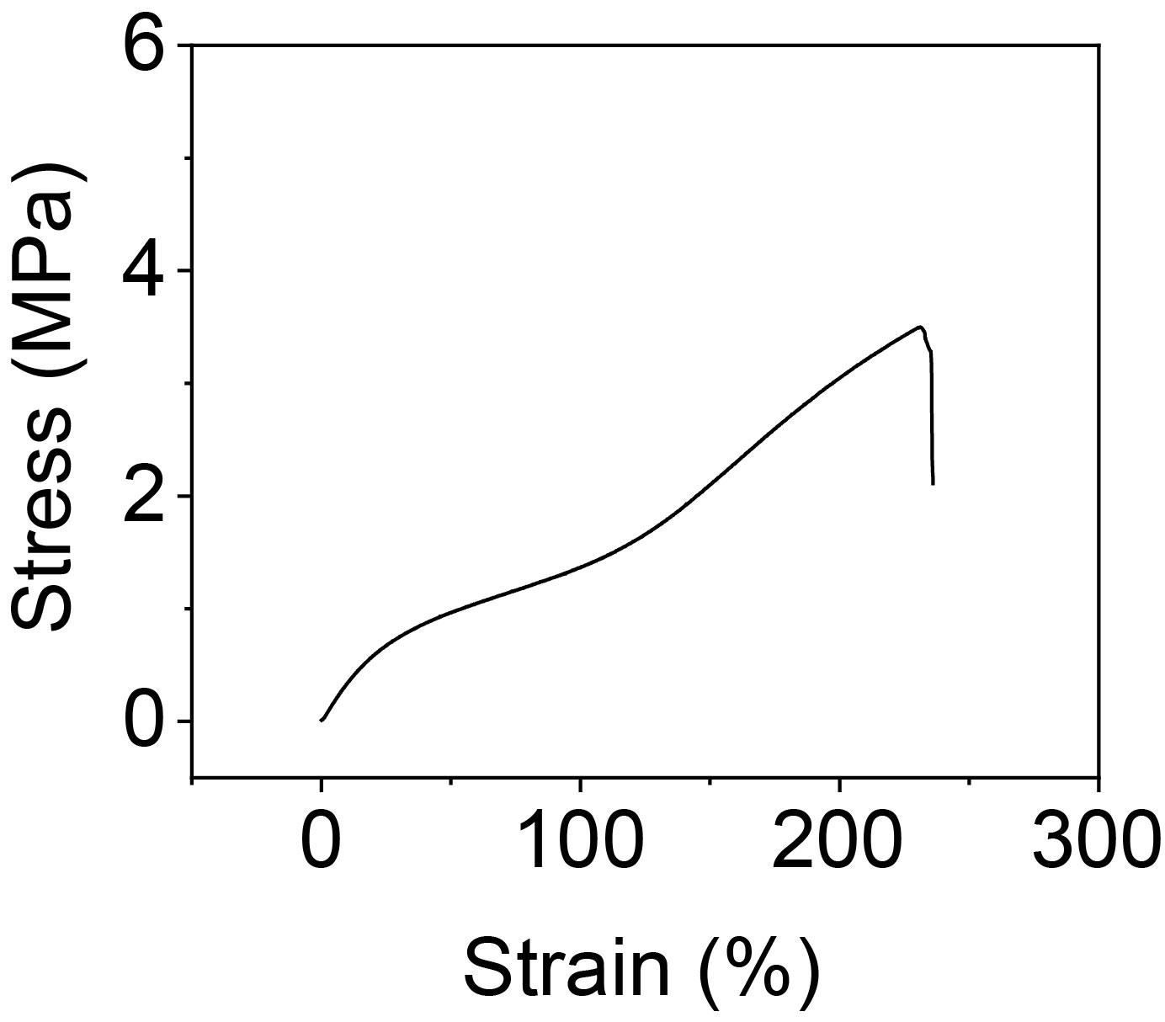
Supplementary Fig. 13. The strain–stress curve of the RE patch.
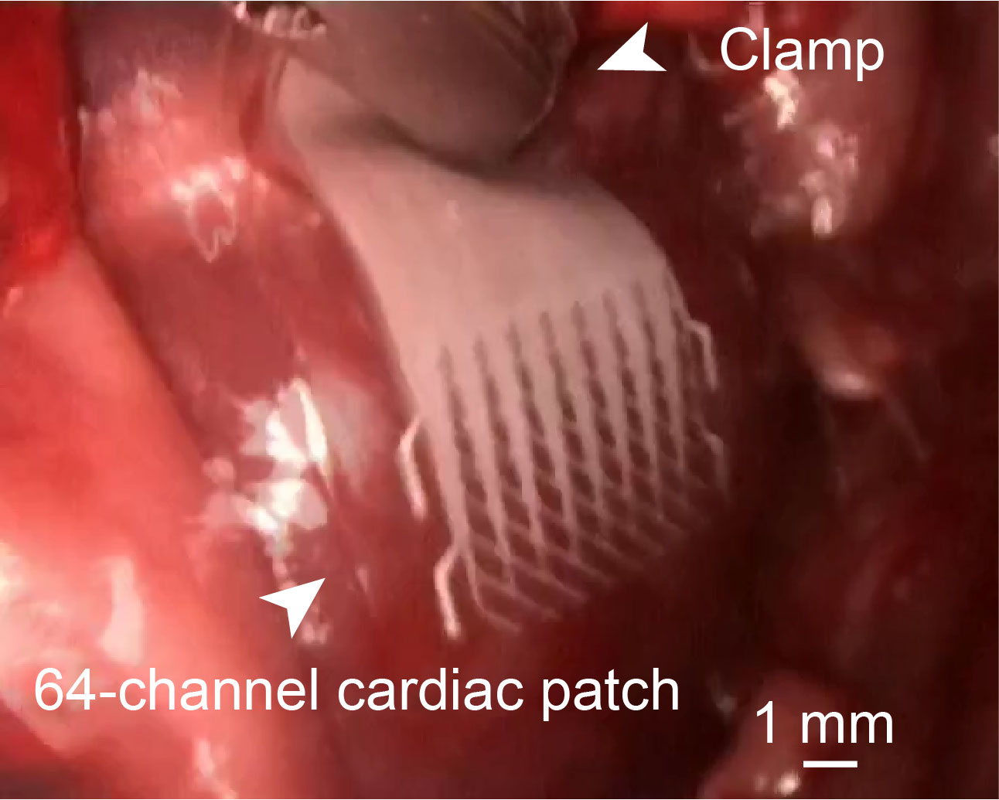
Supplementary Fig. 14. The optical image of a 64-channel cardiac patch during the video-assisted thoracic surgery in a New Zealand rabbit model. Scale bar: 1 mm.
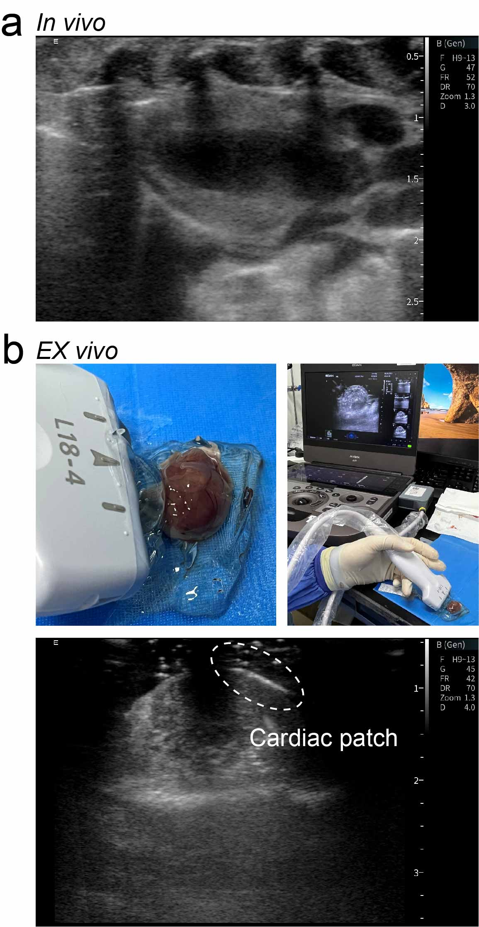
Supplementary Fig. 15. The images of the cardiac patch under echocardiogram in vivo and ex vivo in the SD rat model. a, The image of the cardiac patch under echocardiogram in vivo. b, The optical images of the echocardiogram process ex vivo (Top), and the image of the cardiac patch under echocardiogram ex vivo (Bottom).
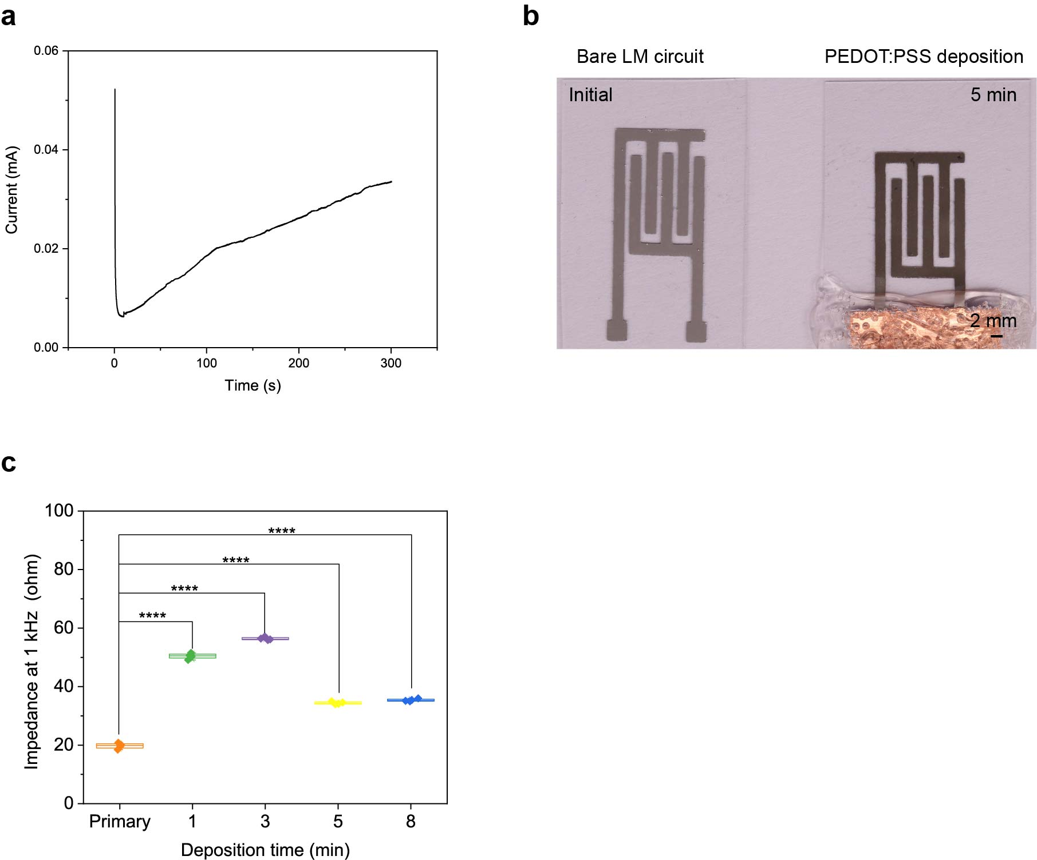
Supplementary Fig. 16. The characteristics of the electrodes electrodeposited by PEDOT:PSS. a, The current change of the RE electrode during the PEDOT:PSS electro-deposition. b, The optical images of the SP pattern before and after electrodeposition. c, Impedance changes at 1kHz frequency of the SP electrode in PBS for different deposition times. Data are presented as mean ± s.e.m. Statistical significance and P values are determined by one-way ANOVA and Tukey’s multiple comparison test. ****P ≤ 0.0001.
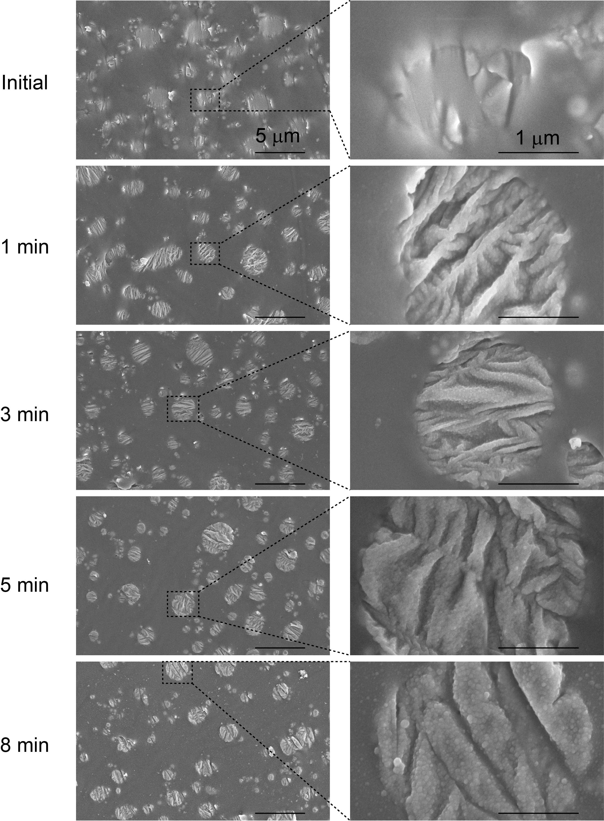
Supplementary Fig. 17. SEM images of the liquid metal circuit electrodeposited by PEDOT:PSS for different deposition times from 0 to 8 minutes.

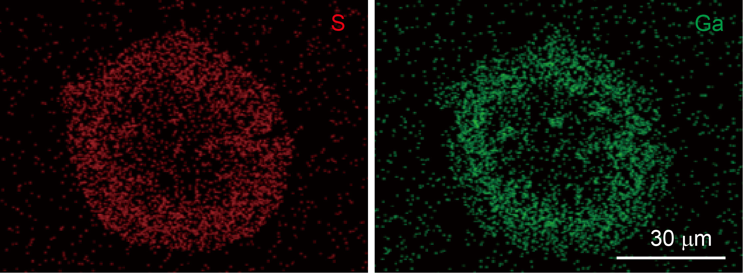
Supplementary Fig. 18. The element maps after depositing the PEDOT:PSS on the RE patch. Scale bar, 30 μm.
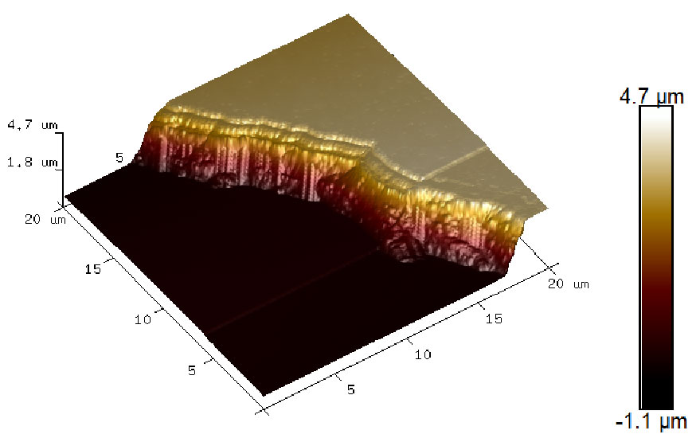
Supplementary Fig. 19. The atomic force microscope (AFM) image of the PEDOT:PSS layer after a 5-minute deposition.
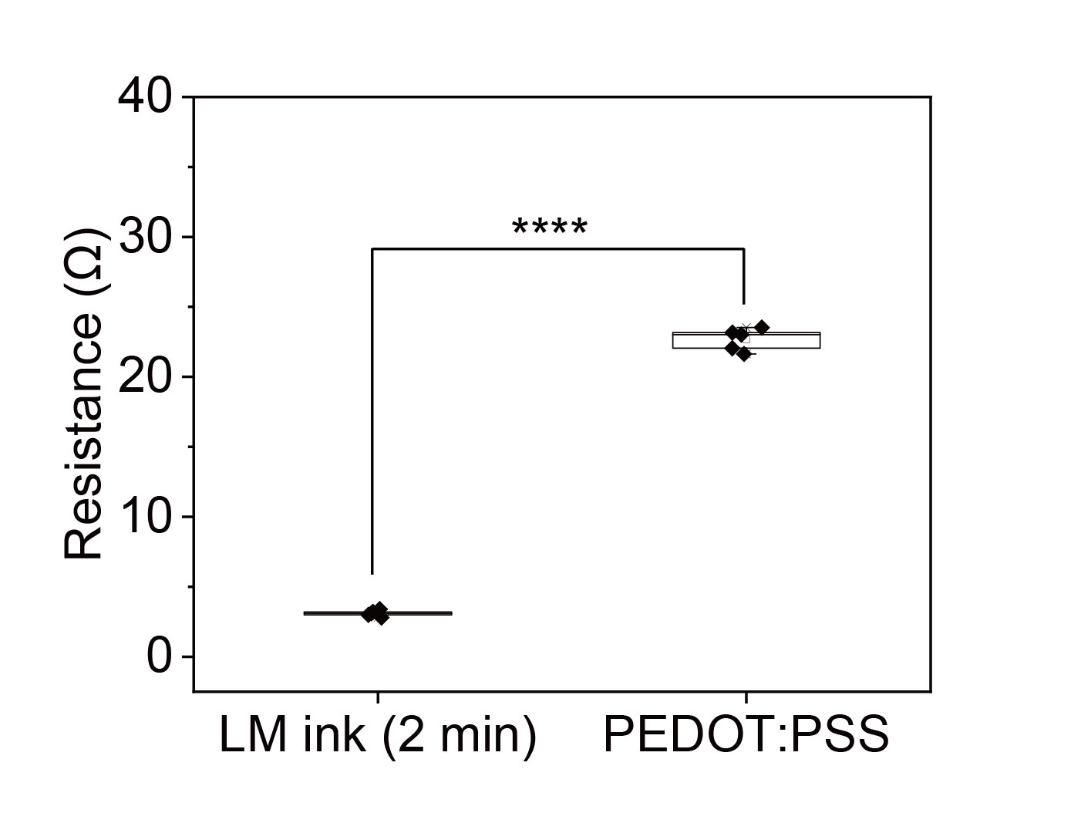
Supplementary Fig. 20. The resistances of the PEDOT:PSS-only and the 2-min sonicated LM circuits.
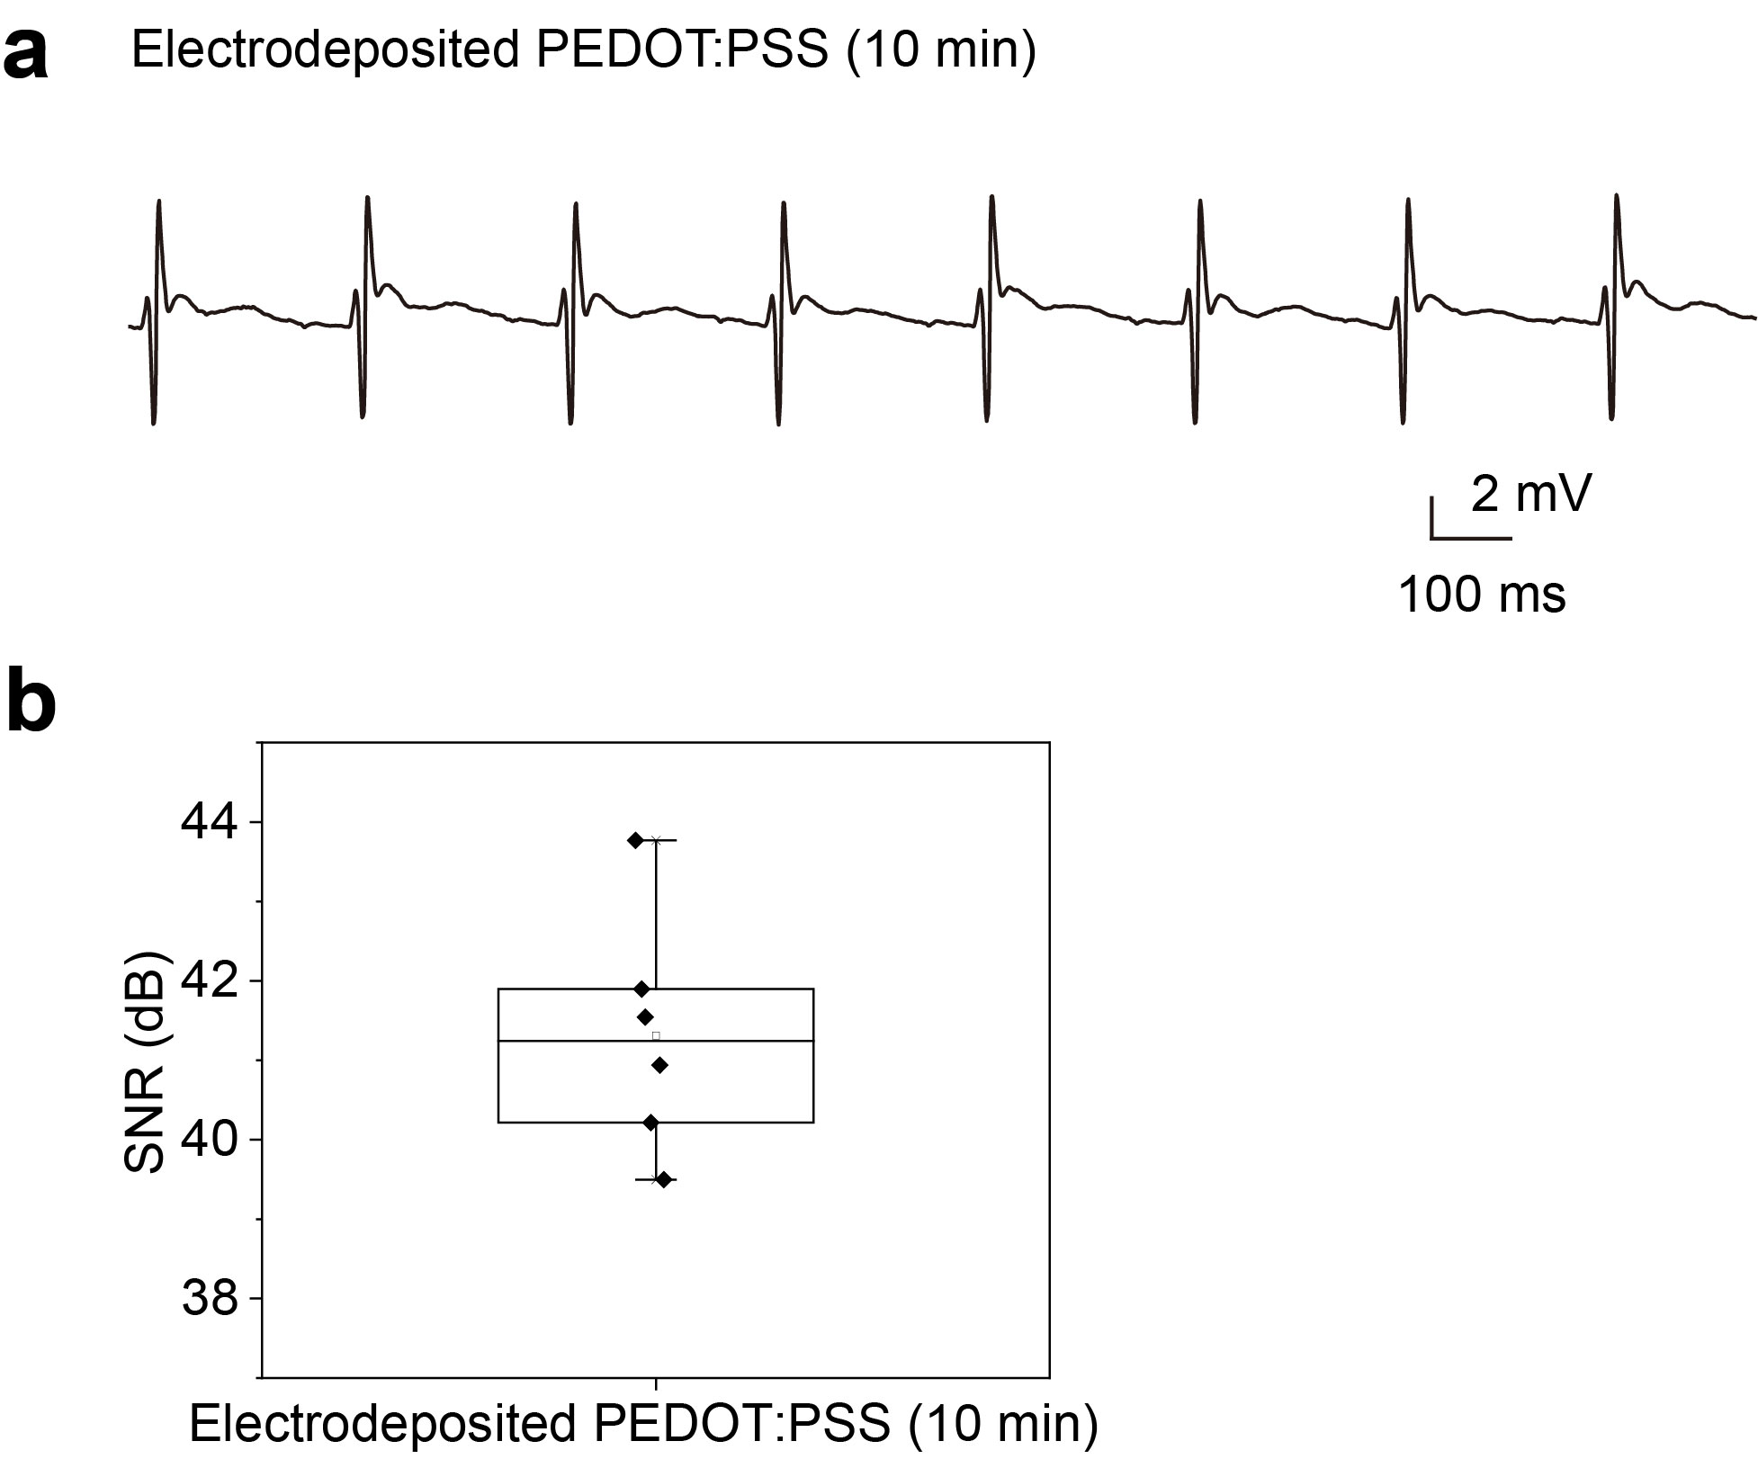
Supplementary Fig. 21. a, The epicardial signal was recorded by the RE patch with a 10-min deposited PEDOT:PSS layer. b, The SNR of the RE patch with the 10-min deposited PEDOT:PSS layer.
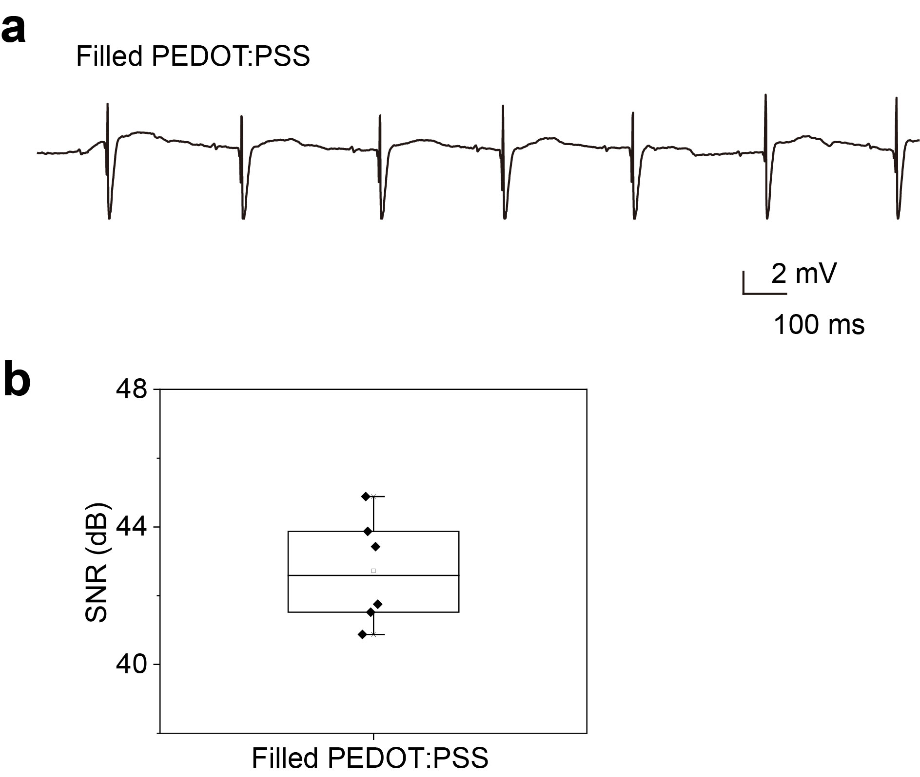
Supplementary Fig. 22. a, The epicardial signal was recorded by the RE patch with a filled PEDOT:PSS layer. b, The SNR of the RE patch with the filled PEDOT:PSS layer.
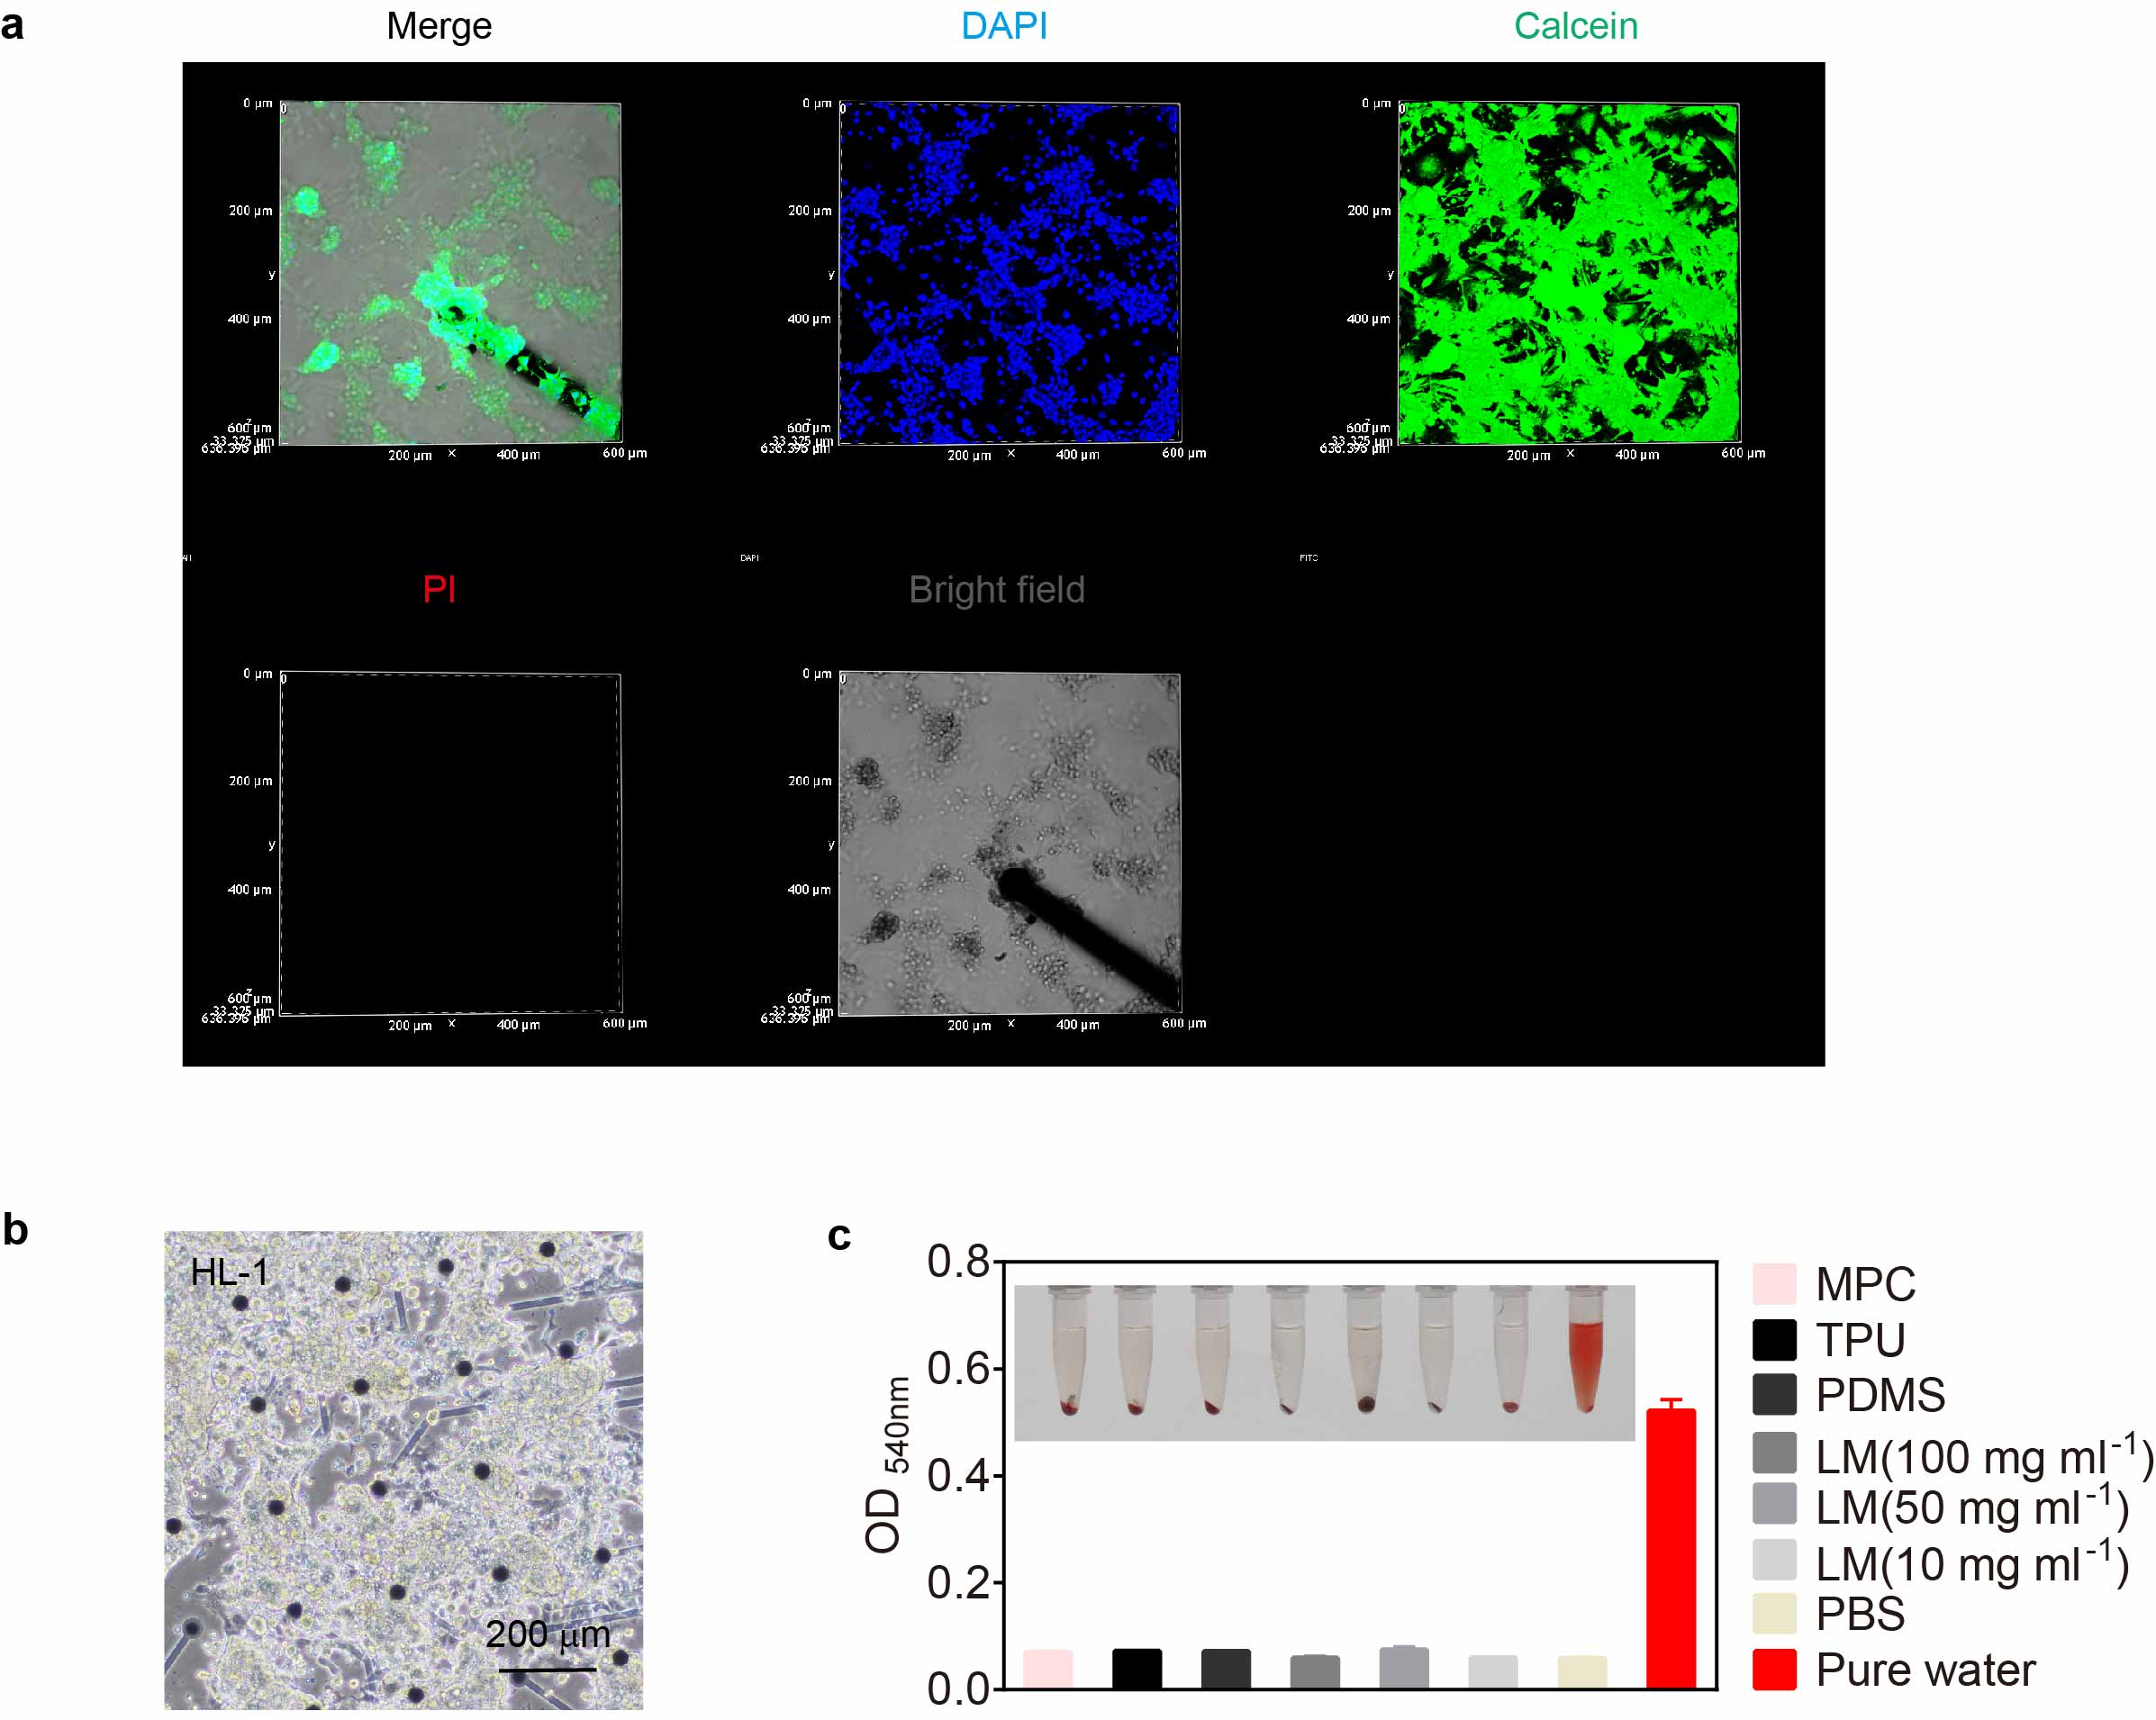
Supplementary Fig. 23. The biocompatibility of the composites in the cardiac patch. a, Cell viability of cardiomyocytes for 1-week incubation. Green (Calcein-AM, live cells), red (PI, dead cells), blue (DAPI, nuclei), and bright field (gray: PDMS, and dark: convex electrodes). b, The HL-1 cells cultured on the MEA. Scale bar, 200 μm. c, Hemolysis test. The MPC membrane, TPU membrane, PDMS, and different concentrations of LM were incubated with the whole rabbit blood respectively for 2h and showed excellent blood compatibility. PBS was used as a negative control, and pure water was used as a positive control.
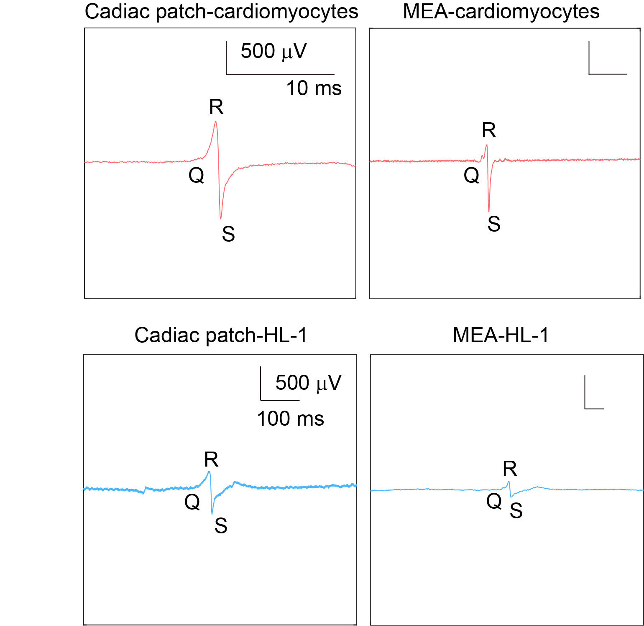
Supplementary Fig. 24. The magnified waveforms of the cells’ field potentials (primary cardiomyocytes and HL-1 cells) from the RE patch and MEA.
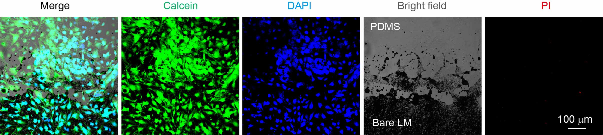
Supplementary Fig. 25. Cell viability of cardiomyocytes after a 3-week incubation. Green (Calcein-AM, live cells), blue (DAPI, nuclei), bright field (gray: PDMS, and dark: bare liquid metal pattern), and red (PI, dead cells). Scale bar, 100 μm.
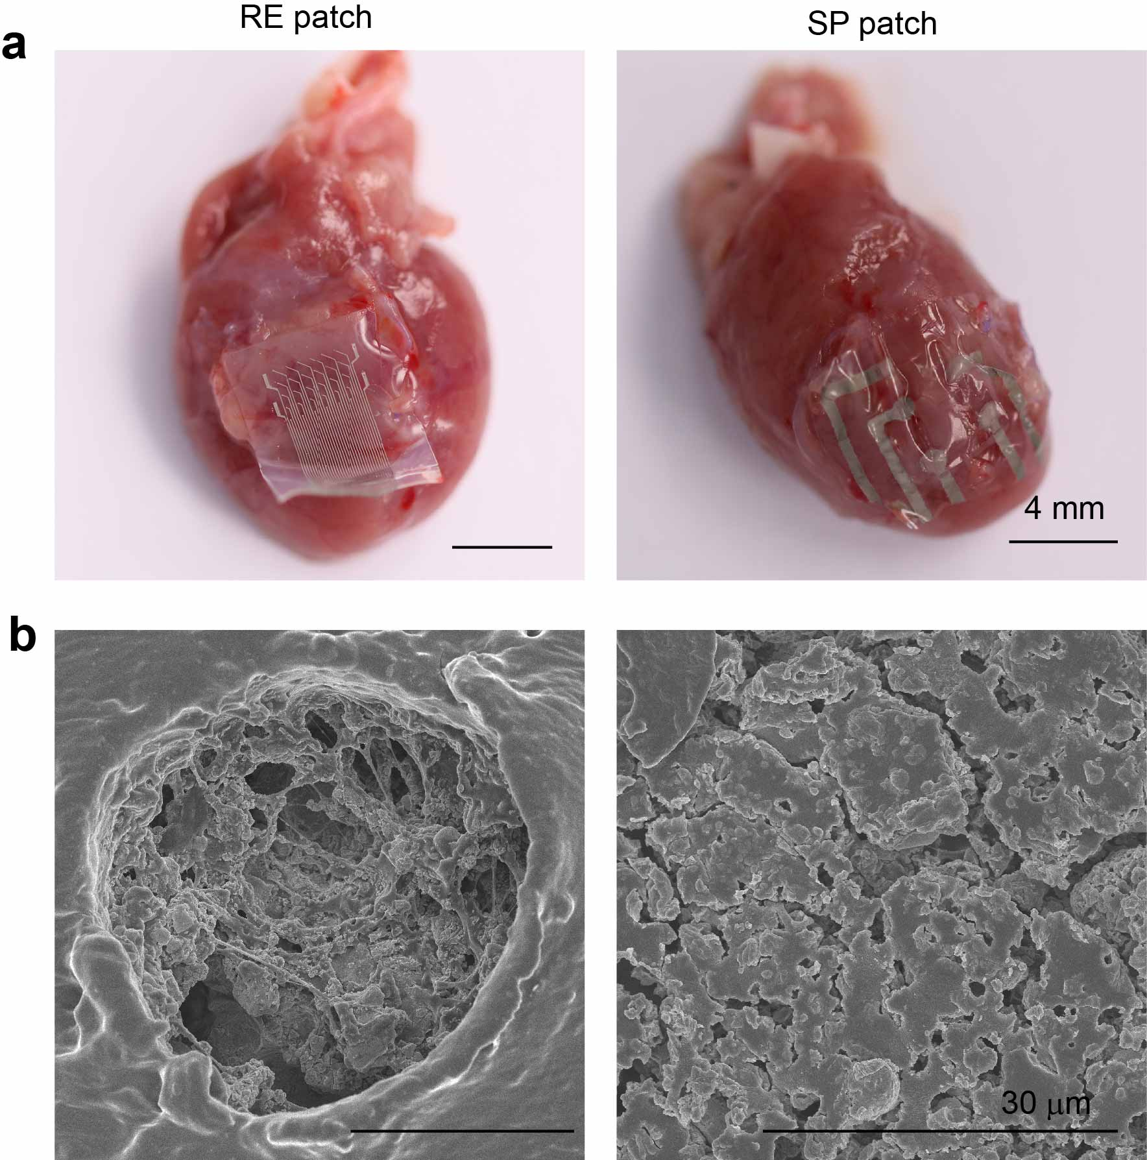
Supplementary Fig. 26. The implants extracted from the heart of the SD rats. a, the optical images of the implants. Left: RE patch (4-week implantation), right: SP patch (1-week implantation). Scale bar, 4 mm. b, The SEM images of the electrode after implantation. Left: RE patch (4-week implantation), right: SP patch (1-week implantation). Scale bar, 30 μm.
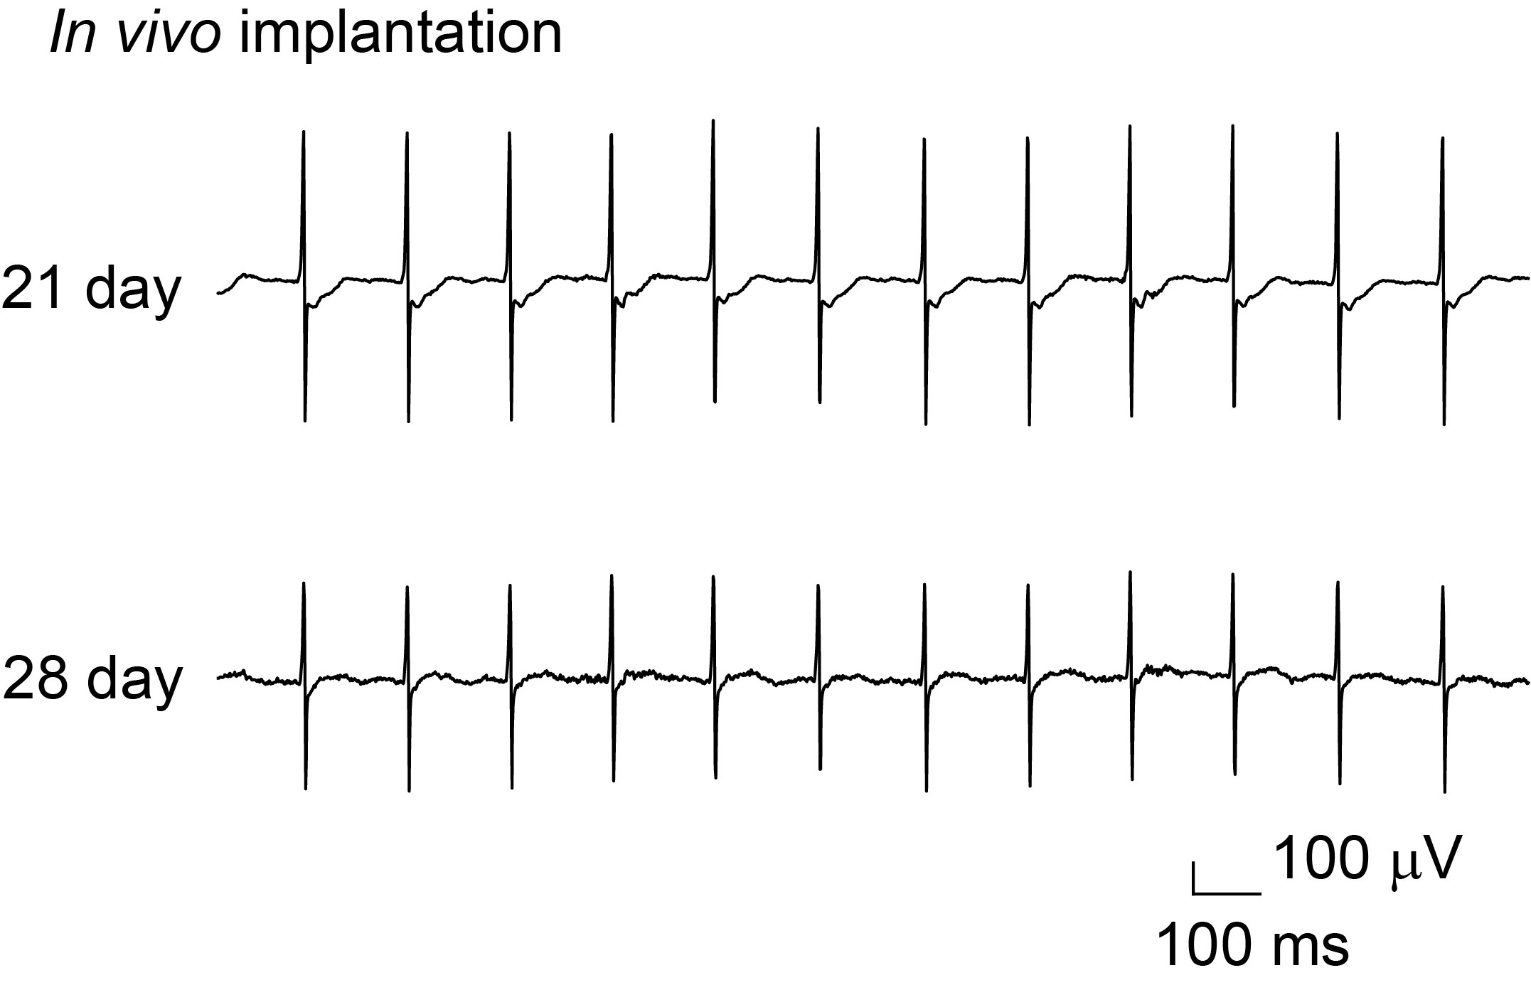
Supplementary Fig. 27. The epicardial signals after a 4-week in vivo implantation for the SD rat.
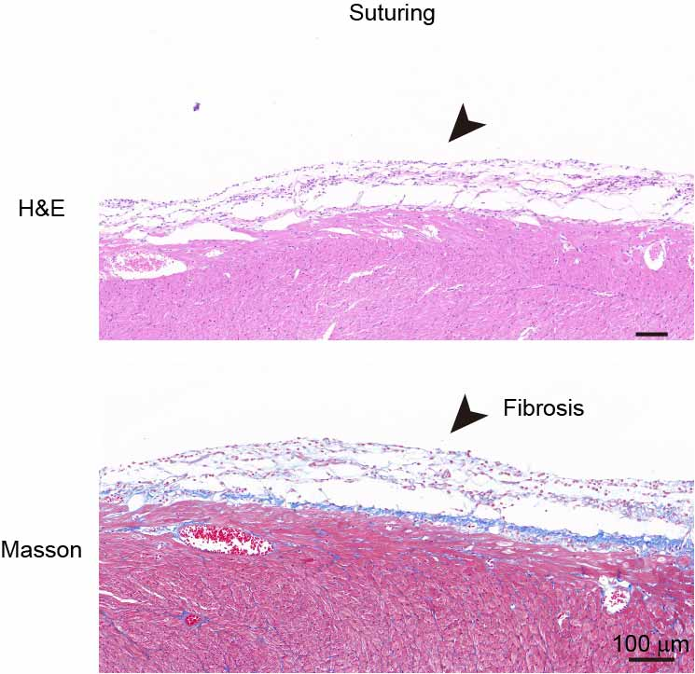
Supplementary Fig. 28. The H&E and Masson staining images of the sutured RE patch after a 14-day implantation.
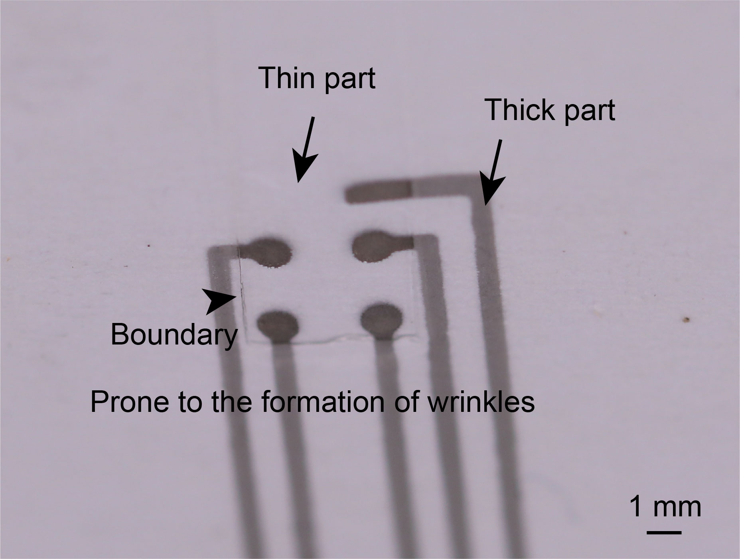
Supplementary Fig. 29. The optical image of the SP patch. Scale bar, 1mm.
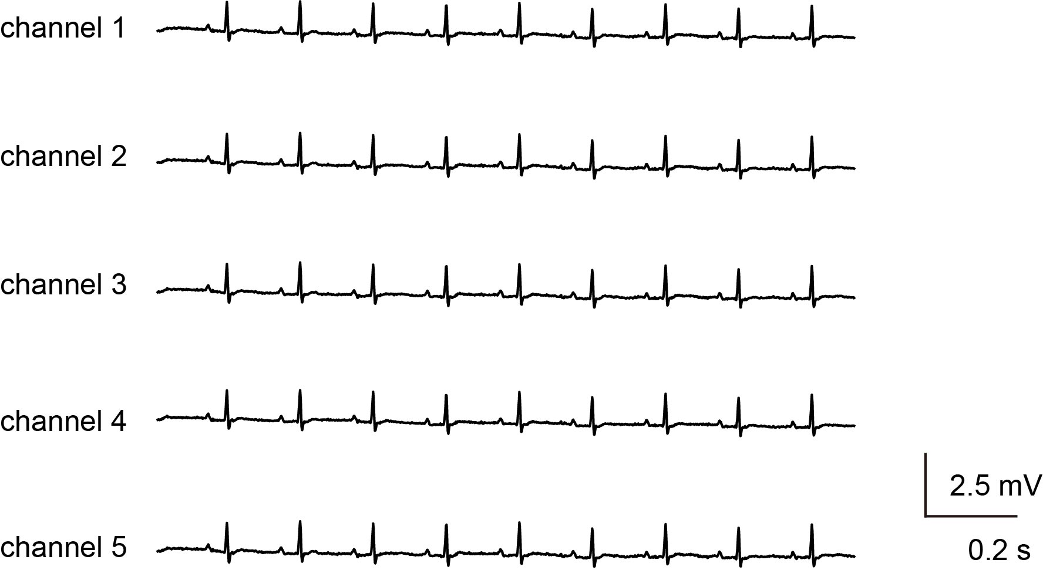
Supplementary Fig. 30. The epicardial signals after a 98-day implantation when the SD rats were in an awake state.
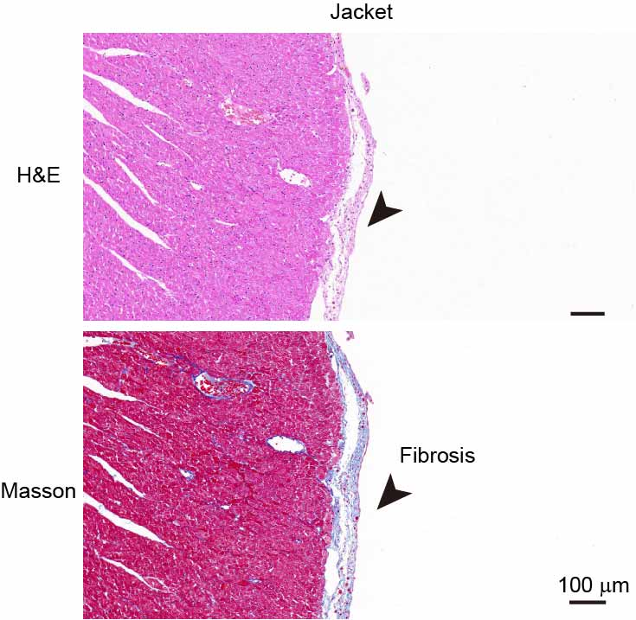
Supplementary Fig. 31. The H&E and Masson staining images of the cardiac jacket with a RE patch after a 28-day implantation.
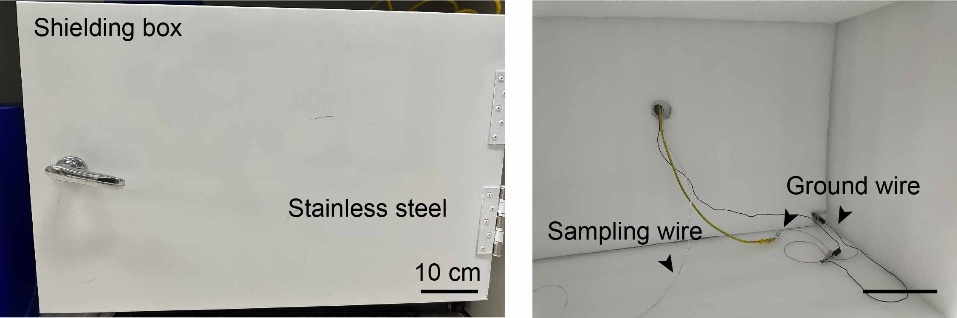
Supplementary Fig. 32. A shielding box made of the stainless steel for avoiding the interference of noise outside. The sampling process was carried out in this box to obtain high-SNR signals. Scale bar, 10 cm.
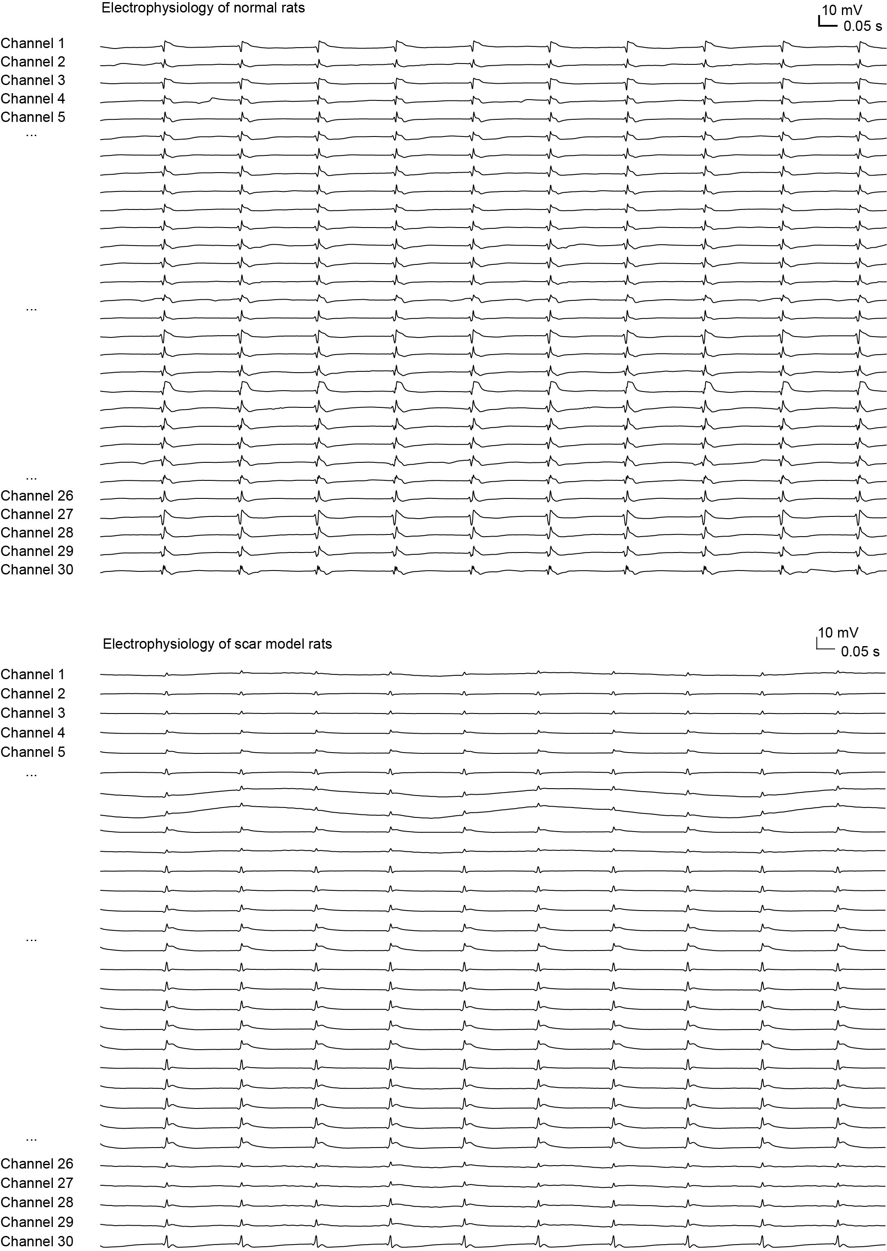
Supplementary Fig. 33. The 30-channel signals of the normal and scar model on the SD rat.
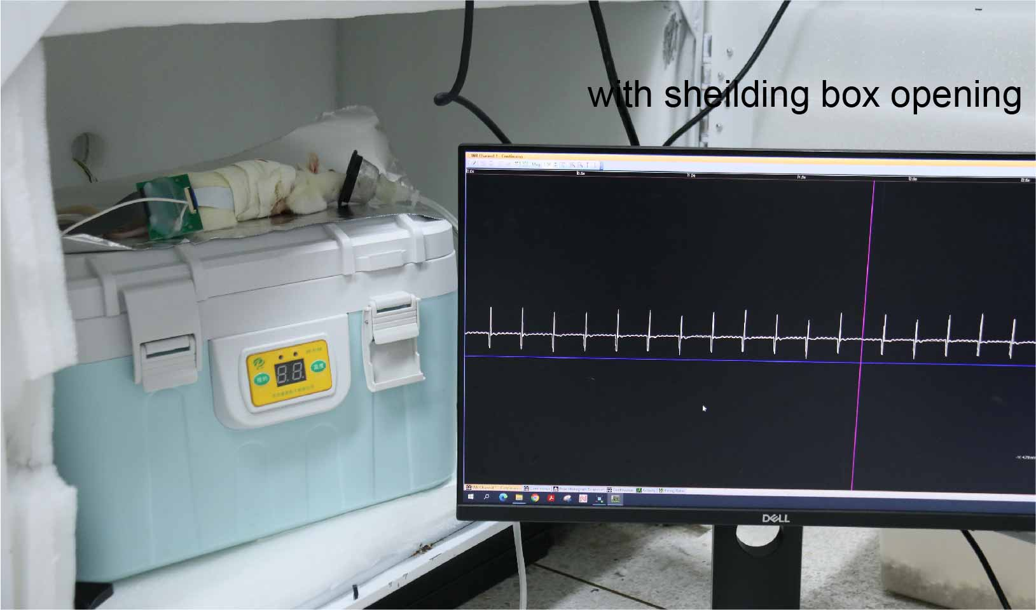
Supplementary Fig. 34. The 30-channel signals of the implanted SD rats with the shielding box opening.
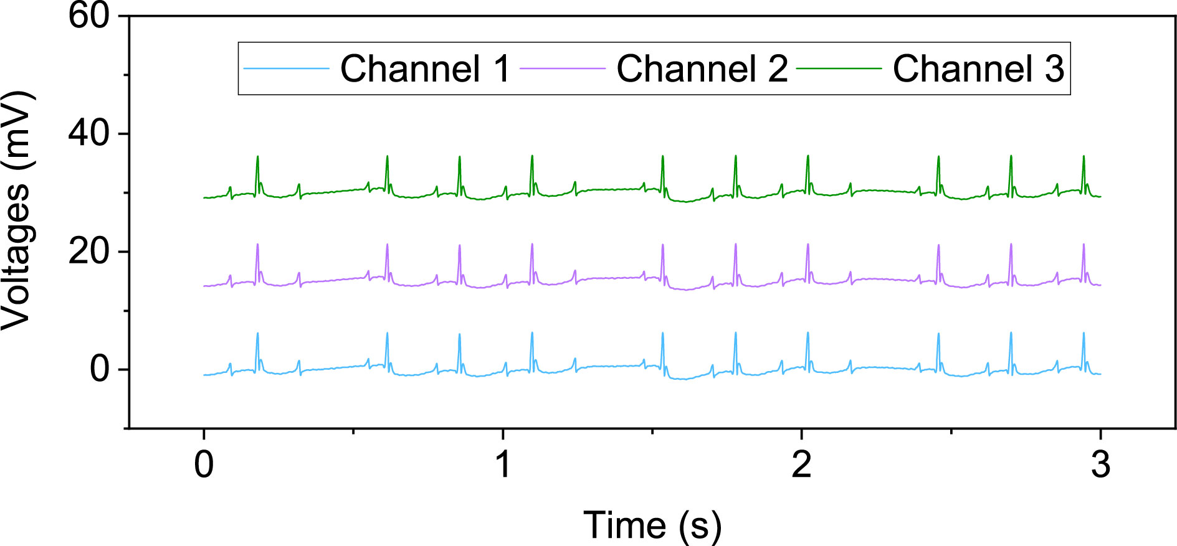
Supplementary Fig. 35. The epicardial signals in a second-degree atrioventricular block Ⅰ model.
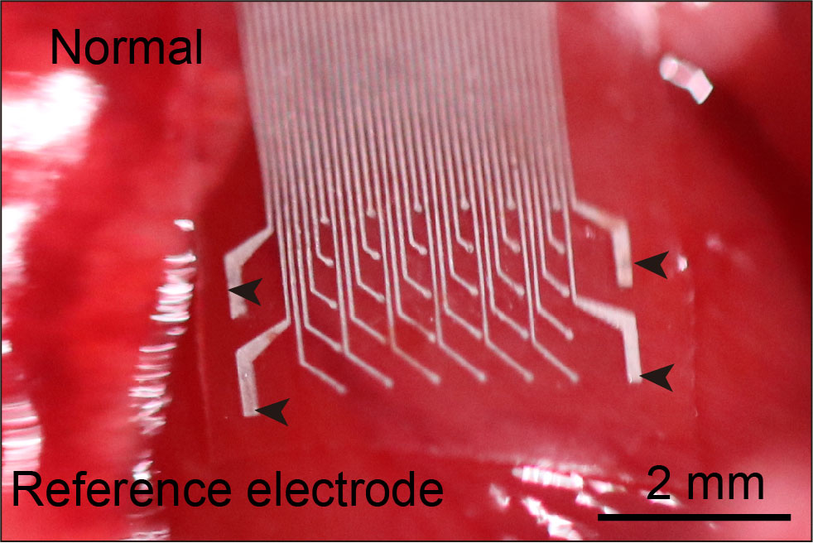
Supplementary Fig. 36. The optical image of the 30-channel cardiac patch attached to the epicardium on the SD rat. Scale bar, 2 mm. The black arrows indicated the reference electrodes.
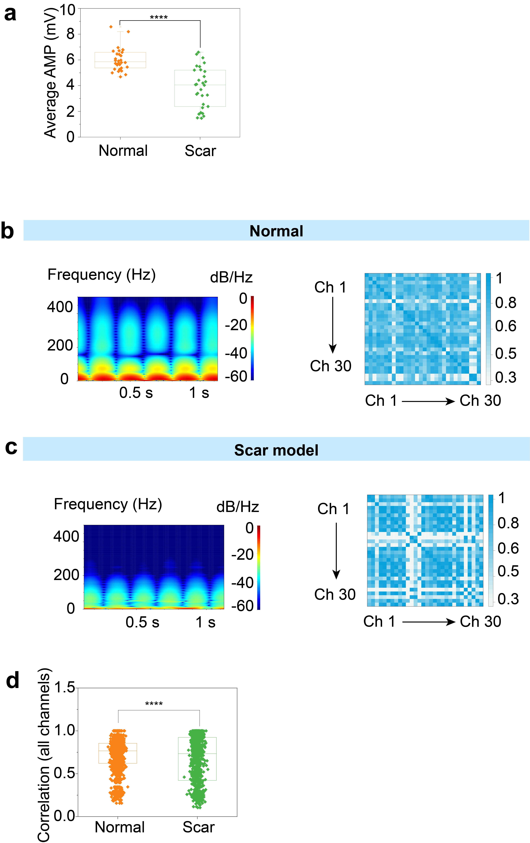

Supplementary Fig. 37. The precise identification for the scar model on the SD rats. a, The average amplitude (AMP) of epicardial signals of all electrodes. Data are presented as mean ± s.e.m. b,c, The time-frequency spectrogram of a representative electrode (left), and the heat plot of the cross-correlation matrix of the raw voltage trace of epicardial signals (right) in the normal and scar model, respectively. d, The average correlation value of the overall channels in normal and scar model. One-way ANOVA and Tukey’s multiple comparison test determine statistical significance and P values. ****P ≤ 0.0001.
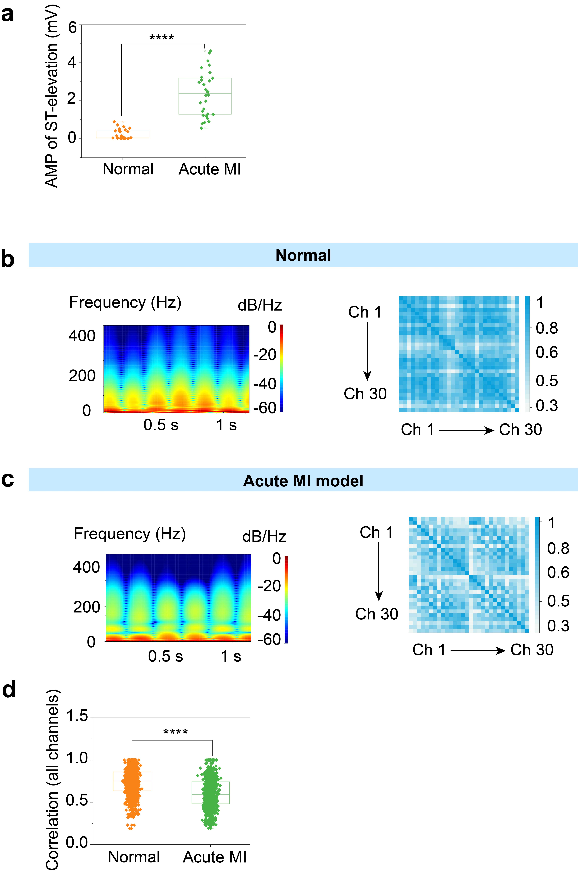
Supplementary Fig. 38. The precise identification for the acute MI model on the SD rats. a, The average AMP of ST-elevation for all electrodes. Data are presented as mean ± s.e.m. b,c, The time-frequency spectrogram of a representative electrode (left), and heat plot of the cross-correlation matrix of the raw voltage trace of epicardial signals (right) in the normal and acute MI model, respectively. d, The average correlation value of the overall channels in normal and acute MI model on the SD rats. One-way ANOVA and Tukey’s multiple comparison test determine statistical significance and P values. ****P ≤ 0.0001.
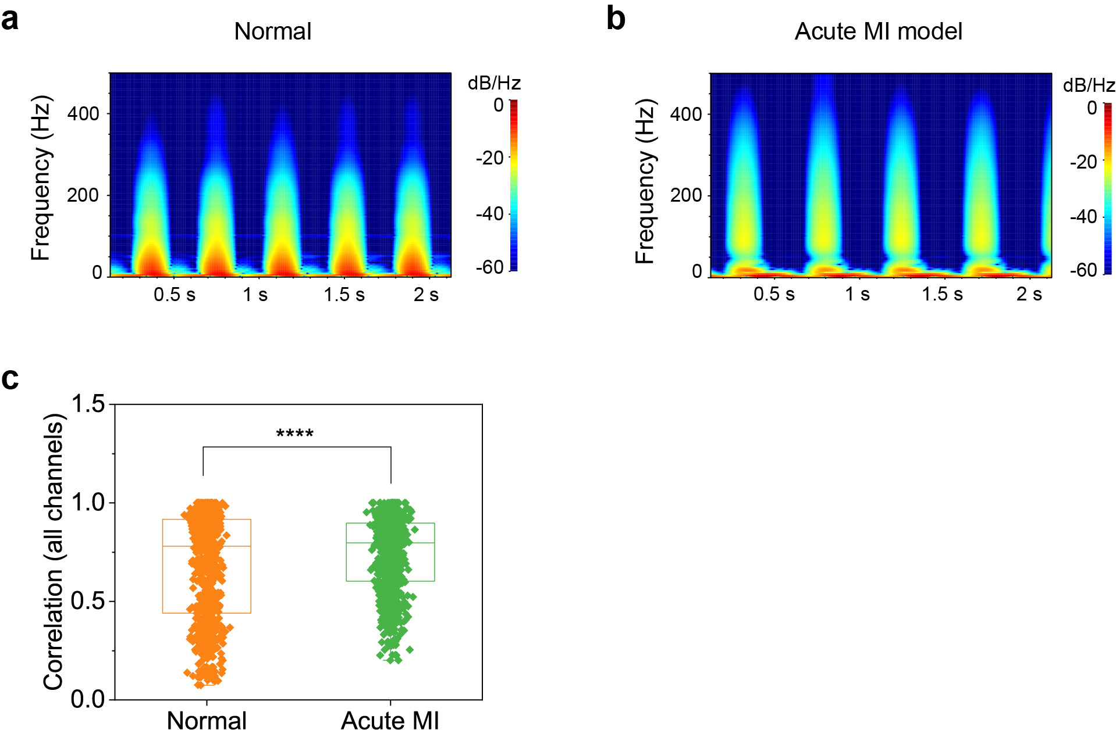
Supplementary Fig. 39. The data from in vivo electrophysiology recording of New Zealand rabbit hearts. a,b, The time-frequency spectrogram of a representative electrode in normal and acute MI model. c, The average correlation value of the overall channels in normal and acute MI model. Data are presented as mean ± s.e.m. in c. Statistical significance and P values are determined by one-way ANOVA and Tukey’s multiple comparison test. ****P ≤ 0.0001.
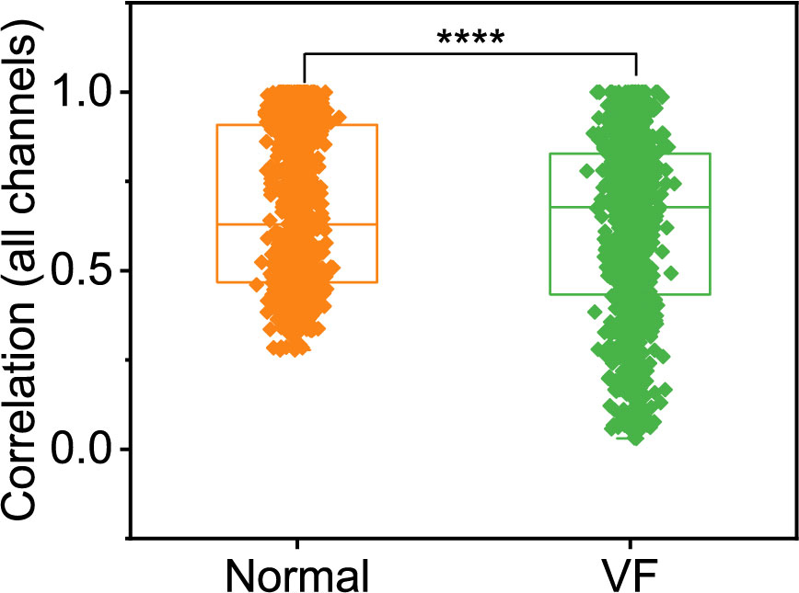
Supplementary Fig. 40. The average correlation value of the overall channels in normal and VF model. Data are presented as mean ± s.e.m. Statistical significance and P values are determined by one-way ANOVA and Tukey’s multiple comparison test. ****P ≤ 0.0001.
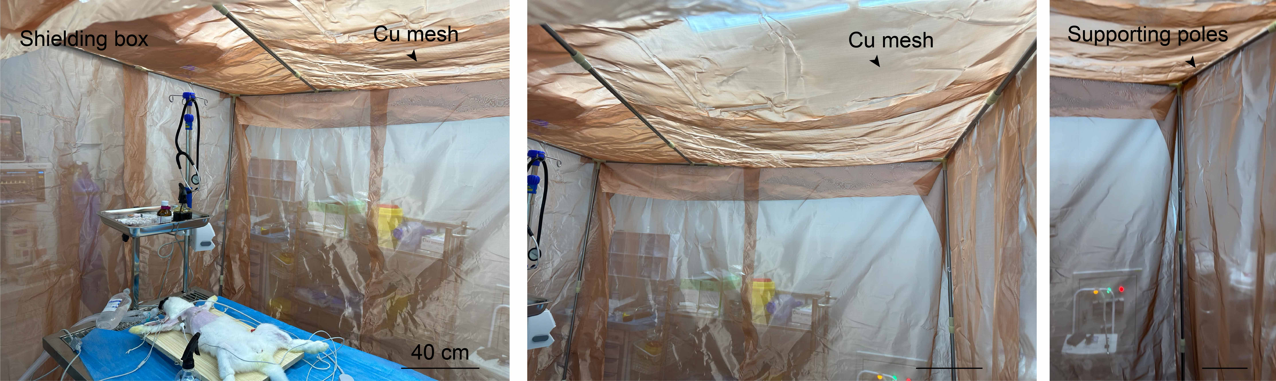
Supplementary Fig. 41. A shielding box made of copper (Cu) mesh for avoiding the interference of noise outside when the cardiac patch was connected with the 3D electrophysiological recording system. The six-sided Cu mesh formed the shielding box without any gaps. The sampling process was carried out in this box to obtain high-SNR signals. Scale bar, 40 cm.
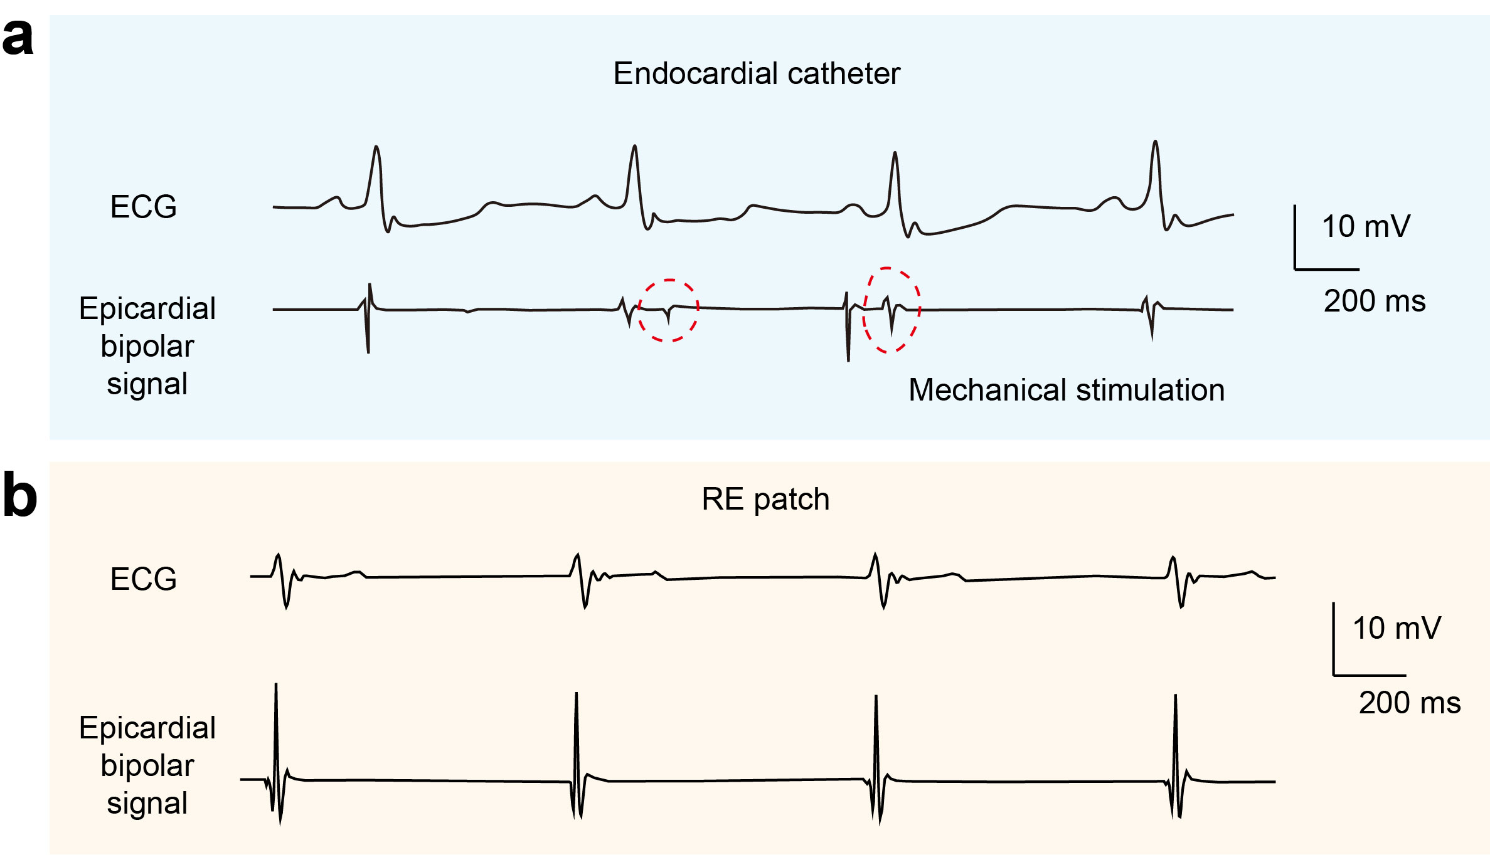
Supplementary Fig. 42. The ECG and epicardial bipolar signals from the endocardial catheter and RE patch. a, The signals from the endocardial catheter. b, The signals from the RE patch. The red dotted circle indicated the stimulated signals due to the mechanical mismatch between the catheter and the soft epicardium.
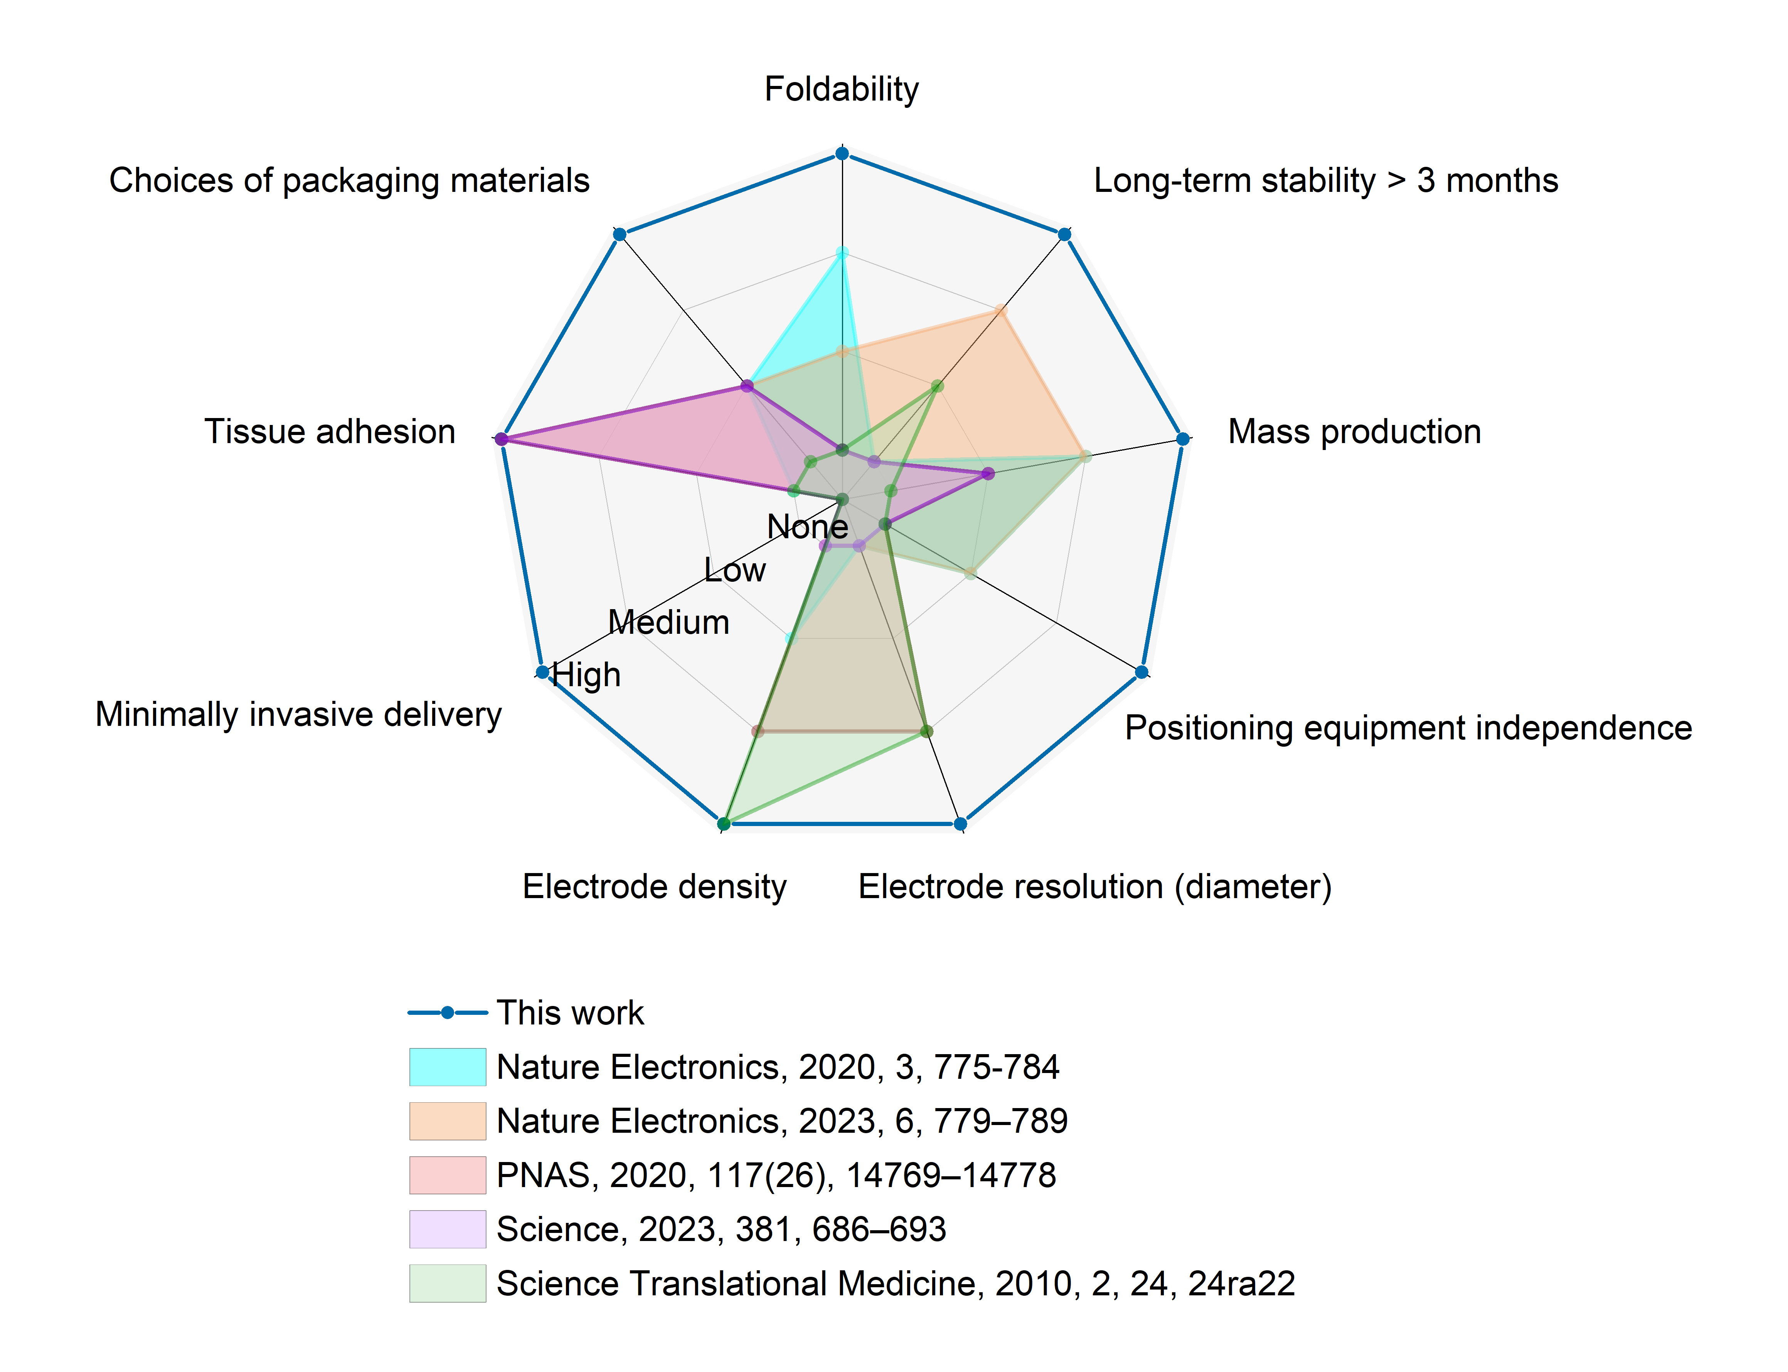
Supplementary Fig. 43. The comparison of our device and other related works in performance.
Supplementary Table 1. The SNR comparison among these related works
Published work | SNR
PNAS, 2020, 117 (26), 14769-14778 | ~100 (~ 40 dB)
Nat. Electron., 2023, 6, 779–789 | ~ 28 dB
Nat. Biomed. Eng., 2017, 1, 38 | ~ 42 dB
Sci. Adv., 2022, 8, eabl5511 | ~ 42 dB
Our work | ~ 45 dB

