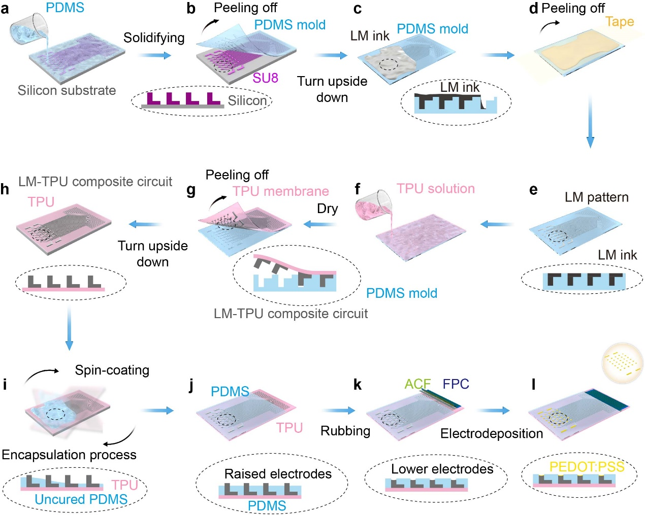
Extended Data Fig.1｜Schematic procedures for the elastic encapsulation of the high-resolution RE patch. a, Fabrication of two-layer SU-8 photoresist pattern and PDMS grooves by pouring the uncurved PDMS (10:1). b, Peeling off the PDMS mold and turning it upside down. c, Filling the PDMS mold with the LM ink. d, Using the tape to remove the extra LM ink and repeat the operation until the pattern is clean and complete. e, Drying the LM pattern. f, Pouring the TPU solution (1.5 wt% in N,N-dimethylformamide, DMF, 20 mL) and drying it at 60 ºC. g, Peeling off the TPU-LM composite circuit and the TPU membrane (MPC membrane). h, Turning the membrane upside down on the silicon substrate covered with a ~100 μm PDMS layer. i, Spin-coating the uncured PDMS for 1 minute at 1,600 rpm. j, Solidifying the PDMS encapsulation layer at 140 ºC for 1 min. k, Rubbing off the raised LM electrodes until there is no extra LM leakage and hot-pressing it with the flexible printed circuit (FPC) and anisotropic conductive film (ACF) at 160 ºC (3 minutes) for the external connection. FPC serves as the external connection part. ACF can improve the adhesion between FPC and TPU. l, Electrodepositing the PEDOT: PSS layer on the exposed electrodes.
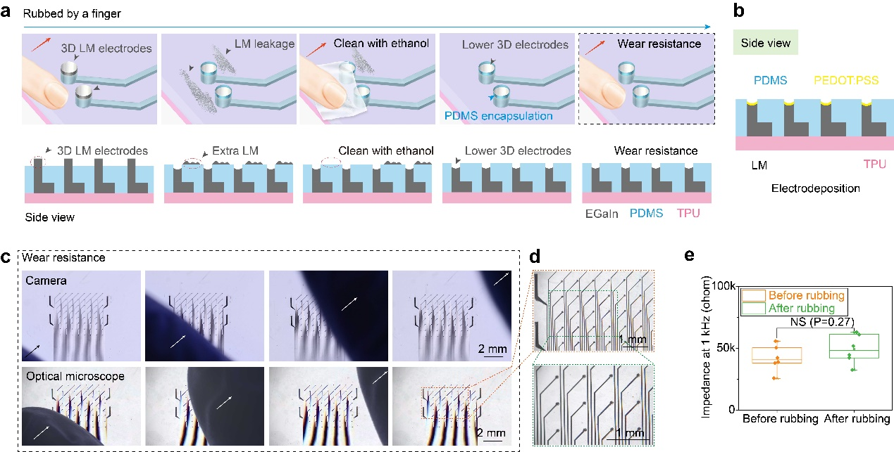
Extended Data Fig.2｜The robust wear resistance and stability of the RE cardiac patch. a, Top: schematic illustrations for the encapsulated 3D raised electrodes rubbed by a finger. Bottom: the side views of the process. b, The schematic side view of the electrodes with electrodeposited PEDOT:PSS layer. c, The wear resistance of cardiac patch rubbed by a finger. The images were recorded by a camera (top) and an optical microscope (bottom). d, Magnified optical views of the raised electrode array after rubbing. e, Impedance changes at 1 kHz frequency of the electrodes in phosphate-buffered saline (PBS) before and after rubbing (100 times). Data are presented as mean ± s.e.m. One-way ANOVA and Tukey’s multiple comparison test determine statistical significance and P values. NS, not significant.
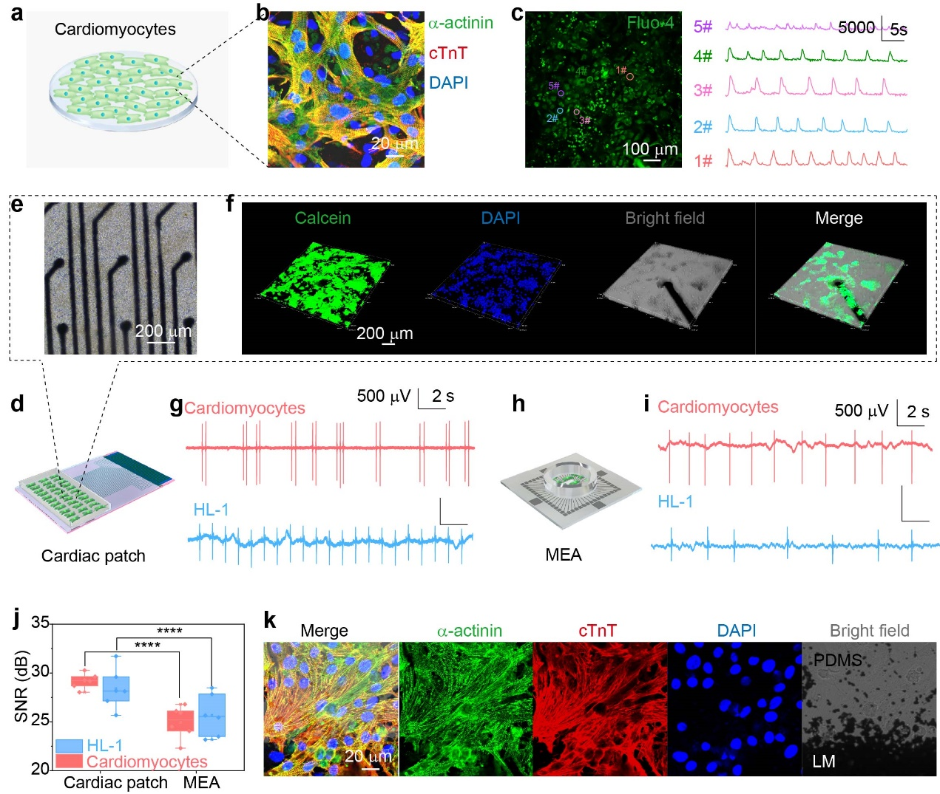
Extended Data Fig.3｜The biocompatibility of the cardiac patch and cells’ field potential signals recording with cell-level resolution. a, A schematic illustration of the primary cardiomyocytes. b, The fluorescence image of cardiomyocytes. Green (α-actinin), red (cTnT), and blue (DAPI). Scale bar, 20 μm. c, Left: calcium imaging of cardiomyocytes with the fluo-4 dye. Scale bar, 100 μm. Right: the changes of fluorescence intensity of cardiomyocytes at five points. d, The schematic illustration of cells cultured on the cardiac patch. e, The bright field image of cardiomyocytes cultured on the cardiac patch for a week. Scale bar, 200 μm. f, Cell viability of cardiomyocytes for 1-week incubation. Green (Calcein-AM, live cells), blue (DAPI, nuclei), and bright field (gray: PDMS, and dark: raised electrodes). Scale bar, 200 μm. g, The cells’ field potential signals of cardiomyocytes and HL-1 recorded by the cardiac patch. h, The schematic illustration of cells cultured on MEA. i, The cells’ field potential signals of cardiomyocytes and HL-1 recorded by MEA. j, The SNR of the signals recorded by the MEA and cardiac patch. k, The fluorescence images of cardiomyocytes for a 2-week incubation on LM and PDMS. Green (α-actinin), red (cTnT), blue (DAPI), and bright field (gray: PDMS, and dark: LM). Scale bar, 20 μm. One-way ANOVA and Tukey’s multiple comparison test determine statistical significance and P values. ****P ≤ 0.0001.
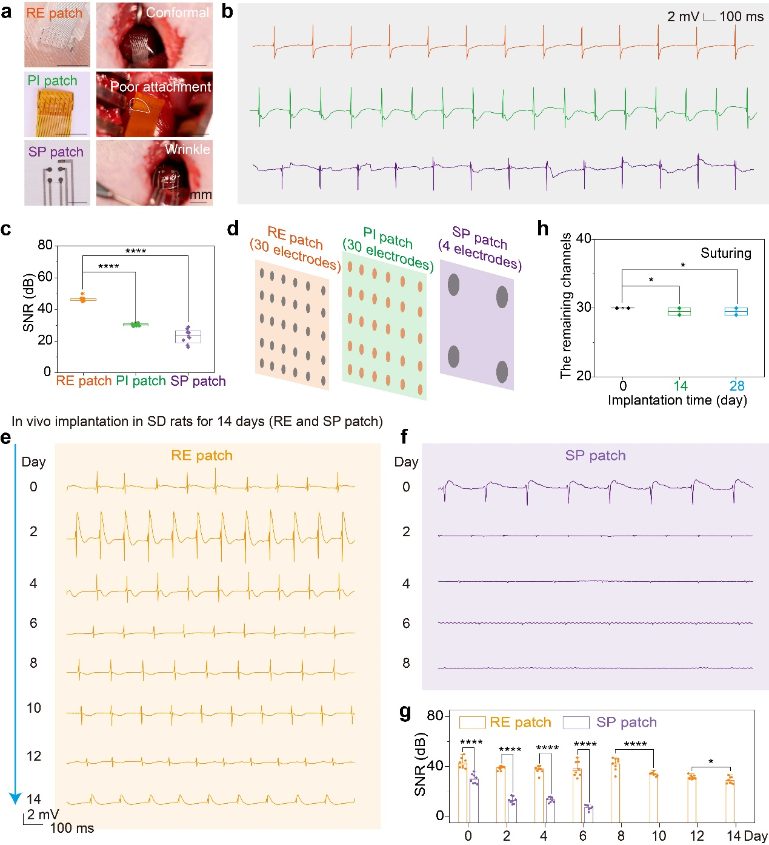
Extended Data Fig.4｜The precise identification of abnormal areas and the long-term reliability of the RE patch for in vivo implantation. a, The optical images of the RE (top), PI (middle), and SP (bottom) patch and their attachment to the heart. Scale bar, 4 mm. b, The epicardial signals collected by the RE (top), PI (middle), and SP (bottom) patch after the open-chest surgery. c, The SNR value of the RE, PI, and SP patch. d, The illustration of three kinds of patches with different numbers of channels in the same collection area. e, The epicardial signals recorded by the RE patch after in vivo implantation for 14 days. f, The epicardial signals recorded by the SP patch after in vivo implantation for 8 days. g, The SNR value of the RE and SP patch during the 14-day in vivo implantation. h, The remaining channel number after implantation. Data are presented as mean ± s.e.m. One-way ANOVA and Tukey’s multiple comparison test determine statistical significance and P values. ****P ≤ 0.0001, *P ≤ 0.05.
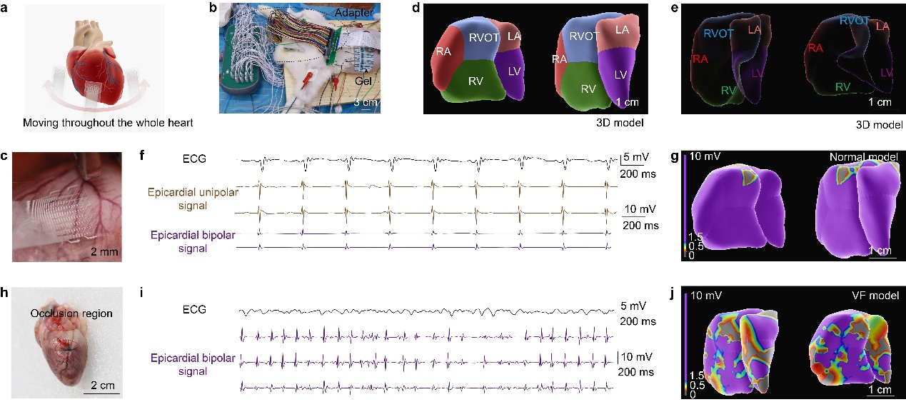
Extended Data Fig.5｜In vivo 3D electroanatomical model reconstruction on the New Zealand rabbits with the VF scene. a, A schematic illustration of the cardiac patch moving throughout the global heart (n=3). b, A 64-channel adapter for connecting the cardiac patch with Abbott EnSite Precision system. Scale bar, 3 cm. c, A photograph of the 64-channel patch attached to the epicardium. Scale bar, 2 mm. d,e, The 3D global heart model and perspective model of anatomy. RA: right atrium, RV: right ventricle, LA: left atrium, LV: left ventricle, RVOT: right ventricular outflow tract. Scale bar, 1 cm. f, The ECG and epicardial unipolar and bipolar signals in a normal model. g, The 3D electrophysiological model. Purple: the normal voltage of the epicardial bipolar signals. Scale bar, 1 cm. h, The occlusion region of LAD for constructing a VF model. Scale bar, 2 cm. i, The ECG and epicardial unipolar and bipolar signals in a VF model. j, The 3D electrophysiological model for a global heart in a VF model. Purple (normal voltage of the epicardial bipolar signals), blue, red, gray (low voltage of the signals). Scale bar, 1 cm.

