Supporting information
A highly photothermal stability Au@Cu_{2-x}Se nanoprobe for photoacoustic-imaging guided dual enhanced NIR- II photothermal/chemodynamic therapy

Figure S1. Hydration radius of nanoprobe.

Figure S2. zeta potential of nanoprobe.

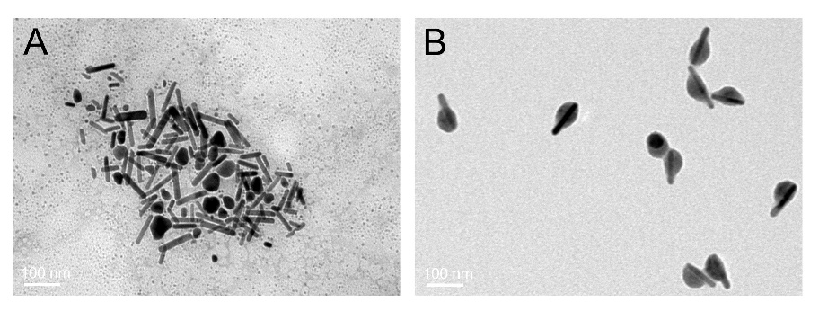
Figure S3. TEM images of AuNR and nanoprobes after 10 min irradiation by 1064 nm laser.

Figure S4. Cell viability of liver cells incubated with different concentrations of nanoprobes for 24,48, and 72 hours.

Figure S5. Apoptosis rate of HepG2 cells after different treatments.

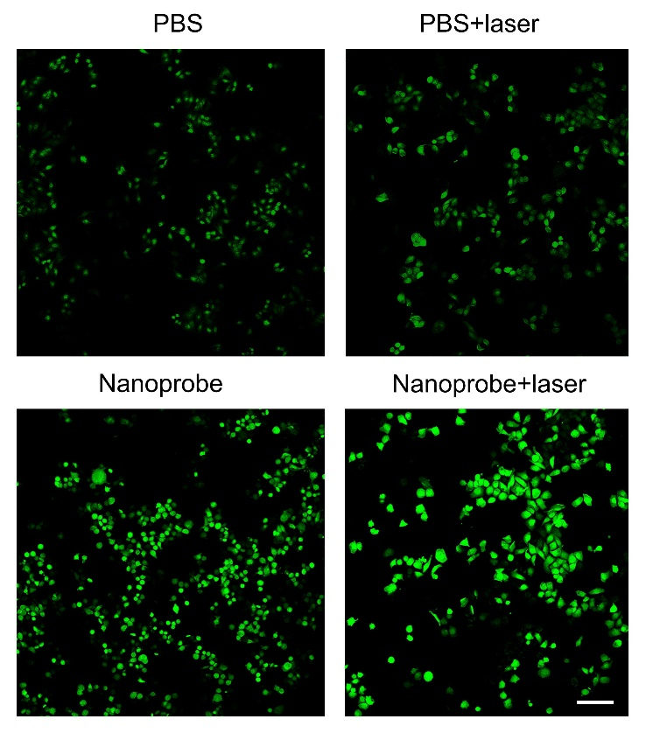
Figure S6. ROS fluorescence images of HepG2 cells cells incubated with PBS or nanoprobe after different treatments.

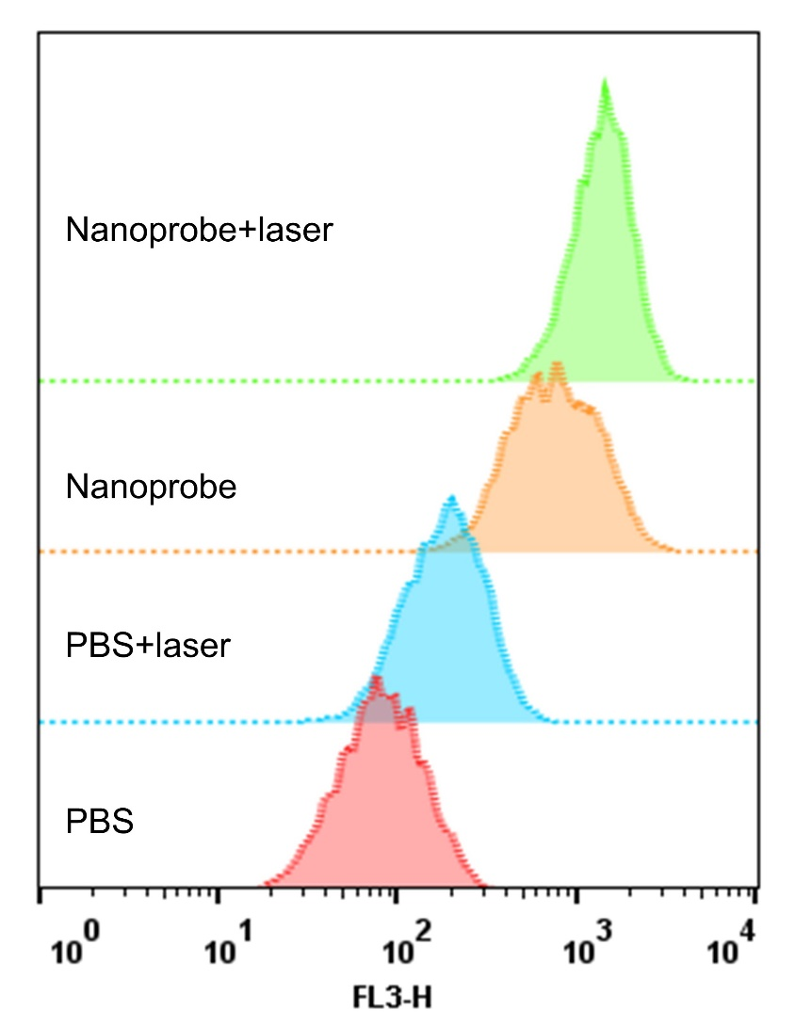
Figure S7. The contents of ROS in hepatocellular carcinoma cells were treated differently after being incubated with PBS or nanoprobe.

Figure S8. The intensity statistics of photoacoustic signal in tumor tissue region at different time.

