Supplemental information

Potential oxygen consumption and community composition of sediment bacteria in a seasonally hypoxic enclosed bay

Fumiaki Mori^{1, 2, †,} *, Yu Umezawa³, Ruji Kondo⁴,
Gregory N. Nishihara^{1, 2}, Minoru Wada¹

¹Graduate School of Fisheries and Environmental Sciences, Nagasaki University 851-2213 Nagasaki, Japan.
²Institute for East China Sea Research, Organization for Marine Science and Technology, Nagasaki University, Nagasaki 851-2213, Japan.
³Department of Environmental Science on Biosphere, Tokyo University of Agriculture and Technology, Tokyo 183-8509, Japan.
⁴Department of Marine Science and Technology, Fukui Prefectural University, Fukui 917-0003, Japan.

†Present address: Kochi Institute for Core Sample Research, Japan Agency for Marine-Earth Science and Technology (JAMSTEC), Kochi, 783-8502, Japan

*Corresponding author: morifu@jamstec.go.jp

Table 1 The result of the comparison experiment of oxygen consumption and INT reduction rate
Pre-incubation time (h) | Aeration time (h) | Sample | Type | O₂ consumption rate  (µmol g-1 day-1) | Range of O₂ consumption rate | INT reduction rate  (µmol g-1 day-1) | Standard error of INT reduction rate | Standard error of O₂ consumption rate | Sample number for O₂ consumption measurement | Sample number for INT reduction measurement
20 | 0.5 | 2017_August | WOC | 104.0 | 4.6 | 15.3 | 1.3 | NA | 2 | 3
20 | 1 | 2017_August | WOC | 148.4 | 1.2 | 15.3 | 0.9 | NA | 2 | 3
20 | 24 | 2017_August | WOC | 75.2 | 1.5 | 10.1 | 0.3 | NA | 2 | 3
20 | 4.5 | 2017_August | WOC | 88.4 | 1.1 | 7.8 | 0.9 | NA | 2 | 3
20 | 2 | 2017_August | WOC | 96.5 | 15.0 | 10.8 | 0.9 | NA | 2 | 3
20 | 48 | 2017_August | WOC | 68.6 | 10.0 | 10.2 | 0.5 | NA | 2 | 3
20 | 4 | 2017_August | WOC | 61.8 | 0.0 | 7.4 | 0.2 | NA | 2 | 3
20 | 0 | 2020_August | WOC | 155.2 | 78.3 | 28.5 | 1.2 | NA | 2 | 3
0 | 3 | 2020_August | WOC | 390.5 | 166.5 | 27.8 | 1.2 | NA | 2 | 3
20 | 2.5 | 2020_August | WOC | 326.7 | 57.3 | 24.4 | 0.7 | NA | 2 | 3
20 | 6.5 | 2020_August | WOC | 532.9* | 37.7 | 9.7 | 0.4 | NA | 2 | 3
20 | 0.25 | 2020_August | WOC | 288.7 | 33.0 | 23.3 | 0.4 | NA | 2 | 3
20 | 44 | 2020_August | WOC | 63.2 | 4.1 | 13.1 | 0.6 | NA | 2 | 3
0 | 5 | 2020_August | WOC | 198.5 | 21.8 | 16.6 | 1.6 | NA | 2 | 3
20 | 39 | 2020_August | WOC | 55.9 | 1.9 | 11.5 | 0.4 | NA | 2 | 3
20 | 17 | 2020_August | WOC | 44.3 | 0.7 | 12.9 | 1.9 | NA | 2 | 3
0 | 18 | 2020_August | WOC | 47.7 | 2.6 | 18.5 | 1.3 | NA | 2 | 3
20 | 0.5 | 2017_August | COC | 42.4 | 1.0 | 2.1 | 0.1 | NA | 2 | 3
20 | 1 | 2017_August | COC | 54.2 | 0.3 | 3.0 | 0.4 | NA | 2 | 3
20 | 24 | 2017_August | COC | 47.4 | 3.5 | 0.6 | 0.0 | NA | 2 | 3
20 | 4.5 | 2017_August | COC | 50.7 | 5.0 | 2.5 | 0.7 | NA | 2 | 3
20 | 2 | 2017_August | COC | 52.0 | 0.4 | 2.4 | 0.2 | NA | 2 | 3
20 | 48 | 2017_August | COC | 54.1 | 6.6 | 1.8 | 0.6 | NA | 2 | 3
20 | 4 | 2017_August | COC | 59.6 | 7.8 | 2.0 | 0.1 | NA | 2 | 3
20 | 0 | 2020_August | COC | 144.5 | 0.4 | 21.7 | 4.2 | NA | 2 | 3
0 | 3 | 2020_August | COC | 124.7 | 15.7 | 25.6 | 0.6 | NA | 2 | 3
20 | 2.5 | 2020_August | COC | 132.8 | 5.6 | 18.8 | 0.7 | NA | 2 | 3
20 | 6.5 | 2020_August | COC | 62.4 | 6.8 | 5.8 | 0.4 | NA | 2 | 3
20 | 0.25 | 2020_August | COC | 147.1 | 17.9 | 22.7 | 1.6 | NA | 2 | 3
20 | 44 | 2020_August | COC | 56.1 | 2.1 | 2.8 | 0.3 | NA | 2 | 3
0 | 5 | 2020_August | COC | 87.8 | 13.4 | 8.9 | 0.6 | NA | 2 | 3
20 | 39 | 2020_August | COC | 38.8 | 2.0 | 5.1 | 2.2 | NA | 2 | 3
20 | 17 | 2020_August | COC | 69.9 | 18.8 | 4.8 | 0.4 | NA | 2 | 3
0 | 18 | 2020_August | COC | 74.8 | 6.9 | 8.6 | 0.1 | NA | 2 | 3
0 | 0 | 2017_August | COC | 80.9 | 19.8 | 4.3 | 3.5 | 6.3 | 3 | 3
0 | 0.25 | 2017_August | COC | 72.2 | 23.7 | 16.5 | 1.3 | 7.6 | 3 | 3
0 | 0.5 | 2017_August | COC | 55.5 | 2.9 | 9.0 | 0.3 | 0.8 | 3 | 3
0 | 2 | 2017_August | COC | 62.1 | 2.7 | 5.6 | 0.1 | 0.9 | 3 | 3
0 | 4 | 2017_August | COC | 52.2 | 2.7 | 3.2 | 0.2 | 0.8 | 3 | 3
0 | 7 | 2017_August | COC | 61.7 | 4.2 | 3.7 | 0.1 | 1.4 | 3 | 3
0 | 24 | 2017_August | COC | 61.7 | 0.6 | 2.3 | 0.2 | 0.2 | 3 | 3
0 | 0 | 2017_August | COC | 82.9 | 6.0 | 12.9 | 0.3 | 1.9 | 3 | 3

NA: not applicable.
*; The value treated as outlier.
Table 2 The relative abundance (%) of ASVs belonging to Acrobacter genus
 | In situ sediment samples |  |  |  |  |  | At the end of incubation
ASVs | 5/19 | 6/20 | 7/18 | 8/24 | 9/20 |  | 5/19 | 6/20 | 7/18 | 8/24 | 9/20
ASV_31 | 0.000 | 0.000 | 0.000 | 0.009 | 0.106 |  | 0.000 | 0.000 | 0.000 | 4.622 | 0.890
ASV_49 | 0.000 | 0.000 | 0.000 | 0.068 | 0.262 |  | 0.000 | 0.000 | 0.000 | 2.788 | 0.685
ASV_91 | 0.000 | 0.013 | 0.023 | 0.009 | 0.003 |  | 0.538 | 2.191 | 0.837 | 0.008 | 0.008
ASV_93 | 0.000 | 0.000 | 0.000 | 0.036 | 0.044 |  | 0.000 | 0.000 | 0.000 | 2.723 | 0.310
ASV_231 | 0.004 | 0.000 | 0.000 | 0.015 | 0.082 |  | 0.000 | 0.000 | 0.000 | 1.149 | 0.400
ASV_407 | 0.000 | 0.000 | 0.000 | 0.408 | 0.015 |  | 0.000 | 0.000 | 0.000 | 0.033 | 0.016
ASV_409 | 0.149 | 0.126 | 0.014 | 0.009 | 0.000 |  | 0.427 | 0.099 | 0.021 | 0.008 | 0.008
ASV_666 | 0.000 | 0.000 | 0.000 | 0.006 | 0.000 |  | 0.000 | 0.000 | 0.000 | 0.783 | 0.000
ASV_857 | 0.000 | 0.000 | 0.000 | 0.000 | 0.000 |  | 0.000 | 0.233 | 0.565 | 0.000 | 0.000
ASV_876 | 0.000 | 0.000 | 0.000 | 0.000 | 0.000 |  | 0.009 | 0.691 | 0.000 | 0.008 | 0.000
ASV_900 | 0.000 | 0.000 | 0.000 | 0.182 | 0.009 |  | 0.000 | 0.000 | 0.000 | 0.106 | 0.000
ASV_1023 | 0.004 | 0.003 | 0.000 | 0.021 | 0.026 |  | 0.000 | 0.000 | 0.000 | 0.342 | 0.073
ASV_1295 | 0.000 | 0.000 | 0.000 | 0.104 | 0.012 |  | 0.000 | 0.009 | 0.000 | 0.098 | 0.016
ASV_1377 | 0.004 | 0.013 | 0.005 | 0.009 | 0.000 |  | 0.248 | 0.117 | 0.000 | 0.000 | 0.000
ASV_1492 | 0.000 | 0.000 | 0.009 | 0.006 | 0.000 |  | 0.009 | 0.242 | 0.157 | 0.000 | 0.000
ASV_1851 | 0.000 | 0.000 | 0.000 | 0.000 | 0.053 |  | 0.000 | 0.000 | 0.000 | 0.024 | 0.131
ASV_1955 | 0.008 | 0.000 | 0.000 | 0.000 | 0.038 |  | 0.000 | 0.000 | 0.000 | 0.073 | 0.082
ASV_2308 | 0.004 | 0.000 | 0.000 | 0.042 | 0.000 |  | 0.000 | 0.045 | 0.000 | 0.057 | 0.000
ASV_2522 | 0.012 | 0.003 | 0.000 | 0.000 | 0.000 |  | 0.077 | 0.090 | 0.000 | 0.000 | 0.000
ASV_2621 | 0.000 | 0.000 | 0.000 | 0.003 | 0.018 |  | 0.000 | 0.000 | 0.000 | 0.041 | 0.082
ASV_2888 | 0.000 | 0.000 | 0.000 | 0.003 | 0.015 |  | 0.000 | 0.000 | 0.000 | 0.008 | 0.090
ASV_3064 | 0.008 | 0.017 | 0.000 | 0.000 | 0.000 |  | 0.000 | 0.054 | 0.021 | 0.000 | 0.000
sum | 0.193 | 0.175 | 0.050 | 0.929 | 0.683 |  | 1.306 | 3.772 | 1.601 | 12.871 | 2.791

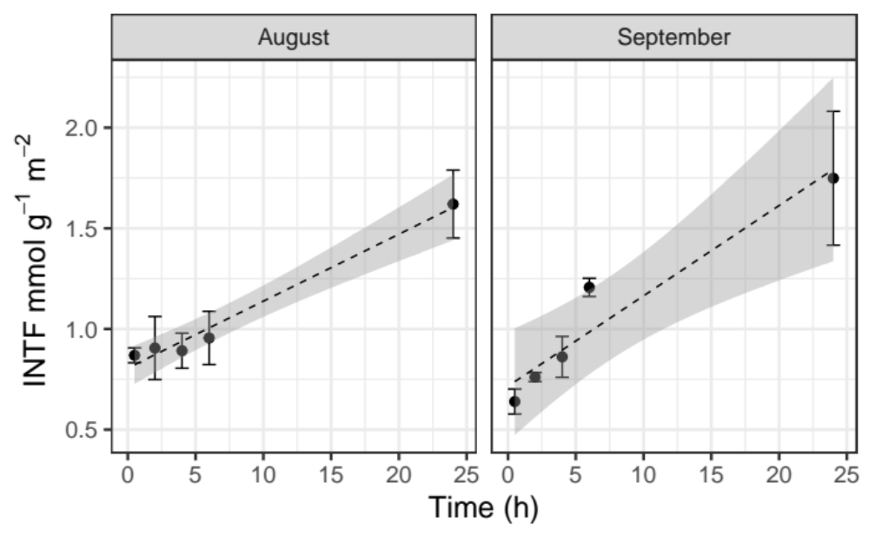
Figure1 Changes in the amount of INTF during the assay incubation. Regression line for August samples : INTF= 0.03 h + 0.81, r =0.99, (P < 0.005). Regression line for September: INTF = 0.05 h + 0.72, r = 0.96, (P < 0.01). Error bars represent the standard error.
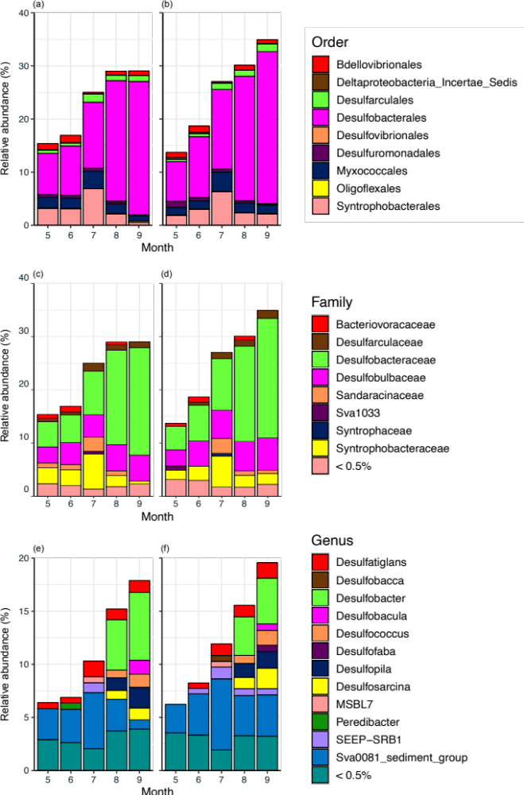Figure 2 Relative abundance (%) for Deltaproteobacteria before (a, c, e) and after (b, d, f) the 24 hours incubation.
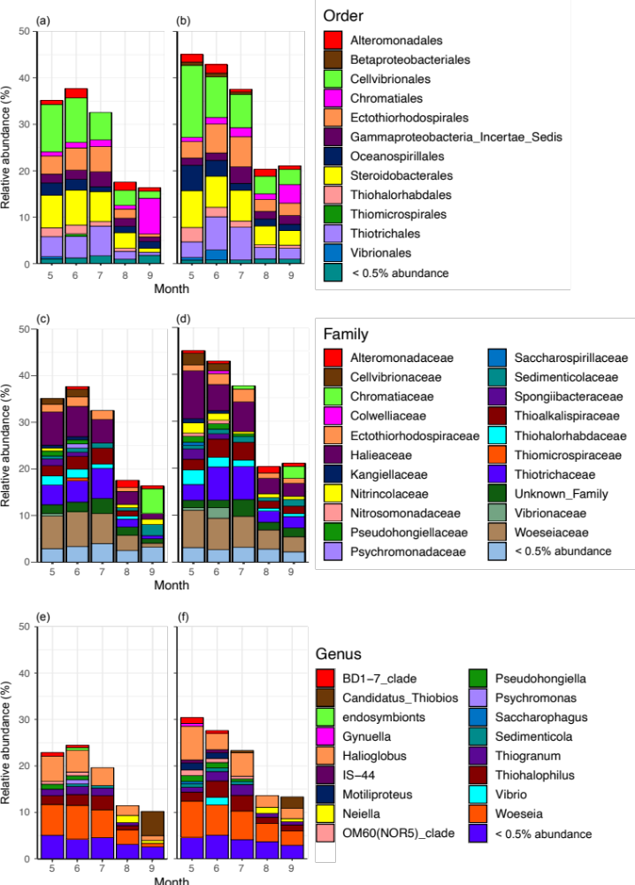Figure 3 Relative abundance (%) for Gammaproteobacteria before (a, c, e) and after (b, d, f) the 24 hours incubation.

