Supplementary Information

A Wearable and Unobstructive Qi Compatible Wireless Charger

Sangjun Kim^{1,8}, Jonathan Wells^{2,8}, Sarnab Bhattacharya², Hamsi Nathan³, Jiaming He⁴, Isabella Tubilla³, Heeyong Huh⁵, Pooja Kakani², Ali Farshkaran², Praveenkum Pasupathy², Jianshi Zhou⁴, Emily Porter², Nathan Lazarus^{6,7}, Nanshu Lu^{1,2,3,4,5}

¹Department of Mechanical Engineering, The University of Texas at Austin, Austin, TX, USA
²Department of Electrical and Computer Engineering, The University of Texas at Austin, Austin, TX, USA
³Department of Biomedical Engineering, The University of Texas at Austin, Austin, TX, USA
⁴Texas Materials Institute, The University of Texas at Austin, Austin, TX, USA
⁵Department of Aerospace Engineering and Engineering Mechanics, The University of Texas at Austin, Austin, TX, USA
⁶Department of Electrical and Computer Engineering, University of Delaware, Newark, DE, USA
⁷US Army Research Laboratory, Adelphi, MD, USA

⁸These authors contributed equally: Sangjun Kim, Jonathan Wells.
e-mail: nlazarus@udel.edu; nanshulu@utexas.edu

Contents
Supplementary Note 1. Calculations of coil-to-coil end charging efficiency of a two-port network with an inductive coupling.
Supplementary Note 2. A calculation of an effective thermal conductivity of Ferrofabric.
Supplementary Note 3. A selection of power specifications for WPT using Qi protocol.
Supplementary Table 1 | State-of-the-art stretchable magnetic materials.
Supplementary Fig. 1 | Characteristics of an oil-based ferrofluid (EMG 900).
Supplementary Fig. 2 | Evaluation of various fabric properties.
Supplementary Fig. 3 | Measured long-term properties of Ferrrofabric.
Supplementary Fig. 4 | An optical microscope image of Ferrrofabric after 157 days of fabrication.
Supplementary Fig. 5 | Geometric properties of the Tx and Rx coil.
Supplementary Fig. 6 | A schematic illustration of WPT concepts.
Supplementary Fig. 7 | AC and DC resistance of rectangular conductors considering the skin effect.
Supplementary Fig. 8 | Simulated electrical properties of Cu and EGaIn coils on Ferrofabric.
Supplementary Fig. 9 | Measured and simulated wireless charging characteristics for the smartphone charging case with various Ferrofabric size and Tx coil thickness.
Supplementary Fig. 10 | Measured and simulated wireless charging characteristics for the e-tattoo charging case with various Ferrofabric size and Tx coil thickness.
Supplementary Fig. 11 | Measured and simulated wireless charging characteristics for the e-tattoo charging case with various charging distances.
Supplementary Fig. 12 | Measured and simulated wireless charging characteristics for the smartphone charging case with various charging distances.
Supplementary Fig. 13 | Thermal simulation model for human and simulation input parameters.
Supplementary Fig. 14 | The effect of electrothermal characteristics.
Supplementary Fig. 15 | Power calculations for measured voltage and current from an oscilloscope.
Supplementary Fig. 16 | Long-term power measurements for smartphone charging.
Supplementary Fig. 17 | On-body and off-body comparison of charging performance.
Supplementary Fig. 18 | Ashby plot of state-of-the-art WPT devices in terms of transmitted power and stretchability.
Supplementary Video 1 | Cyclic palm clenching test between wireless charging of a smartphone.
Supplementary Video 2 | Wireless charging of a smartphone on the palm.
Supplementary Video 3 | Wireless charging of a battery-free chest e-tattoo and real-time ECG/SCG measurement.
References
Supplementary Note 1. Calculations of coil-to-coil end charging efficiency of a two-port network with an inductive coupling.

A two-port network with inductive coupling is depicted in Fig 3a and Supplementary Fig. 6a. To determine the power transfer efficiency, we model the receiver side as a reflected impedance $Z_{e}$ to construct an equivalent circuit¹ as illustrated in Supplementary Fig. 6b from Fig. 3b. The reflected impedance can be derived as:
 | $$Z_{e}=\frac{V_{Z_{e}}}{I_{Z_{e}}}=\frac{ω^{2}M^{2}}{Z_{Rx}}=\frac{ω^{2}M^{2}(\left(R_{Rx}+R_{L}\right)-jωL_{Rx})}{{\left(R_{Rx}+R_{L}\right)}^{2}+ω^{2}L_{Rx}^{2}}$$ | (1)

where $Z_{Rx}=\left(R_{Rx}+R_{L}\right)+jωL_{Rx}$ represents the impedance at the receiver side.
The coil-to-coil end efficiency is defined as:
 | $$η=η_{1}η_{2}=\frac{Re(Z_{e})}{Re\left(Z_{e}\right)+R_{Tx}}∙\frac{R_{L}}{R_{L}+R_{Rx}}$$ | (2)

It is worth noting that the coil-to-coil charging efficiency obtained from active power in each coil ($η=P_{Out,Rx}/P_{Tx}$) is consistent with Equation (1) where $P_{Tx}=I_{Tx}^{2}R_{Tx}+I_{Rx}^{2}R_{Rx}+I_{Rx}^{2}R_{L}$ and $P_{Out,Rx}=I_{Rx}^{2}R_{L}$. Each of these terms in $P_{Tx}$ represents heat dissipation in the Tx coil and Rx coil and the output power directed to the battery.
To obtain the maximum efficiency by optimizing as $(∂η/∂R_{L})=0$,
 | $$η_{max}=\frac{k^{2}Q_{Tx}Q_{Rx}R_{L,opt}/R_{Rx}}{k^{2}Q_{Tx}Q_{Rx}R_{L,opt}/R_{Rx}+{\left(1+R_{L,opt}/R_{Rx}\right)}^{2}+Q_{Rx}^{2}}$$ | (3)

where the optimized resistance $R_{L,opt}$ is given by:
 | $$R_{L,opt}=R_{Rx}\sqrt{1+Q_{Rx}^{2}+k^{2}Q_{Tx}Q_{Rx}}$$ | (4)

Supplementary Note 2. A calculation of an effective thermal conductivity of Ferrofabric.

Effective medium theory² provides a method to determine the macroscopic thermal conductivity of ferrofluid. As shown in Supplementary Fig. 12, the magnetite particles are uniformly distributed within the hydrocarbon oil medium, forming colloids. The effective thermal conductivity of the Ferrofluid ($k_{c}$) depends on the thermal conductivity of the magnetite particles ($k_{p}$) and the oil ($k_{m}$), and respective volumes ($V_{p}$ and $V_{m}$). The expression for the effective thermal conductivity is given by³
 | $$\left(\frac{k_{p}-k_{c}}{k_{p}-k_{m}}\right){\left(\frac{k_{m}}{k_{c}}\right)}^{L}=1-f_{p}$$ | (1)
 | $$f_{p}=\frac{V_{p}}{V_{p}+V_{m}}$$ | (2)

where L represents the depolarization factor, which is assumed to be 1/3 in our calculation due to the spherical nature of the magnetite particles. $f_{p}$ is defined as $V_{p}/(V_{p}+V_{m})$, meaning the volume fraction of the magnetite particles.
The effective thermal conductivity of Ferrofabric is calculated based on the volume fractions of the Ferrofluid and fabric, and can be expressed as
 | $$k_{eff}=f_{c}k_{c}+\left(1-f_{c}\right)k_{f}$$ | (3)

where $f_{c}$ is the volume fraction of Ferrofluid, and $k_{f}$ denotes the thermal conductivity of the fabric.

Supplementary Note 3. A selection of power specifications for WPT using Qi protocol.

To create a wearable WPT system with the Qi protocol, a selection of the power specifications is necessary. In 2015 the Wireless Power Consortium (WPC) designated 5 W charging as the Baseline Power Profile (BPP) and up to 15 W charging as the Extended Power Profile (EPP). The BPP mode has a limited use case for current mobile devices that require significant wattage levels to operate and charge quickly due to the maximum deliverable power of 5 W with 100% efficiency. BPP is ideal for small devices like e-tattoos that only require low power (< 1 W) to operate. Therefore, the BPP 5 W board is not suitable for mobile phone charging (Fig. 5a) and is used only in e-tattoo charging (Fig. 5d). The EPP specification is primarily useful in cases where high wattage levels are needed for faster charge times.
Currently, our WPT device consists of 2 commercial wireless charger design boards, a BPP 5 W board (WCT-NXQ1TXH5, NXP) for low power devices and an EPP 22 W board (WCT-15W1CFFPD, NXP) for high power devices, and an in-house fabricated planar spiral Cu coil with a thickness of 50 μm. The EPP mobile phone and BPP e-tattoo cases require modification to the full bridge invertor and LC resonant tank circuits. The full bridge invertor is a circuit technique that utilizes four power switches and four diodes to convert a DC value to an AC value. A resonant tank circuit shifts a coil’s natural resonant frequency to a designated frequency through ($f=1/\left(2π\sqrt{LC}\right)$). Next, foreign object detection (FOD), the ability to detect the amount of power lost in the WPT path, needs to be adjusted for the new coil. Then the FOD threshold needs to be altered in order to maintain a stable connection for WPT. If this threshold value is too low minor disruptions will halt charging and if it is too high, it will cause the coil to heat up excessively during charging.

Supplementary Table 1 | State-of-the-art stretchable magnetic materials.
Type | Magnetic filler | Matrix | $$μ_{r,filler}$$ | $$μ_{r,comp}$$ | E (kPa) | Stretchability (%) | Thickness | Application | References
Ferrofluid-based | 80.3 vol% ferrofluid (EMG 900) | Bamboo fabric | 19.6 | 11.3 | 75.3 | 50 | 0.5 mm | WPT | This work
Ferrofluid-based | 100% ferrofluid, EFH1 | - | 3.64 | 3.64 | 60 | 100 | 8 mm | WPT | 52
Ferrofluid-based | 100% ferrofluid, EMG900 | - | 19.6 | 19.6 | 60 | 100 | 8 mm | WPT | 52
Ferroelastomer | 25 vol% iron powder | Ecoflex 00-30 | 1,150 | 2.19 | 91.2 | - | 5 mm | WPT | 22
Ferroelastomer | 20 vol% Sendust | Ecoflex 00-30 | 16,000 | 2.25 | 53.6 | 375 | - | WPT | 22
Ferroelastomer | 15 vol% Sendust | Ecoflex 00-30 | 16,000 | 1.95 | 33.3 | 425 | - | WPT | 22
Ferroelastomer | 80 wt% molypermalloy powder | Ecoflex 00-30 | 20,000 | 2.9 | 145 | 100 | - | WPT | 45
Ferroelastomer | 20 wt% Sendust | Ecoflex 00-30 | 16,000-36,000 | 2.8 | 110 | 100 | - | WPT | 45
Ferroelastomer | 20 wt% Sendust | Ecoflex 00-30 | 16,000-36,000 | 2.85 | - | 50 | 2.5 mm | WPT | 37
Ferroelastomer | 33 wt% carbonyl iron particle | PDMS | - | 1.3 | 375 | 50 | - | Actuator | 48
Ferroelastomer | 80 wt% carbonyl iron particle | PDMS | - | 2.6 | 1,400 | 50 | - | Actuator | 48
Ferroelastomer | 70 wt% carbonyl iron particle | Ecoflex 00-30 | 2,000 | 1.95 | 75.2 | 65 | - | Actuator | 46
Ferroelastomer | 70 wt% carbonyl iron particle | PDMS | 1,000 | 1.9 | 2,170 | 100 | 0.2 mm | Actuator | 44
Ferroelastomer | 40 wt% iron oxide particle (EMG 1200) | PDMS | - | 1.6 | 600 | 30 | 35.5 $μm$ | MEMS | 50
Ferroelastomer | 40 wt% iron oxide particle (EMG 1400) | PDMS | - | 1.6 | 1,000 | 20 | 35.5 $μm$ | MEMS | 50
Ferroelastomer | 70 wt% carbonyl iron particle | Polyurethane | - | 1.06 | 200 | - | 3.1 mm | Sensor | 47
Ferroelastomer | 15 vol% nickel particle | PDMS | - | 1.2 | 3,170 | - | - | - | 49

Supplementary Fig. 1 | Characteristics of an oil-based ferrofluid (EMG 900). Data is provided by Ferrotec. a, Transmission electron microscopy (TEM) micrograph of ferrofluid magnetic nanoparticles. b, Size distribution of the magnetic nanoparticles in ferrofluid. c, A magnetization-magnetic field intensity curve of ferrofluid.

Supplementary Fig. 2 | Evaluation of various fabric properties. a, Measured ferrofluid absorption capacity of various cotton fabrics: Duck Canvas (DC), Cotton Muslim (CM), Cotton Sateen (CSa), Cotton Fabric Roll (CR), Cotton T-shirt (CT), Cotton Sheet (CS), Cotton Spandex (CSp), and 38% Raylon Bamboo (38% B). b, Measured Young’s modulus of various fabrics.

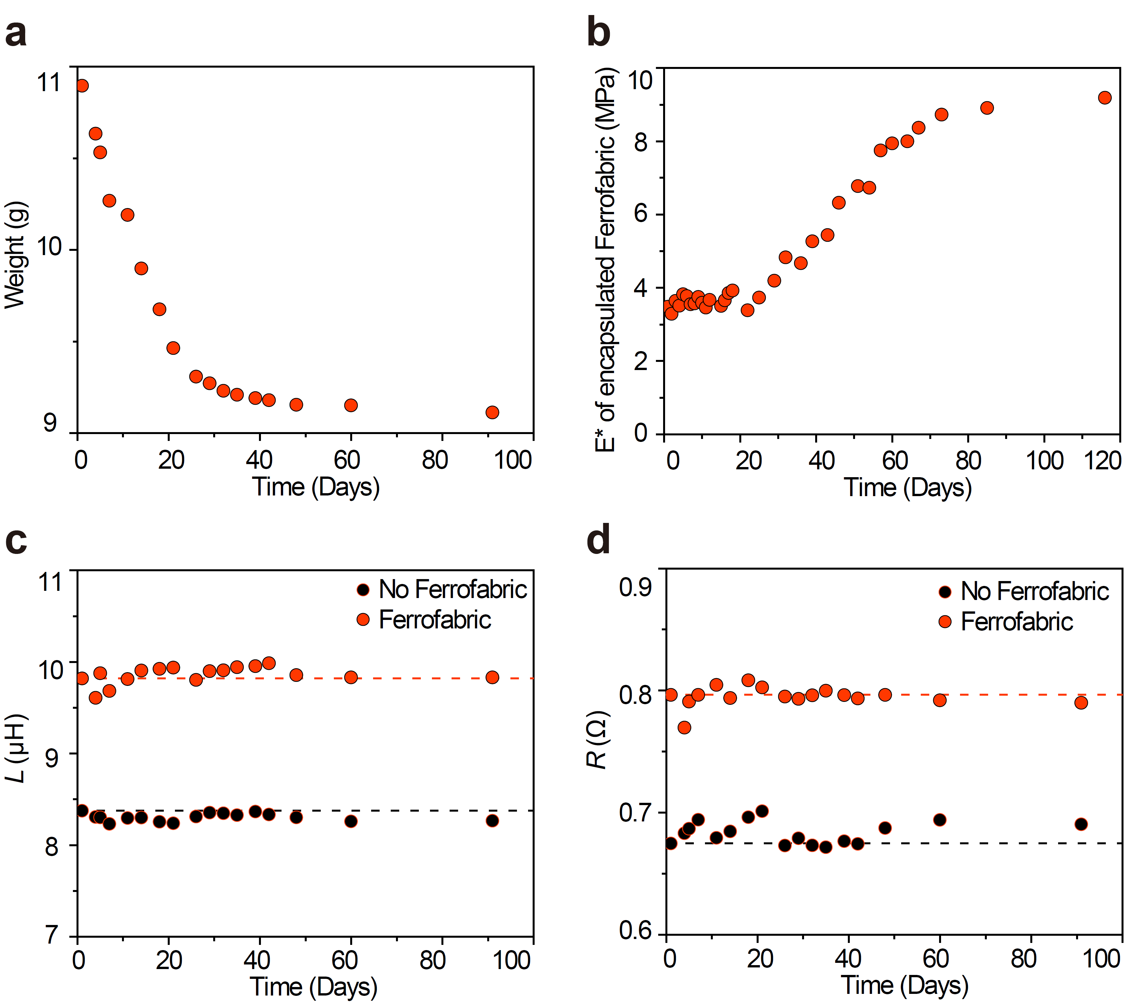
Supplementary Fig. 3 | Measured long-term properties of Ferrofabric. a, Weight of a 70 mm × 70 mm Tegaderm-encapsulated Ferrofabric for 91 days. b, The effective modulus of a Tegaderm-encapsulated Ferrofabric (50 mm x 10 mm) for 116 days. Electrical properties of a Cu coil on a 70 mm x 70 mm Ferrofabric for the first 91 days: c, inductance and d, resistance.

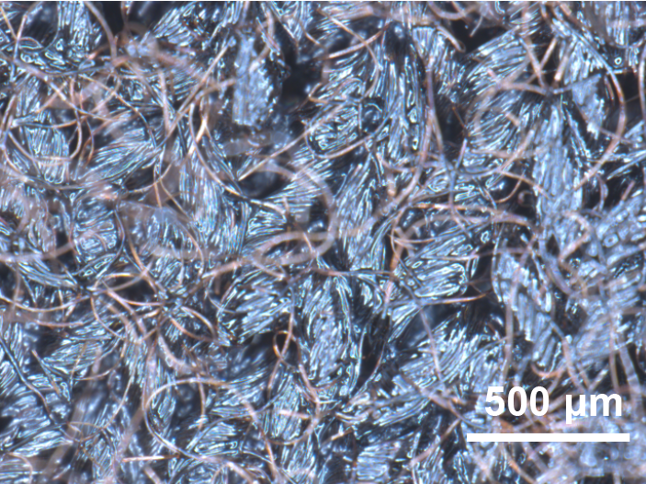
Supplementary Fig. 4 | An optical microscope image of Ferrofabric after 157 days of fabrication.

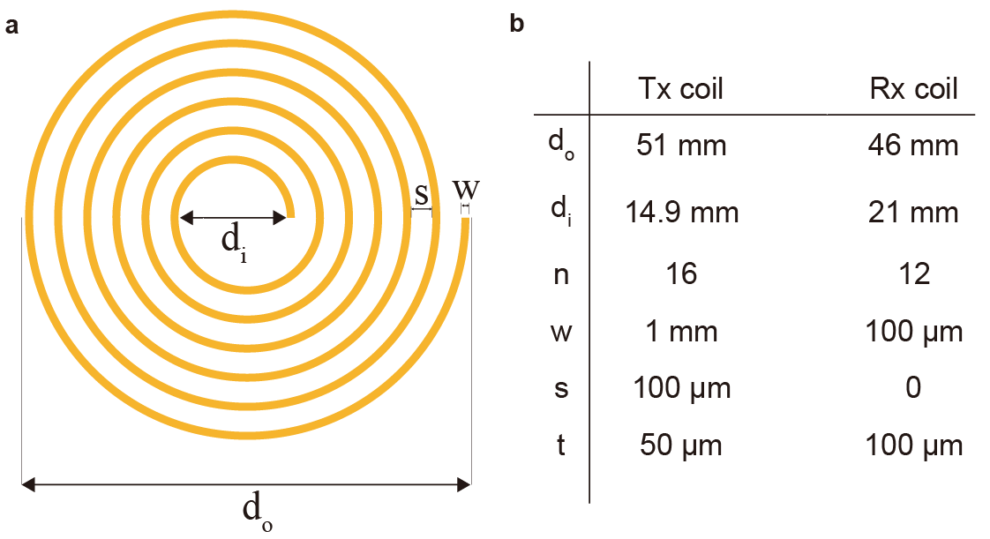
Supplementary Fig. 5 | Geometric properties of the Tx and Rx coil. a, Diagram of the spiral planar coil. b, Table of the coil parameters for the Tx and Rx coil.
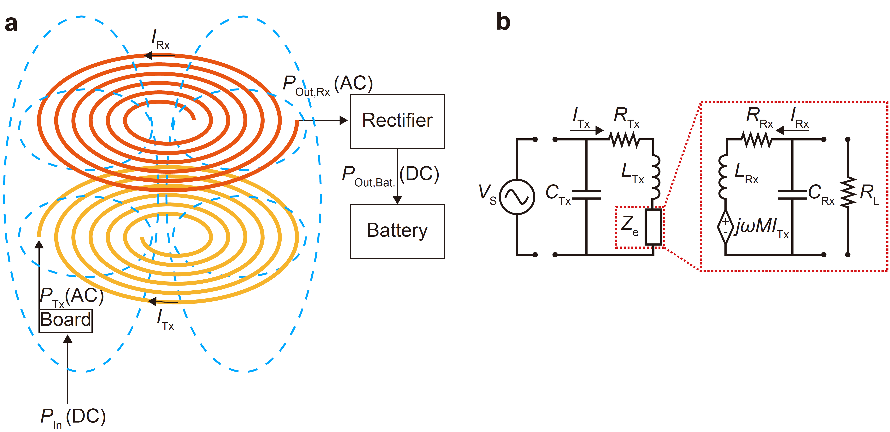
Supplementary Fig. 6 | A schematic illustration of WPT concepts. a, Diagram of inductively coupled two coils with each type of power. b, A WPT circuit model where the secondary side is modeled as a reflected impedance for charging efficiency calculation.

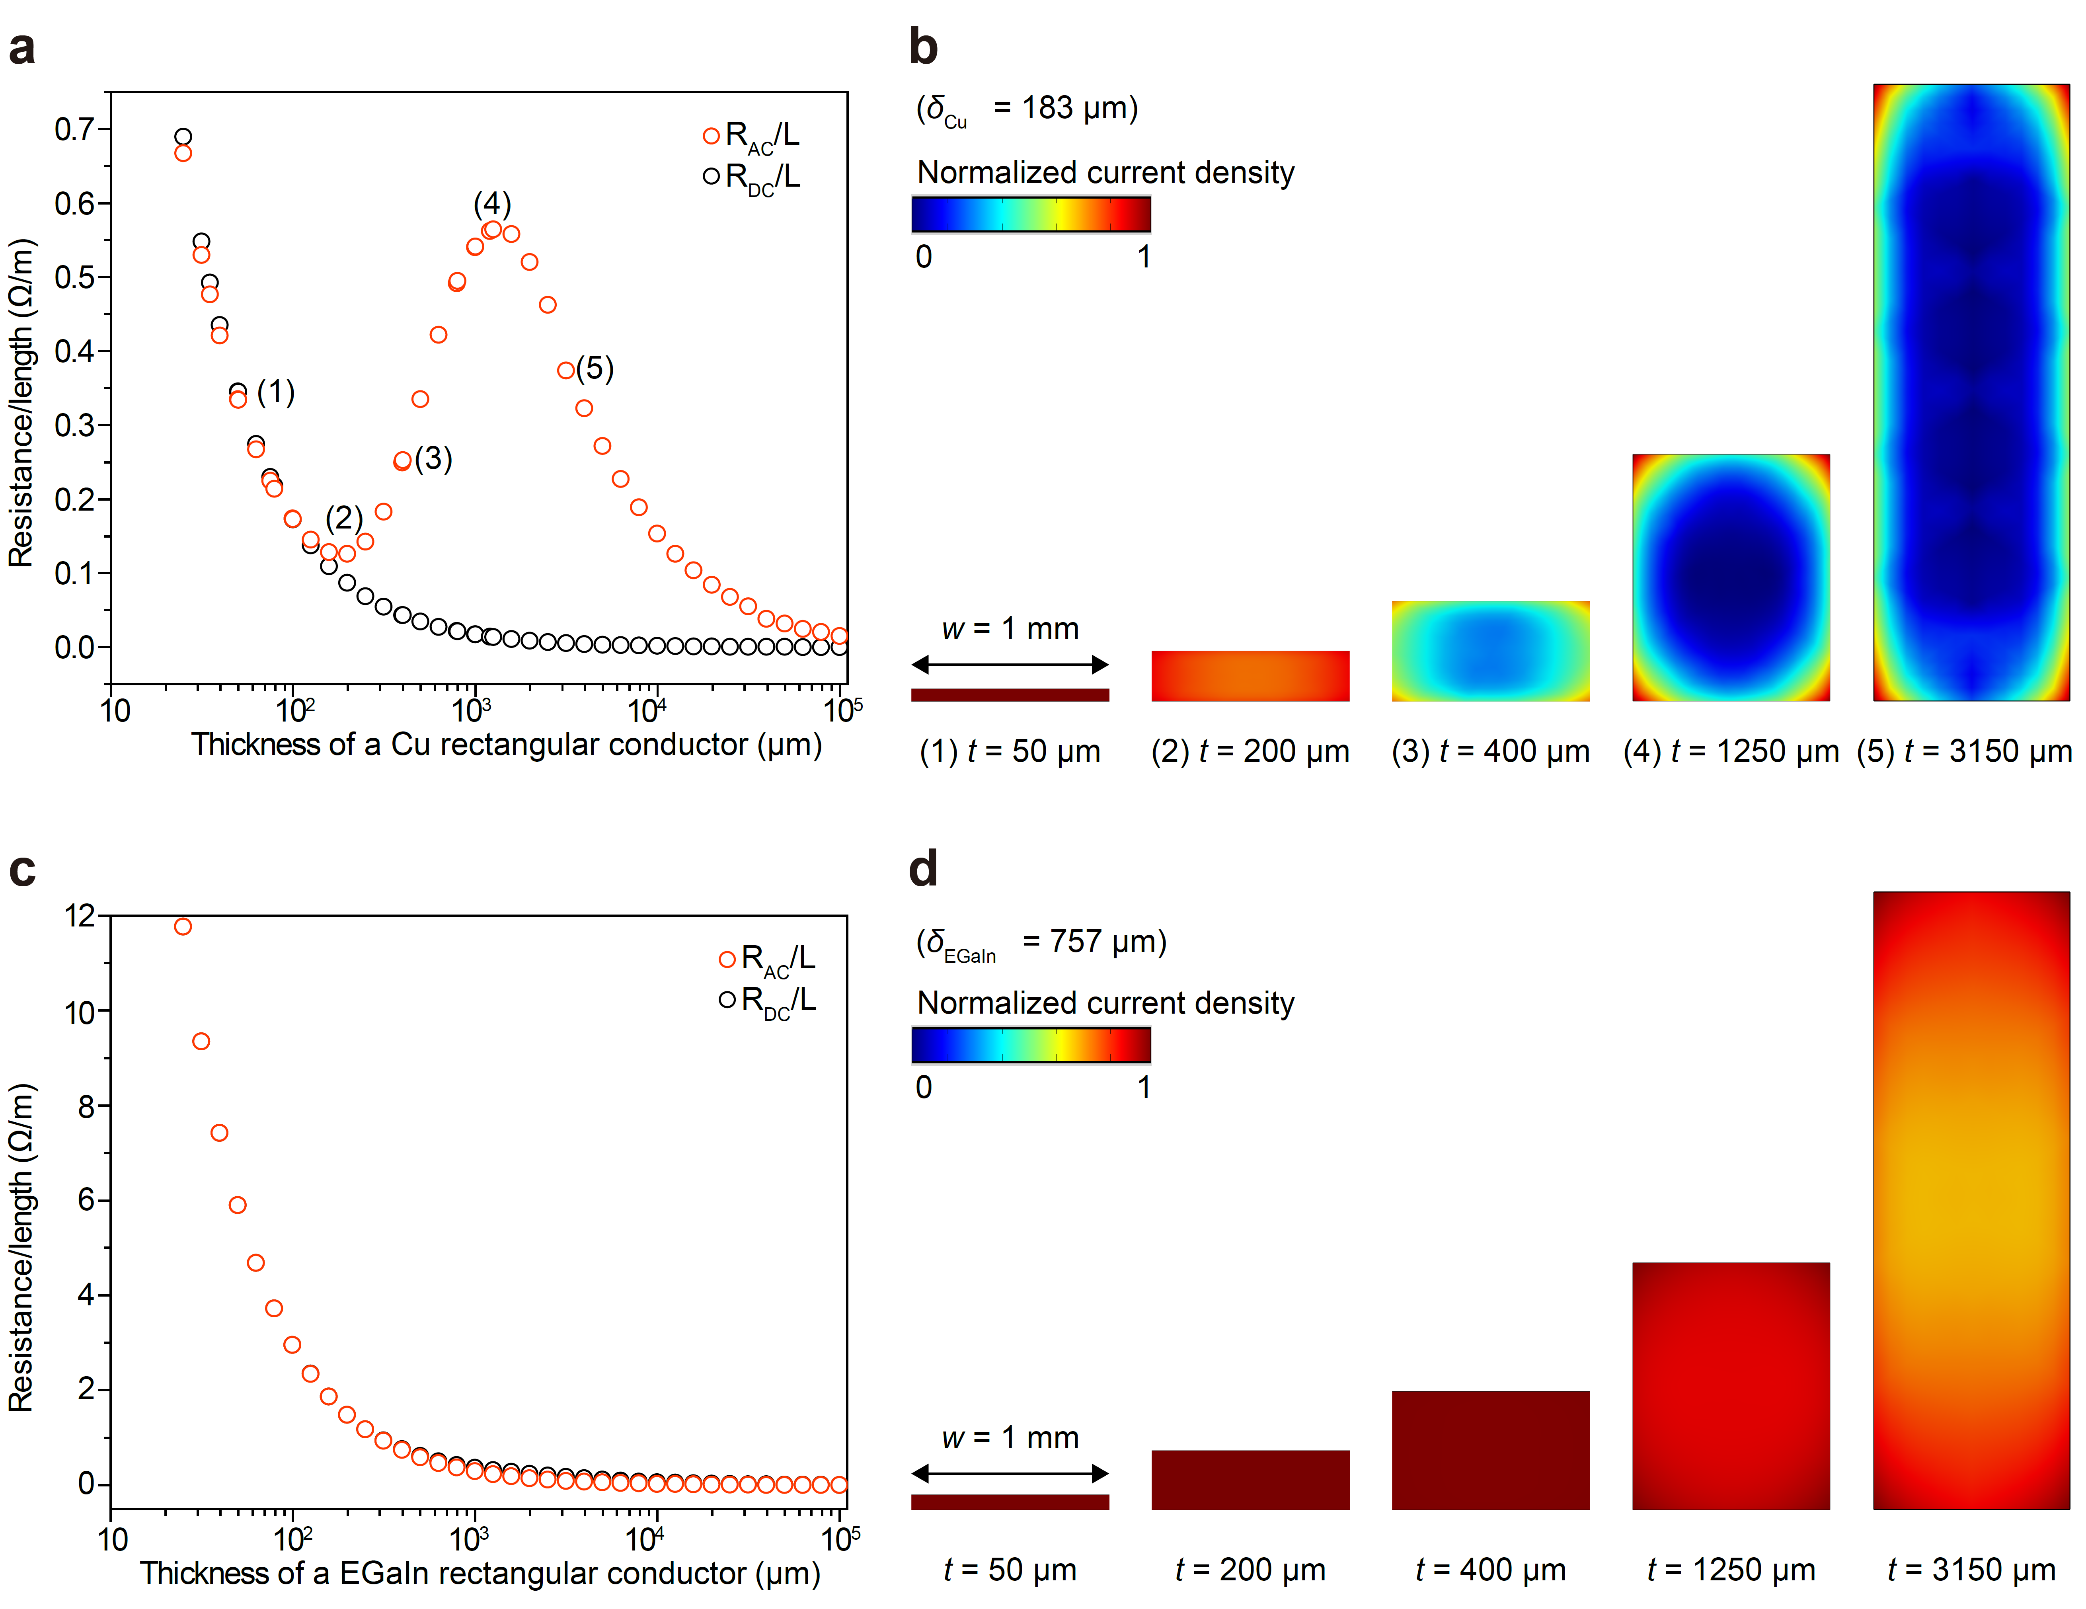
Supplementary Fig. 7 | AC and DC resistance of rectangular conductors considering the skin effect. The conductor width of 1 mm was used. a, AC and DC resistance per unit length for Cu conductors with respect to thickness. b, Distribution of normalized current density across the cross-section. c, AC and DC resistance per unit length for EGaIn conductors with varying thicknesses. d, Distribution of normalized current density across the cross-section. These results illustrate the electrical characteristics of Cu and EGaIn conductors for wearable devices. The difference in the skin depth leads to distinct behaviors in AC resistance and current density distribution. Cu conductors demonstrate a substantial change in current density as thickness varies. When they are thin, AC resistance is consistent with DC resistance as shown from (1) to (2) in a. Further thickness increments result in rising AC resistance (from (2) to (4)) as the skin effect becomes increasingly dominant. As thickness continues to increase, AC resistance decreases, with geometry becoming the dominant factor. This indicates the existence of an optimal conductor thickness for wearable applications operating in AC in terms of AC resistance. In contrast, EGaIn does not show these characteristics since their skin depth and conductor width make EGaIn less susceptible to changes in current density with varying thickness.
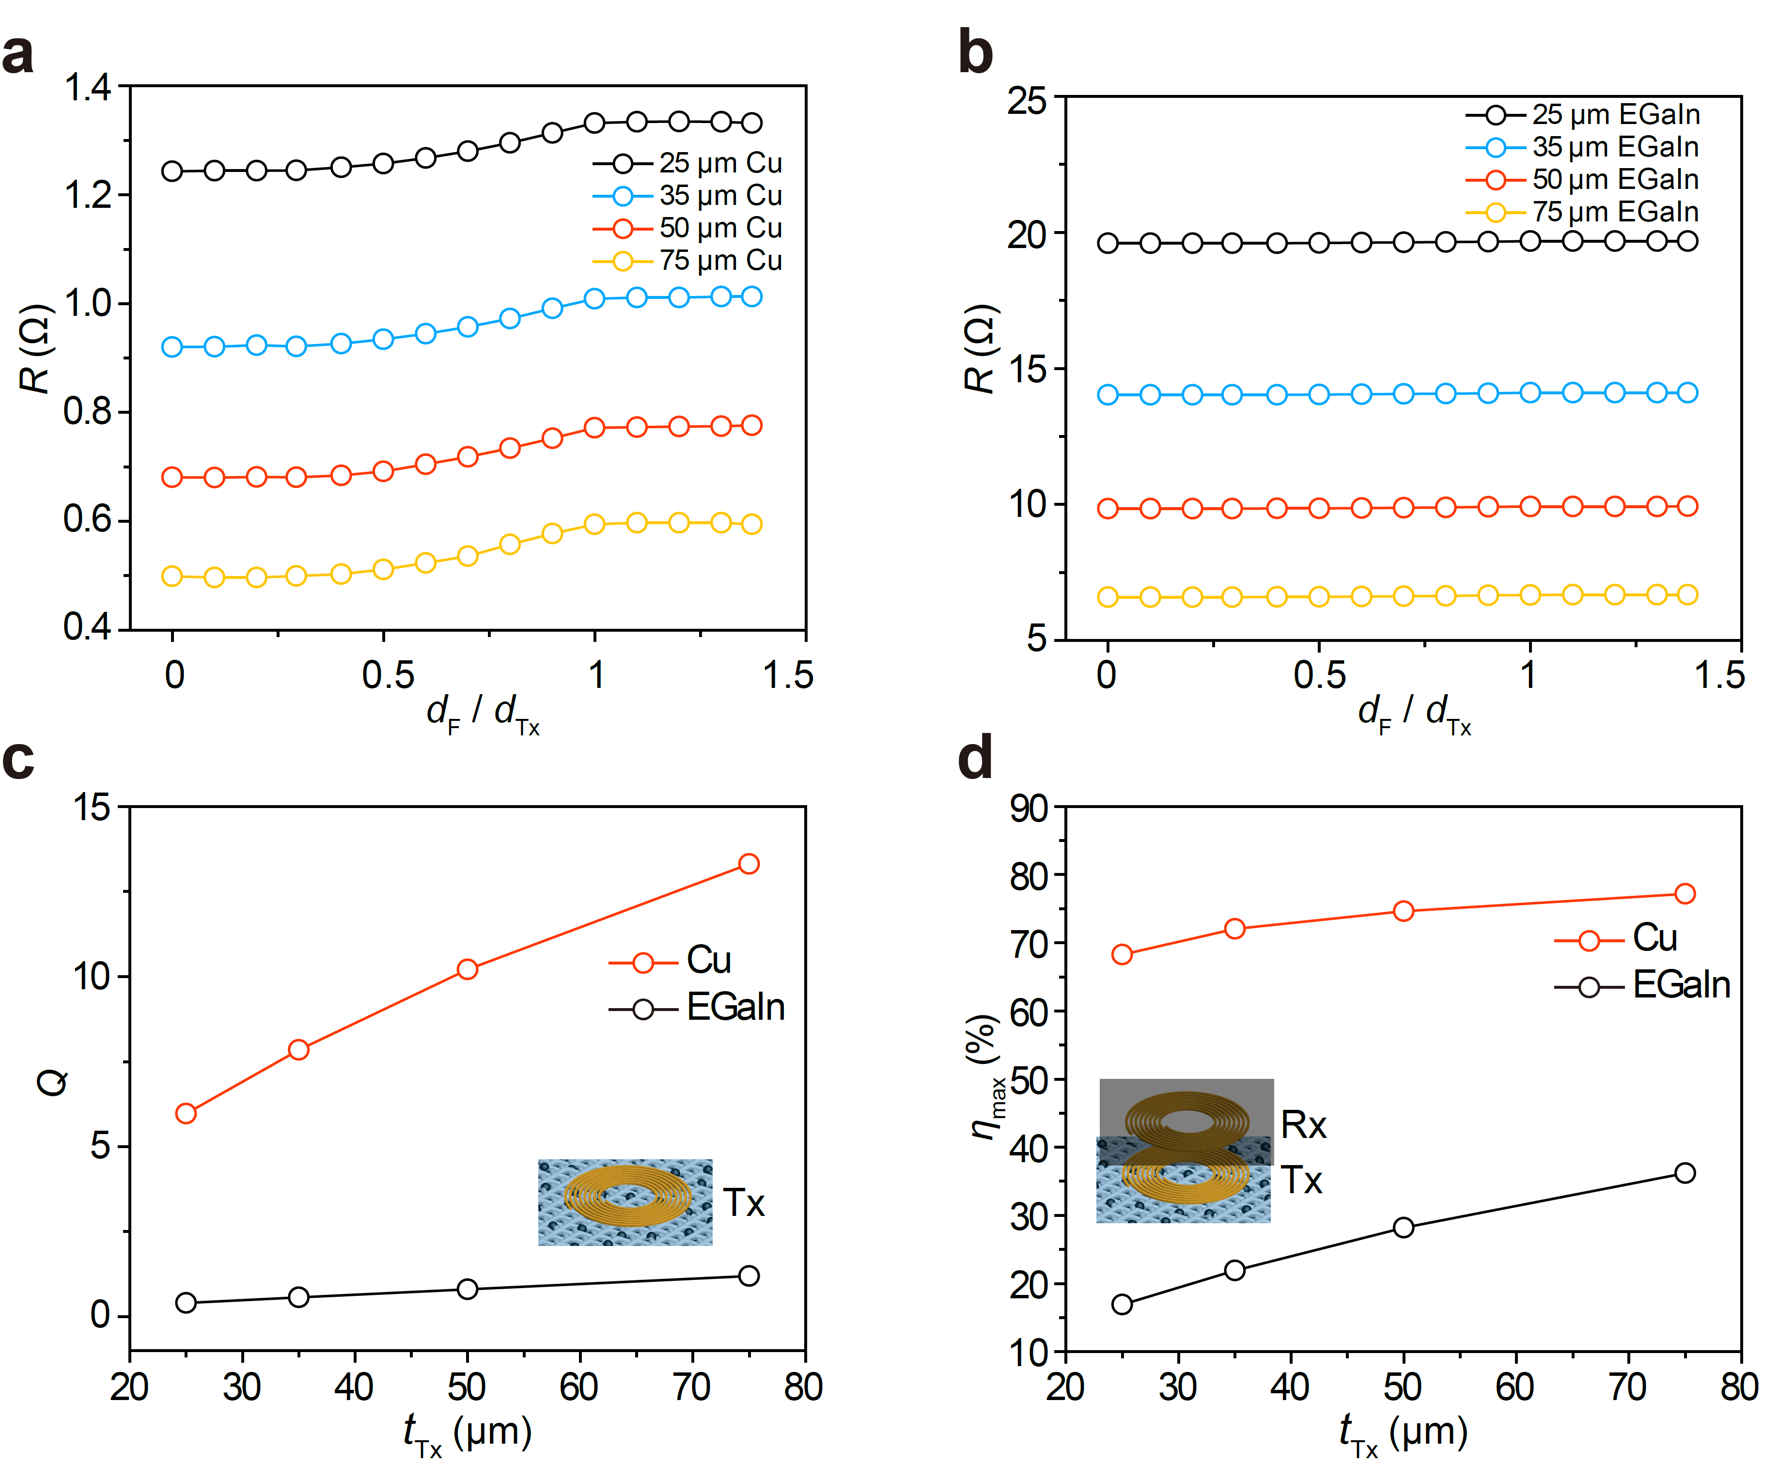
Supplementary Fig. 8 | Simulated electrical properties of Cu and EGaIn coils on Ferrofabric. Resistance vs. Ferrofabric size curves in a single coil system with different thickness of a, Cu coil and b, EGaIn coil. c, Quality factor of Cu and EGaIn coils with different coil thicknesses in a single coil system using fabric pocket sized Ferrofabric. d, Maximum charging efficiency-Tx coil thickness curves for wireless charging of a smartphone using Cu and EGaIn coils and fabric pocket sized Ferrofabric.
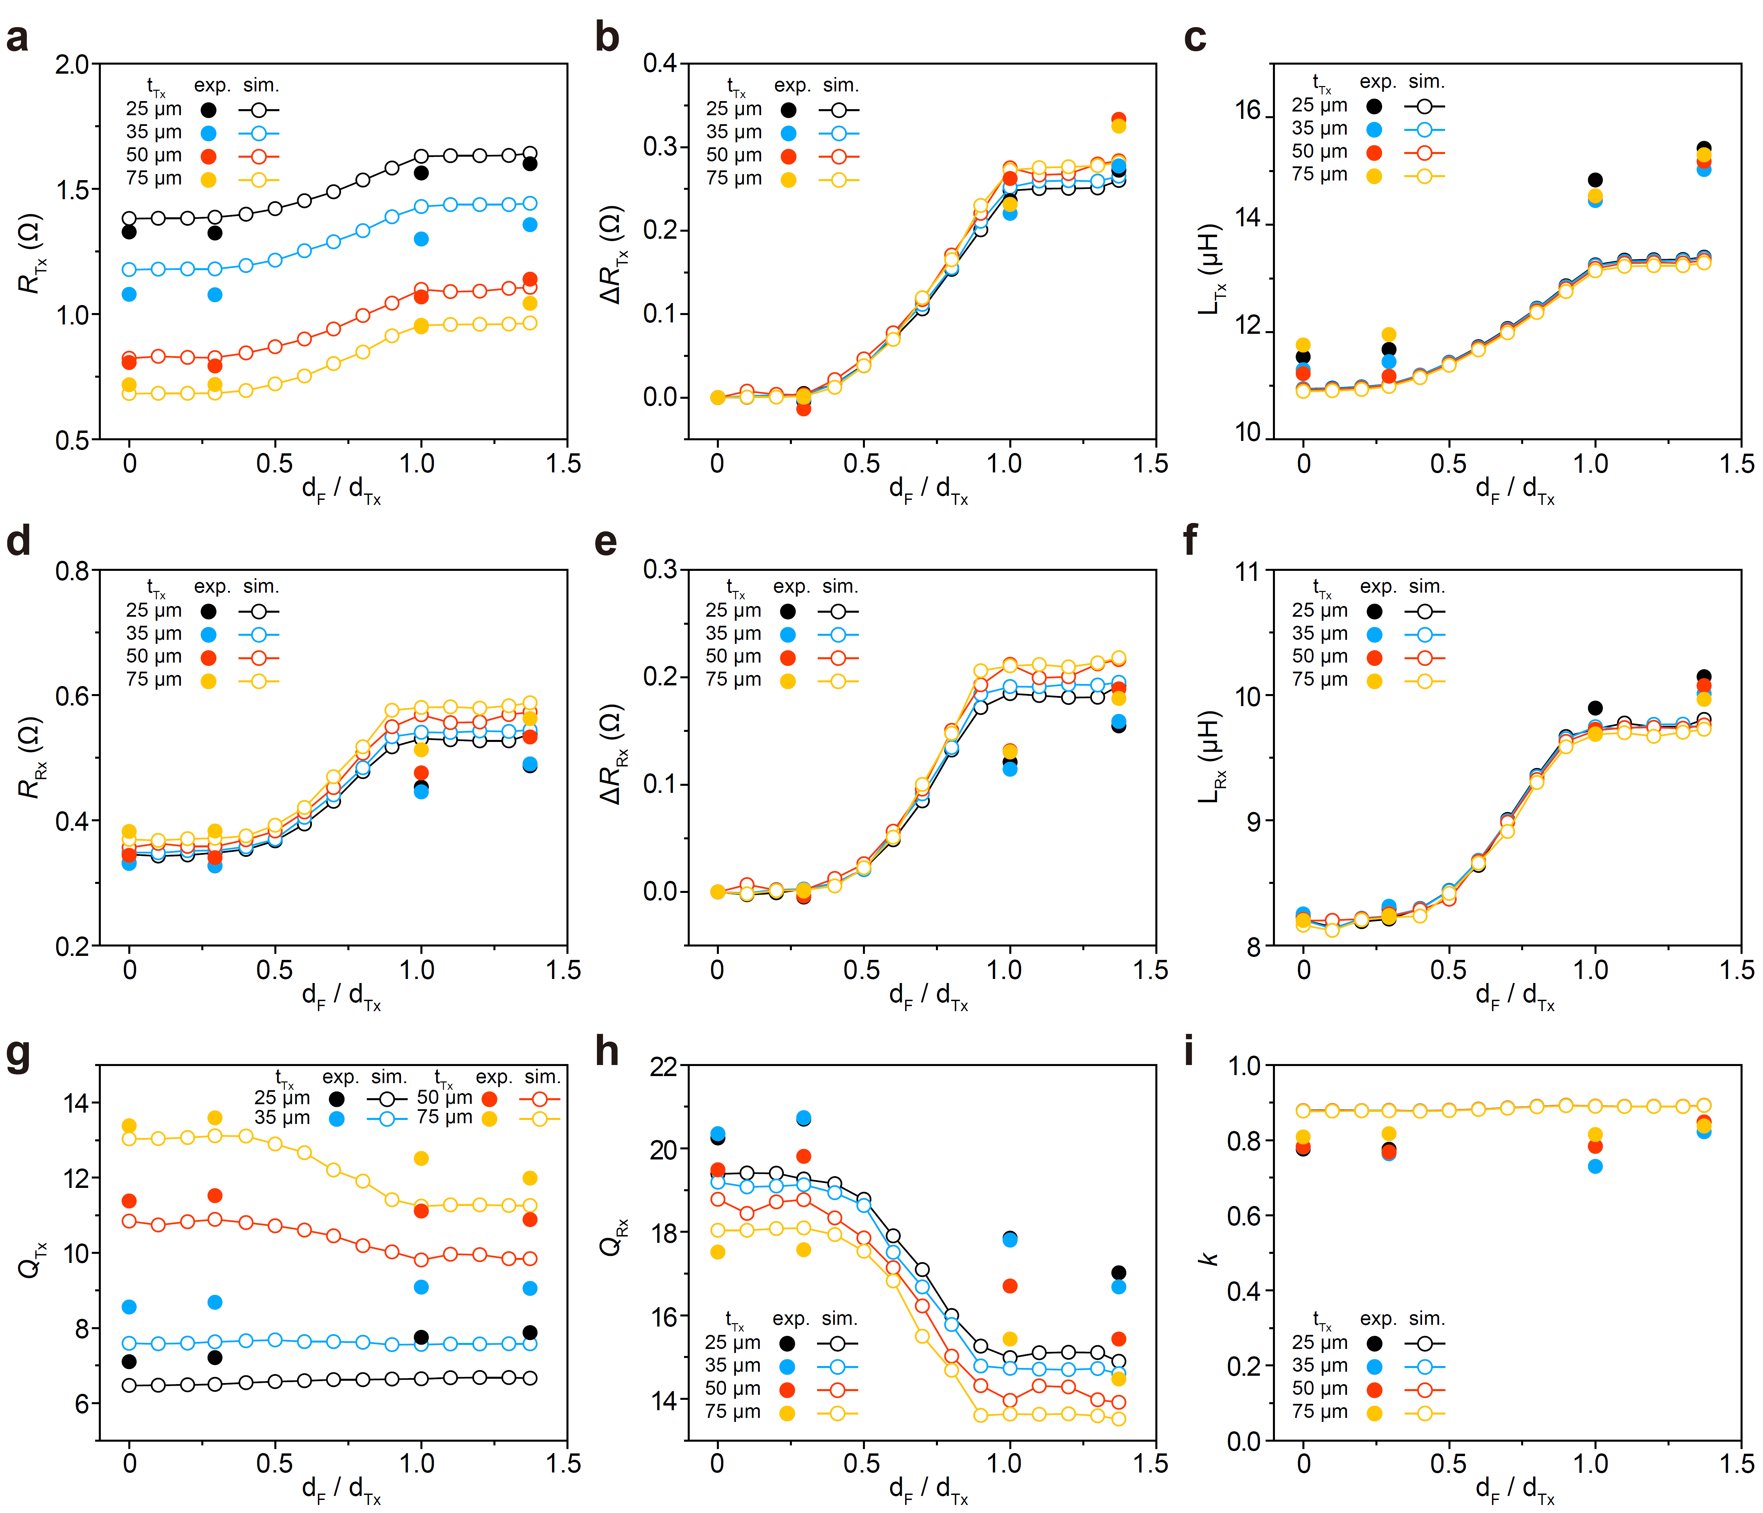
Supplementary Fig. 9 | Measured and simulated wireless charging characteristics for the smartphone charging case with various Ferrofabric size and Tx coil thickness. a, Tx resistance. b, Changes in the Tx resistance. c, Tx inductance. d, Rx resistance. e, Changes in the Rx resistance. f, Rx inductance. g, Tx quality factor. h, Rx quality factor. i, Coupling coefficient.

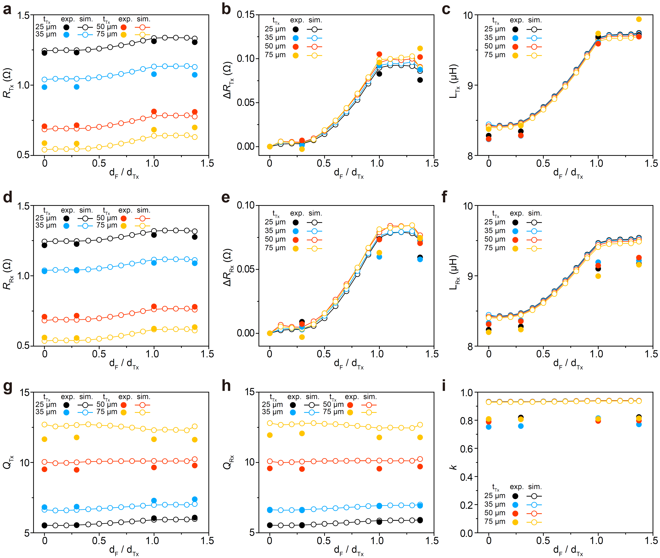
Supplementary Fig. 10 | Measured and simulated wireless charging characteristics for the e-tattoo charging case with various Ferrofabric size and Tx coil thickness. a, Tx resistance. b, Changes in the Tx resistance. c, Tx inductance. d, Rx resistance. e, Changes in the Rx resistance. f, Rx inductance. g, Tx quality factor. h, Rx quality factor. i, Coupling coefficient.

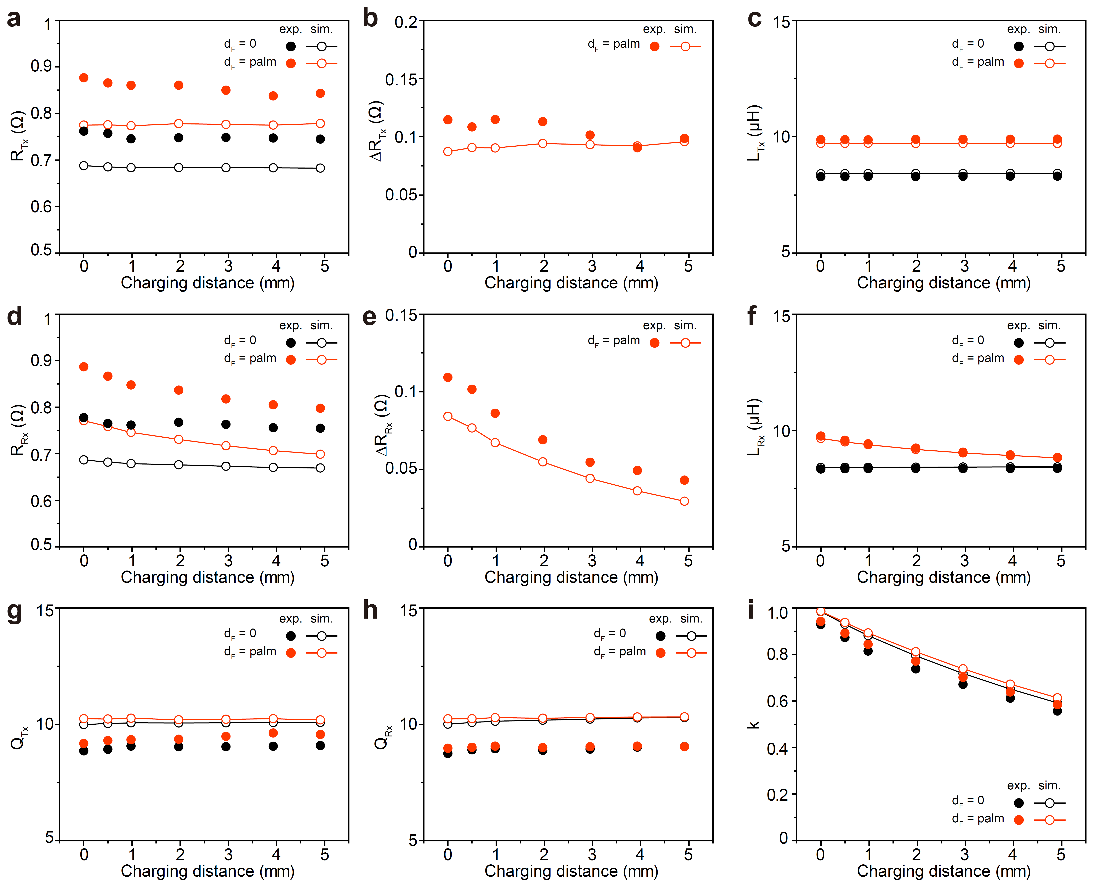
Supplementary Fig. 11 | Measured and simulated wireless charging characteristics for the e-tattoo charging case with various charging distances. a, Tx resistance. b, Changes in the Tx resistance. c, Tx inductance. d, Rx resistance. e, Changes in the Rx resistance. f, Rx inductance. g, Tx quality factor. h, Rx quality factor. i, Coupling coefficient.

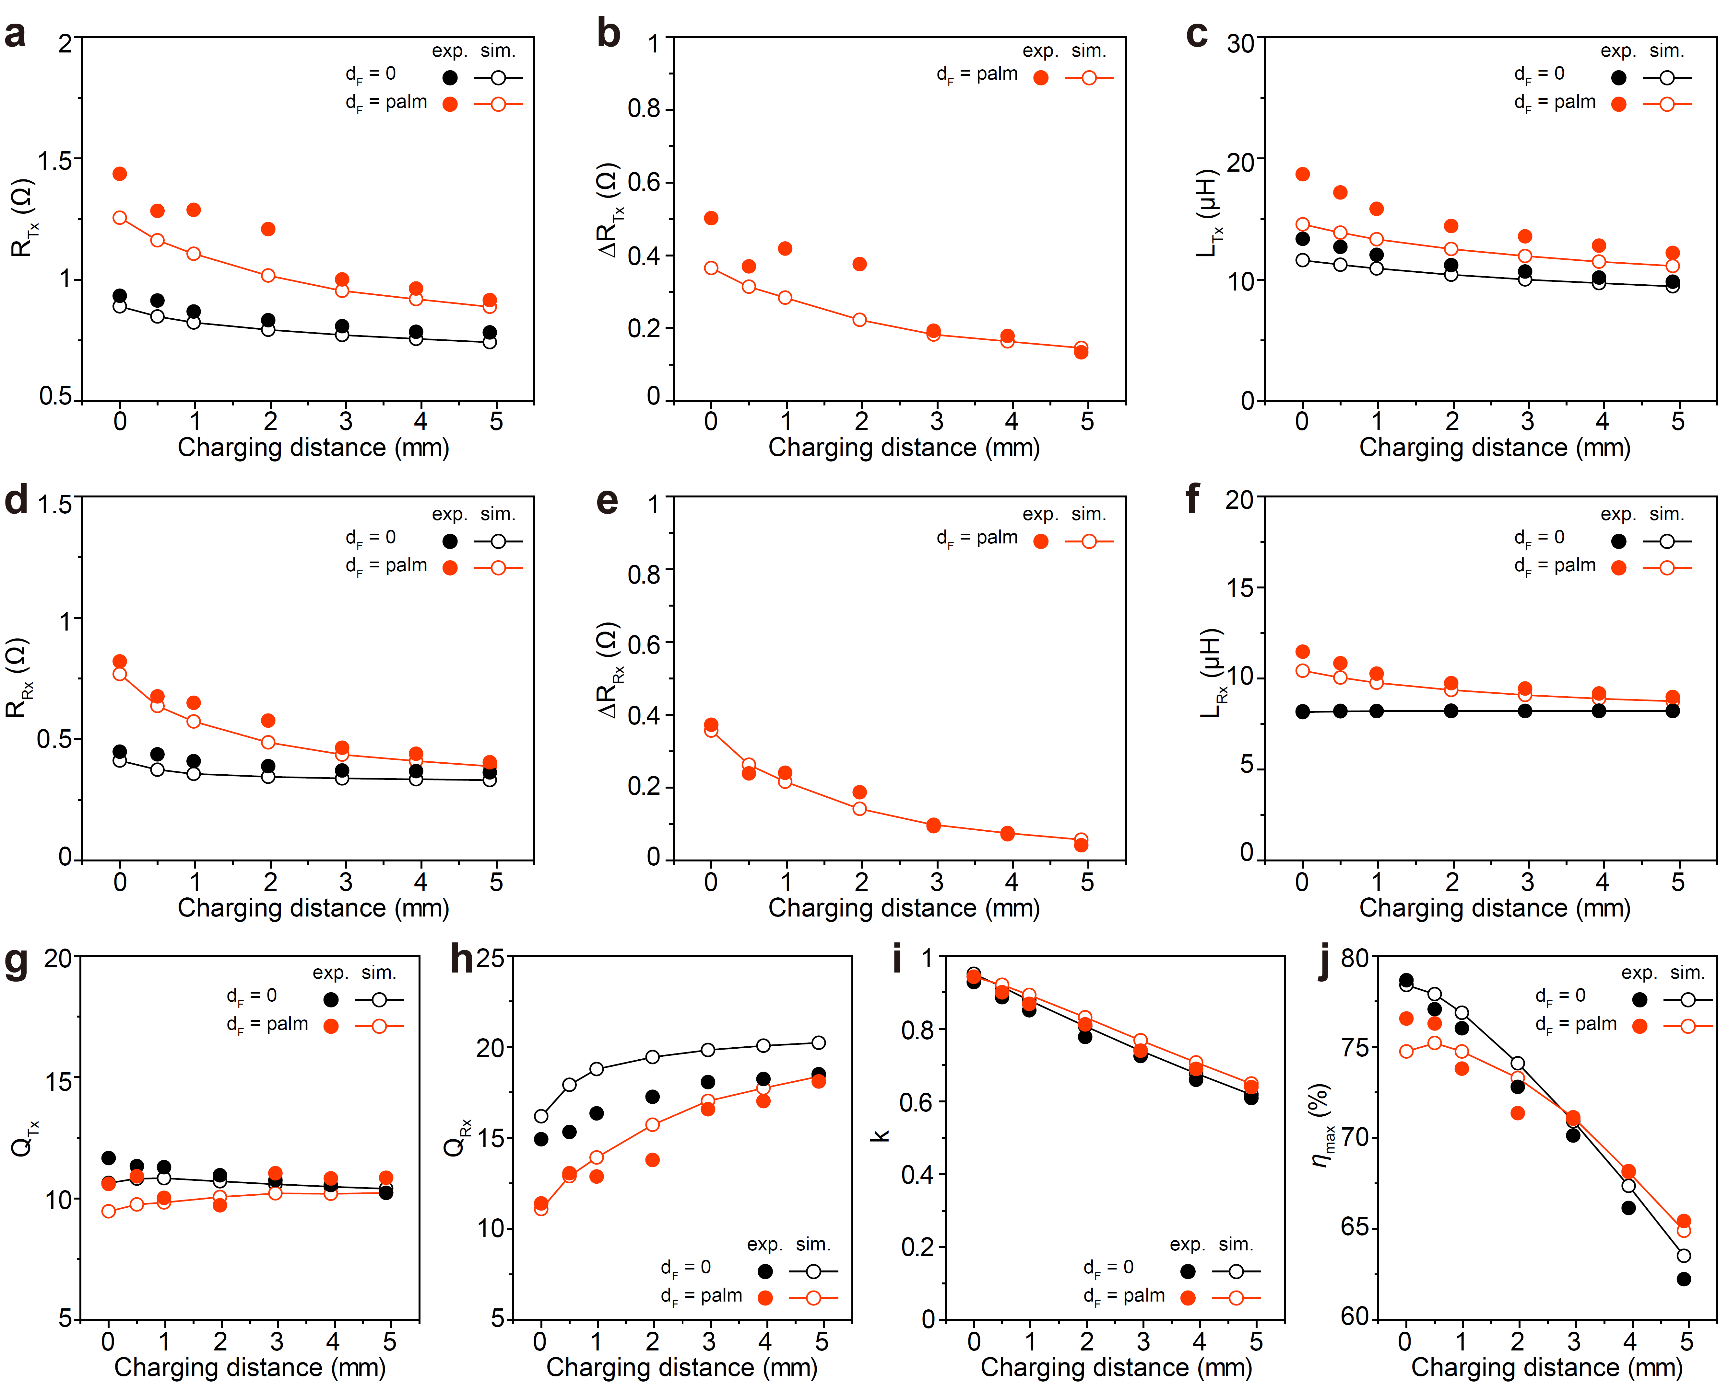
Supplementary Fig. 12 | Measured and simulated wireless charging characteristics for the smartphone charging case with various charging distances. a, Tx resistance. b, Changes in the Tx resistance. c, Tx inductance. d, Rx resistance. e, Changes in the Rx resistance. f, Rx inductance. g, Tx quality factor. h, Rx quality factor. i, Coupling coefficient. j, Maximum charging efficiency.

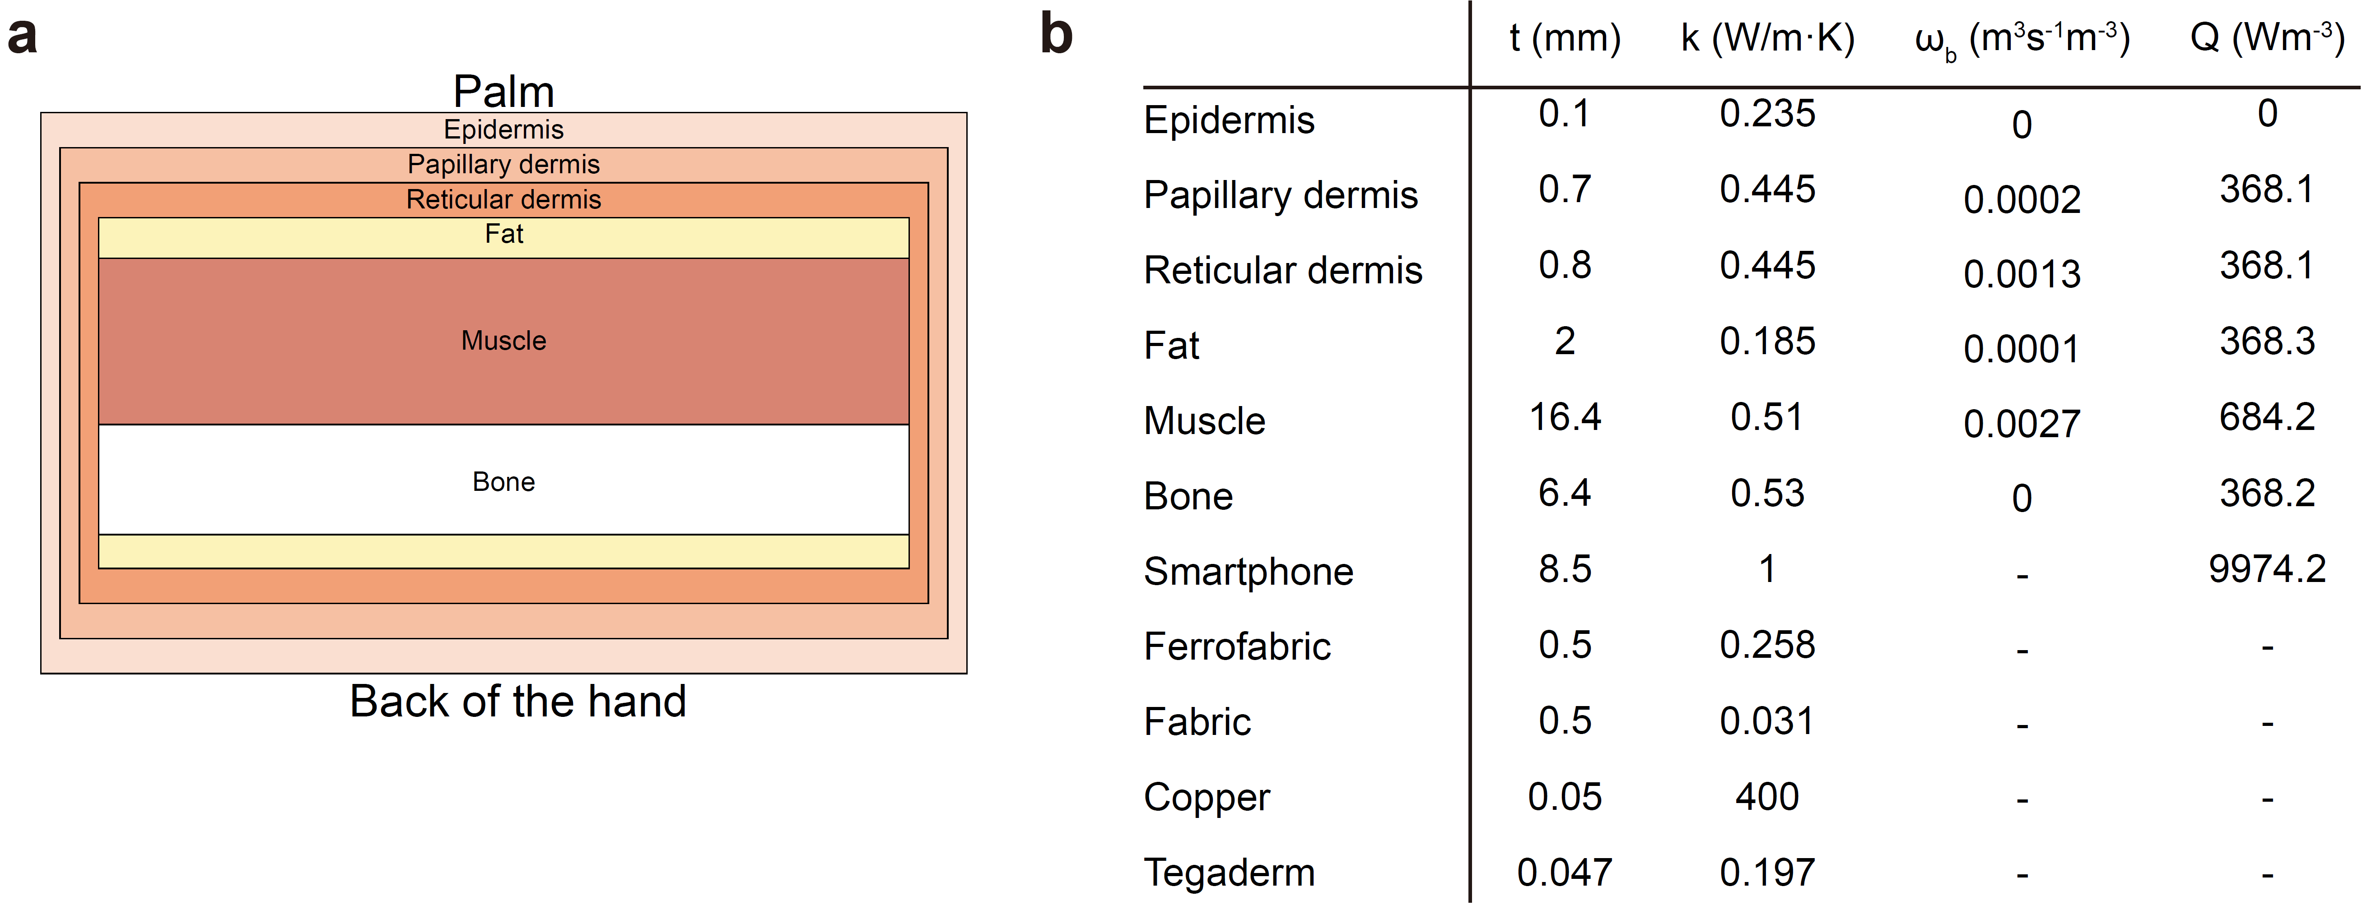
Supplementary Fig. 13 | Thermal simulation model for human hand and simulation input parameters. a, Cross sectional view of the human hand model. b, Geometry and material properties of heat transfer model^{4,5}. Since a steady-state heat transfer model is considered, thermal conductivity is the primary factor impacting the simulated temperature.

Supplementary Fig. 14 | The effect of electrothermal characteristics. a, Maximum charging efficiency versus the Tx resistance. b, Maximum palm temperature as a function of the quality factor of Tx coils.

Supplementary Fig. 15 | Power calculations for measured voltage and current from an oscilloscope. a, Measured Tx voltage and current using an oscilloscope. The voltage signal is quasi-sinusoidal due to the operating frequency being different than the resonant frequency. The closer the operating frequency is to the resonating frequency in a system the more sinusoidal the waveform becomes⁶. b, Measured Rx voltage and current. The voltage signal distortion is from the Qi bi-way communication protocol that uses amplitude modulation (AM) where the receiver measures the received power and sends the information about the required power to the transmitter. c, Power triangle to calculate power values from the oscilloscope results. S, P, and Q stand for apparent, active, and reactive power, respectively.

Supplementary Fig. 16 | Long-term power measurements for smartphone charging. a, Charging efficiency for our device during charging of a smartphone. b, Power measurements of a standard commercial charger during charging of a smartphone. There is an average of the normal charging region (0-95%) for each power value (horizontal solid lines). c, Charging efficiency of a standard commercial charger during charging of a smartphone.

Supplementary Fig. 17 | On-body and off-body comparison of charging performance. a, Maximum charging efficiency comparison with various magnetic shielding materials for smartphone charging. b, Maximum charging efficiency comparison with various magnetic shielding materials for e-tattoo charging. NM, FF, and FR stand for no magnetic layer, Ferrofabric, and ferrite, respectively.

Supplementary Fig. 18 | Ashby plot of state-of-the-art WPT devices in terms of transmitted power and stretchability.

Supplementary Videos
Supplementary Video 1 | Cyclic palm clenching test between wireless charging of a smartphone.

Supplementary Video 2 | Wireless charging of a smartphone on the palm.

Supplementary Video 3 | Wireless charging of a battery-free chest e-tattoo and real-time ECG/SCG measurement.

References
1 Han, S. & Wentzloff, D. D. in 2010 IEEE International 3D Systems Integration Conference (3DIC). (IEEE).
2 Lazarus, N., Meyer, C. D., Bedair, S. S., Slipher, G. A. & Kierzewski, I. M. Magnetic elastomers for stretchable inductors. ACS applied materials & interfaces 7, 10080-10084 (2015).
3 Bartlett, M. D. et al. High thermal conductivity in soft elastomers with elongated liquid metal inclusions. Proceedings of the National Academy of Sciences 114, 2143-2148, doi:10.1073/pnas.1616377114 (2017).
4 Çetingül, M. P. & Herman, C. A heat transfer model of skin tissue for the detection of lesions: sensitivity analysis. Physics in Medicine and Biology 55, 5933-5951, doi:10.1088/0031-9155/55/19/020 (2010).
5 Han, H. R., Park, Y., Yun, C. & Park, C. H. Heat Transfer Characteristics of Aluminum Sputtered Fabrics. Journal of Engineered Fibers and Fabrics 13, 155892501801300, doi:10.1177/155892501801300305 (2018).
6 Sun, Y., Zhang, H., Hu, A. P., Tang, C.-S. & Xiang, L.-J. The Recognition and Control of Nonideal Soft-Switching Frequency for Wireless Power Transfer System Based on Waveform Identification. IEEE Transactions on Power Electronics 32, 6617-6627, doi:10.1109/tpel.2016.2603531 (2017).

