Supplementary Table 1. Bland-Altman analysis, paired t-tests, and ICC by apnea severity
 | Bland-Altman analysis,  mean (-1.96SD, +1.96SD) |  |  | Paired t test,  t (p value) |  |  | ICC,  coefficient (95%CI)
 | AHI |  |  | AHI |  |  | AHI
 | <15 | 15-30 | >30 | <15 | 15-30 | >30 | <15 | 15-30 | >30
 | n = 25 | n = 17 | n = 35 | n = 25 | n = 17 | n = 35 | n = 25 | n = 17 | n = 35
Total sleep time, min | -4.92  (-30.2, 20.4) | -9.29  (-43.8, 25.2) | -4.24  (-25.8, 17.3) | -1.91  (0.069) | -2.18  (0.045) | -2.25  (0.032) | 0.98  (0.96, 0.99) | 0.97  (0.91, 0.99) | 0.99  (0.98, 0.99)
Sleep latency, min | 0.66  (-4.8, 6.1) | 1.85  (-13.8, 17.5) | 1.85  (-9.8, 13.5) | 1.18  (0.248) | 0.96  (0.353) | 1.82  (0.077) | 0.99  (0.98, 0.99) | 0.91  (0.78, 0.97) | 0.93  (0.87, 0.97)
WASO, min | 4.26  (-21.5, 30.0) | 8.07  (-27.2, 23.4) | 2.40  (-16.0, 20.8) | 1.62  (0.117) | 1.85  (0.083) | 1.49  (0.147) | 0.92  (0.84, 0.97) | 0.84  (0.61, 0.94) | 0.99  (0.98, 0.99)
Sleep efficiency, % | -1.01  (-5.9, 3.9) | -1.79  (-7.8, 4.2) | -0.88  (-5.1, 3.4) | -2.02  (0.054) | -2.42  (0.028) | -2.36  (0.024) | 0.95  (0.89, 0.98) | 0.92  (0.79, 0.97) | 0.99  (0.63, 0.99)
N1, % | -6.40  (-14.4, 1.6) | -7.81  (-21.2, 5.6) | -9.94  (-22.5, 2.7) | -7.85  (<0.001) | -4.70  (<0.001) | -9.01  (<0.001) | 0.89  (0.77, 0.95) | 0.73  (0.39, 0.89) | 0.87  (0.76, 0.93)
N2, % | 8.22  (-4.1, 20.6) | 9.08  (-1.3, 19.4) | 10.46  (-2.1, 23.0) | 6.52  (<0.001) | 7.10  (<0.001) | 9.53  (<0.001) | 0.77  (0.56, 0.89) | 0.83  (0.59, 0.93) | 0.80  (0.64, 0.89)
N3, % | -2.27  (-11.2, 6.6) | -2.22  (-9.0, 4.5) | -1.23  (-10.0, 7.6) | -2.50  (0.020) | -2.67  (0.017) | -1.60  (0.120) | 0.85  (0.69, 0.93) | 0.90  (0.74, 0.96) | 0.90  (0.74, 0.96)
REM, % | 0.41  (-6.2, 7.1) | 0.97  (-7.3, 9.2) | 0.71  (-4.8, 6.2) | 0.60  (0.553) | 0.95  (0.355) | 1.47  (0.150) | 0.84  (0.68, 0.93) | 0.46  (-0.01, 0.76) | 0.81  (0.65, 0.90)
REM latency, min | 2.19  (-31.5, 35.9) | 9.82  (-68.5, 88.2) | 16.1  (-115.6, 147.7) | 0.62  (0.540) | 1.01  (0.326) | 1.39  (0.173) | 0.94  (0.87, 0.97) | 0.81  (0.55, 0.93) | 0.71  (0.50, 0.85)
Arousal index | -6.0  (-17.1, 5.1) | -5.8  (-16.7, 5.1) | -3.5  (-22.3, 15.4) | -5.32  (<0.001) | -4.31  (<0.001) | -2.11  (0.042) | 0.82  (0.63, 0.92) | 0.72  (0.37, 0.89) | 0.68  (0.44, 0.82)
note: Apnea-hypopnea index, AHI; WASO, wake after sleep onset; REM, rapid-eye-movement sleep; N, non-REM sleep, ICC, Intraclass correlation coefficient
Supplementary Figure 1. Image of InSomnograf K2®
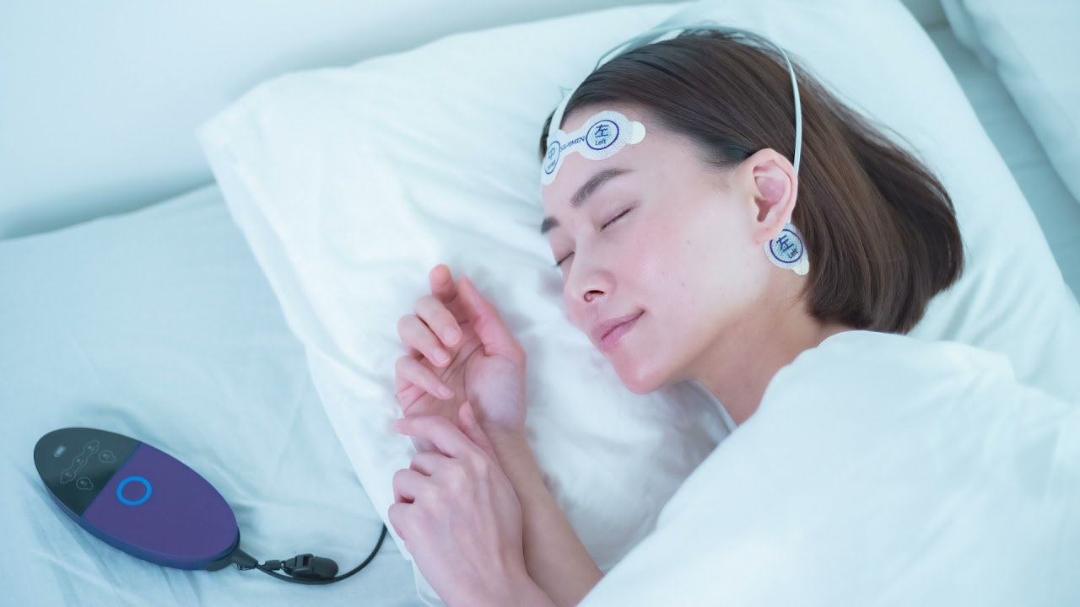
Publicly available at https://www.suimin.co.jp/

Supplementary Figure 2. Confusion matrix for sleep stage classification in all epochs of all recordings by OSA severity.
note: Parentheses indicate the percentage of agreement between the two devices. PSG, polysomnography, REM, rapid-eye-movement sleep; N, non-REM sleep.

Supplementary Figure 3. Comprehensive Analysis of Type I PSG and Portable EEG Devices by Epoch by OSA severity
note: Parentheses indicate the standard error. PSG, polysomnography, REM, rapid-eye-movement sleep; N, non-REM sleep; PABAK, prevalence and bias adjusted Kappa.

