Immune, RNA, and Neurocognitive Genetic Networks in Bipolar Disorder Subtypes: A Transcriptomic Meta-Analysis

Tyler Jang¹ and Marcus Kaul^{1,2,*}

¹University of California, Riverside, Graduate Program of Genetics, Genomics, and Bioinformatics, Riverside, 92507,
USA
²University of California, Riverside, Department of Biomedical Sciences, Riverside, 92507, USA
*Marcus.Kaul@medsch.ucr.edu

Supplementary Information

Supplementary Image 1-83 Contents:
This is an explanation of the name of each supplementary figure:
Name of the data set
Whether it is the bulk, down-regulated, or up-regulated set of DEGs
Biological sample material
Information related to the experiment name
If it ends with MCC_top10 then it is the interaction network containing hub genes. Else, it's the whole interaction network.
Supplementary Figure | File Name | Dataset
Supplementary Figure 1 | Arion_Bulk_Neurons_Bipolar_Type_1_vs_Control | Arion BD 1 vs Control
Supplementary Figure 2 | Arion_Bulk_Neurons_Bipolar_Type_1_vs_Control_MCC_top10 | Arion BD 1 vs Control
Supplementary Figure 3 | Arion_Downregulated_Neurons_Bipolar_Type_1_vs_Control | Arion BD 1 vs Control
Supplementary Figure 4 | Arion_Downregulated_Neurons_Bipolar_Type_1_vs_Control_MCC_top10 | Arion BD 1 vs Control
Supplementary Figure 5 | Arion_Upregulated_Neurons_Bipolar_Type_1_vs_Control | Arion BD 1 vs Control
Supplementary Figure 6 | Arion_Upregulated_Neurons_Bipolar_Type_1_vs_Control_MCC_top10 | Arion BD 1 vs Control
Supplementary Figure 7 | Arion_Bulk_Neurons_Bipolar_NOS_vs_Control | Arion BD NOS vs Control
Supplementary Figure 8 | Arion_Bulk_Neurons_Bipolar_NOS_vs_Control_MCC_top10 | Arion BD NOS vs Control
Supplementary Figure 9 | Arion_Downregulated_Neurons_Bipolar_NOS_vs_Control | Arion BD NOS vs Control
Supplementary Figure 10 | Arion_Downregulated_Neurons_Bipolar_NOS_vs_Control_MCC_top10 | Arion BD NOS vs Control
Supplementary Figure 11 | Arion_Upregulated_Neurons_Bipolar_NOS_vs_Control | Arion BD NOS vs Control
Supplementary Figure 12 | Arion_Upregulated_Neurons_Bipolar_NOS_vs_Control_MCC_top10 | Arion BD NOS vs Control
Supplementary Figure 13 | Bahn_Bulk_Dorsolateral_Prefrontal_Cortex_and_Orbitolateral_Cortex_Bipolar_Disorder_vs_Control | Bahn BD vs Control
Supplementary Figure 14 | Bahn_Bulk_Dorsolateral_Prefrontal_Cortex_and_Orbitolateral_Cortex_Bipolar_Disorder_vs_Control_MCC_top10 | Bahn BD vs Control
Supplementary Figure 15 | Bahn_Downregulated_Dorsolateral_Prefrontal_Cortex_and_Orbitolateral_Cortex_Bipolar_Disorder_vs_Control | Bahn BD vs Control
Supplementary Figure 16 | Bahn_Downregulated_Dorsolateral_Prefrontal_Cortex_and_Orbitolateral_Cortex_Bipolar_Disorder_vs_Control_MCC_top10 | Bahn BD vs Control
Supplementary Figure 17 | Bahn_Upregulated_Dorsolateral_Prefrontal_Cortex_and_Orbitolateral_Cortex_Bipolar_Disorder_vs_Control_MCC_top10 | Bahn BD vs Control
Supplementary Figure 18 | Bousman_Bulk_PBMC_Bipolar_vs_Control | Bousman BD vs Control
Supplementary Figure 19 | Bousman_Bulk_PBMC_Bipolar_vs_Control_MCC_top10 | Bousman BD vs Control
Supplementary Figure 20 | Bousman_Downregulated_PBMC_Bipolar_vs_Control | Bousman BD vs Control
Supplementary Figure 21 | Bousman_Downregulated_PBMC_Bipolar_vs_Control_MCC_top10 | Bousman BD vs Control
Supplementary Figure 22 | Bousman_Upregulated_PBMC_Bipolar_vs_Control | Bousman BD vs Control
Supplementary Figure 23 | Bousman_Upregulated_PBMC_Bipolar_vs_Control_MCC_top10 | Bousman BD vs Control
Supplementary Figure 24 | Clelland_Bulk_Blood_Never_Medicated_Bipolar_Type_1_vs_Control | Clelland BD 1 vs Control
Supplementary Figure 25 | Clelland_Bulk_Blood_Never_Medicated_Bipolar_Type_1_vs_Control_MCC_top10 | Clelland BD 1 vs Control
Supplementary Figure 26 | Clelland_Downregulated_Blood_Never_Medicated_Bipolar_Type_1_vs_Control | Clelland BD 1 vs Control
Supplementary Figure 27 | Clelland_Downregulated_Blood_Never_Medicated_Bipolar_Type_1_vs_Control_MCC_top10 | Clelland BD 1 vs Control
Supplementary Figure 28 | Clelland_Upregulated_Blood_Never_Medicated_Bipolar_Type_1_vs_Control | Clelland BD 1 vs Control
Supplementary Figure 29 | Clelland_Upregulated_Blood_Never_Medicated_Bipolar_Type_1_vs_Control_MCC_top10 | Clelland BD 1 vs Control
Supplementary Figure 30 | Cruceanu_Bulk_Anterior_Cortex_Bipolar_vs_Control | Cruceanu BD vs Control
Supplementary Figure 31 | Cruceanu_Bulk_Anterior_Cortex_Bipolar_vs_Control_MCC_top10 | Cruceanu BD vs Control
Supplementary Figure 32 | Cruceanu_Downregulated_Anterior_Cortex_Bipolar_vs_Control | Cruceanu BD vs Control
Supplementary Figure 33 | Cruceanu_Downregulated_Anterior_Cortex_Bipolar_vs_Control_MCC_top10 | Cruceanu BD vs Control
Supplementary Figure 34 | Cruceanu_Upregulated_Anterior_Cortex_Bipolar_vs_Control | Cruceanu BD vs Control
Supplementary Figure 35 | Cruceanu_Upregulated_Anterior_Cortex_Bipolar_vs_Control_MCC_top10 | Cruceanu BD vs Control
Supplementary Figure 36 | Hilscher_Bulk_Lymphoblast_Fibroblast_Lithium_Treated_Bipolar_vs_Control | Hilscher BD vs Control
Supplementary Figure 37 | Hilscher_Bulk_Lymphoblast_Fibroblast_Lithium_Treated_Bipolar_vs_Control_MCC_top10 | Hilscher BD vs Control
Supplementary Figure 38 | Hilscher_Upregulated_Lymphoblast_Fibroblast_Lithium_Treated_Bipolar_vs_Control_MCC_top10 | Hilscher BD vs Control
Supplementary Figure 39 | Iwamoto_Bulk_Prefrontal_Cortex_Bipolar_vs_Control | Iwamoto BD vs Control
Supplementary Figure 40 | Iwamoto_Bulk_Prefrontal_Cortex_Bipolar_vs_Control_MCC_top10 | Iwamoto BD vs Control
Supplementary Figure 41 | Iwamoto_Downregulated_Prefrontal_Cortex_Bipolar_vs_Control | Iwamoto BD vs Control
Supplementary Figure 42 | Iwamoto_Downregulated_Prefrontal_Cortex_Bipolar_vs_Control_MCC_top10 | Iwamoto BD vs Control
Supplementary Figure 43 | Iwamoto_Upregulated_Prefrontal_Cortex_Bipolar_vs_Control | Iwamoto BD vs Control
Supplementary Figure 44 | Iwamoto_Upregulated_Prefrontal_Cortex_Bipolar_vs_Control_MCC_top10 | Iwamoto BD vs Control
Supplementary Figure 45 | Kim_Bulk_Neurons_Bipolar_Type_1_vs_Control_Time_Independent | Kim BD 1 vs Control
Supplementary Figure 46 | Kim_Bulk_Neurons_Bipolar_Type_1_vs_Control_Time_Independent_MCC_top10 | Kim BD 1 vs Control
Supplementary Figure 47 | Kim_Downregulated_Neurons_Bipolar_Type_1_vs_Control_Time_Independent | Kim BD 1 vs Control
Supplementary Figure 48 | Kim_Downregulated_Neurons_Bipolar_Type_1_vs_Control_Time_Independent_MCC_top10 | Kim BD 1 vs Control
Supplementary Figure 49 | Kim_Upregulated_Neurons_Bipolar_Type_1_vs_Control_Time_Independent | Kim BD 1 vs Control
Supplementary Figure 50 | Kim_Upregulated_Neurons_Bipolar_Type_1_vs_Control_Time_Independent_MCC_top10 | Kim BD 1 vs Control
Supplementary Figure 51 | Logotheti_Bulk_Skin_Fibroblasts_BIpolar_Type_1_vs_Control | Logotheti BD 1 vs Control
Supplementary Figure 52 | Logotheti_Bulk_Skin_Fibroblasts_Bipolar_Type_1_vs_Control_MCC_top10 | Logotheti BD 1 vs Control
Supplementary Figure 53 | Logotheti_Downregulated_Skin_Fibroblasts_BIpolar_Type_1_vs_Control | Logotheti BD 1 vs Control
Supplementary Figure 54 | Logotheti_Downregulated_Skin_Fibroblasts_Bipolar_Type_1_vs_Control_MCC_top10 | Logotheti BD 1 vs Control
Supplementary Figure 55 | Logotheti_Upregulated_Skin_Fibroblasts_Bipolar_Type_1_vs_Control | Logotheti BD 1 vs Control
Supplementary Figure 56 | Logotheti_Upregulated_Skin_Fibroblasts_Bipolar_Type_1_vs_Control_MCC_top10 | Logotheti BD 1 vs Control
Supplementary Figure 57 | Matigian_Bulk_Twin_Lyphocytes_Bipolar_Type_1_vs_Non_Bipolar_Twin | Matigian BD 1 vs Control
Supplementary Figure 58 | Matigian_Bulk_Twin_Lyphocytes_Bipolar_Type_1_vs_Non_Bipolar_Twin_MCC_top10 | Matigian BD 1 vs Control
Supplementary Figure 59 | Matigian_Downregulated_Twin_Lyphocytes_Bipolar_Type_1_vs_Non_Bipolar_Twin | Matigian BD 1 vs Control
Supplementary Figure 60 | Matigian_Downregulated_Twin_Lyphocytes_Bipolar_Type_1_vs_Non_Bipolar_Twin_MCC_top10 | Matigian BD 1 vs Control
Supplementary Figure 61 | Matigian_Upregulated_Twin_Lyphocytes_Bipolar_Type_1_vs_Non_Bipolar_Twin | Matigian BD 1 vs Control
Supplementary Figure 62 | Matigian_Upregulated_Twin_Lyphocytes_Bipolar_Type_1_vs_Non_Bipolar_Twin_MCC_top10 | Matigian BD 1 vs Control
Supplementary Figure 63 | Savitz_Bulk_PBMC_Bipolar_vs_Control | Savitz BD vs Control
Supplementary Figure 64 | Savitz_Bulk_PBMC_Bipolar_vs_Control_MCC_top10 | Savitz BD vs Control
Supplementary Figure 65 | Savitz_Downregulated_PBMC_Bipolar_vs_Control_MCC_top10 | Savitz BD vs Control
Supplementary Figure 66 | Savitz_Upregulated_PBMC_Bipolar_vs_Control | Savitz BD vs Control
Supplementary Figure 67 | Savitz_Upregulated_PBMC_Bipolar_vs_Control_MCC_top10 | Savitz BD vs Control
Supplementary Figure 68 | Savitz_Bulk_PBMC_Bipolar_Type_1_vs_Bipolar_Type_2 | Savitz BD 1 vs BD 2
Supplementary Figure 69 | Savitz_Bulk_PBMC_Bipolar_Type_1_vs_Bipolar_Type_2_MCC_top10 | Savitz BD 1 vs BD 2
Supplementary Figure 70 | Savitz_Downregulated_PBMC_Bipolar_Type_1_vs_Bipolar_Type_2 | Savitz BD 1 vs BD 2
Supplementary Figure 71 | Savitz_Downregulated_PBMC_Bipolar_Type_1_vs_Bipolar_Type_2_MCC_top10 | Savitz BD 1 vs BD 2
Supplementary Figure 72 | Savitz_Upregulated_PBMC_Bipolar_Type_1_vs_Bipolar_Type_2 | Savitz BD 1 vs BD 2
Supplementary Figure 73 | Savitz_Upregulated_PBMC_Bipolar_Type_1_vs_Bipolar_Type_2_MCC_top10 | Savitz BD 1 vs BD 2
Supplementary Figure 74 | Vawter_Bulk_Anterior_Singulate_Bipolar_Type_1_vs_Control | Vawter BD 1 vs Control
Supplementary Figure 75 | Vawter_Bulk_Anterior_Singulate_Bipolar_Type_1_vs_Control_MCC_top10 | Vawter BD 1 vs Control
Supplementary Figure 76 | Vawter_Downregulated_Anterior_Singulate_Bipolar_Type_1_vs_Control | Vawter BD 1 vs Control
Supplementary Figure 77 | Vawter_Downregulated_Anterior_Singulate_Bipolar_Type_1_vs_Control_MCC_top10 | Vawter BD 1 vs Control
Supplementary Figure 78 | Vawter_Upregulated_Anterior_Singulate_Bipolar_Type_1_vs_Control_MCC_top10 | Vawter BD 1 vs Control
Supplementary Figure 79 | Witt_Bulk_Blood_Bipolar_Type_1_vs_Control_MCC_top10 | Witt BD 1 vs Control
Supplementary Figure 80 | Witt_Downregulated_Blood_Bipolar_Type_1_vs_Control | Witt BD 1 vs Control
Supplementary Figure 81 | Witt_Downregulated_Blood_Bipolar_Type_1_vs_Control_MCC_top10 | Witt BD 1 vs Control
Supplementary Figure 82 | Witt_Upregulated_Blood_Bipolar_Type_1_vs_Control | Witt BD 1 vs Control
Supplementary Figure 83 | Witt_Upregulated_Blood_Bipolar_Type_1_vs_Control_MCC_top10 | Witt BD 1 vs Control
Supplementary Images:
Supplementary Figure 1
Arion_Bulk_Neurons_Bipolar_Type_1_vs_Control Arion BD 1 vs Control
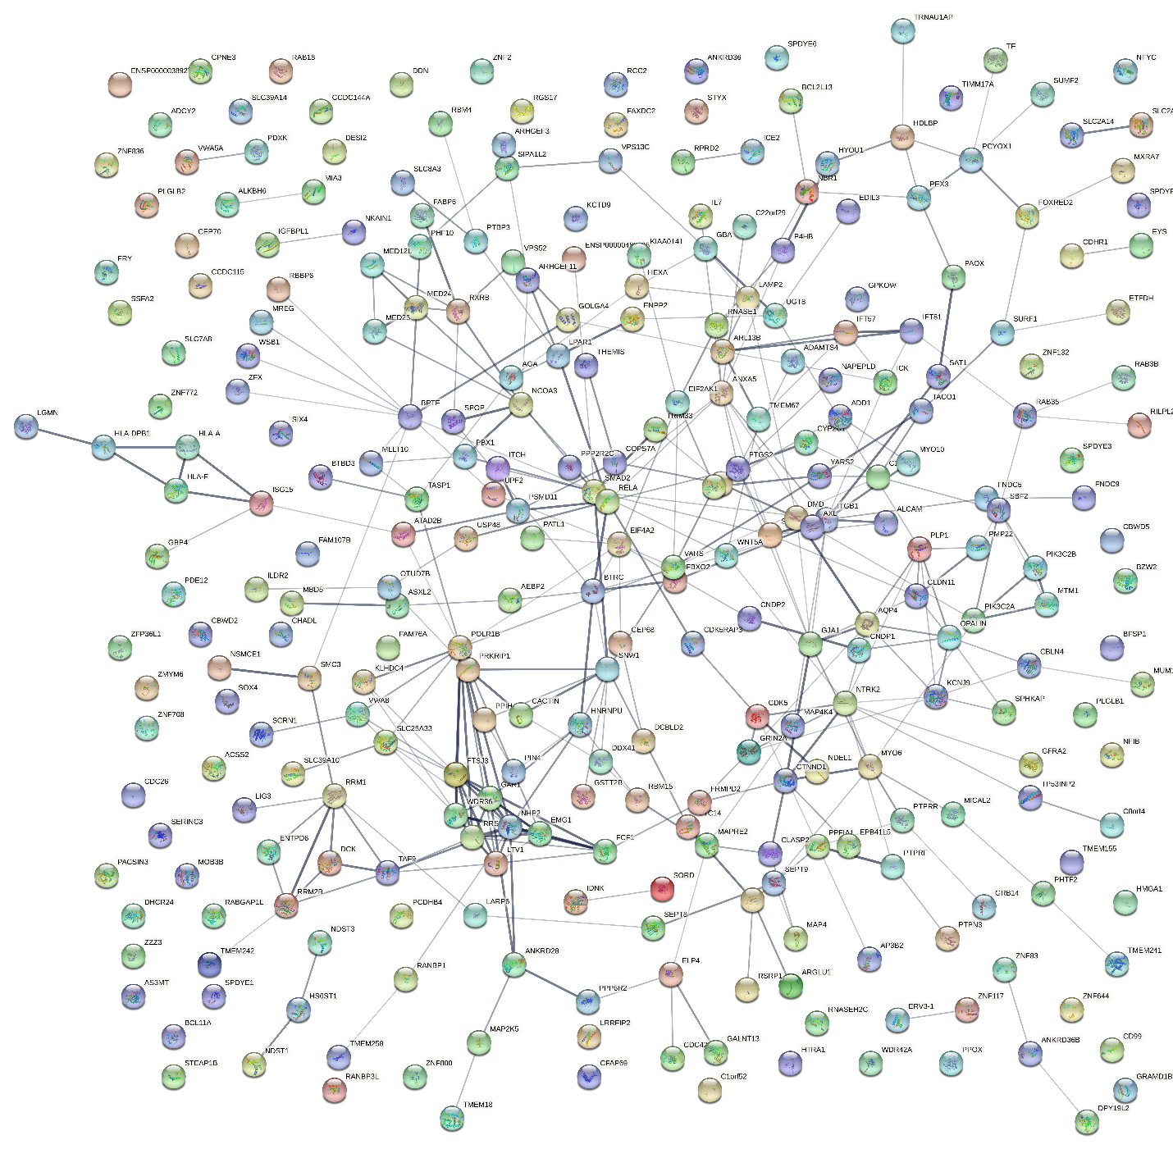

Supplementary Figure 2 Arion_Bulk_Neurons_Bipolar_Type_1_vs_Control_MCC_top10 Arion BD 1 vs Control
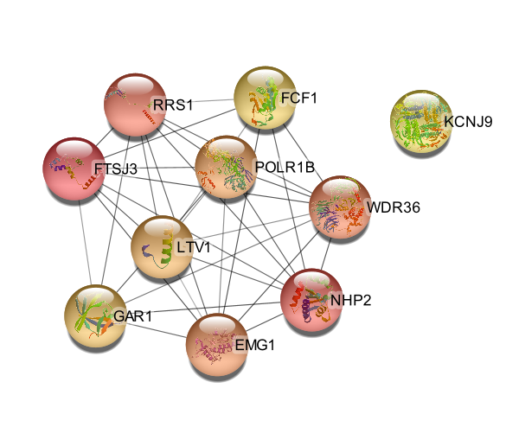
Supplementary Figure 3 Arion_Downregulated_Neurons_Bipolar_Type_1_vs_Control Arion BD 1 vs Control
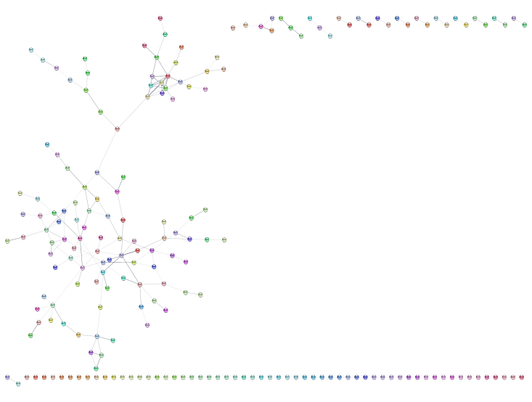
Supplementary Figure 4 Arion_Downregulated_Neurons_Bipolar_Type_1_vs_Control_MCC_top10 Arion BD 1 vs Control
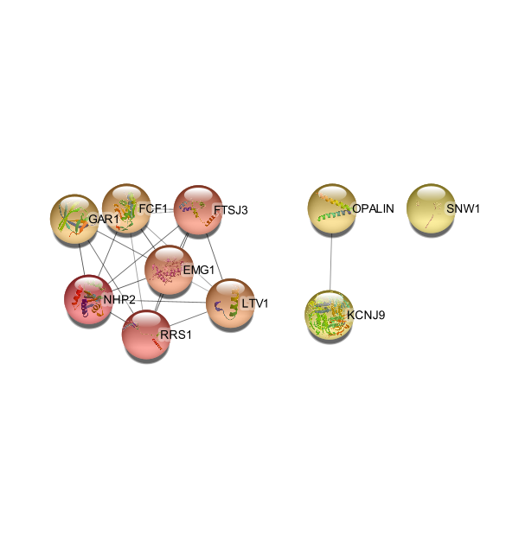
Supplementary Figure 5 Arion_Upregulated_Neurons_Bipolar_Type_1_vs_Control Arion BD 1 vs Control
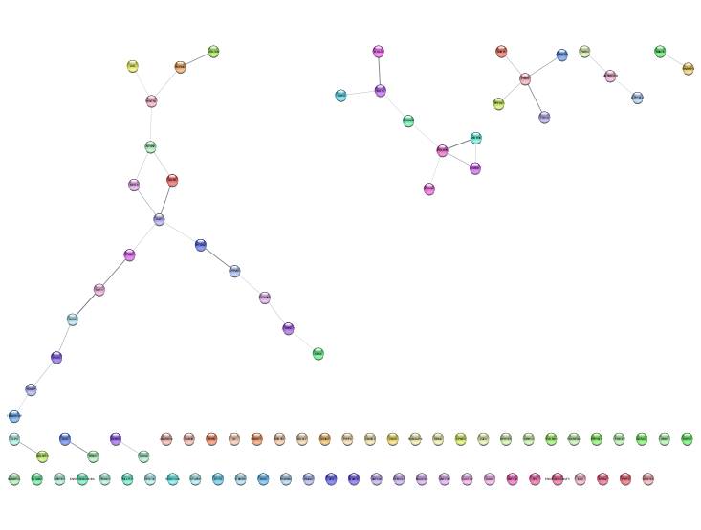
Supplementary Figure 6 Arion_Upregulated_Neurons_Bipolar_Type_1_vs_Control_MCC_top10 Arion BD 1 vs Control
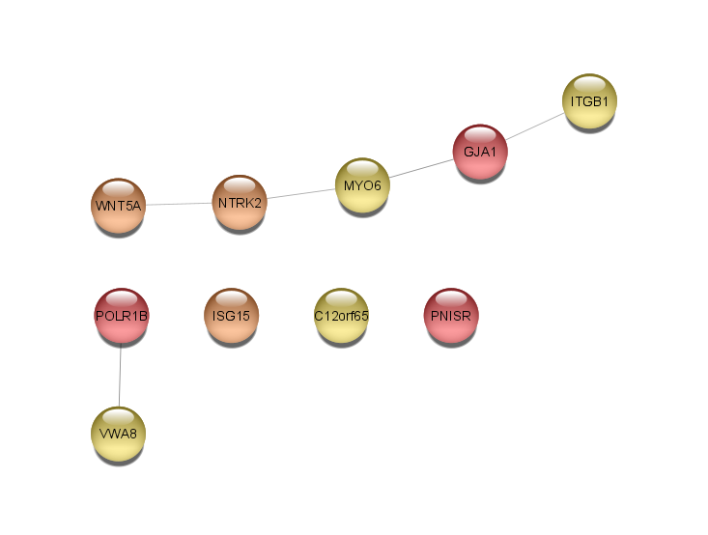
Supplementary Figure 7 Arion_Bulk_Neurons_Bipolar_NOS_vs_Control Arion BD NOS vs Control
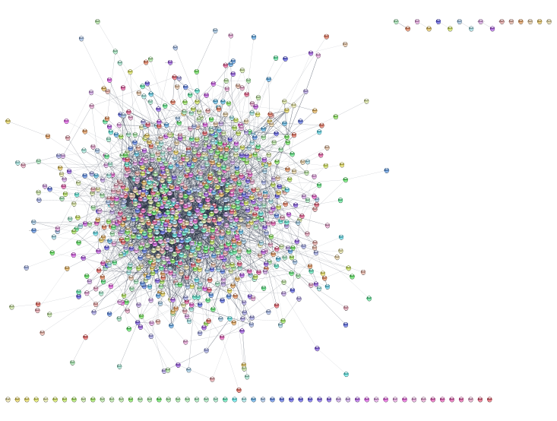
Supplementary Figure 8 Arion_Bulk_Neurons_Bipolar_NOS_vs_Control_MCC_top10 Arion BD NOS vs Control
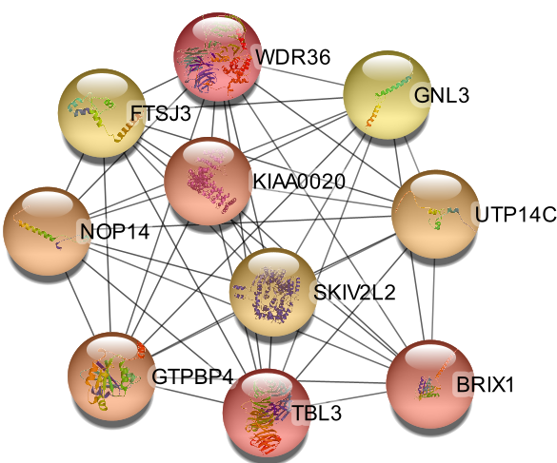
Supplementary Figure 9 Arion_Downregulated_Neurons_Bipolar_NOS_vs_Control Arion BD NOS vs Control
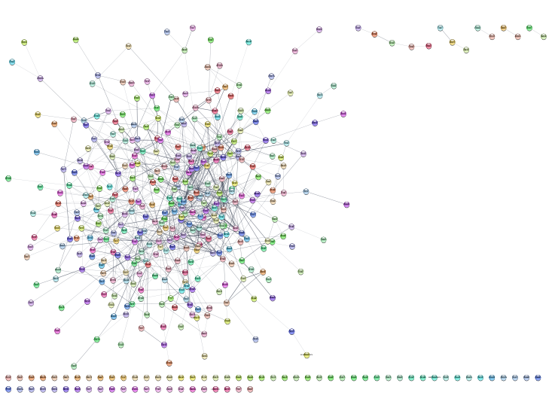
Supplementary Figure 10 Arion_Downregulated_Neurons_Bipolar_NOS_vs_Control_MCC_top10 Arion BD NOS vs Control
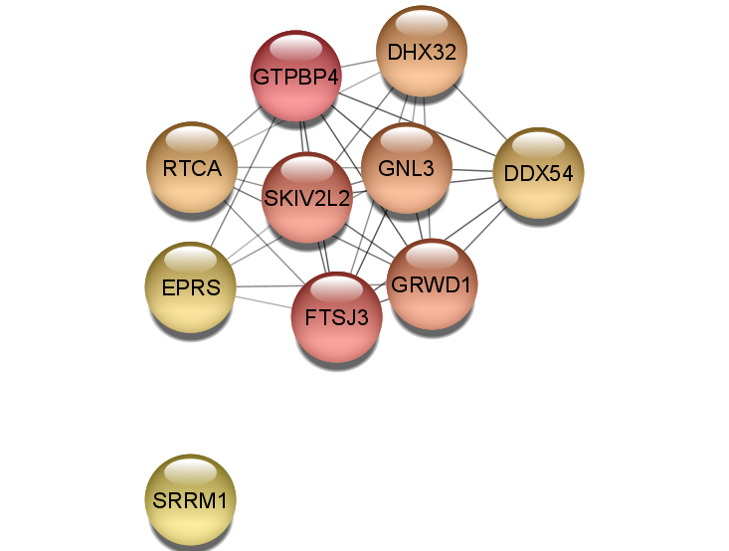
Supplementary Figure 11 Arion_Upregulated_Neurons_Bipolar_NOS_vs_Control Arion BD NOS vs Control
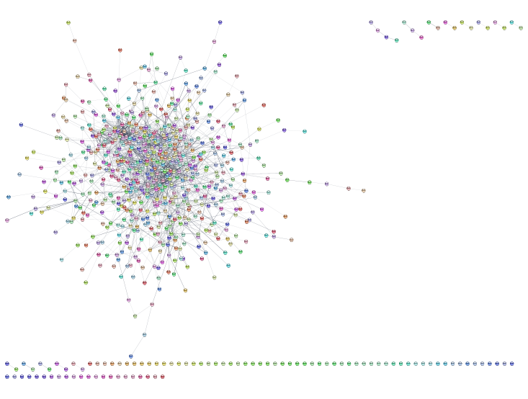
Supplementary Figure 12 Arion_Upregulated_Neurons_Bipolar_NOS_vs_Control_MCC_top10 Arion BD NOS vs Control
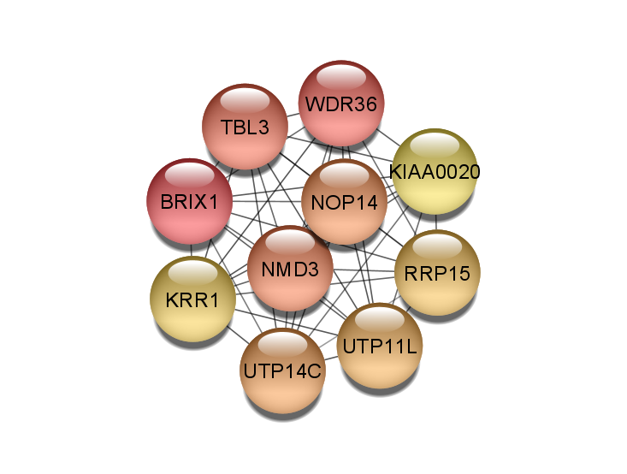
Supplementary Figure 13 Bahn_Bulk_Dorsolateral_Prefrontal_Cortex_and_Orbitolateral_Cortex_Bipolar_Disorder_vs_Control Bahn BD vs Control
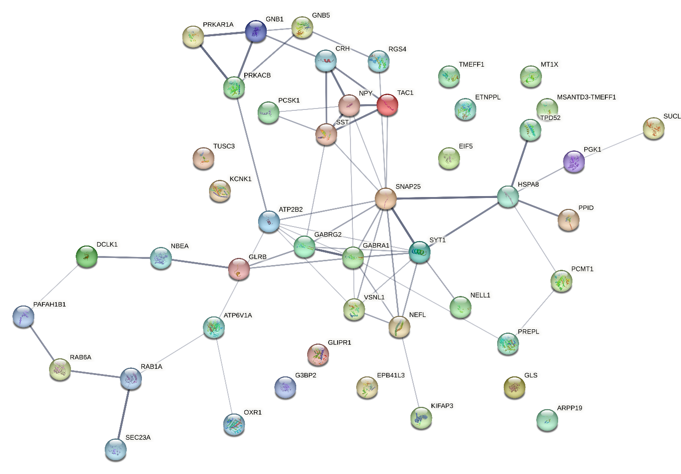
Supplementary Figure 14 Bahn_Bulk_Dorsolateral_Prefrontal_Cortex_and_Orbitolateral_Cortex_Bipolar_Disorder_vs_Control_MCC_top10 Bahn BD vs Control
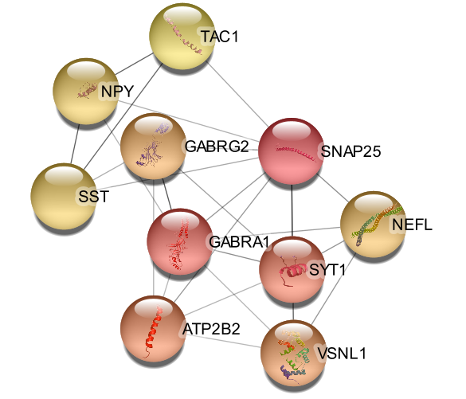
Supplementary Figure 15 Bahn_Downregulated_Dorsolateral_Prefrontal_Cortex_and_Orbitolateral_Cortex_Bipolar_Disorder_vs_Control Bahn BD vs Control
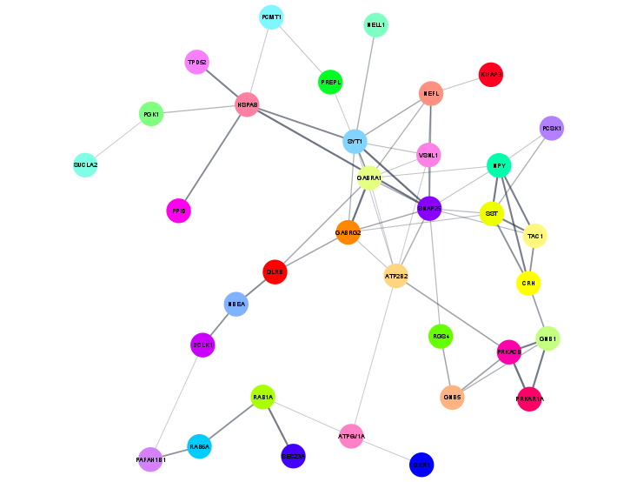
Supplementary Figure 16 Bahn_Downregulated_Dorsolateral_Prefrontal_Cortex_and_Orbitolateral_Cortex_Bipolar_Disorder_vs_Control_MCC_top10 Bahn BD vs Control
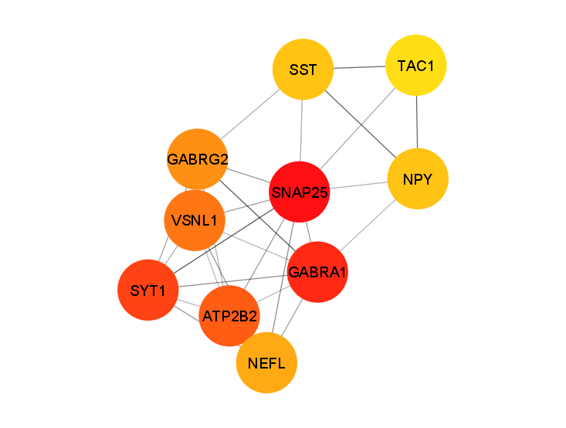
Supplementary Figure 17 Bahn_Upregulated_Dorsolateral_Prefrontal_Cortex_and_Orbitolateral_Cortex_Bipolar_Disorder_vs_Control_MCC_top10 Bahn BD vs Control


Supplementary Figure 18 Bousman_Bulk_PBMC_Bipolar_vs_Control Bousman BD vs Control
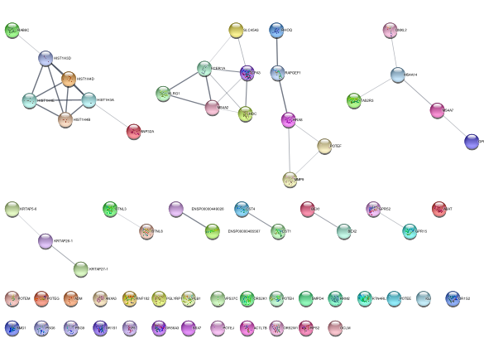
Supplementary Figure 19 Bousman_Bulk_PBMC_Bipolar_vs_Control_MCC_top10 Bousman BD vs Control
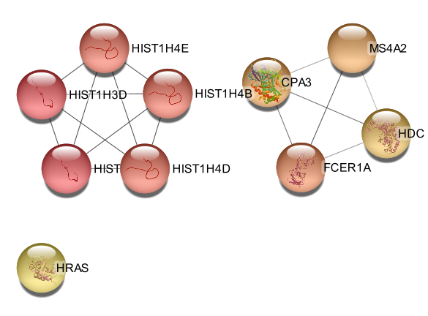
Supplementary Figure 20 Bousman_Downregulated_PBMC_Bipolar_vs_Control Bousman BD vs Control
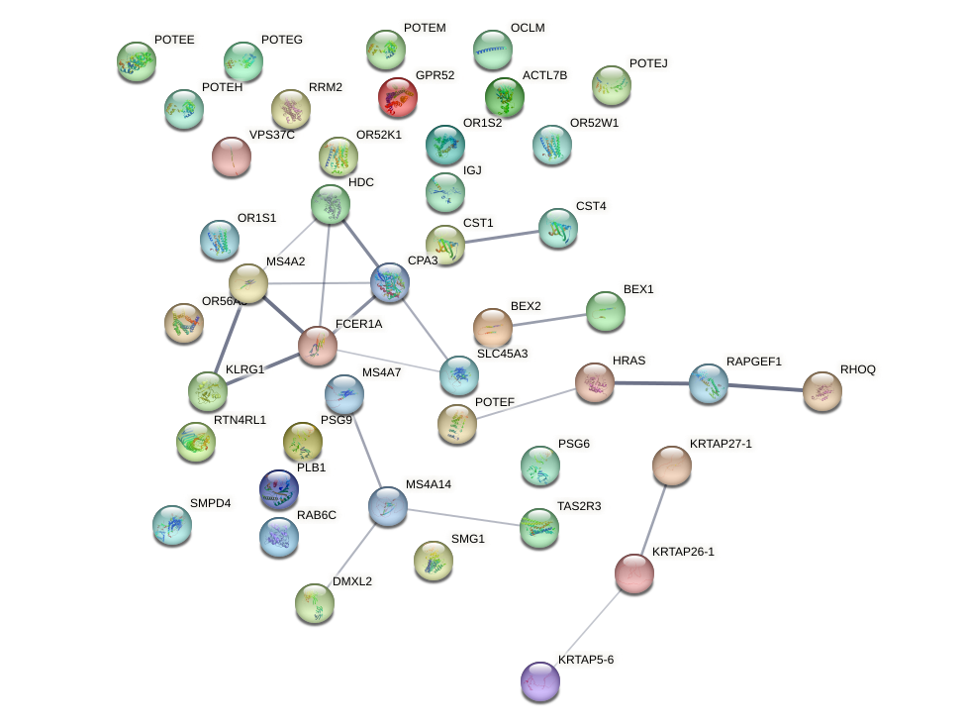
Supplementary Figure 21 Bousman_Downregulated_PBMC_Bipolar_vs_Control_MCC_top10 Bousman BD vs Control
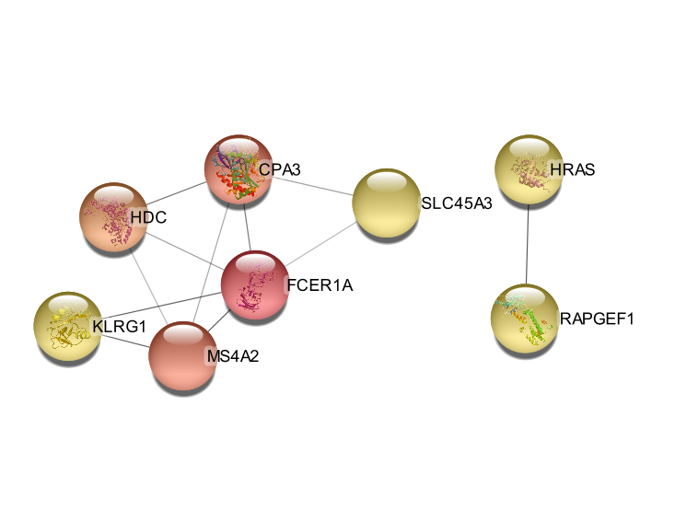
Supplementary Figure 22 Bousman_Upregulated_PBMC_Bipolar_vs_Control Bousman BD vs Control
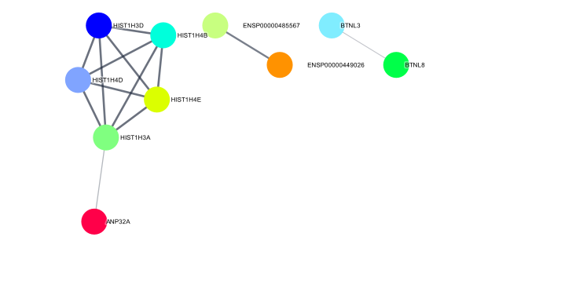
Supplementary Figure 23 Bousman_Upregulated_PBMC_Bipolar_vs_Control_MCC_top10 Bousman BD vs Control
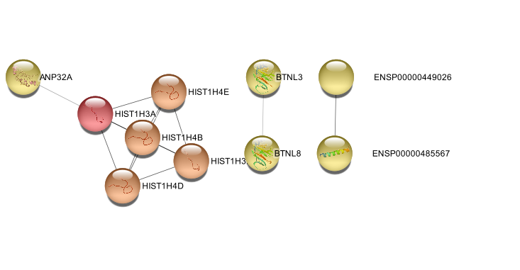

Supplementary Figure 24 Clelland_Bulk_Blood_Never_Medicated_Bipolar_Type_1_vs_Control Clelland BD 1 vs Control
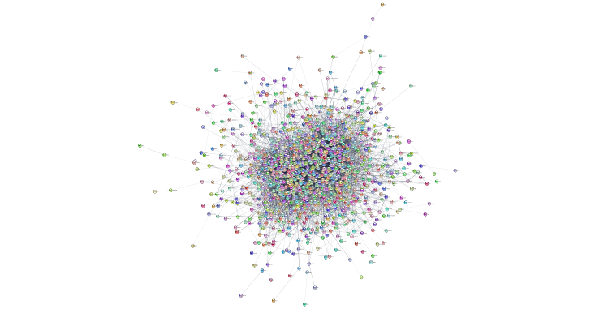
Supplementary Figure 25 Clelland_Bulk_Blood_Never_Medicated_Bipolar_Type_1_vs_Control_MCC_top10 Clelland BD 1 vs Control
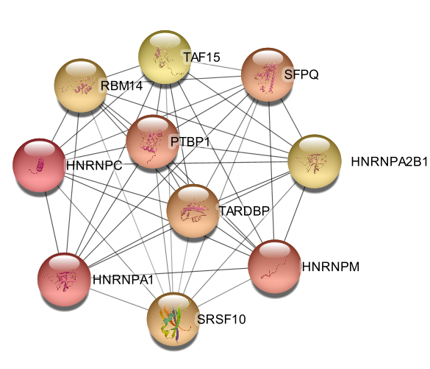
Supplementary Figure 26 Clelland_Downregulated_Blood_Never_Medicated_Bipolar_Type_1_vs_Control Clelland BD 1 vs Control
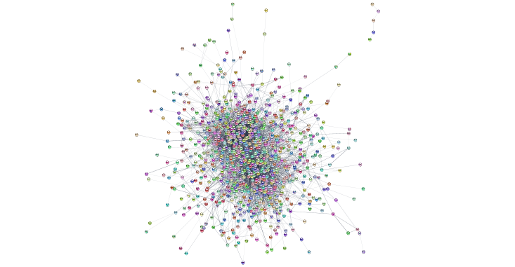
Supplementary Figure 27 Clelland_Downregulated_Blood_Never_Medicated_Bipolar_Type_1_vs_Control_MCC_top10 Clelland BD 1 vs Control
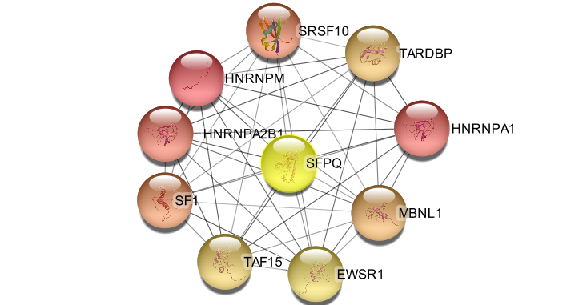

Supplementary Figure 28 Clelland_Upregulated_Blood_Never_Medicated_Bipolar_Type_1_vs_Control Clelland BD 1 vs Control
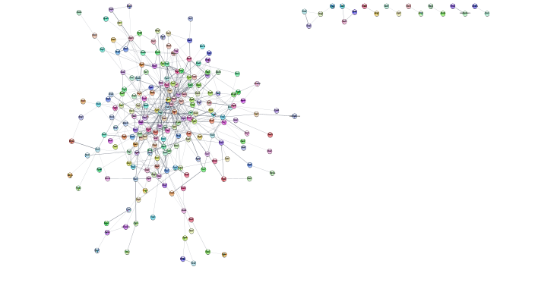
Supplementary Figure 29 Clelland_Upregulated_Blood_Never_Medicated_Bipolar_Type_1_vs_Control_MCC_top10 Clelland BD 1 vs Control
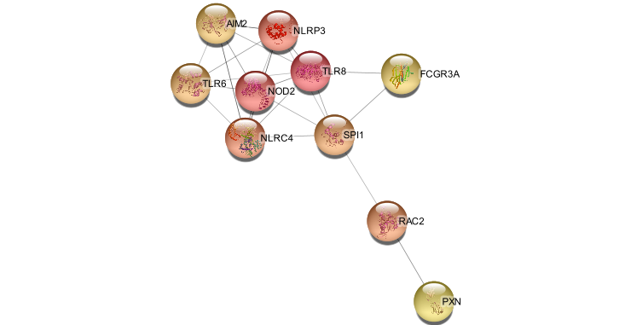

Supplementary Figure 30 Cruceanu_Bulk_Anterior_Cortex_Bipolar_vs_Control Cruceanu BD vs Control
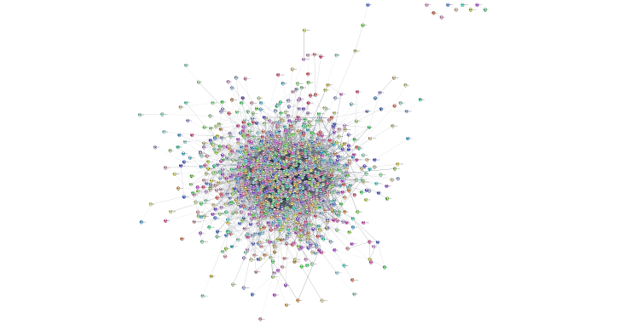
Supplementary Figure 31 Cruceanu_Bulk_Anterior_Cortex_Bipolar_vs_Control_MCC_top10 Cruceanu BD vs Control
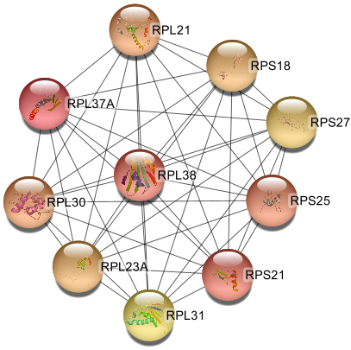
Supplementary Figure 32 Cruceanu_Downregulated_Anterior_Cortex_Bipolar_vs_Control Cruceanu BD vs Control
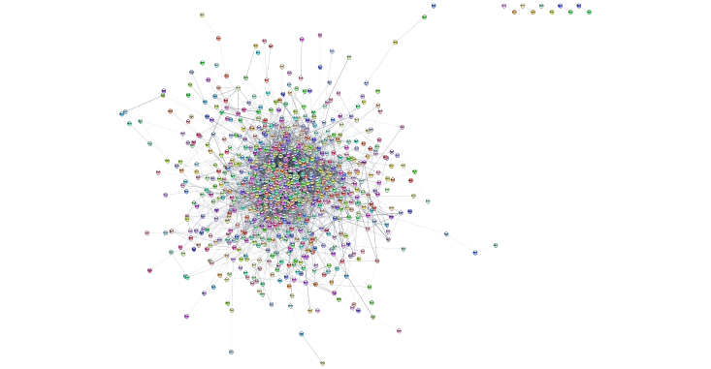
Supplementary Figure 33 Cruceanu_Downregulated_Anterior_Cortex_Bipolar_vs_Control_MCC_top10 Cruceanu BD vs Control
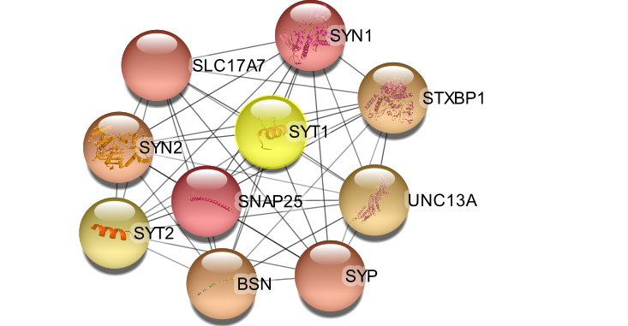

Supplementary Figure 34 Cruceanu_Upregulated_Anterior_Cortex_Bipolar_vs_Control Cruceanu BD vs Control
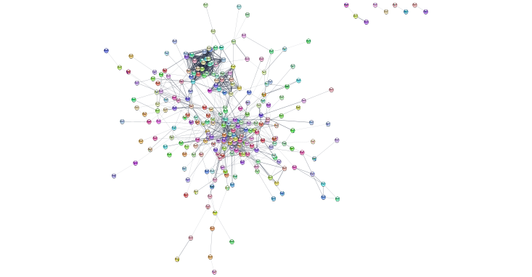
Supplementary Figure 35 Cruceanu_Upregulated_Anterior_Cortex_Bipolar_vs_Control_MCC_top10 Cruceanu BD vs Control
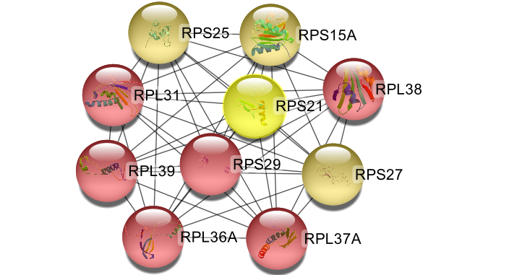

Supplementary Figure 36 Hilscher_Bulk_Lymphoblast_Fibroblast_Lithium_Treated_Bipolar_vs_Control Hilscher BD vs Control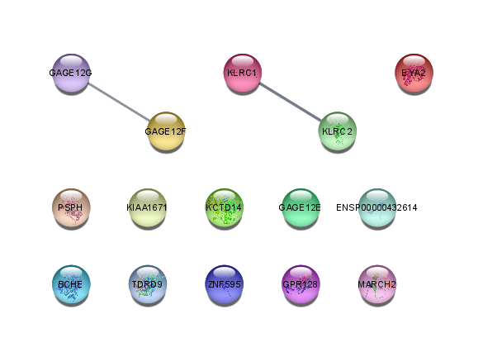
Supplementary Figure 37 Hilscher_Bulk_Lymphoblast_Fibroblast_Lithium_Treated_Bipolar_vs_Control_MCC_top10 Hilscher BD vs Control
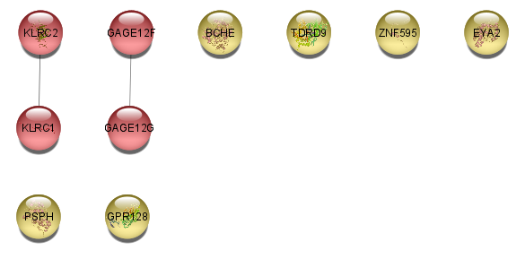
Supplementary Figure 38 Hilscher_Upregulated_Lymphoblast_Fibroblast_Lithium_Treated_Bipolar_vs_Control_MCC_top10 Hilscher BD vs Control
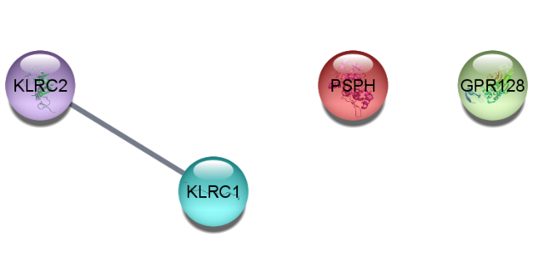
Supplementary Figure 39 Iwamoto_Bulk_Prefrontal_Cortex_Bipolar_vs_Control Iwamoto BD vs Control
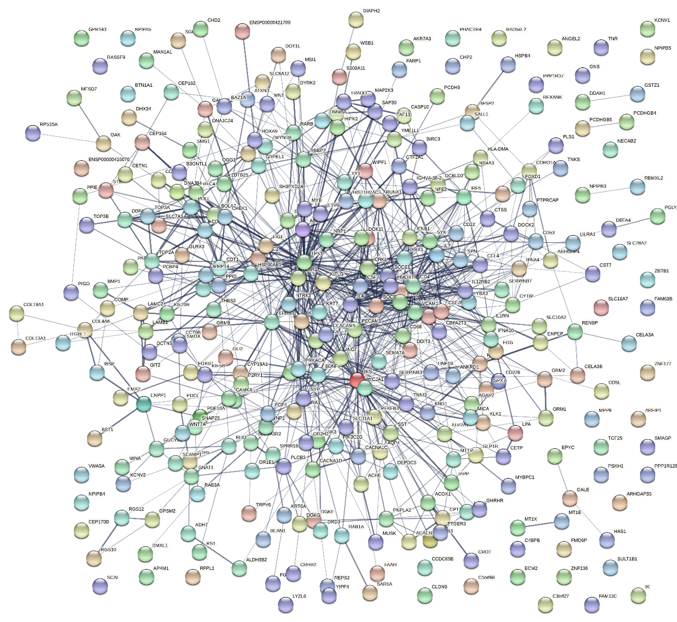
Supplementary Figure 40 Iwamoto_Bulk_Prefrontal_Cortex_Bipolar_vs_Control_MCC_top10 Iwamoto BD vs Control
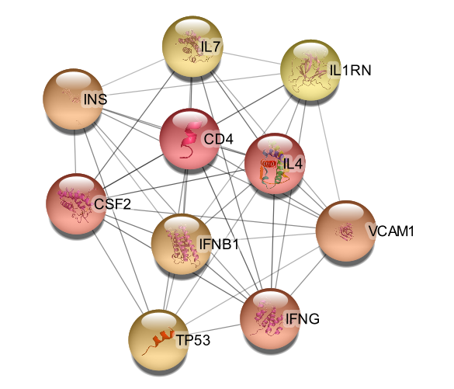
Supplementary Figure 41 Iwamoto_Downregulated_Prefrontal_Cortex_Bipolar_vs_Control Iwamoto BD vs Control
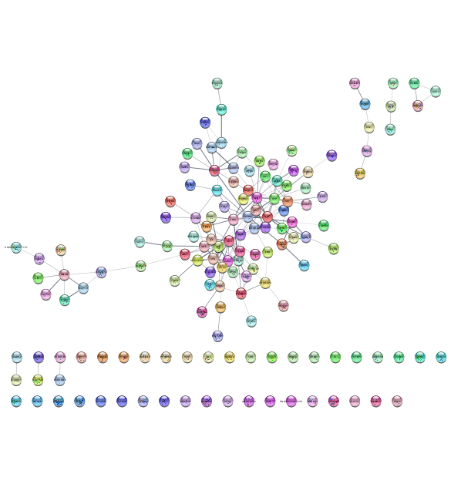
Supplementary Figure 42 Iwamoto_Downregulated_Prefrontal_Cortex_Bipolar_vs_Control_MCC_top10 Iwamoto BD vs Control
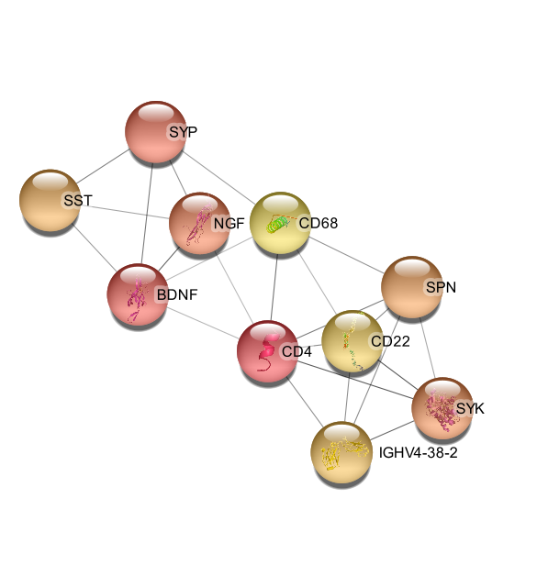
Supplementary Figure 43 Iwamoto_Upregulated_Prefrontal_Cortex_Bipolar_vs_Control Iwamoto BD vs Control
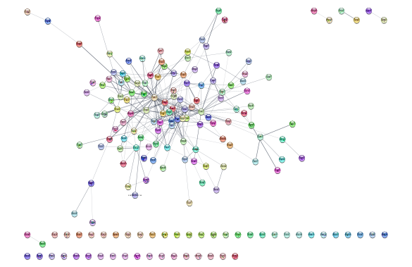
Supplementary Figure 44 Iwamoto_Upregulated_Prefrontal_Cortex_Bipolar_vs_Control_MCC_top10 Iwamoto BD vs Control
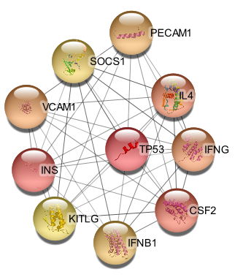
Supplementary Figure 45 Kim_Bulk_Neurons_Bipolar_Type_1_vs_Control_Time_Independent Kim BD 1 vs Control
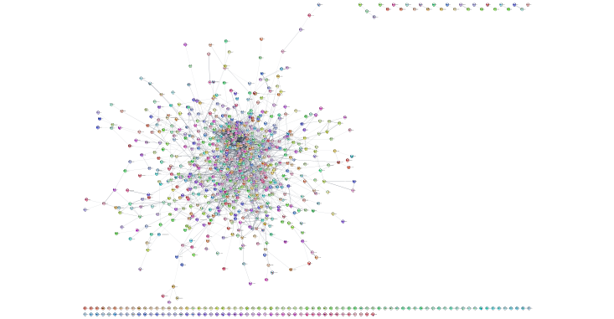
Supplementary Figure 46 Kim_Bulk_Neurons_Bipolar_Type_1_vs_Control_Time_Independent_MCC_top10 Kim BD 1 vs Control
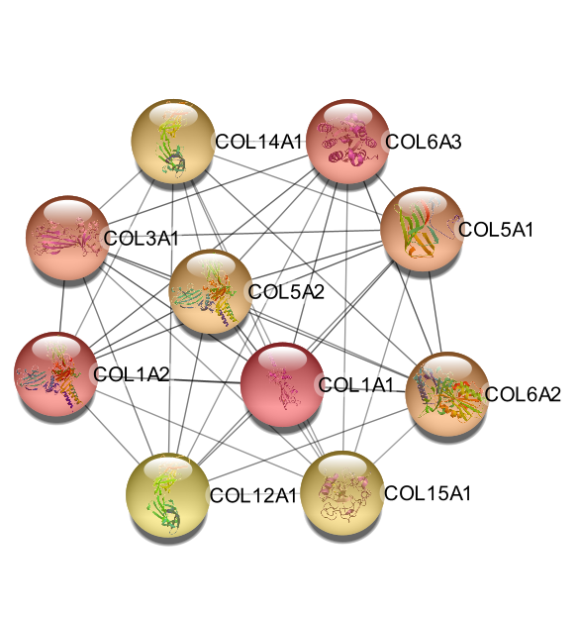
Supplementary Figure 47 Kim_Downregulated_Neurons_Bipolar_Type_1_vs_Control_Time_Independent Kim BD 1 vs Control
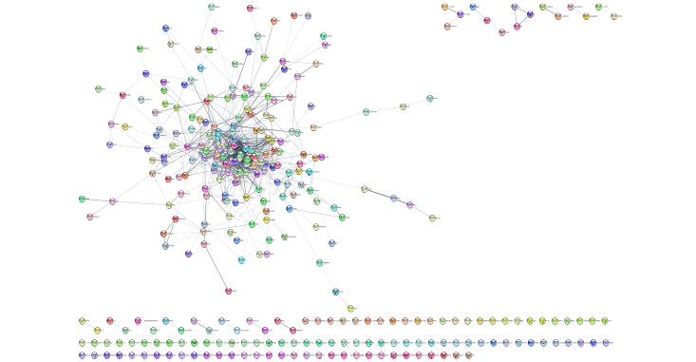
Supplementary Figure 48 Kim_Downregulated_Neurons_Bipolar_Type_1_vs_Control_Time_Independent_MCC_top10 Kim BD 1 vs Control
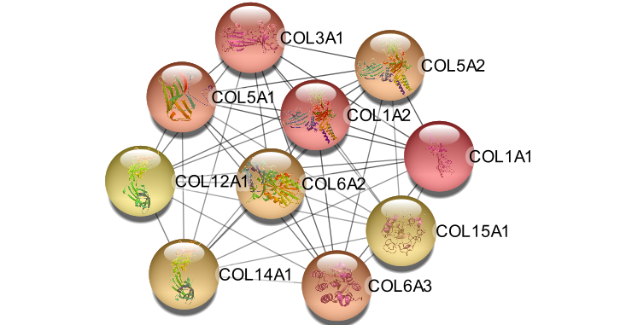
Supplementary Figure 49 Kim_Upregulated_Neurons_Bipolar_Type_1_vs_Control_Time_Independent Kim BD 1 vs Control
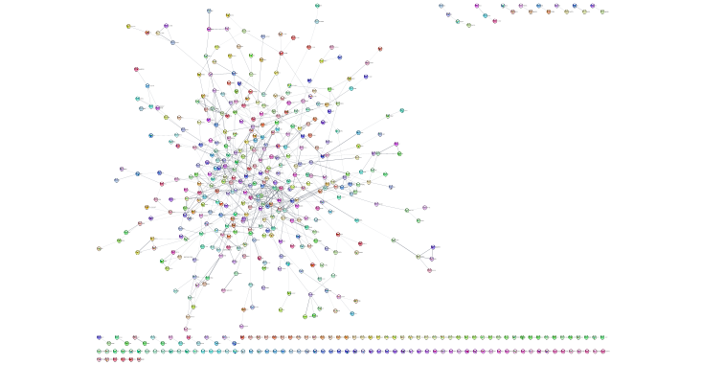

Supplementary Figure 50 Kim_Upregulated_Neurons_Bipolar_Type_1_vs_Control_Time_Independent_MCC_top10 Kim BD 1 vs Control
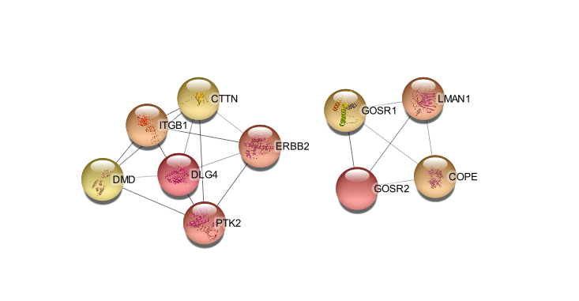
Supplementary Figure 51 Logotheti_Bulk_Skin_Fibroblasts_BIpolar_Type_1_vs_Control Logotheti BD 1 vs Control
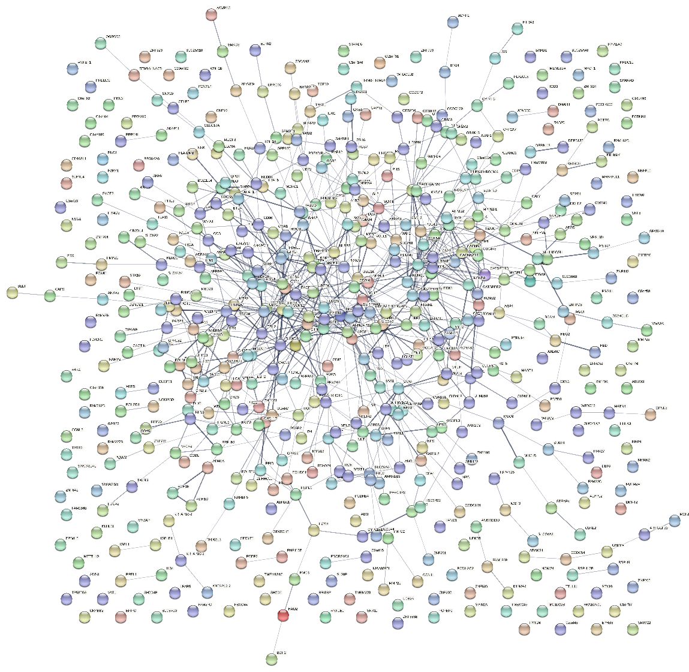
Supplementary Figure 52 Logotheti_Bulk_Skin_Fibroblasts_Bipolar_Type_1_vs_Control_MCC_top10 Logotheti BD 1 vs Control
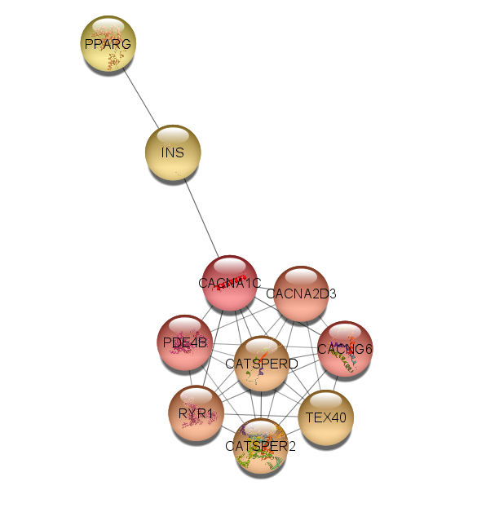
Supplementary Figure 53 Logotheti_Downregulated_Skin_Fibroblasts_BIpolar_Type_1_vs_Control Logotheti BD 1 vs Control
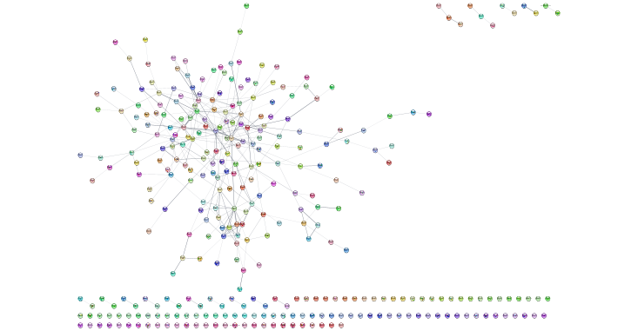
Supplementary Figure 54 Logotheti_Downregulated_Skin_Fibroblasts_Bipolar_Type_1_vs_Control_MCC_top10 Logotheti BD 1 vs Control
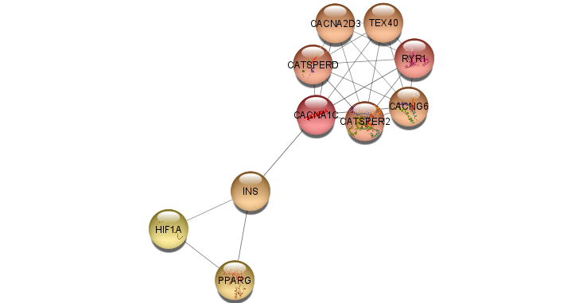
Supplementary Figure 55 Logotheti_Upregulated_Skin_Fibroblasts_Bipolar_Type_1_vs_Control Logotheti BD 1 vs Control
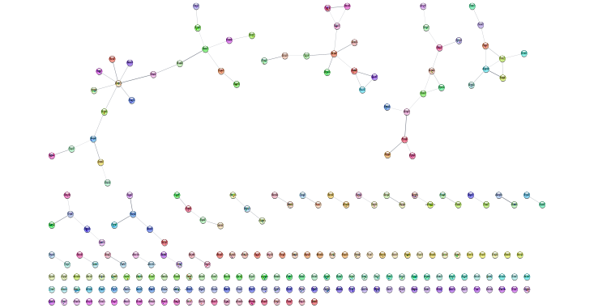

Supplementary Figure 56 Logotheti_Upregulated_Skin_Fibroblasts_Bipolar_Type_1_vs_Control_MCC_top10 Logotheti BD 1 vs Control
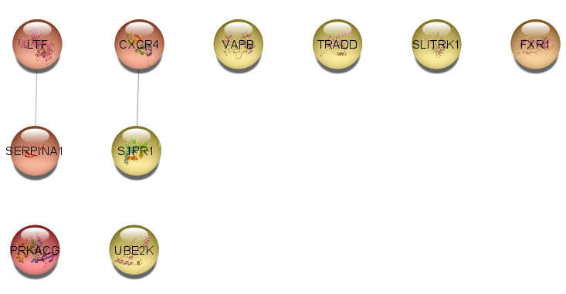
Supplementary Figure 57 Matigian_Bulk_Twin_Lyphocytes_Bipolar_Type_1_vs_Non_Bipolar_Twin Matigian BD 1 vs Control
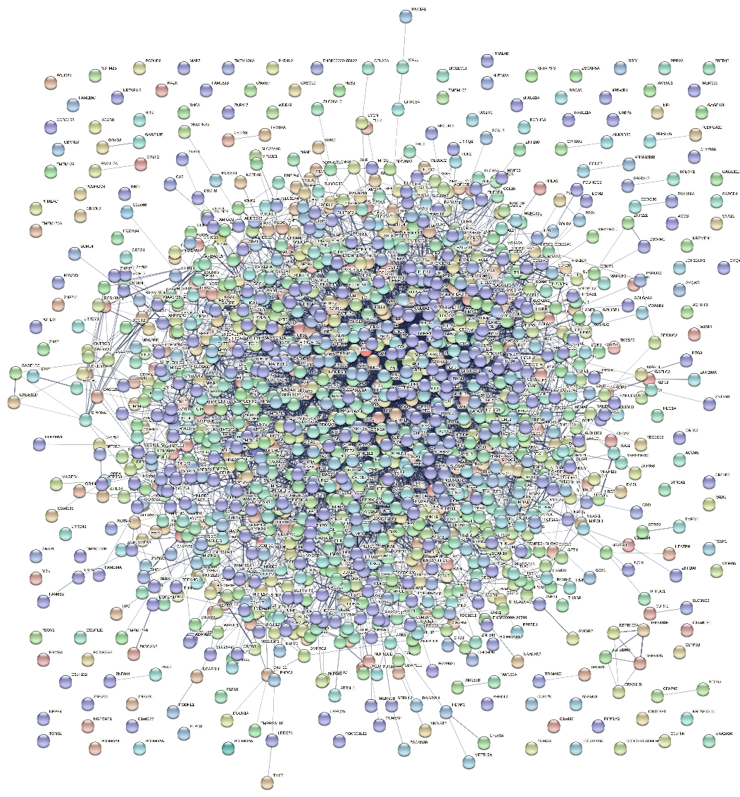
Supplementary Figure 58 Matigian_Bulk_Twin_Lyphocytes_Bipolar_Type_1_vs_Non_Bipolar_Twin_MCC_top10 Matigian BD 1 vs Control
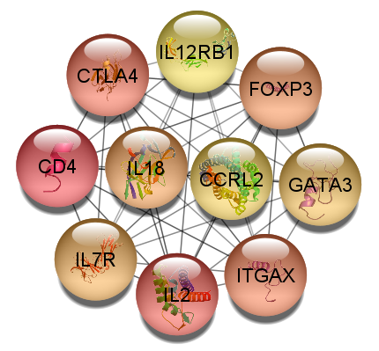
Supplementary Figure 59 Matigian_Downregulated_Twin_Lyphocytes_Bipolar_Type_1_vs_Non_Bipolar_Twin Matigian BD 1 vs Control
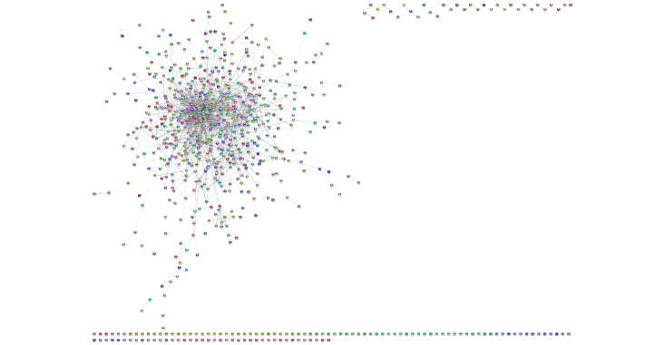

Supplementary Figure 60 Matigian_Downregulated_Twin_Lyphocytes_Bipolar_Type_1_vs_Non_Bipolar_Twin_MCC_top10 Matigian BD 1 vs Control
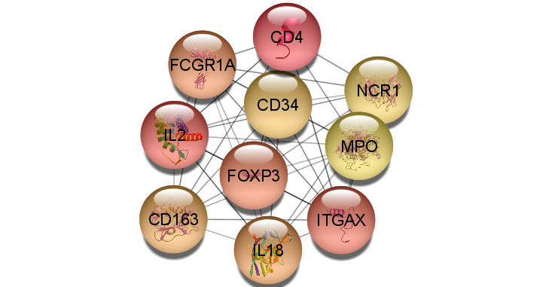
Supplementary Figure 61 Matigian_Upregulated_Twin_Lyphocytes_Bipolar_Type_1_vs_Non_Bipolar_Twin Matigian BD 1 vs Control
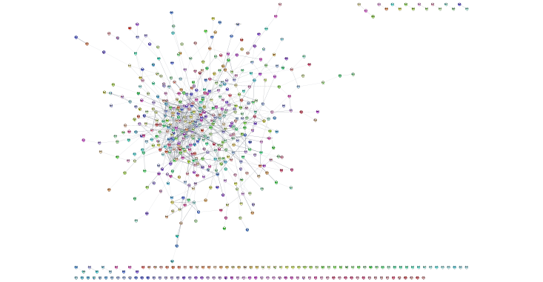

Supplementary Figure 62 Matigian_Upregulated_Twin_Lyphocytes_Bipolar_Type_1_vs_Non_Bipolar_Twin_MCC_top10 Matigian BD 1 vs Control
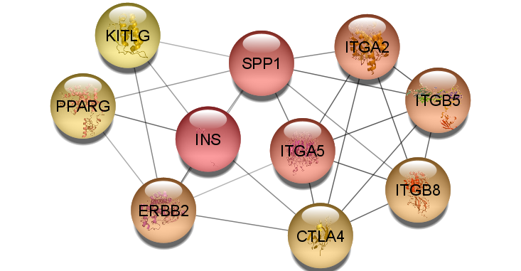
Supplementary Figure 63 Savitz_Bulk_PBMC_Bipolar_vs_Control Savitz BD vs Control
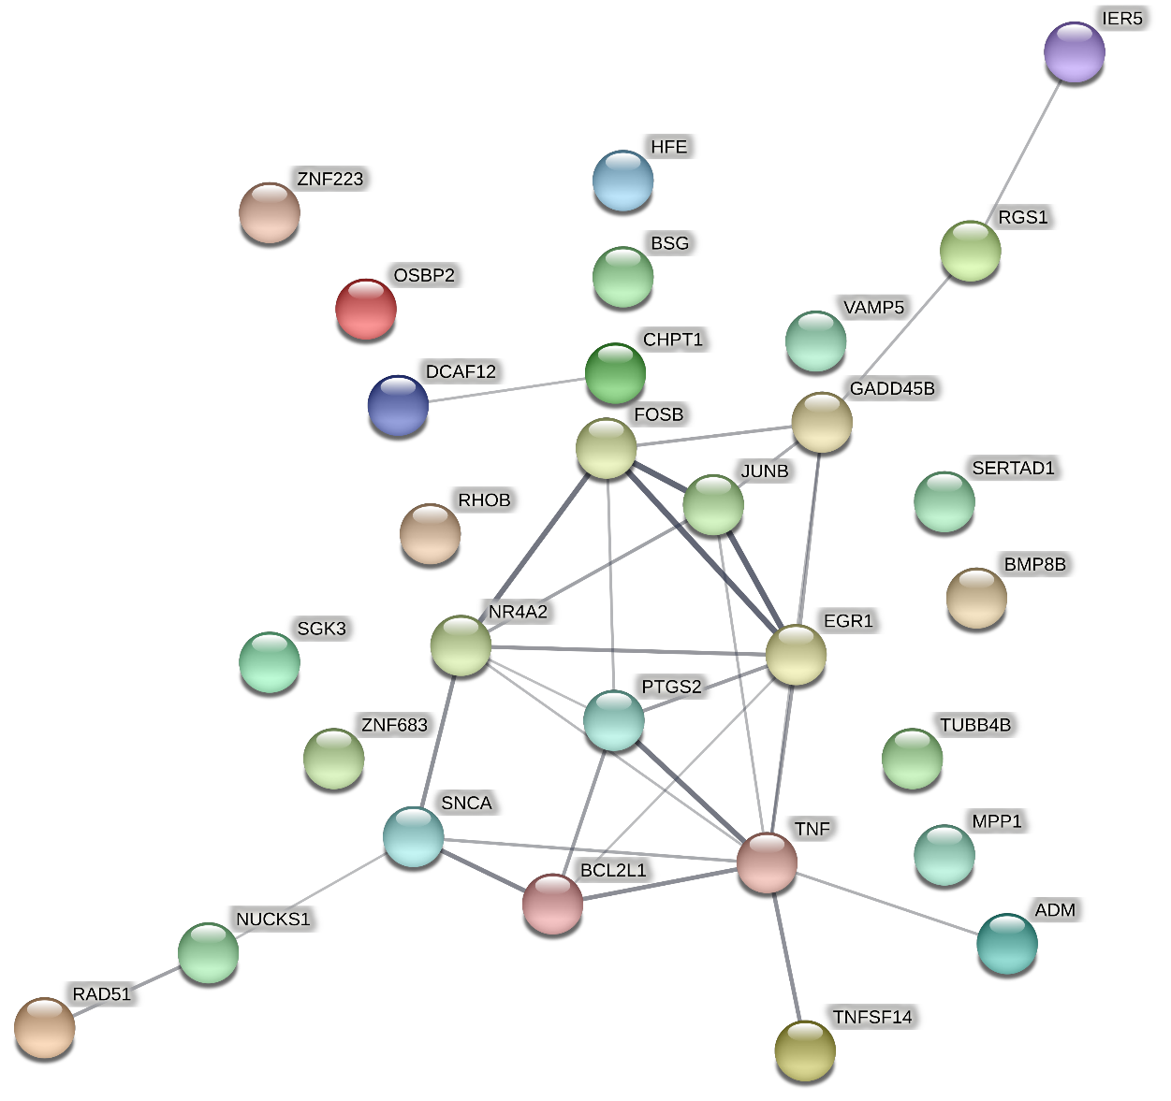
Supplementary Figure 64 Savitz_Bulk_PBMC_Bipolar_vs_Control_MCC_top10 Savitz BD vs Control
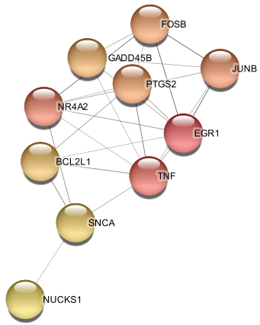
Supplementary Figure 65 Savitz_Downregulated_PBMC_Bipolar_vs_Control_MCC_top10 Savitz BD vs Control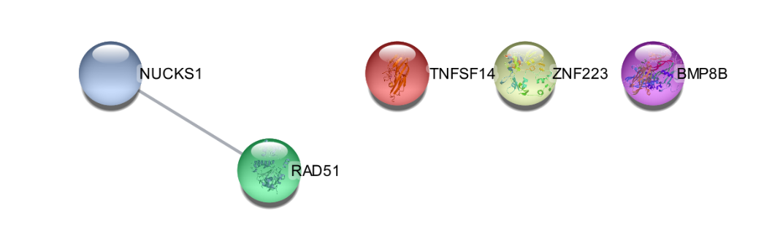
Supplementary Figure 66 Savitz_Upregulated_PBMC_Bipolar_vs_Control Savitz BD vs Control
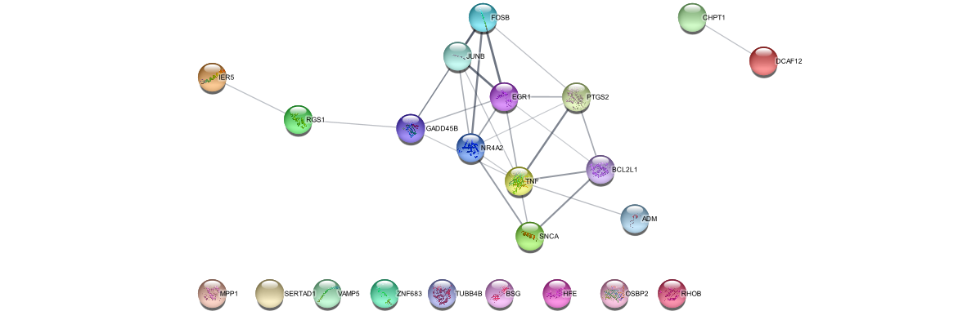
Supplementary Figure 67 Savitz_Upregulated_PBMC_Bipolar_vs_Control_MCC_top10 Savitz BD vs Control

Supplementary Figure 68 Savitz_Bulk_PBMC_Bipolar_Type_1_vs_Bipolar_Type_2 Savitz BD 1 vs BD 2
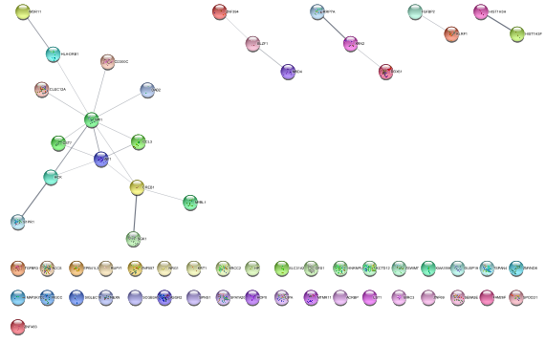

Supplementary Figure 69 Savitz_Bulk_PBMC_Bipolar_Type_1_vs_Bipolar_Type_2_MCC_top10 Savitz BD 1 vs BD 2
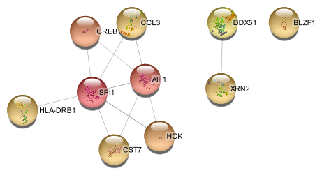
Supplementary Figure 70 Savitz_Downregulated_PBMC_Bipolar_Type_1_vs_Bipolar_Type_2 Savitz BD 1 vs BD 2
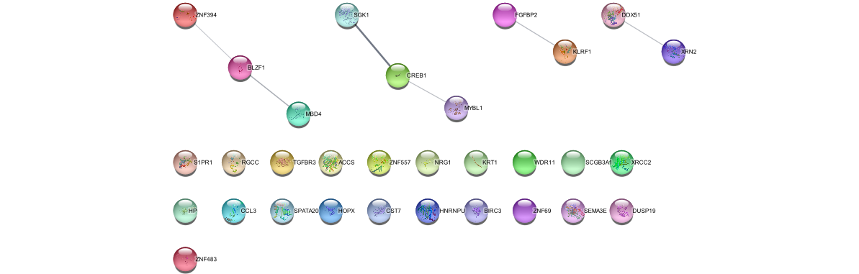
Supplementary Figure 71 Savitz_Downregulated_PBMC_Bipolar_Type_1_vs_Bipolar_Type_2_MCC_top10 Savitz BD 1 vs BD 2
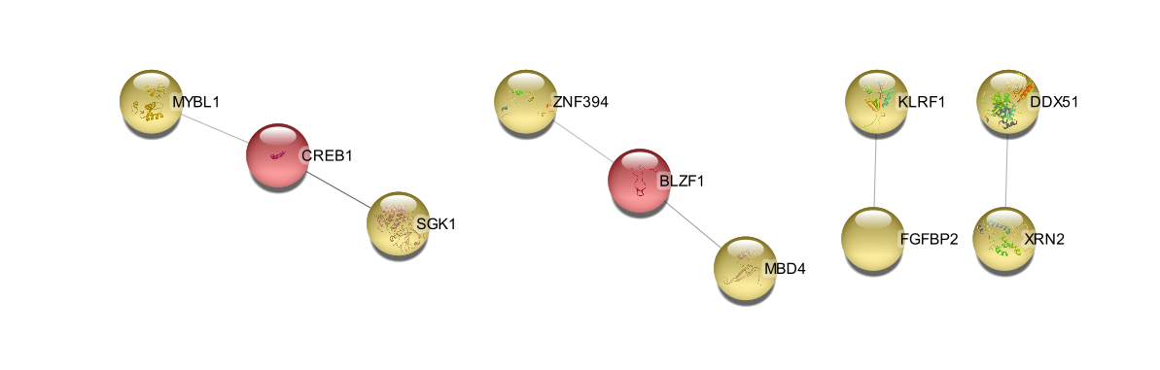
Supplementary Figure 72 Savitz_Upregulated_PBMC_Bipolar_Type_1_vs_Bipolar_Type_2 Savitz BD 1 vs BD 2
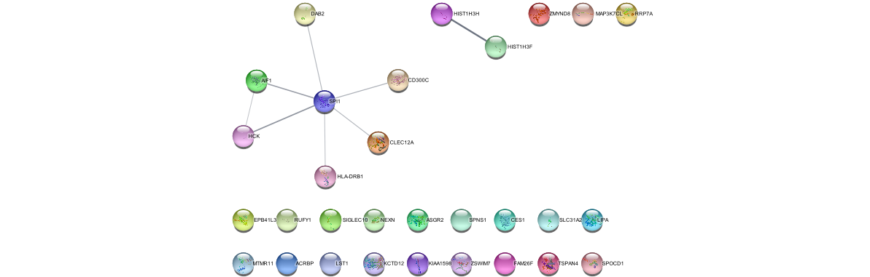
Supplementary Figure 73 Savitz_Upregulated_PBMC_Bipolar_Type_1_vs_Bipolar_Type_2_MCC_top10 Savitz BD 1 vs BD 2
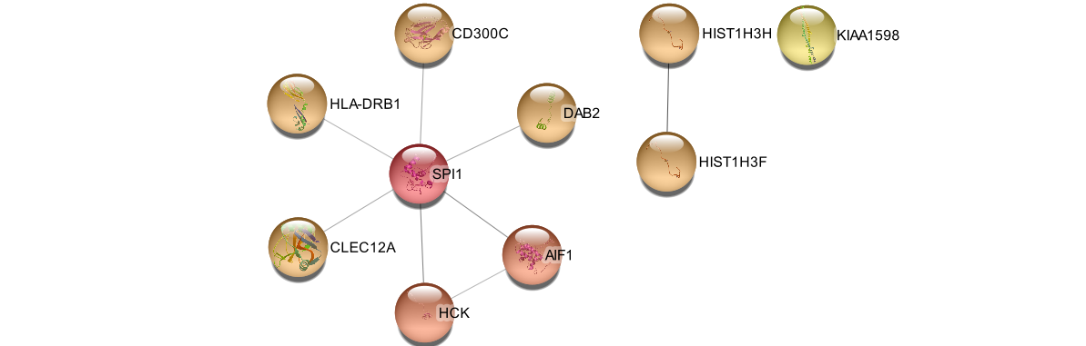
Supplementary Figure 74 Vawter_Bulk_Anterior_Singulate_Bipolar_Type_1_vs_Control Vawter BD 1 vs Control
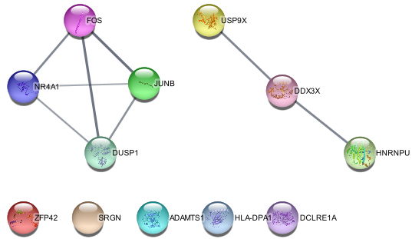
Supplementary Figure 75 Vawter_Bulk_Anterior_Singulate_Bipolar_Type_1_vs_Control_MCC_top10 Vawter BD 1 vs Control
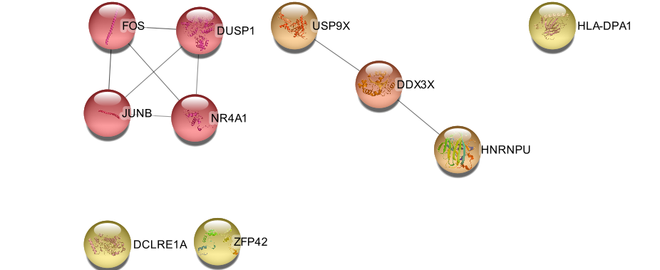
Supplementary Figure 76 Vawter_Downregulated_Anterior_Singulate_Bipolar_Type_1_vs_Control Vawter BD 1 vs Control
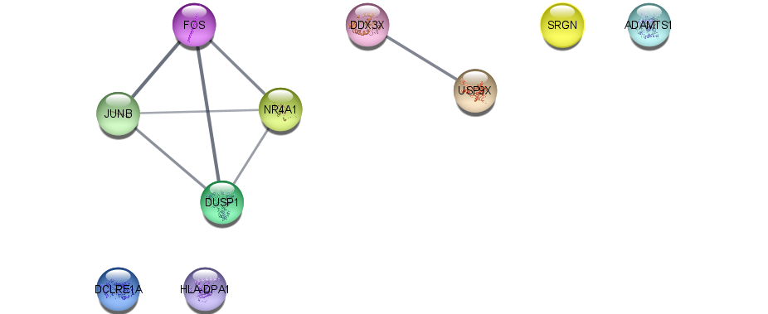
Supplementary Figure 77 Vawter_Downregulated_Anterior_Singulate_Bipolar_Type_1_vs_Control_MCC_top10 Vawter BD 1 vs Control
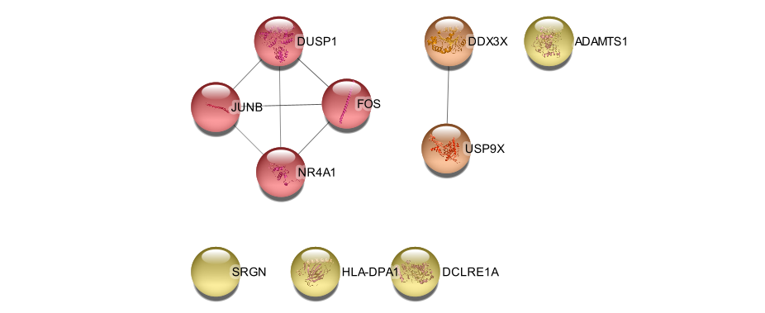
Supplementary Figure 78 Vawter_Upregulated_Anterior_Singulate_Bipolar_Type_1_vs_Control_MCC_top10 Vawter BD 1 vs Control

Supplementary Figure 79 Witt_Bulk_Blood_Bipolar_Type_1_vs_Control_MCC_top10 Witt BD 1 vs Control
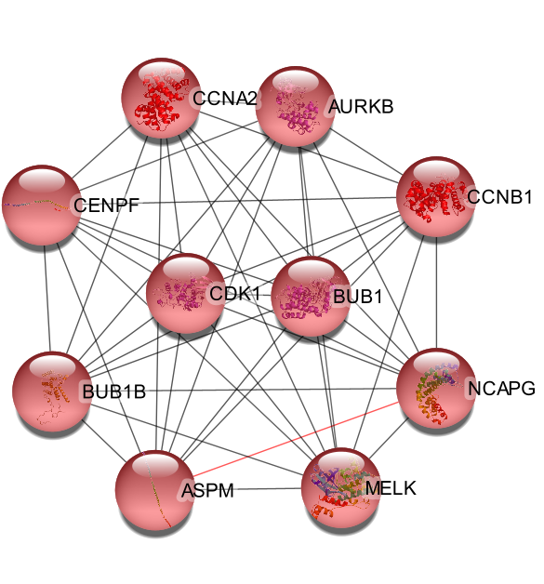

Supplementary Figure 80 Witt_Downregulated_Blood_Bipolar_Type_1_vs_Control Witt BD 1 vs Control
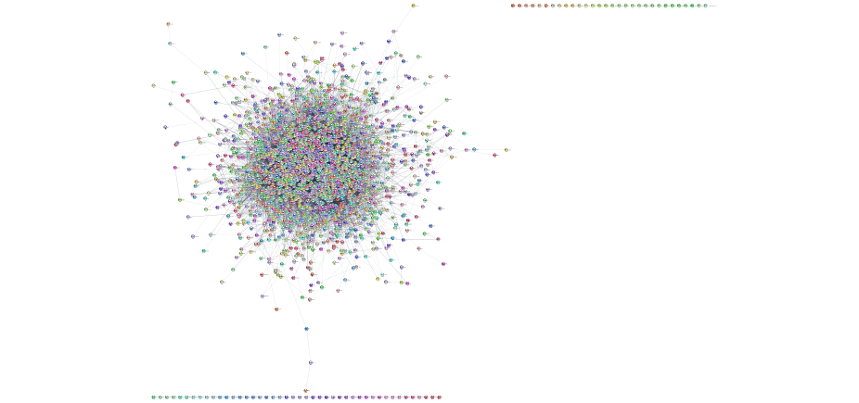
Supplementary Figure 81 Witt_Downregulated_Blood_Bipolar_Type_1_vs_Control_MCC_top10 Witt BD 1 vs Control
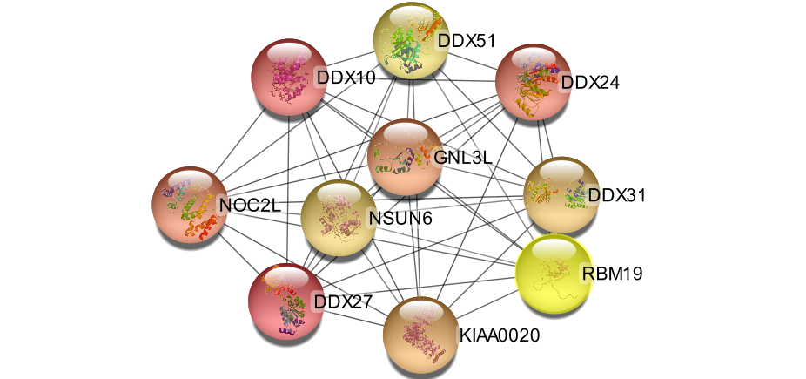

Supplementary Figure 82 Witt_Upregulated_Blood_Bipolar_Type_1_vs_Control Witt BD 1 vs Control
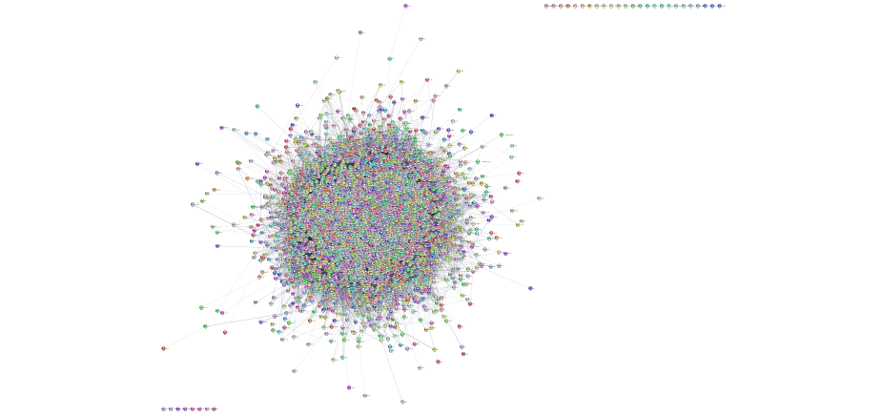
Supplementary Figure 83 Witt_Upregulated_Blood_Bipolar_Type_1_vs_Control_MCC_top10 Witt BD 1 vs Control
