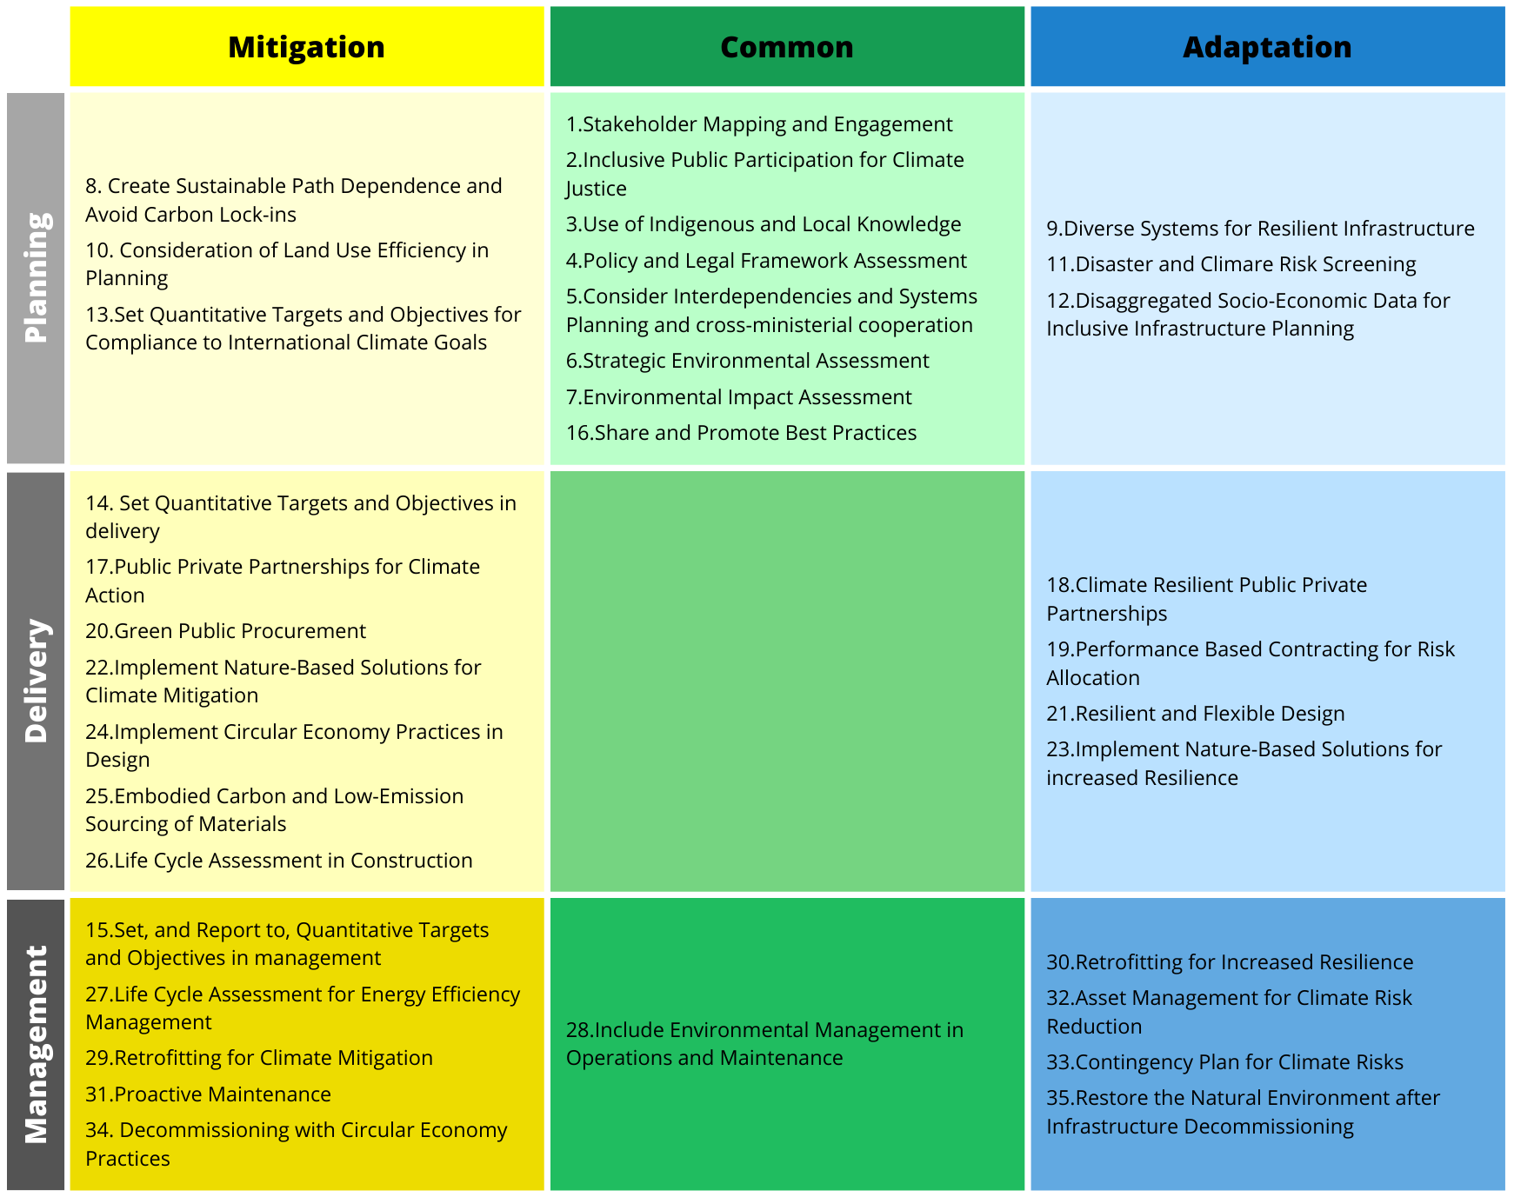
Table 1: Comprehensive list of identified activities from thematic document analysis for energy practitioners. The activities can be implemented to systematically mainstream climate mitigation and adaptation in the energy infrastructure lifecycle in order to support related SDG targets. The list is divided into mitigation and adaptation objectives, and between corresponding lifecycle stages. Activities that are linked with both climate mitigation and adaptation benefits are represented as common activities, the green field. The activities are fully described in Annex II and III.

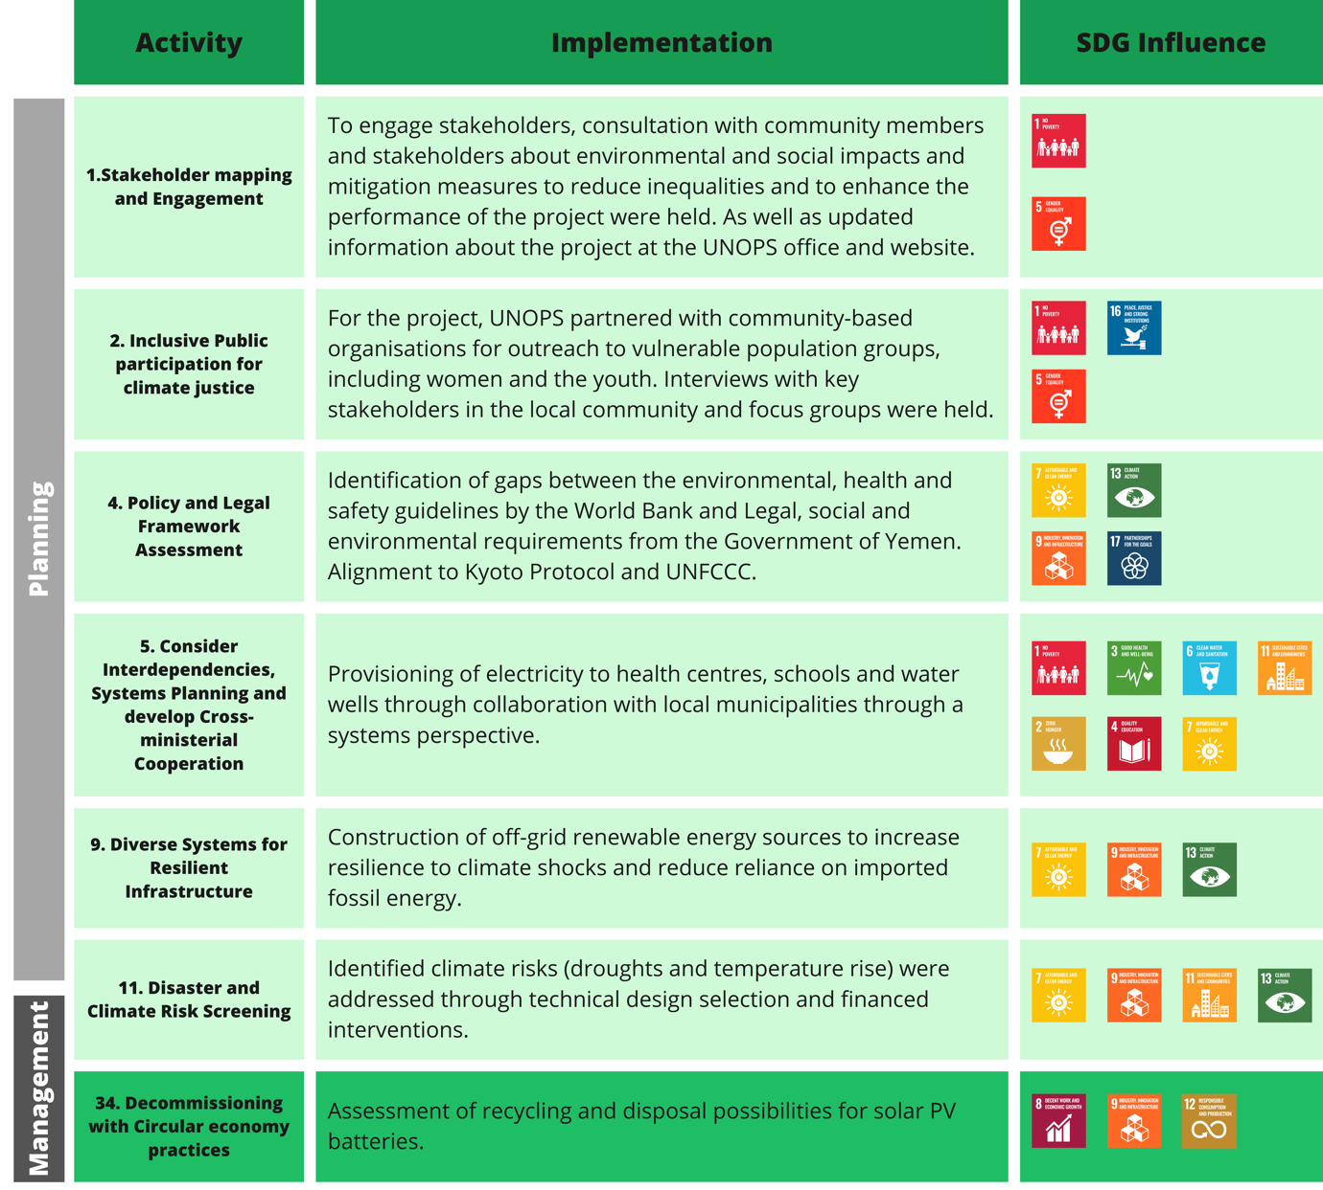
Table 2: Identification of climate activities implemented through stakeholder engagement in YEEAP, with connections to primary SDGs influenced by the climate action activity. For specific SDG targets, see Annex V, Table 1.

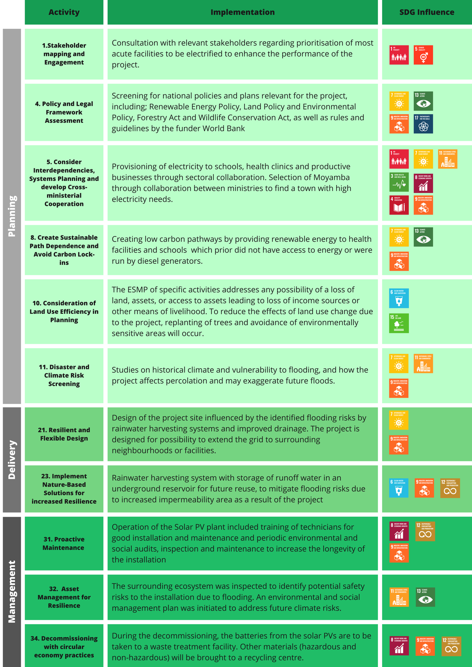Table 3. Climate activities and SDGs in ESLEAP. Identified implementation of climate activities in ESLEAP. Presentation of climate activities that was implemented in ESLEAP with connections to SDG that was influenced by the activity. For specific SDG targets, see Annex V, Table 2.

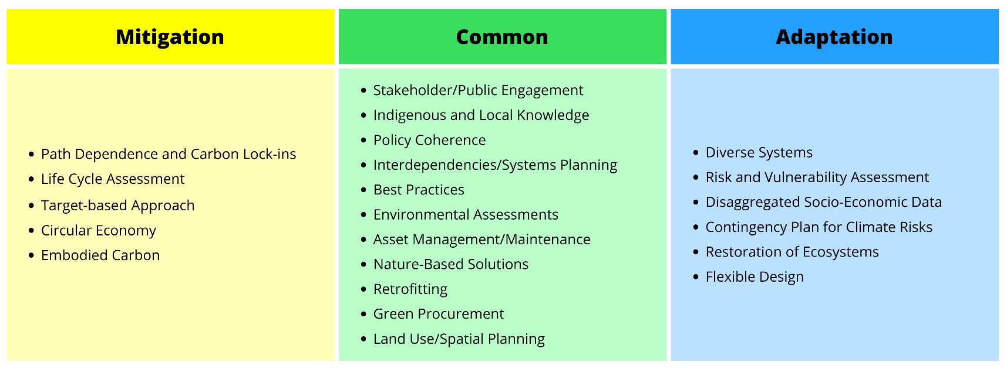
Table 2: Themes from document analysis. Broad themes identified in a comprehensive document analysis of grey literature for the implementation of climate mitigation and adaptation in infrastructure development.

