Degradation of Rhodamine dye using a fluctuating flow type photocatalytic reactor by
external oxidants

Figures

Figure 1: Degradation of Rh B versus treatment time due to the effect of titanium dioxide using zig-zag flow type of photocatalytic reactor (initial dye concentration of 20 ppm, pH of 2.0)

Figure 2: Degradation of Rh B versus treatment time due to the effect of zinc oxide loading using zig-zag flow type of photocatalytic reactor (initial dye concentration of 20 ppm, pH of 2.0)

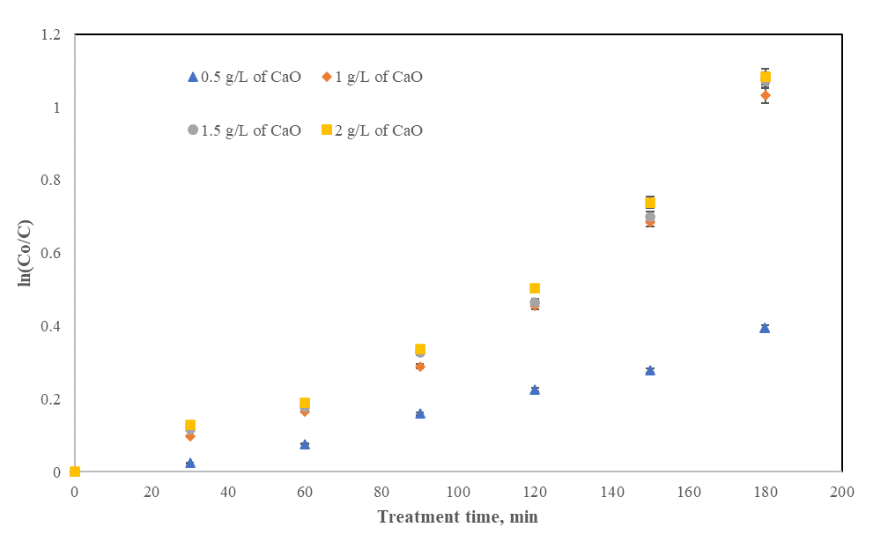
Figure 3: Degradation of Rh B versus treatment time due to the effect of calcium oxide loading using zig-zag flow type of photocatalytic reactor (initial dye concentration of 20 ppm, pH of 2.0)
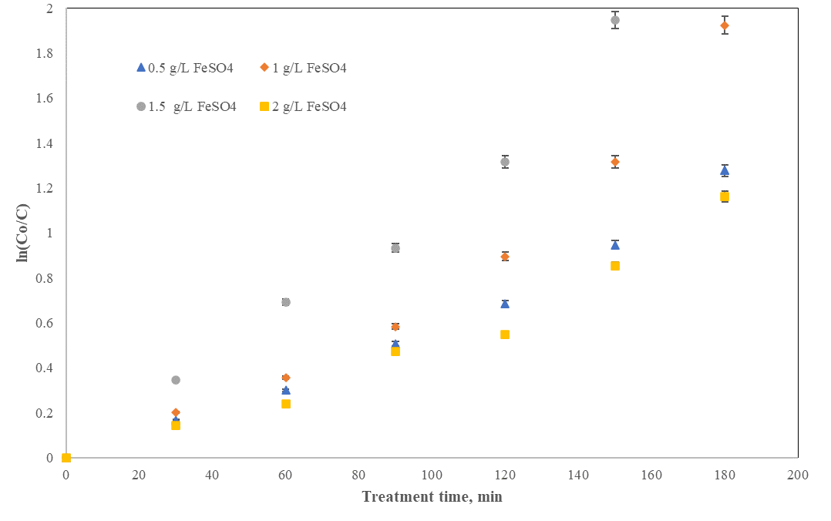
Figure 4: Degradation of Rh B versus treatment time due to the effect of Fenton loading using zig-zag flow type of photocatalytic reactor (initial dye concentration of 20 ppm, pH of 2.0)

