Supplementary information
Combination of percutaneous thermal ablation and adoptive Th9 cell transfer therapy against non-small cell lung cancer

Hanbo Pan^{1†}, Yu Tian^{1†}, Siyu Pei^{1,2†}, Wanlin Yang^{1,2}, Yanyang Zhang¹, Zenan Gu¹, Hongda Zhu¹, Ningyuan Zou¹, Jiaqi Zhang¹, Long Jiang¹, Yingjie Hu¹, Shengping Shen³, Kai Wang⁴, Haizhen Jin⁴, Ziming Li³, Yanyun Zhang², Yichuan Xiao^{2*}, Qingquan Luo^{1*}, Hui Wang^{1*}, Jia Huang^{1*}
¹ Department of Thoracic Surgical Oncology, Shanghai Lung Cancer Center, Shanghai Chest Hospital, Shanghai Jiao Tong University School of Medicine, Shanghai, 200030, China
² Chinese Academy of Sciences Key Laboratory of Tissue Microenvironment and Tumor, Shanghai Institute of Nutrition and Health, University of Chinese Academy of Sciences, Chinese Academy of Sciences, Shanghai, 200030, China
³ Department of Oncology, Shanghai Lung Cancer Center, Shanghai Chest Hospital, Shanghai Jiao Tong University School of Medicine, Shanghai, 200030, China
⁴ Department of Central Laboratory, Shanghai Chest Hospital, Shanghai Jiao Tong University School of Medicine, Shanghai, 200030, China

†Hanbo Pan, Yu Tian, and Siyu Pei have contributed equally to this work.

Supplementary Table 1. Primers used for real-time qPCR
Gene | Forward sequence (5’-3’) | Reverse sequence (5’-3’)
Human Actb | ACTCTTCCAGCCTTCCTTCC | CGTACAGGTCTTTGCGGATG
Human IL9 | CTCTGTTTGGGCATTCCCTCT | GGGTATCTTGTTTGCATGGTGG
Human IFR1 | ATGCCCATCACTCGGATGC | CCCTGCTTTGTATCGGCCTG
Mouse Actb | CGTGAAAAGATGACCCAGATCA | CACAGCCTGGATGGCTACGT
Mouse Il9 | AACAGTCCCTCCCTGTAGCA | AAGGATGATCCACCGTCAAA
Mouse Stat1 | GCTGCCTATGATGTCTCGTTT | TGCTTTTCCGTATGTTGTGCT
Mouse Stat3 | AATATAGCCGATTCCTGCAAGAG | TGGCTTCTCAAGATACCTGCTC
Mouse Stat5 | CAGCCGTGGGATGCTATTGA | GGGACAGCGGTCATACGTG
Mouse Stat6 | CCTGGTCGGTTCAGATGCTTT | GTGCGGCAAGATGCTGTTTC
Mouse Irf1 | AGGCATCCTTGTTGATGTCC | AATTCCAACCAAATCCCAGG
Mouse Irf4 | CAAAGCACAGAGTCACCTGG | TGCAAGCTCTTTGACACACA
Mouse Pu.1 | TTACAGGCGTGCAAAATGGAA | GACGTTGGTATAGCTCTGAATCG
Mouse Traf6 | GATCGGGTTGTGTGTGTCTG | AGACACCCCAGCAGCTAAGA
Mouse Nf-κb1 | AGAGGGGATTTCGATTCCGC | CCTGTGGGTAGGATTTCTTGTTC
Mouse Nf-κb2 | AGTGTGCGCTGTGTCTGTAG | GTTCTTCTTGGTTACATGCAGGA
Mouse Gata3 | GGGGCCTCTGTCCGTTTAC | TCCAGCTTCATGCTATCTGGC
Mouse Mp3k8 | AGAATGGCCGCTACCAAATCG | CCCCGAGGAACGAAACCAG

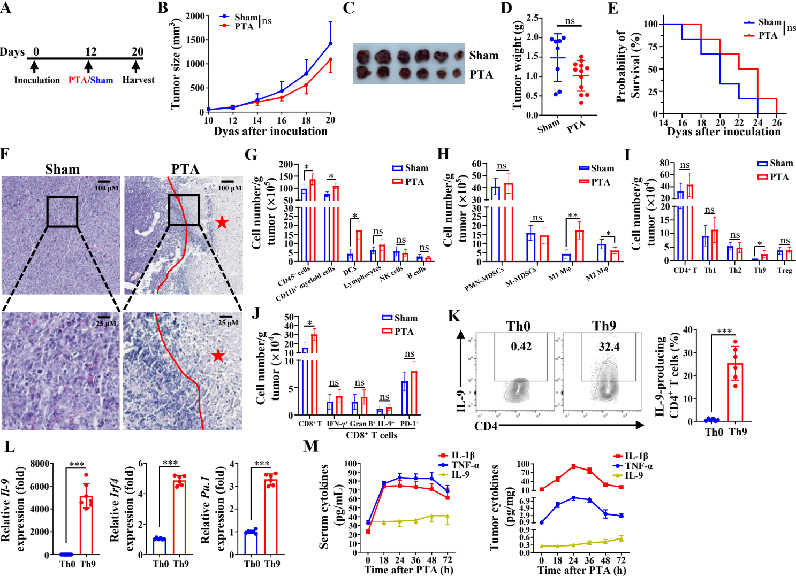
Supplementary Figure 1. PTA induces slight and short-lived anti-tumor effects. (A) The timeline of treatment. Tumor growth (B), representative tumor images (C), tumor weights (D), Kaplan-Meier survival analysis (E), and of C57BL/6 mice that were s.c. inoculated with LLC cells and then underwent sham or PTA (n = 10-12 mice/group). (F) Representative H&E staining images of tumor, as indicated in LLC bearing mice on day 20, as described in (B). The “red star” indicated the necrosis areas in the PTA-treated tumor. (G-J) Flow cytometric analysis of critical tumor-infiltrating immune cells, as indicated in LLC-bearing mice on day 20, as described in (B). (K) ELISA analysis of the dynamic changes of IL-1β, TNF-α, and IL-9 levels over time (0-72 h) in the serum (left panel) and tumor (right panel) of C57BL/6 mice that were s.c. inoculated with LLC cells and then underwent PTA. (L) Flow cytometric analysis of the frequencies of IL-9-producing CD4⁺ T cells under Th0 or Th9 differentiation conditions for 3-4 d (left panel) and the corresponding statistical analysis (right panel). (M) qPCR analysis of the mRNA expression of Th9 signature genes (left panel: Il-9, middle panel: Irf4, and right panel: Pu.1) of CD4⁺ T cells under Th0 or Th9 differentiation conditions for 3-4 days. Results were normalized to the expression of Actb and are presented in relation to that of Th0 cells. Student’s t test was used. Bars, mean; error bars, SEM; *, p < 0.05; ***, p < 0.001; and ns, not significant.

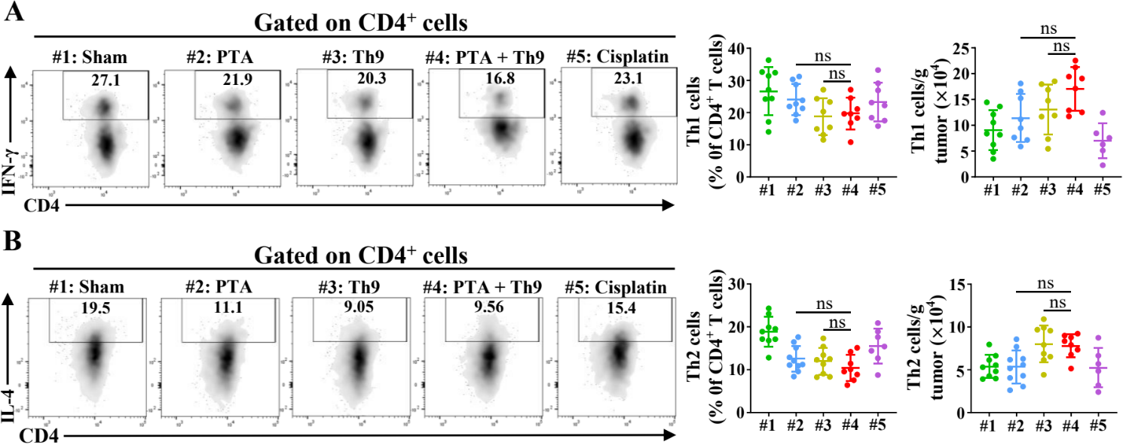
Supplementary Figure 2. Combining PTA and adoptive transfer Th9 cell therapy has no synergistic effects on tumor-infiltrating Th1 and Th2 cells. Flow cytometric analysis of tumor-infiltrating Th1 (A) and Th2 (B) cells, as indicated in LLC-bearing mice on day 20, as described in Figure 1B. Data are presented as representative plots (left panels) and summary graphs (right panels). One-way ANOVA with Tukey’s correction was used. ns, not significant.

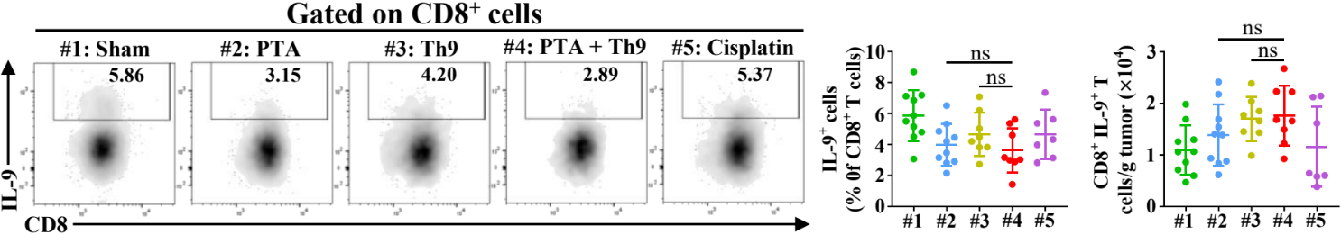
Supplementary Figure 3. Combining PTA and adoptive transfer Th9 cell therapy has no synergistic effects on tumor-infiltrating Tc9 cells. Flow cytometric analysis of tumor-infiltrating CD8⁺ IL-9⁺ T cells, as indicated in LLC-bearing mice on day 20, as described in Figure 1B. Data are presented as representative plots (left panels) and summary graphs (right panels). One-way ANOVA with Tukey’s correction was used. ns, not significant.

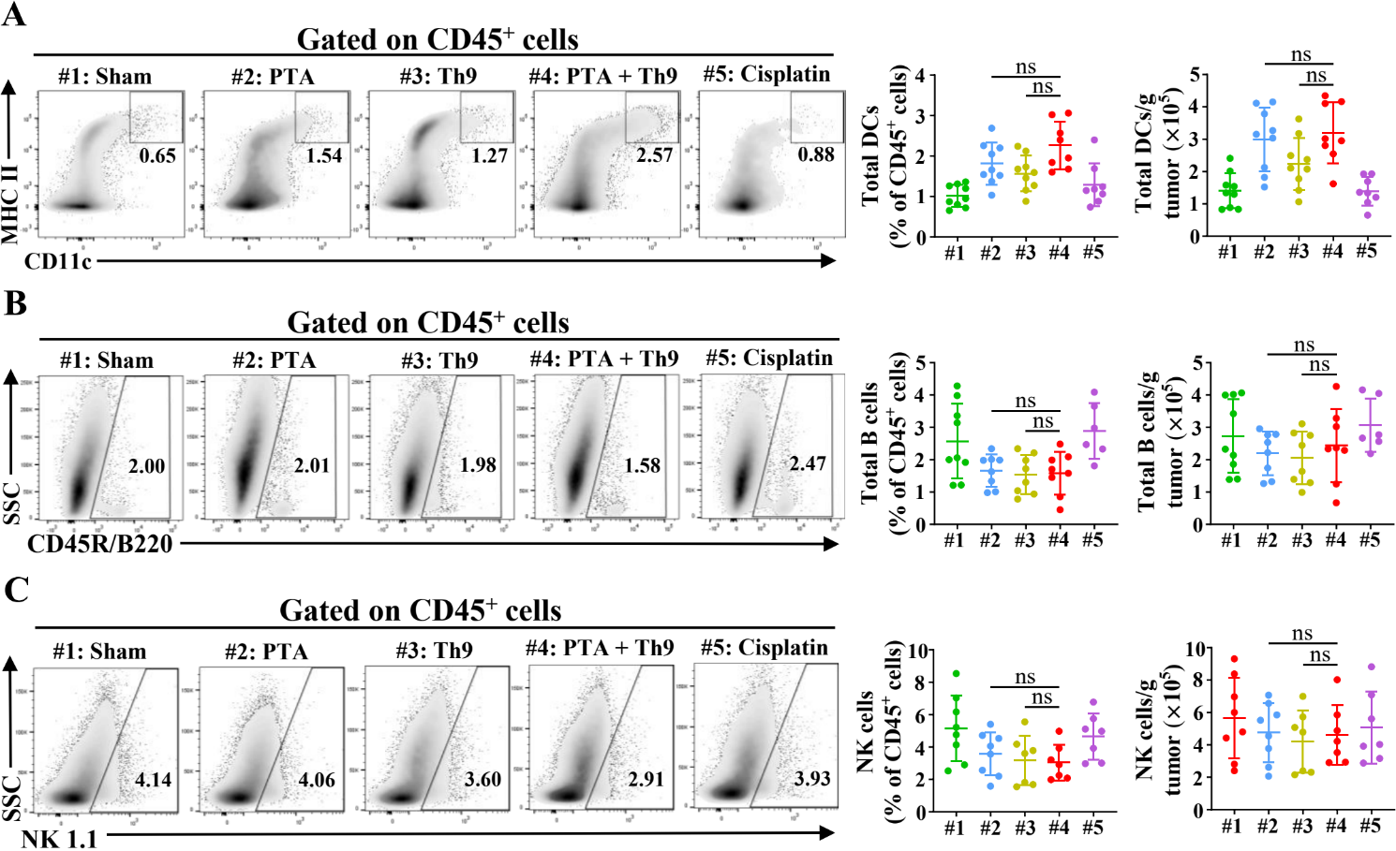
Supplementary Figure 4. Combining PTA and adoptive transfer Th9 cell therapy has no synergistic effects on tumor-infiltrating DCs, B cells, and NK cells. Flow cytometric analysis of tumor-infiltrating DCs (A), B cells (B), and NK cells (C), as indicated in LLC-bearing mice on day 20, as described in Figure 1B. Data are presented as representative plots (left panels) and summary graphs (right panels). One-way ANOVA with Tukey’s correction was used. ns, not significant.

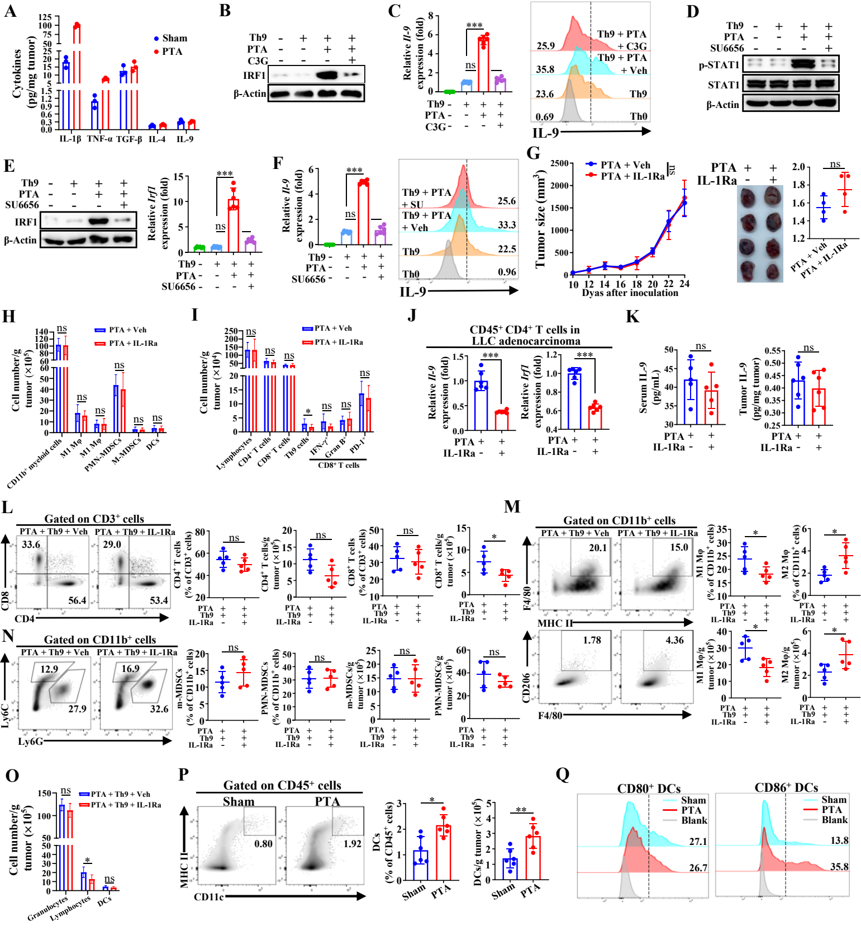
Supplementary Figure 5. PTA promotes Th9 cell differentiation mainly via activating the IL-1β/STAT1/IRF1 pathway and also recruits and activates DCs. (A) ELISA detection of IL-1β, TNF-α, TGF-β, IL-4, and IL-9 levels of tumor lysate supernatants from 24 h-postoperative LLC-bearing mice underwent sham or PTA. In (B-F) naïve CD4⁺ T cells were cultured under Th0 or Th9 conditions in the presence or absence of the tumor lysate supernatants from 24 h-postoperative LLC-bearing mice underwent sham or PTA, and qPCR results were normalized to the expression of Actb and are presented in relation to that of the control Th9 cells. WB analysis of IRF1 expression (B), and qPCR and flow cytometric analysis of Il-9 expression (C) in Th9 cells cultured for 72h, with or without C3G. WB analysis of p-STAT and STAT expressions (D), WB and qPCR analysis of IRF1 expression (E), and qPCR and flow cytometric analysis of Il-9 expression (F) in Th9 cells cultured for 25 mins, with or without SU6656. (G) Tumor growth, representative tumor image, and tumor weight of C57BL/6 mice that were s.c. inoculated with LLC cells and then underwent PTA or PTA + IL-1Ra (n=6 mice/group). (H-I) Flow cytometric analysis of critical tumor-infiltrating immune cells, as indicated in LLC-bearing mice on day 24, as described in (G). (J) qPCR analysis of Il-9 and Irf1 expressions in tumor-infiltrating CD45⁺ CD4⁺ T cells that were isolated from LLC-bearing mice on day 24, as described in (G). Results were normalized to the expression of Actb and are presented in relation to that of the PTA + Veh group. (K) ELISA detection of serum and tumor IL-1β levels in LLC-bearing mice on day 24, as described in (G). Flow cytometric analysis of tumor-infiltrating CD4⁺ and CD8⁺ T cells (L), Mφ (M), and MDCSs (N), as indicated in LLC-bearing mice on day 24, as described in Figure 5J. Data are presented as representative plots (left panels) and summary graphs (right panels). (O) Flow cytometric analysis of tumor-infiltrating granulocytes, lymphocytes, and DCs, as indicated in LLC-bearing mice on day 24, as described in Figure 5J. Flow cytometric analysis of tumor-infiltrating total DCs (P) and mature (CD80⁺ and CD86⁺) DCs (Q), as indicated in LLC-bearing mice on day 20, as described in Supplementary Figure 1B. One-way ANOVA with Tukey’s correction or Student’s t test was used. Bars, mean; error bars, SEM; *, p < 0.05; **, p < 0.01; ***, p < 0.001; and ns, not significant.

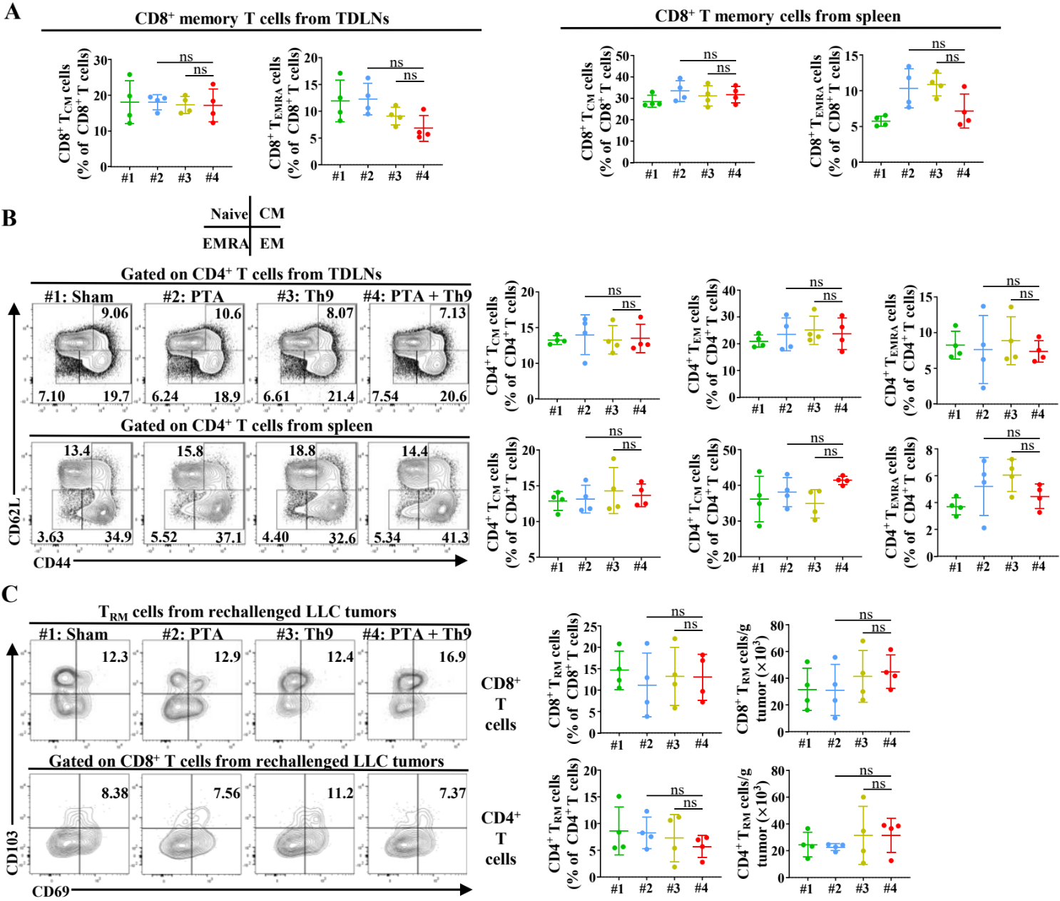
Supplementary Figure 6. Combining PTA and adoptive transfer Th9 cell therapy has no synergistic effects on CD8⁺ T_{CM} and T_{EMRA} and CD4⁺ memory T in the TDLNs and spleen, as well as T_{RM} cells in the tumor foci. (A) The summary graphs of flow cytometric analysis of CD8⁺ T_{CM} and T_{EMRA} cells in the TDLNs (left panel) and spleen (right panel), as indicated in LLC/LUC-bearing mice on day 30, as described in Figure 7B. (B) Flow cytometric analysis of CD4⁺ T_{EM}, T_{CM}, and T_{EMRA} cells in the TDLNs and spleen, as indicated in LLC/LUC-bearing mice on day 30, as described in Figure 7B. Data are presented as representative plots (left panels) and summary graphs (right panels). (C) Flow cytometric analysis of tumor-infiltrating CD8⁺ and CD4⁺ T_{RM} cells, as indicated in LLC/LUC-bearing mice on day 30, as described in Figure 7B. Data are presented as representative plots (left panels) and summary graphs (right panels). One-way ANOVA with Tukey’s correction was used. ns, not significant.

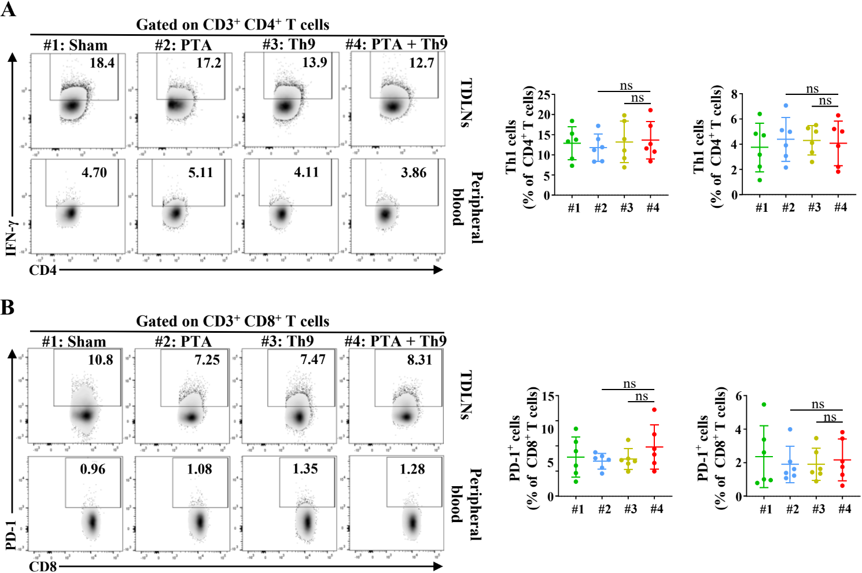
Supplementary Figure 7. Combining PTA and adoptive transfer Th9 cell therapy has no synergistic effects on Th1 and exhausted CD8⁺ T cells in the TDLNs and peripheral blood. Flow cytometric analysis of Th1 (A) and CD8⁺ PD-1⁺ T cells (B) in the TDLNs (left panels) and peripheral blood (right panels), as indicated in LLC/LUC-bearing mice on day 30, as described in Figure 8B. One-way ANOVA with Tukey’s correction was used. ns, not significant.

