Figure S1. Plot of leverage versus student residuals for detection of outliers in the set of seven datasets from patient samples from Spain that were analyzed by MNR (a), from samples from China that were analyzed by GC-MS (b), from samples from the United States that were analyzed by LC-MS (c), from samples from Italy that were analyzed by GC-MS (d), from samples from France that were analyzed by LC-MS (e), from samples from Italy that were analyzed by LC-MS (f) and the samples from Italy that were also analyzed by GC-MS (g). In this graph, a sample is considered an outlier if it simultaneously presents high values ​​of Leverage and student residuals. Although some samples had high leverage values, all samples were within the range of ±2.5 standard deviations of student residuals, so no outlier samples were detected. COVID-19, non-COVID-19, voluntarily healthy samples are represented by red, blue and green circles.
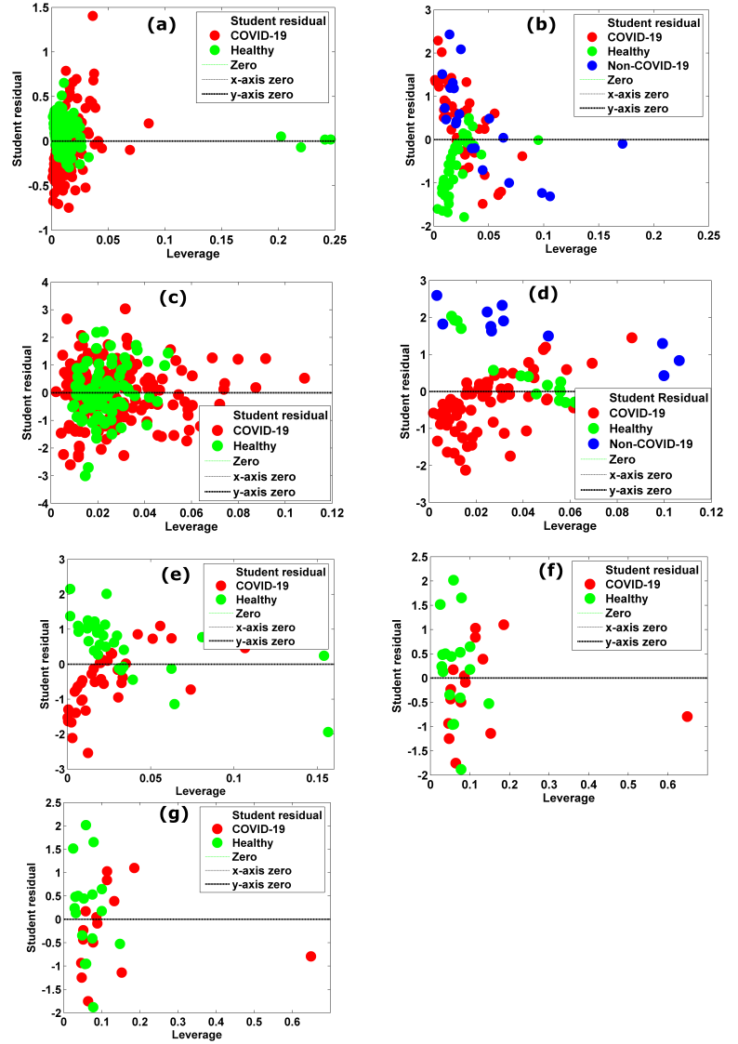

Figure S2. Graphs of Root Mean Square error of Cross validation (RMSECV) versus Number of Latent Variables (LV). This chart aims to select the number of latent variables to be used for training the PLS-DA model. The LV number is selected considering smaller RMSCV values. Thus, the number of LVs used for training the PLS-DA models from data from Spain (dataset 1, MNR data), China (dataset 2, GC-MS data), Spain (dataset 3, LC-MS data), Italy (dataset 4, GC-MS data ), France (dataset 5, LC-MS data), Italy (dataset 6, LC-MS data) and Italy (dataset 7, GC-MS data) are shown in figures (a), (b), (c), (d), (and ), (f) and (g).
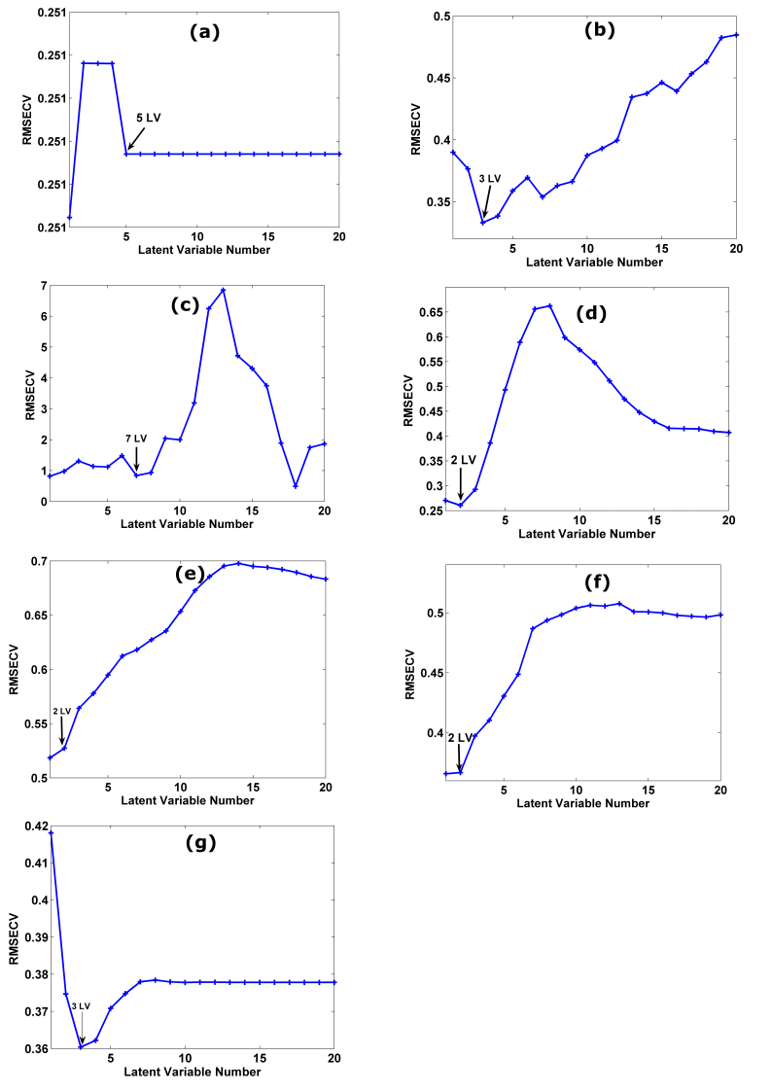

Figure S3. Variable Importance in the projection chart of the most important biomarkers for the diagnosis of COVID-19 using data from Spain (dataset 1, MNR data). The X axis represents all analyzed metabolites; The Y axis represents the VIP score that reflects the importance of each metabolite in predicting the diagnosis of COVID-19. The black dashed line parallel to the X-axis represents the VIP score threshold (VIP score threshold = 1). The metabolites that contribute significantly to the prediction of the different classes of the samples are above the threshold (VIP score > 1).

Figure S4. Variable Importance in the projection chart of the most important biomarkers for the diagnosis of COVID-19 using data from China (dataset 2, GC-MS Data). The X axis represents all analyzed metabolites; The Y axis represents the VIP score that reflects the importance of each metabolite in predicting the different classes of samples (COVID-19 represented by blue color, non-COVID-19 by black color and healthy volunteers by green color). The black dashed line parallel to the X-axis represents the VIP score threshold (VIP score threshold = 1). The metabolites that contribute significantly to the prediction of the different sample classes are above the threshold (VIP score > 1); the top 10 biomarkers have been highlighted in the figure.

Figure S5. Variable Importance in the projection chart of the most important biomarkers for the diagnosis of COVID-19 using Spain dataset (dataset 3, LC-MS data). The X axis represents all analyzed metabolites; The Y axis represents the VIP score that reflects the importance of each metabolite in predicting the diagnosis of COVID-19. The black dashed line parallel to the X-axis represents the VIP score threshold (VIP score threshold = 1). The metabolites that contribute significantly to the prediction of the different classes of the samples are above the threshold (VIP score > 1).

Figure S6. Variable Importance in the projection chart of the most important biomarkers for the diagnosis of COVID-19 using data from Italy (dataset 4, GC-MS Data). The X axis represents all analyzed metabolites; The Y axis represents the VIP score that reflects the importance of each metabolite in predicting the different classes of samples (COVID-19 represented by blue color, non-COVID-19 by black color and healthy volunteers by green color). The black dashed line parallel to the X-axis represents the VIP score threshold (VIP score threshold = 1). The metabolites that contribute significantly to the prediction of the different classes of the samples are above the threshold (VIP score > 1).

Figure S6. Variable Importance in the projection chart of the most important biomarkers for the diagnosis of COVID-19 using data from France (dataset 5, GC-MS Data). The X axis represents all analyzed metabolites; The Y axis represents the VIP score that reflects the importance of each metabolite in predicting the different classes of samples (COVID-19 represented by blue color, non-COVID-19 by black color and healthy volunteers by green color). The black dashed line parallel to the X-axis represents the VIP score threshold (VIP score threshold = 1). The metabolites that contribute significantly to the prediction of the different classes of the samples are above the threshold (VIP score > 1).
Figure S7. Variable Importance in the projection chart of the most important biomarkers for the diagnosis of COVID-19 using data from Italy (dataset 7, LC-MS data). The X axis represents all analyzed metabolites; The Y axis represents the VIP score that reflects the importance of each metabolite in predicting the diagnosis of COVID-19. The black dashed line parallel to the X-axis represents the VIP score threshold (VIP score threshold = 1). The metabolites that contribute significantly to the prediction of the different classes of the samples are above the threshold (VIP score > 1).

Fig S8. Profile of the main blood biomarkers associated with the diagnosis of COVID-19 using data from Spain (MNR dataset). Results are grouped according to classes: healthy (n = 280) and COVID-19 (n = 261). Boxes indicate interquartile ranges (median); horizontal lines indicate minimum and maximum values.
Fig. S9. Profile of the main blood biomarkers associated with the diagnosis of COVID-19 using data from China (GC-MS dataset). Results are grouped according to classes: healthy (n = 57), non-COVID-19 (n = 30) and COVID-19 (n = 60). Boxes indicate interquartile ranges (median); horizontal lines indicate minimum and maximum values.

Fig S10. Profile of the main blood biomarkers associated with the diagnosis of COVID-19 using data from the United States (LC-MS dataset). Results are grouped according to classes: healthy (n = 133) and COVID-19 (n = 254). Boxes indicate interquartile ranges (median); horizontal lines indicate minimum and maximum values.

Figure S11. Profile of the main blood biomarkers associated with the severity of COVID-19 using data from Italy (LC-MS dataset, dataset 6). Results are grouped according to classes: severe COVID-19 patients (n = 16), moderate COVID-19 (n =16), mild COVID-19 (n = 20) and volunteers healthy subjects (n=9). Boxes indicate interquartile ranges (median); horizontal lines indicate minimum and maximum values.

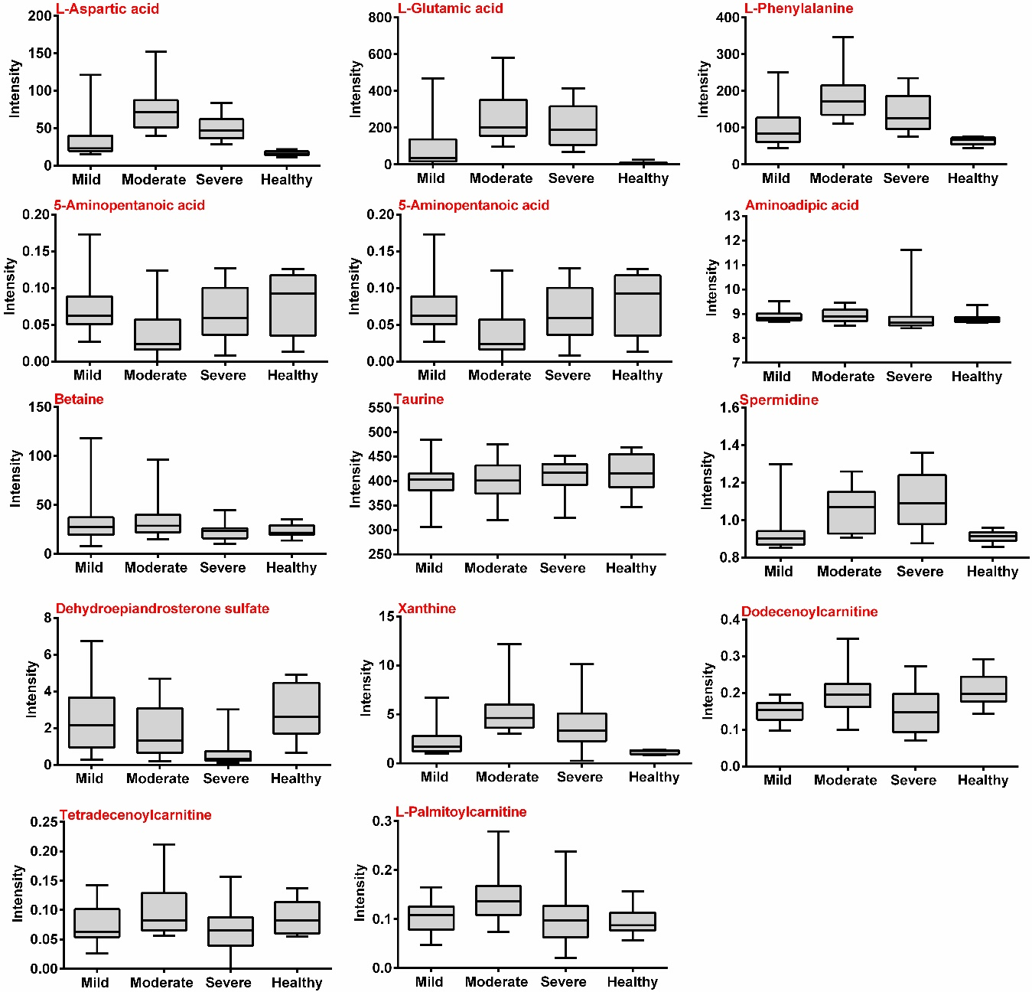

Table S1. Important biomarkers in predicting the diagnosis and severity of COVID-19 were common in two or more different databases investigated in the study.
Biomarker | Thaizou dataset*  (LC-MS, China) | Wuhan dataset*  (LC-MS, China) | Dataset 1  (MNR, Spain) | Dataset 2 (GC-MS, China) | Dataset 3  (LC-MS, Spain) | Dataset 4 (GC-MS, Italy) | Dataset 5 (LC-MS, France) | Dataset 6 (LC-MS, Italy) | Dataset 7  (GC-MS,  Italy) | Outcome
Alanine | + | - | - | - | - | - | - | + | + | Diagnosis
Ribotimidine | + | - | - | - | + | - | - | - | - | Diagnosis
L-Ornithine | + | + |  | + | - | - |  | + | - | Severe
L-Valine | - | - | - | - | - | + |  | + | + | Severity
L-Glutamic acid |  |  |  | + | - | - | - | + | + | Severity
Isoleucine | + | - | - | - | - | - | - | + | + | Severity
N-acetyl-glucosamine-1 phosphate | + | - | - | - | - | + | - | - | - | Severity
2,6 dihidroxypurine | - | - | - | + | - | - | - | - | - | Diagnosis
4-Hydroxyphenylacetoyl carnitine | - | + | - | - | - | - | - | + | - | Severity
Note: (+) present; (-) absent.; * Dataset from our previous study [37].

