Supplementary materials

Supplementary Table 1. Summary of genome-wide association studies (GWAS) datasets in our study.
Phenotype | Author, published year | Consortium | Sample size | PMID | Population
Chronotype | Jones SE et al, 2019 | UKB | 403,195 | 30696823 | European
Sleep duration | Dashti HS et al, 2019 | UKB | 446,118 | 30846698 | European
Insomnia | Jansen PR et al, 2019 | 23andMe / UKB | 1,331,010 | 30804565 | European
Daytime sleepiness | Wang H et al, 2019 | UKB | 452,071 | 31409809 | European
Daytime napping | Dashti HS et al,2021 | UKB | 452,663 | 33568662 | European
Colorectal cancer | 2022 | FinnGen | 293,646 | NA | European

Supplementary Table 2. The summary information for instrumental variables of chronotype.
Sort | Phenotype | SNP | effect_allele | other_allele | beta | se | pval
1 | Chronotype | rs61773390 | G | T | -0.0340792 | 0.00337553 | 1.20E-23
2 | Chronotype | rs17448682 | C | T | -0.0221528 | 0.00318247 | 2.20E-12
3 | Chronotype | rs3816454 | T | G | 0.020082 | 0.00278156 | 4.90E-13
4 | Chronotype | rs12140153 | G | T | 0.0340109 | 0.00468803 | 1.60E-13
5 | Chronotype | rs7547493 | A | G | -0.0376299 | 0.00350319 | 3.90E-27
6 | Chronotype | rs6658041 | G | A | -0.0152482 | 0.00274124 | 1.70E-08
7 | Chronotype | rs11588913 | G | A | 0.0154525 | 0.00273856 | 1.50E-08
8 | Chronotype | rs72720396 | A | G | -0.0271261 | 0.00318521 | 8.40E-18
9 | Chronotype | rs4949980 | A | G | -0.0321893 | 0.00539402 | 2.70E-09
10 | Chronotype | rs17575798 | G | A | 0.0225553 | 0.00339377 | 4.20E-11
11 | Chronotype | rs11587758 | G | A | -0.0241103 | 0.0027375 | 5.50E-19
12 | Chronotype | rs140206235 | C | T | -0.0553854 | 0.00996801 | 2.30E-08
13 | Chronotype | rs975025 | C | T | 0.0321062 | 0.00502525 | 1.30E-10
14 | Chronotype | rs509476 | T | C | 0.1137 | 0.0078575 | 5.70E-47
15 | Chronotype | rs13011556 | C | G | -0.0227424 | 0.00316075 | 1.10E-12
16 | Chronotype | rs2712056 | C | T | -0.022175 | 0.00345992 | 5.10E-11
17 | Chronotype | rs75120545 | C | T | -0.0613917 | 0.00828587 | 1.10E-13
18 | Chronotype | rs786406 | A | G | -0.0235784 | 0.00293536 | 1.90E-16
19 | Chronotype | rs10495976 | A | T | -0.0178512 | 0.00276698 | 5.10E-11
20 | Chronotype | rs7602425 | C | T | -0.031168 | 0.00509212 | 8.50E-10
21 | Chronotype | rs359250 | G | T | -0.0168642 | 0.0027885 | 9.20E-10
22 | Chronotype | rs812925 | C | G | -0.0205641 | 0.00280786 | 6.90E-13
23 | Chronotype | rs2311837 | T | C | -0.0151285 | 0.00272441 | 3.60E-08
24 | Chronotype | rs2422413 | T | C | -0.0162894 | 0.0027689 | 3.60E-09
25 | Chronotype | rs10520176 | T | C | 0.0231498 | 0.00268932 | 1.40E-17
26 | Chronotype | rs28380327 | A | T | 0.0205097 | 0.00277698 | 2.90E-13
27 | Chronotype | rs1947198 | C | T | -0.0241964 | 0.00409707 | 1.80E-09
28 | Chronotype | rs197273 | A | G | 0.0158713 | 0.00269376 | 1.30E-08
29 | Chronotype | rs1064213 | G | A | -0.019141 | 0.00268602 | 1.30E-12
30 | Chronotype | rs114670539 | C | T | -0.0342784 | 0.00580825 | 4.60E-09
31 | Chronotype | rs57435966 | C | T | 0.0549152 | 0.0047647 | 2.60E-30
32 | Chronotype | rs114870822 | G | A | -0.0697522 | 0.0120259 | 2.00E-09
33 | Chronotype | rs62182135 | C | A | 0.0179439 | 0.00284795 | 3.70E-10
34 | Chronotype | rs149611468 | T | C | 0.0776374 | 0.0125983 | 8.50E-10
35 | Chronotype | rs6442446 | A | G | 0.0174738 | 0.00297308 | 3.10E-09
36 | Chronotype | rs9817740 | A | G | 0.0179438 | 0.00326142 | 2.00E-08
37 | Chronotype | rs13059636 | A | G | -0.0182698 | 0.00270236 | 1.60E-11
38 | Chronotype | rs114848860 | A | T | -0.0555837 | 0.00872612 | 3.60E-10
39 | Chronotype | rs11712056 | T | C | 0.0200896 | 0.00270384 | 1.60E-13
40 | Chronotype | rs13316611 | G | T | -0.0178305 | 0.0030789 | 1.70E-08
41 | Chronotype | rs11924337 | G | C | -0.0190701 | 0.00301826 | 2.20E-10
42 | Chronotype | rs957501 | T | A | 0.0154211 | 0.00284661 | 3.00E-08
43 | Chronotype | rs1800828 | C | G | 0.0176235 | 0.00308462 | 1.70E-08
44 | Chronotype | rs13065394 | G | T | 0.017504 | 0.00296404 | 3.00E-09
45 | Chronotype | rs885255 | T | C | 0.0169773 | 0.00283418 | 4.40E-09
46 | Chronotype | rs9831488 | A | G | -0.0183592 | 0.00284523 | 8.40E-11
47 | Chronotype | rs3850174 | T | A | 0.0194471 | 0.00309938 | 6.80E-10
48 | Chronotype | rs2239626 | T | C | -0.0202758 | 0.00292696 | 2.30E-12
49 | Chronotype | rs231398 | G | A | 0.0207867 | 0.00367183 | 8.40E-09
50 | Chronotype | rs28634184 | C | T | 0.0176363 | 0.00310689 | 2.80E-08
51 | Chronotype | rs7691121 | C | G | 0.0220069 | 0.00317772 | 5.60E-12
52 | Chronotype | rs4339281 | A | G | 0.0223188 | 0.00404047 | 3.20E-08
53 | Chronotype | rs4241964 | T | G | -0.020735 | 0.00270449 | 1.10E-14
54 | Chronotype | rs10067113 | C | T | -0.016251 | 0.00277635 | 6.30E-09
55 | Chronotype | rs7701529 | A | T | -0.0188448 | 0.00317247 | 3.60E-09
56 | Chronotype | rs11748798 | G | T | 0.0203788 | 0.00309922 | 5.20E-11
57 | Chronotype | rs56947091 | C | T | -0.0191881 | 0.00268737 | 6.00E-13
58 | Chronotype | rs12055234 | G | A | -0.0188521 | 0.00286239 | 4.00E-11
59 | Chronotype | rs286805 | A | T | 0.0143071 | 0.00269548 | 4.50E-08
60 | Chronotype | rs1027742 | A | G | 0.0183119 | 0.00306482 | 2.80E-09
61 | Chronotype | rs4246036 | C | T | 0.0237433 | 0.00295896 | 2.40E-15
62 | Chronotype | rs7735794 | G | A | -0.0201147 | 0.00340433 | 4.70E-09
63 | Chronotype | rs9395520 | C | T | -0.0231272 | 0.00291912 | 2.10E-15
64 | Chronotype | rs521977 | T | G | 0.0159787 | 0.00286438 | 2.10E-08
65 | Chronotype | rs4714475 | G | T | 0.0190271 | 0.00317856 | 1.60E-09
66 | Chronotype | rs62405438 | T | A | -0.0201979 | 0.00350204 | 6.30E-09
67 | Chronotype | rs2653349 | A | G | 0.0387249 | 0.00327448 | 5.20E-32
68 | Chronotype | rs2881955 | C | T | -0.0161216 | 0.00300229 | 4.30E-08
69 | Chronotype | rs60616179 | A | G | 0.0375809 | 0.00594669 | 1.10E-10
70 | Chronotype | rs827749 | T | C | -0.0236615 | 0.00286775 | 1.00E-16
71 | Chronotype | rs9364767 | T | G | 0.0158538 | 0.00269933 | 5.40E-09
72 | Chronotype | rs9348050 | T | C | 0.016638 | 0.00269048 | 7.50E-10
73 | Chronotype | rs10280205 | T | C | 0.0174497 | 0.00291239 | 1.40E-09
74 | Chronotype | rs17161045 | T | C | 0.0206395 | 0.0028029 | 7.20E-14
75 | Chronotype | rs6967481 | C | T | -0.0206433 | 0.00269925 | 6.90E-15
76 | Chronotype | rs2968511 | C | G | -0.0174599 | 0.00291928 | 4.90E-09
77 | Chronotype | rs202157 | C | T | 0.0255486 | 0.0029433 | 4.10E-18
78 | Chronotype | rs4729854 | T | A | 0.0287186 | 0.00275036 | 3.30E-25
79 | Chronotype | rs1113295 | T | G | 0.0156591 | 0.00270408 | 6.80E-09
80 | Chronotype | rs2971970 | T | G | 0.0188272 | 0.00325601 | 6.00E-09
81 | Chronotype | rs35524253 | G | A | -0.015862 | 0.00281259 | 5.80E-09
82 | Chronotype | rs11786306 | G | C | -0.0183309 | 0.00283083 | 8.70E-11
83 | Chronotype | rs13255030 | A | G | 0.0162198 | 0.00273214 | 2.80E-09
84 | Chronotype | rs12541362 | A | T | -0.0213568 | 0.00282446 | 3.50E-14
85 | Chronotype | rs769066 | T | C | -0.0219436 | 0.00348289 | 3.20E-10
86 | Chronotype | rs4321976 | T | C | 0.0232959 | 0.00324034 | 3.10E-13
87 | Chronotype | rs3100052 | A | G | 0.0170795 | 0.00276058 | 6.90E-10
88 | Chronotype | rs3808477 | C | T | -0.0215613 | 0.00299116 | 2.80E-13
89 | Chronotype | rs34340407 | T | C | -0.0184548 | 0.0031152 | 4.30E-09
90 | Chronotype | rs6477309 | C | T | -0.0174399 | 0.00286276 | 8.00E-10
91 | Chronotype | rs308521 | T | C | 0.0199718 | 0.00275427 | 3.70E-13
92 | Chronotype | rs62553781 | C | T | 0.0504004 | 0.00734656 | 1.20E-11
93 | Chronotype | rs4838161 | T | G | 0.0161104 | 0.00270516 | 2.20E-09
94 | Chronotype | rs10988239 | C | T | 0.0186334 | 0.00273304 | 1.60E-11
95 | Chronotype | rs34619169 | G | A | -0.0169119 | 0.00291571 | 3.80E-09
96 | Chronotype | rs28458909 | C | T | 0.0432803 | 0.00407749 | 2.60E-26
97 | Chronotype | rs4948547 | C | A | 0.0190042 | 0.00307909 | 1.20E-09
98 | Chronotype | rs10823233 | T | C | -0.0151686 | 0.00270212 | 4.30E-08
99 | Chronotype | rs3808964 | G | T | -0.0157096 | 0.00279601 | 2.70E-08
100 | Chronotype | rs72632979 | A | G | 0.021581 | 0.00357606 | 1.20E-09
101 | Chronotype | rs10742179 | A | G | 0.0182967 | 0.00306465 | 1.50E-09
102 | Chronotype | rs4141920 | G | A | 0.0155932 | 0.00270207 | 4.60E-09
103 | Chronotype | rs11032362 | G | A | -0.0395538 | 0.00467579 | 4.80E-17
104 | Chronotype | rs34239319 | G | T | -0.0280114 | 0.00443834 | 3.90E-10
105 | Chronotype | rs3168135 | G | A | 0.0207725 | 0.0031468 | 2.90E-11
106 | Chronotype | rs11227452 | G | A | -0.0194632 | 0.00358768 | 4.60E-08
107 | Chronotype | rs4237555 | C | T | -0.0164771 | 0.00269332 | 6.00E-10
108 | Chronotype | rs4936291 | A | G | -0.0179295 | 0.00283312 | 3.80E-10
109 | Chronotype | rs74357745 | A | G | 0.026546 | 0.00412156 | 8.70E-11
110 | Chronotype | rs7977610 | A | T | 0.0160414 | 0.0028718 | 2.10E-08
111 | Chronotype | rs12811046 | A | G | 0.0169679 | 0.00270358 | 6.20E-10
112 | Chronotype | rs7313852 | G | A | 0.029649 | 0.00271587 | 2.70E-27
113 | Chronotype | rs77384811 | G | C | 0.0247483 | 0.00372778 | 2.80E-11
114 | Chronotype | rs7959983 | T | C | -0.0195258 | 0.00272849 | 9.50E-13
115 | Chronotype | rs7304278 | A | G | -0.020255 | 0.00302264 | 2.20E-11
116 | Chronotype | rs80097534 | G | T | 0.0281025 | 0.00455453 | 9.30E-10
117 | Chronotype | rs9597250 | C | A | 0.0213068 | 0.00343801 | 6.90E-10
118 | Chronotype | rs9573971 | A | G | 0.0727759 | 0.00743443 | 3.60E-22
119 | Chronotype | rs17267683 | C | G | 0.0197414 | 0.00316651 | 2.70E-10
120 | Chronotype | rs9521184 | T | C | 0.0148855 | 0.00270389 | 3.00E-08
121 | Chronotype | rs1952923 | G | A | 0.016877 | 0.00305963 | 3.60E-08
122 | Chronotype | rs698015 | C | T | -0.0161876 | 0.0028566 | 8.80E-09
123 | Chronotype | rs7148842 | C | T | 0.0153777 | 0.00278312 | 1.80E-08
124 | Chronotype | rs10149448 | A | G | 0.0164465 | 0.00275282 | 2.70E-09
125 | Chronotype | rs12432176 | C | A | -0.0161131 | 0.00278357 | 6.50E-09
126 | Chronotype | rs59986227 | C | G | -0.0178401 | 0.00310217 | 8.30E-09
127 | Chronotype | rs9932577 | C | A | 0.0166195 | 0.00271482 | 6.80E-10
128 | Chronotype | rs12927162 | A | G | 0.0286498 | 0.00300067 | 6.80E-22
129 | Chronotype | rs1421085 | T | C | -0.0275621 | 0.00274075 | 1.50E-23
130 | Chronotype | rs4784655 | G | C | 0.0211306 | 0.00288752 | 1.50E-13
131 | Chronotype | rs17604349 | G | A | 0.0257422 | 0.00351443 | 1.70E-13
132 | Chronotype | rs2518022 | T | C | 0.0403075 | 0.00485089 | 4.80E-17
133 | Chronotype | rs3760185 | C | T | 0.0241586 | 0.0031496 | 2.60E-14
134 | Chronotype | rs226090 | C | T | 0.0208783 | 0.00359523 | 4.10E-09
135 | Chronotype | rs28647842 | G | C | 0.0160844 | 0.00269439 | 2.00E-09
136 | Chronotype | rs72829706 | A | G | 0.0407112 | 0.00693598 | 5.10E-09
137 | Chronotype | rs114352914 | G | A | -0.0197917 | 0.00344154 | 7.90E-09
138 | Chronotype | rs2949923 | A | G | -0.016206 | 0.00270197 | 2.10E-09
139 | Chronotype | rs62082401 | C | G | -0.0256287 | 0.00342253 | 1.60E-14
140 | Chronotype | rs4239386 | T | A | 0.0218962 | 0.00285562 | 1.00E-14
141 | Chronotype | rs12969848 | C | T | -0.0218632 | 0.00270301 | 1.30E-15
142 | Chronotype | rs9962650 | C | G | -0.0173129 | 0.00272797 | 1.60E-10
143 | Chronotype | rs9964420 | C | A | 0.0284801 | 0.00293643 | 8.60E-22
144 | Chronotype | rs56076457 | C | T | -0.0162984 | 0.00269462 | 1.30E-09
145 | Chronotype | rs10402849 | C | T | -0.0192609 | 0.00335946 | 8.90E-09
146 | Chronotype | rs9636202 | G | A | 0.0183734 | 0.00305534 | 7.50E-10
147 | Chronotype | rs11670534 | C | T | 0.0209755 | 0.00362802 | 8.50E-09
148 | Chronotype | rs78095690 | T | C | -0.0163477 | 0.00272137 | 1.40E-09
149 | Chronotype | rs6131942 | A | G | -0.0175437 | 0.00273235 | 9.40E-11
150 | Chronotype | rs2072727 | T | C | 0.016352 | 0.00271514 | 8.50E-10
151 | Chronotype | rs139911 | C | T | 0.0233915 | 0.00273231 | 2.30E-17
152 | Chronotype | rs4822107 | G | A | -0.015528 | 0.00270621 | 9.60E-09
SNP, single nucleotide polymorphism; se, standard error
Supplementary Table 3. The summary information for instrumental variables of sleep duration.
Sort | Phenotype | SNP | effect_allele | other_allele | beta | se | pval
1 | Sleep duration | rs915416 | C | G | 0.0192587 | 0.00249452 | 9.90E-15
2 | Sleep duration | rs269054 | T | A | -0.0136431 | 0.00229327 | 2.10E-09
3 | Sleep duration | rs61796569 | C | T | -0.0154442 | 0.00256443 | 1.50E-09
4 | Sleep duration | rs12567114 | G | A | -0.0148307 | 0.0025403 | 4.30E-09
5 | Sleep duration | rs62120041 | T | C | 0.0261113 | 0.00457497 | 9.60E-09
6 | Sleep duration | rs374153 | C | T | 0.0176119 | 0.00310308 | 9.10E-09
7 | Sleep duration | rs2717076 | C | T | -0.0184107 | 0.00234091 | 3.10E-15
8 | Sleep duration | rs75539574 | A | C | -0.0362482 | 0.00406522 | 6.90E-19
9 | Sleep duration | rs7556815 | G | A | -0.0407248 | 0.00274023 | 1.30E-49
10 | Sleep duration | rs35662245 | T | A | -0.0145968 | 0.00239263 | 1.40E-09
11 | Sleep duration | rs11885663 | C | T | -0.0162176 | 0.00261811 | 8.60E-10
12 | Sleep duration | rs10173260 | T | C | -0.0128368 | 0.00231322 | 2.90E-08
13 | Sleep duration | rs112230981 | A | G | 0.0315275 | 0.00522787 | 2.20E-09
14 | Sleep duration | rs17732997 | C | G | 0.0129345 | 0.0022882 | 1.20E-08
15 | Sleep duration | rs7644809 | T | C | 0.0130621 | 0.00230148 | 1.60E-08
16 | Sleep duration | rs13088093 | T | G | -0.0162722 | 0.00240235 | 7.00E-12
17 | Sleep duration | rs2192528 | A | G | 0.0133687 | 0.0022692 | 2.70E-09
18 | Sleep duration | rs17427571 | A | G | 0.0138255 | 0.00243544 | 1.30E-08
19 | Sleep duration | rs35531607 | T | C | -0.0128402 | 0.00227278 | 1.50E-08
20 | Sleep duration | rs13109404 | T | G | 0.0312035 | 0.00440829 | 1.40E-12
21 | Sleep duration | rs365663 | A | G | 0.0146291 | 0.00227857 | 1.00E-10
22 | Sleep duration | rs465700 | C | G | 0.0225148 | 0.00367362 | 1.40E-09
23 | Sleep duration | rs56372231 | C | T | -0.0169439 | 0.00239981 | 2.20E-12
24 | Sleep duration | rs11567976 | C | T | -0.0128042 | 0.00228516 | 2.10E-08
25 | Sleep duration | rs151014368 | G | A | -0.0160924 | 0.00281958 | 9.10E-09
26 | Sleep duration | rs34556183 | A | G | 0.0169228 | 0.00252323 | 2.30E-11
27 | Sleep duration | rs113113059 | T | C | 0.0161406 | 0.00273732 | 8.40E-09
28 | Sleep duration | rs9382445 | T | C | 0.014536 | 0.00233387 | 4.80E-10
29 | Sleep duration | rs2231265 | A | G | -0.014955 | 0.00269917 | 2.70E-08
30 | Sleep duration | rs9345234 | A | C | -0.0130117 | 0.00229893 | 1.80E-08
31 | Sleep duration | rs34731055 | C | T | -0.0194603 | 0.00294778 | 3.70E-11
32 | Sleep duration | rs2079070 | C | G | 0.0175475 | 0.00256638 | 7.50E-12
33 | Sleep duration | rs7806045 | T | C | 0.0147916 | 0.00262577 | 1.40E-08
34 | Sleep duration | rs4841498 | C | T | 0.0139954 | 0.00226922 | 1.20E-09
35 | Sleep duration | rs73219758 | G | A | 0.0164012 | 0.00249526 | 5.60E-11
36 | Sleep duration | rs10973207 | G | T | -0.0204339 | 0.00312394 | 6.00E-11
37 | Sleep duration | rs1776776 | T | C | 0.019963 | 0.00341071 | 4.90E-09
38 | Sleep duration | rs12246842 | A | G | 0.0133949 | 0.00227425 | 3.90E-09
39 | Sleep duration | rs10761674 | C | T | 0.0123329 | 0.00226591 | 4.20E-08
40 | Sleep duration | rs11190970 | G | A | 0.015379 | 0.00282318 | 4.60E-08
41 | Sleep duration | rs7915425 | T | C | 0.0190638 | 0.00298959 | 2.00E-10
42 | Sleep duration | rs1517572 | A | C | -0.0146443 | 0.00229467 | 1.50E-10
43 | Sleep duration | rs4592416 | A | G | -0.0146828 | 0.0022701 | 9.30E-11
44 | Sleep duration | rs11039544 | G | A | 0.018389 | 0.00307361 | 1.90E-09
45 | Sleep duration | rs174560 | T | C | -0.0135751 | 0.00243675 | 2.80E-08
46 | Sleep duration | rs12791153 | A | T | -0.0235481 | 0.0042169 | 1.90E-08
47 | Sleep duration | rs1553132 | A | G | -0.0145068 | 0.00258447 | 2.50E-08
48 | Sleep duration | rs1939455 | G | T | 0.0204253 | 0.00356118 | 1.20E-08
49 | Sleep duration | rs1079727 | T | C | -0.0182922 | 0.00310347 | 5.30E-09
50 | Sleep duration | rs3751046 | A | G | -0.0194129 | 0.00320818 | 1.10E-09
51 | Sleep duration | rs34354917 | C | A | 0.0137464 | 0.00250081 | 3.90E-08
52 | Sleep duration | rs4767550 | A | G | -0.0143001 | 0.0023096 | 6.30E-10
53 | Sleep duration | rs6575005 | T | C | 0.0155637 | 0.00264172 | 4.40E-09
54 | Sleep duration | rs10483350 | A | G | -0.017369 | 0.0028676 | 1.50E-09
55 | Sleep duration | rs61985058 | C | T | -0.0185938 | 0.00322893 | 1.30E-08
56 | Sleep duration | rs55658675 | C | T | 0.0131415 | 0.00236892 | 2.00E-08
57 | Sleep duration | rs11621908 | C | T | 0.0240951 | 0.00416298 | 5.60E-09
58 | Sleep duration | rs8038326 | A | G | 0.0159204 | 0.0025407 | 2.80E-10
59 | Sleep duration | rs3095508 | C | A | 0.0153518 | 0.00230437 | 3.10E-11
60 | Sleep duration | rs11643715 | C | G | -0.013895 | 0.00249658 | 3.20E-08
61 | Sleep duration | rs9937053 | G | A | 0.0169348 | 0.00229041 | 1.20E-13
62 | Sleep duration | rs7198661 | T | C | 0.0133829 | 0.00227449 | 3.90E-09
63 | Sleep duration | rs3027234 | C | T | 0.0151536 | 0.00270628 | 2.30E-08
64 | Sleep duration | rs205024 | C | T | -0.0138261 | 0.00232711 | 3.90E-09
65 | Sleep duration | rs8072993 | T | G | -0.0174776 | 0.00282169 | 4.20E-10
66 | Sleep duration | rs147114641 | C | A | 0.0159801 | 0.00270379 | 3.10E-09
67 | Sleep duration | rs2696429 | G | A | 0.0168884 | 0.00270763 | 4.00E-10
68 | Sleep duration | rs12607679 | T | C | 0.0201387 | 0.00259284 | 8.30E-15
69 | Sleep duration | rs10421649 | T | A | -0.0132975 | 0.00229462 | 6.90E-09
70 | Sleep duration | rs2072727 | T | C | 0.0132425 | 0.00228506 | 7.90E-09

Supplementary Table 4. The summary information for instrumental variables of insomnia.
Sort | Phenotype | SNP | effect_allele | other_allele | beta | se | pval
1 | Insomnia | rs113851554 | T | G | 0.206 | 0.206 | 1.56E-51
2 | Insomnia | rs9527083 | G | A | 0.076 | 0.006 | 1.61E-32
3 | Insomnia | rs10947428 | C | T | 0.068 | 0.007 | 9.06E-21
4 | Insomnia | rs6119267 | G | C | 0.06 | 0.006 | 2.32E-20
5 | Insomnia | rs62158170 | A | G | 0.066 | 0.007 | 1.20E-19
6 | Insomnia | rs55972276 | A | C | 0.073 | 0.009 | 4.19E-17
7 | Insomnia | rs2431108 | C | T | 0.053 | 0.006 | 7.83E-17
8 | Insomnia | rs8180817 | G | C | 0.049 | 0.006 | 1.83E-16
9 | Insomnia | rs118166957 | T | C | 0.068 | 0.008 | 1.95E-16
10 | Insomnia | rs13135092 | G | A | 0.089 | 0.011 | 2.53E-16
11 | Insomnia | rs35322724 | A | C | 0.049 | 0.006 | 3.75E-16
12 | Insomnia | rs4702 | G | A | 0.048 | 0.006 | 6.78E-16
13 | Insomnia | rs16903122 | T | C | 0.055 | 0.007 | 9.04E-16
14 | Insomnia | rs77641763 | T | C | 0.071 | 0.009 | 6.53E-15
15 | Insomnia | rs1927902 | T | C | 0.053 | 0.007 | 1.15E-14
16 | Insomnia | rs62264767 | A | C | 0.065 | 0.008 | 1.63E-14
17 | Insomnia | rs1620977 | A | G | 0.052 | 0.007 | 2.27E-14
18 | Insomnia | rs1015438 | A | G | 0.058 | 0.008 | 2.51E-14
19 | Insomnia | rs17643634 | C | T | 0.06 | 0.008 | 1.34E-13
20 | Insomnia | rs28582096 | G | A | 0.054 | 0.007 | 1.74E-13
21 | Insomnia | rs694786 | C | T | 0.044 | 0.006 | 1.97E-13
22 | Insomnia | rs12912299 | C | T | 0.043 | 0.006 | 4.42E-13
23 | Insomnia | rs7214267 | G | A | 0.044 | 0.006 | 5.09E-13
24 | Insomnia | rs314281 | C | T | 0.043 | 0.006 | 6.03E-13
25 | Insomnia | rs11605348 | G | A | 0.045 | 0.006 | 7.01E-13
26 | Insomnia | rs4981170 | G | A | 0.054 | 0.008 | 7.33E-13
27 | Insomnia | rs9931543 | T | C | 0.048 | 0.007 | 1.11E-12
28 | Insomnia | rs524859 | G | A | 0.044 | 0.006 | 1.48E-12
29 | Insomnia | rs72657797 | C | T | 0.056 | 0.008 | 1.52E-12
30 | Insomnia | rs60565673 | G | T | 0.043 | 0.006 | 1.59E-12
31 | Insomnia | rs10761240 | G | A | 0.043 | 0.006 | 2.12E-12
32 | Insomnia | rs66674044 | T | A | 0.06 | 0.009 | 2.18E-12
33 | Insomnia | rs12666306 | A | G | 0.042 | 0.006 | 2.24E-12
34 | Insomnia | rs10800992 | T | C | 0.042 | 0.006 | 3.84E-12
35 | Insomnia | rs1031654 | C | A | 0.051 | 0.007 | 3.88E-12
36 | Insomnia | rs10947690 | G | A | 0.047 | 0.007 | 4.04E-12
37 | Insomnia | rs9889282 | C | A | 0.042 | 0.006 | 4.70E-12
38 | Insomnia | rs7044885 | G | C | 0.041 | 0.006 | 5.67E-12
39 | Insomnia | rs3774751 | G | T | 0.041 | 0.006 | 7.32E-12
40 | Insomnia | rs61921611 | C | T | 0.044 | 0.006 | 7.84E-12
41 | Insomnia | rs715338 | A | G | 0.041 | 0.006 | 7.85E-12
42 | Insomnia | rs830716 | C | G | 0.045 | 0.007 | 8.68E-12
43 | Insomnia | rs13010288 | G | T | 0.06 | 0.009 | 9.26E-12
44 | Insomnia | rs12983032 | G | A | 0.043 | 0.006 | 1.07E-11
45 | Insomnia | rs8180457 | C | T | 0.056 | 0.008 | 1.12E-11
46 | Insomnia | rs908668 | T | C | 0.05 | 0.007 | 1.41E-11
47 | Insomnia | rs79693059 | G | C | 0.073 | 0.011 | 1.61E-11
48 | Insomnia | rs12991815 | C | G | 0.04 | 0.006 | 3.02E-11
49 | Insomnia | rs12310246 | A | G | 0.045 | 0.007 | 4.74E-11
50 | Insomnia | rs55772859 | A | C | 0.042 | 0.006 | 4.82E-11
51 | Insomnia | rs6808140 | T | C | 0.039 | 0.006 | 5.35E-11
52 | Insomnia | rs2286729 | A | G | 0.07 | 0.011 | 5.37E-11
53 | Insomnia | rs11803128 | G | A | 0.041 | 0.006 | 6.85E-11
54 | Insomnia | rs28611339 | T | G | 0.058 | 0.009 | 8.46E-11
55 | Insomnia | rs35110063 | A | G | 0.039 | 0.006 | 8.82E-11
56 | Insomnia | rs6888135 | A | C | 0.038 | 0.006 | 1.21E-10
57 | Insomnia | rs6562066 | T | C | 0.039 | 0.006 | 1.38E-10
58 | Insomnia | rs6967168 | G | T | 0.044 | 0.007 | 1.39E-10
59 | Insomnia | rs2389631 | C | A | 0.04 | 0.006 | 2.03E-10
60 | Insomnia | rs116466468 | T | C | 0.044 | 0.007 | 2.11E-10
61 | Insomnia | rs1064939 | A | T | 0.13 | 0.02 | 2.16E-10
62 | Insomnia | rs17223714 | A | G | 0.046 | 0.007 | 2.44E-10
63 | Insomnia | rs1038093 | T | C | 0.039 | 0.006 | 2.47E-10
64 | Insomnia | rs224029 | C | T | 0.039 | 0.006 | 2.51E-10
65 | Insomnia | rs2089358 | C | T | 0.041 | 0.007 | 2.75E-10
66 | Insomnia | rs8076183 | C | T | 0.038 | 0.006 | 2.75E-10
67 | Insomnia | rs671985 | G | A | 0.038 | 0.006 | 2.79E-10
68 | Insomnia | rs12251016 | T | A | 0.039 | 0.006 | 3.89E-10
69 | Insomnia | rs4592425 | T | G | 0.04 | 0.006 | 4.31E-10
70 | Insomnia | rs823247 | C | T | 0.037 | 0.006 | 5.25E-10
71 | Insomnia | rs73671843 | G | A | 0.056 | 0.009 | 5.49E-10
72 | Insomnia | rs17005118 | A | G | 0.042 | 0.007 | 6.13E-10
73 | Insomnia | rs4767645 | G | T | 0.037 | 0.006 | 6.47E-10
74 | Insomnia | rs6019663 | T | C | 0.04 | 0.007 | 6.47E-10
75 | Insomnia | rs4502882 | C | T | 0.039 | 0.006 | 7.96E-10
76 | Insomnia | rs1530938 | A | G | 0.036 | 0.006 | 8.82E-10
77 | Insomnia | rs3184470 | G | A | 0.038 | 0.006 | 9.73E-10
78 | Insomnia | rs1147852 | A | G | 0.039 | 0.006 | 9.94E-10
79 | Insomnia | rs72899452 | T | C | 0.074 | 0.012 | 1.00E-09
80 | Insomnia | rs6756610 | C | G | 0.037 | 0.006 | 1.14E-09
81 | Insomnia | rs62068188 | T | C | 0.049 | 0.008 | 1.18E-09
82 | Insomnia | rs6702604 | G | A | 0.037 | 0.006 | 1.30E-09
83 | Insomnia | rs2388840 | G | A | 0.037 | 0.006 | 1.37E-09
84 | Insomnia | rs324017 | A | C | 0.039 | 0.007 | 1.61E-09
85 | Insomnia | rs12520974 | C | T | 0.036 | 0.006 | 1.69E-09
86 | Insomnia | rs62429521 | A | C | 0.051 | 0.008 | 1.78E-09
87 | Insomnia | rs11090039 | A | G | 0.039 | 0.007 | 1.82E-09
88 | Insomnia | rs6734957 | G | T | 0.042 | 0.007 | 1.82E-09
89 | Insomnia | rs6465151 | T | C | 0.056 | 0.009 | 1.90E-09
90 | Insomnia | rs2221119 | C | G | 0.036 | 0.006 | 2.00E-09
91 | Insomnia | rs12605642 | T | G | 0.035 | 0.006 | 2.13E-09
92 | Insomnia | rs11149313 | A | G | 0.04 | 0.007 | 2.38E-09
93 | Insomnia | rs2598293 | T | C | 0.035 | 0.006 | 2.48E-09
94 | Insomnia | rs4709655 | C | T | 0.054 | 0.009 | 3.09E-09
95 | Insomnia | rs214934 | T | A | 0.038 | 0.006 | 3.16E-09
96 | Insomnia | rs492858 | C | T | 0.066 | 0.011 | 3.46E-09
97 | Insomnia | rs7040224 | A | G | 0.037 | 0.006 | 4.24E-09
98 | Insomnia | rs34967082 | A | G | 0.035 | 0.006 | 4.34E-09
99 | Insomnia | rs35539975 | A | G | 0.042 | 0.007 | 4.49E-09
100 | Insomnia | rs6589988 | G | A | 0.038 | 0.006 | 4.70E-09
101 | Insomnia | rs10758593 | G | A | 0.036 | 0.006 | 4.90E-09
102 | Insomnia | rs4664299 | C | T | 0.041 | 0.007 | 4.95E-09
103 | Insomnia | rs11588755 | G | A | 0.035 | 0.006 | 5.14E-09
104 | Insomnia | rs7402939 | C | T | 0.036 | 0.006 | 5.19E-09
105 | Insomnia | rs871994 | A | C | 0.035 | 0.006 | 5.50E-09
106 | Insomnia | rs1289939 | C | T | 0.041 | 0.007 | 6.00E-09
107 | Insomnia | rs1536053 | C | T | 0.038 | 0.006 | 6.04E-09
108 | Insomnia | rs4788203 | G | A | 0.035 | 0.006 | 6.32E-09
109 | Insomnia | rs7475916 | G | C | 0.037 | 0.006 | 6.70E-09
110 | Insomnia | rs701394 | G | A | 0.036 | 0.006 | 6.83E-09
111 | Insomnia | rs2838787 | G | A | 0.036 | 0.006 | 7.65E-09
112 | Insomnia | rs10944696 | G | A | 0.038 | 0.007 | 7.99E-09
113 | Insomnia | rs10898940 | A | C | 0.034 | 0.006 | 8.09E-09
114 | Insomnia | rs12030482 | A | T | 0.041 | 0.007 | 8.16E-09
115 | Insomnia | rs1167132 | T | C | 0.035 | 0.006 | 8.73E-09
116 | Insomnia | rs17367725 | C | T | 0.036 | 0.006 | 9.29E-09
117 | Insomnia | rs176644 | T | G | 0.035 | 0.006 | 9.49E-09
118 | Insomnia | rs728017 | G | A | 0.035 | 0.006 | 9.51E-09
119 | Insomnia | rs2030672 | C | G | 0.034 | 0.006 | 1.10E-08
120 | Insomnia | rs11119409 | C | T | 0.035 | 0.006 | 1.19E-08
121 | Insomnia | rs4858708 | T | A | 0.034 | 0.006 | 1.23E-08
122 | Insomnia | rs5877 | T | C | 0.036 | 0.006 | 1.23E-08
123 | Insomnia | rs72820274 | A | G | 0.034 | 0.006 | 1.28E-08
124 | Insomnia | rs11756035 | C | G | 0.051 | 0.009 | 1.29E-08
125 | Insomnia | rs1731951 | T | A | 0.035 | 0.006 | 1.36E-08
126 | Insomnia | rs62301574 | G | C | 0.042 | 0.007 | 1.37E-08
127 | Insomnia | rs7571486 | G | A | 0.039 | 0.007 | 1.40E-08
128 | Insomnia | rs521484 | G | A | 0.04 | 0.007 | 1.53E-08
129 | Insomnia | rs4588900 | A | G | 0.033 | 0.006 | 1.57E-08
130 | Insomnia | rs17083297 | C | A | 0.044 | 0.008 | 1.60E-08
131 | Insomnia | rs2216427 | C | G | 0.035 | 0.006 | 1.60E-08
132 | Insomnia | rs910187 | G | A | 0.035 | 0.006 | 1.63E-08
133 | Insomnia | rs34490907 | C | G | 0.054 | 0.009 | 1.76E-08
134 | Insomnia | rs10756571 | T | C | 0.036 | 0.006 | 1.80E-08
135 | Insomnia | rs10955647 | T | G | 0.033 | 0.006 | 1.84E-08
136 | Insomnia | rs13138995 | A | G | 0.034 | 0.006 | 1.97E-08
137 | Insomnia | rs16990210 | C | T | 0.046 | 0.008 | 1.97E-08
138 | Insomnia | rs2364921 | C | T | 0.034 | 0.006 | 2.13E-08
139 | Insomnia | rs769449 | G | A | 0.046 | 0.008 | 2.13E-08
140 | Insomnia | rs1567084 | A | G | 0.033 | 0.006 | 2.14E-08
141 | Insomnia | rs17025198 | A | G | 0.041 | 0.007 | 2.19E-08
142 | Insomnia | rs6601080 | A | G | 0.035 | 0.006 | 2.21E-08
143 | Insomnia | rs638746 | A | G | 0.033 | 0.006 | 2.26E-08
144 | Insomnia | rs1580173 | A | G | 0.033 | 0.006 | 2.28E-08
145 | Insomnia | rs742760 | A | T | 0.043 | 0.008 | 2.48E-08
146 | Insomnia | rs11001276 | T | A | 0.038 | 0.007 | 2.52E-08
147 | Insomnia | rs76145129 | G | T | 0.05 | 0.009 | 2.73E-08
148 | Insomnia | rs17520265 | G | A | 0.091 | 0.016 | 2.87E-08
149 | Insomnia | rs647905 | T | C | 0.033 | 0.006 | 2.87E-08
150 | Insomnia | rs28552587 | A | G | 0.033 | 0.006 | 3.30E-08
151 | Insomnia | rs62383308 | G | A | 0.06 | 0.011 | 3.98E-08
152 | Insomnia | rs699844 | A | G | 0.06 | 0.011 | 4.11E-08
153 | Insomnia | rs6973090 | G | A | 0.038 | 0.007 | 4.31E-08
154 | Insomnia | rs9964420 | A | C | 0.035 | 0.007 | 4.54E-08
155 | Insomnia | rs6510033 | G | A | 0.037 | 0.007 | 4.66E-08

Supplementary Table 5. The summary information for instrumental variables of daytime sleepiness.
Sort | Phenotype | SNP | effect_allele | other_allele | beta | se | pval
1 | Daytime sleepiness | rs2787120 | A | G | 0.00778398 | 0.00137756 | 2.00E-08
2 | Daytime sleepiness | rs12140153 | G | T | 0.01658 | 0.00179639 | 2.80E-20
3 | Daytime sleepiness | rs501701 | A | G | 0.0060623 | 0.00103722 | 6.50E-09
4 | Daytime sleepiness | rs17131124 | C | G | -0.0111768 | 0.00183679 | 1.70E-09
5 | Daytime sleepiness | rs57746981 | C | T | 0.00680998 | 0.00107584 | 2.20E-10
6 | Daytime sleepiness | rs825127 | T | G | 0.00591296 | 0.00103275 | 9.50E-09
7 | Daytime sleepiness | rs4665972 | T | C | 0.0066245 | 0.00105853 | 3.90E-10
8 | Daytime sleepiness | rs7598712 | G | T | 0.00579387 | 0.00104191 | 2.20E-08
9 | Daytime sleepiness | rs6741951 | G | A | 0.00681617 | 0.00114107 | 2.70E-09
10 | Daytime sleepiness | rs11123962 | T | G | -0.00804433 | 0.00103439 | 7.50E-15
11 | Daytime sleepiness | rs9712275 | C | T | -0.00588405 | 0.0010319 | 1.30E-08
12 | Daytime sleepiness | rs7607363 | A | G | -0.0060244 | 0.00103841 | 8.00E-09
13 | Daytime sleepiness | rs13010456 | A | G | 0.00774142 | 0.00105125 | 2.10E-13
14 | Daytime sleepiness | rs13097760 | A | C | -0.00598755 | 0.00107776 | 3.20E-08
15 | Daytime sleepiness | rs960986 | C | T | 0.00716034 | 0.00106799 | 1.50E-11
16 | Daytime sleepiness | rs843372 | C | T | 0.00816368 | 0.00122597 | 2.20E-11
17 | Daytime sleepiness | rs11942333 | G | A | -0.00605348 | 0.00110327 | 3.80E-08
18 | Daytime sleepiness | rs13135092 | A | G | -0.0103303 | 0.0018774 | 3.10E-08
19 | Daytime sleepiness | rs6897863 | A | C | 0.00645716 | 0.00104732 | 7.60E-10
20 | Daytime sleepiness | rs12153518 | A | G | 0.00670287 | 0.00103166 | 6.80E-11
21 | Daytime sleepiness | rs6923811 | T | C | 0.00677376 | 0.00110514 | 9.10E-10
22 | Daytime sleepiness | rs55960940 | T | C | 0.00762668 | 0.00135164 | 2.00E-08
23 | Daytime sleepiness | rs3122170 | C | A | 0.00950345 | 0.00122688 | 5.60E-15
24 | Daytime sleepiness | rs62519825 | T | C | -0.0094794 | 0.00162829 | 3.80E-09
25 | Daytime sleepiness | rs285793 | G | A | 0.00676457 | 0.00103539 | 7.90E-11
26 | Daytime sleepiness | rs7837226 | A | G | -0.00574201 | 0.00103269 | 2.00E-08
27 | Daytime sleepiness | rs55818482 | T | C | -0.00973113 | 0.00125942 | 1.40E-14
28 | Daytime sleepiness | rs1566362 | T | C | 0.00631993 | 0.0010687 | 3.80E-09
29 | Daytime sleepiness | rs7476897 | G | A | 0.00743007 | 0.00110192 | 2.70E-11
30 | Daytime sleepiness | rs4765939 | G | C | -0.00627707 | 0.00104601 | 2.00E-09
31 | Daytime sleepiness | rs1846644 | T | C | -0.0113546 | 0.00104777 | 2.50E-27
32 | Daytime sleepiness | rs8015449 | A | G | 0.00619154 | 0.00103462 | 1.90E-09
33 | Daytime sleepiness | rs17356118 | A | G | -0.00765559 | 0.00122087 | 2.60E-10
34 | Daytime sleepiness | rs886114 | C | T | 0.00604278 | 0.00107429 | 1.90E-08
35 | Daytime sleepiness | rs11078398 | G | A | 0.00766031 | 0.00124122 | 7.10E-10
36 | Daytime sleepiness | rs147114641 | C | A | 0.00787842 | 0.00122983 | 1.70E-10
37 | Daytime sleepiness | rs62055936 | T | A | 0.00819979 | 0.00124114 | 4.40E-11
38 | Daytime sleepiness | rs2048522 | A | T | 0.00581823 | 0.00105065 | 3.50E-08

Supplementary Table 6. The summary information for instrumental variables of daytime napping.
Sort | Phenotype | SNP | effect_allele | other_allele | beta | se | pval
1 | Daytime napping | rs35570980 | G | A | -0.00777089 | 0.00123613 | 1.40E-10
2 | Daytime napping | rs2786547 | C | T | 0.0107673 | 0.00158775 | 1.00E-11
3 | Daytime napping | rs4653052 | C | A | -0.00703973 | 0.00128049 | 3.40E-08
4 | Daytime napping | rs12140153 | G | T | 0.0247147 | 0.00211564 | 2.40E-31
5 | Daytime napping | rs1931175 | C | G | -0.00776325 | 0.00124756 | 4.60E-10
6 | Daytime napping | rs12042846 | T | C | -0.00901497 | 0.00159014 | 1.90E-08
7 | Daytime napping | rs6665690 | A | C | 0.00923907 | 0.00161461 | 6.00E-09
8 | Daytime napping | rs35039375 | A | G | -0.0136431 | 0.00210973 | 8.70E-11
9 | Daytime napping | rs200435329 | G | T | -0.00986281 | 0.0014379 | 9.90E-12
10 | Daytime napping | rs2250377 | A | G | 0.0131561 | 0.00127975 | 1.40E-24
11 | Daytime napping | rs13033444 | A | G | -0.00974179 | 0.00135018 | 3.60E-13
12 | Daytime napping | rs75022160 | C | T | 0.00988485 | 0.00176929 | 1.70E-08
13 | Daytime napping | rs9309116 | C | T | -0.00737914 | 0.00127277 | 3.90E-09
14 | Daytime napping | rs2202323 | G | C | 0.00758702 | 0.0012578 | 1.20E-09
15 | Daytime napping | rs350785 | T | C | 0.0126479 | 0.00190975 | 1.50E-11
16 | Daytime napping | rs11682175 | T | C | -0.0069583 | 0.0012166 | 1.10E-08
17 | Daytime napping | rs7423968 | A | G | 0.00767586 | 0.00123216 | 4.80E-10
18 | Daytime napping | rs9287862 | C | T | 0.0122526 | 0.00215162 | 2.00E-08
19 | Daytime napping | rs62189006 | A | G | 0.0120943 | 0.0020982 | 8.30E-09
20 | Daytime napping | rs80163246 | T | C | -0.0119129 | 0.00188438 | 1.40E-10
21 | Daytime napping | rs12992648 | A | G | 0.00765323 | 0.00134659 | 2.40E-08
22 | Daytime napping | rs7422655 | C | T | 0.00783348 | 0.00137827 | 1.10E-08
23 | Daytime napping | rs908442 | A | T | 0.0102781 | 0.00123558 | 1.40E-16
24 | Daytime napping | rs77154532 | A | G | 0.00769324 | 0.0012705 | 1.40E-09
25 | Daytime napping | rs936944 | G | A | 0.00913528 | 0.00164374 | 3.20E-08
26 | Daytime napping | rs76824303 | A | C | 0.0117977 | 0.00207749 | 1.70E-08
27 | Daytime napping | rs4511908 | T | G | -0.00726347 | 0.00128337 | 1.40E-08
28 | Daytime napping | rs1601440 | C | T | 0.00912653 | 0.00135575 | 1.90E-11
29 | Daytime napping | rs2699869 | A | C | 0.00678084 | 0.00121774 | 3.10E-08
30 | Daytime napping | rs253666 | G | A | -0.0081271 | 0.0014309 | 1.80E-08
31 | Daytime napping | rs1001817 | C | T | 0.00775426 | 0.00121418 | 1.70E-10
32 | Daytime napping | rs7697461 | A | T | -0.0082009 | 0.00139778 | 6.00E-09
33 | Daytime napping | rs13150944 | A | G | -0.00860076 | 0.0013218 | 6.80E-11
34 | Daytime napping | rs4692709 | C | T | 0.00723975 | 0.00122517 | 2.40E-09
35 | Daytime napping | rs12657723 | C | T | -0.00818319 | 0.00129849 | 2.00E-10
36 | Daytime napping | rs6452787 | A | G | 0.00772931 | 0.0012169 | 2.00E-10
37 | Daytime napping | rs2943023 | C | T | 0.00710422 | 0.00123055 | 7.40E-09
38 | Daytime napping | rs467897 | G | A | 0.00955698 | 0.00130107 | 2.60E-13
39 | Daytime napping | rs2431108 | T | C | -0.0129827 | 0.00129028 | 7.70E-24
40 | Daytime napping | rs2099810 | A | G | 0.00769192 | 0.00121447 | 2.80E-10
41 | Daytime napping | rs10875606 | C | A | 0.00737707 | 0.0013077 | 1.30E-08
42 | Daytime napping | rs10875622 | G | A | -0.0104621 | 0.0012291 | 1.30E-17
43 | Daytime napping | rs73817091 | C | T | -0.0165127 | 0.00302224 | 3.80E-08
44 | Daytime napping | rs3799380 | T | C | 0.00890214 | 0.00151371 | 1.30E-08
45 | Daytime napping | rs34262487 | C | A | 0.0145107 | 0.00235463 | 1.20E-09
46 | Daytime napping | rs6919087 | T | G | 0.0107806 | 0.0013114 | 1.00E-16
47 | Daytime napping | rs9475168 | T | G | 0.00876859 | 0.00147675 | 1.90E-09
48 | Daytime napping | rs2653349 | A | G | 0.0165942 | 0.00147827 | 3.40E-29
49 | Daytime napping | rs2143792 | G | A | 0.00713406 | 0.00123401 | 9.10E-09
50 | Daytime napping | rs1546977 | A | G | -0.00827718 | 0.00122321 | 1.00E-11
51 | Daytime napping | rs9389556 | C | G | -0.00841517 | 0.00138285 | 9.70E-10
52 | Daytime napping | rs785145 | T | G | -0.0069889 | 0.00122527 | 1.00E-08
53 | Daytime napping | rs614987 | A | C | -0.0110217 | 0.00124925 | 7.50E-19
54 | Daytime napping | rs140506252 | A | T | 0.0227261 | 0.0040886 | 4.30E-08
55 | Daytime napping | rs9460110 | T | C | -0.00735568 | 0.00125751 | 8.40E-09
56 | Daytime napping | rs35851551 | A | G | 0.011194 | 0.00202654 | 3.50E-08
57 | Daytime napping | rs10257273 | A | T | 0.0107366 | 0.00170413 | 8.90E-10
58 | Daytime napping | rs76257331 | G | A | -0.00867666 | 0.0015218 | 1.20E-08
59 | Daytime napping | rs13263535 | G | T | 0.00687135 | 0.00121641 | 1.60E-08
60 | Daytime napping | rs351776 | A | C | -0.00755367 | 0.00122072 | 8.40E-10
61 | Daytime napping | rs2059639 | C | T | 0.0066823 | 0.0012172 | 2.40E-08
62 | Daytime napping | rs285815 | T | A | 0.00753009 | 0.00121983 | 5.80E-10
63 | Daytime napping | rs7814873 | C | T | 0.00720972 | 0.00126385 | 1.50E-08
64 | Daytime napping | rs10811438 | G | C | 0.00721671 | 0.0012428 | 3.20E-09
65 | Daytime napping | rs17502738 | T | C | 0.00870459 | 0.00153004 | 2.00E-08
66 | Daytime napping | rs13284688 | T | C | -0.0150717 | 0.00149894 | 1.70E-23
67 | Daytime napping | rs295278 | G | A | 0.00787804 | 0.00124238 | 2.20E-10
68 | Daytime napping | rs971415 | A | G | 0.0110652 | 0.00185108 | 1.20E-09
69 | Daytime napping | rs4604518 | G | A | 0.00691205 | 0.00122091 | 1.40E-08
70 | Daytime napping | rs12346996 | T | C | 0.00796106 | 0.00136459 | 5.00E-09
71 | Daytime napping | rs11258652 | C | A | 0.0104004 | 0.00142918 | 3.70E-13
72 | Daytime napping | rs224111 | G | A | 0.00798411 | 0.00124912 | 1.60E-10
73 | Daytime napping | rs10840017 | A | G | 0.00894142 | 0.00148101 | 2.00E-09
74 | Daytime napping | rs10835420 | T | A | 0.00889802 | 0.00140206 | 1.70E-10
75 | Daytime napping | rs174541 | T | C | -0.00988214 | 0.00126293 | 4.40E-15
76 | Daytime napping | rs7932966 | A | T | 0.00872023 | 0.00142689 | 1.10E-09
77 | Daytime napping | rs530669754 | A | G | 0.0121029 | 0.00189146 | 1.60E-10
78 | Daytime napping | rs2417268 | A | T | -0.00752263 | 0.00123523 | 1.20E-09
79 | Daytime napping | rs35011311 | G | T | 0.009082 | 0.00138249 | 4.40E-11
80 | Daytime napping | rs60222088 | C | A | 0.0112358 | 0.00172293 | 6.40E-11
81 | Daytime napping | rs11615756 | C | T | -0.0182673 | 0.00123883 | 1.40E-49
82 | Daytime napping | rs2769916 | G | A | -0.00875328 | 0.00131344 | 1.70E-11
83 | Daytime napping | rs10149986 | T | G | -0.0109384 | 0.00156608 | 4.40E-12
84 | Daytime napping | rs2370926 | T | C | 0.00813213 | 0.00126359 | 1.70E-10
85 | Daytime napping | rs11071755 | G | A | 0.00711401 | 0.00122819 | 5.20E-09
86 | Daytime napping | rs17158413 | G | A | -0.00925014 | 0.00142955 | 4.40E-11
87 | Daytime napping | rs10152428 | G | C | -0.00780688 | 0.00136996 | 1.10E-08
88 | Daytime napping | rs60920123 | G | A | 0.00763778 | 0.00122697 | 4.50E-10
89 | Daytime napping | rs9939355 | C | T | 0.00726404 | 0.00122438 | 4.50E-09
90 | Daytime napping | rs378421 | G | A | -0.00697888 | 0.0012384 | 2.40E-08
91 | Daytime napping | rs11860072 | C | T | 0.00897773 | 0.00123952 | 2.80E-13
92 | Daytime napping | rs528301822 | A | T | -0.00803435 | 0.00134223 | 2.80E-09
93 | Daytime napping | rs12451365 | T | C | -0.010628 | 0.00150388 | 1.50E-12
94 | Daytime napping | rs385199 | A | C | 0.0209131 | 0.0014497 | 7.50E-47
95 | Daytime napping | rs112520848 | G | C | -0.00702449 | 0.00125191 | 1.80E-08
96 | Daytime napping | rs3935190 | G | A | -0.00801432 | 0.00122354 | 5.40E-11
97 | Daytime napping | rs962247 | G | A | 0.00796355 | 0.00122493 | 5.70E-11
98 | Daytime napping | rs2033103 | C | T | -0.00725728 | 0.00122022 | 2.60E-09
99 | Daytime napping | rs9965170 | G | A | 0.0136374 | 0.00122874 | 7.80E-29
100 | Daytime napping | rs17265513 | T | C | -0.00913188 | 0.00151965 | 2.00E-09
101 | Daytime napping | rs910187 | G | A | 0.00731754 | 0.00125594 | 4.90E-09
102 | Daytime napping | rs3810484 | A | G | 0.00684147 | 0.001222 | 2.20E-08
103 | Daytime napping | rs1883048 | T | C | -0.00787143 | 0.00122313 | 1.80E-10
104 | Daytime napping | rs2284015 | C | G | -0.00771167 | 0.00138662 | 4.10E-08

Supplementary Table 7. SNPs as instrumental variables in the study of the effect of sleep traits on CRC risk.
Exposure | SNP | Effect  allele | Other  allele | Exposure |  |  | Outcome
 |  |  |  | Beta | SE | P value | Beta | SE | P value
Chronotype | rs10067113 | C | T | -0.016 | 0.003 | 6.30E-09 | -0.015 | 0.019 | 0.439
 | rs10149448 | A | G | 0.016 | 0.003 | 2.70E-09 | 0.020 | 0.018 | 0.263
 | rs1027742 | A | G | 0.018 | 0.003 | 2.80E-09 | 0.003 | 0.020 | 0.868
 | rs10280205 | T | C | 0.017 | 0.003 | 1.40E-09 | 0.014 | 0.019 | 0.449
 | rs10402849 | C | T | -0.019 | 0.003 | 8.90E-09 | 0.009 | 0.020 | 0.645
 | rs10495976 | A | T | -0.018 | 0.003 | 5.10E-11 | -0.002 | 0.018 | 0.928
 | rs10520176 | T | C | 0.023 | 0.003 | 1.40E-17 | -0.005 | 0.018 | 0.792
 | rs10520176 | T | C | 0.023 | 0.003 | 1.40E-17 | 0.066 | 0.438 | 0.881
 | rs1064213 | G | A | -0.019 | 0.003 | 1.30E-12 | -0.026 | 0.018 | 0.163
 | rs10742179 | A | G | 0.018 | 0.003 | 1.50E-09 | -0.015 | 0.021 | 0.459
 | rs10823233 | T | C | -0.015 | 0.003 | 4.30E-08 | 0.005 | 0.018 | 0.787
 | rs10988239 | C | T | 0.019 | 0.003 | 1.60E-11 | -0.002 | 0.018 | 0.905
 | rs11032362 | G | A | -0.040 | 0.005 | 4.80E-17 | -0.010 | 0.039 | 0.805
 | rs1113295 | T | G | 0.016 | 0.003 | 6.80E-09 | -0.012 | 0.018 | 0.495
 | rs11227452 | G | A | -0.019 | 0.004 | 4.60E-08 | 0.067 | 0.023 | 0.004
 | rs114352914 | G | A | -0.020 | 0.003 | 7.90E-09 | -0.046 | 0.022 | 0.035
 | rs114670539 | C | T | -0.034 | 0.006 | 4.60E-09 | -0.064 | 0.055 | 0.244
 | rs114848860 | A | T | -0.056 | 0.009 | 3.60E-10 | 0.086 | 0.056 | 0.125
 | rs114870822 | G | A | -0.070 | 0.012 | 2.00E-09 | 0.009 | 0.082 | 0.915
 | rs11587758 | G | A | -0.024 | 0.003 | 5.50E-19 | -0.007 | 0.018 | 0.692
 | rs11588913 | G | A | 0.015 | 0.003 | 1.50E-08 | 0.012 | 0.019 | 0.529
 | rs11670534 | C | T | 0.021 | 0.004 | 8.50E-09 | 0.025 | 0.027 | 0.355
 | rs11712056 | T | C | 0.020 | 0.003 | 1.60E-13 | -0.026 | 0.019 | 0.173
 | rs11748798 | G | T | 0.020 | 0.003 | 5.20E-11 | 0.024 | 0.021 | 0.245
 | rs11786306 | G | C | -0.018 | 0.003 | 8.70E-11 | -0.018 | 0.018 | 0.318
 | rs11924337 | G | C | -0.019 | 0.003 | 2.20E-10 | 0.033 | 0.024 | 0.166
 | rs12140153 | G | T | 0.034 | 0.005 | 1.60E-13 | -0.046 | 0.034 | 0.176
 | rs12432176 | C | A | -0.016 | 0.003 | 6.50E-09 | -0.008 | 0.018 | 0.657
 | rs12541362 | A | T | -0.021 | 0.003 | 3.50E-14 | -0.020 | 0.019 | 0.309
 | rs12811046 | A | G | 0.017 | 0.003 | 6.20E-10 | 0.010 | 0.018 | 0.575
 | rs12927162 | A | G | 0.029 | 0.003 | 6.80E-22 | 0.026 | 0.019 | 0.177
 | rs12969848 | C | T | -0.022 | 0.003 | 1.30E-15 | -0.026 | 0.018 | 0.158
 | rs13065394 | G | T | 0.018 | 0.003 | 3.00E-09 | 0.020 | 0.020 | 0.322
 | rs13255030 | A | G | 0.016 | 0.003 | 2.80E-09 | 0.002 | 0.019 | 0.900
 | rs13316611 | G | T | -0.018 | 0.003 | 1.70E-08 | 0.016 | 0.021 | 0.441
 | rs139911 | C | T | 0.023 | 0.003 | 2.30E-17 | -0.030 | 0.018 | 0.106
 | rs140206235 | C | T | -0.055 | 0.010 | 2.30E-08 | -0.006 | 0.121 | 0.961
 | rs1421085 | T | C | -0.028 | 0.003 | 1.50E-23 | 0.008 | 0.018 | 0.661
 | rs149611468 | T | C | 0.078 | 0.013 | 8.50E-10 | 0.083 | 0.062 | 0.179
 | rs17161045 | T | C | 0.021 | 0.003 | 7.20E-14 | -0.004 | 0.020 | 0.832
 | rs17267683 | C | G | 0.020 | 0.003 | 2.70E-10 | -0.005 | 0.021 | 0.830
 | rs17448682 | C | T | -0.022 | 0.003 | 2.20E-12 | -0.022 | 0.021 | 0.310
 | rs17575798 | G | A | 0.023 | 0.003 | 4.20E-11 | 0.005 | 0.023 | 0.831
 | rs17604349 | G | A | 0.026 | 0.004 | 1.70E-13 | -0.005 | 0.021 | 0.803
 | rs1800828 | C | G | 0.018 | 0.003 | 1.70E-08 | 0.005 | 0.022 | 0.808
 | rs1947198 | C | T | -0.024 | 0.004 | 1.80E-09 | -0.002 | 0.024 | 0.945
 | rs1952923 | G | A | 0.017 | 0.003 | 3.60E-08 | -0.019 | 0.021 | 0.378
 | rs197273 | A | G | 0.016 | 0.003 | 1.30E-08 | 0.010 | 0.018 | 0.582
 | rs202157 | C | T | 0.026 | 0.003 | 4.10E-18 | 0.013 | 0.022 | 0.551
 | rs2072727 | T | C | 0.016 | 0.003 | 8.50E-10 | -0.024 | 0.018 | 0.186
 | rs2239626 | T | C | -0.020 | 0.003 | 2.30E-12 | -0.053 | 0.022 | 0.013
 | rs226090 | C | T | 0.021 | 0.004 | 4.10E-09 | -0.011 | 0.024 | 0.637
 | rs2311837 | T | C | -0.015 | 0.003 | 3.60E-08 | -0.020 | 0.018 | 0.265
 | rs231398 | G | A | 0.021 | 0.004 | 8.40E-09 | 0.019 | 0.023 | 0.414
 | rs2422413 | T | C | -0.016 | 0.003 | 3.60E-09 | -0.001 | 0.019 | 0.959
 | rs2518022 | T | C | 0.040 | 0.005 | 4.80E-17 | 0.033 | 0.038 | 0.388
 | rs2653349 | A | G | 0.039 | 0.003 | 5.20E-32 | 0.008 | 0.023 | 0.737
 | rs2712056 | C | T | -0.022 | 0.003 | 5.10E-11 | 0.000 | 0.026 | 0.987
 | rs28380327 | A | T | 0.021 | 0.003 | 2.90E-13 | -0.020 | 0.019 | 0.312
 | rs28458909 | C | T | 0.043 | 0.004 | 2.60E-26 | -0.001 | 0.023 | 0.976
 | rs28634184 | C | T | 0.018 | 0.003 | 2.80E-08 | 0.038 | 0.022 | 0.085
 | rs28647842 | G | C | 0.016 | 0.003 | 2.00E-09 | -0.009 | 0.018 | 0.621
 | rs286805 | A | T | 0.014 | 0.003 | 4.50E-08 | 0.012 | 0.018 | 0.515
 | rs2881955 | C | T | -0.016 | 0.003 | 4.30E-08 | -0.003 | 0.021 | 0.892
 | rs2949923 | A | G | -0.016 | 0.003 | 2.10E-09 | 0.008 | 0.018 | 0.661
 | rs2968511 | C | G | -0.017 | 0.003 | 4.90E-09 | 0.004 | 0.022 | 0.852
 | rs2971970 | T | G | 0.019 | 0.003 | 6.00E-09 | -0.012 | 0.025 | 0.618
 | rs308521 | T | C | 0.020 | 0.003 | 3.70E-13 | 0.042 | 0.019 | 0.031
 | rs3100052 | A | G | 0.017 | 0.003 | 6.90E-10 | 0.031 | 0.018 | 0.092
 | rs3168135 | G | A | 0.021 | 0.003 | 2.90E-11 | 0.002 | 0.020 | 0.933
 | rs34239319 | G | T | -0.028 | 0.004 | 3.90E-10 | -0.033 | 0.034 | 0.322
 | rs34340407 | T | C | -0.018 | 0.003 | 4.30E-09 | 0.006 | 0.021 | 0.787
 | rs34619169 | G | A | -0.017 | 0.003 | 3.80E-09 | -0.018 | 0.021 | 0.372
 | rs35524253 | G | A | -0.016 | 0.003 | 5.80E-09 | 0.019 | 0.019 | 0.321
 | rs359250 | G | T | -0.017 | 0.003 | 9.20E-10 | 0.030 | 0.019 | 0.114
 | rs3760185 | C | T | 0.024 | 0.003 | 2.60E-14 | -0.048 | 0.023 | 0.038
 | rs3808477 | C | T | -0.022 | 0.003 | 2.80E-13 | -0.022 | 0.020 | 0.266
 | rs3808964 | G | T | -0.016 | 0.003 | 2.70E-08 | -0.001 | 0.018 | 0.935
 | rs3816454 | T | G | 0.020 | 0.003 | 4.90E-13 | 0.016 | 0.019 | 0.377
 | rs3850174 | T | A | 0.019 | 0.003 | 6.80E-10 | -0.014 | 0.023 | 0.538
 | rs4141920 | G | A | 0.016 | 0.003 | 4.60E-09 | -0.026 | 0.018 | 0.145
 | rs4237555 | C | T | -0.016 | 0.003 | 6.00E-10 | 0.004 | 0.018 | 0.844
 | rs4239386 | T | A | 0.022 | 0.003 | 1.00E-14 | 0.004 | 0.018 | 0.836
 | rs4246036 | C | T | 0.024 | 0.003 | 2.40E-15 | -0.032 | 0.020 | 0.108
 | rs4321976 | T | C | 0.023 | 0.003 | 3.10E-13 | 0.028 | 0.025 | 0.264
 | rs4339281 | A | G | 0.022 | 0.004 | 3.20E-08 | -0.026 | 0.026 | 0.327
 | rs4714475 | G | T | 0.019 | 0.003 | 1.60E-09 | -0.004 | 0.020 | 0.853
 | rs4729854 | T | A | 0.029 | 0.003 | 3.30E-25 | 0.024 | 0.018 | 0.184
 | rs4784655 | G | C | 0.021 | 0.003 | 1.50E-13 | 0.012 | 0.018 | 0.521
 | rs4822107 | G | A | -0.016 | 0.003 | 9.60E-09 | 0.027 | 0.018 | 0.138
 | rs4838161 | T | G | 0.016 | 0.003 | 2.20E-09 | 0.016 | 0.018 | 0.370
 | rs4936291 | A | G | -0.018 | 0.003 | 3.80E-10 | -0.005 | 0.018 | 0.790
 | rs4948547 | C | A | 0.019 | 0.003 | 1.20E-09 | -0.002 | 0.021 | 0.936
 | rs4949980 | A | G | -0.032 | 0.005 | 2.70E-09 | -0.024 | 0.025 | 0.340
 | rs509476 | T | C | 0.114 | 0.008 | 5.70E-47 | -0.061 | 0.071 | 0.390
 | rs521977 | T | G | 0.016 | 0.003 | 2.10E-08 | 0.005 | 0.021 | 0.826
 | rs56076457 | C | T | -0.016 | 0.003 | 1.30E-09 | -0.004 | 0.019 | 0.818
 | rs56947091 | C | T | -0.019 | 0.003 | 6.00E-13 | -0.011 | 0.018 | 0.563
 | rs57435966 | C | T | 0.055 | 0.005 | 2.60E-30 | 0.007 | 0.026 | 0.799
 | rs59986227 | C | G | -0.018 | 0.003 | 8.30E-09 | -0.012 | 0.021 | 0.573
 | rs60616179 | A | G | 0.038 | 0.006 | 1.10E-10 | 0.023 | 0.030 | 0.452
 | rs6131942 | A | G | -0.018 | 0.003 | 9.40E-11 | -0.008 | 0.019 | 0.658
 | rs61773390 | G | T | -0.034 | 0.003 | 1.20E-23 | -0.025 | 0.021 | 0.245
 | rs62082401 | C | G | -0.026 | 0.003 | 1.60E-14 | 0.010 | 0.022 | 0.652
 | rs62405438 | T | A | -0.020 | 0.004 | 6.30E-09 | 0.007 | 0.022 | 0.752
 | rs62553781 | C | T | 0.050 | 0.007 | 1.20E-11 | -0.066 | 0.083 | 0.426
 | rs6442446 | A | G | 0.017 | 0.003 | 3.10E-09 | 0.031 | 0.020 | 0.122
 | rs6477309 | C | T | -0.017 | 0.003 | 8.00E-10 | 0.013 | 0.020 | 0.524
 | rs6658041 | G | A | -0.015 | 0.003 | 1.70E-08 | -0.001 | 0.019 | 0.938
 | rs6967481 | C | T | -0.021 | 0.003 | 6.90E-15 | -0.013 | 0.019 | 0.487
 | rs698015 | C | T | -0.016 | 0.003 | 8.80E-09 | 0.014 | 0.019 | 0.457
 | rs7148842 | C | T | 0.015 | 0.003 | 1.80E-08 | 0.019 | 0.018 | 0.294
 | rs72632979 | A | G | 0.022 | 0.004 | 1.20E-09 | 0.011 | 0.035 | 0.755
 | rs72720396 | A | G | -0.027 | 0.003 | 8.40E-18 | -0.026 | 0.024 | 0.280
 | rs72829706 | A | G | 0.041 | 0.007 | 5.10E-09 | 0.023 | 0.039 | 0.558
 | rs7304278 | A | G | -0.020 | 0.003 | 2.20E-11 | 0.023 | 0.021 | 0.270
 | rs74357745 | A | G | 0.027 | 0.004 | 8.70E-11 | 0.056 | 0.028 | 0.045
 | rs75120545 | C | T | -0.061 | 0.008 | 1.10E-13 | 0.036 | 0.044 | 0.405
 | rs7547493 | A | G | -0.038 | 0.004 | 3.90E-27 | -0.028 | 0.021 | 0.176
 | rs7602425 | C | T | -0.031 | 0.005 | 8.50E-10 | 0.004 | 0.046 | 0.935
 | rs769066 | T | C | -0.022 | 0.003 | 3.20E-10 | 0.015 | 0.025 | 0.554
 | rs7691121 | C | G | 0.022 | 0.003 | 5.60E-12 | 0.005 | 0.021 | 0.808
 | rs7701529 | A | T | -0.019 | 0.003 | 3.60E-09 | -0.019 | 0.024 | 0.421
 | rs7735794 | G | A | -0.020 | 0.003 | 4.70E-09 | 0.001 | 0.021 | 0.964
 | rs77384811 | G | C | 0.025 | 0.004 | 2.80E-11 | 0.011 | 0.021 | 0.614
 | rs786406 | A | G | -0.024 | 0.003 | 1.90E-16 | -0.025 | 0.019 | 0.183
 | rs7959983 | T | C | -0.020 | 0.003 | 9.50E-13 | -0.021 | 0.019 | 0.264
 | rs7977610 | A | T | 0.016 | 0.003 | 2.10E-08 | -0.015 | 0.020 | 0.457
 | rs80097534 | G | T | 0.028 | 0.005 | 9.30E-10 | -0.006 | 0.027 | 0.819
 | rs812925 | C | G | -0.021 | 0.003 | 6.90E-13 | 0.016 | 0.018 | 0.381
 | rs827749 | T | C | -0.024 | 0.003 | 1.00E-16 | -0.028 | 0.020 | 0.165
 | rs885255 | T | C | 0.017 | 0.003 | 4.40E-09 | 0.003 | 0.019 | 0.875
 | rs9348050 | T | C | 0.017 | 0.003 | 7.50E-10 | -0.027 | 0.018 | 0.146
 | rs9364767 | T | G | 0.016 | 0.003 | 5.40E-09 | -0.009 | 0.019 | 0.645
 | rs9395520 | C | T | -0.023 | 0.003 | 2.10E-15 | -0.009 | 0.019 | 0.634
 | rs9521184 | T | C | 0.015 | 0.003 | 3.00E-08 | 0.013 | 0.018 | 0.489
 | rs9573971 | A | G | 0.073 | 0.007 | 3.60E-22 | 0.040 | 0.050 | 0.429
 | rs957501 | T | A | 0.015 | 0.003 | 3.00E-08 | 0.007 | 0.020 | 0.726
 | rs9597250 | C | A | 0.021 | 0.003 | 6.90E-10 | -0.021 | 0.024 | 0.389
 | rs9636202 | G | A | 0.018 | 0.003 | 7.50E-10 | -0.010 | 0.022 | 0.644
 | rs975025 | C | T | 0.032 | 0.005 | 1.30E-10 | -0.016 | 0.031 | 0.609
 | rs9817740 | A | G | 0.018 | 0.003 | 2.00E-08 | 0.022 | 0.021 | 0.312
 | rs9831488 | A | G | -0.018 | 0.003 | 8.40E-11 | 0.020 | 0.020 | 0.322
 | rs9932577 | C | A | 0.017 | 0.003 | 6.80E-10 | 0.011 | 0.018 | 0.556
 | rs9962650 | C | G | -0.017 | 0.003 | 1.60E-10 | -0.041 | 0.019 | 0.033
 | rs9964420 | C | A | 0.028 | 0.003 | 8.60E-22 | 0.003 | 0.020 | 0.896
Sleep duration | rs10173260 | T | C | -0.013 | 0.002 | 2.90E-08 | -0.020 | 0.018 | 0.279
 | rs10483350 | A | G | -0.017 | 0.003 | 1.50E-09 | 0.013 | 0.022 | 0.572
 | rs10761674 | C | T | 0.012 | 0.002 | 4.20E-08 | 0.011 | 0.018 | 0.565
 | rs1079727 | T | C | -0.018 | 0.003 | 5.30E-09 | -0.023 | 0.023 | 0.319
 | rs10973207 | G | T | -0.020 | 0.003 | 6.00E-11 | -0.012 | 0.021 | 0.554
 | rs11039544 | G | A | 0.018 | 0.003 | 1.90E-09 | -0.002 | 0.027 | 0.932
 | rs112230981 | A | G | 0.032 | 0.005 | 2.20E-09 | -0.093 | 0.054 | 0.089
 | rs113113059 | T | C | 0.016 | 0.003 | 8.40E-09 | -0.009 | 0.024 | 0.716
 | rs11567976 | C | T | -0.013 | 0.002 | 2.10E-08 | 0.013 | 0.018 | 0.476
 | rs11621908 | C | T | 0.024 | 0.004 | 5.60E-09 | -0.007 | 0.038 | 0.860
 | rs11643715 | C | G | -0.014 | 0.002 | 3.20E-08 | -0.002 | 0.022 | 0.943
 | rs11885663 | C | T | -0.016 | 0.003 | 8.60E-10 | 0.006 | 0.023 | 0.795
 | rs12246842 | A | G | 0.013 | 0.002 | 3.90E-09 | 0.022 | 0.018 | 0.233
 | rs12567114 | G | A | -0.015 | 0.003 | 4.30E-09 | -0.004 | 0.021 | 0.856
 | rs12607679 | T | C | 0.020 | 0.003 | 8.30E-15 | 0.016 | 0.022 | 0.452
 | rs12791153 | A | T | -0.024 | 0.004 | 1.90E-08 | -0.001 | 0.034 | 0.968
 | rs13088093 | T | G | -0.016 | 0.002 | 7.00E-12 | -0.007 | 0.020 | 0.730
 | rs13109404 | T | G | 0.031 | 0.004 | 1.40E-12 | -0.039 | 0.076 | 0.612
 | rs147114641 | C | A | 0.016 | 0.003 | 3.10E-09 | -0.049 | 0.069 | 0.482
 | rs151014368 | G | A | -0.016 | 0.003 | 9.10E-09 | -0.015 | 0.021 | 0.465
 | rs1517572 | A | C | -0.015 | 0.002 | 1.50E-10 | 0.019 | 0.019 | 0.317
 | rs1553132 | A | G | -0.015 | 0.003 | 2.50E-08 | -0.037 | 0.021 | 0.076
 | rs17427571 | A | G | 0.014 | 0.002 | 1.30E-08 | -0.014 | 0.019 | 0.446
 | rs174560 | T | C | -0.014 | 0.002 | 2.80E-08 | -0.072 | 0.019 | 0.000
 | rs17732997 | C | G | 0.013 | 0.002 | 1.20E-08 | -0.002 | 0.019 | 0.929
 | rs1776776 | T | C | 0.020 | 0.003 | 4.90E-09 | -0.006 | 0.023 | 0.796
 | rs1939455 | G | T | 0.020 | 0.004 | 1.20E-08 | -0.056 | 0.033 | 0.090
 | rs205024 | C | T | -0.014 | 0.002 | 3.90E-09 | 0.011 | 0.018 | 0.536
 | rs2072727 | T | C | 0.013 | 0.002 | 7.90E-09 | -0.024 | 0.018 | 0.186
 | rs2079070 | C | G | 0.018 | 0.003 | 7.50E-12 | 0.025 | 0.023 | 0.271
 | rs2192528 | A | G | 0.013 | 0.002 | 2.70E-09 | 0.016 | 0.018 | 0.373
 | rs2231265 | A | G | -0.015 | 0.003 | 2.70E-08 | 0.005 | 0.024 | 0.841
 | rs269054 | T | A | -0.014 | 0.002 | 2.10E-09 | 0.009 | 0.019 | 0.630
 | rs2696429 | G | A | 0.017 | 0.003 | 4.00E-10 | -0.058 | 0.033 | 0.078
 | rs2717076 | C | T | -0.018 | 0.002 | 3.10E-15 | -0.006 | 0.019 | 0.765
 | rs3027234 | C | T | 0.015 | 0.003 | 2.30E-08 | 0.009 | 0.024 | 0.713
 | rs3095508 | C | A | 0.015 | 0.002 | 3.10E-11 | -0.011 | 0.018 | 0.565
 | rs34354917 | C | A | 0.014 | 0.003 | 3.90E-08 | 0.004 | 0.021 | 0.830
 | rs35531607 | T | C | -0.013 | 0.002 | 1.50E-08 | -0.003 | 0.018 | 0.879
 | rs35662245 | T | A | -0.015 | 0.002 | 1.40E-09 | 0.017 | 0.019 | 0.373
 | rs365663 | A | G | 0.015 | 0.002 | 1.00E-10 | 0.008 | 0.018 | 0.659
 | rs374153 | C | T | 0.018 | 0.003 | 9.10E-09 | 0.036 | 0.022 | 0.108
 | rs4592416 | A | G | -0.015 | 0.002 | 9.30E-11 | 0.001 | 0.018 | 0.949
 | rs465700 | C | G | 0.023 | 0.004 | 1.40E-09 | -0.020 | 0.027 | 0.448
 | rs4767550 | A | G | -0.014 | 0.002 | 6.30E-10 | -0.003 | 0.018 | 0.872
 | rs4841498 | C | T | 0.014 | 0.002 | 1.20E-09 | 0.049 | 0.018 | 0.007
 | rs55658675 | C | T | 0.013 | 0.002 | 2.00E-08 | -0.007 | 0.019 | 0.725
 | rs56372231 | C | T | -0.017 | 0.002 | 2.20E-12 | 0.010 | 0.019 | 0.608
 | rs61985058 | C | T | -0.019 | 0.003 | 1.30E-08 | -0.045 | 0.031 | 0.148
 | rs62120041 | T | C | 0.026 | 0.005 | 9.60E-09 | -0.013 | 0.033 | 0.693
 | rs6575005 | T | C | 0.016 | 0.003 | 4.40E-09 | -0.030 | 0.022 | 0.183
 | rs7198661 | T | C | 0.013 | 0.002 | 3.90E-09 | -0.016 | 0.019 | 0.395
 | rs73219758 | G | A | 0.016 | 0.002 | 5.60E-11 | -0.021 | 0.021 | 0.326
 | rs7556815 | G | A | -0.041 | 0.003 | 1.30E-49 | 0.010 | 0.022 | 0.655
 | rs7644809 | T | C | 0.013 | 0.002 | 1.60E-08 | 0.012 | 0.018 | 0.523
 | rs7806045 | T | C | 0.015 | 0.003 | 1.40E-08 | -0.014 | 0.020 | 0.497
 | rs7915425 | T | C | 0.019 | 0.003 | 2.00E-10 | 0.011 | 0.025 | 0.648
 | rs8038326 | A | G | 0.016 | 0.003 | 2.80E-10 | -0.016 | 0.020 | 0.428
 | rs915416 | C | G | 0.019 | 0.002 | 9.90E-15 | -0.012 | 0.020 | 0.533
 | rs9345234 | A | C | -0.013 | 0.002 | 1.80E-08 | -0.016 | 0.018 | 0.390
 | rs9382445 | T | C | 0.015 | 0.002 | 4.80E-10 | -0.005 | 0.019 | 0.770
 | rs9937053 | G | A | 0.017 | 0.002 | 1.20E-13 | 0.008 | 0.018 | 0.646
Insomnia | rs1015438 | A | A | 0.058 | 0.008 | 2.51E-14 | 0.018 | 0.021 | 0.411
 | rs1031654 | C | A | 0.051 | 0.007 | 3.88E-12 | 0.004 | 0.023 | 0.847
 | rs1038093 | T | C | 0.039 | 0.006 | 2.47E-10 | 0.015 | 0.019 | 0.431
 | rs10756571 | T | T | 0.036 | 0.006 | 1.80E-08 | -0.021 | 0.019 | 0.269
 | rs10758593 | G | A | 0.036 | 0.006 | 4.90E-09 | 0.009 | 0.018 | 0.624
 | rs10761240 | G | A | 0.043 | 0.006 | 2.12E-12 | 0.009 | 0.018 | 0.635
 | rs10800992 | T | T | 0.042 | 0.006 | 3.84E-12 | 0.039 | 0.018 | 0.036
 | rs10898940 | A | C | 0.034 | 0.006 | 8.09E-09 | 0.004 | 0.018 | 0.814
 | rs10944696 | G | A | 0.038 | 0.007 | 7.99E-09 | -0.014 | 0.019 | 0.465
 | rs10947428 | C | C | 0.068 | 0.007 | 9.06E-21 | -0.005 | 0.026 | 0.861
 | rs10947690 | G | G | 0.047 | 0.007 | 4.04E-12 | -0.020 | 0.022 | 0.365
 | rs10955647 | T | T | 0.033 | 0.006 | 1.84E-08 | 0.017 | 0.018 | 0.338
 | rs11090039 | A | A | 0.039 | 0.007 | 1.82E-09 | -0.002 | 0.019 | 0.920
 | rs11119409 | C | T | 0.035 | 0.006 | 1.19E-08 | -0.018 | 0.018 | 0.330
 | rs11149313 | A | G | 0.040 | 0.007 | 2.38E-09 | -0.005 | 0.019 | 0.786
 | rs113851554 | T | T | 0.206 | 0.206 | 1.56E-51 | 0.018 | 0.036 | 0.610
 | rs1147852 | A | A | 0.039 | 0.006 | 9.94E-10 | 0.004 | 0.020 | 0.822
 | rs11588755 | G | A | 0.035 | 0.006 | 5.14E-09 | 0.012 | 0.018 | 0.512
 | rs11605348 | G | A | 0.045 | 0.006 | 7.01E-13 | -0.018 | 0.019 | 0.329
 | rs116466468 | T | C | 0.044 | 0.007 | 2.11E-10 | -0.017 | 0.020 | 0.393
 | rs1167132 | T | T | 0.035 | 0.006 | 8.73E-09 | 0.019 | 0.019 | 0.320
 | rs11756035 | C | C | 0.051 | 0.009 | 1.29E-08 | -0.010 | 0.033 | 0.760
 | rs11803128 | G | G | 0.041 | 0.006 | 6.85E-11 | -0.018 | 0.019 | 0.336
 | rs118166957 | T | T | 0.068 | 0.008 | 1.95E-16 | 0.001 | 0.029 | 0.978
 | rs12030482 | A | A | 0.041 | 0.007 | 8.16E-09 | 0.021 | 0.023 | 0.357
 | rs12251016 | T | T | 0.039 | 0.006 | 3.89E-10 | 0.011 | 0.019 | 0.578
 | rs12310246 | A | A | 0.045 | 0.007 | 4.74E-11 | -0.037 | 0.024 | 0.115
 | rs12520974 | C | C | 0.036 | 0.006 | 1.69E-09 | 0.019 | 0.018 | 0.287
 | rs12605642 | T | T | 0.035 | 0.006 | 2.13E-09 | -0.007 | 0.018 | 0.708
 | rs12666306 | A | G | 0.042 | 0.006 | 2.24E-12 | -0.007 | 0.018 | 0.712
 | rs1289939 | C | C | 0.041 | 0.007 | 6.00E-09 | 0.005 | 0.020 | 0.802
 | rs12912299 | C | T | 0.043 | 0.006 | 4.42E-13 | 0.017 | 0.018 | 0.359
 | rs12983032 | G | A | 0.043 | 0.006 | 1.07E-11 | -0.008 | 0.018 | 0.643
 | rs12991815 | C | G | 0.040 | 0.006 | 3.02E-11 | 0.024 | 0.018 | 0.196
 | rs13010288 | G | T | 0.060 | 0.009 | 9.26E-12 | 0.000 | 0.031 | 0.999
 | rs13135092 | G | G | 0.089 | 0.011 | 2.53E-16 | -0.081 | 0.068 | 0.234
 | rs13138995 | A | G | 0.034 | 0.006 | 1.97E-08 | -0.015 | 0.019 | 0.438
 | rs1530938 | A | G | 0.036 | 0.006 | 8.82E-10 | 0.022 | 0.018 | 0.215
 | rs1536053 | C | T | 0.038 | 0.006 | 6.04E-09 | 0.034 | 0.020 | 0.089
 | rs1567084 | A | G | 0.033 | 0.006 | 2.14E-08 | 0.012 | 0.018 | 0.495
 | rs1580173 | A | A | 0.033 | 0.006 | 2.28E-08 | -0.048 | 0.018 | 0.008
 | rs1620977 | A | G | 0.052 | 0.007 | 2.27E-14 | -0.001 | 0.021 | 0.976
 | rs16903122 | T | T | 0.055 | 0.007 | 9.04E-16 | 0.025 | 0.021 | 0.234
 | rs16990210 | C | C | 0.046 | 0.008 | 1.97E-08 | 0.015 | 0.025 | 0.554
 | rs17005118 | A | A | 0.042 | 0.007 | 6.13E-10 | -0.016 | 0.021 | 0.438
 | rs17025198 | A | A | 0.041 | 0.007 | 2.19E-08 | -0.031 | 0.021 | 0.126
 | rs17083297 | C | A | 0.044 | 0.008 | 1.60E-08 | -0.029 | 0.041 | 0.482
 | rs17223714 | A | G | 0.046 | 0.007 | 2.44E-10 | -0.027 | 0.020 | 0.182
 | rs1731951 | T | A | 0.035 | 0.006 | 1.36E-08 | 0.011 | 0.018 | 0.527
 | rs17367725 | C | T | 0.036 | 0.006 | 9.29E-09 | 0.000 | 0.020 | 0.986
 | rs17520265 | G | A | 0.091 | 0.016 | 2.87E-08 | -0.067 | 0.065 | 0.300
 | rs17643634 | C | T | 0.060 | 0.008 | 1.34E-13 | -0.024 | 0.026 | 0.344
 | rs176644 | T | T | 0.035 | 0.006 | 9.49E-09 | -0.009 | 0.018 | 0.603
 | rs1927902 | T | C | 0.053 | 0.007 | 1.15E-14 | 0.014 | 0.020 | 0.484
 | rs2030672 | C | C | 0.034 | 0.006 | 1.10E-08 | 0.009 | 0.018 | 0.625
 | rs2089358 | C | T | 0.041 | 0.007 | 2.75E-10 | 0.004 | 0.020 | 0.826
 | rs214934 | T | A | 0.038 | 0.006 | 3.16E-09 | 0.010 | 0.019 | 0.615
 | rs2216427 | C | G | 0.035 | 0.006 | 1.60E-08 | -0.011 | 0.020 | 0.570
 | rs2221119 | C | C | 0.036 | 0.006 | 2.00E-09 | -0.035 | 0.018 | 0.051
 | rs224029 | C | C | 0.039 | 0.006 | 2.51E-10 | -0.028 | 0.019 | 0.135
 | rs2364921 | C | C | 0.034 | 0.006 | 2.13E-08 | -0.014 | 0.018 | 0.444
 | rs2388840 | G | A | 0.037 | 0.006 | 1.37E-09 | -0.050 | 0.020 | 0.010
 | rs2389631 | C | C | 0.040 | 0.006 | 2.03E-10 | 0.005 | 0.018 | 0.772
 | rs2431108 | C | C | 0.053 | 0.006 | 7.83E-17 | -0.037 | 0.020 | 0.065
 | rs2598293 | T | T | 0.035 | 0.006 | 2.48E-09 | -0.015 | 0.018 | 0.426
 | rs2838787 | G | A | 0.036 | 0.006 | 7.65E-09 | 0.026 | 0.019 | 0.157
 | rs28552587 | A | G | 0.033 | 0.006 | 3.30E-08 | 0.013 | 0.019 | 0.496
 | rs28582096 | G | A | 0.054 | 0.007 | 1.74E-13 | -0.023 | 0.022 | 0.304
 | rs28611339 | T | T | 0.058 | 0.009 | 8.46E-11 | -0.031 | 0.031 | 0.308
 | rs314281 | C | C | 0.043 | 0.006 | 6.03E-13 | 0.010 | 0.018 | 0.575
 | rs3184470 | G | A | 0.038 | 0.006 | 9.73E-10 | 0.011 | 0.018 | 0.528
 | rs324017 | A | C | 0.039 | 0.007 | 1.61E-09 | 0.015 | 0.019 | 0.430
 | rs34490907 | C | G | 0.054 | 0.009 | 1.76E-08 | 0.018 | 0.030 | 0.556
 | rs34967082 | A | A | 0.035 | 0.006 | 4.34E-09 | 0.031 | 0.019 | 0.090
 | rs35110063 | A | A | 0.039 | 0.006 | 8.82E-11 | 0.041 | 0.018 | 0.025
 | rs35322724 | A | A | 0.049 | 0.006 | 3.75E-16 | -0.012 | 0.018 | 0.522
 | rs35539975 | A | G | 0.042 | 0.007 | 4.49E-09 | 0.032 | 0.020 | 0.104
 | rs3774751 | G | T | 0.041 | 0.006 | 7.32E-12 | 0.021 | 0.018 | 0.252
 | rs4502882 | C | T | 0.039 | 0.006 | 7.96E-10 | 0.013 | 0.020 | 0.498
 | rs4588900 | A | A | 0.033 | 0.006 | 1.57E-08 | -0.013 | 0.018 | 0.464
 | rs4592425 | T | T | 0.040 | 0.006 | 4.31E-10 | 0.002 | 0.020 | 0.908
 | rs4664299 | C | C | 0.041 | 0.007 | 4.95E-09 | -0.012 | 0.024 | 0.606
 | rs4702 | G | A | 0.048 | 0.006 | 6.78E-16 | 0.019 | 0.018 | 0.285
 | rs4709655 | C | T | 0.054 | 0.009 | 3.09E-09 | 0.026 | 0.036 | 0.479
 | rs4767645 | G | T | 0.037 | 0.006 | 6.47E-10 | -0.007 | 0.018 | 0.718
 | rs4788203 | G | A | 0.035 | 0.006 | 6.32E-09 | 0.034 | 0.018 | 0.062
 | rs4858708 | T | T | 0.034 | 0.006 | 1.23E-08 | -0.011 | 0.018 | 0.557
 | rs492858 | C | T | 0.066 | 0.011 | 3.46E-09 | -0.008 | 0.036 | 0.820
 | rs4981170 | G | G | 0.054 | 0.008 | 7.33E-13 | 0.001 | 0.025 | 0.981
 | rs521484 | G | A | 0.040 | 0.007 | 1.53E-08 | 0.014 | 0.023 | 0.552
 | rs524859 | G | A | 0.044 | 0.006 | 1.48E-12 | -0.033 | 0.019 | 0.091
 | rs55772859 | A | A | 0.042 | 0.006 | 4.82E-11 | -0.046 | 0.019 | 0.016
 | rs55972276 | A | A | 0.073 | 0.009 | 4.19E-17 | 0.024 | 0.030 | 0.425
 | rs5877 | T | C | 0.036 | 0.006 | 1.23E-08 | -0.004 | 0.020 | 0.839
 | rs6019663 | T | C | 0.040 | 0.007 | 6.47E-10 | 0.005 | 0.020 | 0.797
 | rs60565673 | G | G | 0.043 | 0.006 | 1.59E-12 | 0.021 | 0.019 | 0.260
 | rs6119267 | G | G | 0.060 | 0.006 | 2.32E-20 | 0.042 | 0.018 | 0.022
 | rs61921611 | C | C | 0.044 | 0.006 | 7.84E-12 | -0.032 | 0.019 | 0.094
 | rs62068188 | T | C | 0.049 | 0.008 | 1.18E-09 | 0.004 | 0.023 | 0.868
 | rs62158170 | A | G | 0.066 | 0.007 | 1.20E-19 | 0.019 | 0.022 | 0.389
 | rs62264767 | A | C | 0.065 | 0.008 | 1.63E-14 | -0.003 | 0.022 | 0.892
 | rs62301574 | G | C | 0.042 | 0.007 | 1.37E-08 | -0.001 | 0.024 | 0.972
 | rs62383308 | G | A | 0.060 | 0.011 | 3.98E-08 | -0.052 | 0.035 | 0.138
 | rs62429521 | A | A | 0.051 | 0.008 | 1.78E-09 | 0.023 | 0.022 | 0.299
 | rs638746 | A | G | 0.033 | 0.006 | 2.26E-08 | -0.046 | 0.019 | 0.015
 | rs6465151 | T | T | 0.056 | 0.009 | 1.90E-09 | -0.059 | 0.029 | 0.044
 | rs647905 | T | T | 0.033 | 0.006 | 2.87E-08 | 0.008 | 0.018 | 0.679
 | rs6510033 | G | G | 0.037 | 0.007 | 4.66E-08 | 0.013 | 0.022 | 0.565
 | rs6562066 | T | C | 0.039 | 0.006 | 1.38E-10 | -0.014 | 0.018 | 0.439
 | rs6589988 | G | G | 0.038 | 0.006 | 4.70E-09 | -0.024 | 0.021 | 0.255
 | rs6601080 | A | A | 0.035 | 0.006 | 2.21E-08 | 0.015 | 0.019 | 0.435
 | rs66674044 | T | T | 0.060 | 0.009 | 2.18E-12 | -0.053 | 0.027 | 0.049
 | rs6702604 | G | G | 0.037 | 0.006 | 1.30E-09 | -0.009 | 0.018 | 0.601
 | rs671985 | G | A | 0.038 | 0.006 | 2.79E-10 | -0.002 | 0.018 | 0.910
 | rs6734957 | G | G | 0.042 | 0.007 | 1.82E-09 | 0.001 | 0.022 | 0.978
 | rs6756610 | C | G | 0.037 | 0.006 | 1.14E-09 | 0.004 | 0.019 | 0.810
 | rs6808140 | T | T | 0.039 | 0.006 | 5.35E-11 | -0.012 | 0.018 | 0.494
 | rs6888135 | A | A | 0.038 | 0.006 | 1.21E-10 | -0.018 | 0.018 | 0.328
 | rs694786 | C | C | 0.044 | 0.006 | 1.97E-13 | 0.024 | 0.018 | 0.192
 | rs6967168 | G | G | 0.044 | 0.007 | 1.39E-10 | -0.014 | 0.020 | 0.475
 | rs6973090 | G | A | 0.038 | 0.007 | 4.31E-08 | -0.039 | 0.021 | 0.066
 | rs699844 | A | G | 0.060 | 0.011 | 4.11E-08 | 0.032 | 0.042 | 0.445
 | rs701394 | G | G | 0.036 | 0.006 | 6.83E-09 | 0.011 | 0.019 | 0.581
 | rs7040224 | A | G | 0.037 | 0.006 | 4.24E-09 | 0.040 | 0.020 | 0.048
 | rs7044885 | G | G | 0.041 | 0.006 | 5.67E-12 | 0.000 | 0.018 | 0.990
 | rs715338 | A | A | 0.041 | 0.006 | 7.85E-12 | 0.044 | 0.019 | 0.019
 | rs7214267 | G | A | 0.044 | 0.006 | 5.09E-13 | 0.004 | 0.018 | 0.825
 | rs72657797 | C | T | 0.056 | 0.008 | 1.52E-12 | 0.035 | 0.028 | 0.203
 | rs728017 | G | G | 0.035 | 0.006 | 9.51E-09 | 0.000 | 0.018 | 0.991
 | rs72820274 | A | A | 0.034 | 0.006 | 1.28E-08 | -0.018 | 0.018 | 0.314
 | rs72899452 | T | T | 0.074 | 0.012 | 1.00E-09 | 0.019 | 0.030 | 0.536
 | rs7402939 | C | C | 0.036 | 0.006 | 5.19E-09 | 0.021 | 0.019 | 0.254
 | rs742760 | A | T | 0.043 | 0.008 | 2.48E-08 | -0.022 | 0.024 | 0.367
 | rs7475916 | G | G | 0.037 | 0.006 | 6.70E-09 | 0.006 | 0.019 | 0.738
 | rs7571486 | G | A | 0.039 | 0.007 | 1.40E-08 | 0.019 | 0.021 | 0.348
 | rs76145129 | G | T | 0.050 | 0.009 | 2.73E-08 | -0.028 | 0.030 | 0.340
 | rs769449 | G | A | 0.046 | 0.008 | 2.13E-08 | -0.067 | 0.025 | 0.009
 | rs77641763 | T | T | 0.071 | 0.009 | 6.53E-15 | -0.003 | 0.023 | 0.913
 | rs79693059 | G | G | 0.073 | 0.011 | 1.61E-11 | 0.040 | 0.038 | 0.290
 | rs8076183 | C | T | 0.038 | 0.006 | 2.75E-10 | -0.021 | 0.018 | 0.253
 | rs8180457 | C | C | 0.056 | 0.008 | 1.12E-11 | -0.035 | 0.026 | 0.172
 | rs8180817 | G | C | 0.049 | 0.006 | 1.83E-16 | -0.019 | 0.018 | 0.308
 | rs823247 | C | T | 0.037 | 0.006 | 5.25E-10 | 0.042 | 0.018 | 0.022
 | rs830716 | C | C | 0.045 | 0.007 | 8.68E-12 | -0.015 | 0.018 | 0.415
 | rs871994 | A | A | 0.035 | 0.006 | 5.50E-09 | -0.027 | 0.019 | 0.153
 | rs908668 | T | T | 0.050 | 0.007 | 1.41E-11 | 0.031 | 0.025 | 0.205
 | rs910187 | G | A | 0.035 | 0.006 | 1.63E-08 | 0.046 | 0.019 | 0.016
 | rs9527083 | G | A | 0.076 | 0.006 | 1.61E-32 | 0.006 | 0.019 | 0.760
 | rs9889282 | C | C | 0.042 | 0.006 | 4.70E-12 | -0.014 | 0.019 | 0.469
 | rs9931543 | T | C | 0.048 | 0.007 | 1.11E-12 | 0.021 | 0.021 | 0.319
 | rs9964420 | A | A | 0.035 | 0.007 | 4.54E-08 | 0.003 | 0.020 | 0.896
Daytime sleepiness | rs11123962 | T | G | -0.008 | 0.001 | 7.50E-15 | -0.024 | 0.018 | 0.192
 | rs11942333 | G | A | -0.006 | 0.001 | 3.80E-08 | 0.008 | 0.021 | 0.692
 | rs12140153 | G | T | 0.017 | 0.002 | 2.80E-20 | -0.046 | 0.034 | 0.176
 | rs12153518 | A | G | 0.007 | 0.001 | 6.80E-11 | 0.006 | 0.018 | 0.721
 | rs13010456 | A | G | 0.008 | 0.001 | 2.10E-13 | -0.009 | 0.019 | 0.644
 | rs13097760 | A | C | -0.006 | 0.001 | 3.20E-08 | 0.029 | 0.019 | 0.133
 | rs13135092 | A | G | -0.010 | 0.002 | 3.10E-08 | -0.081 | 0.068 | 0.234
 | rs147114641 | C | A | 0.008 | 0.001 | 1.70E-10 | -0.049 | 0.069 | 0.482
 | rs1566362 | T | C | 0.006 | 0.001 | 3.80E-09 | 0.000 | 0.018 | 0.996
 | rs17131124 | C | G | -0.011 | 0.002 | 1.70E-09 | 0.020 | 0.029 | 0.496
 | rs17356118 | A | G | -0.008 | 0.001 | 2.60E-10 | 0.018 | 0.025 | 0.455
 | rs1846644 | T | C | -0.011 | 0.001 | 2.50E-27 | 0.000 | 0.018 | 0.982
 | rs2048522 | A | T | 0.006 | 0.001 | 3.50E-08 | 0.035 | 0.018 | 0.055
 | rs2787120 | A | G | 0.008 | 0.001 | 2.00E-08 | 0.006 | 0.023 | 0.791
 | rs285793 | G | A | 0.007 | 0.001 | 7.90E-11 | -0.009 | 0.019 | 0.645
 | rs3122170 | C | A | 0.010 | 0.001 | 5.60E-15 | 0.002 | 0.024 | 0.929
 | rs4665972 | T | C | 0.007 | 0.001 | 3.90E-10 | 0.044 | 0.019 | 0.019
 | rs4765939 | G | C | -0.006 | 0.001 | 2.00E-09 | 0.024 | 0.020 | 0.231
 | rs501701 | A | G | 0.006 | 0.001 | 6.50E-09 | 0.001 | 0.018 | 0.956
 | rs55818482 | T | C | -0.010 | 0.001 | 1.40E-14 | -0.004 | 0.024 | 0.884
 | rs55960940 | T | C | 0.008 | 0.001 | 2.00E-08 | 0.024 | 0.022 | 0.279
 | rs57746981 | C | T | 0.007 | 0.001 | 2.20E-10 | 0.001 | 0.019 | 0.959
 | rs62055936 | T | A | 0.008 | 0.001 | 4.40E-11 | -0.061 | 0.032 | 0.062
 | rs62519825 | T | C | -0.009 | 0.002 | 3.80E-09 | -0.051 | 0.026 | 0.053
 | rs6741951 | G | A | 0.007 | 0.001 | 2.70E-09 | -0.013 | 0.021 | 0.549
 | rs6897863 | A | C | 0.006 | 0.001 | 7.60E-10 | 0.002 | 0.018 | 0.914
 | rs6923811 | T | C | 0.007 | 0.001 | 9.10E-10 | 0.009 | 0.023 | 0.696
 | rs7476897 | G | A | 0.007 | 0.001 | 2.70E-11 | -0.003 | 0.022 | 0.898
 | rs7598712 | G | T | 0.006 | 0.001 | 2.20E-08 | -0.031 | 0.018 | 0.090
 | rs7607363 | A | G | -0.006 | 0.001 | 8.00E-09 | -0.037 | 0.018 | 0.042
 | rs7837226 | A | G | -0.006 | 0.001 | 2.00E-08 | -0.010 | 0.018 | 0.583
 | rs8015449 | A | G | 0.006 | 0.001 | 1.90E-09 | 0.003 | 0.018 | 0.860
 | rs825127 | T | G | 0.006 | 0.001 | 9.50E-09 | 0.013 | 0.018 | 0.469
 | rs843372 | C | T | 0.008 | 0.001 | 2.20E-11 | -0.022 | 0.020 | 0.272
 | rs886114 | C | T | 0.006 | 0.001 | 1.90E-08 | 0.018 | 0.020 | 0.360
 | rs960986 | C | T | 0.007 | 0.001 | 1.50E-11 | 0.019 | 0.018 | 0.294
 | rs9712275 | C | T | -0.006 | 0.001 | 1.30E-08 | -0.027 | 0.018 | 0.146
Daytime napping | rs1001817 | C | T | 0.008 | 0.001 | 1.70E-10 | -0.008 | 0.018 | 0.653
 | rs10149986 | T | G | -0.011 | 0.002 | 4.40E-12 | -0.002 | 0.026 | 0.926
 | rs10152428 | G | C | -0.008 | 0.001 | 1.10E-08 | -0.021 | 0.019 | 0.290
 | rs10257273 | A | T | 0.011 | 0.002 | 8.90E-10 | 0.037 | 0.022 | 0.087
 | rs10811438 | G | C | 0.007 | 0.001 | 3.20E-09 | 0.018 | 0.019 | 0.346
 | rs10835420 | T | A | 0.009 | 0.001 | 1.70E-10 | -0.003 | 0.025 | 0.892
 | rs10840017 | A | G | 0.009 | 0.001 | 2.00E-09 | -0.017 | 0.025 | 0.506
 | rs10875606 | C | A | 0.007 | 0.001 | 1.30E-08 | 0.007 | 0.020 | 0.718
 | rs10875622 | G | A | -0.010 | 0.001 | 1.30E-17 | -0.009 | 0.019 | 0.632
 | rs11071755 | G | A | 0.007 | 0.001 | 5.20E-09 | 0.040 | 0.019 | 0.041
 | rs112520848 | G | C | -0.007 | 0.001 | 1.80E-08 | -0.016 | 0.019 | 0.414
 | rs11258652 | C | A | 0.010 | 0.001 | 3.70E-13 | -0.019 | 0.020 | 0.352
 | rs11615756 | C | T | -0.018 | 0.001 | 1.40E-49 | -0.003 | 0.018 | 0.873
 | rs11682175 | T | C | -0.007 | 0.001 | 1.10E-08 | 0.010 | 0.018 | 0.590
 | rs11860072 | C | T | 0.009 | 0.001 | 2.80E-13 | -0.018 | 0.019 | 0.336
 | rs12042846 | T | C | -0.009 | 0.002 | 1.90E-08 | -0.016 | 0.024 | 0.503
 | rs12140153 | G | T | 0.025 | 0.002 | 2.40E-31 | -0.046 | 0.034 | 0.176
 | rs12346996 | T | C | 0.008 | 0.001 | 5.00E-09 | -0.043 | 0.021 | 0.046
 | rs12451365 | T | C | -0.011 | 0.002 | 1.50E-12 | 0.002 | 0.021 | 0.915
 | rs12657723 | C | T | -0.008 | 0.001 | 2.00E-10 | 0.012 | 0.019 | 0.523
 | rs12992648 | A | G | 0.008 | 0.001 | 2.40E-08 | 0.024 | 0.021 | 0.245
 | rs13033444 | A | G | -0.010 | 0.001 | 3.60E-13 | -0.033 | 0.020 | 0.101
 | rs13150944 | A | G | -0.009 | 0.001 | 6.80E-11 | 0.014 | 0.021 | 0.486
 | rs13263535 | G | T | 0.007 | 0.001 | 1.60E-08 | -0.012 | 0.018 | 0.527
 | rs13284688 | T | C | -0.015 | 0.001 | 1.70E-23 | 0.001 | 0.025 | 0.961
 | rs140506252 | A | T | 0.023 | 0.004 | 4.30E-08 | 0.021 | 0.057 | 0.713
 | rs1546977 | A | G | -0.008 | 0.001 | 1.00E-11 | -0.012 | 0.018 | 0.492
 | rs1601440 | C | T | 0.009 | 0.001 | 1.90E-11 | -0.006 | 0.021 | 0.777
 | rs17158413 | G | A | -0.009 | 0.001 | 4.40E-11 | 0.019 | 0.023 | 0.409
 | rs17265513 | T | C | -0.009 | 0.002 | 2.00E-09 | 0.003 | 0.020 | 0.889
 | rs174541 | T | C | -0.010 | 0.001 | 4.40E-15 | -0.057 | 0.018 | 0.002
 | rs17502738 | T | C | 0.009 | 0.002 | 2.00E-08 | -0.001 | 0.023 | 0.968
 | rs1883048 | T | C | -0.008 | 0.001 | 1.80E-10 | -0.021 | 0.018 | 0.245
 | rs1931175 | C | G | -0.008 | 0.001 | 4.60E-10 | -0.022 | 0.018 | 0.225
 | rs2033103 | C | T | -0.007 | 0.001 | 2.60E-09 | 0.025 | 0.018 | 0.177
 | rs2099810 | A | G | 0.008 | 0.001 | 2.80E-10 | 0.015 | 0.018 | 0.404
 | rs2202323 | G | C | 0.008 | 0.001 | 1.20E-09 | -0.012 | 0.019 | 0.547
 | rs224111 | G | A | 0.008 | 0.001 | 1.60E-10 | 0.021 | 0.018 | 0.252
 | rs2250377 | A | G | 0.013 | 0.001 | 1.40E-24 | -0.023 | 0.020 | 0.252
 | rs2284015 | C | G | -0.008 | 0.001 | 4.10E-08 | -0.030 | 0.019 | 0.104
 | rs2370926 | T | C | 0.008 | 0.001 | 1.70E-10 | -0.008 | 0.022 | 0.705
 | rs2431108 | T | C | -0.013 | 0.001 | 7.70E-24 | -0.037 | 0.020 | 0.065
 | rs253666 | G | A | -0.008 | 0.001 | 1.80E-08 | -0.007 | 0.021 | 0.731
 | rs2653349 | A | G | 0.017 | 0.001 | 3.40E-29 | 0.008 | 0.023 | 0.737
 | rs2699869 | A | C | 0.007 | 0.001 | 3.10E-08 | 0.001 | 0.018 | 0.972
 | rs2769916 | G | A | -0.009 | 0.001 | 1.70E-11 | 0.009 | 0.019 | 0.617
 | rs2786547 | C | T | 0.011 | 0.002 | 1.00E-11 | 0.008 | 0.023 | 0.727
 | rs285815 | T | A | 0.008 | 0.001 | 5.80E-10 | -0.010 | 0.019 | 0.578
 | rs2943023 | C | T | 0.007 | 0.001 | 7.40E-09 | -0.010 | 0.018 | 0.586
 | rs295278 | G | A | 0.008 | 0.001 | 2.20E-10 | -0.012 | 0.018 | 0.498
 | rs34262487 | C | A | 0.015 | 0.002 | 1.20E-09 | 0.069 | 0.045 | 0.125
 | rs35011311 | G | T | 0.009 | 0.001 | 4.40E-11 | 0.007 | 0.021 | 0.737
 | rs350785 | T | C | 0.013 | 0.002 | 1.50E-11 | 0.010 | 0.030 | 0.731
 | rs351776 | A | C | -0.008 | 0.001 | 8.40E-10 | -0.021 | 0.018 | 0.258
 | rs35851551 | A | G | 0.011 | 0.002 | 3.50E-08 | 0.001 | 0.039 | 0.971
 | rs35851551 | A | G | 0.011 | 0.002 | 3.50E-08 | 1.965 | 0.917 | 0.032
 | rs3799380 | T | C | 0.009 | 0.002 | 1.30E-08 | 0.048 | 0.026 | 0.071
 | rs3810484 | A | G | 0.007 | 0.001 | 2.20E-08 | -0.005 | 0.019 | 0.804
 | rs385199 | A | C | 0.021 | 0.001 | 7.50E-47 | -0.058 | 0.032 | 0.072
 | rs3935190 | G | A | -0.008 | 0.001 | 5.40E-11 | 0.013 | 0.018 | 0.481
 | rs4604518 | G | A | 0.007 | 0.001 | 1.40E-08 | 0.013 | 0.018 | 0.495
 | rs4653052 | C | A | -0.007 | 0.001 | 3.40E-08 | 0.023 | 0.019 | 0.227
 | rs467897 | G | A | 0.010 | 0.001 | 2.60E-13 | -0.026 | 0.019 | 0.178
 | rs4692709 | C | T | 0.007 | 0.001 | 2.40E-09 | 0.018 | 0.019 | 0.331
 | rs60222088 | C | A | 0.011 | 0.002 | 6.40E-11 | -0.019 | 0.022 | 0.396
 | rs60920123 | G | A | 0.008 | 0.001 | 4.50E-10 | -0.011 | 0.019 | 0.553
 | rs614987 | A | C | -0.011 | 0.001 | 7.50E-19 | 0.032 | 0.019 | 0.096
 | rs62189006 | A | G | 0.012 | 0.002 | 8.30E-09 | 0.012 | 0.028 | 0.674
 | rs6452787 | A | G | 0.008 | 0.001 | 2.00E-10 | 0.014 | 0.018 | 0.439
 | rs6919087 | T | G | 0.011 | 0.001 | 1.00E-16 | 0.002 | 0.020 | 0.927
 | rs73817091 | C | T | -0.017 | 0.003 | 3.80E-08 | 0.052 | 0.059 | 0.376
 | rs7422655 | C | T | 0.008 | 0.001 | 1.10E-08 | 0.021 | 0.020 | 0.298
 | rs7423968 | A | G | 0.008 | 0.001 | 4.80E-10 | -0.003 | 0.018 | 0.870
 | rs75022160 | C | T | 0.010 | 0.002 | 1.70E-08 | 0.009 | 0.031 | 0.769
 | rs76257331 | G | A | -0.009 | 0.002 | 1.20E-08 | 0.018 | 0.025 | 0.482
 | rs7697461 | A | T | -0.008 | 0.001 | 6.00E-09 | 0.004 | 0.020 | 0.855
 | rs77154532 | A | G | 0.008 | 0.001 | 1.40E-09 | 0.010 | 0.019 | 0.589
 | rs7814873 | C | T | 0.007 | 0.001 | 1.50E-08 | -0.010 | 0.019 | 0.606
 | rs785145 | T | G | -0.007 | 0.001 | 1.00E-08 | 0.002 | 0.018 | 0.911
 | rs7932966 | A | T | 0.009 | 0.001 | 1.10E-09 | -0.010 | 0.022 | 0.657
 | rs80163246 | T | C | -0.012 | 0.002 | 1.40E-10 | -0.010 | 0.027 | 0.696
 | rs908442 | A | T | 0.010 | 0.001 | 1.40E-16 | -0.008 | 0.019 | 0.681
 | rs910187 | G | A | 0.007 | 0.001 | 4.90E-09 | 0.046 | 0.019 | 0.016
 | rs9287862 | C | T | 0.012 | 0.002 | 2.00E-08 | 0.000 | 0.030 | 0.993
 | rs9309116 | C | T | -0.007 | 0.001 | 3.90E-09 | -0.038 | 0.018 | 0.038
 | rs9389556 | C | G | -0.008 | 0.001 | 9.70E-10 | 0.043 | 0.022 | 0.049
 | rs9460110 | T | C | -0.007 | 0.001 | 8.40E-09 | -0.002 | 0.020 | 0.905
 | rs9475168 | T | G | 0.009 | 0.001 | 1.90E-09 | 0.010 | 0.021 | 0.625
 | rs962247 | G | A | 0.008 | 0.001 | 5.70E-11 | 0.004 | 0.018 | 0.833
 | rs971415 | A | G | 0.011 | 0.002 | 1.20E-09 | 0.019 | 0.023 | 0.412
 | rs9939355 | C | T | 0.007 | 0.001 | 4.50E-09 | 0.017 | 0.019 | 0.377

Supplementary Table 8. Manually detected potential pleiotropy in the PhenoScanner database.
SNP | effect_allele | other_allele | beta | se | pval | Potential pleiotropic trait
Chronotype to CRC
rs72720396 | A | G | -0.0271261 | 0.00318521 | 8.40E-18 | Alcohol usually taken with meals/Average weekly beer plus cider intake
rs11712056 | T | C | 0.0200896 | 0.00270384 | 1.60E-13 | Ulcerative colitis/  Average weekly beer plus cider intake
rs17161045 | T | C | 0.0206395 | 0.0028029 | 7.20E-14 | Pack years adult smoking as proportion of life span exposed to smoking/Pack years of smoking preview only
rs1421085 | T | C | -0.0275621 | 0.00274075 | 1.50E-23 | Average weekly beer plus cider intake
rs12140153 | G | T | 0.0340109 | 0.00468803 | 1.60E-13 | Body mass index
rs1064213 | G | A | -0.019141 | 0.00268602 | 1.30E-12 | Body mass index
rs11712056 | T | C | 0.0200896 | 0.00270384 | 1.60E-13 | Body mass index
rs4241964 | T | G | -0.020735 | 0.00270449 | 1.10E-14 | Body mass index
rs9395520 | C | T | -0.0231272 | 0.00291912 | 2.10E-15 | Body mass index
rs62405438 | T | A | -0.0201979 | 0.00350204 | 6.30E-09 | Body mass index
rs4321976 | T | C | 0.0232959 | 0.00324034 | 3.10E-13 | Body mass index
rs3808477 | C | T | -0.0215613 | 0.00299116 | 2.80E-13 | Body mass index
Sleep duration to CRC
rs9937053 | G | A | 0.0169348 | 0.00229041 | 1.20E-13 | Average weekly beer plus cider intake
rs2192528 | A | G | 0.0133687 | 0.0022692 | 2.70E-09 | Body mass index
rs13109404 | T | G | 0.0312035 | 0.00440829 | 1.40E-12 | Body mass index
rs34731055 | C | T | -0.0194603 | 0.00294778 | 3.70E-11 | Body mass index
rs4841498 | C | T | 0.0139954 | 0.00226922 | 1.20E-09 | Body mass index
rs13088093 | T | G | -0.0162722 | 0.00240235 | 7.00E-12 | Body mass index
rs73219758 | G | A | 0.0164012 | 0.00249526 | 5.60E-11 | Body mass index
rs12246842 | A | G | 0.0133949 | 0.00227425 | 3.90E-09 | Body mass index
rs4592416 | A | G | -0.0146828 | 0.0022701 | 9.30E-11 | Body mass index
rs9937053 | G | A | 0.0169348 | 0.00229041 | 1.20E-13 | Body mass index/Body mass index in smokers/  Obesity body mass index
Daytimesleepiness of CRC
rs2787120 | A | G | 0.00778398 | 0.00137756 | 2.00E-08 | Body mass index
rs12140153 | G | T | 0.01658 | 0.00179639 | 2.80E-20 | Body mass index
rs57746981 | C | T | 0.00680998 | 0.00107584 | 2.20E-10 | Body mass index
rs6741951 | G | A | 0.00681617 | 0.00114107 | 2.70E-09 | Body mass index
rs9712275 | C | T | -0.00588405 | 0.0010319 | 1.30E-08 | Body mass index
rs7607363 | A | G | -0.0060244 | 0.00103841 | 8.00E-09 | Body mass index
rs960986 | C | T | 0.00716034 | 0.00106799 | 1.50E-11 | Body mass index
rs13135092 | A | G | -0.0103303 | 0.0018774 | 3.10E-08 | Body mass index
rs4665972 | T | C | 0.0066245 | 0.00105853 | 3.90E-10 | Alcohol intake frequency/Alcohol intake versus 10 years previously
rs11123962 | T | G | -0.00804433 | 0.00103439 | 7.50E-15 | Alcohol intake versus 10 years previously/Ever smoked/Past tobacco smoking/  Smoking status: previous
rs13135092 | A | G | -0.0103303 | 0.0018774 | 3.10E-08 | Crohns disease/Alcohol intake frequency
rs62055936 | T | A | 0.00819979 | 0.00124114 | 4.40E-11 | Alcohol intake frequency
Daytimenapping of CRC
rs2786547 | C | T | 0.0107673 | 0.00158775 | 1.00E-11 | Body mass index
rs12140153 | G | T | 0.0247147 | 0.00211564 | 2.40E-31 | Body mass index
rs1931175 | C | G | -0.00776325 | 0.00124756 | 4.60E-10 | Body mass index
rs2250377 | A | G | 0.0131561 | 0.00127975 | 1.40E-24 | Body mass index
rs76824303 | A | C | 0.0117977 | 0.00207749 | 1.70E-08 | Body mass index
rs1001817 | C | T | 0.00775426 | 0.00121418 | 1.70E-10 | Body mass index
rs10257273 | A | T | 0.0107366 | 0.00170413 | 8.90E-10 | Body mass index
rs378421 | G | A | -0.00697888 | 0.0012384 | 2.40E-08 | Body mass index/Crohns disease/  Alcohol intake frequency
rs6452787 | A | G | 0.00772931 | 0.0012169 | 2.00E-10 | Alcohol intake frequency
rs224111 | G | A | 0.00798411 | 0.00124912 | 1.60E-10 | Crohns disease
Insomnia of CRC
rs13135092 | G | A | 0.089 | 0.011 | 2.53E-16 | Crohns disease/Alcohol intake frequency/Body mass index
rs1620977 | A | G | 0.052 | 0.007 | 2.27E-14 | Body mass index
rs694786 | C | T | 0.044 | 0.006 | 1.97E-13 | Body mass index
rs11605348 | G | A | 0.045 | 0.006 | 7.01E-13 | Body mass index/Alcohol intake frequency
rs524859 | G | A | 0.044 | 0.006 | 1.48E-12 | Body mass index
rs66674044 | T | A | 0.06 | 0.009 | 2.18E-12 | Body mass index
rs1031654 | C | A | 0.051 | 0.007 | 3.88E-12 | Body mass index
rs3774751 | G | T | 0.041 | 0.006 | 7.32E-12 | Body mass index
rs1064939 | A | T | 0.13 | 0.02 | 2.16E-10 | Body mass index
rs12251016 | T | A | 0.039 | 0.006 | 3.89E-10 | Body mass index
rs4502882 | C | T | 0.039 | 0.006 | 7.96E-10 | Body mass index
rs62264767 | A | C | 0.065 | 0.008 | 1.63E-14 | Ever smoked/Past tobacco smoking/Smoking status: previous
rs224029 | C | T | 0.039 | 0.006 | 2.51E-10 | Crohns disease
rs1536053 | C | T | 0.038 | 0.006 | 6.04E-09 | Body mass index
rs4788203 | G | A | 0.035 | 0.006 | 6.32E-09 | Body mass index
rs11119409 | C | T | 0.035 | 0.006 | 1.19E-08 | Body mass index
rs72820274 | A | G | 0.034 | 0.006 | 1.28E-08 | Body mass index/Alcohol intake versus 10 years previously
rs769449 | G | A | 0.046 | 0.008 | 2.13E-08 | Body mass index
rs742760 | A | T | 0.043 | 0.008 | 2.48E-08 | Body mass index
rs176644 | T | G | 0.035 | 0.006 | 9.49E-09 | Ever smoked
rs5877 | T | C | 0.036 | 0.006 | 1.23E-08 | Alcohol usually taken with meals

Supplementary Table 9. Heterogeneity test and pleiotropy test after removing SNPs with potential pleiotropy.
Exposure/Outcome | MR-IVW |  |  | MR-Egger |  |  | MR-Egger intercept |  |  | MR-PRESSO
Exposure/Outcome | Q | Q_df | Q_pval | Q | Q_df | Q_pval | Intercept | SE | P val | Global test Pval
Chronotype/CRC | 81.028 | 90 | 0.739 | 81.0279 | 89 | 0.714 | 1.75E-04 | 6.92E-03 | 0.9798577 | 0.744
Sleep duration/CRC | 26.164 | 31 | 0.713 | 25.7308 | 30 | 0.688 | 8.13E-03 | 1.23E-02 | 0.515274 | 0.729
Insomnia/CRC | 128.810 | 99 | 0.023 | 127.8646 | 98 | 0.023 | 9.98E-03 | 1.17E-02 | 0.3964895 | 0.106
Daytime sleepiness/CRC | 11.973 | 21 | 0.940 | 11.94727 | 20 | 0.917 | -3.47E-03 | 2.15E-02 | 0.8736851 | 0.942
Daytime napping/CRC | 57.454 | 62 | 0.639 | 56.51250 | 61 | 0.639 | 9.69E-03 | 9.98E-03 | 0.3556349 | 0.641
*No SNPs with potential pleiotropy were identifie

Supplementary Figure S1 Forest plot (a), sensitivity analysis (b), scatter plot (c) and funnel plot (d) of the causal effect of Sleep duration on CRC risk。
a
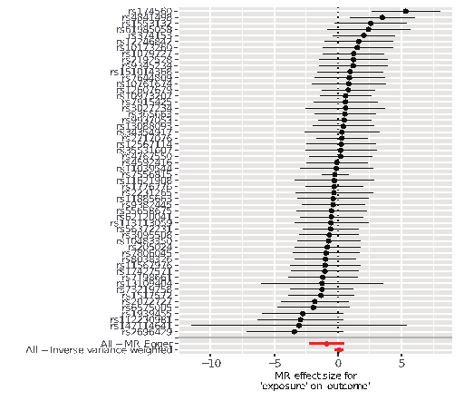
b
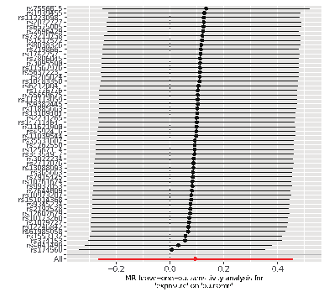
c
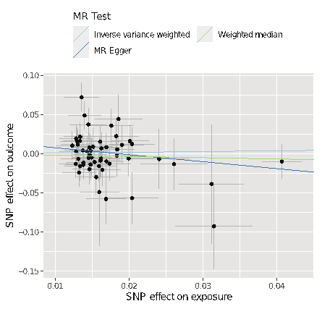
d
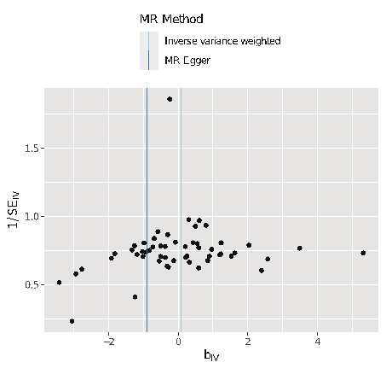
Supplementary Figure S2 Forest plot (a), sensitivity analysis (b), scatter plot (c) and funnel plot (d) of the causal effect of Insomnia on CRC risk。
a
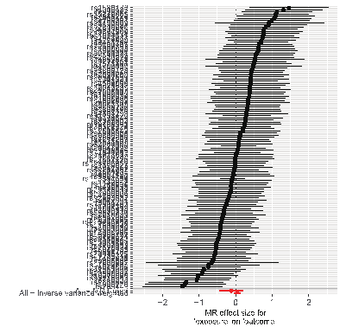
b
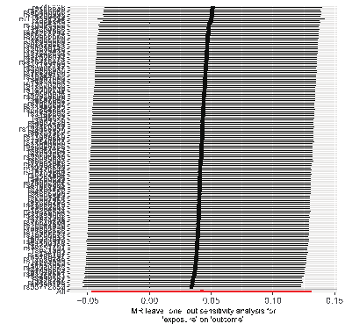

c
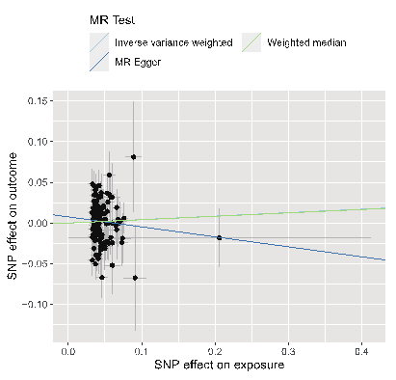
d

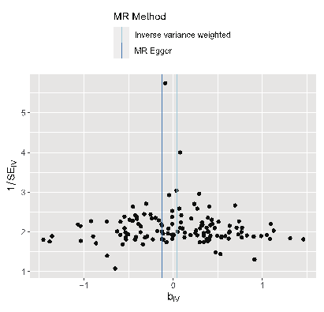
Supplementary Figure S3 Forest plot (a), sensitivity analysis (b), scatter plot (c) and funnel plot (d) of the causal effect of Daytime sleepiness on CRC risk。
a
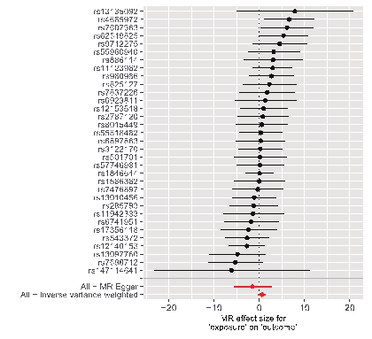
b
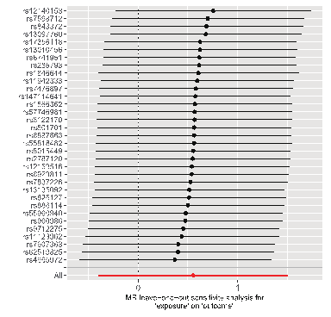

c
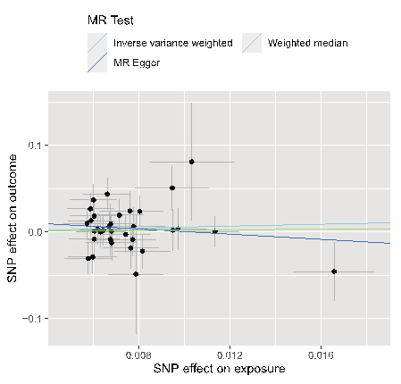
d
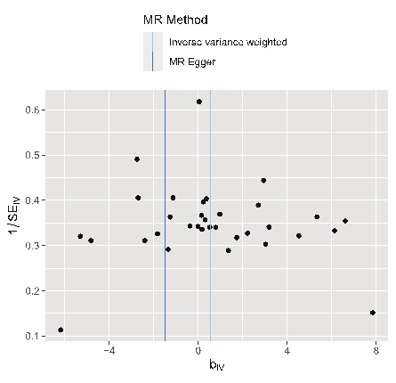
Supplementary Figure S4 Forest plot (a), sensitivity analysis (b), scatter plot (c) and funnel plot (d) of the causal effect of Daytime napping on CRC risk。
a
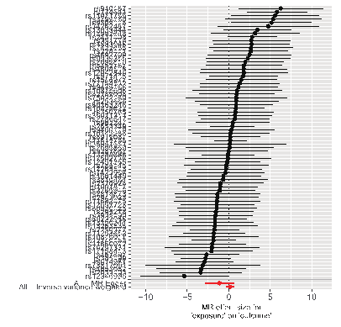
b

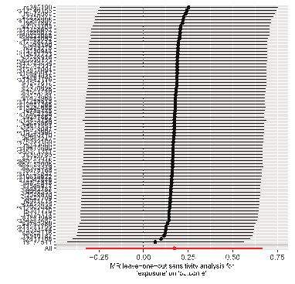

c
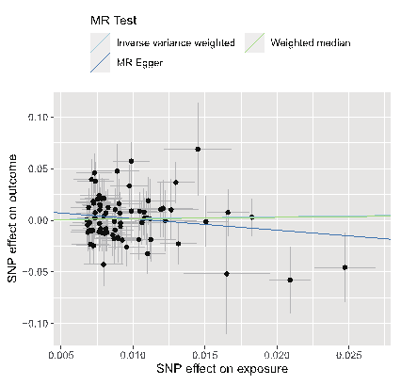
d
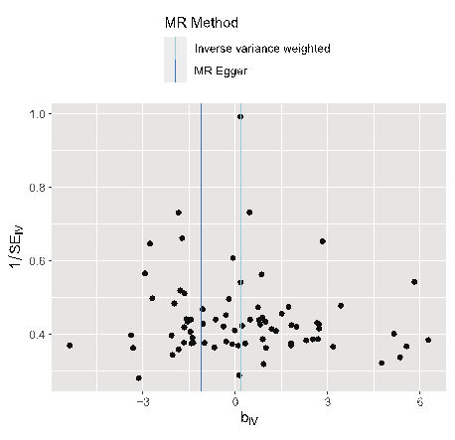
Supplementary Figure S5 Forest plot (a), sensitivity analysis (b), scatter plot (c) and funnel plot (d) of the causal effect of Chronotype on CRC risk after removing SNPs with potential pleiotropy。
a
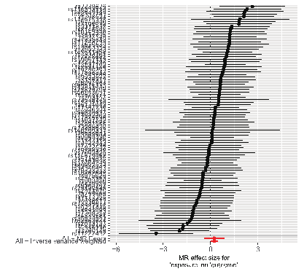
b
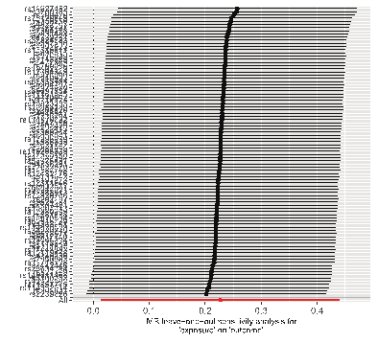

c 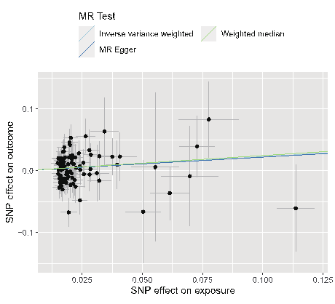
d
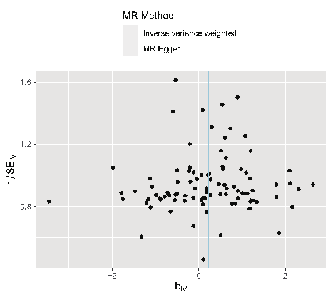
Supplementary Figure S6 Forest plot (a), sensitivity analysis (b), scatter plot (c) and funnel plot (d) of the causal effect of Sleep duration on CRC risk after removing SNPs with potential pleiotropy。
a
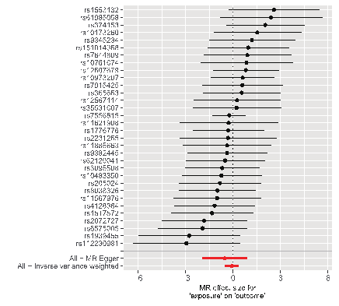
b
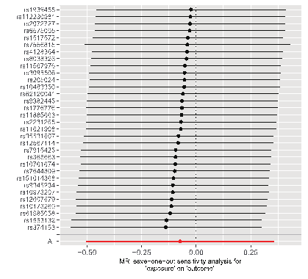

c
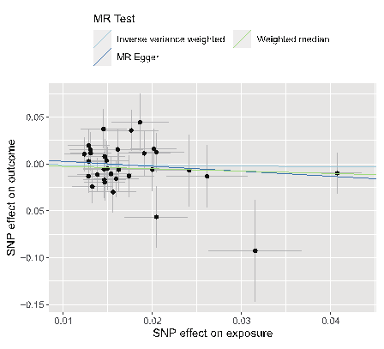
d

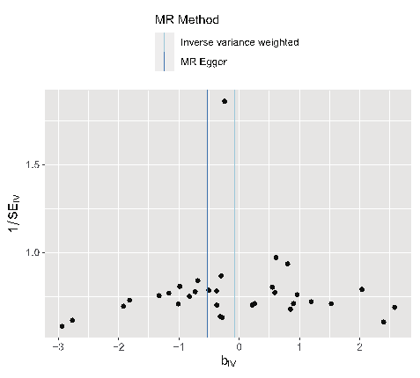
Supplementary Figure S7 Forest plot (a), sensitivity analysis (b), scatter plot (c) and funnel plot (d) of the causal effect of Insomnia on CRC risk after removing SNPs with potential pleiotropy。
a 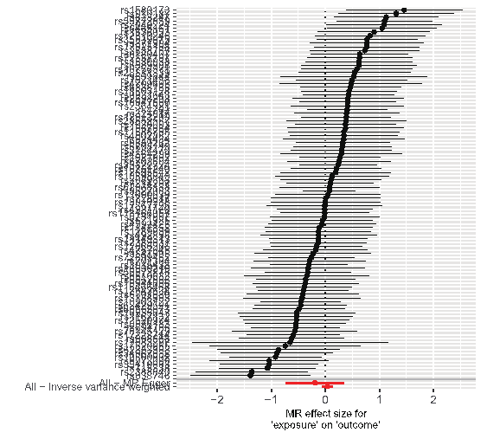

b
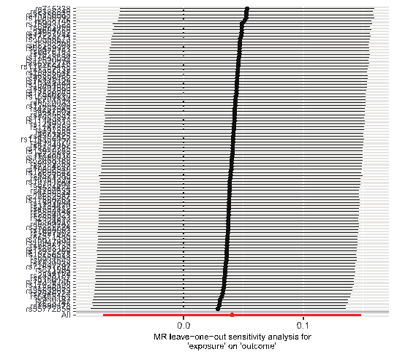

c
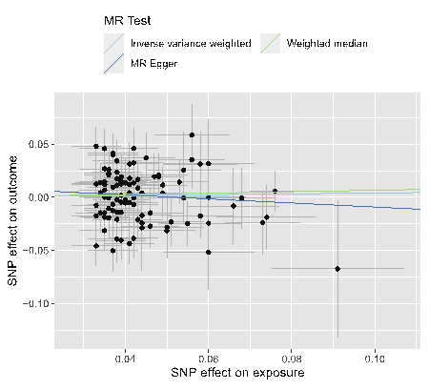
d
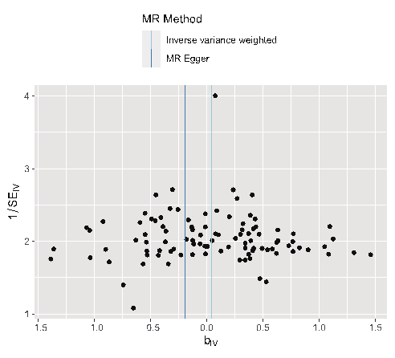
Supplementary Figure S8 Forest plot (a), sensitivity analysis (b), scatter plot (c) and funnel plot (d) of the causal effect of Daytime sleepiness on CRC risk after removing SNPs with potential pleiotropy。
a
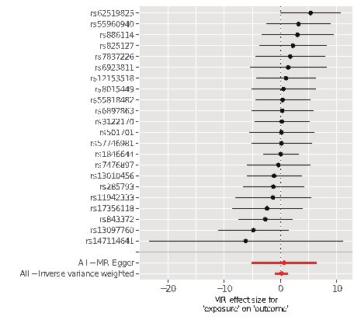
b
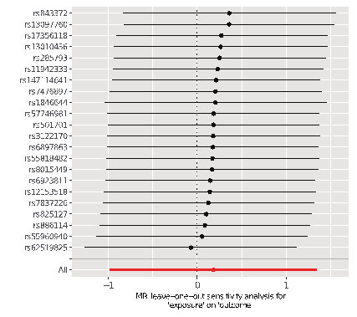
c
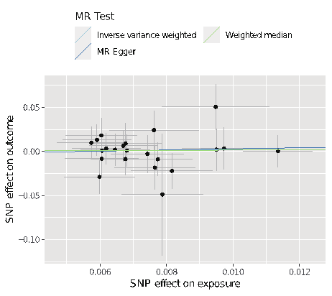
d
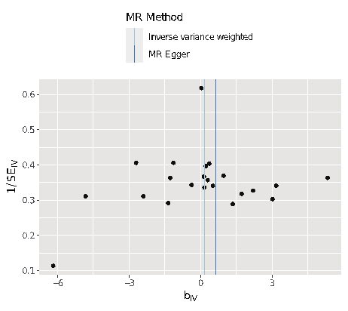

Supplementary Figure S9 Forest plot (a), sensitivity analysis (b), scatter plot (c) and funnel plot (d) of the causal effect of Daytime napping on CRC risk after removing SNPs with potential pleiotropy。
a
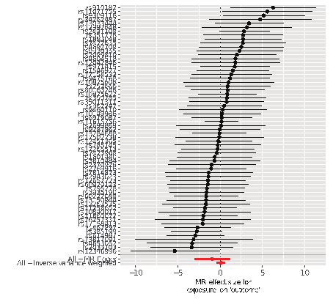

b
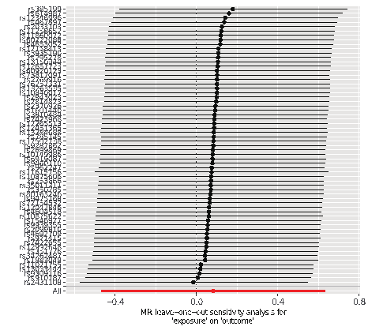
c
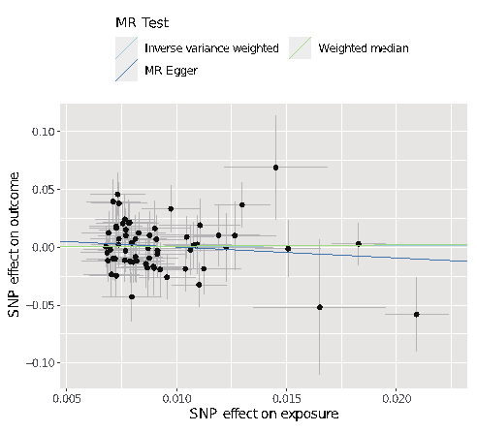
d
