Table 1. Characteristics of Stock cultivars used in the trial
Flower Bud Shape | Petal Color | Percentage of Petals | Flower Color | Cultivar
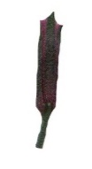 | 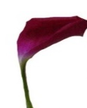 | 80-90 | Red Carmine | Centum Carmine
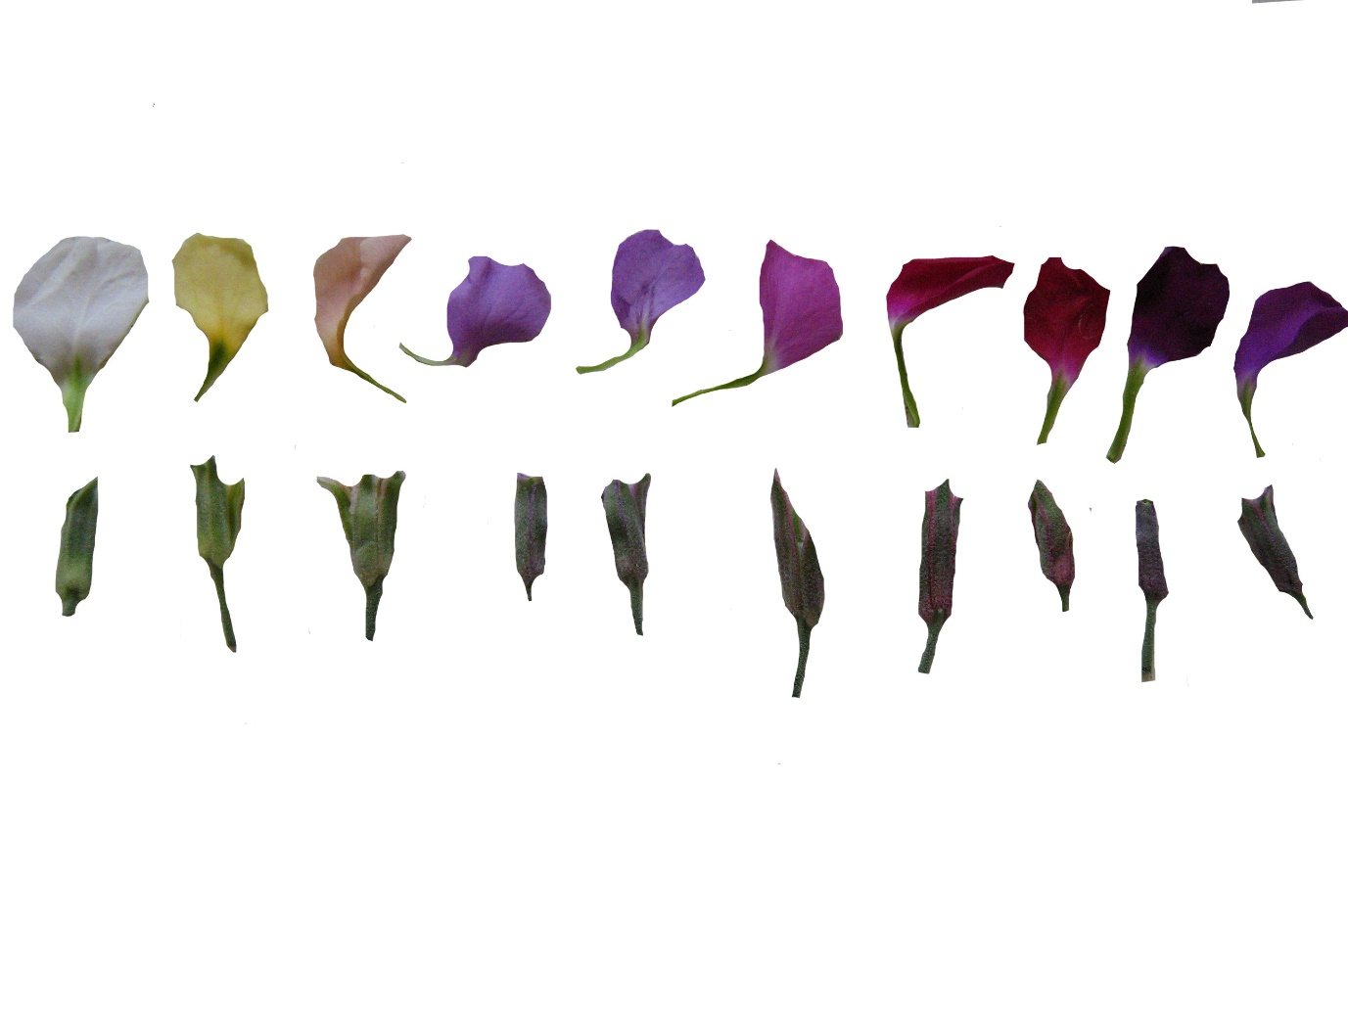 |  | 50 | Red Crimson | Column Crimson
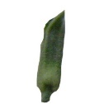 | 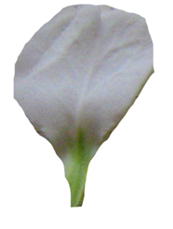 | 50 | White | Column White
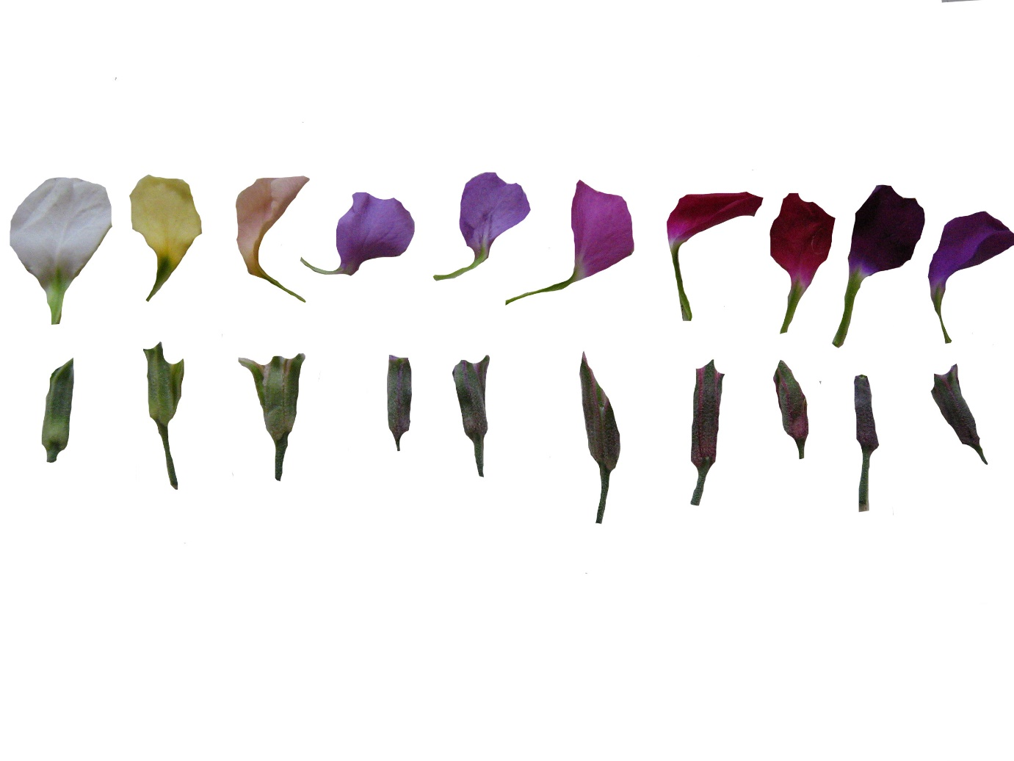 | 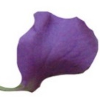 | 50 | Jasmine | Column Lavender
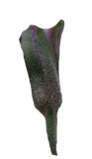 | 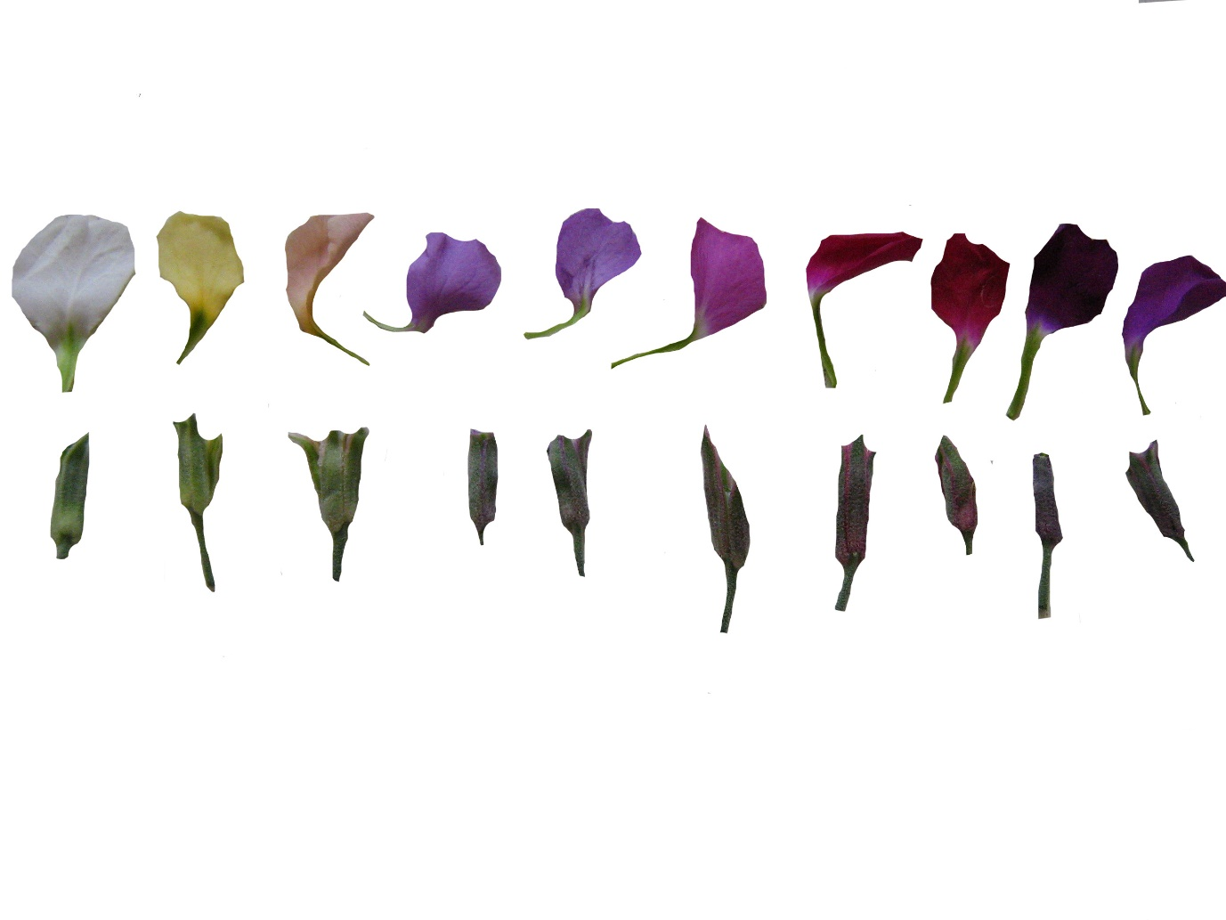 | 50 | Pale purple | Column Lilac- Lavender
 | 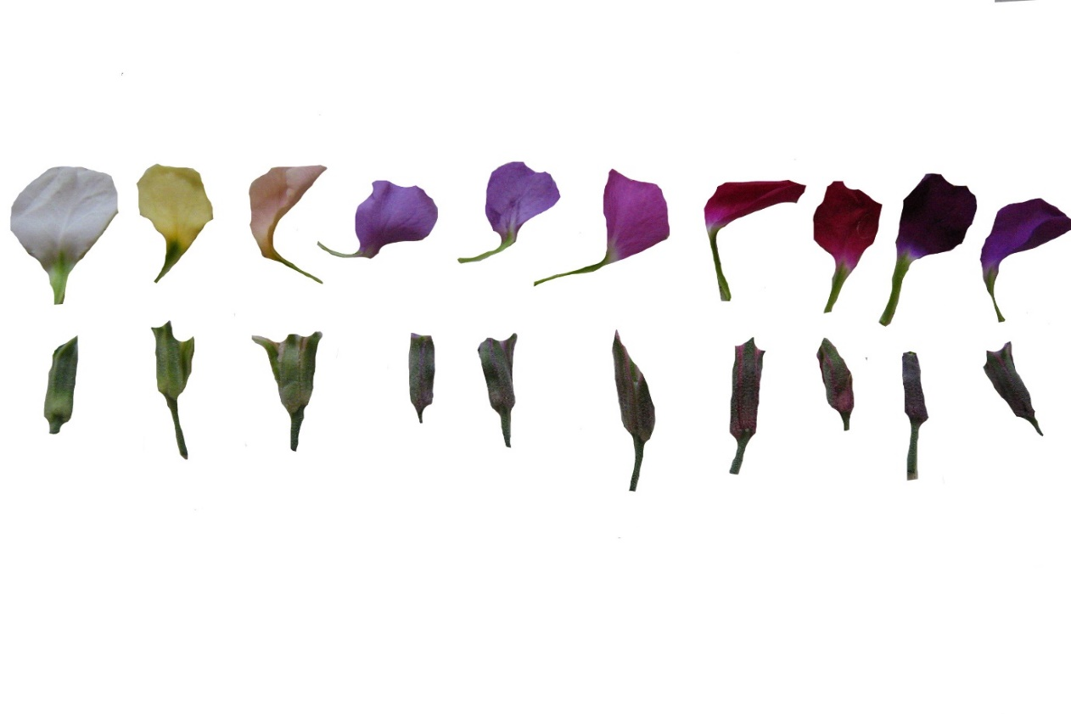 | 50 | Purple | Column Mid-Blue
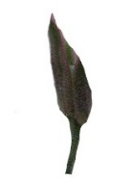 | 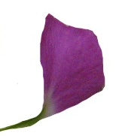 | 50 | Dark pink | Column Rose
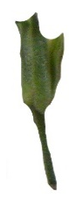 | 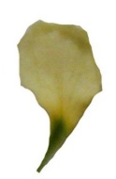 | 50 | Yellow | Column Gold
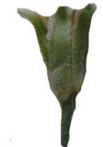 | 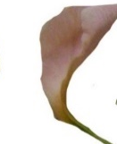 | 50 | Brick red | Column Cooper
 |  | - | Purple | Excelsior Purple- Heart

