Number of amino acids: 4074

Molecular weight: 447576.09

Theoretical pI: 5.95

Amino acid composition:
Ala (A) 227 5.6%
Arg (R) 183 4.5%
Asn (N) 187 4.6%
Asp (D) 167 4.1%
Cys (C) 96 2.4%
Gln (Q) 183 4.5%
Glu (E) 206 5.1%
Gly (G) 312 7.7%
His (H) 102 2.5%
Ile (I) 271 6.7%
Leu (L) 407 10.0%
Lys (K) 129 3.2%
Met (M) 66 1.6%
Phe (F) 173 4.2%
Pro (P) 223 5.5%
Ser (S) 389 9.5%
Thr (T) 253 6.2%
Trp (W) 67 1.6%
Tyr (Y) 104 2.6%
Val (V) 329 8.1%
Pyl (O) 0 0.0%
Sec (U) 0 0.0%

(B) 0 0.0%
(Z) 0 0.0%
(X) 0 0.0%

Total number of negatively charged residues (Asp + Glu): 373
Total number of positively charged residues (Arg + Lys): 312

Atomic composition:

Carbon C 20005
Hydrogen H 31327
Nitrogen N 5393
Oxygen O 5937
Sulfur S 162

Formula: C₂₀₀₀₅H₃₁₃₂₇N₅₃₉₃O₅₉₃₇S₁₆₂
Total number of atoms: 62824

Extinction coefficients:

Extinction coefficients are in units of M⁻¹ cm⁻¹, at 280 nm measured in water.

Ext. coefficient 529460
Abs 0.1% (=1 g/l) 1.183, assuming all pairs of Cys residues form cystines

Ext. coefficient 523460
Abs 0.1% (=1 g/l) 1.170, assuming all Cys residues are reduced

Estimated half-life:

The N-terminal of the sequence considered is M (Met).

The estimated half-life is: 30 hours (mammalian reticulocytes, in vitro).
>20 hours (yeast, in vivo).
>10 hours (Escherichia coli, in vivo).

Instability index:

The instability index (II) is computed to be 45.24
This classifies the protein as unstable.

Aliphatic index: 93.90

Grand average of hydropathicity (GRAVY): -0.003

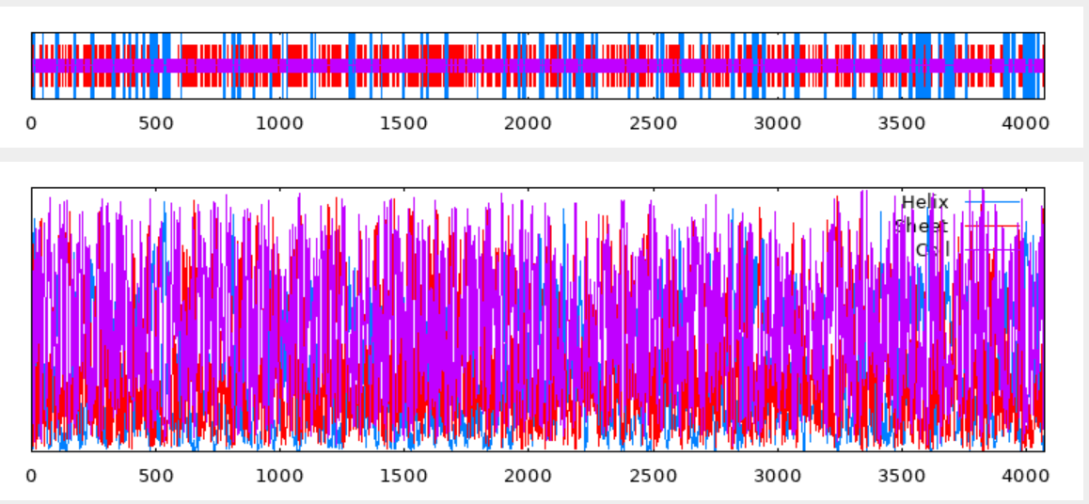
10 20 30 40 50 60 70
| | | | | | |
MIVWLISLMSIEILLLAGPALSFHIEPKEGSLAGGTWITVIFDGLELEQLYPTNGSQLEIHLVNVAVPAL
ccceeeccchhhhhhhcccccccccccccccccccceeeeeeccchhhhhccccccceeeeeeccccccc
PSIPCDVSPVFLDLPVVMCRTRSLLPEVHEGLYYLEAHAGGQVVGSPSPGLQDCCTFKFSREQTPIVYQV
ccccccccceeeccceeeeccccccccccchhhhhhhcccceeeccccccccccceeeccccccceeeee
TPPSGVPGKMIHVYGWIITGRSETFDFDAEYIDSPLILEAQGDKWVTACSLINRQTGSCYPLQENHGLGT
ccccccccceeeeeeeeeeccccccccccccccchhhhhhcccceeeeeceeccccccccccccccccce
LQCRVEGNYIGSQNVSFSVFNKGKSMVHKNAWLVSAKLDLFLYQTYSEILSVFPETGSLGGKTDIIITGD
eeeeecccccccccceeeeecccceeeeehhhhhhhhhhhhhhccccceeeeccccccccccceeeeecc
FFDNPALVTIAGVPCDIRHMSPRKIECTTRAPGKRARLTAPQAGNRGLLFEVGEAVEGLDLTVATPGYRW
cccccceeeecccccccccccccceeccccccccceeeecccccccchhhhhhhhhccccceeeccccce
QIVPNASSPFGFWFKEGQPFRARLSGFFVAPETNNYTFWIQADNQASLYFSQSEDPRMKVKVASIRVGTA
eeecccccccccccccccchhhhhccceecccccceeeeeeecchhhhhhcccccceeeeeeeeeecccc
DWFDAWEQDRNEGVWQRKTPKLELVGGTRYYLEAEHYGRTPSRGMRIGVQIHNTWLNPDVVSTYLREKHQ
chhhhhhhccccccccccccceeecccchhhhhhhcccccccccceeeeeeccccccccchhhhhhhhhh
IRVRAQRLPEIQMLTVSGRGSFFLTWDNVTSQPIPENATAHQIQTAIEELLAVKCKLEPLSANILLWLGF
hhhhhhccchhhhhhhcccceeeeeccccccccccccchhhhhhhhhhhhhhhhhhhcccccchhhhhhc
EQGPEGSSFEGDLTSGTEPFCGRFSLHQPRRLVLTPPAAQKDYWLDRYTHLCIAYKGRMKNILKVTVFFT
cccccccccccccccccccccccccccccceeeeccccccchhhhcceeceeeeeccccceeeeeeeeec
TDFQNFIKKNITCDWNLVGTRPNSWQFTCTDLWETCVHHSMYLQPPLVDSPVLVHRIDLFPLSQETSGFY
ccccceeeeceecceeeeccccccceeeeeeeeeeeeccccccccccccccceeceeccccccccccccc
VDEIIIADTNITVSQADSETAHPGGNLVESLCVVGSPPVYNISFWLVGCGQELPLITASIVPTGGEARRS
eeeeeeccccceeecccccccccccceeeeeeecccccceeeeeeeecccccccceeeeecccccccccc
GLVQVTTQRIQKTSPPLGGYFHIQLPTSVIPDVPVHISASHLRKLLQNNADNFTSRYLNSSDLTVMEDLK
cchhhhhhhccccccccccceeeccccccccccceeechhhhhhhhhcccccceeeeecccchhhhhhhc
SCYEHEWTLSWSSQVGDLPNFIRVSDANLTGVNPAATVRVVYDGGVFLGPVFGDMLVTANQHTQVVVRVN
cceeeeceeeecccccccccceeecccccccccccceeeeeecccceeceeccchhhhccccceeeeeec
DIPAHCSGSCSFQYLEGSTPQIHSAWYSLDGDISLLIYIFGINFSGDPQALEIMVNKTNCKVIFSNQTNV
cccccccccceeecccccccceeeeeecccccceeeeeeecccccccchhhhhhhccccceeeeecccce
ICQTDLLPVGMHRLFMVVRPFGRAINTSGEALFLSVEPRLDAVEPSRAAEIGGLWATIQGSGLEDVSLVL
eeeecccccceeeeeeeeccccccccccchhhhhccccccccccchhhhhhcceeeeeccccccceeeee
FGSQSCAINITTSNSRRIQCRVPPRGKDGPVVNLTVVSGDHSAVLPMAFTYVSSLNPVITSLSRNRSNIA
cccccceeeeeeccccceeeeecccccccceeeeeeecccccceeceeeeeeccccceeeeccccccccc
GGDTLFIRMALLVNYTDLDVEVCIQNTLAPAHVQMPQGLEVVLPPLPAGLYSISVSINGISIRSPGVDLH
ccchhhhhhhhhhccccccchhhhhcccccccccccccceeecccccccceeeeeeeccceecccccccc
IQYITEVFSIEPCCGSLLGGTILSISGIGFIRDPTLVWVFVGNRSCDILNSTETVIWCETPPAALLPDSN
eeeeeeeeeeecccccccccceeeecccceecccceeeeeeccccceeeeecceeeeccccccccccccc
IPAIPVPMEIWAGNVSFARESLLNLSFTFLYEAAMTPVVTAMRGEIINNSLRFYVEGNNLSNSVILLGVS
ccccceeeeeccccchhhhhhhhhhhhhhhhhcccchhhhhhhcccccccceeeeeccccccceeeeeec
HCDLETQTLRNNVSLSGCSFPLHSLEAGFYPLQVRQKQMGFANMSAVPQQYVITPWIMAISPTHGSACGG
cccccccccccceeecccccccccccccccchhhhhhhhhhcccccccceeeeecceeeeeccccccccc
TVLTVRGLALSSRKRSVQVDLLGPFTCVILSLGHQTILCQINKVNDSFPDVSFTLNVTVIVNGLPSECQG
eeeeechhhhhccceeeeeeecccceeeeecccccceeeccccccccccccceecceeeeeccccccccc
NCTLFLQEETTPIVDSLTTNISGSLTMVLIRGRKLGITAVEPMVFVDDHLPCIVTFFNASYVICWISDLT
cceeecccccccccccccccccccchhhhhhcccceecccccceeecccccceeeeecccceeeeeeccc
PGLHYVSVFHARNGYACFGNVSRHFYILPQVFHYFPKNFSIHGGSLLTVEGTALRGKNSTLVYVGQQACL
cccceeeeecccccceeccccccceeechhhhccccccceecccceeeeehhhhcccccceeeeccccce
TVSISTELIQCIVPAGNGSVGLVIEVDGLSYQMGVIGYSSAFTPRLLSISQTDDVLTFAVAQVSGAENVD
eeeecccceeeeeecccccceeeeeecccccceeeeeeccccccceeccccccchhhhhhhhhcccccee
IFIGMSPCVGISGNHTVLQCVVSSLPAGEYPVRGYDRMRGWASSVLVFTSTATISGVTENFGCLGGRLVH
eeeecccceeecccceeeeeeeecccccccceeeeeeccccceeeeeeccccceeeeecccccccceeee
VFGAGFSPGNVSAAVCGAPCQVLANATVSAFSCLVLPLNVSLAFLCGLKHSEESCEASSSTYVQCDLTVT
eeccccccccceeeeccccceeeccccccccceeecccccchhhhcccccccccccccccceeeeeeeee
VGTETLPQSWPYLYICEESPQCLFAPDHWTESTFPWFSGLFISPKVERDEVLIYNSSCNIAMETEAKMEC
ccccccccccceeeeeccccceeeeccccceeccccccccccccccccceeeeeccccceeeeecccccc
ETPNQPITAKITEIRKSRGQSTQGNFSLQFCLRWSRTHSWFPERVPQDGDNVTVENGQLLLLDTNTSILN
cccccccchhhhhhhhccccccccceeeeeeeeeecccccccccccccccceeeecceeeeecccchhhh
LLHIKGGKLIFMDPGPIELRAHAILISDGGELRIGSEDKPFQGKAEIKLYGSSHSTPFFPYGVKFLAVRN
hhhccccceeecccccchhhhhhhhhccccceeeccccccccceeeeeeeccccccccccccceeeeecc
GTLSLHGLLPEVTFTHLQAAAYAGDTVLALEDAVDWHPGDEAVIISRIGVGGAKPMEEIVIVEAVHNTDL
cccccccccccchhhhhhhhhhhchhhhhhhhhhccccccceeeeeeecccccccceeeeeeeeecccce
YLRSPLRYSHNFTENWVAGVLHILKVTVVLLSRSITIQGNLTAERMKHLASCQEASDSEGNLQDCLYSKS
eecccceeeecccchhhhhceeeceeeeeeecccccccchhhhhhhhhhhhccccccccccchhhhhccc
EKMLGSRDLGARVIVQSFPEEPSRVQLRGVQFRDLGQAFRKHVSALTLVGAMRDSYVQGCTVWSSFNRGL
ccccccccccceeeeeccccccchhhhhchhhhhhchhhhhhhhhhhhhhhccccccccceeeeeecccc
SMSMTLGLKVDSNIFYNILGHALLVGTDMDIKYISWEAAPEKKPDWSEQGNIIRNNVIISISGTEGLSSP
eeeeeeccccccchhhhhhcceeeeccccchhhhhhcccccccccccccccccccceeeeeccccccccc
EMLTPSGIYILNPTNVVEGNRVYVAGLGYFFHLVTSQTSQAPLLSFTQNIAHSCTRYGLFIYPQFQPPWD
ccccccceeeeccccccccceeeeecccceeceeccccccccccceeccccccccccceeeecccccccc
DGRGPTLFQNFTVWGSAGGARISRSSNLHLKNFQVYSCRDFGIDILESDANTSVTDSLLLGHFAHKGSLC
cccccceeeeeeeccccccceeehhhhhcccceeeeeccccceeeeeccccccchhhhhhhcccccccee
MSAGIKTPKRWELIISNTTFVNFDLTDCVSIRTCSGCSRGQGGFTVKTNQLKFINSPNLVAFPFPHAAIL
eeccccccceeeeeecccceeecccccceeeeecccccccccceeecccccccccccccccccccchhhh
EDLDGSLSGRNRSHILASMETLSASCLVNLSFSQIVPGSVCGEDVIFHHMSIGLANAPNVSYDLTITDSR
hhhccccccccchhhhhhhhhhcccccccccccceecccccccceeeeceeeceeccccceeeeeeeccc
NKTTTVNYVRDTLSNLYGWMALLLDQETYSLQFETPWISRSLQYSATFGSFAPGNYLLLVHTVLWPYPDI
ccceeeeeeeeeecchhhhhhhhhchhhhhhcccccccccccccccccccccccceeeeeceecccccce
LVRCGSQEGRSLPSLPLPGQDQGCDWFFNTQLRQLIYLVSGEGQVQVTLQVKEGVPPTISASTSAPESAL
eeecccccccccccccccccccccccccccchhhheeecccccceeeeeecccccccceecccccchhhh
KWSLPEAWTGIEEGWGGHNHTIPGPGDDILILPNRTVLVDTNLPFLKGLYVMGTLEFPVDRSNVLSVACM
hhccccccceeeeccccccceccccccceeeeccceeecccccccccceeeeccccccccccceeeeeee
VIAGGELKVGTLDNPLEKEQKLLILLRASEGIFCDRLNGIHIDPGTIGVYGKVQLHGACPKKSWTRLAAD
eeccccccccccccchhhhhhhhhhhhhccccccccccccccccceeeeeeeeeeeeccccccchhhhhh
IASGNERIIVEDAVDWRPHDKIVLSSSSYEPHEAEILTVKEVQAHHVKIYERLKYRHIGSVHVMEDGRCI
hhcccceeeeecccccccccceeeecccccchhhhhhhhhhhhhhhhhhhhhhcceeeeeeeeecccchh
RLAAEVGLLTRNIQIQPDISCRARLLVGSFRNSSSKEFSGVLQLSNVEIQNFGSPLYSSIEFTNASAGSW
hhhhhhhhhhccccccccccceeeeeecccccccccccceeeeeccccccccccccccccceecccccce
IISSSLHQSCSGGIRAAASHGIILNDNIVFGTVGHGIDLEGQNFSLSNNLVVLMTQSAWSTVWVAGIKAN
eeeeccccccccchhhhhhhceeeccceeeeeecccccccccccccccceeeeeeecccchhhhhhhhhc
QAKDINLYGNVVAGSERIGFHIQGHRCSSPEARWSDNVAHSSLHGLHLYKENGLDNCTGISGFLAFKNFD
cchhhhcccceecccccceeeeeeceeecccccccccccccccccceeeecccccccccccceecccccc
YGAMLHVENSVEIENITLVDNSIGLLATVYVSSVPKSHIENVQIVLRNSVIIATSSSFDCIQDRVKPRSA
ccceeeeccccccceeeecccccceeeeeeeccccccchhhhhhhhcccceeeccccccccccccccccc
NLTSSDRAPSNPRGGRVGILWPIFTSEPNWWPQEPWHRVRNGHSTSGILKLQDVTFSNFVKSCYSDDLDI
cccccccccccccccceeeeeeeeeecccccccccceeeeccccccceeecccceecceecceecccccc
CILPNVENTGIMHPIMAEGTRMLKIKDKNKFYFPPLQARKGLGILVCPESDCENPRKYLFKDLDGRALGL
ceeecccccceeechhhhhhhhhhhhcccccccccccccccceeeecccccccccceeeccccccccccc
PPPVSVFPKTEAEWTGSFFNTGTFREEQKCTYRALIQGYICKQSDQAILILDNADATWAMQKLYPVVSVT
cccccccccccccccceeeccceecchhhheeeeeecceecccccchhhhhhchhhhhhhhcccceeeec
RGFVDTFSSVNADAPCSTSGSASTFYSILPTREITKICFVDQTPQVLRFFLLGNRSTSKLLLAVFYHELQ
ccccccceeecccccccccccccceeeeccccceeeeeeccccccceeeeeccccccchhhhhhhhhccc
NPRVFIGESFIPPIMVQSTSSLLDESIGSNYFSILDNLLYVVLQGQEPIEIHSGVSIHLALTVMFSVLEK
ccceeeccccccceeeeccccccccccccchhhhhhhhhhhhhcccccceecccchhhhhhhhhhhhhhc
GWEIIILERLTDFLQVSQDQIRFIHEMPGNEATLKAIADNKAKRKRNCPTVTCASPYRVGQRRPLMTEMS
chhhhhhhhhhhhhhhchhhheeeeccccchhhhhhhhhhhhhhcccccceeeccccccccccccccccc
SYRVPSPTIMETASKVIVIEIGDLPTIRSTRLISYLTSNKLQNLAHQIITAQQTGVLENVLNMTIGALLV
cccccccchhhhhcceeeeeeccccccccchhhhhhhhhhhhhhhhhhhhhhhhhhhhhhhhhhhhhhhh
TQPKGVTDYGNASSFKTGNFIYIRPYALSVLVQPSDGEVGKELTVQPRLVFLDKQNQRIESLGPPSEPWA
hccccceeccccccccccceeeeccccceeeeccccccccccccccchhhhhhhcccceeecccccccce
ISVSLEGTSDPVLKGCTQAESQDGYVSFSNLAVLISGSNWHFIFTVTSPPGANFTARSRSFTVLPAAPSE
eeeeccccccceecccccccccccceeecceeeeeccccceeeeeeccccccccccccccceeecccccc
KSSIILAVSLCSVASWLALCCLVCCWFRKSKSRKIKSEDISEFKTNDQKSHIHMSSKHPRSQETKKEDTM
ccceeeeeeeeeecceeeeececccccccccccccccccccccccccceeceeeeccccccchhhhhhhh
MGEDMKIKVIMDKVNQLPHQSLNGVSRRKVSRRAVREEGSSREEDVVPAPRIISITSQGHTCVPGSPDQQ
hhhhhhhhhhhhhccccccccccccchhhhhhhhhhhcccccccccccccceeeeecccceeecccccch
IYLQEAGNWKEAQEQLVSYQLAGQDQRLLLCPDLRRERQQLQGQSQLGQEGGSVGLSQEKKASGGATQAS
hhhhhhcchhhhhhhhhhhhhhccchhhhhccccchhhhhhhhhhhccccccccchhhhhhhcccccccc
CPHLVHPETIQEQL
Ccccccccccceec
GOR4 :
Alpha helix (Hh) : 721 is 17.70%
3₁₀ helix (Gg) : 0 is 0.00%
Pi helix (Ii) : 0 is 0.00%
Beta bridge (Bb) : 0 is 0.00%
Extended strand (Ee) : 1049 is 25.75%
Beta turn (Tt) : 0 is 0.00%
Bend region (Ss) : 0 is 0.00%
Random coil (Cc) : 2304 is 56.55%
Ambiguous states (?) : 0 is 0.00%
Other states : 0 is 0.00%

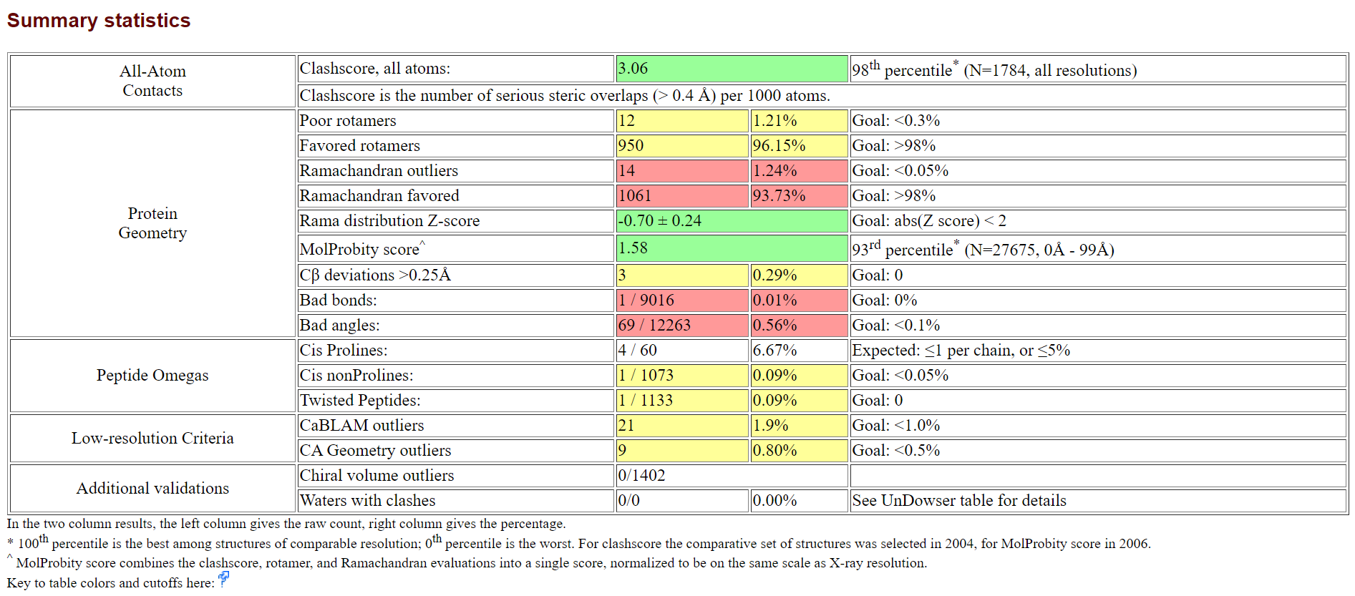
Dog

