Number of amino acids: 4059

Molecular weight: 444882.10

Theoretical pI: 5.90

Amino acid composition:
Ala (A) 238 5.9%
Arg (R) 180 4.4%
Asn (N) 172 4.2%
Asp (D) 169 4.2%
Cys (C) 96 2.4%
Gln (Q) 171 4.2%
Glu (E) 210 5.2%
Gly (G) 309 7.6%
His (H) 105 2.6%
Ile (I) 210 5.2%
Leu (L) 423 10.4%
Lys (K) 132 3.3%
Met (M) 63 1.6%
Phe (F) 180 4.4%
Pro (P) 218 5.4%
Ser (S) 389 9.6%
Thr (T) 278 6.8%
Trp (W) 65 1.6%
Tyr (Y) 102 2.5%
Val (V) 349 8.6%
Pyl (O) 0 0.0%
Sec (U) 0 0.0%

(B) 0 0.0%
(Z) 0 0.0%
(X) 0 0.0%

Total number of negatively charged residues (Asp + Glu): 379
Total number of positively charged residues (Arg + Lys): 312

Atomic composition:

Carbon C 19871
Hydrogen H 31069
Nitrogen N 5349
Oxygen O 5930
Sulfur S 159

Formula: C₁₉₈₇₁H₃₁₀₆₉N₅₃₄₉O₅₉₃₀S₁₅₉
Total number of atoms: 62378

Extinction coefficients:

Extinction coefficients are in units of M⁻¹ cm⁻¹, at 280 nm measured in water.

Ext. coefficient 515480
Abs 0.1% (=1 g/l) 1.159, assuming all pairs of Cys residues form cystines

Ext. coefficient 509480
Abs 0.1% (=1 g/l) 1.145, assuming all Cys residues are reduced

Estimated half-life:

The N-terminal of the sequence considered is M (Met).

The estimated half-life is: 30 hours (mammalian reticulocytes, in vitro).
>20 hours (yeast, in vivo).
>10 hours (Escherichia coli, in vivo).

Instability index:

The instability index (II) is computed to be 41.35
This classifies the protein as unstable.

Aliphatic index: 91.62

Grand average of hydropathicity (GRAVY): -0.012

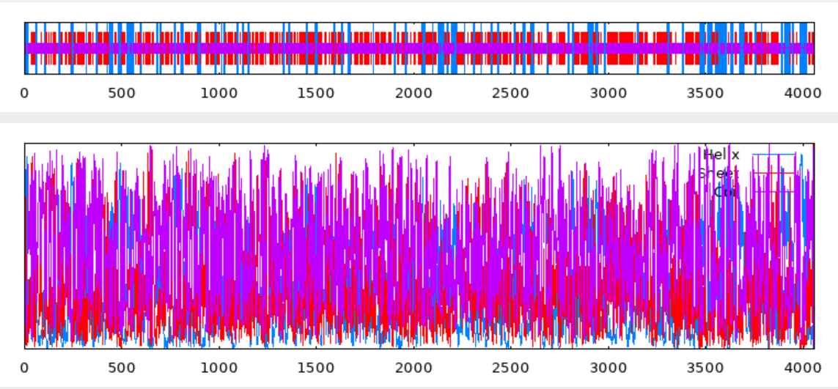

10 20 30 40 50 60 70
| | | | | | |
MMLAWLVSLLSMEVLLLAKPYSSFQFEPAEGSLAGGTWITVVFDGLDRSILYPNNGSQLQIDLVSVAIPT
ccccchhhhhhhhhhhhcccccccccccccccccccceeeeeecccccceeccccccchhhhhhhccccc
LRIPCDVSPAFVDLPVVTCQTRSLPSEADAGPYSLEMRSGEQVLGTPCPGSLDSCTFKFSKDQTPVLYQV
ccccccccccccccceeecccccccccccccchhhhhcccceeecccccccccccceeecccccceeeee
YPASGVPGEVVSVYGRVITTWLETFDPDVDYIESPLILEAREDKWLTPCSLINRQTGSCFPIQEEHGLGN
cccccccceeeeeeceeeeeeeeccccccccccchhhhhhhhcccccccceecccccccccccccccccc
VQCRVEGDYIGSQNVSFSVFNKGRSMVHKEAWLISAKQELFLYQTYPEILSVFPKVGSLGGRTDIIITGD
eeeeeccccccccccceeeecccceeehhhhhhhhhhhhhhhhccccceeeeccccccccccceeeeecc
FFDPSARVTIAGIPCDIRYVSPRKIECTTRAPGNEARLTAPQAGNRGLRFEVGDATKDVELTEATPGYRW
cccccceeeeecccccceeecccceeccccccccchhhhccccccccceeeeccccceeeeeecccccce
QIVPNASSPSGFWSKEGRPFRARLSGFFVAPQTNNYTFWIQADSQASLCFSSSEEPRTKVEVASVGVGTA
eeeccccccccccccccccchhhhccceecccccceeeeeecccccceeecccccccceeeeeeeeccee
DWFDSWEQIGNEGSWHQKTTKLELQGGAKYYLEAEQHGIAPSRGMRIGVQIHNTWLNPDVVNTYLLEKHQ
ccchhheeecccccccchhhhhhhhcchhhhhhhhhccccccccceeeeeeccccccccccchhhhhhhh
IRARAQRLPEIQVLHVSGKGNFFLTWGNVSSQPVPANATAQQIQTTIEELLVVKCNLAPFSAHVLLRLGF
hhhhhhhcceeeeeeeccccceeeeecccccccccccchhhhhhhhhhhhhhhcccccccchhhhhhhhh
EQGLEGSRSDGVRTSSTEPFCGRFSLGQLGHLILIPEAADKGYQLDRYPYLCLAYRGHMNKTLDMTVSFL
hccccccccccceecccccccceeccccccceeechhhhcccccccccceeeeeeccccccccceeeeee
FGFQTIMKNITCDWSLTDPHPESWQFTCINLWDTCLCHSEDIQSSLANTPLLAHRIDIRPVVPEAGLLYV
cccceeeeeeeeeeeeeccccccceeeeeeecceeeccccccccccccchhhhhhhccccccccccchhh
DEIILADTNVTVSQADSGRACPGGNVVESVSVVGVPPVYSISSWLAGCGSELPLITACSVSTEGTGDGSE
hheeeccccceeeeccccccccccceeeeeeeeccccceeeeeeecccccccceeeeeeeccccccccch
LIEVTAQRLQRTSPPLGGHFFLYLSDTVIPDVPVRMSARQLHKLLQDSADESTSGYLNAGDFTVTEDLNS
hhhhhhhhhcccccccccceeeecccccccccchhhhhhhhhhhhhhcccccccceecccceeeeecccc
CYEHVWTLSWTTQTGDLPNFIRVSDQNLTGVNPTVTARVVYDGGVFLGPIFGDMLATANQQTQVAVQVND
ceeeeeeeecccccccccceeeecccccccccccceeeeeeccceeecccchhhhhhhhhhhhheeeecc
IPAYCSGSCSFQYQQESTPSVDHVWYSLGSDVNLLVHFTGTGFPRDTQFLQVTVNKTSCEVLFSNETNVA
cccccccccccccccccccccceeeeeccccceeeeeeccccccccceeeeeeecccceeeeecccchhh
CELALLPVGVHQIFMLVIPSGLAVHASGEDLLLHVEPRLDAVEPSTAAEIGGRWVTLRGSSLEGVSLVLF
hhhhccccccceeeeeeeccceeeeccccchhhhhccccccccccchhhhcceeeeecccccccceeeee
GTQSCVIDAIRSNSQQIQCKVPPRGKDGYTVNVTVISGDHSTVLARAFTYVSSLNPVIVSLSRNRSSIAG
ccccceeeccccccceeeceecccccccceeeeeeeccccchhhhhhhhhcccccceeeeeccccccccc
GEILFLGMSLLVNYTDLDVQIHVQDTSAQVLSQTAWGLEVVLPPLVPGIHVISAFINGVSIRSQGVDLYI
chhhhhceeeeeccccccceeeeccchhhhhhhhccceeeecccccccceeeeeeccccccccccceeee
QYLTEVFSVEPCSGSLLGGTLLSLLGTGLGRDPALIRVLVDNHPCDIVNLTEVNIWCETPPAVLPPRADV
eeeeeeeeeccccccccccceeeeecccccccceeeeeeecccccceeeeecccccccccccccccccce
LTVLASVEIWAGNTSFFHGPSLVGKGFTFTYEAAATPVVTAMWGEFRNNSVRFYVEGSNISDSVILLGSL
eeeeeeeeeeccccceecccccccccceeeeecccceeeeeeeccccccceeeeeecccccceeeeeccc
KCELEVQFFGDSMNLSGCFFPLHSLEAGVYTLQVRHKRMGFANMSVVPQKFELSPQIIAIFPTHGSKCGG
cchhhhhhcccccccccceeeecccccchhhhhhhceecccccceeccccccccceeeeeeccccccccc
TVLTVKGMAFSSRKRSVHVDISGPFACMILSLEDHTVLCQTRFVGDQFSEASLALNITVLVNGLTSKCKG
eeeeecccccccccceeeeeecccceeeeeeecccceeccceecccchhhhhhhhhheeeecceeecccc
NCTLFIEEAATPIVDALTISISGSLTMVLMRGRRLATTADEPIAFVDDQLPCHTTFFNTSHVACQIRDLA
ccceeecccccceeeeeeeeeccchhhhhhhhhhhhcccccceeeecccccceeeeeccccccccccccc
PGFHYLSAVHTSAGYACLNSVSRNFFIVPQVLDYFPKDFSIHGGSLLTIKGTALRGWKATVVYVGRQACL
cccceeeeecccccccccccccccceecccccccccccceecccceeeehhhhhhccceeeeeeccccce
TVNFSSDFIQCIVPAGNGSAALEIDVNGVLYHIGLVDYSSIFTPELLSVSRSQDILTFTVARISGAANVD
eecccccceeeeeccccccchhhhccccceeeeccccccccccccccccccccchhhhhhhhhcccccce
IFIGTSPCLGVAGNRTVLQCMVPLLPAGEYLVTGYDHSRGWASSTLILVLRATVTSVTKNYGCLGGRLLH
eeecccccccccccceeeeeeeccccccceeeeeecccccccceeeeeeeeccceeeeccccccccceee
VLGAGFSPGNISAAVCGAPCQVLANATVSAFSCLVLPLHVSLAFLCDLRHAEDSCKVRSSTYLRCDLTVS
eeccccccccceeeeccccceeecccccccccceecccccchhhhhccccccccceeeccceeeeeeeee
MGTERLPGSWPYVYLCEESSLCLFEPDHWTESVFPSFSGLFLSPKVERDEVLIYNSSCNITMETEAEMEC
ccccccccccceeeeccccceeeecccccceeecccccccccccccccceeeeeccccceeeeecccccc
EMPNQPITAKITEIQKSWGQNTQGNFSFQFCRRWSRPHSWFPQRVPHDGDSVTVETGHLLLLDANTSFLN
cccccccchhhhhhhhhcccccccceeeeeeeeeccccccccccccccccceeeeeeeeeeecccchhhh
SLHIKGGKLIFMDPGPIELRAHSILITDGGELHIGSEEKPFQGKARIKIYGSVHSTPFFPYGVKFLAVRN
hhhcccceeeeccccccccccceeeeeccccccccccccccccceeeeeeccccccccccccceeeeecc
GTLSLHGSVPEVTVTYLQAAAHAGDKVLTLGEAVDWKPGDEAVITSGMTVAGAEATEVVVVETVHNADLH
ceeeccccccceeehhhhhhhhhchhhhhhcceeccccccceeeeccceecccccceeeeeeeccchhhh
LRNPLRYSYDFRENWVAGENPILKPTVALLSRNIIIQGNFTLERVKLLNSCQEANTAKGNLKHCLYSKSE
ccccceeeeceeecccccccccccchhhhhhhhhhhcccchhhhhhhhhhhhhhcccccccceeeecccc
KMLGARDLGARVIIQSFPEEPSFVKLKGVQFRDLGQAFHKHLSSLALVGAMRGSYIQSCSVWNSFSRGLS
hhhhhhhcceeeeeeccccccchhhhcchhhhhhchhhhhhhhhhhhhhhhccceecccceeeeeeceee
MHRTWGLKVDSNVFYKIVGHALLLGSYLDGRFSTSETVTGRKNGWWEQGSTIRNNVIISVSAAEGLSGSE
eceecceecccceeeeeechhhhhcccccccccccceeeeccccccccccccccceeeeecccccccchh
MLAPAGIYTFSPTNVMEGNRVCAAGYGYVFHLVTSQTLQAPLLSFNWNTAHSCTRYGLLVYPKFQPPWNN
hhcccceeeeccceeccccceeeeccceeeeeecchhhhcceeeecccccccccccceeeeccccccccc
DTGFTLFQNFMVWGSAGGAQIFRSNNLHLKNFQVYACRDFGIDILESDANTLITDSFLLGHFTHKGSLCM
ccceeeeeceeeeeccccchhhhhccccccceeeeecccccceeeecccchhhhhhhhhcceeccceeee
SAGIKTPQRWELTISNTTFVNFDGNCVAIRTCSGCFQGQGGYTVKTRQLKFVNSSNLVAFPFPHAAVLED
eccccccceeeeeeccceeeccccceeeeeeccccccccccceeeeeeeeeccccccccccccchhhhhh
LDGSLSGKNGSHVLASMETLSDTCLTNASFSQIVPGSVCGEAVLFHRMSIALANSLDVPKNLTITDISNK
hccccccccceeeeeeeeecccccccccccceeeccccccchhhhhhhhhhhhhcccccccceeeecccc
TITVNYVEDTLSNYYGWMALLLDQETYSLQFESPWMNRSLQYSATFDSFAPGNYLLIMHRDLPPYPDILL
eeeeeeecceecchhhhhhhhhchhhheeeecccccccccccccccccccccceeeeeccccccccceee
RCGSQVGHSLPFHPLPSQDRACDWFFNRQLRQLTYLVSGEGQVKVFLQLKPGVPPSVSASTSVPESASRW
ecccccccccccccccccccccchhhhhhhhhheeeecccceeeeeeecccccccccccccccccccccc
SLPETWQDVEKGWGGYNHTIPGPGDDVLILPNKTVLVDTDLPVLRCLYVMGTLEFPVDRSNVLSVACLLI
ccccceeceecccccccceecccccceeeecccceeeccccceeeeeeeccccccccccccchhhhhhhh
AGGELKVGTLENPLEKDQRLLIFLRASEEVVCDYFEGIHVDPGTIGVYGKLRLHSAYPKKSWVHLGADIA
ccccccccccccchhhhhhhhhhhhcccceecccccceeccccccceecceeecccccccceeeeccccc
PGNERIIVHNAVDWQPHDTIVLSSSSYEAHEAEVLTVKEVKGHHIRIYERLKHRHIGSTHTMEDGQQVHL
cccceeeeeeeecccccceeeeeccchhhhhhhhhhhhhccccchhhhhhhhceeeeeeceeechhhhhh
AAEVGLLTRNIRIQPDSSCRGRLLVGSFRKSSGEDFSGVLQLLNVEIQNMGLPLYSSIEFTGVSAGSWVI
hhhhhhhhcceeecccccccceeeeeccccccccccchhhhhhhhhhhcccccceeccceeeecccceee
SSTVHQSCSVGIHASSSHGVILTDNVVFGTNGHGIDVEGQNYSLTNNLVILTMQSANSSPWVAGIKVNYA
eeccccccceeeecccccceeeecceeeeccccceeeeccccccccceeeeeeccccccceeeeeecccc
EDIILHGNVVAGSERLGFHVGGHGCSSEVLWSDNVVHSSLHGLHLYKKHESNNCTGVSGFMAFKNFDYGA
cceeeeccccccccceeeeecccccceeeeeccceeccccccceeeeeccccccccccceeccccccccc
MVQTENSVDIQNITLVDNTVGLLAITYVSSALLSSVSTVQITLRNSVIVATSSSFDCIHDRKAPQSANWT
hhhhhcccccceeeecccccceeeeeeccccccccccceeeecccceeeecccccccccccccccccccc
STDRAPSNPRGGRIGILWPVSASEPNAWPQEPWHKVRSRHSVPGIMKLQDVTFSSFVKSCYSNDLDVCIL
cccccccccccceeeeeeceecccccccccccceeeeecccccceeeeccceeeceeceeeccccceeee
PNEYSTGVMYPITAERTRMLGIKDKNKFYFPVLQSSKDLVGTICPTLVCEYPRKYLFTDLDGRTLGLPPP
ccccccceeechhhhhhhhhhhcccccceeeeecccccccccccccccccccccceeecccccccccccc
VSVFPRTEEEWTGSFLNTGIFREEQKCTFRAMNQGFFCKQTEHAVLILDNVDATWTIPKSHPLVSVTNGF
ccccccccccccccccccchhhhhhhhhhhccccccecccccceeeeecccccceeecccccceeecccc
VDTFSIVKDSDLCPPTSSLSTFYSILPTRQMTKVCFPEQTPPFLRFLLLGNQRASKLILAVFYNEIQSPH
cceeeeeeccccccccccccceeeeeccccceeeccccccccchhhhhhhchhhhhhhhhhhcccccccc
VFLDKSFIPPTPLESAFSLLAEPSGANYFDIMNNLLYVVLQGEEPVEIHSSVSIHLALTVTFSVLEKGWE
eeccccccccccchhhhhhhhcccccchhhhhhceeeeeccccccceeccchhhheeecceeehhhhhhh
RAMLESLSDFFQIDPNQIRLTLEMPGNKETLEAIANSERKRKRNCPSVTCGGPSIRYGQRRPLMAEMTSL
hhhhhhhhhhcccccchhhhhhcccccchhhhhhhhhhhhccccccceeccccccccccchhhhhhhhhc
KITPATTLETFSKVIVIEVGDLPNIRNSEPIQSLPSNRLQRLVNQVITAQQTGALENVLGMTVGALLVTQ
ccccccccccccceeeeeecccccccccccccccccchhhhhhhhhhhhhhhhhhhhhhccccceeeeec
SKGVTGYRNASSLITGNLIYTRPSELSILVQPSDGEVGIELPVQPRLVFLDEKNERVESLGLPSEPWIIS
cccccceeccccccccceeeccccceeeeeccccccccccccccchhhhhhcccceeeeccccccceeee
VSLEGASESVLKGCTLAETRDGYVTFSRLAVLISGSNWHLFFTVISPPGTNFTARSRTFVVLPVASKERS
eeccccchhhhcccceeecccceeeeeeeeeeecccccceeeeeecccccccccccceeeeeecccccce
TIILALSLCSVASWVALSCLVCCWFKKSKTRKIKPEDISESQAKEQKKNTHNSSKPRGLQAKTAKENTLM
eeeeeeccccccceeeeeceecceecccccccccccchhhhhhhhhhhccccccccchhhhhhhhhhhhh
GEDMRMKVMQGMQSQFPQHSMDGVSKRKVSRLAVTEERTTTPAPKIPRITCVPGSLAQQLTLQEPGNWQE
hhhhhhhhhhhhhhceeccccccchhhhhhheeeccccccccccccceeeecccccccccccccccchhh
AQQQLLRYQLAGRNQLLLLRPDLRQERKQGQEPSQLDKGSDCTGLSQEKATCIPTETFSLHTAPPETIQ
hhhhhhhhhhhhhhhhhhhchhhhhhhhcccccccccccccceeecccccccccccceecccccceeec
GOR4 :
Alpha helix (Hh) : 709 is 17.47%
3₁₀ helix (Gg) : 0 is 0.00%
Pi helix (Ii) : 0 is 0.00%
Beta bridge (Bb) : 0 is 0.00%
Extended strand (Ee) : 1100 is 27.10%
Beta turn (Tt) : 0 is 0.00%
Bend region (Ss) : 0 is 0.00%
Random coil (Cc) : 2250 is 55.43%
Ambiguous states (?) : 0 is 0.00%
Other states : 0 is 0.00%

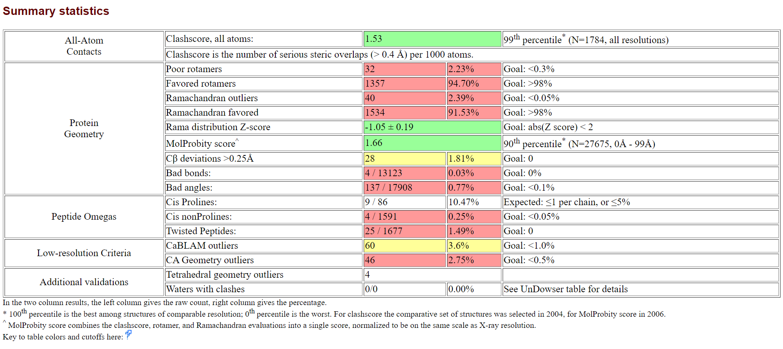
Mouse

