Number of amino acids: 4074

Molecular weight: 446701.72

Theoretical pI: 6.12

Amino acid composition:
Ala (A) 230 5.6%
Arg (R) 186 4.6%
Asn (N) 194 4.8%
Asp (D) 159 3.9%
Cys (C) 100 2.5%
Gln (Q) 183 4.5%
Glu (E) 208 5.1%
Gly (G) 324 8.0%
His (H) 115 2.8%
Ile (I) 238 5.8%
Leu (L) 409 10.0%
Lys (K) 127 3.1%
Met (M) 70 1.7%
Phe (F) 170 4.2%
Pro (P) 215 5.3%
Ser (S) 374 9.2%
Thr (T) 262 6.4%
Trp (W) 64 1.6%
Tyr (Y) 97 2.4%
Val (V) 349 8.6%
Pyl (O) 0 0.0%
Sec (U) 0 0.0%

(B) 0 0.0%
(Z) 0 0.0%
(X) 0 0.0%

Total number of negatively charged residues (Asp + Glu): 367
Total number of positively charged residues (Arg + Lys): 313

Atomic composition:

Carbon C 19902
Hydrogen H 31204
Nitrogen N 5430
Oxygen O 5919
Sulfur S 170

Formula: C₁₉₉₀₂H₃₁₂₀₄N₅₄₃₀O₅₉₁₉S₁₇₀
Total number of atoms: 62625

Extinction coefficients:

Extinction coefficients are in units of M⁻¹ cm⁻¹, at 280 nm measured in water.

Ext. coefficient 502780
Abs 0.1% (=1 g/l) 1.126, assuming all pairs of Cys residues form cystines

Ext. coefficient 496530
Abs 0.1% (=1 g/l) 1.112, assuming all Cys residues are reduced

Estimated half-life:

The N-terminal of the sequence considered is M (Met).

The estimated half-life is: 30 hours (mammalian reticulocytes, in vitro).
>20 hours (yeast, in vivo).
>10 hours (Escherichia coli, in vivo).

Instability index:

The instability index (II) is computed to be 44.73
This classifies the protein as unstable.

Aliphatic index: 92.43

Grand average of hydropathicity (GRAVY): -0.020

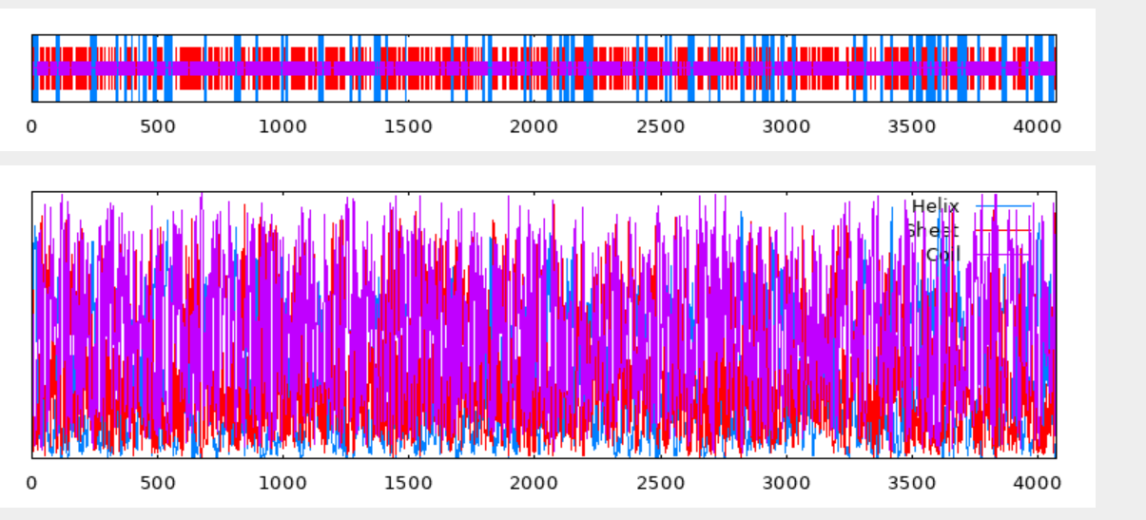
10 20 30 40 50 60 70
| | | | | | |
MTAWLISLMSIEVLLLAVRHLSLHIEPEEGSLAGGTWITVIFDGLELGVLYPNNGSQLEIHLVNVNMVVP
cccceecchhhhhhhhhhhhhhcccccccccccccceeeeeecccccceeccccccceeeeeecccceee
ALRSVPCDVFPVFLDLPVVTCRTRSVLSEAHEGLYFLEAYFGGQLVSSPNPGPRDSCTFKFSKAQTPIVH
eeccccccccceecccceeeccccccccchhhhhhhhhhhcccceeccccccccccceeeecccccceee
QVYPPSGVPGKLIHVYGWIITGRLETFDFDAEYIDSPVILEAQGDKWVTPCSLINRQMGSCYPIQEDHGL
eeecccccceeeeeeeeeeeecccccccccccccccceeeeeeccceecccceeccccccceeeeccccc
GTLQCHVEGDYIGSQNVSFSVFNKGKSMVHKKAWLISAKQDLFLYQTHSEILSVFPETGSLGGRTNITIT
ceeeeeccccccccccceeeeecccchhhhhhhhhhhhhhhhhhhccccceeeecccccccccccceeee
GDFFDNSAQVTIAGIPCDIRHVSPRKIECTTRAPGKDVRLTTPQPGNRGLLFEVGDAVEGLELTEATPGY
cccccccceeeecccccccccccccceeecccccccceeeecccccccceeeeccchhhhhhhhhccccc
RWQIVPNASSPFGFWSQEGQPFRARLSGFFVAPETNNYTFWIQADSQASLHFSWSEEPRTKVKVASISVG
ceeeecccccccccccccccchhhhhccceecccccceeeeeeecchhhhccccccccccceeeeeeecc
TADWFDSWEQNRDEGTWQQKTPKLELLGGAMYYLEAEHHGIAPSRGMRIGVQIHNTWLNPDVVTTYLREK
ccccchhhhccccccccccccchhhhhcchhhhhhhhcccccccccceeeeeeccccccccchhhhhhhh
HQIRVRAQRLPEVQVLNVSGRGNFFLTWDNVSSQPIPANATAHLIQTTIEELLAVKCKLEPLWSNILLRL
hhhhhhhhcccceeeeecccccceeeeeccccccccccchhhhhhhhhhhhhhhhhccccccchhhhhhh
GFERGPEVSNSDGDLTSGTEPFCGRFSLRQPRHLVLTPPAAQKGYRLDQYTHLCLAYKGHMNKILKMIVS
cccccccccccccceecccccccccccccccceeeeccccccccceecceeceeeeeccccceeeeeeee
FTIGFQNMVKNTTCDWSLTRTSPESWQFDCTDLWETCVRCFGDLQPPPANSPVLVHQINLLPLAQETGLF
eeecceeeeeceecceeeeccccccceeeeeceeeceeeecccccccccccceeehhhhcchhhhccccc
YVDEIIIADTNVTVSQADSGTARPGGNLVESVSVVGSPPVYSVTSWLAGCGTELPLITARSVPTEGTEEG
cceeeeeccccceeeeccccccccccceeeeeeecccccceeeeeeecccccccceeecccccccccccc
SGLVLVTTQRRQRTSPPLGGHFRIQLPNTVISDVPVQISAHHLHQLLQNNADDFTSRYLNASDFTVKEDL
cceeeeecccccccccccccceeeecccccccccchhhhhhhhhhhhhcccccchhhhhccccceeeece
YTCYEHVWTLSWSTQIGDLPNFIRVSDENLTGVNPAAATRVVYDGGVFLGPIFGDMLATANQHTQVVVRV
eeeeeeeeeecccccccccccceeeccccccccccccceeeeeccceeecccchhhhhhhccceeeeeee
NDVPAHCPGSCSFQYLQGSTPCVHSVWYSIDGDINLMIYITGTGFSGDSQFLQVTVNKTSCKVIFSNQTN
ccccccccccceeeecccccceeeeeeeeccccceeeeeeccccccccceeeeeecccccceeeeccccc
VVCQTDLLPVGMHRILMLVRPSGLAISATGEDLFLNVKPRLDMVEPSRAADIGGLWATIRGSSLEGVSLI
eeeeecccccchhhhhhhhccccceecccchhhhhcccccccccccccccccccceeeecccccccceee
LFGSYSCAINVATSNSSRIQCKVPPRGKDGRIVNVTVIRGDYSAVLPRAFTYVSSLNPVIVTLSRNISNI
eeccccceeeeccccccceeeeccccccccceeeeeeccccccccccccceecccccceeeeeccccccc
AGGETLVIGVARLMNYTDLDVEVHVQDALAPVHTQSAWGLEVALPPLPAGLHRISVSINGVSIHSQGVDL
cccceeeeeeeeeccccccchhhhhhhccccchhhhhhhhhhcccccccccceeeeeeccceecccccee
HIQYLTEVFSIEPCCGSLLGGTILSISGIGFSRDPALVWVLVGNRSCDIVNLTEASIWCETLPAPQIPDA
eeeeeeeeeeeecccccccccceeeeccccccccceeeeeeecccccceeeeeccccccccccccccccc
GAPTVPAAVEVWAGNRFFARGPSPSLVGKGFTFMYEAAATPVVTAMQGEITNSSLSLHVGGSNLSNSVIL
cccccchhhhhhcccceeccccccccccccceeeeeccccchhhhcccccccceeeeeeccccccceeee
LGNLNCDVETQSFQGNVSLSGCSIPLHSLEAGIYPLQVRQKQMGFANMSVVLQQFAVMPRIMAIFPSQGS
eccccccccccccccceeecccccccccccccccchhhhhhhhcccchhhhhhhhcccceeeeeeccccc
ACGGTILTVRGLLLNSRRRSVRVDLSGPFTCVILSLGDHTILCQVSLEGDPLPGASFSLNVTVLVNGLTS
cccceeeehhhhhhccccceeeeeccccceeeeeeccccceeeeeecccccccccccccceeeeeccccc
ECQGNCTLFIREEASPVMDALSTNTSGSLTTVLIRGQRLATTADEPMVFVDDQLPCNVTFFNASHVVCQT
cccccceeeeeccccchhhhhcccccccceeeeeecceeecccccceeeecccccceeeeecccceeccc
RDLAPGPHYLSVFYTRNGYACSGNVSRHFYIMPQVFHYFPKNFSLHGGSLLTIEGTGLRGQNTTSVYIDQ
cccccccceeeeeeeecccccccccccceeeceeeeeeccccccccccceeeeccccccccccceeeecc
QTCLTVNIGAELIRCIVPTGNGSVALEIEVDGLWYHIGVIGYNKAFTPELISISQSDDILTFAVAQISGA
ccceeeecccceeeeeecccccceeeeeecccceeeeeeeecccccccceeecccccchhhhhhhhhccc
ANIDIFIGMSPCVGVSGNHTVLQCVVPSLPAGEYHVRGYDCIRGWASSALVFTSRVIITAVTENFGCLGG
cceeeeeecccceeecccceeeeeeeccccccceeeeeeeeecccccchhhhcceeeeeeeecccccccc
RLVHVFGAGFSPGNVSAAVCGAPCRVLANATVSAFSCLVLPLDVSLAFLCGLKREEDSCEAARHTYVQCD
eeeeeeccccccccceeeeccccceeeccccccccceeecccccchhhhccccccccccccccchhhhhh
LTVAMATEQLLESWPYLYICEESSQCLFVPDHWAESMFPSFSGLFISPKLERDEVLIYNSSCNITMETEA
hhhhhhhhhhhcccceeeecccccceeeecccccccccccccccccccccccceeeeeccccceeeeecc
EMECETPNQPITVKITEIRKRWGQNTQGNFSLQFCRRWSRTHSWFPERLPQDGDNVTVENGQLLLLDTNT
cccccccccccceeeeeeeeeeccccccceeeeeeeeeecccccccccccccccceeeecceeeeecccc
SILNLLHIKGGKLIFMAPGPIELRAHAILVSDGGELRIGSEDKPFQGRAQITLYGSSYSTPFFPYGVKFL
hhhhhhhccccceeeecccchhhhhhheeeccccceeecccccccccceeeeeeccccccccccccceee
AVRNGTLSLHGSLPEVIVTCLRATAHALDTVLALEDAVDWNPGDEVVIISGTGVKGAKPMEEIVTVETVQ
eecccceeccccccceeehhhhhhhhhhhhhhhhhhhhccccccceeeeeccccccccccceeeeeeecc
DTDLYLKSPLRYSHNFTENWVAGEHHILKATVALLSRSITIQGNLTNEREKLLVSCQEANAPEGNLQHCL
chhhhccccceeeeceeechhhcccchhhhhhhhhccccccccccccchhhhhhhhhhccccccceeeee
YSMSEKMLGSRDMGARVIVQSFPEEPSQVQLKGVQFQVLGQAFHKHLSSLTLVGAMRESFIQGCTVRNSF
eeeceeeeccccccceeeeecccccchhhhhcchhhhhhhhhhhhhhchhhhhhhhhhhhhccceeccee
SRGLSMCGTLGLKVDSNVFYNILGHALLVGTCTEMRYISWEAIHGRKDDWSGHGNIIRNNVIIQVSGAEG
eccccccceeccccccceeeeeeceeeeeccceeeeeeceeeeecccccccccccccccceeeeeccccc
LSNPEMLTPSGIYICSPTNVIEGNRVCGAGYGYFFHLMTNQTSQAPLLSFTQNIAHSCTRYGLFVYPKFQ
cccccceeccceeeecccceecccceeeccceeeeeeeccccccccccceeccccccccccceeeecccc
PPWDNVTGTTLFQSFTVWESAGGAQIFRSSNLRLKNFKVYSCRDFGIDVLESDANTSVTDSLLLGHFAHK
ccccccccceeeceeeeeeccccchhhhhhhhhhcceeeeeccccceeeeeccccccchhhhhhhccccc
GSLCMSSGIKTPKRWELMVSNTTFVNFDLINCVAIRTCSDCSQGQGGFTVKTSQLKFTNSSNLVAFPFPH
ceeeeeccccccceeeeeecccceeeccceeceeeeecccccccccceeeeeeeeeeccccccccccccc
AAILEDLDGSLSGKNRSHILASMETLSASCLVNSSFGRVVHGSACGGGVLFHRMSIGLANTPEVSYDLTM
hhhhhhhccccccccchhhhhhhhhhccccccccccceeeeccccccceeeeeeecccccccceeeeeee
TDSRNKTTTVNYVRDTLSNPRGWMALLLDQETYSLQSENLWINRSLQYSATFDNFAPGNYLLLVHTDLPP
eeccccceeeeeeeeeecccchhhhhhhchhhhhhhhhhhhhhhccccccccccccccceeeeecccccc
YPDILLRCGSRVGLSFPFLPSPGQNQGCDWFFNSQLRQLTYLVSGEGQVQVILRVKEGMPPTISASTSAP
ccceeeeccccccccccccccccccccccceeccchhhheeeeccccceeeeeeecccccceeecccccc
ESALKWSLPETWQGVEEGWGGYNNTIPGPGDDVLILPNRTVLVDTDLPFFKGLYVMGTLDFPVDRSNVLS
hhhhhccccccccceeeccccccccccccccceeeeccceeeeccccccccceeeeccccccccceeeee
VACMVIAGGELKVGTLENPLEKEQKLLILLRASEGVFCDRMNGIHIDPGTIGVYGKVHLYSAYPKNSWTH
eeeeeecccccccccccchhhhhhhhhhhhhcccccccccccceeeccceeceeeeeeeeecccccccce
LGADIASGNERIIVEDAVDWRPHDKIVLSSSSYEPHEAEVLTVKEVKGHHVRIYERLKHRHIGSVHVTED
ecchhhcccceeeeecccccccccceeeeccccccchhhhhhhhhccccceeehhhhhccceeeeeeccc
GRHIRLAAEVGLLTRNIQIQPDVSCRGRLFVGSFRKSSREEFSGVLQLLNVEIQNFGSPLYSSVEFSNVS
cchhhhhhhhhhhhcccccccccccccceeeccccccchhhhhhhhhhhhhhhcccccccccccceeecc
AGSWIISSTLHQSCGGGIHAAASHGVLLNDNIVFGTAGHGIDLEGQAYTVTNNLVVLMTQPAWSTIWVAG
ccceeeeeccccccccchhhhhhhhhhhccceeeecccccccccccceeeecceeeeeeecccceeeeee
IKVNQVKDINLHGNVVAGSERLGFHIRGHKCSSCELLWSDNVAHSSLHGLHLYKESGLDNCTRISGFLAF
eccccccccccccceecccccceeeeecccceeeeeecccccccccccceeeeecccccccccccceecc
KNFDYGAMLHVENSVEIENITLVDNTIGLLAVVYVFSAPQNSVKKVQIVLRNSVIVATSSSFDCIQDKVK
ccccccceeeeccccceeeeeecccccceeeeeeeeccccccceeeeeeecccceeeccccccccccccc
PHSANLTSTDRAPSNPRGGRIGILWPVFTSEPNQWPQEPWHKVRNDHSISGIMKLQDVTFSSFVKSCYSD
ccccccccccccccccccceeeeeeeeeecccccccccccceecccceeechhhhccceeecccceeecc
DLDVCILPNAENSGIMHPITAERTRMLKIKDKNKFYFPSLQPRKDLGKVVCPELDCASPRKYLFKDLDGR
ccceeeeccccccceecchhhhhhhhhhhhcccccccccccccccccceeccccccccccceeccccccc
ALGLPPPVSVFPKTEAEWTASFFNAGTFREEQKCTYQFLMQGFICKQTDQVVLILDSADAIWAIQKLYPV
ccccccccccccccchhhhhhhhccccccccccccceeeccceecccccceeeeechhhhhhhhhccccc
VSVTSGFVDVFSSVNANIPCSTSGSVSTFYSILPIRQITKVCFMDQTPQVLRFFLLGNKSTSKLLLAVFY
eeccccceeeeeeeccccccccccccceeeeecccceeeeecccccccceeeeeeccccccchhhhhhhh
HELQSPHVFLGESFIPPTLVQSASLLLNESIGANYFNIMDNLLYVVLQGEEPIEIRSGVSIHLALTVMVS
hcccccceeccccccccchhhhhhhhhhhhccccccchhhhheeeeecccccceeecccchhhhhhhhhh
VLEKGWEIVILERLTNFLQIGQNQIRFIHEMPGHEETLKAIADSRAKRKRNCPTVTCTSHYRRVGQRRPL
hhhcchhhhhhhhhhhhhhhccceeeeeecccchhhhhhhhhhhhhhhcccccceeeeccccccceeehh
MMEMNSHRASPPMTVETISKVIVIEIGDSPTVRSTGMISSLSSNKLQNLAHRVITAQQTGVLENVLNMTI
hhhhccccccccceeeeccceeeeeecccceeceeeeeechhhhhhhhhhhhhhhhhccchhhhhhhhhh
GALLVTQSKGVIGYGNTSSFKTGNLIYIRPYALSILVQPSDGEVGNELPVQPQLVFLDEQNRRVESLGPP
hhhhhccccceeeecccccccccceeeecccceeeeeccccccccccccccchhhhhhhhccceeecccc
SEPWTISASLEGASDSVLKGCTQAETQDGYVSFYNLAVLISGSNWHFIFTVTSPPGVNFTARSKPFAVLP
cccceeeeccccccccccccccccccccceeeeeceeeeeccccceeeeeeccccccccccccccceeee
VTRKEKSTIILAASLSSVASWLALSCLVCCWLKRSKSRKTKPEEIPESQTNNQNIHIHISSKRRESQGPK
eccccchhhhhhhhhhhhhhhhhhhccccccccccccccccccccccccccccceeeeeccccccccccc
KEDTVVGEDMRMKVMLGKVNQCPHQLMNGVSRRKVSRHIVREEEAAVPAPGTTGITSHGHICAPGAPAQQ
ccceeeeeeeeeeeeeeeecccccceeccceechhhhhhhhhhhccccccccceeeecccccccccccch
VYLQETGNWKEGQEQLLRYQLAGQNQLLLLCPDFRQERQQLPGQSRLSKQSGSLGLSQEKKASCGATEAF
hhhhccccchhhhhhhhhhhhhccchhhhcccccccccccccccccccccccccccchhhhhccccchhh
CLHSVHPETIQEQL
hcccccccccceec
GOR4 :
Alpha helix (Hh) : 687 is 16.86%
3₁₀ helix (Gg) : 0 is 0.00%
Pi helix (Ii) : 0 is 0.00%
Beta bridge (Bb) : 0 is 0.00%
Extended strand (Ee) : 1136 is 27.88%
Beta turn (Tt) : 0 is 0.00%
Bend region (Ss) : 0 is 0.00%
Random coil (Cc) : 2251 is 55.25%
Ambiguous states (?) : 0 is 0.00%
Other states : 0 is 0.00%

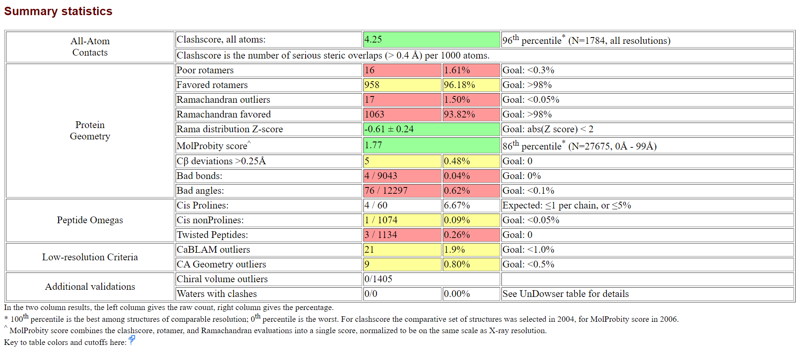
Human

