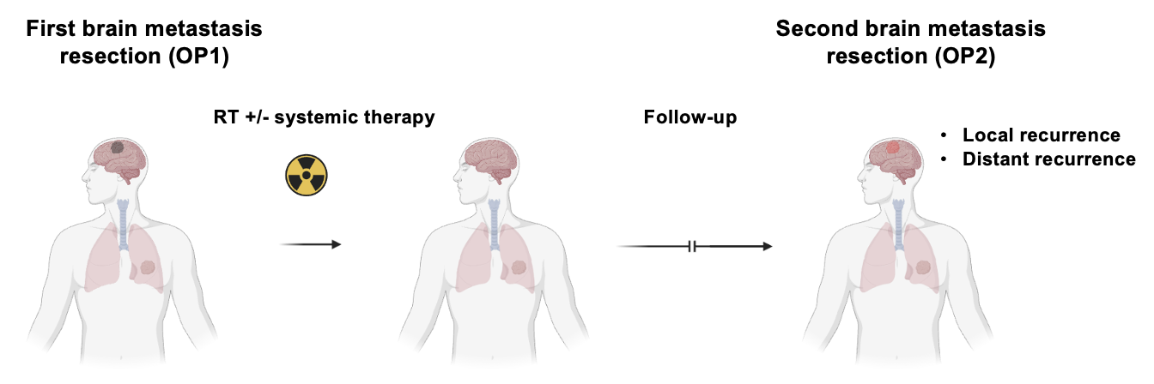

Supplementary figure 1: Graphical abstract of the study
The patient cohort investigated is summarized; Patients underwent a first brain metastasis resection (OP1) and subsequently received adjuvant treatment with radiotherapy with or without adjuvant systemic therapy (see Figure 2). Patients included in this study presented with either distant or local disease recurrence and underwent another brain metastasis resection (OP2), i.e., resection of either local or distant brain metastasis recurrence.

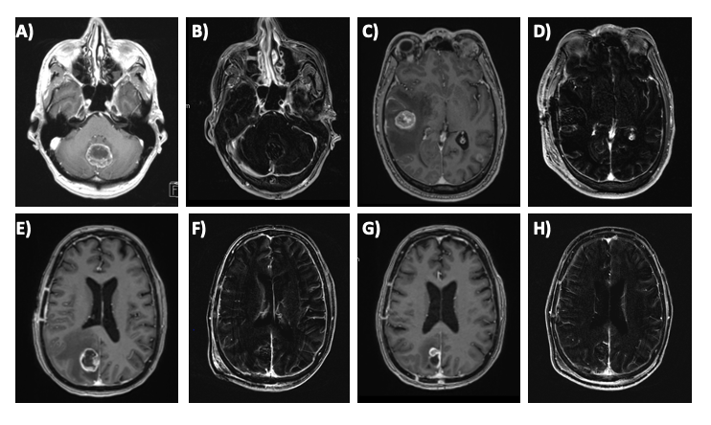
Supplementary figure 2: Representative cranial MR imaging of recurrent brain metastases Representative pre- and postoperative cranial MR imaging of a patient that underwent a resection of a cerebellar brain metastasis secondary to NSCLC A) with postoperative MRI scan B) and experienced a distant disease relapse approximately 4 months after the initial surgery in the right temporal region with marked perifocal edema C). The patient underwent a re-resection D). In another patient, MR imaging shows an occipital NSCLC brain metastasis E). The postoperative MRI following the resection shows gross total resection F). The patient experience local relapse of his NSCLC brain metastasis approximately 6 months later G) and underwent successful re-resection H).

