Supporting Information to
Mesoporous SBA-15 supported Ru nanoparticles for effective hydrogenation of ethyl levulinate at room temperature
Jie Yang^{a,}*, Yongshiling Huª, Qi Yang^{b}, Yejun Guan^{b,}*
a. College of Mathematics and Physics, Shanghai University of Electric Power, Changyang Road 2588, 200090, Shanghai, China
b. Shanghai Key Laboratory of Green Chemistry and Chemical Processes, School of Chemistry and Molecular Engineering, East China Normal University, North Zhongshan Road 3663, 200062 Shanghai, China.
*Corresponding authors. Dr. J. Yang (jyang1@shiep.edu.cn); Dr. Y. Guan (yjguan@chem.ecnu.edu.cn)

Figure S1 XRD patterns of xRu-SBA15.
Figure S2 XRD pattern (A) and H₂-TPR profile (B) of 3Ru-SBA-15-imp.
Figure S3 TEM image of 3Ru-SBA-15 used after six batches.
Table S1 Conversions and apparent activation energies of EL hydrogenation on 3Ru-SBA-15 catalysts prepared by deposition-precipitation and impregnation methods.

Figure S1 XRD patterns of xRu-SBA-15.

Figure S2 XRD pattern (A) and H₂-TPR profile (B) of 3Ru-SBA-15-imp.

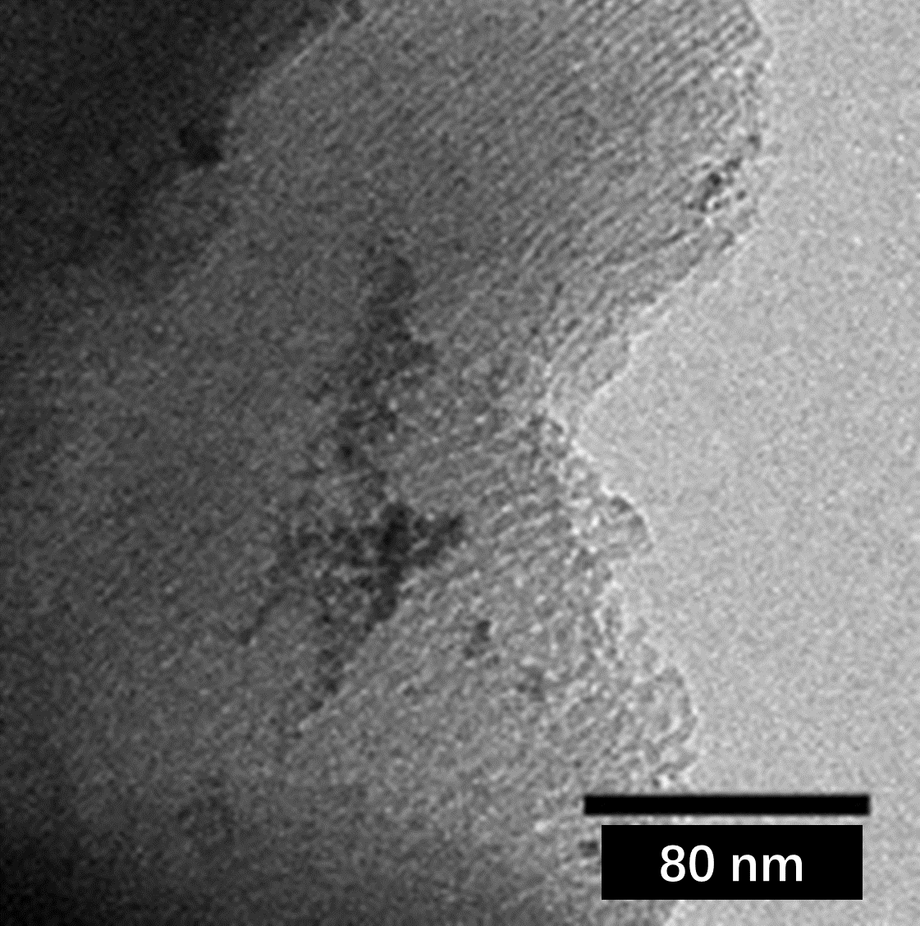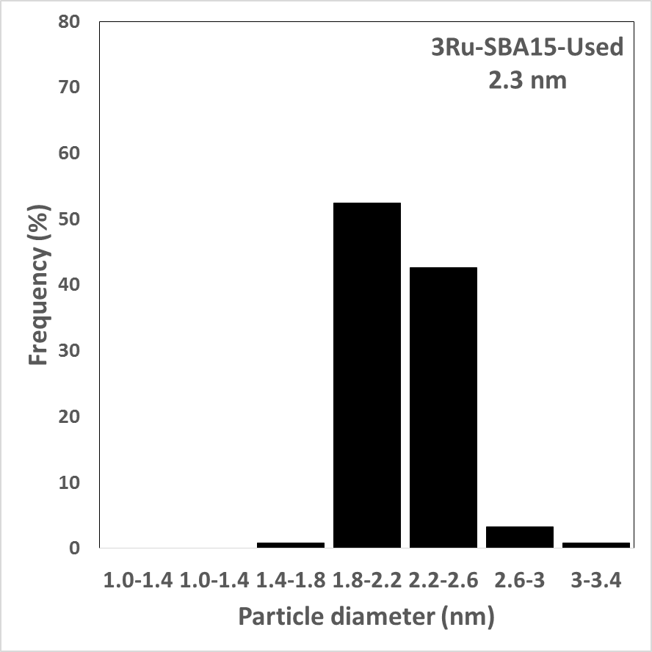
Figure S3 TEM image of 3Ru-SBA-15 used after six batches.

Table S1 Conversions and apparent activation energies of EL hydrogenation on 3Ru-SBA-15 catalysts prepared with different methods.
Catalysts | Temp. (ºC) | Time (min) | Conv. (%) | Ea (kJ/mol)
3Ru-SBA15 | 24 | 20 | 24 | 20
3Ru-SBA15 | 34 | 20 | 33 | 20
3Ru-SBA15 | 50 | 10 | 23 | 20
3Ru-SBA15-imp | 25 | 90 | 10 | 68
3Ru-SBA15-imp | 35 | 40 | 14 | 68
3Ru-SBA15-imp | 51 | 30 | 20 | 68
Reaction conditions: 10 mL of 0.25 mol/L EL aqueous solution; 0.5 MPa H₂ pressure; 20 mg catalyst (3 wt.% Ru); 1000 rpm.

