Extended Data

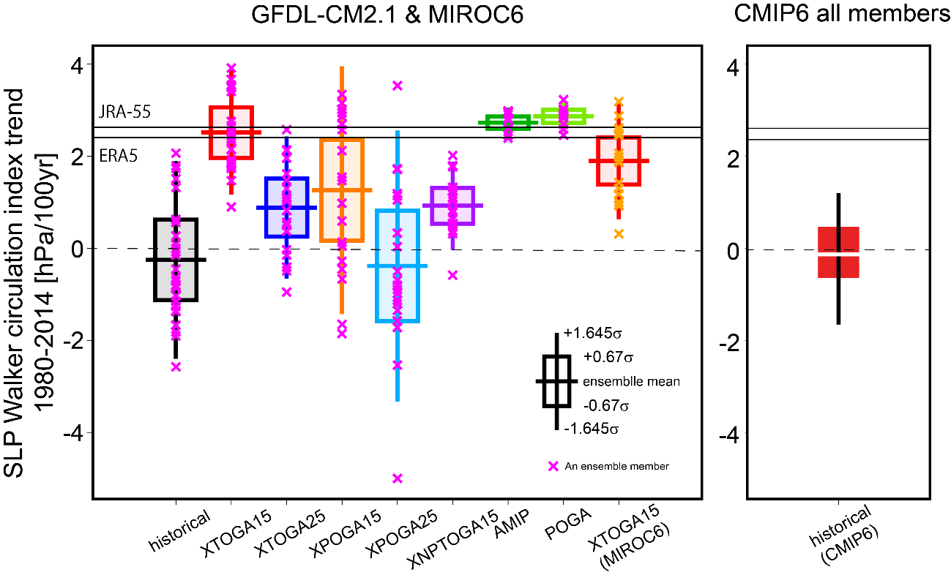
Extended Data Figure 1: Observed and simulated PWC trends for 1980-2014. Trend of the SLP PWC index for 1980-2014 in the series of experiments (left) and in the CMIP6 multi-model ensemble (right). Boxes and whiskers respectively indicate (left) ±0.67σ and ±1.645σ ranges (where σ denotes one s.d.), corresponding to 50% and 90% ranges of a normal distribution, and (right) the interquartile and 5th-95th percentile ranges.

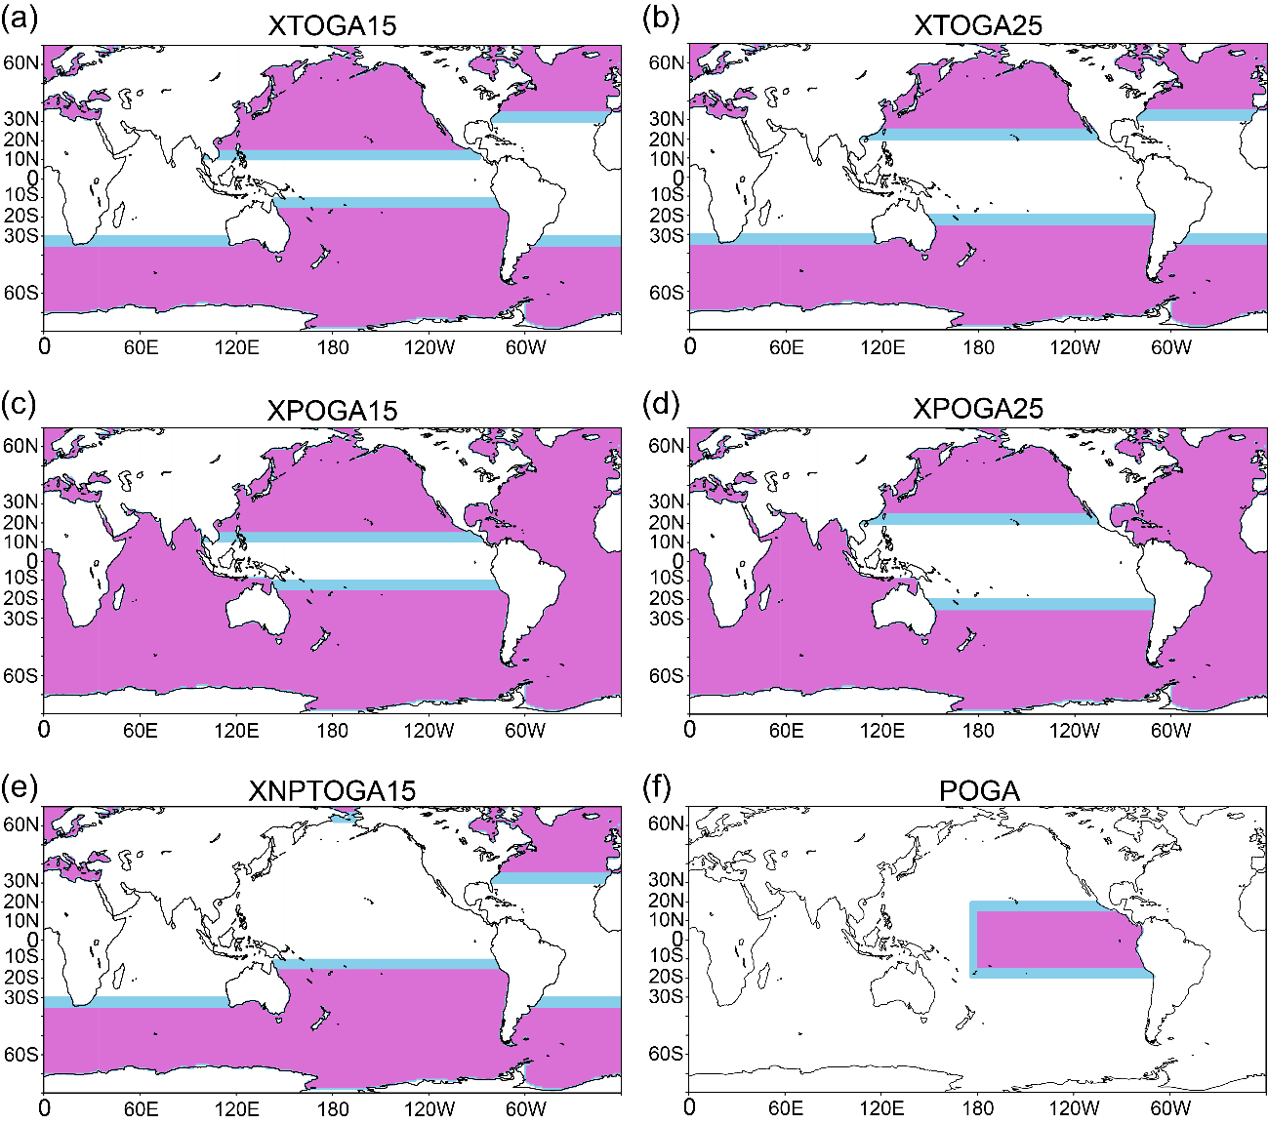

Extended Data Figure 2: The restoration region and buffer zones for pacemaker experiments. The restoration region (pink) and buffer zones (sky-blue) for each pacemaker experiment as indicated. See Methods for the detailed explanation of the restoration region and buffer zones.

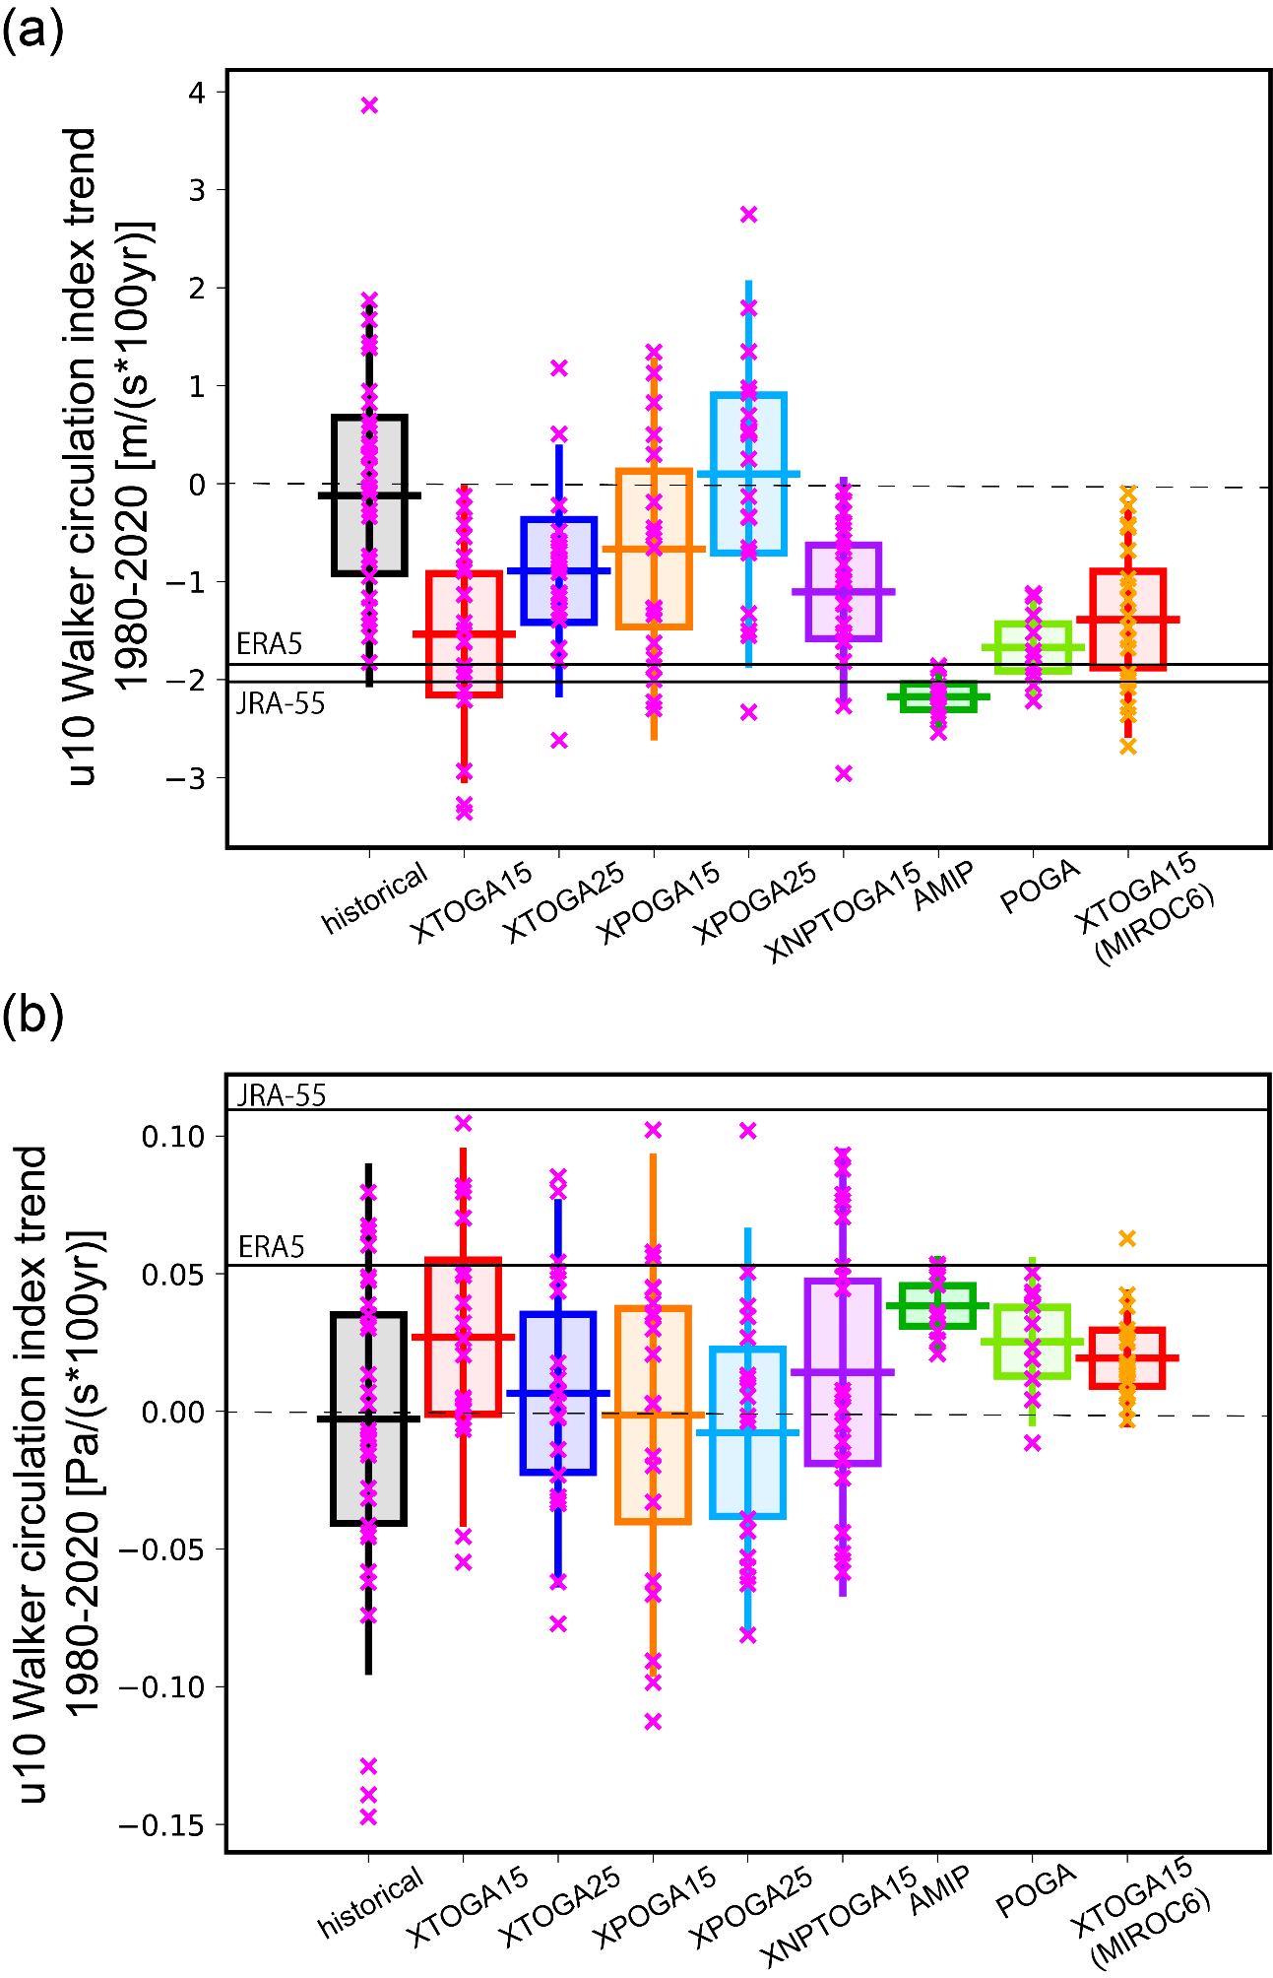
Extended Data Figure 3: Trends of the u10 and ω500 PWC indices for 1980-2020
As in Fig. 1a left, but with (a) the u10 index and (b) the ω500 index.
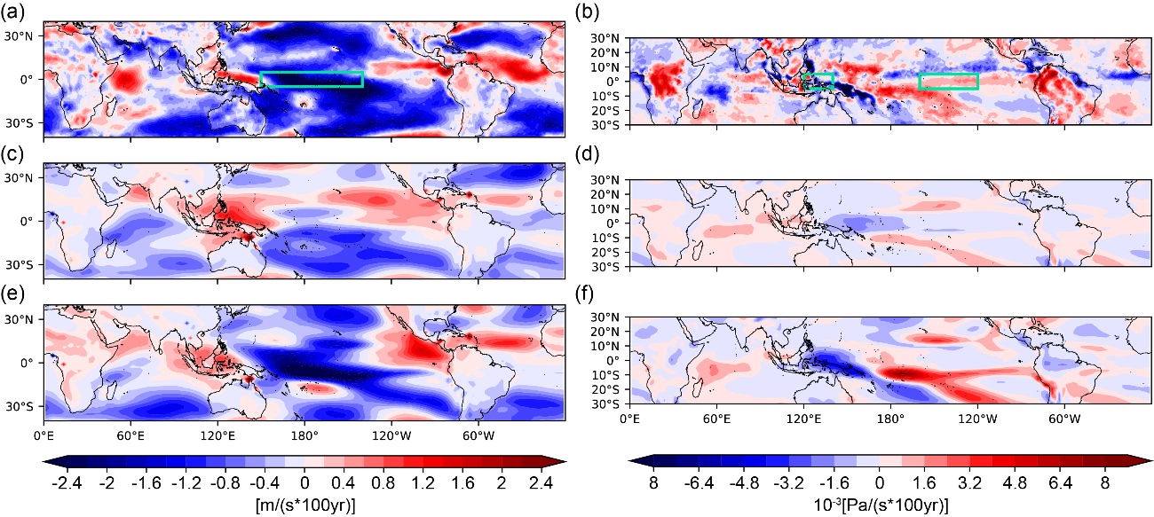
Extended Data Figure 4: Spatial trend patterns of surface zonal wind velocity and mid-tropospheric vertical velocity
(a,c,e) The horizontal distribution of u10 trend for 1980-2020 in (a) ERA5 and CM2.1 ensemble means of (c) HIST and XTOGA15. (b,d,f) As in (a,c,e), but for ω500 (positive if downward). The green boxes in (a) and (b) are the reference region for the u10 and ω500 PWC indices.

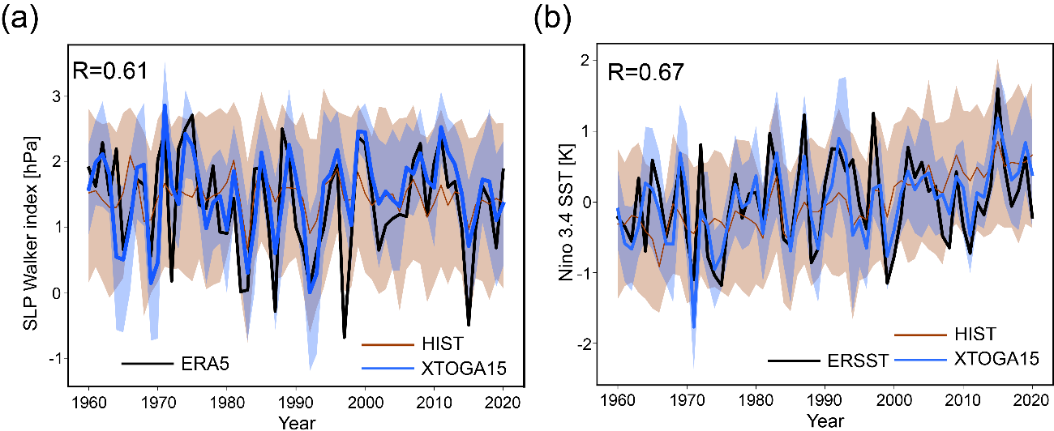
Extended Data Figure 5: Time series of tropical Pacific indexes between the experiment and observations
(a) Time series of the annual mean SLP PWC index in XTOGA15 and HIST of CM2.1 and ERA5. Shadings indicate the ensemble range from minimum to maximum. The correlation coefficient between XTOGA15 ensemble mean and ERA5 is given at the top left. (b) As in (a) but for the ENSO index (Niño 3.4 SST anomalies). The black line represents ERSSTv5

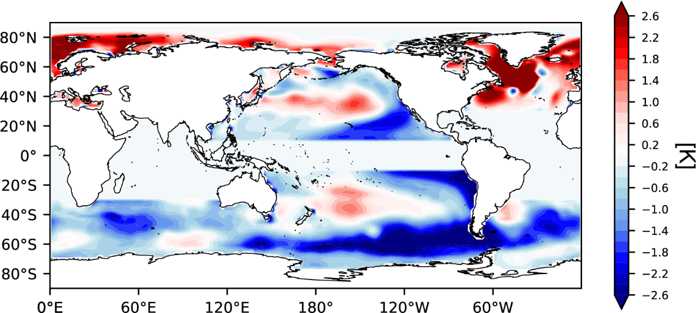
Extended Data Figure 6: Annual mean SST forcing prescribed to aXTOGA15 and sXTOGA15
The 1980-2020 SST trend difference between XTOGA15 and HIST scaled to 100 yr changes. In aXTOGA15, this difference, weighted in the same manner as in XTOGA15 restoring, is superposed on HIST climatology. In sXTOGA15, SST is restored toward this difference plus HIST climatology with the same weighting as in XTOGA15.

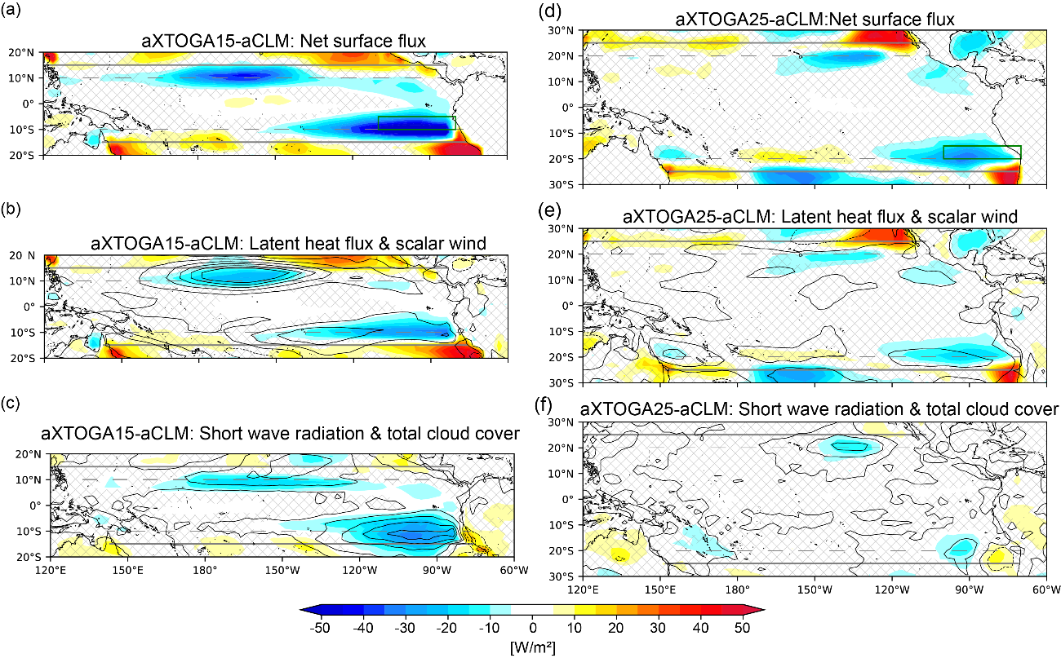
Extended Data Figure 7: Surface heat flux and surface atmospheric circulation responses obtained by atmosphere-only experiments
(a-c) The horizontal pattern of (a) net (turbulent and radiation) heat flux at surface, (b) latent heat flux (color) and scalar wind speed at the 10 m level (contour), (c) surface short wave radiation flux (color) and low-level cloud cover (contour) obtained by subtracting aCLM from aXTOGA15. Downward flux is positive. Contours are drawn (b) from -0.3 to 1.5 W m^{–2} with intervals of 0.3 and (c) from 0 to 24 % with intervals of 8. Hatching indicates that the difference is not significant at the 95% confidence level for each surface flux. The gray solid lines and dot lines represent 15°N or S and 10°N or S, respectively. The region between a solid line and a dotted line corresponds to the buffer zone indicated in Extended Data Fig.2a. (d-f) As in (a-c) but obtained by subtracting aCLM from aXTOGA25. The gray solid lines and dot lines represent 25°N or S and 20°N or S, respectively. The region between a solid line and a dotted line corresponds to the buffer zone indicated in Extended Data Fig.2b.

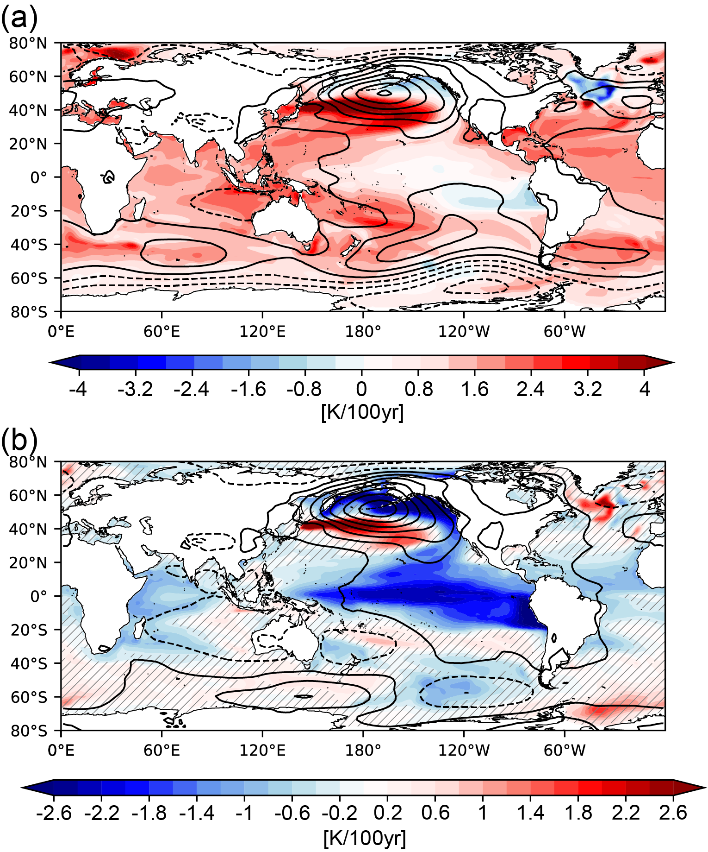
Extended Data Figure 8: SST and SLP trends for 1980-2020 induced by the tropical Pacific SST changes with and without radiative forcing
As in Fig. 1e,f but for POGA (a) and POGA minus HIST (b). The contours are drawn from -5.6 to 8.4 hPa at every 1.4 interval.

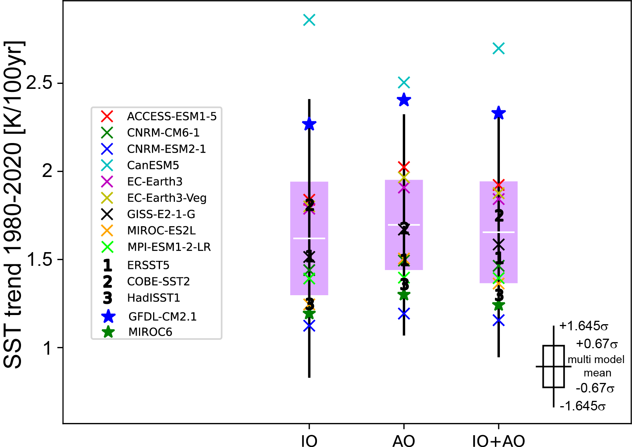
Extended Data Figure 9: Observed and simulated SST trends in the tropical Indian and Atlantic Oceans.
SST trends in the tropical Indian Ocean (15°S-15°N, 40°-100°E), Atlantic Ocean (5°S-15°N, 50°W-0°E) and their average for 1980-2020. Crosses and stars indicate ensemble mean trends of individual models, and numbered makers represent observational datasets. White lines represent multi-model average of individual model ensemble means, and boxes and whiskers indicate ±0.67σ and ±1.645σ ranges, respectively. Models with 7 or more ensemble members are used for this analysis.

