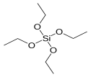
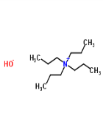
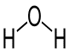
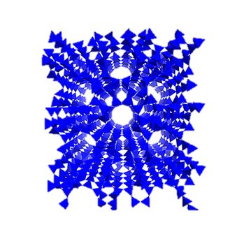

Temperature
Si⁴⁺
Si⁴⁺

TEOS
TPAOH
Water
MFI
MFI
Silicalite-1

Silicalite-1

Silicalite-1
Silicalite-1

Si⁴⁺
Si⁴⁺

Scheme 1. Schematic diagram of silicalite-1


Mesoporous silicalite-1 interact with methylene blue solution
Methylene blue is adsorbing on the adsorbent surface
Methylene blue adsorbed completely on the silicalite-1
After recycle the methylene blue is completely removed
Silicalite-1
Methylene blue

Scheme 2. Mechanism for MB adsorption on mesoporous silicalite-1

