Title: Climatic and topographic changes since the Miocene influenced the diversification and biogeography of tent tortoise (Psammobates tentorius) species complex in Southern Africa

Authors: Zhongning Zhao¹, Neil Heideman^{1,*}, Phillip Bester², Adriaan Jordaan¹ and Margaretha D. Hofmeyr³

Supplementary Materials

1. Supplementary Tables
* Note: Tables which were too large to fit in the main text and are therefore supplied separately as single Excel files.

Table S1*. The sequence polymorphisms of all genes used in this study, including fragment length (bp), number of variable sites, variable site percentage, parsimony informative sites, and the percentage of parsimony informative sites.

Table S2*. The Migrate analysis results (using microsatellite data) estimating effective population sizes of the seven mtDNA clades (Θ1-Θ7), and the potential gene flow rate (M). M1->2 denotes the gene flow rate from Clade 1 to Clade 2. The directional gene flow occurring in the two intergradation zones, between Clade 1 and Clade 2, and between C2 and C4 are in bold.

Table S3. The node age (Ma) and 95% HPD at each node (see Fig. 5 and Fig. S3) generated from BEAST calibration dating analyses in both gene trees and species trees of the mtDNA and (mtDNA+nDNA) datasets, respectively.

 | mtDNA |  |  |  | mtDNA+nDNA
 | Gene tree |  | Species tree |  | Gene tree |  | Species tree
Node | Age | 95% HPD | Age | 95% HPD | Age | 95% HPD | Age | 95% HPD
n1 | 26.8 | 25.32–29.74 | 26.82 | 24.99–30.12 | 32.88 | 28.75–37.26 | 33.28 | 28.99–37.9
n2 | 19.6 | 18.37–21.89 | 19.51 | 17.53–22.16 | 23.44 | 20.61–26.24 | 23.1 | 20.25–26.01
n3 | 17 | 15.21–19.12 | 16.95 | 15.11–18.32 | 20.28 | 18.38–21.57 | 20.12 | 18.07–21.57
n4 | 8.13 | 6.89–9.31 | 8.33 | 7.09–9.58 | 10.01 | 8.27–11.8 | 9.98 | 8.2–11.79
n5 | 7.37 | 5.92–8.36 | 7.83 | 6.17–8.79 | 8.96 | 7–10.46 | 9.14 | 6.97–10.52
n6 | 4.52 | 3.48–5.62 | 4.64 | 3.52–5.83 | 5.75 | 4.36–7.25 | 5.72 | 4.26–7.26
n7 | 4.42 | 3.5–5.38 | 4.27 | 3.4–5.26 | 5.34 | 4.12–6.62 | 4.93 | 3.77–6.17
n8 | 3.16 | 2.41–3.94 | 3.05 | 2.3–3.34 | 3.85 | 2.89–4.39 | 3.54 | 2.62–4.56
n9 | 2.2 | 1.54–2.88 | 2.13 | 1.42–2.86 | 2.71 | 1.9–3.58 | 2.5 | 1.63–3.38

Table S4. The independent BioGeoBEARS model test results for the six habitat reconstruction models with consideration of the “founder effect” parameter “J” on geographic regions, biome and topographic barriers datasets. The selected best model of each analysis with its criteria is shown in bold.

Geographic |  | log | Number of |  | Parameters |  |  | AICc
region | Model | likelihood | parameters | d | e | j | AICc | weight
 | DEC | -25.05 | 2 | 0.026 | 0.057 | 0 | 57.1 | 3.60E-02
 | DEC+J | -91.33 | 3 | 0.006 | 3.80E-09 | 0.0034 | 188.8 | 0.039
 | DIVALIKE | -96.35 | 2 | 0.012 | 1.00E-12 | 0 | 196.8 | 0.0007
 | DIVALIKE + J | -88.13 | 3 | 0.007 | 1.00E-12 | 0.0034 | 182.4 | 0.96
 | BAYAREALIKE | -120.8 | 2 | 0.012 | 0.12 | 0 | 245.7 | 1.70E-14
 | BAYAREALIKE + J | -102.8 | 3 | 0.006 | 0.062 | 0.0039 | 211.8 | 3.90E-07
 |  | log | Number of |  | Parameters |  |  | AICc
Biome | Model | likelihood | parameters | d | e | j | AICc | weight
 | DEC | -25.05 | 2 | 0.026 | 0.057 | 0 | 57.1 | 3.60E-02
 | DEC+J | -91.33 | 3 | 0.006 | 3.80E-09 | 0.0034 | 188.8 | 0.039
 | DIVALIKE | -96.35 | 2 | 0.012 | 1.00E-12 | 0 | 196.8 | 0.0007
 | DIVALIKE + J | -88.13 | 3 | 0.007 | 1.00E-12 | 0.0034 | 182.4 | 0.96
 | BAYAREALIKE | -120.8 | 2 | 0.012 | 0.12 | 0 | 245.7 | 1.70E-14
 | BAYAREALIKE + J | -102.8 | 3 | 0.006 | 0.062 | 0.0039 | 211.8 | 3.90E-07
Topographic |  | log | Number of |  | Parameters |  |  | AICc
barrier | Model | likelihood | parameters | d | e | j | AICc | weight
 | DEC | -25.05 | 2 | 0.026 | 0.057 | 0 | 57.1 | 3.60E-02
 | DEC+J | -91.33 | 3 | 0.006 | 3.80E-09 | 0.0034 | 188.8 | 0.039
 | DIVALIKE | -96.35 | 2 | 0.012 | 1.00E-12 | 0 | 196.8 | 0.0007
 | DIVALIKE + J | -88.13 | 3 | 0.007 | 1.00E-12 | 0.0034 | 182.4 | 0.96
 | BAYAREALIKE | -120.8 | 2 | 0.012 | 0.12 | 0 | 245.7 | 1.70E-14
 | BAYAREALIKE + J | -102.8 | 3 | 0.006 | 0.062 | 0.0039 | 211.8 | 3.90E-07

Table S5. The ANOVA based LRT test results retrieved from the likelihood function models of different scenarios investigated under character dependency analyses BiSSE and MuSSE with different models of regions, biomes and the two sides of the Orange River. “Minimal”: the null model assumed all parameters are equal between different characters states; “all different”: the full parameter model considered lambda, mu and q as different between character states; “free.lambda”: the model considered lambda as different only between different character states, “free.mu”: the model considered only mu as different between different character states, “free.lambda.mu”: the model considered only lambda and mu as differ between different character states, “free.q”: the model considered only q as different between different character states. The best model with its criteria from the LRT test in each analysis is shown in bold.

Object | Model | df | ln Likelihood | AIC | Δ AIC | Chi-square | p-value | AIC weight
Region (MuSSE) | Minimal | 3 | -199.57 | 405.15 | 50.87 | NA | NA | 8.77E-12
 | all.different | 12 | -165.14 | 354.28 | 0 | 68.87 | *** | 9.75E-01
 | free.lambda | 5 | -178.66 | 367.31 | 13.03 | 41.835 | *** | 1.44E-03
 | free.mu | 5 | -176.12 | 362.24 | 7.96 | 46.908 | *** | 1.82E-02
 | free.lambda.mu | 7 | -175.44 | 364.87 | 10.59 | 48.275 | *** | 4.88E-03
 | free.q | 8 | -195.15 | 406.29 | 52.01 | 8.856 | NS | 4.95E-12
Biome (MuSSE) | Minimal | 3 | -279.86 | 565.72 | 82.67 | NA | NA | 1.12E-18
 | all.different | 12 | -229.52 | 483.05 | 0 | 100.674 | *** | 1.00E+00
 | free.lambda | 5 | -267.19 | 544.38 | 61.33 | 25.345 | *** | 4.82E-14
 | free.mu | 5 | -264.77 | 539.54 | 56.49 | 30.185 | *** | 5.42E-13
 | free.lambda.mu | 7 | -247.74 | 509.47 | 26.42 | 64.25 | *** | 1.83E-06
 | free.q | 8 | -243.14 | 502.28 | 19.23 | 73.439 | *** | 6.66E-05
Orange River (BiSSE) | all.different | 6 | -157.26 | 326.51 | NA | NA | NS | NA
 | free.lambda | 5 | -157.26 | 324.53 | NA | 0.018 | NS | NA
 | free.q | 5 | -168.64 | 347.28 | NA | 22.769 | *** | NA
Significance code: | 0–0.001: '***'
 | 0.001–0.01: '**'
 | 0.01–0.05: '*'
 | > 0.05: 'NS'
 | “NA”: Not applicable
 | df: degrees of freedom

Table S6. The average test AUC criterion under the ROC curve and its standard deviation (SD) generated by ENM analyses for each group through the given timeline. LIG: Last Interglacial, LGM: Last Glacial Maximum, and MIDH: Middle Holocene.

Group | LIG |  | LGM |  | MIDH |  | Current |  | Future
 | Test AUC | SD | Test AUC | SD | Test AUC | SD | Test AUC | SD | Test AUC | SD
C1 | 0.961 | 0.017 | 0.954 | 0.022 | 0.955 | 0.011 | 0.955 | 0.02 | 0.96 | 0.011
C2 | 0.958 | 0.015 | 0.961 | 0.013 | 0.951 | 0.011 | 0.958 | 0.02 | 0.957 | 0.01
C3 | 0.99 | 0.014 | 0.994 | 0.004 | 0.99 | 0.004 | 0.991 | 0 | 0.992 | 0.005
C4 | 0.993 | 0.006 | 0.991 | 0.008 | 0.992 | 0.006 | 0.992 | 0.01 | 0.992 | 0.008
C5 | 0.992 | 0.015 | 0.967 | 0.053 | 0.994 | 0.005 | 0.995 | 0 | 0.996 | 0.005
C6 | 0.977 | 0.034 | 0.973 | 0.043 | 0.967 | 0.045 | 0.963 | 0.05 | 0.973 | 0.039
C7 | 1 | 0 | 0.999 | 0.001 | 1 | 0 | 0.995 | 0.01 | 1 | 0
entire complex | 0.905 | 0.016 | 0.919 | 0.016 | 0.904 | 0.019 | 0.912 | 0.02 | 0.904 | 0.016

Table S7. The results of the optimization of parameters settings for all ENM analyses across groups and timelines. Features: Linear features (L), Quadratic features (Q), Product features (P) and Hinge features (H); RM = Regularization multiplier. LIG: Last Interglacial, LGM: Last Glacial Maximum, and MIDH: Middle Holocene.

Group | LIG |  | LGM |  | MIDH |  | Current |  | Future
 | Features | RM | Features | RM | Features | RM | Features | RM | Features | RM
C1 | LQ | 0.5 | LQ | 0.5 | LQ | 0.5 | LQH | 3 | LQH | 2.5
C2 | LQHP | 1.5 | LQHP | 2 | LQ | 0.5 | LQH | 2 | LQH | 1.5
C3 | LQH | 3 | LQ | 0.5 | LQ | 0.5 | LQ | 1 | LQ | 0.5
C4 | LQH | 2.5 | LQ | 2.5 | LQHP | 2.5 | LQHP | 1.5 | LQHP | 1.5
C5 | LQHP | 1 | LQHP | 1 | LQHP | 1 | LQHP | 1 | LQHP | 1
C6 | LQH | 3 | LQH | 1.5 | LQ | 0.5 | LQ | 0.5 | LQH | 2.5
C7 | LQHP | 0.5 | LQHP | 0.5 | LQHP | 0.5 | LQHP | 0.5 | LQHP | 0.5
All | LQH | 2 | LQ | 0.5 | LQHP | 1 | LQHP | 1 | LQHP | 2.5

Table S8. The pairwise results of niche difference analysis between clades (candidate species). The pairwise comparisons showing significant niche differences are in bold, whilst, comparisons without significant niche differences are underlined. Note: If the point estimated value (the matrix at the bottom-left) was lower than the 5% threshold value (the matrix at the top-right), then the niches were significantly different.

Taxon | C1 | C2 | C3 | C4 | C5 | C6 | C7
C1 | 1.00 | 0.79 | 0.75 | 0.79 | 0.59 | 0.70 | 0.64
C2 | 0.78 | 1.00 | 0.74 | 0.76 | 0.69 | 0.75 | 0.72
C3 | 0.39 | 0.19 | 1.00 | 0.80 | 0.72 | 0.71 | 0.72
C4 | 0.65 | 0.56 | 0.48 | 1.00 | 0.75 | 0.76 | 0.72
C5 | 0.67 | 0.38 | 0.55 | 0.67 | 1.00 | 0.66 | 0.87
C6 | 0.44 | 0.55 | 0.09 | 0.25 | 0.20 | 1.00 | 0.70
C7 | 0.81 | 0.55 | 0.45 | 0.65 | 0.66 | 0.21 | 1.00

Table S9. The ENM analyses estimating the area of suitable habitats of clades 1–7 and the entire P. tentorius species complex, as well as changes in the area of suitable habitats against the timeline (for details about the timeline see the Materials and Methods). The arrow " ↑ " represents increasing area, whilst, " ↓ " indicates decreasing area. Groups currently showing a decrease in the area of suitable habitats or future habitats are given in bold.

 | LIG | LGM |  | MIDH |  | Current |  | Future (km²)
Clade 1 | 309455.59 | 367477.15 | ↑ | 322701.53 | ↓ | 361375.33 | ↑ | 216495.14 | ↓
Change |  | 58021.57 |  | -44775.62 |  | 38673.81 |  | -144880.20
Clade 2 | 289803.82 | 297078.23 | ↑ | 305394.95 | ↑ | 297729.67 | ↓ | 271476.65 | ↓
Change |  | 7274.41 |  | 8316.71 |  | -7665.27 |  | -26253.02
Clade 3 | 69161.18 | 63819.38 | ↓ | 62386.21 | ↓ | 78498.49 | ↑ | 67380.58 | ↓
Change |  | -5341.81 |  | -1433.17 |  | 16112.28 |  | -11117.90
Clade 4 | 76088.16 | 67597.73 | ↓ | 69769.20 | ↑ | 61105.05 | ↓ | 66555.43 | ↑
Change |  | -8490.43 |  | 2171.47 |  | -8664.15 |  | 5450.38
Clade 5 | 98649.69 | 118410.03 | ↑ | 151894.03 | ↑ | 137584.07 | ↓ | 123404.40 | ↓
Change |  | 19760.34 |  | 33484.00 |  | -14309.96 |  | -14179.67
Clade 6 | 276036.73 | 229784.51 | ↓ | 226918.17 | ↓ | 263029.65 | ↑ | 235517.18 | ↓
Change |  | -46252.22 |  | -2866.33 |  | 36111.48 |  | -27512.47
Clade 7 | 17241.44 | 13463.09 | ↓ | 8794.44 | ↓ | 72070.95 | ↑ | 80648.24 | ↑
Change |  | -3778.35 |  | -4668.65 |  | 63276.51 |  | 8577.29
All | 640734.41 | 614264.24 | ↓ | 572246.38 | ↓ | 522997.53 | ↓ | 553137.48 | ↑
Change |  | -26470.17 |  | -42017.86 |  | -49248.84 |  | 30139.94

Table S10*. The climatic variables that made significant impacts in each group across different period (All: including all individuals, C1-C7: Clade 1-7) from the ENM analyses.

Table S11*. List of all samples, their corresponding localities and NCBI GenBank accession numbers across different genes. All NCBI accessions of outgroups used in this study are given at the bottom.

Table S12*. List of primers used in the study with corresponding oligo sequences, optimized annealing temperatures and sources.

Table S13. Optimal partition scheme, substitution model, likelihood score (-InL), Gamma shape, proportion of estimated invariable sites for the mtDNA+nDNA based BEAST phylogenetic inference.

Partition scheme | Model | -InL | Gamma shape | P-inv
12S | TIM3+I+G | 1733.56 | 0.661 | 0.397
16S | TIM2+I+G | 2096.84 | 0.58 | 0.511
Cytb_1 | TPM2uf+I | 1090.84 | NA | 0.6
ND4_2, Cytb_2 | TPM3uf+G | 648.6 | 0.1 | NA
Cytb_3 | TVM+I+G | 2250.85 | 4.99 | 0.03
ND4_1 | TrN+G | 1254.58 | 0.306 | NA
ND4_3 | TIM1+G | 2303.49 | 2.41 | NA
tRNA | TrN+G | 448.23 | 0.35 | NA
PRLR_1 | TPM1uf+I | 338.38 | NA | 0.79
PRLR_2 | TrN+G | 379.73 | 0.45 | NA
PRLR_3 | K80 | 438.53 | NA | NA
Note: " * " - p < 0.05
" ** " - p < 0.01
" *** " indicate p < 0.0001
"NA"- Not applicable

Table S14*. Allele size ranges, repeat motifs with their NCBI GenBank accession numbers, multiple-mix reaction grouping schemes, the oligo-nucleotide sequences of primers with dyes, optimal annealing temperatures and the sources of primers of all microsatellite DNA markers tested in this study. "NA" indicates the primer pair failed to amplify.

Table S15*. The genotyping results of 14 microsatellite DNA loci used in this study, together with locality and subpopulation information.

Table S16. Optimal partition scheme, substitution model, likelihood score (-InL), Gamma shap, and proportion of estimated invariant sites for the BEAST calibration dating analyses.

Partition scheme | Model | -InL | Gamma shape | P-inv
12S | GTR+I+G | 1733.3 | 0.682 | 0.407
16S | GTR+I+G | 2078.7 | 0.598 | 0.513
Cytb_1 | TVM+I+G | 1111.64 | 0.677 | 0.589
Cytb_2，ND4_2 | GTR+I+G | 650.18 | 0.461 | 0.462
Cytb_3 | GTR+I+G | 2257.6 | 5.368 | 0.044
ND4_1 | TrN+G | 1244.97 | 0.309 | NA
ND4_3 | TIM1+G | 2327.01 | 2.193 | NA
tRNA | TrN+G | 447.4 | 0.41 | NA
PRLR_1 | HKY+I | 318.72 | NA | 0.496
PRLR_2 | TrN | 361.84 | NA | NA
PRLR_3 | HKY+I+G | 427.63 | 1.63 | 0.288
Note: " * " - p < 0.05
" ** " - p < 0.01
" *** " indicate p < 0.0001
"NA"- Not applicable

Table S17. The constraint of the five most recent common ancestors used in the BEAST calibration dating analyses for the mtDNA and mtDNA+nDNA datasets.

MRCA | Node position | mtDNA (Ma) | mtDNA+nDNA (Ma)
1 | P. oculifer+P. geometricus | 16.89 | 16.89–21.57
2 | Stigmochelys+Psammobates | 26.63 | 26.63–39.72
3 | Chersina+Chersobius | 19.68 | 19.68–29.51
4 | Homopus+(Chersina+Chersobius) | 28.64 | 28.64–42.20
5 | Astrochelys+Pyxis | 26.44 | 26.44–36.29

Table S18*. The bioclimatic variables and their percentage contribution, permutation importance and jack-knife test AUC’s used in the ENM to determine suitable habitat ranges of the P. tentorius species complex. Variables with AUC above 0.75 were considered as potentially useful (given in bold).

Table S19*. The correlation matrix retrieved from the correlation test between each pair of bioclimatic variables. The R-square values varied from zero to one, with "zero" representing no correlation and "one" representing 100% correlation. The bioclimatic variables (in bold) are the ones used in further niche modelling analyses after trimming variables showing strong correlation. The pairwise values (R-square) > 70 or < -70 were considered as strong correlations. All pairwise R-square values showing a strong correlation between bioclimatic variables are underlined.

2. Supplementary Figures

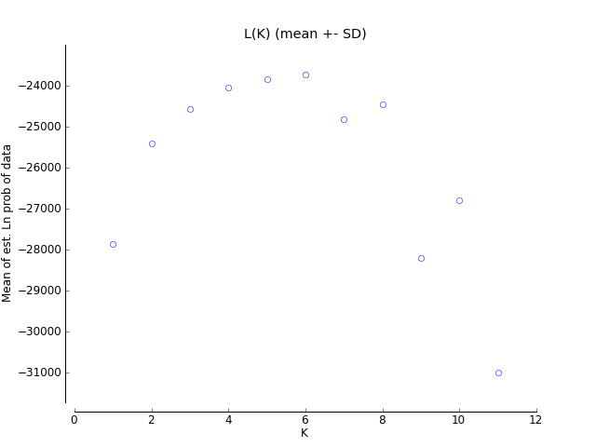
Figure S1. The results of the Bayesian clustering analysis with STRUCTURE. The plot shows the values of ΔK calculated according to Evanno et al. [47].

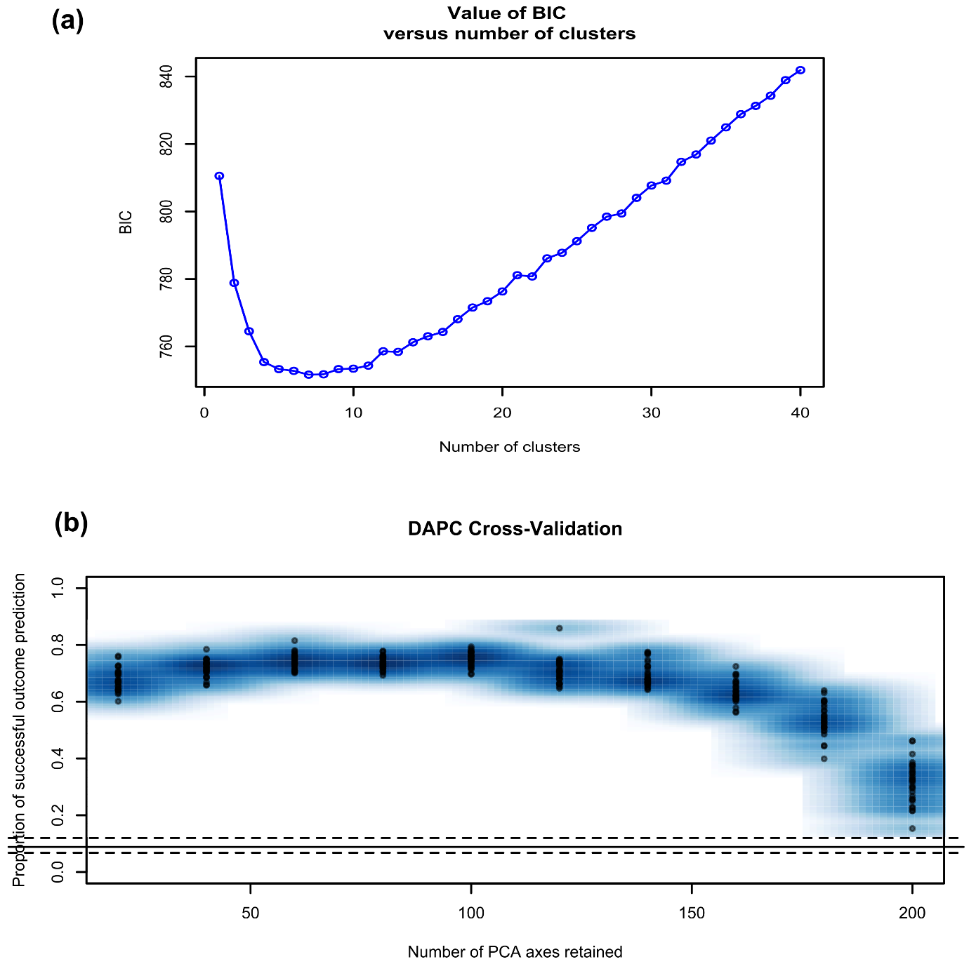

Figure S2. (a) Results of BIC value versus the number of clusters to determine the optimal clustering scheme in the DAPC analyses. (b) The Cross-Validation test results determining the optimal number of PCs retained.

Figure S3. The species tree chronograms generated from the BEAST calibration dating analyses, A: mtDNA chronogram, B: mtDNA+nDNA chronogram. The red dots were the five constrained calibration points for calibration dating analyses.

Figure S4. The macroevolution cohort matrix for the seven clades of the P. tentorius species complex. BAMM Bayesian diversification rate analysis based on the mean phylorate plot trees, are shown at the top and on the left side of the cohort matrix, for purposes of comparison. The matrix shows pairwise probabilities of two groups sharing the same evolutionary dynamics. The “warm” colours represent high cohort similarities (highest value “1” refers to 100% similarity), whilst, the “cool” colours represent low cohort similarities (lowest value “0” refers to 0% similarity).

Figure S5. Visualizing the single-chain MCMC diagnostics for a CoMET analysis with empirically estimated diversification hyperpriors. Blue bars/dots represent passed tests and red bars/dots mean failed tests (failed convergence).

