Table S2 Major phytocompounds identified in GC-MS profiling of methanolic extracts of shoots (MS) of P. nepalensis.
Sl. No | Compounds | Chemical formula | SMILES format | PubChem ID | 2D Structures
2a | Hexadecanoic acid,methyl ester | C17H34O2 | CCCCCCCCCCCCCCCC(=O)OC | 8181 | 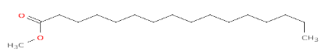
2b | 1,1,1,5,7,7,7-Heptamethyl-3,3- bis(trimethylsiloxy)tetrasiloxane | C13H40O5Si6 | C[Si](O[Si](C)(C)C)O[Si](O[Si](C)(C)C)(O[Si](C)(C)C)O[Si](C)(C)C | 6329081 | 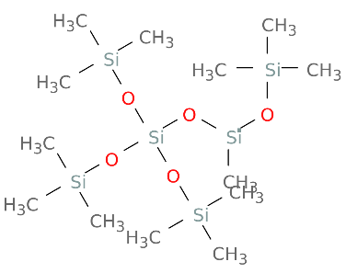
2c | Oxalic acid, 2TMS derivative | C8H18O4Si2 | C[Si](C)(C)OC(=O)C(=O)O[Si](C)(C)C | 519543 | 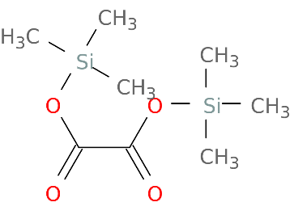
2d | Cyclooctasiloxane, hexadecamethyl- | C16H48O8Si8 | C[Si]1(O[Si](O[Si](O[Si](O[Si](O[Si](O[Si](O[Si](O1)(C)C)(C)C)(C)C)(C)C)(C)C)(C)C)(C)C)C | 11170 | 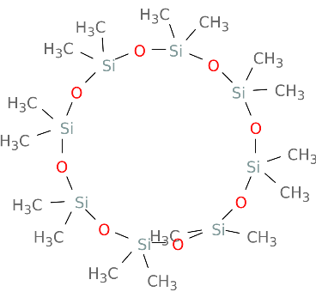
2e | 3-Ethyl-7-hydroxyphthalide | C10H10O3 | CCC1C2=C(C(=CC=C2)O)C(=O)O1 | 591119 | 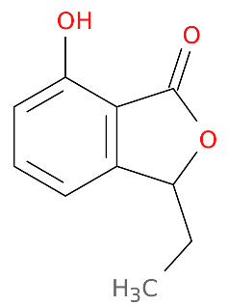
2f | Phthalic acid, butyl hex-3-yl ester | C18H26O4 | CCCCOC(=O)C1=CC=CC=C1C(=O)OC(CC)CCC | 91720282 | 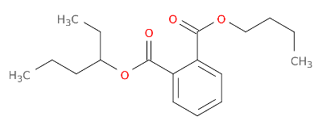
2g | 1,1,1,3,5,5,7,7,7-Nonamethyl-3-  (trimethylsiloxy)tetrasiloxane | C12H36O4Si5 | C[Si](C)(C)O[Si](C)(C)O[Si](C)(O[Si](C)(C)C)O[Si](C)(C)C | 553706 | 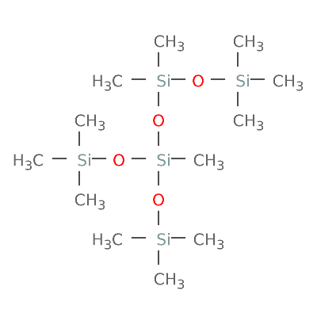
2h | 1-Hexyl-1-nitrocyclohexane | C12H23NO2 | CCCCCCC1(CCCCC1)[N+](=O)[O-] | 544063 | 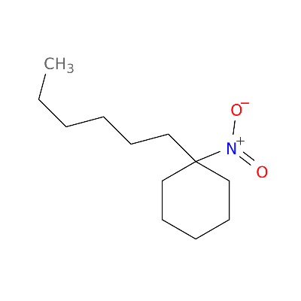
2i | Isobutyl 4-hydroxybenzoate | C11H14O3 | CC(C)COC(=O)C1=CC=C(C=C1)O | 20240 | 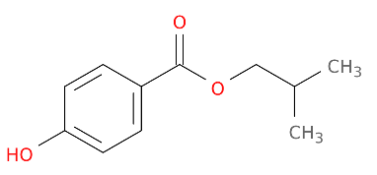
2j | Octanoic acid, 5-(acetyloxy)-, methyl ester | C11H20O4 | CCCC(CCCC(=O)OC)OC(=O)C | 539496 | 