Table S3 Major phytocompounds identified in GC-MS profiling of n-hexane extracts of roots (NR) of P. nepalensis.
Sl. No | Compounds | Chemical formula | SMILES format | PubChem ID | 2D Structures
3a | Trichloromethyl 9-anthracenecarbodithioate | C16H9Cl3S2 | C1=CC=C2C(=C1)C=C3C=CC=CC3=C2C(=S)SC(Cl)(Cl)Cl | 613595 | 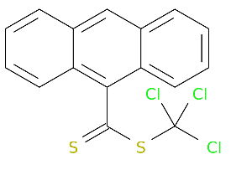
3b | Heptane, 3,3-dimethyl- | C9H20 | CCCCC(C)(C)CC | 520991 | 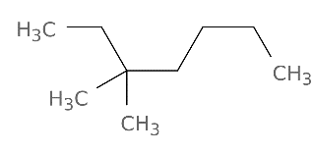
3c | Hexadecane | C16H34 | CCCCCCCCCCCCCCCC | 11006 | 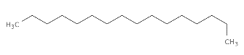
3d | 1,1,1,5,7,7,7-Heptamethyl-3, 3- bis(trimethylsiloxy)tetrasiloxane | C13H40O5Si6 | C[Si](O[Si](C)(C)C)O[Si](O[Si](C)(C)C)(O[Si](C)(C)C)O[Si](C)(C)C | 6329081 | 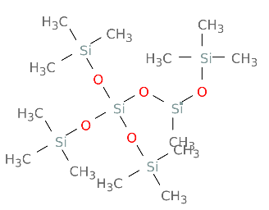
3e | Dodecane | C12H26 | CCCCCCCCCCCC | 8182 | 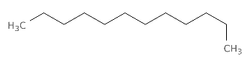
3f | Eicosane | C20H42 | CCCCCCCCCCCCCCCCCCCC | 8222 | 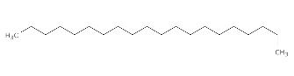
3g | 1,1,1,3,5,5,7,7,7-Nonamethyl-3-(trimethylsiloxy) tetrasiloxane Propanoicacid, | C12H36O4Si5 | C[Si](C)(C)O[Si](C)(C)O[Si](C)(C)O[Si](C)(C)O[Si](C)(C)C | 8853 | 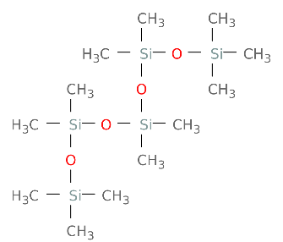
3h | 2-oxo-3-(trimethylsilyl)-, trimethylsilyl ester | C9H20O3Si2 | CCOC(=O)C1(CC2C(=C(C(=O)O2)[Si](C)(C)C)C1)C(=O)OCC | 102119459 | 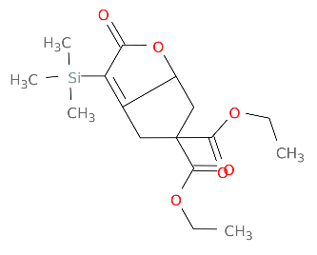
3i | 1,1,1,3,5,7,7,7-Octamethyl-3,5- bis(trimethylsiloxy) tetrasiloxane | C14H42O5Si6 | C[Si](C)(C)O[Si](C)(O[Si](C)(C)C)O[Si](C)(O[Si](C)(C)C)O[Si](C)(C)C | 553110 | 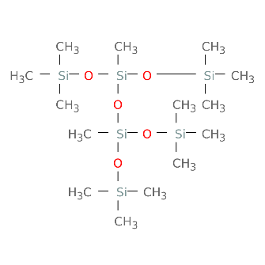
3j | 2,4,6,9-Dehydroadamantane | C10H12 | C1C2CC3C4C1C5C2C5C34 | 562325 | 