Table S1 Major phytocompounds identified in GC-MS profiling of methanolic extracts of roots (MR) of P. nepalensis
Sl. No | Compounds | Chemical formula | SMILES format | PubChem ID | 2D Structures
1a | Tetradecanoic acid, 10,13-dimethyl-, methyl ester | C₁₇H₃O₄ | CC(C)CCC(C)CCCCCCCCC(=O)OC | 554145 | 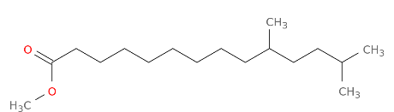
1b | Heptadecanoic acid, 16-methyl-, methyl ester | C₁₉H₃₈O₂ | CC(C)CCCCCCCCCCCCCCC(=O)OC | 110444 | 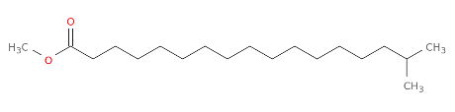
1c | 1,1,1,5,7,7,7-Heptamethyl-3,3-bis(trimethylsiloxy) tetrasiloxane | C₁₃H₄₀O₅Si₆ | C[Si](O[Si](C)(C)C)O[Si](O[Si](C)(C)C)(O[Si](C)(C)C)O[Si](C)(C)C | 6329081 | 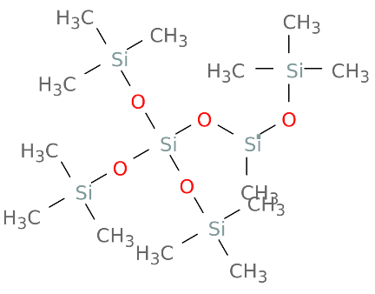
1d | Phthalic acid, butyl hept-4-yl | C₁₉H₂₈O₄ | CCCCOC(=O)C1=CC=CC=C1C(=O)OC(CCC)CCC | 91720764 | 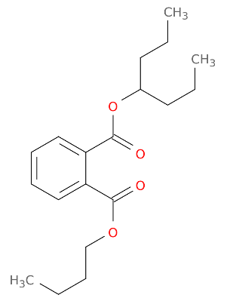
1e | 1,1,1,3,5,5,7,7,7-Nonamethyl-3-(trimethyl siloxy) tetrasiloxane | C₁₂H₃₆O₄Si₅ | C[Si](C)(C)O[Si](C)(C)O[Si](C)(C)O[Si](C)(C)O[Si](C)(C)C | 8853 | 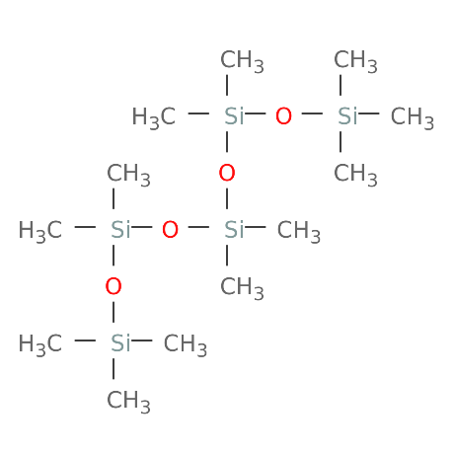
1f | Norepinephrine, (R)-, 4TMS derivative | C₂₀H₄₃NO₃Si₄ | CCOC1=CC=CC=C1O[C@@H]([C@H]2CNCCO2)C3=CC=CC=C3 | 12751 | 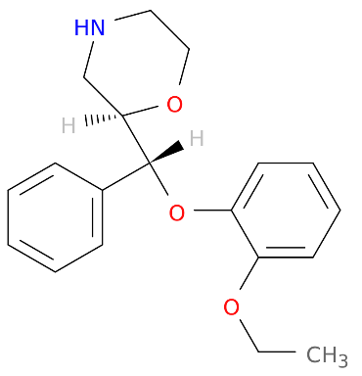
1g | 2-Isopropyl-6- phenylnicotinonitrile | C₁₅H₁₄N₂ | CC(C)C1=C(C=CC(=N1)C2=CC=CC=C2)C#N | 610213 | 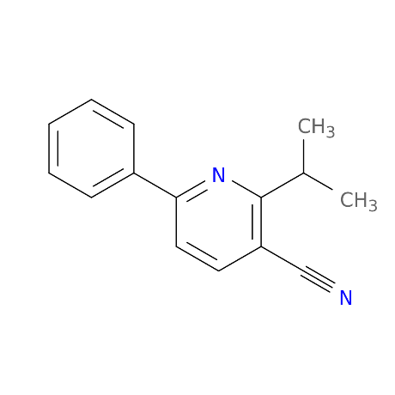
1h | Cyclononasiloxane, octadecamethyl | C₁₈H₅₄O₉Si₉ | C[Si]1(O[Si](O[Si](O[Si](O[Si](O[Si](O[Si](O[Si](O[Si](O1)(C)C)(C)C)(C)C)(C)C)(C)C)(C)C)(C)C)(C)C)C | 11172 | 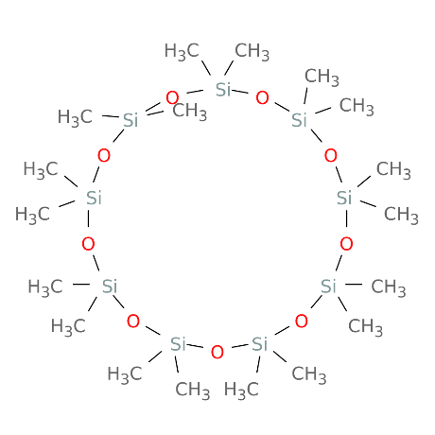
1i | Oxalic acid, 2TMS derivative | C₈H₁₈O₄Si₂ | C[Si](C)(C)OC(=O)C(=O)O[Si](C)(C)C | 519543 | 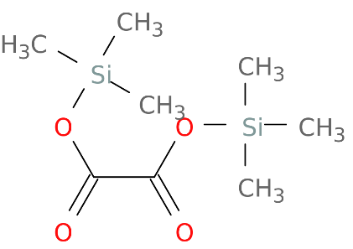
1j | 2-Tetradecanol | C₁₄H₃₀O | CCCCCCCCCCCCC(C)O | 20831 | 