Table S4 Major phytocompounds identified in GC-MS profiling of n-hexane extracts of shoots (NS) of P. nepalensis
Sl. No | Compounds | Chemical formula | SMILES format | PubChem ID | 2D Structures
4a | Benzene, 1,3,5-tri-tert-butyl- | C18H30 | CC(C)(C)C1=CC(=CC(=C1)C(C)(C)C)C(C)(C)C | 15089 | 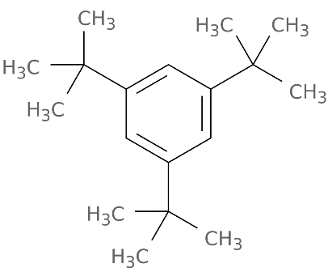
4b | 1,1,1,3,5,5,5-Heptamethyltrisiloxane 4H-1-Benzopyran-2-carboxylic acid | C7H22O2Si3 | C[Si](O[Si](C)(C)C)O[Si](C)(C)C | 6327366 | 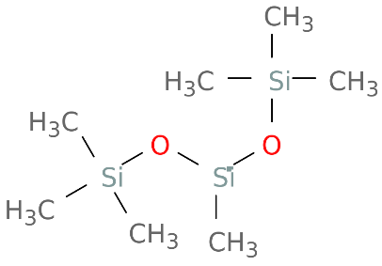
4c | 5-amino-6-hydroxy-4-oxo-, ethyl ester | C12H11NO5 | CCOC(=O)C1=CC(=O)C2=C(O1)C=CC(=C2N)O | 619354 | 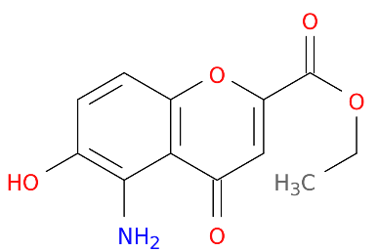
4d | 1-Propene, 3-methoxy- | C4H8O | COCC=C | 69392 | 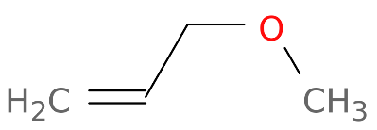
4e | Phthalic acid, butyl hept-4-yl ester | C19H28O4 | CCCCOC(=O)C1=CC=CC=C1C(=O)OC(CCC)CCC | 91720764 | 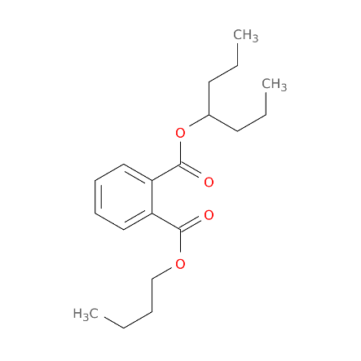
4f | Heptane, | C9H20 | CCCCCCC | 8900 | 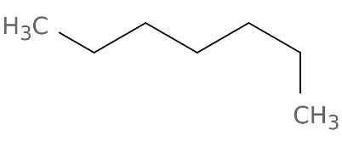
4g | 3,3-dimethyl- N- (Methyl sulfonyl)-N, O-bis (trimethyl silyl) hydroxylamine | C7H21NO3SSi2 | CN([Si](C)(C)C)S(=O)(=O)O[Si](C)(C)C | 155620124 | 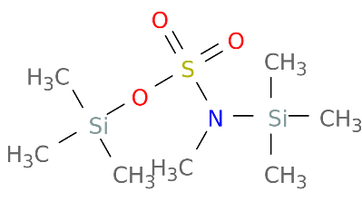
4h | Dodecanoic acid, 2-methyl- | C13H26O2 | CCCCCCCCCC[C@@H](C)C(=O)O | 5312339 | 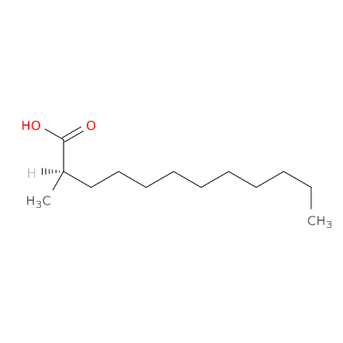
4i | 2-Acetyl-3-ethylpyrazine | C8H10N2O | CCC1=NC=CN=C1C(=O)C | 61918 | 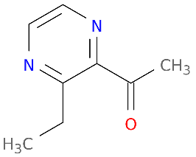
4j | Eicosane | C20H42 | CCCCCCCCCCCCCCCCCCCC | 8222 | 