Supplementary information

Table. S1 The combination weight of water stress index
Category | Indexes | Combination weight | Property
Demand side | Domestic water withdrawal | 0.069 | -
Demand side | Irrigation water withdrawal | 0.221 | -
Demand side | Manufacturing water withdrawal | 0.080 | -
Demand side | Evapotranspiration | 0.072 | -
Supply side | Groundwater recharge resources | 0.071 | +
Supply side | Groundwater runoff | 0.057 | +
Supply side | Snow water equivalent | 0.150 | +
Supply side | Total soil moisture content | 0.056 | +
Supply side | Subsurface runoff | 0.057 | +
Supply side | Surface runoff | 0.167 | +

Table. S2 Z-score values and corresponding P-values and confidence levels
Z-score | P-value | Confidence
< -1.65 or > +1.65 | < 0.10 | 90%
< -1.96 or > +1.96 | < 0.05 | 95%
< -2.58 or > +2.58 | < 0.01 | 99%

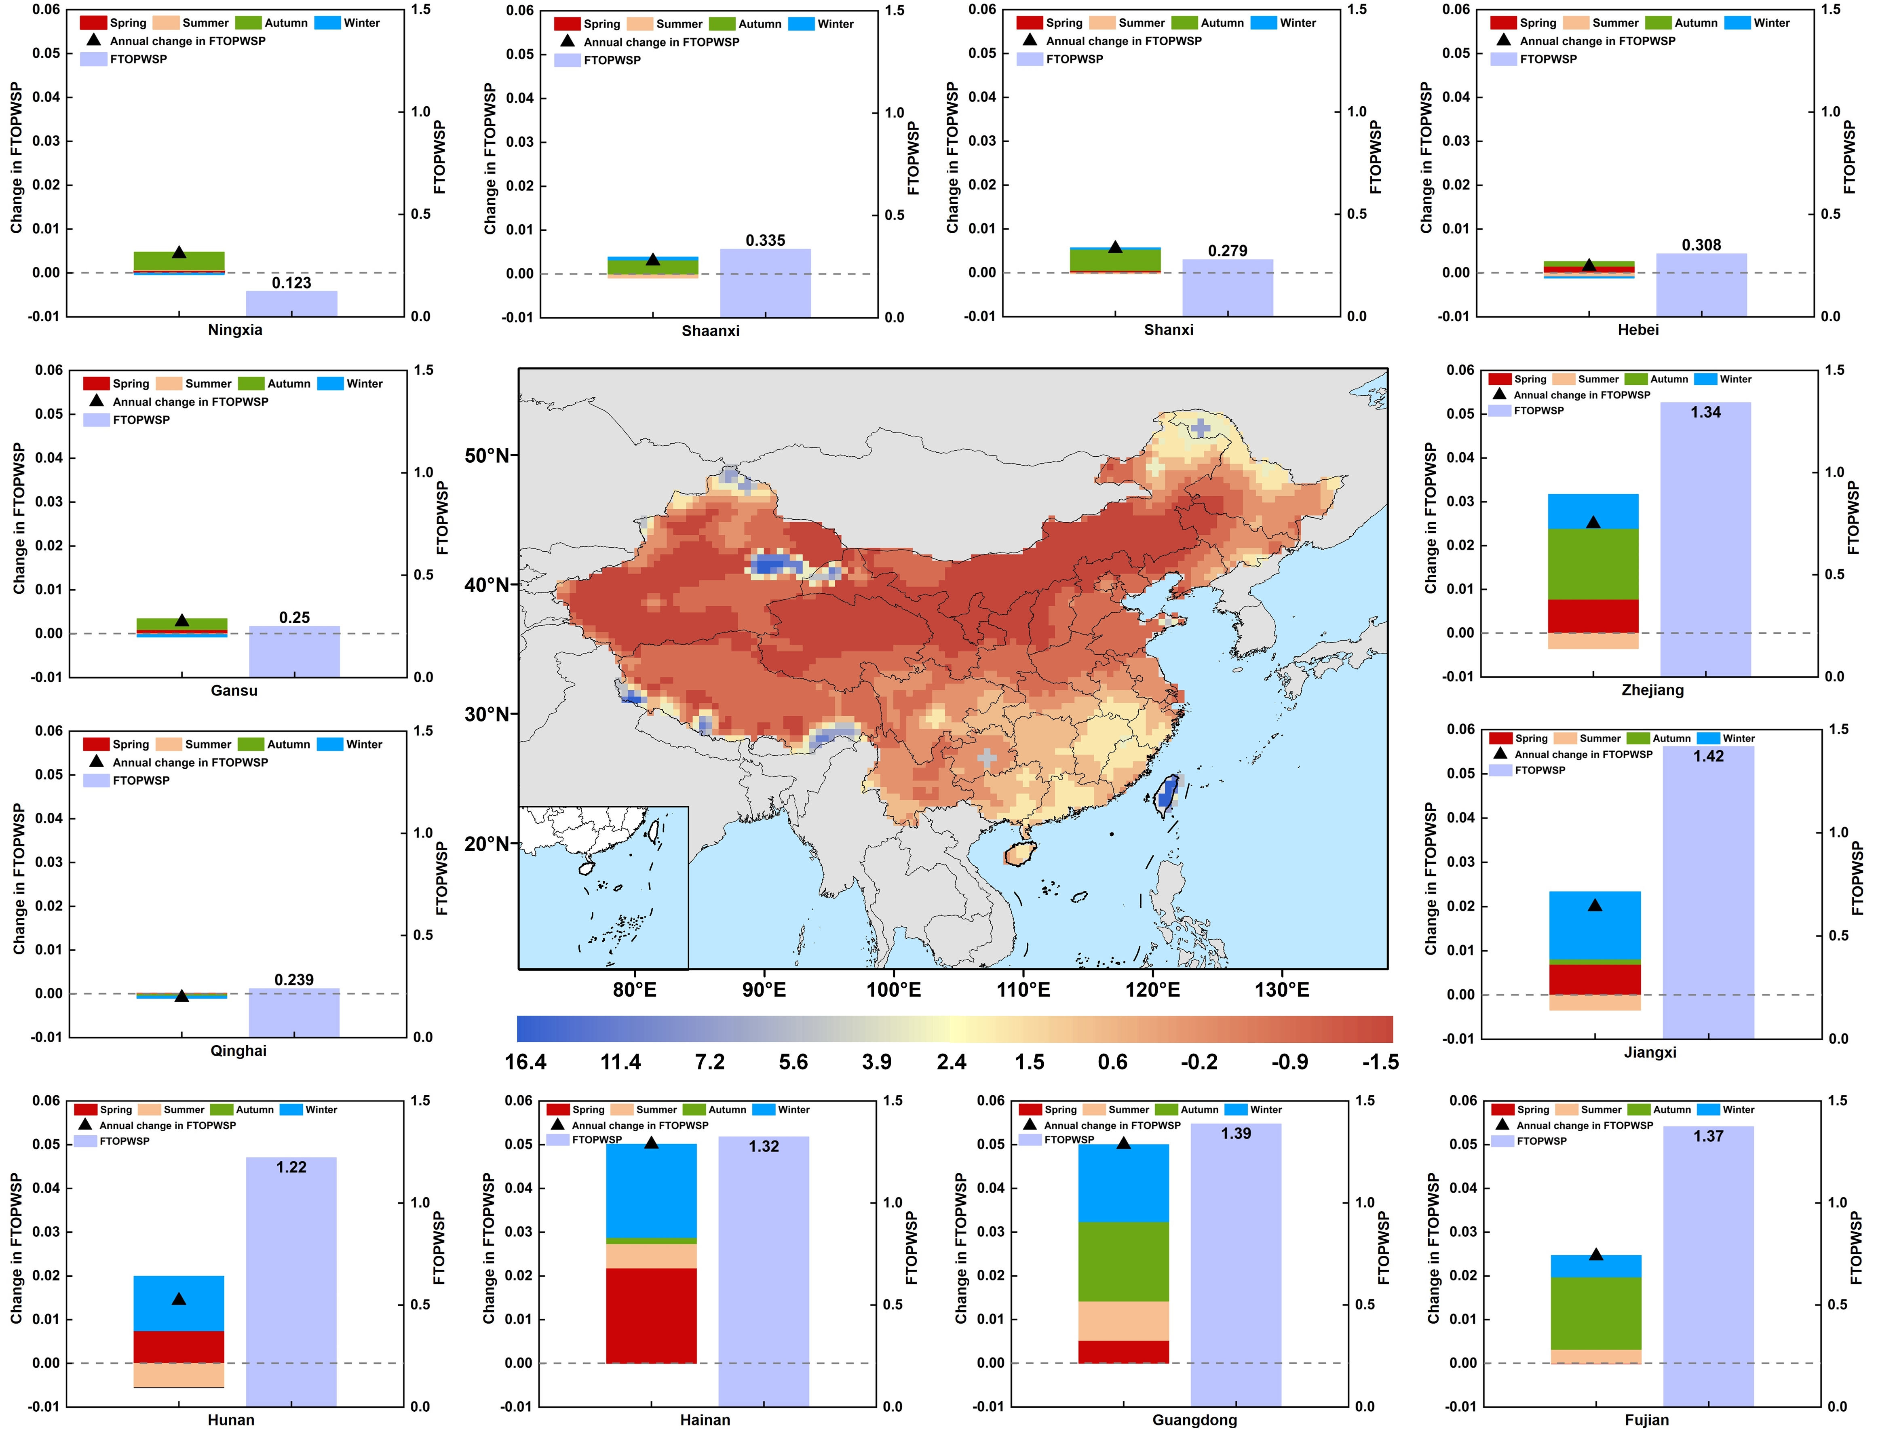
Figure. S1 Hotspot analysis of water stress under RCP2.6-SSP2 scenario. The central map represents the spatial distribution of Z-score values from Getis-Ord hotspot analysis. Surrounding bar charts represent the provincial average FTOPWSP values and seasonal changes.

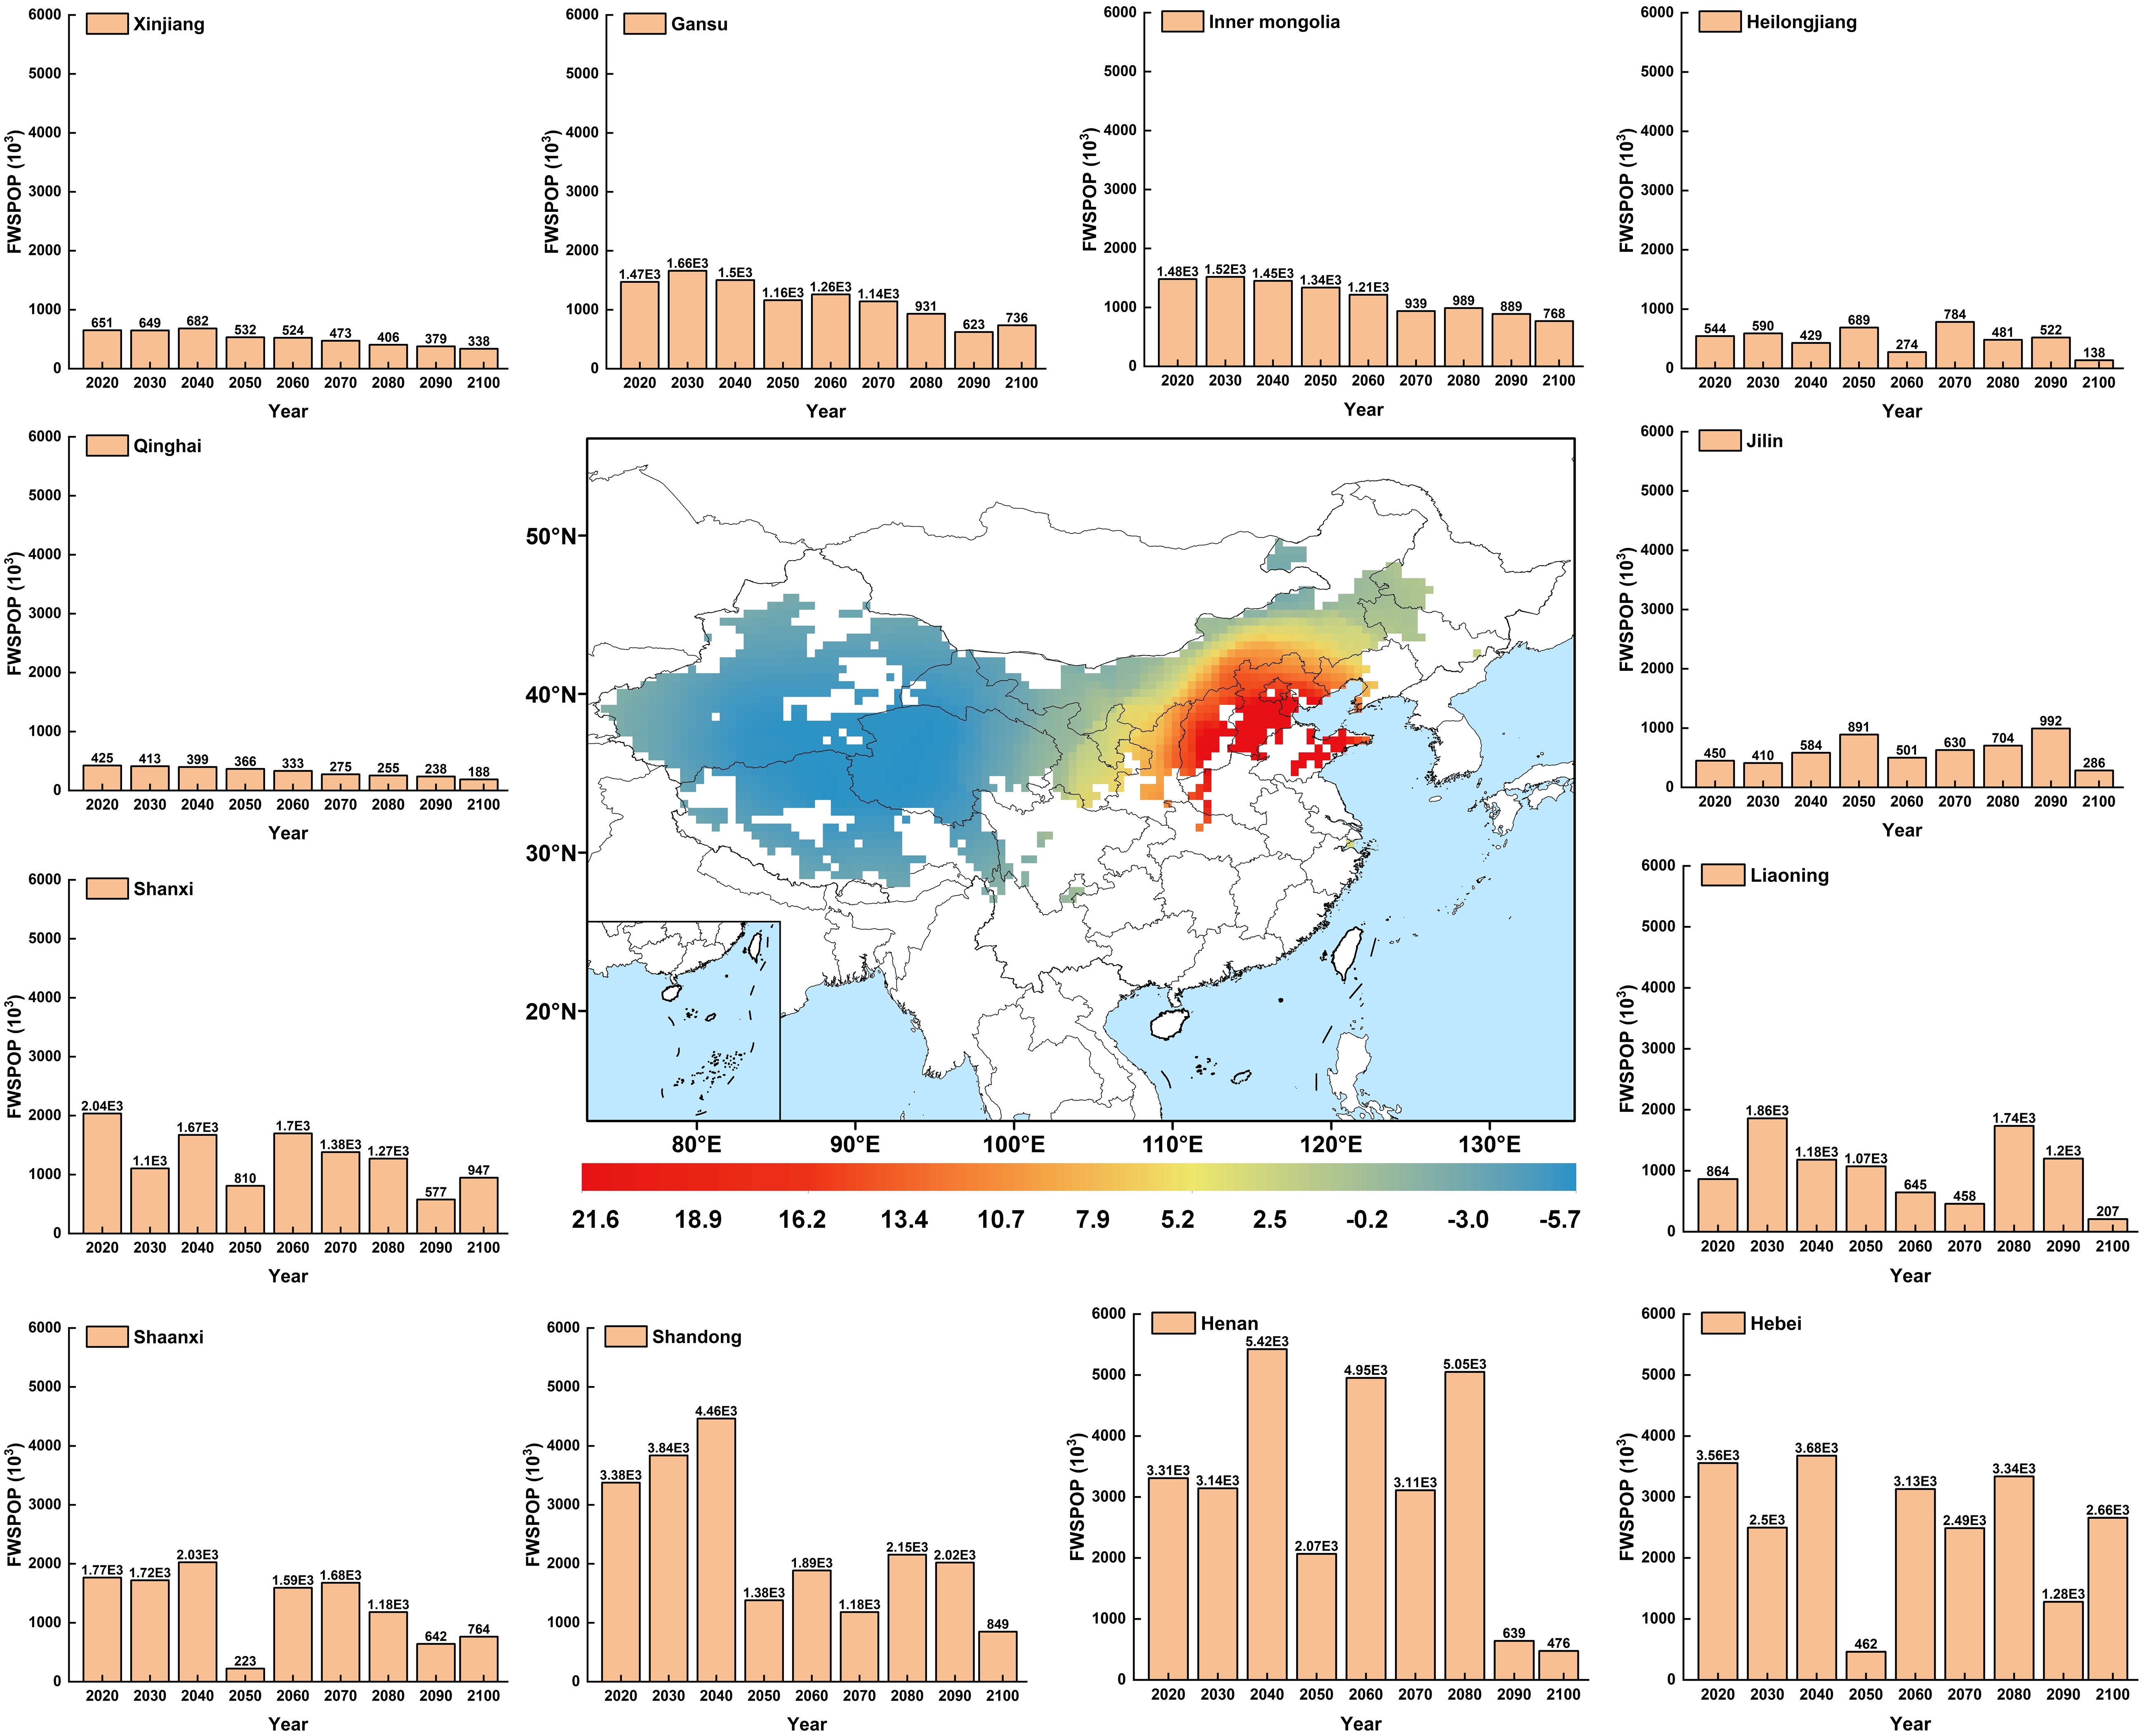
Figure. S2 Hotspot analysis of FWSPOP under RCP2.6-SSP2 scenario. The central map represents the spatial distribution of Z-score values from Getis-Ord hotspot analysis. Surrounding bar charts represent the FWSPOP changing trends of 12 provinces with the largest number of FWSPOP.

