Supporting Information

Nitrogen-doped carbon dots@COF_{BTH-TT} composite for high-performance lithium ions battery anode

Yuan Li, Kaixiang Chen, Hao Yu, Yonghai Song and Yan Du∗

National Engineering Research Center for Carbohydrate Synthesis/Key Lab of Fluorine and Silicon for Energy Materials and Chemistry of Ministry of Education, College of Chemistry and Chemical Engineering, Jiangxi Normal University, 99 Ziyang Road, Nanchang 330022, China.

Materials
Citric acid anhydrous, urea, glacial acetic acid, N,N-dimethylformamide (DMF), acetone and other reagents purchased from Aladdin Reagent Company. 1,3,5-benzoylhydrazine (BTH), thieno [3,2-b] thiophen-2,5-dicarboxylaldehyde (TT) were purchased from Jilin Yanshen Technology Co., LTD. (Changchun, China). All reagents were analytically pure grade without further purification. The ultrapure water was purified by Millopore-Q apparatus (18.2 MΩ cm⁻¹).

Characterization
Fourier-transform infrared spectroscopy (FTIR) spectra were measured in the 4000-400 cm⁻¹ range on a Perkin-Elmer Spectrum I spectrometer with samples prepared as KBr pellets. Scanning electron microscopy (SEM) images and energy-dispersive X-ray spectroscopy (EDS) were obtained on a HITACHI S3400 performing at an acceleration voltage of 20 kV with an energy dispersive X-ray analyzer (EDXA). Transmission electron microscopy (TEM) images were obtained with JEM-2010 (HR). Powder X-ray diffraction (XRD) analysis was carried out on a D/Max 2500 V/PC X-ray powder diffractometer using Cu Kα radiation. X-ray photoelectron spectroscopy (XPS) analysis was obtained by an ESCALAB 250Xi spectrometer (ThermoFisher Scientific Co., United States). N₂ adsorption and desorption isothermal test was carried out by Autosorb-iQ (Quantachrome) under a liquid nitrogen atmosphere of 77 K. All samples were subjected to vacuum treatment at 120°C before the test. The specific surface of the sample was calculated using the method of Langmuir and Brunauer-Emmett-Teller (BET). The pore size distribution was calculated by the method of Barret-Joyner-Halenda (BJH).

Electrochemical measurements
The working electrode was derived from a homogeneous slurry which included active materials, acetylene black and poly(vinylidene fluoride) (PVDF) with a weight ratio of 8:1:1. The mixture was added into N-methylpyrrolidone, then dispersed evenly on copper foil. Next, the working electrodes were kept at 60ºC in a vacuum oven overnight. The thickness of the loading active material was 50 μm. The total weight of the materials in the working electrode loaded on the copper foil was about 1.172 mg, the proportion of the target materials 80%, specifically 0.938 mg, and the load on the copper foil was 0.8 mg cm⁻². The separator was Celgard 2300 microporous polypropylene film. The half-cell was assembled in an argon-filled glove box. The electrolyte was composed of 1.0 M LiPF₆ added in a solvent mixed with ethylene carbonate, diethyl carbonate and dimethyl carbonate. Finally, galvanostatic charging/discharging tests were carried out at a voltage range from 3.0 to 0.01 V versus Li/Li⁺ on a Neware BTS test system (Shenzhen, China). Cyclic voltammograms (CV) and electrochemical impedance spectroscopy (EIS) were determined by a CHI 760E electrochemical workstation obtained from Shanghai CH Instruments. The scanning rate of the parameters of the CV test was 0.2 mV s⁻¹, and the scanning voltage range was 0.01-3 V at room temperature. EIS was conducted by applying a perturbation voltage of 5 mV and DC open-circuit voltage in the frequency range of 100 kHz-0.01 Hz at room temperature. And cells were poised at the selected potential for at least 5 min before measurement. A traditional three-electrode system, lithium metal acted as the counter and reference electrode and target materials acted as the working electrode, was employed in the above electrochemical test.

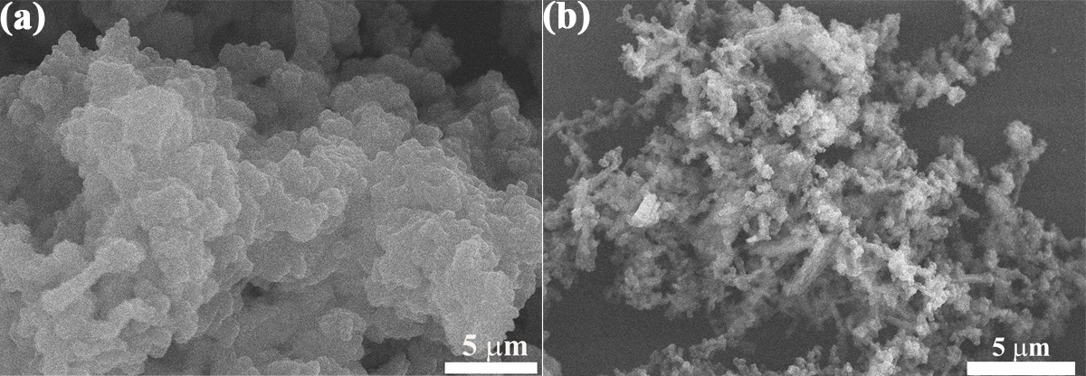

Fig. S1. SEM images of COF_{BTH-TT} (a) and NCDs@COF_{BTH-TT} (b).

Fig. S2. EDX spectra of NCDs (a), COF_{BTH-TT} (d) and NCDs@COF_{BTH-TT} (g). Element mapping of NCDs (b, c), COF_{BTH-TT} (e, f) and COF_{BTH-TT} (h, i).

Fig. S3. XRD patterns of NCDs, COF_{BTH-TT}, and NCDs@COF_{BTH-TT}.

Fig. S4. (a) Full XPS spectrum of COF_{BTH-TT}, high-resolution XPS spectra for C1s (b), N1s (c), and S2p (d) of COF_{BTH-TT}.
Fig. S5. (a) Bode plots obtained from EIS measurements of NCDs@COF_{BTH-TT}-10 (a), NCDs@COF_{BTH-TT}-30 (b), NCDs@COF_{BTH-TT}-50 (c) COF_{BTH-TT} (d), and NCDs (e) electrodes.

Table S1. Comparison of COFs-based composites.
Electrode material | Current density (mA g⁻¹) | Specific capacity  (mAh g⁻¹) | Reference
2D-PAI | 100 | 104 | [1]
DAAQ-ECOF | 20 | 145 | [2]
Tb-DANT-COF | 50 | 144.4 | [3]
P14AQ | 500 | 1023 | [4]
HATNPF2 | 200 | 205 | [5]
PDB | 20 | 249 | [6]
NCDs@COF_{BTH-TT}-30 | 200 | 210.7 | This Work

Table S2. EIS fitting data of each part obtained according to equivalent circuit fitting.
Sample | R_{s} (Ω) | R_{SEI} (Ω) | R_{ct} (Ω)
NCDs@COF_{BTH-TT}-10 | 2.18 | 97.63 | 151.80
NCDs@COF_{BTH-TT}-30 | 1.77 | 66.80 | 148.10
NCDs@COF_{BTH-TT}-50  COF_{BTH-TT} | 1.57  6.85 | 30.45  143.80 | 97.09  177.10
NCDs | 1.97 | 87.49 | 164.3

References
- Wang G, Chandrasekhar N, Biswal BP, Becker D, Paasch S, Brunner E, Addicoat M, Yu M, Berger R, Feng X (2019) A Crystalline, 2D Polyarylimide Cathode for Ultrastable and Ultrafast Li Storage. Adv Mater 31(28):e1901478
- Wang S, Wang Q, Shao P, Han Y, Gao X, Ma L, Yuan S, Ma X, Zhou J, Feng X, Wang B (2017) Exfoliation of covalent organic frameworks into few-layer redox-active nanosheets as cathode materials for lithium-ion batteries. J Am Chem Soc 139(12):4258-4261
- Yang D, Yao Z, Wu D, Zhang Y, Zhou Z, Bu X (2016) Structure-modulated crystalline covalent organic frameworks as high-rate cathodes for Li-ion batteries. J Mater Chem A 4(47):18621-18627
- Song Z, Qian Y, Gordin ML, Tang D, Xu T, Otani M, Zhan H, Zhou H, Wang D (2015) Polyanthraquinone as a reliable organic electrode for stable and fast lithium storage. Angew Chem Int Ed 54(47):13947-13951
- Wang J, Chen C, Zhang Y (2017) Hexaazatrinaphthylene-Based Porous Organic Polymers as Organic Cathode Materials for Lithium-Ion Batteries. ACS Sustain Chem Eng 6(2):1772-1779
- Xie J, Wang Z, Xu Z, Zhang Q (2018) Toward a High-Performance All-Plastic Full Battery with a Single Organic Polymer as Both Cathode and Anode. Adv Energy Mater 8(21):1703509

∗Corresponding author: Tel/Fax: +86079188120861. E-mail: wjxdu01@163.com (Y. Du)

