Supplementary
A Novel Enzyme-Free Approach for Precursor microRNA Cloning and Expression

Figure. 1S: Scheme of pJEBB-eGFP-miR-21
Table 1. Primers used in the present study

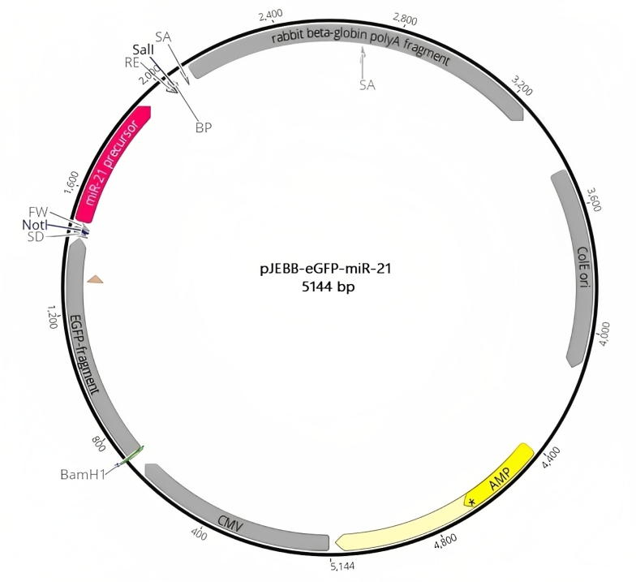
Figure. 1S

Table 1.
Primer name | Sequence (5'-3') | Reason/Product lenght
F-miR21 primer | ATAGAAGCGGCCGCGGGTTCGATCTTAACAGGCC | To amplify miRNA-21 precursor of genomic DNA/ 430bP
R-miR21 primer | GCATTCACTATCAAAACCCACAATGCAGCT | To amplify miRNA-21 precursor of genomic DNA/ 430bP
F-miR21-sticky primer | CACCTATAGAAGCGGC | To amplify Forward strand of precursor/434bp
R-miR21-sticky primer | AAACTGCATTCACTATC | To amplify reverse strand of precursor/434bp
Oligonucleotide-1 | GGCCGCCACCGGGTCTTCGAGAAGACCTGTTTTG | To confirm presence of Oligo1and Oligo2 in plasmid/190bp
RVpJEBB | GTCGAGGACCTGGAGGG | To confirm presence of Oligo1and Oligo2 in plasmid/190bp
FVpJEBB | CTGCCCGACAACCACTACC | To confirm presence of Oligo1and Oligo2 in plasmid/100bp
Oligonucleotide-2 | TCGACAAAACAGGTCTTCTCGAAGACCCGGTGGC | To confirm presence of Oligo1and Oligo2 in plasmid/100bp
miR-21 RT primer | CCAGTGAGCAGAGTGACGAGGACTCGAGCTCAAGCTTTTTTTTTTTTTTTTTGA | To cDNA synthesizes of miR-21
U48 RT primer | CCAGTGAGCAGAGTGACGAGGACTCGAGCTCAAGCTTTTTTTTTTTTTTTTTGG | To cDNA synthesizes of U48
miR21F primer | GGCGTAGCTTATCAGACTGATG | To conduct qPCR for relative expression of miR-21/ 72bp
RUni | CCAGTGAGCAGAGTGACG | To conduct qPCR for relative expression of miR-21/ 72bp
U48F primer | TGATGACCCCAGGTAACTCTG | To conduct qPCR for relative expression of U48 as references gene/ 72bp
RUni | CCAGTGAGCAGAGTGACG

