Supplementary Materials for
Global Evolutionary Optimized Metasurface for Broad-angle Multisource Invisibility Cloaking

Min Huang¹, Bin Zheng^{1,2,3*}, Ruichen Li¹, Lian Shen¹, Xiaofeng Li⁴, Huan Lu^{1,3}, Rongrong Zhu^{1,5}, Tong Cai⁴, Hongsheng Chen^{1,2,3*}
¹Interdisciplinary Center for Quantum Information, State Key Laboratory of Modern Optical Instrumentation, ZJU-Hangzhou Global Scientific and Technological Innovation Center, Zhejiang University, Hangzhou 310027, China
²International Joint Innovation Center, Key Lab. of Advanced Micro/Nano Electronic Devices & Smart Systems of Zhejiang, The Electromagnetics Academy at Zhejiang University, Zhejiang University, Haining 314400, China
³Jinhua Institute of Zhejiang University, Zhejiang University, Jinhua 321099, China
⁴Air and Missile Defense College, Air Force Engineering University, Xi’an 710051, China
⁵School of Information and Electrical Engineering, Zhejiang University City College, Zhejiang 310015, China

*Corresponding author. Email: Bin Zheng, zhengbin@zju.edu.cn; HongSheng Chen, hansomchen@zju.edu.cn;

The PDF file includes:
Supplementary Note 1. Simulation details on multiple simultaneous incident sources
Supplementary Note 2. Wideband and high-reflectivity meta-atom design
Supplementary Note 3. Full wave simulation of PEC plane and meta-cloak under plane wave irradiation
Supplementary Note 4. Simulation results of horn irradiation
Supplementary Note 5. Cloaking performance of three simultaneous incident electromagnetic waves
Supplementary Note 6. Cloaking performance at any frequency and incident direction
Supplementary Note 7. Control circuit for metasurface voltage supply

Supplementary Note 1. Simulation details on multiple simultaneous incident sources
In the simulation software, CST Microwave Studio, it is impossible to conveniently create two incident sources at the same time, so we extract the real and imaginary parts of the electric and magnetic fields at a certain distance to superimpose together to equivalent the multiple simultaneous incident sources. The case of two sources incident at the same time is taken as an example. First, to facilitate location determination, a slab of air of the same size as PEC was created in the simulation, as shown in Fig. S1 a and b. The oblique incident plane waves are used as the excitation sources. The real and imaginary parts of the electric and magnetic fields at z=200 mm (the black boxes in Fig. S1 a and b) from the plate is extracted respectively. Secondly, the electric and magnetic fields are added together to obtain the synthetic electric and magnetic field, which is imported into CST as equivalent incidence source, as shown in Fig. S1 c. The total synthetic field, containing the field information of two oblique incident waves, is equivalent to two plane waves irradiated at the same time. In the simulation, the x and z directions are open boundaries, and the y direction is periodic boundaries. The boundary conditions of the three simulations are consistent.
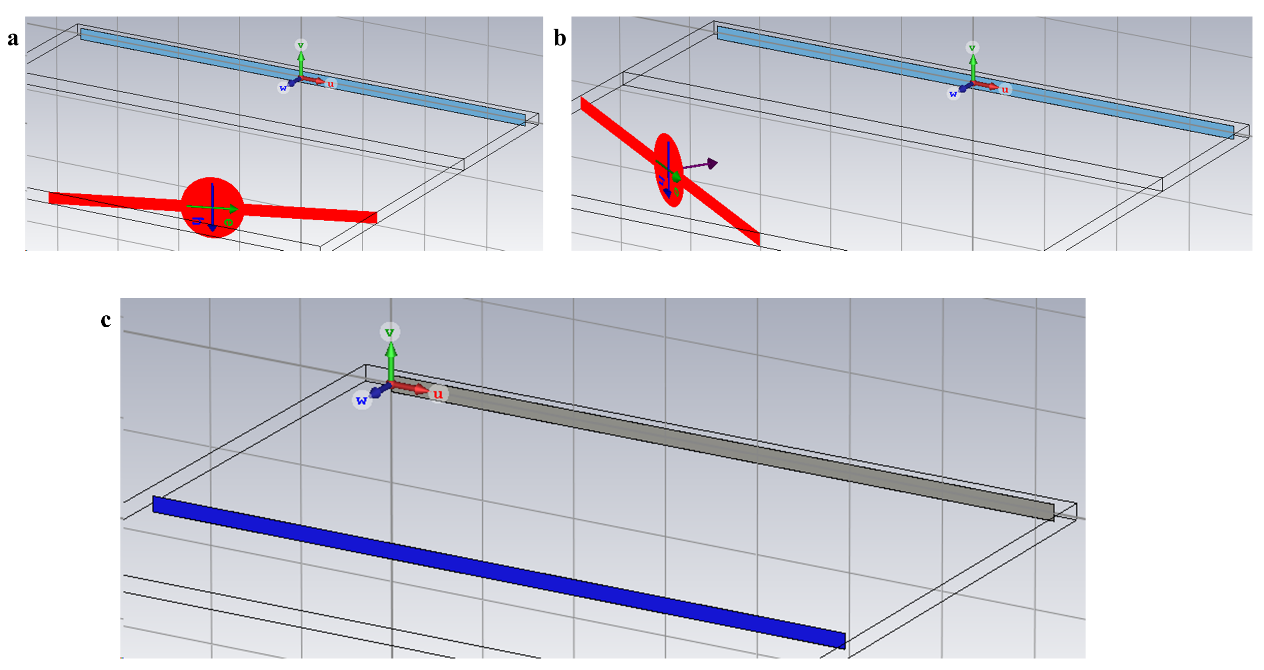
Fig. S1. Simulation setup of synthetic equivalent source. Incident electromagnetic fields of ${-20}^{°}$ (a) and ${35}^{°}$ (b) oblique incidence. c The equivalent incidence source at two oblique incidence angles is incident on the PEC.

Supplementary Note 2. Wideband and high-reflectivity meta-atom design
The metasurface cloak uses a highly reflective unit (as shown in Fig. S2a) that covers about ${300}^{°}$ of phase. It consists of two metal layers and one 3-mm-thick F4B dielectric ($ε_{r}=2.65$ and tan$δ=0.001$) layer. Two columns of metal polars with a radius of 0.4 mm and a spacing of 0.8 mm are arranged on both sides of the unit to act as electrical walls and effectively reduce electromagnetic coupling (as shown in Fig. S2b). Detailed parameters are shown in Table S1. Two thin metal strips extending to the edge supply power to the varactor diodes (SMV2019-079LF). The equivalent circuit of a varactor diode consists of a resistor $R_{var}$, an inductor $L_{var}$ and a capacitor $C_{var}$ in series. The equivalent capacitance $C_{var}$ varies from 0.27 pF to 2.8 pF upon applying a DC voltage from -19 V to 0 V. The equivalent resistance $R_{var}$ and inductance $L_{var}$ values are approximately 3 Ohm and 0.7 nH, respectively. The unit is insensitive to the incident angle and maintains a constant reflectivity, as shown in Fig. S2d. In Fig. S2c, the phase gap of oblique incident wave is consistent with that of vertical incident wave. Figures S2e and f show that the unit has a wide working frequency range of 5 GHz to 5.8 GHz. Figures S2g and h demonstrate the experimental results of the phase and amplitude response of the unit, basically consistent with the simulation results in Fig. S2e.

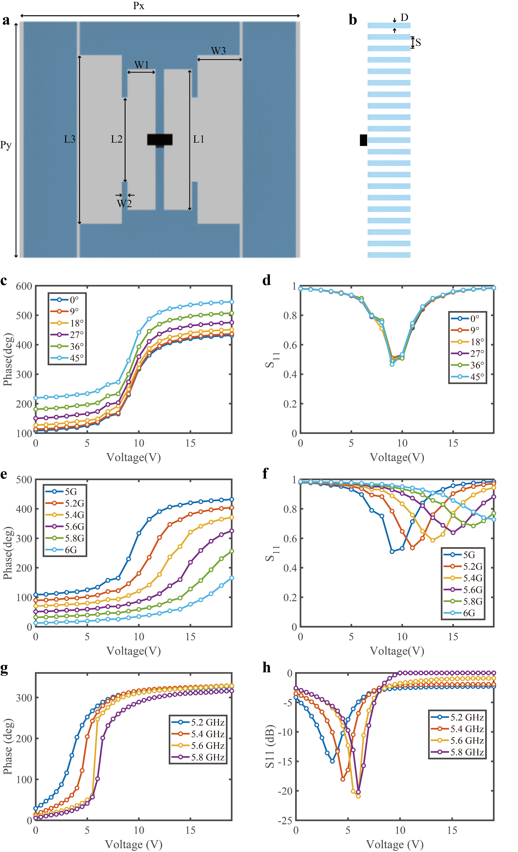
Fig S2. Unit parameters and its amplitude and phase response. a Top view of metasurface unit. b Side view of unit. Simulation results of phase (c) and amplitude (d) at different oblique incidence angles. Simulation results of phase (e) and amplitude (f) of different frequencies at vertical incidence. Experimental results of phase (g) and amplitude (h) of 5.2-5.8 GHz at vertical incidence.

Table S1. Parameters for the transmissive meta-atom in millimeters
Parameter | Px | Py | L1 | W1 | L2 | W2 | L3 | W3
Value | 20 | 16.8 | 10 | 2 | 6 | 0.4 | 12 | 3

Parameter | D | S | H | t | gap
Value | 0.4 | 0.8 | 3 | 0.035 | 0.6

Supplementary Note 3. Full wave simulation of PEC plane and meta-cloak under plane wave irradiation
To mimic the experimental scenario, the bumps and invisibility cloak are placed on the PEC ground plane (Fig. S3a and b). The cloak is made up of 36 columns of individually controllable units, with bumps hidden underneath (Fig. S3a). In the direction of the electric field, the ground plane is 500 mm long, about $9λ$. Considering the simulation speed, the solution is carried out in the frequency domain. In simulation, the open (add space) boundary is selected in the x and z directions, and the period boundary is applied to the y direction. Multiple sources are set up the same way as a single plane wave incident.
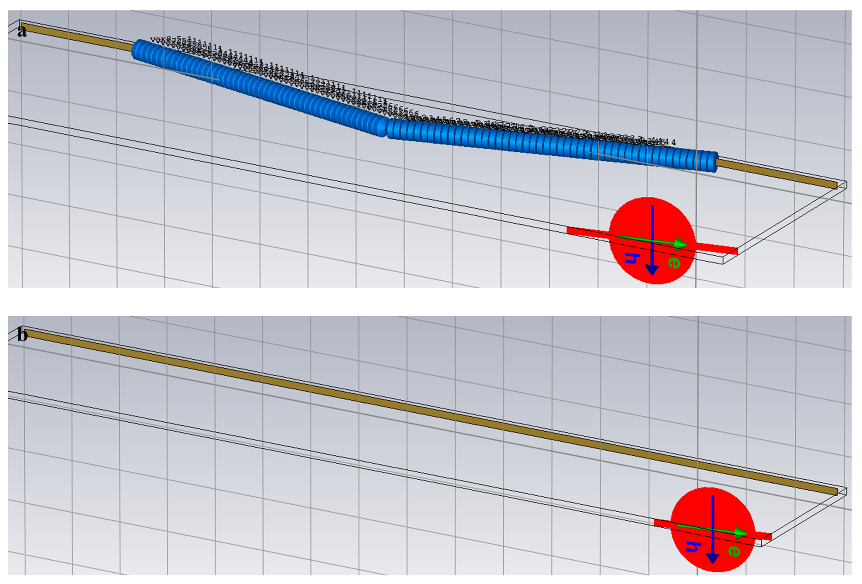
Fig. S3 Schematic of full wave simulation diagram in CST. a The oblique incident plane wave of ${10}^{°}$ illuminates the bump covered by the cloak. b Plane waves are oblique incident on the PEC ground.

Supplementary Note 4. Simulation results of horn irradiation
As shown in Fig. S4a, all simulations of bumps in this work use the horn as the incident source. In order to be realistic, the model of this horn is created exactly according to the actual horn size. The frequency domain solver is used in CST. The boundary conditions are open (add space) in all directions. The wave emitted by the horn is not an ideal plane wave, but a spherical wave. It can be seen from the near field in Fig. S4b that the new reflection is caused by the angle between the triangle bump and the ground when the spherical wave is incident. The undesirable reflection interferes with the reflection from the inclined and planar PEC. The far field in Fig. S4c illustrates four distinct crests at angles of ${-14.52}^{°}$, ${1.49}^{°}$, ${36}^{°}$ and ${54}^{°}$. For comparison, Fig. S4d shows the simulation using plane waves as the excitation source. The reflected near field in Fig. S4e obviously has a different beam deflection direction than that in Fig. S4c. In the case of plane wave incidence, there are only three peaks, with angles of ${-9}^{°}$, ${20}^{°}$ and ${51}^{°}$, which is different from the case of spherical wave incidence (Fig. S4f). The spherical wavefront treats the included angle as a new incline, reflecting constantly. The extra sidelobes with high energy near the peaks are formed by the spherical wave incident at the included angle.

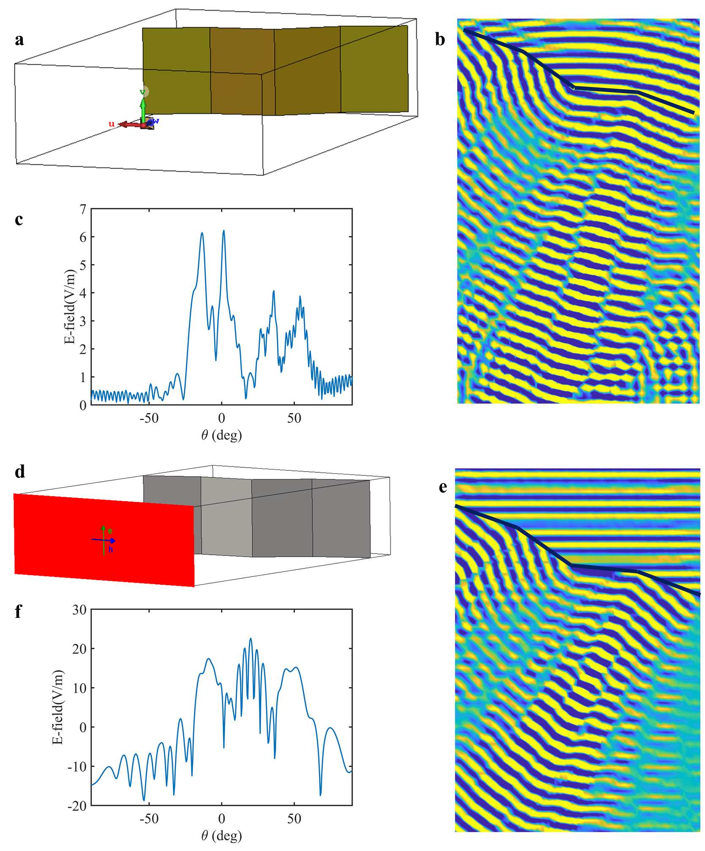
Fig. S4 The horn, as the emission source, is incident on the bump with the PEC background. a Simulation setup in CST Microwave Studio. b Reflection near field of horn oblique incidence. c Far-field results obtained by simulation. d Plane waves illuminate the triangular PEC bump. e Reflection near field of d. f The far field irradiated by plane waves.

Supplementary Note 5. Cloaking performance of three simultaneous incident electromagnetic waves
Similarly, we use genetic algorithm to optimize the phase arrangement that can simultaneously hide three incident waves at 5.5 GHz (same frequency with directions of $0^{°}$, $-10^{°}$ and ${25}^{°}$). Considering the metasurface modulation, the optimized actual output is voltage arrangement. The simulation also fully considers the varying capacitance characteristics of varactor under the same voltage in different electromagnetic environments. That is, the capacitance of varactor supplied by the same voltage is different under different incoming waves is, that is, the phase is different.

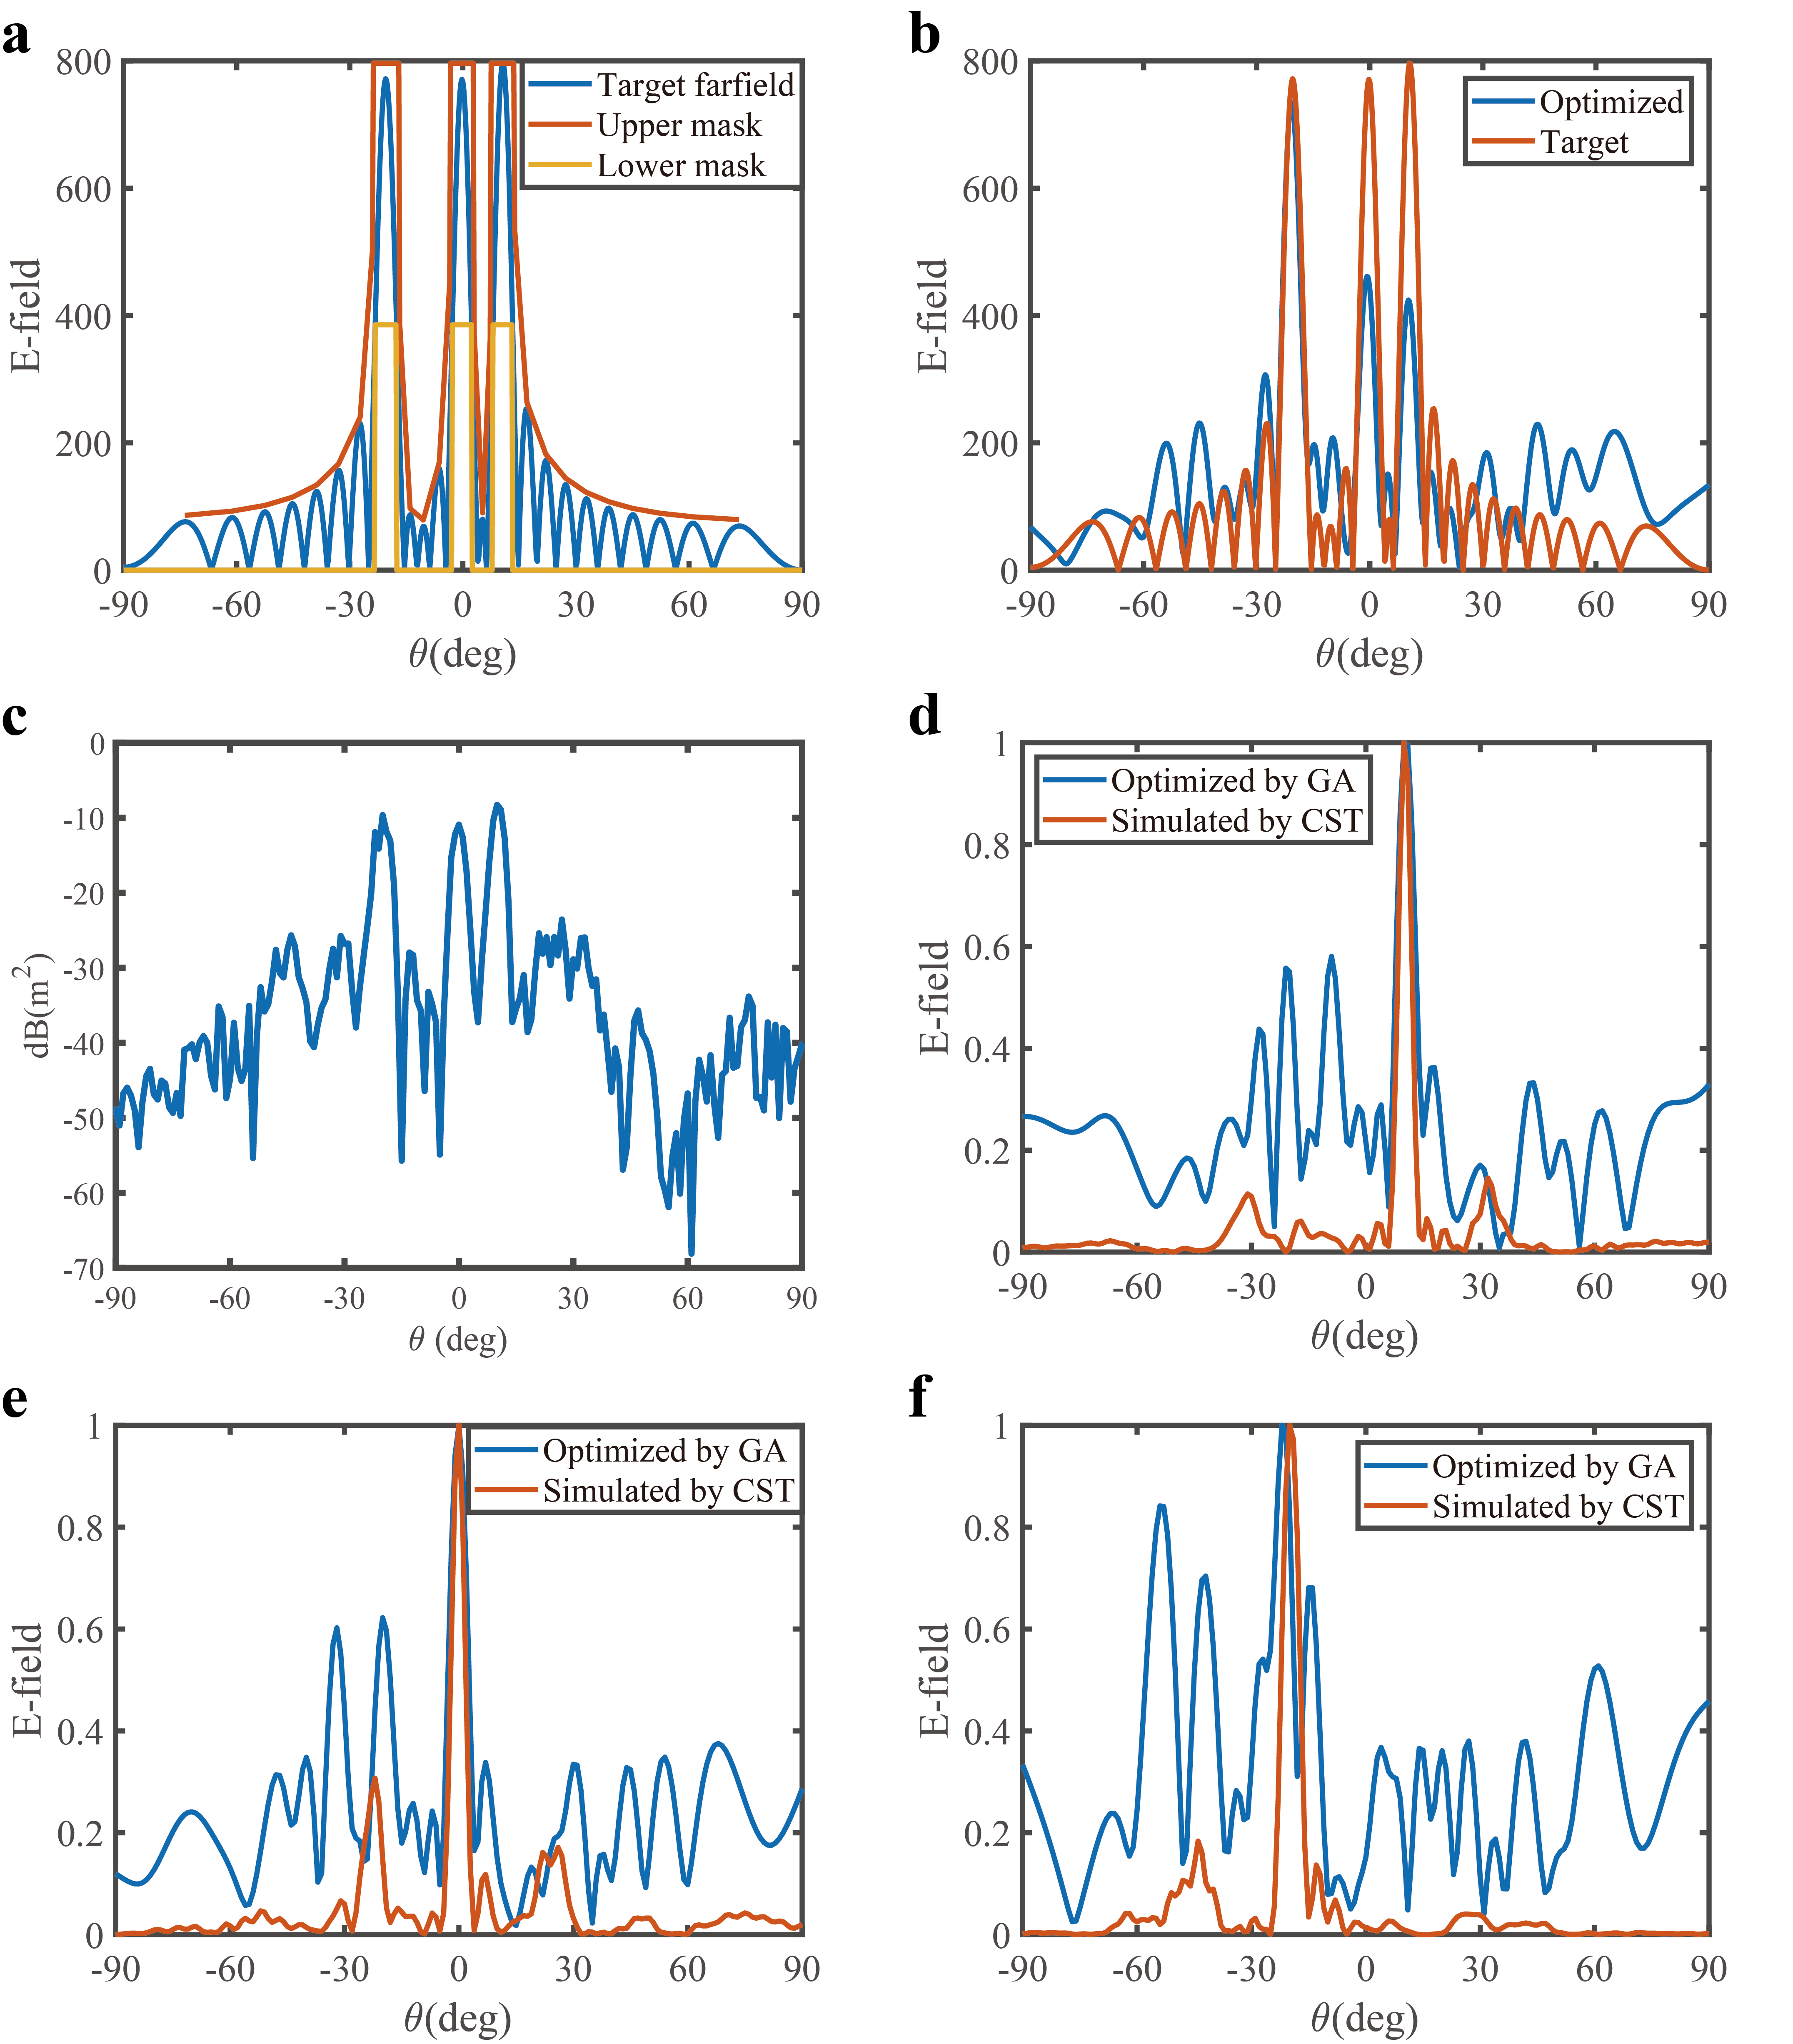
Fig. S5 The performance of the cloak under three arbitrary directions. a Customized upper and lower mask based on the target scattering pattern. b Comparison between optimization results and target patterns. c Simulation cloaking results of three sources incident at the same time. d, e, f Optimization and simulation results of a single oblique incident plane wave. The incident directions are ${-10}^{°}$, $0^{°}$ and ${25}^{°}$.

Table S2. Capacitance values for 36 units under three arbitrary directions
Units | 1 | 2 | 3 | 4 | 5 | 6 | 7 | 8 | 9
Capacitance (pF) | 0.363 | 0.384 | 2.43 | 2.82 | 2.67 | 1.08 | 2.28 | 2.46 | 2.66
Units | 10 | 11 | 12 | 13 | 14 | 15 | 16 | 17 | 18
Capacitance (pF) | 2.66 | 0.877 | 1.90 | 2.39 | 2.26 | 0.655 | 1.52 | 1.09 | 1.01
Units | 19 | 20 | 21 | 22 | 23 | 24 | 25 | 26 | 27
Capacitance (pF) | 2.11 | 1.42 | 0.530 | 1.78 | 1.99 | 2.75 | 1.06 | 0.630 | 0.746
Units | 28 | 29 | 30 | 31 | 32 | 33 | 34 | 35 | 36
Capacitance (pF) | 2.73 | 0.452 | 0.321 | 1.64 | 0.564 | 0.717 | 0.356 | 2.78 | 1.04

Supplementary Note 6. Cloaking performance at any frequency and incident direction
In the optimization of genetic algorithm, the stealthy effect of incoming wave at two frequencies is quantified respectively, and finally the respective fitness values are added to become the total fitness. As an explanatory example, incoming waves at 5 GHz and 5.5 GHz were selected for cloaking verification. Fig. S6a and b show the comparison between the optimized results of genetic algorithm and the targets under two frequencies. Fig. S6c and d shows the simulation results, indicating that the metasurface cloak has great potential to achieve the ability to hide incoming waves at any frequency and direction. Table S3 lists the optimized supply voltage for each column of units. The corresponding capacitance values were used in the simulation.

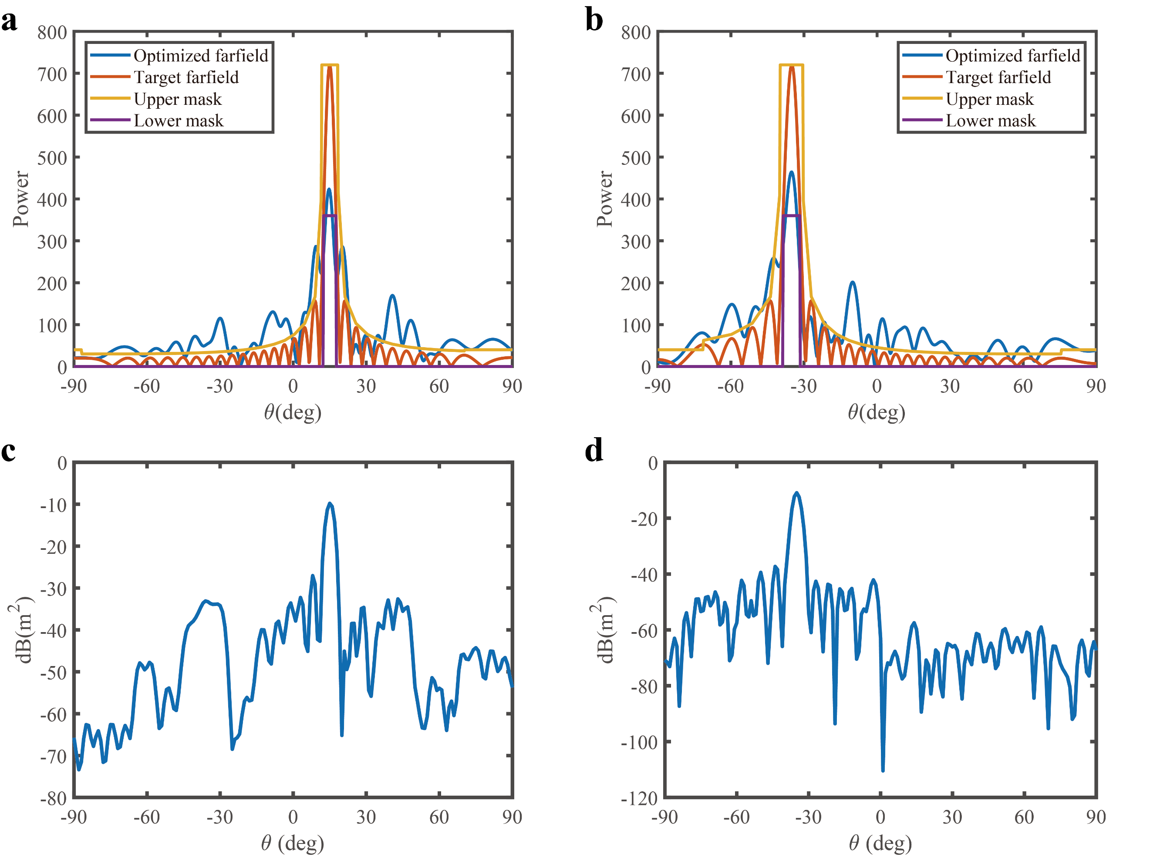
Fig. S6. Electromagnetic waves of different frequencies and directions are incident on the metasurface cloak. a, b Optimized E-field distributions in two frequencies. c, d Simulated results of far-field distribution.

Table S3. Voltages for 36 units in different frequencies and incident directions
Units | 1 | 2 | 3 | 4 | 5 | 6 | 7 | 8 | 9
Voltage (V) | 9.91 | 18.98 | 6.56 | 5.79 | 2.09 | 2.05 | 18.32 | 9.26 | 6.77
Units | 10 | 11 | 12 | 13 | 14 | 15 | 16 | 17 | 18
Voltage (V) | 6.66 | 5.86 | 1.51 | 2.08 | 2.40 | 9.18 | 6.59 | 8.25 | 6.01
Units | 19 | 20 | 21 | 22 | 23 | 24 | 25 | 26 | 27
Voltage (V) | 3.39 | 6.71 | 6.69 | 13.50 | 0.95 | 2.22 | 3.24 | 6.18 | 6.66
Units | 28 | 29 | 30 | 31 | 32 | 33 | 34 | 35 | 36
Voltage (V) | 7.50 | 18.85 | 0.12 | 1.34 | 2.71 | 6.27 | 6.67 | 10.07 | 17.47

Supplementary Note 7. Control circuit for metasurface voltage supply
The bias lines and ground lines of each column of the metasurface are connected separately, as shown in Fig. S7a. The units in the same column share the same voltage, and the metasurface is effective for X-polarized electromagnetic waves. The varactors need to be reversed in order to work normally, so the positive and negative electrodes of the diodes are connected to the ground and the bias layer respectively in the metasurface wiring. Fig. S7b shows a voltage control board that can independently output 64 0-20V voltages. We use STM32 as the main control chip and 8 DAC7718 chips for voltage output. The output voltage of DACs can be controlled by writing instructions to STM32.

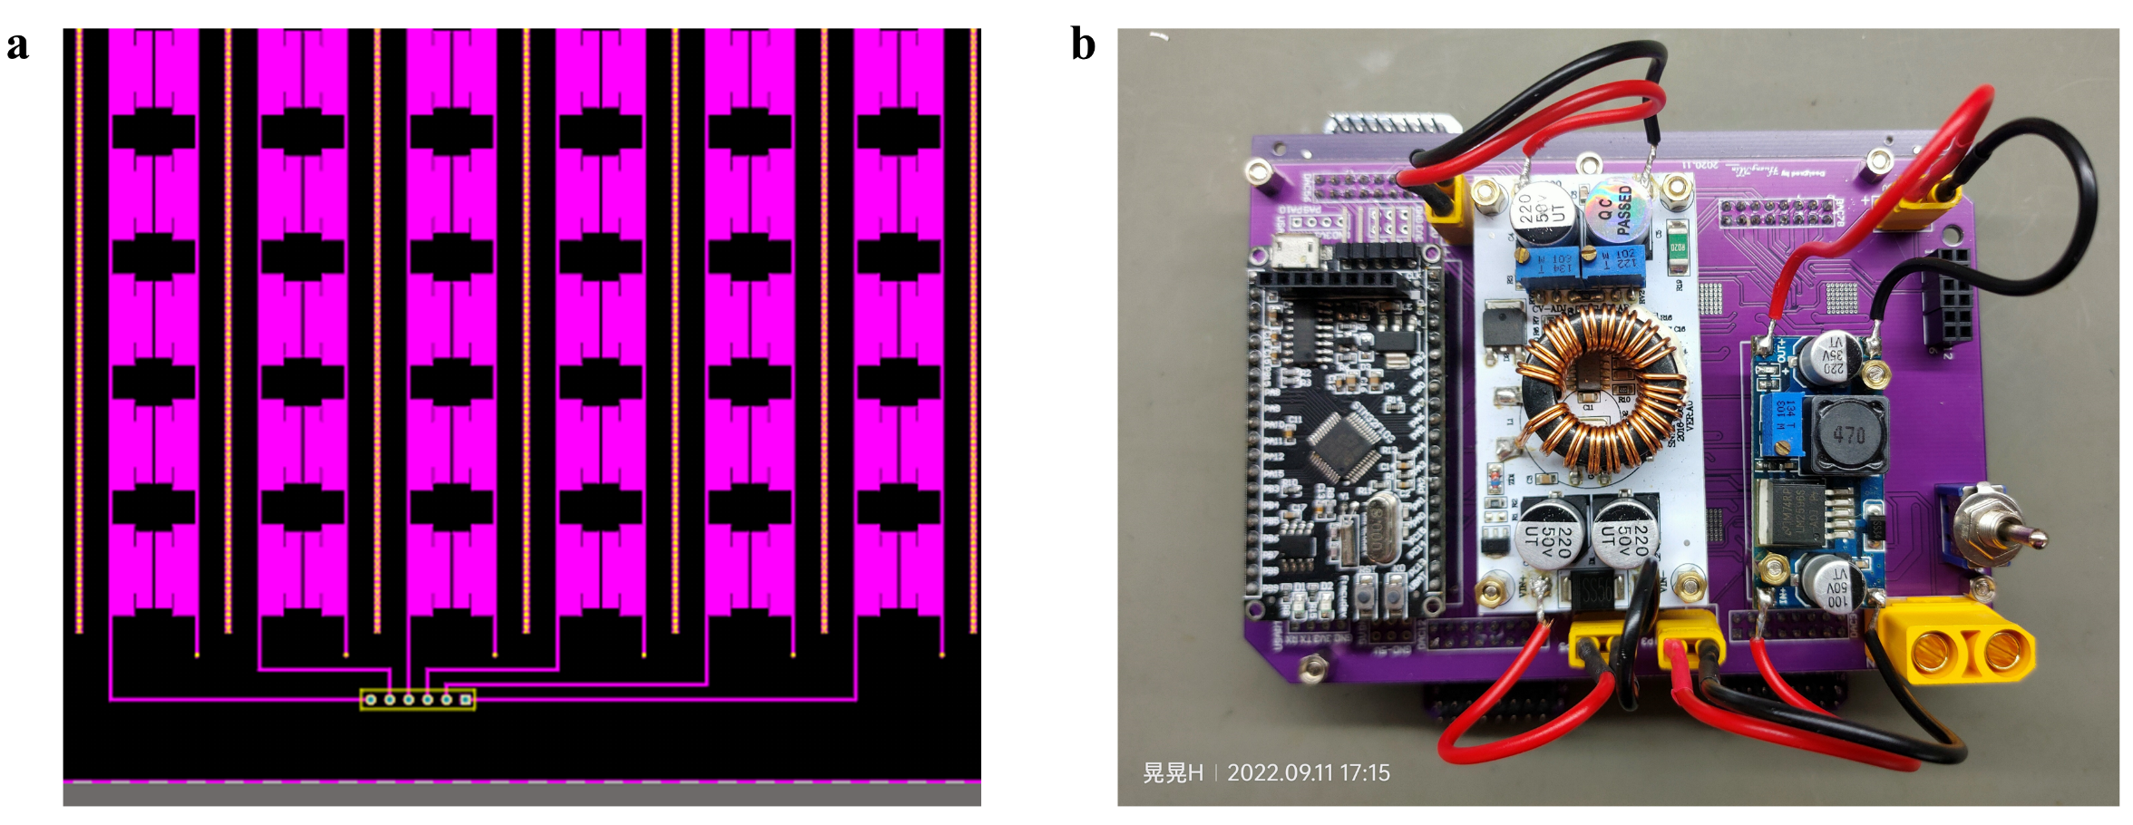
Fig. S7 Power supply settings for the metasurface cloak. a Metasurface power supply wiring. b Voltage control board output 0-20V specified voltage, to achieve independent control of 36 units.

