Supplementary Information
for
Continuously tuneable laser in the full visible spectrum formed in 10 minutes with cholesteric liquid crystal cells based on the electrothermal effect.

Table of Contents

Supplementary figures

S1 .........................................................................................................................................................2

S2 .........................................................................................................................................................3

S3 .........................................................................................................................................................4

S4 .........................................................................................................................................................5

S5 .........................................................................................................................................................6

S6 .........................................................................................................................................................6

S7 .........................................................................................................................................................7

S8 .........................................................................................................................................................7

S9 .........................................................................................................................................................8

S10 ……………………………………………………………………………………..……………9

Supplementary text S1 ....................................................................................................................10

Supplementary Movies ...................................................................................................................10

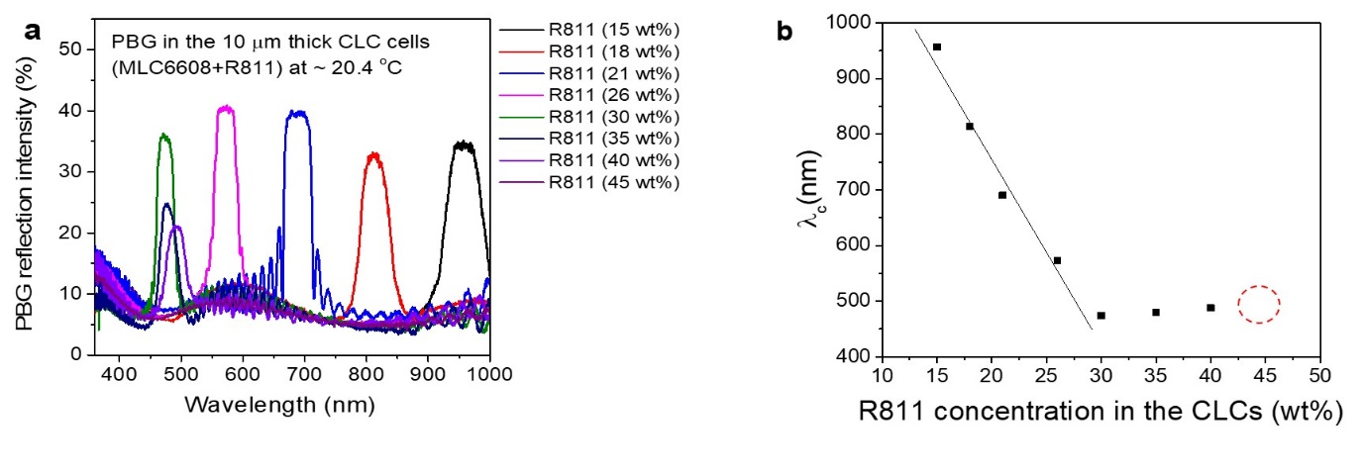
Supplementary Fig. 1: Change in the PBG of the 8 CLC cells with the concentration of the chiral material R811. The PBG in the cells was measured at room temperature (~20.4 $℃$). a, Eight PBG spectra of the eight plane CLC cells (with 10 μm thickness) with different R811 concentrations (15 wt%, 18 wt%, 21 wt%, 26 wt%, 30 wt%, 35 wt%, 40 wt%, and 45 wt%). b, Changes in the PBG centre wavelength position, $λ_{c}$, of the eight CLC cells in response to the eight different concentrations of R811 in a. From these data of a and b, we can see that as the relative ratio of the R811 to MLC6608 concentration increased, $λ_{c}$ shifted towards a shorter wavelength, reaching 474 nm at 30 wt.%. However, abnormally, at a 35 wt% concentration of R811, $λ_{c}$shifted to a longer wavelength, and the wavelength amplitude in the PBG decreased. Finally, at 45 wt% R811, the PBG disappeared, and the data position is indicated by a red dotted circle. This behaviour suggests that the CLC mixture with 45 wt% R811 is supersaturated at room temperature (~20.4 °C). The solid line of b is a guide for the eye.

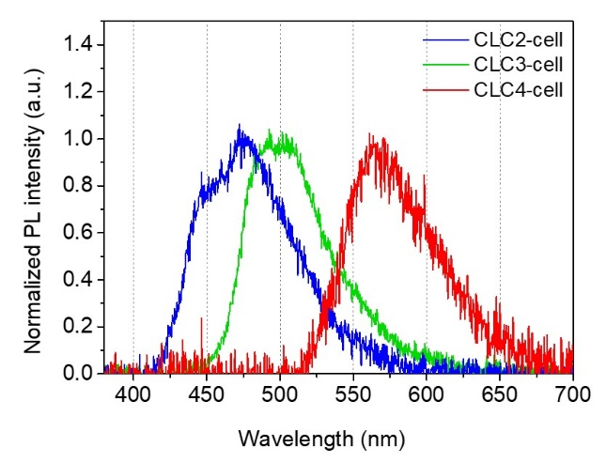
Supplementary Fig. 2: PL spectrum of the CLC cells filled with three CLC mixtures. The PL spectra were generated when a 355 nm ND-YAG laser pumped the CLC cells. ($-$), the PL spectrum of the SCLC2 cell containing the Cou.500 dye only spans 420 nm to 580 nm. ($-$), the PL spectrum of the SCLC3-cell containing Cou.500 and Cou.540A dyes spans 450 nm to 600 nm. Notably, the PL intensity in the 420-450 nm range is strong in the SCLC2-cell, whereas the PL intensity in the 420-450 nm range disappears in the SCLC3-cell despite it containing Cou.500 dye. This is because the Cou.500 dye and Cou.540A dye are mixed into the liquid crystal together, resulting in Förster resonance energy transfer, in which the high energy of the excited Cou500 is not emitted as light but transferred to the low energy Cou.540A. ($-$), the PL spectrum of the SCLC4-cell containing DCM and LDS698 dyes spans 550 nm to 670 nm. The PL spectra of the three CLC cells cover the full visible spectrum.

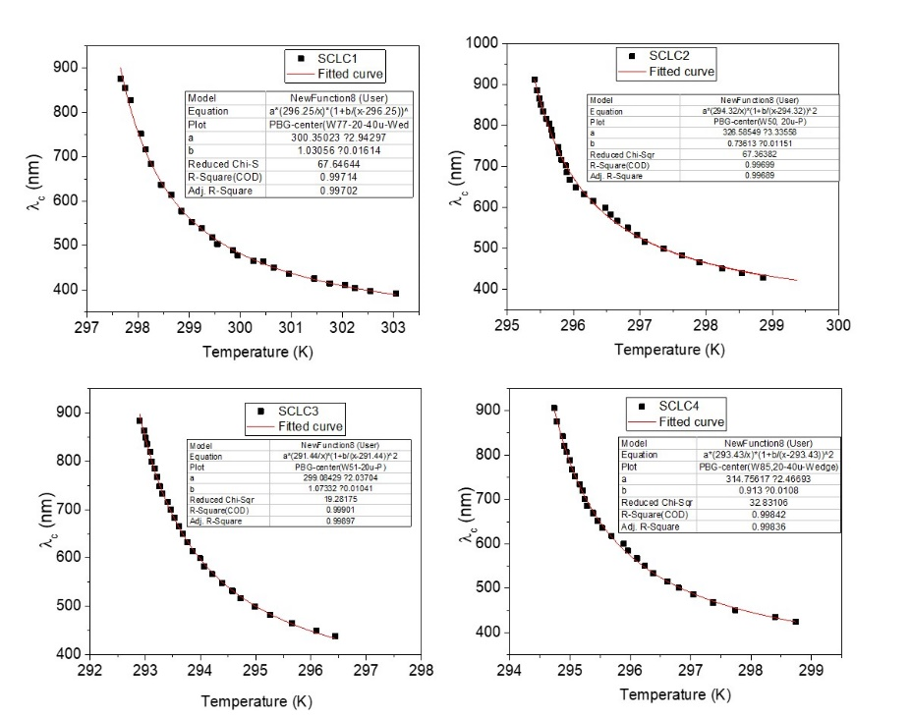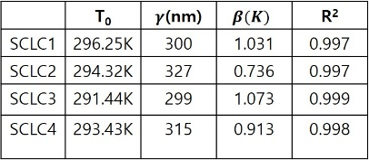

Supplementary Fig. 3: PBG change due to temperature change of the four CLC cells and parameters fitted based on Keating theory. a, Change in the PBG centre wavelength ($λ_{c}$) in the CLC cells with different laser dyes as the temperature changes. The data were fitted based on Keating theory (solid red lines), $λ_{c}(T)=γ({T_{0}}/T){(1+ β/{(T-T_{0})} )}^{2}$, where $T_{0 }$is the SmA-CLC transition temperature and $γ and β$ are fitting parameters.
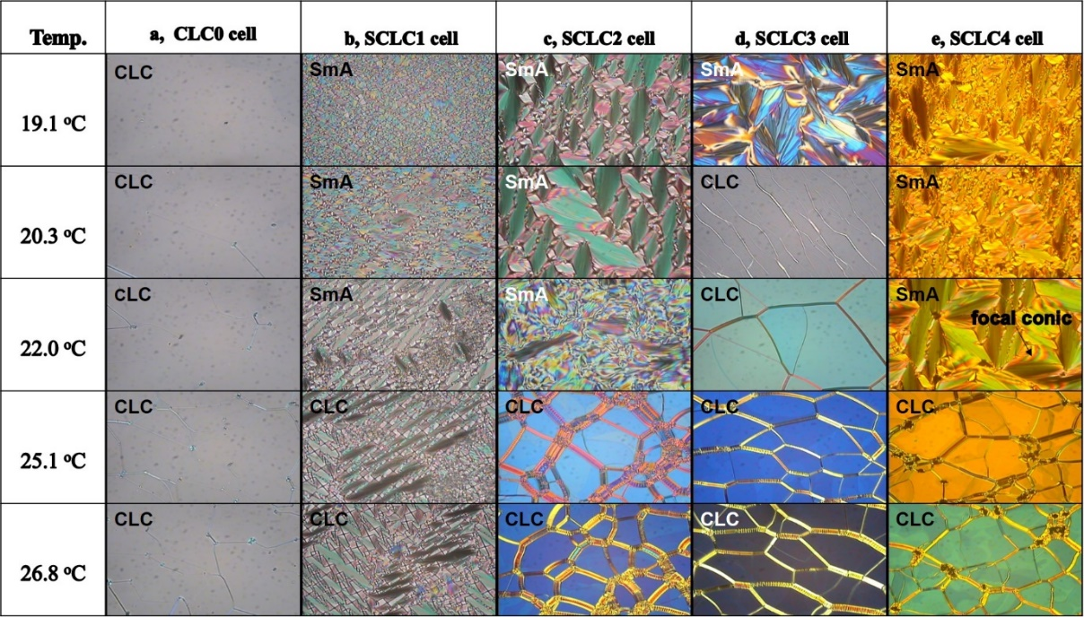

Supplementary Fig. 4 Cross-polarized optical microscopy (POM) images of the 5 CLC cells in the SmA and CLC phases at five different temperatures. a, Textures of the CLC0 cell (MLC6608 (79 wt%) + R811 (21 wt%)) showing only the CLC phase over all temperature ranges and the same PBG centre wavelength of $λ_{c}$= 690 nm (see Supplementary Fig. 1). b, Textures of the SCLC1 cell (MLC6608 (55 wt%) + R811 (45 wt%)) showing the CLC phase and SmA phase. c, Textures of the SCLC2 cell (MLC6608 (79 wt%) + R811 (21 wt%) + Con.500) showing the CLC phase and SmA phase. d, Textures of the SCLC3 cell (MLC6608 (79 wt%) + R811 (21 wt%) + Con.500 + Cou.540A) showing the CLC phase and SmA phase. e, Textures of the SCLC4 cell (MLC6608 (79 wt%) + R811 (21 wt%) + DCM + LDS698) showing the CLC phase and SmA phase at temperatures of 19.1$℃$, 20.3$℃$, 22$℃$, 25.1$℃,$ and 26.8$℃, with ΔT=± 0.2℃$. These SmA phases with various focal-conic fan structures occur due to the rod-like nature of the chiral dopant, and the large amount of R811 causes the packed layers to form a smectic phase below the SmA/CLC transition temperature. We can see from the POM results that in the case of dye-doped SCLC2, SCLC3, and SCLC4 cells, phase transitions from the CLC to SmA phase occur at different temperatures depending on the type of dye doped.
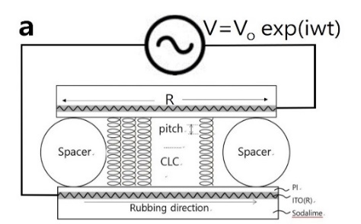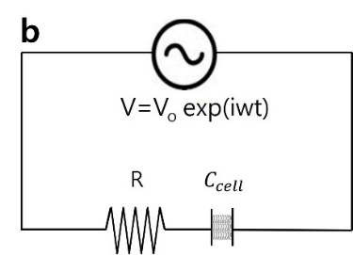

Supplementary Fig. 5 Schematic diagram of a parallel CLC cell structure with a small surface area. a, The parallel CLC cell structure has a uniform thickness in the cell. b, Equivalent circuit of the parallel CLC cell in a.; V, applied AC voltage; R, total resistance of the ITO substrate; $C_{cell}$, capacitance of CLC cell; PI, polyimide; ITO, indium tin oxide; and soda lime, glass substrate.

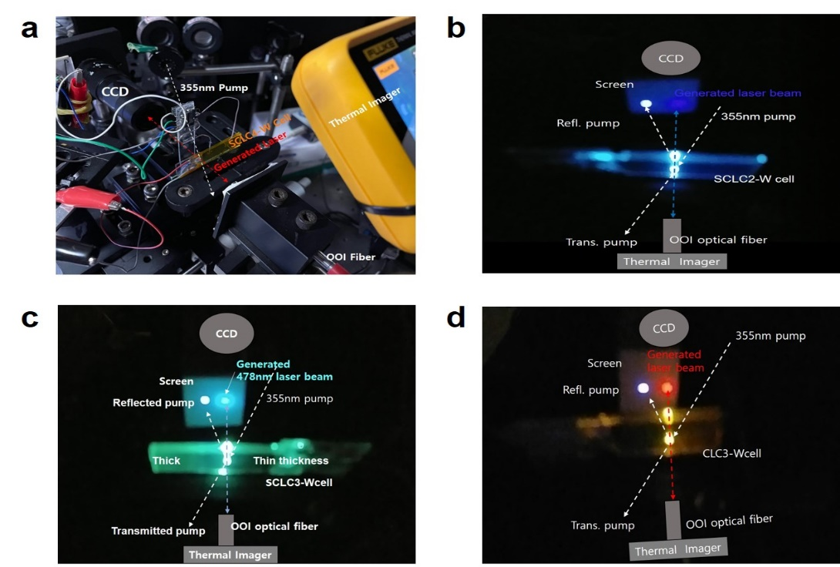

Supplementary Fig. 6 Photos of the experimental setup for lasing with wedge SCLC cells. a, Experimental setup with the SCLC4-W cell. Electric wires for applying a voltage to the cell and measuring the temperature change at 2 different thickness positions of the cell when applying an electric field are connected to the cell. b, Lasing photo of the wedge SCLC2-W cell. c, Lasing photo of the wedge SCLC3-W cell. d, Lasing photo of the wedge SCLC4-W cell.
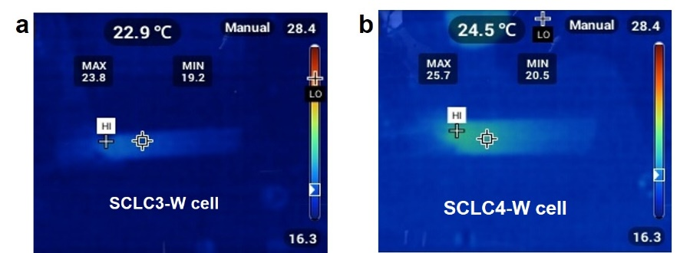

Supplementary Fig. 7 IR images of the SCLC3-W cell and SCLC4-W cell showing the formation of a temperature gradient along the wedge direction of the cells due to the electric field-induced thermal effect of the $r_{i,ITO}-c_{i,cell}$ circuit. a. IR image of the SCLC3-W cell. b, IR image of the SCLC4-W cell.

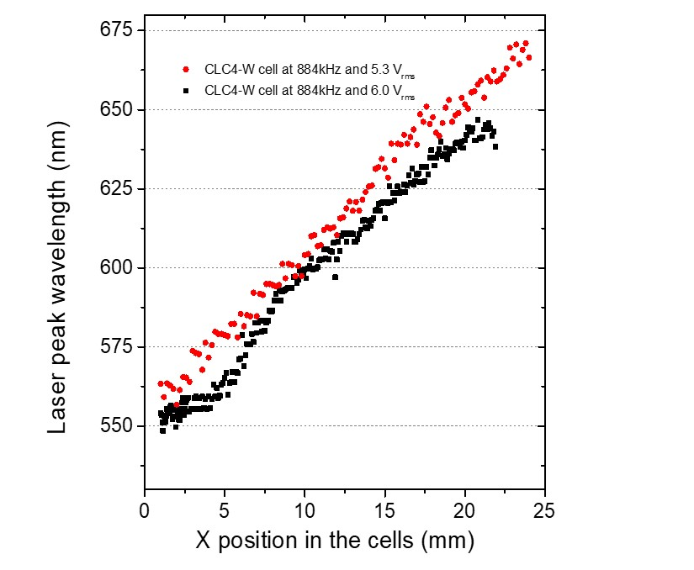
Supplementary Fig. 8 Two laser tuning spectrum ranges measured with another SCLC4-W cell with 20 μm and 40 μm spacers under two different voltage conditions. (●), at 5.3 $V_{rms}$and $884 kHz,$the laser tuning range was 116.2 nm from 555.8 nm to 671.0 nm for a 23.2 mm movement with $∆x=200 μm,$and (■), at 6$.0 V_{rms}$ and 884 kHz, the laser tuning range was 99.3 nm from 548.6 nm to 646.9 nm for a 20.9 mm movement with $∆x=50 μm$.
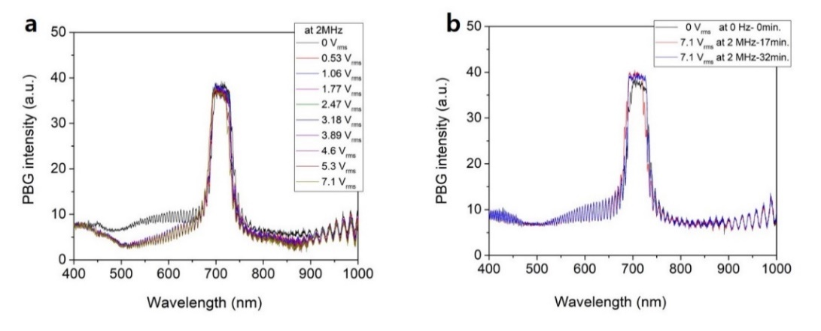
Supplementary Fig. 9 PBG change in a parallel CLC0 cell under various applied voltages. CLC0 cell with a mixture of MLC6608 (79 wt%) and R811 (21 wt%) with a cell thickness and size of ~19.8 µm and ~1.1 cm x 1.3 cm, respectively. a, There are no changes in the position or shape of the PBG in the cell for an applied voltage of 0 to 7.1 V_{rms} at 2 MHz at room temperature (20.4 °C), while the temperature of the cell is increased by 3.5 °C. Each data point was collected after applying the voltage to the cell for 8~10 min to ensure that the cell temperature and pitch change reached a steady state at each applied voltage. b, There are no changes in the position and shape of the PBG in the cell for the applied voltage of 7.1 V_{rms} at 2 MHz for a long time up to 32 min. Furthermore, as the frequency of the applied voltage was increased to 10 MHz and the amplitude was increased to 7.1 V_{rms}, the PBG did not change.

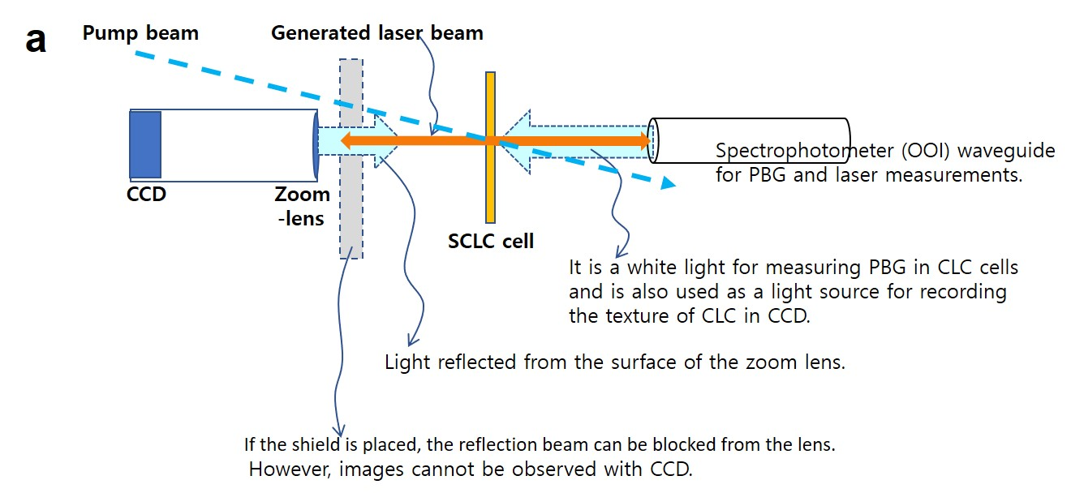
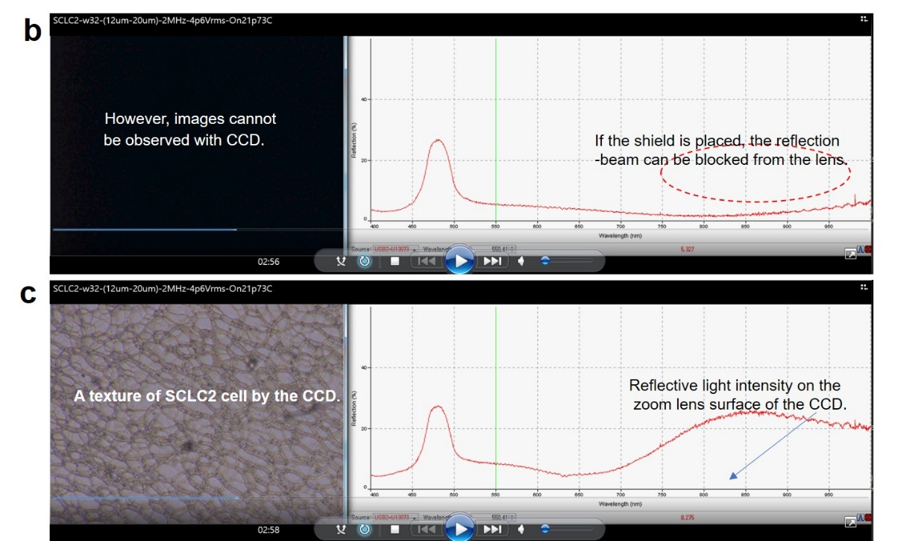
Supplementary Fig. 10 Effect of light rays reflected from the zoom lens of the CCD on observing PBG changes in SCLC cells. a, Experimental set-up in real-time measurement. b, A PBG spectrum of the SCLC2 cell when a shield is in front of the zoom lens of CCD. c, A PBG spectrum of the SCLC2 cell without the shield in front of the zoom lens of CCD. In movies that record PBG changes and laser generation by electric field application in real-time, light reflected from the zoom lens surface of the CCD enters the optical waveguide with light reflected from the PBG of CLCs, making it difficult to observe changes in PBG in spectrum range above 750 nm. Therefore, PBG movement was observed by occasionally blocking light reflected from the lens with a screen.
Supplementary text S1
Regarding the principle of the formation of the pitch gradient more specifically, the first reason (1) is that since the cell is composed of two ITO substrates with a surface resistance, when moving from p1 (thin thickness position) to p2 (thick thickness position) in Fig. 2a and b, a voltage drop occurs due to the resistance of ITO. Thus, the temperature is higher at p1 than at p2 (Fig. 2a). The second reason (2) is that as the cell thickness $d_{i}$increases when moving from p1 to p2, the capacitance $c_{i}$ decreases. When a voltage with frequency $f_{1}=1/2πr_{1}c_{1}$ is applied to the cell, heat is well generated at the $c_{1}$ position in the wedge cell in Fig. 2b. However, if $f_{1}$is applied to the $i_{th }$capacitor $c_{i}$instead, since $f_{i}=\frac{1}{2πr_{i}c_{i}}$, the heat generation efficiency is reduced. Therefore, based on reasons (1) and (2), as the position in the cell moves from the thinner p1 to the thicker p2, the generated heat gradually decreases, forming a temperature gradient in the wedge cell. XXX. Therefore, by applying an AC voltage with a frequency of $f_{1}$to the CLC wedge cell, electric field and temperature gradients are formed through the electrothermal effect of the $r_{i,ITO}-c_{i,cell}$ circuit array formed along the wedge direction in the SCLC cell, or as the thickness of the wedge cell increases, the voltage and temperature decrease, resulting in the formation of a continuous wavelength-tuneable PBG array along the wedge direction at one time.

From the nine Movies, it is possible to see in real-time that the domain of CLC forms and grows in size as the voltage is applied to the SCLC-W cells, and the continuous colour change of the domain indicates a continuous pitch change. In addition, it is possible to check the laser line that is continuously tuned in the full visible spectrum range.

Movie S1. In-situ measurement of forming a PBG array and laser generation in 8min 7 sec by
applying 5.3 V_{rms} at 2 MHz to the SCLC2-W cell (by 20 $μm$ and 40 $μm$spacers). Here, it can be
seen that the domain of CLC is formed and the size increases as the voltage is applied, and the
continuous color change of the domain indicates a continuous pitch change.
Movie S2. Real-time measurement of continuous wavelength tuning of lasing from the SCLC2-W cell
(by 20 $μm$ and 40 $μm$spacers) by applying 5.0 V_{rms} at 2 MHz.
Movie S3. Real-time measurement of continuous wavelength tuning of lasing from the SCLC2-W cell
(by 20 $μm$ and 40 $μm$spacers) by the camera.
Movie S4. Real-time measurement of continuous wavelength tuning of lasing from the SCLC2-W
cell (by 12 $μm$ and 20 $μm$spacers) by applying 6.0 V_{rms} at 884 kHz.
Movie S5. Real-time measurement of continuous wavelength tuning of lasing from the SCLC3-W
Cell (by 12 $μm$ and 20 $μm$spacers) by applying 6.0 V_{rms} at 884 kHz.
Movie S6. Real-time measurement of continuous wavelength tuning of lasing from the SCLC3-W
cell (by 20 $μm$ and 40 $μm$spacers) by the camera.
Movie S7. Real-time measurement of continuous wavelength tuning of lasing from the SCLC4-W
Cell (by 15 $μm$ and 20 $μm$spacers) by applying 4.2 V_{rms} at 2 MHz..
Movie S8. Real-time measurement of continuous wavelength tuning of lasing from the SCLC4-W
cell (by 15 $μm$ and 20 $μm$spacers) by applying 4.2 V_{rms} at 2 MHz..
Movie S9. Real-time measurement of continuous wavelength tuning of lasing from the SCLC4-W
Cell (by 20 $μm$ and 40 $μm$spacers) by the camera.

