Supplementary information

Title: The SOC of steppe grasslands is more sensitive to grazing than desert-steppe grasslands and is regulated by precipitation outside the growing season in the Mongolian Plateau

Zhijia Quan1; Yunxiang Cheng1*;Mitsuru Tsubo 2; Masato Shinoda3

1. School of Ecology and Environment, Inner Mongolia University, Hohhot, China； Key Laboratory of Ecology and Resource Use of the Mongolian Plateau, Ministry of Education of China, Hohhot 010021, China

2.Arid Land Research Center, Tottori University, 1390 Hamasaka, Tottori 680-0001, Japan

3. Graduate School of Environmental Studies, Nagoya University, Nagoya 464-8601, Japan

Correspondence: chengyx@imu.edu.cn

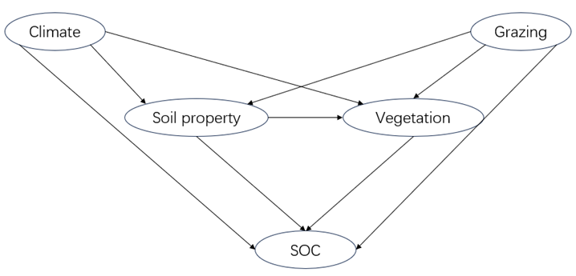
Fig S1. A structure equation model showing the hypothesized causal paths to examine the effects of climate, grazing, soil texture, and vegetation on the soil organic carbon (SOC). Ellipses denote the latent variables included in the model. Single-headed arrows denote the paths. Double-headed arrows indicate an interaction effect between a pair of variables. Climate: climate factors; Grazing: grazing intensity; Soil property: soil properties; Vegetation: plant diversity index; SOC: soil organic carbon.

Table S1
Total, direct, and indirect effects of influencing factors on soil carbon analyzed by structural equation modeling
 | desert-steppe |  |  |  |  | steppe
 | GST | EC |  | SRf |  | OGSP | GI | PH | SRf
Total effect | -0.39 |  | 0.48 | 0.27 |  | 0.90 | -0.09 | 0.20 | 0.16
Direct effect | -0.33** |  | 0.48*** | 0.27* |  | 0.94*** | -0.04 | 0.12* | 0.16**
Indirect effect | -0.06 |  | - | - |  | -0.04 | -0.05 | 0.08 | -
Note: “*”, “**”, and “***” indicate significant differences at P < 0.05, P < 0.01, and P < 0.001. GI denotes grazing intensity; GST denotes growing season temperature; OGSP denotes outside growing season precipitation; EC denotes electric conductivity; PH denotes potential of hydrogen; Moisture denotes soil moisture; SRf denotes species richness of forb.

Table S2
C4 plant cover/C3 plant cover at different grazing intensities in steppe grasslands
Site name | Grazing intensity | C₄ plant cover/C₃ plant cover
Arvayheer | LG | 0.03
 | MG | 0.26
 | HG | 0.06
 | OG | 0.34
Baiyan-Unjuu | NG | 0.79
 | MG | 1.25
 | HG | 3.02
 | OG | 2.01
Bayanhongor | LG | 0.02
 | MG | 0.02
 | OG | 0.03
Erendalay | LG | 0.64
 | MG | 0.49
 | OG | 0.83
Note: NG, no grazing; LG, light grazing intensity; MG, middle grazing intensity; HG, high grazing intensity; OG, overgrazing intensity.

